**Crowdsourcing Audio Transcription**

While progress has been made with deep learning, audio transcription is difficult for machines to get right but is relatively easy for human beings. We take an approach to engage human beings in games to transcribe audio while providing the players with entertainment similar to Candy Crush Sage game. This human input will complement and top off (>99%) the accuracy of machine transcription.

We have built a prototype app to enable crowdsourcing of audio transcription. The players can see their scores, completion percentage, and the performance of their peers. The app will rank the performance of players and networked groups of players with informed consent. The audio library screen is shown here:

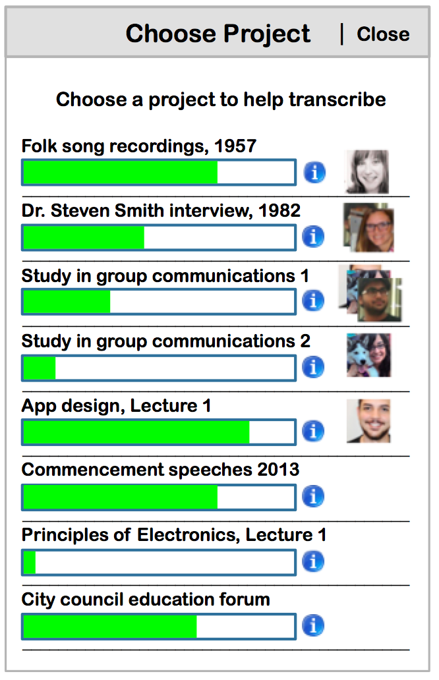

There are several visual games; one of them is JigSaw. Jigsaw is where a sequence of blocks is provided, but shuffled. The transcriptions for each are provided at the bottom. Complete transcription and arrangement is the goal.

