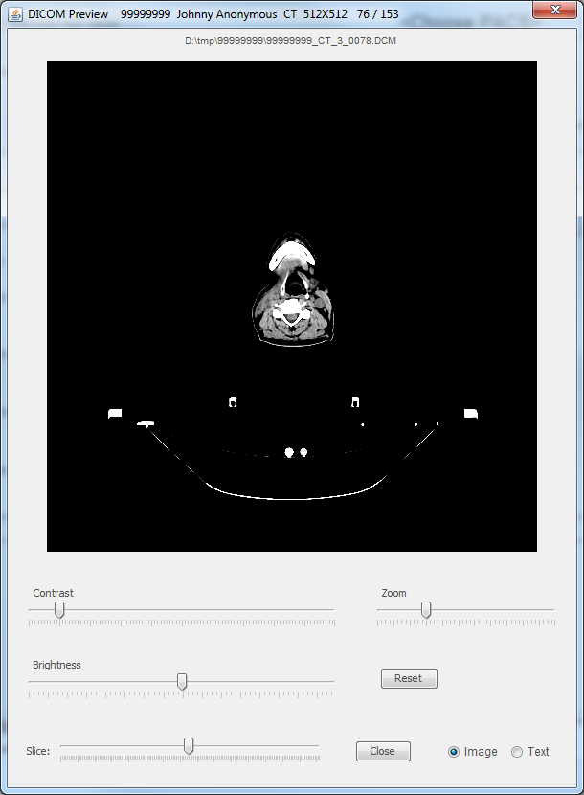
Contents of
DICOM file as image
Source file.
Supports
copy+paste
Summary of current file. Contains Patient ID, patient name,
series number, modality, series desription,
slice number / number of slices in series
Adjust image
contrast
Select slice
To view
Adjust image
brightness
Adjust
Image size
Select text or
image preview
Close this window
Reset contrast, brightness,
and zoom to default
Sliders may be moved one increment by
either clicking to the right or left, or, by
using the keyboard left and right arrow keys.

