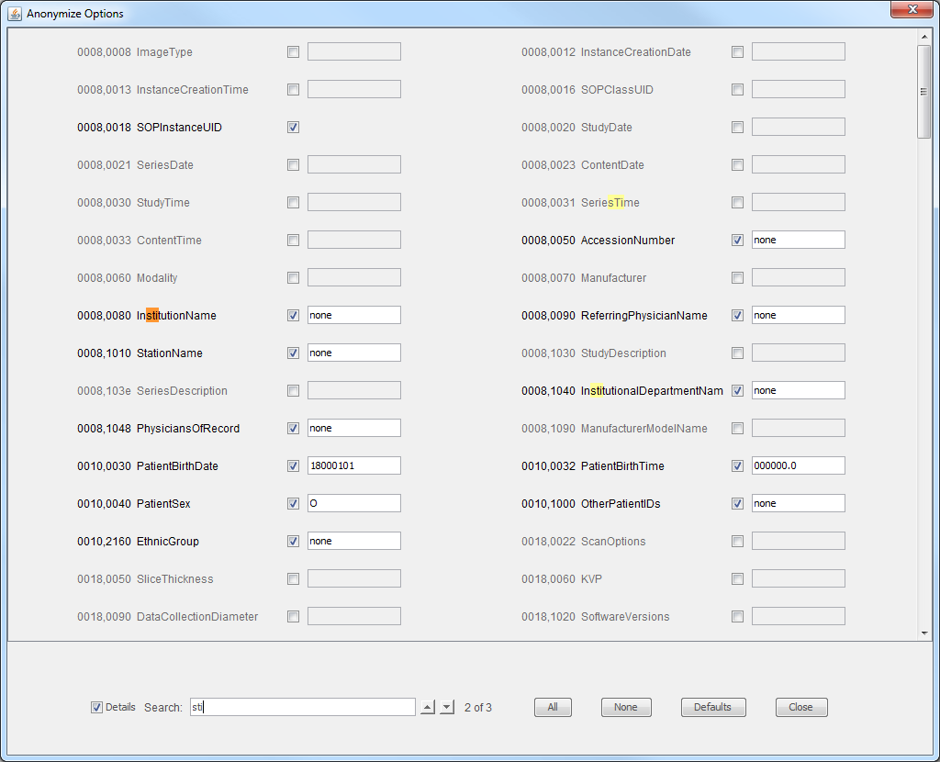
Only checked items
will be anonymized
Search as
you type
Makes all
values anonymized
Makes no
values anonymized
Resets to
default selections
Close this
window
UIDs can not be
given custom values
for anonymization
Value to
anonymize to
Items matching search
are highlighted

