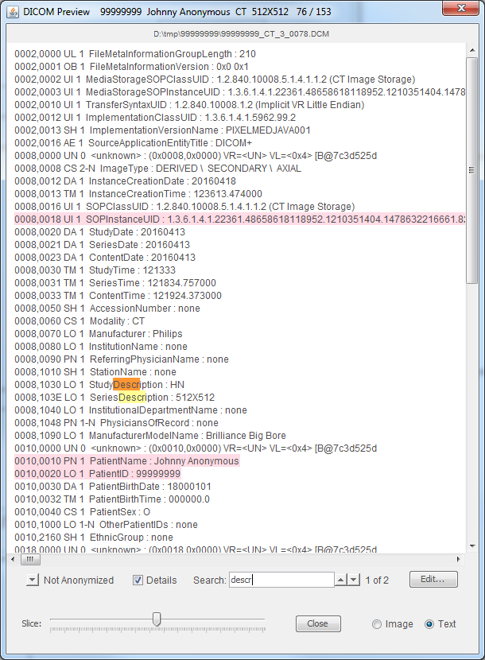
Arrow changes display between
1: No Highlighting (normal color)
2: Not Anonymized (but will be : red) /
3: Anonymized (anoymized value : green)
Summary of current file. Contains Patient ID, patient name,
series number, modality, series desription,
slice number / number of slices in series
Source file.
Supports
copy+paste
Select slice
To view
Select text or
image preview
Close this window
Open
Edit
Window
Toggle display of
group and element numbers,
VR (Value Representation)
And VM (Value Multipllicity)
Search as you type.
Current selection in orange,
others in orange
Metadata shown as text.
Use mouse to select text.
Ctrl-A : select all
Ctrl-C : copy selected
Ctrl-F : search for selected
Copied text can be pasted to
other apps like MS Word.
Highlighted by
Search feature

