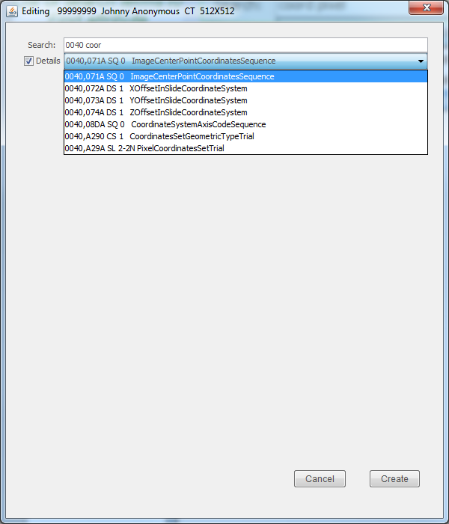
Toggle display of
group,element,
VR, and VM
Enter blank separated
list of search terms to
find attribute

