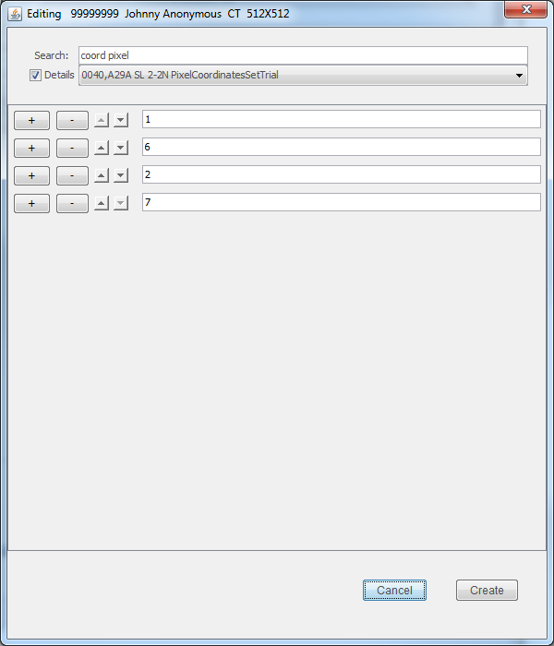
Use + and - buttons to
add and remove values
Use arrow buttons to
reposition values
up and down the list
Enter new values here

