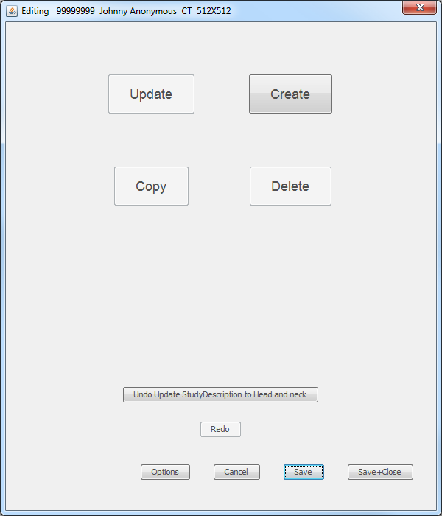
Series
identification
Change the
Value of an
attribute
Make a new
attribute
Remove an
attribute
Copy and
attribute
Undo the latest change
Redo what
was undone
Save to disk and
close this window
Save to disk but
Leave window open
Close this window and
discard unsaved changes
Show options
for saving
Note: Use the mouse in
the preview window
to select an attribute to edit

