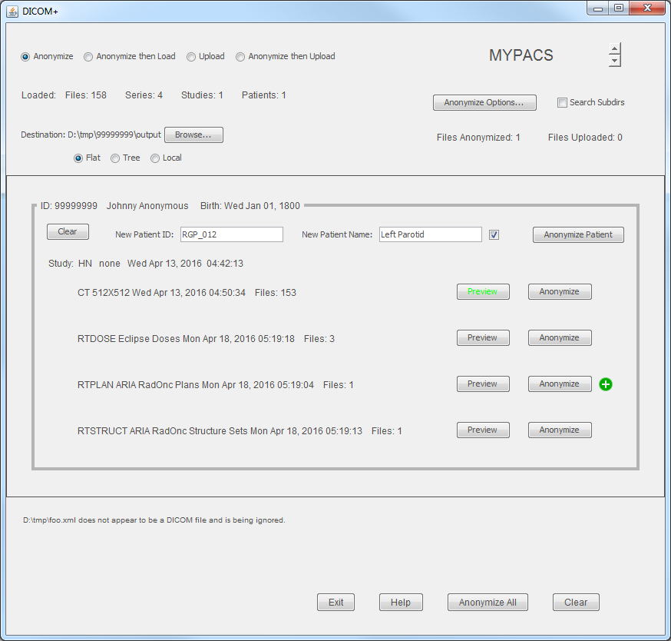
Mode
Program Name
(configurable)
Upload Destination and selector arrows
Shows Anonymize Options window
When reading files,
recursively search
subdirectories
When writing files,
controls the hierarchy
Count of
loaded objects
Count of
Uploaded and
anonymized files
New files
are put here
Patient ID and
demographics
Unloads this patient
from this application
User entered patient ID
User entered patient name
Allows patient id
and name to differ
Processes all series
for this patient
Processes the series.
Button name will
change with mode
(anonymize, upload, etc.)
Preview the series as
either images or text.
Text mode allows editing.
Currently previewed
Series is highlighted
Shows that processing
was successful
Series modality,
description, date, time,
and number of files
Series modality,
description, date, time,
and number of files
Study description,
ID, date and time
Errors and
Warnings.
(allows copy
and paste)
Exits DICOM+
Shows help window
Unloads all patients from
this applicdation. Also
clears errors and warnings.
Processes all series.
Button name will
change with mode
(anonymize, upload, etc.)

