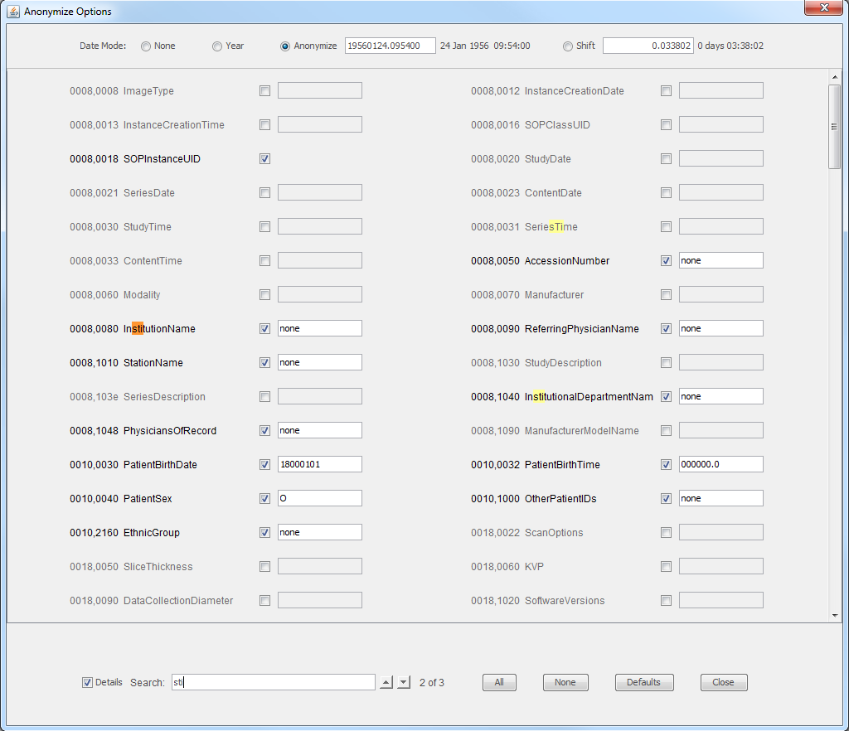
Only checked items
will be anonymized
Search as
you type
Makes all
values anonymized
Makes no
values anonymized
Resets to
default selections
Close this
window
UIDs can not be
given custom values
for anonymization
Value after
anonymization
Items matching search
are highlighted
Toggles showing of
attributes' group
and element numbers
Shift dates+times forward
or back by given amount.
Set all dates and times
to a given value
Truncate all dates to Jan 1of
that year. Do not change times.
Do not changes dates or times.
Select date 1
of 4 modes

