**LSDTable**

**User Guide**

**Jim Irrer 13 April 2020**

The LSDTable utility zeros out table angles in DICOM files. Specifically, the DICOM attributes:

300A,0140 TableTopPitchAngle

300A,0144 TableTopRollAngle

300A,0125 TableTopEccentricAngle

Before changing values, the files are checked to make sure that:

* No angle has an absolute value defined by the environment variable MaxTableAngle.
* All DICOM files have the same frame of reference.
* All DICOM files refer to the same patient.

If any of these are violated, then the entire set of files is rejected and no files are created.

Besides zeroing table angles, the program also creates new series by replacing the SOP Instance UIDs and Series Instance UIDs with new ones. This allows the files to be imported into a treatment planning system without conflicting with their previous versions.

Finally, the Series Description is modified by appending it with ‘LSDTable zero’ to differentiate it from previous versions. If there is no Series Description, then it is created as ‘LSDTable zero’.

The files are written to a sibling directory with the name appended with ‘-LSDTable-output’.

**MaxTableAngle**

MaxTableAngle is an environment variable that sets the upper bound of absolute values of table angles. If not specified or invalid, the program will default to 1.0.

**Running the Program**

To run the program, export the pertinent DICOM files to a file folder.

Next, navigate to:

**T:\Radonc_Shared\shared\Physics\Projects\DICOM\LSDTable**

with Windows File Explorer as shown below:

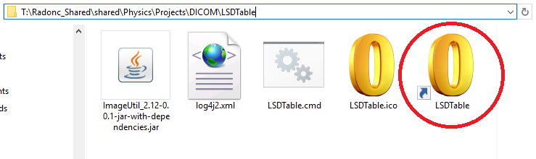

Drag and drop the folder containing DICOM files onto the LSDTable shortcut circled in red above.

*Note: You may copy and paste this shortcut to your desktop as a convenience for future use.*

Dropping the DICOM folder will start the program and show progress in a DOS command window and potential errors. Press any key to close the window.

The new DICOM files will then be ready for import into the treatment planning system.