**DicomSort**

**User Manual**

Jim Irrer 22 February 2021

DicomSort is a utility for sorting and organizing a large number of DICOM files. It addresses the situation where DICOM files are in a local directory but are named in such a way as to provide little indication as to their contents.

The program is run by dragging a single directory onto the DicomSort.cmd file. It will make a new sibling directory that contains the original DICOM files, renamed and put into a tree reflecting their content.

The program is installed at:

\\corefs.med.umich.edu\shared2\Radonc_Shared\shared\Physics\Projects\DICOM\dicomsort

Note: Running this program will change the input directory.

The tree is organized as a hierarchy:

Patient

Study

Series

Instance

It tries to minimize the number of directories created, so:

* If there is only one patient, then there is not an extra directory level for that patient
* If a series only contains one file, then the series will not have the extra directory level

Files are moved, not copied. This means that the original directory will be different.

The input directory will be searched recursively for DICOM files.

The output directory will be named after the input directory with “output” appended.

The program may be run as a command line, giving the input directory as the parameter. If a second parameter is given, then it will be used as the output directory.

When files are moved, they are renamed to reflect their contents.

Duplicate files are ignored. If more than one DICOM file has the same unique ID, then only one is moved.

Non-DICOM files are ignored.

When finished, empty directories in the input directory are automatically deleted.

The example below demonstrates the output:

* “LotsOfDicom” was the input directory
* The file hierarchy shows the patient ID $TX2_OBI_2020Q4, with the Study directory within it.
* Study directories are prefixed with “Study”, followed by the study description. The overall name length is restricted.
* Series are named with:
  + Date+Time
  + Modality
  + Number of slices
  + Frame of References (FOR). Each FOR has a unique small identifying integer.
  + Series description (with maximum length restricted).

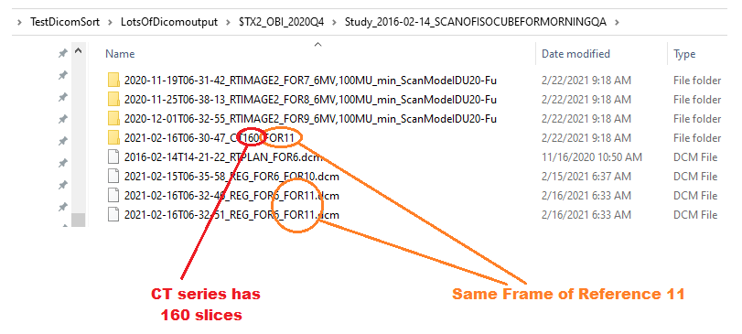

*Example Windows Explorer output*