**Using the mouse wheel and dragging horizontally in the chart area changes the horizontal scale and position.**

**Using the mouse wheel and dragging vertically in the Vertical Adjust Area changes the vertical scale and position.**

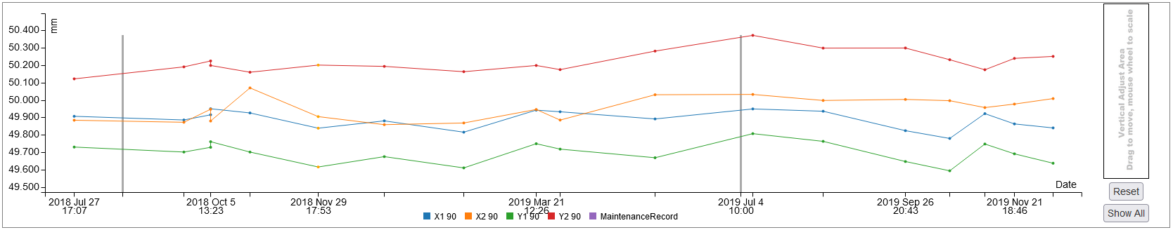

**Sets vertical scale and position to show all data. points.**

**Resets vertical scale and position to original settings.**

***Note: Scrolling and rescale controls only apply to charts showing data verses time.***