Ian Romano

Computer Assignment 1

ELEG 811

Fall 2021

Linear Density Parity Check Decoder

In this implementation of LDPC, the BSC and AWGN channels are simulated using separate python files; LDPC_BSC.py and LDPC_AWGN.py. Each file passes an n=20000 length zero-codeword into the decoder at 500 blocks. This takes approximately 12 hours each so I recommend reducing the BLOCKS constant on line 11 from 500 to 1 if you need to test it.

Each program can be ran with Python3 using the following commands:

python LDPC_BSC.py

python LDPC_BSC.py

The programs require Numpy, Scipy and matplotlib installed using the pip command to operate.

Running the BSC program I received the following results:

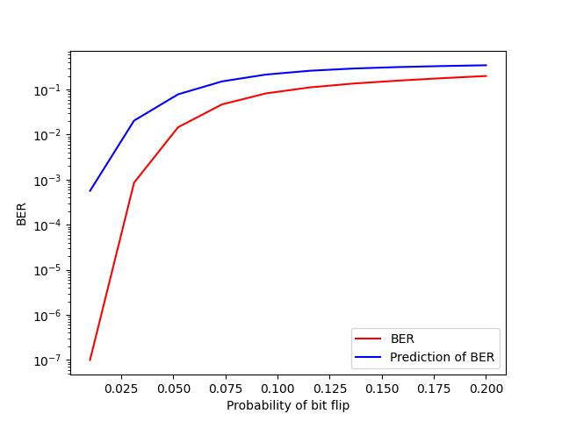

The program appears to run better than the predicted BER with probability values between 0.01 to 0.21

Running the AWGN program produced the following results:

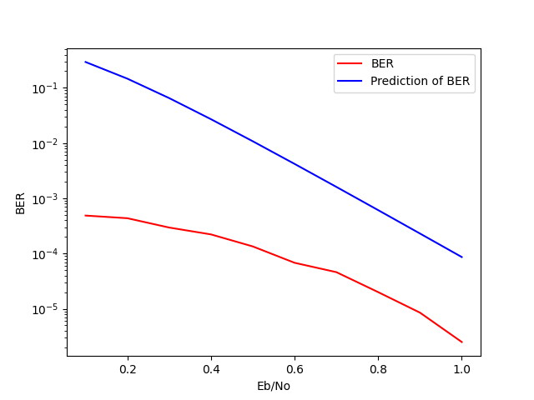

This used Eb /No values of 0.1 to 1.3 and also appeared to perform better than the predicted performance.