**Title: Can Good Wills be Biased? – An Explorational Analysis on Chinese Donors’ Preference through Online Fund-raising Platform**

**Research Question**

What factors affects the amount of donation received by women-focused philanthropic projects through online fund-raising platforms? Examining host organizations’ characteristics, nature of projects, and the narrative strategies.

To narrow down the focus area and collect comparable data, this project would focus on projects related to women.

**Background**

Fundraising and financial sustainability is one of the major concerns for non-profit organizations (NPOs). While fundings from the state and generous donations from high-net individuals or large enterprises have historically contributed to large proportion, a recent trend in China brings public donation back to the central stage. According to data from Tencent, its philanthropic platform has attracted 29 billion rmb donation from the public to support more than one hundred-thousand projects.

This new trend is motivated by tech-giants in China with the rise of e-payment and social media. Leading enterprises like Tencent, or ByteDance, and AliPay utilized their technologies in operating e-business started online fund-raising platforms as part of their corporate social responsibility. Any organizations acknowledged with legal status by the state could post their project on these platforms where they could accept direct donation from anyone who sees the message, with no limitation on the amounts (Figure 1).

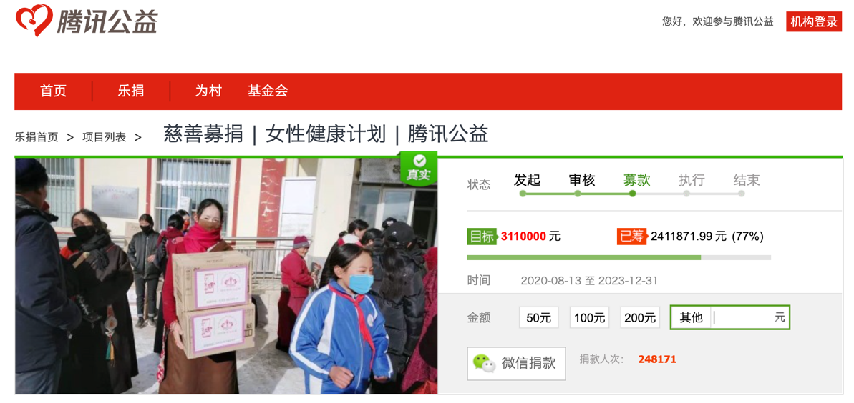

Figure 1 A sample page

**Data Source**

***1. Project Data Mining***

This analysis would use the platform established by Tencent for analysis for two reasons. First, the Tencent philanthropic is the leading platform with most donations and number of projects, providing abundant data. Second, the data is transparent in structured website for easier data-mining.

A chrome extension named webscraper could be used to scrape form the website to construct an original database. The in-build search engine could be used to select women-related projects featuring keywords (“妇女”, “女性”). An initial research feature 5332 entries of projects.

HTML: <https://gongyi.qq.com/succor/project_list.htm>

For each entry, the following data would be collected (figure 2 & figure 3).

- project title [text]

- short description [text]

- long description [text]

- the name of the executing non-profit organization [text]

- fundraising goals [numerical]

Figure 2

Figure 3

***2. Features of the Organizations***

- geographical location

- the level of administrative divisions (national, province, city, county, non-specified)

- organization size, illustrated by the registered capital (data available at the Ministry of Civil Affairs)

- Organization type (GONGO, Grassroot, Others)[1]

**Methodology – Data Analysis**

***1. Choropleth map***

This part would use the donation amount data and the location of NGOs to visualize the unequal geographic distribution of public donation.

***2. Text Analysis for project title and short description– Dictionary / Supervised Learning Method?***

The aim is to automatically classify project into categories that indicate the project’s 1) intervention; 2) target group. This would add two categorical variable data to each project.

Descriptive statistics could be included to analyze how donation unevenly flows to different interventions and target groups, indicating the under-attended group and the preferred intervention by public donations.

***3. Regression to evaluate variables related to the amount of donations***

Dependent Variable: The amount of donation for each project

Potential Independent Variables and Underlying Hypothesis:

- Features of the Organizations (as indicated in Data Source, part 2)

Hypothesis 1: Larger organizations receives more public donations

- Intervention and target groups;

Hypothesis 2: The donations received is significantly related the intervention used and target groups.

- (Optional) sentimental analysis and the affective styles of long description data

Hypothesis 3: Stronger sentimental language used in the description is positively related to the donation amounts.

1. GONGO(Government-organized non-governmental organization) refers to these under direct supervision of the state.