

Red Hat Enterprise Linux – Overview

Prepared by:
Irsal Yunus
Authorized by:
Adhi Prasetia

Table of Contents
Table of Changes 4
1. Overview 5
1.1 Purpose 5
1.2 Document Conventions 5
1.3 Intended Audience and Reading Suggestions 5
1.4 Scope of Project 5
1.5 References 5
2. Glossary 7
3. Introduction to Command Line 8
4. Kernel and User Spaces 10
5. Orientation to the Graphical User Interface 11
6. File Management in Linux 16
7. The File System Hierarchy 18
8. Editing Files Using Vim 20
9. Organizing Users and Groups 23
10. File Permissions 25
11. Managing Software 30
12. Configuring Networking 33
13. Controlling System Startup Processes 37
14. Appendix 38
List of Tables
Table 1: References 6
Table 2: Glossary 7
List of Figures
Figure 1: Example of User Command 9
Figure 2: Example of Crontab Command 10
Figure 3: Example of SSH Command 11
Figure 4: Example of Processes List 12
Figure 5: Example of All Processes 12
Figure 6: The GNOME 3 Standard Desktop 15
Figure 7: Workspaces 16
Figure 8: The GNOME Desktop with the Rhythmbox Application and the Favorites Submenu of the Applications Menu 17
Figure 9: Window Overview with "hasOverview": true 20
Figure 10: Window Overview with "hasOverview": false 21
Figure 11: Creating Directories 23
Figure 12: Example of Copying File 24
Figure 13: Move or Rename Command 24
Figure 14: Example of Hierarchy Directory in Linux 26
Figure 15: Example of Directories List in / 26
Figure 16: Example of Creating a File Using Vim 29
Figure 17: Example of Tutorial in Vim 31
Figure 18: Example of Managing User 32
Figure 19: Example of Managing Group 33
Figure 20: Example of Switching User 33
Figure 21: Example of Directory Permissions 34
Figure 22: Example of User Permissions 35
Figure 23: User and Group Permissions 40
Figure 24: Example of Registering Red Hat Subscription 42
Figure 25: Example of Repositories List 42
Figure 26: Example of Repository Information 43
Figure 27: Example of Installing Package from Repository 43
Figure 28: Example of Removing or Uninstalling Package 44
Figure 29: Example of nmcli Command Output 45
Figure 30: Example of nmcli Command Shows Devices 46
Figure 31: Example of nmcli Command Adding Connection 48
Figure 32: Example of nmcli Command Turning Up Connection 48
Figure 33: Example of nmcli Command Deleting Connection 48
Figure 34: Example of systemctl Command List 49

Table of Changes
The following table contains all changes made since version 1.0. It is expected that any change to the document is included in this table.
Changed Section | Version | Change Description | Person in Charge | Date of Change
All | 1.0 | Initial Draft |  | 30 Jul 2018

Overview
This course is intended to develop the skills needed for basic administration and configuration of Red Hat Enterprise Linux. This course introduces key command line concepts and enterprise-level tools, laying the foundation for the rapid deployment of Red Hat Enterprise Linux. The curriculum also introduces the basic administration skills needed for resolving configuration issues and integrating Red Hat Enterprise Linux systems with other existing environments. This offering lays the foundation for secure user and group administration, and develops skills that allow administrators to use available storage solutions more efficiently and securely. This course is the first of a two-part series that turns a computer professional who knows nothing about Linux into a fully capable Linux administrator. Red Hat has created this course in a way intended to benefit our customers, but each company and infrastructure is unique, and actual results or benefits may vary.

Purpose
This course is geared toward Windows system administrators, network administrators, and other system administrators who are interested in supplementing current skills or backstopping other team members, in addition to Linux system administrators who are responsible for these tasks.
Configuring, installing, upgrading, and maintaining Linux systems using established standards and procedures Providing operational support Managing systems for monitoring system performance and availability Writing and deploying scripts for task automation and system administration.

Document Conventions
Italics is used for highlighting necessary points.

Intended Audience and Reading Suggestions
This Software Design Document is intended for use for 1rstWAP Basic technical user skills with computer applications on some operating systems are expected. DevOps as background reference material.

Scope of Project
As a result of attending this course, you should be able to perform essential Linux administration tasks, including installation, establishing network connectivity, managing physical storage, and basic security administration.

References
References of documents which have relevant information.
No | Document No | Title | Link
Table 1: References

Glossary
Term | Definition
Table 2: Glossary

What is Linux, Open Source Software, and a Distrbution?

Introduction to the Shell
The Linux command shell and some of its basic utilities. It is assumed that the reader has zero or very limited exposure to the Linux command prompt. This document is designed to accompany an instructor-led tutorial on this subject, and therefore some details have been left out. Explanations, practical examples, and references to DOS commands are made, where appropriate.

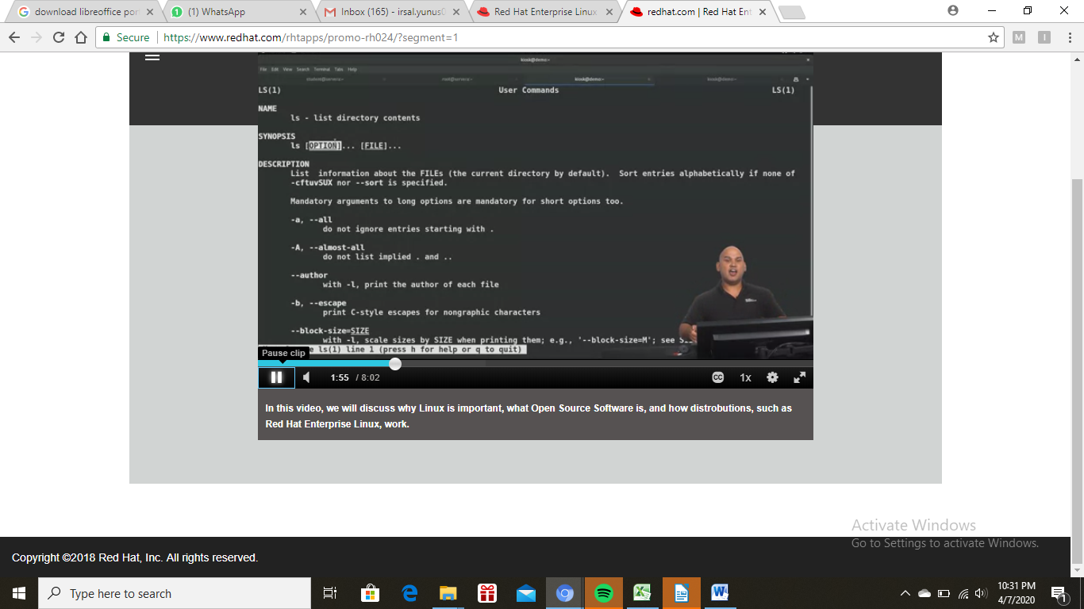Figure 1: Example of User Command

The crontab command is used to view or edit the table of commands to be run by cron.Each user on your system can have a personal crontab.Crontab files are located in /var/spool/ (or a subdirectory such as /var/spool/cron/crontabs), but they are not intended to be edited directly. Instead, they are edited by running crontab. Cron command entries Each cron command entry in the crontab file has five time and date fields (followed by a username, only if it is the system crontab file), followed by a command. Commands are executed by cron when the minute, hour, and month fields match the current time, and at least one of the two day fields (day of month, or day of week) match the current day. The cron daemon checks the crontab once every minute.
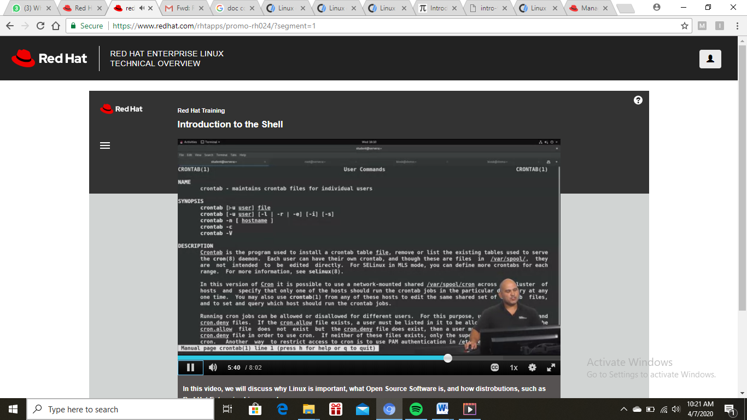Figure 2: Example of Crontab Command

The ssh command provides a secure encrypted connection between two hosts over an insecure network. This connection can also be used for terminal access, file transfers, and for tunneling other applications.
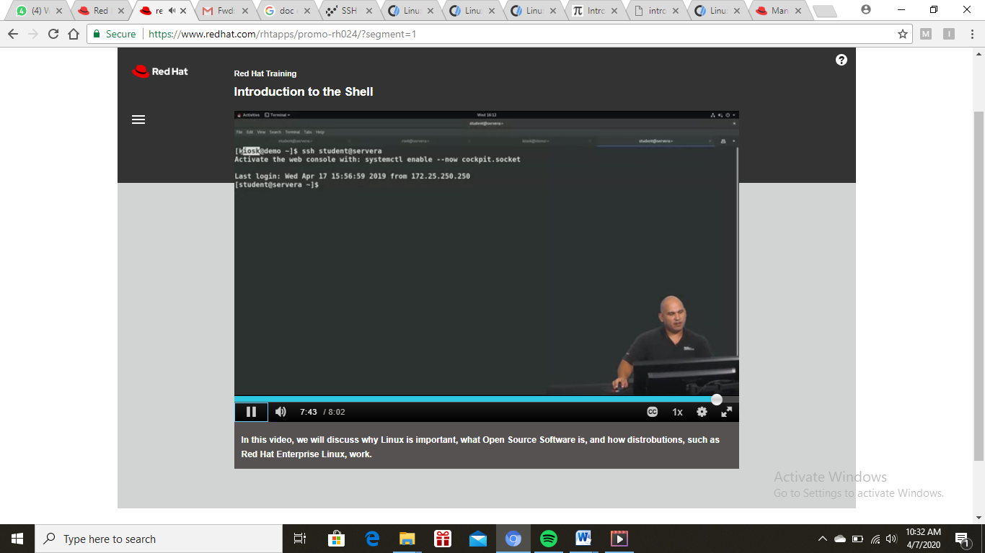Figure 3: Example of SSH Command

Kernel and User Spaces
The kernel is a core part of a Linux operating system, which manages the system resources, and provides interface between hardware and software applications. The Red Hat kernel is a custom-built kernel based on the upstream Linux mainline kernel that Red Hat engineers further develop and harden with a focus on stability and compatibility with the latest technologies and hardware.
The term userland (or user space) refers to all code that runs outside the operating system's kernel. Userland usually refers to the various programs and libraries that the operating system uses to interact with the kernel: software that performs input/output, manipulates file system objects, application software, etc.
Each user space process normally runs in its own virtual memory space, and, unless explicitly allowed, cannot access the memory of other processes. This is the basis for memory protection in today's mainstream operating systems, and a building block for privilege separation. With enough privileges, processes can request the kernel to map part of another process's memory space to its own, as is the case for debuggers. Programs can also request shared memory regions with other processes, although other techniques are also available to allow inter-process communication.
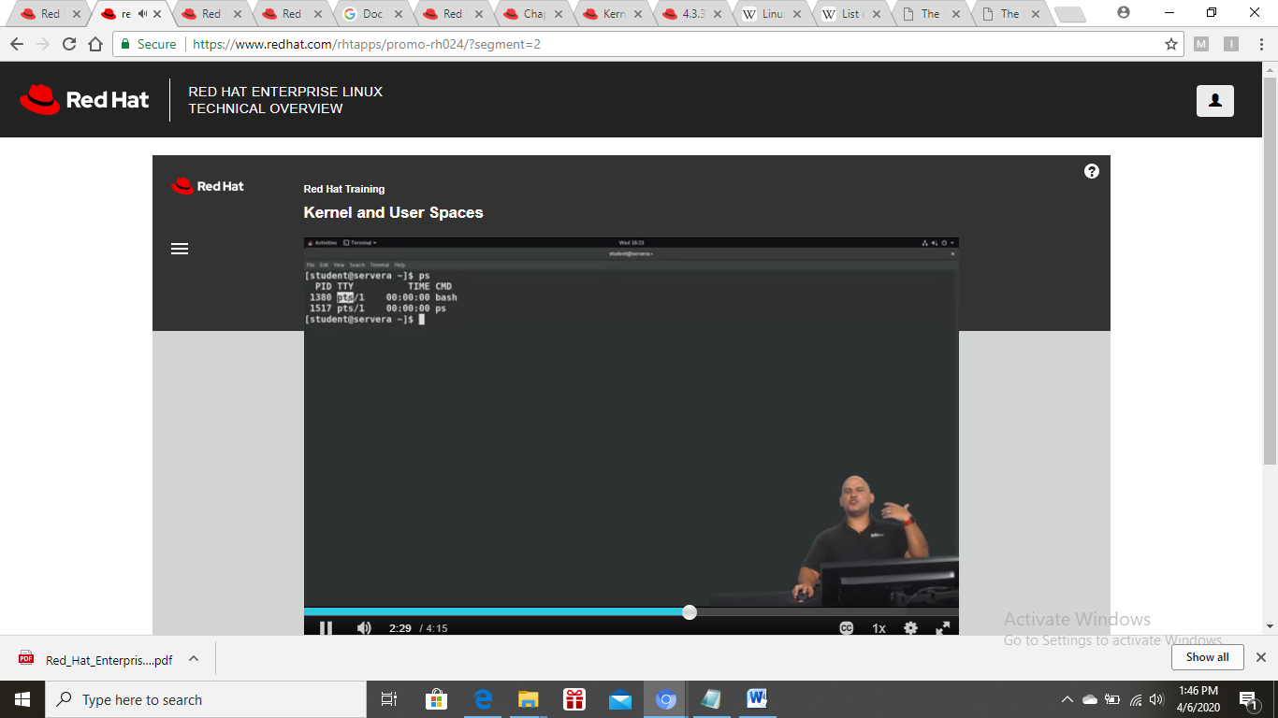Figure 4: Example of Processes List
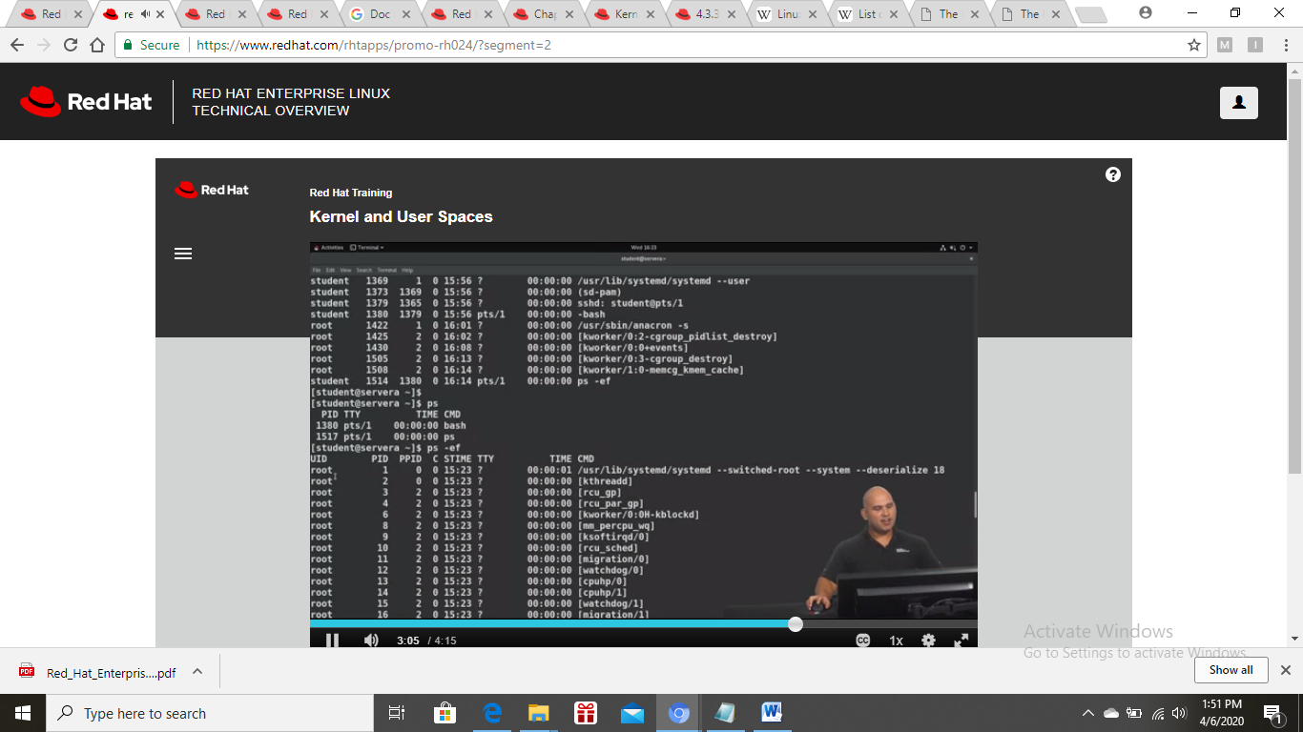Figure 5: Example of All Processes

Orientation to the Graphical User Interface
This chapter describes how to customize and use GNOME, which is the only desktop environment available in RHEL. The basics of using GNOME Shell and displaying the graphics are given, as well as the instructions for system administrators for configuring GNOME on a low level and customizing the desktop environment for multiple users. The documentation also describes how to handle selected system administration tasks using the desktop environment.
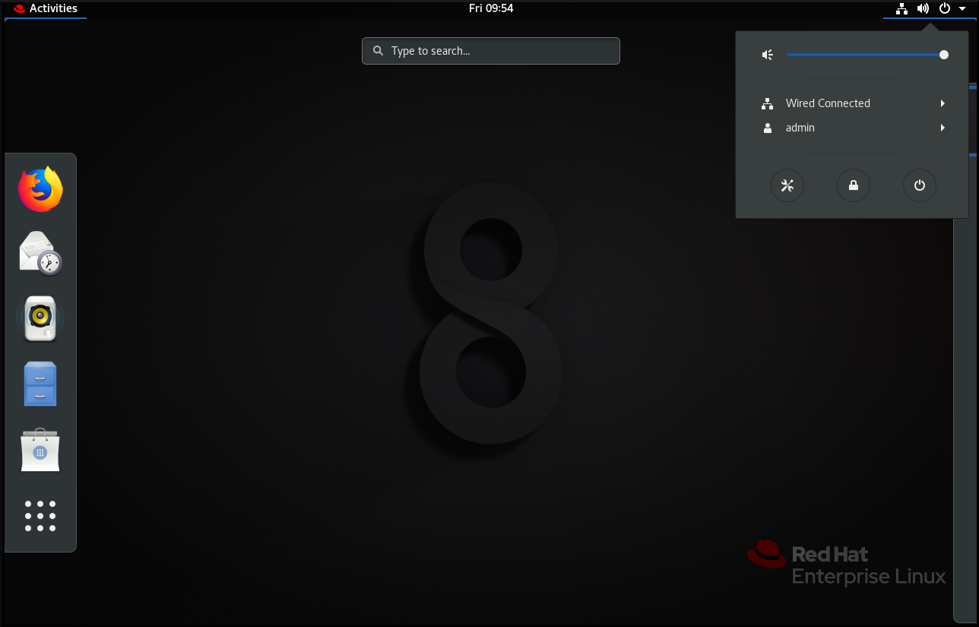Figure 6: The GNOME 3 Standard Desktop
GNOME user interface consists of these major components:
- Applications and Places
The Applications menu is displayed at the top left of the screen. It gives the user access to applications organized into categories. If you enable window overview, you can also open the Activities Overview from that menu.
The Places menu is displayed next to the Applications menu on the top bar. It gives the user quick access to important folders, for example Downloads or Pictures.
- Taskbar
The taskbar is displayed at the bottom of the screen, and features:
  - A window list
  - A notification icon displayed next to the window list
  - A short identifier for the current workspace and total number of available workspaces displayed next to the notification icon
- Four available workspaces
In GNOME, the number of workspaces available to the user is by default set to 4.

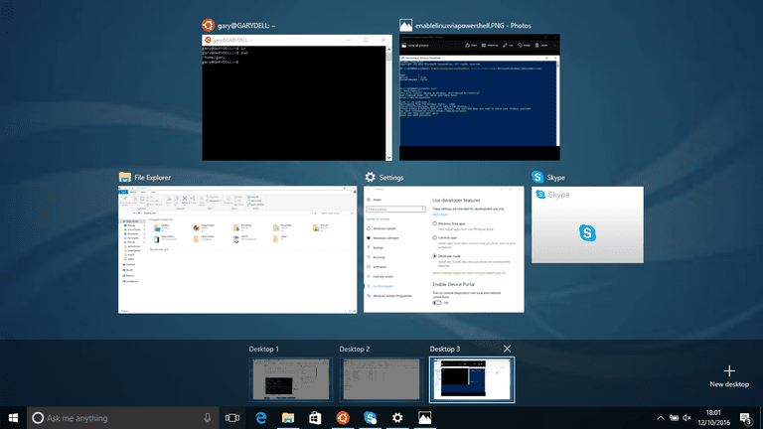Figure 7: Workspaces
- Minimize and maximize buttons
Window titlebars in GNOME feature the minimize and maximize buttons that let the user quickly minimize the windows to the window list, or maximize them to take up all of the space on the desktop.
- A traditional Super+Tab window switcher
In GNOME, windows in the Super+Tab window switcher are not grouped by application.
- System menu
The system menu is located in the top right corner, and enables you:
- Updating settings
- Controlling the sound bar
- Finding information about your Wi-Fi connection
- Switching user
- Logging out
- Turning off the computer

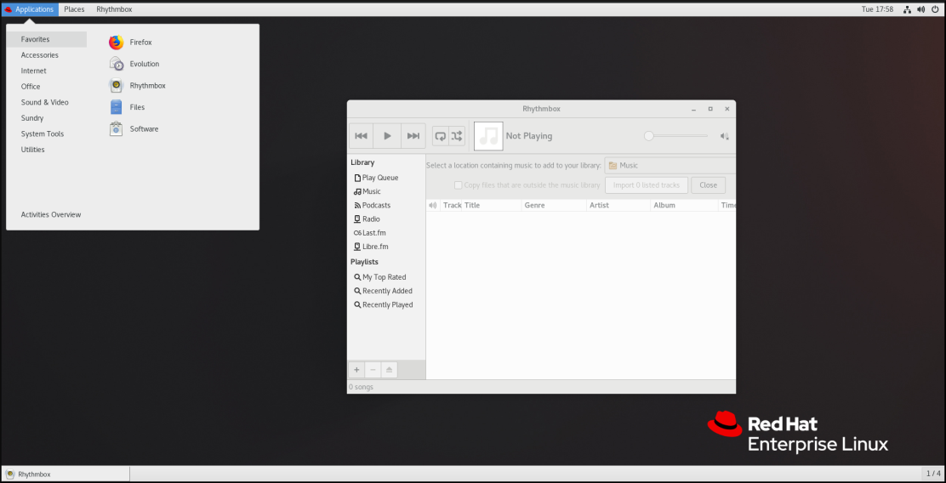Figure 8: The GNOME Desktop with the Rhythmbox Application and the Favorites Submenu of the Applications Menu
In GNOME, the overview of windows that are open is not available by default. You can see the list of all open windows in the taskbar at the bottom of the screen. However, you can enable the windows overview similar to what is by default available in GNOME Standard by changing the default settings of the GNOME environment as described, “Enabling window overview in GNOME”.
In GNOME Classic, the overview of open windows is not available by default. This procedure enables the window overview for all users on the system:
- Open the /usr/share/gnome-shell/modes/classic.json file as the root user.
- Find the following line in the file:
"hasOverview": false
- Change the line to the following:
"hasOverview": true
- Save changes, and close the /usr/share/gnome-shell/modes/classic.json file.
- Restart the user session.
Verification steps:
- In your GNOME Classic session, open multiple windows.
- Press the Super key to open the window overview.
- In the overview, check that:
  - The Dash (the vertical panel on the left side of the screen) is displayed.
  - The bottom panel is not displayed.
  - The workspace switcher is displayed on the right side of the screen.
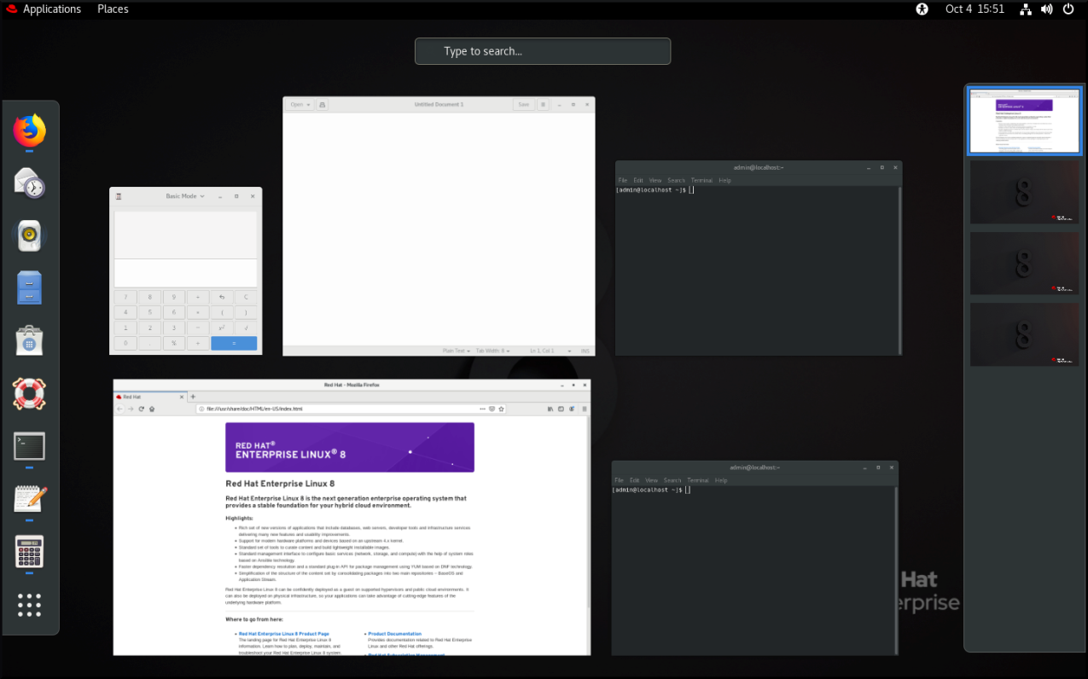Figure 9: Window Overview with "hasOverview": true
- With the default settings ("hasOverview": false), the overview has the following features: The Dash is not displayed.
- The bottom panel is displayed. It includes the Window picker button in its left part and the workspace switcher in its right part.
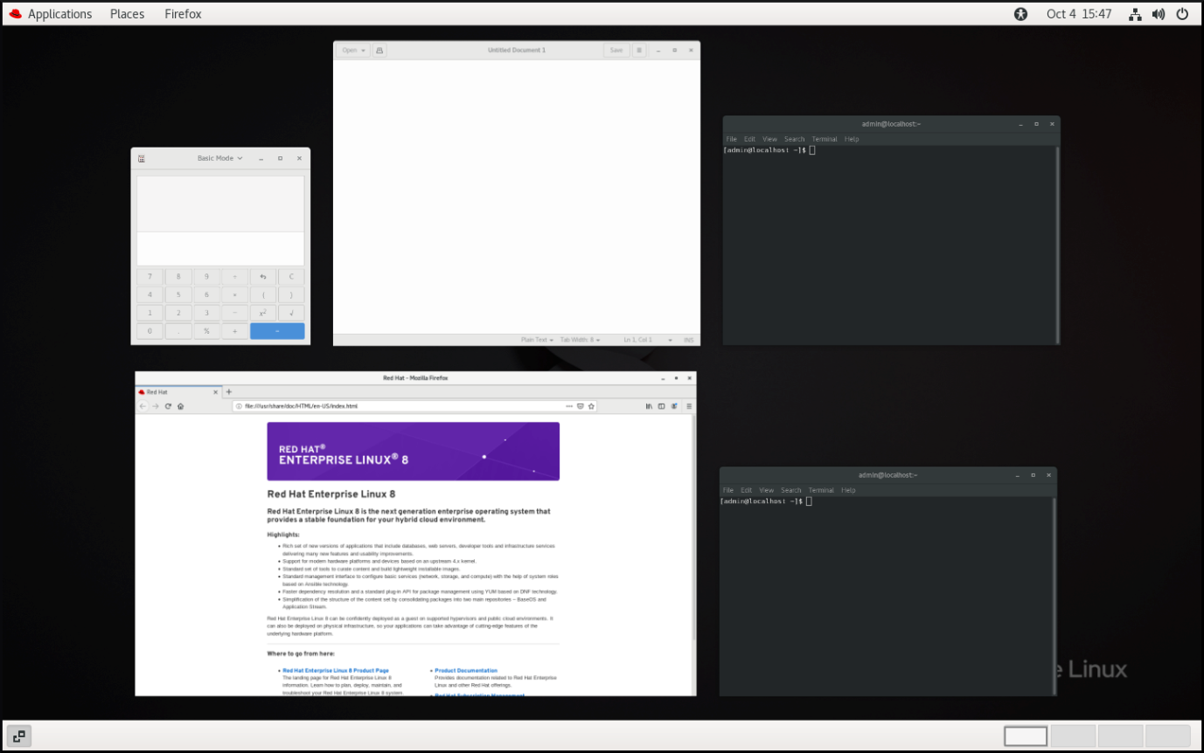Figure 10: Window Overview with "hasOverview": false

File Management in Linux
All data in Unix is organized into files. All files are organized into directories. These directories are organized into a tree-like structure called the filesystem.
When you work with Unix, one way or another, you spend most of your time working with files. This tutorial will help you understand how to create and remove files, copy and rename them, create links to them, etc.
In Unix, there are three basic types of files:
- Ordinary Files − An ordinary file is a file on the system that contains data, text, or program instructions. In this tutorial, you look at working with ordinary files.
- Directories − Directories store both special and ordinary files. For users familiar with Windows or Mac OS, Unix directories are equivalent to folders.
- Special Files − Some special files provide access to hardware such as hard drives, CD-ROM drives, modems, and Ethernet adapters. Other special files are similar to aliases or shortcuts and enable you to access a single file using different names.
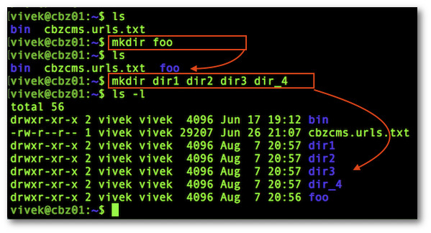Figure 11: Creating Directories

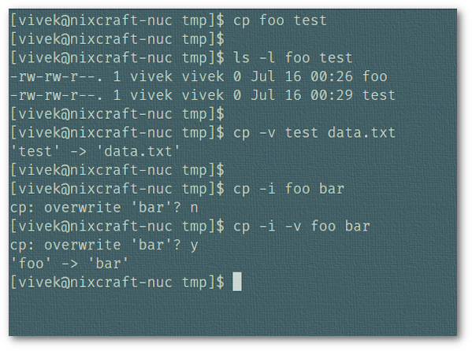Figure 12: Example of Copying File
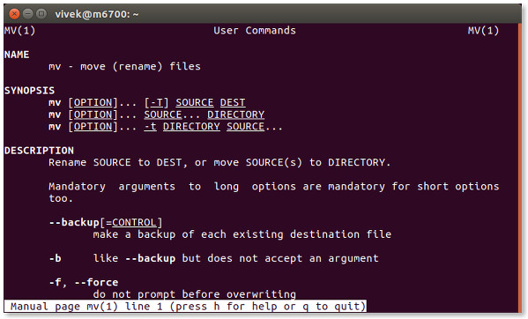Figure 13: Move or Rename Command

The File System Hierarchy
The Linux File Hierarchy Structure or the Filesystem Hierarchy Standard (FHS) defines the directory structure and directory contents in Unix-like operating systems.It is maintained by the Linux Foundation.
- In the FHS, all files and directories appear under the root directory /, even if they are stored on different physical or virtual devices.
- Some of these directories only exist on a particular system if certain subsystems, such as the X Window System, are installed.
- Most of these directories exist in all UNIX operating systems and are generally used in much the same way; however, the descriptions here are those used specifically for the FHS, and are not considered authoritative for platforms other than Linux.
Modern Linux distributions include a /run directory as a temporary filesystem (tfs). which stores volatile runtime data, following the FHS version 3.0. According to the FHS version 2.3, such data were stored in /var/run but this was a problem in some cases because this directory is not always available at early boot. As a result, these programs have had to resort to trickery, such as using /dev/.udev, /dev/.mdadm, /dev/.systemd or /dev/.mount directories, even though the device directory isn't intended for such data. Among other advantages, this makes the system easier to use normally with the root filesystem mounted read-only. For example, below are the changes Debian made in its 2013 Wheezy release:
- /dev/.* → /run/*
- /dev/shm → /run/shm
- /dev/shm/* → /run/*
- /etc/* (writeable files) → /run/*
- /lib/init/rw → /run
- /var/lock → /run/lock
- /var/run → /run
- /tmp → /run/tmp

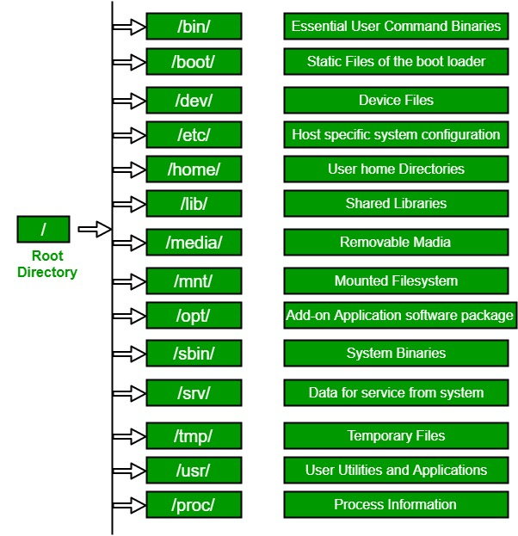Figure 14: Example of Hierarchy Directory in Linux

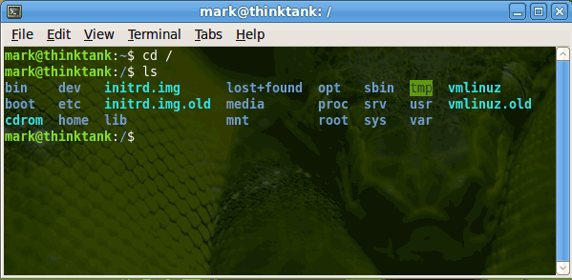Figure 15: Example of Directories List in /

Editing Files Using Vim
Editing a file with Vim means:
- Reading the file into a buffer.
- Changing the buffer with editor commands.
- Writing the buffer into a file.
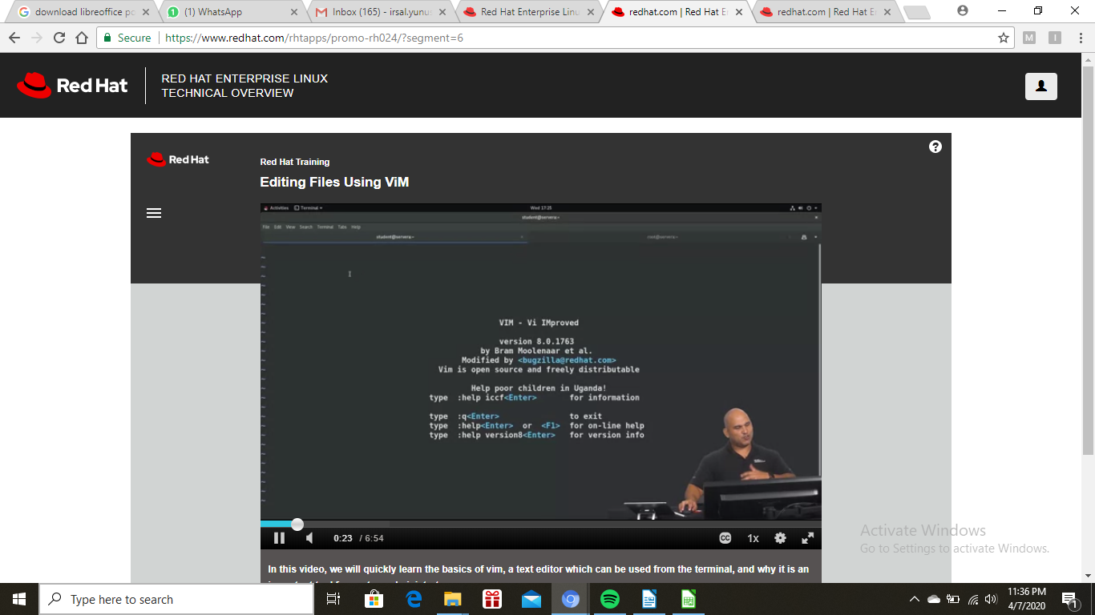Figure 16: Example of Creating a File Using Vim
*current-file*
As long as you don't write the buffer, the original file remains unchanged. If you start editing a file (read a file into the buffer), the file name is remembered as the "current file name". This is also known as the name of the current buffer. It can be used with "%" on the command line |:_%|.
*alternate-file*
If there already was a current file name, then that one becomes the alternate file name. It can be used with "#" on the command line |:_#| and you can use the |CTRL-^| command to toggle between the current and the alternate file. However, the alternate file name is not changed when |:keepalt| is used.
*:keepalt* *:keepa* :keepalt {cmd}
Execute {cmd} while keeping the current alternate file name. Note that commands invoked indirectly (e.g., with a function) may still set the alternate file name. {not in Vi}
All file names are remembered in the buffer list. When you enter a file name, for editing (e.g., with ":e filename") or writing (e.g., with ":w filename"), the file name is added to the list. You can use the buffer list to remember which files you edited and to quickly switch from one file to another (e.g., to copy text) with the |CTRL-^| command. First type the number of the file and then hit CTRL-^. {Vi: only one alternate file name is remembered}
CTRL-G or *CTRL-G* *:f* *:fi* *:file* :f[ile]
Prints the current file name (as typed, unless ":cd" was used), the cursor position (unless the 'ruler' option is set), and the file status (readonly, modified, read errors, new file). See the 'shortmess' option about how to make this message shorter. {Vi does not include column number}

:f[ile]!
like |:file|, but don't truncate the name even when 'shortmess' indicates this.
{count}CTRL-G
Like CTRL-G, but prints the current file name with full path. If the count is higher than 1 the current buffer number is also given. {not in Vi}
*g_CTRL-G* *word-count* *byte-count* g CTRL-G
Prints the current position of the cursor in five ways: Column, Line, Word, Character and Byte. If the number of Characters and Bytes is the same then the Character position is omitted. If there are characters in the line that take more than one position on the screen (<Tab> or special character), both the "real" column and the screen column are shown, separated with a dash. See also 'ruler' option. {not in Vi}
*v_g_CTRL-G* {Visual}g CTRL-G
Similar to "g CTRL-G", but Word, Character, Line, and Byte counts for the visually selected region are displayed. In Blockwise mode, Column count is also shown. (For {Visual} see |Visual-mode|.) {not in VI}
*:file_f* :f[ile][!] {name}
Sets the current file name to {name}. The optional ! avoids truncating the message, as with |:file|. If the buffer did have a name, that name becomes the |alternate-file| name. An unlisted buffer is created to hold the old name.
*:0file* :0f[ile][!]
Remove the name of the current buffer. The optional ! avoids truncating the message, as with |:file|. {not in Vi}
:buffers :files :ls
List all the currently known file names. See 'windows.txt' |:files| |:buffers| |:ls|. {not in Vi}
Vim will remember the full path name of a file name that you enter. In most cases when the file name is displayed only the name you typed is shown, but the full path name is being used if you used the ":cd" command |:cd|.
*home-replace*
If the environment variable $HOME is set, and the file name starts with that string, it is often displayed with HOME replaced with "~". This was done to keep file names short. When reading or writing files the full name is still used, the "~" is only used when displaying file names. When replacing the file name would result in just "~", "~/" is used instead (to avoid confusion between options set to $HOME with 'backupext' set to "~").
When writing the buffer, the default is to use the current file name. Thus when you give the "ZZ" or ":wq" command, the original file will be overwritten. If you do not want this, the buffer can be written into another file by giving a file name argument to the ":write" command.
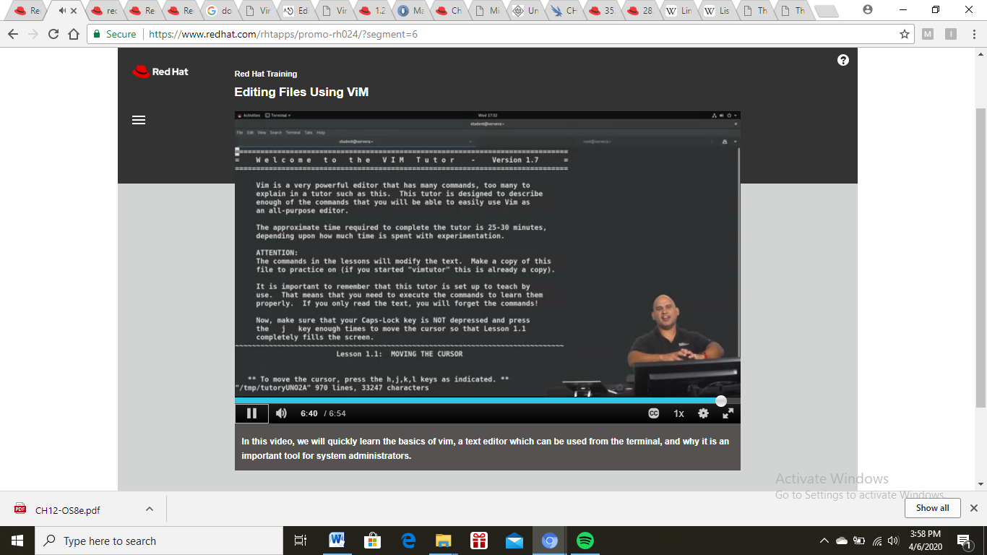Figure 17: Example of Tutorial in Vim

Organizing Users and Groups
Linux is a multi-user operating system, which means that more than one user can use Linux at the same time. Linux provides a beautiful mechanism to manage users in a system. One of the most important roles of a system administrator is to manage the users and groups in a system. All the commands used in this article are explained using the CentOS Linux distro.
A user or account of a system is uniquely identified by a numerical number called the UID (unique identification number). There are two types of users – the root or super user and normal users. A root or super user can access all the files, while the normal user has limited access to files. A super user can add, delete and modify a user account. The full account information is stored in the /etc/passwd file and a hash password is stored in the file /etc/shadow. Some operations on a user account are discussed below.
Creating a user with a default setting: A user can be added by running the useradd command at the command prompt.
The system automatically assigns a UID, creates the home directory (/home/<username>) and sets the default shell to /bin/bash. The useradd command creates a user private group whenever a new user is added to the system and names the group after the user.
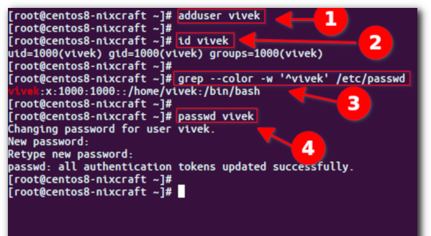Figure 18: Example of Managing User
Linux group is a mechanism to organise a collection of users. Like the user ID, each group is also associated with a unique ID called the GID (group ID). There are two types of groups – a primary group and a supplementary group. Each user is a member of a primary group and of zero or ‘more than zero’ supplementary groups. The group information is stored in /etc/group and the respective passwords are stored in the /etc/gshadow file. Some operations such as creating, deleting and modifying on a group are discussed below.
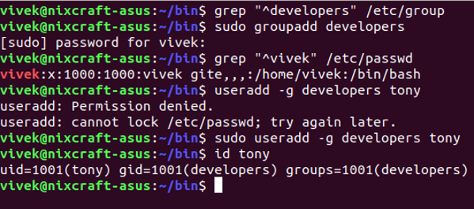Figure 19: Example of Managing Group
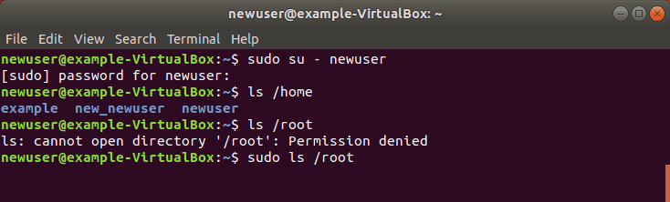Figure 20: Example of Switching User

File Permissions
Although there are already a lot of good security features built into Linux-based systems, one very important potential vulnerability can exist when local access is granted – – that is file permission based issues resulting from a user not assigning the correct permissions to files and directories. So based upon the need for proper permissions, I will go over the ways to assign permissions and show you some examples where modification may be necessary.
Each file and directory has three user based permission groups:
- Owner – The Owner permissions apply only the owner of the file or directory, they will not impact the actions of other users.
- Group – The Group permissions apply only to the group that has been assigned to the file or directory, they will not effect the actions of other users.
- All users – The All Users permissions apply to all other users on the system, this is the permission group that you want to watch the most.
Each file or directory has three basic permission types:
- Read – The Read permission refers to a user’s capability to read the contents of the file.
- Write – The Write permissions refer to a user’s capability to write or modify a file or directory.
- Execute – The Execute permission affects a user’s capability to execute a file or view the contents of a directory.
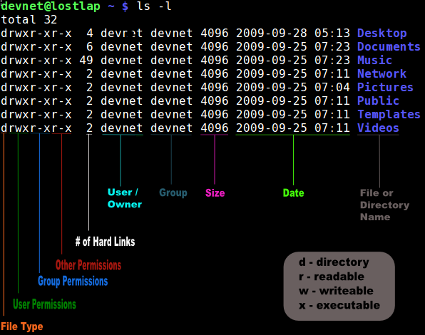Figure 21: Example of Directory Permissions
You can view the permissions by checking the file or directory permissions in your favorite GUI File Manager (which I will not cover here) or by reviewing the output of the “ls -l” command while in the terminal and while working in the directory which contains the file or folder.The permission in the command line is displayed as: _rwxrwxrwx 1 owner:group
- User rights/permissions
  - The first character that I marked with an underscore is the special permission flag that can vary.
  - The following set of three characters (rwx) is for the owner permissions.
  - The second set of three characters (rwx) is for the Group permissions.
  - The third set of three characters (rwx) is for the All Users permissions.
- Following that grouping since the integer/number displays the number of hardlinks to the file.
- The last piece is the Owner and Group assignment formatted as Owner:Group.
When in the command line, the permissions are edited by using the command chmod. You can assign the permissions explicitly or by using a binary reference as described below.
To explicity define permissions you will need to reference the Permission Group and Permission Types. The Permission Groups used are:
- u – Owner
- g – Group
- o – Others
- a – All users
The potential Assignment Operators are + (plus) and – (minus); these are used to tell the system whether to add or remove the specific permissions. The Permission Types that are used are:
- r – Read
- w – Write
- x – Execute
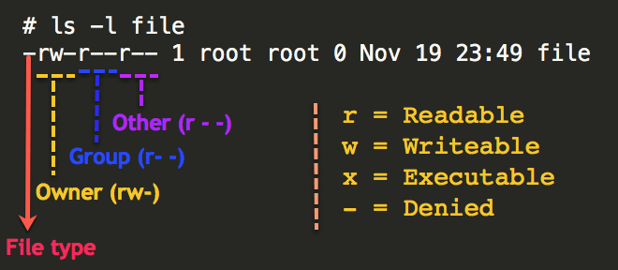Figure 22: Example of User Permissions
So for an example, lets say I have a file named file1 that currently has the permissions set to _rw_rw_rw, which means that the owner, group and all users have read and write permission. Now we want to remove the read and write permissions from the all users group.
- To make this modification you would invoke the command: chmod a-rw file1
- To add the permissions above you would invoke the command: chmod a+rw file1
As you can see, if you want to grant those permissions you would change the minus character to a plus to add those permissions.
Now that you understand the permissions groups and types this one should feel natural. To set the permission using binary references you must first understand that the input is done by entering three integers/numbers.
A sample permission string would be chmod 640 file1, which means that the owner has read and write permissions, the group has read permissions, and all other user have no rights to the file.
The first number represents the Owner permission; the second represents the Group permissions; and the last number represents the permissions for all other users. The numbers are a binary representation of the rwx string.
- r = 4
- w = 2
- x = 1
You add the numbers to get the integer/number representing the permissions you wish to set. You will need to include the binary permissions for each of the three permission groups. So to set a file to permissions on file1 to read _rwxr_____, you would enter chmod 740 file1.
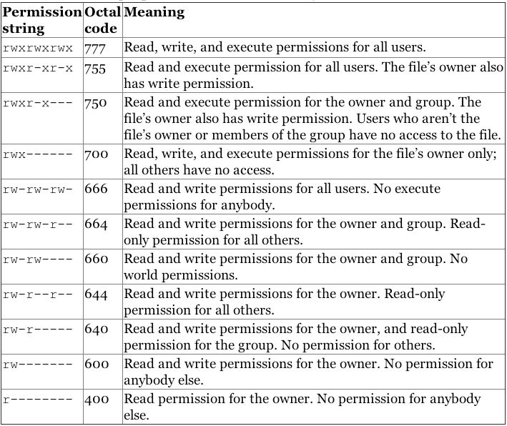Figure 23: User and Group Permissions
I have made several references to Owners and Groups above, but have not yet told you how to assign or change the Owner and Group assigned to a file or directory.
You use the chown command to change owner and group assignments, the syntax is simplechown owner:group filename, so to change the owner of file1 to user1 and the group to family you would enter chown user1:family file1.
The special permissions flag can be marked with any of the following:
- _ – no special permissions
- d – directory
- l – The file or directory is a symbolic link
- s – This indicated the setuid/setgid permissions. This is not set displayed in the special permission part of the permissions display, but is represented as a s in the read portion of the owner or group permissions.
- t – This indicates the sticky bit permissions. This is not set displayed in the special permission part of the permissions display, but is represented as a t in the executable portion of the all users permissions
The setuid/setguid permissions are used to tell the system to run an executable as the owner with the owner’s permissions.
Be careful using setuid/setgid bits in permissions. If you incorrectly assign permissions to a file owned by root with the setuid/setgid bit set, then you can open your system to intrusion.You can only assign the setuid/setgid bit by explicitly defining permissions. The character for the setuid/setguid bit is s.So do set the setuid/setguid bit on file2.sh you would issue the command chmod g+s file2.sh.
The sticky bit can be very useful in shared environment because when it has been assigned to the permissions on a directory it sets it so only file owner can rename or delete the said file.You can only assign the sticky bit by explicitly defining permissions. The character for the sticky bit is t.To set the sticky bit on a directory named dir1 you would issue the command chmod +t dir1.
When Permissions Are Important
To some users of Mac- or Windows-based computers you don’t think about permissions, but those environments don’t focus so aggressively on user based rights on files unless you are in a corporate environment. But now you are running a Linux-based system and permission based security is simplified and can be easily used to restrict access as you please. So I will show you some documents and folders that you want to focus on and show you how the optimal permissions should be set.
- home directories– The users’ home directories are important because you do not want other users to be able to view and modify the files in another user’s documents of desktop. To remedy this you will want the directory to have the drwx______ (700) permissions, so lets say we want to enforce the correct permissions on the user user1’s home directory that can be done by issuing the command chmod 700 /home/user1.
- bootloader configuration files– If you decide to implement password to boot specific operating systems then you will want to remove read and write permissions from the configuration file from all users but root. To do you can change the permissions of the file to 700.
- system and daemon configuration files– It is very important to restrict rights to system and daemon configuration files to restrict users from editing the contents, it may not be advisable to restrict read permissions, but restricting write permissions is a must. In these cases it may be best to modify the rights to 644.
- firewall scripts – It may not always be necessary to block all users from reading the firewall file, but it is advisable to restrict the users from writing to the file. In this case the firewall script is run by the root user automatically on boot, so all other users need no rights, so you can assign the 700 permissions.

Managing Software
Installing and managing software on a Linux server running as an operating system is fairly easy. You can accomplish this by using a package manager called yum. First of all, connect to your VPS via SSH and check whether some of the installed packages on your system have available updates.
Red Hat subscription is a software support model followed by Red Hat for its customers. It allows customers to download software packages, patches, updates, and upgrades for Redhat Enterprise Linux. Along with software support, customers will also get technical support for the product.
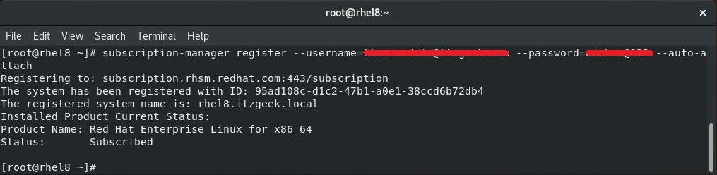Figure 24: Example of Registering Red Hat Subscription
The yum package manager allows you to search for a package and retrieve more information about it before installing it on your system. The package manager will check the enabled repositories on your system and will search for the package in their databases.
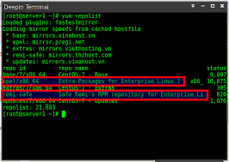Figure 25: Example of Repositories List
Now, to search for a package you can use the ‘yum search’ command. In our examples we will use the package named maap. The package maap provides the maap Application. For example, to list all the packages that match the string maap.
To display information about a certain package you can use the command ‘yum info’. To install a package, you can use the ‘yum install’. to remove a package from your system you can use the ‘yum remove’ command.
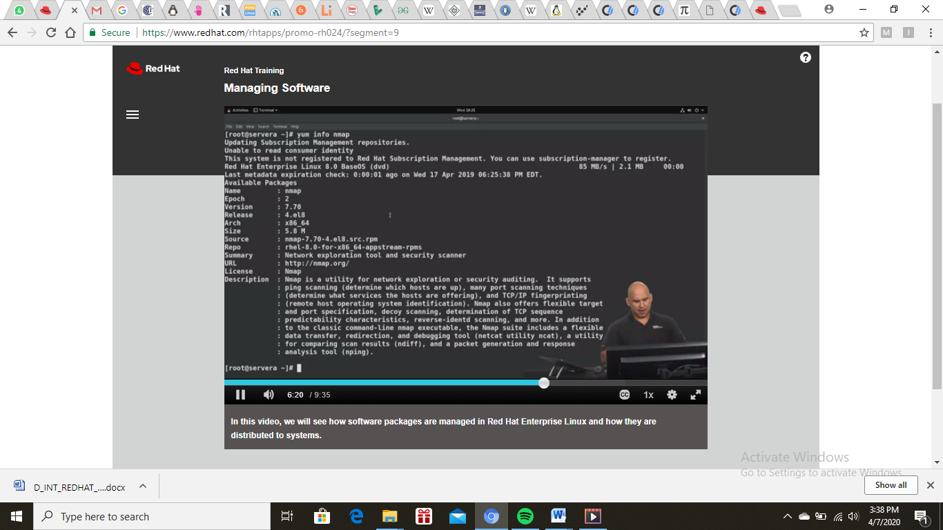Figure 26: Example of Repository Information
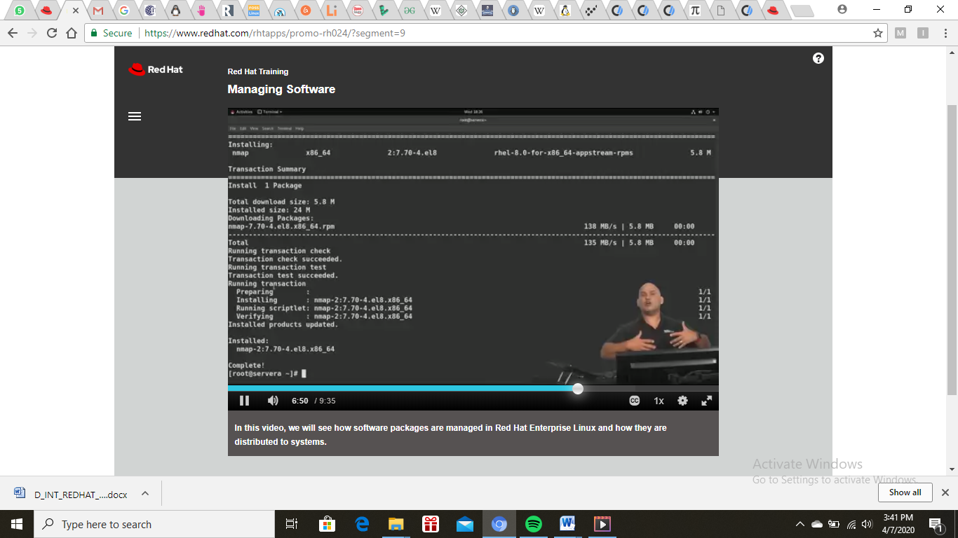Figure 27: Example of Installing Package from Repository
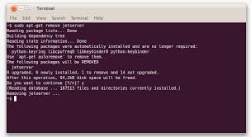Figure 28: Example of Removing or Uninstalling Package

Configuring Networking
The nmcli (NetworkManager Command Line Interface) command-line utility is used for controlling NetworkManager and reporting network status. It can be utilized as a replacement for nm-applet or other graphical clients. nmcli is used to create, display, edit, delete, activate, and deactivate network connections, as well as control and display network device status.
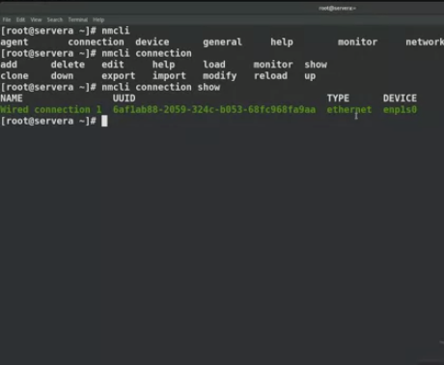Figure 29: Example of nmcli Command Output
The nmcli utility can be used by both users and scripts for controlling NetworkManager:
- For servers, headless machines, and terminals, nmcli can be used to control NetworkManager directly, without GUI, including creating, editing, starting and stopping network connections and viewing network status.
- For scripts, nmcli supports a terse output format which is better suited for script processing. It is a way to integrate network configuration instead of managing network connections manually.
Where OBJECT can be one of the following options: general, networking, radio, connection, device, agent, and monitor. You can use any prefix of these options in your commands. For example, nmcli con help, nmcli c help, nmcli connection help generate the same output.
Some of useful optional OPTIONS to get started are:
- -t, terse
This mode can be used for computer script processing as you can see a terse output displaying only the values.
- -f, field
This option specifies what fields can be displayed in output. For example, NAME,UUID,TYPE,AUTOCONNECT,ACTIVE,DEVICE,STATE. You can use one or more fields. If you want to use more, do not use space after comma to separate the fields.
- -p, pretty
This option causes nmcli to produce human-readable output. For example, values are aligned and headers are printed.
- -h, help
Prints help information.
The nmcli tool has some built-in context-sensitive
- help:nmcli help
This command lists the available options and object names to be used in subsequent commands.
- nmcli object help
This command displays the list of available actions related to a specified object.
The nmcli tool can be used to start and stop any network interface, including masters.
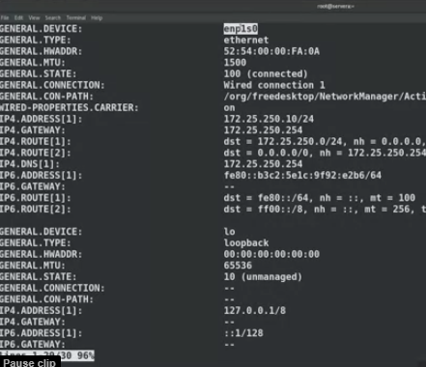Figure 30: Example of nmcli Command Shows Devices
The nmcli c add accepts two different types of parameters Property names the names which NetworkManager uses to describe the connection internally:
- connection.type
- connection.interface-name
- connection.id
Following are some of the important nmcli property options. See the comprehensive list in the nmcli(1) man page :
- connection.type
A connection type. Allowed values are: adsl, bond, bond-slave, bridge, bridge-slave, bluetooth, cdma, ethernet, gsm, infiniband, olpc-mesh, team, team-slave, vlan, wifi, wimax. Each connection type has type-specific command options. You can see the TYPE_SPECIFIC_OPTIONS list in the nmcli(1) man page.
You will be prompted to enter a valid connection type from the list displayed. After entering a connection type you will be placed at the nmcli prompt. If you are familiar with the connection types you can add a valid connection type option to the nmcli con editcommand and be taken straight to the nmcli prompt.
- connection.id
The connection.id is the name of a connection profile and should not be confused with the interface name which denotes a device (wlp61s0, ens3, em1). However, users can name the connections after interfaces, but they are not the same thing. There can be multiple connection profiles available for a device. This is particularly useful for mobile devices or when switching a network cable back and forth between different devices. Rather than edit the configuration, create different profiles and apply them to the interface as needed. The id option also refers to the connection profile name.
The most important options for nmcli commands such as show, up, down are:
  - id
An identification string assigned by the user to a connection profile. Id can be used in nmcli connection commands to identify a connection. The NAME field in the command output always denotes the connection id. It refers to the same connection profile name that the con-name does.
  - uuid
A unique identification string assigned by the system to a connection profile. The uuidcan be used in nmcli connection commands to identify a connection.
- connection.interface-name

Adding an Ethernet connection means creating a configuration profile which is then assigned to a device. Before creating a new profile. To add an Ethernet configuration profile with dynamic IP configuration, allowing DHCP to assign the network configuration.
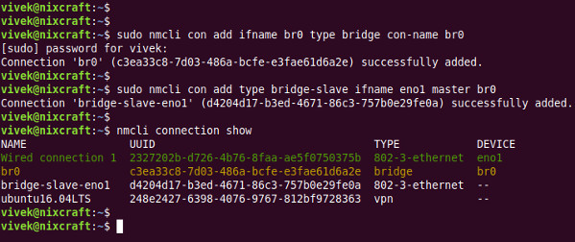Figure 31: Example of nmcli Command Adding Connection
Note that the NAME field in the output always denotes the connection ID (name). It is not the interface name even though it might look the same. In the second connection shown above, ens3 in the NAME field is the connection ID given by the user to the profile applied to the interface ens3.
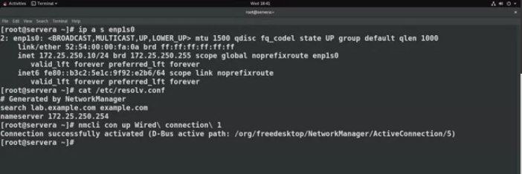Figure 32: Example of nmcli Command Turning Up Connection
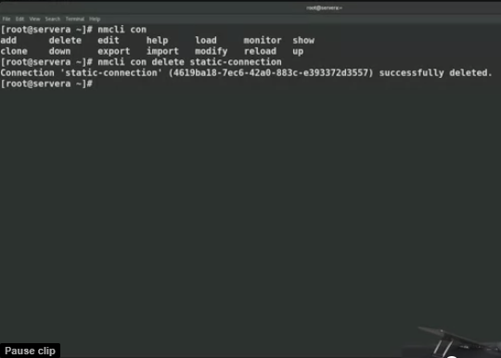Figure 33: Example of nmcli Command Deleting Connection

Controlling System Startup Processes
Systemd is a system and service manager for Linux operating systems. It is designed to be backwards compatible with SysV init scripts, and provides a number of features such as parallel startup of system services at boot time, on-demand activation of daemons, or dependency-based service control logic. In Red Hat Enterprise Linux 7, systemd replaces Upstart as the default init system.
Systemd introduces the concept of systemd units. These units are represented by unit configuration files located in one of the directories, and encapsulate information about system services, listening sockets, and other objects that are relevant to the init system. For a complete list of available systemd unit types.
The default configuration of systemd is defined during the compilation and it can be found in systemd configuration file at /etc/systemd/system.conf. Use this file if you want to deviate from those defaults and override selected default values for systemd units globally.
For example, to override the default value of the timeout limit, which is set to 90 seconds, use the DefaultTimeoutStartSec parameter to input the required value in seconds.
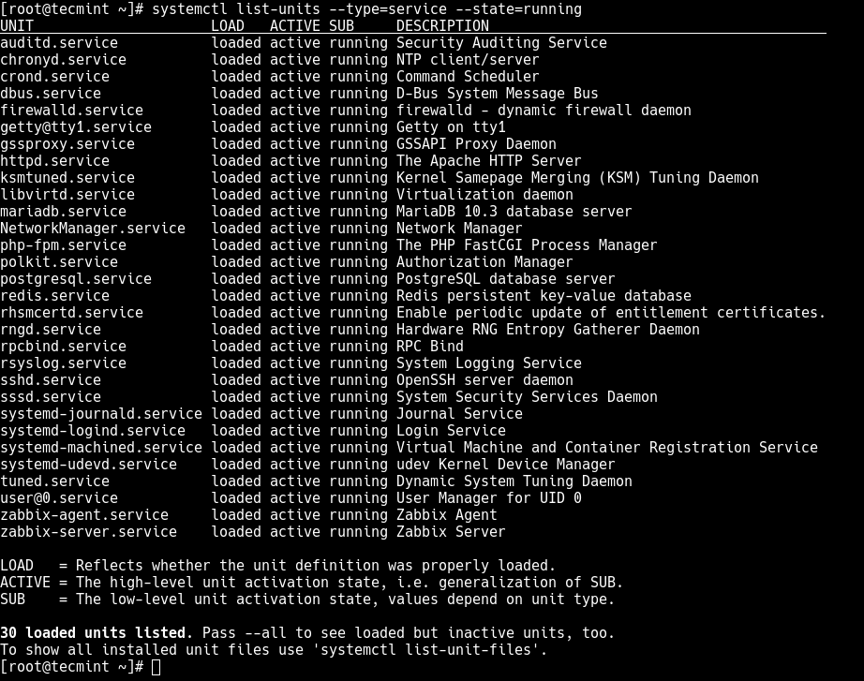Figure 34: Example of systemctl Command List

Appendix

