✅ 1. Visual Architecture Map
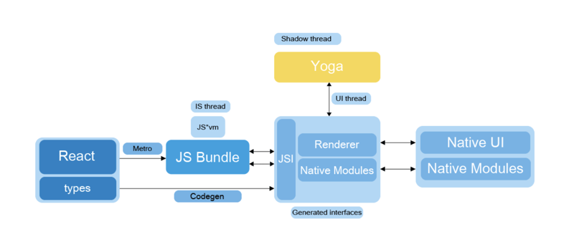
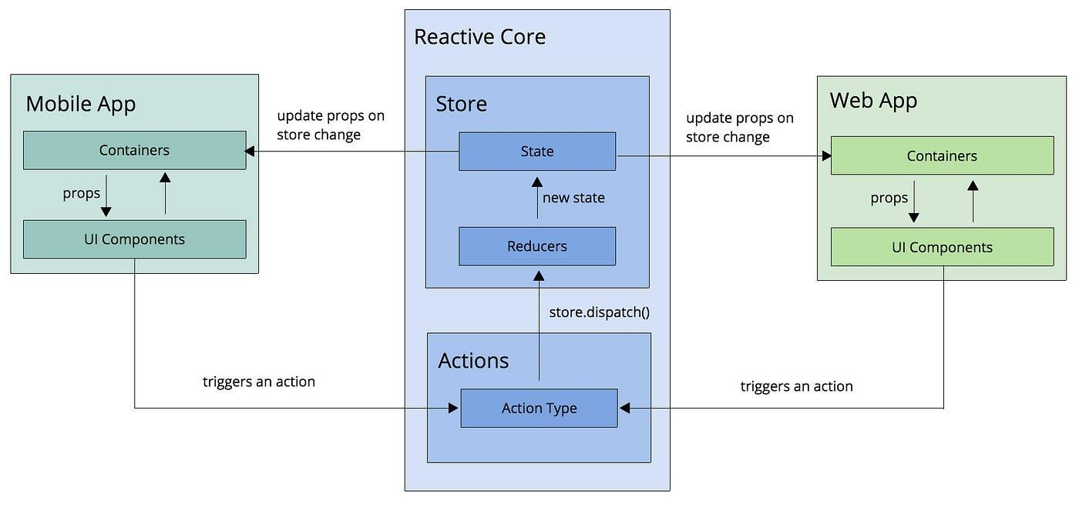

ExpenseApp – High-Level Architecture
┌────────────────────────────────────────────────────────────────┐
│ ExpenseApp (Mobile) │
│ React Native + Expo Router │
│ │
│ ┌─────────────────────────── UI Layer ─────────────────────┐ │
│ │ Screens, Navigation (Tabs + Drawer), Components, Theming │ │
│ └──────────────────────────────────────────────────────────┘ │
│ │
│ ┌────────────────────────── Logic Layer ───────────────────┐ │
│ │ Contexts: Auth, Theme │ │
│ │ State, Filters, Validation (Formik + Yup) │ │
│ └──────────────────────────────────────────────────────────┘ │
│ │
│ ┌────────────────────────── Services Layer ─────────────────┐ │
│ │ transaction-service ││
│ │ budget-service ││
│ │ category-service ││
│ │ feedback-service ││
│ │ account-service ││
│ │ settings-service ││
│ └──────────────────────────────────────────────────────────┘ │
│ │
│ ┌────────────────────────── API Layer ─────────────────────┐ │
│ │ REST API – FastAPI backend ││
│ │ JWT Authentication ││
│ │ CRUD for all modules ││
│ │ AI endpoint (/ai/ask) ││
│ └──────────────────────────────────────────────────────────┘ │
└────────────────────────────────────────────────────────────────┘

✅ 2. Module-by-Module README
Below is a complete README structure covering every feature area.

📘 ExpenseApp – Module Documentation

1. Authentication Module

Features
- Login, Register, Logout
- Forgot Password workflow
- JWT-based auth using backend
- Role-based access (User / Super Admin)
- Persistent session using AsyncStorage

Files
/src/app/(auth)/login.tsx
/src/app/(auth)/register.tsx
/src/app/(auth)/forgot-password.tsx
/src/app/(drawer)/logout.tsx
/src/contexts/auth-context.tsx

2. Intro & Splash Flow

Features
- Splash → Intro Screens → Login → App
- AsyncStorage flag: hasSeenIntro
- Reusable intro screen template

Files
/src/app/splash.tsx
/src/app/intro/first_screen.tsx
/src/app/intro/second_screen.tsx
/src/app/intro/third_screen.tsx
/src/app/intro/intro-template.tsx

3. Dashboard Module

Features
- Expense breakdown by category (Pie Chart)
- Monthly trend line chart
- Legend & color-coded categories
- Filters: Year / Quarter / Month

Files
/src/app/dashboard.tsx
/src/components/charts/*

4. Transactions Module

Features
- Add / Edit / Delete transaction
- Chips for category / type / currency
- Searchable list
- Date picker integration
- Scrollable Formik form

Files
/src/app/(transaction)/index.tsx
/src/app/(transaction)/add.tsx
/src/app/(transaction)/[id].tsx
/src/components/transaction-form.tsx
/src/services/transaction-service.ts

5. Accounts Module

Features
- Add / Edit / Delete accounts
- Role-based access (Admin sees all accounts)
- Balance display + active/inactive
- Card-style UI

Files
/src/app/(account)/index.tsx
/src/app/(account)/add.tsx
/src/app/(account)/[id].tsx
/src/components/account-form.tsx
/src/services/account-service.ts

6. Categories Module

Features
- Create / Edit / Delete categories
- Status indicator
- List view with action buttons

Files
/src/app/(category)/index.tsx
/src/app/(category)/add.tsx
/src/app/(category)/[id].tsx
/src/components/category-form.tsx
/src/services/category-service.ts

7. Budgets Module

Features
- Create, Edit, Delete budgets
- Amount, date range, type, currency, period
- Active/inactive visualization

Files
/src/app/(budget)/index.tsx
/src/app/(budget)/add.tsx
/src/app/(budget)/[id].tsx
/src/components/budget-form.tsx
/src/services/budget-service.ts

8. Feedback Module

Features
- Submit feedback with rating
- Admin reply mode
- Search + filter by Type + Status
- Owner can edit/delete
- Admin can reply or update status

Files
/src/app/(feedback)/index.tsx
/src/app/(feedback)/add.tsx
/src/app/(feedback)/[id].tsx
/src/components/feedback-form.tsx
/src/services/feedback-service.ts

9. Settings Module

Preferences
- Theme (Light / Dark / System)
- Default Currency
- Date Format
- Dashboard Period
- Budget Alerts toggle

Account
- Profile
- Change Password

Files
/src/app/(settings)/index.tsx
/src/contexts/theme-context.tsx
/src/services/settings-service.ts

10. AI Assistant

Features
- Chat UI
- /ai/ask backend integration
- Fallback error handling

Files
/src/app/ai-assistant.tsx
/src/services/ai-service.ts

11. Shared Core Components
- Header
- Tab Bar
- Drawer
- Skeleton loaders
- App-wide styles + theme colors

Files
/src/components/*
/src/styles/styles.ts
/src/constants/COLORS.ts
/src/hooks/use-app-colors.ts

✅ 3. System Diagram (API + App Flows)
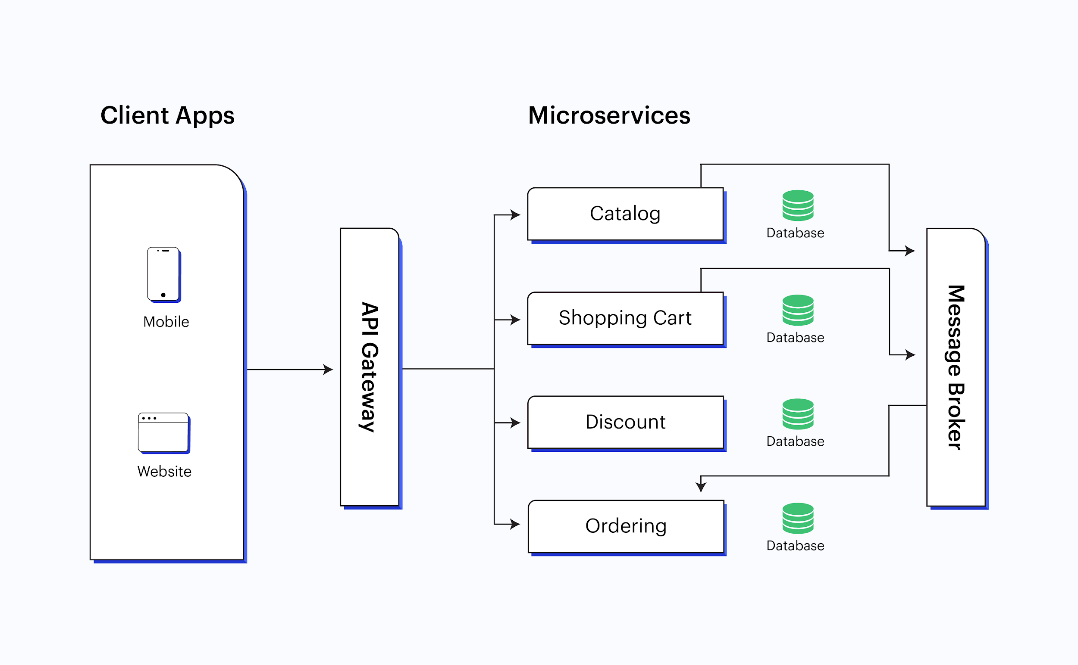
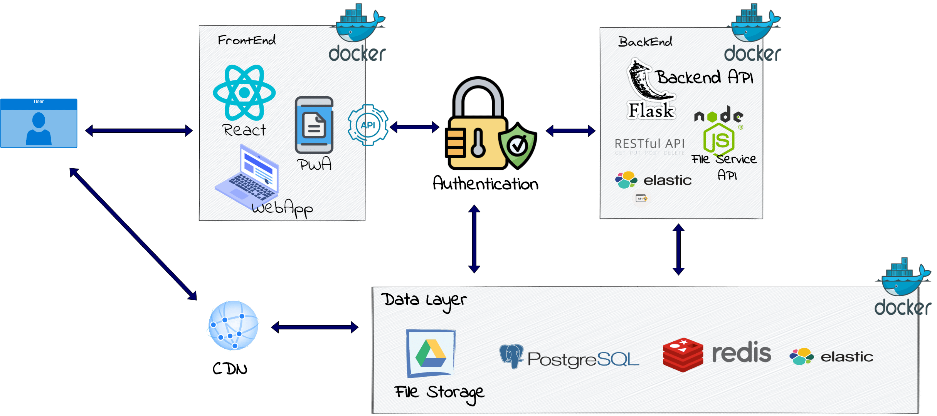

ExpenseApp – End-to-End System Flow
┌─────────────────────────┐
│ Mobile App (RN) │
│ UI + Navigation + UX │
└─────────────┬───────────┘
│
▼
┌─────────────────────────────────────────┐
│ Auth Context (JWT Handler) │
│ - Login, Register, Logout │
│ - Stores token in AsyncStorage │
└──────────────────┬──────────────────────┘
│
┌──────────────▼──────────────────┐
│ Services Layer (API) │
│---------------------------------│
│ transaction-service │
│ budget-service │
│ category-service │
│ feedback-service │
│ account-service │
│ settings-service │
│ ai-service │
└───────────────┬────────────────┘
│ HTTP (REST)
▼
┌──────────────────────────────────────┐
│ Backend API │
│ FastAPI + PostgreSQL │
│ /auth/login │
│ /auth/register │
│ /transactions/* │
│ /accounts/* │
│ /categories/* │
│ /budgets/* │
│ /feedback/* │
│ /settings/* │
│ /ai/ask (LLM Retrieval + Intent) │
└──────────────────────────────────────┘
│
▼
┌─────────────────────────────────────────┐
│ Database (PostgreSQL / MySQL) │
│ Users, Transactions, Accounts, etc. │
└─────────────────────────────────────────┘

