**Low-Code/No-Code, Digital Process Automation(DPA)**

Low-code / no-code workflow and DPA platforms, in particular, enable you to totally automate business processes and workflows without any programming knowledge.

Software development teams, and information technology (IT) groups in general, are under a lot of pressure and have very little time. Business units require more efficiency and the automation of internal procedures, but IT has no resources to assist them. Low-code / no-code platforms make it simple for business people to develop apps without having to know how to code or rely on IT.

What is low-code/no-code

Low-code/no-code platform will take care of technical challenges and make it easy for business people to develop apps with less / without programming knowledge.

* Enable business people for faster development and evolution of apps. As a result, the company can adapt to internal and external demands more rapidly.
* By utilising less hours of often costly professions like Software developers, UI designer etc.
* More applications may be created per unit of time, resulting in higher productivity.
* Faster digital transformation, with simpler acceptance of new digital applications in less time.
* Low-code/no-code platform are simple and easy to adopt. Because business person don't have to know how to code, making modifications is simple and quick.
* Because applications are prototyped and verified faster, deviations may be discovered in real time, lowering the chance of failure. Corrections are also more affordable.
* It enhances the client experience by eliminating the need to wait months for a new application and allowing for much faster implementation of enhancements.

**Low-code/no-code depends on following which makes it less programming**

1. Defining the data storage structure
2. In a suitable notation, draw the process flow.
3. Deploying the process in place and moving into production.

**Define and store data without programming**

Every business operation has data connected with it that must be saved. For eample, Leave approval process flow have to store some basic information like employee name, leave start date, leave end date, no of days & leave type etc.

A form designer with in low-code/no-code platform makes it more powerful to get the data from user. You may use this tool to drag and drop different fields into a form, which will centralized all necessary data.

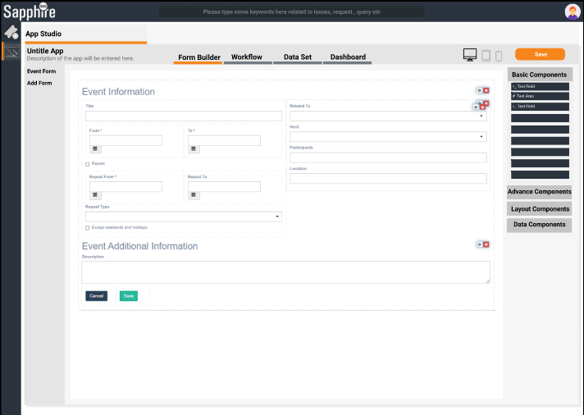

**Draw a business process workflow**

The workflow must then be defined (process flow). The graphical notations for doing it have changed a lot since the historical flow diagrams. .

A business user can create their process using low-code / no-code workflow and BPM systems, by drag and drop. One can specify a process in minutes and leave it well-documented this way.

A prototype design of same to create process workflow

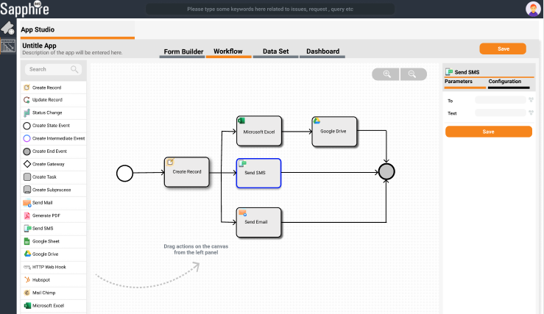

**Deploy process workflow as a low-code/no-code app**

This approach is substantially enabled by low-code / no-code platforms. Essentially, it allow the process to be deployed and made available to end-users by clicking a single button. All of the complexity must be resolved in a transparent manner by the platform. It must create an internal structure to hold the data, understand the process diagram, and verify permissions, among other things.

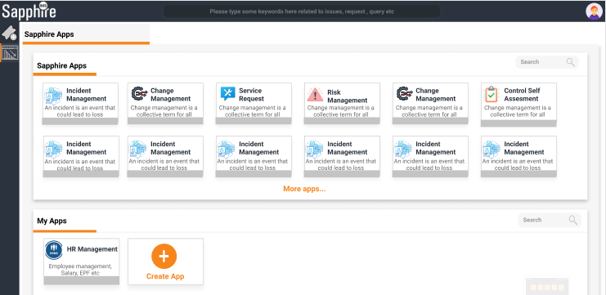

Business units may use low-code / no-code platforms to create workflow and BPM apps without having to programme. With a press a button to "Deploy the Process," and utilise it. That's where low-code and no-code process tools shine.