FVT TEST AUTOMATION GUI DOCUMENTATION

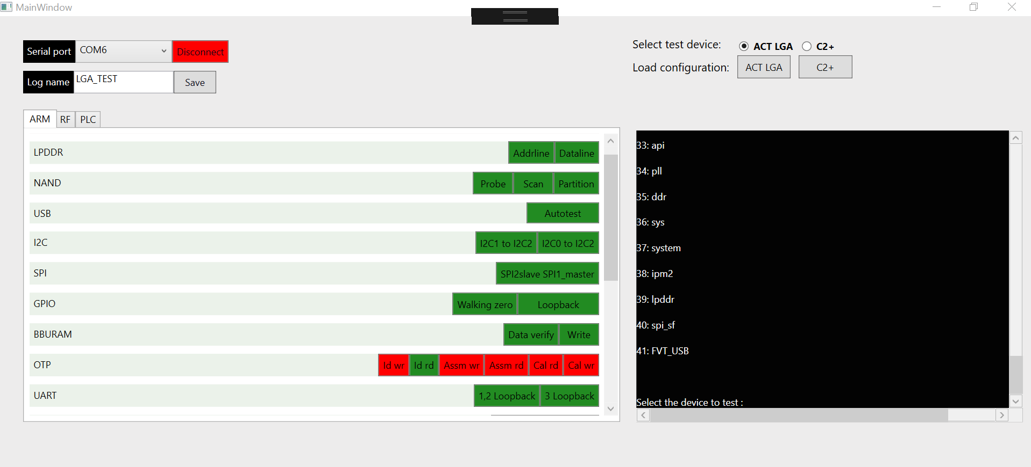

This UI contains all the FVT test commands and their corresponding pass messages to speed FVT Testing.

INSTRUCTIONS:

1. Power up and connect LGA or C2+ Fixture
2. Select serial port and connect
3. There is a default configuration file the application loads commands and pass cases from, this can be modified (Section II)
4. Simple select the device you have connected ACT LGA / C2+ from the select device options.
5. Input a valid file name in the Log file and click save to update the log file name. The log file stores all data printed to the serial port and if no name is provided, the name ‘defualt’ is used. The log files can be found in the LOG folder of the root directory

UPDATING CONFIGURATION FILES

By default, there are two configuration files in the application root directory

1. ACT_LGA_Commands.csv
2. C2+_Commands.csv

For LGA and c2+ respectively. These excel sheets contain the name of the button the command is tied to, the command on click and the pass case. Please do not edit the button name as this must match in the application else the button would no longer be recognized.

|  |  |  |
| --- | --- | --- |
| Button name | Command | Pass case |
| lpddr_addrline | lpddr:fvt_addrline | SRAM_ADDRLINE_PROBE_TEST_RESULT, 1 |
| lpddr_dataline | lpddr:fvt_dataline | SRAM_DATALINE_PROBE_TEST_RESULT, 1 |
| nand_probe | nandflash:nand_probe 0 MT29F4G16ABBDA3W | nand_probe,1 |

Updates can be made to the command or the pass case as the firmware requirements change.

Updating the command needs to use the ‘:’ delimiter navigating to the module from the Firmware.

For example

|  |  |  |
| --- | --- | --- |
| Button name | Command | Pass case |
| lpddr_addrline | lpddr:fvt_addrline | SRAM_ADDRLINE_PROBE_TEST_RESULT, 1 |

To run the LPDDR address line test, we must first select “lpddr” option from the menu

39: lpddr

40: spi_sf

41: FVT_USB

Select the device to test : lpddr

Then we need to run the fvt_addrline command to run the test

fvt_addrline : fvt sram address_line test

exceptionTst : trigger exception

q : quit lpddr access

cmd:> fvt_addrline

Therefore the command for the entire test would be “lpddr:fvt_addrline”. The “:” delimiter separates the subsequent commands to be entered.