Mobile : 9961262027

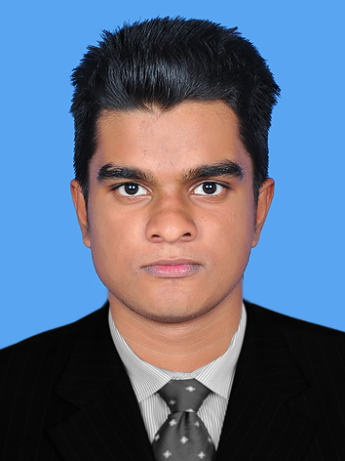

*Present address:*

Makkiyan valappil house

Mudur post

Pottur

Malappuram dist

*Permanent address:*

Makkiyan valappil house

Mudur post

Pottur

Malappuram dist

Kerala

India

*Personal information:*

Age & Date of birth: 19

12-05-1997

Religion: Islam

*Language known:*

English, Malayalam and Tamil

*Sex and martial status:*

Male, single

**IRSHAD.M.V**

Email : mv.irshad7@gmail.com

**OJECTIVES**

Seeking a position to utilize my academic background skills and abilities.

**Educational qualification**

* Doing BCA degree
* PLUS TWO
* S.S.L.C

**Professional profile**

* Have fair spoken skills in English , Malayalam and

Tamil

* Energetic &enthusiastic.
* Well organized, reliable& highly organized.
* Friendly , pleasing mannered and can get along

With people of diverse nature

**Experience**

* Fresher

**Hobbies**

* Playing football
* Practicing cpp
* traveling

**Declaration**

**I hereby declare that all the information mentioned above is true to the best of my knowledge**.

Place : pottur **IRSHAD.M.V**

Date :