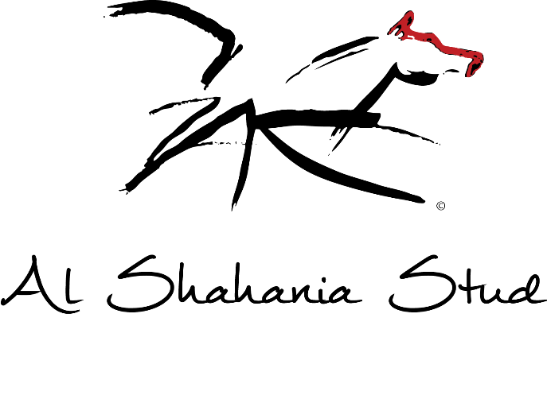

2/15/2023

PREPARED BY: SHANU

**PROMOTIONAL ITEMS**

MONTHLY REPORT – JAN 2023