CS6403-SOFTWARE ENGINEERING
UNIT I
PART - A
1. What are the characteristics of software?
- Software is engineered or developed, it is not manufactured in the classical sense.
- Software doesn’t wear out.
- Although the industry is moving toward component based assembly, most software continues to be custom built.
2. Write down the generic process framework that is applicable to any software project. (NOV/DEC 2010)(APR/MAY 2015)
The following generic process framework is applicable to vast majority of software projects:
- Communication: This framework activity involves heavy communication and collaboration with the customer and encompasses requirements gathering and other related activities.
- Planning: This activity establishes a plan for the software engineering work that follows. It describes the technical tasks to be conducted, the risks that are likely, the resources that will be required, the work products to be produced, and a work schedule.
- Modeling: The activity encompasses the creation of models that allow the developer and the customer to better understand software requirements and the design that will achieve those requirements.
- Construction: This activity combines code generation and the testing that is required to uncover errors in the code.
- Deployment: The software is delivered to the customer who evaluates the delivered product and provides feedback based on the evaluation.
3. List the goals of Software Engineering. (APR/MAY 2011)
Software Engineering is the establishment and use of sound engineering principles in order to obtain economically software that is reliable and works efficiently on real machines. The goals of software engineering are:
- Software production which consists of developed programs and associated documentation.
- The software product should have the essential product attributes maintainability, dependability, efficiency and acceptability.
- It should also include suggestions for the process to be followed, the notations to be used, system models to be developed and rules governing these models and design guidelines.
4. What are the difference levels of CMMI?

- Level 0 – Incomplete.
- Level 1 – Performed.
- Level 2 – Managed.
- Level 3 – Defined.
- Level 4 – Quantitatively Managed.
- Level 5 – Optimized.

5. Give two reasons why system engineers must understand the environment of a system. (MAY/JUN 2012)
The reason why system engineers must understand the environment of the system:
- Limited scope for rework during system development: Once some system engineering decisions have been made, they are very expensive to change. Reworking the system design to solve these problems is rarely possible.
- Interdisciplinary involvement: Many engineering disciplines are involved in system engineering. There is a lot of scope for misunderstanding because different engineers use different terminology and conventions.
6. What are the two types of software products? (MAY/JUN 2012)
The two fundamental types of software product are
- Generic products: These are stand alone systems developed by organizations and sold on open market to any customer who is able to buy them.
- Customized products: These are systems which are commissioned by a particular customer. A software contractor develops the software especially for that customer.
7. What is Software Engineering? (NOV/DEC 2013)(NOV/DEC 2014)
Software engineering is a discipline in which theories, methods and tools are applied to develop professional software. (Or)
Software engineering is the systematic approach to develop and maintain a software product in a cost effective and efficient way.

8. What is RAD?
Rapid Application Development (RAD) is an incremental software development process. When tools are interpreted, the information created by one tool can be used by another. A system for the support of software development called computer aided software engineering is established.
9. List out evolutionary software process model.

- Incremental model
- Spiral model
- WINWIN spiral model
- Concurrent development model
- Object oriented model
- Embedded model
- Synchronize and stabilize model

10. What are the difference between product and process?
PROCESS | PRODUCT
It is a frame work which has a set of rules to  be followed in key processing areas (KPA),  rules for framing task sets, setting a milestone for it and applying s/w quality assurance points. | It is the final shipment outcome of the  process.
It is used to obtain quality product. | Various process paradigms/models are used  to build a quality product.
11. What is CPF?
A Common Process Framework (CPF) is established by defining a small number of framework activities that are applicable to all software projects, regardless of their size or complexity.
12. What are the advantages and disadvantages of Waterfall Model?
Advantages:
- It provides a template into which methods for analysis, design, and other phases can be placed.
- It provides for baseline management.
- It is better than any haphazard approach to software development.
Disadvantages:
- It lacks the perception for a reverse engineering on how to engineer an existing legacy system.
- The client has to wait until the installation and checkout phase to see how a system works. Thus a complex system requires considerable time and effort.
- There is no rapid prototyping and incremental development.
- Real time software cannot follow this model. Customer satisfaction is not full filled.
13. What are the advantages and disadvantage of Incremental Model?
Advantages:
- The software development activities are repeated each time there is a new release of software.
- It provides a platform for evaluation by the user.
- It can be planned to manage technical risks.
- It enables partial functionality to be delivered to end users without ordinary delay.
Disadvantage:
- It makes the unrealistic assumptions that system as well as software requirements remain stable which is not true.
14. What are the advantages and disadvantages of Spiral Model?
Advantages:
- It provides the potential for rapid development for incremental versions of the software.
- It can be applied throughout the life of the computer software.
- It allows the developer to apply the prototyping approach at any stage.
- It demands a direct consideration of technical risks at all stages.
Disadvantages:
- It may be difficult to convince the customers at times especially in contrast solutions.
- It demands considerable risks assessment expertise and relies on them for success.
- It takes time for determining the efficacy and thus the model cannot be used as widely as others.

15. What are the advantages and disadvantage of WINWIN SPIRAL MODEL?
Advantages:
- It has a provision for system stakeholders to negotiate mutually satisfactory specifications. Customer satisfaction is fulfilled.
- It overcame the problem of lack of anchor points to correlate the completion of the spiral cycles and organization major milestones.
Disadvantage:
- The model does not specifically address the issues of how developers specify, design and test the conceptual construct software.
16. What are the advantages and disadvantage of Object Oriented Model?
Advantages:
- Object oriented concepts like encapsulation can be improvised in this model.
- It simplifies software development because it hides complexity. Reusability is enhanced.
Disadvantage:
- In safety critical conditions they require a design by contract in the construction of reliability software.
17. Define Computer based system and specify its components.
A set of arrangement of elements that are organized to accomplish some predefined goals by processing information. Its components are software, hardware, people, database, documentation and procedure.
18. Give the restraining factors that are to be considered to construct a system model. Assumptions that reduce the number of possible permutations and variations thus enabling the model to reflect the problem in a reasonable manner, Simplifications that enable the model to be created in a timely manner, Limitations that help to bound the system, Constraints that will guide the manner in which the model is created and the approach taken when the model is implemented. Preferences that indicate the preferred architecture for all data, functions, and technology.
19. What are the advantages and disadvantages of Prototyping Model?
Advantages:
- It produces the products quickly and thus saves the time and solves the waiting problem in waterfall model.
- It minimizes the cost and product failure.
- It is possible for
- the developers and client to check the function of preliminary implementations of system models before committing to a final system.
- It obtains feedback from clients and changes in system concept.
Disadvantages:
- It ignores quality, reliability maintainability and safety requirements. Customer satisfaction is not achieved.
20. What does a System Engineering Model accomplish?
- Define processes that serve needs of view.
- Represent behavior of process and assumption.
- Explicitly define Exogenous and Endogenous Input.
- Represent all Linkages that enable engineer to better understand view.
21. What are the different considerations that have to be followed for project estimation?
To achieve reliable cost and effort estimation, the following options are considered,
- Delay estimation until late in the project.
- Base estimates on similar projects that have already been completed.
- Use relatively simple decomposition techniques to generate project cost and effort estimates.
- Use one or more empirical models for software cost and effort estimation.
22. Define process-based estimation. State the advantages and disadvantages in LOC based Cost Estimation. (APR/MAY2015)
The process is decomposed into a relatively small set of tasks and the effort required to accomplish each task is estimated.
Advantages of LOC:
- Simple to measure.
- An intuitive metric for measuring the size of software due to the fact that it can be seen and the effect of it can be visualized.

Disadvantages of LOC:
- Difficult to measure LOC in the early stages of a new product.
- Source instructions vary with coding languages, design methods and with programmer’s ability.
- No industry standard for measuring LOC.
- LOC cannot be used for normalizing if platforms and languages are different.
The only way to predict LOC for a new app to be developed is through analogy based on similar software application.
- Programmers may be rewarded for writing more LOC based on a misconception of higher management by thinking that more the LOC, means more the productivity of the programmer.
23. What are the different hierarchies of estimation models?

- Application Composition Models
- Early Design Stage Models.
- Post-Architecture Stage Models.

24. What are the guidelines for Project Scheduling?(APR/MAY 2015)

- Compartmentalization.
- Interdependency.
- Time allocation.
- Effort validation.

25. What are the characteristics of Risks?
- Uncertainty – the risk may or may not happen
- Loss – if the risk becomes reality, unwanted consequences or losses will occur
PART – B
- Explain the following: (i) waterfall model (ii) Spiral model (iii) RAD model (iv) Prototyping model(NOV/DEC 2010)(NOV/DEC 2013)(MAY/JUNE 2014)(APRIL/MAY 2015)
WATERFALL MODEL
When the requirements of a problem are reasonably well understood-when work flows from communication through deployment in a reasonably linear fashion. This situation is encountered when
- Well defined adaptations or enhancements to an existing system must be made.
- In limited number of new development efforts, but only when requirements are well defined and reasonably stable.
The waterfall model, called the classic life cycle suggests a systematic, sequential approach
to software development.
- Begins with customer specification of requirements
- Progresses through planning
- Modelling
- Construction
- Deployment

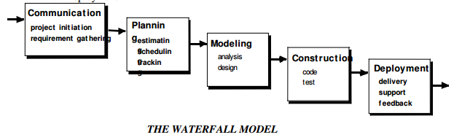
Problems encountered when Waterfall Model is applied:
- Real projects rarely follow the sequential flow that the model proposes. Although the linear model can accommodate iteration, it does so indirectly. As a result, changes can cause confusion as the project team proceeds.
- It is often difficult for the customer to state all the requirements explicitly. The waterfall model requires this and has difficulty accommodating uncertainty that exists at the beginning of many projects.
- The customer must have patience. A working version of the program will not be available until late in the project life-span. A major blunder, if undetected until the working program is reviewed can be disastrous.
Linear structure of the waterfall model leads to blocking states in which some project team members must wait for other members of the team to complete dependent tasks. Blocking states are more prevalent at the beginning and end of the linear sequential process.
SPIRAL MODEL
The spiral model is an evolutionary software process model that couples the iterative nature of prototyping with the controlled and systematic aspects of the waterfall model. It provide the potential for rapid development of increasingly more complex versions of the software. Boehm definition:
The spiral development model is a risk-driven process model generator. It has two main distinguishing features :
- One is a cyclic approach for incrementally growing a system’s degree of definition and implementation while decreasing its degree of risk.
- The other is a set of anchor point milestones for ensuring stakeholder commitment to feasible and mutually satisfactory system solutions.
Using spiral model, software is developed in a series of evolutionary releases. During early iterations, the release is a paper model or prototype. During later iterations, more complex versions of the engineered system are produced.
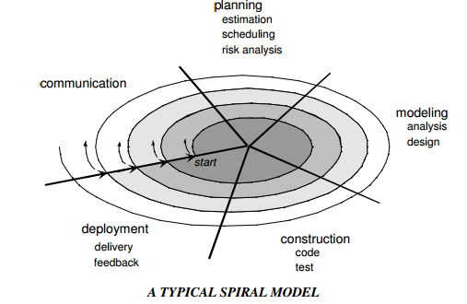
A spiral model is divided into a set of framework activities defined by the software engineering team. Each of the framework activities represents one segment of the spiral path as shown in the figure.
- As evolution begins the software team performs activities implied by the by the circuit around the spiral, in clockwise direction, beginning at the center.
- Risk is considered at each revolution made.
- Anchor point milestones-a combination of work products and conditions that are attained along the path of the spiral are noted for each evolutionary pass.
- First circuit around the spiral results in the development of product specifications.
- Subsequent passes develop a prototype, progressively lead to sophisticated version of the software.
- Cost and schedule are adjusted based on feedback derived from the customer after delivery.
- Unlike other process models that end when the software is delivered, the spiral model can be adapted throughout the life of the software.
- The first spiral represents a Concept Development Project which starts at core and continues for multiple iterations until concept development is implemented.
- The concept developed to an actual product, proceeds outward on the spiral and a New Product Development Project commences.
- The new product may evolve to represent Product Enhancement Project.
Features of Spiral Model:
- Realistic approach to the development of large scale-systems and software.
- Because the software evolves as the process progresses, the developer and customer better understand and react to risks at each evolutionary level.
- Enables the developer to apply the prototyping approach at any stage in the evolution of the product.
- It maintains the systematic stepwise approach of classic life cycle but in incorporates it into an iterative framework that realistically reflects the real world.
- It demands direct consideration of technical risks at all stages of the project and if applied properly, reduce risks before they become problematic.
RAD MODEL
Rapid Application Development (RAD) is an incremental software process model that emphasizes a short development cycle. The RAD model is a high-speed adaptation of the waterfall model, in which rapid development is achieved by using component-based construction approach. If requirements are well understood and project scope is constrained, the RAD process enables a development team to create a fully functional system within a very short time period.
Like other process models, RAD approach maps to the generic framework activities as
- Communication, works to understand the business problem and the information characteristics that the software must accommodate.
- Planning, is essential because multiple software teams work in parallel on different system functions.
- Modeling, encompasses three major phases-business modeling, data modeling and process modeling- and establishes design representations that serve as the basis for RAD’s construction activity.
- Construction, emphasizes the use of pre-existing software components and the application of automatic code generation.
- Deployment, establishes a basis for subsequent iterations, if required.
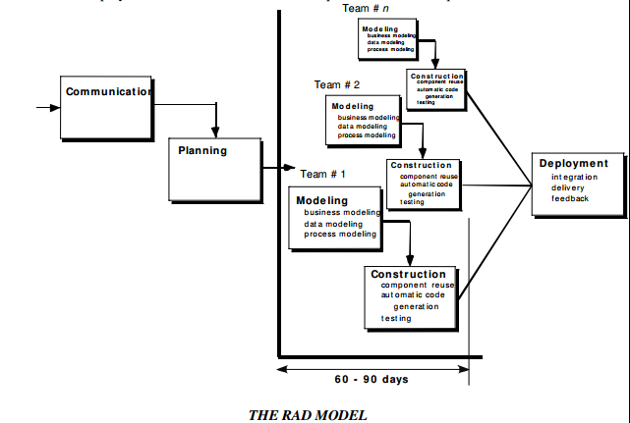
If a business application can be modularized in a way that enables each major function to be completed in less than three months, it is a candidate for RAD. Each major function can be addressed by a separate RAD team and then integrated to form a whole.
RAD Drawbacks:
- For large, but scalable projects, RAD requires sufficient human resources to create the right number of RAD teams.
- If developers and customers are not committed to the rapid fire activities, RAD project fails.
- If a system is not properly modularized, building the components for RAD will be problematic.
- If high performance is an issue and performance is to be achieved through tuning the interfaces to system components, the RAD approach may not work.
- Not appropriate when technical risks are high or when new technology is used.
PROTOTYPING MODEL
The customer usually defines a set of general objectives for software, but does not identify detailed input, processing or output requirements. The developer may be unsure of
- The efficiency of an algorithm
- The adaptability of an operating system
- The form that human-machine interaction should take
In these and many other situations, a prototyping paradigm may offer the best approach. Although prototyping can be used as a standalone process model, it is more often used as a technique that can be implemented within the context of any one of the other process models. The prototyping paradigm assists the software engineer and the customer to better understand what is to be built when the requirements are fuzzy.
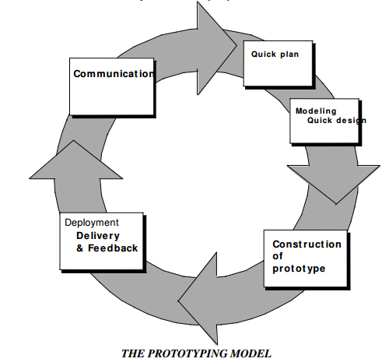
- The prototyping paradigm begins with communication. The software engineer and the customer meet and
- Define the overall objectives for the software
- Outline areas whether further definition is mandatory
- Identify whatever requirements are known
- The quick design leads to construction of a prototype.
- The prototype is deployed and then evaluated by customer/user. The feedback is used to refine requirements for the software.
- Iteration occurs as the prototype is tuned to satisfy the needs of the customer, while at the same time enabling the developer to better understand what needs to be done.
- Prototyping serves as a mechanism for identifying software requirements. If a working prototype is built, the developer attempts to make use of existing program fragments or applies tools that enable working programs to be generated quickly.
- The prototype can serve as the first system. Both customers and developers like the prototyping paradigm. Users get a feel for the actual system and developers get to build something immediately.
Problems with Prototyping
- The customer sees what appears to be a working version of the software, unaware that in the rush to get it working, the quality or maintainability is not considered. When informed that the software has to be rebuilt, demands for a few fixes to make it a working product.
- The developer often makes implementation compromises to make the prototype work quickly. An inappropriate OS or programming language is used, but the developer forgets why these choices are inappropriate and gets comfortable with the system. The less-than-ideal choice has now become an integral part of the system.

- Describe waterfall, incremental and iterative models based SLCS and compare.(NOV/DEC 2012)
The Waterfall Model
The waterfall model is a sequential design process, used in software development processes, in which progress is seen as flowing steadily downwards (like a waterfall) through the phases of Conception, Initiation, Analysis, Design, Construction, Testing, Production/Implementation and Maintenance. The following phases are followed in order:
- Requirements specification resulting in the product requirements document
- Design resulting in the software architecture
- Construction (implementation or coding) resulting in the actual software
- Integration
- Testing and debugging
- Installation
- Maintenance

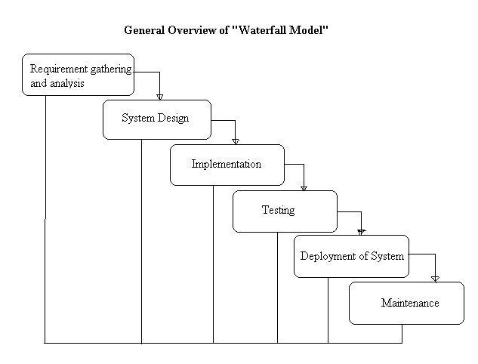
Advantages:
- Easy to understand and implement.
- Widely used and known (in theory!).
- Reinforces good habits: define-before- design, design-before-code.
- Identifies deliverables and milestones.
- Document driven, URD, SRD,. etc. Published documentation standards,
- Works well on mature products and weak teams.
Disadvantages:
- Idealized, doesn’t match reality well.
- Doesn’t reflect iterative nature of exploratory development.
- Unrealistic to expect accurate requirements so early in project.
- Software is delivered late in project, delays discovery of serious errors.
- Difficult to integrate risk management.
- Difficult and expensive to make changes to documents, ”swimming upstream”.
- Significant administrative overhead, costly for small teams and projects
Incremental models
The incremental model applies linear sequences in a staggered fashion as calendar time progresses. Each linear sequence produces deliverable “increments” of the software in a manner that is similar to the increments produced by an evolutionary process flow.

- When an incremental model is used, the first increment is often a core product.
- The core product is used by the customer (or undergoes detailed evaluation).
- As a result of use and/or evaluation, a plan is developed for the next increment. The plan addresses the modification of the core product to better meet the needs of the customer and the delivery of additional features and functionality.
- This process is repeated following the delivery of each increment, until the complete product is produced.
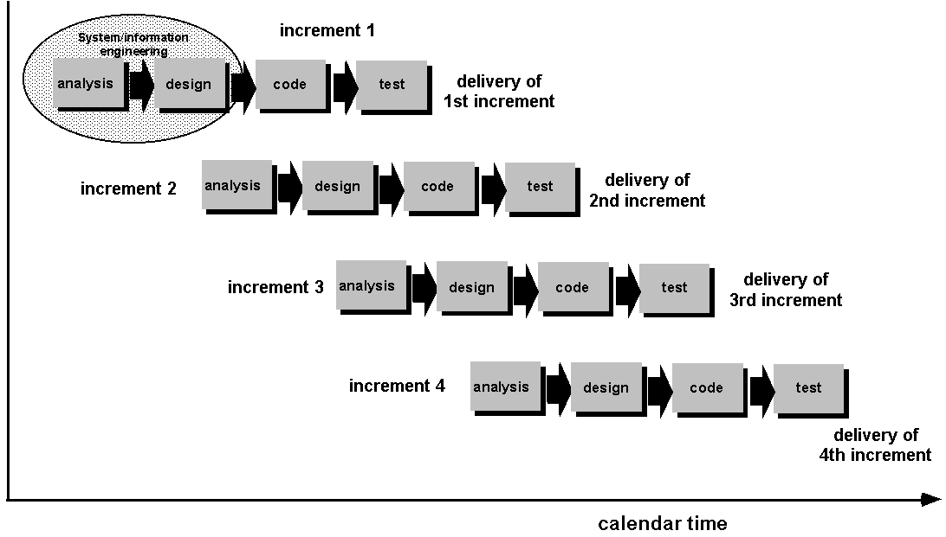
Advantages of Incremental model:
- Generates working software quickly and early during the software life cycle.
- This model is more flexible – less costly to change scope and requirements.
- It is easier to test and debug during a smaller iteration.
- In this model customer can respond to each built.
- Lowers initial delivery cost.
- Easier to manage risk because risky pieces are identified and handled during it’d iteration.
Disadvantages of Incremental model:
- Needs good planning and design.
- Needs a clear and complete definition of the whole system before it can be broken down and built incrementally.
- Total cost is higher than waterfall.

Iterative models

An iterative life cycle model does not attempt to start with a full specification of requirements. Instead, development begins by specifying and implementing just part of the software, which can then be reviewed in order to identify further requirements. This process is then repeated, producing a new version of the software for each cycle of the model.
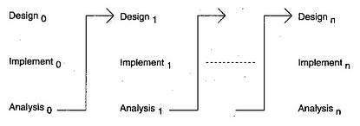
Advantages of Iterative model:
- In iterative model we can only create a high-level design of the application before we actually begin to build the product and define the design solution for the entire product. Later on we can design and built a skeleton version of that, and then evolved the design based on what had been built.
- In iterative model we are building and improving the product step by step. Hence we can track the defects at early stages. This avoids the downward flow of the defects.
- In iterative model we can get the reliable user feedback. When presenting sketches and blueprints of the product to users for their feedback, we are effectively asking them to imagine how the product will work.
- In iterative model less time is spent on documenting and more time is given for designing.

Disadvantages of Iterative model:
- Each phase of an iteration is rigid with no overlaps
- Costly system architecture or design issues may arise because not all requirements are gathered up front for the entire lifecycle

- Discuss in detail the project structure and programming team structure of a software organization. (NOV/DEC 2010)

A PROCESS FRAMEWORK
A process framework establishes the foundation for a complete software process by
identifying a small number of framework activities that are applicable to all software projects, regardless of their size or complexity. In addition, the process framework encompasses a set of umbrella activities that are applicable across the entire software process.
Each framework activity is populated by a set of software engineering actions-a collection of related tasks that produces a major software engineering work product. Each action is
populated with individual work tasks that accomplish some part of the work implied by the
action.
The following generic process framework is applicable to vast majority of software projects:
- Communication: this framework activity involves heavy communication and collaboration with the customer and encompasses requirements gathering and other related activities.
- Planning: this activity establishes a plan for the software engineering work that follows. It describes the technical tasks to be conducted, the risks that are likely, the resources that will be required, the work products to be produced, and a work schedule.
- Modeling: the activity encompasses the creation of models that allow the developer and the customer to better understand software requirements and the design that will achieve those requirements.
- Construction: this activity combines code generation and the testing that is required to uncover errors in the code.
- Deployment: the software is delivered to the customer who evaluates the delivered product and provides feedback based on the evaluation.
The modeling activity is composed of two software engineering actions:
- Analysis encompasses a set of work tasks requirements gathering, elaboration, negotiation, specification and validation that lead to the creation of the analysis model or requirements specification.
- Design encompasses work tasks data design, architectural design, interface design and component-level design and create a design model or design specification.
Each software engineering action is represented by a number of different task sets-each a collection of software engineering work tasks, related work products, quality assurance points and project milestones. The task set that best accommodates the needs of the project and characteristics of the team is chosen. The framework described in the generic view of software engineering is completed by a number of umbrella activities. Typical activities in this category include:
- Software Project Tracking and Control-allows the software team to assess
progress against the project plan and take the necessary action to maintain schedule.
- Risk Management-assess the risks that may effect the outcome of the project or the
quality of the product.
- Software Quality Assurance-defines and conducts the activities required to ensure
software quality.
- Formal Technical Reviews-assesses software engineering work products in an effort
to uncover or remove errors before they are propagated to the next action or activity.
- Measurement-defines and collects process, project and product measures that assist the team in delivering software that meets customer needs.
- Software Configuration Management-manages the effects of change throughout
the software process.
- Reusability Management-defines criteria for work product reuse and establishes mechanisms to achieve reusable components.
- Work Product Preparation and Production-encompasses the activities required to create work products such as models, documents, logs, forms and lists.
All process models can be categorized within the process framework discussed. But process models do differ fundamentally in:
- The overall flow of activities and tasks and the interdependencies among activities and tasks.
- The degree to which work tasks are defined within each framework activity.
- The degree to which work products are identified and required.
- The manner which quality assurance activities are applied.
- The manner in which project tracking and control activities are applied.
- The overall degree of detail and rigor with which the process is described.
- The degree to which customer and other stakeholders are involved within the project.
- The level of autonomy given to the software project team.

A PROCESS FRAMEWORK
A process framework establishes the foundation for a complete software process by
identifying a small number of framework activities that are applicable to all software projects, regardless of their size or complexity. In addition, the process framework encompasses a set of umbrella activities that are applicable across the entire software process.
Each framework activity is populated by a set of software engineering actions-a collection of related tasks that produces a major software engineering work product. Each action is
populated with individual work tasks that accomplish some part of the work implied by the
action.
The following generic process framework is applicable to vast majority of software projects:
- Communication: this framework activity involves heavy communication and collaboration with the customer and encompasses requirements gathering and other related activities.
- Planning: this activity establishes a plan for the software engineering work that follows. It describes the technical tasks to be conducted, the risks that are likely, the resources that will be required, the work products to be produced, and a work schedule.
- Modeling: the activity encompasses the creation of models that allow the developer and the customer to better understand software requirements and the design that will achieve those requirements.
- Construction: this activity combines code generation and the testing that is required to uncover errors in the code.
- Deployment: the software is delivered to the customer who evaluates the delivered product and provides feedback based on the evaluation.
The modeling activity is composed of two software engineering actions:
- Analysis encompasses a set of work tasks requirements gathering, elaboration, negotiation, specification and validation that lead to the creation of the analysis model or requirements specification.
- Design encompasses work tasks data design, architectural design, interface design and component-level design and create a design model or design specification.
Each software engineering action is represented by a number of different task sets-each a collection of software engineering work tasks, related work products, quality assurance points and project milestones. The task set that best accommodates the needs of the project and characteristics of the team is chosen. The framework described in the generic view of software engineering is completed by a number of umbrella activities. Typical activities in this category include:
- Software Project Tracking and Control-allows the software team to assess
progress against the project plan and take the necessary action to maintain schedule.
- Risk Management-assess the risks that may effect the outcome of the project or the
quality of the product.
- Software Quality Assurance-defines and conducts the activities required to ensure
software quality.
- Formal Technical Reviews-assesses software engineering work products in an effort
to uncover or remove errors before they are propagated to the next action or activity.
- Measurement-defines and collects process, project and product measures that assist the team in delivering software that meets customer needs.
- Software Configuration Management-manages the effects of change throughout
the software process.
- Reusability Management-defines criteria for work product reuse and establishes mechanisms to achieve reusable components.
- Work Product Preparation and Production-encompasses the activities required to create work products such as models, documents, logs, forms and lists.
All process models can be categorized within the process framework discussed. But process models do differ fundamentally in:
- The overall flow of activities and tasks and the interdependencies among activities and tasks.
- The degree to which work tasks are defined within each framework activity.
- The degree to which work products are identified and required.
- The manner which quality assurance activities are applied.
- The manner in which project tracking and control activities are applied.
- The overall degree of detail and rigor with which the process is described.
- The degree to which customer and other stakeholders are involved within the project.
- The level of autonomy given to the software project team.
- The degree to which team organization and roles are prescribed.
- Discuss the various life cycle models in software development.(APR/MAY 2011) (NOV/DEC 2014)
INCREMENTAL PROCESS MODEL
There are situations in which the initial software requirements are reasonably well-defined. There may be a need to provide the software functionality to users quickly and then refine and expand on that functionality. In such cases a process model that is designed to produce the software in increments is chosen
The Incremental Model
The incremental model combines the elements of the waterfall model applied in an iterative
fashion.

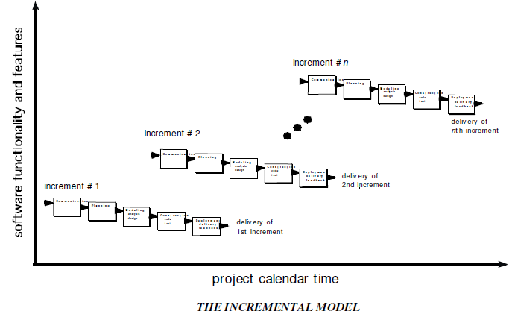
The incremental model applies linear sequences in a staggered fashion as calendar time progresses. Each linear sequence produces deliverable increments of the software. When an incremental model is used:
- The first increment is often called the core product.
- The basic requirements are addressed.
- Many supplementary features remain undelivered.
- The core product is used by the customer.
- As a result of use and/or evaluation, a plan is developed for the next increment.
- The plan includes modification of the core product to better meet the needs of the customer and the delivery of additional features and functionality.
- The process is repeated until the complete product is delivered.
The incremental process model, like prototyping is iterative in nature. But unlike prototyping, the incremental model focuses on the delivery of an operational product with each increment.
- Early increments are stripped down versions of the final product, but they do provide capability that serves the user and platform for evaluation by the user.
- Incremental development is particularly useful when staffing is unavailable for a complete implementation by the business deadline.
- Early increments are implemented with fewer people.
If the core product is received well, additional staff can be added to implement the next increment.
THE CONCURRENT DEVELOPMENT MODEL
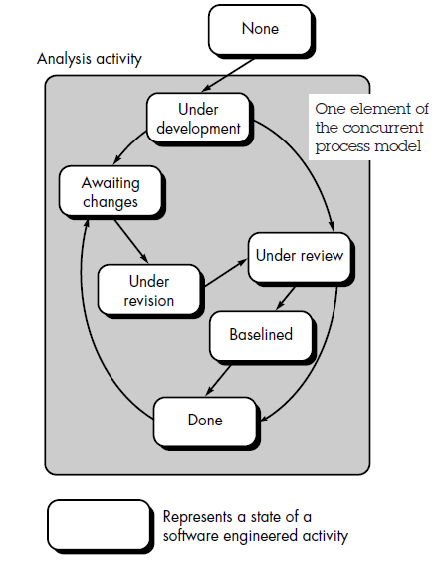
The Concurrent Development Model also called Concurrent Engineering, is represented as a
series of
- Framework activities
- Software engineering actions and tasks
- And their associated states
The figure provides a representation of one software engineering task within the modeling
activity for the concurrent process model. The activity-modeling-may be in any one of the states noted at a given time. Similarly other activities or tasks can be represented in an analogous manner. All activities exist concurrently but reside in different states.
For example
- Early in a project the communication activity has completed its first iteration and exists in the awaiting changes state.
- The modeling activity which exists in the none state while initial communication was completed, now makes a transition into the under development state.
- If customer indicates changes in the requirements, the modeling activity moves from the under development state into the awaiting changes state.
The concurrent process model defines a series of events that will trigger transitions from state to state for each of the software engineering activities, actions or tasks. The concurrent
process model is applicable to all types of software development and provides an accurate
picture of the current state of a project. This model defines a network of activities. Events triggered at one point in the process network trigger transitions among the states.

- Discuss about the COCOMO Models(Basic, Intermediate and Detailed)for cost estimation.(APRIL/MAY2015)
Barry Boehm introduced COCOMO II (COst COnstructive MOdel) which is an hierarchy of estimation models that addresses the following areas:
- Application composition model. Used during the early stages of software engineering, when prototyping of user interfaces, consideration of software and system interaction, assessment of performance, and evaluation of technology maturity are paramount.
- Early design stage model. Used once requirements have been stabilized and basic software architecture has been established.
- Post-architecture-stage model. Used during the construction of the software.
Three different sizing options are available as part of the model hierarchy: object points, function points, and lines of source code.
OBJECT TYPE | COMPLEXITY WEIGHT
OBJECT TYPE | SIMPLE | MEDIUM | DIFFICULT
Screen | 1 | 2 | 3
Report | 2 | 5 | 8
3GL component |  |  | 10
The object point is an indirect software measure that is computed using counts of the number of (1) screens (at the user interface), (2) reports, and (3) components likely to be required to build the application.
When component-based development or general software reuse is to be applied, the percent of reuse (%reuse) is estimated and the object point count is adjusted:
NOP=(Object points)*[(100-%reuse)/100]
where NOP is defined as new object points.
To derive an estimate of effort based on the computed NOP value, a “productivity rate” must be derived.
NOP
PROD=--------------------------
Person-month

for different levels of developer experience and development environment maturity.
Once the productivity rate has been determined, an estimate of project effort is computed using
NOP
Estimated effort=------------
PROD
In more advanced COCOMO II models, 12 a variety of scale factors, cost drivers, and adjustment procedures are required.

Developer’s experience/capability | Very low | Low | Nominal | High | Very high
Environment maturity/capability | Very low | Low | Nominal | High | Very high
PROD | 4 | 7 | 13 | 25 | 50
The Software Equation
The software equation is a dynamic multivariable model that assumes a specific distribution of effort over the life of a software development project.

LOC*B^{0.333} 1
E=-------------------- * ----------
P3 t⁴

where
E --effort in person-months or person-years
t --project duration in months or years
B-- “special skills factor”13
P -- “productivity parameter” that reflects: overall process maturity and management practices, the extent to which good software engineering practices are used, the level of programming languages used, the state of the software environment, the skills and experience of the software team, and the
complexity of the application software equation has two independent parameters:
- an estimate of size (in LOC) and
- an indication of project duration in calendar months or years.
To simplify the estimation process and use a more common form for their estimation model, Putnam and Myers suggest a set of equations derived from the software equation. Minimum development time is defined as

LOC
Tmin=8.14----------- IN months for t_{min}>6 months
P ^{0.43}

E=180Bt³ in person-months for E>=20 person-months

- Describe at least one scenario where
  - RAD model would be applicable and not waterfall model.
  - Waterfall model is preferable to all other models.
RAD Model would be applicable and not waterfall model
The RAD model is suitable for information system applications, business applications and for systems that can be modularized because of the following reasons:
- This model is similar to waterfall model but uses very short development cycle.
- It uses component based construction and emphasizes reuse and code generation.
- This model uses multiple teams on scalable projects.
- The RAD model is suitable for the projects where technical risks are not high.
- The RAD model requires heavy resources.
In waterfall model “blocking state” situation occurs. In blocking state situation, project team members have to wait for other members of the team to complete the dependent tasks. For high speed and short time development projects, RAD model would be applicable, where as waterfall model is unsuited for these types of projects.
Waterfall model is preferable to all other models
- Waterfall model is useful for the projects in which the requirements are well
understood and unlikely to change radically during the system development.
- The waterfall model is simple to implement, compared to all other software models.
- For implementation of small systems waterfall model is useful.
- Waterfall model suggests a systematic, sequential approach to software development.
- This model consists of information domain, function, and behavioral requirements of the system.
- It is the oldest software paradigm. It is also called as “linear-sequential model” or “classic lifecycle model”.
- Compare and contrast the different lifecycle models. (NOV/DEC 2011)
PROCESS  MODEL | CONCEPT | ADVANTAGE | DISADVANTAGE
The waterfall model | The waterfall model,  called the classic life  cycle suggests a  systematic,  sequential approach  to software  development. | It provides a template  into which methods  for analysis, design,  and other phases can  be placed. It provides  for baseline  management. It is  better than any  haphazard approach  to software  development. | It lacks the  perception for a  reverse engineering  on how to engineer  an existing legacy  system. The client  has to wait until the  installation and  checkout phase to see  how a system works.  Thus a complex  system requires  considerable time and  effort. Real time  software cannot  follow this model.  Customer satisfaction  is not full filled.
The incremental  model | The incremental  model combines the  elements of the  waterfall model  applied in an  iterative fashion. The  incremental model  applies linear  sequences in a  staggered fashion as  calendar time  progresses. Each  linear sequence  produces deliverable  increments of the  software. | The software  development  activities are repeated  each time there is a  new release of  software. It  provides a platform  for evaluation by the  user. It can be  planned to manage  technical risks. It  enables partial  functionality to be  delivered to end users  without ordinary  delay. | It makes the  unrealistic  assumptions that  system as well as  software  requirements remain  stable which is not  true.
Prototyping | The prototyping  paradigm assists the  software engineer  and the customer to  better understand  what is to be built  when the  requirements are  fuzzy. The customer  usually defines a set  of general objectives  for software, but  does not identify  detailed input,  processing or output  requirements. | It produces the  products quickly and  thus saves the time It  and solves the  waiting problem in  waterfall model. It  minimizes the cost  and product failure. It  is possible for the  developers and client  to check the function  of preliminary  implementations of  system models before  committing to a final  system. It obtains  feedback from clients  and changes in  system concept. | It ignores quality,  reliability  maintainability and  safety requirements.  Customer satisfaction  is not achieved
Spiral model | The spiral model is  an evolutionary  software process  model that couples  the iterative nature of  prototyping with the  controlled and  systematic aspects of  the waterfall model.  It provides the  potential for rapid  development of  increasingly more  complex versions of  the software. | It provides the  potential for rapid  development for  incremental versions  of the software. It can  be applied throughout  the life of the  computer software. It  allows the developer  to apply the  prototyping approach  at any stage. It  demands a direct  consideration of  technical risks at all  stages. | It may be difficult to  convince the  customers at times  especially in contrast  solutions. It demands  considerable risks  assessment expertise  and relies on them for  success. It takes time  for determining the  efficacy and thus the  model cannot be used  as widely as others.
RAD model | Rapid Application  Development (RAD)  is an incremental  software process  model that  emphasizes a short  development cycle.  The RAD model is a  high-speed  adaptation of the  waterfall model, in  which rapid  development is  achieved by using  component-based  construction  approach. | If requirements are  well understood and  project scope is  constrained, the RAD  process enables a  development team to  create a fully  functional system  within a very short  time period. | RAD requires  sufficient human  resources to create  the right number of  RAD teams. If  developers and  customers are not  committed RAD  project fails. If a  system is not  properly  modularized, building  the components for  RAD will be  problematic.  High performance  cannot be achieved.  Not appropriate when  technical risks are  high or when new  technology is used.

- Discuss briefly about the techniques used for Project scheduling.
Software project scheduling is an action that distributes estimated effort across the planned project duration by allocating the effort to specific software engineering tasks. Scheduling for software engineering projects can be viewed from two rather different perspectives. In the first, an end date for release of a computer-based system has already (and irrevocably) been established. The software organization is constrained to distribute effort within the prescribed time frame. The second view of
software scheduling assumes that rough chronological bounds have been discussed but that the end date is set by the software engineering organization.
Basic Principles
- Compartmentalization. The project must be compartmentalized into a number of manageable activities and tasks. To accomplish compartmentalization, both the product and the process are refined.
- Interdependency. The interdependency of each compartmentalized activity or task must be determined. Some tasks must occur in sequence, while others can occur in parallel. Some activities cannot commence until the work product produced by another is available. Other activities can occur independently.
- Time allocation. Each task to be scheduled must be allocated some number of work units (e.g., person-days of effort). In addition, each task must be assigned a start date and a completion date that are a function of the interdependencies and whether work will be conducted on a full-time or part-time basis.
- Effort validation. Every project has a defined number of people on the software team. As time allocation occurs, you must ensure that no more than the allocated number of people has been scheduled at any given time. For example, consider a project that has three assigned software engineers (e.g., three person-days are available per day of assigned effort4). On a given day, seven concurrent tasks must be accomplished. Each task requires 0.50 person-days of effort. More effort has been allocated than there are people to do the work.
- Defined responsibilities. Every task that is scheduled should be assigned to a specific team member.
- Defined outcomes. Every task that is scheduled should have a defined outcome. For software projects, the outcome is normally a work product (e.g., the design of a component) or a part of a work product. Work products are often combined in deliverables.
- Defined milestones. Every task or group of tasks should be associated with a project milestone. A milestone is accomplished when one or more work products has been reviewed for quality.
The Relationship Between People and Effort
L, is related to effort and development time by the equation:
L=P*E¹/3t^{4/3}

Rearranging this software equation, we can arrive at an expression for development effort E:
L³
E=-------------------
P³ t⁴
Effort Distribution
A recommended distribution of effort across the software process is often referred to as the 40–20–40 rule. Forty percent of all effort is allocated to frontend analysis and design. A similar percentage is applied to back-end testing. 20 percent of effort is deemphasized in the coding.
Because of the effort applied to software design, code should follow with relatively little difficulty. A range of 15 to 20 percent of overall effort can be achieved. Testing and subsequent debugging can account for 30 to 40 percent of software development effort. The criticality of the software often dictates the amount of testing that is required. If software is human rated (i.e., software failure can result in loss of life), even higher percentages are typical.

- Discuss LOC and FP- Cost Estimation Models in detail.
Size-Oriented Metrics
- LOC measure claim that LOC is an “artifact” of all software development projects that can be easily counted, that many existing software estimation models use LOC or KLOC as a key input, and that a large body of literature and data predicated on LOC already exists.
- The planner must estimate the LOC to be produced long before analysis and design has been completed.
Function-Oriented Metrics
- Function-oriented software metrics use a measure of the functionality delivered by the application as a normalization value. The most widely used function-oriented metric is the function point (FP). Computation of the function point is based on characteristics of the software’s information domain and complexity.
- The function point, like the LOC measure, is controversial. Proponents claim that FP is programming language independent, making it ideal for applications using conventional and nonprocedural languages, and that it is based on data that are more likely to be known early in the evolution of a project, making FP more attractive as an estimation approach.
- Opponents claim that the method requires some “sleight of hand” in that computation is based on subjective rather than objective data, that counts of the information domain (and other dimensions) can be difficult to collect after the fact, and that FP has no direct physical meaning—it’s just a number.
Reconciling LOC and FP Metrics
The relationship between lines of code and function points depends upon the programming language that is used to implement the software and the quality of the design. Function points and LOC-based metrics have been found to be relatively accurate predictors of software development effort and cost. However, in order to use LOC and FP for estimation, an historical baseline of information must be established.
Within the context of process and project metrics, productivity and quality should be concerned which are the measures of software development “output” as a function of effort and time applied and measures of the “fitness for use” of the work products that are produced. For process improvement and project planning purposes, the interest is historical.

- Give a brief account about Risk Management.
Project risks threaten the project plan. That is, if project risks become real, it is likely that the project schedule will slip and that costs will increase. Project risks identify potential budgetary, schedule, personnel (staffing and organization), resource, stakeholder, and requirements problems and their impact on a software project.
Technical risks threaten the quality and timeliness of the software to be produced. If a technical risk becomes a reality, implementation may become difficult or impossible. Technical risks identify potential design, implementation, interface, verification, and maintenance problems.
Business risks threaten the viability of the software to be built and often jeopardize the project or the product. Candidates for the top five business risks are
- building an excellent product or system that no one really wants (market risk),
- building a product that no longer fits into the overall business strategy for the company (strategic risk),
- building a product that the sales force doesn’t understand how to sell (sales risk),
- losing the support of senior management due to a change in focus or a change in people (management risk), and
- losing budgetary or personnel commitment (budget risks).
Known risks are those that can be uncovered after careful evaluation of the project plan, the business and technical environment in which the project is being developed, and other reliable information sources (e.g., unrealistic delivery date, lack of documented requirements or software scope, poor development environment).
Predictable risks are extrapolated from past project experience (e.g., staff turnover, poor communication with the customer, dilution of staff effort as ongoing maintenance requests are serviced). Unpredictable risks are the joker in the deck. They can and do occur, but they are extremely difficult to identify in advance.
Risk Identification:
Risks are about events that, when triggered, cause problems or benefits. Hence, risk identification can start with the source of our problems and those of our competitors (benefit), or with the problem itself.
- Source analysis - Risk sources may be internal or external to the system that is the target of risk management (use mitigation instead of management since by its own definition risk deals with factors of decision-making that cannot be managed). Examples of risk sources are: stakeholders of a project, employees of a company or the weather over an airport.
- Problem analysis- Risks are related to identified threats. For example: the threat of losing money, the threat of abuse of confidential information or the threat of human errors, accidents and casualties. The threats may exist with various entities, most important with shareholders, customers and legislative bodies such as the government.
Risk Assessment:
Once risks have been identified, they must then be assessed as to their potential severity of impact (generally a negative impact, such as damage or loss) and to the probability of occurrence. These quantities can be either simple to measure, in the case of the value of a lost building, or impossible to know for sure in the case of the probability of an unlikely event occurring. Therefore, in the assessment process it is critical to make the best educated decisions in order to properly prioritize the implementation of the risk management plan.
Composite Risk Index = Impact of Risk event x Probability of Occurrence
Risk mitigation:
Risk mitigation measures are usually formulated according to one or more of the following major risk options, which are:
- Design a new business process with adequate built-in risk control and containment measures from the start.
- Periodically re-assess risks that are accepted in ongoing processes as a normal feature of business operations and modify mitigation measures.
- Transfer risks to an external agency (e.g. an insurance company)
- Avoid risks altogether (e.g. by closing down a particular high-risk business area)

Prioritizing the risk management processes too highly could keep an organization from ever completing a project or even getting started. This is especially true if other work is suspended until the risk management process is considered complete.

- What is CMMI? Explain the different levels of CMMI and its goals?
The CMMI represents a process meta-model in two different ways: (1) as a “continuous” model and (2) as a “staged” model. Each process area (e.g., project planning or requirements management) is formally assessed against specific goals and practices and is rated according to the following capability levels:
Level 0: Incomplete—the process area (e.g., requirements management) is either not performed or does not achieve all goals and objectives defined by the CMMI for level 1 capability for the process area.
Level 1: Performed—all of the specific goals of the process area (as defined by the CMMI) have -been satisfied. Work tasks required to produce defined work products are being conducted.
Level 2: Managed—all capability level 1 criteria have been satisfied. In addition, all work associated with the process area conforms to an organizationally defined policy; all people doing the work have access to adequate resources to get the job done; stakeholders are actively involved in the process area as required; all work tasks and work products are “monitored, controlled, and reviewed; and are evaluated for adherence to the process description” .
Level 3: Defined—all capability level 2 criteria have been achieved. In addition, the process is “tailored from the organization’s set of standard processes according to the organization’s tailoring guidelines, and contributes work products, measures, and other process-improvement information to the organizational process assets” .
Level 4: Quantitatively managed—all capability level 3 criteria have been achieved. In addition, the process area is controlled and improved using measurement and quantitative assessment. “Quantitative objectives for quality and process performance are established and used as criteria in managing the process” .
Level 5: Optimized—all capability level 4 criteria have been achieved. In addition, the process area is adapted and optimized using quantitative (statistical) means to meet changing customer needs and to continually improve the efficacy of the process area under consideration.
The CMMI defines each process area in terms of “specific goals” and the “specific practices” required to achieve these goals. Specific goals establish the characteristics that must exist if the activities implied by a process area are to be effective. Specific practices refine a goal into a set of process-related activities.
- Explain Specialized Process and Unified Process Models in detail.
Specialized Process Models:
Component-based development
The component-based development model incorporates many of the characteristics of the spiral model. It is evolutionary in nature, demanding an iterative approach to the creation of software. However, the component-based development model constructs applications from prepackaged software components.
The component-based development model incorporates the following steps:
- Available component-based products are researched and evaluated for the application domain in question.
- Component integration issues are considered.
- A software architecture is designed to accommodate the components.
- Components are integrated into the architecture.
- Comprehensive testing is conducted to ensure proper functionality.
Formal Methods Model
The formal methods model encompasses a set of activities that leads to formal mathematical specification of computer software.
- The development of formal models is currently quite time consuming and expensive.
- Because few software developers have the necessary background to apply formal methods, extensive training is required.
- It is difficult to use the models as a communication mechanism for technically +unsophisticated customers.
Aspect-oriented software development
Aspect-oriented software development (AOSD), often referred to as aspect-oriented programming (AOP), is a relatively new software engineering paradigm that provides a process and methodological approach for defining, specifying, designing, and constructing aspects—“mechanisms beyond subroutines and inheritance for localizing the expression of a crosscutting concern”.
Unified Process Model
The Unified Process recognizes the importance of customer communication and streamlined methods for describing the customer’s view of a system. It emphasizes the important role of software architecture and “helps the architect focus on the right goals, such as understandability, reliance to future changes, and reuse” [Jac99]. It suggests a process flow that is iterative and incremental, providing the evolutionary feel that is essential in modern software development
Phases of Unified Process Model
The inception phase of the UP encompasses both customer communication and planning activities. By collaborating with stakeholders, business requirements for the software are identified; a rough architecture for the system is proposed; and a plan for the iterative, incremental nature of the ensuing project is developed. Fundamental business requirements are described through a set of preliminary use cases that describe which features and functions each major class of users desires.
The elaboration phase encompasses the communication and modeling activities of the generic process model. Elaboration refines and expands the preliminary use cases that were developed as part of the inception phase and expands the architectural representation to include five different views of the software—the use case model, the requirements model, the design model, the implementation model, and the deployment model.
The construction phase of the UP is identical to the construction activity defined for the generic software process. Using the architectural model as input, the construction phase develops or acquires the software components that will make each use case operational for end users.
The transition phase of the UP encompasses the latter stages of the generic construction activity and the first part of the generic deployment (delivery and feedback) activity. Software is given to end users for beta testing and user feedback reports both defects and necessary changes.
The production phase of the UP coincides with the deployment activity of the generic process. During this phase, the ongoing use of the software is monitored, support for the operating environment (infrastructure) is provided, and defect reports and requests for changes are submitted and evaluated.

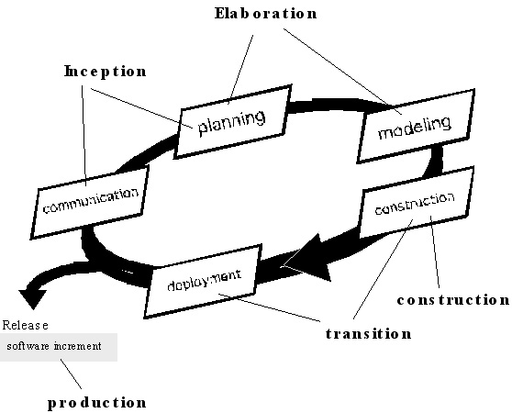
UNIT - II
PART – A
- What are User Requirements and System Requirements?
- User requirements are statements, in a natural language, of what services the system is
expected to provide and the constraints under which it must operate.
- System requirements set out the system's functions, services and operational constraints in detail. It should define exactly what is to be implemented. It may be part of the contract between the system buyer and the software developers.
2. Define functional and non-functional requirements. (NOV/DEC 2010)(APR/MAY 2011) (MAY/JUN 2012)(NOV/DEC 2014)
The functional requirements of a system describe what the system should do. These requirements depend on the software being developed, the expected users of the software and the general approach taken by the organization when writing requirements.
Non-functional requirements are requirements that are not directly concerned with the specific functions delivered by the system.

- Reliability
- Response time
- Storage capacity
- Data representation in system interfaces
- capability of I/O device
- System performance
- Security
- Availability

3. List two advantages of using traceability tables in the requirements management phase. (NOV/DEC 2013)
These traceability tables are maintained as part of a requirements database so that they may be quickly searched to understand how a change in one requirement will affect different aspects of the system to be built.
4. Draw the DFD notations for a) External entity b) Data items. (NOV/DEC 2011)

- Data items-labeled arrows(→)
- External entity-boxes( )

5. What are the processes involved in requirement engineering? (MAY/JUN 2012)

- Requirements elicitation.
- Requirements analysis &negotiation.
- Requirements specification.
- System modeling.
- Requirements validation.
- Requirements management.

6. What are the types of viewpoints?
Viewpoints can be used as a way of classifying stakeholders and other sources of requirements. There are three generic types of viewpoint:
- Interactor viewpoints represent people or other systems that interact directly with the system.
- Indirect viewpoints represent stakeholders who do not use the system themselves but who influence the requirements in some way.
- Domain viewpoints represent domain characteristics and constraints that influence the system requirements.
7. Give the disadvantages of requirements elicitation.
- Problems of scope: The requirements may address too little or too much informations.
- Problems of understanding: Different stakeholders have different requirements, which they may express in different ways. Requirements engineers have to consider all potential sources of requirements and discover commonalities and conflict.
- Problems of volatility: It represents the changing nature of the requirements.
8. Define requirements validation.
It examines the specifications to ensure that all system requirements have been stated unambiguously by detecting and correcting the inconsistencies, omissions, and errors. It also ensures whether the work products conform to the standards established for the process, the project, and the product.
9. Define requirements management.
It is a set of activities that help the project team to identify, control, and track requirements and changes to requirements at any times as the project proceeds.
10. Define requirement analysis.
It is a software engineering task that bridges the gap between system level requirements engineering and software design.
11. How the software requirements analysis can be divided?
The software requirements analysis can be divided into the following:

- Problem recognition.
- Evaluation and synthesis.
- Modeling.
- Specification.
- Review.

12. Define Traceability
Traceability is the overall property of requirements specification which reflects the ease of finding related requirements. Three types of traceability information to be maintained are:

- Source traceability information
- Requirement traceability information
- Design traceability information

13. Mention some of the Notations for requirements specification.
- Structured natural language: Use standard form or Templates.
- Design description language: Programming language is used.
- Graphical notation: Text annotation is used.
- Mathematical Specifications: Based on finite state machines or sets.
14. What are the different types of checks carried out during Requirement Validation?
(or) How are the requirements validated? (APR/MAY 2015)

- Validity checks
- Consistency checks
- Completeness checks
- Realism checks
- Verifiability.

15. Give the set of guidelines principles for requirement engineering.
- Understand the problem before beginning the analysis model.
- Develop prototypes that enable a user to understand how human/machine interaction will occur.
- Record the origin of and the reason for each and every requirement.
- Use multiple views of requirements.
- Rank the requirements and eliminate the ambiguity.
16. What is the need for feasibility analysis? (APR/MAY 2015)
The aim of a feasibility study is to find out whether the system is worth implementing within the given budget and schedule. The purpose of feasibility study is not to solve the problem, but to determine whether the problem is worth solving. This helps to decide whether to proceed with the project or not.
17. Define throwaway prototyping.
A prototype serves solely as a rough demonstration of requirements. It is an close-ended approach.
18. Name three generic classes of methods and tools used in prototyping.
Fourth generation techniques, Reusable software components, Formal specification and prototyping environments
19. Name the three objectives used in analysis model.
The three objectives used in analysis model are:
- To describe what the customer requires.
- To establish a basis for the creation of a software design.
- To define a set of requirement that can be validated once the software is built.
20. Give the two uses of data flow diagram (DFD).
- To provide an indication of how data are transformed as they move through the system.
- To depict the functions that transforms the data flow.
21. Define data flow diagram.
It is a graphical representation that depicts information flow and the transforms that are applied as data move from input to output. It may be used to represent a system or software at any level of abstraction.
22. What is data dictionary? What are the informations contained in data dictionary? (NOV/DEC 2014)
Data dictionary provides definitions for all elements in the system which includes the following:
- Meaning of data flows and stores in DFDs
- Composition of the data flows e.g. customer address breaks down to street number, street name, city and postcode.
- Composition of the data in stores e.g. in Customer store include name, date of birth, address, credit rating etc.
- Details of the relationships between entities.
Informations in data dictionary are Name, Alias, Where-used/how- used, Content description and Supplementary information.
23. Give some guidelines to derived data flow diagram?
- The level 0 data flow diagram should depict the software/system as a single bubble.
- Primary input and output should be carefully noted.
- Refinement should begin by isolating candidate processes, data objects, and stores to be represented at the next level.
- All arrows and bubbles should be labeled with meaningful names.
- Information flow continuity must be maintained from level to level.
- One bubble at a time should be refined.
24. Define Requirements engineering.
Requirement Engineering provides the appropriate mechanism for understanding what the customer wants, analyzing need, assessing feasibility, negotiating a reasonable solution, specifying the solution unambiguously, validating the specification and managing the requirements as they are transformed into an operational system.
25. What are Petri Nets? Petri net is a directed bipartite graph, in which the nodes represent transitions (i.e. events that may occur, signified by bars) and places (i.e. conditions, signified by circles). The directed arcs describe which places are pre- and/or post conditions for the transitions (signified by arrows).
Part - B
- (i) What is the purpose of feasibility study?
(ii) State the ‘inputs and results of the feasibility study.
(iii) List any four issues addressed by a feasibility study.
(iv) Elaborate the phases involved when carrying out a feasibility study. (NOV/DEC 2013)

(i) The aims of a feasibility study are to find out whether the system is worth implementing and if it can be implemented, given the existing budget and schedule.
The purpose of feasibility study is not to solve the problem, but to determine whether the problem is worth solving. This helps to decide whether to proceed with the project or not.

(ii) The input to the feasibility study is a set of preliminary business requirements, an outline description of the system and how the system is intended to support business processes. The results of the feasibility study should be a report that recommends whether or not it is worth carrying on with the requirements engineering and system development process.

(iii)
- Gives focus to the project and outline alternatives.
- Narrows business alternatives
- Identifies new opportunities through the investigative process.
- Identifies reasons not to proceed.
- Enhances the probability of success by addressing and mitigating factors early on that could affect the project.
- Provides quality information for decision making.
- Provides documentation that the business venture was thoroughly investigated.
- Helps in securing funding from lending institutions and other monetary sources.
- Helps to attract equity investment.
The feasibility study is a critical step in the business assessment process. If properly conducted, it may be the best investment you ever made
(iv)Carrying out a feasibility study involves information assessment, information collection and report writing.
- Explain functional and non-functional requirements in detail.(NOV/DEC 2014)
Functional requirements
- Statements of services the system should provide, how the system should react to particular inputs and how the system should behave in particular situations.
- Describe functionality or system services
- Depend on the type of software, expected users and the type of system where the software is used
- Functional user requirements may be high-level statements of what the system should do but functional system requirements should describe the system services in detail
Examples of functional requirements
- The user shall be able to search either all of the initial set of databases or select a subset from it.
- The system shall provide appropriate viewers for the user to read documents in the document store.
Requirements Imprecision:
Problems arise when requirements are not precisely stated
Ambiguous requirements may be interpreted in different ways by developers and users
Consider the term ‘appropriate viewers’
  - User intention - special purpose viewer for each different document type
  - Developer interpretation - Provide a text viewer that shows the contents of the document
Requirements completeness and consistency:
In principle requirements should be both complete and consistent
Complete
  - They should include descriptions of all facilities required
Consistent
  - There should be no conflicts or contradictions in the descriptions of the system facilities
In practice, it is impossible to produce a complete and consistent requirements document
Non-functional requirements
- constraints on the services or functions offered by the system such as timing constraints, constraints on the development process, standards, etc.
- Define system properties and constraints e.g. reliability, response time and storage requirements. Constraints are I/O device capability, system representations, etc.
- Process requirements may also be specified mandating a particular CASE system, programming language or development method
- Non-functional requirements may be more critical than functional requirements. If these are not met, the system is useless
Non-functional Classification
Product requirements
- Requirements which specify that the delivered product must behave in a particular way e.g. execution speed, reliability, etc.
Organisational requirements
- Requirements which are a consequence of organisational policies and procedures e.g. process standards used, implementation requirements, etc.
External requirements
- Requirements which arise from factors which are external to the system and its development process e.g. interoperability requirements, legislative requirements, etc.
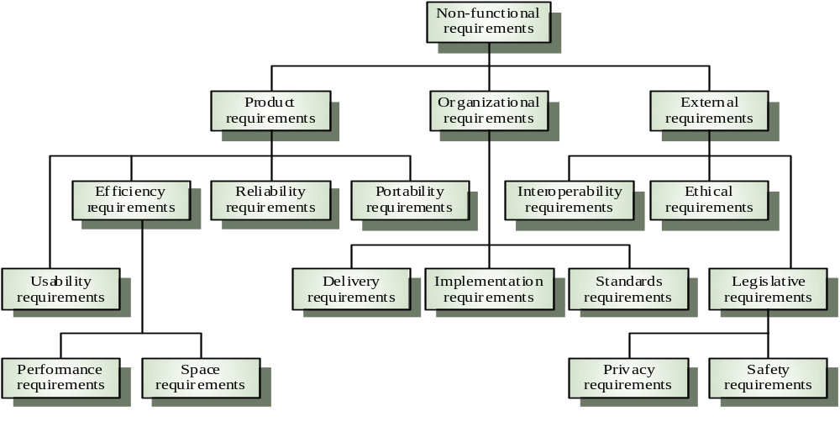

Examples of non-functional requirements:
Product requirement
  - It shall be possible for all necessary communication between the APSE and the user to be expressed in the standard Ada character set
Organisational requirement
  - The system development process and deliverable documents shall conform to the process and deliverables defined in XYZCo-SP-STAN-95
External requirement
  - The system shall not disclose any personal information about customers apart from their name and reference number to the operators of the system
Goals and requirements:
Non-functional requirements may be very difficult to state precisely and imprecise requirements may be difficult to verify.
Goal
  - A general intention of the user such as ease of use
Verifiable non-functional requirement
  - A statement using some measure that can be objectively tested
Goals are helpful to developers as they convey the intentions of the system users
Requirement measures:

Property | Measure
Speed | Processed trasactions/second user/Event response time Screen refresh time
Size | K Bytes Number of RAM chips
Ease of Use | Training time  Number of help frames
Reliability | Mean time to failure  Probability of unavailability  Rate of failure occurrence  Availability
Robustness | Time to restart after failure  Percentage of events causing failure  Probability of data corruption on failure
Probability | Percentage of target dependent statement  Number of target systems

Requirements Interaction:
Conflicts between different non-functional requirements are common in complex systems
Spacecraft system
  - To minimise weight, the number of separate chips in the system should be minimised
  - To minimise power consumption, lower power chips should be used
  - However, using low power chips may mean that more chips have to be used. Which is the most critical requirement?

- Explain the execution of seven distinct functions accomplished in requirement engineering process. (NOV/DEC 2010)(APR/MAY 2011) (NOV/DEC 2012)(MAY/JUNE 2013) (NOV/DEC 2014)(APR/MAY 2015)
- Seven distinct tasks
  - Inception
During inception, the requirements engineer asks a set of questions to establish…
  - A basic understanding of the problem
  - The people who want a solution
  - The nature of the solution that is desired
  - The effectiveness of preliminary communication and collaboration between the customer and the developer

  - Elicitation
Elicitation may be accomplished through two activities
- Collaborative requirements gathering
- Quality function deployment

  - Elaboration
During elaboration, the software engineer takes the information obtained during inception and elicitation and begins to expand and refine it
Elaboration focuses on developing a refined technical model of software functions, features, and constraints

  - Negotiation
During negotiation, the software engineer reconciles the conflicts between what the customer wants and what can be achieved given limited business resources
Requirements are ranked (i.e., prioritized) by the customers, users, and other stakeholders
Risks associated with each requirement are identified and analyzed

  - Specification
A specification is the final work product produced by the requirements engineer
It is normally in the form of a software requirements specification
It serves as the foundation for subsequent software engineering activities
It describes the function and performance of a computer-based system and the constraints that will govern its development

  - Validation
  - During validation, the work products produced as a result of requirements engineering are assessed for quality
  - The specification is examined to ensure that
  - all software requirements have been stated unambiguously
  - inconsistencies, omissions, and errors have been detected and corrected
  - the work products conform to the standards established for the process, the project, and the product
  - The formal technical review serves as the primary requirements validation mechanism
  - Members include software engineers, customers, users, and other stakeholders

  - Requirements Management
  - During requirements management, the project team performs a set of activities to identify, control, and track requirements and changes to the requirements at any time as the project proceeds
  - Each requirement is assigned a unique identifier
  - The requirements are then placed into one or more traceability tables

- Some of these tasks may occur in parallel and all are adapted to the needs of the project
- All strive to define what the customer wants
- All serve to establish a solid foundation for the design and construction of the software

- Explain Petri Nets in detail.
- A Petri Nets (PN) comprises places, transitions, and arcs
  - Places are system states
  - Transitions describe events that may modify the system state
  - Arcs specify the relationship between places
- Tokens reside in places, and are used
- to specify the state of a PN
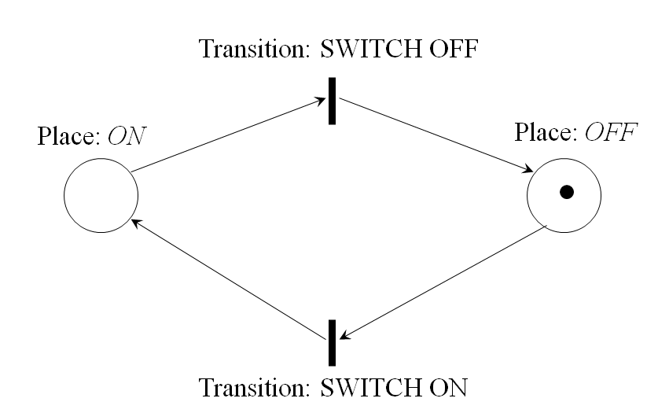
- Two places: Off and On
- Two transitions: Switch Off and Switch On
- Four arcs
- The off condition is true
- A transition can fire if an input token exists
  - One token is moved from the input place to the output place.
PN properties
- 8-tuple mathematical model
  - M={P,T,I,O,H,PAR,PRED,MP}
  - P - the set of places
  - T - the set of transitions
  - I,O,H - Input, output, inhibition function
  - PAR - the set of parameters
  - PRED - Predicates restricting parameter range
  - PM - Parameter value
- From this linear algebra can be used to analyze a network
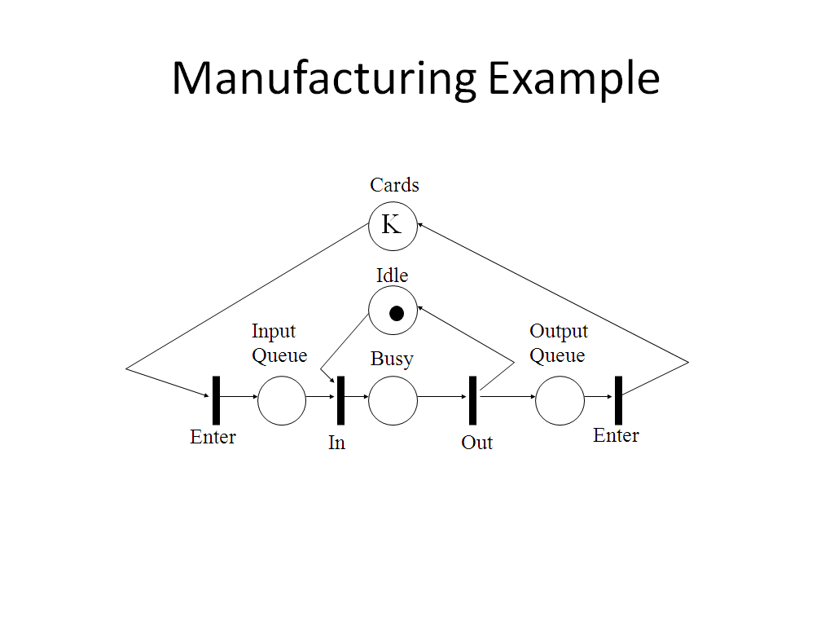
- Very rich modeling
- Easily capable of modeling software project, requirements, architectures, and processes
- Drawbacks
  - Complex rules
  - Analysis quite complex

- What is data dictionary? Explain with an example. (APR/MAY 2011)
- Provides definitions for all elements in the system which include:
  - Meaning of data flows and stores in DFDs
  - Composition of the data flows e.g. customer address breaks down to street number, street name, city and postcode
  - Composition of the data in stores e.g. in Customer store include name, date of birth, address, credit rating etc.
  - Details of the relationships betw+een entities
- Data dictionary Notation
= is composed of
+ and
( ) optional ( may be present or absent)
{ } iteration
[ ] select one of several alternatives
** comment
@ identifier (key field) for store
| separates alternative choices in the [ ] construct

- Data dictionary Examples
name = courtesy-title + first-name + (middle-name) + last-name
courtesy-title = [Mr. | Miss | Mrs. | Ms. | Dr. | Professor]
first-name = {legal-character}
middle-name ={legal-character}
last-name = {legal-character}
legal-character = [A-Z|a-z|0-9|’|-| |]
Current-height =** *units: metres; range: 1.00-2.50*
sex =***values: [M|F]*
As both are elementary data, no composition need be shown, though an explanation of the relevant units/symbols is needed order = customer-name + shipping-address + 1{item}10 means that an order always has a customer name and a shipping address and has between 1 and 10 items
- How does the analysis modeling help to capture unambiguous and consistent requirements? Discuss several methods for requirements validation.(NOV/DEC 2011)
Goals of Analysis Modeling
- Provides the first technical representation of a system
- Is easy to understand and maintain
- Deals with the problem of size by partitioning the system
- Uses graphics whenever possible
- Differentiates between essential information versus implementation information
- Helps in the tracking and evaluation of interfaces
- Provides tools other than narrative text to describe software logic and policy
- Flow-oriented modeling – provides an indication of how data objects are transformed by a set of processing functions
- Scenario-based modeling – represents the system from the user's point of view
- Class-based modeling – defines objects, attributes, and relationships
- Behavioral modeling – depicts the states of the classes and the impact of events on these states
Requirements validation
- Concerned with demonstrating that the requirements define the system that the customer really wants.
- Requirements validation covers a part of analysis in that it is concerned with finding problems with requirements.
- Requirements error costs are high so validation is very important
  - Fixing a requirements error after delivery may cost up to 100 times the cost of fixing an implementation error.
  - In fact, a change to the requirements usually means that the system design and the implementation must also be changed and the testing has to be performed again.
Checks required during the requirements validation process
- Validity checks. Does the system provide the functions which best support the customer’s needs? ( Other functions maybe identified by a further analysis )
- Consistency checks. Are there any requirements conflicts?
- Completeness checks. Are all the requirements needed to define all functions required by the customer sufficiently specified?
- Realism checks. Can the requirements be implemented given available budget, technology and schedule?
- Verifiability. Can the requirements be checked?
Requirements validation techniques
The following techniques can be used individually or in conjunction.
- Requirements reviews
  - Systematic manual analysis of the requirements performed by a team of reviewers
- Prototyping
  - Using an executable model of the system to check requirements.
- Test-case generation
  - Developing tests for requirements to check testability.
  - If the test is difficult to design, usually the related requirements are difficult to implement.

- Draw Use Case and Data Flow diagrams for a “Restaurant System”. The activities of the Restaurant system are listed below.
Receive the Customer food Orders, Produce the customer ordered foods, Serve the customer with their ordered foods, Collect Payment from customers, Store customer payment details, Order Raw Materials for food products, Pay for Raw Materials for food products, Pay for Raw Materials and Pay for Labor.(APR/MAY2015)

Use Case Diagram
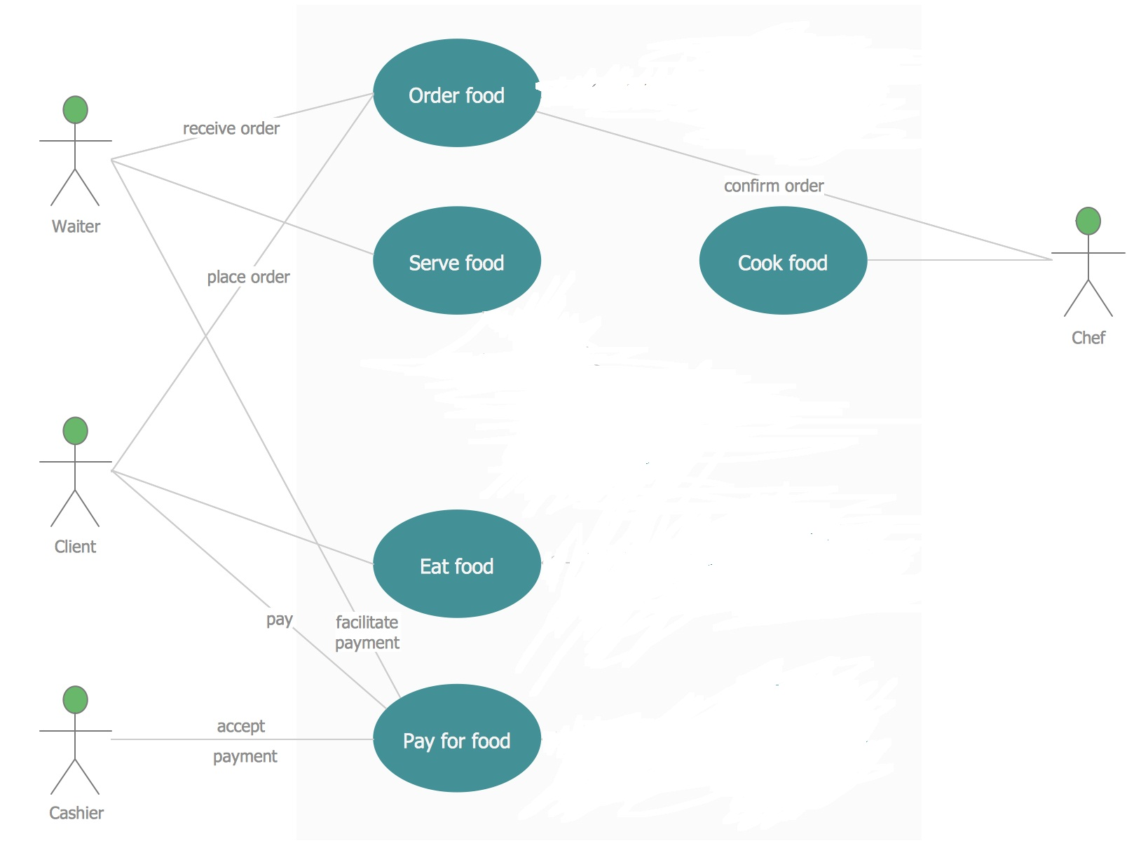
Data Flow Diagram
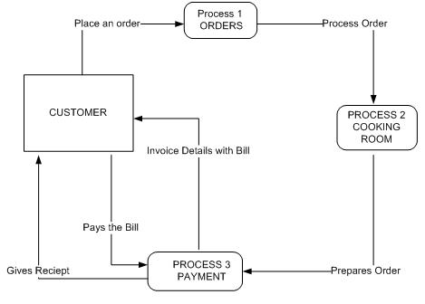

- (i)What are the components of the standard structure for the software requirements document? Explain in detail.
- The requirements document is the official statement of what is required of the system developers.
- Should include both a definition of user requirements and a specification of the system requirements.
- It is NOT a design document. As far as possible, it should set out WHAT the system should do rather than HOW it should do it
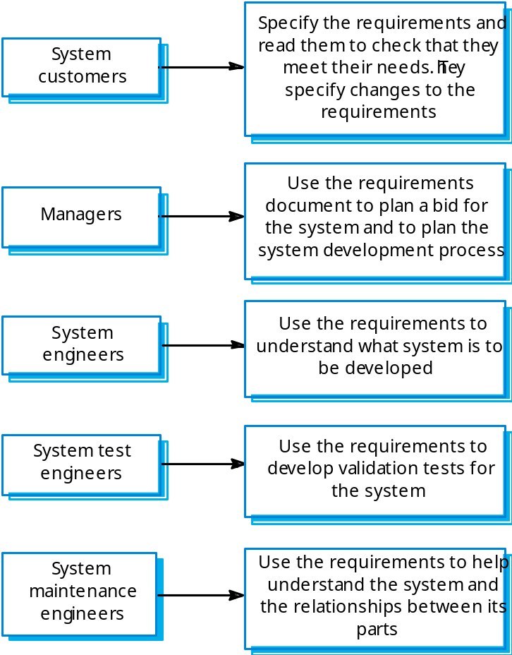
- IEEE Standard
- Defines a generic structure for a requirements document that must be instantiated for each specific system.
  - Introduction.
  - General description.
  - Specific requirements.
  - Appendices.
  - Index.
- Requirement Document Structure
- Preface
- Introduction
- Glossary
- User requirements definition
- System architecture
- System requirements specification
- System models
- System evolution
- Appendices
- Index
(ii)Write the software requirement specification for a system of your choice. (MAY/JUNE 2014)
ONLINE TICKET RESERVATION SYSTEM
PROBLEM STATEMENT:
This project is about online ticket reservation and consists of two modules. The reservation and the cancellation module. The reservation module allows the user to reserve tickets for a particular train on a particular date. If there is a ticket available, the users can know the vacancy details through the enquiry module. The cancellation module allows user to cancel the tickets for a particular date through reservation officer (system). This module performs status reveal before tickets are being reserved and after they get booked. All these modules together prove to be a flexible online reservation system and it provides complete flexibility to end users and it assumes the desired performance.
OVERALL DESCRIPTION:
MODULES:
- Login
- Display train list
- Search for train
- Reservation
- Cancellation
- Train Status
MODULE DELIVERABLES:
1. LOGIN
Basic Flow
This use case starts when the passenger wishes to Login to the Online Ticket Reservation system
- The System requests that the passenger enter his/her name and password
- The passenger enters his/her name and password
- The System validates the entered name and password and logs the passenger into the System
Alternative Flows: Invalid Name/Password
If, in the Basic flow, the passenger enters an invalid name and/or password, the system displays an error message. The passenger chooses to either return to the beginning of the Basic flow or cancel the login, at which point the use case ends.
Pre-Conditions: None
Post-Conditions: If the use case was successful, the passenger is now logged into the system. If not, the system State is unchanged.
2. Display Train List
Basic Flow: This use case gives passenger information about each train namely train no, train name, Stations passes, Arrival Time, Departure Time etc
Alternative Flows: None
Pre-Conditions: None
Post-Conditions: If the use case was successful, the passenger information about each train namely train no, train name, Stations passes, Arrival Time, Departure Time etc
3. Search for Train
Basic flow
The passenger can obtain train information either by entering train no or Source and Destination Station
1. If the passenger train no gives the information about train
2. If the passenger enter Source and Destination Station from list gives information about list of trains passing through station. From the list link will be provided to each train, which contains the information
Alternate flow: If the passenger enters an invalid train no then it gives error message invalid train no and asks the passenger to enter a valid train no.
Pre-Conditions: None
Post-Conditions: If the use case was successful, the passenger can able to view the list of trains.
4.Reservation
Basic flow
1. The user reserves the ticket by giving following
a) Passenger name, Sex, Age, Address
b) Credit Card No, Bank Name
c) Class through passenger is going to travel i.e First class or Second class or AC
d) Train no and Train name, Date of Journey and number of tickets to be booked.
2. If the ticket is available in a train then the ticket will be issued with PNR No.else the ticket will be issued with a waiting list number.
Alternative flow: If the passenger gives an invalid credit card no or specified a bank where does have any account. Error message will be displayed.
Pre-Conditions: The passenger has to decide about the train he is going to travel.
Post-Conditions: If the use case was successful, the passenger will get the ticket.
5. Cancellation
Basic flow
This use case used by passenger to cancel the ticket, which he/she booked earlier by Entering PNR No. The cancellation has been done reallocating the tickets allotted to the Passenger.
Alternate flow: If the Passenger had entered invalid PNR No then has been asked to enter valid PNR No.
Pre-Conditions: The Passenger had reserved tickets in a train.
Post-Conditions: If the use case was successful, the passenger can cancel the ticket.
6. Ticket Status
Basic flow
1. The passenger should give PNR No to know the status of ticket, which he/she booked earlier.
2. If the PNR No is valid, the status of the ticket will be displayed.
Alternate flow: If passenger had entered an invalid no or PNR NO, which does not exists then error Message will be displayed.
Pre-Conditions: The Passenger had reserved tickets in a train.
Post-Conditions: If the use case was successful, the passenger can view status of the ticket.

- Give an account about data models and explain with appropriate diagrams.
Data modeling examines data objects independently of processing, focuses attention on the data domain, creates a model at the customer’s level of abstraction and indicates how data objects relate to one another.
Data objects
Something that is described by a set of attributes and that will be manipulated within the software(system)
- Each instance of an object can be identified uniquely.
- Each plays a necessary role in the system (i.e) the system could not function without access to instance of the object.
- Each is described by attribute that are themselves data items
Typical objects
- External entities
- Things
- Occurrence or events
- Roles
- Organizational units
- Places
- Structures
Data objects and Attributes
- A data objects contains set of attributes that act as an aspect, quality, characteristics or descriptor of the object
Object : Automobiles
Attributes:
Make
Model
Body type
Price
Option code
Relationship
Relationship indicates “connectedness”; a fact that must be remembered by the system and cannot or is not computed or derived mechanically
- Several instance of a relationship can exist
- Objects can be related in many different ways
Person
Car

(a)A basic connection between data objects
Owns
Person
Car

Insured to drive

(b)Relationships between data objects

Cardinality
It specifies how the number of occurrence of one object are related to the number of occurrence of another object (1:1, 1:N, N:M)
Modality
Zero (0) – for optional object relationship
One (1) – for mandatory relationship

- What are the types of behavioral models? Explain with examples.(MAY/JUNE 2013,2014)
- The behavioral model indicates how software will respond to external events
- To create the model, you should perform the following steps:
- Evaluate all use cases to fully understand the sequence of interaction within
the system.
- Identify events that drive the interaction sequence and understand how these
events relate to specific objects.
- Create a sequence for each use case.
- Build a state diagram for the system.
- Review the behavioral model to verify accuracy and consistency.
Identifying Events with the Use Case
A use case is examined for points of information exchange.
- The homeowner uses the keypad to key in a four-digit password.
- The password is compared with the valid password stored in the system.
- If the password is incorrect, the once and reset itself for additional input.
- If the password is control panel will beep correct, the control panel awaits further action.
- Once all events have been identified, they are allocated to the objects involved.
- Objects can be responsible for generating events.
State Representations
- The state of each class as the system performs its function and
- The state of the system as observed from the outside as the system performs its function.
Two different behavioral representations are State diagrams for analysis classes that represent active states for each class and the events (triggers) that cause changes between these active states. The second type of behavioral representation, called a sequence diagram in UML, indicates how events cause transitions from object to object.

UNIT - III
PART - A
1. Define design process.
Design process is a sequence of steps carried through which the requirements are translated into a system or software model.
2. List the architectural models that can be developed. (NOV/DEC2010)
Architectural models that may be developed may include:
- A static structural model shows the sub-system or components that are to be developed as separate units.
- A dynamic process model shows how the system is organized into processes at run-time.
- An interface model defines the services offered by each sub-system through its public interface.
- Relationship model shows relationships, such as data flow between the subsystems.
- A distribution model shows how sub-systems may be distributed across computers
3. What is a pattern?
A pattern is an insight which conveys the essence of a proven solution to a recurring problem within a certain context amidst competing concerns.
4. List four design principles of a good design. (APR/MAY 2011) (NOV/DEC 2013)
The principles of a good design are:
- The design must implement all of the explicit requirements contained in the analysis model.
- It must accommodate all of the implicit requirements desired by the customer.
- The design must be readable, understandable guide for those who generate code and for those who test and subsequently support the software.
- The design should provide a complete picture of the software, addressing the data, functional, and behavioral domains from an implementation perspective.
5. Explain the qualitative criteria for measuring independence. (NOV/DEC 2011)
Independence is assessed using two qualitative criteria:
- Cohesion is an indication of the relative functional strength of a module.
- Coupling is the indication of the relative interdependence among modules.

6. Distinguish fan-in and fan-out. (NOV/DEC 2011)
FAN-OUT | FAN-IN
Fan-out is a measure of the number of modules that are directly controlled by another module. | Fan-in indicates how many modules directly control a given modules.
7. List out design methods. (MAY/JUN 2012)
The design methods can be listed as:

- Data abstraction
- System architecture
- Design patterns
- Modularity
- Information hiding
- Functional independence
- Refinement
- Refactoring
- Design classes

8. What is the work product of software design process and who does this?
A design model that encompasses architectural, interface, component level and their representations is the primary work product that is produced during software design. Software engineers conduct each of the design tasks.
9. Define super-ordinate and subordinate.
The control relationship among modules is expressed in the following way: A module that controls another module is said to be super ordinate to it and conversely, a module controlled by another is said to be subordinate to the controller.
10. Define information hiding and modularity.(NOV/DEC 2014)
The principle of information hiding suggests that modules be “characterized by design decisions that hides from all others”. In other words, modules should be specified and designed so that information contained within a module is inaccessible to other modules.
“Modularity is a single attribute of software that allows a program to be intellectually manageable”. Monolithic software cannot be easily grasped by a software engineer. This leads to “divide and conquer” strategy – it’s easier to solve a complex problem when you break it into manageable pieces which would reduce the effort.
11. What is the use of Architectural design?
The Architectural design defines the relationship between major structural elements of the software, the “design patterns” that can be used and the constraints that affect the way in which architectural design patterns can be applied.
12. Define procedure and data abstraction.
A procedural abstraction is a named sequence of instructions that has a specific and limited function. A data abstraction is named collection of data that describes a data object.
13. Define software architecture and mention its characteristics.
Software architecture alludes to “the overall structure of the software and the ways in which that structure provides conceptual integrity for a system”. Structural properties, Extra functional properties, Families of related systems.
14. What are the three distinct types of activities of software design?
External design, Architectural design and Detailed design.
15. What are the characteristics of External design?
External design of software design involves conceiving, planning out and specifying the external observable characteristics of the software product.
16. Which is referred as internal design? Mention its characteristics.
Architectural and detailed designs are collectively referred to as internal design. Internal design involves conceiving, planning out and specifying the internal structure and processing details of the software product.
17. What are the goals of internal design?
The goals of Internal design are to specify internal design and processing details, to record design decisions, to elaborate the test plan and to provide a blueprint for implementation testing and maintenance activities.
18. What are the work products of internal design?
The products of internal design include a specification of architectural structure, the details of algorithms and data structures and the test plan.

19. What are the fundamental concepts of software design?
Fundamental concepts of software design include abstraction, structure information hiding, modularity, concurrency, and verification and design aesthetics.
20. Define abstraction.
Abstraction is the intellectual tool that allows dealing with concept apart from particular instances of those concepts. During requirements definition and design, abstraction permits separation of the conceptual aspects of a system from the implementation details.
21. What are the principles of Component-level design?
- The Open-Closed Principle(OCP)
- The Liskov-Substitution Principle(LSP)
- Dependency Inversion Principle(DIP)
- The Interface Segregation Principle(ISP)
- The Release Reuse Equivalency Principle(REP)
- The Common Closure Principle(CRP)
22. Define Cohesion and Coupling.
Cohesion implies that the component or class encapsulates only attributes and operations that are closely related to one another and to the class or component itself.
Coupling is a quantitative measure of the degree to which classes are connected to one another. As classes become more interdependent, coupling increases.
23. Draw diagrams to demonstrate architectural styles.(APR/MAY 2015)
Data-Centric Architecture
Client Software
Client Software

Client Software
Data Store (repository or blackboard)
Client Software

Client Software
Client Software

Client Software
Client Software

Data-Flow Architecture
Filter
Filter
Filter
Filter
Filter
Filter
Filter

Pipes
Filter
Filter

Filter

24. What are the steps for interface design?(APR/MAY 2015)
- Using information developed during interface analysis, the interface objects and operations are defined.
- The events that will cause the change in the state of the user interface are defined and modeled.
- Each interface state is depicted as it will actually look to the end-user.
- An indication of how the user interprets the state of the system from information provided through the interface is provided.
25. Define Archetypes.
An archetype is a class or pattern that represents a core abstraction that is critical to the design of the architecture for the target system.
PART - B
- What is system modeling? Explain the process of creating models and the factors that should be considered when building models. (NOV/DEC 2013)
System modelling helps the analyst to understand the functionality of the system and models are used to communicate with customers
- Identify the process necessary to carry out the task you are creating the business process model for.
- Outline the processes necessary in the sequence they need to be performed in order to accomplish the business tasks presented by the process model.
- Discuss and document the business process in which you are creating the process model for.
- Create a flow chart of the steps necessary to achieve the process in which you are creating the model for.
- Begin the process by writing the first step to your task inside of an oval shape.
- Write the next step as an activity performed in the process using a rectangle shape
- Write yes or no questions in diamond shapes for steps that require decisions
- Create more rectangle boxes after your decision diamond in order to show what active tasks are necessary to continue the task's process.
- Finish the flow chart just as you started it, by using an oval shape to signify it's completion.
- Go over your flow chart numerous times with both employees who know the process as well as employees who have never done the process in order to ensure it is complete and successfully accuracy.

- Explain the core activities involved in user interface design process with necessary block diagrams. (NOV/DEC 2010)
User interface (UI) design is an iterative process where users interact with designers and interface prototypes to decide on the features, organization and the look and feel of the system user interface. Sometimes the interface is separately prototyped in parallel with other software engineering activities. When iterative development is used, the user interface design proceeds incrementally as the software is developed. In both cases before programming starts, some paper-based designs must be developed and ideally tested. The overall UI design process is shown in the figure.
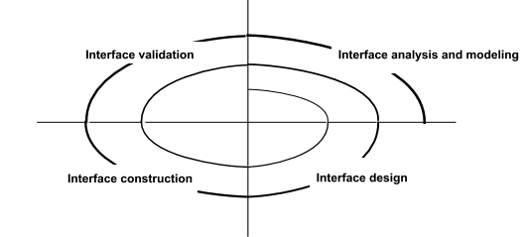
THE USER INTERFACE DESIGN PROCESS
There are three core activities in this process:
User analysis: In the user analysis process, develop an understanding of the tasks that the user does, their working environment, the other systems that they use, how they interact with other people in their work. For products with a diverse range of users, develop this understanding through focus groups, trails with potential users and similar exercises.
System prototyping: User interface design and development is an iterative process. Although users may talk about the facilities they need from an interface, it is very difficult for them to be specific until something tangible is seen. So prototype systems are developed and exposed to the users, which can guide the evolution of the interface.
Interface evaluation: Even though there are discussions with the users during the prototype process, a more formalized evaluation activity is required, where information about users’ actual experience with the interface is collected. The scheduling of the UI design within the software process depends to some extent on other activities. Prototyping may be used as a part of requirements engineering process and also to start the UI design process at this stage. In iterative processes UI design is integrated with the software development. Like the software itself the UI design may have to be refactored and redesigned during development.
User analysis: A critical user interface design activity is the analysis of the user activities that are to be supported by the computer system. To develop these understanding, task analysis, ethnographic studies, user interviews and observations or a mixture of all methods can be used.
The challenge for engineers involved in user analysis is to find a way to describe user analyses so that they communicate the essence of the tasks to other designers and to the users themselves. UML sequence charts can be used but they can be too technical for the users, so a natural language scenario to represent user activities must be developed.
Cannot expect users’ analysis to generate very specific user interface requirements. The analysis helps to understand the needs and concerns of the system users. As more information is obtained how they work, their concerns and their constraints it can be taken into account of the design.
User interface prototyping:
Because of the dynamic nature of user interfaces, textual description and diagrams are not good enough for expressing user interface requirements. Evolutionary or exploratory prototyping with end-user involvement is the only practical way to design and develop graphical user interfaces for software systems. The aim of prototyping is to gain direct experience with the interface. It is difficult to think abstractly about a user interface to explain exactly what is required. But when presented with examples it is easy to identify the characteristics that are liked and disliked.
When prototyping a user interface, a two-stage prototyping process is adopted:
- Very early in the process, develop paper prototypes-mock ups of screen designs-and
walk through these with end-users.
- Then refine the design and develop increasingly sophisticated automated prototypes,
- then make them available to users for testing and activity simulation.
There are three approaches that can be used for user interface prototyping:
- Script-driven approach
- Visual programming languages
- Internet-based prototyping
Interface evaluation:
Interface evaluation is the process of assessing the usability of an interface and checking that
it meets user requirements. It should be part of the normal verification and validation process
for software systems.
- (i) Discuss the design heuristics for effective modularity design.
- Coupling describes the interconnection among modules
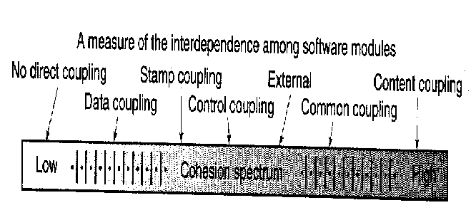

- Data coupling
  - Occurs when one module passes local data values to another as parameters
- Stamp coupling
  - Occurs when part of a data structure is passed to another module as a parameter
- Control Coupling
  - Occurs when control parameters are passed between modules
- Common Coupling
  - Occurs when multiple modules access common data areas such as Fortran Common or C extern
- Content Coupling
  - Occurs when a module data in another module
- Subclass Coupling
  - The coupling that a class has with its parent class
DESIGN HEURISTICS
- Evaluate 1st iteration to reduce coupling & improve cohesion
- Minimize structures with high fan-out; strive for depth
- Keep scope of effect of a module within scope of control of that module
- Evaluate interfaces to reduce complexity and improve consistency
- Define modules with predictable function & avoid being overly restrictive
- Avoid static memory between calls where possible
- Strive for controlled entry -- no jumps into the middle of things
- Package software based on design constraints and portability requirements
(ii)Explain the architectural styles used in the architectural design. (MAY/JUNE 2013, 2014)
ARCHITECTURAL DESIGN
- Establishing the overall structure of a software system
- Objectives
  - To introduce architectural design and to discuss its importance
  - To explain why multiple models are required to document a software architecture
  - To describe types of architectural model that may be used
- Architectural (high-level) design = the process of establishing the subsystems of a larger software system and defining a framework for subsystem control and communication
- Software architecture = the output of the high-level design process
- Defining and documenting the software architecture provides support for:
  - Stakeholder communication
  - System analysis
  - Large-scale software reuse
- The software architecture of a program or computing system is the structure or structures of the system, which comprise software components
- architecture is not the operational software
- Enables a software engineer
- Analyze the effectiveness of the design in meeting its stated requirements
- Consider architectural alternatives at a stage when making design changes is still relatively easy
- Reducing the risks associated with the construction of the software.
- Representations of software architecture are an enabler for communication between all parties
- The architecture highlights early design decisions that will have a profound impact on all software engineering work
- Architecture “constitutes a relatively small, intellectually graspable model of how the system is structured
Architectural Styles
- Each style describes a system category that encompasses:
  - a set of components (e.g., a database, computational modules) that perform a function required by a system,
  - a set of connectors that enable “communication, coordination, and cooperation” among components,
  - constraints that define how components can be integrated to form the system, and
  - semantic models that enable a designer to understand the overall properties of a system.
Specific Styles
- Data-centered architecture
- Data flow architecture
- Call and return architecture
- Object-oriented architecture
- Layered architecture
- Discuss class-based components along with its principles in detail. For a Case study of your choice show the architectural and Component design. (APR/MAY 2015)
Identifying Analysis Classes
- External entities that produce or consume information
- Things that are part of the information domain
- Occurrences or events
- Roles played by people who interact with the system
- Organizational units
- Places that establish context
- Structures that define a class of objects
Class Selection Criteria
- Retained information
- Needed services
- Multiple attributes
- Common attributes
- Common operations
- Essential requirement
Identifying Classes
Potential class | Classification | Accept / Reject
homeowner | role; external entity | reject: 1, 2 fail
sensor | external entity | accept
control panel | external entity | accept
installation | occurrence | reject
(security) system | thing | accept
number, type | not objects, attributes | reject: 3 fails
master password | thing | reject: 3 fails
telephone number | thing | reject: 3 fails
sensor event | occurrence | accept
audible alarm | external entity | accept: 1 fails
monitoring service | organizational unit; ee | reject: 1, 2 fail

Class Diagram
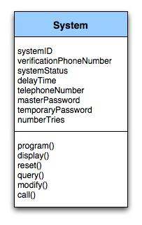
Class diagram for the system class
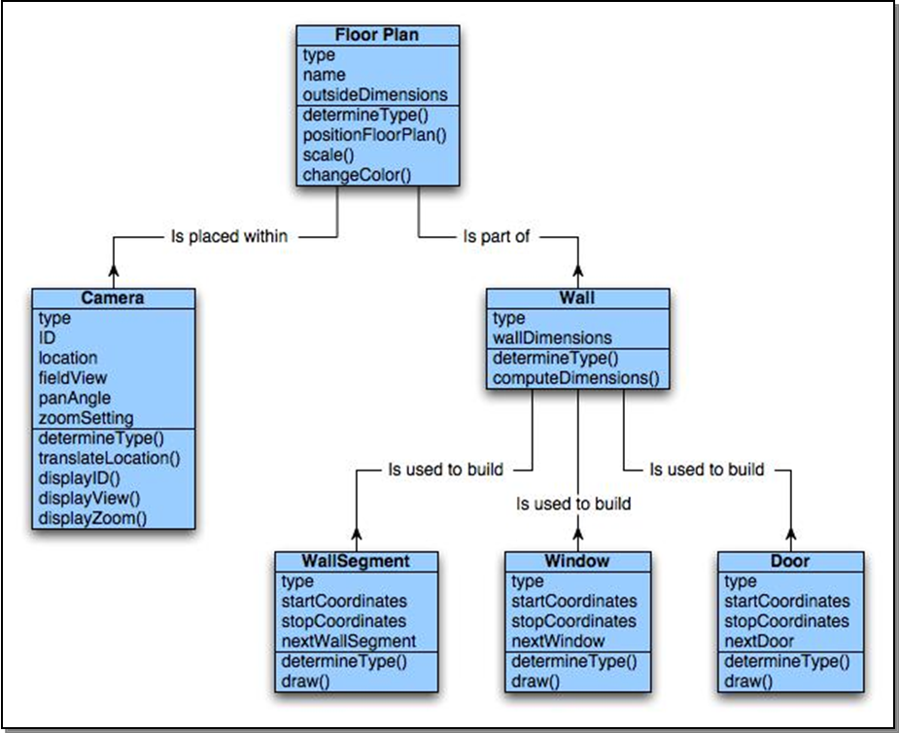

Class Responsibilities
- Distribute system intelligence across classes.
- State each responsibility as generally as possible.
- Put information and the behavior related to it in the same class.
- Localize information about one thing rather than distributing it across multiple classes.
- Share responsibilities among related classes, when appropriate.
Class Collaborations
- Relationships between classes:
- is-part-of — used when classes are part of an aggregate class.
- has-knowledge-of — used when one class must acquire information from another class.
- depends-on — used in all other cases.
- Explain the interface analysis and discuss the goals of task analysis involved in detail.
- Interface analysis means understanding
(1) the people (end-users) who will interact with the system through the interface;
(2) the tasks that end-users must perform to do their work,
(3) the content that is presented as part of the interface
(4) the environment in which these tasks will be conducted.
- Are users trained professionals, technician, clerical, or manufacturing workers?
- What level of formal education does the average user have?
- Are the users capable of learning from written materials or have they expressed a desire for classroom training?
- Are users expert typists or keyboard phobic?
- What is the age range of the user community?
- Will the users be represented predominately by one gender?
- How are users compensated for the work they perform?
- Do users work normal office hours or do they work until the job is done?
- Is the software to be an integral part of the work users do or will it be used only occasionally?
- What is the primary spoken language among users?
- What are the consequences if a user makes a mistake using the system?
- Are users experts in the subject matter that is addressed by the system?
- Do users want to know about the technology the sits behind the interface?
Task Analysis and Modeling
- Task Analysis answers the following questions …
  - What work will the user perform in specific circumstances?
  - What tasks and subtasks will be performed as the user does the work?
  - What specific problem domain objects will the user manipulate as work is performed?
  - What is the sequence of work tasks—the workflow?
  - What is the hierarchy of tasks?
- Use-cases define basic interaction
- Task elaboration refines interactive tasks
- Object elaboration identifies interface objects (classes)
- Workflow analysis defines how a work process is completed when several people (and roles) are involved

- What are the issues that have to be constrained in the design process? Explain the design evaluation in detail.
Design Issues
- Response time: System response time has 2 important characteristics: length and variability. Variability refers to the deviation from average response time.
- Help facilities: Help must be available for all system functions. Include help menus, print documents.
- Error handling: describe the problem in a language the user can understand. Never blame the user for the error that occurred.
- Menu and command labeling: menu options should have corresponding commands. Use control sequences for commands.
- Application accessibility: especially for the physically challenged.
- Internationalization: The Unicode standard has been developed to address the daunting challenge of managing dozens of natural languages with hundred of characters and symbols.
Design Evaluation Cycle
Two interface design evaluation techniques are mentioned in this section, usability questionnaires and usability testing. The process of learning how to design good user interfaces often begins with learning to identify the weaknesses in existing products.

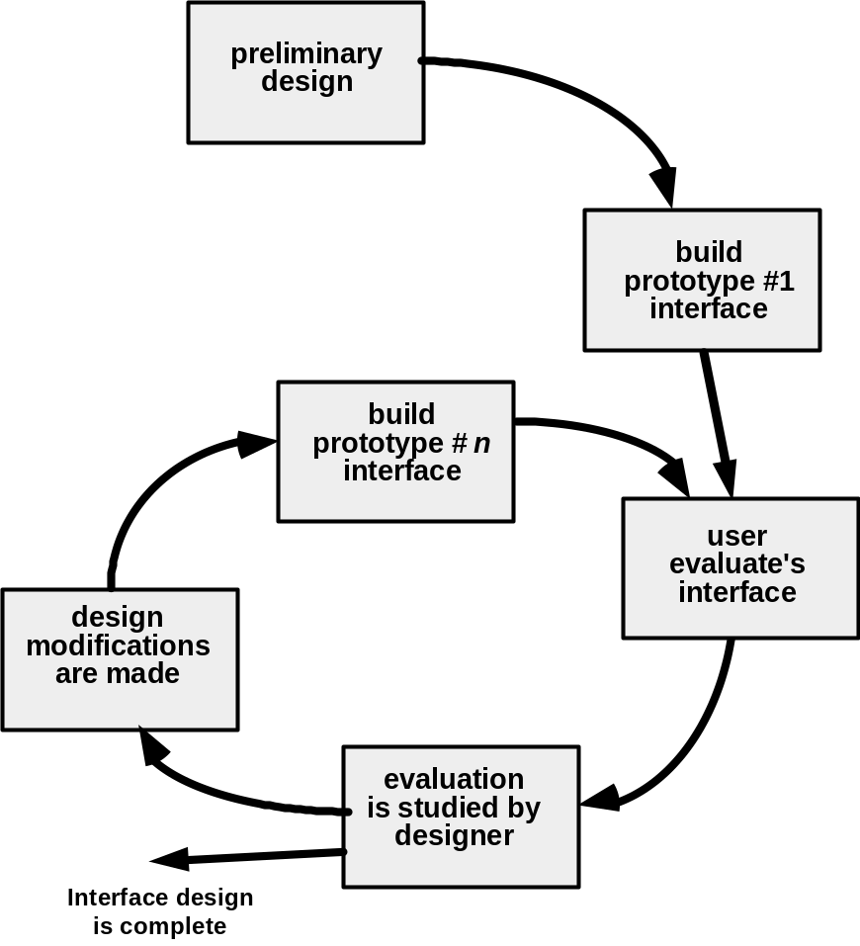
Once the first prototype is built, the designer can collect a variety of qualitative and quantitative data that will assess in evaluating the interface. Questions can be a simple Y/N response, numeric response, scaled response, Likert scale (strongly agree, etc.), percentage response, and open-ended ones.
- Discuss about software architecture design, which emphasize on fan in, fan out, coupling, cohesion and factoring? (NOV/DEC 2011) (NOV/DEC 2012)(APR/MAY 2015)
In the AD phase, the software requirements are transformed into definitions of software components and their interfaces, to establish the framework of the software. This is done by examining the SRD and building a 'physical model' using recognized software engineering methods. The physical model should describe the solution in concrete, implementation terms. Just as the logical model produced in the SR phase structures the problem and makes it manageable, the physical model does the same for
the solution.

The physical model is used to produce a structured set of component specifications that are consistent, coherent and complete. Each specification defines the functions, inputs and outputs of the component
The major software components are documented in the Architectural Design Document (ADD). The ADD gives the developer's solution to the problem stated in the SRD. The ADD must cover all the
requirements stated in the SRD (AD20), but avoid the detailed consideration of software requirements that do not affect the structure.

The main outputs of the AD phase are the:
- Architectural Design Document (ADD);
- Software Project Management Plan for the DD phase (SPMP/DD);
- Software Configuration Management Plan for the DD phase(SCMP/DD);
- Software Verification and Validation Plan for the DD Phase (SVVP/DD);
- Software Quality Assurance Plan for the DD phase (SQAP/DD);
- Integration Test Plan (SVVP/IT).
Figure 2.1 summarizes activities and document flow in the AD phase. The following subsections describe the activities of the AD phase in more detail.

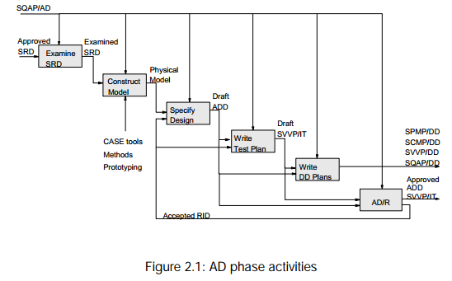
Design quality
Designs should be adaptable, efficient and understandable. Adaptable designs are easy to modify and maintain. Efficient designs make minimal use of available resources. Designs must be understandable if they are to be built, operated and maintained effectively.
Attaining these goals is assisted by aiming for simplicity. Metrics should be used for measuring simplicity/complexity (e.g. number of interfaces per component and cyclomatic complexity).
Simple components are made by maximizing the degree to which the activities internal to the component are related to one another (i.e. 'cohesion').
Simple structures can be made by:
- minimizing the number of distinct items that are passed between components (i.e. 'coupling');
- ensuring that the function a component performs is appropriate to its place in the hierarchy (i.e. 'system shape');
- ensuring the structure of the software follows the structure of the data it deals with (i.e. 'data structure match');
- designing components so that their use by other components can be maximised (i.e. 'fan-in');
- restricting the number of child components to seven or less (i.e. 'fanout');
- removing duplication between components by making new components (i.e. 'factoring').
Designs should be 'modular', with minimal coupling between components and maximum cohesion within each component. Modular designs are more understandable, reusable and maintainable than designs consisting of components with complicated interfaces and poorly matched groupings of functions. Each level of a design should include only the essential aspects and omit inessential detail. This means they should have the appropriate degree of 'abstraction'. This enhances understandability, adaptability and maintainability.

Design metrics
- Cohesion
The parts of a component should all relate to a single purpose.
Cohesion measures the degree to which activities within a component are related to one another. The cohesion of each component should be maximized. High cohesion leads to robust, adaptable, maintainable software.

Cohesion should be evaluated externally (does the name signify a specific purpose?) and internally (does it contain unrelated pieces of logic?).

Types of cohesion:
- functional cohesion;
- sequential cohesion;
- communicational cohesion;
- procedural cohesion;
- temporal cohesion;
- logical cohesion;
- coincidental cohesion.
Functional cohesion is most desirable and coincidental cohesion should definitely be avoided. The other types of cohesion are acceptable under certain conditions. The seven types are discussed below with reference to typical components that might be found in a statistics package.

Functionally cohesive components contain elements that all contribute to the execution of one and only one problem-related task. Names carry a clear idea of purpose (e.g. CALCULATE_MEAN). Functionally cohesive components should be easy to reuse. All the components at the
bottom of a structure should be functionally cohesive.
Sequentially cohesive components contain chains of activities, with the output of an activity being the input to the next. Names consist of specific verbs and composite objects (e.g. CALCULATE_TOTAL_AND_MEAN). Sequentially cohesive components should be split into functionally cohesive components.

Communicationally cohesive components contain activities that share the same input data. Names have over-general verbs but specific objects (e.g. ANALYSE_CENSUS_DATA), showing that the object is used for a range of activities. Communicationally cohesive components should be split into functionally cohesive components.

Procedurally cohesive components contain chains of activities, with control passing from one activity to the next. Individual activities are only related to the overall goal rather than to one another. Names of procedurally cohesive components are often 'high level', because they convey an idea of
their possible activities, rather than their actual activities (e.g. PROCESS_CENSUS_DATA). Procedurally cohesive components are acceptable at the highest levels of the structure.
Temporally cohesive components contain activities that all take place simultaneously. The names define a stage in the processing (e.g. INITIALISE, TERMINATE). Bundling unrelated activities together on a temporal basis is bad practice because it reduces modularity. An initialisation component may have to be related to other components by a global data area, for example, and this increases coupling and reduces the possibilities for reuse. Temporal cohesion should be avoided.
Logically cohesive components perform a range of similar activities. Much of the processing is shared, but special effects are controlled by means of flags or 'control couples'. The names of logically cohesive components can be quite general, but the results can be quite specialized (e.g. PROCESS_STATISTICS). Logical cohesion causes general sounding names to appear at the bottom levels of the structure, and this can make design less understandable. Logical cohesion should be avoided, but this may require significant restructuring. Coincidentally cohesive components contain wholly unrelated activities. Names give no idea of the purpose of the component (e.g. MISCELLANEOUS_ROUTINE). Coincidentally cohesive components are often invented at the end of the design process to contain miscellaneous activities that do not neatly fit with any others. Coincidental cohesion severely reduces understandability and maintainability, and should be avoided, even if the penalty is substantial redesign.
Practical methods for increasing cohesion are to:
    - make sure that each component has a single clearly defined function;
    - make sure that every part of the component contributes to that function;
    - keep the internal processing short and simple.

- coupling
A 'couple' is an item of information passed between two components. The 'coupling' between two components can be measured by the number of couples passed. The number of couples flowing into and out of a component should be minimized.

The term 'coupling' is also frequently used to describe the relative independence of a component. 'Tightly' coupled components have a high level of interdependence and 'loosely' coupled components have a low level of interdependence. Dependencies between components should be minimized to maximize reusability and maintainability.

five types of coupling:
  - data coupling;
  - stamp coupling;
  - control coupling;
  - common coupling;
  - content coupling.

Data coupling is most desirable and content coupling should be avoided. The other types of coupling are all acceptable under certain conditions, which are discussed below. Data coupling is passing only the data needed. The couple name is a noun or noun phrase. The couple name can be the object in the
component name. For example a component called 'CALCULATE_MEAN' might have an output data couple called 'MEAN'.

Stamp coupling is passing more data than is needed. The couple name is a noun or noun phrase. Stamp coupling should be avoided. Components should only be given the data that is relevant to their task. An example of stamp coupling is to pass a data structure called 'CENSUS_DATA' to a component that only requires the ages of the people in the census to calculate the average age.

Control coupling is communication by flags. The couple name may contain a verb. It is bad practice to use control coupling for the primary control flow; this should be implied by the component hierarchy. It is acceptable to use control coupling for secondary control flows such as in error handling.
Common coupling is communication by means of global data, and causes data to be less secure because faults in components that have access to the data area may corrupt it. Common coupling should normally be avoided, although it is sometimes necessary to provide access to data by components that do not have a direct call connection (e.g. if A calls B calls C, and A has to pass data to C).
Content coupling is communication by changing the instructions and internal data in another component. Communication coupling is bad because it prevents information hiding. Only older languages and assembler allow this type of coupling.

Practical methods of reducing coupling are to:
- structure the data;
- avoid using flags or semaphores for primary control flow and use messages or component calls;
- avoid passing data through components that do not use it;
- provide access to global or shared data by dedicated components.
- make sure that each component has a single entry point and exit point.

Fan-in
The number of components that call a component measures its 'fan-in'. Reusability increases as fan-in increases. Simple fan-in rules are: 'maximize fan-in' and 'reuse components as often as possible'.
Fan-out
The number of components that a component calls measures its 'fan-out'. Fan-out should usually be small, not more than seven. However some kinds of constructs force much higher fan-out values (e.g. case statements) and this is often acceptable. Simple fan-out rules are: 'make the average fan-out seven or less' or 'make components depend on as few others as possible'.

- Explain the various modular decomposition and control styles commonly used in any organizational model. (NOV/DEC 2010)
After a structural architecture has been designed , the next stage of the architectural designprocess is the decomposition of sub-systems into modules.
Two models are used when decomposing a sub-system into modules:
An object-oriented model
The system is decomposed into a set of communicating objects. Modules are objects withprivate state and defined operations on that state. In the data-flow model, modules arefunctional transformations.
Object Models
The system is divided into a set of loosely coupled objects with well defined interfaces.Objects call on the services provided by other objects. The system can issue invoices to customers, receive payments, issue receipts for thesepayments and remainders for unpaid invoices. Operations are represented as rounded rectangle representing the object. Dashed arrow indicates that an object uses the attributes orservices provided by other object.
This decomposition is concerned with object classes, their attribute and operations. When implemented, objects are created from these classes and some control model is used tocoordinate object operations.
Advantages
- Since objects are loosely coupled, the implementation of objects can be modified without affecting other objects.
- Objects are often represented of real –world entities so the structure of the system is readily understandable.
- Objects can be reused.
- Object-oriented programming languages have been developed which provide direct implementations of architectural components.
Disadvantages
- To use services, objects must explicitly reference the name and the interface of other objects.
- More complex entities are sometimes difficult to represent as objects.
Data-flow models
In a data-flow model, functional transformations process their inputs and produce output Data flows from one to another and is transformed as it moves through the sequence. Eacprocessing step is implemented as a transform. The transformations may execute sequentiallor in parallel. The data can be processed by each transform item by item or in a single batch. When the transformations are represented as separate processes, this model is sometimecalled the pipe and filter model.
Advantages
- It supports the reuse of transformations.
- It is intuitive in that many people think of their work in terms of input and output processing.
- Evolving the system by adding new transformations is usually straightforward.
- It is simple to implement either as a concurrent or a sequential system.
Disadvantage
- Need for a common format for data transfer which can be recognized by all transformations.
- Interactive systems are difficult to write using the data-flow model because of the need for a stream of data to be processed.
- Explain the basic concepts of software design. (APR/MAY 2011)(NOV/DEC 2014)
A set of fundamental software design concepts has evolved over the history of software
engineering. M. A. Jackson once said: “The beginning of wisdom for a [software engineer] is to recognize the difference between getting a program to work, and getting it right.”
Abstraction
When we consider a modular solution to any problem, many levels of abstraction can be posed. At the highest level of abstraction, a solution is stated in broad terms using the language of the problem environment. At the lower levels of abstraction, a more detailed description of the solution is provided.
A procedural abstraction refers to a sequence of instructions that have a specific and limited function. And on this abstraction details are suppressed. An example of a procedural abstraction would be the word open for a door. Open implies a long sequence of procedural steps (e.g., walk to the door, reach out and grasp knob, turn knob and pull door, step away from moving door, etc.).
A data abstraction is a named collection of data that describes a data object. In the context of the procedural abstraction open, we define a data abstraction called door. Like any data object, the data abstraction for door would encompass the a set of attributes that describe the door (e.g., door type, swing direction, opening mechanism, weight, dimensions). It follows that the procedural abstraction open would make use of information contained in the attributes of the data abstraction door.
Architecture
Software architecture alludes to “the overall structure of the software and the ways in which that structure provides conceptual integrity for a system”. Architecture is the structure or organization of program components (modules), the manner in which these components interact , and the structure of data that are used by the components. A set of architectural patterns enable a software engineer to reuse design-level concepts.
The architectural design can be represented using one or more of a number of different models. Structural models represent architecture as an organized collection of programs of program components. Framework models increase the level of design abstraction by attempting to identify repeatable architectural design frameworks that are encountered in similar types of application. Dynamic models address the behaviour aspects of the program architecture , indicating how the structure or system configuration may change as a function of external events. Process models focus on the design of the business or technical process that the system must accommodate. Finally, functional models can be used to represent the functional hierarchy of a system.
Patterns
“A pattern is a named nugget of insight which conveys the essence of a proven solution to a
recurring problem within a certain context amidst competing concerns”.
The intent of each design pattern is to provide a description that enables a designer to determine
- whether the pattern is applicable to the current work,
- whether the pattern can be reused, and
- whether the pattern can serve as a guide for developing a similar, but functionality or structurally different pattern.
Modularity
Software architecture and design patterns embody modularity. “ Modularity is a single attribute of software that allows a program to be intellectually manageable”. Monolithic software cannot be easily grasped by a software engineer. Consider two problems, p1 and p2. If the perceived complexity of p1 is greater than the perceived complexity of p2, it follows that the effort required to solve p1 is greater than the effort required to solve p2. As a general case, this result is intuitively obvious. It takes more time to solve a difficult problem. It also follows that the perceived complexity of two problems when they are combined is often greater than the sum of the perceived complexity when each is taken separately. This leads to “divide and conquer” strategy – it’s easier to solve a complex problem when you break it into manageable pieces. This has important implications with regard to modularity
and software. If we subdivide software indefinitely, the effort required to develop it will become negligibly small.
Information hiding
The principle of information hiding suggest that modules be “characterized by design decisions that hides from all others.” Modules should be specified and designed so that information contained within a module is inaccessible to other modules that have no need for such information.
Functional Independence
The concept of functional independence is a direct outgrowth of modularity and the concepts of abstraction and information hiding. It is achieved by developing modules with “single minded” function and an “aversion” to exercise interaction with other modules. Independence is assessed using two qualitative criteria: cohesion and coupling. Cohesion is an indication of the relative functional strength of a module. Coupling is a indication of the relative interdependence among modules.
Refinement
Stepwise refinement is a top-down design strategy. A program is developed successively refining levels of procedure detail. A hierarchy is developed by decomposing a macroscopic statement of function in a stepwise fashion until programming language statements are reached. Refinement is actually a process of elaboration. Abstraction and refinement are complementary concepts.
Refactoring
It is the process of a changing a software system in such a way that it does not alter the external behaviour of the code yet proves its internal structure. When software is refactored, then the existing design is examined for redundancy, unused design elements, inefficient or unnecessary algorithms, poorly constructed or inappropriate data structures, or any other design failure that can be corrected to yield a better design.
Design Classes
As the design model evolves, the software team must define a set of design classes that
- refine the analysis classes by providing design detail that will enable the classes to be implemented, and
- create a new set of design classes that implement a software infrastructure to support the business solution.
Five different types of design classes are created by the designer. They are
- User interface classes
- Business domain classes
- Process classes
- Persistent classes
- System classes
Design classes can be reviewed to ensure that it is “well-formed”. So four characteristics of a well-formed design classes are
- Complete and sufficient
- Primitiveness
- High cohesion
- Low Coupling
- Discuss the process of translating the analysis model into a software design. (APR/MAY 2011)
It provides the software designer with a representation of information, function, and behaviour that can be translated to architectural, interface, and component-level designs. Finally, the analysis model and the requirements specification provide the developer and the customer with the means to assess quality once software is built.
Overall objectives and Philosophy
It has three primary objectives.
- To describe what the customer requires.
- To establish a basis for the creation of a software design and
- To define a set of requirements that can be validated once the software is built.
Analysis Rule of Thumb
- The model should focus on requirements that are visible within the problem or business domain.
- Each element of the analysis model should add to an overall understanding of the software requirements and provide insight into the information design, function, and behaviour of the system.
- Delay consideration of infrastructure and other non-functional modules until design.
- Minimize coupling throughout the system.
- Be certain that the analysis model provides value to all stakeholders.
- Keep the model as simple as possible.

Domain Analysis
It is the identification, analysis, and specification of common requirements from a specific application domain, typically for reuse on multiple projects within the application domain. The “specific application domain” can range from avionics to banking, from multimedis video games to software embedded within the medical devices.

Analysis Modeling Approaches
One view of analysis modelling, called structured analysis, considers data and the processes that transform the data as separate entities. Data objects are modeled in a way that defines their attributes and relationships.
A second approach to analysis modelling, called object-oriented analysis, focuses on definition of classes and the manner in which they collaborate with one another to effect customer requirements.

Data Modeling Concepts
Analysis modelling begins with data modeling.

- Data Object
A data object is a representation of almost any composite information that must be understood by software. A data object can be an external entity. A data object encapsulates data only. e.g., Car
- Data Attribute
Data Attribute define the properties of a data object. They can be used to
- Name an instance of the data object
- Describe the instance, or
- Make reference to another instance in another table.
- Relationships
Data objects are connected to one another in different ways. Consider the two data objects, person and car. A connection is established between person and car because two objects are related.
For example,
- A person owns a car.
- A person is insured to drive a car.
- The relationship owns and insured to drive define the relevant connections between person and car.

- Cardinality and Modality
Cardinality is the specification of the number of occurrences of one object that can be related to the number of occurrences of another object. It also defines “ the maximum number of object that can participate in a relationship”. The modality of a relationship is 0 if there is no explicit need for the
relationship to occur or the relationship is optional. The modality is 1 if an occurrence of the relationship is mandatory.
- Object Oriented Analysis
To accomplish this, a number of tasks must occur:
- Basic user requirements must be communicated between the customer and the software engineer.
- Classes must be identified.
- Class hierarchy is defined.
- Object to object relationship should be represented.
- Object behaviour must be modelled.
- Above tasks are reapplied iteratively until the model is complete.
- Scenario based Modeling
- Writing usecases
The concept of a use case is relatively easy to understand and to describe a specific usage scenario in straight forward language from the point of view of a defined actor.
  - What to write about
  - How much to write about it
  - How detailed to make a description
  - How to organise the description
- Flow Oriented Modeling
A few simple guidelines can aid immeasurably during derivation of a data flow diagram. The level0 data flow diagram should depict the software as a single bubble .Primary input and output should be carefully noted.
- Refinement should begin by isolating candidate process, data objects and data stores to be represented.
- All arrows and bubbles should be labelled with meaningful names
- Information flow continuity must be maintained from level to level
- One bubble at a time should be refined.
- Class based modeling
Identifying analysis classes:
Analysis classes manifest themselves in one of the following ways
- External entities
- Things
- Occurences or events
- Roles
- Organizational event
- Places
- Structures
Behavioral Model
The behavioural model indicates how software will respond to external events or stimuli. To
create a model, the analyst must perform the following steps:
- Evaluate all use-cases to fully understand the sequence of interaction within the system.
- Identify events that derive the interaction sequence and understand how these events relate to specific classes.
- Create a sequence for each use-case.
- Build a state diagram for the system.
- Review the behaviour model to verify accuracy and consistency.
UNIT- IV
PART - A
1. Distinguish between stress and load testing. (MAY/JUN 2012)
Stress testing executes a system in a manner that demands resources in abnormal quality, frequency or volume. Load testing is a testing in which real world loading is tested at a variety of load levels and in a variety of combinations.
2. What is boundary condition testing? (MAY/JUN 2012)
A greater number of errors occurs at the boundaries of the input domain rather than in “center”. It is a test case design that complements equivalence partitioning.
3. Define black box testing. (MAY/JUN 2012)
Black-box testing is also called behavioral testing which focuses on the functional requirements of the software. This testing enables the software engineer to derive sets of input conditions that will fully exercise all functional requirements for a program.
4. What is the purpose of regression testing?(NOV/DEC 2011)
Regression testing is the re-execution of some subset of tests that have already been conducted to ensure that changes have not propagated unintended side effects. The regression testing suite contains the following different test cases
- A representative sample of tests that will exercise all software functions
- Additional tests that focus on software functions that are likely to be affected by the change.
- Tests that focus on the software components that have been changed.
5. What is integration testing? (APR/MAY 2011) Integration testing is a systematic technique for constructing the software architecture while at the same time conducting tests to uncover errors associated with interfacing. The objective is to take unit tested components and build a program structure that has been dictated by design.
6. What is regression testing? (APR/MAY 2011) (NOV/DEC2013)(APR/MAY 2015)
Regression testing is the re-execution of some subset of tests that have already been conducted to ensure that changes have not propagated unintended side effects.
7. Define error, fault and failure. (NOV/DEC2010)
- Error: A discrepancy between a computed, observed value and the true, specified correct value or condition.
- Failure: The inability of a system or component to perform its requirements functions within specified requirements.
- Fault: An incorrect step, process or definition in a computer program which causes the program in an unintended or unanticipated manner.
8. What are the characteristics of a good tester? (NOV/DEC2010)
The characteristics of a good tester are
- A software team should conduct effective formal technical reviews. Many errors may be eliminated before testing commences.
- Testing should begin at component level and work outward toward the integration of the entire computer based system.
- Different testing techniques are appropriate at different points in time.
- Testing is conducted by the developer of the software and for large projects an independent test group.
- Testing and debugging must be accommodated in any test strategy.
9. What are the levels at which testing is done? (NOV/DEC2013)

- Functional testing
- Non-Functional testing

10. Give the two major groupings of software testing?
- Black Box Testing: This approach focuses on inputs, outputs, and principle function of software module.
- Glass Box Testing: This approach looks into the structure of code for a software module.
11. What are the main steps followed in the testing scheme?
Select what is to be measured by the test, Decide how whatever is being is to be tested, develop the test cases, Determine what the expected results of the test, Execute the test cases, Compare the results
12. Give the major types of software testing?
Functional tests, Performance tests, Stress tests, Testing in the small , Testing in the large, Black box testing and White (glass) box testing
13. What are the objectives of testing?
- Testing is a process of executing a program with the intend of finding an error.
- A good test case is one that has high probability of finding an undiscovered error.
- A successful test is one that uncovers as an-yet undiscovered error.
14. What are the various testing activities?

- Test planning
- Test case design
- Test execution
- Data collection
- Effective evaluation

15. What is the purpose of stress tests?
Stress tests are designed to overload a system in ways. Examples of stress tests include attempting to sign or more than the maximum number of allowed terminals, processing more than the allowed number of identifies or static levels or disconnecting a communication links.
16. What are the contents of maintenance guide?
A maintenance guide provides a technical description of the operational capabilities of the entire system and hierarchy diagrams, call graphs and cross reference directories for the system.
17. Give some examples of functional boundary tests.
Examples of functional boundary tests include testing real-valued square root routines with small positive numbers, zero and negative numbers or testing matrix inversion routine on a one-by-one matrix and a singular matrix.
18. What are Validation and Conditional testing?(NOV/DEC 2014)
Validation testing is the process to demonstrate that the product fulfills its intended use when deployed on appropriate environment.
Conditional testing is a test case design method that exercise the logical conditions contained in a program module.
19. What is data flow testing?
The data flow testing method selects test paths of a program according to the locations of definitions and uses of variables in the program.
20. What is system testing?
Software and hardware are integrated and a full range of system tests are conducted in an attempt to uncover errors at the software and hardware interfaces. Most real system process interrupts. Therefore testing the handling of these Boolean events is essential.
21. What is the overall strategy for the software testing?
A Strategy for software testing may also be viewed in the context of the spiral. Unit test begins at the vertex of the spiral and concentrates on each unit of the software as implemented in the source code. Testing progresses by moving outward along the spiral to integration testing, where the focus is on design and the construction of the software architecture.
22. What are the errors commonly found during Unit testing?
Misunderstood or incorrect arithmetic precedence, Mixed mode operation. Incorrect initialization, Precision inaccuracy, Incorrect symbolic representation of an expression

23. What is security testing?
Security testing attempts to verify that protection mechanisms built into a system will in fact protect it from improper penetration. The system security is to of course be tested for invulnerability from frontal attack but must also be tested for invulnerability from flank or rear attack.
24. What is “Smoke Testing”?
Smoke testing is an integration testing approach that is commonly used when “shrink wrapped” software products are being developed. It is designed as a pacing mechanism for time critical projects, allowing the software team to assess its project on a frequent basis.
25.What is Code Refactoring? What are best practices for “CODING”?(APR/MAY 2015)
Code refactoring is the process of restructuring existing computer code without changing its external behaviour. Refactoring improves non-functional attributes of the software.
The best practices for CODING are:
- To know what the code block must perform
- Indicate a brief description of what a variable is for (reference to commenting)
- To correct errors as they occur.
- Keep your code simple
- Maintain naming conventions which are uniform throughout.
PART - B
- Given a set of numbers ‘n’ ,the function FindPrime(a[ ],n) prints a number- if it is a prime number. Draw a control flow graph, calculate the cyclomatic complexity and enumerate all paths. State how many test case-s are- needed to adequately cover the code in terms of branches, decisions and statement? Develop the necessary test cases using sample values for ‘a’ and ‘n’. (NOV/DEC2013)
Ans:-Software metrics can be defined as the continuous application of measurement based techniques to the software development process and its products to supply meaningful and timely management information together with the use of those techniques to improve that process and its products.
cyclomatic complexity is a measure of the complexity of a module’s decision structure.It is the number of linearly independent paths and the minimum number of paths to be tested. Actual complexity is the number of independent paths traversed during testing.
Module design complexity metric is the complexity of design-reduced module and reflects the complexity of the module’s calling patterns to its subordinate modules.This metric differenciates between modules and complicates the design of the program.
A control flow graph (CFG) in computer science is a representation, using graph notation, of all paths that might be traversed through a program during its execution.
In a control flow graph each node in the graph represents a basic block, i.e. a straight-line piece of code without any jumps or jump targets; jump targets start a block, and jumps end a block. Directed edges are used to represent jumps in the control flow. There are, in most presentations, two specially designated blocks: the entry block, through which control enters into the flow graph, and the exit block, through which all control flow leaves.
Because of its construction procedure, in a non-trivial CFG (i.e. one with more than zero edges), every edge A→B has the property that:
Outdegree(A) > 1 or indegree(B) > 1 (or both).
Consider the following fragment of code:
0: (A) x = read_n
For (i=2,i<n/2,i++)
1: (A) if (n%i)== 0
2: (B) print n+ " is prime."
3: (B) goto 5
4: (C) print n + " iscomposite."
5: (D) end program
In the above, we have 4 basic blocks: A from 0 to 1, B from 2 to 3, C at 4 and D at 5. In particular, in this case, A is the "entry block", D the "exit block" and lines 4 and 5 are jump targets. A graph for this fragment has edges from A to B, A to C, B to D and C to D.
Based on this a control flow graph with logic involved .
Precondition:let the prime no be n
case1: expected o/p (prime no)result
divide the no n by 1 remainder=0 pass
divide the no n by n remainder=0 pass
divide the no n by 2 remainder!=0 pass
.
.
divide the no n by upto n-1 and if remanider not equal zero
then it is a prime no.Approximately 4 test cases can be roughly designed and tested.
Testcase ID test condition Result
1 1 true
2 3 true
3 4 false
4 5 true
Like this many other test cases can be formulated and output can be determined.
- (i)What is black box testing?
Ans:- Black box testing is a software testing technique that focuses on the analysis of software functionality ,versus internal system mechanism.It was developed as a method of analyzing client requirements ,specifications and high level strategies.
A black box software tester selects a set of valid and invalid input and code execution conditions and checks for valid output responses. A black box software tester selects a set of valid and invalid input and code execution conditions and checks for valid output responses.
Black box testing is also known as functional testing.
(ii) What is Equivalence Class Partitioning? List rules used to define valid and invalid equivalence classes. Explain the technique using examples.
Ans:- Equivalence class portioning :-If a tester is viewing the software under test as a black box with well-defined inputs and outputs, a good approach to selecting test inputs is to use a method called equivalence partitioning.
It results in a partitioning of the input domain of the software under test..The technique can also be used to partition the output domain.
The finite number of partitions on equivalence classes that result allow the tester to select a member of the equivalence class as a representative of the class.
How do testers identify equivalence classes?:-
One approach is to use a set of what Glen Myers calls “interesting input conditions”. The input conditions usually come from a description in the specification of the software to be tested.The tester uses the conditions to partition the input domain into equivalence classes and then develops test cases to cover all the classes.
(iii)What is Boundary Value Analysis? Explain the technique specifying rules and its usage with the help of an example. (NOV/DEC2013)
Ans:- Boundary Value Analysis:-
A greater number of errors occurs at the boundaries of the input domain rather than
in the “center.” It is for this reason that boundary value analysis (BVA) has been developed
as a testing technique. Boundary value analysis leads to a selection of test cases that exercise
bounding values.
Boundary value analysis is a test-case design technique that complements equivalence partitioning. Rather than selecting any element of an equivalence class, BVA leads to the selection of test cases at the “edges” of the class. Rather than focusing solely on input conditions, BVA derives test cases from the output domain as well
Guidelines for BVA are similar in many respects to those provided for equivalence partitioning:-
1. If an input condition specifies a range bounded by values a and b, test cases should be designed with values a and b and just above and just below a and b.
2. If an input condition specifies a number of values, test cases should be developed that exercise the minimum and maximum numbers. Values just above and below minimum and maximum are also tested.
3. Apply guidelines 1 and 2 to output conditions. For example, assume that a temperature versus pressure table is required as output from an engineering analysis program. Test cases should be designed to create an output report that produces the maximum (and minimum) allowable number of table entries.
4. If internal program data structures have prescribed boundaries (e.g., a table has a defined limit of 100 entries), be certain to design a test case to exercise the data structure at its boundary.

- Illustrate black-box testing with an example. Write short notes on unit testing and debugging. (APR/MAY 2010) (APR/MAY 2015)
Ans:- Black-box testing, also called behavioral testing, focuses on the functional requirements of the software. That is, black-box testing techniques enable you to derive sets of input conditions that will fully exercise all functional requirements for a program.Black-box testing is not an alternative to white-box techniques. Rather, it is a complementary approach that is likely to uncover a different class of errors than whitebox testing.
Black-box testing attempts to find errors in the following categories: (1) incorrect or missing functions, (2) interface errors, (3) errors in data structures or external database access, (4) behavior or performance errors, and (5) initialization and termination errors.
Unlike white-box testing, which is performed early in the testing process, blackbox testing tends to be applied during later stages of testing .Because black-box testing purposely disregards control structure, attention is focused on the information domain. Tests are designed to answer the following questions:-
• How is functional validity tested?
• How are system behavior and performance tested?
• What classes of input will make good test cases?
• Is the system particularly sensitive to certain input values?
• How are the boundaries of a data class isolated?
• What data rates and data volume can the system tolerate?
• What effect will specific combinations of data have on system operation?

The concept of Black-box testing can be explained with model-based testing as an example:-.
Model-based testing (MBT) is a black-box testing technique that uses information contained in the requirements model as the basis for the generation of test cases. In many cases, the model-based testing technique uses UML state diagrams, an element of the behavioral model, as the basis for the design of test cases.
The MBT technique requires five steps:
- Analyze an existing behavioral model for the software or create one.
Recall that a behavioral model indicates how software will respond to external events or stimuli. To create the model, you should perform the steps:-
- evaluate all use cases to fully understand the sequence of interaction within the system,
- identify events that drive the interaction sequence and understand how these events relate to specific objects,
- create a sequence for each use case,
- build a UML state diagram for the system and
- review the behavioral model to verify accuracy and consistency.
- Traverse the behavioral model and specify the inputs that will force the software to make the transition from state to state. The inputs will trigger events that will cause the transition to occur.
- Review the behavioral model and note the expected outputs as the software makes the transition from state to state. Recall that each state transition is triggered by an event and that as a consequence of the transition, some function is invoked and outputs are created. For each set of inputs (test cases) you specified in step 2, specify the expected outputs as they are characterized in the behavioral model. “A fundamental assumption of this testing is that there is some mechanism, a test oracle, that will determine whether or not the results of a test execution are correct”. In essence, a test oracle establishes the basis for any determination of the correctness of the output. In most cases, the oracle is the requirements model, but it could also be another document or application, data recorded elsewhere,or even a human expert.
- Execute the test cases. Tests can be executed manually or a test script can be created and executed using a testing tool.
- Compare actual and expected results and take corrective action as required.MBT helps to uncover errors in software behavior, and as a consequence, it is extremely useful when testing event-driven applications.
- Model-based testing can also be used when software

- What is white box testing? Explain how basis path testing helps to derive test cases to test every statement of a program. (NOV/DEC 2012) (APR/MAY 2015)
Ans:-White box testing is a complimentary approach to test design where the tester has knowledge of the internal logic structure of the software under test.
Goal:-The tester’s goal is to determine if all the logic and data elements in the software unit function function properly. this is called white box or glass box approach to test case design.The knowledge needed for white box testing design approach becomes available to the tester in the later phases of the software life cycle specifically during the detailed design phase of development.It follows blackbox testing as the test efforts for the given project progress in time.
Goals of white box testing:-
- To ensure that the internal components of a program are functioning properly.
- A common focus is on structural elements like statements and branches.
- He tester develops test cases that exercise these structural elements to determine if defects exist in the program structure.
- By exercising all of the selected structural elements,the tester hopes to improve the chances of detecting defects.
Test Adequacy Criteria:-
Testers need a framework to decide which structural elements to select as a focus of testing,for choosing appropriate test data and for deciding when the testing efforts are adequate enough to terminate the process with confidence that the software is working properly.such a framework exists in the form of test adequacy criteria.
If a test Adequacy criteria focuses on the structural properties of a program,it is called program based adequacy criterion.
They use either:-
- logical & control structures (or)
- program text (or)
- data flow (or)
- faults as the focal point of an adequacy evaluation
Coverage Analysis:-
The concept of test data adequacy criteria and the requirement that certain properties or features of the code are to be exercised by test cases, leads to an approach called coverage analysis which in practice I used:- to set testing signals ,to develop & evaluate test data .
The logic elements mostly used in coverage are based on the flow of control in a unit of code:-They are :-program statements, decision/branches ,conditions, combinations of decisions & conditions and paths

- Explain unit testing in detail. (NOV/DEC 2009)(MAY/JUNE 2013)
Ans:- Unit testing focuses verification effort on the smallest unit of software design—the software component or module. Using the component-level design description as a The relative complexity of tests and the errors those tests uncover is limited by the constrained scope established for unit testing. The unit test focuses on the internal processing logic and data structures within the boundaries of a component.This type of testing can be conducted in parallel for multiple components.
Unit-test considerations:-
The module interface is tested to ensure that information properly flows into and out of the program unit under test. Local data structures are examined to ensure that data stored temporarily maintains its integrity during all steps in an algorithm’s execution. All independent paths through the control structure are exercised to ensure that all statements in a module have been executed at least once. Boundary conditions are tested to ensure that the module operates properly at boundaries established to limit or restrict processing. And finally, all error-handling paths are tested.Data flow across a component interface is tested before any other testing is initiated.If data do not enter and exit properly, all other tests are moot. In addition, local data structures should be exercised and the local impact on global data should be ascertained (if possible) during unit testing.
Selective testing of execution paths is an essential task during the unit test. Test
cases should be designed to uncover errors due to erroneous computations, incorrect comparisons, or improper control flow.
Boundary testing is one of the most important unit testing tasks. Software often fails at its boundaries. That is, errors often occur when the nth element of an n-dimensional array is processed, when the ith repetition of a loop with i passes is invoked, when the maximum or minimum allowable value is encountered. Test cases that exercise data structure, control flow, and data values just below, at, and just above maxima and minima are very likely to uncover errors.
A good design anticipates error conditions and establishes error-handling paths to reroute or cleanly terminate processing when an error does occur. Yourdon [You75] calls this approach anti bugging. Unfortunately, there is a tendency to incorporate error handling into software and then never test it. A true story may serve to illustrate:
A computer-aided design system was developed under contract. In one transaction processing
module, a practical joker placed the following error handling message after a series of conditional tests that invoked various control flow branches: ERROR! THERE IS NO WAY YOU CAN GET HERE. This “error message” was uncovered by a customer during user training!
Among the potential errors that should be tested when error handling is evaluated are: (1) error description is unintelligible, (2) error noted does not correspond to error encountered, (3) error condition causes system intervention prior to error handling, (4) exception-condition processing is incorrect, or (5) error description does not provide enough information to assist in the location of the cause of the error.
Unit-test procedures.-
Unit testing is normally considered as an adjunct to the coding step. The design of unit tests can occur before coding begins or after source code has been generated. A review of design information provides guidance for establishing test cases that are likely to uncover errors in each of the categories discussed earlier. Each test case should be coupled with a set of expected results.
Because a component is not a stand-alone program, driver and/or stub software must often be developed for each unit test. The unit test environment is illustrated in Figure 17.4. In most applications a driver is nothing more than a “main program” that accepts test case data, passes such data to the component (to be tested), and prints relevant results. Stubs serve to replace modules that are subordinate (invoked by) the component to be tested. A stub or “dummy subprogram” uses the subordinate module’s interface, may do minimal data manipulation, prints verification of entry, and
returns control to the module undergoing testing.
Drivers and stubs represent testing “overhead.” That is, both are software that must be written (formal design is not commonly applied) but that is not delivered with the final software product. If drivers and stubs are kept simple, actual overhead is relatively low. Unfortunately, many components cannot be adequately unit tested with “simple” overhead software. In such cases, complete testing can be postponed until the integration test step (where drivers or stubs are also used). Unit testing is simplified when a component with high cohesion is designed. When only one function is addressed by a component, the number of test cases is reduced and errors can be more easily predicted and uncovered.

- Explain in detail about Basis path testing and validation testing? (NOV/DEC 2010)
(MAY/JUNE 2014)

Ans:- Validation testing begins at the culmination of integration testing, when individual components have been exercised, the software is completely assembled as a package, and interfacing errors have been uncovered and corrected. At the validation or system level, the distinction between conventional software, object-oriented Validation can be defined in many ways, but a simple (albeit harsh) definition is that validation succeeds when software functions in a manner that can be reasonably expected by the customer. At this point a battle-hardened software developer might protest: “Who or what is the arbiter of reasonable expectations?” If a Software Requirements Specification has been developed, it describes all user-visible attributes of the software and contains a Validation Criteria section that forms the basis for a validation-testing approach.
Validation-Test Criteria:-
Software validation is achieved through a series of tests that demonstrate conformity with requirements. A test plan outlines the classes of tests to be conducted, and a test procedure defines specific test cases that are designed to ensure that all functional requirements are satisfied, all behavioral characteristics are achieved, all content is accurate and properly presented, all performance requirements are attained, documentation is correct, and usability and other requirements are met (e.g., transportability, compatibility, error recovery, maintainability). After each validation test case has been conducted, one of two possible conditions exists: (1) The function or performance characteristic conforms to specification and is accepted or (2) a deviation from specification is uncovered and a deficiency list is created. Deviations or errors discovered at this stage in a project can rarely be corrected prior to scheduled delivery. It is often necessary to negotiate with the customer .
Basis path testing is a white-box testing technique first proposed by Tom McCabe [McC76]. The basis path method enables the test-case designer to derive a logical complexity measure of a procedural design and use this measure as a guide for defining a basis set of execution paths. Test cases derived to exercise the basis set are guaranteed to execute every statement in the program at least one time during testing.
Flow Graph Notation:-
Before we consider the basis path method, a simple notation for the representation of control flow, called a flow graph (or program graph) must be introduced. Each structured construct (Chapter 10) has a corresponding flow graph symbol.
3 In actuality, the basis path method can be conducted without the use of flow graphs. However, they
serve as a useful notation for understanding control flow and illustrating the approach. Here, a flowchart is used to depict program control structure. maps the flowchart into a corresponding flow graph (assuming that no compound conditions are contained in the decision diamonds of the flowchart). Referring to Figure 18.2b, each circle, called a flow graph node, represents one or more procedural statements. A sequence of process boxes and a decision diamond can map into a single
node. The arrows on the flow graph, called edges or links, represent flow of control and are analogous to flowchart arrows. An edge must terminate at a node, even if the node does not represent any procedural statements (e.g., see the flow graph symbol for the if-then-else construct). Areas bounded by edges and nodes are called regions. When counting regions, we include the area outside the graph as a region.

- Explian in detail about integration testing.(MAY/JUNE 2013,2014) (OR) Describe about the various Integration and Debugging strategies followed in Software development. (NOV/DEC 2014) (APR/MAY 2015)
Ans:- A neophyte in the software world might ask a seemingly legitimate question once all
modules have been unit tested: “If they all work individually, why do you doubt that they’ll work when we put them together?” The problem, of course, is “putting them together”—interfacing. Data can be lost across an interface; one component can have an inadvertent, adverse effect on another; subfunctions, when combined, may not produce the desired major function; individually acceptable imprecision may be magnified to unacceptable levels; global data structures can present problems. Sadly, the list goes on and on.
Integration testing is a systematic technique for constructing the software architecture while at the same time conducting tests to uncover errors associated with interfacing. The objective is to take unit-tested components and build a program structure that has been dictated by design. There is often a tendency to attempt non incremental integration; that is, to construct the program using a “big bang” approach. All components are combined in advance. The entire program is tested as a whole. And chaos usually results! A set of errors is encountered. Correction is difficult because isolation of causes is complicated by the vast expanse of the entire program. Once these errors are corrected, new ones appear and the process continues in a seemingly endless loop. Incremental integration is the antithesis of the big bang approach. The program is constructed and tested in small increments, where errors are easier to isolate and correct; interfaces are more likely to be tested completely; and a systematic test approach may be applied. In the paragraphs that follow, a number of different incremental
integration strategies are discussed.
Top-down integration. Top-down integration testing is an incremental approach to construction of the software architecture. Modules are integrated by moving downward through the control hierarchy, beginning with the main control module .Modules subordinate (and ultimately subordinate) to the main control module are incorporated into the structure in either a depth-first or breadth-first manner.
Referring to the Figure depth-first integration integrates all components on a major control path of the program structure. Selection of a major path is somewhat arbitrary and depends on application-specific characteristics. For example, selecting the left-hand path, components M1, M2 , M5 would be integrated first. Next, M8 or (if necessary for proper functioning of M2) M6 would be integrated. Then, the central and right-hand control paths are built.
Breadth-first integration incorporates all components directly subordinate at each level, moving across the structure horizontally. From the figure, components M2, M3, and M4 would be integrated first. The next control level, M5, M6, and so on, follow.
The integration process is performed in a series of five steps:
1. The main control module is used as a test driver and stubs are substituted for
all components directly subordinate to the main control module.
2. Depending on the integration approach selected (i.e., depth or breadth first),
subordinate stubs are replaced one at a time with actual components.
3. Tests are conducted as each component is integrated.
4. On completion of each set of tests, another stub is replaced with the real
component.
5. Regression testing (discussed later in this section) may be conducted to
ensure that new errors have not been introduced.The process continues from step 2 until the entire program structure is built.
- What is the purpose of testing? Explain clearly several testing strategies for conventional softwares and object-oriented softwares. (NOV/DEC 2010)
Ans:-Testing is the process of exercising a s/w component with a selected set of test cases with the intention of revealing defects, to evaluate quality.
The following are the testing strategies:-
- When the test objective is to detect defects,then a good test-case is one that has high probability of revealing a yet-undetected defect.
- Test result should be inspected meticulously.
- A test cse should contain the expected output.
- Test cases should be developed for both valid and invalid input conditions.
- The probability of detecting additional defects in a s/w component is directly proportional to the no of defects already detected in that component.
- Testing should be carried out by a group that is independent of the development group.
- It should be re-usable and repeatable.
- Testing should be planned.
- Testing activities should be integrated into the s/w development life cycle.
- It is a creative and challenging task.
- (i)Define regression testing.
Ans:- Regression testing. Each time a new module is added as part of integration testing, the software changes. New data flow paths are established, new I/O may occur, and new control logic is invoked. These changes may cause problems with functions that previously worked flawlessly. In the context of an integration test strategy, regression testing is the reexecution of some subset of tests that have already been conducted to ensure that changes have not propagated unintended side effects. In a broader context, successful tests (of any kind) result in the discovery of errors, and errors must be corrected. Whenever software is corrected, some aspect of the software configuration (the program, its documentation, or the data that support it) is changed. Regression testing helps to ensure that changes (due to testing or for other reasons) do not introduce unintended behavior or additional errors.
Regression testing may be conducted manually, by reexecuting a subset of all test cases or using automated capture/playback tools. Capture/playback tools enable the software engineer to capture test cases and results for subsequent playback and comparison. The regression test suite (the subset of tests to be executed) contains three different classes of test cases:
• A representative sample of tests that will exercise all software functions.
• Additional tests that focus on software functions that are likely to be affected by the change.
• Tests that focus on the software components that have been changed.
(ii)Distinguish top down and bottom-up integration.
Ans:- Top-down integration. Top-down integration testing is an incremental approach to construction of the software architecture. Modules are integrated by moving downward through the control hierarchy, beginning with the main control module (main program). Modules subordinating (and ultimately subordinate) to the main control module are incorporated into the structure in either a depth-first or breadth-first manner.
The top-down integration strategy verifies major control or decision points early in the test process. In a “well-factored” program structure, decision making occurs at upper levels in the hierarchy and is therefore encountered first. If major control problems do exist, early recognition is essential. If depth-first integration is selected, a complete function of the software may be implemented and demonstrated. Early demonstration of functional capability is a confidence builder for all stakeholders.
Bottom-up integration. Bottom-up integration testing, as its name implies, begins construction and testing with atomic modules (i.e., components at the lowest levels in the program structure). Because components are integrated from the bottom up, the functionality provided by components subordinate to a given level is always available and the need for stubs is eliminated. A bottom-up integration strategy may be implemented with the following steps:
Low-level components are combined into clusters (sometimes called builds) that perform a specific software sub function.
A driver (a control program for testing) is written to coordinate test case input and output.
The cluster is tested.
Drivers are removed and clusters are combined moving upward in the program structure.
(iii)How testing different from debugging? Justify. (NOV/DEC 2010)
- Software testing is a process that can be systematically planned and specified. Test case design can be conducted, a strategy can be defined, and results can be evaluated against prescribed expectations.
- Debugging occurs as a consequence of successful testing. That is, when a test case uncovers an error, debugging is the process that results in the removal of the error. Although debugging can and should be an orderly process, it is still very much an art. As a software engineer, you are often confronted with a “symptomatic” indication of a software problem as you evaluate the results of a test. That is, the external manifestation of the error and its internal cause may have no obvious relationship to one another. The poorly understood mental process that connects a symptom to a cause is debugging.
- Debugging is not testing but often occurs as a consequence of testing.
- What is system testing? Discuss types of system tests.(NOV/DEC 2014)

System Testing (ST) is a black box testing technique performed to evaluate the complete system the system's compliance against specified requirements. In System testing, the functionalities of the system are tested from an end-to-end perspective.
System testing is performed on the entire system in the context of a Functional Requirement Specification(s) (FRS) and/or a System Requirement Specification (SRS). System testing tests not only the design, but also the behaviour and even the believed expectations of the customer. It is also intended to test up to and beyond the bounds defined in the software/hardware requirements specification(s) .Some of system testing are as follows:

System testing is actually a series of different tests whose primary purpose is to fully exercise the computer-based system. Although each test has a different purpose,all work to verify that system elements have been properly integrated and perform allocated functions.

Recovery testing is a system test that forces the software to fail in a variety of ways and verifies that recovery is properly performed. If recovery is automatic (performed by the system itself), reinitialization, check pointing mechanisms, data recovery, and restart are evaluated for correctness. If recovery requires human intervention, the mean-time-to-repair (MTTR) is evaluated to determine whether it is within acceptable limits.

Security Testing
Security testing attempts to verify that protection mechanisms built into a system

Stress testing executes a system in a manner that demands resources in abnormal quantity, frequency, or volume. For example, (1) special tests may be designed that generate ten interrupts per second, when one or two is the average rate, (2) input data rates may be increased by an order of magnitude to determine how input functions will respond, (3) test cases that require maximum memory or other
resources are executed, (4) test cases that may cause thrashing in a virtual operating system are designed, (5) test cases that may cause excessive hunting for disk-resident data are created. Essentially, the tester attempts to break the program.

Performance testing occurs throughout all steps in the testing process. Even at the unit level, the performance of an individual module may be assessed as tests are conducted. However, it is not until all system elements are fully integrated that the true performance of a system can be ascertained.

Deployment testing-software must execute on a variety of platforms and under more than one operating system environment. Deployment testing, sometimes called configuration testing, exercises the software in each environment in which it is to operate. In addition, deployment testing examines all installation procedures and specialized installation software (e.g., “installers”) that will be used by customers and all documentation that will be used to introduce the software to end users

- What is Code refactoring? Explain different techniques of refactoring?
Ans:- Code refactoring is the process of restructuring existing computer code– changing factoring without changing its external behavior. Refactoring improves nonfunctional attributes of the software.
It is the process of changing a software system in such a way that it does not always alter the external behavior of the code yet improves its internal structure."
Just cleaning up code.:-
Contrary to idealized development strategy:
- analysis and design
- code
- test
At first, code is pretty good but as requirements change or new features are added, the code structure tends to atrophy. Refactoring is the process of fixing a bad or chaotic design.
Amounts to moving methods around, creating new methods, adding or deleting classes, ...
TJP: Sometimes it means completely redoing the entire code base (i.e., throwing stuff away). Avoid the second system effect!

Why refactoring??
Improve code structure and design
- more maintainable
- easier to understand
- easier to modify
- easier to add new features
Cumulative effect can radically improve design rather than normal slide into decay.
Flip-flop code development and refactoring. Only refactor when refactoring--do not add features during refactoring.
TJP: kind of like an immune system that constantly grooms the body looking for offensive and intrusive entities.
Bad code usually takes more code to do the same thing often because of duplication:
When not to refactor?
- Sometimes you should throw things out and start again.
- Sometimes you are too close to a deadline.

UNIT - V
PART - A
1. What is project planning? (MAY/JUN 2012)(APR/MAY 2015)
The objective of project planning is to provide a framework that enables the manager to make reasonable estimates of resources, cost and schedule.
2. What is risk management?
Risk management is a series of steps that helps a software team to understand and manage uncertainty.
3. What are the processes of risk management? (NOV/DEC 2010)

- Risk identification
- Risk analysis
- Risk Monitoring

4. What are different risk strategies?
- Reactive risk strategy-monitors the project for likely risks.
- Proactive risk strategy-Potential risks are identified, their probability and impact are assessed, and they are ranked by importance.
5. Define Software Quality (NOV/DEC 2013)
Software quality is a complex mix of factors that will vary across different applications and the customers who request them
6. What is Risk? Give an example of risk (NOV/DEC 2013)(NOV/DEC 2014)
Risk concerns with failure happenings. Risk involves change, such as in changes in mind, opinion, actions, or places. Risk involves choice and the uncertainty that choice itself entails. A risk is a potential problem—it might happen, it might not. But, regardless of the outcome, it’s a really good idea to identify it, assess its probability of occurrence, estimate its impact, and establish a contingency plan should the problem actually occur.
Example: Unrealistic delivery rate, Staff turnover
7. How are the software risks assessed? (NOV/DEC 2012)
By answering the questions have derived from risk data obtained by surveying experienced software project managers in different part of the world .The questions are ordered by their relative importance to the success of a project. If any one of these questions is answered negatively, mitigation, monitoring, and management steps should be instituted without fail.
8. Give the interpretation of software metrics?
- Number derived from a software process or product of resource.
- Scale of measurement identifiable software attributes.
- Data- driven model.
9. Define software measure. Give the 5 characteristics of the software measurement.
A Software measure is a mapping from a set of objects in the software engineering world into a set of mathematical constructs such as numbers or vectors of numbers.

- Object of measurement.
- Purpose of measurement.
- Source of measurement.
- Measured property.
- Context of measurement.

10. How is the accuracy of a software project is estimated?
- The degree to which the planner has properly estimated the size of the product to be built.
- The ability to translate the size estimate to human effort.
- The degree to which the project plan reflects the abilities of the software team.
- The stability of the product requirements and the environment that supports the software engineering effort.
11. What is called software maintenance?
The maintenance of existing software can account for over 60% of all effect expend by a development organization, and the percentage continues to rise as more software is produced.
12. What is Risk exposure?
The risk exposure is determined by, RE=P*C where P is the probability of occurrence for a risk and C is the cost to the project should the risk occur.
13. What is application composition model?
Application Composition model uses object points, an indirect software measure that is computed using user interfaces, reports and components.
14. What is Early stage design model?
Early stage design model is used once requirements have been stabilized and the basic software architecture has been established.
15. What is Post-architecture stage model?
Post-architecture stage model is used during the construction of the software.
16. What are the different sizing options?

- Object points.
- Function points.
- LOC

17. What are the various cost estimation techniques?

- Problem-based estimation
- LOC-based estimation.
- FP-based estimation.
- Process-based estimation.

18. What are the methods of cost estimation?

- Constructive cost model.
- Delphi method of cost estimation.

19. What are the three different types of software maintenance?

- Perfective maintenance or enhancement.
- Preventive maintenance or reengineering.
- Corrective maintenance.
- Adaptive maintenance.

20. What is meant by Process metrics?
Process metrics assess the effectiveness and quality of software process, determine maturity of the process, effort required in the process , effectiveness of defect removal during development and so on.
21. Define Product metrics.
In software development process, a working product is developed at the end of each successful phase. Each product can be measured at any stage of its development. Product metrics help software engineer to detect and correct potential problems before they result in catastrophic defects. They also help to assess internal product attributes to know the efficiency.
22. Give the procedure of the Delphi method.
- The coordinator presents a specification and estimation form to each expert.
- Coordinator calls a group meeting in which the experts discuss estimation issues with the coordinator and each other.
- Experts fill out forms anonymously.
- Coordinator prepares and distributes a summary of the estimates.
- The Coordinator then calls a group meeting. In this meeting the experts mainly discuss the points where their estimates vary widely.
- The experts again fill out forms anonymously.
- Again coordinator edits and summarizes the forms and the steps 5 and 6 are followed until the coordinator is satisfied with the overall prediction synthesized from experts.
23. What is EVA?
Earned Value Analysis is a technique of performing quantitative analysis of the software project. It provides a common value scale for every task of software project. It acts as a measure for software project progress.
24. What is COCOMO model?
COnstructive COst MOdel is a cost model, which gives the estimate of number of man-months it will take to develop the software product.
25. What are the advantages and disadvantages of size measure?
Advantages:
- Artifact of software development which is easily counted.
- Many existing methods use LOC as a key input.
- A large body of literature and data based on LOC already exists.
Disadvantages:
- This method is dependent upon the programming language.
- This method is well designed but shorter program may get suffered.
- It does not accommodate non procedural languages.
- In early stage of development it is difficult to estimate LOC.
PART – B
- (i)Explain the COCOMO model for estimation. (NOV/DEC 2012) (NOV/DEC 2013, 2009)
Barry Boehm introduced COCOMO II (COst COnstructive MOdel) which is an hierarchy of estimation models that addresses the following areas:
- Application composition model. Used during the early stages of software engineering, when prototyping of user interfaces, consideration of software and system interaction, assessment of performance, and evaluation of technology maturity are paramount.
- Early design stage model. Used once requirements have been stabilized and basic software architecture has been established.
- Post-architecture-stage model. Used during the construction of the software.
Three different sizing options are available as part of the model hierarchy: object points, function points, and lines of source code.

OBJECT TYPE | COMPLEXITY WEIGHT
OBJECT TYPE | SIMPLE | MEDIUM | DIFFICULT
Screen | 1 | 2 | 3
Report | 2 | 5 | 8
3GL component |  |  | 10

The object point is an indirect software measure that is computed using counts of the number of (1) screens (at the user interface), (2) reports, and (3) components likely to be required to build the application.
When component-based development or general software reuse is to be applied, the percent of reuse (%reuse) is estimated and the object point count is adjusted:

NOP=(Object points)*[(100-%reuse)/100]
where NOP is defined as new object points.
To derive an estimate of effort based on the computed NOP value, a “productivity rate” must be derived.
NOP
PROD = -------------------------
Person-month

for different levels of developer experience and development environment maturity.
Once the productivity rate has been determined, an estimate of project effort is computed using

NOP
Estimated effort=------------
PROD

In more advanced COCOMO II models,12 a variety of scale factors, cost drivers, and adjustment procedures are required.
Developer’s experience/capability | Very low | Low | Nominal | High | Very high
Environment maturity/capability | Very low | Low | Nominal | High | Very high
PROD | 4 | 7 | 13 | 25 | 50

(ii)State ZIPF’s law.
Frequency of occurrence of words is inversely proportional to the rank in this frequency of occurrence

(iii)What is the purpose of Delphi method? State advantages and disadvantages of the method. (NOV/DEC 2014)
Under this method of software estimation, the project specifications would be given to a few experts and their opinion taken. The actual number of experts chosen would depend on their availability. A minimum of three is normally selected to have a range of values. Delphi method has the following steps –
- Selection of experts
- Briefing to the experts
- Collation of estimates from experts
- Convergence of estimates and finalization
Merits of Delphi technique
- Very useful when the organization does not have any in-house experts with the domain
- knowledge or the development platform experience to come out with a quick estimate
- Very quick to derive an estimate
- Simple to administer and use

Demerits of Delphi technique
- This is too simplistic
- It may be difficult to locate right experts
- It may also be difficult to locate adequate number of experts willing to participate in the
- estimation
- The derived estimate is not auditable
- It is not possible to determine the causes of variance between the estimated value and the
- actual values
- Only size and effort and estimation are possible – schedule would not be available.

- What are the metrics used for measuring software quality? Explain the defect removal efficiency along with its equations.
Correctness, maintainability, integrity, and usability provide useful indicators for the project team for measuring software quality.
Correctness: A program must operate correctly or it provides little value to its users. Correctness is the degree to which the software performs its required function.The most common measure for correctness is defects per KLOC, where a defect is defined as a verified lack of conformance to requirements.When considering the overall quality of a software product, defects are those problems reported by a user of the program after the program has been released for general use. For quality assessment purposes, defects are counted over a standard period of time, typically one year.
Maintainability: Software maintenance and support accounts for more effort than any other software engineering activity. Maintainability is the ease with which a program can be corrected if an error is encountered, adapted if its environment changes, or enhanced if the customer desires a change in
requirements. There is no way to measure maintainability directly; therefore, you must use indirect measures. A simple time-oriented metric is mean-time-to-change (MTTC), the time it takes to analyze the change request, design an appropriate modification, implement the change, test it, and distribute the change to all users. On average, programs that are maintainable will have a lower MTTC (for equivalent types of changes) than programs that are not maintainable.
Integrity: Software integrity has become increasingly important in the age of cyber terrorists and hackers. This attribute measures a system’s ability to withstand attacks (both accidental and intentional) to its security. Attacks can be made on all three components of software: programs, data, and documention.
To measure integrity, two additional attributes must be defined: threat and security. Threat is the probability (which can be estimated or derived from empirical evidence) that an attack of a specific type will occur within a given time. Security is the probability (which can be estimated or derived from empirical evidence) that the attack of a specific type will be repelled. The integrity of a system can then be defined as:
Integrity=∑[1-(threat*(1-security))]
Usability: If a program is not easy to use, it is often doomed to failure, even if the functions that it performs are valuable. Usability is an attempt to quantify ease of use.
Defect Removal Efficiency
A quality metric that provides benefit at both the project and process level is defect removal efficiency (DRE).When considered for a project as a whole, DRE is defined in the following manner:

E
DRE=------------------
E+D

where E is the number of errors found before delivery of the software to the end user and D is the number of defects found after delivery. DRE can also be used within the project to assess a team’s ability to find errors before they are passed to the next framework activity or software engineering action.
For example, requirements analysis produces a requirements model that can be reviewed to find and correct errors. Those errors that are not found during the review of the requirements model are passed on to design (where they may or may not be found). When used in this context, we redefine DRE as
E_{j}
DRE_{j} =------------------
E_{j}+D_{j+1}

where Ei is the number of errors found during software engineering action i and Ei+ 1 is the number of errors found during software engineering action i + 1 that are traceable to errors that were not discovered in software engineering action i. A quality objective for a software team (or an individual software engineer) is to achieve DREi that approaches 1. That is, errors should be filtered out before they are passed on to the next activity or action.

- Explain in detail about Empirical Estimation models.
An estimation model should be calibrated to reflect local conditions. The model should be tested by applying data collected from completed projects, plugging the data into the model, and then comparing actual to predicted results. If agreement is poor, the model must be tuned and retested before it can be used.
The Structure of Estimation Models
A typical estimation model is derived using regression analysis on data collected from past software projects. The overall structure of such models takes the form
E=A+B*(e_{v})^{c}
where A, B, and C are empirically derived constants, E is effort in person-months, and ev is the estimation variable (either LOC or FP).
Among the many LOC-oriented estimation models proposed in the literature are

E=5.2*(KLOC)^{0.91} Walston-Felix model

E=5.5+0.73*(KLOC)^{1.16} Bailey-Basili model

E=3.2*(KLOC)^{1.05} Boehm simple model

E=5.288*(KLOC)^{1.047} Doty model for KLOC>9
FP-oriented models have also been proposed. These include

E= -91.4+0.355 FP Albrecht and Gaffbey model
E=-37+0.96 FP Kemerer model
E=-12.88+0.405 FP Small project regression model
A quick examination of these models indicates that each will yield a different result for the same values of LOC or FP. The implication is clear. Estimation models must be calibrated for local needs.
The COCOMO II Model
Barry Boehm introduced COCOMO II (COst COnstructive MOdel) which is an hierarchy of estimation models that addresses the following areas:
- Application composition model. Used during the early stages of software engineering, when prototyping of user interfaces, consideration of software and system interaction, assessment of performance, and evaluation of technology maturity are paramount.
- Early design stage model. Used once requirements have been stabilized and basic software architecture has been established.
- Post-architecture-stage model. Used during the construction of the software.
Three different sizing options are available as part of the model hierarchy: object points, function points, and lines of source code.

OBJECT TYPE | COMPLEXITY WEIGHT
OBJECT TYPE | SIMPLE | MEDIUM | DIFFICULT
Screen | 1 | 2 | 3
Report | 2 | 5 | 8
3GL component |  |  | 10

The object point is an indirect software measure that is computed using counts of the number of (1) screens (at the user interface), (2) reports, and (3) components likely to be required to build the application.
When component-based development or general software reuse is to be applied, the percent of reuse (%reuse) is estimated and the object point count is adjusted:
NOP=(Object points)*[(100-%reuse)/100]
where NOP is defined as new object points.
To derive an estimate of effort based on the computed NOP value, a “productivity rate” must be derived.
NOP
PROD=--------------------------
Person-month

for different levels of developer experience and development environment maturity.
Once the productivity rate has been determined, an estimate of project effort is computed using
NOP
Estimated effort=------------
PROD

In more advanced COCOMO II models,12 a variety of scale factors, cost drivers, and adjustment procedures are required.
Developer’s experience/capability | Very low | Low | Nominal | High | Very high
Environment maturity/capability | Very low | Low | Nominal | High | Very high
PROD | 4 | 7 | 13 | 25 | 50

The Software Equation
The software equation is a dynamic multivariable model that assumes a specific distribution of effort over the life of a software development project.

LOC*B^{0.333} 1
E=-------------------- * ----------
P3 t⁴

where
E --effort in person-months or person-years
t --project duration in months or years
B-- “special skills factor”13
P -- “productivity parameter” that reflects: overall process maturity and management practices, the extent to which good software engineering practices are used, the level of programming languages used, the state of the software environment, the skills and experience of the software team, and the
complexity of the application software equation has two independent parameters:
(1) an estimate of size (in LOC) and
(2) an indication of project duration in calendar months or years.

To simplify the estimation process and use a more common form for their estimation model, Putnam and Myers suggest a set of equations derived from the software equation. Minimum development time is defined as

LOC
T_{min}=8.14----------- IN months for t_{min}>6 months
P ^{0.43}

E=180Bt³ in person-months for E>=20 person-months

- Describe in detail about project scheduling. (MAY/JUN 2013) (APR/MAY 2015)
Software project scheduling is an action that distributes estimated effort across the planned project duration by allocating the effort to specific software engineering tasks. Scheduling for software engineering projects can be viewed from two rather different perspectives. In the first, an end date for release of a computer-based system has already (and irrevocably) been established. The software organization is constrained to distribute effort within the prescribed time frame. The second view of
software scheduling assumes that rough chronological bounds have been discussed but that the end date is set by the software engineering organization.
Basic Principles
- Compartmentalization. The project must be compartmentalized into a number of manageable activities and tasks. To accomplish compartmentalization, both the product and the process are refined.
- Interdependency. The interdependency of each compartmentalized activity or task must be determined. Some tasks must occur in sequence, while others can occur in parallel. Some activities cannot commence until the work product produced by another is available. Other activities can occur independently.
- Time allocation. Each task to be scheduled must be allocated some number of work units (e.g., person-days of effort). In addition, each task must be assigned a start date and a completion date that are a function of the interdependencies and whether work will be conducted on a full-time or part-time basis.
- Effort validation. Every project has a defined number of people on the software team. As time allocation occurs, you must ensure that no more than the allocated number of people has been scheduled at any given time. For example, consider a project that has three assigned software engineers (e.g., three person-days are available per day of assigned effort4). On a given day, seven concurrent tasks must be accomplished. Each task requires 0.50 person-days of effort. More effort has been allocated than there are people to do the work.
- Defined responsibilities. Every task that is scheduled should be assigned to a specific team member.
- Defined outcomes. Every task that is scheduled should have a defined outcome. For software projects, the outcome is normally a work product (e.g., the design of a component) or a part of a work product. Work products are often combined in deliverables.
- Defined milestones. Every task or group of tasks should be associated with a project milestone. A milestone is accomplished when one or more work products has been reviewed for quality.
The Relationship Between People and Effort

L, is related to effort and development time by the equation:
L=P*E¹/3t^{4/3}
Rearranging this software equation, we can arrive at an expression for development effort E:

L³
E=-------------------
P³ t⁴
Effort Distribution
A recommended distribution of effort across the software process is often referred to as the 40–20–40 rule. Forty percent of all effort is allocated to frontend analysis and design. A similar percentage is applied to back-end testing. 20 percent of effort is deemphasized in the coding.
Because of the effort applied to software design, code should follow with relatively little difficulty. A range of 15 to 20 percent of overall effort can be achieved. Testing and subsequent debugging can account for 30 to 40 percent of software development effort. The criticality of the software often dictates the amount of testing that is required. If software is human rated (i.e., software failure can result in loss of life), even higher percentages are typical.

- Explain problem-based and process-based estimations with relevant illustrations.
Problem-Based Estimation
LOC and FP data are used in two ways during software project estimation: (1) as estimation variables to “size” each element of the software and (2) as baseline metrics collected from past projects and used in conjunction with estimation variables to develop cost and effort projections.
There is often substantial scatter in productivity metrics for an organization, making the use of a single-baseline productivity metric suspect. In general, LOC/pm or FP/pm averages should be computed by project domain. That is, projects should be grouped by team size, application area, complexity, and other relevant parameters. Local domain averages should then be computed. When a new project is estimated, it should first be allocated to a domain, and then the appropriate domain average for past productivity should be used in generating the estimate.
The LOC and FP estimation techniques differ in the level of detail required for decomposition and the target of the partitioning. When LOC is used as the estimation variable, decomposition is absolutely essential and is often taken to considerable levels of detail. The greater the degree of partitioning, the more likely reasonably accurate estimates of LOC can be developed.
For FP estimates, decomposition works differently. Rather than focusing on function, each of the information domain characteristics—inputs, outputs, data files, inquiries, and external interfaces—as well as the 14 complexity adjustment values are estimated. The resultant estimates can then be used to derive an FP value that can be tied to past data and used to generate an estimate. Regardless of the estimation variable that is used, you should begin by estimating a range of values for each function or information domain value. Using historical data or (when all else fails) intuition, estimate an optimistic, most likely, and pessimistic size value for each function or count for each information domain value. An implicit indication of the degree of uncertainty is provided when a range
of values is specified.
A three-point or expected value can then be computed. The expected value for the estimation variable (size) S can be computed as a weighted average of the optimistic (s_{opt}), most likely (s_{m}), and pessimistic (s_{pess}) estimates. For example
S_{opt}+4S_{m}+S_{pess}
S= --------------------------
6
gives heaviest credence to the “most likely” estimate and follows a beta probability distribution.
Process-based Estimation
Process-based estimation begins with a delineation of software functions obtained from the project scope. A series of framework activities must be performed for each function.
Costs and effort for each function and framework activity are computed as the last step. If process-based estimation is performed independently of LOC or FP estimation, two or three estimates for cost and effort are considered that may be compared and reconciled. If both sets of estimates show reasonable agreement, there is good reason to believe that the estimates are reliable. If, on the other hand, the results of these decomposition techniques show little agreement, further investigation and analysis must be conducted.

- Brief about calculating Earned Value Measures. (MAY/JUN 2012)
The earned value system provides a common value scale for every [software project] task, regardless of the type of work being performed. The total hours to do the whole project are estimated, and every task is given an earned value based on its estimated percentage of the total.
To determine the earned value, the following steps are performed:
- The budgeted cost of work scheduled (BCWS) is determined for each work task represented in the schedule.
- The BCWS values for all work tasks are summed to derive the budget at completion (BAC). Hence,
BAC=∑(BCWS_{k}) for all task k
- Next, the value for budgeted cost of work performed (BCWP) is computed. The value for BCWP is the sum of the BCWS values for all work tasks that have actually been completed by a point in time on the project schedule.
Given values for BCWS, BAC, and BCWP, important progress indicators can be computed:
BCWP
Schedule performance index, SPI = -------------
BCWS
Schedule Variance, SV = BCWP-BCWS
BCWS
Percent scheduled for completion=--------------------
BAC
BCWP
Percent complete=----------------
BAC
BCWP
Cost performance index,CPI=---------------
ACWP
Cost variance, CV=BCWP-ACWP
A CPI value close to 1.0 provides a strong indication that the project is within its defined budget. CV is an absolute indication of cost savings (against planned costs) or shortfall at a particular stage of a project. Like over-the-horizon radar, earned value analysis illuminates scheduling difficulties before they might otherwise be apparent. This enables you to take corrective action before a project crisis develops.

- Define Risk. Explain its four major categories. (MAY/JUN 2012, 2014) (OR) State the need for Risk Management and explain the activities under Risk Management.(APR/MAY 2015)
Risk concerns with failure happenings. Risk involves change, such as in changes in mind,
opinion, actions, or places.
- uncertainty—the risk may or may not happen;
- loss—if the risk becomes a reality, unwanted consequences or losses will occur
Project risks threaten the project plan. That is, if project risks become real, it is likely that the project schedule will slip and that costs will increase. Project risks identify potential budgetary, schedule, personnel (staffing and organization), resource, stakeholder, and requirements problems and their impact on a software project.
Technical risks threaten the quality and timeliness of the software to be produced. If a technical risk becomes a reality, implementation may become difficult or impossible. Technical risks identify potential design, implementation, interface, verification, and maintenance problems.
Business risks threaten the viability of the software to be built and often jeopardize the project or the product. Candidates for the top five business risks are
- building an excellent product or system that no one really wants (market risk),
- building a product that no longer fits into the overall business strategy for the company (strategic risk),
- building a product that the sales force doesn’t understand how to sell (sales risk),
- losing the support of senior management due to a change in focus or a change in people (management risk), and
- losing budgetary or personnel commitment (budget risks).
Known risks are those that can be uncovered after careful evaluation of the project plan, the business and technical environment in which the project is being developed, and other reliable information sources (e.g., unrealistic delivery date, lack of documented requirements or software scope, poor development environment).
Predictable risks are extrapolated from past project experience (e.g., staff turnover, poor communication with the customer, dilution of staff effort as ongoing maintenance requests are serviced). Unpredictable risks are the joker in the deck. They can and do occur, but they are extremely difficult to identify in advance.
Risk Identification
Risk identification is a systematic attempt to specify threats to the project plan (estimates, schedule, resource loading, etc.). By identifying known and predictable risks, the project manager takes a first step toward avoiding them when possible and controlling them when necessary.
There are two distinct types of risks for each of the categories: generic risks and product-specific risks.
- Generic risks are a potential threat to every software project.
- Product-specific risks can be identified only by those with a clear understanding of the technology, the people, and the environment that is specific to the software that is to be built.
One method for identifying risks is to create a risk item checklist. The checklist can be used for risk identification and focuses on some subset of known and predictable risks in the following generic subcategories:
- Product size—risks associated with the overall size of the software to be built or modified.
- Business impact—risks associated with constraints imposed by management or the marketplace.
- Stakeholder characteristics—risks associated with the sophistication of the stakeholders and the developer’s ability to communicate with stakeholders in a timely manner.
- Process definition—risks associated with the degree to which the software process has been defined and is followed by the development organization.
- Development environment—risks associated with the availability and quality of the tools to be used to build the product.
- Technology to be built—risks associated with the complexity of the system to be built and the “newness” of the technology that is packaged by the system.
- Staff size and experience—risks associated with the overall technical and project experience of the software engineers who will do the work.
Risk Projection
Risk projection, also called risk estimation, attempts to rate each risk in two ways— the likelihood or probability that the risk is real and the consequences of the problems associated with the risk, should it occur. You work along with other managers and technical staff to perform four risk projection steps:
- Establish a scale that reflects the perceived likelihood of a risk.
- Delineate the consequences of the risk.
- Estimate the impact of the risk on the project and the product.
- Assess the overall accuracy of the risk projection so that there will be no misunderstandings.
A risk table provides you with a simple technique for risk projection.
The overall risk exposure RE is determined using the following relationship:
RE =P * C

Risk Refinement
One way to do this is to represent the risk in condition-transition-consequence (CTC) format. That is, the risk is stated in the following form:
Given that <condition> then there is concern that (possibly) <consequence>.
This general condition can be refined in the following manner:
Subcondition 1. Certain reusable components were developed by a third party with no knowledge of internal design standards.
Subcondition 2. The design standard for component interfaces has not been solidified and may not conform to certain existing reusable components.
Subcondition 3. Certain reusable components have been implemented in a language that is not supported on the target environment.
Risk Mitigation,Monitoring and Management
An effective strategy must consider three issues: risk avoidance, risk monitoring, and risk management and contingency planning.
To mitigate this risk, a strategy has to be developed for reducing turnover. Among the possible steps to be taken are:
- Meet with current staff to determine causes for turnover (e.g., poor working conditions, low pay, competitive job market).
- Mitigate those causes that are under your control before the project starts.
- Once the project commences, assume turnover will occur and develop techniques to ensure continuity when people leave.
- Organize project teams so that information about each development activity is widely dispersed.
- Define work product standards and establish mechanisms to be sure that all models and documents are developed in a timely manner.
- Conduct peer reviews of all work (so that more than one person is “up to speed”).
- Assign a backup staff member for every critical technologist.

- Describe in detail about software maintenance.
It begins almost immediately. Software is released to end users, and within days, bug reports filter back to the software engineering organization. Within weeks, one class of users indicates that the software must be changed so that it can accommodate the special needs of their environment. And within months, another corporate group who wanted nothing to do with the software when it was released now recognizes that it may provide them with unexpected benefit.
The challenge of software maintenance has begun by facing with a growing queue of bug fixes, adaptation requests, and outright enhancements that must be planned, scheduled, and ultimately accomplished. Before long, the queue has grown long and the work it implies threatens to overwhelm the available resources. As time passes, your organization finds that it’s spending more money and time maintaining existing programs than it is engineering new applications. In fact, it’s not unusual for a software organization to expend as much as 60 to 70 percent of all resources on software maintenance.
Another reason for the software maintenance problem is the mobility of software people. It is likely that the software team (or person) that did the original work is no longer around. Worse, other generations of software people have modified the system and moved on. Maintainability is a qualitative indication of the ease with which existing software can be corrected, adapted, or enhanced.
- Corrective maintenance is a maintenance task performed to identify, isolate, and rectify a fault.
- Adaptive maintenance includes changes to the functionality of the system developed for specific customer needs.
- Perfective maintenance or enhancement involves making enhancements to improve processing performance, interface usability, or to add desired, but not necessarily required, system features.
- Preventive maintenance or reengineering involves changes made to a system to reduce the chance of future system failure.

- Briefly explain about decomposition techniques.
The decomposition approach was discussed from two different points of view: decomposition of the problem and decomposition of the process.
Software Sizing
The accuracy of a software project estimate is predicated on a number of things:
- the degree to which you have properly estimated the size of the product to be built;
- the ability to translate the size estimate into human effort, calendar time, and dollars
(a function of the availability of reliable software metrics from past projects);
- the degree to which the project plan reflects the abilities of the software team; and
- the stability of product requirements and the environment that supports the software engineering effort.
Problem-Based Estimation
LOC and FP data are used in two ways during software project estimation: (1) as estimation variables to “size” each element of the software and (2) as baseline metrics collected from past projects and used in conjunction with estimation variables to develop cost and effort projections.
There is often substantial scatter in productivity metrics for an organization, making the use of a single-baseline productivity metric suspect. In general, LOC/pm or FP/pm averages should be computed by project domain. That is, projects should be grouped by team size, application area, complexity, and other relevant parameters. Local domain averages should then be computed. When a new project is estimated, it should first be allocated to a domain, and then the appropriate domain average for past productivity should be used in generating the estimate.
The LOC and FP estimation techniques differ in the level of detail required for decomposition and the target of the partitioning. When LOC is used as the estimation variable, decomposition is absolutely essential and is often taken to considerable levels of detail. The greater the degree of partitioning, the more likely reasonably accurate estimates of LOC can be developed.
For FP estimates, decomposition works differently. Rather than focusing on function, each of the information domain characteristics—inputs, outputs, data files, inquiries, and external interfaces—as well as the 14 complexity adjustment values are estimated. The resultant estimates can then be used to derive an FP value that can be tied to past data and used to generate an estimate. Regardless of the estimation variable that is used, you should begin by estimating a range of values for each function or information domain value. Using historical data or (when all else fails) intuition, estimate an optimistic, most likely, and pessimistic size value for each function or count for each information domain value. An implicit indication of the degree of uncertainty is provided when a range
of values is specified.
A three-point or expected value can then be computed. The expected value for the estimation variable (size) S can be computed as a weighted average of the optimistic (s_{opt}), most likely (s_{m}), and pessimistic (s_{pess}) estimates. For example
S_{opt}+4S_{m}+S_{pess}
S= --------------------------
6
gives heaviest credence to the “most likely” estimate and follows a beta probability distribution.
Process-based Estimation
Process-based estimation begins with a delineation of software functions obtained from the project scope. A series of framework activities must be performed for each function.
Costs and effort for each function and framework activity are computed as the last step. If process-based estimation is performed independently of LOC or FP estimation, two or three estimates for cost and effort are considered that may be compared and reconciled. If both sets of estimates show rea sonable agreement, there is good reason to believe that the estimates are reliable. If, on the other hand, the results of these decomposition techniques show little agreement, further investigation and analysis must be conducted.(LOC and FP-based estimations, process and problem-based estimations examples has to be provided.
Estimation with Use Cases
- Use cases are described using many different formats and styles—there is no standard form.
- Use cases represent an external view (the user’s view) of the software and can therefore be written at many different levels of abstraction.
- Use cases do not address the complexity of the functions and features that are described.
- Use cases can describe complex behaviour (e.g., interactions) that involve many functions and features.
Reconciling Estimates
The estimation techniques discussed in the preceding sections result in multiple estimates that must be reconciled to produce a single estimate of effort, project duration, or cost.
- the scope of the project is not adequately understood or has been misinterpreted by the planner, or
- productivity data used for problem-based estimation techniques is inappropriate for the application, obsolete (in that it no longer accurately reflects the software engineering organization), or has been misapplied.

- (i)Explain function point approach to estimate size of a project.

A function point is a "unit of measurement" to express the amount of business functionality an information system (as a product) provides to a user. Function points measure software size. The cost (in dollars or hours) of a single unit is calculated from past projects.
It can be used to estimate
i.the cost or effort required to design, code and test the software.
ii.predict the number of errors that will be encountered during testing
iii.forecast the number of components and/or the number of projected source lines in the implemented system.
- External inputs: those items provided by the user that describe distinct application-oriented data (such as file names and menu selections). Enquiries are counted separately. Inputs used to update internal logical files(ILFs)
- External outputs: those items provided to the user that generate distinct application-oriented data (such as reports and messages).
- External inquiries: interactive inputs requiring a response.
- External files: machine-readable interfaces to other systems.
- Internal files: logical master files in the system.
FP=count total *[0.65+0.01* ∑ (Fi)]
Where count total is the sum of all FP entries obtained from the below table.
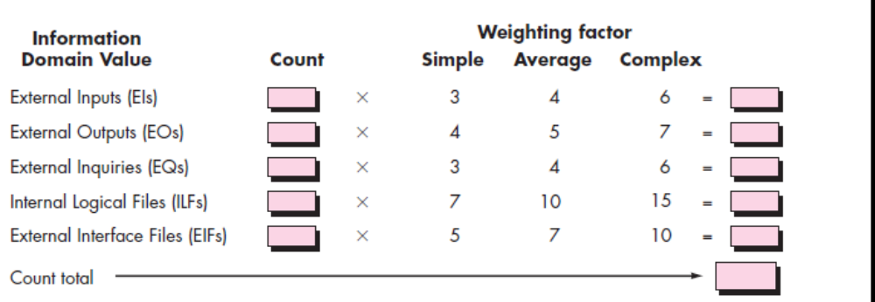

The Fi (I 1 t0 14) are valued adjustment factors based on responses to the following questions

- Does the system require reliable backup and recovery?
- Are specialized data communications required to transfer information to or from the application?
- Are there distributed processing functions?
- Is performance critical?
- Will the system run I existing ,heavily utilized operational environment ?
- Does the system require online data entry?
- Does the online data entry require the input transaction to be built over multiple screens or operations?
- Are the ILFs updated online?
- Are the inputs,outputs,files or inquiries complex?
- Is the internal processing complex?
- Is the code designed to be reusable?
- Are conversion and installation included in the design?
- IS the system designed for multiple installations in different organizations?
- Is the application designed to facilitate change and ease of use by the user?

(ii)Compute function point value for a project with the following information domain characteristic: No of external inputs-30, No of external outputs-52, No of external inquiries-22, No.of log files-12 and No. of external interface files-2

Assume complexity adjustment values for above are average(4,5,4,10,7 respectively)(NOV/DEC 2014)

 | Count | Weighting factor | Count  *  Weighting factor
No of external inputs | 30 | 4 | 120 | For complex product  46(adjusting factor)
No of external outputs | 52 | 5 | 260 | For complex product  46(adjusting factor)
No of external inquiries | 22 | 4 | 88 | For complex product  46(adjusting factor)
No.of log files | 12 | 10 | 120 | For complex product  46(adjusting factor)
No. of external interface files | 2 | 7 | 14 | For complex product  46(adjusting factor)
Count Total |  |  | 602 | 46

FP=602*(0.65+(0.01*46))= 668.22

