
UART To LCD
Advanced Embedded Systems

Authors: Dr. Gilberto Ochoa Ruiz
Msc. Jorge German Perez Blanco
Contents
Introduction 3
Learning Objectives 3
What the Example Does 3
FreeRTOS Usage 5
Execution Flow 5
UART Interface 6
Suggested Tests 6
Suggested Changes 6
Annexes 7
Usage examples 7
Echoing UART 7
Sending a message longer than 16 characters 7
Application code 7
Main app code 7

Introduction
This example demonstrates how to use FreeRTOS to handle communication between a serial interface (UART) and an LCD display on the FRDM-KL25Z board. The application shows how text entered in a serial terminal can be sent to the microcontroller and displayed on the LCD in real time.
By separating functionality into tasks, you will learn how to:
- Receive and process UART input using an interrupt-driven queue.
- Validate and safely store messages with the help of a mutex.
- Refresh the LCD at a fixed rate from a dedicated renderer task.
This project illustrates the integration of interrupts, shared resources, and task scheduling, providing a clear foundation for building more advanced human–machine interfaces in embedded systems.

Learning Objectives
- Use FreeRTOS tasks to separate input processing and output rendering.
- Learn how to send text commands via UART and display them on an LCD.
- Protect a shared buffer with a mutex.
- Understand how to limit string size to avoid overflow on a small LCD display.
- Practice ISR → task communication with a FreeRTOS queue.

What the Example Does
- Initializes the LCD in 8-bit mode and clears the screen.
- Accepts strings through UART0. Each string must be terminated with Enter (\r or \n).
- Displays the received string on the LCD:
  - If the string length ≤ 16 characters → displayed correctly.
  - If the string length > 16 characters → displays the message "String_size > 16".
- The LCD is updated every 500 ms by a dedicated task.
How to send commands
To send commands to the device, we will use the Terminal included in the MCUExpresso IDE.
To establish the serial communication with the board through the Terminal, click on the button highlighted in the figure, located in the bottom panel under the Terminal tab.
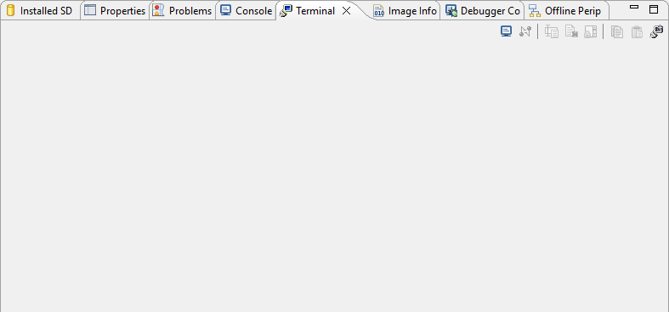
As a result, the terminal configuration window will appear, as shown in the following figure. Leave de defaukt configuration as it matches the UART configuration done by code, just press the Ok button and the serial communication with the board will start.
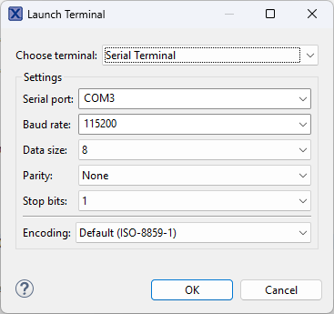
Now we need to enable the command input field that its disabled by default each time we open serial communication, otherwise we can’t send the commands. To toggle the command input field, press the button highlighted on the following figure, located in the bottom panel under the Terminal tab.
Now you are able to input commands to the board as shown on the next figure. Just type the command on the input field and press the Enter key of your keyboard.
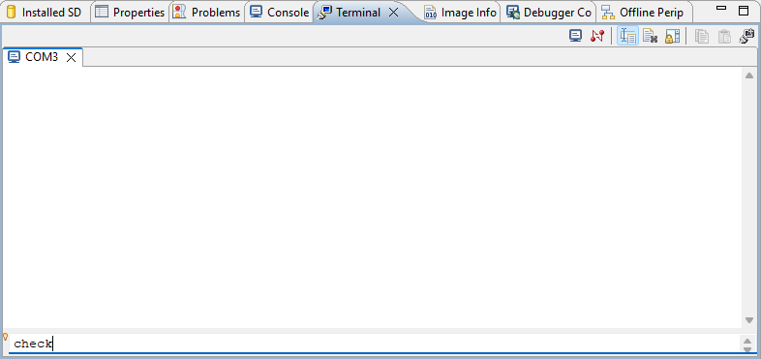

FreeRTOS Usage
• Tasks
- vTaskUART (prio 1, stack 256): consumes queue messages from UART ISR, validates and copies to LCD_BUFFER.
- vTaskLCDRenderer (prio 2, stack 256): updates LCD every 500 ms.
• Queue
- xQueueUART (4 items × 32 bytes): receives complete command strings from UART ISR.
• Mutex
- xMutexLCD: ensures exclusive access to LCD_BUFFER while tasks write/read.
• ISR
- UART0_IRQHandler: assembles characters until CR/LF, sends complete string to the queue.

Execution Flow
• main() initializes hardware, UART0, TPM0, LCD, creates queue/mutex, and tasks.
• UART0 ISR collects characters until CR/LF and enqueues the string.
• vTaskUART reads the queue and checks string size.
- If valid (<16 chars) → copies to LCD_BUFFER.
- Else → writes error message "String_size > 16".
- vTaskLCDRenderer clears the LCD, moves the cursor to line 1, and writes the contents of LCD_BUFFER.
- Runs every 500 ms.

UART Interface
- Baudrate: 115200, Format: 8N1.
- Type any string into the terminal and press Enter.
- If ≤16 chars → string is displayed.
- If >16 chars → LCD shows "String_size > 16".

Suggested Tests
- Send short messages: Hello, FreeRTOS, etc.
- Send exactly 16 characters → should fit.
- Send 20 characters → error message "String_size > 16".
- Send multiple lines quickly → check queue buffering.
- Try pressing Enter with no text → LCD clears line.

Suggested Changes
- Add support for both LCD lines.
- Implement scrolling or line wrapping.
- Keep history of last 2–4 messages.
- Use a queue of “LCD messages” instead of a single shared buffer.

Annexes

Usage examples

Echoing UART
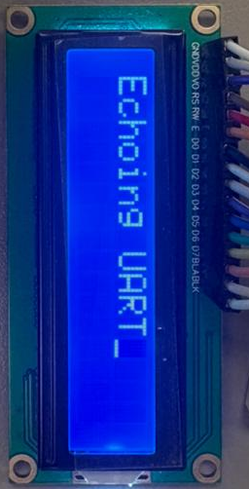

Sending a message longer than 16 characters
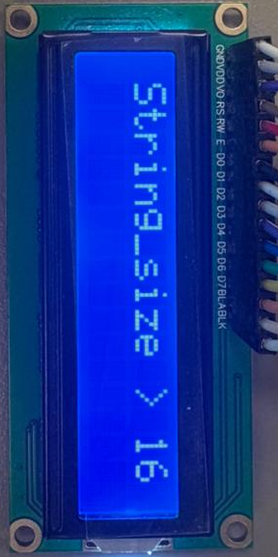

Application code

Main app code
//Program (7): Sending data to the LCD

/* Initialize and display “Hello” on the LCD using 8-bit data mode.

* Data pins use Port D, control pins use Port A.
* This program does not poll the status of the LCD.
* It uses delay to wait out the time LCD controller is busy.

* Timing is more relax than the HD44780 datasheet to accommodate the variations among the LCD modules.

* You may want to adjust the amount of delay for your LCD controller. */

#include <MKL25Z4.H>
#include <string.h>

/* FreeRTOS kernel includes. */
#include "FreeRTOS.h"
#include "task.h"
#include "queue.h"
#include "timers.h"
#include "semphr.h"

/* Freescale includes. */
#include "fsl_device_registers.h"
#include "fsl_debug_console.h"
#include "board.h"
#include "pin_mux.h"

/*******************************************************************************
* Definitions
******************************************************************************/
#define RS 0x08 /* PTC3 mask */
#define RW 0x10 /* PTC4 mask */
#define EN 0x20 /* PTC5 mask */

// === COLA PARA COMANDOS UART ===
#define UART_BUFFER_LEN 32
static QueueHandle_t xQueueUART;
static SemaphoreHandle_t xMutexLCD;

/*******************************************************************************
* Prototypes
******************************************************************************/
void TPM_1ms_configure();
void delayMs(int n);

void LCD_command(unsigned char command);
void LCD_data(unsigned char data);
void LCD_init(void);

void UART0_Init(void);
void UART0_IRQHandler(void);

void data_validation(char *cmd);

/* Tasks*/
void vTaskUART(void *pvParameters);
void vTaskLCDRenderer(void *pvParameters);

/*******************************************************************************
* Globals
******************************************************************************/
char LCD_BUFFER[32] = "Waiting...";

/*******************************************************************************
* Code
******************************************************************************/
/*!
* @brief Application entry point.
*/
int main(void){
/* Init board hardware. */
BOARD_InitPins();
BOARD_BootClockRUN();
BOARD_InitDebugConsole();

UART0_Init();
TPM_1ms_configure();
LCD_init();

xQueueUART = xQueueCreate(4, UART_BUFFER_LEN);
xMutexLCD = xSemaphoreCreateMutex();

/* Tasks */
xTaskCreate(vTaskLCDRenderer, "LCD", 256, NULL, 2, NULL);
xTaskCreate(vTaskUART, "UART", 256, NULL, 1, NULL);

vTaskStartScheduler();
for (;;)
;
}

void LCD_init(void)
{
SIM->SCGC5 |= 0x1000; /* enable clock to Port D */
PORTD->PCR[0] = 0x100; /* make PTD0 pin as GPIO */
PORTD->PCR[1] = 0x100; /* make PTD1 pin as GPIO */
PORTD->PCR[2] = 0x100; /* make PTD1 pin as GPIO */
PORTD->PCR[3] = 0x100; /* make PTD1 pin as GPIO */
PORTD->PCR[4] = 0x100; /* make PTD1 pin as GPIO */
PORTD->PCR[5] = 0x100; /* make PTD1 pin as GPIO */
PORTD->PCR[6] = 0x100; /* make PTD6 pin as GPIO */
PORTD->PCR[7] = 0x100; /* make PTD7 pin as GPIO */
PTD->PDDR = 0xFF; /* make PTD7-0 as output pins */
SIM->SCGC5 |= 0x0800; /* enable clock to Port C */
PORTC->PCR[3] = 0x100; /* make PTC3 pin as GPIO */
PORTC->PCR[4] = 0x100; /* make PTC4 pin as GPIO */
PORTC->PCR[5] = 0x100; /* make PTC5 pin as GPIO */
PTC->PDDR |= 0x38; /* make PTC5, 4, 3 as out pins*/

delayMs(30); /* initialization sequence */

LCD_command(0x30);
delayMs(10);
LCD_command(0x30);
delayMs(1);
LCD_command(0x30);
/* set 8-bit data, 2-line, 5x7 font */
LCD_command(0x38);
/* move cursor right */
LCD_command(0x06);
/* clear screen, move cursor to home */
LCD_command(0x01);
/* turn on display, cursor blinking */
LCD_command(0x0F);}

void LCD_command(unsigned char command)
{
PTC->PCOR = RS | RW; /* RS = 0, R/W = 0 */
PTD->PDOR = command;
PTC->PSOR = EN; /* pulse E */

// delayMs(0);
delayMs(1);
PTC->PCOR = EN;

if (command < 4)
delayMs(4); /* command 1 and 2 needs up to 1.64ms */
else
delayMs(1); /* all others 40 us */
}

void LCD_data(unsigned char data)
{
PTC->PSOR = RS; /* RS = 1, R/W = 0 */

PTC->PCOR = RW;

PTD->PDOR = data;

PTC->PSOR = EN; /* pulse E */

// delayMs(0);
delayMs(1);
PTC->PCOR = EN;
delayMs(1);
}

/* Delay function */
void delayMs(int n) {
for (int i = 0; i < n; i++)
{
while((TPM0->SC & 0x80) == 0) { }
/* wait until the TOF is set */
TPM0->SC |= 0x80; /* clear TOF */
}
}

void TPM_1ms_configure()
{
/* Init code */
SIM->SCGC6 |= 0x01000000; /* enable clock to TPM0 */
SIM->SOPT2 |= 0x01000000; /* use 32.76khz as clock */
TPM0->SC = 0; /* disable timer while configuring */
TPM0->SC = 0x02; /* prescaler /4 */
TPM0->MOD = 0x2000; /* max modulo value 8192*/
TPM0->SC |= 0x80; /* clear TOF */
TPM0->SC |= 0x08; /* enable timer free-running mode */
}

// === CONFIGURACIÓN UART0 (115200-8N1) ===
void UART0_Init(void)
{
SIM->SCGC4 |= SIM_SCGC4_UART0_MASK;
SIM->SCGC5 |= SIM_SCGC5_PORTA_MASK;

// PTA1 = RX, PTA2 = TX
PORTA->PCR[1] = PORT_PCR_MUX(2);
PORTA->PCR[2] = PORT_PCR_MUX(2);

UART0->C2 &= ~(UART_C2_TE_MASK | UART_C2_RE_MASK);
UART0->BDH = 0;
UART0->BDL = (uint8_t) (SystemCoreClock / (16 * 115200));
UART0->C4 = UART0_C4_OSR(15);

UART0->C1 = 0;
UART0->C2 |= UART_C2_RE_MASK | UART_C2_TE_MASK | UART_C2_RIE_MASK;

NVIC_EnableIRQ(UART0_IRQn);
}

// === INTERRUPCIÓN UART ===
void UART0_IRQHandler(void)
{
static char rx_buffer[UART_BUFFER_LEN];
static uint8_t index = 0;

if ((UART0->S1 & UART_S1_RDRF_MASK))
{
char c = UART0->D;

if (c == '\r' || c == '\n')
{
rx_buffer[index] = '\0';
xQueueSendFromISR(xQueueUART, &rx_buffer, NULL);
index = 0;
}
else if (index < UART_BUFFER_LEN - 1)
{
rx_buffer[index++] = c;
}
}
}

// === TAREA: PROCESAMIENTO UART ===
void vTaskUART(void *pvParameters)
{
char buffer[UART_BUFFER_LEN];

while (1)
{
if (xQueueReceive(xQueueUART, &buffer, portMAX_DELAY))
{
data_validation(buffer);
}
}
}

// === Validar datos ===
void data_validation(char *cmd)
{
char size = strlen(cmd);

if(size < 16)
{
xSemaphoreTake(xMutexLCD, portMAX_DELAY);
memset(LCD_BUFFER, 0, 32);
memcpy(LCD_BUFFER, cmd, size);
xSemaphoreGive(xMutexLCD);
}
else
{
xSemaphoreTake(xMutexLCD, portMAX_DELAY);
memset(LCD_BUFFER, 0, 32);
memcpy(LCD_BUFFER, "String_size > 16", 16);
xSemaphoreGive(xMutexLCD);
}
}

void vTaskLCDRenderer(void *pvParameters)
{
char size;
for( ;; )
{
LCD_command(1); /* clear display */
LCD_command(0x80); /* set cursor at first line */

xSemaphoreTake(xMutexLCD, portMAX_DELAY);
size = strlen(LCD_BUFFER); // mide hasta el tope

for(int i=0; i<size; i++)
{
LCD_data(LCD_BUFFER[i]);
}

xSemaphoreGive(xMutexLCD);

vTaskDelay(500);
}
}

