February 22, 2024
Mohamed Irsyadudin bin sutiro
210502783

ST2187 Coursework

Table of Contents
Executive Summary 2
Analysis of Story 3
Sales and Profitability Analysis 3
Customer Analysis 4
Product Analysis 5
Order and Shipping Efficiency 6
Discount and Profitability 7
Conclusion 8

Executive Summary

In the forthcoming analysis, I’ll present pivotal findings derived from a comprehensive review of a worldwide superstore’s data spanning 2019 to 2022. This has been facilitated by employing Tableau for the extraction and visualisation of data, enabling an investigation into prevailing trends, patterns, and connections.

Accompanying this analysis is a PDF attachment that features a narrative composed of five distinct dashboards:
- Sales and Profitability Analysis
- Product Analysis
- Customer Analysis
- Order and Shipping Efficiency
- Discount and Profitability

In the subsequent sections, the focus will be on elucidating the information each dashboard presents and the manner in which this can aid the executive management in formulating strategies to bolster the firm’s financial success.

The data has been augmented with several newly computed metrics, which include:
- Profit Margin: A financial ratio used to evaluate company’s profitability.
- Shipping Time (Days): How long does the order take from order date to shipping date (in terms of days).
- Discount Bracket: Placing discounts into different brackets to gauge certain measures.

Analysis of Story

Sales and Profitability Analysis
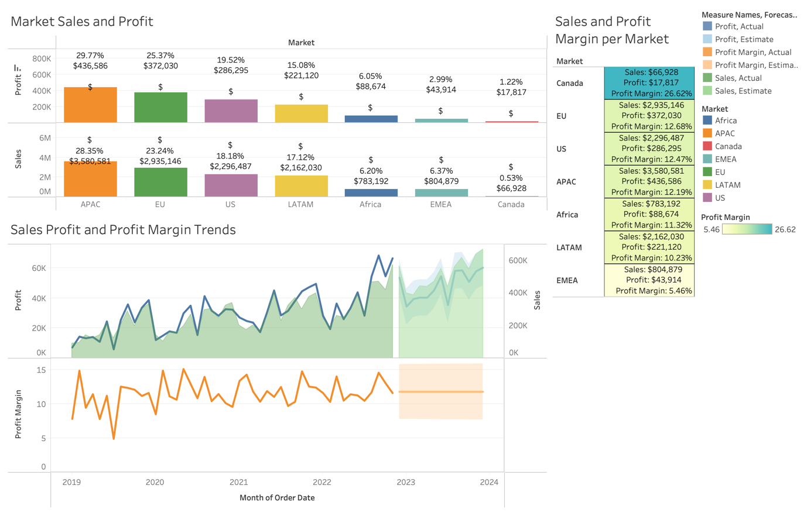
Figure 1: Sales and Profitability Analysis

The sales and profitability dashboard is intended to offer senior management with insights on the company’s sales and profitability over time and across many markets. The dashboard shows a summary of crucial metrics including sales, profits, and profit margin. The profit margin is used to measure the company’s profitability in several market sectors and to highlight market sectors that require further attention from the senior management. At the bottom of the dashboard, trend lines are used to compare profit to sales and forecast the company future overall success.

The bar chart shows that APAC is the market with the highest sales and profit: $3,580,581 Sales and $436,586 in profit across 4 years. However, we can see that it does not correspond with the profitability as APAC’s profit margin is 12.19%, the fourth largest profit margin in comparison to other markets. Canada has the lowest sales and profit values generated: $66,980 in Sales and $17,817 in Profit, but the highest profit margin at 26.62%, indicating that Canada is the most profitable market for the superstore. The superstore may consider examining the EMEA market, which has the lowest profit margin at 5.46%. Their sales and profit values are also not particularly high: $804,879 in Sales and $43,914 in Profit (2nd from the bottom).

Looking at the trend lines, we can see a general rise in sales and profit across 2019 and 2022. Generally, profit is higher than sales, but we can see that in the last quarter of 2020, the superstore has more sales than profit. This affects the profitability of the company as we can see the profit margin trend line dipping during the same period. There is a steep dip for sales, profit, and profit margin during the middle of 2019. The profit margin dropped nearly 50% while the profit dropped to nearly $5,000. This could be due to the start of the Covid-19 pandemic that affected global sales. From the trend lines we made a forecast for 2023 and we can see that the sales and profit is predicted to increase while the superstore’s profit margin is predicted to remain constant.

Customer Analysis
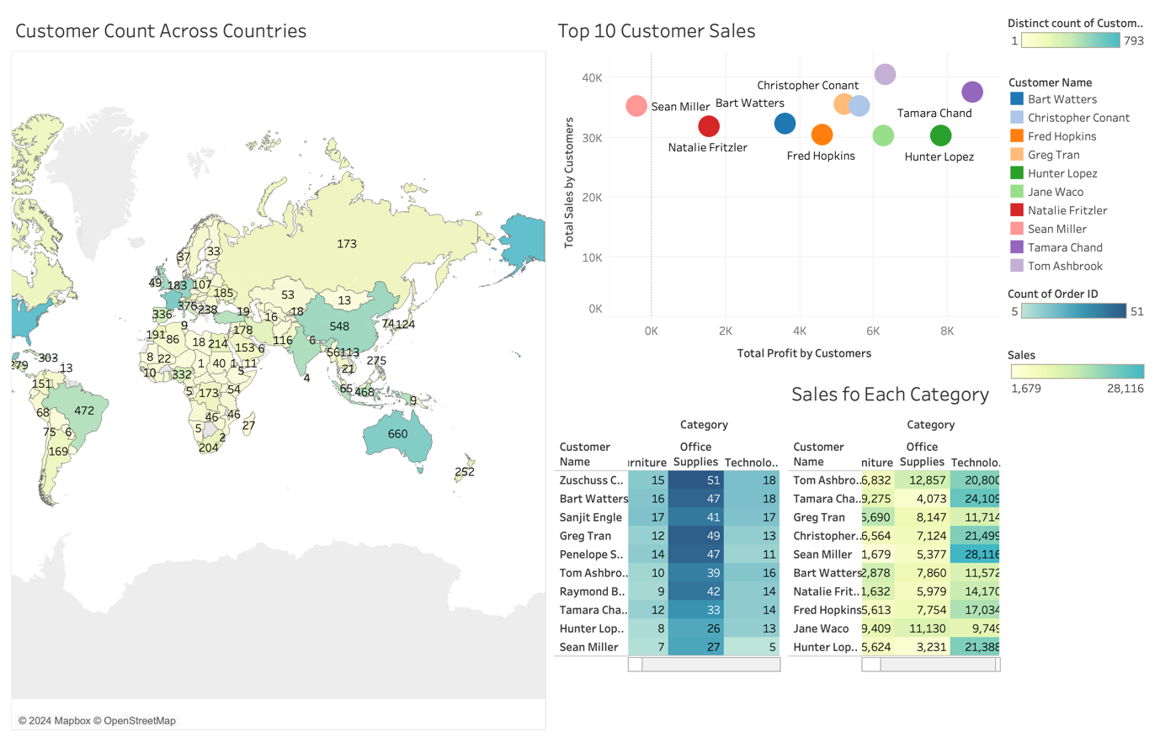
Figure 2: Customer Analysis Dashboard

The Customer Analysis dashboard illustrates a detailed analysis of customer distribution and sales performance. The map shows the customer density across various countries, highlighting significant customer bases in countries like the United States, England, France Germany, China, India, and Australia. In the Top 10 Customer Sales scatter plot and the tree maps at the bottom right, shows the top 10 customers that contributed to the sales and profit of the superstore.

The tree map segregates sales into three product categories, providing insights to which segments generate the most revenue and could be indicative of customer preference or market trends. Evidently, the Technology category shows a substantial lead in sales, suggesting a focused demand in that sector. However, senior management may consider aligning sales strategies to increase sales in office supplies as it has the highest count of purchase among the categories.

As the tree map and scatter plot identifies individual customers and breaks down sales figures into product category, this granular view allows for identification of top contributors in each segment, potentially guiding targeted marketing strategies or sales initiatives. Moreover, it allows senior management to align sales strategies with profitable customer segments and regions.

Product Analysis
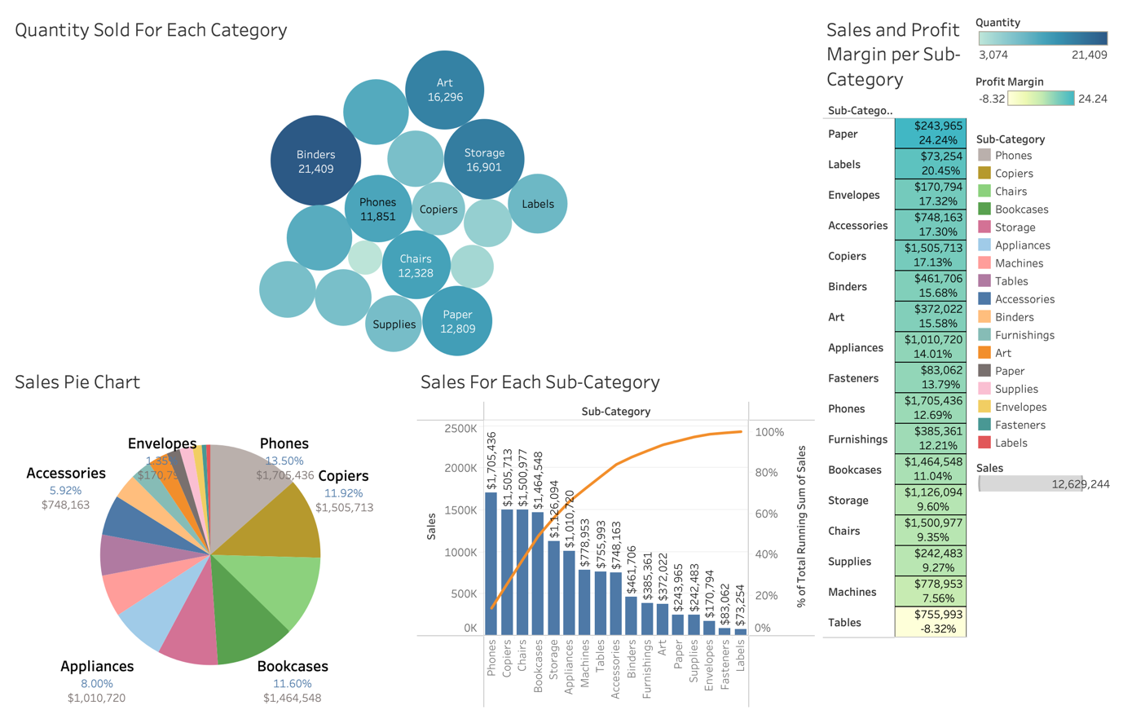
Figure 3: Product Analysis Dashboard

The Product Analysis Dashboard visualises product performance in several dimensions: quantity sold, sales revenue, and profit margins across different sub-categories. The bubble chart displays relative quantities, with binders and storage standing out in terms of volume. The sales pie chart and pareto chart breaks down total sales by category highlighting Phones ($1,705,436) and copiers (1,505,713) as substantial revenue drivers. They show significant height in terms of total profit which may indicate high profitability. Conversely, Fasteners ($83,062) and Labels ($73,254) generated the least number of sales.

The highlight table “Sales and Profit Margin per Sub-Category” provides a detailed breakdown of sales and profit margins by sub-category. While Phones has the most significant sales figure, the profit margin is moderate as compared to other categories. Despite being fifth from the bottom in terms of sales generated, Paper has the highest profit margin. This suggests that despite lower sales volume, Paper yields a higher return relative to its sales. This is understandable as paper can be seen as a necessity among customers.

This visualisation aids in identifying high-value areas such as phone and copier sales while also revealing high-efficiency segments like paper where profit margins are substantial despite lower total sales. This analysis can assist management in strategic decision making with aims to optimise sales and profit distribution across sub-categories. Combining figure 2 and 3, we can see that management may consider maximising sales in the technology sector, primarily on phones and appliances. With the rise in artificial intelligence and sophisticated technology innovation, the superstore can benefit from phones and appliances sales.

Order and Shipping Efficiency
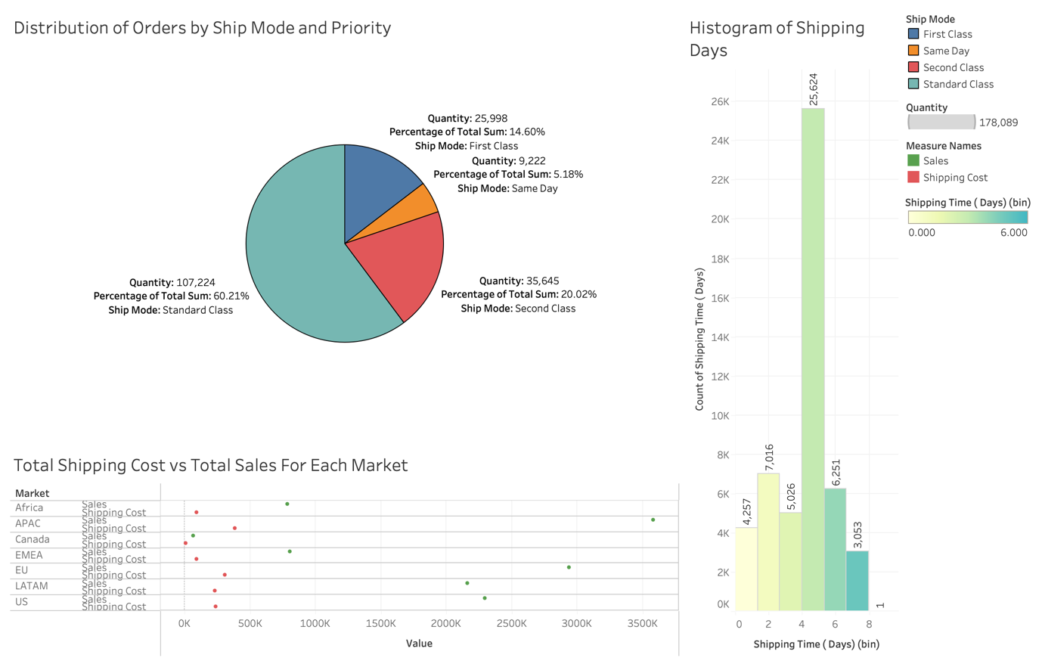
Figure 4: Order and Shipping Efficiency

The order and efficiency dashboard provides an insightful analysis of order distribution by shipping method, a comparison of shipping costs against sales in various markets, and a histogram of shipping days. The pie chart shows a majority of orders are being shipped via Standard class, comprising of 60.21% of the total, indicating a strong preference for this shipping mode over quickly but more likely expensive options like Same Day or First Class.

The scatter plot below the pie chart contrasts total sales with shipping costs across different markets. The APAC region stands out with the highest sales but also with significant shipping costs, suggesting a high volume of transactions that entail substantial logistic expenses. This could prompt an evaluation of shipping strategies to optimise costs while also maintaining sales volumes.

The histogram reveals the distribution of shipping time, with the notable peak at two days. This peak suggests a concentration of orders being delivered within this timeframe, which might be indicative of the efficiency of the shipping process.

Overall, this visualisation provides a strategic view of the superstore’s logistic performance and customer service efficiency, highlighting potential areas for cost optimisation and improved shipping strategies to enhance customer satisfaction and profitability.

Discount and Profitability
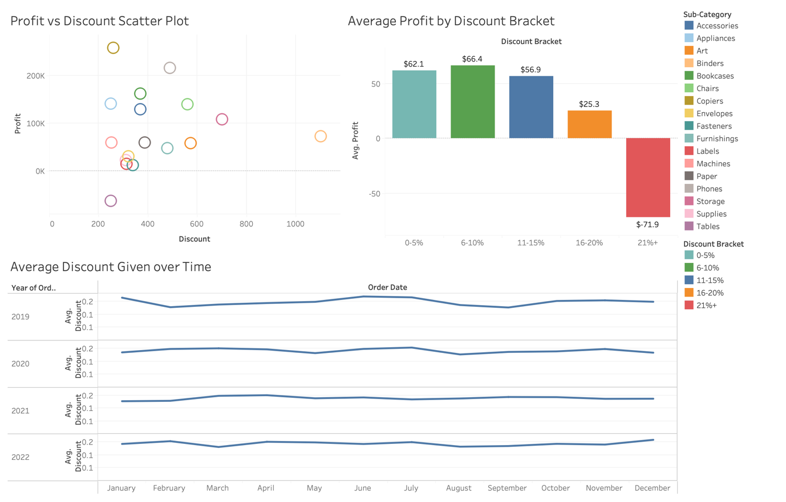Figure 5: Discount and Profitability

The Discount and Profitability dashboard showcases an analysis of profitability against discount levels along with an overview of discount trends. The scatter plot displays a relationship between discount and profit, with no clear positive correlation, implying that higher discounts do not necessarily lead to higher profits. The “Average Profit by Discount Bracket” bar chart reveals that moderate discount bracket (6-10%) yields highest average profits at $66.40, but very high discounts lead to drastic profit drop, shown by the negative average profit in the highest discount bracket. This suggests the most ideal discount bracket is 6-10%. The “Average Discount Given over Time” line graphs illustrate a consistent discounting strategy over the years with no significant fluctuations, indicating a steady discount policy. However, we can still observe an increase in discount rates during June-July and November-December period. This could be due to shopping deals such as mid-year shopping sales and year-end shopping sales like Black Friday or Christmas sales.

This analysis suggests that while discounts are a stable part of the sales strategy, their impact on profit varies, and excessive discounting is detrimental to profitability.

Conclusion

To conclude, the dashboards collectively provide a comprehensive, multi-dimensional view of the company’s sales operations, customer distribution, and profitability metrics. They reveal the importance of strategic discounting, effectiveness of various shipping modes in relation to order fulfilment, and the correlation between sales activities and profit margins across different market segments.

The data suggest a re-evaluation of discount policies could enhance profit margins, as excessive discounts negatively impact profitability. A focused approach to customer segmentation and targeting may optimise sales strategies, especially in high-performing categories and regions.

The analysis of customer count across countries underlines potential markets for expansion and the need for tailored strategies to capitalise on larger existing markets. Additionally, the assessment of top customer sales emphasises the value of nurturing profitable customer relationships.

Informed by these insights, senior management is positioned to make data-driven decisions to refine sales strategies, improve operational efficiency and foster customer engagement to drive the company’s profitability forward. Each dashboard serves as a strategic tool, providing clarity on where to allocate resources effectively and how to adjust tactics to better meet market demands and customer needs.

Word count excluding executive summary: 1370 words.

