**Document Preprocessing**

**Removal of Stop Words**

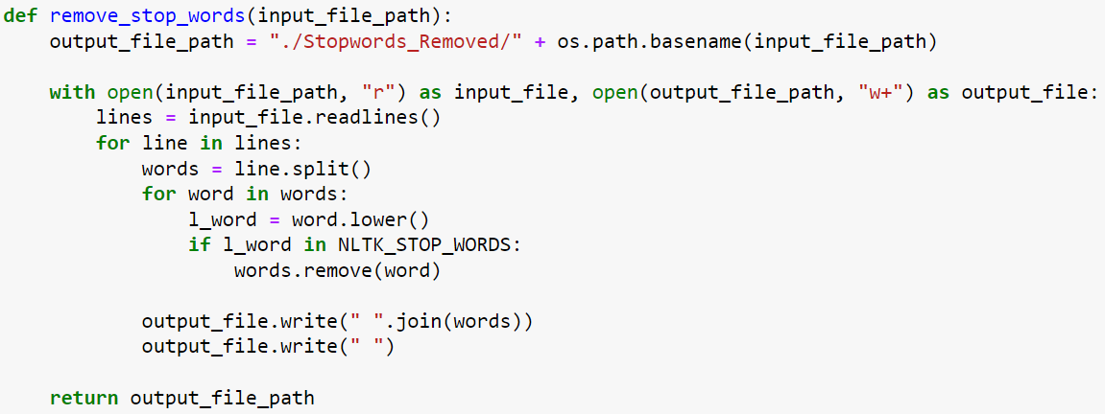

**Removal of Punctuation**

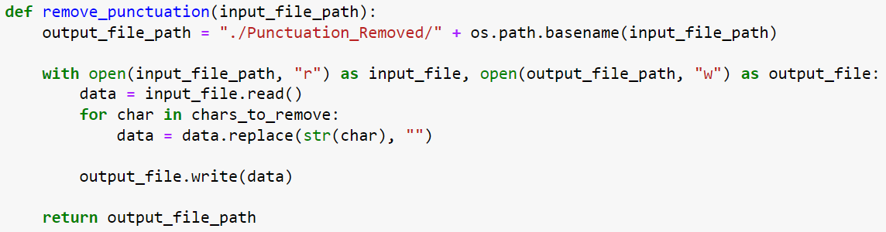

**Converting Documents’ Content to Lowercase**

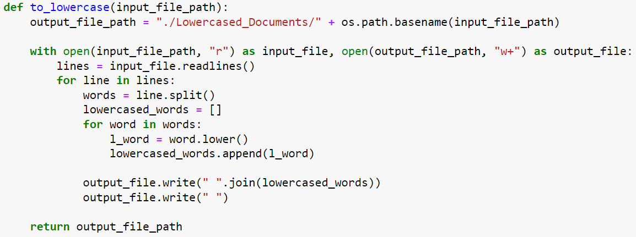

**Preparing Meta Data**

**Calculating Document Term Frequency**

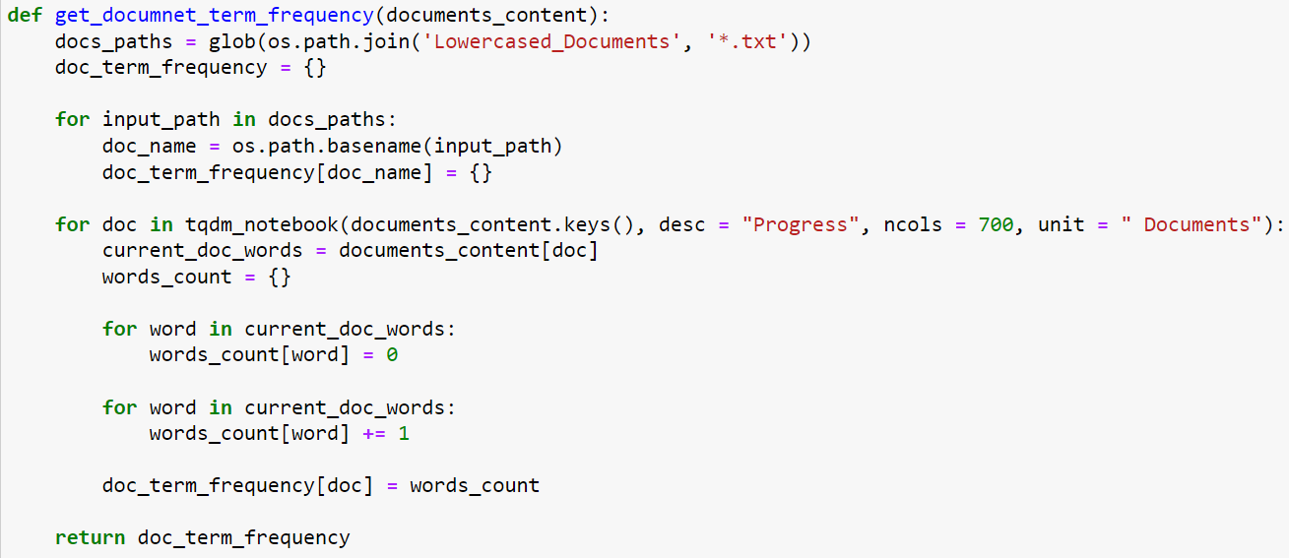

**Calculating Word Document Frequency**

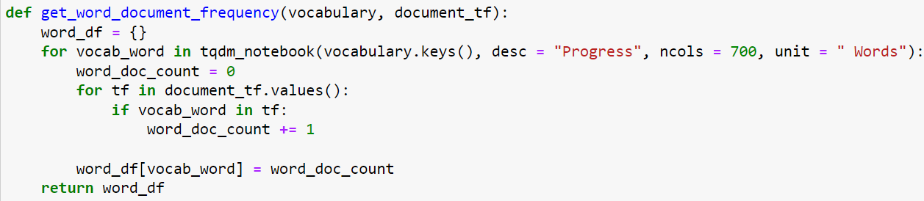

**Calculating Inverse Document Frequency for Vocabulary**

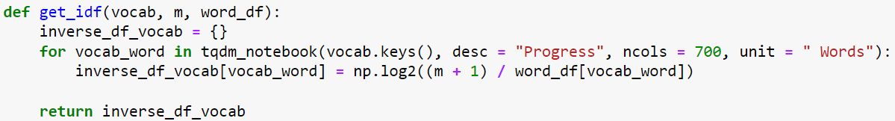

**Calculating Term Frequency – Inverse Document Frequency for all Documents**

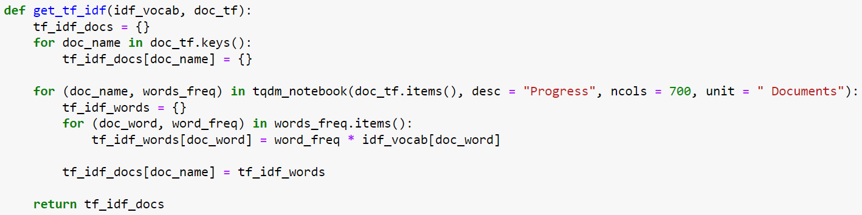

**Calculating Relevance Scores**

**Applying Vector Space Model with TF – IDF**

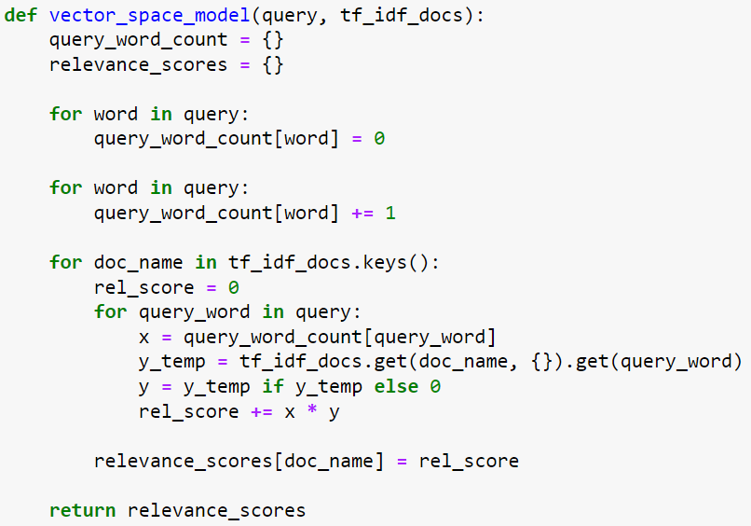

**Calculating, Sorting and Printing Results**

**Looping over all Queries and Printing Top 5 Document Results**

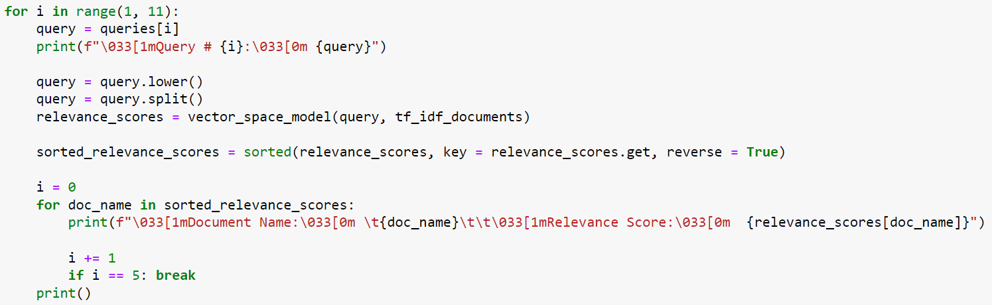

**Results**

