Executive Summary
Nassau Candy Distributor - Shipping Route Efficiency
Prepared for government stakeholders | Orders Jan 2024 - Dec 2025

Purpose
This review examined 10,194 order lines shipped from five factories to customers across the United States and Canada to learn which delivery routes are fast, which are slow, and where to act.

Key findings
- Average time from order to shipment is 4.3 days. About one in four shipments (24.7%) takes longer than 5 days.
- The shipping method decides speed. Standard Class makes up 60% of shipments, averages 5.3 days and is late 39% of the time. Same Day and First Class are never late, and Second Class is late 7.5% of the time.
- Geography matters little. Regions differ by under 0.15 days, and shipments from Arizona reach the East Coast as quickly as the West Coast. The delay appears to come from processing and handoff, not distance.
- A few states genuinely lag. Tennessee, Minnesota, New Jersey, Indiana and New Mexico are consistently slower. Ohio is consistently faster, which makes it a useful benchmark.
- Two factories handle 97% of volume. Lot's O' Nuts and Wicked Choccy's set the national result; the other three are too small to rank.
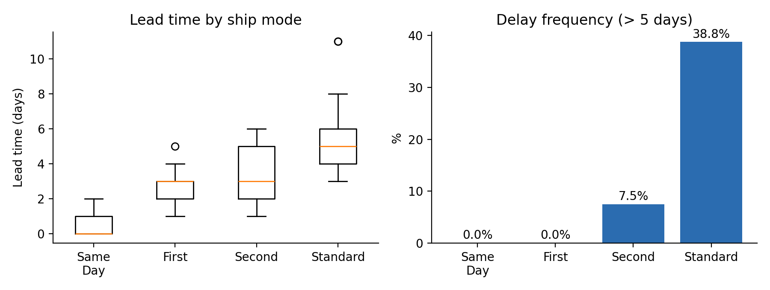
Lead time and delay frequency by ship mode

Recommended actions
- Move suitable Standard Class orders to a faster tier, after checking freight cost, since this is the largest available gain.
- Measure and shorten the time between order and dispatch at the two main factories.
- Review carrier and dispatch practice on the five slow states, using Ohio as the comparison.
- Set delay targets by ship mode instead of one threshold for all.
- Correct the shipping-date records and add delivery dates and shipping cost to future data.

Data caution
Ship dates in the source file were offset by roughly 2.5 to 4.5 years. They were corrected using a pattern in the data, which is an inference that the data owner should confirm. Lead time measures order to shipment, not arrival. Routes with fewer than 10 orders were not ranked.

Deliverables
Full research paper (methods, tables, charts, limitations) and an interactive Streamlit dashboard with route leaderboard, US map, ship-mode comparison and order-level drill-down.

