Shipping Route Efficiency Analysis
Nassau Candy Distributor: factory-to-customer lead times, delays and bottlenecks
Unified Mentor project | Orders January 2024 - December 2025 | 10,194 order lines

Abstract
Nassau Candy ships from five factories to customers across the United States and Canada, but has no route-level view of delivery speed. This paper cleans 10,194 order lines, rebuilds shipping lead time, defines routes as factory to customer state and region, and benchmarks them on lead time, variability and delay frequency. The main finding is that ship mode, not geography, drives delivery time. Standard Class (60% of shipments) averages 5.3 days and is late 38.8% of the time against a 5-day threshold, while Same Day, First Class and Second Class are late 0%, 0% and 7.5% of the time. Differences between regions and factories are under 0.15 days. A minority of state routes (Ohio, Tennessee, Minnesota, New Jersey, Indiana, New Mexico) differ from the national average by more than chance would explain, and these are the routes to investigate first.

1. Background and objectives
Shipping efficiency affects customer satisfaction, delays raise operating cost, and inefficient routes limit scalability. Logistics decisions at Nassau have been reactive. The objectives were to find which factory-to-customer routes are consistently efficient, which are frequently delayed, how performance varies by region, state and ship mode, and where geographic bottlenecks sit.

2. Data and cleaning
The file has 18 fields per order line: order and ship dates, ship mode, customer geography, product, sales, units, cost and gross profit. Products were mapped to one of five factories using the product-factory table supplied with the brief.

2.1 Validation steps
- Dates parsed as dd-mm-yyyy: 0 invalid, 0 missing ship dates.
- Text fields trimmed; 59 state/province values standardised and mapped to USPS codes for the 50 states plus DC. 200 lines (2%) are Canadian provinces and are kept in tables but left off the US map.
- All 15 products mapped to a factory; 0 unmapped.
- Negative lead times: 0 after correction (see below).
- 1,645 order lines share an Order ID and Product ID with another line; these were kept because quantities and values differ.

2.2 A date problem that had to be corrected
Taken literally, Ship Date minus Order Date gives lead times of 904 to 1,642 days (about 2.5 to 4.5 years), which is impossible. The excess is a constant block of days within each Order-ID year: Same Day orders sit at a floor of 904 days for 2021 IDs, 1,269 for 2022 and 2023 IDs, and 1,634 for 2024 IDs. Subtracting each block floor gives lead times of 0 to 11 days with the expected ordering by ship mode (Same Day 0-2, First Class 1-5, Second Class 1-6, Standard 3-11).
Assumption: the floor of each block is the true Same Day lead time (0 days). This is an inference from the data pattern, not something the dataset documents, and it should be confirmed with the data owner. All lead times below are the corrected values.
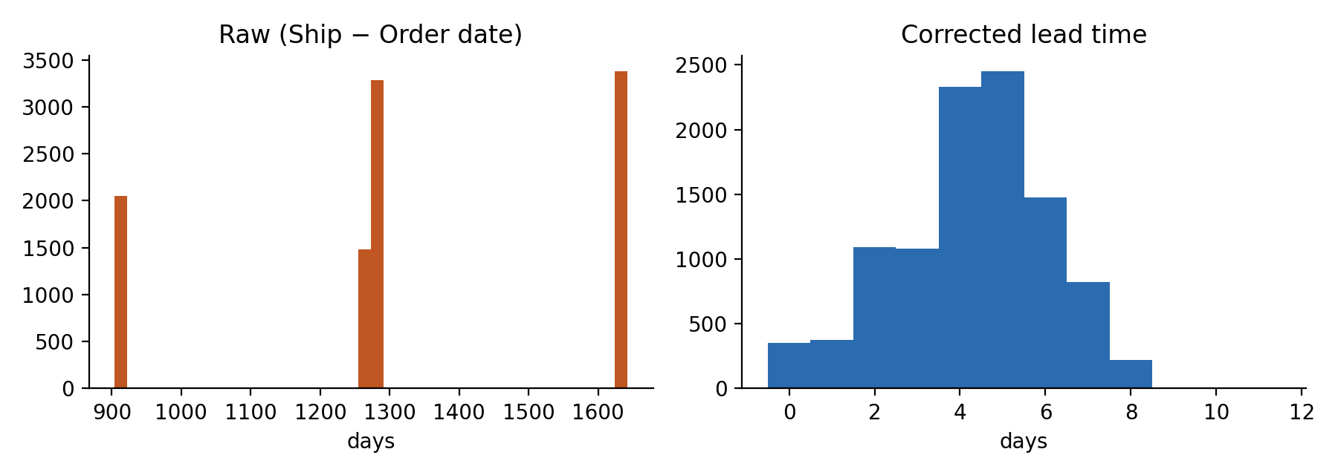
Figure 1. Raw versus corrected lead time

3. Methodology
Shipping lead time is Ship Date minus Order Date in days. Routes are Factory to Customer State (196 routes, 96 with at least 10 shipments) and Factory to Customer Region (20 routes). For each route the analysis computes shipment count, mean, median and standard deviation of lead time, and delay frequency, the share of shipments above a threshold (default 5 days). The Route Efficiency Score min-max scales mean lead time across routes so the fastest route scores 100 and the slowest 0. To separate route effects from ship-mode mix, a mode-adjusted difference compares each route with the lead time expected from its own mix of ship modes. State rankings use routes with at least 10 shipments because averages from 1 to 5 orders are not reliable.

4. Findings

4.1 Overall performance
The average lead time is 4.29 days (median 4, standard deviation 1.80), and 24.7% of shipments exceed 5 days. Chocolate lines dominate: Lot's O' Nuts (5,692 lines) and Wicked Choccy's (4,152) account for 96.6% of shipments, so they set the national picture. Sugar Shack (33), The Other Factory (100) and Secret Factory (217) are too small for firm route conclusions.

4.2 Ship mode is the dominant driver
Ship mode | Shipments | Avg lead time | Std dev | Delay > 5 days | Avg gross profit
Same Day | 547 | 0.38 | 0.53 | 0.0% | $8.59
First Class | 1,548 | 2.55 | 0.89 | 0.0% | $9.05
Second Class | 1,979 | 3.57 | 1.28 | 7.5% | $9.25
Standard Class | 6,120 | 5.32 | 1.13 | 38.8% | $9.22

An ANOVA on lead time by ship mode gives F = 5,613 (p < 0.001), far larger than any geographic factor. Cost-time trade-off (descriptive): the dataset has no shipping-fee column, so cost and profit per line were used as a proxy. Gross margin is about 66% in every mode and average product cost varies by only a few cents, which means faster modes are not visibly priced into these orders. The data cannot say what each mode costs Nassau to ship.
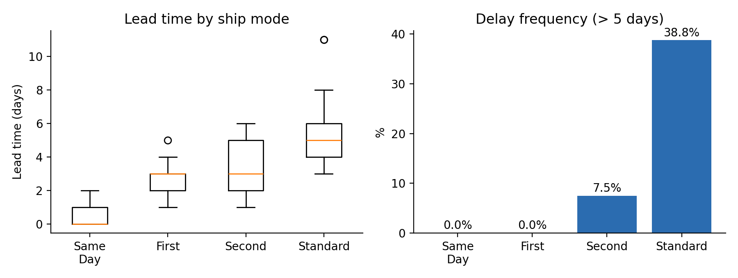
Figure 2. Lead time and delay frequency by ship mode

4.3 Region and factory differences are small
Regional averages are Atlantic 4.24, Pacific 4.27, Gulf 4.30 and Interior 4.38 days. The Interior-Atlantic gap is 0.14 days. The two main factories average 4.26 (Lot's O' Nuts) and 4.35 (Wicked Choccy's) days; the three small factories range from 3.98 to 4.67 but rest on only 33 to 217 lines each. The Arizona-based Lot's O' Nuts factory reaches Pacific customers in 4.24 days and Atlantic customers, roughly 2,000 miles farther, in 4.21 days. Within Standard Class alone, regional means are 5.27 to 5.37 days. These differences are statistically detectable with 10,000 lines (p about 0.03 to 0.05) but are of no practical size. Lead time in this data does not rise with distance, which suggests the delay sits in order processing or carrier handoff rather than transit.
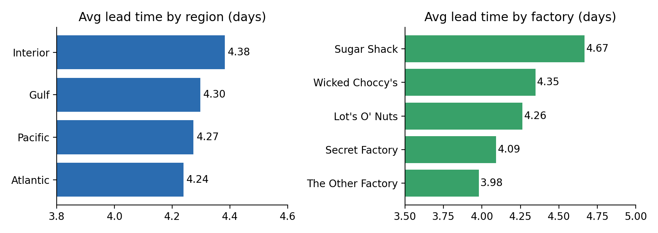
Figure 3. Average lead time by region and by factory

4.4 Route benchmarking
Among state routes with at least 10 shipments, mean lead time ranges from 3.27 to 5.44 days (standard deviation across routes 0.42 days). The tables below show the ten fastest and ten slowest.
Fastest routes | Orders | Avg days | Delay > 5 d | Score
Wicked Choccy's → Louisiana | 15 | 3.27 | 6.7% | 100
Lot's O' Nuts → Ontario | 28 | 3.36 | 0.0% | 96
Lot's O' Nuts → New Hampshire | 13 | 3.46 | 0.0% | 91
Secret Factory → Illinois | 13 | 3.54 | 7.7% | 88
Lot's O' Nuts → Louisiana | 24 | 3.54 | 4.2% | 87
Lot's O' Nuts → Rhode Island | 30 | 3.57 | 16.7% | 86
Wicked Choccy's → South Carolina | 19 | 3.63 | 10.5% | 83
Lot's O' Nuts → Nebraska | 23 | 3.65 | 0.0% | 82
Secret Factory → Texas | 16 | 3.69 | 12.5% | 81
Wicked Choccy's → Alabama | 22 | 3.73 | 9.1% | 79

Slowest routes | Orders | Avg days | Delay > 5 d | Score
Lot's O' Nuts → New Mexico | 18 | 5.44 | 44.4% | 0
Wicked Choccy's → New Mexico | 17 | 5.18 | 41.2% | 12
Wicked Choccy's → Indiana | 54 | 5.04 | 46.3% | 19
Wicked Choccy's → Quebec | 24 | 5.00 | 20.8% | 20
Lot's O' Nuts → Minnesota | 43 | 5.00 | 25.6% | 20
Wicked Choccy's → Minnesota | 45 | 4.91 | 37.8% | 24
Wicked Choccy's → Tennessee | 67 | 4.91 | 35.8% | 25
Lot's O' Nuts → New Jersey | 65 | 4.89 | 40.0% | 25
Lot's O' Nuts → Alberta | 16 | 4.88 | 25.0% | 26
Lot's O' Nuts → Oklahoma | 41 | 4.78 | 41.5% | 30

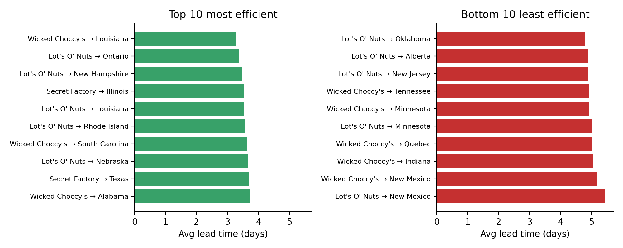
Figure 4. Ten fastest and ten slowest state routes (10+ shipments)
How much of this is real? With 10 to 60 orders per route, a route average moves by roughly 0.3 to 0.6 days from chance alone. A funnel check (Figure 5) shows 15 of 96 routes fall outside the 95% chance band, against about 5 expected by luck. So some routes are genuinely different, but most of the leaderboard movement is noise. The routes that are both outside the band and have meaningful volume are the credible ones: Ohio (fast; 189 and 262 orders from the two main factories), California from Lot's O' Nuts (slightly fast; 1,125 orders), and Tennessee, Minnesota, New Jersey, Indiana and New Mexico (slow). Top-10 lists built from 13 to 30 orders, such as Louisiana or New Hampshire, should be treated as hints rather than proof.
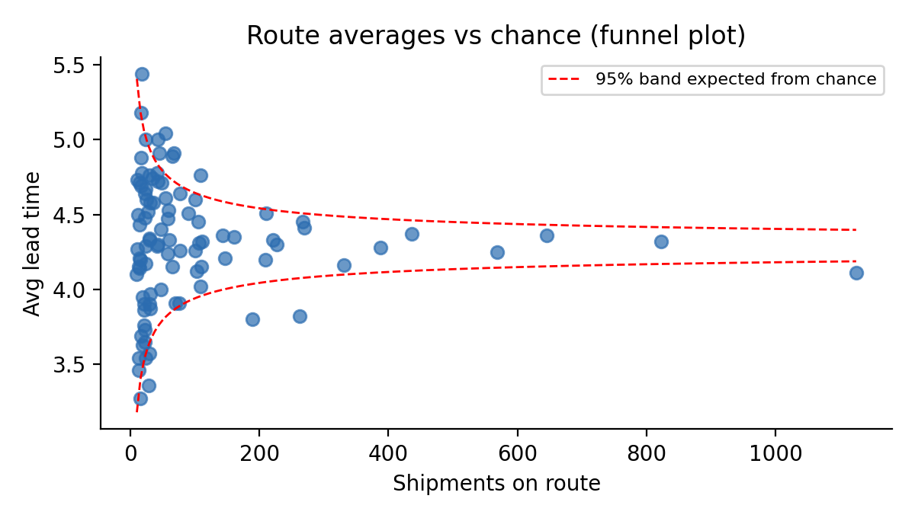
Figure 5. Route averages versus the range expected by chance

4.5 Geographic bottlenecks
California (2,001 lines), New York (1,128), Texas (985), Pennsylvania (587) and Washington (506) generate the most volume. Their averages are 4.19, 4.37, 4.25, 4.21 and 4.38 days, so no large state is a severe outlier. Among states with above-median volume (82 or more shipments) and an above-average lead time, the worst are Minnesota (4.96 days, 31% delayed), Tennessee (4.81, 35%), New Jersey (4.75, 35%), Indiana (4.71, 34%) and Oregon (4.60, 34%). Ohio is the standout performer at 3.81 days despite 469 lines. Michigan has the highest large-state delay rate (32%).
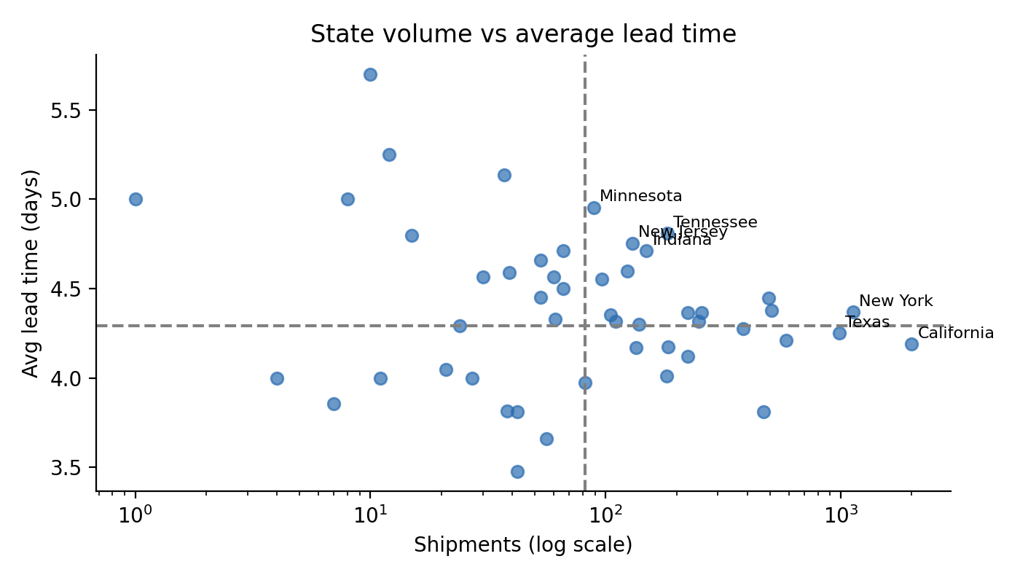
Figure 6. State shipment volume versus average lead time

4.6 Trend
Orders placed in 2025 average 4.45 days against 4.07 for 2024. This depends on the date correction in section 2.2, so it should be read cautiously until the date offsets are confirmed.

5. Recommendations
- Shift volume away from Standard Class where margin allows. It carries 60% of orders and nearly all delays. Moving even a fifth of Standard orders to Second Class would cut average lead time and delay frequency more than any route change. Confirm the freight price difference first, since the data has no shipping cost.
- Investigate processing and handoff time, not distance. Lead time is flat across 2,000 miles, so check order-to-dispatch time at the two main factories.
- Review the credibly slow routes first: Tennessee, Minnesota, New Jersey, Indiana and New Mexico from the two main factories, and compare carriers and dispatch practices against Ohio.
- Use a delay target by mode. A single 5-day threshold penalises Standard by design. Track Standard against 6 days, Second Class against 4, and First Class against 3, plus a Same Day check at 1.
- Fix the data pipeline. Ship dates carry a block offset that makes raw lead times unusable. Confirm the offset with the source system and add a validation rule to reject lead times above 30 days.
- Capture factory, carrier and dispatch dates in the orders table. Today factory is inferred from product, which hides where delays occur.

6. Limitations
- The date correction is inferred, not documented. If Same Day lead time is not truly 0 to 1 days, absolute lead times shift, but route and mode comparisons stay the same because the shift is uniform within each Order-ID year.
- The factory is inferred from the product table. An order with several products may in reality ship from several factories.
- No shipping cost, carrier or delivery date is present. Lead time here is order to ship, not order to delivery, so customer-experienced delay is not measured.
- Three factories have under 220 lines each; their routes are too thin to rank with confidence.
- Chocolate dominates volume (96.6% of lines), so conclusions about the Sugar and Other divisions are weak.

7. Dashboard
The accompanying Streamlit application (app.py) implements the four required modules: Route Efficiency Overview with leaderboard, Geographic Shipping Map, Ship Mode Comparison and Route Drill-Down with order-level timelines, with filters for date range, region, state, ship mode, factory and delay threshold.

