UNIFIED MENTOR | DATA ANALYTICS PROJECT
United States Top 50 Playlist Performance and Song Popularity Trend Analysis
Research paper: exploratory data analysis, insights and recommendations
Prepared for: Atlantic Recording Corporation
Data analysed: Daily US Top 50 playlist snapshots, 18 May 2024 to 27 November 2025
Scope: 27,750 chart slots, 977 songs, 243 primary artists
Date: October 2026
Companion deliverables: Streamlit dashboard (app.py) and one-page executive summary.

Contents
Executive summary
1. Background and objectives
2. Data and methodology
3. Playlist ranking analysis
4. Song-level performance
5. Artist performance
6. Popularity score analytics
7. Content attribute analysis
8. Key performance indicators
9. Insights and recommendations
10. Limitations and next steps
Appendix: dashboard guide and reproducibility

Executive summary
This study analyses 555 daily snapshots of the US Top 50 playlist (18 May 2024 to 27 November 2025) to explain how songs rise, persist and fade, which artists dominate, and whether content attributes such as explicit flags, release type and duration relate to chart success. It is a historical analysis; it does not forecast or recommend songs.

Key findings
- Chart life is short for most songs, and concentrated in a few. The median song stays 7 days and 54% are gone within a week, yet the 76 songs that last 100+ days (7.8% of songs) fill 53% of all chart slots.
- Peak rank is the clearest signal of staying power. Songs that reached #1 (56 of them) lasted a median 95.5 days versus 6 for the rest (Spearman rho = -0.58 between best rank and days on chart).
- The top of the chart is stable; the bottom churns. Songs ranked 1-5 move 1.0 place per day on average, against 3.3 in ranks 21-35. 87% of songs leave from the lower half, only 3% from the Top 10.
- A few artists own a large share of the chart. The top 3 artists hold 20.1% of slots and the top 10 hold 39.9%, while 58% of artists placed a single song. Dominance moves in waves tied to releases.
- Singles outperform album tracks. Singles are 24.9% of songs but 28.8% of slots, reach the Top 10 in 25.1% of their slots (albums: 18.0%) and last a median 13 days versus 6.
- Explicit content and song length are not levers. Explicit and clean songs sit within one point of each other on Top-10 share (20.5% vs 19.5%), and duration shows essentially no relationship with rank (rho = -0.04) or popularity (rho = 0.00).

Recommendations
- Judge a release by its first two weeks, then back it. Half of all songs vanish within a week, while fast risers show momentum quickly (e.g. i like the way you kiss me went from #46 to #6 in seven days). Concentrate marketing spend on songs that are climbing early, because climbers that reach the Top 10 rarely leave from there.
- Lead with singles; use albums to feed the catalog. Single releases give the best Top-10 conversion and longevity. Album tracks still matter for artist share, but they dilute attention across many songs.
- Plan release windows around turnover waves. Large entry days (28 Dec 2024: 49 new songs; 21 Apr 2025: 32 new songs; 29 Jul 2024: 30 new songs) are when the chart reshuffles. Releasing into those windows means competing for the same slots; releasing in quieter weeks (386 days had three or fewer new entries) gives a new song a clearer path.
- Treat seasonal catalog as a recurring asset. Holiday and Halloween songs were among the fastest risers (Monster Mash climbed 44 to 2 in a week). Catalog owners can plan annual re-promotion.
The full set of recommendations and the evidence behind each is in Section 9. Two data caveats (a one-year date offset that needs confirming, and a doubled snapshot on 1 March 2025) are explained in Section 2.

1. Background and objectives
Music consumption in the streaming era changes daily. Playlist rankings influence streams and revenue, and an artist's visibility depends on how long songs stay on a chart, not only on the peak they reach. For a record label such as Atlantic Recording Corporation, understanding playlist behaviour over time informs artist promotion, release timing, marketing spend and catalog strategy.
Daily Top 50 data is widely available, but stakeholders often lack a structured view of four things: how stable or volatile rankings are, how long songs stay relevant, which artists dominate and keep reappearing, and how song attributes relate to popularity. Without that structure, playlist insight stays anecdotal.

Objectives
- Measure ranking stability and volatility using consistent, reproducible metrics.
- Quantify song longevity and compare peak rank with persistence.
- Identify artist dominance and repeat-appearance patterns.
- Test how popularity score relates to rank and to chart volatility.
- Compare content attributes (explicit flag, single vs album, duration, album size) on performance.
- Deliver the findings as a research paper, an interactive Streamlit dashboard and an executive summary.

2. Data and methodology

2.1 Dataset
The file contains one row per playlist position per day. After cleaning it holds 27,750 rows covering 555 daily snapshots.
Table 1. Dataset fields
Field | Description
date | Date of playlist snapshot (dd-mm-yyyy in the file)
position | Playlist rank, 1 to 50
song | Song title
artist | Credited artist(s)
popularity | Popularity score (0-100) from the Atlantic API
duration_ms | Song duration in milliseconds
album_type | single, album or compilation
total_tracks | Number of tracks on the release
is_explicit | Explicit content flag
album_cover_url | Album artwork URL

2.2 Validation and cleaning
Every step in the brief was applied before analysis. The results are summarised below.
Table 2. Data validation results
Check | Result | Treatment
Rank range 1-50 | 0 violations | None needed
Rows per snapshot | 554 days with 50 rows; 1 March 2025 has 100 | Kept the first block of 50, dropped the second
Duplicate rows | 10 exact duplicates (all within the doubled day) | Removed with the second block
Missing calendar days | 4 of 559 days absent (2025-03-14, 2025-03-25, 2025-07-11, 2025-08-13) | Left as gaps; movement is measured only across consecutive days
Popularity = 0 | 189 rows (0.7%) | Treated as missing API values and excluded from popularity statistics
Artist formatting | 1 case variant merged (Charli XCX / Charli xcx); whitespace normalised | Canonical spelling = most frequent form
Song identity | 977 unique song + artist pairs | Same title by different artists treated as different songs
The doubled 1 March 2025 snapshot contained two different 50-song lists. Neither matched its neighbouring days clearly enough to call one stale, so the first block was kept. The effect is one day out of 555.
Artist standardisation. Credits are joined with " & " (for example "Post Malone & Morgan Wallen"). The analysis uses the first-listed artist as the primary artist, with exceptions for acts whose names contain the separator (such as Earth, Wind & Fire). 9.5% of chart slots carry more than one credit. The dashboard can switch between primary-artist and full-credit views.

2.3 Date check
Please confirm the calendar dates with the data provider. Several well-known release events appear in this file one year later than their real-world dates. For example, Tyler, The Creator's album CHROMAKOPIA (released late October 2024) fills the top of the 31 October 2025 snapshot, and Lady Gaga and Bruno Mars's "Die With A Smile" shows 103 days on chart, which matches its release in August 2024 running to the end of November 2024 rather than 2025. A constant one-year offset would not change any ranking, longevity, artist or attribute result in this paper, because those depend on order and duration rather than calendar year. It would change the calendar labels in month-level charts and in the event references below.
This paper reports dates exactly as supplied. If the offset is confirmed, set DATE_SHIFT_YEARS = -1 in analytics.py and re-run run_analysis.py; every figure and number will be regenerated.

2.4 Feature engineering
Table 3. Derived metrics
Metric | Definition
Days on Chart | Number of distinct snapshot days a song appears (per song + artist)
Average Rank / Best Rank | Mean and minimum position over the song's chart life
Rank Volatility Index | Standard deviation of the song's daily rank
Popularity Trend Score | 7-day rolling mean of a song's popularity (per song, ordered by date)
Duration (minutes) | duration_ms divided by 60,000
Artist Dominance Index | An artist's chart slots as a percentage of all chart slots in the selected period
Day-over-day move | Previous rank minus current rank, only when both days are consecutive (positive = climbed)
Explicit Content Share | Share of chart slots held by explicit songs
Statistics used. Rank, longevity and popularity are not normally distributed, so relationships are measured with Spearman rank correlation. Group differences in longevity use the Mann-Whitney U test. All results are descriptive and observational: they describe what happened on the chart and do not prove cause.

3. Playlist ranking analysis

3.1 Rank movement
Day-to-day movement is small. The median song moves 1 place between consecutive days, 32% of song-days show no change at all, and 75% move by three places or fewer. Only 5.9% of movements are ten places or more.
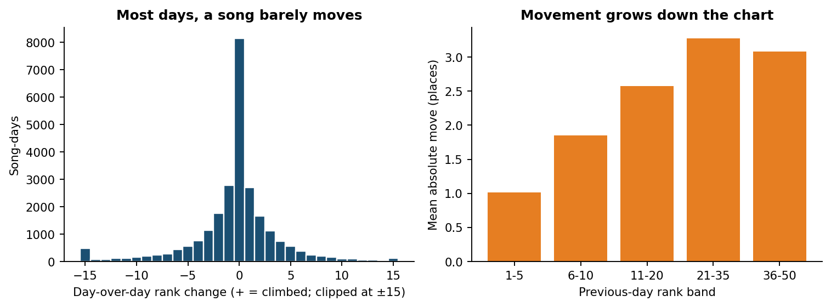
Figure 1. Distribution of day-over-day rank change (left) and mean absolute movement by previous-day rank band (right).
Movement is not uniform. Songs in ranks 1-5 shift an average of 1.0 place per day, rising to 2.6 in ranks 11-20 and 3.3 in ranks 21-35 before levelling off. A song that has reached the top of the chart tends to hold its place, while the middle and lower positions are where reshuffling happens.

3.2 Entry and exit behaviour
On an average day 3.5 songs enter the chart (median 2). 386 days saw three or fewer new songs, while 38 days saw ten or more. The largest single-day turnover was 28 Dec 2024, when 49 of 50 songs were new, followed by 21 Apr 2025 (32) and 29 Jul 2024 (30).
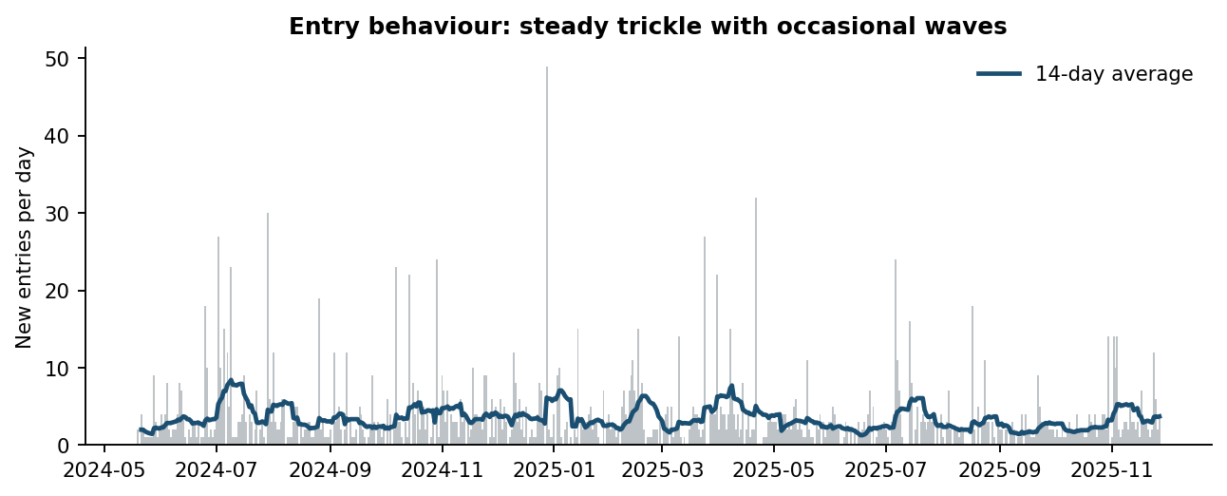
Figure 2. New entries per day with a 14-day moving average. Spikes are album-release or seasonal playlist changes.
Songs most often debut in the middle of the chart: the median entry rank is 23, 25% debut in the Top 10, and 47% debut in the lower half. Exit tells a sharper story: 87% of songs make their last appearance in the lower half and just 3.0% leave from the Top 10. Songs drift down before they leave; they rarely fall off from the top.

3.3 Fast risers and slow decliners
Fast risers are songs with the biggest climb in their first seven days on the chart. Slow decliners are long-running songs (100+ days) that lose rank gradually, measured as the slope of rank against time.
Table 4. Fastest risers (rank on entry vs rank on day 7)
Song | Artist | Entry rank | Day-7 rank | Places gained
Monster Mash | Bobby "Boris" Pickett & The | 44 | 2 | 42
i like the way you kiss me | Artemas | 46 | 6 | 40
It's the Most Wonderful Time of the Year | Andy Williams | 41 | 5 | 36
A Holly Jolly Christmas | Burl Ives | 43 | 8 | 35
End of Beginning | Djo | 43 | 8 | 35
My Love Mine All Mine | Mitski | 50 | 17 | 33
Several of the fastest risers are seasonal catalog songs (Halloween and Christmas titles re-entering at the bottom and reaching the Top 10 within a week), alongside genuinely new hits. 30 songs ran 100+ days while losing under 0.1 places per day. "Something in the Orange" (Zach Bryan) lost only 0.025 places a day over 536 days, roughly one place every 40 days.

4. Song-level performance

4.1 Longevity
Chart presence is highly skewed. The average song lasts 28.4 days but the median is 7; 54% of songs last a week or less. At the other end, 76 songs lasted 100 days or more, and together they occupy 53% of all chart slots.
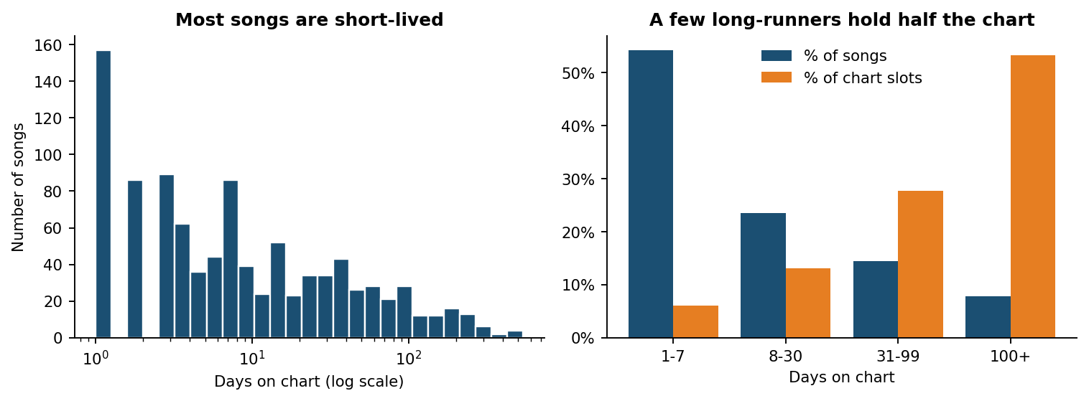
Figure 3. Left: distribution of days on chart (log scale). Right: share of songs versus share of chart slots by longevity band.
Table 5. Songs with the longest playlist presence
Song | Artist | Days | Avg rank | Best | Volatility
Something in the Orange | Zach Bryan | 536 | 26.3 | 9 | 9.3
Last Night | Morgan Wallen | 492 | 22.6 | 1 | 14.6
I Remember Everything (feat. Kacey Mus | Zach Bryan | 446 | 13.9 | 1 | 9.9
See You Again (feat. Kali Uchis) | Tyler, The Creator | 443 | 29.3 | 4 | 11.8
Stick Season | Noah Kahan | 414 | 18.3 | 1 | 11.4
Cruel Summer | Taylor Swift | 388 | 16.9 | 1 | 13.6
Lose Control | Teddy Swims | 329 | 23.5 | 5 | 8.7
Thinkin’ Bout Me | Morgan Wallen | 324 | 39.0 | 21 | 7.1
Beautiful Things | Benson Boone | 307 | 14.7 | 1 | 8.9
You Proof | Morgan Wallen | 302 | 32.6 | 9 | 12.0
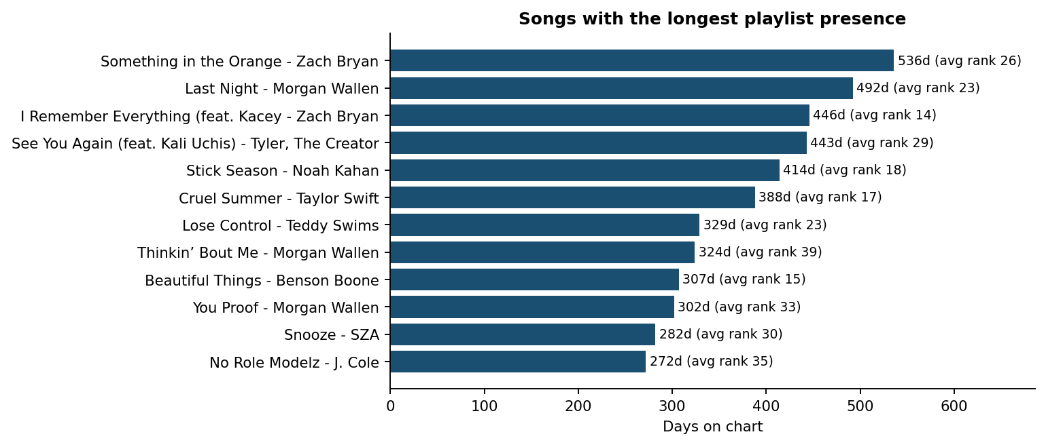
Figure 4. Twelve songs with the longest playlist presence, annotated with average rank.

4.2 Peak rank versus longevity
Reaching a high peak goes with staying longer. The Spearman correlation between best rank and days on chart is -0.58 (a better peak, meaning a lower rank number, goes with more days). The 56 songs that hit #1 lasted a median 95.5 days, against 6 for songs that never did. Songs whose best rank was inside the Top 10 lasted a median 20 days; the 662 songs that never entered the Top 10 lasted 4.
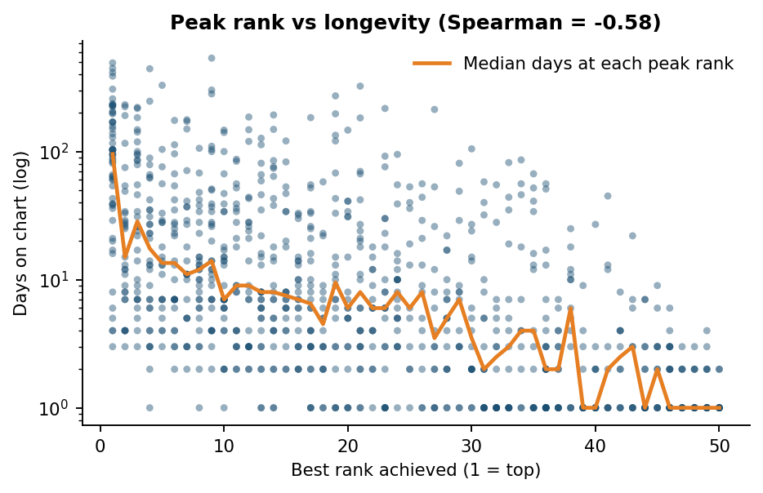
Figure 5. Best rank achieved versus days on chart (log scale). Each dot is a song; the line is the median at each peak rank.
The relationship is not deterministic. Some songs with modest peaks (for example "Thinkin' Bout Me", best rank 21) lasted over 300 days by sitting steadily in the lower-middle of the chart. Longevity is built either by a strong peak or by consistent mid-chart presence.

4.3 Popularity and volatility at song level
Among songs with at least 100 days on chart, the median rank volatility index is 11.1. The most stable were songs parked near the top: "BIRDS OF A FEATHER" (3.1), "Die With A Smile" (3.6), "Who" (5.1). The most volatile were songs with sharp peaks and slow decays: "CARNIVAL" (17.9), "End of Beginning" (16.2), "redrum" (15.5). The highest average popularity among songs with 30+ days belonged to "un x100to" (99.2) and "LALA" (98.7).

5. Artist performance
243 primary artists appear in the data. 141 of them (58%) placed exactly one song. At the top, Taylor Swift accounts for 7.3% of all chart slots across 96 different songs, followed by Zach Bryan (6.8%) and Morgan Wallen (6.0%). The top 3 artists together hold 20.1% of the chart and the top 10 hold 39.9%.
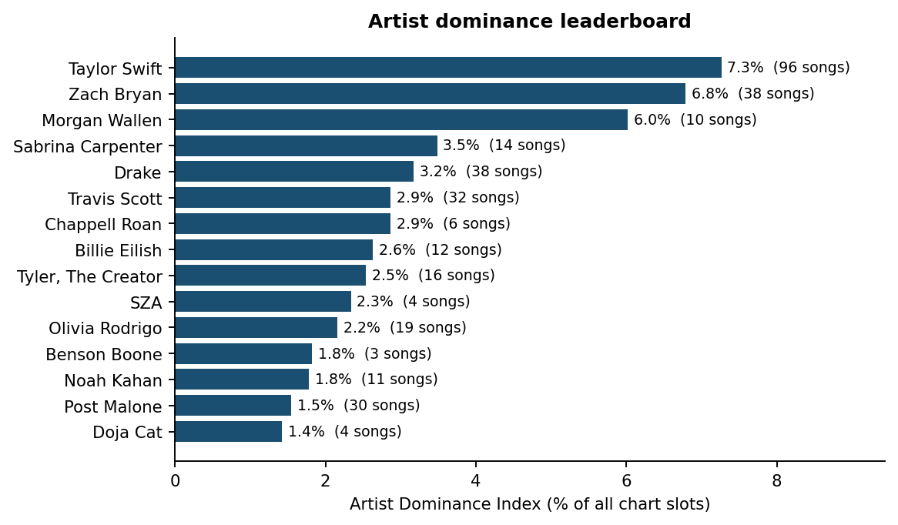
Figure 6. Artist Dominance Index: share of all chart slots by primary artist, with number of unique songs charted.
Table 6. Artist leaderboard (top 10)
Artist | Unique songs | Days on chart | Slots | Avg rank | Dominance
Taylor Swift | 96 | 438 | 2,015 | 24.6 | 7.3%
Zach Bryan | 38 | 546 | 1,882 | 25.7 | 6.8%
Morgan Wallen | 10 | 540 | 1,669 | 30.6 | 6.0%
Sabrina Carpenter | 14 | 316 | 967 | 17.6 | 3.5%
Drake | 38 | 326 | 881 | 26.3 | 3.2%
Travis Scott | 32 | 338 | 795 | 25.5 | 2.9%
Chappell Roan | 6 | 232 | 794 | 20.6 | 2.9%
Billie Eilish | 12 | 333 | 729 | 20.4 | 2.6%
Tyler, The Creator | 16 | 444 | 705 | 25.3 | 2.5%
SZA | 4 | 401 | 649 | 26.2 | 2.3%

Different routes to dominance
The leaderboard hides two distinct patterns. Taylor Swift dominates through breadth: 96 songs appear but each spends few days (about 21 slots per song), and presence is concentrated in a release window. Morgan Wallen takes 6.0% of slots with only 10 songs, so each song is a long-runner. Zach Bryan combines both: 38 songs and presence on 546 of 555 days, the highest of any artist.
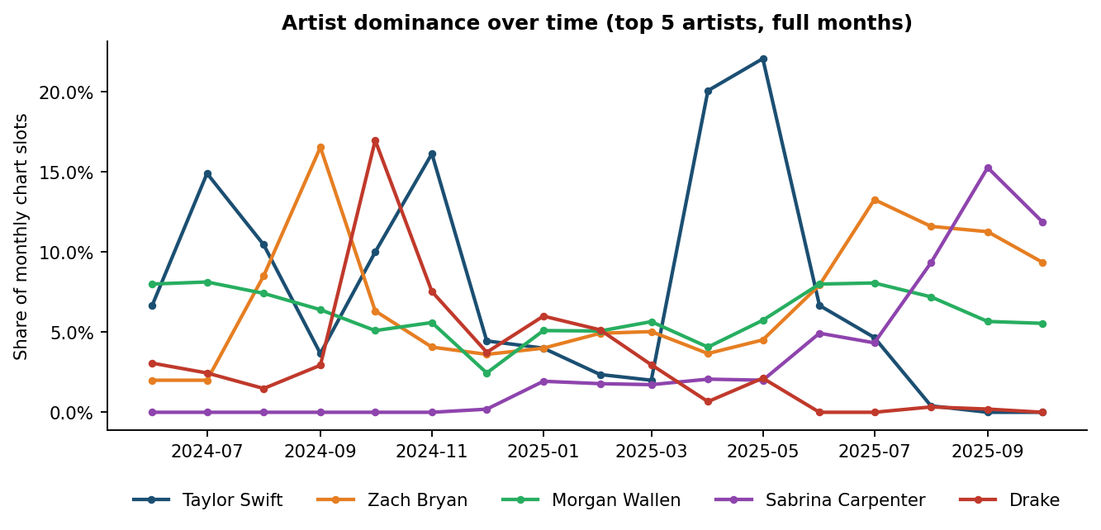
Figure 7. Monthly share of chart slots for the five most frequent artists (full months only; dates as supplied in the file).
Dominance is episodic. The highest monthly shares were Taylor Swift in May 2025 (22%), Taylor Swift in Apr 2025 (20%), Drake in Oct 2024 (17%), each tied to a release wave, and each later fading as other artists rose. A strong artist presence therefore depends on the release calendar, not just on a long-term audience.

6. Popularity score analytics

6.1 Popularity versus rank
Popularity scores in the Top 50 are high and compressed: the average is 88.3 and 92% of slots score 80 or more. The relationship with rank is negative but modest (Spearman rho = -0.26), meaning higher-ranked positions tend to carry higher popularity, with lots of overlap.
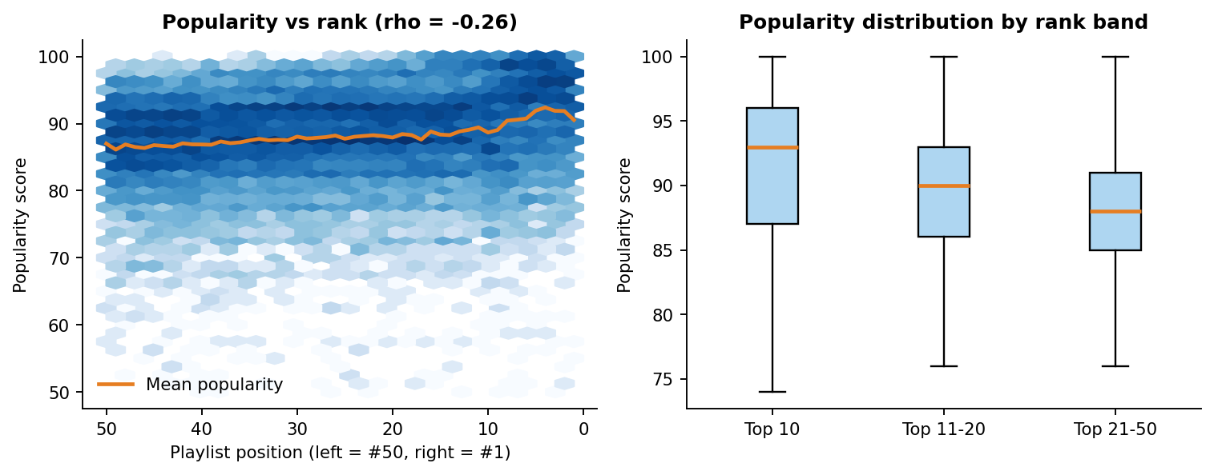
Figure 8. Popularity versus playlist position (left, with mean popularity per position) and popularity by rank band (right).
Table 7. Popularity by rank band
Rank band | Mean | Median | Std. dev.
Top 10 | 90.81 | 93 | 8.67
Top 11-20 | 88.50 | 90 | 7.52
Top 21-50 | 87.34 | 88 | 6.98
The Top 10 averages 90.8 against 87.3 for ranks 21-50, a gap of about 3.5 points. The Top 10 also has the widest spread (std. dev. 8.7), because a handful of weeks with lower popularity scores sit inside it.

6.2 Popularity as a longevity signal
At song level, average popularity is a strong companion to longevity: the correlation between a song's mean popularity and its days on chart is 0.71. Popularity is therefore more informative about how long a song lasts than about its rank on any single day.

6.3 Popularity stability versus chart volatility
For songs with at least 14 days on chart, the median within-song popularity standard deviation is 2.9 points, small next to the median rank volatility of 10.2 places. The two are modestly linked (rho = 0.26): songs whose popularity swings more also tend to swing more in rank. A song's average popularity level is unrelated to its rank volatility (rho = 0.00), so popular songs are not necessarily more stable.
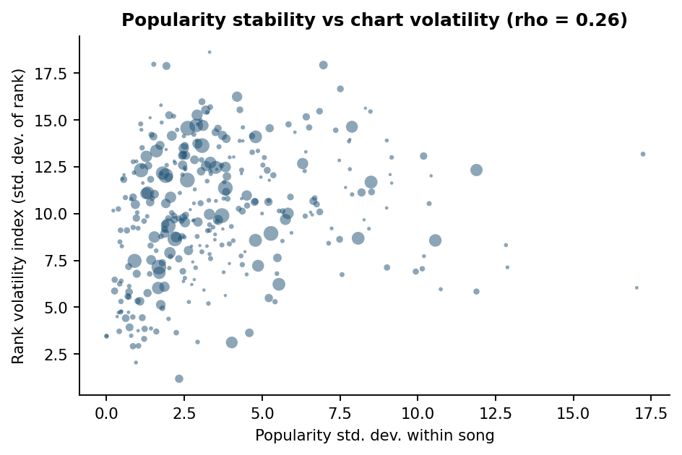
Figure 9. Within-song popularity standard deviation versus rank volatility index (bubble size = days on chart).

7. Content attribute analysis

7.1 Explicit versus non-explicit
Explicit songs account for 47.9% of all chart slots, with no large difference by rank band (Top 10: 49.2%, ranks 21-50: 47.9%). Explicit songs average rank 25.4 versus 25.6, and popularity 88.1 versus 88.4.
Table 8. Explicit versus non-explicit
Group | Songs | Slots | Avg rank | Avg popularity | Top-10 share | Median days
Explicit | 512 | 13,303 | 25.39 | 88.13 | 20.5% | 6
Non-explicit | 465 | 14,447 | 25.60 | 88.38 | 19.5% | 7
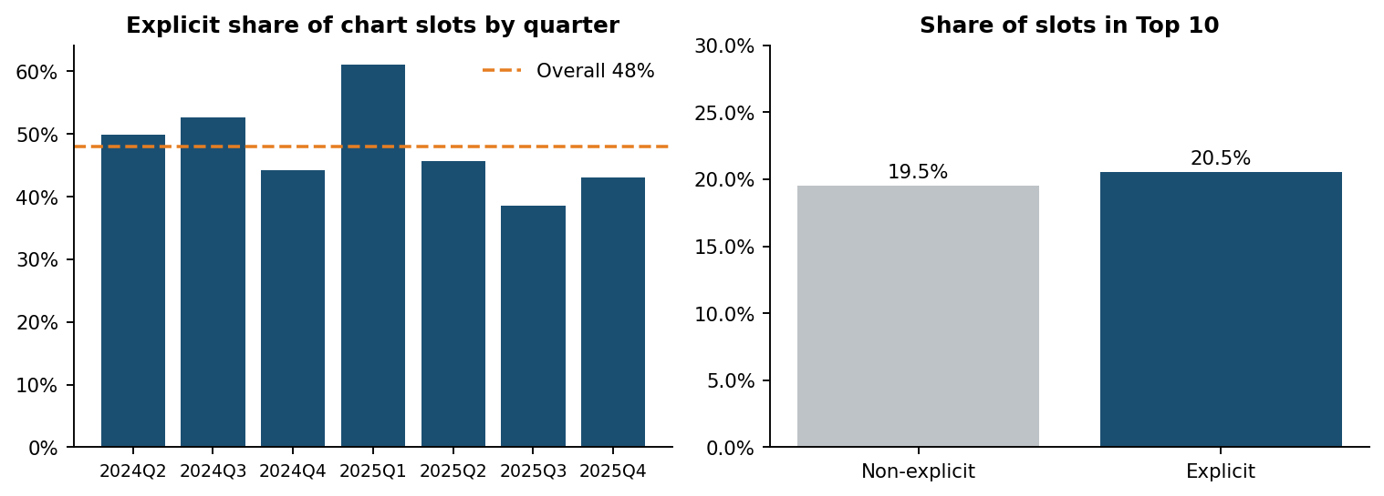
Figure 10. Explicit share of chart slots by quarter (left) and Top-10 share for explicit versus non-explicit songs (right).
The difference in longevity between explicit and clean songs is not statistically significant (Mann-Whitney p = 0.076), and the popularity gap is 0.25 points. The explicit share does vary by quarter, from 39% to 61%, which reflects which albums were on the chart rather than a performance advantage.

7.2 Single versus album tracks
Table 9. Release type comparison
Type | Songs | Slots | Avg rank | Avg popularity | Top-10 share | Median days
Single | 243 | 8,001 | 24.0 | 90.5 | 25.1% | 13
Album | 725 | 19,707 | 26.1 | 87.4 | 18.0% | 6
Compilation | 9 | 42 | 33.2 | 78.4 | 7.1% | 2
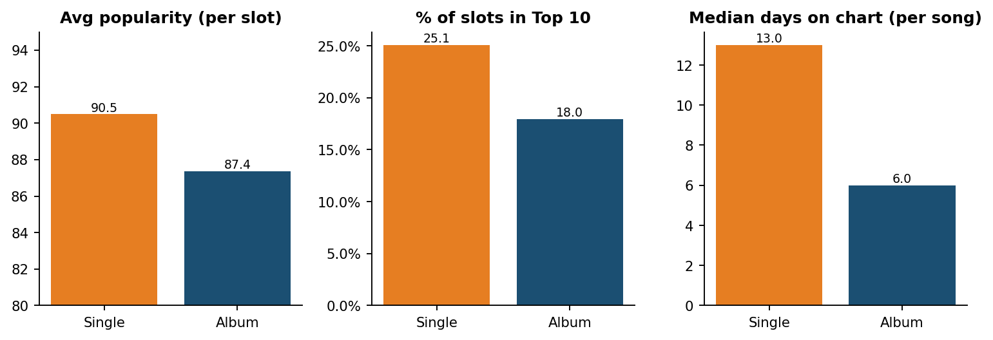
Figure 11. Singles versus album tracks: popularity, Top-10 share and median days on chart.
Singles are the strongest performers. They reach the Top 10 in 25.1% of their slots versus 18.0% for album tracks, carry higher popularity (90.5 vs 87.4) and last twice as long at the median (13 vs 6 days; Mann-Whitney p < 0.001). Compilation tracks are too rare (9 songs, 42 slots) to draw conclusions, though they rank lower on every measure.
Interpretation: this comparison mixes marketing intent with song quality. Labels typically promote singles harder, so the gap likely reflects release strategy as well as format.

7.3 Duration and album size
Song length averages 3.4 minutes (median 3.4; range 0.6 to 12.3). Duration has almost no association with popularity (rho = 0.00), rank (rho = -0.04) or longevity (rho = -0.06). Songs over five minutes have a slightly better average rank but the shortest median chart life, so there is no length that reliably helps.
Album size shows a clearer pattern. Releases with a single track last a median 17 days, against 7 to 8 for releases with 2 to 15 tracks and 5 for those with 16 to 20 (correlation of total tracks with days on chart: rho = -0.17). This is largely the singles effect again, as single-track releases are singles by definition. Large albums spread listening across many songs, which shortens each song's stay.
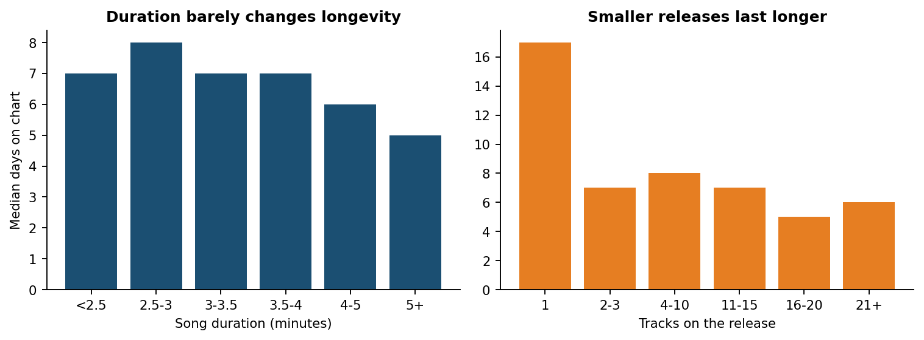
Figure 12. Median days on chart by song duration (left) and by number of tracks on the release (right).

8. Key performance indicators
Table 10. KPI summary for the full period
KPI | Value | How to read it
Days on Chart (median) | 7 | Typical song lasts a week; the longest, 536 days
Average Rank | 25.5 | Mid-chart by construction; useful for comparing songs and groups
Rank Volatility Index | 9.9 | Mean standard deviation of rank, songs with 7+ days
Popularity Score Trend | 88.3 | Average score; range of monthly means 86.0 to 90.7
Artist Dominance Index (leader) | 7.3% | Taylor Swift's share of all chart slots
Explicit Content Share | 47.9% | Share of chart slots held by explicit songs

9. Insights and recommendations
The recommendations below follow directly from the evidence in this report. Each describes what the historical data supports; none is a prediction.
- Judge a release by its first two weeks, then back it. Half of all songs vanish within a week, while fast risers show momentum quickly (e.g. i like the way you kiss me went from #46 to #6 in seven days). Concentrate marketing spend on songs that are climbing early, because climbers that reach the Top 10 rarely leave from there.
- Lead with singles; use albums to feed the catalog. Single releases give the best Top-10 conversion and longevity. Album tracks still matter for artist share, but they dilute attention across many songs.
- Plan release windows around turnover waves. Large entry days (28 Dec 2024: 49 new songs; 21 Apr 2025: 32 new songs; 29 Jul 2024: 30 new songs) are when the chart reshuffles. Releasing into those windows means competing for the same slots; releasing in quieter weeks (386 days had three or fewer new entries) gives a new song a clearer path.
- Treat seasonal catalog as a recurring asset. Holiday and Halloween songs were among the fastest risers (Monster Mash climbed 44 to 2 in a week). Catalog owners can plan annual re-promotion.
- Do not engineer songs for length or explicit flags. Neither shows a meaningful relationship with chart performance in this data, so content decisions should rest on other factors.
- Use popularity as a long-run signal, with days-on-chart and volatility beside it. Scores cluster high (92% of slots are 80 or above), so they separate rank bands only modestly (rho = -0.26), but a song's average popularity tracks its longevity strongly (rho = 0.71).

10. Limitations and next steps
- The data covers only the Top 50. Songs that are popular but ranked below 50 are invisible, so days on chart and entry rank are truncated at the 50-position boundary.
- There are no stream counts or revenue figures. Findings describe chart behaviour, not financial return, and cannot yet be tied to marketing spend.
- The analysis is observational. Differences between singles and album tracks, for example, include marketing intent and artist profile as well as format.
- The calendar dates appear to be offset by one year (Section 2.3). This does not affect ranking, longevity or attribute findings but does affect date labels, and should be confirmed.
- One snapshot (1 March 2025) was loaded twice with different content, four days are missing, and 189 popularity values were recorded as zero. All are handled and disclosed, but they add small uncertainty.
- Seasonal songs (Christmas, Halloween) re-enter every year and are treated as separate runs within a single song record; a longer window would show their yearly pattern.
Suggested next steps: validate the date offset; add stream and revenue data to connect rank to financial outcomes; extend the window to cover a full second year so seasonality can be separated from release cycles; and track Atlantic-owned artists as a labelled group in the dashboard.

11. Conclusion
US Top 50 playlist success is defined by persistence. Most songs pass through in days, while a small group of long-running songs occupies the majority of the chart. Peak rank is the best early sign of that persistence, the top of the chart is stable, and the churn happens lower down. Artist visibility moves in release-driven waves, and singles convert to Top-10 placement and longevity better than album tracks. Explicit content and song length, by contrast, make no meaningful difference. For Atlantic Recording Corporation this points to a clear strategy: back songs that climb early, lead with singles, time releases around chart turnover, and keep catalog and seasonal songs active.

Appendix: dashboard guide and reproducibility
Running the dashboard. Install the requirements and run the app from the project folder:
pip install -r requirements.txt
streamlit run app.py
Table 11. Dashboard modules
Tab | Contents
Playlist timeline | Snapshot explorer with album art and daily movement, rank distribution of long-runners, entries and exits, fast risers and slow decliners
Song trends | Rank and popularity-trend charts for chosen songs, song scorecard, peak rank versus longevity
Artist dominance | Leaderboard (primary or full credit), dominance over time, repeat appearances
Popularity vs rank | Scatter with mean line, distribution by rank band, stability versus volatility
Explicit vs non-explicit | Performance panel, explicit share over time and by rank band
Content attributes | Single vs album, duration and album-size comparisons
Data & quality | Validation summary and filtered CSV download
Filters. Date range, rank-range slider, album-type selection, explicit toggle, artist selection and song-title search apply to every tab.
Files. analytics.py (cleaning, features, KPIs), app.py (dashboard), run_analysis.py (figures and statistics for this report), build_report.js (this document).

