**NORTH SOUTH UNIVERSITY**



**Department of Electrical and Computer Engineering**

**Summer 2019**

**Report**

**BCD to 7-segment display**

Course code: CSE231

Course name: Digital Logic Design

Sec: 6

Group: 03

Submitted to:

Group members:

Name ​ ​ ​ ​ ​ ​ ​ID

Irtiza Nahian Faiza Sanha ​ ​ ​ ​ ​1520448042

Shah Alam Chowdhury ​ ​ ​ ​ ​1430501042

Abhijit Paul ​ ​ ​ ​ 1511562042

Md Faisal 1821725042

**Acknowledgement**

**The completion of this project could not have been possible without the participation and assistance of so many people whose names may not all be mentioned. The contributions are sincerely appreciated and gratefully acknowledged. However, the group would like to express their deep appreciation and indebtedness particularly to the following:**

**Rishad Arfin, our honorable faculty member for his support, kind and understanding spirit during our presentation.**

**To all friends and others who shared the support financially or physically, thank you.**

**Above all, to the Great Almighty, the author of knowledge and wisdom.**

**We thank you.**

​

**Table of contents**

|  |  |  |
| --- | --- | --- |
|  | Title | Page Number |
| 1 | Cover Page | 1 |
| 2 | Acknowledgement | 2 |
| 3 | Introduction | 4 |
| 4 | 1.1 Project Description | 4 |
| 5 | 1.2 Project Gantt Chart | 4 |
| 6 | Design | 5 |
| 7 | 2.1 Design of Combinational Logic Circuit | 5 |
| 8 | 2.2 Justification of Choice of Design | 6 |
| 9 | 2.3 Simulation of Combinational Circuit | 7 |
| 10 | 2.4 Design of Sequential Logic Circuit | 7 |
| 11 | State Diagram | 7 |
| 12 | Characteristic Table of Design | 8 |
| 13 | K-Map | 9 |
| 14 | 2.5 Justification of choice of Design | 9 |
| 15 | 2.6 Simulation of Digital Logic Circuit | 10 |
| 16 | 3. Implementation | 12 |
| 17 | Description | 12 |
| 18 | Equipment Required | 12 |
| 19 | Hardware Used | 13 |
| 20 | Conclusion | 15 |
| 21 | 4.2 Difficulties Faced | 15 |
| 22 | 4.3 Future Recommendation | 15 |
| 23 | 5. Appendix A | 16 |

1. **Introduction**

1.1 **Project description**

This is a BCD to seven segment display project. This project consists of two main parts. Sequential logic circuit and combinational logic circuit.

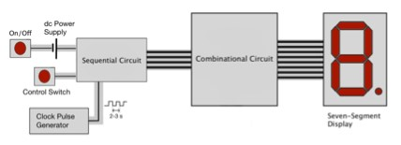

Figure 1: Circuit block diagram. Sequential circuit produces a sequence of codes. Code from sequential circuit is decoded by combinational circuit to light up corresponding segments of a seven-segment display.

Consider the digital system shown in Fig. 1. Switching on the circuit results in a string of characters “CSE231-6-3” being scrolled between 10 seven-segment display at a set time interval of 1-2 seconds.

The sequential logic circuit produces a sequence of codes that are required to represent the string of characters for the seven-segment display. A control switch is present to change the direction of the sequence moving forward or backward. The sequential logic circuit is connected to a seven-segment display via a combinational logic circuit. The latter decodes the input codes from the sequential logic circuit in order to drive the individual segments of the seven-segment display to show each character as dictated.

# 1.2 Project Gantt chart

Start date End date Duration

Combinational Circuit Aug’22 Feb’22 1-day Design

|  |  |  |  |
| --- | --- | --- | --- |
| Combinational Circuit Implementation | Aug’ 28 | Aug’ 30 | 3 days |
| Sequential Circuit Design | Aug’23 | Aug’ 24 | 2 days |
| Final project setup | Aug 30 | Aug 31 | 2 days |

1. **Design**

# 2.1 Design of Combinational Logic circuit

|  |  |  |  |
| --- | --- | --- | --- |
| Reference | Character | WXYZ | abcdefg |
| 0 | C | 0000 | 1001110 |
| 1 | S | 0001 | 1011011 |
| 2 | E | 0010 | 1001111 |
| 3 | 2 | 0011 | 1101101 |
| 4 | 3 | 0100 | 1111001 |
| 5 | 1 | 0101 | 0110000 |
| 6  7  8  9  10  11  12  13  14  15 | -  6  -  3  *  *  *  *  *  * | 0110  0111  1000  1001  1010  1011  1100  1101  1111 | 0000001  1011111  0000001  1111001  *******  *******  *******  *******  ******* |
|

**Figure: Truth Table**

**K-Maps**

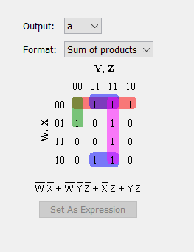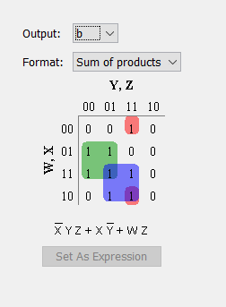

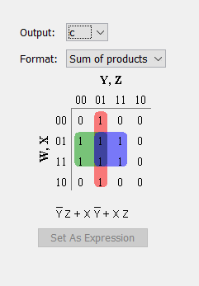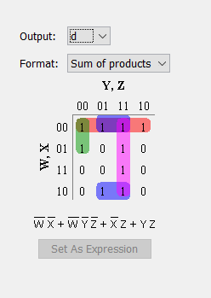

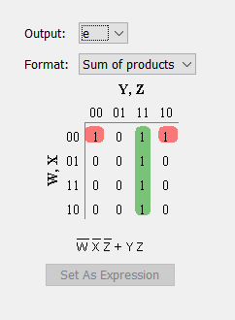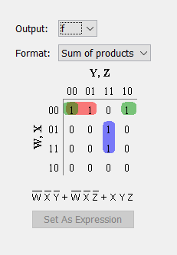

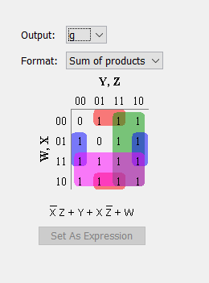

# 2.2 Justification of choice of design

We have used the minimal of basic gates of AND and OR gates for combinational logic circuit. Since this circuit has the minimum number of logic gates, it will be cost efficient. No other gates are needed rather than only AND, OR and NOT gates.

# 2.3 Simulation of Combinational circuit

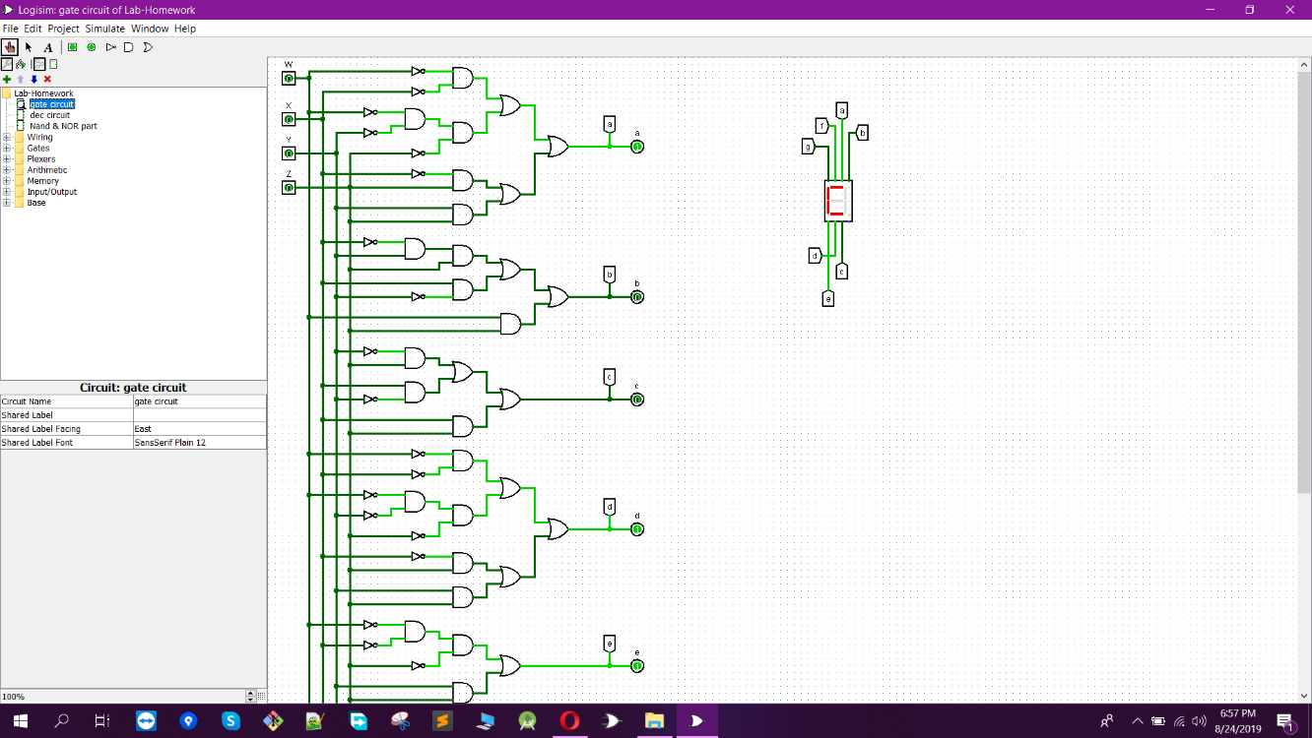

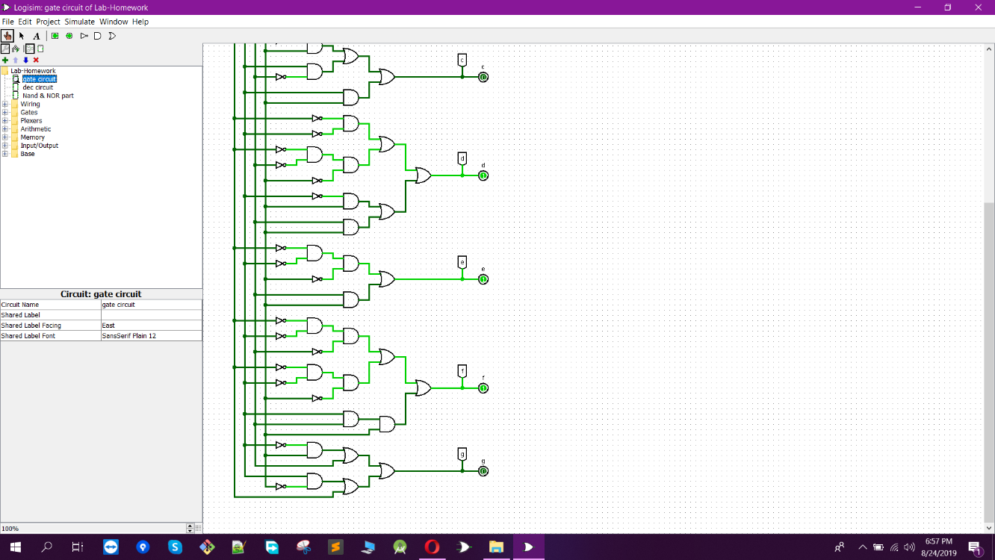

​ ​ ​ ​ ​ ​

**2.4** **Design of Sequential Logic circuit**

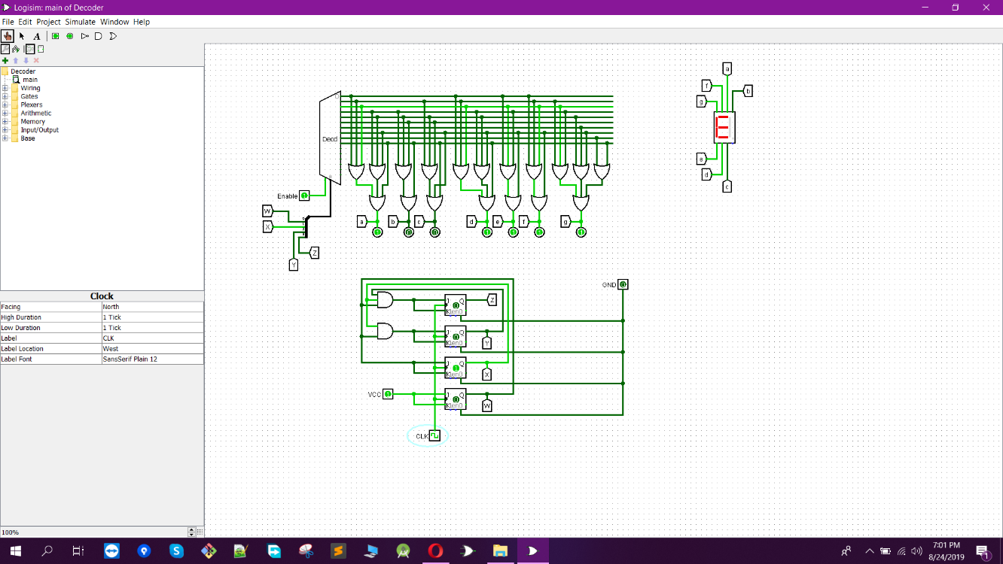

​ ​ ​ ​ ​

Figure: Sequential Logic Circuit

**Figure: State Diagram of the Design**

|  |  |  |
| --- | --- | --- |
| Present State | Next State | Output |

|  |  |  |  |  |  |  |  |  |  |  |  |  |  |
| --- | --- | --- | --- | --- | --- | --- | --- | --- | --- | --- | --- | --- | --- |
|  | Wt | Xt | Yt | Zt | Wt+1 | Xt+1 | Yt+1 | Zt+1 | Tw | Tx | Ty | Tz | Display |
| 0 | 0 | 0 | 0 | 0 | 0 | 0 | 0 | 1 | 0 | 0 | 0 | 1 | C |
| 1 | 0 | 0 | 0 | 1 | 0 | 0 | 1 | 0 | 0 | 0 | 1 | 1 | S |
| 2 | 0 | 0 | 1 | 0 | 0 | 0 | 1 | 1 | 0 | 0 | 0 | 1 | E |
| 3 | 0 | 0 | 1 | 1 | 0 | 1 | 0 | 0 | 0 | 1 | 1 | 1 | 2 |
| 4 | 0 | 1 | 0 | 0 | 0 | 1 | 0 | 1 | 0 | 0 | 0 | 1 | 3 |
| 5 | 0 | 1 | 0 | 1 | 0 | 1 | 1 | 0 | 0 | 0 | 1 | 1 | 1 |
| 6 | 0 | 1 | 1 | 0 | 0 | 1 | 1 | 1 | 0 | 0 | 1 | 1 | - |
| 7 | 0 | 1 | 1 | 1 | 1 | 0 | 0 | 0 | 1 | 1 | 1 | 1 | 6 |
| 8 | 1 | 0 | 0 | 0 | 1 | 0 | 0 | 1 | 0 | 0 | 0 | 1 | - |
| 9 | 1 | 0 | 0 | 1 | 0 | 0 | 0 | 0 | 1 | 0 | 0 | 1 | 3 |

**Figure: Characteristic Table of the Design**

**K-Maps**

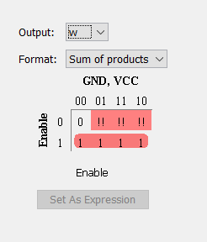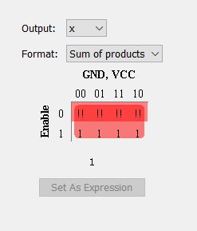

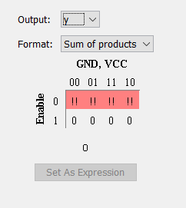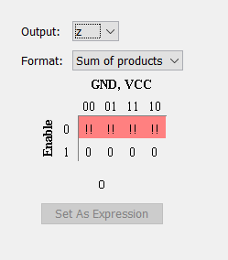

## 2.5 Justification of choice of design

The sequential logic circuit we chose to build is using two 8:1 MUX and three T flip flops. If we use T flip flop then TC becomes 1 so we need 1 MUX less in our circuit.

But the alternate circuits need more ICs in place of MUX. The output logic circuit is simply a decoder and OR gates where only 2 ICs are need. So, these choices made our circuit cost efficient.

## 2.6 ​Simulation of Digital Logic circuit





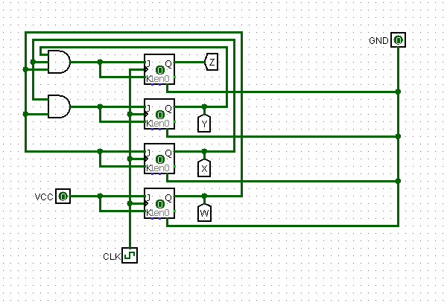

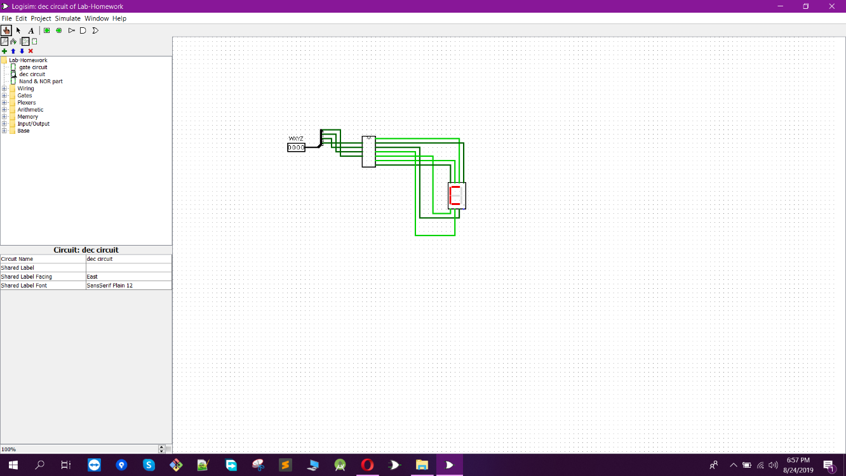

1. **Implementation**

## Description

The circuit we have built can be divided into 3 groups, sequential logic, combinational logic and output logic. In the sequential logic, we have used AND, OR, NOT gates, JK Flipflops, amplifier, 7-segment display, 555 timer ic, LEDs. The flipflops changes the states with every clock pulse. The connection goes to the 7-Segment Display followed by the combinational circuit of the sequence. The output is observed from the 7-segment display.

​

## Equipment Required

|  |  |  |  |  |
| --- | --- | --- | --- | --- |
|  | Component | IC Number | Quantity | Price |
| 1 | 3 input OR gate | IC7411 | 3 | 22*3=66 |
| 2 | Display | Common Cathode 7 segment Display | 1 | 13 |
| 3 | Timer | IC555 | 1 | 8 |
| 4 | J-K flip flop | IC7476 | 2 | 24 |
| 5 | 2 input AND gate | IC7408 | 4 | 25*4=100 |
| 6 | Resistors | - | 2 | 4 |
| 7 | LED | - | 1 | 2 |
| 8 | Wires | - | As required | 150 |
| 9 | Bread Board | - | 4 | 90*4=360 |
| 10 | Battery | - | 3 (9v) | 45 |
| Total |  |  |  | 772 |

## Hardware used

1. 7411 IC

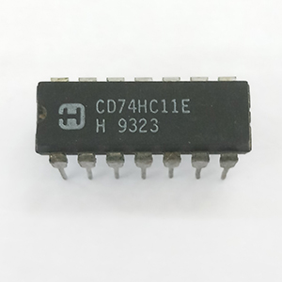

1. 7476 IC

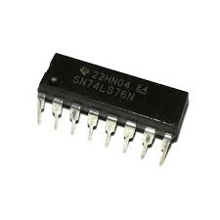

1. 7408 IC

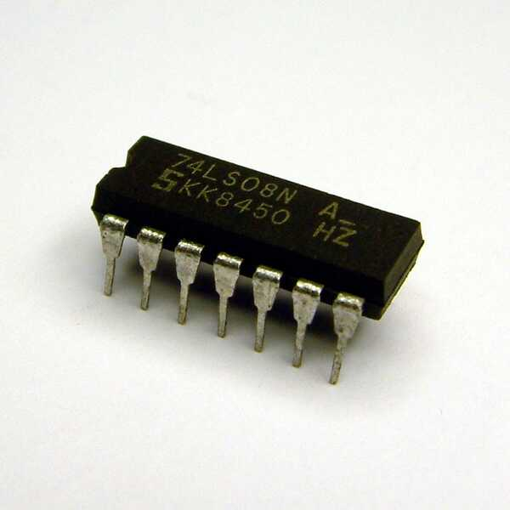

1. LED

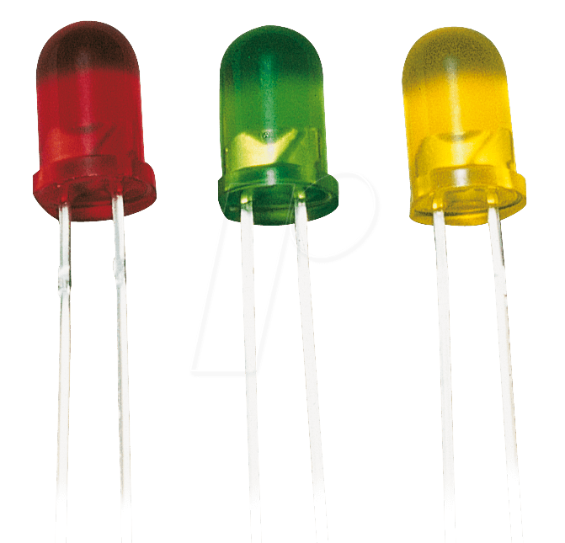

1. Breadboard

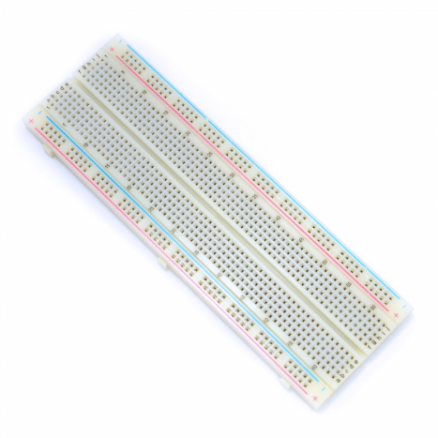

1. 7-Segment Display

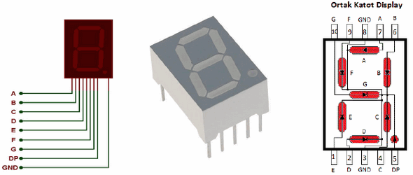

1. Battery

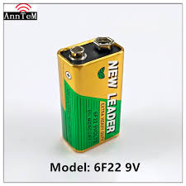

1. **Conclusion**

Despite of all the hardships, we have been able to complete the project successfully. We have made the connections as shown in the schematic diagrams. We are delighted to say that the circuit is working fine and the characters are also scrolling through the 7-segment display.

## 4.2 Difficulties faced

Throughout this project we have face many difficulties. Starting from implementation, we tried implementing the circuit using decoder, but for unavailability we could not get active-high decoder and proper outputs did not show with active-low decoder. So, we had to switch to basic gates. This took our time and also couple LEDs got damaged. Also, we had to check each ICs and flipflops and 7-segment display before using them to avoid faulty equipment. We had to be very careful with all the devices because of their sensitivity. We had to learn how to build clock pulse with the help of Google, which was very confusing and also consumed a lot of time.

## 4.3 Future Recommendation

We implement this circuit for lengthier displays. We can also use multiple displays to scroll a string of characters for general purpose to print different messages in public places. This can be used for practical purpose as signboards or etc.

1. **Appendix A**

**Logisim schematics of alternate combinational logic circuits**

