Question 1[2 marks]

Finish following requirements. Please note that you are asked to use git bash

1) Follow link to setup your username for every repository on your machine as your first name and last name e.g. John Smith so that your professor can identify you
2) Follow link to setup email for every repository on your machine, please make sure to use your my.centennialcollege.ca email address
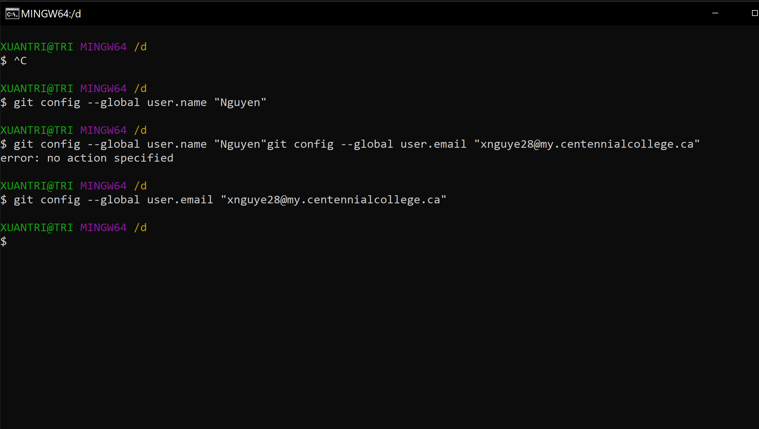
3) Sign up with GitHub using your my.centennialcollege.ca email
4) Create a GitHub PAT(Personal Access Token) and keep it safe somewhere because it will be required in future labs
I already sign up previously.
Provide screenshots to demonstrate that you have already done what are required

Question 2 [4 marks]

Practice most commonly used git commands on a local git repository by using git bash

1) Create a local git repository on your machine named comp367(yourlastname)-lab1(e.g., comp367Li-lab1)
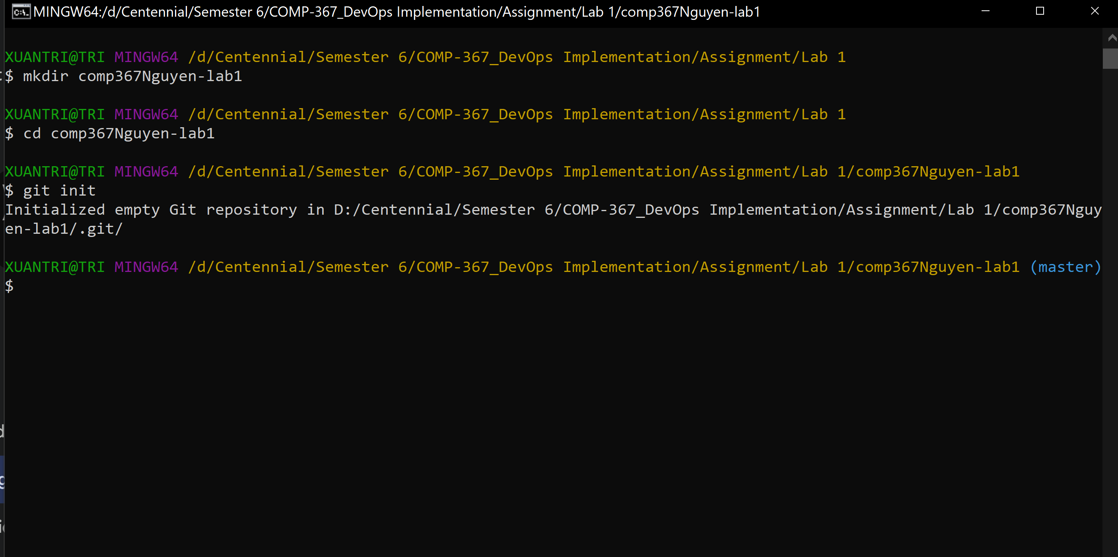
2) Create a file README.md and add your name and email address as the contents, make intentional typing error(s)
3) Add README.md file to your repository with “my first commit” as commit message
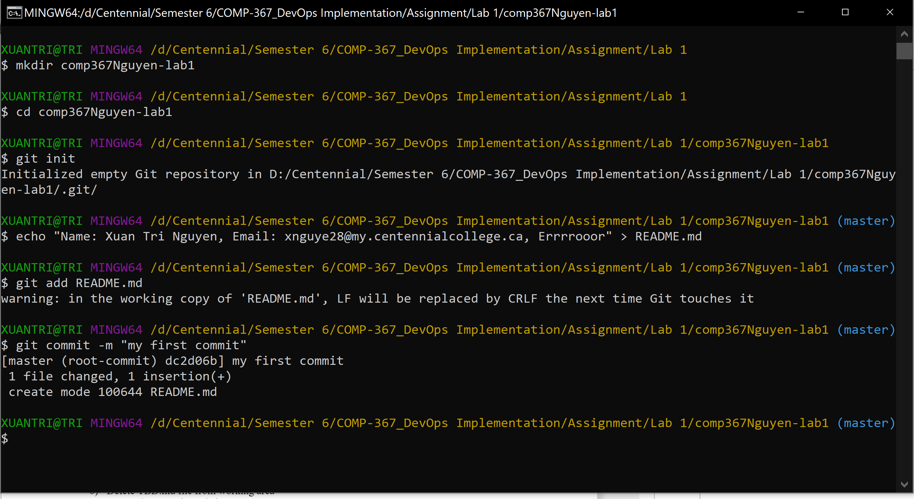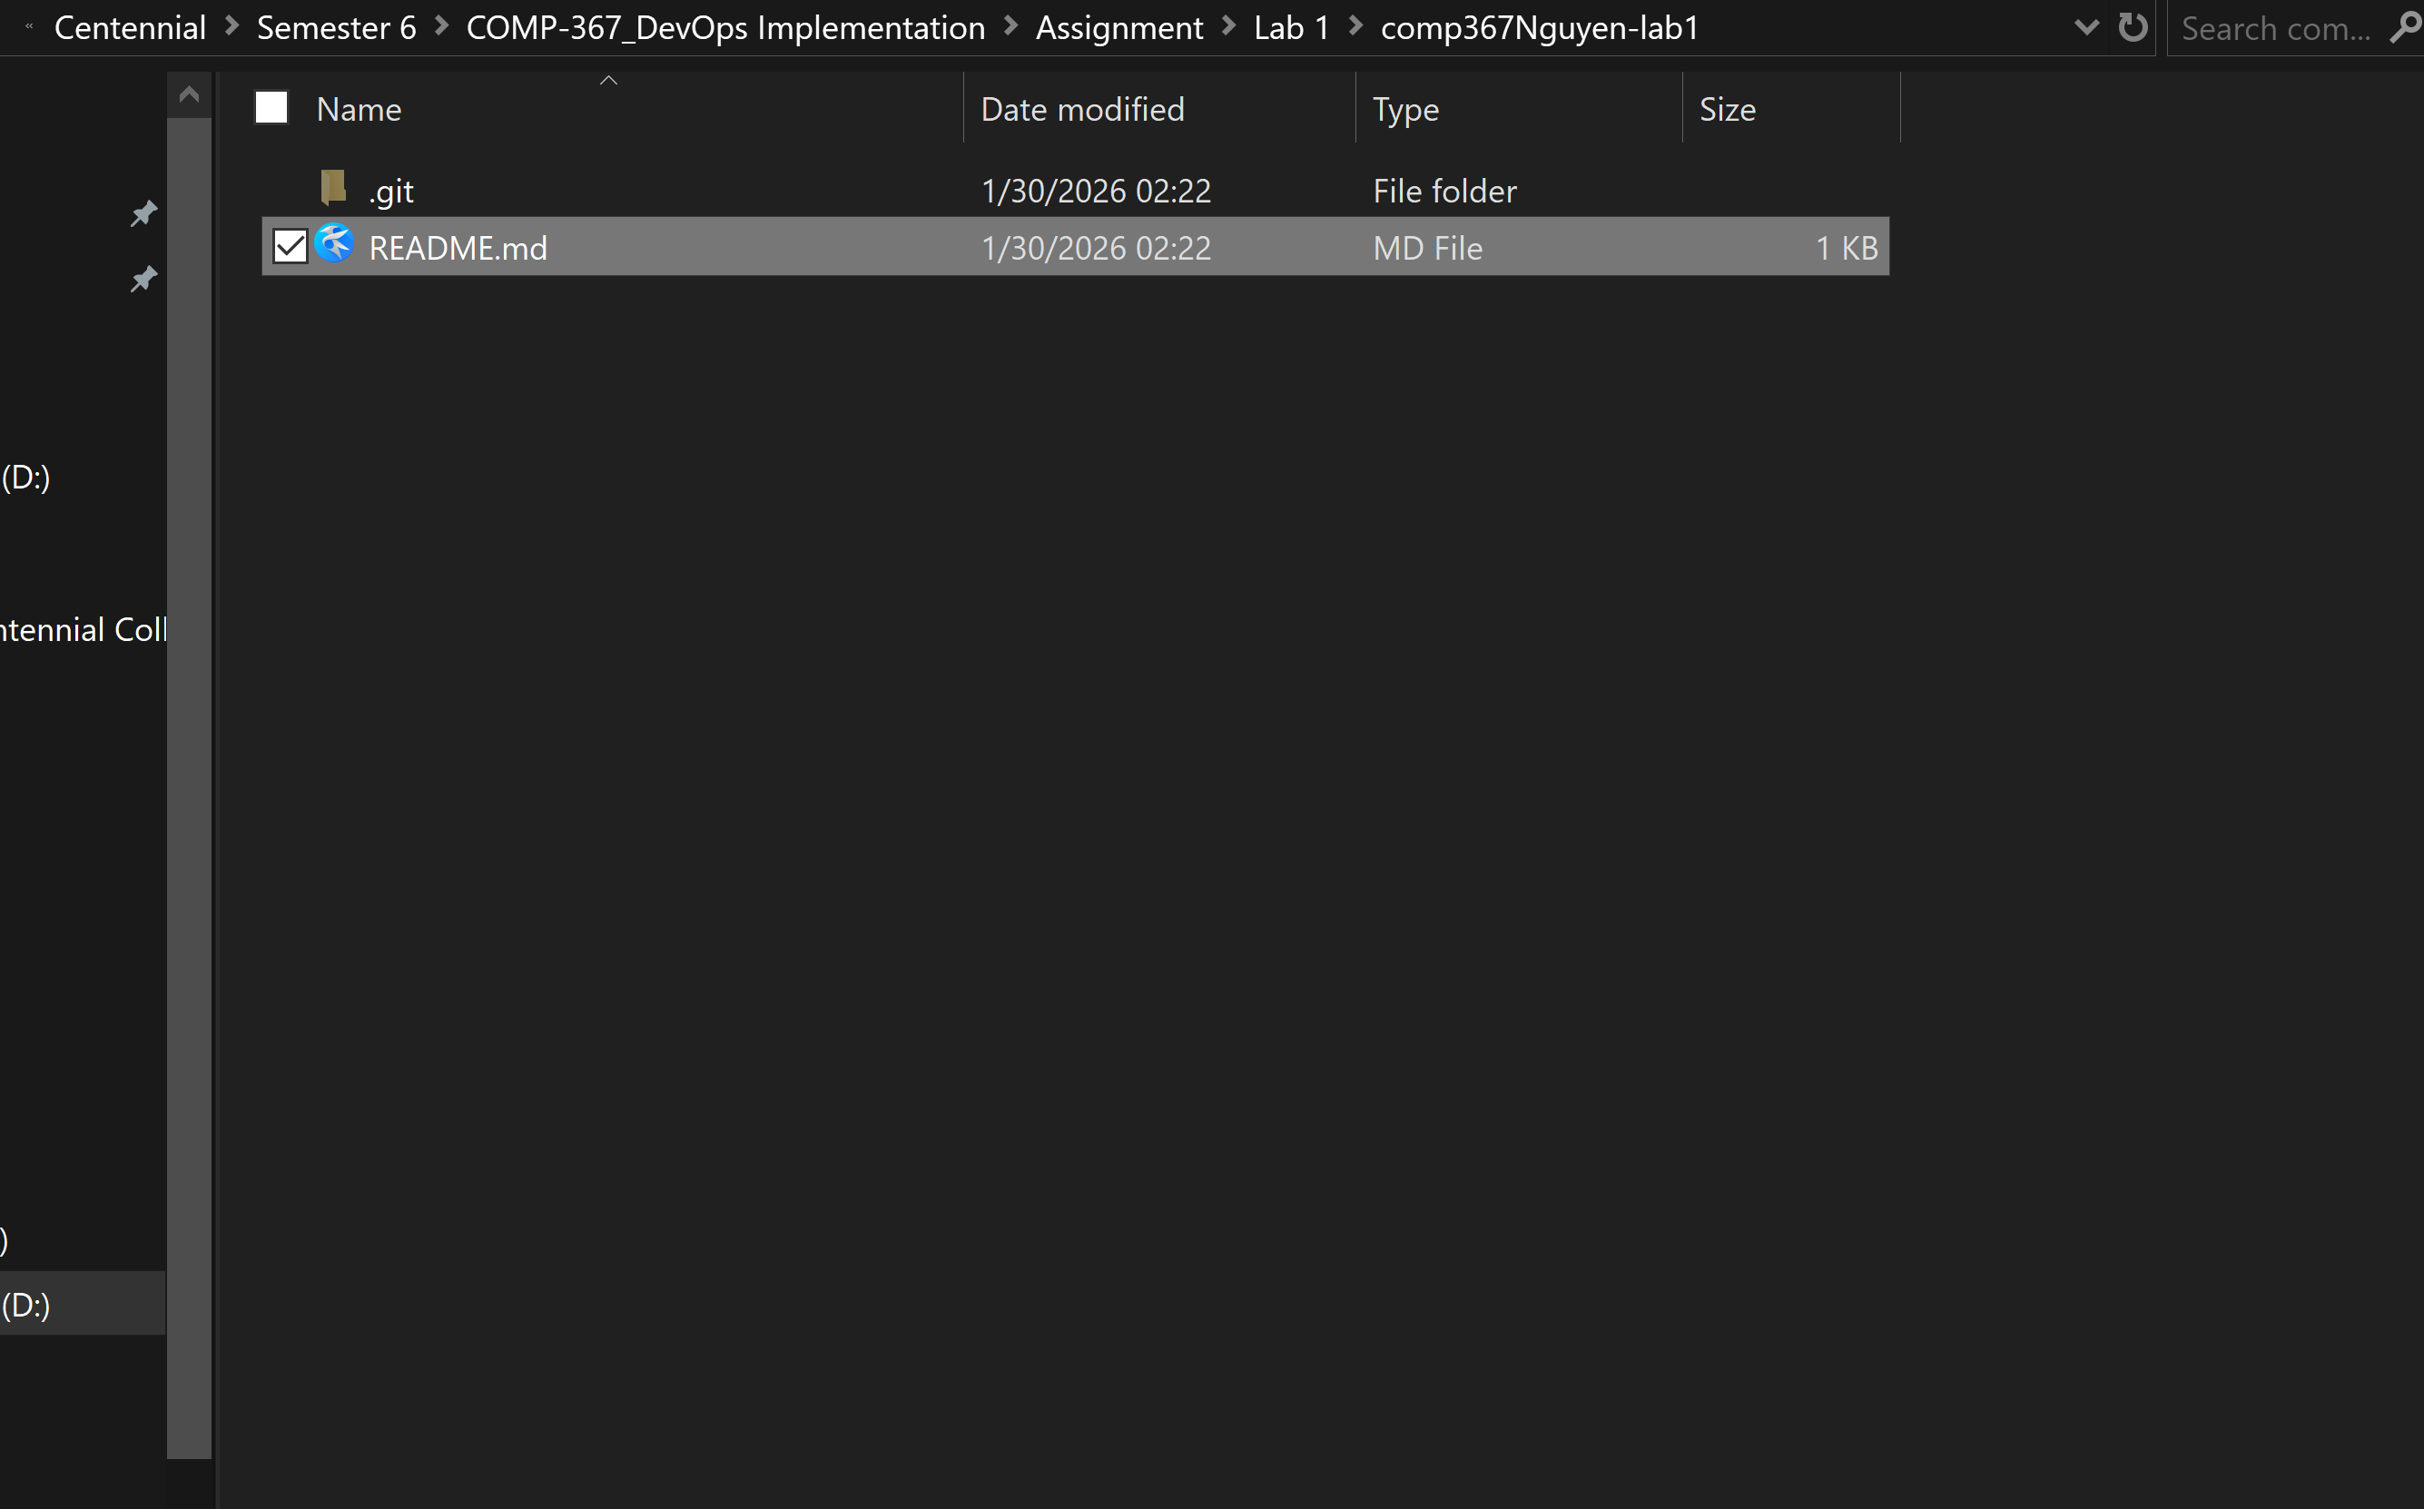
4) Add a new file name TBD.md and add your name and email address as the contents
5) Add TBD.md file to your git repository with “my second commit” as commit message
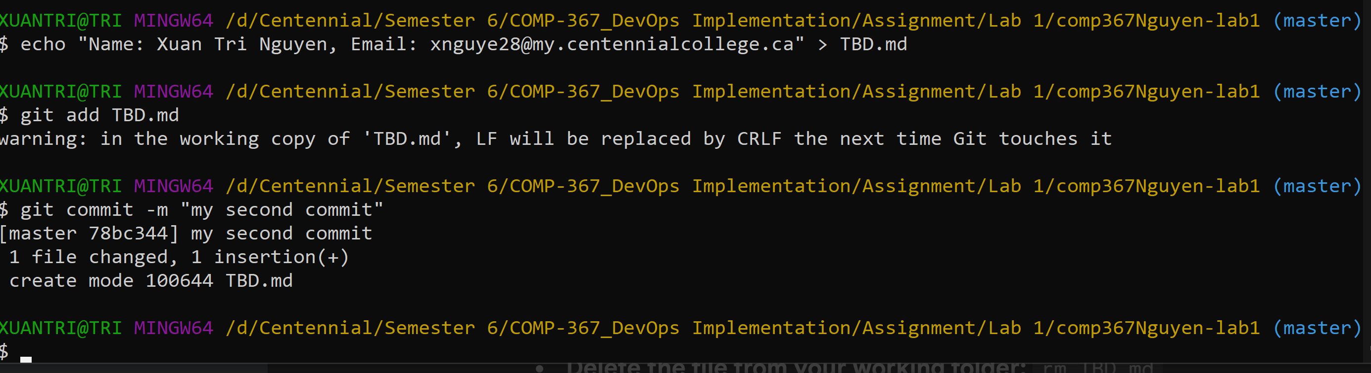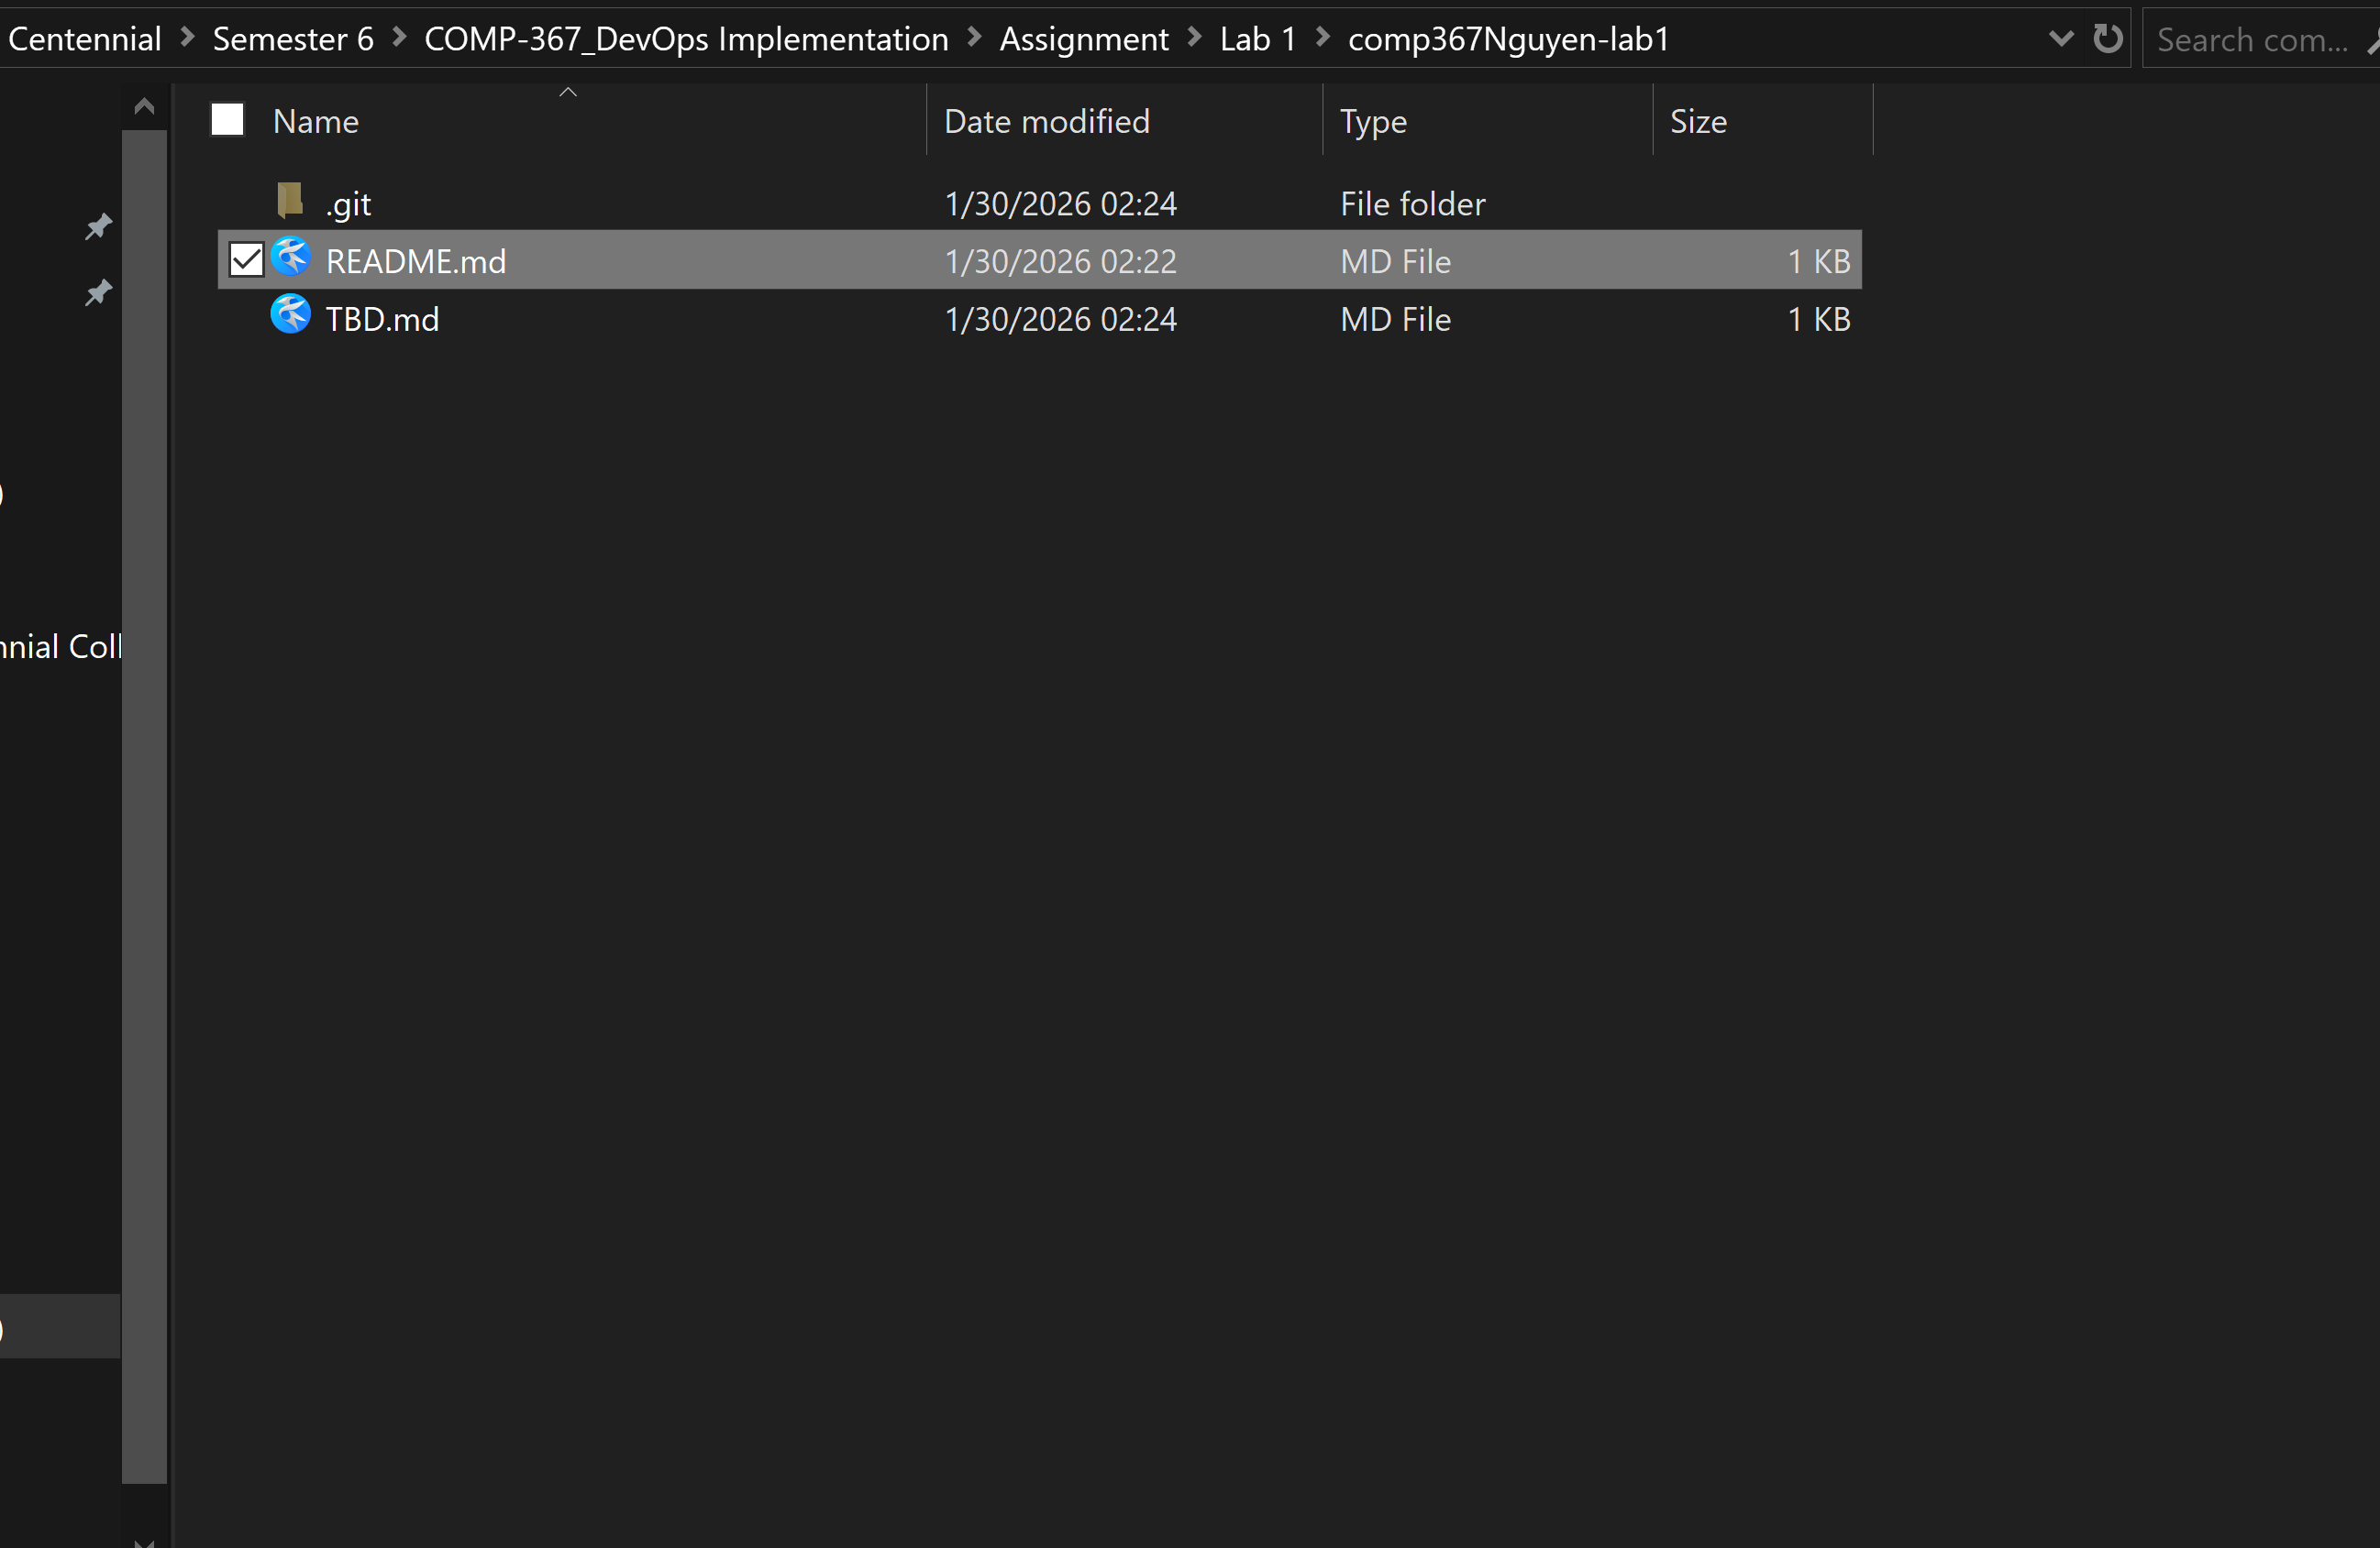
6) Delete TBD.md file from working area
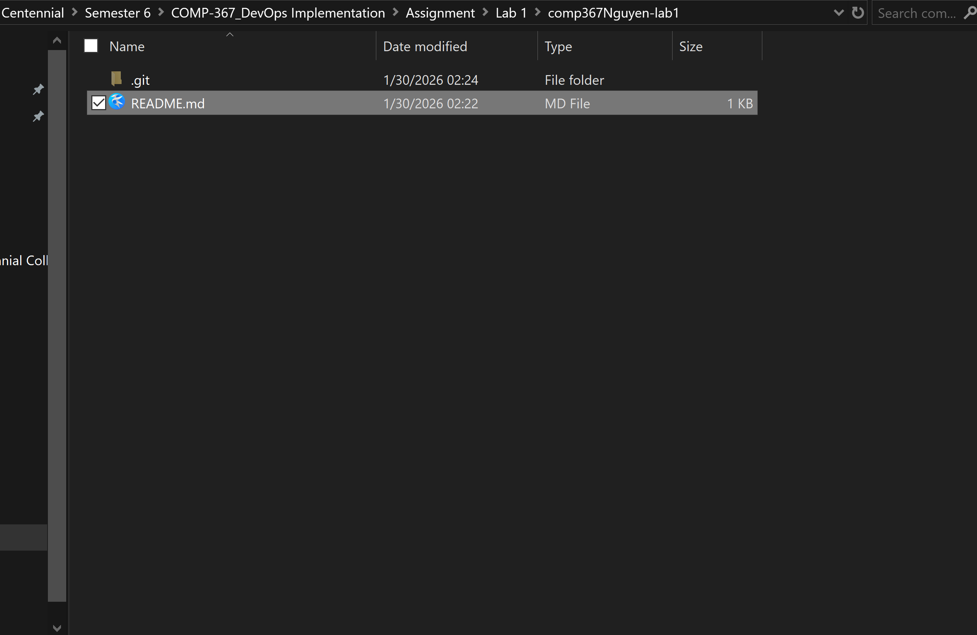
7) Revert the commit made in step 3
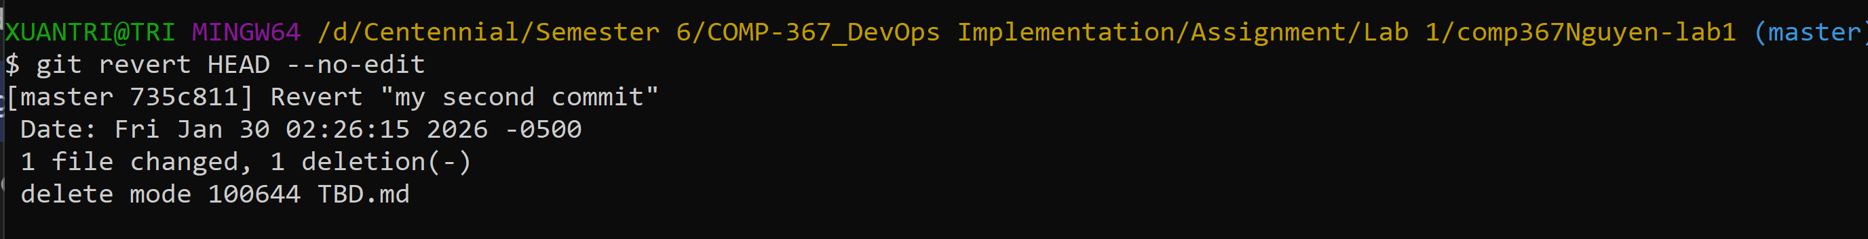
8) Correct the README.md and commit
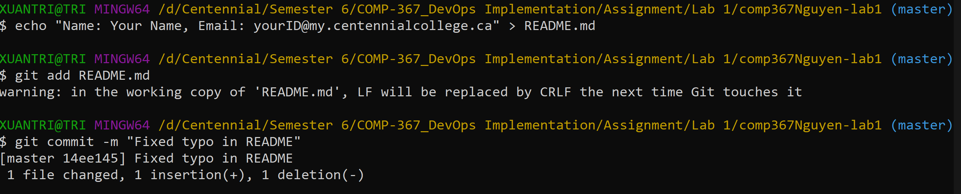
Include the screenshot of the output of git log --oneline command in your submission

Question 3 [2 marks]

Implement a web app by finishing the tutorial at https://docs.microsoft.com/en-us/visualstudio/get-started/csharp/tutorial-aspnet-core?view=vs-2022. Create a Git repository and push it to GitHub. Please make sure to use public repo so that your professor can access it.
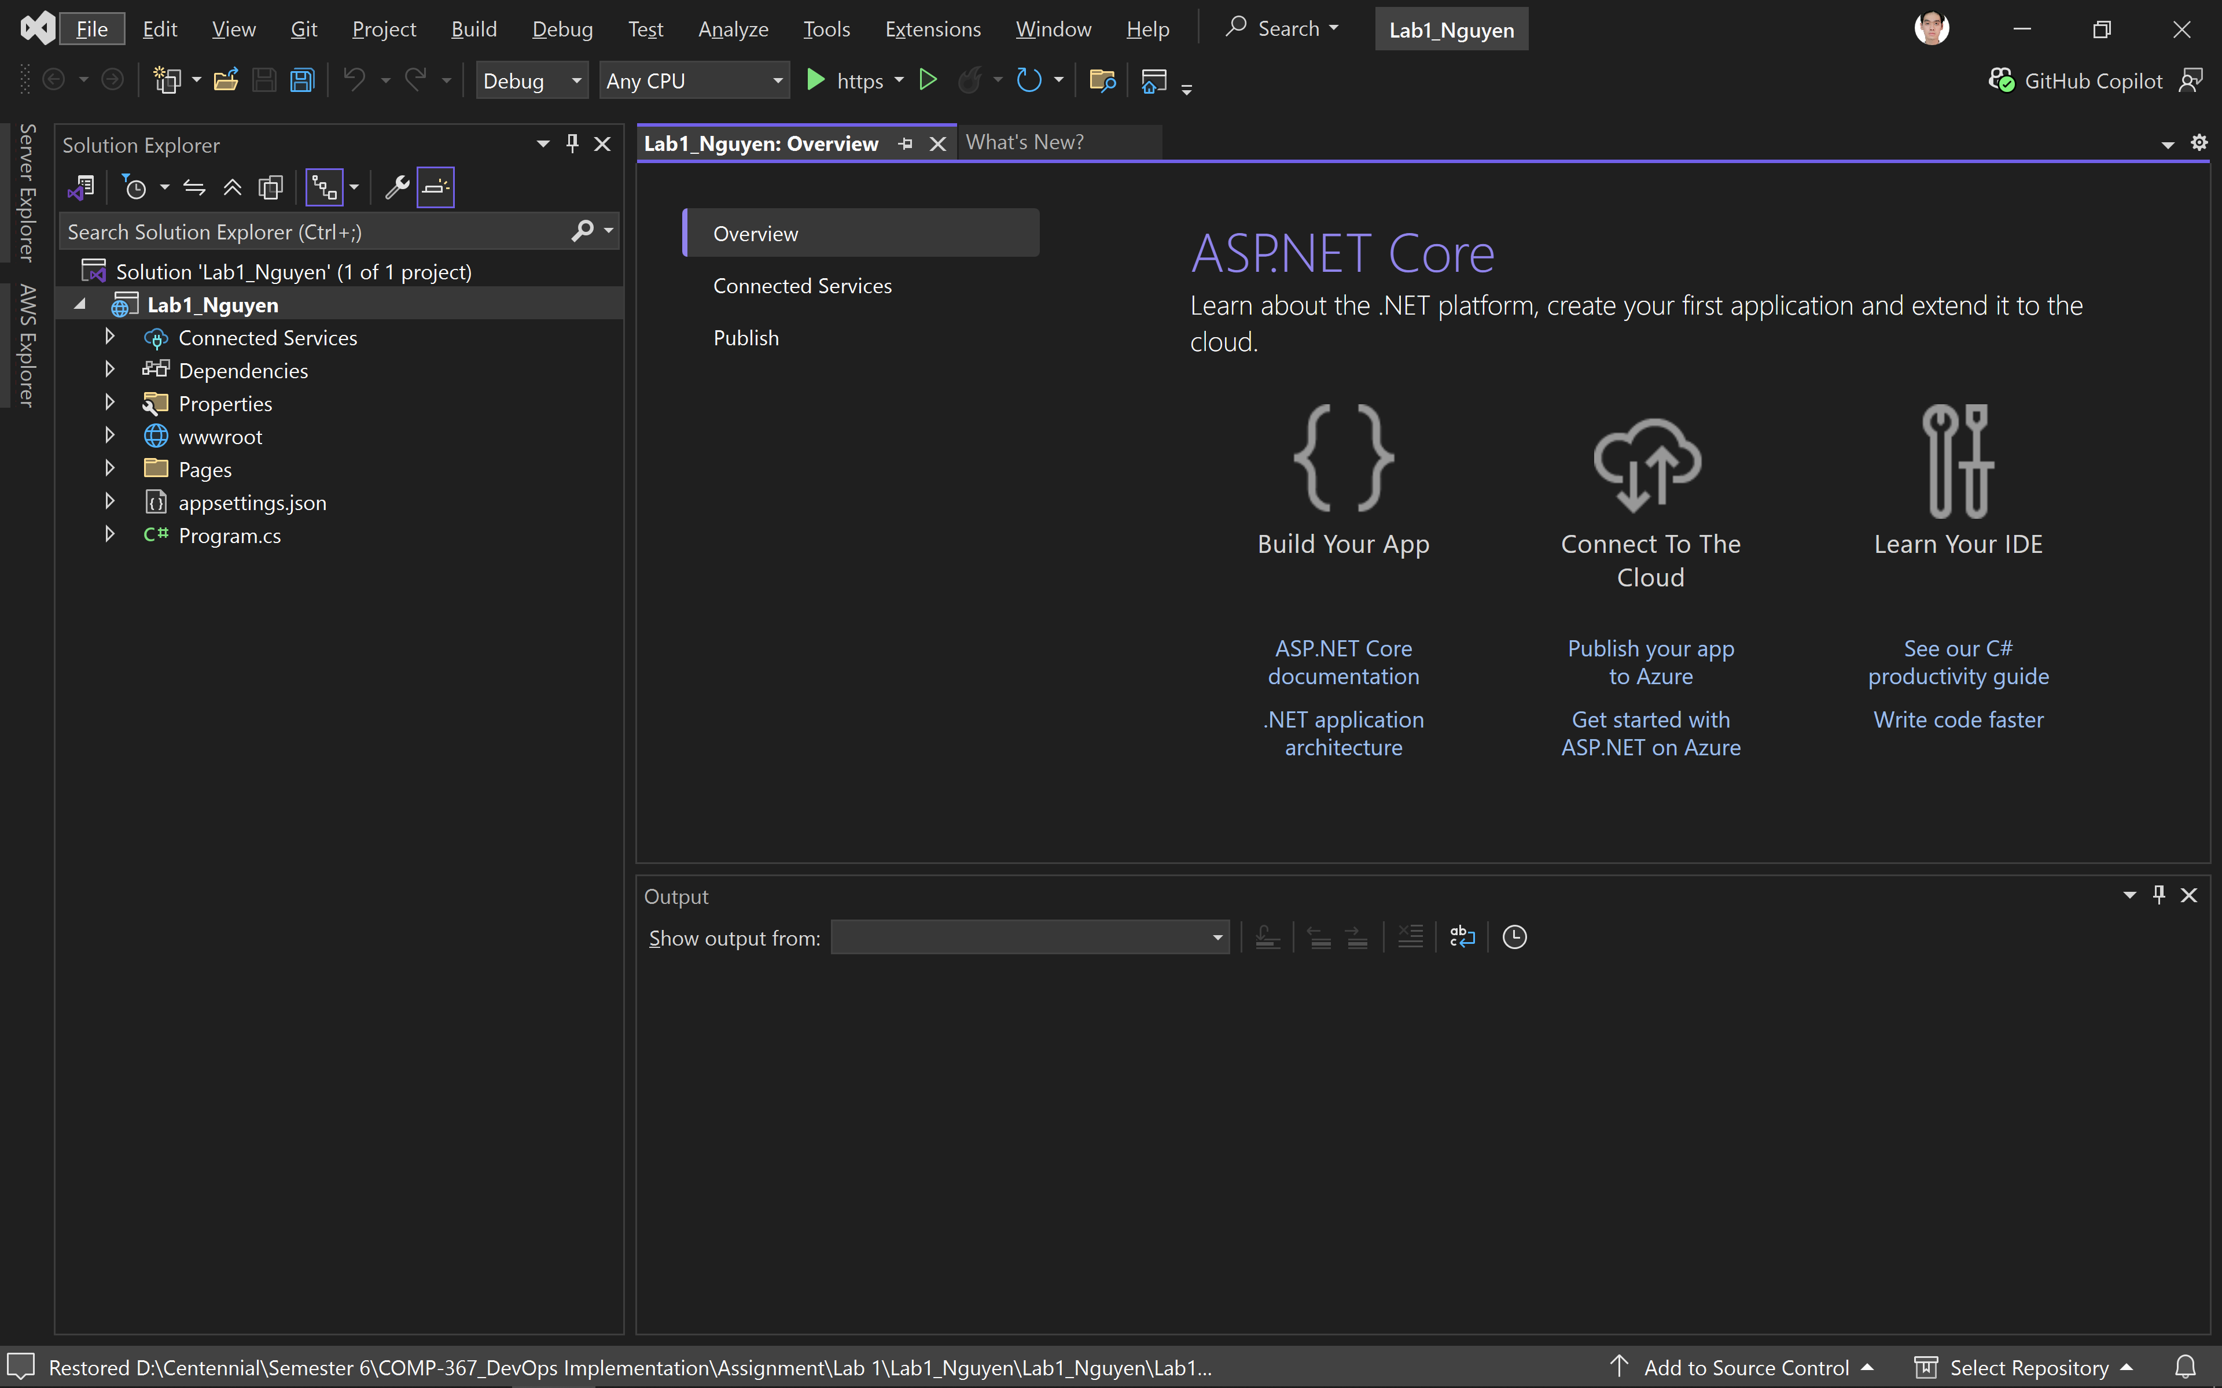
Include the URL of your repo on github.com in your submission

Question 4 [3 marks]

This question is to continue Question 3 by modifying the project so that “Hello Your name” will be displayed rather than “Hello world”. Please finish following steps:
1) Create a new issue with proper title and add label to this issue
2) Create a branch with proper name
3) Change the code
4) Create .gitignore file and ignore the obj directory and Properties directory
5) Commit your changes with a proper message
6) Push to GitHub

Include screenshot of the output of git log –oneline command, URL of your GitHub issue, and .gitignore file

Question 5 [3 marks]

This question is to continue Question 4 by merging the branch created in Question 4 by finishing following steps:
1) Create a pull request with proper description
2) Add a reviewer for the pull request (Hint: you can sign up two GitHub account, one uses your college email, the other uses your personal email)
3) The reviewer adds some comments (e.g., some change suggestions)
4) After the suggested change has been made, the reviewer approves the pull request
5) Merge the branch to the main branch
6) Make sure that the associated issue is automatically closed upon merging

Include screenshot of the output of git log command, URL of the pull request, and URL of the issue

Question 6 [1 mark]

I have used Git and GitHub for approximately 4 years. The main purpose for me to use Git and GitHub has been to manage source code for my college assignments, collaborate with my group members on projects like our Arjo case study, and maintain a version history of my lab exercises to prevent data loss.

https://github.com/irtnaux0910/Lab1_Nguyen

