**Temperature anomalies in selected regions**

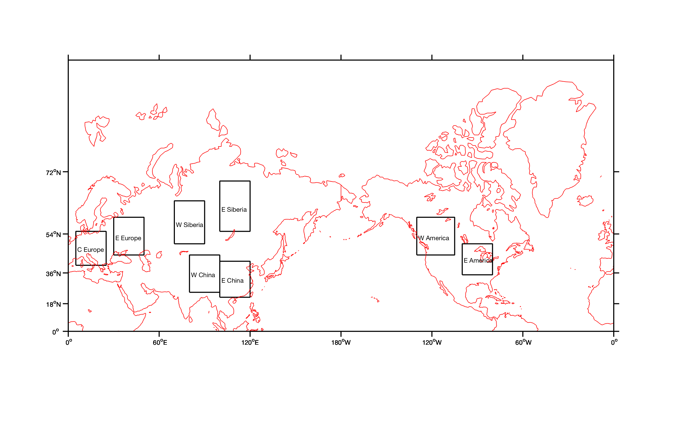

**Fig. 1.** Selected regions.

Daily temperature anomalies were analysed in six regions over the NH for two seasons (JFM and JAS). Winter and summer seasons were shifted by one month to correspond better with the sea ice annual cycle as we aim to link mid latitudinal anomalies to the advection (or absence of such) from the polar regions.

Method:

* For the period 1980-2017 daily 2m temperature anomalies from climatological mean for each day were derived from ERA-Interim. The data for 29 February were excluded from the analysis.
* 15 or 9 day running average was applied to all data. For the start of the year the data from the previous years were added for averaging. (No averaging, also considered here, is sometimes referred as 0-day averaging in the plots.)
* For each region averaged temperature was calculated for each day of the season.
* For each region, all seasons were stacked together to get a time series of 38x90 and 38x92 values for winter and summer, respectively.
* Estimated standard deviation of temperature for each region and season.
* Looked for 15 most strong positive and negative anomalies for each region/season. A 60 day window was applied to all temperature anomalies, meaning that all data 30 days before and after an extreme temperature event were removed from the analysis. This is done to make sure that all anomalies are independent form each other.
* Plotted raw and normalized (by standard deviation) anomalies.

Figure 2 shows the *dates* of positive and negative summer anomalies. Note, that X axis shows days, with labels marking the start of each season, i.e. there can be up to three anomaly per year (given the 60-day window).

!!! there is might be a problem with x axis labelling. E.g. heatwave in 2010 seems to be marked as 2009, I’ll need to fix it, I believe that it is plotting problem though. This applies to all other plots

The plot suggests an increase in the number of warm anomalies in Europe from 1992 and, in particular, in China since 1997. For other regions warm anomalies seem to be equally distributed.

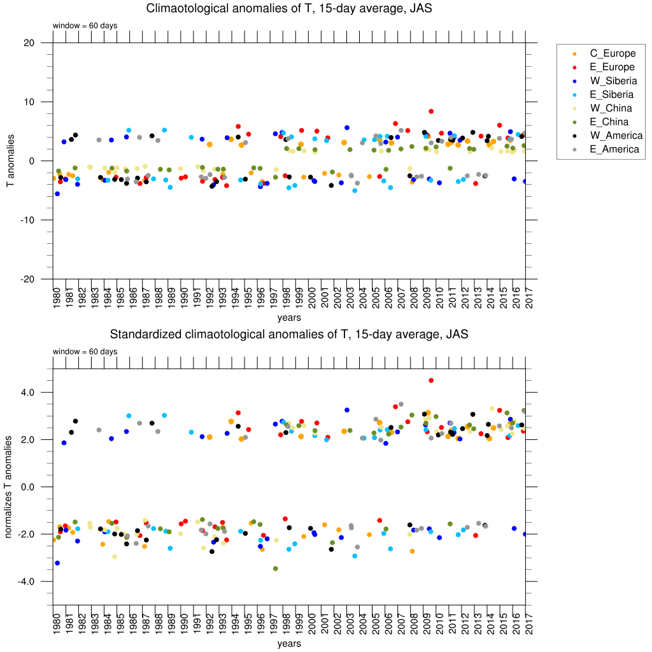

Fig. 2. (top) Raw and (bottom) normalized JAS temperature anomalies for each region for 1980 – 2017.

For the cold anomalies, the opposite is true – the frequency of cold events has decreased since 1980s. This may confirm the suggestion that cold air outbreaks from the Arctic are not that cold any more (Serreze et al. 2011, Screen 2014).

Figure 3 shows the same data as Fig. 2 except the time period is different – from 1997 till 2017 (again, year labelling might be slightly wrong). The frequency of cold event is still showing signs of a decrease over the last 21 years.

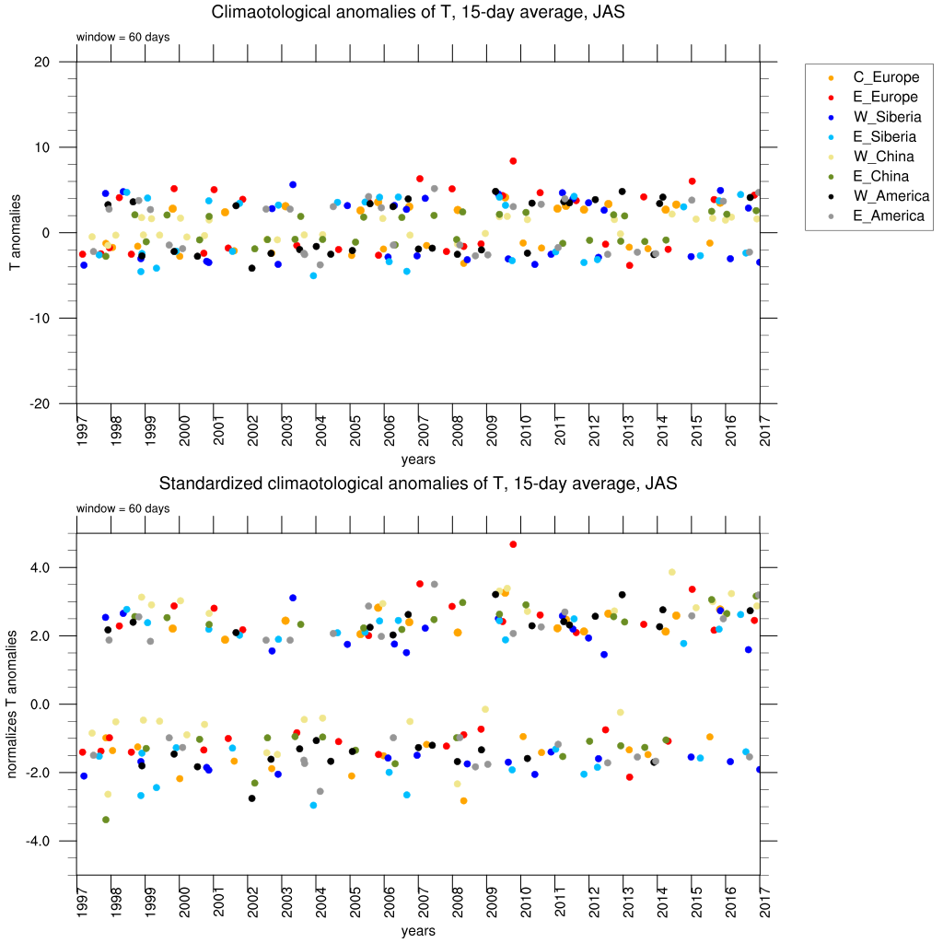

Fig.3. (top) Raw and (bottom) normalized JAS temperature anomalies for each region for 1997 – 2017.

Figure 4 shows extreme temperature anomalies for JFM 1980-2017. Warm anomalies in Eastern China also do not occur until 1997, but in Western China and in Europe the anomalies are absent only till 1987. The frequency of cols event looks evenly distributed except there no extreme cold event since the beginning of 2014 (except one case in Eastern America).

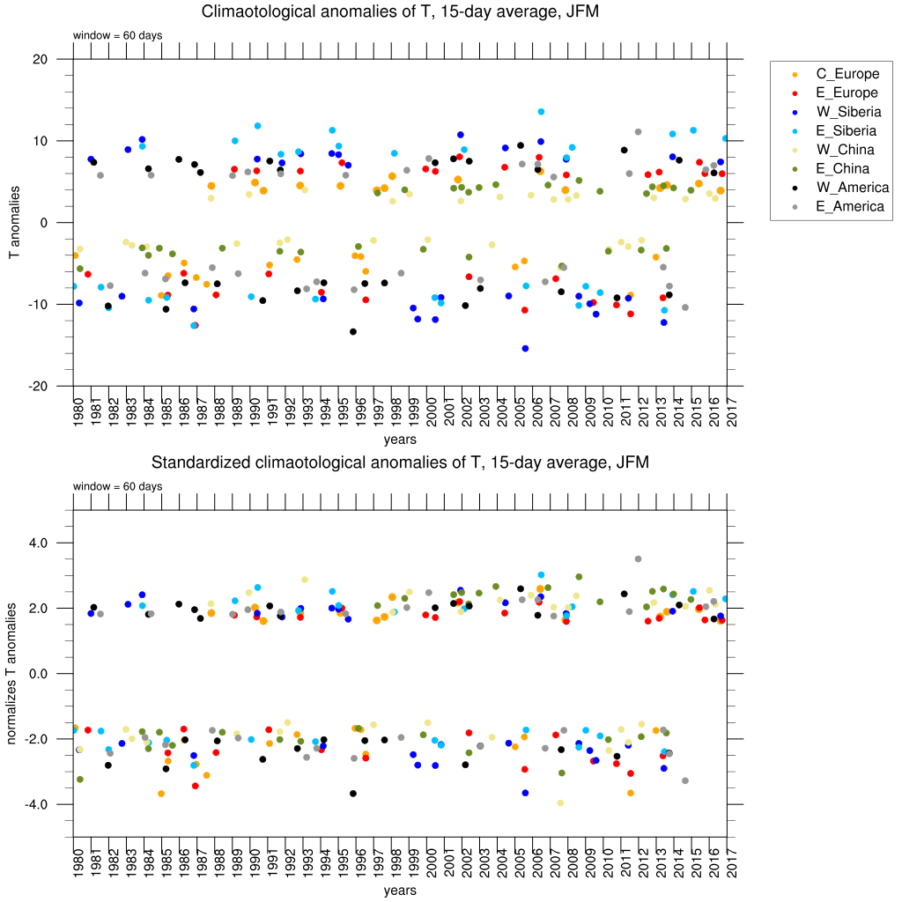

Fig. 4. (top) Raw and (bottom) normalized JFM temperature anomalies for each region for 1980 – 2017.

In plots below I show similar plots for other averaging periods (0 and 9 days). The plots are also interesting in comparison the time of event – some anomalies occur in two or even more regions simultaneously, others are more regional.

If we are happy with the selection of dates of extreme temperature events, I can now start plotting composites of Ks numbers for different lag time (I think about 7 and 15 days).

