**Temperature anomalies in selected regions**

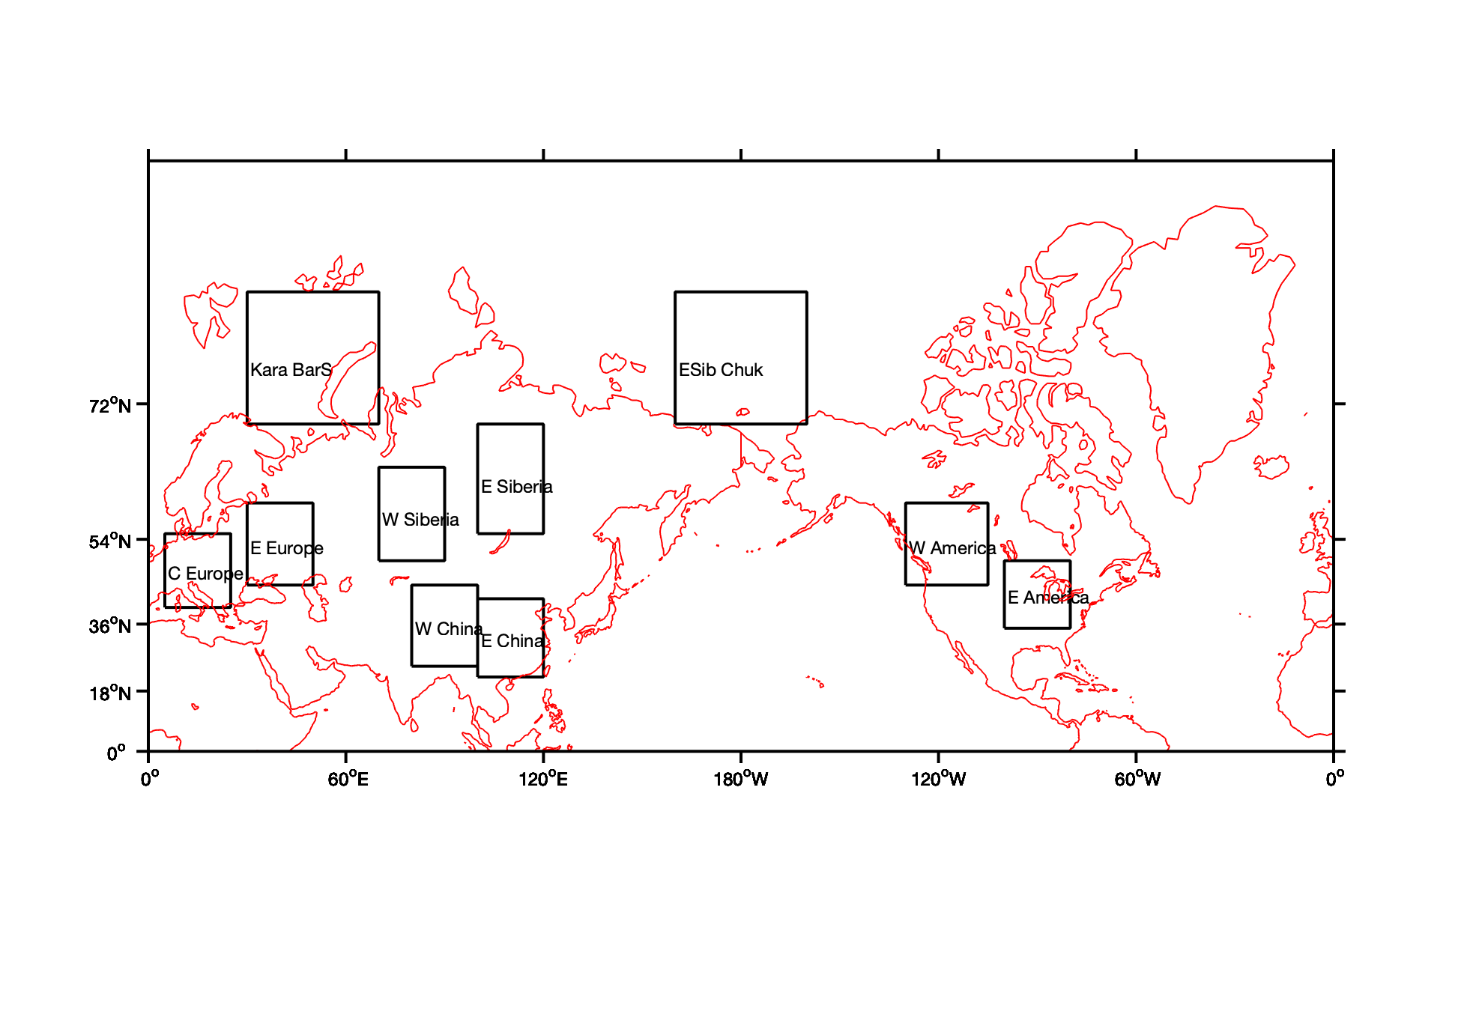

**Fig. 1.** Selected regions.

Daily temperature anomalies were analysed in six regions over the NH for two seasons (JFM and JAS). Winter and summer seasons were shifted by one month to correspond better with the sea ice annual cycle as we aim to link mid latitudinal anomalies to the advection (or absence of such) from the polar regions.

Two Arctic regions were added – (1) the Kara and Barents Seas and (2) the Eastern-Siberian and Chukchi Seas

Method:

* For the period 1980-2017 daily 2m temperature were derived from ERA-Interim. The data for 29 February were excluded from the analysis.
* For *detrended* daily 2m temperatures, the temperature trend was removed at every grid point for each day of the season
* Calculated anomalies from climatological mean
* 15 or 9 day running average was applied to all data. For the start of the year the data from the previous years were added for averaging. (If averaging was not applied it is referred as 0-day averaging in the plots.)
* For each region averaged temperature was calculated for each day of the season.
* For each region, all seasons were stacked together to get a time series of 38x90 and 38x92 values for winter and summer, respectively.
* Estimated standard deviation of temperature for each region and season.
* Looked for 15 most strong positive and negative anomalies for each region/season. A 60 day window was applied to all temperature anomalies, meaning that all data 30 days before and after an extreme temperature event were removed from the analysis. This is done to make sure that all anomalies are independent form each other.
* Plotted raw and normalized (by standard deviation for the corresponding day) anomalies.

Figure 2 shows the *dates* of positive and negative summer anomalies. Note, that X axis shows days, with labels marking the start of each season, i.e. there can be up to three anomaly per year (given the 60-day window).

The plot suggests an increase in the number of warm anomalies in Europe from 1992 and, in particular, in China since 1997. For other regions warm anomalies seem to be equally distributed.

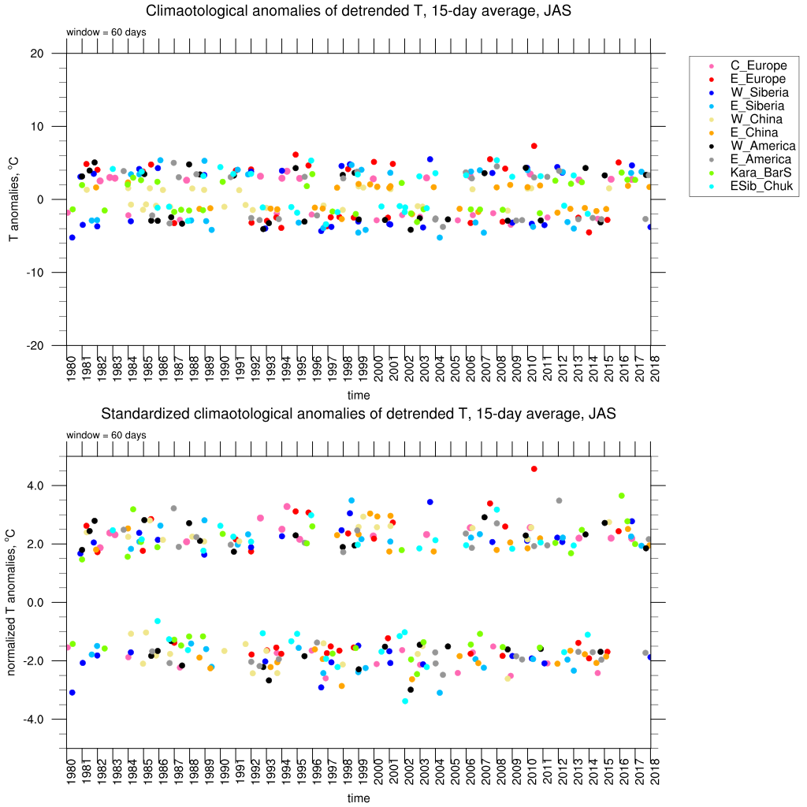

Fig. 2. (top) Raw and (bottom) normalized JAS temperature anomalies for each region for 1980 – 2017.



Fig. 3. (top) Raw and (bottom) normalized *detrended* JAS temperature anomalies for each region for 1980 – 2017.

For the cold anomalies, the opposite is true – the frequency of cold events has decreased since 1980s. In the Arctic regions cold event only occurred until early 2000s.

This may confirm the suggestion that cold air outbreaks from the Arctic are not that cold any more (Serreze et al. 2011, Screen 2014).

However, extremes in detrended temperatures are much more evenly distributed within the whole time period (Fig. 3). This holds for both warm and cold extremes.

The next plot (Fig. 4) presents an overview of the frequency of extreme events in the NH as a cumulative number of such events in ten regions. This plot confirms that if the warming trend is removed then the overall number of extreme events does not change over time within the last four decades.

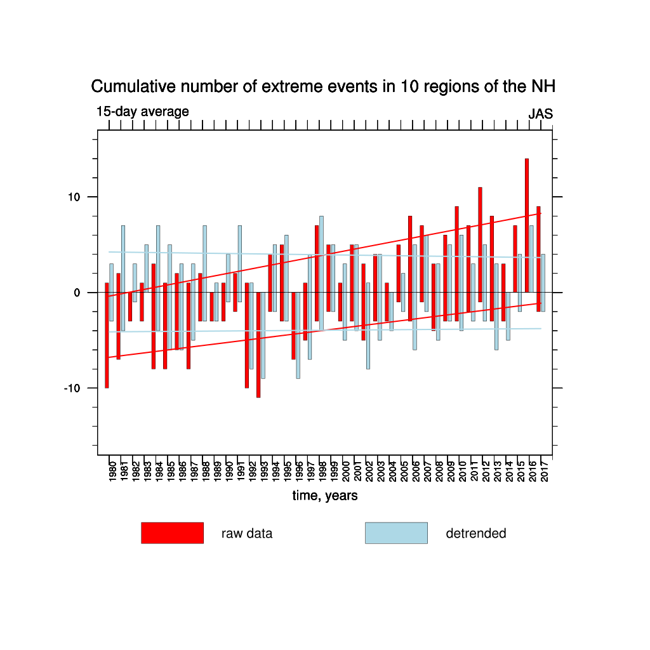

Fig. 4. Cumulative number of JAS extreme events in all 10 regions of the NH for the (red) raw and (lightlue) detrended data. Trends are shown with lines.

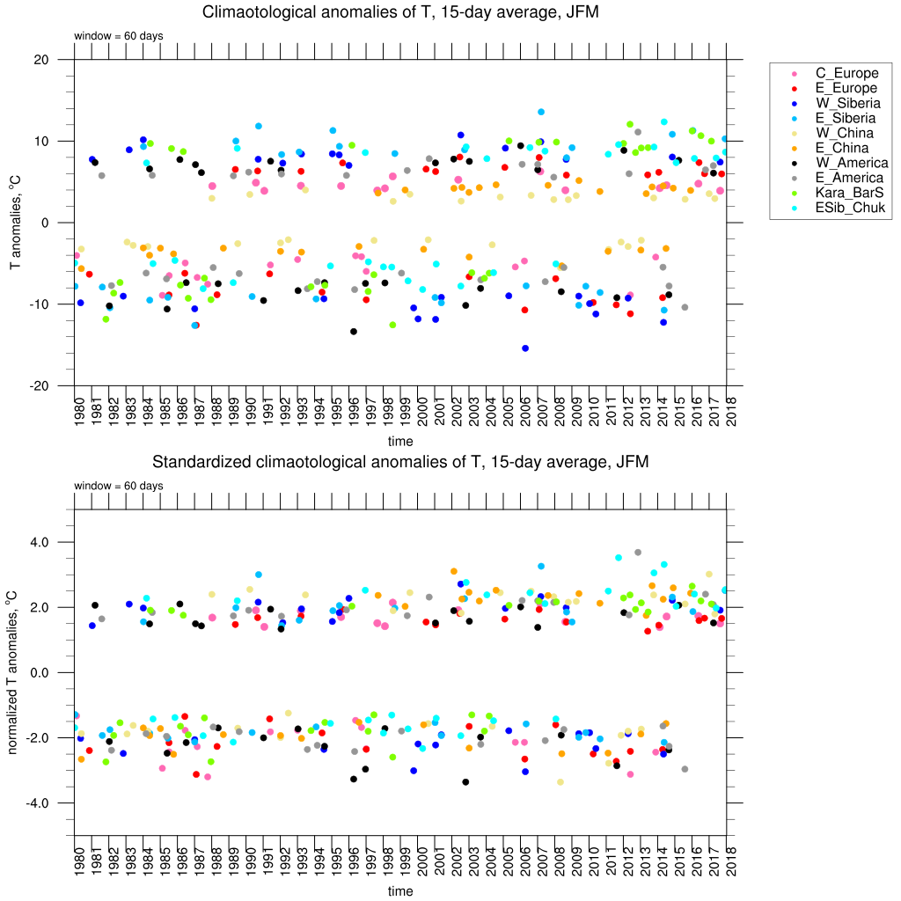

Fig.5. (top) Raw and (bottom) normalized JFM temperature anomalies for each region for 1980 – 2017.

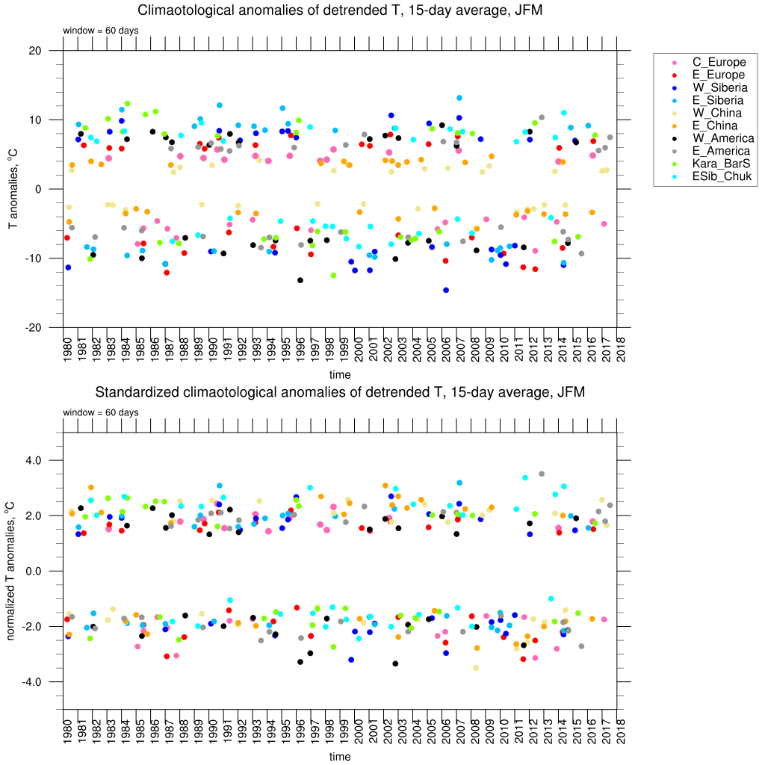

Fig.6. (top) Raw and (bottom) normalized JFM detrended temperature anomalies for each region for 1980 – 2017.

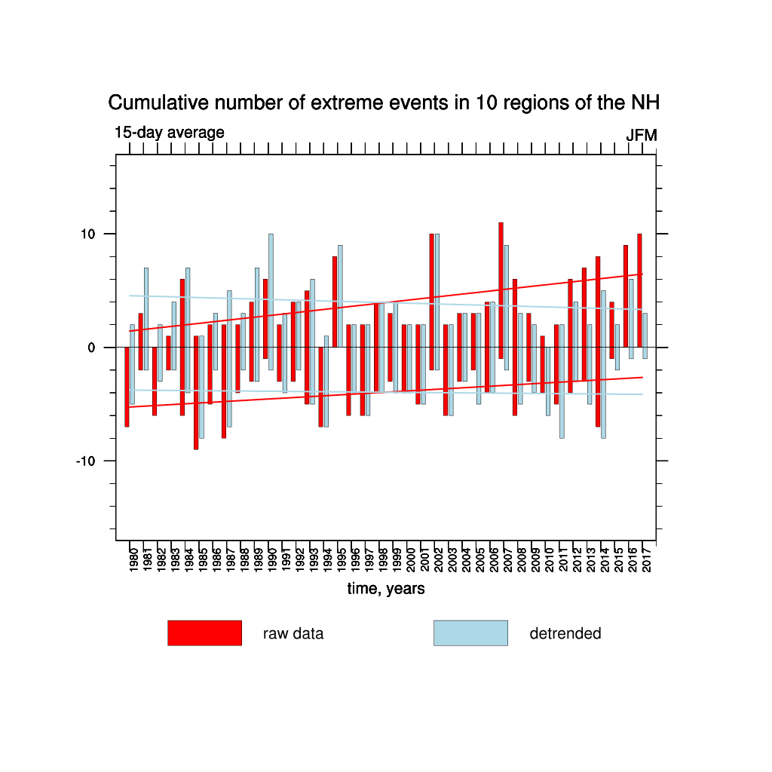

Fig. 7. Cumulative number of JFM extreme events in all 10 regions of the NH for the (red) raw and (lightlue) detrended data. Trends are shown with lines.

Since 2015 there is a noticeable reduction in cold events even in detrended timeseries.

Similar plots were made for non-averaged (0-days) data. The plots are below.

