**Irum Hussain**

**SETTING UP DOCKER IN LINUX**

Step 1 : Open the terminal

Step 2 : Install docker using following command:

**sudo apt install docker.io**

if there is some error make system up to date by :

**sudo apt-get update**

Step 3: Can check docker version

**docker --version**

Step 4 :Pull some sample image from docker

**sudo docker run hello-world**

Step 5: To display all containers

**sudo docker ps**

**OUTPUT**

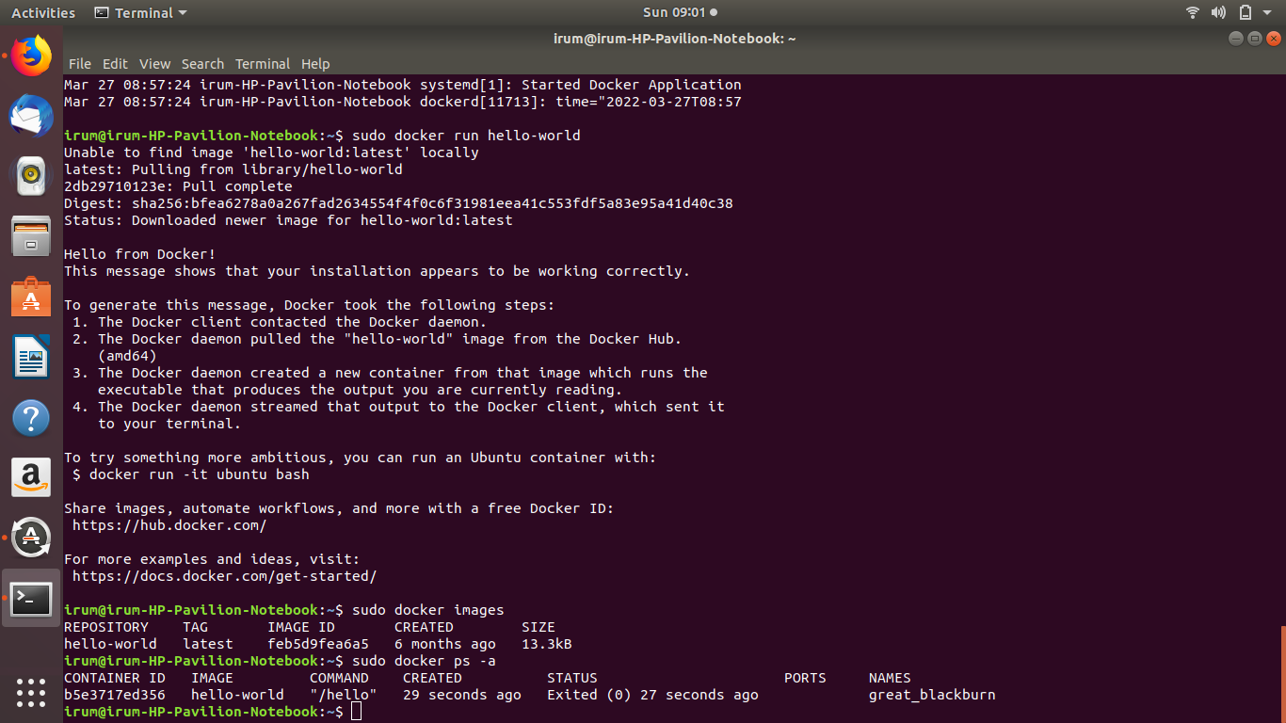

**Other Useful Commands:**

* To check if docker image has been pulled and is present in your system

**sudo docker images**

* To start one or more containers

**sudo start b5e3717ed356**

* To stop one or more containers

**sudo stop b5e3717ed356**

**SETTING UP POSTGRESQL IN DOCKER**

Step 1: Setting the docker container container with password ,name and port and pulling postgreSQL from hub

$ sudo docker container run -d –name = pg -p 5432:5432 –e POSTGRES_PASSWORD=secret –e PGDATA =/pgdata -v /pgdata :/pgdata postgres:11.4

Step 2: List the containers

$ docker container ls

Step 3:Execute the docker using bash

$ sudo docker exec -it pg /btn/bash

Step 4: Create database and run SQL queries

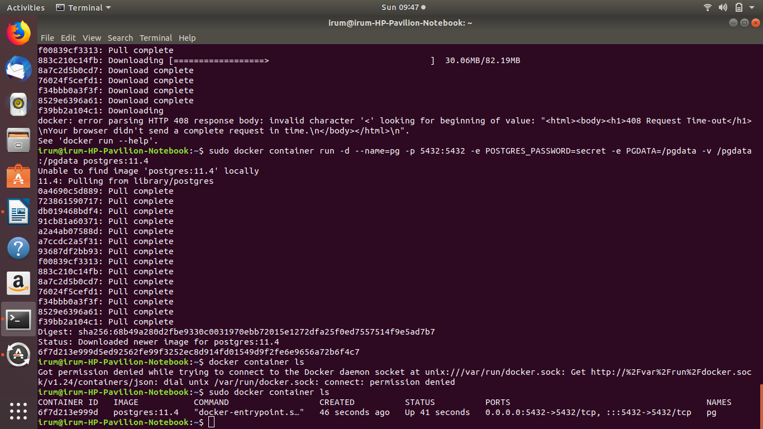

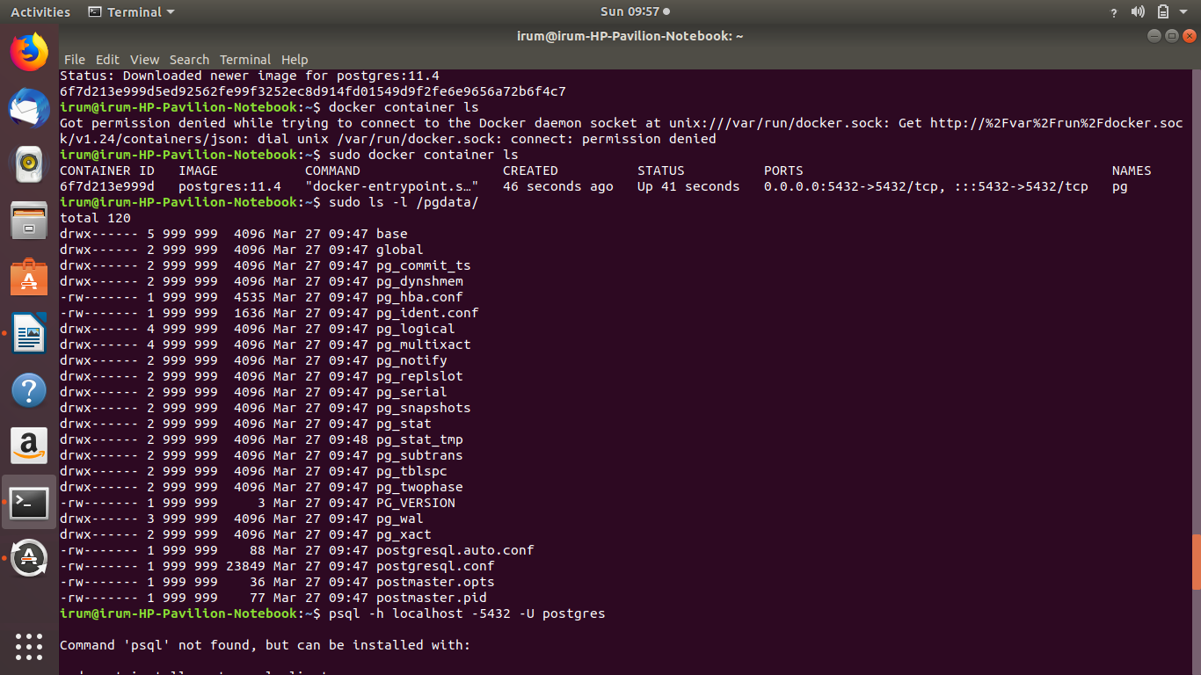

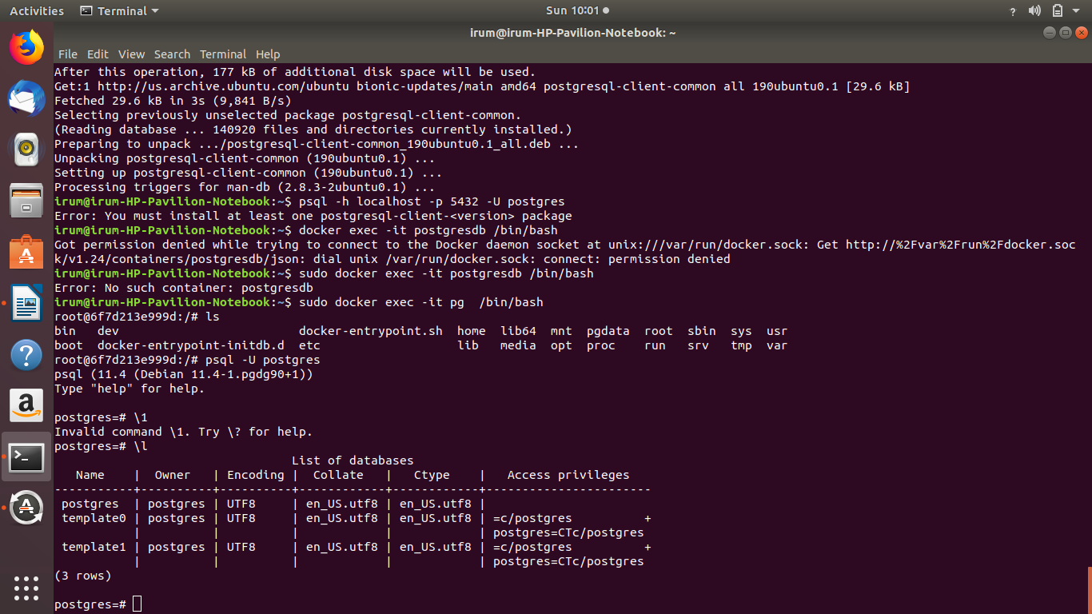

**SETTING UP JUPYTER NOTEBOOK CONTAINER IN DOCKER**

Step 1: Run the command to pull jupyter notebook of your choice .

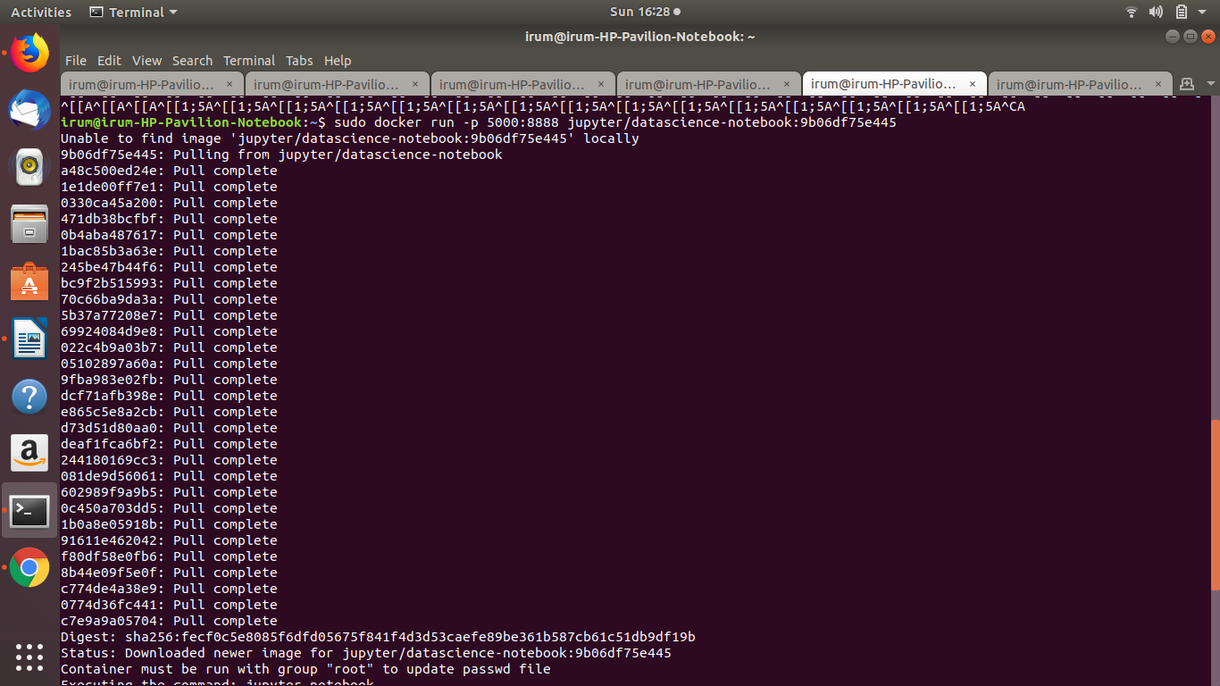

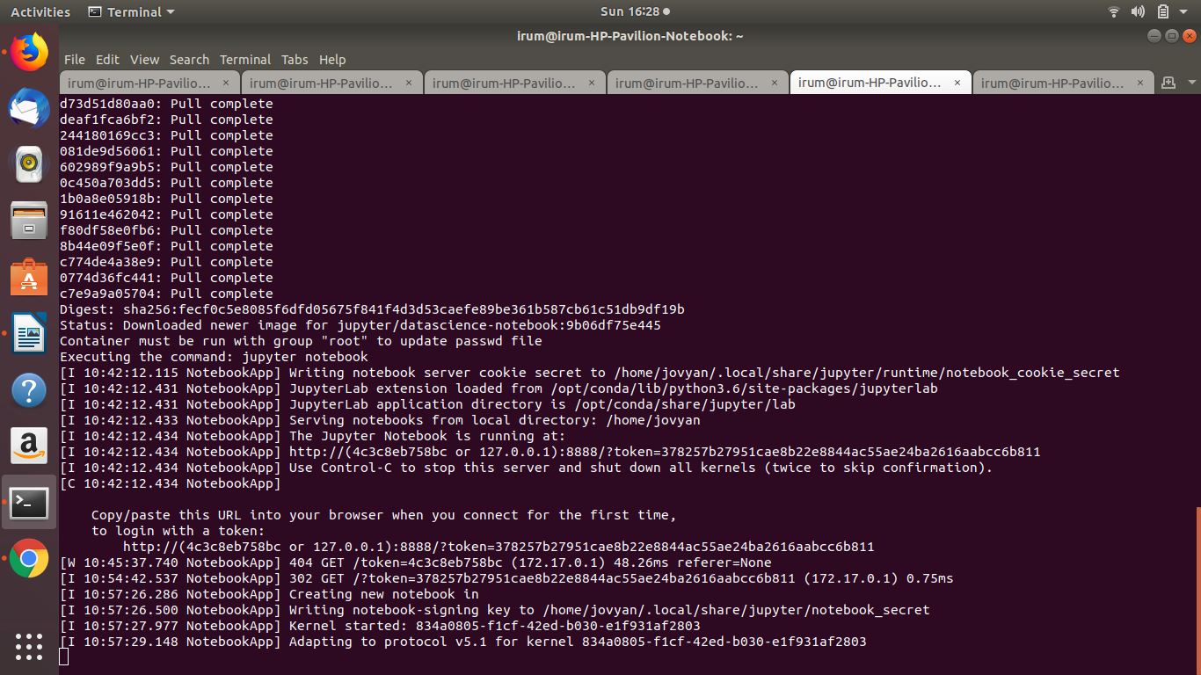

Now a URL will be displayed .Use this URL to open jupyter notebook . Once opened the ipynb file is added for your convenience to set up in notebook.