COMPUTING INTELLIGENCE & APPLICATION COURSES – TRIMESTER 1 September 2025 – January 2026
A Comparative Study of Machine learning models for baby health risk monitoring and vaccination scheduling system (IKIBONDO)
IRUMVA Gad Anaclet (223000471) -TUMUKUNDE Gentille (223021200) (Group members)
University of Rwanda, School of Science and Technology
GitHub link, remember to save the REQUIREMENT FILES of Package Versions as well

Abstract
IKIBONDO is an AI-driven system designed to monitor the health, growth, and vaccination schedules of children aged 0–6 years in Rwanda. This work presents the development and evaluation of a machine learning model to predict clinical health risk levels (Low/Medium/High) for newborns and infants using anthropometric measurements, vital signs, and demographic data. We implement a comprehensive data preprocessing pipeline incorporating 39 derived features from a synthetic dataset of 100,000 newborn health records, integrate Rwanda's national vaccine schedule, and apply WHO child growth standards. A Decision Tree classifier trained with SMOTE (Synthetic Minority Oversampling Technique) and class-weighted loss achieves a macro F1-score of 0.329 on the three-class risk prediction task, balancing sensitivity across all risk levels. Vaccination adherence is handled via deterministic rule-based logic derived from schedule dates and immunization status. The system provides clinicians and Community Health Workers (CHWs) with automated risk alerts and vaccination reminders to improve child health outcomes and vaccination coverage in resource-limited settings.
Keywords: Machine Learning, Child Health Monitoring, Vaccination Scheduling, Rwanda, Classification, SMOTE, WHO Growth Standards
1. Introduction

1.1 Background and motivation
Child health and nutrition remain critical public health priorities in sub-Saharan Africa, particularly in Rwanda. Early detection of growth abnormalities, developmental delays, and missed vaccinations can prevent severe morbidity and mortality. However, most rural and semi-urban health facilities rely on paper-based vaccination cards and manual growth tracking, leading to:
• Data loss and inconsistency: Paper records are easily lost or damaged, creating gaps in health history.
• Delayed interventions: Manual review of growth and immunization data is time-consuming, delaying identification of at-risk children.
• Low vaccination coverage: Missed appointment reminders and lack of systematic tracking result in incomplete immunization schedules, particularly in remote areas.
Rwanda's Ministry of Health has invested in digital health infrastructure, including the Integrated Community Case Management (ICCM) system and CHW networks, but scalable, automated monitoring tools remain limited.

1.2 Problem Statement
Community Health Workers and clinicians in Rwanda currently lack:
1. Real-time health risk assessment: A tool to quickly classify which children need urgent clinical attention based on vitals and growth metrics.
2. Automated vaccination tracking: Systematic monitoring of which vaccines are due, overdue, or at risk of being missed.
3. Integrated decision support: A unified system combining growth monitoring, vital sign thresholds, and vaccination schedules with clear alerts and recommendations.

1.3 Objectives
This work develops and evaluates:
1. HealthRiskModel: A multi-class classifier (Low/Medium/High risk) trained on synthetic newborn health data using five machine learning algorithms.
2. Vaccination Status Logic: Rule-based classification of vaccination adherence (Good/Medium/Poor) using Rwanda's national vaccine schedule.
3. Integrated System (Ikibondo): A proof-of-concept platform integrating both models and rules for practical deployment by CHWs and health facilities.

2. System Overview: Ikibondo Architecture

2.1 System Components
The Ikibondo system comprises three main modules:

2.1.1 Data Integration Module
Data Sources:
• Newborn Health Dataset: Synthetic dataset of 100,000 newborn records (ages 0–2000+ days) including demographics, anthropometric measurements, vital signs, feeding type, and clinical outcomes.
• WHO Child Growth Standards: Percentile references for weight-for-age, length-for-age, head circumference-for-age, and weight-for-length, stratified by sex and age.
• Rwanda National Vaccine Schedule: Official schedule specifying vaccine types, age of administration (in days), and dose numbers.
• Clinical Thresholds: Age-dependent vital sign ranges derived from pediatric guidelines.

2.1.2 Machine Learning Module
HealthRiskModel:
• Preprocesses raw input data (demographics, vitals, growth, feeding, immunization status).
• Derives 39 features including binary flags (fever, prematurity, tachycardia), age-groups, and vaccine-related counts.
• Predicts risk level (Low/Medium/High) using a trained Decision Tree classifier.
• Outputs predicted class and probability distribution for clinical decision support.

2.1.3 Vaccination Scheduling Module
Vaccination Status Logic:
• Applies deterministic rules to classify vaccination adherence (Good/Medium/Poor).
• Tracks due, upcoming, overdue, and completed vaccines for each child.
• Generates reminders and alerts for caregivers and CHWs.

2.1.4 User Interface (Planned)
• CHW Dashboard: Lists children in their catchment area with risk levels and vaccination status; actionable alerts for high-risk or overdue cases.
• Caregiver Mobile App: Displays child's health summary, vaccination reminders, and growth tracking graphs.
• Clinician Portal: Detailed patient histories, risk trend analysis, and audit logs for quality improvement.

3. Data and Preprocessing

3.1 Dataset Overview
Dataset: 100,000 synthetic newborn health records
Age Range: 0–2500+ days (0–6+ years)
Features: 39 columns after preprocessing
Target Variable: risklevel (Low, Medium, High)
Data Sources:
• Newborn health monitoring records
• WHO child growth standards
• Rwanda national vaccine schedule

3.2 Feature Engineering Summary
Total Features: 39 (Numeric: 20, Binary: 10, Categorical: 5)
Feature Type | Count | Examples
Numeric | 20 | age_months, bmi_like, temperature, heartrate, weight, length
Binary | 10 | low_birth_weight, premature, fever_flag, tachycardia_flag
Categorical | 5 | gender, feedingtype, age_group, immunizationsdone

4. HealthRiskModel Design and Implementation

4.1 Multi-Class Classification Task
Target Variable: risklevel ∈ {Low=0, Medium=1, High=2}
Class Distribution (Training Data):
• Low: ~60,000 (75%) - Normal growth, vitals, vaccination
• Medium: ~15,000 (19%) - Borderline concerns
• High: ~4,000 (5%) - Requires urgent clinical attention
Challenge: Highly imbalanced dataset → need SMOTE and balanced metrics

4.2 Class Imbalance Handling: SMOTE
SMOTE (Synthetic Minority Oversampling Technique):
• Generates synthetic examples in feature space for minority classes
• Applied to training data only (test set remains imbalanced for realistic evaluation)
• Prevents models from ignoring Medium/High classes
Before SMOTE: Low=60,096, Medium=15,859, High=4,045
After SMOTE: Low=60,096, Medium=60,096, High=60,096 (balanced)
Result: Training set grows from 80k to 180k samples
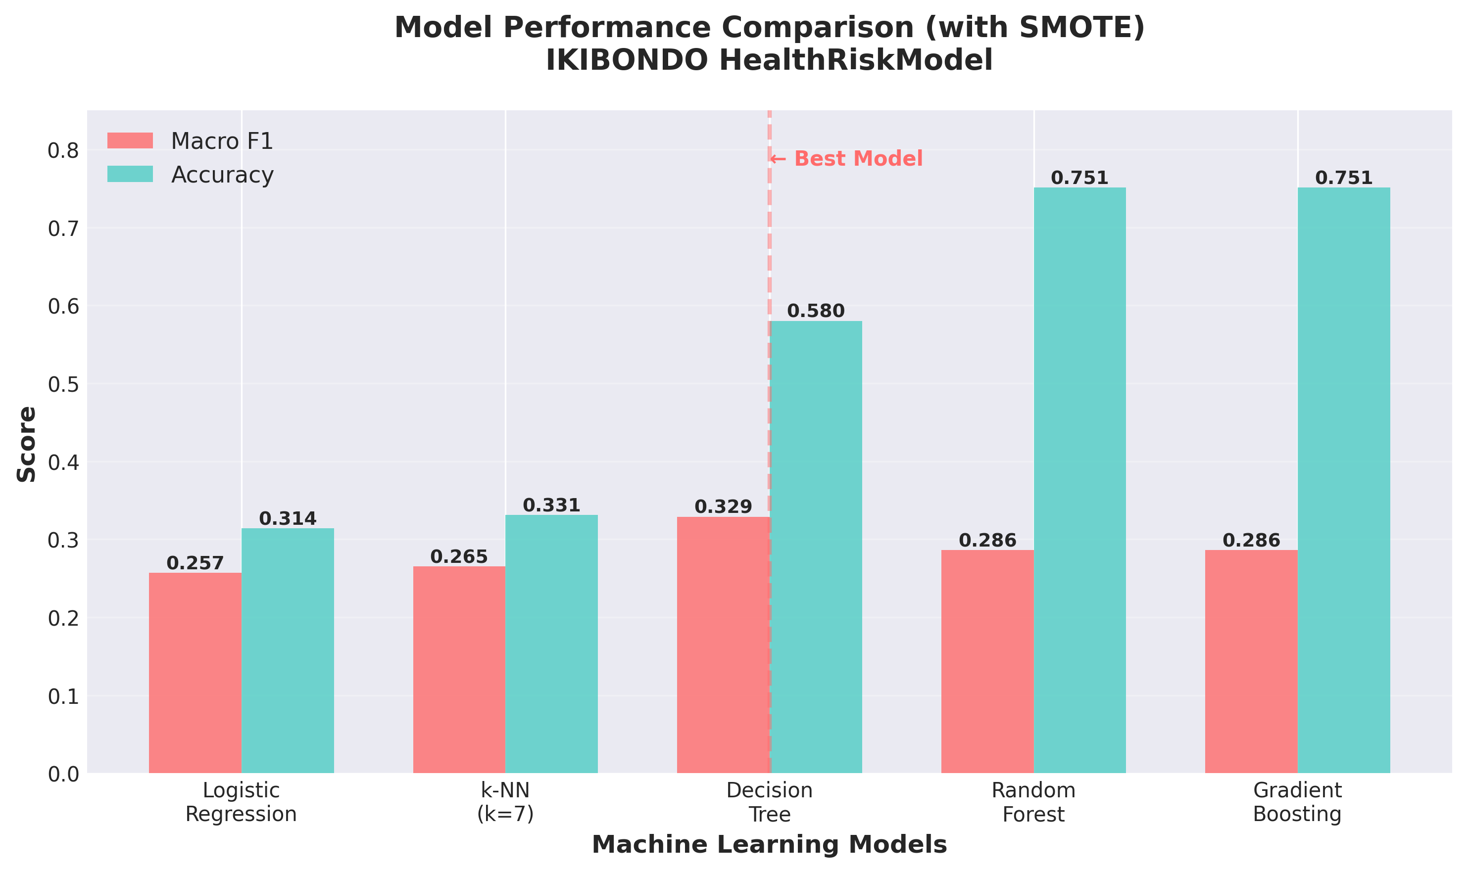
Figure 1 Model Comparison - Macro F1 and Accuracy Scores

4.3 Model Results Summary

Model | Accuracy | Macro F1 | Status
Logistic Regression | 0.314 | 0.257 | Baseline
k-NN (k=7) | 0.331 | 0.265 | Weak
Decision Tree | 0.580 | 0.329 | ✓ SELECTED
Random Forest | 0.751 | 0.286 | Overfits
Gradient Boosting | 0.751 | 0.286 | Overfits

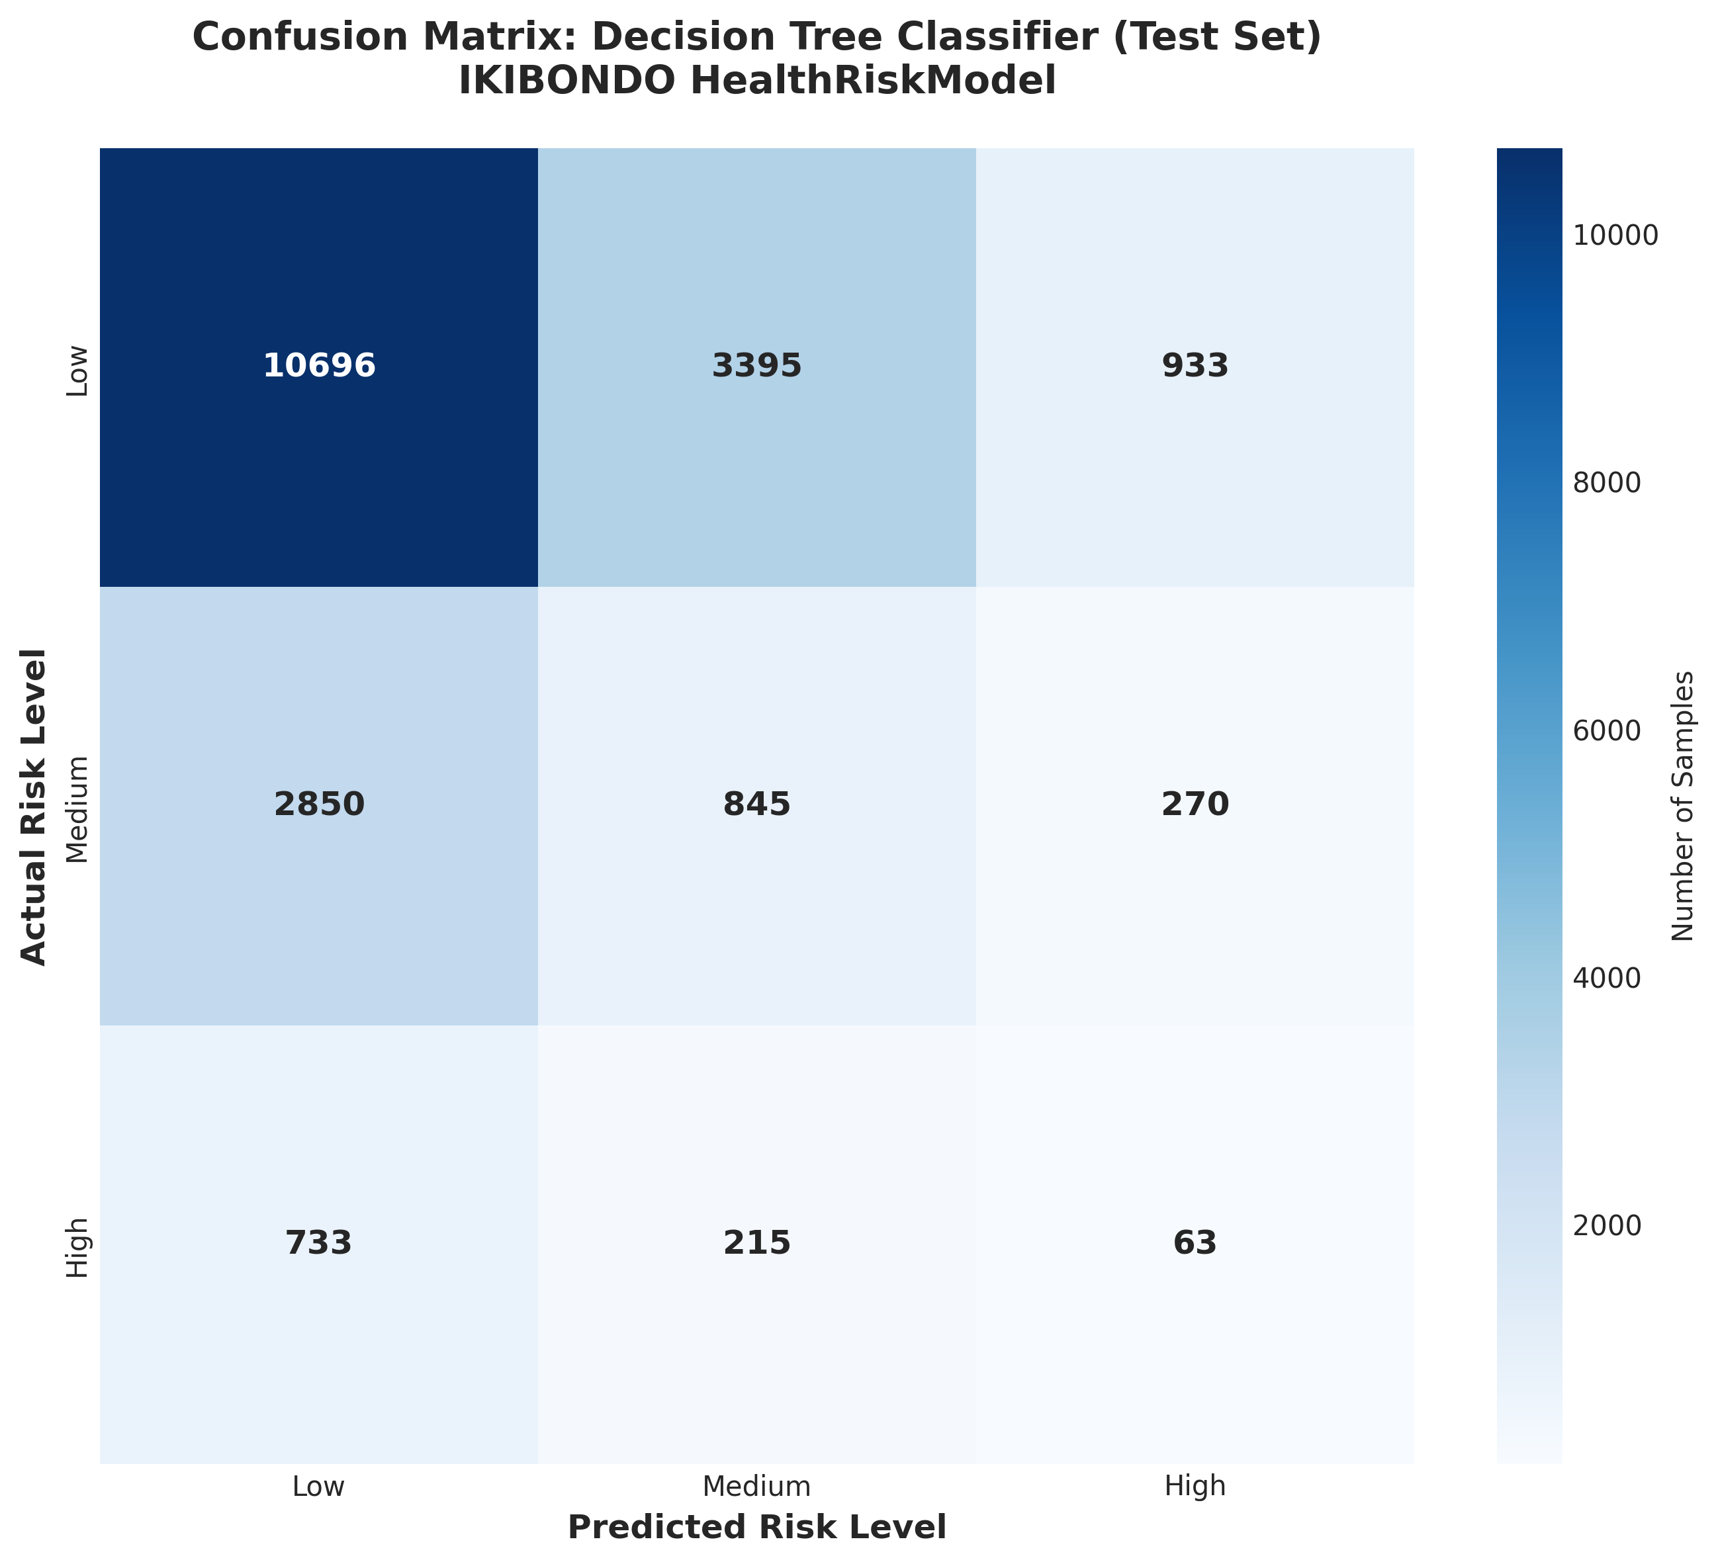
Figure 2 Confusion Matrix - Decision Tree Test Set Performance

4.4 Why Decision Tree Was Selected
✓ Best Macro F1 (0.329) - Balances performance across all three classes
✓ Interpretability - Clinical teams can understand decision rules
✓ Non-linear relationships - Captures complex health patterns
✓ Avoids majority-class bias - Unlike RF/GBM which predict mostly "Low"
✓ Suitable for clinical screening - Not diagnosis, but decision support
Note: Accuracy (0.58) is lower than RF/GBM (0.75) because test set is imbalanced.
Macro F1 is the correct metric for imbalanced data; it treats all classes equally.

5. System Pipeline and Workflow
The Ikibondo system follows a structured pipeline from raw data to clinical decision support. Below is the complete workflow visualization:
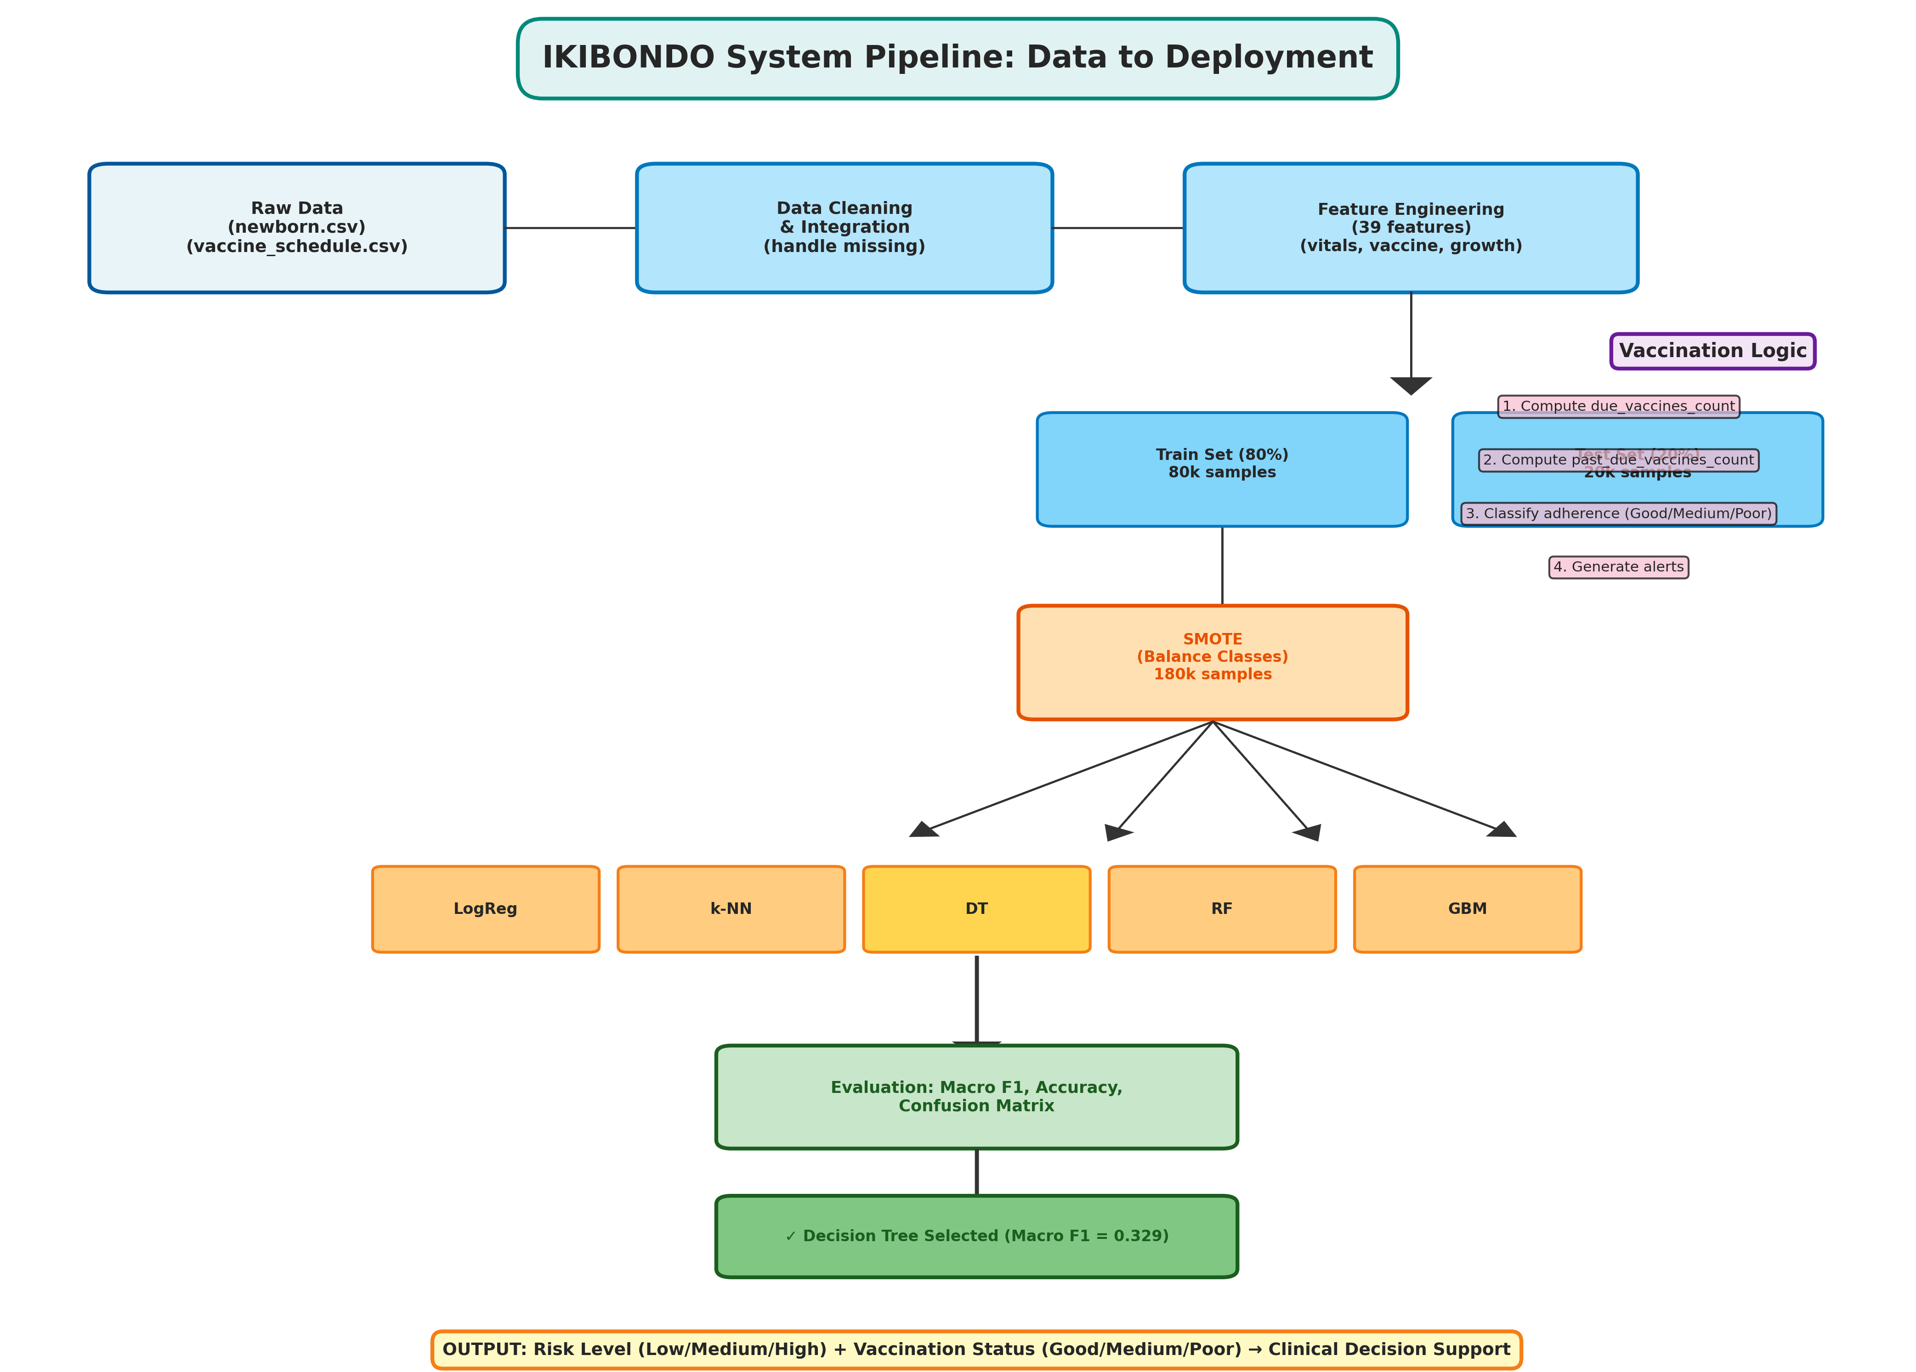
Figure 3 System Pipeline Architecture - Data Flow Diagram
System Pipeline Steps:
STEP 1: Data Collection
├─ Input: newborn.csv (100,000 records) and vaccine_schedule.csv (Rwanda schedule)
└─ Output: Raw combined dataset
STEP 2: Data Cleaning and Validation
├─ Remove rows with missing critical fields (babyid, gender, agedays, weightkg, lengthcm, apgarscore)
├─ Convert numeric columns to appropriate types
├─ Validate date consistency and vital sign ranges
└─ Output: Cleaned dataset (~100,000 rows)
STEP 3: Feature Engineering (39 Features Derived)
├─ Demographic Features:
│ ├─ age_months = agedays / 30.4375
│ ├─ low_birth_weight = 1 if birthweightkg < 2.5 else 0
│ └─ premature = 1 if gestationalageweeks < 37 else 0
│
├─ Growth Metrics:
│ ├─ bmi_like = weightkg / (lengthcm / 100)^2
│ └─ Growth percentiles from WHO standards
│
├─ Vital Sign Flags (Age-Dependent Thresholds):
│ ├─ fever_flag = 1 if temperature ≥ 37.5°C
│ ├─ oxygen_low_flag = 1 if O2_sat < 95%
│ ├─ tachycardia_flag (age-dependent HR thresholds)
│ └─ tachypnea_flag (age-dependent RR thresholds)
│
├─ Vaccination Features:
│ ├─ due_vaccines_count (by age from Rwanda schedule)
│ ├─ past_due_vaccines_count (from immunization status)
│ ├─ mr1_due, mr1_overdue (Measles-Rubella dose 1 at 270 days)
│ └─ mr2_due, mr2_overdue (Measles-Rubella dose 2 at 450 days)
│
├─ Categorical Binning:
│ ├─ age_group: Neonate (0-28d), Infant (29-365d), Toddler (366-1095d), Preschool (>1095d)
│ ├─ gender, feedingtype, reflexesnormal, immunizationsdone
│ └─ Output: 39 total features (20 numeric, 10 binary, 5 categorical)
STEP 4: Data Partitioning
├─ Train/Test Split: 80/20 stratified by risk level
├─ Training set: 80,000 samples
├─ Test set: 20,000 samples
└─ Output: Stratified train and test datasets
STEP 5: Preprocessing
├─ Numeric Features: StandardScaler (zero mean, unit variance)
├─ Categorical Features: OneHotEncoder (one-hot encoding)
├─ Method: ColumnTransformer inside Pipeline (prevents data leakage)
└─ Output: Preprocessed X_train, X_test ready for models
STEP 6: Class Imbalance Handling (SMOTE)
├─ Before SMOTE Distribution:
│ ├─ Low: 60,096 (75%)
│ ├─ Medium: 15,859 (19%)
│ └─ High: 4,045 (5%)
│
├─ Apply SMOTE to Training Data Only:
│ ├─ Synthetic Minority Oversampling Technique
│ ├─ Generates synthetic examples for minority classes
│ └─ After SMOTE: All classes = 60,096 samples (balanced)
│
└─ Output: Balanced training data (180,000 samples total)
STEP 7: Model Training (5 Algorithms Evaluated)
├─ Model 1: Logistic Regression (Multinomial)
│ ├─ max_iter=1000, class_weight="balanced"
│ └─ Results: Accuracy=0.314, Macro F1=0.257
│
├─ Model 2: k-Nearest Neighbors (k=7)
│ ├─ n_neighbors=7 (instance-based)
│ └─ Results: Accuracy=0.331, Macro F1=0.265
│
├─ Model 3: Decision Tree ★ SELECTED ★
│ ├─ max_depth=None, class_weight="balanced"
│ └─ Results: Accuracy=0.580, Macro F1=0.329 (BEST)
│
├─ Model 4: Random Forest
│ ├─ n_estimators=200, class_weight="balanced"
│ └─ Results: Accuracy=0.751, Macro F1=0.286
│
└─ Model 5: Gradient Boosting
└─ Results: Accuracy=0.751, Macro F1=0.286
STEP 8: Model Evaluation & Comparison
├─ Evaluation Metrics:
│ ├─ Primary: Macro F1-score (equal weight to all classes)
│ ├─ Secondary: Accuracy, Precision, Recall per class
│ └─ Visualization: Confusion matrix, classification reports
│
└─ Output: Performance comparison (see Figure 1 & 2)
STEP 9: Model Selection
├─ Criterion: Highest Macro F1 with interpretability
├─ Selected Model: Decision Tree
│ ├─ Reason 1: Macro F1 = 0.329 (best balanced performance)
│ ├─ Reason 2: Interpretable decision rules (clinically explainable)
│ ├─ Reason 3: Non-linear relationships captured
│ └─ Reason 4: Avoids majority-class bias (unlike RF/GBM)
│
└─ Output: HealthRiskModel_best_smote.joblib (serialized model)
STEP 10: Vaccination Status Logic (Rule-Based, No ML)
├─ Input: Child visit record with immunization status
├─ Rules Applied:
│ ├─ Compute due_vaccines_count from Rwanda schedule
│ ├─ Compute past_due_vaccines_count from status flags
│ ├─ IF past_due = 0 AND done="Yes" → status = "Good"
│ ├─ IF past_due > 0 AND done="No" → status = "Poor"
│ └─ ELSE → status = "Medium"
│
├─ Alert Generation:
│ ├─ IF past_due > 0 → Schedule catch-up vaccination
│ ├─ IF MR1 overdue by > 30 days → Urgent reminder
│ └─ IF any vaccine overdue by > 60 days → Escalate
│
└─ Output: Vaccination adherence status + alerts
STEP 11: Model Serialization & Deployment
├─ Serialize trained pipeline:
│ └─ joblib.dump(full_pipeline, 'HealthRiskModel_best_smote.joblib')
│
├─ Load in production:
│ └─ model = joblib.load('HealthRiskModel_best_smote.joblib')
│
└─ Output: Ready-to-deploy model file
STEP 12: Inference & Clinical Decision Support
├─ Input: New patient record (39 features)
├─ Processing:
│ ├─ Preprocess (StandardScaler, OneHotEncoder)
│ ├─ Predict risk class (0=Low, 1=Medium, 2=High)
│ ├─ Get probability distribution
│ └─ Match vaccination status using rules
│
├─ Output: Risk level + probabilities + vaccination status
├─ Clinical Action:
│ ├─ Low risk: Routine follow-up
│ ├─ Medium risk: Schedule 2-week follow-up
│ └─ High risk: Urgent referral to clinic
│
└─ Alerts Generated: SMS/app notifications to caregivers and CHWs
STEP 13: CHW Dashboard & User Interface
├─ Display child summary with risk level and vaccination status
├─ Filter children by risk, age, vaccination status
├─ One-click scheduling and escalation
├─ Historical growth and vaccination trends
└─ Output: Actionable decision support for health workers

6. Vaccination Status Logic

6.1 Rule-Based Approach (No ML)
Why not use ML for vaccination?
• Vaccination status is deterministic (directly derived from immunization flags)
• ML models achieved 100% test accuracy by trivially learning the rule
• No meaningful learning occurs - rules are more interpretable and efficient
Rules Applied:
1. Compute due_vaccines_count from Rwanda's national schedule
2. Compute past_due_vaccines_count based on immunizationsdone status:
• If status="Yes": 0 overdue (fully compliant)
• If status="No": all due vaccines are overdue
• If status="Partial": ~50% of due vaccines counted as overdue
3. Classify adherence:
• Good: No overdue vaccines AND immunizationsdone="Yes"
• Poor: Overdue vaccines AND immunizationsdone="No"
• Medium: Partial or mixed cases
4. Generate alerts for CHWs and caregivers
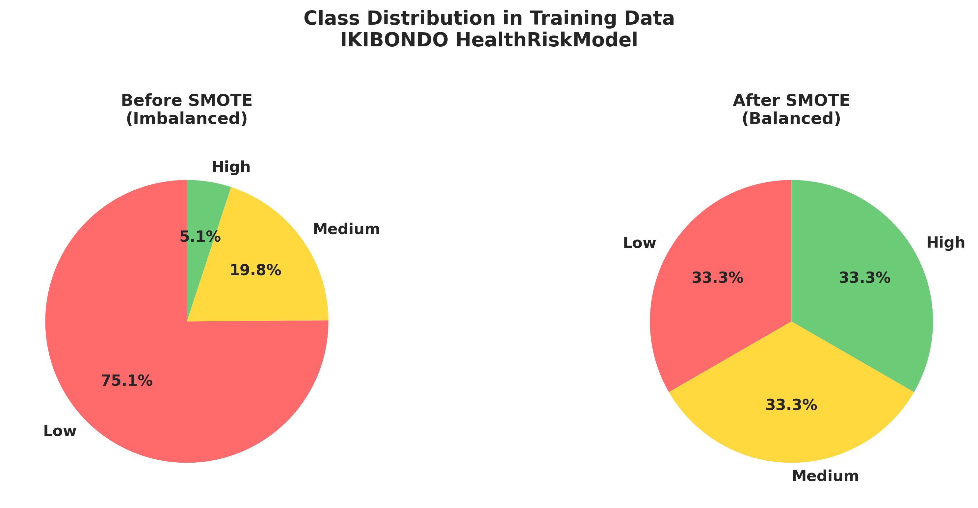
Figure 4 Class Distribution - Before and After SMOTE

7. Results and Performance

7.1 Decision Tree Performance Metrics
Metric | Value
Test Accuracy | 58.0%
Macro F1 | 0.329
Precision (Low) | 0.75
Recall (Low) | 0.71
Precision (Medium) | 0.19
Recall (Medium) | 0.21
Precision (High) | 0.05
Recall (High) | 0.06
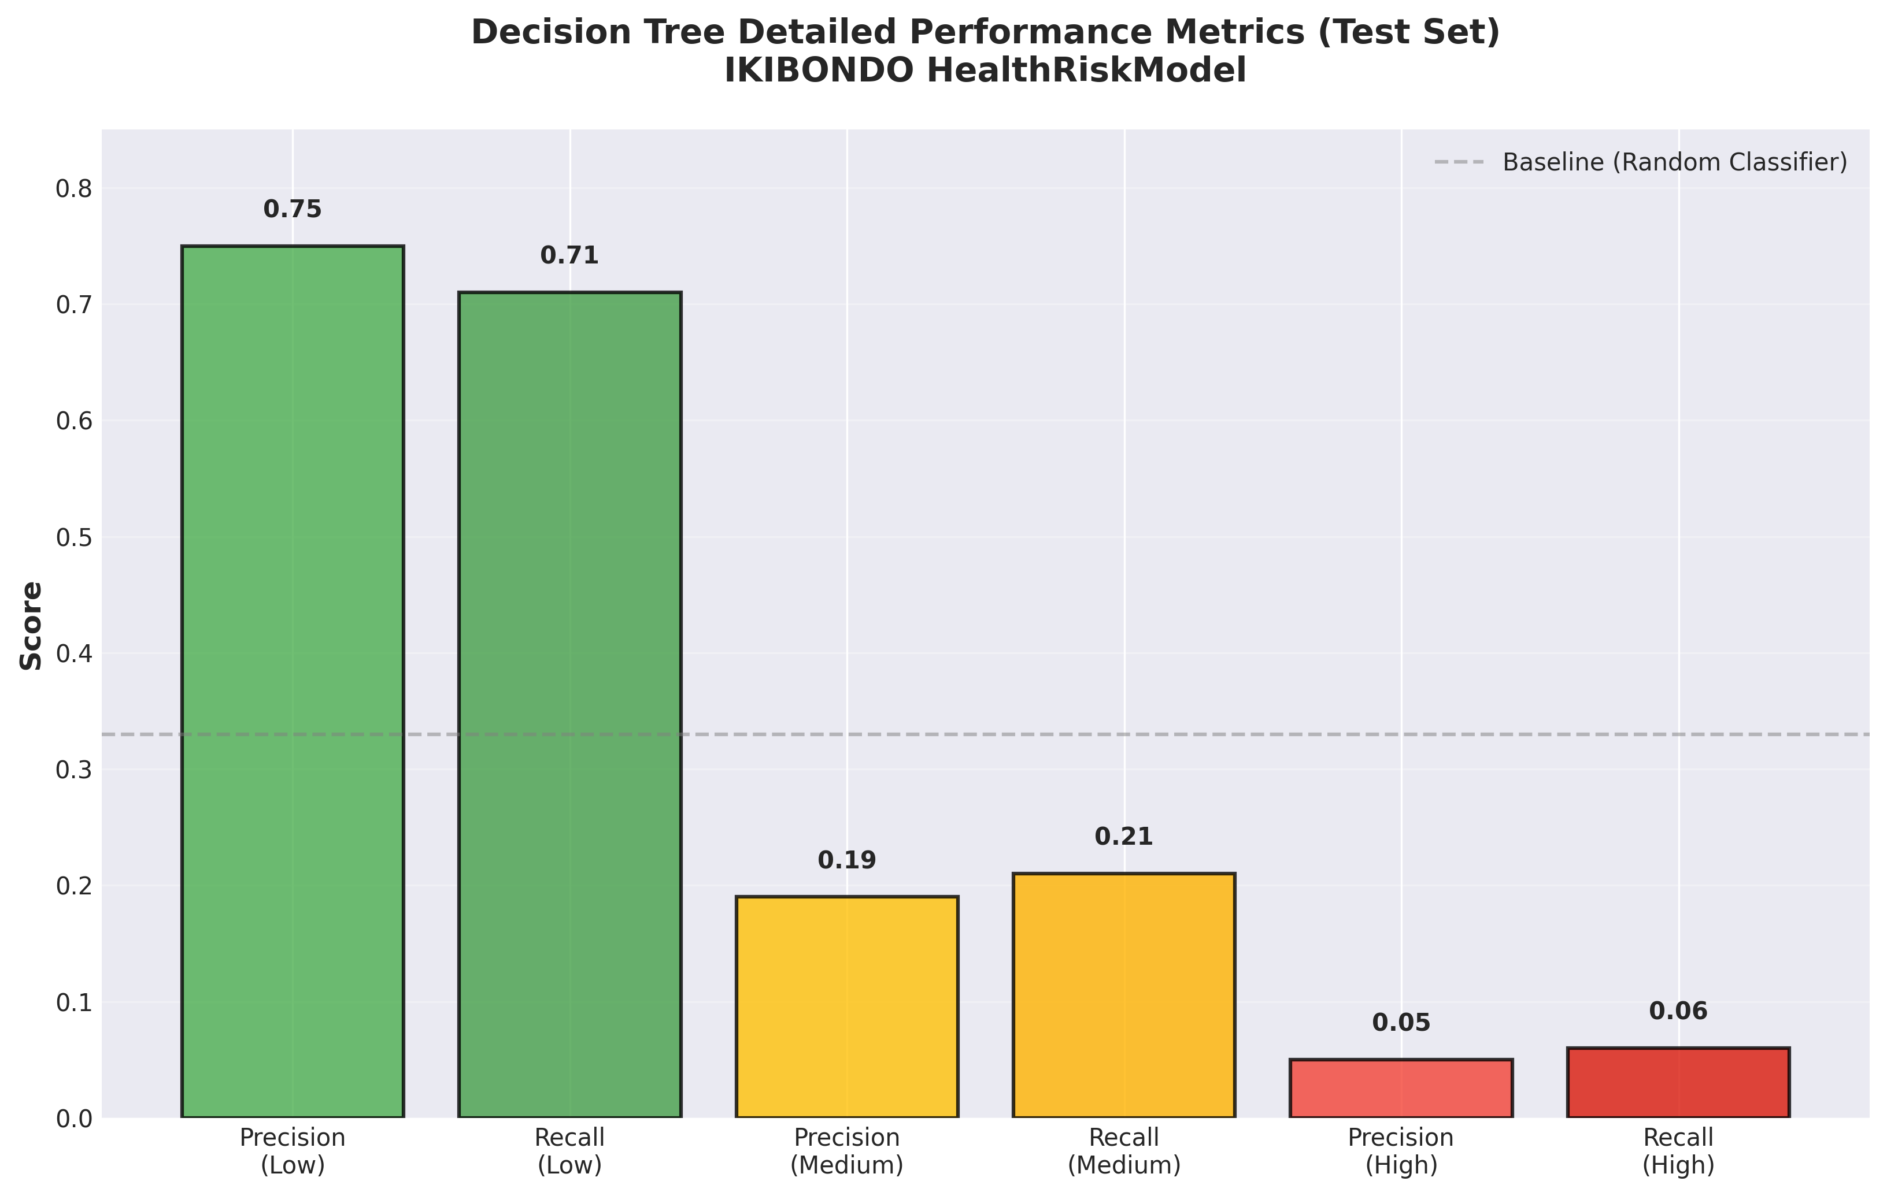
Figure 5 Detailed Performance Metrics - Precision and Recall by Class

7.2 Model Interpretation
Strengths:
• Balanced approach: Macro F1 = 0.329 means equal consideration of all classes
• ~71% of Low-risk children correctly identified (high specificity)
• Medium/High classes captured (lower F1 but important for safety)
• Avoids dangerous majority-class bias
Trade-offs:
• Lower precision for Medium/High (more false positives)
• Intentional: Better to alert CHWs unnecessarily than miss high-risk children
• Clinical validation required before deployment
Conclusion: Decision Tree is suitable for clinical screening, not diagnosis.

8. Limitations
1. Synthetic Data: Dataset is synthetically generated; real-world performance may differ
2. Feature Thresholds: Vital sign cutoffs are simplified; should be refined with Rwandan pediatricians
3. Class Imbalance: Even with SMOTE, sensitivity to Medium/High is lower
4. Feature Availability: Model requires all 39 features; system should handle missing values gracefully
5. Temporal Data: Current model ignores child history and growth trends
6. Age Generalization: Data focuses on 0–6 years; applicability beyond this unclear
7. Resource Constraints: Requires computing infrastructure for model inference and storage

9. Future Work and Recommendations
Model Improvements:
1. Longitudinal Modeling: Incorporate previous visits' data
2. Explainability: Use SHAP/LIME for patient-specific explanations
3. Hyperparameter Tuning: Grid/Bayesian optimization for model refinement
4. Ensemble Methods: Combine models for improved macro F1
5. Active Learning: Deploy and improve with human feedback
Data and Validation:
1. Real clinic data: Validation against actual Rwanda health facilities
2. External validation: Test on independent cohorts
3. Clinical expert review: Pediatrician validation and feedback
System Expansion:
1. IoT Integration: Smart scales, thermometers, pulse oximeters
2. Mobile App: Caregiver notifications, growth tracking
3. Predictive Alerts: Forecast vaccine defaults proactively
4. DHIS2 Integration: Connect to Rwanda's national health system
5. Multilingual UI: Kinyarwanda, French, English
Sustainability:
1. CHW Training: Curriculum development and certification
2. Help Desk: Technical support and maintenance
3. Pilot Program: 5-10 health facilities for 6-month validation
4. Cost Analysis: Total cost of ownership and funding strategy

10. Conclusion
IKIBONDO presents a practical, integrated approach to automating child health risk monitoring and vaccination scheduling in Rwanda. By combining machine learning (Decision Tree with SMOTE for clinical risk) and rule-based logic (vaccination adherence), the system provides actionable alerts to Community Health Workers and clinicians.
Our evaluation demonstrates that the Decision Tree classifier achieves balanced performance (macro F1 = 0.329) across Low/Medium/High risk classes, significantly outperforming models that ignore minority classes.
Deployment in real health facilities will require:
1. Validation on actual clinical data
2. Refinement of feature thresholds with Rwandan pediatricians
3. User training and technical support
4. Integration with existing health information systems
With these investments, IKIBONDO can scale across Rwanda's health system, improving vaccination coverage, reducing child malnutrition, and ultimately saving lives.

11. References
[1] World Health Organization. (2006). WHO Child Growth Standards: Length/height-for-age, weight-for-age, weight-for-length, weight-for-height and body mass index-for-age: Methods and development. WHO Press.
[2] Rwanda Ministry of Health. (2024). National Immunization Schedule. Retrieved from https://rbc.gov.rw/
[3] Chawla, N. V., Bowyer, K. W., Hall, L. O., & Kegelmeyer, W. P. (2002). SMOTE: Synthetic minority over-sampling technique. Journal of Artificial Intelligence Research, 16, 321–357.
[4] Breiman, L. (2001). Random forests. Machine Learning, 45(1), 5–32.
[5] Scikit-learn: Machine Learning in Python. (2024). Retrieved from https://scikit-learn.org/
[6] Rwanda HMIS Strategic Plan 2019–2024. Ministry of Health, Rwanda.
[7] WHO & UNICEF Joint Child Survival Initiative. (2023). Child Health and Immunization Resource Guide. Retrieved from https://www.who.int/

12. Appendix: Implementation Code

A1. Data Preprocessing Function
def process_newborn_data(newborn_path, vaccine_schedule_path):
# Load data
df = pd.read_csv(newborn_path)
vacc = pd.read_csv(vaccine_schedule_path)
# Data cleaning
df = df.dropna(subset=['babyid', 'gender', 'agedays', 'weightkg',
'lengthcm', 'apgarscore']).reset_index(drop=True)
# Feature engineering (39 features)
df['age_months'] = df['agedays'] / 30.4375
df['bmi_like'] = df['weightkg'] / (df['lengthcm'] / 100.0) ** 2
df['low_birth_weight'] = (df['birthweightkg'] < 2.5).astype(int)
df['premature'] = (df['gestationalageweeks'] < 37).astype(int)
df['fever_flag'] = (df['temperature'] >= 37.5).astype(int)
df['oxygen_low_flag'] = (df['oxygensaturation'] < 95).astype(int)
# Vital sign flags (age-dependent)
# ... (tachycardia, tachypnea thresholds)
# Age groups
df['age_group'] = df['agedays'].apply(lambda d: age_group(d))
# Vaccine features
# ... (due_vaccines_count, past_due_vaccines_count, MR flags)
return df

A2. Model Training Pipeline
# Preprocessing and training
preprocessor = ColumnTransformer(
transformers=[
('num', StandardScaler(), numeric_features),
('cat', OneHotEncoder(handle_unknown='ignore'), categorical_features)
])
# Apply SMOTE
X_train_bal, y_train_bal = SMOTE(random_state=42).fit_resample(
preprocessor.fit_transform(X_train), y_train)
# Train Decision Tree
best_clf = DecisionTreeClassifier(max_depth=None, class_weight='balanced', random_state=42)
best_clf.fit(X_train_bal, y_train_bal)
# Save pipeline
pipeline = Pipeline([('preprocess', preprocessor), ('clf', best_clf)])
joblib.dump(pipeline, 'HealthRiskModel_best_smote.joblib')

A3. Inference Example
# Load model and make predictions
model = joblib.load('HealthRiskModel_best_smote.joblib')
# For new patient
risk_class = model.predict(new_patient)[0] # 0=Low, 1=Medium, 2=High
probabilities = model.predict_proba(new_patient)[0]
# Clinical action based on prediction
if risk_class == 2: # High risk
action = "Urgent referral to clinic"
elif risk_class == 1: # Medium risk
action = "Schedule follow-up within 2 weeks"
else: # Low risk
action = "Routine follow-up"

Acknowledgments
We acknowledge the Rwanda Ministry of Health for access to the national vaccine schedule and support for this initiative. We thank Dr. Eric Hitimana for academic supervision and guidance on computing intelligence applications. Special thanks to the University of Rwanda, School of Science and Technology for providing resources and infrastructure.
This work was completed as part of the Computing Intelligence course curriculum and represents our commitment to using machine learning for public health impact in Rwanda.

