Application and scope
Irving College Baptist Church — LG webOS TV version 1.0.1
App ID: church.irvingcollege.icbc | Launcher: Irving College BC
English; United States only; no login, payment or subscription flow.
Support/privacy contact: icbcnextsteps@gmail.com
Prepared for reviewer use; not an official completed LG form or a certification claim.
Browser screenshots are genuine app captures using a read-only production catalog snapshot. They do not prove production CORS or native TV playback.
User reported a visually successful Mac webOS26 simulator launch of 1.0.0. Recheck 1.0.1. No physical LG television has been tested.
ICBC | LG submission preparation | 1.0.1 | Browser evidence; physical TV unverified

Home and primary navigation
Use arrows and OK, or pointer movement and click. The focused control has a visible outline.
Watch Live opens the church HLS stream; Browse Sermons focuses the first archive; Refresh reloads the catalog.
Only Sunday worship is streamed, starting 10:30 AM U.S. Central Time. Other listed meetings are not livestreamed.
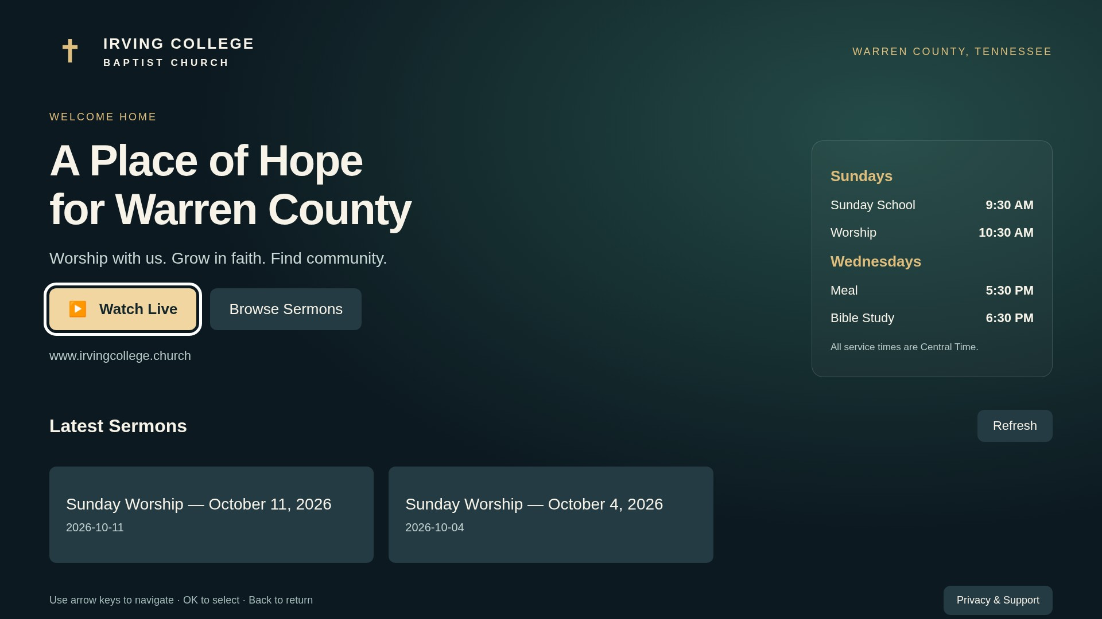
ICBC | LG submission preparation | 1.0.1 | Browser evidence; physical TV unverified

Recorded sermon library
Choose Browse Sermons, navigate the cards and select a title. Cards preserve the live catalog order.
Player controls: Play/Pause, minus/plus 30 seconds for archives, Retry and Back to Home.
Back/Stop closes playback and restores the originating card. A failed Refresh retains existing sermons.
No production video playback is depicted here. Real MP4 ranges/seek/end and native HLS remain hardware checks.
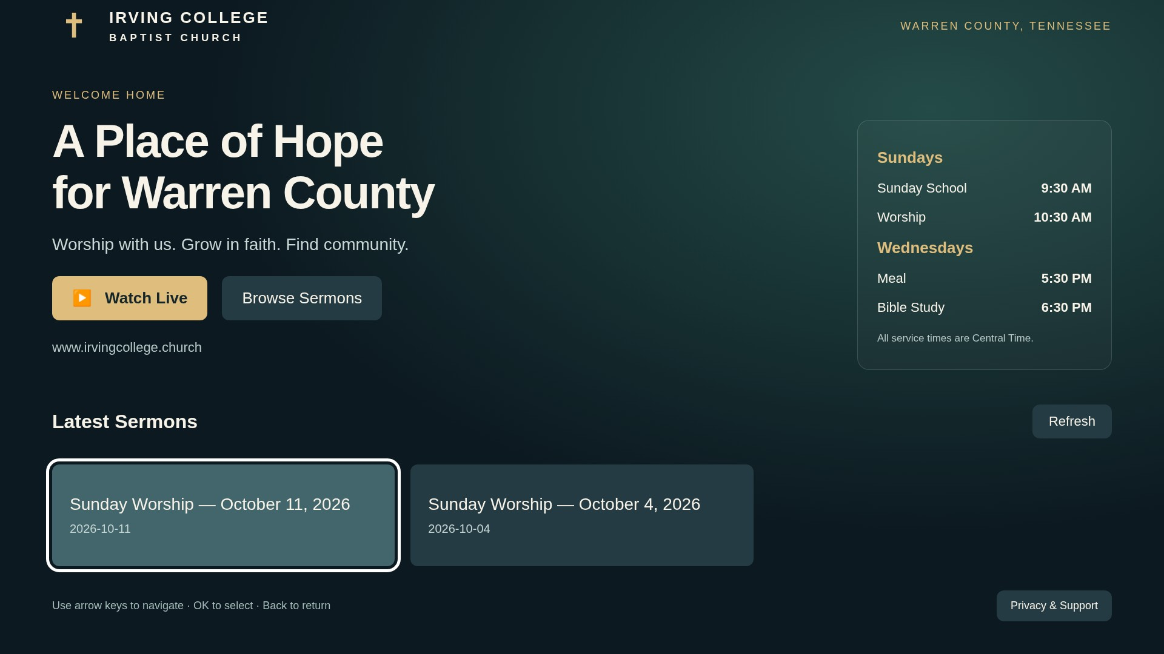
ICBC | LG submission preparation | 1.0.1 | Browser evidence; physical TV unverified

Privacy and support
Choose Privacy & Support from the home footer. Use Back to Home or remote Back to return.
Church-confirmed policy: no retained visitor/IP logs; no account, advertising, analytics or viewing-history storage.
IP/network request details are necessarily processed transiently to deliver the catalog and video.
Public policy and support URLs are in listing.md; contact icbcnextsteps@gmail.com.
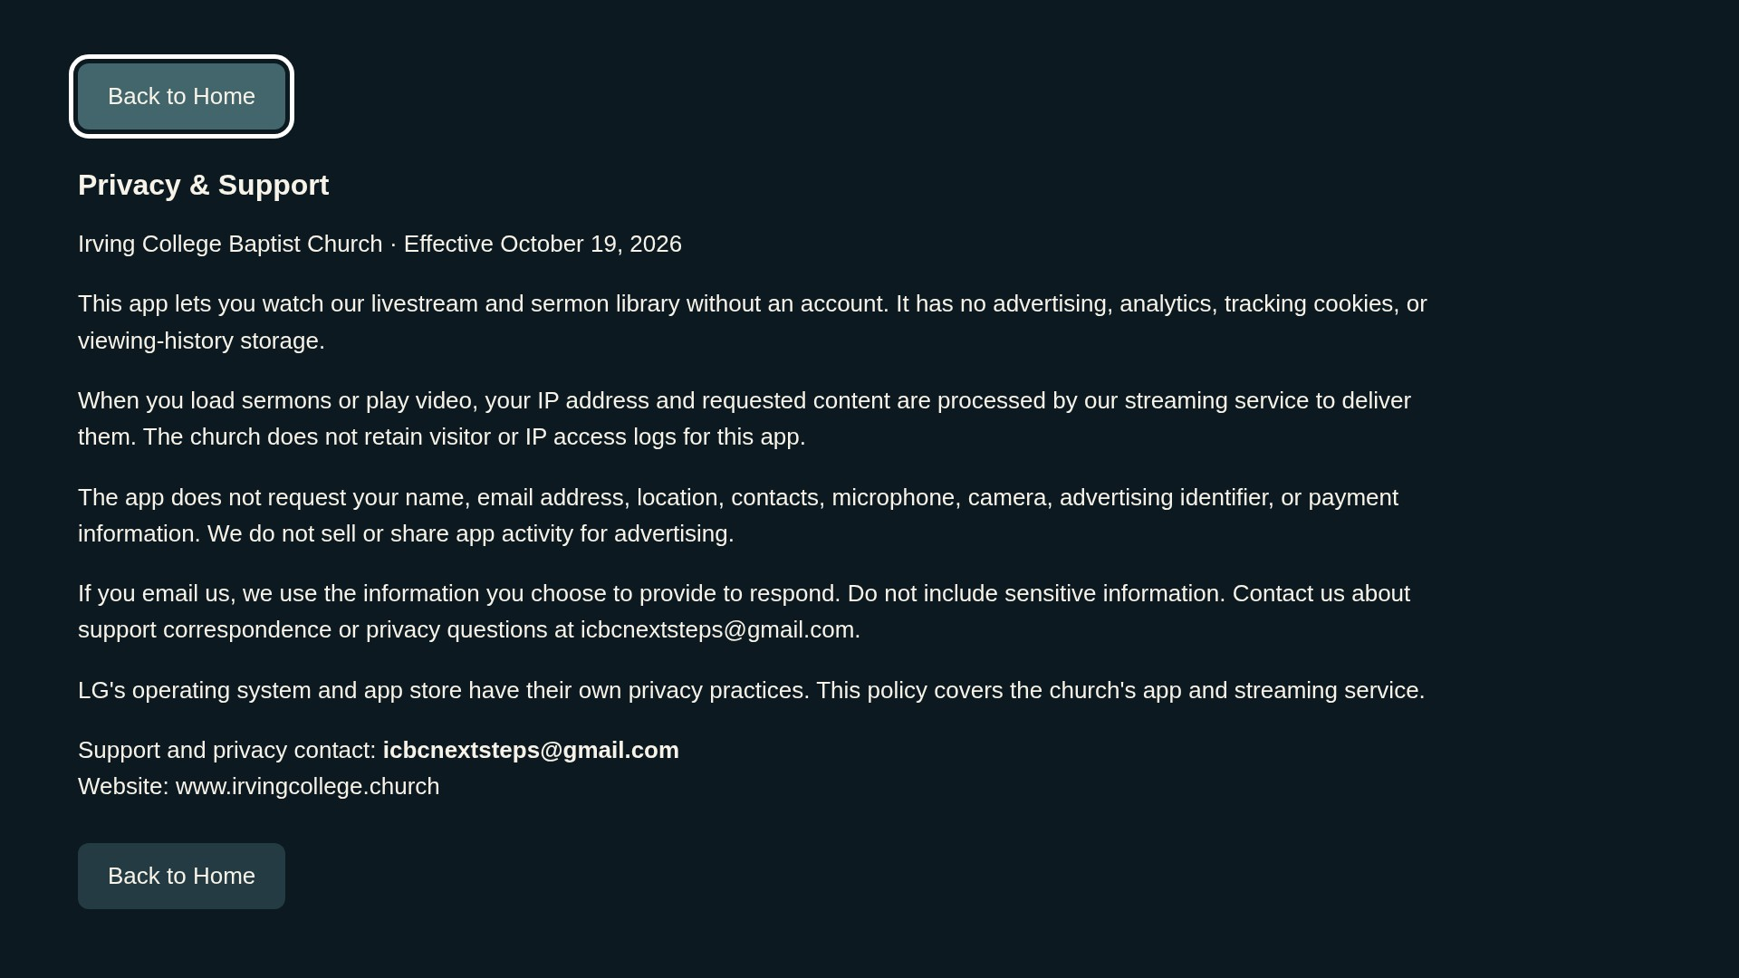
ICBC | LG submission preparation | 1.0.1 | Browser evidence; physical TV unverified

Back and application exit
Player Back returns to the originating screen; archive Back returns to home; privacy Back returns home.
At entry, this candidate shows Stay / Exit App. Stay dismisses; Exit requests window closure.
Remote and native shell exit must be validated on hardware. Check the webOS23–25-specific Home rule in LG’s current checklist before choosing those targets.
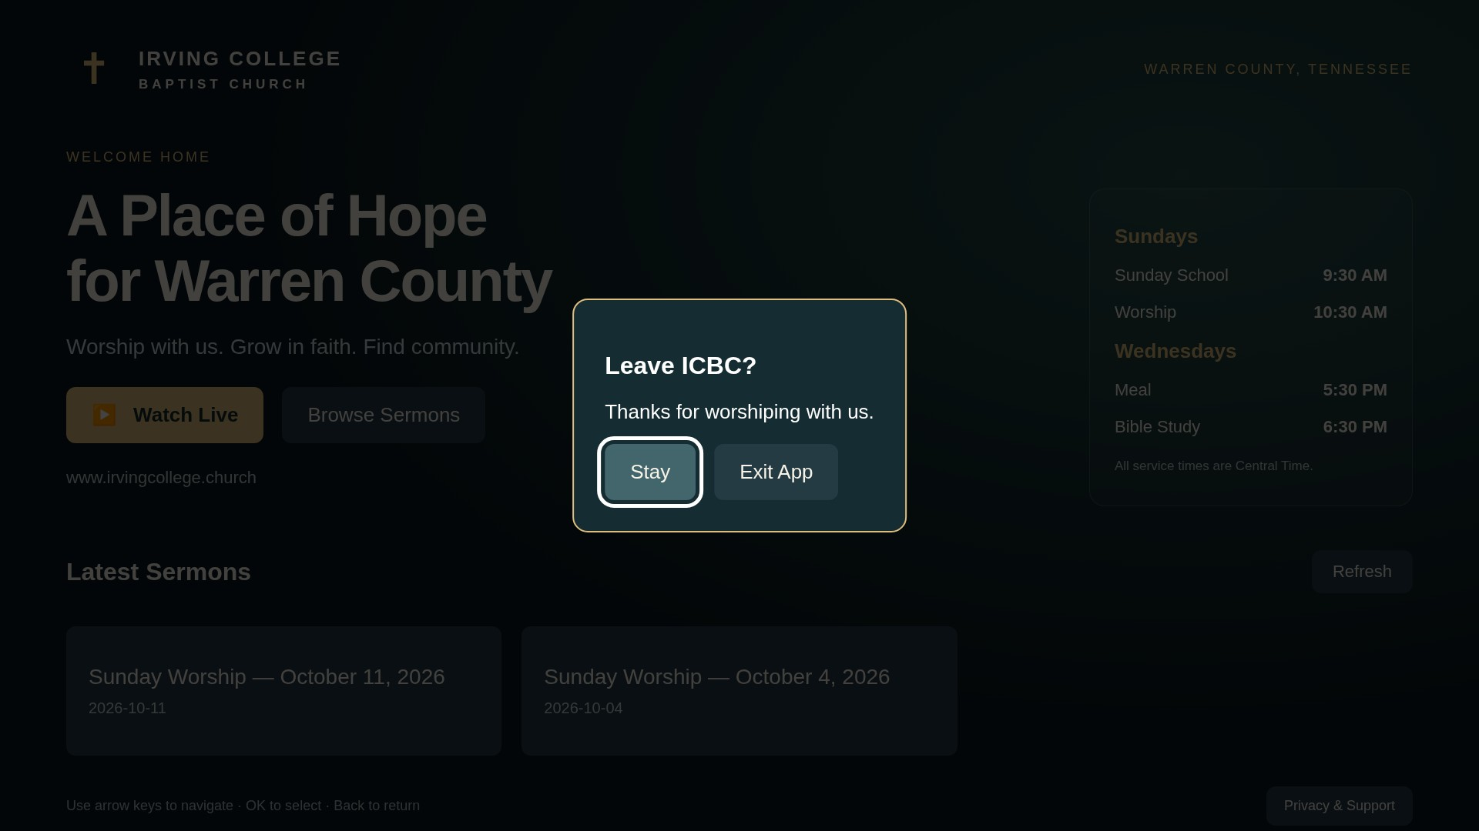
ICBC | LG submission preparation | 1.0.1 | Browser evidence; physical TV unverified

Playback, recovery and review windows
Live: https://live.irvingcollege.church/hls/stream.m3u8
Catalog: https://live.irvingcollege.church/sermons/catalog.json
Sunday worship is the only livestream; begins 10:30 AM U.S. Central Time (America/Chicago); duration varies.
Use an archive outside broadcast windows. No test account or external activation is required.
Live seeking is disabled. Startup or stalled playback reaches a recovery message after a bounded wait. Retry reopens the same URL.
Leaving the app pauses media; returning requires Play. Closing playback releases resources.
30 local automated tests pass; evidence logs are included. Fixture playback and mocks are not TV results.
ICBC | LG submission preparation | 1.0.1 | Browser evidence; physical TV unverified

Readiness and owner actions
Prepared: versioned official CLI IPK, checksums, branded assets, listing copy, privacy/support policy, reviewer route and evidence worksheet.
Open: installed-app catalog CORS; native TV live/archive playback; physical remote/lifecycle/exit tests; model-group Back requirement.
Open: current official LG self-checklist/UX template transfer, content/age questionnaire, final model selection and authorized seller declarations.
Church confirms sermon distribution rights, exclusion of music for rights reasons, US-only distribution and no visitor/IP logs.
No production streaming server configuration was changed. No Seller Lounge account was accessed and nothing was submitted.
Use the official forms linked in requirements-sources.md; transfer actual results only.
ICBC | LG submission preparation | 1.0.1 | Browser evidence; physical TV unverified

