Test Case Name :SiteTracker_Assignment_01

Test Case Execution Date :2020-05-21 14:06:49:344

Test Step 1

Description (Actions)

Navigate to the link: https://developer.salesforce.com/docs/component-library/documentation/en/48.0/lwc

Actual Results:

App Loaded Succesfully
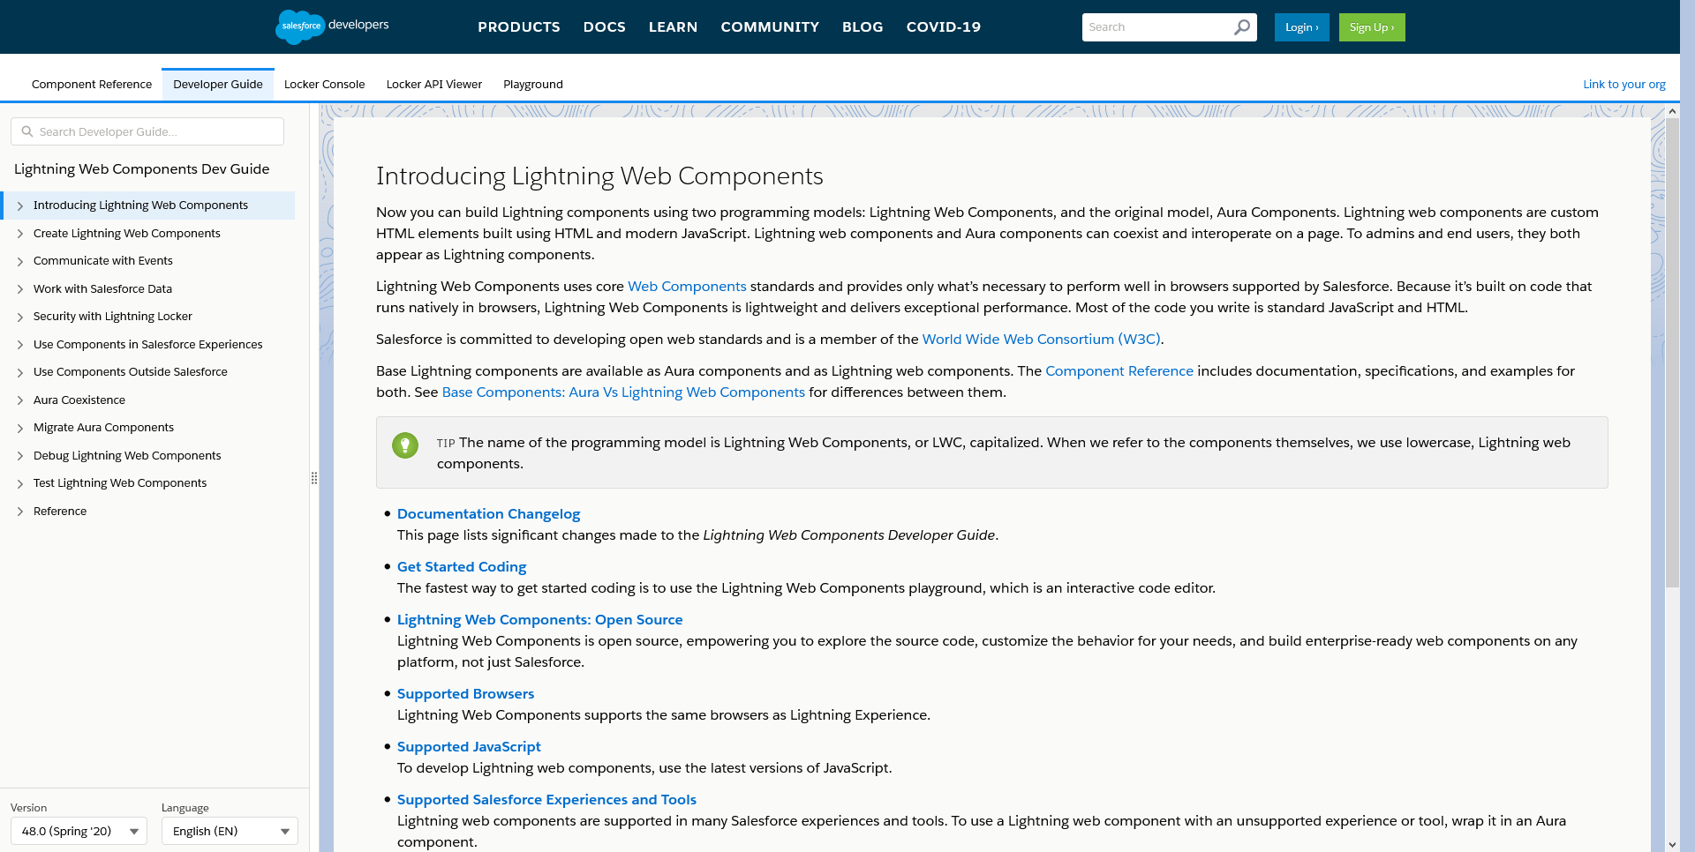

Test Step 2

Description (Actions)

Switch to the Component Reference tab

Actual Results:

Switched to Component Reference tab
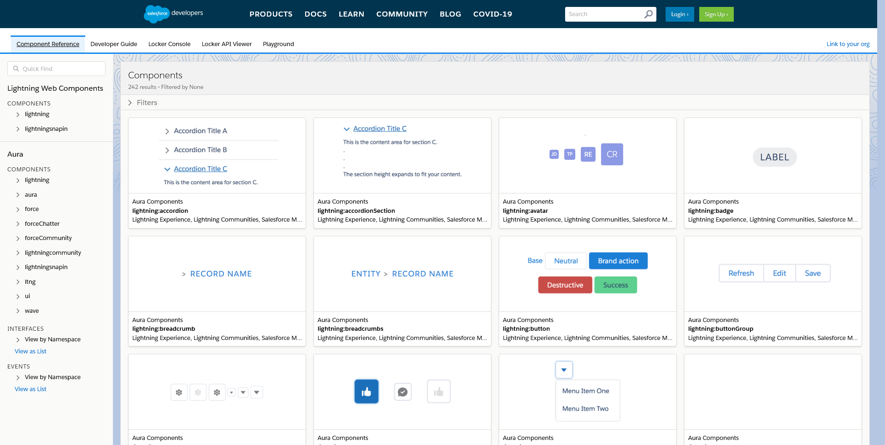

Test Step 3

Description (Actions)

Search in Quick Find for 'datatable'

Actual Results:

'Quick Find' Set
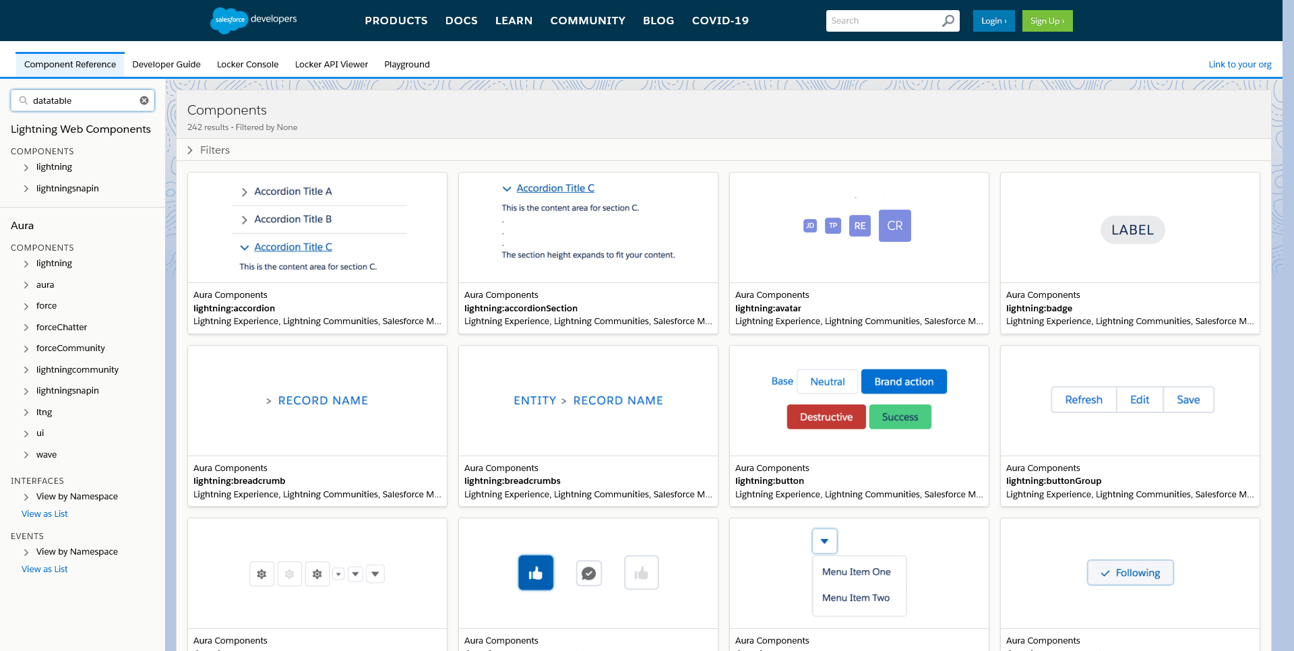

Test Step 4

Description (Actions)

Under Lightning Web Components, click on the Components>lightning>“datatable” on the left menu panel

Actual Results:

'datatable' link clicked
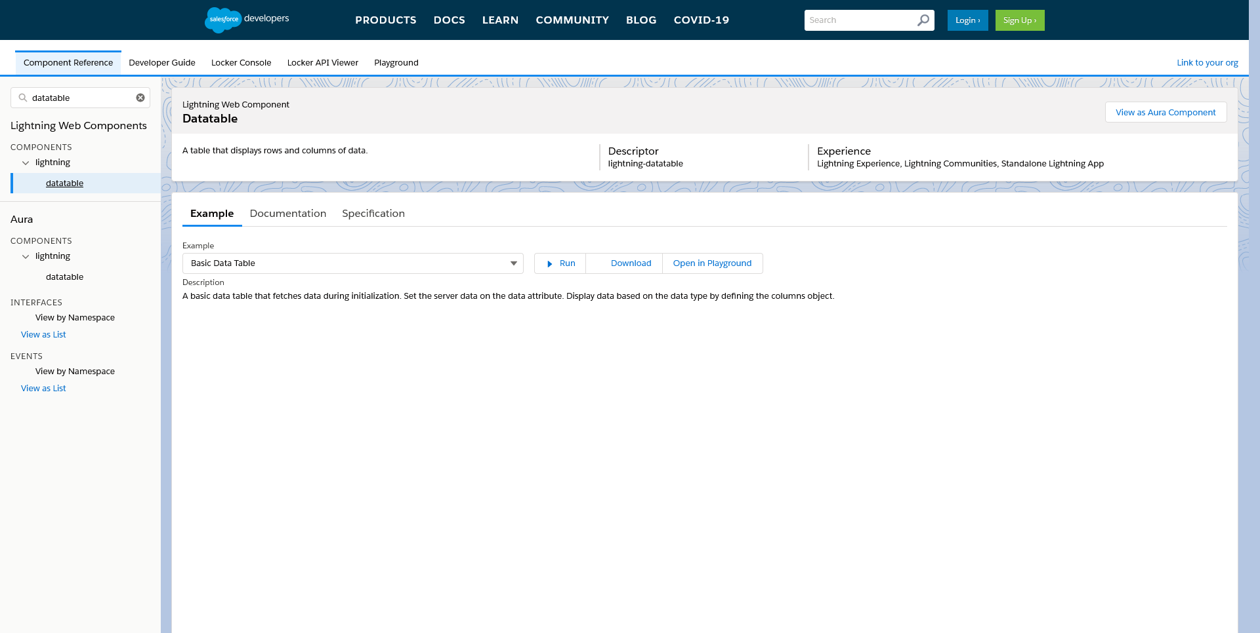

Test Step 5

Description (Actions)

Under Example tab on the main pane > select “Datatable from Inline Edit” from the dropdown

Actual Results:

“Datatable from Inline Edit” Selected
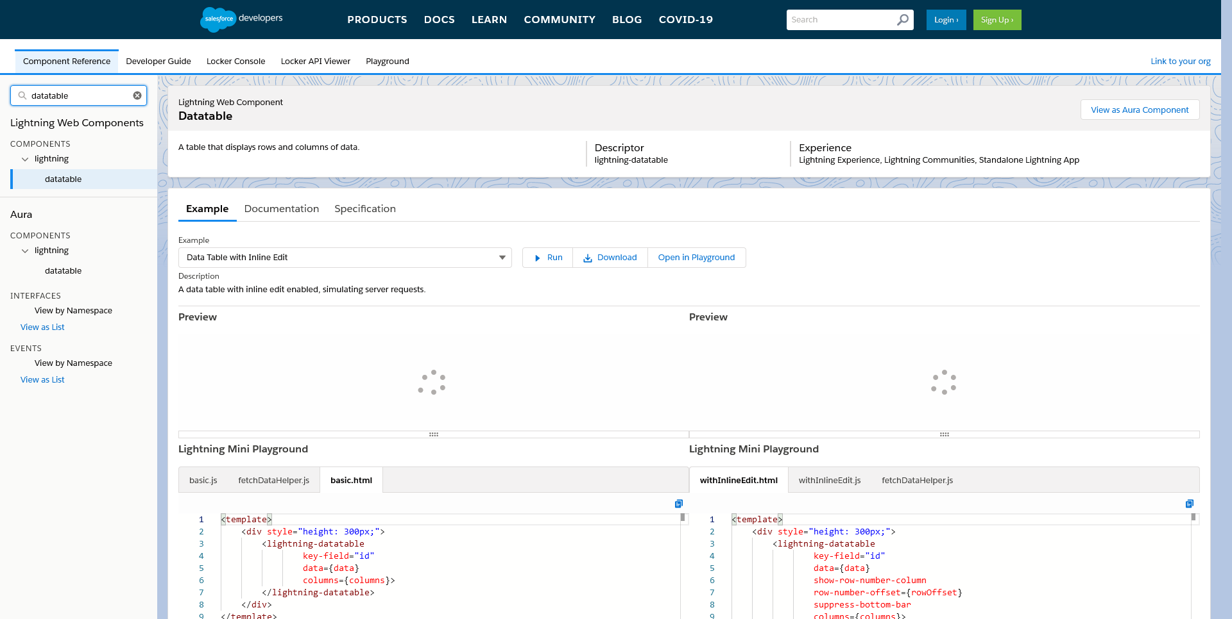

Test Step 6

Description (Actions)

Click on the “Open in Playground” button

Actual Results:

The “Open in Playground” button is clicked
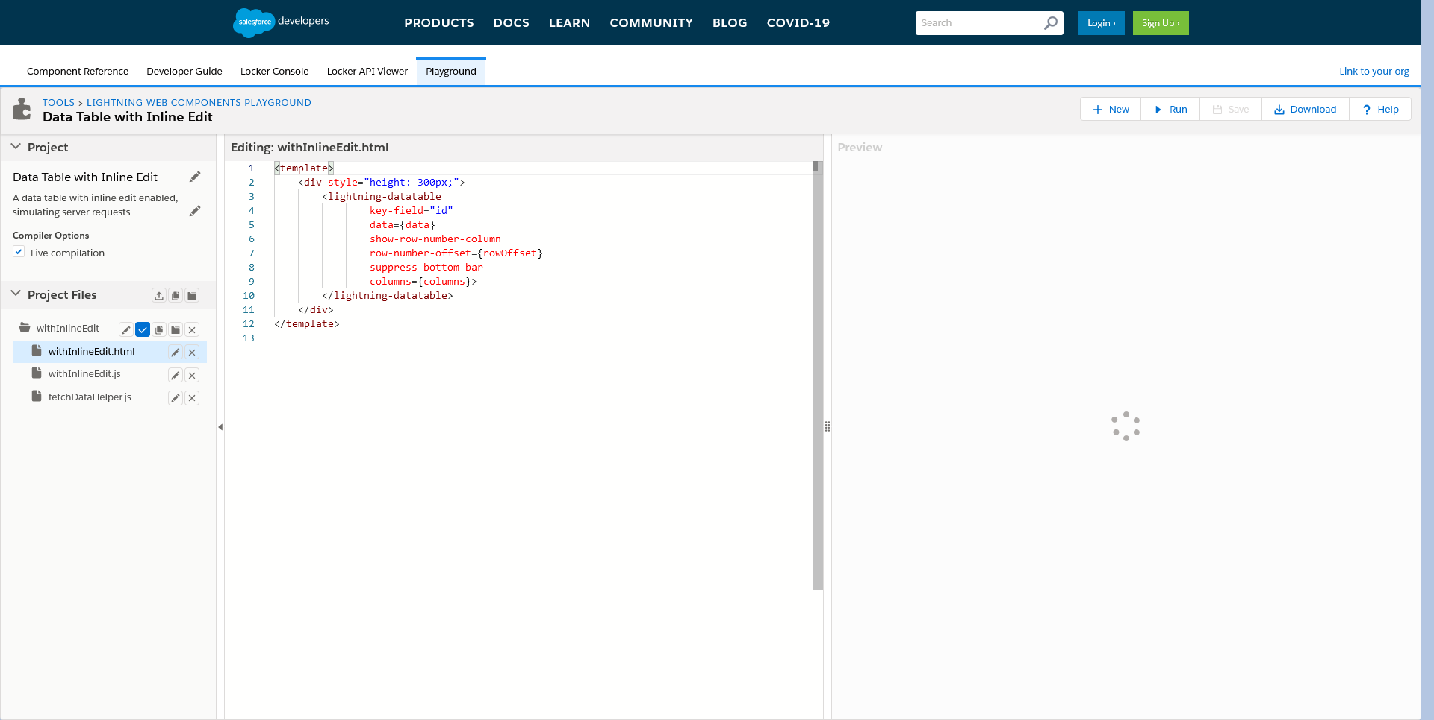

Test Step 7

Description (Actions)

Under the rightmost section “Preview” -> Edit/Update the values for all the columns in row 3 in the table

Actual Results:

All the columns in row 3 are Updated
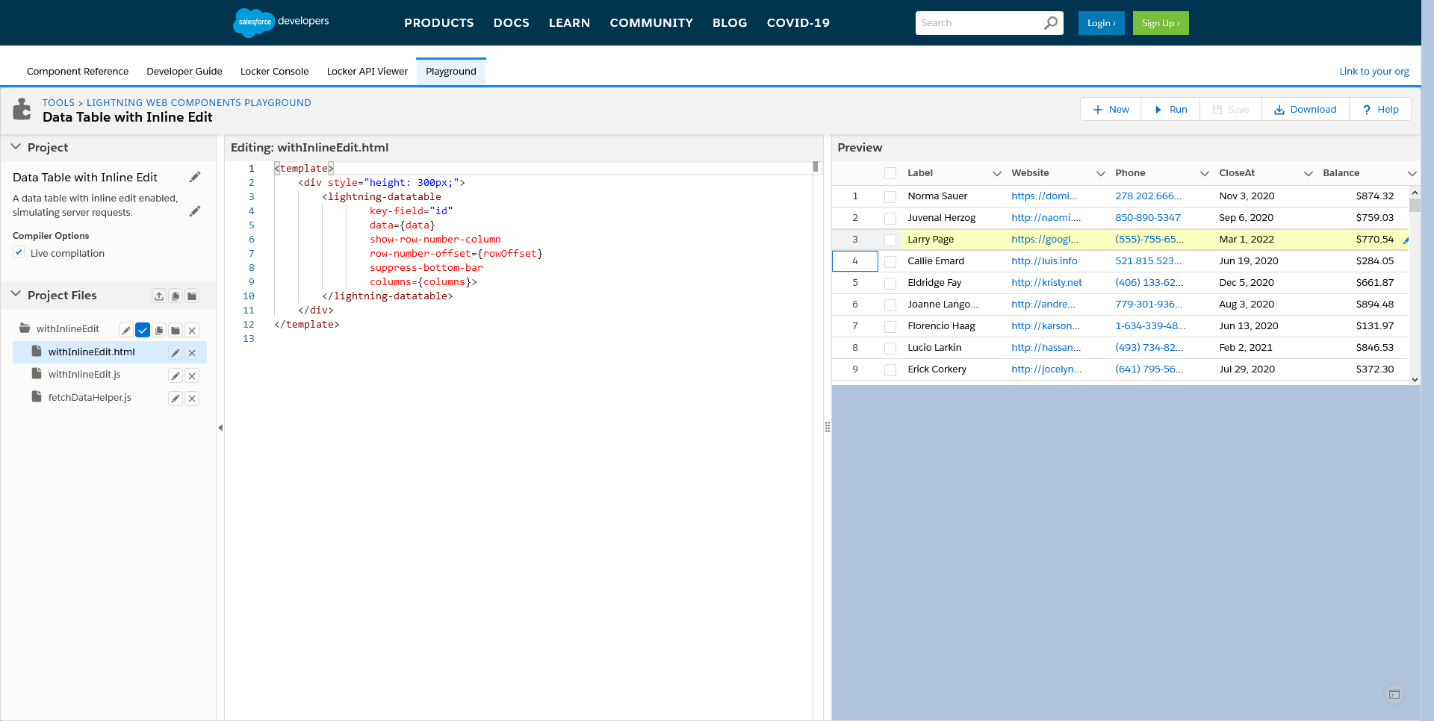

Test Step 8

Description (Actions)

Assert the above have been updated in the table

Actual Results:

Data in table is successfully updated

Test Step 9

Description (Actions)

Navigate back to the previous page and Repeat step 5 by selecting the “Datatable With Row Actions” from the dropdown

Actual Results:

Switched to Component Reference tab
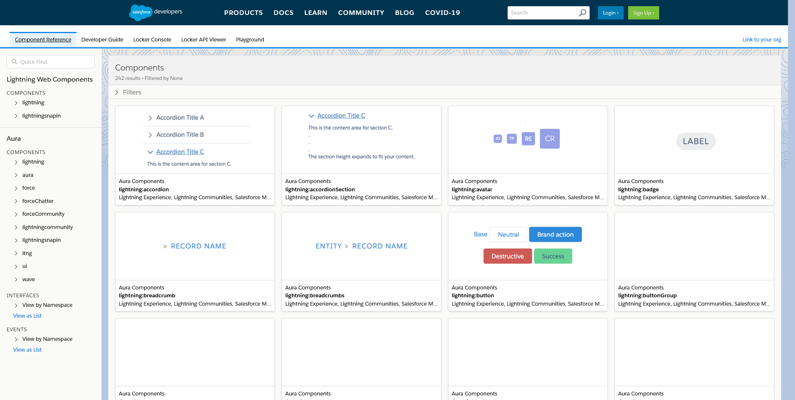

Actual Results:

'Quick Find' Set

Actual Results:

'datatable' link clicked
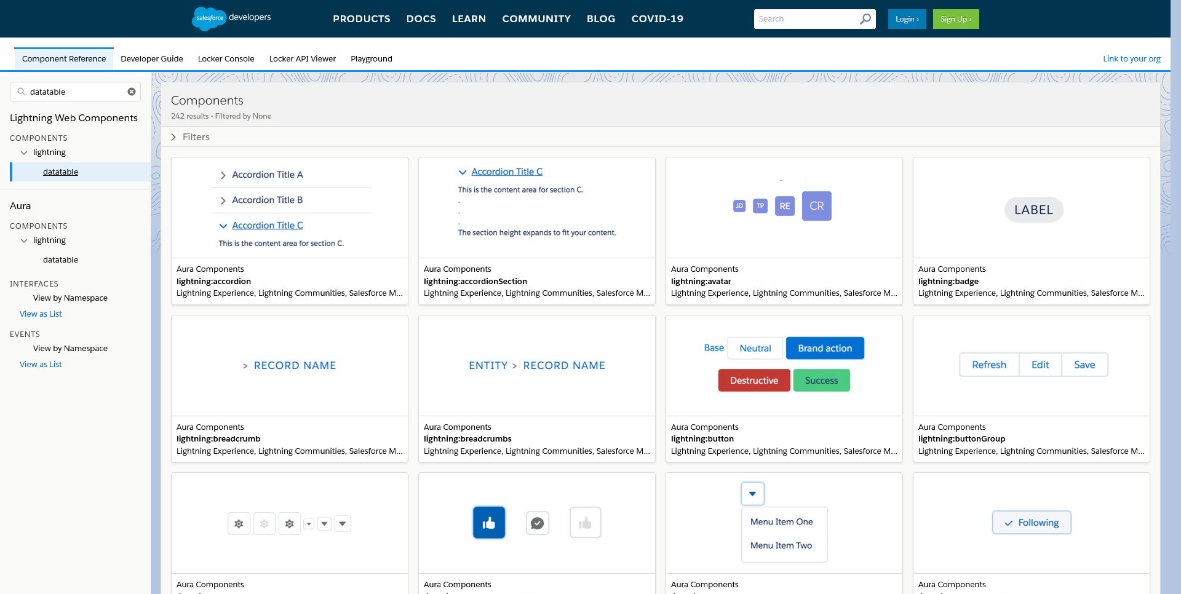

Actual Results:

“Datatable from Inline Edit” Selected
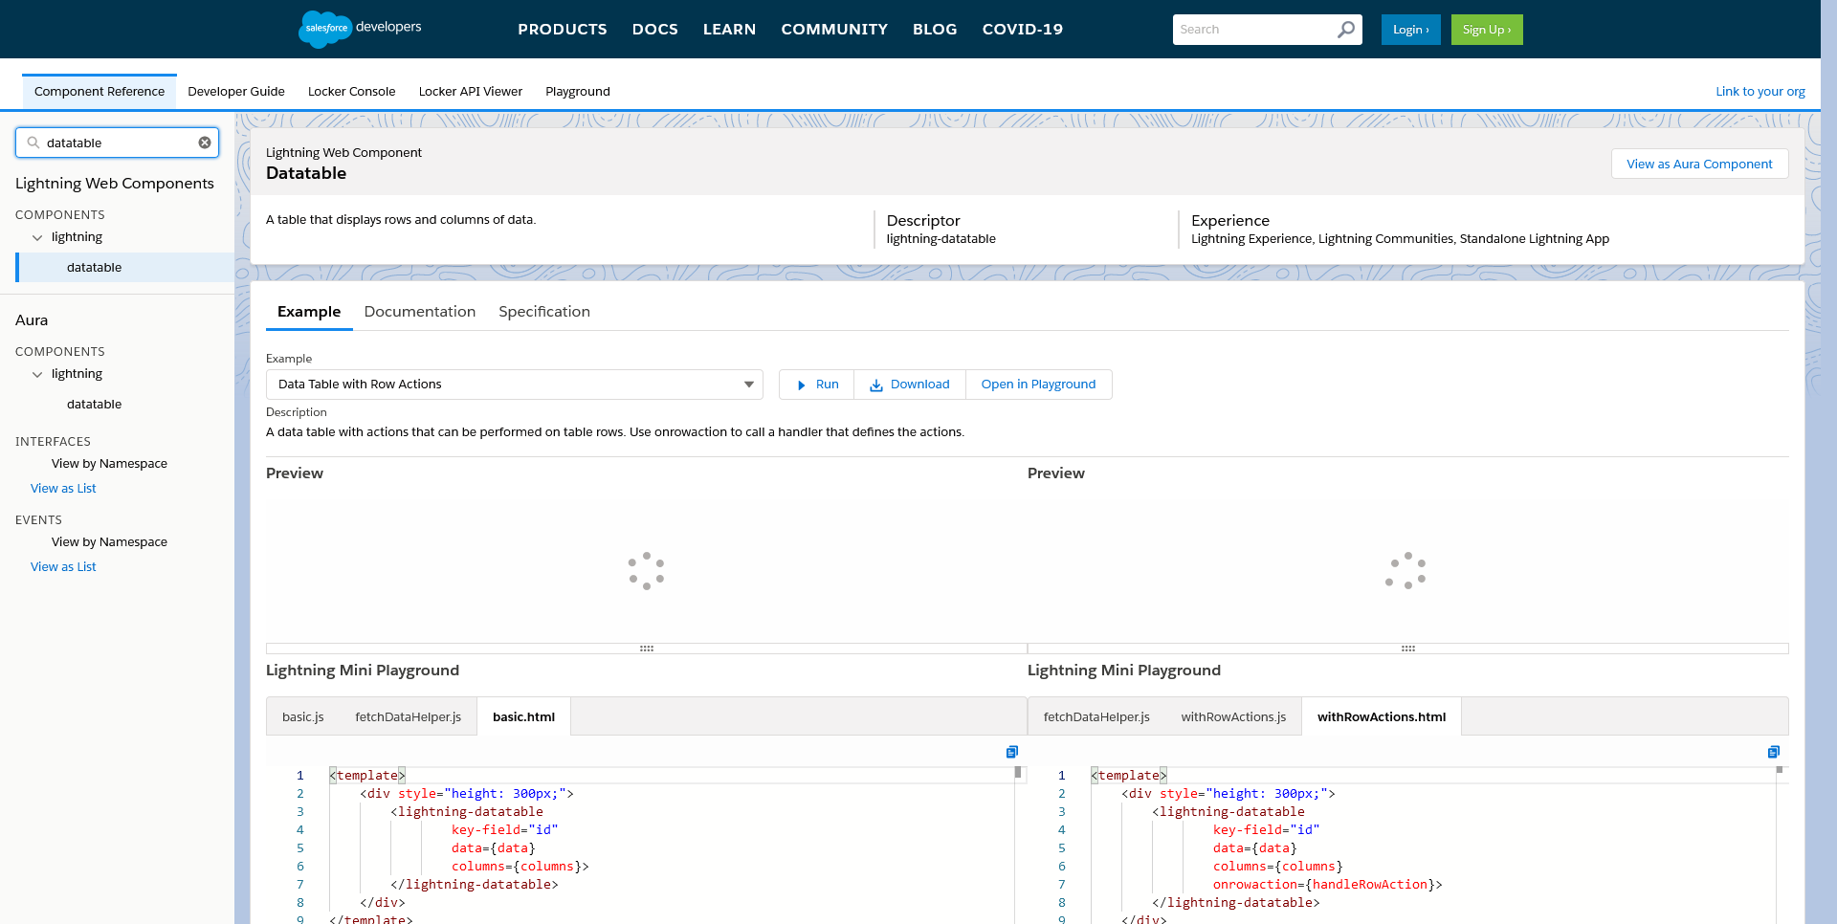

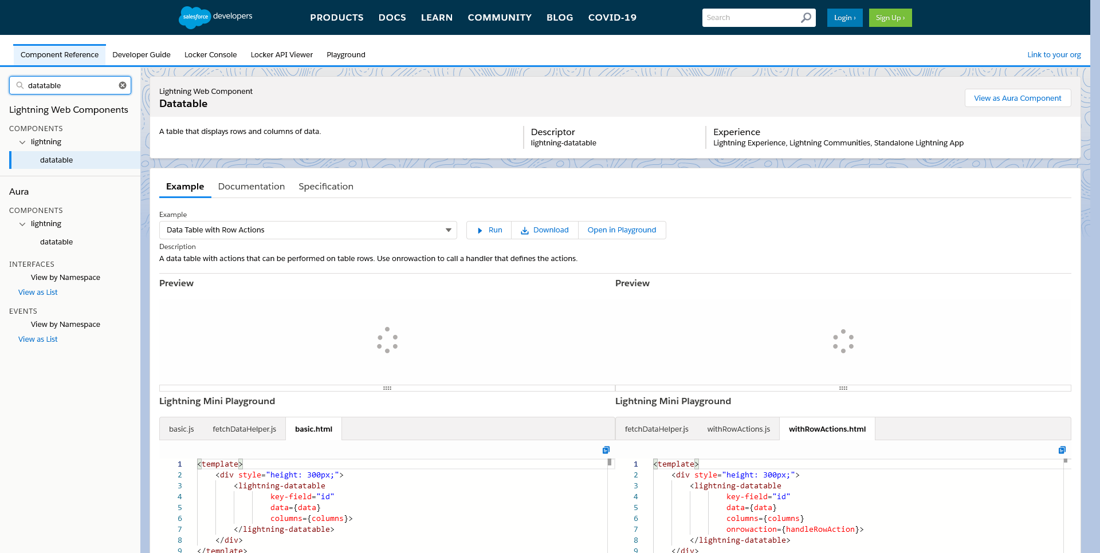

Test Step 10

Description (Actions)

Click on the “Open in Playground” button

Actual Results:

The “Open in Playground” button is clicked
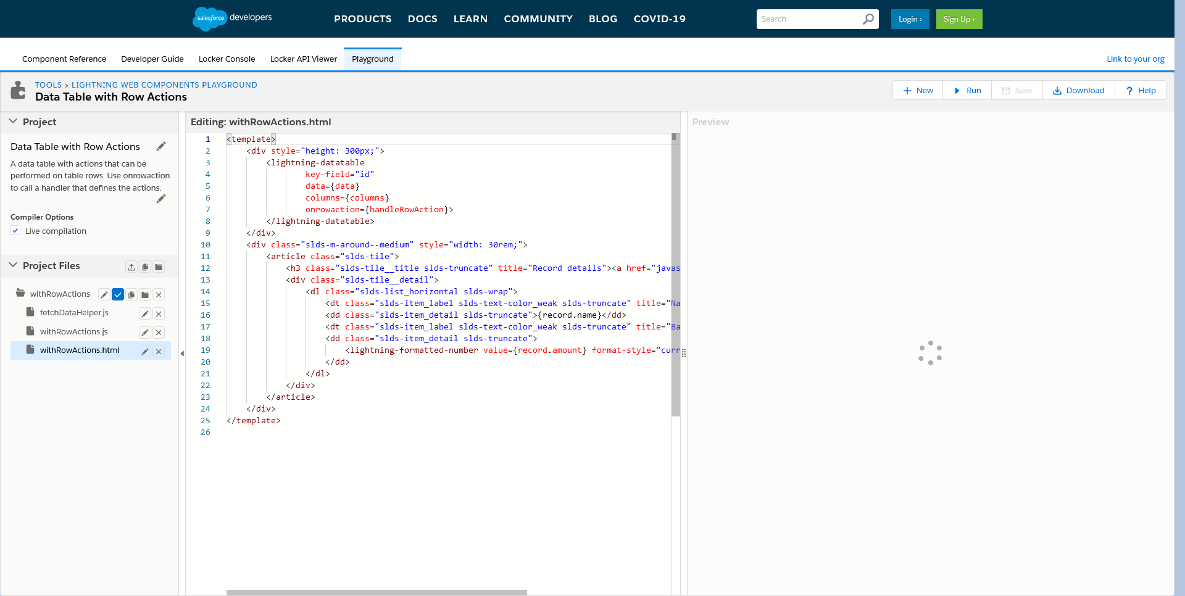

Test Step 11

Description (Actions)

Under the rightmost section “Preview” -> Scroll down to the end of the table

Actual Results:

Last record found
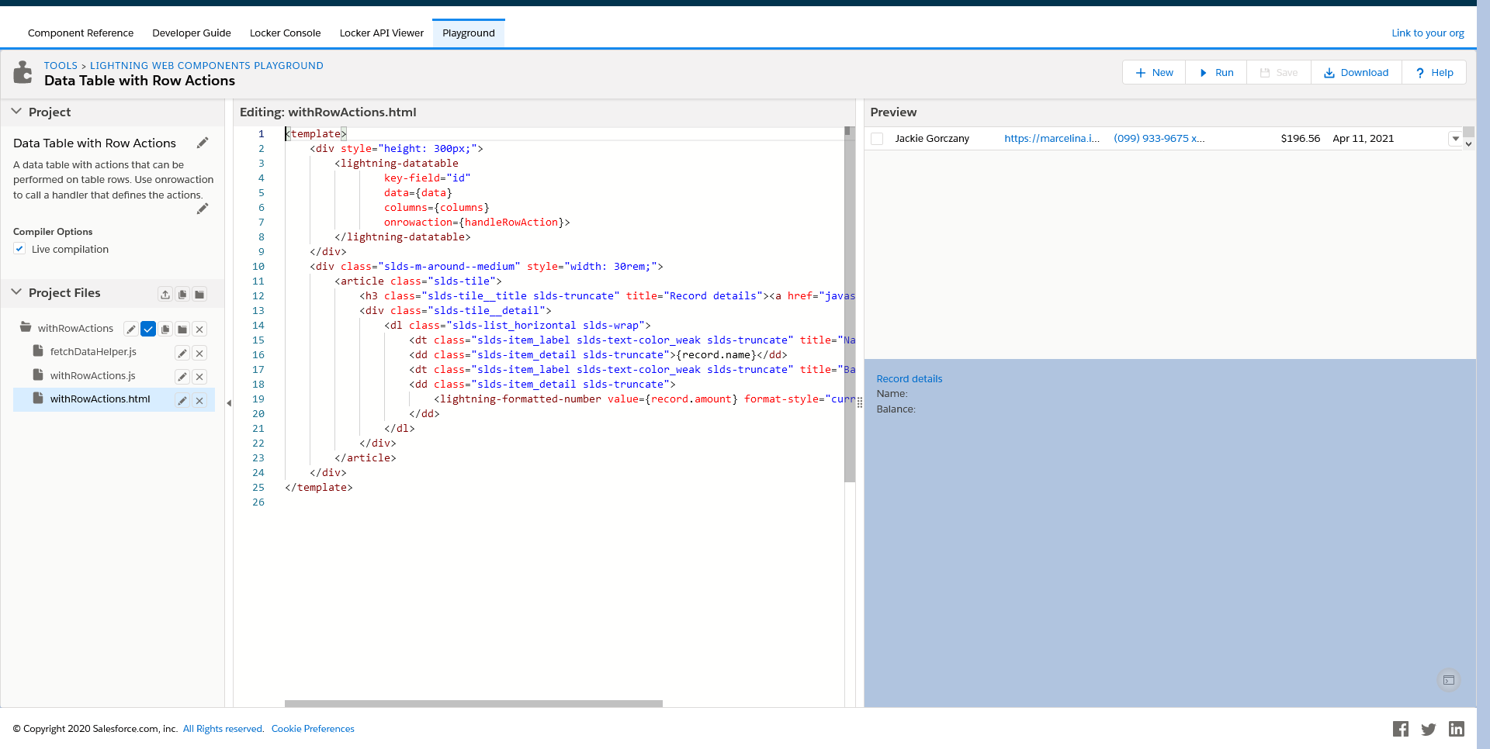

Test Step 12

Description (Actions)

Click on the down caret icon for the last row and select “Show Details

Actual Results:

Not Possible to click on 'Show Details'
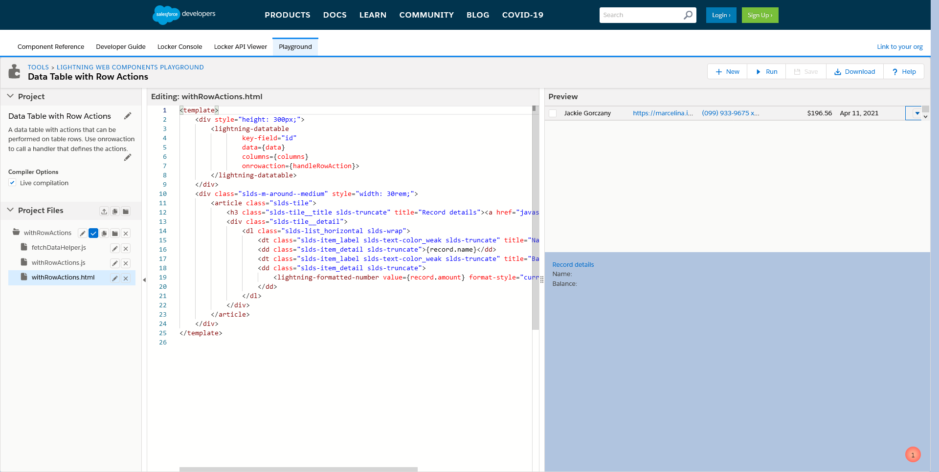

Test Step 13

Description (Actions)

Assert the record details “Name” and “Balance” are the same as the last row in the Blue Section below the table

End Date :2020-05-21 14:08:25:914

