**Irving VELÁZQUEZ RAMÍREZ**

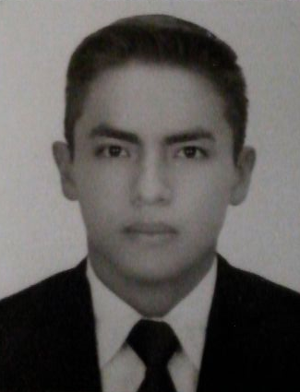

**Age:** 26 Years old.

**Marital Status:** Single

**Address:**  Street Victoriano Agüeros N. 1495

**Col**. Obrera

**Municipio:** Guadalajara

C.P. 44140.

**Country, City:** Jalisco

**Phone:** 41 67 34 69

**Cell Phone:** (55) 91 70 88 60

**E-mail:** [ing.irvingver@gmail.com](mailto:ing.irvingver@gmail.com)

**Professional Objective**

Develop my knowledge, experience , skills and abilities for a common benefit, with this can benefit to the company and at the same time increasing my professional experience.

Being a successful Computer Engineer, in a continuous process to achieve a development family, social , professional , personal and occupational based primarily to be a valuable contributor to any consulting / company wishing to have my services.

**Studies**

**Years 2008-2014 University**, **Degree**: Degree in Computer Engineering

**México, D.F.** Universidad Autónoma Metropolitana Cuajimalpa.

**Languages**

**Engish:** Intermediate - Advanced. 80%

**Skills**

* Active.
* Achiever.
* Responsible.
* Dynamic.
* Punctual
* Easy to understand, comprehend and use different types of programming languages.
* Methodologies:
  + Scrum
  + Agile
  + UP
* Development of systems and applications:
  + Query's
  + Client - Server
  + Client – Server – Web
* Design World Wide Web with management applications:
  + HTML5
  + CSS templates
  + PHP
  + JSP
  + Java Script
* Frameworks
  + JQuery
  + Spring
  + Maven
  + Bootstrap
  + Hibernate
  + JPA
  + Angular
  + Stripes
* Programming
  + C y C++
  + Java
  + Python
  + OpenGL
  + Visual Basic
  + .NET
* Databases management
  + SQL
  + Mysql
  + Oracle
* Others
  + iReport
  + UML
* Basics:
  + Digital Systems.
  + Operating Systems.
  + Distributed Systems.
  + Network Architecture.
* Realization of big software projects .

**WORK EXPERIENCE**

**(From 17/05/2016 to Actual Guadalajara, Jalisco)**

TATA Consultancy and Service, Development area.

**Position**: Java Developer.

**Completed task:**

* Project development and attention to applications defects:
  + - Using agile methodology.
    - JAVA
    - JPA
    - Java Script
    - Angular
    - Bootstrap
    - Maven
    - Spring
    - HTML5
    - Css
    - Jsp
    - Sql

**(From 13/08/2014 to 31/03/2016 México, D.F.)**

SOFTTEK, Development area.

**Position**: Java Development.

**Completed task:**

* Development of reports in PDF with the tool IReport.
* Development of Queries for the reports.
* Project development and attention to applications defects:
  + - JAVA
    - JPA
    - PHP
    - Java Script
    - Maven
    - Hibernate
    - Struts
    - Spring
    - Jsp
    - Sql

**(From 02/05/2013 to 31/10/2013 México, D.F.)**

INTERTEK S.A. de C.V., Systems area.

**Position**: Development of internal applications.

**Completed task:**

* Development of Query's.
* Development of application client-server.
* Analysis and detection of defects.
* Restructuring stored processes.
* Realization of User Manuals.

**WORK REFERENCES**

**Cynthia Nohemi ARRIAGA MARTÍNEZ**

Softtek (México, D.F.)

Technical Leader.

Cell Phone: 044 55 42 44 76 43 E-mail: Cynthia.arriaga@softtek.com

**Guillermo Rodrigo León Millán**

Softtek (México, D.F.)

Technical Leader.

Cell Phone: 044 55 22 57 94 18 E-mail: guillermo.leon@softtek.com