A DOCUMENTATION OF FIELD EXPERIENCES UNDER
FIELD INSTRUCTION 1
(WORKING WITH INDIVIDUALS AND GROUP)

At the

STILL WATERS KID’S HOME INC.
MAJAYJAY LAGUNA

Presented to the Faculty of Bachelor of Science in Social Work

Dalubhasaan ng Lungsod ng Lucena

In Partial Fulfillment of the Requirements for the Degree
BACHELOR OF SCIENCE IN SOCIALWORK

ANDREI VINCENT T. SOREZO

FIRST SEMESTER, AY 2025-2026
NOVEMBER 2025

TABLE OF CONTENTS

- INTRODUCTION………………………………………………………………...
- RATIONALE……………………………………………………………………...
- The Case Studies and Group Study……………………………………………...
- Case Studies
Case Study 1………………………………………………………………..
Case Study 2………………………………………………………………..
Case Study 3………………………………………………………………..
Case Study 4………………………………………………………………..
Case Study 5………………………………………………………………..
Group Study………………………………………………………………...
Group Profile……………………………………………………………….
Summary of the Groupwork………………………………………………..
IV. INTEGRATIVE PAPER…………………………………………………………….. V. REFERENCES………………………………………………………………………… VI. APPENDICES………………………………………………………………………... 1. Student’s Placement Requirements……………………………………………
- Placement Preference Form
- Letter of Intent
- Autobiography
- Parent’s/ Guardian’s Consent
- Medical Certificate
- Insurance Certificate
- Learning Contract
- Supervisor Profile
- Agency Profile
2. Field Placement- related documents
  - General and Weekly Work Plan
  - Daily Placement Log
  - Process Recording
  - Letter
  - Minutes of the Meetings
  - Documentation
- Curriculum Vitae

I. INTRODUCTION
Field Instruction 1 is the first step for social work students to finally apply what they have been learning inside the classroom into real-life situations. After years of discussing theories, approaches, and principles, FI1 allows students to see how social work truly works on the field, especially when dealing with real clients, real problems, and real emotions. This phase helps students understand that social work is not just about memorizing concepts, but also about knowing how to respond to people’s needs with empathy and professionalism. Through FI1, students begin to see the connection between theory and practice, and how their academic training prepares them for actual fieldwork.
During this field placement, the affiliate was assigned to Still Waters Kid’s Home Inc. in Majayjay, Laguna, a residential facility for abandoned, neglected, orphaned, and abused children. Being placed in this type of setting exposed the affiliate to a variety of cases involving young children with different backgrounds and experiences. It also challenged the affiliate to adjust to the environment, understand the agency’s rules and routines, and interact with the children in ways that are developmentally appropriate. Through daily exposure, the student learned how to observe children’s behavior, communicate with them gently, and identify areas where support or intervention might be needed.
Throughout the placement, the affiliate handled several case studies and worked closely with the social worker, house parents, and the rest of the agency staff. This involved interviewing, collecting background information, preparing reports, updating dossiers, and understanding the legal processes related to child protection and adoption. At the same time, the affiliate also facilitated sessions and activities for groupwork, which required creativity, planning, and the ability to lead children in meaningful and age-appropriate tasks. These responsibilities helped the affiliate strengthen his skills in communication, documentation, and coordination, skills that are essential for every future social worker.
The affiliate also had the chance to experience the everyday operations inside the Home, such as maintaining routines, observing house rules, attending agency meetings, and participating in small tasks that support the children’s daily needs. Through these experiences, the affiliate realized the importance of teamwork and how every staff member plays a role in ensuring the safety and well-being of the children. The environment of Still Waters provided many learning opportunities, especially on how to handle children with diverse personalities and emotional needs. The affiliate saw firsthand how patience, consistency, and compassion greatly impact a child’s development.
Overall, Field Instruction 1 served as a meaningful introduction to what it truly feels like to be part of the social work profession. It allowed the affiliate to understand the realities of working with children in residential care and gave them the confidence to apply what they have learned in class. This field placement helped shape the student’s values, improved their communication and documentation skills, and strengthened their desire to continue growing as a future social worker. FI1 was not just an academic requirement, it was a valuable experience that prepared the affiliate for the next stages of their training.

II. RATIONALE
Field instruction is a major part of social work training because it allows students to apply what they have learned in the classroom to real-life situations. It helps them understand how social work values, principles, and skills are used in actual practice, especially when working with agencies and communities that serve vulnerable groups. By experiencing real interactions with clients, students learn how to respond to different challenges while building confidence and a deeper sense of purpose as future social workers.
The affiliate chose to undergo Field Instruction 1 with the goal of growing both personally and professionally. Being placed at Still Waters Kid’s Home gave the affiliate the chance to work with children facing different emotional and developmental needs. Through interviews, case documentation, and group activities, the affiliate was able to observe the children closely and learn how to support them in ways that are appropriate and compassionate. This experience strengthened the affiliate’s skills in communication, assessment, and teamwork, skills that are essential in the social work profession.
Another reason the affiliate embraced field instruction was to discover his strengths and address areas where he still needed improvement. Although the student first entered the course with some uncertainty, the hands-on experience gradually helped him appreciate the real purpose of social work. Seeing how social workers advocate for children and help create positive change made the affiliate more committed to the profession. Through FI1, the student realized the importance of patience, empathy, and consistency when working with clients.
Overall, this rationale emphasizes that Field Instruction 1 was not just a requirement, but also a meaningful opportunity for learning and growth. Through his time at Still Waters Kid’s Home, the affiliate developed a stronger understanding of the profession and gained valuable experiences that will guide him as he continues preparing to become a social worker.

III. THE CASE STUDIES AND GROUP STUDY
A. CASE STUDIES
Case study 1

- Identifying Information

Last Name |  | Globio
First Name |  | Princess Angel (Angel)
Middle Name |  | N/A
Address  (house no, street, purok, barangay, town/city/municipality, province |  | Still Waters Kid’s Home Inc. ACBS Compound  Barangay Ilayang Banga, Majayjay, Laguna
Contact Number |  | N/A
Age:  8y/o  Sex:  Female | Civil Status:  Single |  | Religion:  Born Again Christian
Birthday:  February 15, 2017 |  |  | Birthplace:  Parañaque City

Education
Level | School | Year attended
Day care/Kindergarten | Basic Life Empowerment and Support System program (BLESS) | 2023-2024
Elementary (1-6) | Philippine Christian School of Tomorrow (SOT)  (Home Schooling) | 2024-Present
High School | N/A | N/A
College | N/A | N/A
Vocational Course | N/A | N/A
ALS | N/A | N/A

- Problem Presented

Princess Angel Globio or simply Angel, an 8-year-old child, was abandoned by her biological mother and later rescued from the care of her maternal relatives due to neglect and severe malnutrition. Angel is currently under the temporary care of Still Waters Kid’s Home Inc. while awaiting the completion of her legal adoption process. Therefore, there is an urgent need to comply with the necessary requirements in order to proceed with regional matching and eventually secure a permanent adoptive placement that will best serve her needs and overall well-being.

- Family Background and Information

  - Family Composition

Name | Age/Sex | Birthday | Relationship to the Client | Educational Attainment | Occupation/Income
Gemma | 38 years old | Unknown | Mother | Unknown | Unknown
Gherald | 28 years old | Unknown | Uncle | Unknown | Farmer  ₱300.00/day
Shaira | 29 years old | Unknown | Aunty in law | Unknown | Housewife
Mark Henry | 10 years old | Unknown | Cousin | Unknown | N/A
Mark Anthony | 8 years old | Unknown | Cousin | Unknown | N/A

  - Family Background of the Client: (home condition, kind of relationship, strengths, coping mechanisms)

The child was rescued by the MSWDO of Bay Laguna, and referred by Ms. Anastacia C. Erasga to Still Waters Kid’s Home Inc. for proper case management.

The information regarding the family of Angel was very limited. Her mother’s name is Ms. Gemma, who left her under the care of her half-brother, Mr. Gherald, and his partner, Ms. Shaira. Gherald and Shaira have 2 children of their own and their income was not enough to provide for their family and angel’s daily needs. While living with them, Angel was neglected because of their financial problems, which caused her to suffer from severe malnutrition.
Angel was rescued by the authorities due to a report from a concerned neighbor informing them that they often hear a child crying non-stop inside Gherald’s house. When the authorities visited Gherald’s house, they found the child in a dire condition, extremely thin and malnourished. Angel was immediately removed from the custody of her uncle and eventually referred by the by Ms. Anastacia C. Erasga, a social worker of Bay Laguna to Still Waters Kid’s Home for proper care and case management.

Presently, Angel is staying at Still Waters Kid’s Home in Majayjay, Laguna. It’s a licensed children’s home inside the Asia Center for Biblical Studies (ACBS) compound. The place cares for kids who were abandoned, neglected, orphaned, or abused, from newborns up to six years old. The home is made to be safe and comfortable, with separate rooms for babies, girls, and boys. Each room has beds, cabinets, and toys. There’s also a small clinic with medical supplies, a kitchen and dining area where kids eat healthy meals together three times a day, a laundry area, and a play/receiving area. The building has CCTV cameras and fire safety tools, and the walls are painted with bright, child-friendly designs. The children can also use books, art supplies, and videos for fun and learning.

The place is led by the Executive Director, Ms. Mary Rose O. Bautista, together with staff and case managers. They look after the kids’ daily needs, make activities for them, and check their progress regularly. Each day has a schedule for play, learning, meals, and rest, so the children can grow well in every aspect. Still Waters doesn’t only provide food and shelter, but also gives the children a chance to enjoy, laugh, and grow emotionally and spiritually. It’s a safe and caring environment where Angel and the other kids can feel loved and supported.

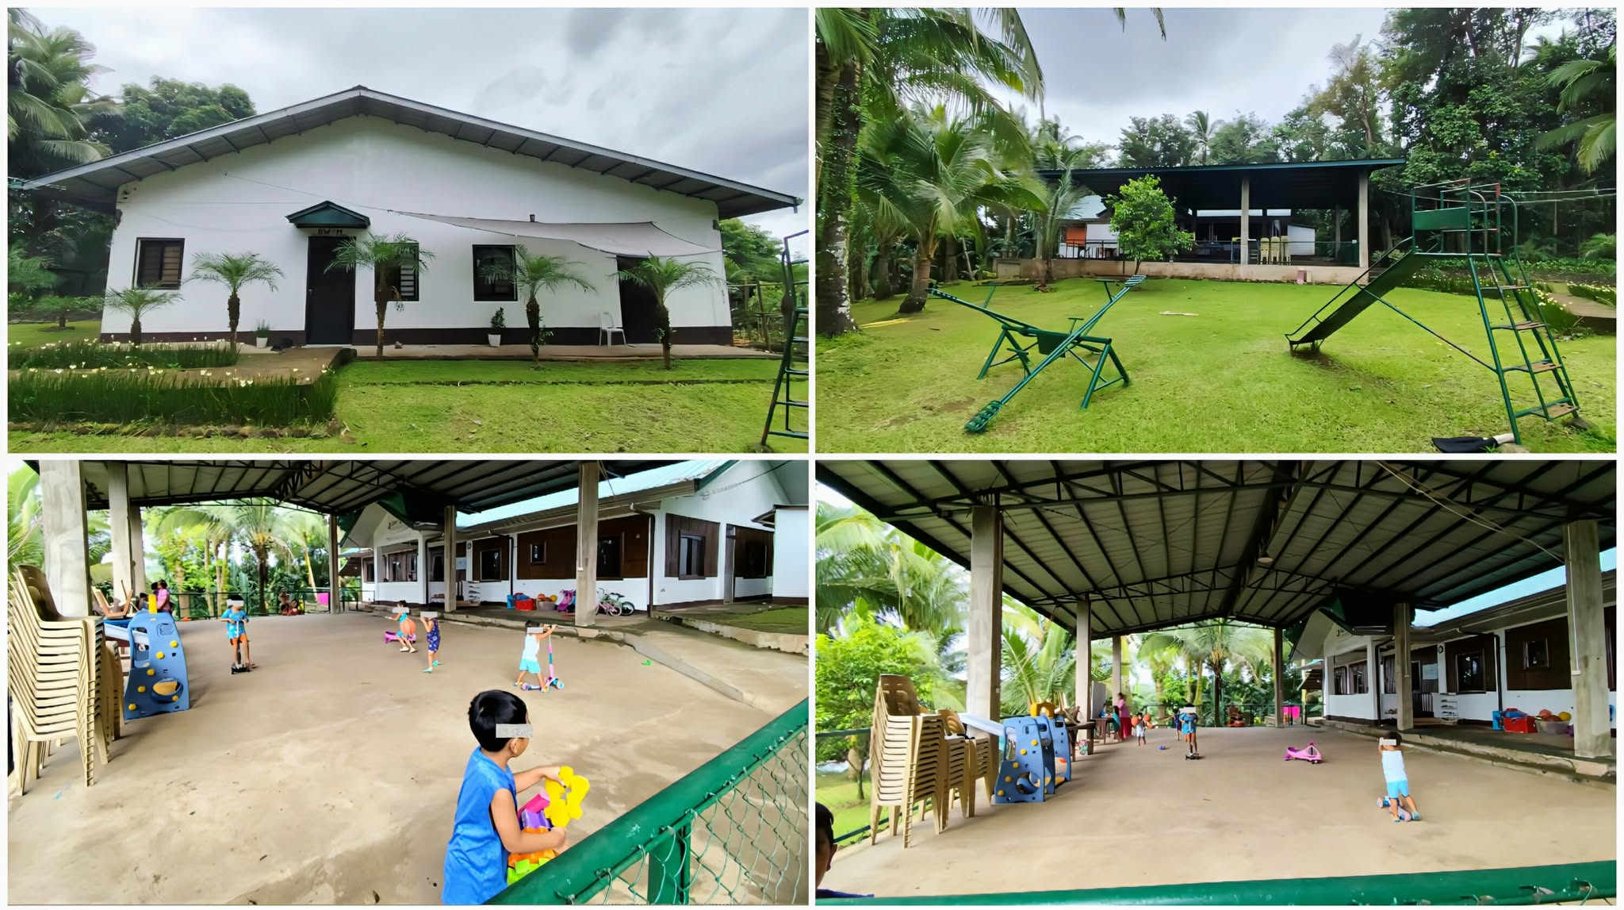
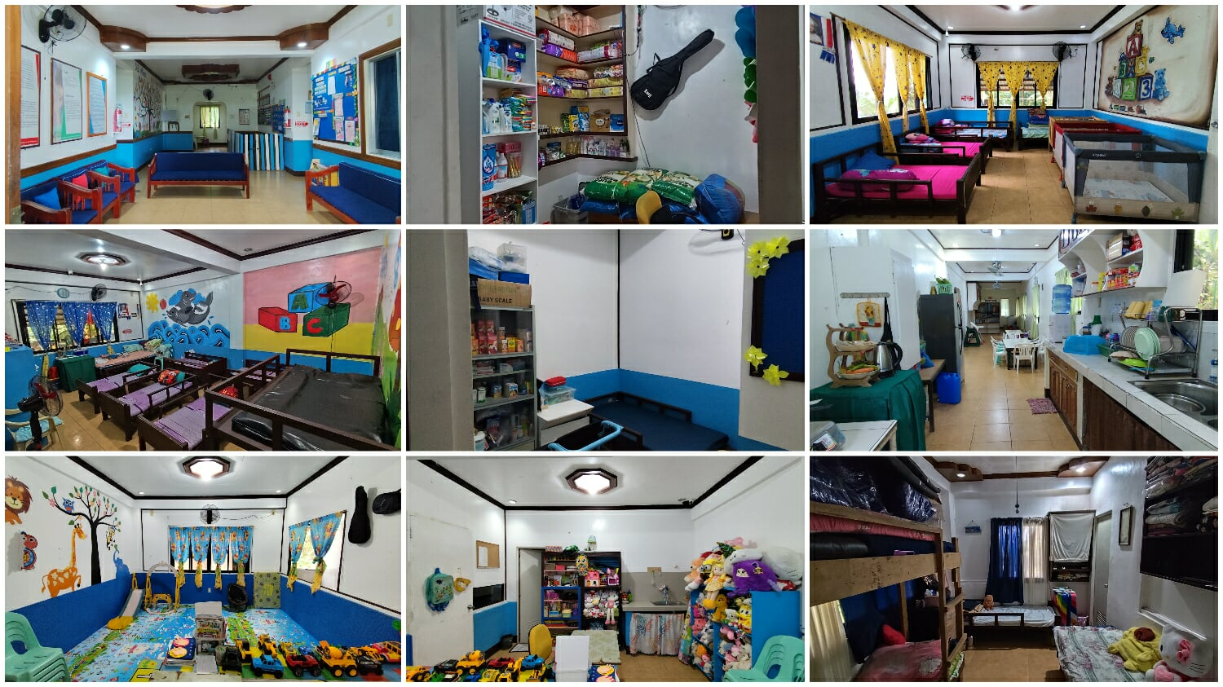
The following are the photos of the “Home”

  - The Client (description of the client, bio-psychosocial, cultural condition of the client, life experiences of the client contributing to the problem, illness, abuse, etc. institutions affecting clients functioning.

Angel is an 8-year-old child and the fourth (4th) among their siblings. She was born in Parañaque City. Angel weighs 29 kilograms and stands 138.5 centimeters in height. Her head circumference is 53 centimeters, her chest measures 64 centimeters, and her abdomen circumference is 56 centimeters.

Socially, Angel sometimes appears to be timid and reserved when interacting with new visitors, she’s often shy having eye contacts while talking to them and other adults as observed by the Social Work Affiliate, she also has this “shaky and toned way of speaking”, but she is able to interact and play well with other children and staff in the Home. She shows positive traits by being friendly, approachable, and willing to participate in activities when encouraged. However, she still needs guidance and opportunities to further develop her social skills and self-esteem.

Moreover, church and school are the primary institutions that help her improve her personality and character development. Spiritually, Angel shows a strong connection to her spiritual growth. She consistently attends not only church every Sunday, but also participates in Sunday school to learn more on biblical teachings. Moreover, just like other kids in the Home, Angle has memorized several Bible verses and is enthusiastic in showcasing her knowledge in Bible stories such as the story of Samson and Delilah.

Presently, Angel is generally healthy. On October 2019, she was diagnosed with Dilated Cardiomyopathy after being advised to be admitted to Mt. Carmel Diocesan General Hospital (MCDGH). And after more than two (2) years of continuous maintenance/medication for Dilated Cardiomyopathy, on March 2022, the results of her 2D Echocardiogram and Doppler Study showed that it was normal. Angel is considered by the Agency’s staff and house parents as miracle baby/child, for the reason that despite being found with severe malnutrition in 2019 as per her medical record, being diagnosed with dilated cardiomyopathy in the same year, diagnosed with bronchopneumonia in 2022 and a number of minor sicknesses such as: cold and runny nose, she was able to conquer them all. As of the moment, she’s as healthy as ever, continues to be active, cheerful, as well as continuing to develop further with the guidance and proper care of the agency.

- Assessment of the client/case, Family, Environment/community
(interpretation, Analysis and Conclusion integrating theory/ies and approaches)

This is a case of a child named Princess Angel Globio, or simply “Angel”, who was rescued by the authorities from the hardship she was experiencing. She was abandoned by her biological mother, and suffered neglect and severe malnutrition from the care of her maternal relatives. Angel was later referred by Ms. Anastacia C. Erasga, a social worker from the MSWDO of Bay, Laguna to Still Waters Kid’s Home Inc. for proper case management.

Under the category of an abandoned child, supported by the Article 1, Section 4 of the Republic Act No. 11642 also known as “Domestic Administrative Adoption and Alternative Child Care Act” of 2022, abandoned child refers to a child who has no proper parental care or guardianship, a foundling, or on who has been deserted by one’s parents for a period of at least three (3) continuous months, and has been declared as such by the NACC, with the proper case management of the institution, and the issuance of the Certificate Declaring a Child Legally Available for Adoption (CDCLAA), the Article 4, section 26 of the R.A 11642 stated that there shall be a matching process for case of legally available children thirty (30) calendar days after the issuance of the CDCLAA or the next matching conference, whichever is applicable.

a. Client
Angel shows strength and resilience despite her struggles in the early stage of her life. She was abandoned, experienced neglect, and suffered from severe malnutrition, but she has managed to overcome many health issues such as; dilated cardiomyopathy and bronchopneumonia. Her recovery and current good health highlight her strong will to survive. She has experienced a rocky start, however, slowly but surely, she’s on her way to a better future.

b. Family
Angel’s biological family couldn’t take care of her because of poverty, neglect, and lack of responsibility. Her mother left her, and her relatives also were not able to meet her needs, so she ended up in institutional care. This shows that her family had a weak support system and couldn’t cope well with their problems. Because she didn’t have stable and caring relationships with her biological family, her sense of belonging may have been affected. For now, staying at Still Waters gives her guidance, care, and support until she can hopefully be adopted. What she really needs most is a permanent family who can give her love, stability, and long-term support.

c. Community
Angel is under the proper care of Still Waters Kid’s Home, where she has been staying for more than six years already. The institution provides her with a safe and nurturing environment, daily routines, education, and medical support. While the Home ensures her basic and developmental needs are met, her long-term welfare still depends on finding a permanent adoptive family who can provide stability, love, and belonging that she truly deserves.

Aside from the supporting details in the R.A 11642, Angel’s case can also be understood through Maslow’s Hierarchy of Needs, it shows that a child’s development depends on meeting basic to higher-level needs. In Angel’s case, her physiological and safety needs were unmet due to abandonment and neglect, resulting in malnutrition and poor health.
Now in Still Waters Kid’s Home, her basic needs are being met, she has food, shelter, medical care, and routine. However, she still lacks permanent emotional support and belonging, which only a stable adoptive family can provide. Meeting these needs is essential for her to develop confidence, self-worth, and reach her full potential.

- Plan of Action (Should include plans at the Micro – client level; Mezzo – Family and Community and Macro – Policy and Program implications). Use the planning template below

GOAL: Complete and updated documents for the regional matching of the child

Issue/s, problem/s to work on | Objectives | Activities | Resources needed | Time Frame | Expected result
- Facilitation of the completion of the necessary documents as required by the RACCO for the regional matching | - To introduce the idea of adoption and family to the child | - Introduction of the child with the idea adoption and family through counseling and play therapy | - Social work affiliate, client,  - Toys (dolls, drawings, etc.) | - August – October 2025  - Every Monday afternoon during play time (3:00pm – 4:00pm) | - Angel become more aware of the idea of adoption and family
 | - To safely travel from the agency to Lucena City and ensure that the child undergoes a proper psychological evaluation | - Travel to Lucena City and psychological evaluation | - Social work affiliate, house parent, client  - Transportation allowance, notebook, and pen/pencil | - September 5, 2025 | - Social work affiliate obtains a psychological evaluation result
 | - To safely travel to Sta. Cruz Laguna and ensure that the child undergoes a proper medical check-up | - Travel to Sta. Cruz Laguna for the medical check-up of the child | - Social worker, social work affiliate, client  - Transportation allowance, phone | - September 8, 2025 | - Social work affiliate obtains the medical check-up result
 | - To update the health and medical profile of the child (summarized measurement from admission to present) | - Health and medical profile of the child | - Social worker, social work affiliate  - Bond paper, printer, computer, phone, and pen | - September 12, 2025 | - Updated and summarized health and medical profile of the child
 | - To provide a powerpoint presentation of the child’s case and current functioning as required for the regional matching | - Presentation of the child’s case and current functioning (Powerpoint presentation) | - Social work affiliate  - Laptop/computer, phone, and data/Wi-Fi | - September 30, 2025 | - Power point presentation regarding the child’s case and current functioning

- Implementation of Action (Progress of the Case)
The planned intervention for Angel, which focuses on counseling through play therapy, has been successfully carried out every Monday afternoon during playtime. The sessions between the social work affiliate and Angel have been going smoothly. Angel has shown noticeable improvement in her knowledge and interest in the idea of adoption and family. She often asks about what it is like to sleep next to a mother, she also tells that when she gets adopted, she will help her Mama to do the dishes and other house chores. Moreover, she often asks the affiliate regarding the things she wants to do once she gets adopted such as she wants to visit the institution often, she wants to meet many friends, she also wants to watch many movies, and she wants to be a social worker, saying that her inspiration is Sir Julius, who is the Social Worker of the institution.

Moreover, on September 5, 2025, Angel successfully underwent her psychological evaluation as required for the adoption process. This represented an important step in meeting the requirements for her eventual regional matching.

In addition, on September 8, 2025, Angel also underwent a medical check-up in Sta-Cruz Laguna, which served to update her health and medical profile. This ensures that her current health status is well-documented for both the agency and future adoptive parents.

Furthermore, on May 2025, the social worker of the agency submitted the updated case study report of Angel. This report consolidated her background, current status, and progress in preparation for the adoption process. These developments show that the intervention plan has been effectively implemented, addressing both Angel’s psychosocial needs and the administrative requirements for her adoption.

- Evaluation and Recommendation
With the collective effort and help from the agency staff, house parents, social work affiliates, and Angel herself, the development and improvement on her case became possible. The consistent play therapy sessions have helped Angel become more aware of the idea of adoption and family.

Moreover, the continuous efforts on attending to the requirements needed for the regional matching such as psychological evaluation, the updated case study report, and updated health & medical profile has been on time and efficient, bringing her one step closer to finding a permanent home.

The affiliate’s recommendation to Angel’s case is to ensure her continued growth and well-being, it is important to maintain or continue the play therapy sessions she has been undergoing. Regular interactions through play, especially with people older than her will continue to improve her social skills, especially her ability to interact with adults without being shy and reserved. Together with this, finding a suitable adoptive family for Angel should be prioritized. The right family will provide the nurturing environment she needs to continue overcoming her weaknesses and gain a sense of belonging.

Furthermore, the continuous monitoring on Angel’s emotional and physical health will be crucial, making sure she adapts to any changes in her life, especially when the pre-entrustment and entrustment are underway.

Lastly, in preparation for her adoption, it is very important to continue introducing her the concept of adoption, highlighting the idea of a loving and caring family. With the right guidance and support from all the people in the Home, Angel will definitely be more prepared to move forward with confidence and find the loving home she deserves.

Prepared by: Andrei Vincent T. Sorezo

Date: August 28, 2025

Comments by Agency Field Supervisor

Noted: (Signed) Agency Supervisor: Julius B. Torres, RSW

Comments by School Field Instructor

Noted by:

Noted: (Signed) Field Instruction Supervisor: Romulo A. Oserin Jr., RSW, MSSW

Case study 2

- Identifying Information

Last Name |  | Mangabat
First Name |  | France Zion (Zion)
Middle Name |  | N/A
Address  (house no, street, purok, barangay, town/city/municipality, province |  | Still Waters Kid’s Home Inc. ACBS Compound  Barangay Ilayang Banga, Majayjay, Laguna
Contact Number |  | N/A
Age:  4 years old  Sex:  Male | Civil Status:  Single |  | Religion:  Roman Catholic
Birthday:  April 04, 2021 |  |  | Birthplace:  Calamba City, Laguna, Laguna

Education
Level | School | Year attended
Day care/Kindergarten | N/A | N/A
Elementary (1-6) | N/A | N/A
High School | N/A | N/A
College | N/A | N/A
Vocational Course | N/A | N/A
ALS | N/A | N/A

- Problem Presented

The main issue centers on the possibility of Zion’s reunification with his mother. While his current environment provides safety, care, and proper development, the long-term plan is to ensure that the child is emotionally and mentally prepared when he is reunified with his mother.

- Family Background and Information

  - Family Composition

Name | Age/Sex | Birthday | Relationship to the Client | Educational Attainment | Occupation/Income
Honeyzen | 22 years old | Unknown | Mother | Senior High School Graduate | House Helper/Maid
Francisco | 30 years old | Unknown | Father | ALS Undergrad | N/A
Honce Lemon | 5 years old | Unknown | Sister | Unknown | N/A
Eufemia “Gemma” | 73 years old | Unknown | Great-Grand Mother | 3rd Year High School | Vendor/₱9,000.00

  - Family Background of the Client: (home condition, kind of relationship, strengths, coping mechanisms)

Zion’s great-grandmother, Ms. Gemma, was the one who sought help from the Women and Children Protection Unit due to her inability to sustain his needs. Zion’s mother has been identified but has not yet fully taken responsibility for him. The PCAR is being conducted to assess her readiness and capability to assume parental duties.

The client’s mother, Ms. Honeyzen, had her first child at 17 and later gave birth to Zion the following year. The children were raised with the help of their great-grandmother, Ms. Gemma, since their father, Francisco, was unemployed. When Ms. Honeyzen’s father passed away in 2021, she started working as a housemaid outside Calamba, leaving the children in their father’s and grandmother’s care. Later, Ms. Gemma took custody of the children as their father left then.

In 2024, Ms. Gemma suffered a stroke which affected her livelihood as a vendor and making it hard for her to provide for the family. She eventually surrendered the children (Zion and her sister Lemon) to the City Social Service Department and eventually placed under the custody of Calamba Children Shelter of Hope (CCHS) in early 2025. Ms. Honeyzen, who still works in Parañaque, recently said she plans to get her children back by September the same year with the help of her new partner, who may support her financially so she can care for them herself.

The family has experienced financial struggles, leading to Zion being temporarily placed under the care of Still Waters. Despite this, the possibility of reunification remains open if his mother can show the stability and willingness to care for him.

Presently, Zion is staying at Still Waters Kid’s Home in Majayjay, Laguna. It’s a licensed children’s home inside the Asia Center for Biblical Studies (ACBS) compound. The place cares for kids who were abandoned, neglected, orphaned, or abused, from newborns up to six years old. The home is made to be safe and comfortable, with separate rooms for babies, girls, and boys. Each room has beds, cabinets, and toys. There’s also a small clinic with medical supplies, a kitchen and dining area where kids eat healthy meals together three times a day, a laundry area, and a play/receiving area. The building has CCTV cameras and fire safety tools, and the walls are painted with bright, child-friendly designs. The children can also use books, art supplies, and videos for fun and learning.

The agency is led by the Executive Director, Ms. Mary Rose O. Bautista, together with staff and case managers. They look after the kids’ daily needs, make activities for them, and check their progress regularly. Each day has a schedule for play, learning, meals, and rest, so the children can grow well in every aspect. Still Waters doesn’t only provide food and shelter, but also gives the children a chance to enjoy, laugh, and grow emotionally and spiritually. It’s a safe and caring environment where Zion and the other kids can feel loved and supported.


The following are the photos of the above mentioned “Home”:

  - The Client (description of the client, bio-psychosocial, cultural condition of the client, life experiences of the client contributing to the problem, illness, abuse, etc. institutions affecting clients functioning.

Zion is a bright and playful 4-year-old boy. His height is 94cm, he weighs 13kg, his head circumference is 50cm, chest is 52cm, lastly, his abdomen is 54cm in circumference. Upon admission, he has short height for his age, he was generally healthy but had scabies, which was treated immediately at the Home by avoiding to feed him chicken and oily foods. He is cheerful, sociable, and curious, traits that allows him to easily adjust to his environment. He enjoys playing, talking with other kids, and showing affection to the house parents and staff.

Zion is also the most energetic among the kids in the home, asking non-stop questions, continuous movement even during the daily morning devotion, and consistently showing his affection by complimenting the staff and house parents with “ang ganda n’yo po”, “ang pogi n’yo po”, and “mahal po kita”. He’s also called by one of the social work affiliates as the Gary V (Mr. Pure Energy) of the home with his seemingly unlimited energy. Even during trips, Zion would constantly talk and ask everything he sees including buildings, animals, other vehicles and such.

Overall, Zion is progressing well at Still Waters. He has adjusted well and quick in the institution even for a short period of time. He has also shown resilience and eagerness to learn, which are strong indicators of his potential to thrive in a family setting.

- Assessment of the client/case, Family, Environment/community
(interpretation, Analysis and Conclusion integrating theory/ies and approaches)

a. Client
Zion’s case shows a possibility for reunification. His great-grandmother surrendered him due to financial problem, not due to abuse or neglect. His biological mother remains a possible caregiver, especially when she meets the standards of parental capability through the ongoing PCAR.

Physically, Zion is generally healthy and energetic. He has recovered from his past skin condition (scabies) and now remains active in play and other activities. He shows strong motor skills like biking and running, while also developing his fine motor abilities such as building with blocks and using utensils. His physical health is being maintained through regular meals, vitamins, and medical monitoring at the Home. Socially, Zion is cheerful, talkative, and easily builds relationships with the other kids and staff. He greets visitors politely, engages in conversations, and enjoys playing with other children. However, he can be sensitive when his needs or wants are not met, often crying or becoming upset. With gentle guidance, he is able to calm down and show cooperation. His openness and friendliness show his strong social potential.

b. Family
Zion’s biological family background shows instability in meeting his needs. His great-grandmother, who initially took the responsibility of taking care of him, eventually surrendered the child due to financial struggles, stroke, and old age. His biological father is absent in his life, and his mother’s capability is still under assessment. These circumstances highlight a weak support system and lack of consistent parental care. However, reunification with his mother is possible if she is found capable and prepared. Strengthening family ties and providing parental guidance will be key in ensuring Zion’s long-term stability and well-being.

Until then, Zion will remain under the temporary custody of Still Waters Kid’s Home to ensure his continued well-being and development, while preparing him for the possible reunification.

c. Community
At Still Waters Kid’s Home, Zion has adjusted well to routines and rules even for a short period of time since he was admitted. He follows daily activities like mealtime, lining up, and bedtime schedules. The Home provides him with opportunities to learn, play, and develop emotionally and spiritually. While he is thriving in this environment, it remains a temporary placement until a permanent family care arrangement is determined.

Zion’s case can be understood through several psychological theories. Psychosocial Development theory, developed by Psychologist Erik Erikson, helps us understand that at age of 4, Zion is in the “Initiative vs Guilt” stage. At this age, kids are starting to explore more, take initiative especially during playtime, and assert themselves socially. Zion is showing this through his eagerness to interact with people, his curiosity and his excitement in trying new activities such as building with blocks, counting, and singing. However, Zion can sometimes be easily frustrated and cries when he is not able to get what he wants, showing the challenge of his emotional control.

Nevertheless, reunification with his mother can play a crucial role by providing consistent guidance and encouragement, she can help him build more confidence and resilience. However, it is crucial to ensure that the child is mentally and emotionally ready for the possible reunification with his mother.

Furthermore, in Bowlby’s Attachment Theory, it focuses on the importance of forming a strong bond with a primary caregiver and a child during the early childhood. Zion, in his early childhood, experienced being separated from his great-grandmother who was taking care of him, leading to his placement in the Home. While he already adjusted well and formed positive interactions with staff and other kids, his affectionate side, such as giving hugs and saying loving words shows his need for emotional closeness and stability.

Hence, the reunification with his mother can rebuild his strong attachment. A consistent bond will not only help Zion feel loved and valued, but also strengthen his ability to trust others as he grows. Therefore, reunification will not only be about giving physical needs but also ensuring emotional security by stable caregiver-child relationship.

- Plan of Action (Should include plans at the Micro – client level; Mezzo – Family and Community and Macro – Policy and Program implications). Use the planning template below

GOAL: Preparation of the child for the possible reunification with his biological mother

Issue/s, problem/s to work on | Objectives | Activities | Resources needed/Persons involved | Time Frame | Expected result
- Zion was primarily raised by his great-grandmother, which limited the development of a strong attachment to his biological mother | - To help Zion understand, in simple terms, the concept of reunification | - Use storytelling and visual tools (e.g., toys, drawings, family-themed stories) to gently introduce the idea of reunification with his family | - Social work affiliate, client, bond paper, pencil, crayons | - September – October 2025  (Every Friday, 9:30am – 10:30am) | - Zion becomes familiar with the idea of reunification
 | - To strengthen Zion’s emotional resilience and coping skills | - Conduct one-on-one sessions focused on identifying and naming emotions (happy, sad, angry, afraid, etc.), using games and drawings to talk about feelings | - Social work affiliate, client, visual aid, bond paper, pencil, crayons | - October 2025 (Every Thursday (9:30am – 10:30am) | - Zion is better able to express his feelings
 | - To support emotional expression and processing of family dynamics and possible reunification | - Play therapy-inspired sessions (Social work affiliates will engage in role-play as a family members/parent/s, to help Zion explore feelings and expectations | - Social work affiliates, client, toys/dolls, space to play | - October 2025 (Every Thursday (10:30am – 11:00) | - Zion becomes more open in expressing thoughts and emotions about family
 | - To help the house parents with strategies to support Zion’s emotional preparation for reunification through daily interactions | - Briefing with house parents on how to use simple, reassuring language and incorporate informal “transitional conversations” about family and change during daily routines (e.g., “What do you think a home with a mommy feels like?”) | - Social work affiliate, house parents | - October 6, 8, 10, 2025 | - Zion becomes more emotionally prepared and more open to the idea of reunification

- Implementation of Action (Progress of the Case)
The planned intervention for Zion, which focuses on his preparation for the possible reunification with his mother has been going smoothly. Every Friday morning at around 9:30am to 10:30am, the affiliate was able to introduce the idea of reunification to Zion using storytelling and drawings. At first, Zion was confused as he thought that he’s going to be in the institution forever. The affiliate introduced the idea of reunification to Zion by asking questions such as “Do you remember the time you were with you grandmother?”, Zion started to tell many stories about the things he remembers such as playing with his sister, Lemon, eating with his grandmother and other relatives, as well as seeing a rainbow when he goes out of their house often.

Afterwards, the affiliate intervenes by providing more ideas regarding family such as showing a drawing of a family composed of a father, mother, and their children. Zion then became more excited and asked if he can be with his sister again. That is when the affiliate gave the idea of reunification, telling the child that reunification is about reuniting him with his mother. Zion cheerfully laughed and told the affiliate that he wanted to be with his mother and Lemon.

Moreover, the implementation on other intervention plans such as play therapy, and consultation with the house parents have been successful. The role-playing with the social work affiliates provided Zion the idea on how he will act with his family/mother and what he would expect in a family environment when he reunified with them.

Furthermore, the consultation of the social work affiliate with the house parents has been successful as well. The affiliate briefed the house parents regarding the addition of introducing Zion to the idea a family through asking questions about his mother and what he would think or feel when he reunified with her. And according to the house parents, the implementation has been going smoothly, as Zion is now able to share his thoughts on what he will do when he gets reunified with his mother, even without the house parents asking for it.

Nevertheless, while the process of the reunification is still on its way, it is crucial for Zion to be more familiar with these ideas in order to make sure that the child is mentally and emotionally prepared when he gets reunified with his mother.

- Evaluation and Recommendation
Zion’s journey has been filled with various challenges, beginning at a very young age. His mother had to work away from them, leaving him behind, and his father abandoned them, leaving Zion under the care of their great-grandmother. However, due to financial struggles and health issues, his great-grandmother eventually had to surrender him to the authorities. This transition was difficult, but when Zion arrived at the institution, he was able to adapt quickly. Despite the hardships he had endured, Zion’s cheerful and energetic personality have shined, impressing the people around him. His resilience and ability to adjust to a new environment were clear signs of his inner strength, which would prove to be invaluable in his future.

Presently, with the effort from his mother, there is hope for Zion’s reunification with her. However, this reunion requires careful preparation to ensure it is a successful and lasting transition. With the support of social work affiliates, social workers, staff, and house parents, Zion is being gradually prepared for the idea of family and reunification. They are working to ensure that his emotional and psychological readiness is prioritized, helping him understand the importance of family bonds in a healthy and nurturing way. Additionally, Zion's physical well-being is being monitored, and he is receiving the care and attention he needs in the institution. He is also being taught good manners and spiritual values, including the words of God. These teachings, along with the ongoing support, will not only help Zion as he prepares for his return to his mother but also equip him for a brighter future filled with hope and love.

To further support Zion’s preparation for the reunification, it is recommended that the affiliate continue the foregoing implementation of the intervention plan while he is still in the institution, ensuring that the idea of family will remain on the child.

To ensure the long-term plan for Zion’s case to succeed, it is recommended to encourage the house parents to continue to incorporate informal transitional conversation that will help Zion to be more familiar on what is the expectations in a family setting.

Prepared by: Andrei Vincent T. Sorezo
Date: September 3, 2025

Comments by Agency Field Supervisor

Noted: (Signed) Agency Supervisor: Julius B. Torres, RSW

Comments by School Field Instructor

Noted by:

Noted: (Signed) Field Instruction Supervisor: Romulo A. Oserin Jr., RSW, MSSW

Case Study 3
- Identifying Information

Last Name |  | Atienza
First Name |  | Angelo Ivan Michael
Middle Name |  | N/A
Address  (house no, street, purok, barangay,town/city/municipality, province |  | Still Waters Kid’s Home Inc. ACBS Compound  Barangay Ilayang Banga, Majayjay, Laguna
Contact Number |  | N/A
Age:  4 years old  Sex:  Male | Civil Status:  Single |  | Religion:  Born Again Christian
Birthday:  October 17, 2020 |  |  | Birthplace:  Tanauan City, Batangas

Education
Level | School | Year attended
Day care/Kindergarten | Basic Life Empowerment and Support System (BLESS) | Present
Elementary (1-6) | N/A | N/A
High School | N/A | N/A
College | N/A | N/A
Vocational Course | N/A | N/A
ALS | N/A | N/A

- Problem Presented

As Ivan grew older in the institution, house parents and social work affiliates began to notice recurring behavioral concerns. While he is affectionate and playful at times, Ivan has become increasingly difficult to handle, especially when he is corrected or disciplined. His tantrums often escalate beyond ordinary crying, involving loud shouting and persistent refusal to follow instructions. This pattern of behavior makes him one of the hardest children to manage inside the Home, requiring caregivers to spend extra time calming him down and redirecting his actions.

- Family Background and Information

  - Family Composition

Name | Age/Sex | Birthday | Relationship to the Client | Educational Attainment | Occupation/Income
Karylle | 21/Female | Unknown | Mother | College (Present) | N/A
Oliver | Deceased | Unknown | Father | Unknown | N/A
Rhea | 42/Female | Unknown | Grandmother | Unknown | Unknown
Librada | 69/Female | Unknown | Great-Grandmother | Unknown | Kakanin Vendor

  - Family Background of the Client: (home condition, kind of relationship, strengths, coping mechanisms)

According to the documents provided by the referring party, Ms. Karylle, Ivan’s biological mother, is the eldest of three siblings from Barangay Tinurik, Tanauan City. Her father, Oliver, worked as a construction worker while her mother, Rhea, was a housekeeper. The family lived on her father’s income, which was just enough for their daily needs.

Karylle experienced sexual abuse from her father starting at the age of twelve, which was later discovered by her grandmother, Librada, when she noticed changes in Karylle’s body. This led to Karylle being referred to Tanauan Kanlungan Center and later transferred to Marilac Hills in Alabang for proper care and intervention. In 2022, her father was jailed for the abuse but later died by suicide.

After her discharge in October 2022, Karylle began rebuilding her life. She helped her cousin with catering work during school breaks and also joined their barangay volleyball team, which helped her socialize and reintegrate into the community. She was also able to restore her relationship with her siblings and her mother. In 2023, she prepared her documents with the help of Tanauan Institute and enrolled as a Criminology student under a scholarship program.

Ivan was admitted to Still Waters Kid’s Home on July 16, 2021 due to his mother’s inability to care for him as a victim of rape by her biological father.
Presently, Ivan is staying at Still Waters Kid’s Home in Majayjay, Laguna. It’s a licensed children’s home inside the Asia Center for Biblical Studies (ACBS) compound. The place cares for kids who were abandoned, neglected, abused, from newborns up to six years old. The home is made to be safe and comfortable, with separate rooms for babies, girls, and boys. Each room has beds, cabinets, and toys. There’s also a small clinic with medical supplies, a kitchen and dining area where kids eat healthy meals together three times a day, a laundry area, and a play/receiving area. The building has CCTV cameras and fire safety tools, and the walls are painted with bright, child-friendly designs. The children can also use books, art supplies, and videos for fun and learning.

The agency is led by the Executive Director, Ms. Mary Rose O. Bautista, together with staff and case managers. They look after the kids’ daily needs, make activities for them, and check their progress regularly. Each day has a schedule for play, learning, meals, and rest, so the children can grow well in every aspect. Still Waters doesn’t only provide food and shelter, but also gives the children a chance to enjoy, laugh, and grow emotionally and spiritually. It’s a safe and caring environment where Ivan and the other kids can feel loved and supported.


The following are the photos of the above mentioned “Home”:



  - The Client (description of the client, bio-psychosocial, cultural condition of the client, life experiences of the client contributing to the problem, illness, abuse, etc. institutions affecting clients functioning.

Ivan was almost 9 months old when he was admitted to Still Waters Kid’s Home. He appeared to be physically healthy with out any deformities. Presently, at 5 years old, Ivan is 106.5cm tall, he weighs 17.5kg, has a 50.5 head circumference, 52cm chest and finally, 50cm abdomen in circumference. Ivan is energetic and lively during play time. He often explores with playing by using any toy he gets, he also loves playing tag with other kids and just running alone, moreover, he enjoys riding a two-wheeled bicycle and maneuvers it consistently. At his age, Ivan shows a healthy balance in multiple areas such as his academic readiness, physical growth, and social maturity.

However, despite of being a sociable and energetic child, he often throws tantrums when being disciplined or reminded of rules, and his crying usually escalates into loud shouting. He is described as one of the hardest children to handle inside the institution. These behavioral struggles impact not only his relationship with house parents but also the overall environment in the Home. His stubbornness and resistance to rules create challenges in training him with daily routines and expected behaviors. Moreover, his loud outbursts when disciplined can influence the behavior of other children, sometimes disrupting group activities. While Ivan’s actions may be rooted in his emotional background and need for attention, his difficulty in regulating emotions signals the need for interventions to support his social and emotional development.

- Assessment of the client/case, Family, Environment/community
(interpretation, Analysis and Conclusion integrating theory/ies and approaches)

a. Client
Physically, Ivan is a healthy and active child. He shows much energy during play and other activities. He enjoys “bahay-bahayan” as well as riding a two-wheeled bicycle with a consistent maneuver with it.

Socially and emotionally, although he’s a sociable child, he struggles with authority and discipline, making it difficult for him to maintain good relationships with the house parents and at times with his peers. However, he is capable of showing affection and enjoys interacting with others when calm. The admin assistant of Still Waters also said that when Ivan is calm and in a better mood, he’s so affectionate and sweet, and when he’s in a bad mood, the admin assistant said “mas mabilis s’yang pakalmahin pag lalambingin mo sya pero wag mong hahayaan na isipin nya na kaya ka n’yang kontrolin”. Moreover, one of the house parents, Nay Eckay, highlighted that “kapag naiyak s’ya at nasigaw habang umiiyak, wag mo s’yang hahayaan, kailangang mapagsabihan mo agad s’ya, pero wag mong biglain, dapat mahinahon ka”. This statements and observations from the staff show that even with excellent improvements with Ivan, his behavior must be attended well.

b. Family
Although Ivan was surrendered at 10 months old, the circumstances of his birth, including being a child of incest and possible early exposure to a traumatic environment, may have affected his emotional development. The lack of stable caregiving early in life could be part of why he struggles with discipline and emotional control now. These factors should be considered as possible influences on his behavior, even without a formal diagnosis.

c. Community
In the institution, Ivan is seen as one of the most challenging children to handle because of his resistance to discipline and difficulty in following some of the rules. His outbursts can affect the group setting, but the Home continues to provide him with structure, care, and emotional support to help him cope.

Ivan’s case can be understood with Behaviorism, particularly Operant Conditioning by B.F. Skinner. The house parents’ technique of giving rewards when Ivan follows rules reflects positive reinforcement, which encourages him to repeat the good behavior. On the other hand, not letting him have his way during tantrums is a form of punishment. This theory applies well in his case because his actions are often driven by immediate reactions and emotions, and consistent reinforcement can help shape his behavior towards more positive outcomes.

Additionally, Attachment Theory by John Bowlby is also relevant. Ivan shows a need for affection (lambing and papuri), whether he is in a good or bad mood. This reflects his search for emotional closeness and security, which may come from the instability of his biological family background. By addressing his emotional needs through consistent affection and nurturing, the house parents can help him develop a secure attachment, which is essential for his emotional regulation and social development.

- Plan of Action (Should include plans at the Micro – client level; Mezzo – Family and Community and Macro – Policy and Program implications). Use the planning template below

GOAL: Improved positive behavior

Issue/s, problem/s to work on | Objectives | Activities | Resources needed/Persons involved | Time Frame | Expected result
- The house parents have different approach on how to handle the child | - To synchronize the houseparents’ techniques and approaches in disciplining and guiding the child | - House parents’ consultation on the different techniques of the house parents in handling the child’s behavior | - Social work affiliate, House parents  - Notes, pen | - September 19, 2025 (House parents’ monthly meeting) | - House parents will have a unified approach in disciplining the child
- The child’s recurring behavioral concerns | - To address the emotional needs of the child and guide the child in developing positive behavior | - Counseling (Play therapy reminding the child on respecting and listening to house parents | - Social work affiliate, client/child  - Toys (play therapy) | - September – October 2025  - Every Friday afternoon (1:00pm – 2:00pm) | - The child will consistently improve his positive behavior
- The need for updated progress reports to address where the intervention plan needs adjustment | - To assess the child’s development and response to intervention | - Monitoring the child’s progress through observation, and interview with house parents and staff | - Social work affiliate, house parents, staff  - Progress monitoring tools or checklist | - October 13, 15, and 18, 2025 | - Accurate and updated reports reflecting the child’s progress
- Lack of consistent positive engagement with other children and house parents | - To encourage cooperation and respect for other kids and house parents | - Social skills training through group work sessions | - Social work affiliates, house parents, staff, children | - September – October 2025  - Every group work session | - Improved engagement with peers and house parents

- Implementation of Action (Progress of the Case)
The planned intervention for Ivan, which focuses on improving his positive behavior, particularly the problem in his tantrums escalating to loud shouting when he is corrected or reminded by house parents has gone smoothly.

To make sure that Ivan would not be shocked or confused with the changes of the techniques of the house parents. The affiliate conducted a consultation during the monthly staff meeting on September 19, 2025. The affiliate discussed the situation with the house parents and asked for each house parent especially those who are in charge on the boys to discuss their technique/s in handling Ivan’s ongoing problem. Afterwards, the affiliate together with the house parents, decided to come up with a specific technique which are effective to Ivan such as, being gentler and calmer when Ivan is throwing tantrum. It was observed by everyone that is more obedient when being reminded calmly and gentle parenting is the most appropriate technique for Ivan instead of showing authority.

Moreover, to monitor Ivan’s current behavior, the affiliate conducted counseling/play therapy. This helped Ivan to be more obedient gradually. Through play therapy such as showing Ivan different scenarios such as; one shows a scene on how to respect and obey the house parents and one that shows when someone is being disrespectful to house parents, Ivan was able to identify which is the right one to do.

In addition, because the house parents have different shifts per set, on October 21, 24, and 26, 2025, the affiliate interviewed each house parents regarding Ivan’s improvement, wherein most of them discussed that Ivan’s behavior is improving as days goes by, while some of them haven’t seen any improvements yet. These interviews will serve as the guide for the house parents and staff on how to address Ivan’s problem and how to help him in the most efficient way possible.

Lastly, the group work sessions also helped Ivan to be more connected and engaged with his peers, promoting a welcoming and positive environment for him.

- Evaluation and Recommendation

Ivan had difficulty building a stable and consistent relationship with the house parents due to his frequent tantrums, which often resulted in loud crying and shouting. These outbursts usually happened when he did not want to follow rules in the home, when he is reminded, or when he disliked the food. This behavior created challenges for the house parents, as they worked different shifts and could not always communicate about which strategies were the most effective in handling Ivan’s behavior. As a result, the social work affiliate decided to intervene with a set of activities aimed at improving Ivan’s behavior and emotional control, with the goal of reducing the need for disciplinary actions and fostering better relationships with both the house parents and his peers.

The intervention began with monthly meetings where the house parents, staff and the affiliate discussed their observations and shared techniques for guiding Ivan without using aggressive communication or discipline. This was followed by counseling sessions with Ivan to monitor his progress and support the house parents in teaching him proper behavior and control his emotion. Additionally, group work sessions were held, which focused on strengthening the relationships between the children in the Home and their house parents, addressing Ivan’s specific needs with collaborative activities and collaborative environment.

Presently, with the collective efforts of the affiliate, house parents, and staff, Ivan has continued to improve his behavior and relationships, not just with the house parents but with everyone in the Home. He’s now more likely to seek attention from the house parents and staff when he does something good, hoping to receive praise from them. Moreover, his tantrums have also become much less frequent, especially during mealtime, which has helped the house parents stay focused and ensure that all the children, especially the toddlers, are fed properly.

To further support Ivan’s continued improvement with his behavior and relationship with everyone in the Home, it is recommended that the affiliate continue the implementation of the intervention plan, especially the continuous monitoring to Ivan’s behavior through play therapy, as well as the continuous interviews with the house parents regarding their perspective and observation on the child.

Lastly, to ensure the success of the long-term goal for Ivan, it is recommended that the institution acquire and utilize the same intervention for the child in order to help him maintain a positive relationship with everyone in the Home.

Prepared by: Andrei Vincent T. Sorezo

Date: September 10, 2025

Comments by Agency Field Supervisor

Noted: (Signed) Agency Supervisor: Julius B. Torres, RSW

Comments by School Field Instructor

Noted by:

Noted: (Signed) Field Instruction Supervisor: Romulo A. Oserin Jr., RSW, MSSW

Case Study 4
- Identifying Information

Last Name |  | Tejares
First Name |  | Nathan Nhelle (Nathan)
Middle Name |  | N/A
Address  (house no, street, purok, barangay, town/city/municipality, province |  | Still Waters Kid’s Home Inc. ACBS Compound  Barangay Ilayang Banga, Majayjay, Laguna
Contact Number |  | N/A
Age:  2 years old  Sex:  Male | Civil Status:  Single |  | Religion:  Born Again Christian
Birthday:  May 1, 2023 |  |  | Birthplace:  Bay, Laguna

Education
Level | School | Year attended
Day care/Kindergarten | N/A | N/A
Elementary (1-6) | N/A | N/A
High School | N/A | N/A
College | N/A | N/A
Vocational Course | N/A | N/A
ALS | N/A | N/A

- Problem Presented

Nathan, a 2-year-old abandoned child, was removed from a lesbian couple’s custody due to involvement in an alleged illegal adoption process and his biological mother's failure to comply with legal procedures. He was admitted to Still Waters Kid’s Home Inc. on May 26, 2023, and is awaiting the issuance of Certificate Declaring the Child Legally Available for Adoption (CDCLAA).

- Family Background and Information

  - Family Composition

Name | Age/Sex | Birthday | Relationship to the Client | Educational Attainment | Occupation/Income
Minda | 32/Female | Unknown | Mother | Unknown | Unknown
Thalia | 5/Female | Unknown | Sister | Unknown | N/A

  - Family Background of the Client: (home condition, kind of relationship, strengths, coping mechanisms)

According to the information provided by the referring party, Mr. Aivin Nuguid, Nathan’s mother had no other option but to give her child to a lesbian couple. According to her, the said couple were the ones who covered all the expenses related to her hospitalization, along with other financial needs she was unable to meet at the time. Faced with difficult circumstances and lacking the resources to support her child, she had no choice but to let them take care of Nathan. Later, she decided to report the situation to the Municipal Social Welfare and Development Office (MSWDO) in Bay, Laguna. She asked for help in getting her child back.

However, when the authorities conducted a Parental Capability Assessment Report (PCAR) to evaluate whether she could properly care for Nathan again, she unfortunately did not meet the requirements. Based on the results, it was determined that she was not yet in the right condition financially and emotionally to take back custody of her child. Because of this, Nathan was officially removed from her custody. The MSWDO of Bay Laguna then referred him to Still Waters Kid’s Home Inc. and was formally admitted on May 26, 2023.

Moreover, according to the interview on September 19, 2025, with the Social Worker of the municipal Social Welfare and Development Office (MSWDO) of bay Laguna, Mr. Aivin Nuguid, Nathan's biological mother has not been in touch for over three months. Her relatives have not seen or spoken to her, and the phone number she provided to the MSWDO of Bay, Laguna is no longer active and can no longer be contacted. It's also believed that she is no longer in Bay. The MSWDO of Bay, Laguna has also issued a barangay non-residency certificate for Nathan's mother, confirming that she's no longer living in her previous address.

Presently, Nathan is staying at Still Waters Kid’s Home in Majayjay, Laguna. It’s a licensed children’s home inside the Asia Center for Biblical Studies (ACBS) compound. The place cares for kids who were abandoned, neglected, abused, from newborns up to six years old. The home is made to be safe and comfortable, with separate rooms for babies, girls, and boys. Each room has beds, cabinets, and toys. There’s also a small clinic with medical supplies, a kitchen and dining area where kids eat healthy meals together three times a day, a laundry area, and a play/receiving area. The building has CCTV cameras and fire safety tools, and the walls are painted with bright, child-friendly designs. The children can also use books, art supplies, and videos for fun and learning.

The agency is led by the Executive Director, Ms. Mary Rose O. Bautista, together with staff and case managers. They look after the kids’ daily needs, make activities for them, and check their progress regularly. Each day has a schedule for play, learning, meals, and rest, so the children can grow well in every aspect. Still Waters doesn’t only provide food and shelter, but also gives the children a chance to enjoy, laugh, and grow emotionally and spiritually. It’s a safe and caring environment where Nathan and the other kids can feel loved and supported.


The following are the photos of the above mentioned “Home”:

  - The Client (description of the client, bio-psychosocial, cultural condition of the client, life experiences of the client contributing to the problem, illness, abuse, etc. institutions affecting clients functioning.

Nathan is a 2-year-old child and born in Bay, Laguna. His height is 88.5cm, he weighs 12kg, his head circumference is 50.5cm, chest is 50cm, finally, hi abdomen is 49cm in circumference. He is an active, cheerful, and curious 2-year-old boy. Observations from his development show that he has achieved significant milestones in motor, cognitive, social, and emotional aspects.

Socially, Nathan is very interactive to everyone in and outside of the Home. He’s not shy and often gives a smile every time he sees agency staff and even visitors who are not familiar to him. Moreover, he appears to love playing, particularly picking up different things or objects he’s curious about and show to his peers, staff, and affiliates with a curious face while asking what the name of the object in his hands is all the time.

Cognitively, Nathan shows curiosity and understanding about different things in his surroundings. He can fully understand what people are saying to him. He can also understand simple concepts such as direction (up and below), as well as big and small.

In terms of his motor skills, he appears to love playing tag and catch. He demonstrates good skills in dribbling a basketball and the ability to catch a ball in a distance as well as the agility and quickness in running against other kids in his age.

Emotionally, Nathan appears to be an energetic and cheerful kid. He often expresses his excitement when he encounters the staff or affiliates by waving his hands while shouting “Hi” together with a big smile on his face. However, at times, Nathan appears to be afraid of loud and unfamiliar noises or sounds such as heavy rain and thunder which makes him cry and seek comfort from his house parents.

Overall, Nathan is an active and cheerful 2-year-old boy who is developing well in all key areas such as motor, cognitive, social, and emotional. He is very friendly and enjoys interacting with both familiar people and strangers. He shows curiosity about his surroundings and understands simple concepts and instructions. Physically, he is active and enjoys games that involve running, catching, and dribbling a ball. Emotionally, he is expressive and usually happy, though he gets scared by loud noises like thunder and seeks comfort from his house parents. Nevertheless, Nathan is a well-adjusted child showing healthy growth and development.

- Assessment of the client/case, Family, Environment/community
(interpretation, Analysis and Conclusion integrating theory/ies and approaches)

This is a case of a child named Nathan Nhelle Tejares or simply “Nathan”, who’s initially considered under the category of a neglected child. He was removed from the custody of a lesbian couple due to alleged illegal process of adoption and neglected by his biological mother because of her financial situation.

However, due to the information provided by the referring party regarding the whereabouts of Nathan’s biological mother and under the Republic Act No. 11642 also known as “Domestic Administrative Adoption and Alternative Child Care Act” of 2022, Nathan is now under the category of abandoned child, according to the policy, abandoned child refers to a child who has no proper parental care or guardianship, a foundling, or on who has been deserted by one’s parents for a period of at least three (3) continuous months, and has been declared as such by the NACC.

a. Client
Nathan demonstrates age-appropriate development across all aspects such as physical, cognitive, emotional, and social. His curiosity and cheerful personality show a stable emotional condition due to consistent caregiving in SWKH. However, due to his young age and early separation from his biological family, he remains emotionally dependent on his house parents for security and affection.

b. Family
There is a lack of family support or involvement in Nathan’s case. The failure of his biological mother to comply with legal adoption procedures and Parental Capability Assessment Report (PCAR) indicate a lack of responsible parental care. This makes Nathan’s case suitable for the issuance of a CDCLAA as he meets the condition of being abandoned under R.A 11642.

c. Community
The environment at SWKH provides Nathan with consistent safety, and emotional support. Through its daily routines, health services, and nurturing environment, the institution ensures that Nathan’s basic and developmental needs are met. The home also coordinates with social workers and authorities to process his legal adoption requirements.

Nathan’s situation can be understood through Attachment Theory, which emphasizes the importance of a child's early relationships with caregivers in developing emotional security and social well-being. Since Nathan did not have the opportunity to form a bond with his biological mother, he was at risk of developing insecure attachment. However, his current placement at Still Waters Kid’s Home Inc. (SWKH), where he receives consistent and nurturing care, has allowed him to form new, healthy attachments with his house parents. His emotional responses such as seeking comfort during distress, smiling at staff and visitors, and displaying affectionate behavior, suggest that he is developing a secure attachment within this environment. Therefore, a permanent, stable family through legal adoption is necessary for Nathan to continue building healthy attachment relationships, reinforcing the importance of issuing a CDCLAA in support of his long-term well-being.

Additionally, Nathan’s case can also be understood using a Child Rights-Based Approach, based on the UN Convention on the Rights of the Child (UNCRC) and RA 11642, or the Domestic Administrative Adoption and Alternative Child Care Act of 2022. This approach sees Nathan as a child with the right to be cared for, protected, and raised in a permanent, loving family. While he’s currently getting consistent care at Still Waters Kid’s Home, he hasn’t received any parental care from his biological parents since he was abandoned at just 17 days old. Issuing a CDCLAA is an important step toward giving him the stable and permanent family environment he needs and deserves.

- Plan of Action (Should include plans at the Micro – client level; Mezzo – Family and Community and Macro – Policy and Program implications). Use the planning template below

GOAL: To complete the necessary documents for the issuance of the Certificate Declaring a Child Legally Available for Adoption (CDCLAA)

Issue/s, problem/s to work on | Objectives | Activities | Resources needed/Persons involved | Time Frame | Expected result
- Facilitation of the completion of necessary documents for the issuance of CDCLAA | - To obtain a blotter report and barangay certification proving the mother’s non-residency | - Travel to Bay, Laguna to conduct fieldwork for the issuance of the mother’s Non-Residency Certificate and Blotter Report | - Social worker, social work affiliate,  - Travel allowance, phone, notebook, pen, load | - September 19, 2025 | - Secured blotter report and non-residency of the child’s mother
 | - To provide a “panawagan” to be aired in the radio station | - Conduct fieldwork in Lucena City for a radio broadcast on 92.7 Brigada News FM Lucena | - Social worker, social work affiliate  - Script of “panawagan”, travel allowance, phone, load | - October 17, 2025 | - Child's case aired to the public for possible leads
 | - To provide wider public notice regarding the effort to locate Nathan’s mother | - Facilitate a print media feature in a local newspaper (Laguna News Courrier) | - Social work affiliate  - Phone, computer | - October 18, 2025 | - Published notice for public awareness
 | - To secure updated photos and videos of Nathan for legal documentation | - Conduct a photo shoot for recent photographs and videos of the child | - Social work affiliate, client  - Phone, camera | - October 22, 2025 | - Updated photographs and videos included in child’s dossier

- Implementation of Action (Progress of the Case)

The planned intervention for Nathan, which focuses on the completion of the necessary documents required by the RACCO and NACC for the issuance of his Certificate declaring a Child Legally for Adoption (CDCLAA) has been a success. All the necessary documents have been filed and submitted by the affiliate to the social worker of the institution.

The first intervention of the case which is the fieldwork has been conducted on September 19, 2025, in Bay Laguna. The affiliate was able to interview the referring party, Mr. Aivin Nuguid of the MSWDO regarding the case of the child. Mr. Nuguid provided information regarding the biological mother of the child. He stated that Nathan’s mother has not been in touch for more than 3 months, and the phone number she provided before was no longer active as well. Along with this, the affiliate was also able to obtain a non-residency of the child’s biological mother, confirming that she is no longer living in her address.

Moreover, the affiliate conducted a fieldwork to Lucena City, sending a script or “panawagan” for a radio broadcast to be aired in 92.7 Brigada News FM Lucena on October 17, 2025. The panawagan or announcement aimed to call for the attention of the biological mother of Nathan. This is required by the RACCO and NACC as proof of effort to locate the biological mother of the child along with the barangay blotter report and print media (newspaper announcement).

Furthermore, on October 18, 2025, the affiliate has sent the script for print media (newspaper) to the executive director of the institution. This is because the executive director of the agency is the one who sends it to Laguna News Courrier.

Lastly, on October 22, 2025, the affiliate successfully conducted a simple photo and video shoot for the Nathan. The photos and videos are also required by the RACCO and NACC, it will be used in the presentation of the child’s case once the CDCLAA has been issued. Additionally, the updated photos will be used to the child’s dossier.

A complete child’s dossier is important and required for the legal process of adoption, and the completion of the necessary documents for the petition on the issuance of CDCLAA will take Nathan one step closer to finally have a permanent family who will not only love and care for him, but a family that will support his long-term well-being.

- Evaluation and Recommendation

Nathan Nhelle Tejares is a cheerful, curious, and active 2-year-old who has been under the care of Still Waters Kid’s Home since May 2023. Despite being abandoned at such a young age and removed from an unregulated custody situation, Nathan has adjusted really well in the Home. He's shown healthy development physically, emotionally, socially, and even in how he interacts with people. He's always smiling, loves to play, and is very affectionate with both the staff and even people he’s just met.
In terms of his case progress, all the steps needed to declare Nathan legally available for adoption have been completed. This includes securing the barangay blotter report and non-residency certificate for his biological mother, airing a radio announcement to help locate her, publishing a notice in a local newspaper, and collecting updated photos and videos for legal documentation. These are all part of the requirements by RACCO and NACC, and they were all submitted successfully with help from the affiliate and the social worker.
Nathan continues to thrive in the environment at Still Waters. He clearly feels safe, loved, and supported there, and his strong attachment to his house parents shows that he’s capable of forming healthy bonds. This highlights how important it is for him to have a permanent family soon, one that will continue to give him the same level of love, stability, and care.
With everything now in place, it is recommended that the institution move forward with the adoption process as soon as the CDCLAA is officially issued. Matching him with a loving family will give Nathan the permanent home he needs and deserves. It’s also suggested that the Home keeps track of his adjustment later through post-adoption/post-entrustment monitoring, just to make sure he’s doing well emotionally and developmentally.

Prepared by: Andrei Vincent T. Sorezo

Date: September 18, 2025

Comments by Agency Field Supervisor

Noted: (Signed) Agency Supervisor: Julius B. Torres, RSW

Comments by School Field Instructor

Noted by:

Noted: (Signed) Field Instruction Supervisor: Romulo A. Oserin Jr., RSW, MSSW

Case Study 5
- Identifying Information
Last Name |  | Blackford
First Name |  | Matthew (Matthew/Mat-mat)
Middle Name |  | N/A
Address  (house no, street, purok, barangay, town/city/municipality, province |  | Still Waters Kid’s Home Inc. ACBS Compound  Barangay Ilayang Banga, Majayjay, Laguna
Contact Number |  | N/A
Age:  1 year old  Sex:  Male | Civil Status:  Single |  | Religion:  N/A
Birthday:  April 5, 2024 |  |  | Birthplace:  Lumban, Laguna

Education
Level | School | Year attended
Day care/Kindergarten | N/A | N/A
Elementary (1-6) | N/A | N/A
High School | N/A | N/A
College | N/A | N/A
Vocational Course | N/A | N/A
ALS | N/A | N/A

- Problem Presented

Matthew is a foundling child who was abandoned as a newborn inside a tricycle in Barangay Maytalang 2, Lumban, Laguna. There is a need for the completion of necessary documents for the regional matching and entrustment as required by the Regional Alternative Child Care Office (RACCO) to process his legal adoption so that he can grow up in a stable, loving, and supportive environment where his long-term needs can be met.

- Family Background and Information

  - Family Composition

Name | Age/Sex | Birthday | Relationship to the Client | Educational Attainment | Occupation/Income
N/A | N/A | N/A | N/A | N/A | N/A

  - Family Background of the Client: (home condition, kind of relationship, strengths, coping mechanisms)

Matthew’s biological family remains unknown. Only the names of the foster couple (Mr. and Mrs. Gannaban), who temporarily cared for him before admission, are documented. Matthew was abandoned shortly after birth, with no documents or family members claiming him. The authorities tried searching for his biological mother, but no leads were found. He has no known relatives, and no birth records were issued.

Presently, Matthew is staying at Still Waters Kid’s Home in Majayjay, Laguna. It’s a licensed children’s home inside the Asia Center for Biblical Studies (ACBS) compound. The place cares for kids who were abandoned, neglected, abused, from newborns up to six years old. The home is made to be safe and comfortable, with separate rooms for babies, girls, and boys. Each room has beds, cabinets, and toys. There’s also a small clinic with medical supplies, a kitchen and dining area where kids eat healthy meals together three times a day, a laundry area, and a play/receiving area. The building has CCTV cameras and fire safety tools, and the walls are painted with bright, child-friendly designs. The children can also use books, art supplies, and videos for fun and learning.

The agency is led by the Executive Director, Ms. Mary Rose O. Bautista, together with staff and case managers. They look after the kids’ daily needs, make activities for them, and check their progress regularly. Each day has a schedule for play, learning, meals, and rest, so the children can grow well in every aspect. Still Waters doesn’t only provide food and shelter, but also gives the children a chance to enjoy, laugh, and grow emotionally and spiritually. It’s a safe and caring environment where Matthew and the other kids can feel loved and supported.



The following are the photos of the above mentioned “Home”:

  - The Client (description of the client, bio-psychosocial, cultural condition of the client, life experiences of the client contributing to the problem, illness, abuse, etc. institutions affecting clients functioning.

Matthew Blackford or simply “Matthew/Matmat”, a 1year and 5months old boy. He weighs 9.5kg, 80cm tall, his head circumference is 47cm, chest is 47.5cm, and abdomen circumference is 48cm. Matthew was found as a newborn inside a tricycle located at Brgy. Maytalang 2, Lumban, Laguna with his umbilical cord still attached. He was found by Ms. Emely Elep Y. Canitan, a resident where Matthew was found. The child was temporarily placed to a couple, Mr. and Ms. Gannaban, and was later referred at Still Waters Kid’s Home Inc. by Ms. Lorelyn D. Sagales, a Social Worker of the Municipal Social Welfare and Development Office (MSWDO) of Pagsanjan, Laguna on April 8, 2024. Afterwards, Matthews was officially admitted in the agency on May 20, 2024.

Upon admission, he was physically healthy and showed no deformities. Over time, he faced some health issues such as skin rashes, atopic dermatitis, and acute gastroenteritis, but he recovered well with medication. He continues to be monitored for possible milk and egg allergies and is now taking a lactose-free milk formula.

Physically, Matthew is developing normally. At 1 year and 5 months, he can already walk faster and loves to play go-cart/twisted car, he also loves to play with other children, and staff. He also likes to hold his own spoon and feed himself, drink from a training cup, and often reject when the house parents try to feed him, which shows a sign of independence at early age. He enjoys exploring his surroundings, responds well to music, and is starting to form simple words such as “mama”, “papa”, “ate”, “kuya”, “Leny”, and “nanay”.

Socially and emotionally, Matthew is attached to his houseparent especially one of the house parents named “Nanay Leny” and often cries when separated from them, which shows he feels secure and loved. He also smiles, laughs, and enjoys interacting with other children. He is friendly even with visitors and try to make sounds to get the attention of someone he wants to interact with, showing he is open to social interactions including the social work affiliates. He also loves to give flying kisses with sounds and smiles afterwards.

- Assessment of the client/case, Family, Environment/community
(interpretation, Analysis and Conclusion integrating theory/ies and approaches)

a. Client
Matthew is a resilient child who, despite being abandoned, is growing healthily in a caring environment. He has adjusted well to life in Still Waters, meeting developmental milestones in motor skills, communication, and social interaction. His health issues are manageable and do not hinder his growth. However, he needs the stability of a permanent family for his long-term well-being.

b. Family
Matthew has no biological family background to rely on, which makes adoption the best option for him. Since no one has claimed him, his biological family is considered absent in his life.

c. Community
Still Waters Kid’s Home provides a safe and nurturing community and environment where Matthew can temporarily grow. The staff are committed to his care, but institutional care is not a substitute for a permanent family. Adoption will give him the belongingness and long-term support he needs.

Matthew’s situation can be understood through Attachment Theory, developed by John Bowlby, emphasizes the critical role of a stable and nurturing caregiver in a child’s emotional and psychological development. This theory suggests that early attachments formed between children and their caregivers significantly influence a person’s ability to form healthy relationships and regulate emotions later in life. In the context of foundling children just like Matthew, those abandoned or with unknown parentage, this initial attachment is either absent or severely disrupted, which can lead to long-term developmental challenges.

Moreover, this can also be supported by the RA 11642, or the Domestic Administrative Adoption and Alternative Child Care Act of 2022. The law addresses the gaps in Matthew’s situation by ensuring that foundlings are provided with permanent, loving homes through an efficient and child-centered adoption process. By facilitating immediate placement into a stable family environment, the law supports the formation of secure attachments during a child’s formative years. In doing so, it directly aligns with the principles of Attachment Theory, recognizing the necessity of consistent caregiving for the well-being and healthy development of every child.

- Plan of Action (Should include plans at the Micro – client level; Mezzo – Family and Community and Macro – Policy and Program implications). Use the planning template below

GOAL: Completion of the necessary documents needed for the Regional Matching and Entrustment of the child

Issue/s, problem/s to work on | Objectives | Activities | Resources needed/Persons involved | Time Frame | Expected result
- Facilitation of the completion of necessary documents and other requirements for the child’s regional matching and entrustment | - To send the child’s dossier to RACCO via LBC Express | - Submission of the child’s dossier to the RACCO thru LBC Express | - Social work affiliate, child’s dossier, shipping fee allowance | - September 19, 2025 | - Successful delivery of the child’s dossier to RACCO
 | - To document the child’s current functioning | - Video and photo shoot regarding the child’s current functioning | - Social work affiliate, client, phone, toys, food, utensils | - October 6, 7, and 8, 2025 | - Updated photo and video documentation of the child’s current functioning
 | - To create a video presentation highlighting the child’s current functioning | - Creation of the child’s current functioning video | - Social work affiliate, phone, video & photo documents | - October 11 & 12, 2025 | - Short but complete video highlighting the child’s current functioning
 | - To provide a summarized and detailed information of the child thru powerpoint presentation | - Creation of power point document for the presentation on regional matching | - Social work affiliate, computer, phone | - October 13, 2025 | - Completed PowerPoint presentation for the social worker to present
 | - To confirm approval of the proposed match between Matthew and the PAPs | - Create an acceptance letter for the proposed match of Matthew and the PAPs | - Social work affiliate, social worker, bond paper, computer, phone | - October 23, 2025 | - An acceptance letter stating that the match has been reviewed and officially approved
 | - To conduct a video call of the child with the prospective adoptive parents | - Pre-entrustment of the child (Video call with the Prospective adoptive parents) | - Social worker, social work affiliate, client, PAPs | - October 27, 2025 | - The prospective adoptive parents become more familiar with the child’s health, interests, and current functioning
 | - To officially place the child under the care of the adoptive parents through a formal entrustment process | - Entrustment of the child to the adoptive parents | - Social worker, social work affiliates, client, agency staff, adoptive parents | - November 14, 2025 | - The child is officially entrusted to the adoptive parents with all legal documents signed and witnessed

- Implementation of Action (Progress of the Case)

The primary goal for Matthew’s case was the completion and submission of the necessary documents for regional matching and entrustment to support his long-term placement through adoption. The intervention began with the submission of his dossier to RACCO via LBC Express on September 19, 2025, to ensure that his case is included in the upcoming matching conference.
Moreover, to support the matching process, the affiliate conducted photo and video documentation of Matthew on October 6, 7, and 8, 2025, showcasing his current functioning, such as playing with toys, interacting with peers and staff, and feeding himself. These activities reflected his developmental progress and sociability.
Additionally, after gathering documentation, a short video presentation was created on October 11–12, 2025, to provide a clear and compassionate look at Matthew’s personality and capabilities. This was followed by the preparation of a PowerPoint presentation on October 13, 2025, which compiled a summary of Matthew’s background, current functioning, and legal status.
Furthermore, all the outputs have been submitted and reviewed by the social worker of the agency and on October 16, 2025, the regional matching for Matthew was held in an online meeting via Google Meet. Afterwards, the social worker of the agency updated all the staff during the house parents’ meeting on October 18, 2025, that the result on Matthew’s matching has been successful.
On October 23, 2025, both the agency and the prospective adoptive parents of Matthew have sent their acceptance letters, confirming their mutual agreement to the matching. With this important step completed, everyone is now preparing for the formal entrustment ceremony scheduled for November 14, 2025.
Lastly, on October 27, 2025, the pre-entrustment of the child began with a video call between the child, social worker, social work affiliate, and prospective adoptive parents to further introduce the child to the PAPs, as well as to provide the PAPs information regarding the child’s health, interests, and current functioning. These milestones will bring Matthew even closer to having a permanent family that will provide him with love, stability, security, and a supportive environment for his growth and development.

- Evaluation and Recommendation

Despite being abandoned at birth, Matthew has shown consistent growth and strong resilience in a safe and nurturing environment of Still Waters Kid’s Home. His early medical concerns have been managed successfully, and he is now meeting key developmental milestones. Socially and emotionally, he has formed a secure attachment with his primary caregivers in Still Waters, indicating a healthy capacity for bonding and trust.

The efforts made to gather and submit the required documentation for regional matching have been completed efficiently and within the schedule. The photos, video presentation, and Power Point presentation all provided an updated and accurate reflection of Matthew’s condition, which will be helpful in introducing him to prospective adoptive families.

With his positive developmental progress and ability to form emotional bonds, Matthew is ready for permanent placement. Based on his current situation and in line with Attachment Theory and the RA 11642 (Domestic Administrative Adoption and Alternative Child Care Act of 2022), a timely and successful adoption will greatly benefit Matthew’s long-term emotional and psychological development.

To support Matthew’s adoption, it is recommended that the institution continue to closely coordinate with the prospective adoptive parents of the child and maintain a positive engagement between the child, prospective adoptive parents, and the agency staff. Additionally, while he remains in temporary care, regular observation reports should still be maintained to monitor any changes in his behavior, health, or emotional needs.

Prepared by: Andrei Vincent T. Sorezo
Date: September 15, 2025

Comments by Agency Field Supervisor

Noted: (Signed) Agency Supervisor: Julius B. Torres, RSW

Comments by School Field Instructor

Noted by:

Noted: (Signed) Field Instruction Supervisor: Romulo A. Oserin Jr., RSW, MSSW

GROUP STUDY

GROUP WORK CASE STUDY REPORT
Name of Agency: | Still Waters Kid’s Home Inc.
Address of Agency: | ACBS Compound, Barangay Ilayang Banga, Majayjay, Laguna
Name of Group | SWKH (Strong Warriors with Kind Hands)

- History and background of the group /Rationale for group formation

The Still Waters Kid’s Home Inc. (SWKH) is a Child Caring Agency (CCA) accredited by the Department of Social Welfare and Development that provides temporary custody and holistic support to children who are abandoned, neglected, surrendered, and foundling ages 0 to 6. The institution ensures that the residents are being cared for and the basic needs of the children are met while also promoting their physical, emotional, spiritual, and social development through proper nutrition, informal education, and value formative activities.

The group SWKH (Strong Warriors with Kind Hands) was formed as part of the agency’s developmental and psychosocial program. Considering the age range of the participants, the affiliates decided to create a group name for them with the approval of their social worker as well as the executive director. The name was inspired by the acronym of the institution itself, symbolizing the children’s resilience and strength despite their circumstances as “Strong Warriors,” while also highlights the kindness and faith as children with “Kind Hands”, that they develop during their stay in the Home.

During the initial observations, it was noted that although the eight children, aged 4 to 8, lives under the same roof, their interactions were mostly at a surface level. They interact and always play together, yet their connections lacked in depth and emotional understanding. The children also have limited knowledge about family relationships, as most of them never even met their biological parents or family. Moreover, many of them sometimes ask what terms such as mother, father, siblings, ate, and kuya truly means.

Given these circumstances, the group was established to strengthen the relationship among the children, between them, and their house parents. The group sessions aims to promote genuine bonds and understanding, helping the children experience a sense of belonging and family. Through guided play, storytelling, role playing, and interactive activities, the group seeks to nurture positive interactions, empathy, and cooperation among members.

Ultimately, SWKH (Strong Warriors with Kind Hands) aims to help the children build meaningful relationships and experience the warmth of family-like connections within the Home. By fostering a sense of unity and emotional awareness, the group supports the agency’s broader goal of holistic child development and readiness for future family placement through adoption.

- Individual Profile of Group members

Name/Surname | Sex/Age | Address | Religion | Educational Attainment
Angel | F/8 | Still Waters Kid’s Home | Born Again Christian | Level 2  (Informal/Home Schooling)
Marcus | M/7 | Still Waters Kid’s Home | Born Again Christian | Level 2  (Informal/Home Schooling)
Carl | M/6 | Still Waters Kid’s Home | Born Again Christian | Level 1  (Informal/Home Schooling)
Jewel | F/5 | Still Waters Kid’s Home | Born Again Christian | Level 1  (Informal/Home Schooling)
Tim | M/5 | Still Waters Kid’s Home | Born Again Christian | Preschool
Ivan | M/4 | Still Waters Kid’s Home | Born Again Christian | Preschool
Pejay | M/4 | Still Waters Kid’s Home | Born Again Christian | Preschool
Zion | M/4 | Still Waters Kid’s Home | Roman Catholic | N/A

Three (3) out of eight (8) participants are surrendered, three (3) are abandoned, one (1) is foundling, and the other one (1) is abused.

- Common Problems (Assessment/discussion of the problem with the worker’s professional judgment and application of theories

The members of the SWKH (Strong Warriors with Kind Hands) group experienced difficulties in building and maintaining positive relationships with one another and with their house parents. Although they live under the same roof, their interactions often involve minor conflicts, particularly over toys, as well as attention, which sometimes escalate into physical altercations. These disputes, though not severe, reveal underlying issues in cooperation, sharing, and emotional regulation. The children also show reluctance in collective play, often preferring solitary or selective interactions. This limited social engagement hinders their ability to develop trust and teamwork among peers.

Additionally, some of the children exhibit disobedience and resistance when being reminded or disciplined by their house parents. These behaviors may be rooted in the children’s past experiences of neglect, abandonment, or inconsistent caregiving, which affect their understanding of authority, discipline, and family relationships. The lack of deep emotional bonds and understanding of what a family represents also contributes to their difficulty in connecting with others on a more personal and respectful level.

The situation of the group can be understood through Attachment Theory by John Bowlby. The children in Still Waters Kid’s Home have experienced abandonment, neglect, and abuse at a very young age, which may have affected how they form relationships and how to trust others. According to Attachment Theory, children learn how to connect and depend on people based on their early relationships with caregivers. Since most of the kids didn’t have stable or consistent parents growing up, it’s natural that they might struggle with trusting or showing affection. Through the group sessions, the children were given a chance to experience consistency, warmth, and care from their peers, house parents, and the social work affiliates. Simple activities like storytelling, sharing feelings, and teamwork games helped them slowly build more trust and feel that they are safe and valued. Over time, these small but meaningful experiences can help them form more secure attachments and understand what it feels like to be part of a loving family.

Moreover, the affiliates utilized the Developmental Approach. This approach focuses on guiding children step by step as they develop emotionally, socially, and behaviorally. Through activities like drawing, storytelling, role-playing, and teamwork games, the group sessions helped the children understand their emotions, build friendships, learn respect, and develop cooperation. Since most of them experienced neglect and abandonment, the developmental approach also allowed them to experience consistency, care, and positive interactions in a safe environment. By focusing on their strengths and helping them learn through play and shared experiences, the group was able to support their overall growth and help them form healthier relationships with their peers and house parents.

- Planning with the group

Before conducting the groupwork session, the affiliates gathered the participants short while and explain the purpose of the said sessions. In which they discussed that it addresses the areas of improvement most importantly on how they will build a stable connection and meaningful relationship towards each other as well as their house parents. This includes seven (7) session with different set of child-appropriate activities. They also established and discussed primary rules and regulations before starting the session. The affiliates mentioned that during the time of every session, they were under the supervision of the affiliates in which they must obey and follow their instructions. If so happened that their behavior caused any disturbances towards the session, the house parents on duty or even the affiliate will bring them back inside the Home and will not allowed to participate the current session.

Goal: To facilitate structured child-appropriate activities and guided interactions that will help children build meaningful relationships with one another and strengthen their positive connection with their house parents, as measured by their active participation and improved communication during the seven (7) sessions.
Objectives | Activity/ies | Resources Needed & | Responsible Person/s | Time Frame | Expected Result
To know each and every one more in a deeper level | Session 1: “Let’s Know Each Other More”  -Draw what they want to be in the future & their favorite things  -Show and discuss it to the group | - Pencil  - Bond Paper  - Colored Pencil  - Crayons  - Snacks for members | - Social work affiliates  - Group members | September 27, 2025 | Members express themselves creatively and begin building trust and rapport with peers
To show the children the proper behavior when it comes to their toys or even attention | Session 2: “Let’s Fix it, Don’t Fight”  -Role play a toy snatching scenario and let or ask the Group to find solutions | - Toys  - Prizes for members | - Social work affiliates  - Group members  - House Parent | October 4, 2025 | Children learn conflict resolution, sharing, and problem-solving skills
To learn how to familiarize, acknowledge and express their feelings and emotions | Session 3: “Color My Feelings”  -Emotion faces/emoji drawing  -Sharing: What makes me happy, angry sad, or scared | - Pencil  - Colored Pencil  - Crayons  - Bond papers  - Printed emojis  - Snacks for members | - Social work affiliates  - Group members | October 11, 2025 | Children recognize and express emotions, improving emotional awareness and empathy
To give the members the idea of each other’s strengths and how they see their peers’ strengths | Session 4: “My Strengths, Your Strengths”  -Superpower drawing: Members will draw themselves with a superpower (being kind, fast runner, good reader, etc.)  -Sharing: This is my strength and my friend’s strength | - Pencil  - Colored Pencil  - Crayons  - Bond papers  - Snacks for members | - Social work affiliates  - Group members | October 16, 2025 | Children identify their own and peers’ strengths, fostering self-esteem and mutual appreciation
To know what teamwork is, its application, as well as how they will build teamwork | Session 5: “Stronger When We Work Together”  -Group games (pass the ball/catch without dropping, build the tallest tower)  -Reflection: What happens when we cooperate/ when we don’t cooperate? | - Ball/s  - Building blocks  - Prizes for members | - Social work affiliates  - Group members  - House Parent/s | October 23, 2025 | Group understand teamwork, cooperation, and the benefits of working together
To be more knowledgeable about the idea of respect, and how will they show their respect towards other people | Session 6: “Respecting Our House Parents”  -Storytelling/role playing short story or skit about members meeting a new house parent with two versions  --One group is being respectful  --One group is being naughty/disrespectful  -Reflection: Which group makes the Home happy?  Rules creation: Together, the members will create a list of simple rules on “how to respect” | - Pen/pencil  - Bond papers  - Toys | - Social work affiliates  - Group members  - House parents | October 25, 2025 | Members understand respect, appropriate behavior, and how to show respect to house parents
To have celebration and acknowledgment for each and every one as the group work sessions ends | Session 7: “Together, We’re Happy”  -Group symbol making (group handprint poster: each member traces or paints their handprint on a big piece of paper)  -Sharing circle: Each member will share one learning or favorite experience from the group sessions  -Awarding/recognition: Distribute/giving of simple certificates, stickers or small tokens to celebrate participation | - Pencils  - Pen  - Bond papers  - Colored pencil  - Crayons  - Certificates  - Tokens  - Non-toxic paint | - Social work affiliates  - Group members  - House parents  - SWKH staff | October 28, 2025 | Children celebrate achievements, reflect on learning, strengthen group cohesion, and feel valued

- Progress Report (Status of Plan Implementation)

The group work began with Session 1 entitled “Let’s Know Each Other More”, held on September 27, 2025. This session focused on helping the participants to know each other in a deeper level by means of drawing themselves and presenting their works with everyone. This session fostered not only self-expression but also stronger connections among the participants. By drawing and sharing about themselves, they became more comfortable, learned about each other's personalities, and started to build trust and friendship within the group.

In Session 2 entitled “Let’s Fix it, Don’t Fight”, held on October 4, 2025, the affiliates aimed to show participants the proper behavior when it comes to their toys and attention during their play time by doing a role-play showing different scenarios about kids during play time such as fighting over toys, how to ask nicely when borrowing toys, and patience on waiting for their turn. This session emphasized the importance of respect, sharing, asking politely, and resolving conflicts peacefully among the participants and with their house parents.

The third session entitled “Color My Feelings” was held on October 11, 2025, and it helped the participants learn how to understand and show their emotions. They drew and colored emojis that showed how they usually feel, like happy, sad, angry, or scared. After finishing their drawings, some participants shared the reasons behind their feelings, like being happy when playing or feeling sad when missing their parents. Through this activity, the participants learned that it’s okay to feel different emotions and that sharing them can help others understand them better. The session also helped them become more open and aware of other’s feelings as well as their own.

Session 4 entitled “Your Strength, My Strength” was held on October 16, 2025. The activity helped the participants discover and appreciate their own strengths. During the activity, they drew themselves and added symbols or “superpowers” that showed what they were good at, like singing, helping with chores, or being good in school. The affiliates also shared their own drawings to give examples and helped participants recognize their hidden skills. When participants presented their work, they learned more about what makes each of them special and unique. The session helped build their self-confidence, self-awareness, and appreciation for one another’s strengths, making them proud of what they can do.

The fifth session entitled “Stronger When We Work Together” was held on October 18, 2025. The session aimed to help the participants understand the importance of teamwork and cooperation. They were divided into two groups and played different games like ball catching, a ball race, and building a tower with blocks. Each activity tested how well they could work together, communicate, and support their teammates. Even though some felt sad when they lost, the affiliates reminded them that winning isn’t everything, what matters is learning how to cooperate and respect each other. By the end of the session, the participants realized that working together makes tasks easier and more fun, and that teamwork helps everyone grow stronger as a group.

The sixth session called “Respecting Our House Parents” was held on October 25, 2025. The activity aimed to help the participants understand what respect means and how to show it, especially toward their house parents. The session started with a sharing activity where the participants reflected on their behaviors and realized how their actions affect their relationship with their house parents. Through storytelling led by the affiliates, they compared examples of disrespectful and respectful behavior, which helped them see the importance of listening, helping, and speaking politely. They also made lists of what they should and shouldn’t do to show respect, like saying “please” and “thank you,” asking permission, and helping with chores. By the end of the session, the participants realized that respect means valuing and obeying their house parents, who act as their temporary parent figures and guide them to become better individuals.

The last session entitled “Together, We’re Happy” was held on October 28, 2025. It served as a celebration and reflection of all the sessions the participants had. They started by recalling their favorite sessions and sharing what they learned, like teamwork, respect, and helping others. The highlight of the session was the “Heartfelt Connection” activity, where the participants gave colorful paper hearts to their house parents and staff to express love, gratitude, forgiveness, and respect. This helped them understand the value of appreciating and building good relationships with the people who care for them. Lastly, they made a group artwork by tracing their colorful handprints and pasting their pictures on a big paper, symbolizing unity, hope, and the bond they formed throughout the program. The session ended with awarding certificates, snacks, and picture-taking, leaving the participants happy and proud of everything they had learned and accomplished together.

Despite the groupwork’s success, the group and affiliates faced significant challenges such as unexpected activities and events the tight schedules of participants due to their home-schooling during weekdays, which required adjustments to the schedules and timelines for each session. However, with the collective efforts from the affiliates and the cooperation of the administrative staff, the sessions were successfully implemented.

Overall, the group work was a success. Through the different sessions, the participants learned more about themselves, their emotions, and how to build better relationships with others. They developed important values like respect, teamwork, patience, and self-confidence. As the groupwork progresses, the affiliates noticed a great development in all domains. They became much aware of what it is to be an older sister or older brother. They discovered how it is to do a task of an older sibling. It was very commendable as they developed a sense of responsibility as they knew more how to do some house hold chores (such as preparing the table, washing the dishes, as well as sweeping and mopping the floor) that somehow help the house parents. They also learned how to look after and took care of personal belongings of the younger ones, distributing their water bottles, asking them to fall in line as the teacher will fetch them to school, as well as taking a role of looking after the younger children at Home or even in school while the house parents on duty were doing some other tasks. When it comes to their toys, they also showed great development as parallel play was lessen as they enjoyed playing with each other. The said sessions also helped them learn how to patiently wait for their turn in a certain toy or even ask permission if he) she can borrow someone else’s toy during their play time. While, when it comes to their emotions, they can now openly acknowledge and communicate how they feel. Furthermore, with the help of the self-made list they created during one of the sessions, they developed a much effective way of showing respect towards their house parents by means of obeying and listening, asking permission before doing some tasks, consistency when using “po” and “opo”, the use of “please” and “thank you”, and most importantly the use of their signs (such as 1 for asking permission for urinating/ peeing, 2 for poops, and 3 for asking permission to drink water). In the end, the participants became more open, cooperative, and respectful, showing real growth in both their behavior and connection with their house parents and peers.

- Current Status

The group sessions were all successfully carried out from September 27 to October 28, 2025. Even though the session lasted for only a short period of time, as well as facing some challenges such as sudden events as well as the participants’ busy home-school schedule, the affiliates were able to adjust and continue the activities as planned. With everyone’s cooperation and teamwork, each session was done smoothly and meaningfully.

Throughout the sessions, the participants showed positive changes in their behavior and attitude. They became more open in expressing themselves, learned how to manage their emotions, and started showing more respect and care toward their house parents and peers. They also improved in working together and gained more confidence in themselves.

Now that the sessions are done, it’s clear that the children learned a lot and applied these lessons in their daily lives. The success of the group work showed the effort, patience, and teamwork of both the affiliates and participants in making the whole program enjoyable and worthwhile.

Currently, the affiliates have continous communication with the SWKH staff wherein there were consistent follow up regarding the current status of the group. For instance, they asked the staff most especially the house parents on duty for the continuity of implementation of activities from the previous sessions, or might as well introduce a more innovative and interactive set of activities that will keep nurturing the relationship, they built with one another throughout the sessions.

- Recommendation or Plans for Follow up (follow-up actions)

As part of the follow up for the upper mentioned activities, it is very essential to track if there was any progress when it comes to the relationship of the children inside the agency with each other, most importantly their relationship between their care givers/ house parents. There must be regular monitoring regarding the status of their relationship to evaluate the effectiveness of modifying building stronger and much stable relationship between them, as well as knowing if there were still areas for improvement.

For instance, house parents were encouraged to think of other parent and child appropriate activities that focuses on building connections between them and the children. By that, they were able to modify and strengthen bonds that will also contribute into building a healthier social environment where the children will be free to express themselves. In that sense, they will feel that they were heard, they were valued and appreciated, and they were understood.

Furthermore, the affiliates recommended the SWKH staff, most especially the house parents to facilitate continuous implementation of activities from the previous sessions, or the introduction of more innovative approaches that would further enhance and strengthen the participants’ relationships with one another. They also suggested consistently practicing the words and proper behaviors discussed during the Sixth Session to demonstrate respect toward their caregivers. This practice not only helps in nurturing a stronger bond with their caregivers but also serves as preparation for a smoother transition for they eventually become part of their own permanent family.

Moreover, the affiliate herein recommended to continue conducting emotion-based activities (such as sharing circle, storytelling, as well as role playing) to keep nurturing their ability to acknowledge their feelings and emotions, communicate how they feel, and improved self-control. It was also highly recommended to conduct monthly observations and monitoring of the activities to track the progress and effectivity of the set of activities as well as evaluating and addressing areas of improvement if possible.

Prepared by:

_______NAME_______ | DATE | SIGNATURE
FI student

Andrei Vincent T. Sorezo
AFS

Julius B. Torres, RSW
AFI

Romulo A. Oserin Jr., RSW, MSSW

Appendices

Session Number | 1
Time/Date/Place of Meetings | September 27, 2025/1:00 pm-3:00pm
Activities/Event Titles | “Let’s Know Each other More”
Objectives | To know each and every one more in a deeper level by means of telling and drawing themselves, as well as making the group name

On September 27, 2025, the first session entitled “Let’s Know Each Other More” was conducted and was primarily aimed to know each other more in a deeper context by means of conducting a child appropriate activity such as drawing themselves and presenting their works in front. The said session was held at Still Waters Kid’s Home compound at approximately 1:00 to 2:30 in the afternoon. The initial session was attended by 8 residents of SWKH ages 4 to 8 years old. At first, the affiliates informed the house parents that they will start at 1:00 pm while they were preparing the materials needed. In this regard, the house parents prepared the children. The affiliate fetches them inside their bedrooms and asked them to line up. When they were already in line, the affiliate asked them to hold each other’s hands to look like a train, reason for them to sing a song “The Wheels on the bus go round and round” while walking from the Home up to the venue which is a nipa hut that was only few steps away from Home.
The session began with an opening prayer led by Carl. That was followed by Ms. Landicho ‘s explanation on what they were going to do with the art materials that they saw in the table. First, they were informed that they will create a group name and their logo that will symbolize the group. They were all given a chance to paint their hands with washable paints and put traces of their hands in a big paper with their group name at the center. They were guided by Mr. Sorezo and Ms. Landicho on the said activity. Meanwhile, Angel and Marcus were asked to draw themselves as well as what they wanted to be when they grew up considering the fact that they were older than the other residents and was much capable of following instructions. Meanwhile, Carl, Jewel, Timothy, Ivan, Pejay, and Zion were instructed to draw their favorites or whatever they want based on their imagination. They were given 30 minutes to draw and another 30 minutes coloring their works, 20 minutes for the presentation of their works, another 30 minutes for the group name and logo making, and the remaining 10 minutes for the distribution and eating their snacks.
As the affiliates decided, they came up with the decision to still use the letters S-W-K-H but they will replace it with another set of words that best suits the children. So that they named the group “Strong Warriors with Kind Hands” Once they were settled, Mr. Sorezo started the distribution of pencils and papers to draw to. While they were drawing and coloring each of their works, the affiliates noticed how broad their imagination was. It was every evident for Marcus and Angel that they were able to follow instructions. While for those younger, though their works were composed of random shapes and colors especially the works of the younger ones, it was very evident that their imagination as well as expressing themselves by means of drawing is becoming broader.
The first one to present was Jewel who drew a house with trees around it. Followed by Timothy who drew 10 human images in which he mentioned that it was all of us together. Next was Pejay followed by Ivan which both of them were quite shy to present their works which was not bad considering their age as well as having six remaining sessions that will enhance how they will present themselves and how will their peers will know them on a deeper context Next to present was Carl who confidently tell every one that he drew a giant green robot ship with two wheels, a big stair with a red rocket on top of it. Meanwhile, Zion presented his work, though it seems like an abstract he was able to tell everyone that he drew a house with threes beside it and big rocks around it. Next was Angel who was known to be very timid among all the residents, but he was able to present her work in front. She drew herself in a classroom with chairs on it. He was asked by Ms. Landicho why she came up with that work. While she stated that when she grow up she wanted to be a teacher. Finally, Marcus presented his work. He used two different papers illustrating his dreams. The first one was a human wearing a gear in which he stated that he wanted to be an astronaut. He also explained the reason why he asked another blank paper to Mr. Sorezo, turns out he drew a room with chairs with him at the center of the hall standing in a podium in which he stated that he also wanted to be a pastor that will share the word of God. He added that it was also the reason why he was always wearing black shoes and tucked in polo during Sunday service.
Furthermore, when all their presentation ended, Mr. Sorezo gave them snacks as their reward for the accomplishment and their participation in the first session. Since they have their certain period of snack time, they were reminded not to eat their snacks yet. Afterwards, they were asked to gather for the photo opportunity for the purpose of documentation. Finally, to formally end the session, Ms. Landicho led the prayer and asked the residents to fall in line for they will go back to the Home.

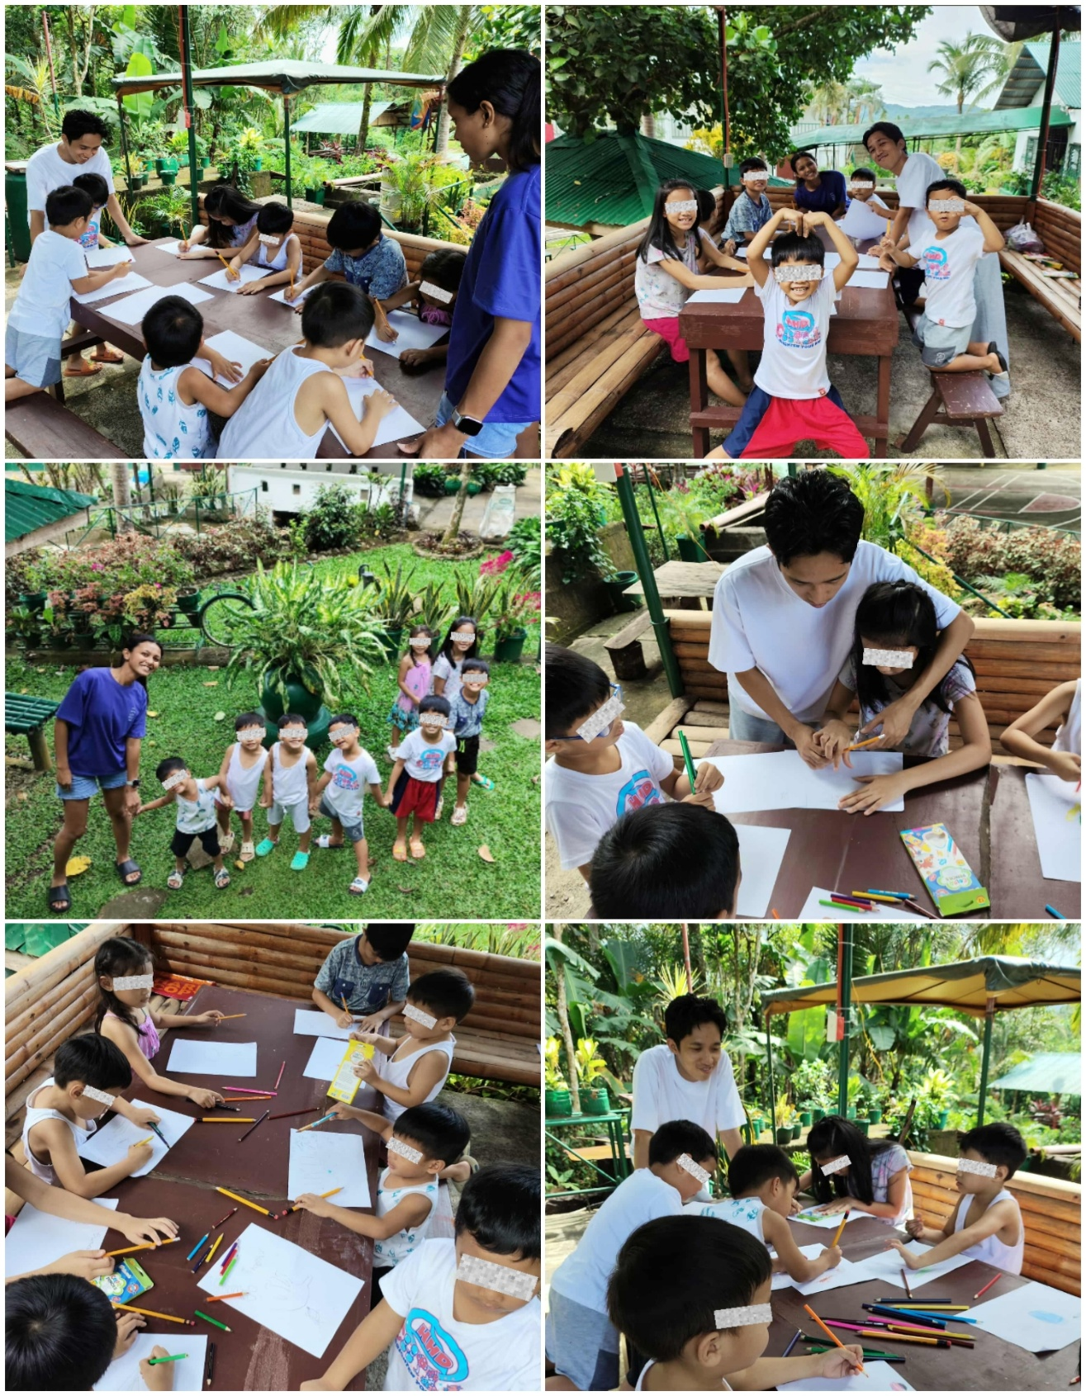

Session Number | 2
Time/Date/Place of Meetings | October 4, 2025/3:00 pm-4:30 pm
Activities/Event Titles | “Let’s Fix it, Don’t Fight”
Objectives | To show the children the proper behavior when it comes to their toys or even attention especially during play time.

On October 4, 2025, the second session entitled “Let’s Fix it, Don’t Fight” was conducted and was primarily aimed to show the children the proper behavior when it comes to their toys or even attention during play time. In which, the said session was held at Still Waters Kid’s Home compound at approximately 3:00 to 4:30 in the afternoon. The second session was attended by 8 residents of SWKH ages 4 to 8 years old and the assistant house parent. First, the affiliates informed the house parents on duty that after their nap time they will have another activity. At approximately 3:00 in the afternoon, Ms. Landicho asked the house parents that the activity will start reason for them to ask the children to line up. Additionally, Mr. Sorezo asked the assistant house parent Nanay Shiela if she could help them facilitate the said activity since they also need a house parent for the reenactment that was part of the activity prepared by the two affiliates.
Before the session started, Mr. Sorezo led the opening prayer. Followed by Ms. Landicho who was in charge to explain the children what the activity was all about. First, she mentioned that upon their observations, they frequently noticed that during play time they were fighting because of toys. Either the other one cannot wait for their turn to play with a certain toy that the other one was still using, someone is taking away someone’s toy, or someone ruined someone else’s toy. In which it became the affiliates’ main consideration why they came up with the said activity in the second session. In this regard, the affiliates prepared four scenarios in which the affiliates will read the situations, while the children together with the house parent need to reenact as well as finding solutions.
The first scenario was read by Ms. Landicho, at the same time Mr. Sorezo and Sofia (the director’s daughter) reenacted the said situation. It was about Sofia and Andrei who both wanted to play with the red truck. Andrei was the first one to get the truck, however Sofia took the toy from him, hide it behind her back and shouted at Andrei that she wanted to play with the truck. Andrei scolded her and asked to give it back to him because that was his toy. After the reenactment, Ms. Landicho asked the children on what the right response towards the situation was. Meanwhile, the children raise their hands while talking simultaneously. Reason for Mr. Sorezo to remind the children that they do not need to shout their answers, instead they need to raise their hands and he will call them one by one. After that, Mr. Sorezo called them one by one in which they have the same answers wherein according to them the right thing to do was to wait until its their turn to play the toy. Then that was the time that Nanay Shiela reenact the right response in which she approached both of them telling not to fight, instead wait for each other’s turn. Give enough time for each other to play with the toy and acknowledge the both of them for they agreed to wait for each other’s turn.
Meanwhile, the second scenario was reenacted by Carl and Jewel as well as Ivan and Timothy in which Ms. Landicho narrated the scenario in which there was a new block inside the play area. In which all of them run as fast as they could just to get the toy. Ivan gets ahead of the others so that he got the toy blocks. Now, they were asked by Mr. Sorezo on what was the right thing to do upon the situation. Jewel says that Ivan should share the blocks in order for all of them to play with it. Then, that was the time Ms. Landicho let them act on sharing the toy with each other.
For the third and last situation Mr. Sorezo narrated the scenario reenacted by Ms. Landicho and Marcus in which Ms. Landicho brought her favorite rubric’s cube from their home. While Marcus wanted to borrow the toy, but she refused to do so. It hurts him, reason for Marcus to shout at her and tell that she is very greedy that she does not know how to share a toy. Then, that was the time that the Nanay Shiela explained both of them that it is okay not to let someone to borrow your toy especially when it is your favorite. At the same time, it was not right to force someone to give you what you asked for considering that it was a personal thing. Additionally, Nanay Shiela told Ms. Landicho to let Marcus borrowed her toy for a while, while they were looking a toy for Marcus. They agreed upon it, so that Nanay Shiela acknowledge them for they manifested obedience and appropriate behavior towards the situation.
For instance, Nanay Shiela shared insights and experiences facing the same situation with the children. She mentioned that there were instances that the residents were taking toys from the visitors without asking permission. So that Ms. Landicho and Mr. Sorezo mentioned the residents what are the much acceptable and appropriate behavior towards the same situation. They were taught that they must always ask permission if they may borrow a toy especially with the visitors who brought their personal toy during their visit. As well as making them realize that the cannot force them to let them borrow their toys if they do not want to, considering the fact that it was their personal toy.
Furthermore, the prayer was led by Nanay Shiela before the session ends. The residents were asked by Mr. Sorezo to sit in their designated seats for the distribution of their snacks. They also took a short time for the photo opportunity for the purpose of documentation. The affiliates also asked permission to Nanay Shiela if the residents may eat their snacks already. Then, Nanay Shiela agreed, that is why they spent their remaining play time eating their snacks.

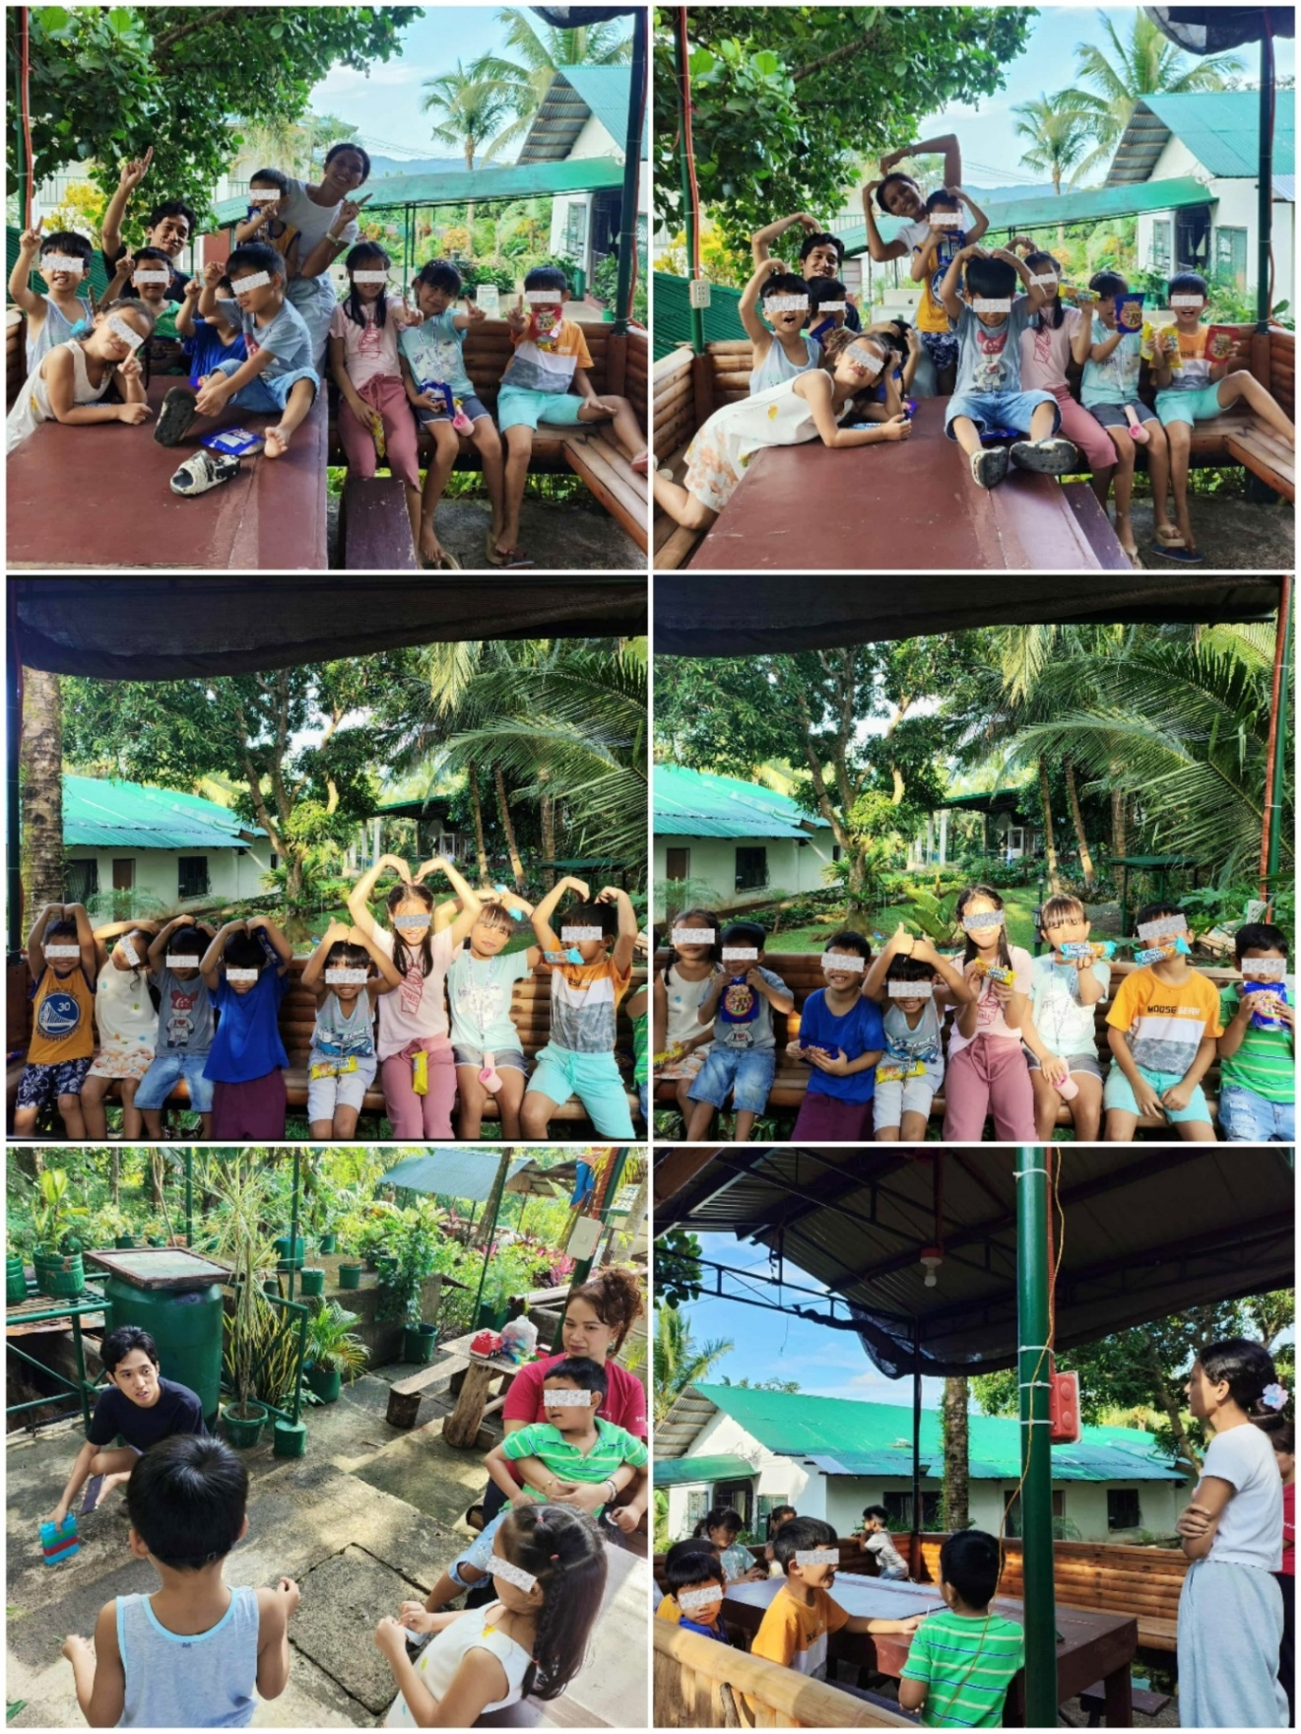

Session Number | 3
Time/Date/Place of Meetings | October 11, 2025/1:40 pm-4:00 pm
Activities/Event Titles | “Color my Feelings”
Objectives | To learn how to express their feelings and emotions by means of child appropriate activities that will introduce them to various emotions they were not much aware of.

On October 11, 2025, the third session entitled “Color my Feelings” was conducted and was primarily aimed for the children to acknowledge and express their feelings and emotions by means of child appropriate activities that will introduce them to various emotions that they were not familiar of. In which, the said session was held at Still Waters Kid’s Home compound at approximately 1:40 to 4:00 in the afternoon. The third session was attended by 8 residents of SWKH ages 4 to 8 years old. First, the affiliates informed the house parents on duty that after their nap time they will have another activity. At approximately 1:40 in the afternoon, Ms. Landicho asked the house parents that the activity will start reason for them to wake them up and asked them to line up for those who wanted to attend.
Before the session started, Marcus led the opening prayer. Followed by Mr. Sorezo who was incharge of providing explanation to the participants showed them the printed material of emojis consisting of happy, sad, angry, and fear. Initially, Marcus asked what was the last emoji. Suggesting that he was not that familiar to the said emoji. After that, Ms. Landicho distributed the art materials for them to start the given task. They were allotted one pencil, two bond papers, and one box of crayon for each participant for them not to fight over the materials like the previous session. They were given 1 hour to draw the emojis they frequently feel. While, they were given 30 minutes coloring their works. Once they were all done, Ms. Landicho collected all their outputs for the presentation, and asked the participants whether to call them in order or if she will pick who will present their paper randomly. The participants asked the facilitators Ms. Landicho and Mr. Sorezo to pick who will present their output randomly.
The first one to present was Jewel who drew two emotions which was happy and sad emojis. She was asked by Mr. Sorezo the reason why she feel those emotions. According to her, she felt happy whenever they were allowed to play. While, what makes him sad and at the same time mad was whenever she was told an prohibited to do some actions as well as if she was told by the house parents not to do certain things.
The second participant to present was Pejay who drew only one emoji. He was asked by Ms. Landicho why he drew the fear emoji. According to him, he was very afraid whenever he saw a dog.
The next participant to present was Timothy. He showed his work in which the facilitators did not expected what the child discussed as he showed that he completed all the emotions. At first, he was asked by Ms. Landicho of what was the things that makes him mad or afraid, he stated that it makes him angry and at the same time scared when a snake enters their house. Next, he was asked what makes him happy. He said that his mother was his source of happiness. Meanwhile, he was asked what makes him sad. At the same time, his mother makes him sad since according to him, he does not have a mother anymore. It was noticeable that the child was aware of what he said. Reason for Ms. Landicho to explain to him that for now his mother might not be around but time will come that they will meet each other again.
Next to present was Marcus who also drew all the emotions presented. Mr. Sorezo asked him what are the things that made him feel all those emotions. He was asked the reasons why he drew all the emotion. According to him, the things that makes him happy was when they were allowed to play as well as whenever he was playing with the other children. What makes him feel afraid is when the house parents got angry if he did something wrong. What made him sad is having no permanent family yet still hoping. Meanwhile, what makes him angry was if a toy was taken away from him or whenever he was hit and got hurt by the other resident, that causes him triggers.
While the other residents were not able to present their outputs because they were shy and some of them were not in the mood to participate in the presentation.
As the presentation was about to end, Mr. Sorezo prepared their snacks. The session was ended by a prayer led by Angel. After the prayer, both facilitators distributed their snacks and asked permission to Nanay Shiela if the participants may eat one of their snacks. With her permission, they ate their snacks and used the remaining time to play with the facilitators since it was still their play time.
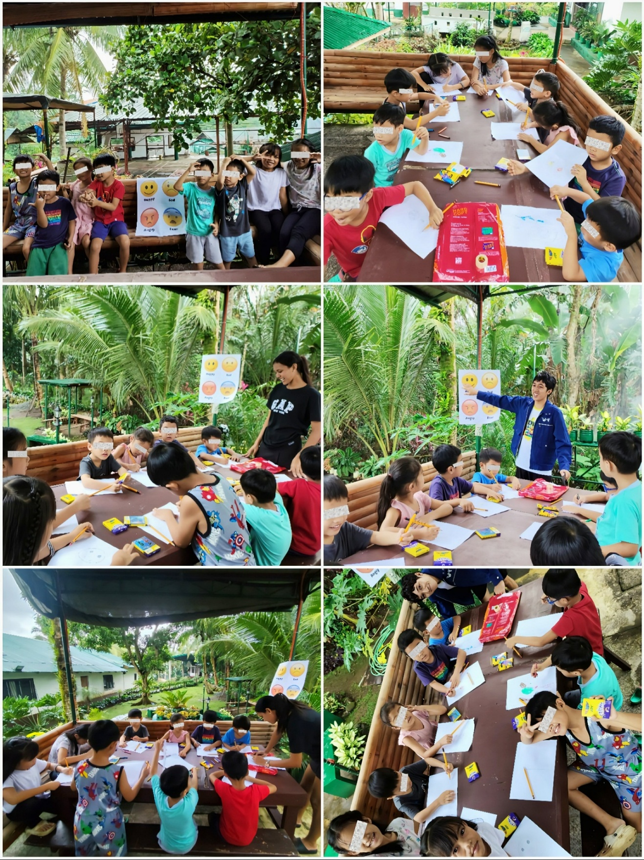

Session Number | 4
Time/Date/Place of Meetings | October 16, 2025/1:40 pm-4:00 pm
Activities/Event Titles | “Your Strength, My Strength”
Objectives | To identify and acknowledge their strengths.

On October 16, 2025, the fourth session entitled “Your Strength, My Strength” was conducted and was primarily aimed for the children to identify and acknowledge and their strengths by means of drawing and explaining their outputs in front of everyone. In which, the said session was held at Still Waters Kid’s Home compound at approximately 3:30 to 5:00 in the afternoon. The fourth session was attended by 8 residents of SWKH ages 4 to 8 years old. First, the affiliates informed the house parents on duty that after they attended their school time they will have another activity. At approximately 3:30 in the afternoon, Mr. Sorezo cleaned the venue and prepared all the materials needed, while Ms. Landicho asked the house parents that the activity will start reason for them to line up for those who wanted to attend. Providentially, they all attended the said session.
Before the session started, the facilitators draw themselves to set an example for the participants. To start the activity, Mr. Sorezo led the prayer. After that, Mr. Sorezo started explaining in which they need to draw themselves and think of what superpowers do they think they have. Meaning to say, skills they were good at. Mr. Sorezo showed them his art which he illustrated an image of man with math symbol beside it in which it shows that one of his strengths is being good at mathematics. For instance, he also drew a bubble thought with “hahaha” inside it which means he was good and joking as well as making people happy. Lastly, he drew a computer set in which he mentioned that he was also good at playing games in a computer. Now, after he presented, Ms. Landicho distributed the art materials and was given them time to draw and color their output. While they were working on their paper, Ms. Landicho discussed the strengths and skills she saw to each and everyone of them in order for them to have a clearer idea and better understand what they really need to do. After that, she saw some of them considered the strength she told to them as she saw that they draw those strengths. Once they were done with drawing, they were given time coloring their outputs. After that, the affiliates told them to present their outputs.
The presentation was led by the director’s daughter, Sofia. Since the affiliates also invited her to the said activity. As she presented her output, she illustrated a girl wearing her favorite clothes and was holding a microphone. Beside her was two speakers as well as a computer set on the bottom right side of her paper. According to her, she was holding a microphone because she was good at singing, while she drew a computer set because she was good at her typing lessons.
Meanwhile, Marcus presented his output in which he divided his paper into two parts. On the upper part, he draws a scientist which symbolizes his great skills when it comes to memorization even Mathematics, English, as well as memorizing Bible verses. While, on the bottom part of his paper, he drew a house with a label “building a house” beside it. In which, it symbolizes his great ability to build blocks in a creative manner.
For instance, Angel presented her output which she illustrated a girl with vines on her hands. According to her if she will be given a chance to have a superpower, she wanted to have vines in her hands to grow plants. In addition, she also stated that her strength is that she knows how to do household chores such as wiping the tables, sweeping the floor, washing the dishes, and such, she also mentioned that she frequently uses those skills to assist and help their house parents managing the home along with the tasks while taking care of them.
After their presentation, all of them have had a greater and wider understanding and knowledge when it comes to strengths, skills, and expertise of each and every one of them. Furthermore, to end the session, Ms. Landicho led the closing prayer followed by the distribution of snacks. Since it was already 5:00 in the afternoon and it was very close to their dinner, the affiliates asked them to give their snacks to their house parents first.

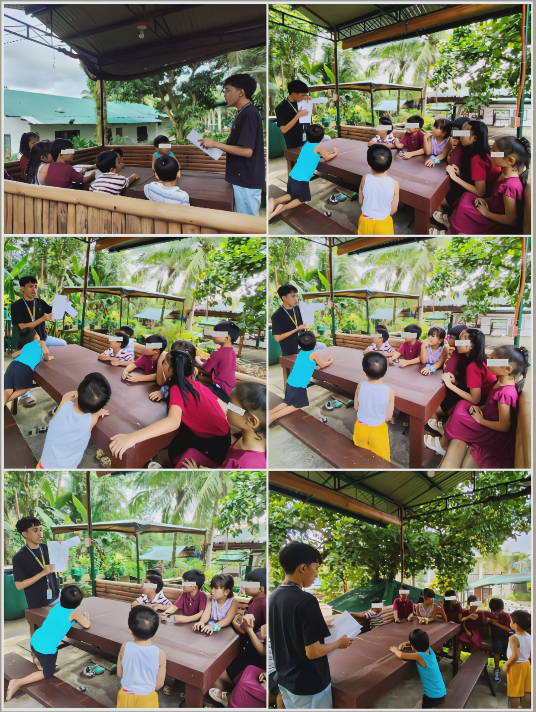

Session Number | 5
Time/Date/Place of Meetings | October 23, 2025/1:40 pm-4:00 pm
Activities/Event Titles | “Stronger when we Work Together”
Objectives | To know what teamwork is, its application, as well as how will they build teamwork.

On October 18, 2025, the fifth session entitled “Stronger when we work Together” was conducted and was primarily aimed for the children to know what teamwork is, its application, as well as how will they build teamwork. In which, the said session was held at Still Waters Kid’s Home compound at approximately 3:30 to 5:00 in the afternoon. The fifth session was attended by 8 residents of SWKH ages 4 to 8 years old. First, the affiliates informed the house parents on duty that after they attended their school, they will have another activity. At approximately 3:30 in the afternoon, Mr. Sorezo cleaned the venue and prepared all the materials needed, such as balls, chairs, building blocks, and the speaker, while Ms. Landicho asked the house parents that the activity will start so that they were asked to line up for those who wanted to attend. The affiliates also asked one of the house parents to accompany and look after them while the affiliates were facilitating the activity. Providentially, they all attended the said session since they know that the session was more on playing.
First, Mr. Sorezo explained that they will be divided into two groups with four members. The Group 1 consists of Angel, Sofia, Carl, and Timothy. Meanwhile, Group 2 consists of Marcus, Jewel, Ivan, and Pejay. After that, the affiliate introduced to them the first game that will test their coordination. He also explained the mechanics of the game. Each pair of each group will represent their team to catch the ball, one will throw, and the other one will catch the ball and vice versa. If they can catch the ball, they will move one step away from each other and so on. If one pair fail to catch the ball, then the other pair from the other team will get one point. Whichever group got five points first, they will be the winner for the first game. Each team showed eagerness to win by means of catching the ball carefully. Both teams got four points already, which means the game was about to end which Group 1 ended the game with the score of 5 points.
At some points of the game, Ms. Landicho noticed that there were minimal problems in which some of them were blaming the other members, while some of them were sad because they loose in the first game. So that, the affiliate reminded them the real purpose of their group which is to learn what sportsmanship is and most importantly to learn how the group will function if they do not have cooperation and teamwork or if they learn the value of teamwork.
Meanwhile, Mr. Sorezo set up the next game which was a kind of ball race. While Ms. Landicho explained the mechanics of the game. The two groups will race while holding a basketball. The first member will run, turn around the chair on the other side of the court while holding a ball, and pass it to the next member. Then the second member need to do the same procedure and so on to the last two members of the group. When the ball reaches the last member of the group, he/she will do the same thing but once the last member who was holding the ball reaches the base, all of them will run another circle. The first team to reach three points will win. For the second time, the First group won.
Now, they proceeded to the last game which was building a tower of blocks. Again, Ms. Landicho explained the mechanics of the game. With the same group, they will choose two runners to get the blocks from the other side of the court, while the other two member will wait for the building blocks and build the tower. The runners of each team can only get two blocks at a time. Each team needs to build a tower and made it stand in a given period of time. Both teams showed their eagerness as well as showing how good they were when it comes to building a strategy. For instance, they showed teamwork upon getting the blocks and building it into a tower. The first group to finish their tower was the second group, while the first group just finished and made a taller tower. So that, the affiliates decided to give both groups a point.
After the last game, the affiliates noticed that some of them were not happy about the result of their scores, so that the affiliates explained to them that it was not always a win. What important is they showed and learned what to to do the given tasks with cooperation and teamwork. All in all, they enjoyed the activity that the affiliates prepared. As the activity comes to an end, the affiliates asked them what will happen if they do not have teamwork. According to them, tasks would not be easy to accomplish unlike when all of the members of the team have cooperation and teamwork just like what they showed during the entire activity. Lastly, they distributed prizes to each teams and asked them to ask permission first to their house parents if they could eat the snacks.
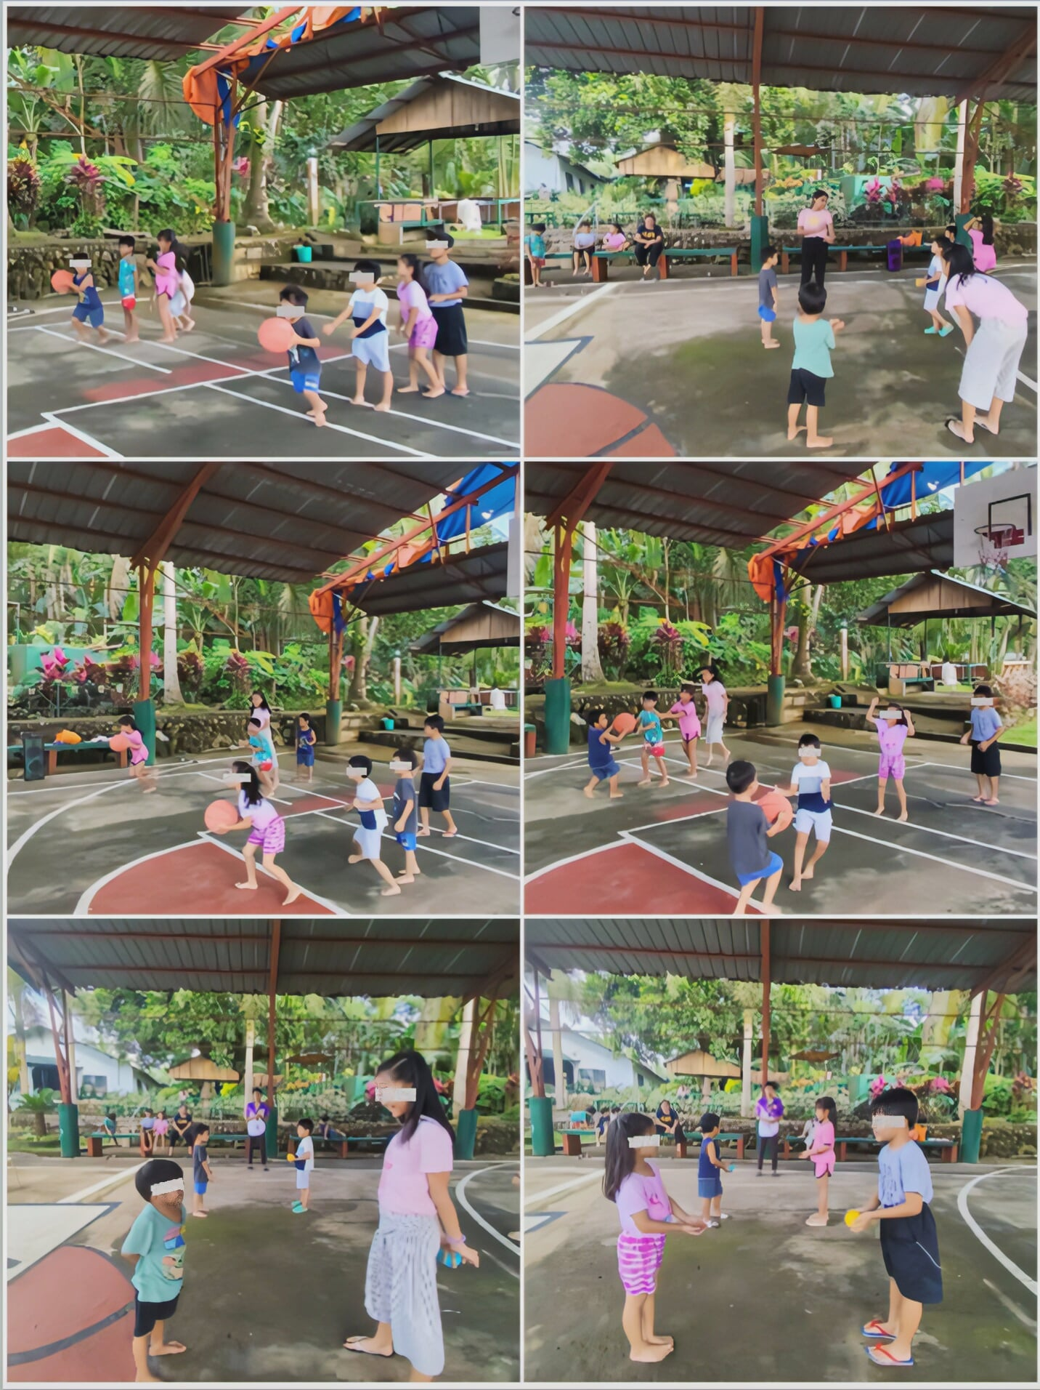

Session Number | 6
Time/Date/Place of Meetings | October 25, 2025/3:00 pm-5:00 pm
Activities/Event Titles | “Respecting Our House Parents”
Objectives | To be more knowledgeable about the idea of respect, and how will they show their respect towards other people especially the House parents

On October 25, 2025, the sixth session entitled “Respecting Our House Parents” was conducted and was primarily aimed for the children to be more knowledgeable about the idea of respect, and how will they show their respect towards other people especially the house parents. In which, the said session was held at Still Waters Kid’s Home compound at approximately 3:30 to 5:00 in the afternoon. The sixth session was attended by 8 residents of SWKH ages 4 to 8 years old, with the supervision of one of the house parents, Nanay Shiela. First, the affiliates informed the house parents on duty that after they attended their school, they will have another activity. At approximately 3:30 in the afternoon, Mr. Sorezo cleaned the venue and prepared all the materials needed, such as papers and pencils, while Ms. Landicho asked the house parents that the activity will start so that they were asked to line up for those who wanted to attend. The affiliates also asked one of the house parents to accompany and look after them while the affiliates were facilitating the activity. For instance, she played a crucial role with the said activity since it will tackle about the children’s respect towards their house parents.
The said session started with a prayer led by Timothy. Followed by a quick sharing regarding their behavior towards their house parents. Ms. Landicho asked questions regarding the negative behaviors of each child and was answered by Nanay Shiela. The true essence of the sharing and the house parent’s feedback mainly aimed for the children to figure out and realize their actions that greatly affects their relationship toward their house parents. It was very noticeable that they were admitting that there were times that they tend to misbehave, most especially when they were reprimanded and controlled.
After the sharing, they proceeded to the story telling in which Ms. Landicho introduced them two stories. One showed disobedience and disrespect towards their house parents in which the given scenario was about a newly arrived house parent who greets the children but not even a single child gave her attention. Instead, they continued what they were doing like fighting over a toy, not even obeying the instructions to clean up the toys, as well as not talking back to their house parent with respect. While the other story showed obedience and respecting their house parents, which was totally different from the first scenario. That includes a newly arrived house parent who greets the children. The children approached her in a very welcoming way, they also obeyed their house parent’s instructions which is to fix and clean up their toys, waiting when it is their turn when it comes to using a toy, as well as talking to her nicely. After telling two different stories, Ms. Landicho asked the participants kind of behavior does the children showed to their house parent in the first story. Each one of them shared the things they remembered. According to Pejay, one of the negative behaviors that the children showed was not helping their house parent to fix and clean up the toys, while according to Marcus it was not following the instructions. While, they were asked by Mr. Sorezo regarding the positive behavior that the children showed to their house parent. According to Angel, it was following instructions, meanwhile according to Jewel it was helping the house parent when fixing and cleaning up the toys.
Now, for the last activity, they were given a sheet of paper and pencil to list down the things to do as well as the things they must not do to show that they value and respects their house parents. Since the others were not still able to write, Mr. Sorezo asked them then listed the things that they mentioned. As the activity came to a near end, they shared the things as well as the tasks they must do that was written on their lists. Ms. Sorezo also verbalized what the other children mentioned. According to Timothy you need to have self-control. While, according to Marcus, always say the magic words such as please, thank you, and forgive me. Some of them also added that they must always ask permission first before doing something, helping the house parents, as well as talking to them nicely. To sum it up, all of the things they listed as well as those things that was discussed focused on making the house parents feel that they were valued and respected by means of obeying them.
Lastly, before the session ended, Ms. Landicho asked them why they need to fix and regulate their behavior as well as treating their house parents with respect. According to them, as their house parents were their temporary parent figures, they need to obey and treat them with respect to give back to them for taking care of them. Furthermore, since they were knowledgeable regarding the idea of adoption, they mentioned that since their house parents were their temporary parent figures, they must treat them with respect along with manners to give back for taking care of them while they were still inside the agency. They also mentioned that their house parents were only correcting their misbehaviors and is considered as one of their preparations once they have their own family soon.
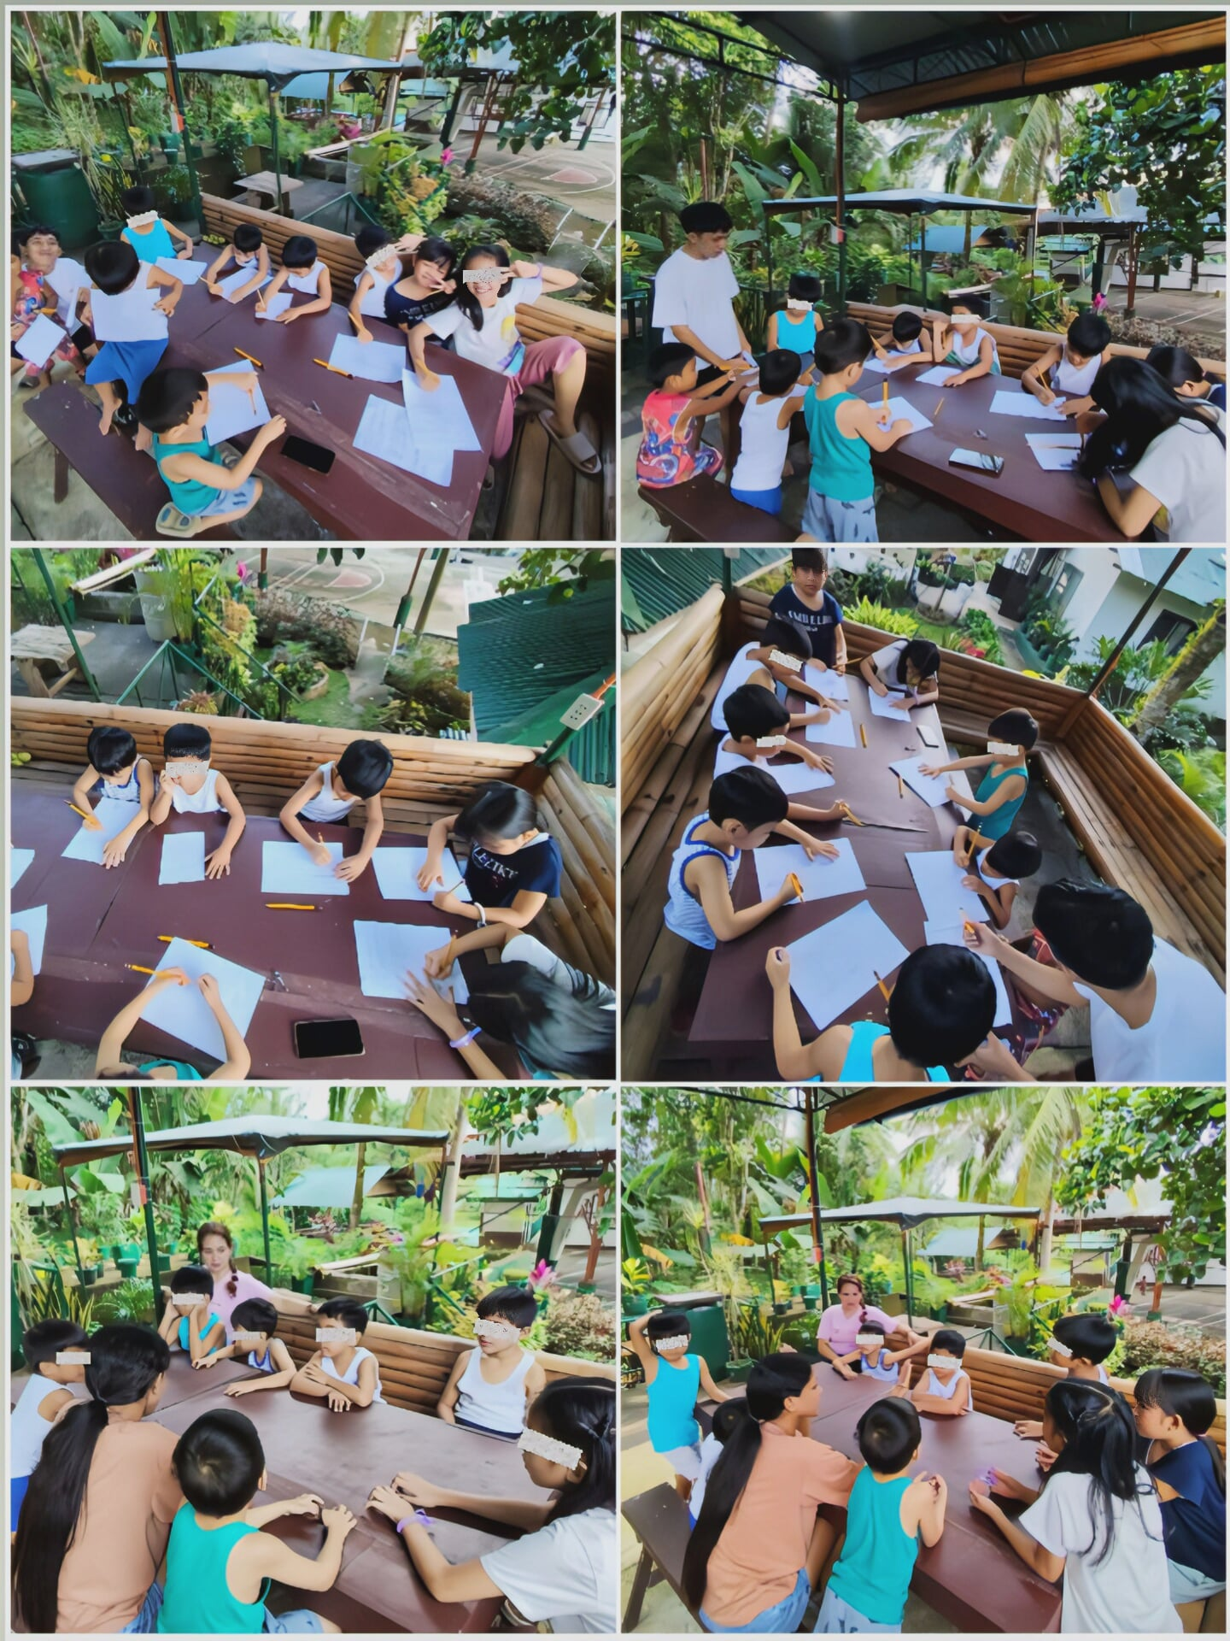

Session Number | 7
Time/Date/Place of Meetings | October 28, 2025/3:00 pm-5:00 pm
Activities/Event Titles | “Together, We’re Happy”
Objectives | To have celebration and acknowledgment for each and every one as the group work sessions ends

On October 28, 2025, the sixth session entitled “Together, We’re Happy” was conducted and was primarily aimed for the children to have celebration and acknowledgment for each and every one as the group work sessions ends. In which, the last session was held at Still Waters Kid’s Home compound at approximately 3:30 to 5:00 in the afternoon. The last session was attended by 8 residents of SWKH ages 4 to 8 years old, with the supervision of two of the house parents on duty, Nanay Lenie and Nanay Ekay, as well as the Executive Director, Ma’am Mary Rose. First, the affiliates informed the house parents on duty that after they attended their school, they will have the last activity. At approximately 3:00 in the afternoon, the affiliate prepared the venue, which was at the balcony of the Home, and prepared all the materials needed, such as paper hearts, cut out images, a bog paper with their group name, and the poster paint with brushes. After that, Ms. Landicho asked the house parents that the activity will start in a few minutes after the participants had their snack. The affiliates also asked both of the house parents on duty that they were included to the activities as well as accompanying and looking after them while the affiliates were facilitating the activity.
To start the last session, they were asked to form a circle, after that Jewel led the prayer, followed by Ms. Landicho who asked them to recall all the sessions. The participants together with the affiliates recall and reflected each session in which, one by one, they were asked what their favorite part was together with their learnings among all the sessions. According to Jewel and Pejay, their favorite part was the sixth session which was focused on respecting their house parents, while according to Marcus and Angel, their favorite part was the fifth session, specifically the building of blocks in which they need to race to get blocks and build a tall tower that tested their patience, coordination, and the ability to strategize. Now, they were asked by Mr. Sorezo on what did they learned from the said activity. According to them, they learned what teamwork is and what it is to have a teamwork among each member of the team.
After the said activity, they proceeded to the next activity with the title of “Heartfelt Connection”. The affiliates prepared paper hearts, each color of hearts have its own meaning (red symbolizes I Love You, white for Thank You, blue for Forgive Me, and purple for You are Valued and Respected). The affiliates gave each one of them one color of each paper hearts then let them give to the person they want to give the corresponding color as well as explaining the person why they give them a certain color of paper heart. After explaining the instructions of the said activity, the affiliates gave them the permission to start giving the paper hearts. First, the children gave paper hearts to their house parents while saying thank you for taking care of them as well as giving them red hearts which symbolizes their love to their house parents. While they also gave hearts to the director, in which most of them gave her blue hearts that was asking for forgiveness for their misbehaviors sometimes. After giving the paper hearts to the director and the house parents since they were at the venue, both of the affiliates accompanied them to give their hearts to the administrative assistant Ma’am Vivian, and the Social Worker Sir Julius. Both of them received all of the colors. They gave both red hearts to express their love to the both of them. They also received purple hearts that symbolizes the children’s respect towards to them, blue hearts that were asking for forgiveness considering their misbehaviors, lastly was the while hearts which tells them that they were very thankful for facilitating and fixing their documents for them to have their own permanent family. The said activity highlighted their social awareness and broader understanding regarding building stronger relationships to those people who were taking care of them while they were still inside the agency, as well as appreciating their efforts of giving them the things they need not only on a daily basis but the care and affection they need.
Furthermore, they proceeded to the last and the highlight of the last session which was the “Group Artwork” in which the children will paste an image of a kid to the logo and group name that the affiliates prepared on a big sheet of paper. For instance, they will leave traces of their handprints on the paper that will serve as the logo of the group. Since Mr. Sorezo and Ms. Landicho already prepared their group name on a paper, posted outside the balcony. All they must do is to paste the image of ever child to as well as tracing their handprints to their logo. After posting images one by one, the affiliates decided to paint the residents’ hands and leave traces on a paper which symbolizes the children’s unending hope and being small warriors who keep on fighting. They decided to use bright colors as bright as their futures despite all their experiences. They were asked to line up, when they were all settled Ms. Landicho painted their hands while Mr. Sorezo assisted them on tracing their hands to the paper. While enjoying their bright colors in their hands, it was unavoidable to mess with their faces as well as living traces in their clothes. Reason for the affiliates to decide to wash their hands and faces and asked assistance to the house parents.
At last, after they washed their hands, they proceeded to the awarding of certificates to the participants. Mr. Sorezo called their names one by one to receive their certificates. After receiving their certificate of recognition, they proceeded to the photo opportunity. They gathered all the participants to sit beside their logo to take pictures of them together with the affiliates. For instance, they took photos not only the participants but all the children inside the Home. The affiliates were not able to facilitate the entire photo documentation. Thankfully, they were assisted by the director as well as the teacher taking photos of the entire session. Once, they were done, they proceeded to the distribution of snacks consist of drinks, bread, and some candies as their small token. That concludes the last session of their group entitled “BUILDING BRIDGES: STRENGTHENING BONDS THROUGH FUN AND TEAMWORK”

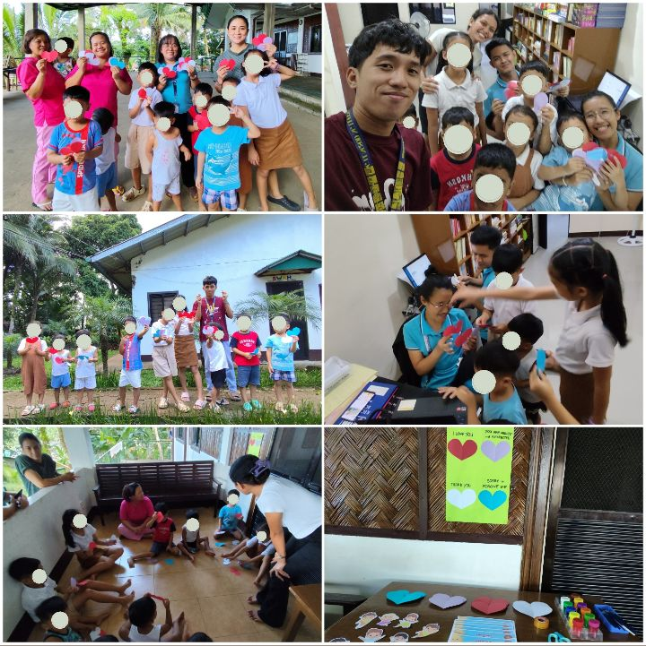

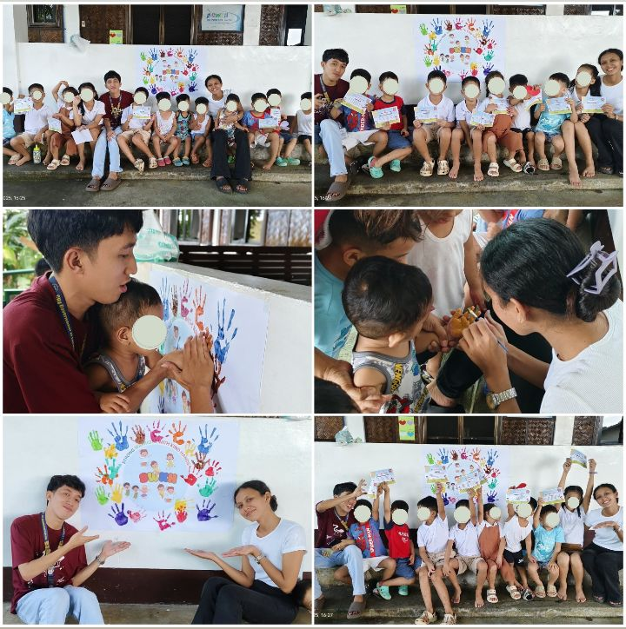

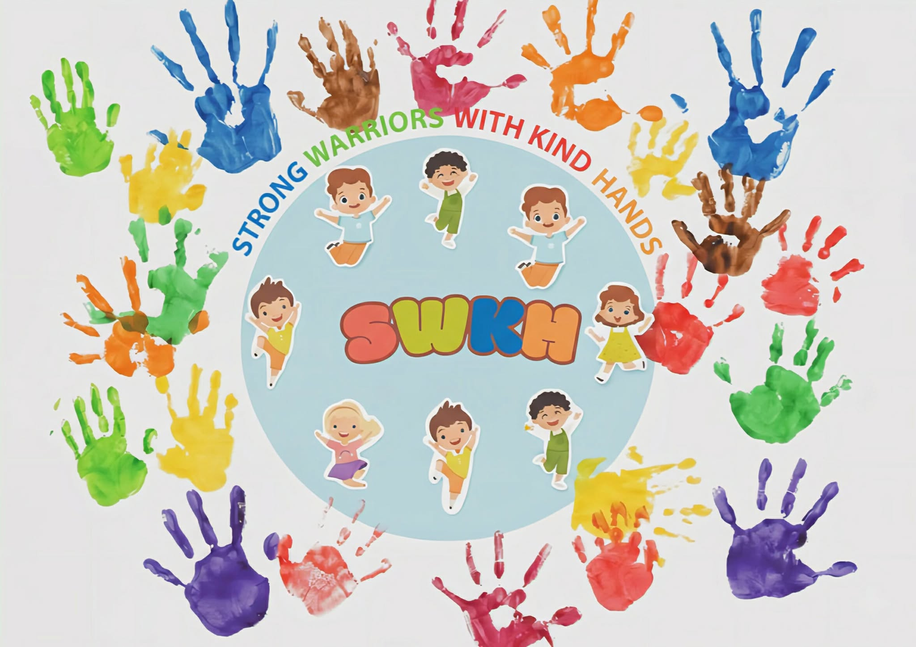

Group Profile

Personal Data
Name: Marcus Mendrano
Birth Date: February 13, 2018
Birthplace:
Present Address: Still Waters Kid’s Home Inc. Barangay Ilayang Banga, Majayjay, Laguna
Contact Number:
Nationality: Filipino
Religion: Born Again Christian
Civil Status: Single
Skills: Artistic/ Creative

Educational Background
SCHOOL | INCLUSIVE YEAR
Basic Life Empowerment and Support System | 2022-2023
Philippine Christian School of Tomorrow | 2024-present

Family Background
Name | Relationship | Date of Birth | Educational Attainment | Occupation
Jinnie Mendrano | Birth mother

Personal Data
Name: Carl Gonzales
Birth Date: June 2, 2019
Birthplace: Ospital ng Cabuyao, Barangay Tres, City of Cabuyao Laguna
Present Address: Still Waters Kid’s Home Inc. Barangay Ilayang Banga, Majayjay, Laguna
Contact Number:
Nationality: Filipino
Religion: Born Again Christian
Civil Status: Single
Skills: Artistic/ Creative and imaginative

Educational Background
SCHOOL | INCLUSIVE YEAR
Basic Life Empowerment and Support System | 2023-2024
Philippine Christian School of Tomorrow | present

Family Background
Name | Relationship | Date of Birth | Educational Attainment | Occupation
Telda Gonzales | mother | June 15, 1984
Ruelito | Step father
Bernie Gonzales | father
Kyla | sister
Jake | brother
Cindy | sister
John Ruel | brother

Personal Data
Name: Jewel De Leon
Birth Date: May 29, 2020
Birthplace: Tanauan Bible Church Barangay Poblacion 3, Tanauan City, Batangas
Present Address: Still Waters Kid’s Home Inc. Barangay Ilayang Banga, Majayjay, Laguna
Contact Number:
Nationality: Filipino
Religion: Born Again Christian
Civil Status: Single
Skills: Artistic/ Creative

Educational Background
SCHOOL | INCLUSIVE YEAR
Basic Life Empowerment and Support System | 2024-2025
Philippine Christian School of Tomorrow | present

Family Background
Name | Relationship | Date of Birth | Educational Attainment | Occupation
Lara De Leon | Birth mother

Personal Data
Name: Timothy Incomio
Birth Date: November 29, 2019
Birthplace: Biñan City, Laguna
Present Address: Still Waters Kid’s Home Inc. Barangay Ilayang Banga, Majayjay, Laguna
Contact Number:
Nationality: Filipino
Religion: Born Again Christian
Civil Status: Single
Skills: Artistic/ Creative

Educational Background
SCHOOL | INCLUSIVE YEAR
IFL-Children’s Academy | 2023
Basic Life Empowerment and Support System | 2024-present

Family Background
Name | Relationship | Date of Birth | Educational Attainment | Occupation
Rochelle Incomio | Mother | June 14, 1999
Jerome | Step father
John Ati | Brother | February, 2016
Faora | sister | April 12, 2022

Personal Data
Name: Princess Angel Globio
Birth Date: February 15, 2017
Birthplace: Parañaque City
Present Address: Still Waters Kid’s Home Inc. Barangay Ilayang Banga, Majayjay, Laguna
Contact Number:
Nationality: Filipino
Religion: Born Again Christian
Civil Status: Single
Skills: Artistic/ Creative

Educational Background
SCHOOL | INCLUSIVE YEAR
Basic Life Empowerment and Support System | 2023-2024
Philippine Christian School of Tomorrow | 2024-present

Family Background
Name | Relationship | Date of Birth | Educational Attainment | Occupation
Gema Globio | Mother
Gherald Globio | Uncle
Shaira | Aunt in law
Mark Henry | Cousin
Mark Anthony | Cousin

Personal Data
Name: Angelo Ivan Michael Atienza
Birth Date: October 17, 2020
Birthplace:
Present Address: Still Waters Kid’s Home Inc. Barangay Ilayang Banga, Majayjay, Laguna
Contact Number:
Nationality: Filipino
Religion: Born Again Christian
Civil Status: Single
Skills: Artistic/ Creative

Educational Background
SCHOOL | INCLUSIVE YEAR
Basic Life Empowerment and Support System | present

Family Background
Name | Relationship | Date of Birth | Educational Attainment | Occupation
Karylle | Mother
Oliver | Father
Rhea Atienza | Grand Mother
Librada | Great Grand Mother

Personal Data
Name: France Zion Mangabat
Birth Date: April 4, 2021
Birthplace:
Present Address: Still Waters Kid’s Home Inc. Barangay Ilayang Banga, Majayjay, Laguna
Contact Number:
Nationality: Filipino
Religion: Born Again Christian
Civil Status: Single
Skills: Artistic/ Creative

Family Background
Name | Relationship | Date of Birth | Educational Attainment | Occupation
Honeyzen Mangabat | Mother
Francisco Mangabat | Father
Honce Lemon Mangabat | Sister
Eufemia Mangabat | Great Grand Mother

Summary of Group Work
The affiliates facilitated a groupwork entitled " Building Bridges: consisting of 7 sessions including child-appropriate activities that will help them be engaged all throughout the sessions. Together, the affiliates build a group namely Strong Warriors with Kind Hands in which they decided to name the group after the acronym of Still Waters Kid’s Home that symbolizes the children’s resilience and strength despite their circumstances.
During the observations, although the children were living in one roof their interactions were mostly surface level. They frequently play and interact with each other, yet their connection and emotional understanding lacked in depth, as well as towards their care givers/house parents. Given the upper mentioned circumstances, the group was established to strengthen their relationship among their peer, and their house parents. The sessions were carefully designed consisting of guided play storytelling, role playing and interactive activities that aimed to establish and promote genuine bonds and understanding helping the children experience a sense of belonging and family.
Throughout the program, the children showed noticeable improvement. They began cooperating more, expressing emotions openly, practicing patience, and showing increased respect for their caregivers. House parents also observed positive behavioral changes such as better listening, sharing, and helpfulness. Though challenges occurred, such as sudden schedule adjustments, the sessions were completed successfully through the cooperation of staff and affiliates.
Overall, the group work successfully met its goal of building meaningful connections, enhancing emotional and social skills, and promoting family-like relationships within the Home. Continuous monitoring and follow-up activities are recommended to sustain the progress and further support the children’s readiness for future permanent family placements.

INTEGRATIVE PAPER

on

FIELD INSTRUCTION 1
(WORKING WITH INDIVIDUALS AND GROUP)

In Partial Fulfillment of the Requirements for the Course
Field Instruction 1 conducted in
STILL WATERS KID’S HOME INC.

ANDREI VINCENT T. SOREZO
Social Work Affiliate

ROMULO A. OSERIN JR.
Field Instructor

Dalubhasaan ng Lungsod ng Lucena
November 22, 2025

TABLE OF CONTENTS

I. COVER PAGE …..………………………………………………………. 01
II. TABLE OF CONTENTS……………………………………………….. 02
III. INTRODUCTION………………………………………………….….. 03
IV. DISCUSSION………………………………………………………........04
- Knowledge………………………………………………………........04
- Skills………………………………………………………..................08
- Attitude……………………………………………………….............10
V. CONCLUSION……………………………………………………….......15
REFERENCE………………………………………………………...............16

III. INTRODUCTION

Field instruction is the heart of social work training. It's where students finally get to move beyond the textbooks and use everything they’ve learned in class. After 3 years of studying, this part of the journey lets students test their knowledge and skills in real life situations. It's the time they can genuinely apply those core values, principles, and ethics they were taught while working with different people and communities. By using various theories and approaches, students start to get a much clearer picture of what their clients go through and how to help them effectively. These hands-on experiences don't just make students better at supporting others, they show them what social work is truly like in real life. Field instruction is what connects all those classroom lessons to actual practice, making it a very important step in becoming a social worker.
This integrative paper walks through the affiliate’s experiences and what he learned during Field Instruction 1 at Still Waters Kid’s Home Inc. It combines the insights he picked up from both classroom discussions and the actual time he spent at the agency. The paper highlights how different social work areas, such as human behavior, practice skills, ethics, diversity, values, and social justice, played out in a real setting. Throughout his practicum, he encountered moments that really called for patience, empathy, and understanding. These experiences became the foundation for seeing exactly how the lessons from school connect with actual, day-to-day social work practice.

IV. DISCUSSION

KNOWLEDGE
Still Waters Kid’s Home Inc. is a Child Caring Agency accredited by the DSWD and is located inside the ACBS Compound in Barangay Ilayang Banga, Majayjay, Laguna. The affiliate learned that the agency primarily serves children who have been abandoned, abused, neglected, or orphaned, especially those from birth to six years old. The agency provides not only shelter but also protection, emotional support, basic education, and spiritual upbringing. It aims to offer these children stability while they wait for adoption, foster care, or possible reunification with their families. The place is built to be peaceful and nurturing so that the children can heal from their past experiences and grow into emotionally healthy individuals.
The affiliate was assigned to a community of children with different backgrounds and needs. Most of them had complicated histories, which meant they required structured routines, close supervision, and consistent emotional support. The affiliate saw how each child behaved differently depending on the trauma and experiences they carried, which made the work both challenging and meaningful.
In understanding the work inside the agency, the affiliate also became aware of several laws that guide child welfare, such as the Domestic Adoption Act of 1998 (RA 8552), the Foster Care Act of 2012 (RA 10165), and the Domestic Administrative Adoption and Alternative Child Care Act of 2022 (RA 11642). These laws shape how the institution handles cases, especially when it comes to adoption, placement, and child care procedures. Through these laws, the affiliate realized that every decision in the agency must consider the best interest of the child.
In applying the principles of social work, the affiliate was able to consistently practice acceptance and confidentiality. Acceptance was important because each child had a different personality, story, and emotional struggle. The affiliate made sure to welcome each child without judgment and treated them with kindness regardless of their background or behavior. This meant seeing the child not as someone defined by trauma or difficulties, but as someone who still had strengths, potential, and the capacity to grow. Confidentiality was also crucial because the children’s stories were sensitive. The affiliate respected their right to privacy and understood that sharing their information carelessly could harm their sense of safety. This practice strengthened trust, especially in a setting where many children already had trouble trusting adults.
However, the affiliate struggled at first with the principle of controlled emotional involvement. During the early stages, especially while doing the intake process alongside the agency supervisor, house parents, and other staff, the affiliate found it difficult not to get emotionally overwhelmed. Hearing the children’s painful histories made the affiliate feel deeply sad and sorry for them. Even though the affiliate tried to appear strong and composed on the outside, internally the affiliate felt like crying and carried emotional heaviness after listening to their stories. As time went on, the affiliate slowly learned how to balance empathy with emotional control. The affiliate realized that caring too much to the point of being overwhelmed would make it harder to support the children effectively. Through continued exposure and guidance, the affiliate learned to listen with compassion but still remain steady so that the children and the staff could rely on the affiliate’s presence.
In terms of approaches, especially during the group work case study, the affiliate mainly used the Developmental Approach. The affiliate learned that the group’s main problem was difficulty in forming healthy relationships with one another and with their house parents. Because they had different backgrounds and emotional needs, the affiliate designed activities that were fun, age-appropriate, and centered on building teamwork, respect, communication, and patience. Activities that encouraged cooperation, sharing, and self-expression helped the children practice positive behavior in a safe and enjoyable way. Small group games allowed them to interact with each other without pressure, while creative activities gave them space to express feelings that they were not used to verbalizing.
The affiliate also applied the concepts of Attachment Theory in the group work. Many of the children’s relationship problems were tied to their early experiences as orphans. Because they did not experience stable and consistent caregivers, some found it hard to trust, some became overly attached quickly, and others rejected closeness out of fear of being hurt again. Understanding these patterns helped the affiliate tailor the group sessions in a way that slowly encouraged emotional safety. The affiliate made sure that activities did not force the children to be vulnerable too quickly but instead allowed them to build comfort step by step. The affiliate recognized that their difficulty in forming bonds was not simply a behavioral issue but a deeper emotional struggle tied to their history. By combining the developmental and attachment-based perspectives, the affiliate was able to create sessions that supported both their social development and their emotional healing.
In handling cases, the theory that guided the affiliate the most was Attachment Theory. The affiliate observed that many of the children in the agency were able to form warm, trusting relationships with the house parents and staff. Instead of showing difficulty in attachment, they actually showed the opposite, they were capable of building healthy emotional bonds when given consistent care and attention. This helped the affiliate understand that their ability to connect with adults was a strong sign that adoption or long-term family placement would support their overall well-being. Since they could develop secure attachments within the agency setting, the affiliate learned that the children also had the potential to build stable and loving relationships with adoptive parents in the future. Attachment Theory helped the affiliate interpret their behavior in a positive way, recognizing that the safe environment provided by the agency allowed these children to practice trust, affection, and emotional security.
Moreover, the affiliate applied the concepts of Attachment Theory in the group work. Some of the children’s relationship problems were tied to their early experiences as orphans. Because they did not experience stable and consistent caregivers, some became overly attached quickly as they basically grew up in the agency and others rejected closeness out of fear of being hurt again. Understanding these patterns helped the affiliate tailor the group sessions in a way that slowly encouraged emotional safety. The affiliate made sure that activities did not force the children to be vulnerable too quickly but instead allowed them to build comfort step by step. The affiliate recognized that their difficulty in forming bonds was not simply a behavioral issue but a deeper emotional struggle tied to their history. By combining the developmental approach and attachment-based perspectives, the affiliate was able to create sessions that supported both their social development and their emotional healing.
Furthermore, in terms of approaches, especially during the group work case study, the affiliate mainly used the Developmental Approach. The affiliate learned that the group’s main problem was difficulty in forming healthy and consistent relationships with one another and with their house parents. Because they had different backgrounds and emotional needs, the affiliate designed activities that were fun, age-appropriate, and centered on building teamwork, respect, communication, and patience. Activities that promoted cooperation, sharing, and self-expression helped the children practice positive behavior in a safe and enjoyable way. Small group games allowed them to interact with each other without pressure, while creative activities gave them space to express thoughts, talents, and feelings that they were not used to verbalize.
In applying the principles of social work, the affiliate was able to consistently practice acceptance and confidentiality. Acceptance was important because each child had a different personality, story, and struggle. The affiliate made sure to welcome each child without judgment and treated them with kindness regardless of their background or behavior. This meant seeing the child not as someone defined by trauma or difficulties, but as someone who still had strengths, potential, and the capacity to grow. Confidentiality was also crucial because the children’s stories were sensitive. The affiliate respected their right to privacy and understood that sharing their information carelessly could harm their safety. This practice strengthened trust, especially in a setting where many children already had trauma and struggles.
However, the affiliate struggled at first with the principle of controlled emotional involvement. During the early stages, especially while doing the intake process with the agency supervisor, house parents, and other staff, the affiliate found it difficult not to get emotionally overwhelmed. Hearing the children’s painful histories made the affiliate feel deeply sad and sorry for them. Even though the affiliate tried to appear strong and composed on the outside, internally the affiliate felt like crying and carried emotional heaviness after listening to their stories. As time went on, the affiliate slowly learned how to balance empathy with emotional control. The affiliate realized that caring too much to the point of being overwhelmed would make it harder to support the children effectively. Through continued exposure and guidance, the affiliate learned to listen with compassion but still remain steady so that the children and the staff could rely on the affiliate’s presence.

SKILLS
Before the affiliate entered the agency for field instruction, he believed that one of his strongest skills was communication. He saw himself as talkative and comfortable speaking with classmates, friends, and even in front of crowds when needed. He also often used his communication skills to resolve personal conflicts or express his thoughts clearly. Another skill the affiliate was proud of before practicum was his mathematical ability. He had always used math in his daily life, and he felt confident that this strength would eventually help him in different tasks.
However, when the affiliate actually began his work in the agency, he quickly realized that his communication skills were not yet as strong as he thought. During his first few days, he struggled to talk to the children and the staff because he felt shy and unsure of how to approach them. Even though he was naturally talkative, the new environment made him hesitant at first. But with time, the affiliate slowly became more comfortable. He practiced his communication by having small conversations with the staff, especially with the agency supervisor, and eventually with the children. These consistent interactions helped him regain his confidence.
The different activities and events inside the agency also played a big role in improving the affiliate’s communication skills. Because the agency often had celebrations, church gatherings, and special programs, the affiliate had many opportunities to speak in front of people. He even experienced being an emcee during chapel time, which pushed him to step out of his comfort zone. The affiliate also performed and participated in various activities, which helped reduce his shyness. With these experiences, he slowly became more confident when interacting with others, and these improvements carried over to fieldwork tasks outside the agency where he had to talk to other people confidently and ask questions without hesitation.
Aside from communication, the affiliate also used his mathematical skills inside the agency. He often helped several children with their math assignments, especially during study time. One of his most meaningful experiences was becoming the math tutor of a grade six student who was the child of a pastor living inside the compound. By helping with schoolwork, the affiliate not only used his skills but also created stronger relationships with the children. His patience in teaching math helped the kids trust him more and see him as someone they could rely on.
During field instruction, the affiliate also developed new skills that he did not expect to learn deeply. One of these was listening. Because he worked closely with children, he needed to listen carefully to their stories, questions, and emotions. Many children enjoyed sharing simple things about their day, and the affiliate learned how important it was to give full attention to them so they would feel valued and understood. Another skill he developed was time management. Field instruction required a different type of workload compared to his previous jobs, and the affiliate had to adjust to the deadlines, schedules, and tasks assigned to him. He learned to organize his day better so he could keep up with the flow of activities and always be on time.
When handling cases, the affiliate used his friendly personality as a kind of informal technique for building rapport. At first, the children were shy and hesitant to talk to him because he was new to them. But the affiliate patiently approached them through play, small conversations, and simply being available whenever they needed company. By showing that he was kind, approachable, and willing to listen, he eventually earned their trust. The affiliate made sure that the children felt safe and secure with him, and he let them know he was always willing to listen to whatever they wanted to share.
Because of this approach, the children grew more comfortable with the affiliate. They invited him to play with them more often and enjoyed spending time with him. Some of them even looked for the affiliate at night and asked for help with their assignments. These moments showed that the affiliate’s techniques in communication, rapport building, and patience were effective. His ability to combine friendliness with consistency helped him form meaningful connections that made the children feel supported and understood.

ATTITUDE
Before Field Instruction 1 even started, the affiliate already believed that the experience would be challenging, but still felt confident that his positive traits would help him survive. One of the affiliate’s strengths before entering the field was being easy to be with, because of his friendly and talkative nature. This helped the affiliate communicate comfortably with others and build rapport quickly. The affiliate also entered FI1 with a strong sense of open-mindedness. He knew from the start that he would meet people with different personalities and backgrounds, so he prepared himself to understand them without judgment. This mindset became useful not just with the children, but also with the staff, house parents, and community members.
As the field instruction progressed, the affiliate’s open-mindedness became even more helpful. It helped him understand the children’s situations without being overwhelmed, even when their backgrounds were heavy and emotional. Another positive attitude that surfaced was the affiliate’s friendliness. Because of this, the staff and children were able to get close to him with ease. Even church members, youth from outside the agency, and visitors naturally approached him. This made the affiliate feel comfortable in the environment. Professionalism also became one of the affiliate’s strengths. There were many moments where the agency encountered difficulties, yet the affiliate managed to stay composed and respectful. He learned to follow protocols, meet deadlines, and handle sensitive information carefully.
Moreover, cooperation was also a big factor in the affiliate’s progress. He showed willingness to participate in different agency tasks, whether inside or outside the compound. He accepted challenges even when they were outside his comfort zone. The affiliate also demonstrated bravery despite his shyness. He emceed events, shared testimonies in church, and led morning devotion. Although these things made him nervous, he still stepped forward because he understood that learning happens when you say yes to responsibilities and challenges.
However, despite these strengths, the affiliate faced several personal challenges. One major difficulty was speaking and performing in front of a crowd. The affiliate tended to freeze at first, especially when all eyes were on him. Another challenge was adjusting to the heavy workload of FI1. He was used to the workload from his previous jobs, but FI1 pushed him differently. There were days when tasks piled up, including documentation, case studies, group work, and agency activities.
Moreover, homesickness was also a huge struggle for the affiliate. Being away from family, his dogs, and his usual environment made him emotional during the first weeks. There were quiet moments when the affiliate wanted to go home just to rest and be with familiar faces.
In handling case studies, the affiliate also struggled with limited knowledge about adoption and certain laws related to adoption as well. This made some tasks confusing in the beginning because he was unsure if he was doing them correctly.
When it came to the affiliate’s relationship with his Field Instructor, he would describe it as very professional in a constructive and positive way. Even though they did not always get the chance to talk or meet often, the affiliate still learned a lot from him, especially about being realistic and resilient despite the challenges and corrections he received. They both maintained a professional attitude toward each other, and this helped the affiliate grow more in his field instruction journey.
The agency and the agency supervisor also played a huge role in supporting the affiliate. They became one of his strongest support systems, constantly motivating and encouraging him to overcome the challenges he faced. The agency supervisor, in particular, was extremely supportive. He always made time to answer the affiliate’s countless questions and often said, “Kaya mo ’yan,” and “Kapag hindi mo kaya, sabihin mo lang sa akin, tutulungan kita.” These simple lines inspired the affiliate and boosted his confidence. The supervisor also made sure the affiliate’s work was done correctly and reminded him right away whenever something needed improvement, especially in his case studies. He was thoughtful as well, checking on the affiliate whenever he seemed troubled or whenever he got sick. Aside from the supervisor, the house parents, administrative assistant, and executive director were also big sources of support. They helped him during intake processes, provided resources whenever needed, and taught him many things, not only about agency work but also about life in general.
When it came to the community and the people he met in the agency, such as the children in the Home, the youth outside the agency, and the church members, the affiliate formed close bonds with all of them. This made his stay more enjoyable and gave him a sense of belonging. He eventually became very attached to the children because of their good manners, their sweetness, and their constant effort to invite him to play with them. They never forgot to say “po” and “opo” or to do “mano/bless,” and they often gave him small compliments or asked for his help with assignments and fun activities. These simple interactions made the affiliate feel valued and appreciated.
Overall, everyone inside and outside the agency did not just give the affiliate friendships, they gave him bonds that felt like family. They helped him grow in many areas of his life, but what the affiliate is most grateful for is how they helped deepen his relationship with God. Through Sunday services, chapel time, daily morning devotions, and their constant invitations to join Bible studies and prayer meetings, the people around him brought him closer to God’s Word. This spiritual growth is something the affiliate will carry with him for the rest of his life.
When it comes to weaknesses, the affiliate realized that he had a soft heart, especially when learning about the children’s histories. It became difficult for him to absorb their stories without feeling emotional, which sometimes affected his focus. Another challenge was the delays in group work due to the children's weekday schedule for informal schooling. The affiliate became impatient at times because he wanted to push things forward without fully planning ahead.
These weaknesses did not go unnoticed. The agency staff, especially the supervisor, identified some areas for improvement, including patience and motivation. Instead of denying it, the affiliate accepted these observations and used them as learning opportunities.
To improve motivation, the affiliate’s co-affiliate and agency supervisor encouraged him constantly. They reminded him that it was normal to feel down, but it was important to get back up. Their support helped him regain strength during stressful weeks.
Additionally, the affiliate also learned to be more patient by collaborating more with his co-affiliate. He stopped making rushed decisions and became more open to suggestions before finalizing plans for group work.
Another attitude he unlearned was the pressure to do everything alone. FI1 taught him that teamwork makes things easier and more effective. The affiliate also became more resilient. He learned to view challenges not as barriers, but as steppingstones for growth and more opportunities. Whenever he made mistakes, he treated them as lessons.
Gratitude became a big part of the affiliate’s attitude as well. He appreciated every house parent, staff member, and child who contributed to his learning. Their presence made FI1 lighter and more meaningful. The affiliate also grew spiritually. Being surrounded by people who valued God made him reflect more deeply about his own faith. He learned that closeness to God is not just taught but practiced in everyday life. By the end of FI1, the affiliate realized that he had grown not just as a student, but as a person. His weaknesses slowly turned into learning points, and his strengths became even more developed.
V. CONCLUSION
As the affiliate looked back on his FI1 journey, he realized how much he had grown throughout his stay in Still Waters Kid’s Home. What started as an overwhelming experience eventually turned into a meaningful chapter filled with lessons, relationships, and self-discovery. The environment, the community, the children, and the staff all became part of his learning, teaching him things that no classroom discussion could fully capture.
He discovered strengths he didn’t know he had and also became aware of the areas he still needed to improve on. The affiliate learned how to communicate better, manage his time, build rapport, and control his emotions. He faced challenges like heavy workloads, homesickness, and self-doubt, yet he managed to overcome them through patience, guidance, and support from the people around him. These struggles turned into opportunities that helped him become more resilient and mature.
FI1 also deepened his understanding of what it means to be a future social worker. He learned that the work involves more than just completing tasks, it requires empathy, respect, responsibility, and the ability to truly listen. The affiliate saw how trust is built slowly and how important it is to create a safe and supportive environment for children who have gone through difficult experiences.
By the end of FI1, the affiliate realized that he had changed in many positive ways. His weaknesses became learning points, and his strengths became more developed. The experience shaped him not only professionally but personally, giving him a stronger sense of purpose and a clearer vision of the kind of social worker he wants to become. FI1 did not just teach him lessons, it helped him grow.

VI. REFERENCE

Domestic Administrative Adoption and Alternative Child Care Act (2022)
https://lawphil.net/statutes/repacts/ra2022/ra_11642_2022.html

Domestic Adoption Act (1998)
https://lawphil.net/statutes/repacts/ra1998/ra_8552_1998.html

Foster Care Act (2012)
https://lawphil.net/statutes/repacts/ra2012/ra_10165_2012.html

McLeod, S. (2025) Attachment Theory in Psychology
Simply Psychology
https://www.simplypsychology.org/attachment.html

Social Workin (2023) What is the Developmental Approach in Social Work?
Social Workin
https://www.socialworkin.com/2023/10/what-is-developmental-approach-in.html

Still Waters Kid’s Home (2008) Organization Profile
https://www.scribd.com/document/628757245/Organization-profile-updated

APPENDICES

Placement Preference Form

FIELD PLACEMENT PREFERENCE FORM
Field Instruction 1, 1st semester AY 2025-2026
Name of Affiliate | Andrei Vincent T. Sorezo
Contact Number | 09919514085

*Please indicate your agency preference according to rank of 1-3, 1 being the first priority.
Placement Area | Reason/s
- Still Waters Kid’s Home Inc. Majayjay, Laguna | Lingid po sa kaalaman nyo Ma’am/Sir ay pinanganak at lumaki po ako sa Laguna, malapit din po sa puso ko ang mga bata at matatanda, kaya ang mapagsilbihan po ang sektor na hiling ko sa mismong probinsya kung saan po ako lumaki ay malaking karangalan po para sa akin. Gayon na rin po ang pagiging malapit ng Majayjay sa munting bayan namin sa Magdalena, kung mapagbibigyan po ako ay malaking tulong po ito sakin dahil malapit ito sa amin at makakalibre po ako sa bahay at iba pang gastusin kaya hiling ko po na sana mapagbigyan nyo ako dito.
- Bahay Tuluyan  San Antonio, Quezon | Dito naman po is nakapanood po ako ng isa sa mga videos nila which is nung November 2024 po na video at kagaya nga po ng sabi ko, malapit po ang puso ko sa mga bata ganon na rin sa mga kabataan, hinestly, sumaya po yung puso ko sa napanood ko dahil nakita ko kung gaano kasaya at ka fulfilling yung nararansan ng mga kabataan doon at kung paano po nila nae-express yung pagiging thankful and grateful nila sa institusyon, hindi lamang po sa pag kupkop sa kanila kundi pati na din po sa lahat ng natutunan nila at kung paano po nila nakikita ngayon ang value ng buhay nila.
- Unbound Lucena | Dito naman po sa Unbound Lucena is more on pagiging praktikal na po talaga ako, lumapit padin po ako sa nais kong sektor kasabay na din po na dahil nasa Lucena lang ito, ay mas magiging matipid po ito sa akin at magbibigay pa po ng oportunidad sa akin na makapag ipon para naman po sa FI-2. Lahat ng po mga nabanggit ko ay talagang gusto ko at ikagagalak ko po kung sa isa sa mga ito ako mapapa punta lalo na po sa kauna-unahan dahil ilalayo man po ako nito sa bayan natin, ilalapit naman po ako nito sa lugar at mga tao na malapit sa puso ko

Student Andrei Vincent T. Sorezo Date signed

(Signature over printed name)

Letter of Intent
June 23, 2025

Ms. Flordelisa N. Escultura, RSW, MSSW
Chairperson, BSSW Department
Dalubhasaan ng Lungsod ng Lucena (DLL)
Barangay Isabang, Lucena City

Dear Ms. Escultura,

I hope this letter finds you well. I am writing to formally express my intent to take Field Instruction 1 this coming semester as part of the requirements in the Bachelor of Science in Social Work (BSSW) program.
As a student who is passionate about the field of social work, I believe that Field Instruction 1 is a great opportunity for me to apply the theories and knowledge I have learned in class into actual practice. This will be my first step into real-world field experience, and I am both excited and willing to learn from it.
Through this training, I am hoping to gain a deeper understanding of how social workers function in various settings, and to further develop my professional values, skills, and attitude. I am ready to face the responsibilities that come with this learning experience and am committed to doing my best in whatever agency I may be assigned to.
I truly believe that this practicum will help shape me into a more competent and prepared future Registered Social Worker. I look forward to the guidance and support of our department as we begin this journey.
I am respectfully seeking your approval and consideration to be one of the takers of Field Instruction 1. Thank you very much for your time, and I hope for a positive response.

Sincerely,

Andrei Vincent T. Sorezo
Social Work Affiliate

Autobiography

Andrei Vincent T. Sorezo, born on October 13, 1998 in Sta. Cruz Laguna. We are four siblings in the family and I’m the 2nd child of my parents. I took my elementary education Ricardo A. Pronove Elementary School in Magdalena Laguna and eventually, my parents decided to live here in Lucena City. I took my secondary education at Quezon National High School, Lucena City, and after I graduated, I decided to not go to college yet and try to improve myself and to help my family by working. I became a part time Tricycle Driver for a year, a Chat basis sales agent for half a year as well, and then I decided to continue my studies, I went to Gulang-Gulang National High School as a STEM student and lived my high school life to the fullest. But then after graduation, I once again decided to stop again because of the pandemic brought by the COVID-19 and work again. I worked at SM Supermarket as a Bagger, a porter "pahinante" of a truck together with my father as the driver of which and while being a part time DITO distributor agent. I can say that I'm happy with what I am doing. I can help our family a bit, spoil myself and even buy stuff for my siblings and parents. But then I came up with a lot of questions in my mind, is this really what I want? Is this kind of life really what I dreamed of?, At my age, is this the only I can do?, Is this my limit?, And many more. Suddenly I realized, I can do more, I can show more, I am more than this.
During that time, I remembered my dreams, my goals, and my family. I started to have dreams again, to be ambitious, to be motivated, and it all thanks to the struggles and battles that we went through and until now. I remembered back when I was younger, the time when my 6th grade teacher asked us what we want when we grow up. 1 answered a lot of professions like, to be a teacher, a navy man, a chef, a police man, and many more, my teacher asked why I have a lot of preferences, and then I said, all professions for me are all about helping, there is no such profession that is not into helping. I answered a lot of stuff because generally I want to be a "Reliable" person. At that time I thought that all I had said was cool and easy, but growing up, 1 started to understand the reality and it really was a hard thing to do. And because of that. I decided to continue my dreams, which is to help, and in order to do that, I discovered the Social Work profession. Honestly, there is no one that inspired me to be one. But my Senior High School experience pushed me more and inspired me. It's ironic that I'm a STEM student and then I want to be a social worker but here's the story.
In Gulang-Gulang National High School (GNHS), during our time, there were only four strands: STEM, HUMSS, TVL, and ABM. As a small school, the rooms for Senior High School students were very limited, and they came up with the idea of merging STEM and HUMMS into one room, also the TVL and ABM. That is why most of the time, we STEM students were with HUMSS students in one room, we were only being separated during specialized subjects. And during the time that we didn't have classes on our specialized subjects, we always overheard the discussions of the HUMSS' specialized subjects. And that is what really inspired me aside from my dreams to be a reliable person. I loved their topics, their discussions and more.
After that, I found out that the DLL offers the course of Social Work where my dreams and interest suit. I honestly never dreamed of being a social worker, but helping, and being a reliable person is what I really dreamed of. And now I'm currently aspiring to be a Social Worker, a reliable person and a helping hand I always dreamed of. I can say that if there’s a thing that really inspired me to be a Social Worker, it is my dream, and my experiences in life. It wasn’t easy, for the last 2 or almost 3 years of our journey in this course, me and my classmates experienced a lot, some funny and joyful moments, tears of exhaustion, and even sleepless nights, but here we are now still fighting for our dreams not only for us, but for our families as well. I know that our journey does not end here yet, there are lots of obstacles we are going to face moving forward, but I know that were built different and were built for these kinds of moments and I’m looking forward to seeing us wearing that black toga.

Parent’s Consent Letter
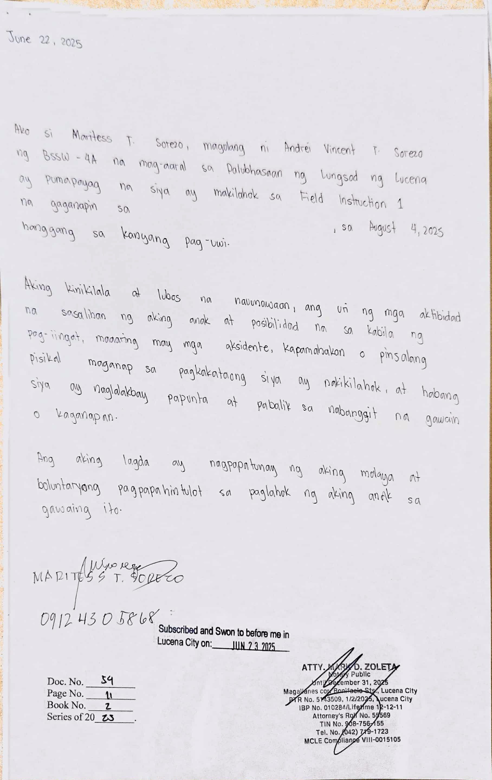
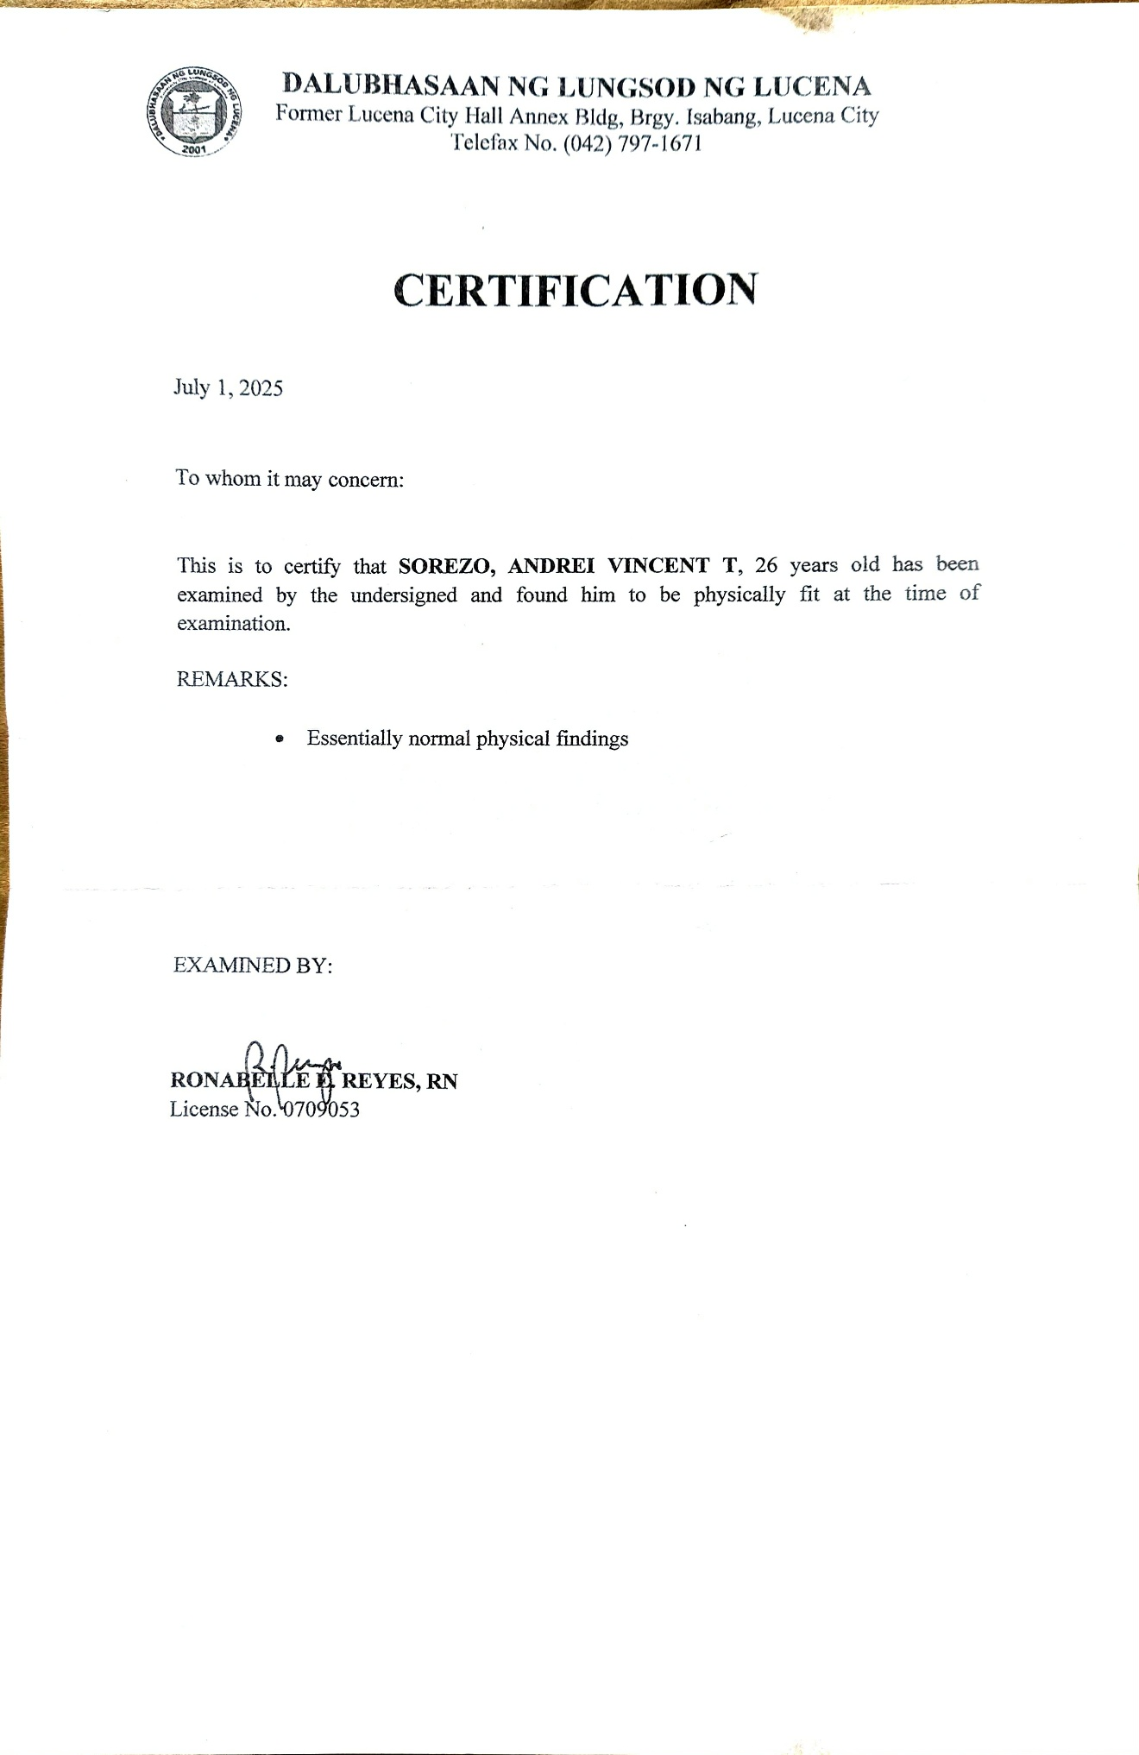
Medical Cetificate

Insurance Certificate
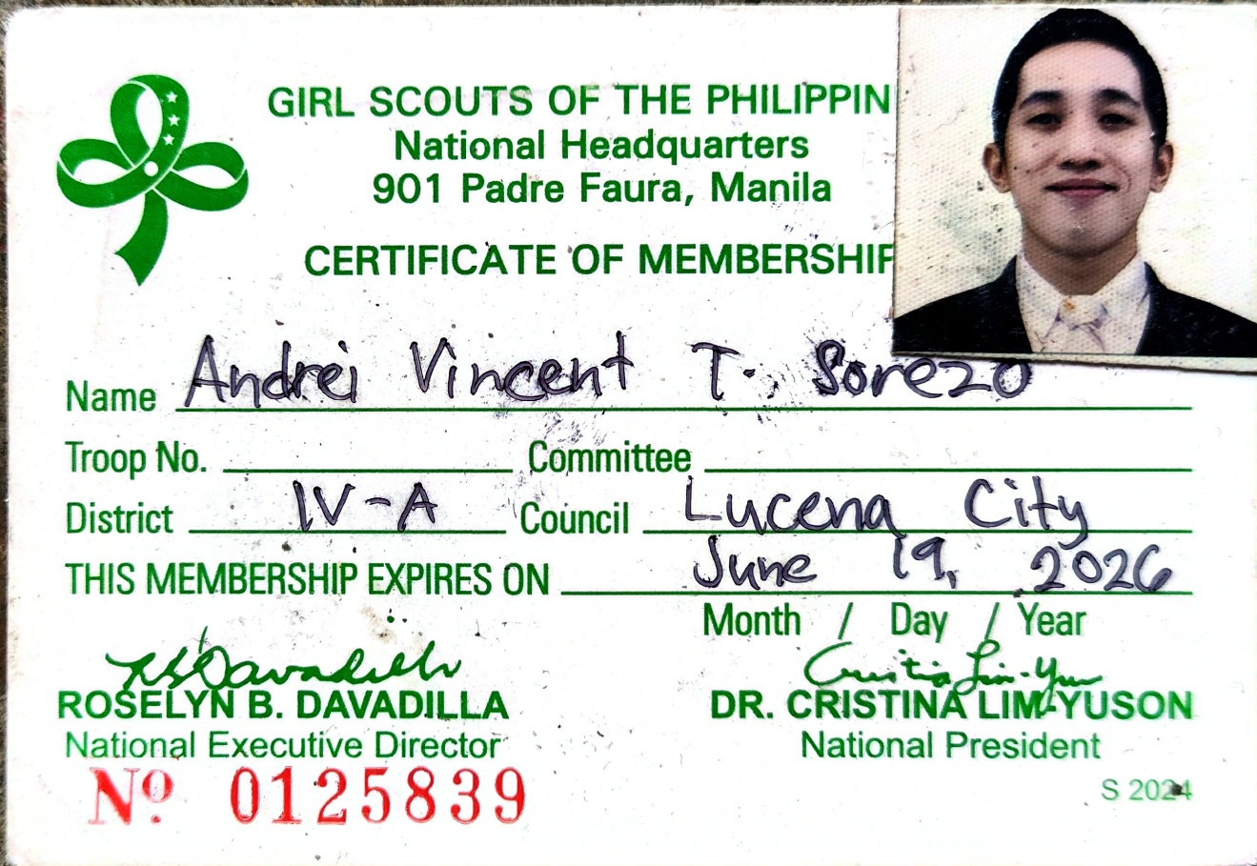

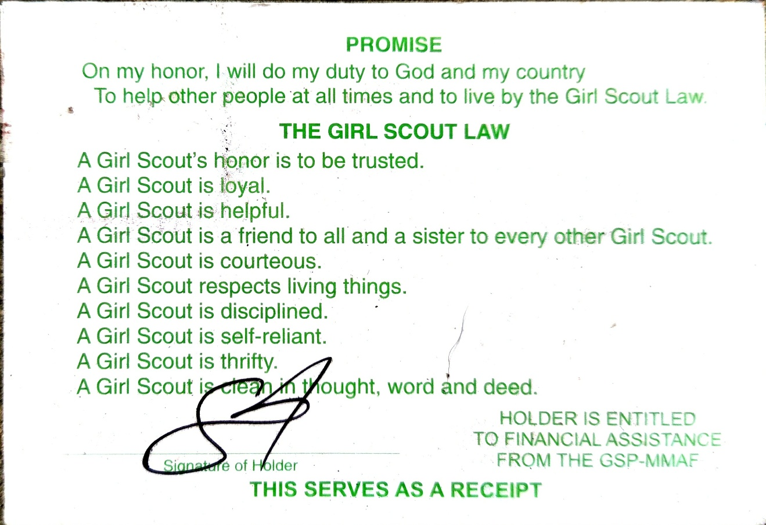

Learning Contract
Learning Objectives: What do you want to learn? | What tasks and learning activities will you engage in at the agency to reach your learning objective? | How will you measure what you have learned?
Social Work as a Profession  I want to understand how social work is practiced in real life settings and how social workers help clients in every day basis. I also want to see how social work values and ethics are applied in real situations, not just in class. | At first, I will observe the social worker/s as they handle clients and assist with small tasks they assign to me before pursuing to handle my own cases. Also, I will join agency activities so I can understand the work flow and the responsibilities of a social worker. I will also ask questions when I don’t understand something to necessarily avoid mistakes. | I will know I learned something if I can clearly explain the role of a social worker in the agency. I should also be able to identify the values and ethics shown by the workers in actual cases. Lastly, I can connect what I observed to what I learned in class, that means I achieved my goal.
Organizational Context of Practice  I want to know how the agency works internally, including who does what and why each role is important. I want to understand how the system works and helps clients receive the services they need and deserve. | I will attend staff meetings and activities related to the practice, read or ask for the agency’s background or manual, and observe how staff members interact and perform their tasks. Also, I will ask questions about the process of what’s the agency’s program and services, documentation, and service delivery. | I can say I learned something if I can describe the agency’s structure in my own words. I should also be able to explain how clients go through the system, from intake to receiving services.
Community Context of Practice  I want to understand the community the agency serves and the common problems people face in that area. This will help me connect the agency’s services to the needs of the community. | I will join community visits or outreach activities and observe the environment where the clients live. I will also talk to staff about the main issues in the community so I can better understand the context. | I’ll know I learned something if I can explain the major community issues and how the agency responds to them. I should also be able to identify the strengths and needs of the community.
Assessment  I want to learn how to assess clients properly, even at a basic level. I want to understand how social workers gather information and identify the main problem. | I will observe client interviews, read sample case notes, and practice writing simple assessment notes when allowed. I will also listen to how social workers draw out important information from clients. | If I can create a basic assessment and identify the client’s main concerns, then I know I’m learning. I should also be able to explain why assessment is important in planning interventions.

Learning Objectives: What do you want to learn? | What tasks and learning activities will you engage in at the agency to reach your learning objective? | How will you measure what you have learned?
Diversity  I want to learn how to respect differences among clients, including age, behavior, personality, background, and culture. I want to become more aware of how each client’s background affects their situation. | I will observe how social workers adjust their approach depending on the client. I will practice showing empathy and being open-minded when dealing with different types of people. | I’ll know I improved when I’m able to interact comfortably with different individuals without judgment. I should also be able to explain why diversity matters in social work.
Communication Skills  I want to improve not only how I talk to clients but also with other people such as the agency staff and other member of the community, and how I listen to them. I want to be more confident but still respectful and clear. | I will assist in interviews when allowed and practice active listening. I will also improve my documentation and ask for feedback from my supervisor. Moreover, I will use some of my characteristics such as being easy to be with and talkative as instrument to build positive relationships with the people in the agency. | If I can communicate clearly with all the people in the agency and make clients feel heard, then I know I’m improving. I should also be able to write simple but complete documentation. Moreover, I will be more confident communicating with people I just met.
Knowledge and Use of Self  I want to become more aware of my strengths and weaknesses as a future social worker. I want to learn how to manage my reactions and emotions while doing my job inside the agency and even during field work. | I will reflect after tasks and activities and ask for feedback from my supervisor and co-affiliate. I will also observe how my personal values affect the way I interact with clients and them. | I’ll know I achieved this if I can honestly describe and acknowledge my strengths, weaknesses, and what I need to work on. I should also be able to act professionally even when situations feel challenging.
Planning and Intervention  I want to learn the basics of planning interventions and programs for clients. I want to understand how social workers choose the right approach. | I will observe how the social worker/s plan activities and programs. I will also help prepare materials and assist during interventions to see how they work in real life. | If I can explain the steps of planning and why certain interventions are used, then I know I learned something. I should also be able to help in small parts of the planning when given the chance.

Learning Objectives: What do you want to learn? | What tasks and learning activities will you engage in at the agency to reach your learning objective? | How will you measure what you have learned?
Closure and Evaluation  I want to understand how cases or services are ended/terminated properly and respectfully. I also want to learn how workers evaluate if the intervention was effective. | I will observe how workers close/terminate cases, talk to clients about ending services, and read sample evaluation reports. I will practice making simple summaries if allowed. | I’ll know I improved if I can explain why proper closure/termination is important. I should also be able to create a basic evaluation summary.
Understanding Social Problems  I want to learn about the common social problems experienced by the clients the agency serves. Understanding these problems will help me see the bigger picture. | I will observe cases, read documents, and discuss these problems with the staff. I will also relate what I learn to what we study in class. | I know I learned something if I can explain some social problems and how they affect people’s lives. I should also be able to connect these issues to the services of the agency.
Social Policy and Social Change  I want to understand how laws and policies protect clients and guide social workers. I also want to see how social workers help push for positive change in their clients and even in the society. | I will read and study about the laws and policies related to the agency and ask the workers how they apply these in real-life situations. I will also observe if the agency participates in advocacy or community awareness activities. | I’ll know I learned something if I can explain how certain laws or policies support clients. I should also be able to describe the role of social workers in promoting social change.

Student Andrei Vincent T. Sorezo Date __________________
Agency Supervisor Julius B.Torres, RSW Date __________________

School Field Instructor Romulo A. Oserin Jr., RSW, MSSW Date ___________________

Supervisor’s Profile

SUPERVISOR’S PROFILE

Name: Julius B. Torres
Position: Case Manager / Social Work Affiliates Supervisor
Agency: Still Waters Kids Home
License Number and Date of Registration: 0041979 – February 16, 2024

Profile:
Julius Torres is a Registered Social Worker who has been serving at Still Waters Kids Home for two years, a Child-Caring Agency that provides residential care to children who are abandoned, neglected, abused, or orphaned. As the primary case manager of the Home, he facilitates the complete case documentation of each child, including the preparation of a comprehensive case study, efforts to locate biological parents and relatives, conduct of case conferences, and the completion of requirements for the issuance of a Certificate Declaring a Child Legally Available for Adoption (CDCLAA). He also prepares the necessary documents for Regional, Inter-Regional, and Inter-Country Matching before the successful entrustment of the child to his or her adoptive parents. In addition, he oversees the admission and discharge processes of all children, ensuring that every placement, whether upon entry or reintegration/adoption, is conducted in accordance with agency protocols and always grounded in the best interest of the child. He ensures that every case is handled with accuracy, ethical practice, and full adherence to legal processes set by the Regional Alternative Child Care Office (RACCO).
In addition to his case management work, Julius functions as the Supervisor of Social Work Affiliates, guiding them in understanding child welfare, the adoption process, proper casework management, and appropriate interventions. He provides direction in designated cases, reviews their outputs, answers technical questions regarding adoption requirements, and helps them develop the competencies they will need once they become Registered Social Workers. He also accompanies affiliates during fieldwork, such as home visits, interviews, and coordination with agencies, to expose them to actual practice and ensure that activities are done safely and professionally. With a balanced approach of supervision and accountability, he ensures that affiliates are equipped to deliver quality and child-centered interventions.
Driven by compassion and grounded in professional ethics, Julius remains committed to advocating for every child’s right to safety, permanency, and a nurturing family, whether through family reunification or adoption.

Duties and Responsibilities as Social Work Affiliates Supervisor
1. Provide Orientation
  - Conducts orientation on agency policies, mission, vision, and child-caring standards.
  - Introduces affiliates to the adoption process, child protection protocols, and required case documentation.

2. Case Assignment and Guidance
- Assigns child cases to affiliates and orients them on the background of each case, including the reason for the child’s admission, current case status, and the needed interventions or documentation tasks.
- Provides clear instructions and expectations for their duties (e.g., preparing Child case study reports, Weekly and General Work Plan, conducting home visits, assisting in contacting the family, and completing required documentation).
3.Technical Assistance and Consultation
- Responds to affiliates’ questions regarding the adoption process, CDCLAA requirements, and casework procedures.
- Guides affiliates in addressing challenges that arise during case handling.
4.Review and Quality Assurance of Outputs
- Reviews and provides feedback on case study, and other documents prepared by affiliates.
5.Supervision and Monitoring
- Monitors progress of assigned cases through regular case consultations.
- Accompanies Social Work Affiliates during fieldwork activities such as home visits, family interviews, and documentation follow-ups to provide real-time guidance, modeling, and supervision.
6. Coordination with Agency Staff and External Stakeholders
- Coordinates with LGUs, DSWD, and partner agencies when affiliates are involved in tasks requiring external collaboration.
7.Upholding Ethical Standards
- Ensures that affiliates understand and practice professional ethics, confidentiality, and child safeguarding.
8.Supportive Supervision Environment
- Creates a safe learning space where Social Work Affiliates feel comfortable asking questions and exploring complex cases.
- Provides constructive feedback, guidance, and encouragement to help them grow both professionally and personally.

Agency Profile


STILL WATERS KIDS HOME INC.
To serve and protect children in the Philippines

“He leads me beside still waters; He restores my soul.”
Psalm 23:2-3

Rev. Virgilio C. Jacinto
Founder

Linda Blackford Jacinto
Co-Founder

Mary Rose O. Bautista, RSW
Executive Director
Basic Organization Information

Address: Ilayang Banga, Majayjay, Laguna Philippines 4005

Email Address: swkhphil@yahoo.com

Contact No.: +63 939-4117-0842

Contact Person: Ptr.Virgilio C. Jacinto/Mary Rose O. Bautista, RSW

Founder: Ptr. Virgilio and Linda Blackford-Jacinto

Year of Establishment: Year 2008

Registration and License to Operate
DSWD Registration
and License No. DSWD-SB-RL-2025-000075
and Accreditation: DSWD- SB-A-0121-2019

S.E.C. Reg. No.: CN200834112

Company TIN No.: 007-197-891-0000

Local Accreditation: Accredited NGO of Sangguniang Barangay of Majayjay, Laguna

Member of: Area Based Standard Network (ABSNET Laguna Cluster)
Philippine Children Ministries Network (PCMN)

HISTORY BACKGROUND
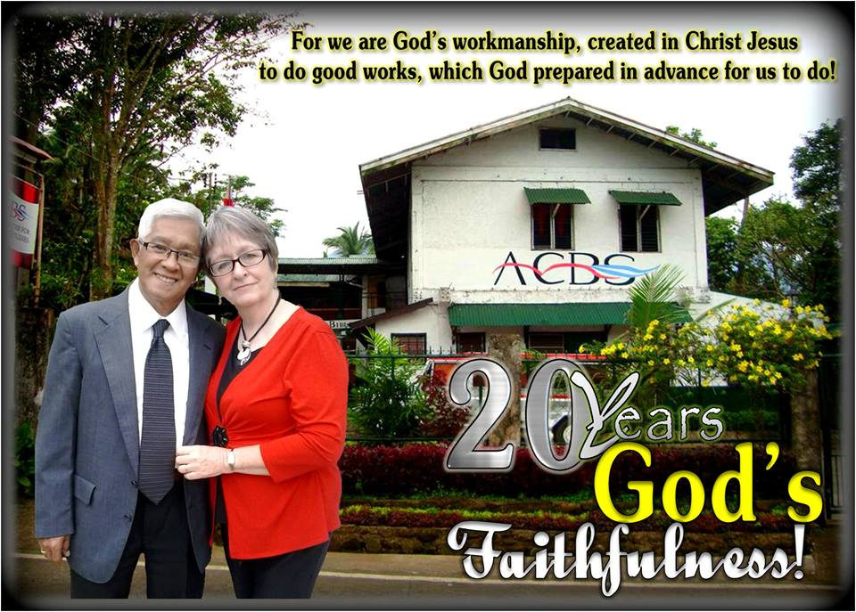

“Pure and undefiled religion before GOD and the FATHER is this:
to visit orphans and widows in their trouble…”
James 1:27

PTR. VIRGILIO and LINDA JACINTO
Founder of SWKH Inc.

Still Waters Kid’s Home was first conceived in 2008 by Pastor Virgilio and Linda Jacinto who shared the vision and the plan for building the home with Myrna Lorraine Barr from Champaign, Illinois. Miss Barr had desired to be a part of an orphanage for many years. She came to the Philippines to help with the process of setting up an orphanage to serve newborn babies and children up to the age of six years old.

The Jacinto’s oversaw the construction of the building and Miss Barr oversaw the finishing work and all the paperwork associated with the project.

The land was already available for the construction on the compound of Asia Center for Biblical Studies in Majayjay, Laguna and a blue print was drawn up by Engineer Khim Dolatre for the construction of the building.

A Christian foundation heard about the plans to build the orphanage and donated $25,000 and an additional $10,000 was given by a family from the United States and the building project was begun. The construction was completed in 2010.

Still Waters Kid’s Home had not started its operation after the building has done for Ms. Barr had to leave for home in the US.Ptr. Virgilio and Linda Jacinto prayed and year 2013 month of June, Ptr. Sander and Joan Rose Laqueo came and officially hired as Administrators of the SWKH. Until finally God allowed them to pursue and follow His will that is according to His words and let His love be shared to these abandoned, neglected, abused and orphaned children ages 0-6 in Majayjay, Laguna and nearby town.

MINISTRY STATEMENT

“He leads me beside still waters; He restores my soul.” Psalm 23:2-3
The Bible is clear and tells us that our God is a Good Shepherd; He leads us to still waters to restores our soul. Kids are so especial and loved by God and He wants them to experience the kind of peace that he offered especially in this time where violence and hardship existed. Children should be love, care, and have a happy and peaceful life.

The existence of the Still Waters Kid’s Home is borne out of need to provide not only temporary physical shelter and care for abandoned, neglected, abused and orphaned children, but also seeks to address the more important aspect of the spiritual upbringing of children. It believes that many of the problems in our country today particularly the rise in criminality can be traced to a dearth of spiritual values in our society.

“STILL WATERS KID’S HOME”? Still Waters stands for peace, and a home where they can find love, care and someone to nurture and guide those less fortunate children in the manner that will eventually make them become testimonies of God’s grace and power.

OUR VISION STATEMENT
Still Waters Kid’s Home desire to establish a mission compound that provides peace and protection, happiness and hope, serenity and security for abandoned, neglected, abused and orphaned children as their home suitable for their growth and clean living such time that an adoptive or foster family is found for them or when they can be reunited to their biological family. This temporary facility is committed to protect, care and provide basic necessities and a peaceful environment to the less fortunate children to grow up to be productive citizens of our country.

OUR MISSION STATEMENT
Still Waters Kid’s Home Incorporated is committed to establishing a compound in three stages, as funds become available.
- A home to house deprived children, particularly those orphaned, abandoned, abuse and neglected.
- A site for non- formal education for children living in the home, including religious training.
- A place of worship for the children, and other residents of the community, enabling them to study the Word of God.

OUR GOALS
1. To create an atmosphere of serenity and security for the disadvantaged children in the Philippines.
2. To create a nurturing environment physical and spiritual growth.

OBJECTIVES

1. To provide residential-based social services to the orphaned, abandoned, abused and neglected children.
2. To admit neglected, abandoned, orphaned and abused children ages from birth to six (6) years old and provide them optimum care and guidance until provision of permanent placement through adoption or foster care and reunification to their family can be granted to them.
3. To provide a setting whereby spiritual, physical, emotional, and educational needs can be met.
4. To provide education opportunities that allows student to reach their maximum potential.

List of Governing Board

Name of the Board Members Position and Title Nationality

- Rev. Virgilio C. Jacinto President Filipino

- Ptr. Jonathan B. Jacinto General Secretary Filipino

- Ptr. Celestino Lamar Treasurer Filipino

- Ptr. Linda Blackford-Jacinto Board member American

- Ptr. Marcosa Piso Board Member Filipino

- Mrs. Josephine Beltran Board Member Filipino

- Mrs. Andrea Marie Ingrum Board Member Filipino

List of Hired Staff and Volunteers

Name Position Status

- Mary Rose Bautista Executive Director Hired

- Julius Torres Social Worker Hired1

- Vivian Joy Arimbuyutan Admin Staff Hired

- Angelica Coroza BLESS Program Teacher Hired

- Cielito Jacinto SOT Supervisor Hired

- Ma. Erika Villarmil House Parent Hired

- Lennie Quierra House Parent Hired

- Rosemarie Pardilla House Parent Hired

- Marynor Villarmil House Parent Hired

- Ronna May Borines House Parent Hired

- Lorna Molina House Parent Hired

- Cristy Obciana Cook Hired

- Leni Mercurio Cleaner & Cook Reliever Hired

- Babylyn Quinto Alternate Cleaner Hired

- Junel Galicha Maintenance Hired

FINANCE / SOURCE OF FUNDING

- SWKH funds come from voluntary contribution or donations from relatives and friends and church groups; both local and foreign.

- Specific funds are given by certain individuals for a specific project such as construction of duplex building and school, activity and play area, or purchase of equipment or transportation; all are properly accounted.

- All funds received or allocated for SWKH shall on the name of the organization being its legal holder. The funds shall be deposited in a credible bank and will be disbursed only based on annual budgetary outlay. Signatories to bank account shall be any of the five Board of Directors.

- All funds receipt and disbursements are recorded at the ledger/journal of accounts. All transactions are recorded immediately subject to inspections and audit by the board.

- Accounting and Auditing of disbursement follow a sound accounting rules and regulations.

- An annual budget is prepared at the last month of the previous year. This is prepared by the Accounting Clerk and the Social Worker and submitted to the Board for approval.

- The Executive Director directly supervise the management of the and submits to the Board a monthly financial report for review and approval.

- A petty cash for daily operational expenses is released to the office Clerk each month. This fund is replaced after the liquidation of funds earlier released for the purpose.

- The service of the Certified Public Accountant shall be hired to conduct an annual audit funds.

SWKH PROGRAMS AND SERVICES

While under the care off this institution, the SWKH children were continuously being given appropriate services and their inclusion to different programs being offered was guaranteed. Among these programs and services were the following;

SOCIAL SERVICES

This Institution was committed in providing its residents a permanent home either through reunification to their families or placement to adoptive family through adoption. The Social service program of SWKH mobilizes resources to help a child and his family deal with identified dysfunctional behaviors. Developing access to these resources can help them cope with such conflicts. The helping process involves intake and assessment, treatment and rehabilitation, planning and implementation, locating of parents and relatives and other alternative placements like adoption or foster placement.

In cases of abandoned and surrendered children, SWKH completes and processes dossiers for permanent placement. The child’s best interest is the paramount consideration in the process of placement. The Social Worker, through the Supervision of the Executive Director will be the Case Manager and is the one in-charge and shall ensure the proper implementation of the following prescribed laws:

1.a Implementation of Republic Act 9523, “An Act Declaring the Child Legally Available for Adoption”

1.b Implementation of Republic Act 8552, “Domestic Adoption Law”.

1.c. Implementation of Republic Act 8043, “Inter-Country Adoption Law”.

HOME LIFE/ GROUP LIVING PROGRAM

Provision of adequate housing facilities and clothing for the abandoned, neglected, abused and orphaned children. Daily provision of meals and snacks for the residents. Providing them with clear atmosphere of brotherhood and sisterhood through freeful mingling with each other, play, recreation and setting of responsibilities. Direct and indirect teaching of the value of honesty, obedience, self-reliance and being responsible through individual responsibilities on cleaning, good grooming, washing clothes and doing chores.

Each child admitted into care is trained based on their readiness, capability and age. The following areas are the focus of training:

- Group Living activities and responsibilities

- Learning healthy social interaction with staff, co-residents, visitors and others
- Daily monitoring and devotion (Bible story-telling and prayer)
- Play and recreation - indoor and outdoor
- Celebrating birthdays and special occasions together

- Physical and Personal Grooming

- Provision of basic personal needs such as toiletries, towels, cosmetics, clothing for daily wear and special occasions, shoes, slippers, underwear, etc.
- Supervision from waking up, during meals up to bed time
- Comforting residents who are sick, suffering depressions and feeling lonely, sad and confused.
- Supervision of personal care and grooming

- Medical/ Dental and Nutrition

SWKH provides for the medical, dental and nutritional needs of the children. It provides a health program to assess, monitor and treat various health and nutritional problems. This program includes adequate feeding and teaching the importance of proper eating habits and personal hygiene. Medical and Dental check-ups are also conducted regularly through the volunteer doctors who help the Center. Provisions of daily supplements and vitamins, medicines and first aid kits are also done to ensure their good health condition.

- Play and Recreation

Play is a universal need of every child. It is a haven of many feelings that children are expressing in daily life much more for those abused ones. Thru play they will have venue to express their feelings aside from having fun and learning sportsmanship and how to work with others.

EDUCATIONAL SERVICES

SWKH provides the residents with excellent education through home school education program. Residents under temporary care, ages 3 to 4 years old shall be enrolled at the nearest Child Development Center while children ages 5 years old and above shall be enrolled at the nearest public schools. The children shall be accompanied daily by the designated Houseparent who will endorse the children to the respective teachers. On the other hand, residents who are being processed for permanent placement through adoption shall be enrolled under the BLESS (Basic Life Empowerment and Support Services) Reading program and home school education program being offered by this Institution. Moreover, SWKH shall also provide its residents with excellent learning opportunities inside the Home through provision of learning materials such as books, colorful visual aids and charts, song and coloring books, colorful blocks and different kind of educational toys for learning purposes and opportunities for the child’s cognitive abilities to fully develop.

SPIRITUAL ENRICHMENT AND CHARACTER BUILDING

SWKH provides opportunities for spiritual development of its residents. The children together with the staff are strongly encouraged to regularly participate in daily devotions, and Bible reading being conducted in the Center as well as Sunday Church Service in the affiliated church. The children’s participation in the Daily Vacation Bible School (DVBS) during summer is also part of spiritual enrichment for the residents. On the other hand, Bible principles are being used to promote healthy and positive character in the children. Children are being counseled using Bible principles. In addition, the “stick” system is being used to encourage and reinforce positive and acceptable behavior of the children in the care of SWKH.

COMMUNITY OUTREACH SERVICE
SWKH strongly adhere helping not only the children within the Home but also those who are outside. It is our desire and commitment to help the community through outreach activities such as feeding, values formation activities, home visitations, and gift giving. SWKH believe that through the children’s involvement in these activities, they will learn the value of sharing and caring for others and that a simple act of kindness can bring a great impact in the society at large.

SWKH MONTHLY EXPENSES

HOMELIFE EXPENSES
HOUSEHOLD/FOOD/COMMUNICATION ALLOWANCE P 50,000.00
MEDICAL/DENTAL P 10,000.00
CONSTRUCTION/MAINTENANCE P 10,000.00
UTILITIES/STOCKS/MISCELLANEUS P 10,000.00
P 80,000.00
EDUCATION
SCHOOL SUPPLIES P 3,000.00
(For non-formal Education)
OTHER NEEDS (SHOES, BAGS, UNIFORMS, SNACKS) P 3,000.00
P 6,000.00
DOCUMENTS
CHILDREN'S DOSSIERS P 10,000.00

ADMINISTRATIVE/PROGRAM EXPENSES
AGENCY HEAD P 22,000.00
6 HOUSE PARENTS P 60,000.00
SOCIAL WORKER P 18,000.00
BLESS TEACHER P 9,000.00
ADMIN STAFF P 14,000.00
COOK P 10,000.00
MAINTENANCE AND CLEANERS P 26,000.00
GENERAL POSTAGE P 2,500.00
OFFICE SUPPLIES P 2,500.00
TRANSPORTATION EXPENSES P 10,000.00
P 174,000.00

OTHERS

SEMINARS AND TRAINING (Staff) P 10,000.00 PROFESSIONAL FEES(Psychologist, nurse, etc.)
Monthly Special Activity P 8,000.00

TOTAL MONTHLY EXPENSES

HOME LIFE P 80,000.00
EDUCATION P 6,000.00
DOCUMENTS P 10,000.00
ADMIN/PROGRAM EXPENSES P 174,000.00
OTHERS P 18,000.00
TOTAL P288,000.00

2. Field Placement - related documents

General Work Plan
General Work Plan
Name of Affiliate | Andrei Vincent T. Sorezo  Fionna A. Landicho
Placement | Still Waters Kid’s Home Inc.  ACBS Compound, Barangay Ilayang Banga, Majayjay, Laguna
Objectives | Activities/Strategies/Methodologies | Date | Resources Needed/Persons Responsible | Expected Output | Remarks
To identify if the students are mentally fit for Field Instruction 1 | Neurological Test | June 14,2025 | Pen, Money,  Psychometrician | The Social Work Affiliate will determine if they have cognitive dysfunction or fit to work for Field Instruction 1
To find out the general status of the Social Work Affiliate health | Medical | June 16,2025 | Financial  Medical Technologist Psychometrician | The Social Work Affiliate are declared physically fit for Field Instruction 1 based on medical examination results.
To submit all the requirements needed for the Field Instruction 1 | Submission of Field Instruction 1 Requirements | June 23,2025 | Envelope, Pen, Money | The Social Work Affiliate successfully submitted all required documents for Field Instruction 1
To provide the parents all the information needed for the Field Instruction 1 | Parents’ Meeting with the Program Head | July 19,2025 | Visual Presentation, Parents,  Program Head,  Faculty Members | Parents are informed and equipped with all the necessary information for Field Instruction 1.
To provide the students all the information regarding the Field Instruction 1 | Students’ Field Instruction 1 Orientation | July 22,2025 | Visual Presentation, Students,  Program Head,  Faculty Members | Students acquire complete and accurate information regarding Field Instruction 1.
To conduct a formal event for the upcoming deployment | Send – Off / Pinning Ceremony | July 27,2025 | Pin, Food, Money, Students,  Program Head,  Faculty Members | Students are able to celebrate their eligibility as new social work affiliates
To allow the Social Work Affiliates express themselves and build good relationships with their groupmates/partners | Encounter | July 29,2025 | Pen, Journal, food, Myrtle’s Agricultural Farm,  Students, Faculty Members | Social Work Affiliates build a good connection together with their groupmates.
To safely accompany the social work affiliates to their respective agency | Deployment | August 6,2025 | Faculty Members, Social Work Affiliates,  Agency Supervisor | Safe arrival of the Social Work Affiliates and their orientation at the agency
To conduct a formal meeting with the agency supervisor and Field Instruction (FI) instructor to formally introduce the social work affiliates  To ensure equitable, efficient, and appropriate assignment of child cases to social work affiliates  To develop a comprehensive, time-bound work plan that outlines the key activities  To establish trust, safety, and open communication with children to facilitate effective case management | Entry Trialogue  Distribution of the child cases  Creating a General Work Plan  Building rapport with the Kids | 1st Week of August | FI 1 Instructor, Agency Supervisor, Social Work Affiliates | The Social Work Affiliates were formally introduced to the agency and agency supervisor A case distribution matrix, including case study reports, child’s profile, assigned staff, and priority level  A detailed work plan document  Improved child engagement and communication through trust-building activities
Gather all available details from the first case so far, such as records, intake, and preliminary decisions  Review the current plan to identify gaps, delays, or areas needing improvement.  To formulate and accomplish the first Case Study Report | Review of the First Case and Highlighting Key Details  Revision of the General Work Plan  Review and Preparation of the First Case (adjust the date) | 2nd to 3rd Week of August 2025 | Case Study Report, Social Work Affiliates  General Work Plan, Social Work Affiliates  Pen, Paper, Child/Case Study Report, Social Work Affiliates, Agency Supervisor | A concise list of significant events, findings, or discussions that have happened up to this point.  An updated version of the general work plan with the latest changes and improvements  The Social Work Affiliates accomplished their First Case Study Report
To formulate and accomplish the first case | Revision and submission of the first case | 4th Week of August, 2025 | Pen, Paper, Child/Case Study Report, Social Work Affiliates, Agency Supervisor | The Social Work Affiliates accomplished their Second Case Study Report
To gather all necessary details regarding the second case such as records, intake form the referral party and progress reports  To formulate and accomplish the second Case Study Report | Review, Preparation of the Second Case  Revision and Submission of the Second Case | 1st Week of September 2025 | Pen, Paper, Child/Case Study Report, Social Work Affiliates, Agency Supervisor | Necessary details acquired  The Social Work Affiliates accomplished their Second Case Study Report
To gather all necessary details regarding the second case such as records, intake form the referral party and progress reports  To formulate and accomplish the third Case Study Report | Review, and Preparation of the Third Case  Revision and Submission of the Third Case | 2nd Week of September 2025 | Pen, Paper, Child/Case Study Report, Social Work Affiliates, Agency Supervisor | Necessary details acquired  The Social Work Affiliates accomplished their Third Case Study Report
To gather all necessary details regarding the second case such as records, intake form the referral party and progress reports  To formulate and accomplish the fourth Case Study Report | Review and Preparation of the Fourth Case  Revision and Submission of the Fourth Case | 2nd to 3rd Week of September 2025 | Pen, Paper, Child/Case Study Report, Social Work Affiliates, Agency Supervisor | Necessary details acquired  The Social Work Affiliates accomplished their Fourth Case Study Report
To gather all necessary details regarding the second case such as records, intake form the referral party and progress reports  To formulate and accomplish the last Case Study Report | Review and Preparation of the Last Case  Revision and Submission of the Last Case | 4th Week of September 2025 | Pen, Paper, Child/Case Study Report, Social Work Affiliates, Agency Supervisor | Necessary details acquired  The Social Work Affiliates accomplished their Last Case Study Report
To have a proper meeting with the agency supervisor and FI instructor regarding the finalization and submission of the case studies | Midterm Trialogue  Supervision  Consultation | 4th Week of September 2025 | FI 1 Instructor, Agency Supervisor, Social Work Affiliates, Case study Reports | The case Study Reports were finalized and submitted.
To know each and every one more in a deeper level by means of telling and drawing themselves, as well as making the group name | First Session of Group Work  “Let’s Know Each Other More”  Problem: Children only know each other on surface (names, playmates)  Activity: “My Favorite things” show and tell or drawing  Group name creation  Group symbol making (make a group handprint poster: each child traces or paints their handprint on a big paper. At the Center, write the chosen group name | 4th Week of September 2025 | Art materials, Prizes, Social Work Affiliates, House parents, SWKH residents | The group knew each and every one in a deeper level
To show the children the proper behavior when it comes to their toys or even attention especially during play time | Second Session of Group Work  “Let’s Fix it, Don’t Fight”  Problem: Frequent quarrels or jealousy over toys/ attention  Activity: Role plays a toy snatching scenario and let the Group find solutions  What should we do to avoid conflicts? | 1st Week of October 2025 | Toys, Prizes, Social Work Affiliates, House parents, SWKH residents | The group learned how to manage their frustrations and behave in a more acceptable manner
To learn how to express their feelings and emotions by means of child appropriate activities that will introduce them to various emotions they were not much aware of, as well as identifying and acknowledging their strengths | Third and Fourth Session of Group Work  3rd session “Color My Feelings”  Problem: Difficulty expressing emotions properly  Activity: Emotion Faces drawing  Sharing: What makes me happy/sad/ angry  4th session” My strengths your strengths”  Problem: Some children are shy, while others are too dominant  Superpower drawing: Children draw themselves with a superpower (being kind, fast runner, good reader)  Sharing- This is my strength and this is my friend strength | 2nd Week of October 2025 | Art materials, Prizes, Social Work Affiliates, House parents, SWKH residents | The group learned how to acknowledge their emotions as well as discovering and showcasing their strengths
To know what teamwork is, its application, as well as how they will build teamwork  To be more knowledgeable about the idea of respect, and how will they show their respect towards other people especially the House parents | Fifth and Sixth Session of Group Work  5th session “Stronger when we work together”  Problem: Lack of teamwork and cooperation  Act. Group games (pass the ball without dropping, build the tallest tower)  Reflection” what happens when we don’t cooperate?  6th session Respecting Our House parents  Problem: The Children sometimes misbehave or test limits when a new houseparent is around  Activities: Storytelling/ Role play- short story or skit about children meeting a new houseparent. Show two versions.  One group of children being respectful  One group being naughty/ disrespectful  Then ask: Which group makes the Home happy  Group rules creation: Together, the children create a list of simple rules on “how to respect”  Ex. Listen when they talk, say po and opo, help when asked, greet them politely, | 3rd Week of October 2025 | Balls, blocks, Prizes, Social Work Affiliates, House parents, SWKH residents | The group learned what teamwork and were able to practice working and helping each other  The group learned more on how to practice respect towards others especially their house parents
To have celebration and acknowledgment for each and every one as the group work sessions ends | 7th sessions “Together, We’re happy “  Problem: The group needs closure celebration of learning, and stronger bonding  Activities: GROUP ARTWORK- On a big paper, the children draw and color “A happy Family in Our Home”  SHARING CIRCLE: Each child shares one learning or favorite experience from the experience from the group sessions  AWARDING/RECOGNITION: give simple certificates, stickers or small tokens to celebrate participation | 4th Week of October 2025 | Art materials, certificates, tokens, Social Work Affiliates, House parents, SWKH staff, SWKH residents | The last session was executed successfully
To have a proper meeting with the agency supervisor and FI instructor regarding the finalization and submission of the Group Work | Exit Trialogue | 1st Week of November 2025 | FI 1 Instructor, Agency Supervisor, Social Work Affiliates, Case study Reports | Finalized and submitted Group Work
To formally bid farewell to the agency. | Last day of Deployment | 1st Week of November 2025 | Social Work Affiliates, Agency Supervisor, Executive Director, Admin Assistant, House parents, other staff | Finalized tasks and accomplishments, worked longer hours and began transition of going back home.
To prepare and compile all the documents that are needed | Preparation of all Documents to be submitted | 2nd -3rd Week of November 2025 | Case Studies, Group Work, and other documents | Successfully completed all the documents needed for the Submission of Portfolio
To present the cases comprehensively | Case Conference | 3rd Week of November 2025 | Money, logistics, Panel Members, Faculty Members, Social Work Affiliates | Cases presented comprehensively
To submit the complete and revised documents | Submission of Portfolio | 3rd Week of November 2025 | Money, Integrative paper, FI1 Instructor, Social Work Affiliates | Complete and revised documents were submitted

Weekly Work Plan
WEEKLY WORKPLAN for the period August 6-8, 2025

Name of Affiliate | Andrei Vincent T. Sorezo
Placement | Still Waters Kid’s Home Inc.
Objectives | Activities/Strategies/Methodologies | Date | Resources Needed/Persons Responsible | Expected Output | Remarks
To properly orient the Affiliates regarding the programs and policies, introduce them to the agency, staff, and children.  To introduce and distribute the cases to the affiliates. | Orientation  Discussion of Programs and Policies, and Distribution of Cases | August 6, 2025 | Notebook and Pen Executive Director, Agency Supervisor, and Social Work Affiliate  Notebook and Pen Executive Director, Agency Supervisor, and Social Work Affiliate | Theaffiliates must be familiar to the agency’s policies and programs, as well as the staff and children.
To learn and be familiar to a specific case given by the supervisor.  To be more used to sorting and filing of documents. | Filing of Case/Child Study Report  Discussion of Specific Cases | August 7, 2025 | Child Study Reports, Expandable Folder, Tape, Bond Paper, and Paper Fastener  Social Work Affiliates, Agency Supervisor | More organized Child Study Report
To be more connected and have a better relationship with the Service Users | Interaction and Building Rapport with the Service Users | August 8, 2025 | Affiliates, Service Users/Children | Be able to play games with the children.

Prepared by:  ANDREI VINCENT T. SOREZO  Social Work Affiliate |  | Date: _____________________________________
Noted by:  JULIUS B. TORRES, RSW  Agency Supervisor |  | Date: _____________________________________
ROMULO A. OSERIN JR., RSW, MSSW  FI-1 Instructor |  | Date: _____________________________________
(Signatures over printed name)

WEEKLY WORKPLAN for the period August 11-15, 2025
Name of Affiliate | Andrei Vincent T. Sorezo
Placement | Still Waters Kid’s Home Inc.
Objectives | Activities/Strategies/Methodologies | Date | Resources Needed  Persons Responsible | Expected Output | Remarks
To revise the general work plan to be submitted to the Agency Supervisor, and FI 1 Instructor  To Interact with the Kids and Have a better Relationship with them  To Precisely Correct the Errors pointed out by the Supervisor  To formulate a Weekly Work Plan for the 2nd week | Revision of General Work Plan  Interaction/Play with the Kids  Revision of Previous Weekly Work Plan  Formulation of Weekly Work Plan | August 11, 2025 | Pen, Paper, Phone, Social Work Affiliates  Social Work Affiliates, House Parents, SWKH Kids  Phone, Pen, Computer, Social Work Affiliate  Pen, Paper, Phone, Social Work Affiliates | Submitted the revised version of the General Work  Better Relationship with the Kids  More Accurate and Improved Weekly Work Plan  Formulated Weekly Work Plan for the 2nd week
To Surprise Ma’am Vivian with a Simple Birthday Celebration | Simple Celebration of Ma’am Vivian’s Birthday | August 12, 2025 | Social Work Affiliates, Agency Staff Members | Ma’am Vivian happily celebrate her birthday
To review all the necessary documents regarding the first case  To Edit a more Refined DPL & PR | Review and Formulation of the First Case  Editing of DPL and PR with the New Format | August 13, 2025 | Pen, Paper, Child/Case Study Report, Social Work Affiliates  Phone, Computer, Social Work Affiliates | Reviewed and acquire relevant information that are needed for the first case.  Refined and Comprehensive DPL & PR
To construct an Initial Case/Child Study Report | Drafting of the 1st Initial Paper/Soft Copy of Case/Child Study Report | August 14, 2025 | Bond papers, Child Study Report, Social Work Affiliate | Initial Paper/Soft Copy of Case/Child Study
To submit the revised version of the Weekly Work Plan to be submitted to the Agency Supervisor  To Interact with the Kids and Have a better Relationship with them | Revision of Weekly Work plan  Interaction/Play with the Kids | August 15, 2025 | File, Phone, Social Work Affiliates, FI 1 Instructor  Social Work Affiliates, House Parents, SWKH Kids | Submitted the revised version of the Weekly Work Plan  Better Relationship with the Kids

Prepared by:  ANDREI VINCENT T. SOREZO  Social Work Affiliate |  | Date: _____________________________________
Noted by:  JULIUS B. TORRES, RSW  Agency Supervisor |  | Date: _____________________________________
ROMULO A. OSERIN JR., RSW, MSSW  FI-1 Instructor |  | Date: _____________________________________
(Signatures over printed name)
Name of Affiliate | Andrei Vincent T. Sorezo
Placement | Still Waters Kid’s Home Inc.
WEEKLY WORKPLAN for the period August 18-22, 2025
Objectives | Activities/Strategies/Methodologies | Date | Resources Needed/Persons Responsible | Expected Output | Remarks
To Identify the Possible Plan of Activities for the week  To Carefully Sort, File, and Organize the Child Study Reports | Formulation of Weekly Work Plan  Filing of Case/Child Study Report | August 18, 2025 | Pen, Paper, Phone, Computer, Social Work Affiliates  Fasteners, Hole Puncher, Expandable Folder, Social Work Affiliate | Weekly Work Plan for the 3rd week will be formulated  Organized and Well-Filed Child Study Reports
To Carefully Sort, File, and Organize the Child Study Reports  To Precisely Correct the Errors pointed out by the Supervisor | Filing of new Set of Child’s Dossier  Revision of the Weekly Work Plan | August 19, 2025 | Fasteners, Hole Puncher, Expandable Folder, Social Work Affiliate  Phone, Pen, Computer, Social Work Affiliate | Organized and Well-Filed Child Study Reports  More Accurate and Improved Weekly Work Plan
To Have a Better Understanding and be more Familiar with the 1st Case  To be more Familiar with Adoption Process by Asking Some Questions with the RACCO Staff and Agency Supervisor | Review of the First Case  RACCO Visitation | August 20, 2025 | Child/Case Study Report, Social Work Affiliates  Child Study Reports, Agency Staff Members, Social Work Affiliates | Improved Knowledge on the Different Areas of the Case/Child Study Report will be acquired  Well-Filed Child Study Reports
To analyze the assessment and recommendation sections of the First Child Study Report | Further review of the First Child Study Report, particularly the assessment and recommendation | August 21, 2025 | Bond Paper, Pen, Computer, Phone, Social Work Affiliate | Improved understanding of ideas from the assessment and recommendation of the First Child Study Report
To Identify the key details of the First Child Study Report that are relevant to the child’s needs | In-depth review of the First Child Study Report, with emphasis on highlighting key details | August 22, 2025 | Notebook, Bond Paper, Pen, Computer, Phone, Social Work Affiliate | Comprehensive understanding of the First Child Study Report for improved planning

Prepared by:  ANDREI VINCENT T. SOREZO  Social Work Affiliate |  | Date: _____________________________________
Noted by:  JULIUS B. TORRES, RSW  Agency Supervisor |  | Date: _____________________________________
ROMULO A. OSERIN JR., RSW, MSSW  FI-1 Instructor |  | Date: _____________________________________
(Signatures over printed name)

WEEKLY WORKPLAN for the period August 25-29, 2025
Name of Affiliate | Andrei Vincent T. Sorezo
Placement | Still Waters Kid’s Home Inc.
Objectives | Activities/Strategies/Methodologies | Date | Resources Needed  Persons Responsible | Expected Output | Remarks
To Identify the Possible Plan of Activities for the week  To accompany the assigned child for the social work affiliate | Formulation of Weekly Work Plan  Attend a birthday celebration activity with the agency staff and kids | August 25, 2025 | Pen, Paper, Phone, Computer, Social Work Affiliates  Van, Agency Staff, Children, Social Work Affiliate | Weekly Work Plan for the 4th week will be formulated  Positive engagement between agency staff, children, and attendees during the celebration.
To Carefully Sort, File, and Organize the Child Study Reports  To Precisely Correct the Errors pointed out by the Supervisor  To welcome and accommodate the birthday celebrant to the Home | Filing of new Set of Child’s Dossier  Revision of the Weekly Work Plan  Celebration of a visitor’s birthday in the Home | August 26, 2025 | Fasteners, Hole Puncher, Expandable Folder, Social Work Affiliate  Phone, Pen, Computer, Social Work Affiliate  Social Work Affiliates, Children, Agency Staff | Organized and Well-Filed Child Study Reports  More Accurate and Improved Weekly Work Plan  A simple and respectful birthday celebration held within the Home setting
To continue gathering, organizing, and analyzing relevant data for the 1st case study  To celebrate national identity through cultural performances, traditional games, and competition | Resumption of constructing the first case study report  Celebration of “Buwan ng Wika” | August 27, 2025 | Child/Case Study Report, Notebook, Social Work Affiliates  Social Work Affiliates, Agency Staff, Children | Updated and organized notes/data compiled into a working draft  Active participation of children, social work affiliate, and staff in various cultural activities
To review, edit, and complete all sections of the first case study report | Finalization of the 1st case study report | August 28, 2025 | Computer, Phone, Pen, Notes, Social Work Affiliate | A completed and finalized first case study report, ready for submission or filing
To gather and organize relevant data for the second case study | Formulation of the 2nd case study report | August 29, 2025 | Notebook, Bond Paper, Pen, Computer, Phone, Social Work Affiliate | Relevant data and case notes compiled for use in the report

Prepared by:  ANDREI VINCENT T. SOREZO  Social Work Affiliate |  | Date: _____________________________________
Noted by:  JULIUS B. TORRES, RSW  Agency Supervisor |  | Date: _____________________________________
ROMULO A. OSERIN JR., RSW, MSSW  FI-1 Instructor |  | Date: _____________________________________
(Signatures over printed name)

WEEKLY WORKPLAN for the period September 1-5, 2025
Name of Affiliate | Andrei Vincent T. Sorezo
Placement | Still Waters Kid’s Home Inc.
Objectives | Activities/Strategies/Methodologies | Date | Resources Needed  Persons Responsible | Expected Output | Remarks
To Identify the Possible Plan of Activities for the week  To analyze the 2nd case study report in order to identify key findings, gaps, and areas for improvement. | Formulation of Weekly Work Plan  Further Review of the 2nd case study report | September 1, 2025 | Pen, Paper, Phone, Computer, Social Work Affiliates  Computer, Phone, Pen, Bond Paper, Social Work Affiliate | Weekly Work Plan for the 4th week will be formulated  A summarized review highlighting important details and insights from the 2nd case study report to support future interventions
To Precisely Correct the Errors pointed out by the Supervisor  To complete and finalize the 2nd case study report by ensuring accuracy and alignment with the required format | Revision of the Weekly Work Plan  Finalization of the 2nd case study report | September 2, 2025 | Phone, Pen, Computer, Social Work Affiliate  Case Study Report, Social Work Affiliate | More Accurate and Improved Weekly Work Plan  A polished and finalized 2nd case study report ready for submission
To develop the 3rd case study report by gathering relevant data and analyzing findings from the intake and observations  To gather and document, including plans, and concerns, for better coordination and program improvement | Formulation of the 3rd case study report  Monthly Staff Meeting | September 3, 2025 | Phone, Computer, Bond Paper, Pen, Social Work Affiliate  Social Work Affiliates, Still Waters’ Staff | A draft of the 3rd case study report containing complete information and analysis  Comprehensive minutes of meeting highlighting staff concerns, plans, and agreed action steps
To review and edit some of the possible gaps in the initial draft of the case study report | Further review of the 3rd case study report | September 4, 2025 | Computer, Phone, Pen, Notes, Social Work Affiliate | An edited and reviewed case study highlighting the important details.
To complete the 3rd case study report with accuracy and alignment with re required format | Finalization of the 3rd case study report | September 5, 2025 | Computer, Phone, Social Work Affiliate | Complete and finalized case study report

Prepared by:  ANDREI VINCENT T. SOREZO  Social Work Affiliate |  | Date: _____________________________________
Noted by:  JULIUS B. TORRES, RSW  Agency Supervisor |  | Date: _____________________________________
ROMULO A. OSERIN JR., RSW, MSSW  FI-1 Instructor |  | Date: _____________________________________
(Signatures over printed name)

WEEKLY WORKPLAN for the period September 8-12, 2025
Name of Affiliate | Andrei Vincent T. Sorezo
Placement | Still Waters Kid’s Home Inc.
Objectives | Activities/Strategies/Methodologies | Date | Resources Needed  Persons Responsible | Expected Output | Remarks
To Identify the Possible Plan of Activities for the week  To analyze the 3nd case study report in order to identify key findings, gaps, and areas for improvement. | Formulation of Weekly Work Plan  Further Review of the 3rd case study report | September 8, 2025 | Pen, Paper, Phone, Computer, Social Work Affiliates  Computer, Phone, Pen, Bond Paper, Social Work Affiliate | Weekly Work Plan for the 6th week will be formulated  A summarized review highlighting important details and insights from the 2nd case study report to support future interventions
To Precisely Correct the Errors pointed out by the Supervisor  To complete and finalize the 2nd case study report by ensuring accuracy and alignment with the required format | Revision of the Weekly Work Plan  Finalization of the 3rd case study report | September 9, 2025 | Phone, Pen, Computer, Social Work Affiliate  Case Study Report, Social Work Affiliate | More Accurate and Improved Weekly Work Plan  A polished and finalized 3rd case study report ready for submission
To develop the 4th case study report by gathering relevant data and analyzing findings from the intake and observations  To gather and document, including plans, and concerns, for better coordination and program improvement | Formulation of the 4th case study report  Monthly Staff Meeting | September 10, 2025 | Phone, Computer, Bond Paper, Pen, Social Work Affiliate  Social Work Affiliates, Still Waters’ Staff | A draft of the 4th case study report containing complete information and analysis  Comprehensive minutes of meeting highlighting staff concerns, plans, and agreed action steps
To review and edit some of the possible gaps in the initial draft of the case study report  To conduct a field work in Batangas regarding the 4th case study report | Further review of the 3rd case study report  Field work in Batangas | September 11, 2025 | Computer, Phone, Pen, Notes, Social Work Affiliate  Phone, Notebook, Pen, Social Work Affiliates, Agency Supervisor (Social Worker) | An edited and reviewed case study highlighting the important details.  Comprehensive insights from the fieldwork
To complete the 4th case study report with accuracy and alignment with re required format | Finalization of the 4th case study report | September 12, 2025 | Computer, Phone, Social Work Affiliate | Complete and finalized case study report

Prepared by:  ANDREI VINCENT T. SOREZO  Social Work Affiliate |  | Date: _____________________________________
Noted by:  JULIUS B. TORRES, RSW  Agency Supervisor |  | Date: _____________________________________
ROMULO A. OSERIN JR., RSW, MSSW  FI-1 Instructor |  | Date: _____________________________________
(Signatures over printed name)

WEEKLY WORKPLAN for the period September 15-19, 2025
Name of Affiliate | Andrei Vincent T. Sorezo
Placement | Still Waters Kid’s Home Inc.
Objectives | Activities/Strategies/Methodologies |  | Date | Resources Needed  Persons Responsible |  | Expected Output | Remarks
To Identify the Possible Plan of Activities for the week  To analyze the 4th case study report in order to identify key findings, gaps, and areas for improvement. | Formulation of Weekly Work Plan  Further Review of the 4th case study report |  | September 15, 2025 | Pen, Paper, Phone, Computer, Social Work Affiliates  Computer, Phone, Pen, Bond Paper, Social Work Affiliate |  | Weekly Work Plan for the 7th week will be formulated  A summarized review highlighting important details and insights from the 4th case study report to support future interventions
To Precisely Correct the Errors pointed out by the Supervisor  To complete and finalize the 4th case study report by ensuring accuracy and alignment with the required format | Revision of the Weekly Work Plan  Finalization of the 4th case study report |  | September 16, 2025 | Phone, Pen, Computer, Social Work Affiliate  Case Study Report, Social Work Affiliate |  | More Accurate and Improved Weekly Work Plan  A polished and finalized 4th case study report ready for submission
To develop the 5th case study report by gathering relevant data and analyzing findings from the intake and observations | Formulation of the 5th case study report |  | September 17, 2025 | Phone, Computer, Bond Paper, Pen, Social Work Affiliate |  | A draft of the 5th case study report containing complete information and analysis
To review and edit some of the possible gaps in the initial draft of the case study report | Further review of the 3rd case study report |  | September 18, 2025 | Computer, Phone, Pen, Notes, Social Work Affiliate |  | An edited and reviewed case study highlighting the important details.
To complete the 5th case study report with accuracy and alignment with re required format | Finalization of the 5th case study report |  | September 19, 2025 | Computer, Phone, Social Work Affiliate |  | Complete and finalized case study report
Prepared by:  ANDREI VINCENT T. SOREZO  Social Work Affiliate |  |  |  |  | Date: _______________________________
Noted by:  JULIUS B. TORRES, RSW  Agency Supervisor |  |  |  |  | Date: _______________________________
ROMULO A. OSERIN JR., RSW, MSSW  FI-1 Instructor |  |  |  |  | Date: _______________________________
(Signatures over printed name)

WEEKLY WORKPLAN for the period September 22-26, 2025
Name of Affiliate | Andrei Vincent T. Sorezo
Placement | Still Waters Kid’s Home Inc.
Objectives | Activities/Strategies/Methodologies |  | Date |  | Resources Needed  Persons Responsible | Expected Output | Remarks
To Identify the Possible Plan of Activities for the week  To analyze the 5th case study report in order to identify key findings, gaps, and areas for improvement  To prepare a clear and organized PowerPoint for the case presentation. | Formulation of Weekly Work Plan  Further Review of the 5th case study report  Formulation of PPT presentation for the case presentation |  | September 22, 2025 |  | Pen, Paper, Phone, Computer, Social Work Affiliates  Computer, Phone, Pen, Bond Paper, Social Work Affiliate  Computer, Case Study Report, Social Work Affiliate | Weekly Work Plan for the 8th week will be formulated  A summarized review highlighting important details and insights from the 5th case study report to support future interventions  A complete PPT that summarizes the case study and is ready to present.
To Precisely Correct the Errors pointed out by the Supervisor  To discuss and present the selected case during the midterm trialogue | Revision of the Weekly Work Plan  Midterm trialogue & case presentation |  | September 23, 2025 |  | Phone, Pen, Computer, Social Work Affiliate  Social work affiliate, FI Instructor, FI Supervisor | More Accurate and Improved Weekly Work Plan  A clear and engaging case presentation with active participation in the trialogue
To complete and finalize the 5th case study report by ensuring accuracy and alignment with the required format | Finalization of the 5th case study report |  | September 24, 2025 |  | Case Study Report, Social Work Affiliate | A polished and finalized 5th case study report ready for submission
To prepare and submit a project proposal for the upcoming group activities | Formulation & passing of project proposal for the upcoming group work activities |  | September 25, 2025 |  | Computer, Social Work Affiliates, Bond Paper, Printer | A complete and approved project proposal ready for the group work
To plan and prepare for the upcoming group work activities | Planning and preparation for the groupwork activities |  | September 26, 2025 |  | Computer, Phone, Social Work Affiliates | A clear plan and all materials ready for the group activities
Prepared by:  ANDREI VINCENT T. SOREZO  Social Work Affiliate |  |  |  | Date: _______________________________
Noted by:  JULIUS B. TORRES, RSW  Agency Supervisor |  |  |  | Date: _______________________________
ROMULO A. OSERIN JR., RSW, MSSW  FI-1 Instructor |  |  |  | Date: _______________________________
(Signatures over printed name)

WEEKLY WORKPLAN for the period September 29 – October 3, 2025
Name of Affiliate | Andrei Vincent T. Sorezo
Placement | Still Waters Kid’s Home Inc.
Objectives | Activities/Strategies/Methodologies | Date | Resources Needed  Persons Responsible | Expected Output | Remarks
To enjoy the trip, enhance awareness of wildlife conservation and learn about animal rescue and rehabilitation efforts including non-native animals  To confidently host and perform during Chapel Time, ensuring a smooth and meaningful event  To Identify the Possible Plan of Activities for the week  To complete and finalize the 5th case study report by ensuring accuracy and alignment with the required format | Trip to APA Wildlife Rescue & Conservation Park  Chapel Time (Emcee & Performer)  Formulation of Weekly Work Plan  Finalization of the 5th case study report | September 29, 2025 | Agency Staff, Social Work Affiliates, SWKH Children  Agency Staff, SWKH Children, Social Work Affiliates, Ministry Members  Pen, Paper, Phone, Computer, Social Work Affiliates  Case Study Report, Social Work Affiliate | Increased awareness of animal protection and exposure to uncommon species  Well-organized program flow, clear delivery, and positive engagement from the audience  Weekly Work Plan for the 9th week will be formulated  A polished and finalized 5th case study report ready for submission
To Precisely Correct the Errors pointed out by the Supervisor | Revision of the Weekly Work Plan | September 30, 2025 | Phone, Pen, Computer, Social Work Affiliate | More Accurate and Improved Weekly Work Plan
To complete and finalize the 5th case study report by ensuring accuracy and alignment with the required format | Finalization of the 5th case study report | October 1, 2025 | Case Study Report, Social Work Affiliate | A polished and finalized 5th case study report ready for submission
To revise and submit a project proposal for the upcoming group activity | Revision passing of project proposal for the upcoming group work activity | October 2, 2025 | Computer, Social Work Affiliates, Bond Paper, Printer | A revised and approved project proposal ready for the group work
To plan and prepare for the upcoming group work activity | Planning and preparation for the 2nd group work session | October 3, 2025 | Computer, Phone, Toys, House Parent, Social Work Affiliates | A clear plan and all materials ready for the group activity

Prepared by:  ANDREI VINCENT T. SOREZO  Social Work Affiliate |  | Date: _______________________________
Noted by:  JULIUS B. TORRES, RSW  Agency Supervisor |  | Date: _______________________________
ROMULO A. OSERIN JR., RSW, MSSW  FI-1 Instructor |  | Date: _______________________________
(Signatures over printed name)

WEEKLY WORKPLAN for the period October 6-10, 2025
Name of Affiliate | Andrei Vincent T. Sorezo
Placement | Still Waters Kid’s Home Inc.
Objectives | Activities/Strategies/Methodologies | Date | Resources Needed  Persons Responsible | Expected Output | Remarks
To Identify the Possible Plan of Activities for the week  To create a clear and comprehensive radio script that informs the listeners regarding the importance of the announcement | Formulation of Weekly Work Plan  Formulating a script for a radio announcement as one of the requirements for tri-media | October 6, 2025 | Pen, Paper, Phone, Computer, Social Work Affiliates  Pen, Computer, Paper, Social Work Affiliate | Weekly Work Plan for the 10th week will be formulated  A short but well-written radio script
To Precisely Correct the Errors pointed out by the Supervisor  To continue working on the Group Work Case Study Report | Revision of the Weekly Work Plan  Continuation of Group Work Case Study Report | October 7, 2025 | Phone, Pen, Computer, Social Work Affiliate  Phone, Computer, Social Work Affiliates | More Accurate and Improved Weekly Work Plan  A comprehensive and well-structured case study report that reflects the group’s analysis and insights
To complete and submit an initial draft of the group work case study report | Submit an initial draft of group work case study report to the agency supervisor for further review | October 8, 2025 | Group Work Case Study Report, Social Work Affiliate, Agency Supervisor | Initial group work case study report draft to be submitted to agency supervisor
To revise the initial draft of group work case study report | Revision of the initial draft of group work case study report | October 9, 2025 | Group Work Case Study Report, Computer, Social Work Affiliates | A revised and improved group work case study report in line with the agency supervisor’s comments and suggestions
To plan and prepare for the upcoming group work activity | Planning and preparation for the 3rd group work session | October 10, 2025 | Computer, Phone, Toys, House Parent, Social Work Affiliates | A clear plan and all materials ready for the group activity

Prepared by:  ANDREI VINCENT T. SOREZO  Social Work Affiliate |  | Date: _______________________________
Noted by:  JULIUS B. TORRES, RSW  Agency Supervisor |  | Date: _______________________________
ROMULO A. OSERIN JR., RSW, MSSW  FI-1 Instructor |  | Date: _______________________________
(Signatures over printed name)

WEEKLY WORKPLAN for the period October 13-17, 2025
Name of Affiliate | Andrei Vincent T. Sorezo
Placement | Still Waters Kid’s Home Inc.
Objectives | Activities/Strategies/Methodologies | Date | Resources Needed  Persons Responsible | Expected Output | Remarks
To Identify the Possible Plan of Activities for the week  To update the implementation of action (progress of the case) in the 1st case study report | Formulation of Weekly Work Plan  Updating the progress of the 1st case study report | October 13, 2025 | Pen, Paper, Phone, Computer, Social Work Affiliate  Computer, Phone, Social Work affiliate | Weekly Work Plan for the 11th week will be formulated  Updated the 1st case study report
To Precisely Correct the Errors pointed out by the Supervisor  To continue working on the Group Work Case Study Report | Revision of the Weekly Work Plan  Continuation of Group Work Case Study Report | October 14, 2025 | Phone, Pen, Computer, Social Work Affiliate  Phone, Computer, Social Work Affiliates | More Accurate and Improved Weekly Work Plan  A comprehensive and well-structured case study report that reflects the group’s analysis and insights
To acquire knowledge and skills about saving lives and first aid from the mentioned seminar  To enjoy the food and company of the kids and staff, as well as the people wo invited us for the dinner | Attend the seminar of MDRRMO Majayjay  Travel to Sta. Cruz Laguna for a dinner with the kids and staff | October 15, 2025 | Social Work Affiliates, Staff, MDRRM Officers, Notes, Pen, Phone  Social Work Affiliates, Staff, Children | Affiliate become more knowledgeable and skilled in first aid and disaster response  Improved relationship with the staff and kids as well as positive engagement with the people who invited us
To update the implementation of action (progress of the case) in the 2nd case study report | Updating the progress of the 2nd case study report | October 16, 2025 | Computer, Phone, Social Work affiliate | Updated the 2nd case study report
To safely travel and conduct a fieldwork to Lucena City | Travel to Lucena City for a fieldwork (Sending/bringing the script for the radio broadcast) | October 17, 2025 | Social Work Affiliates, Travel Allowance, Phone, Load | Successful conduct of fieldwork for the implementation if the intervention plan

Prepared by:  ANDREI VINCENT T. SOREZO  Social Work Affiliate |  | Date: _______________________________
Noted by:  JULIUS B. TORRES, RSW  Agency Supervisor |  | Date: _______________________________
ROMULO A. OSERIN JR., RSW, MSSW  FI-1 Instructor |  | Date: _______________________________
(Signatures over printed name)

Name of Affiliate | Andrei Vincent T. Sorezo
Placement | Still Waters Kid’s Home Inc.
WEEKLY WORKPLAN for the period October 20-24, 2025
Objectives | Activities/Strategies/Methodologies | Date | Resources Needed  Persons Responsible | Expected Output | Remarks
To Identify the Possible Plan of Activities for the week  To update the implementation of action (progress of the case) in the 4th case study report | Formulation of Weekly Work Plan  Updating the progress of the 4th case study report | October 20, 2025 | Pen, Paper, Phone, Computer, Social Work Affiliate  Computer, Phone, Social Work affiliate | Weekly Work Plan for the 12th week will be formulated  Updated the 4th case study report
To Precisely Correct the Errors pointed out by the Supervisor  To continue working on the Group Work Case Study Report | Revision of the Weekly Work Plan  Continuation of Group Work Case Study Report | October 21, 2025 | Phone, Pen, Computer, Social Work Affiliate  Phone, Computer, Social Work Affiliates | More Accurate and Improved Weekly Work Plan  A comprehensive and well-structured case study report that reflects the group’s analysis and insights
To engage participants (staff and kids) in a collaborative experience that fosters understanding, appreciation, and respect for cultural diversity through performances, music, and costume displays. | Celebration of United Nation’s Day | October 22, 2025 | Social work affiliates, SWKH staff, kids | A vibrant, colorful display of global cultures through performances, dances, songs, and costumes, bringing different countries’ traditions to life for the audience.
To safely travel to Batangas to conduct a fieldwork locating the biological mothers of some of the kids in the Home | Travel to Batangas for fieldwork | October 23, 2025 | Social worker, social work affiliates, phone, allowance, load | Update regarding the whereabouts of the biological mothers of some of the kids in the Home
To update the implementation of action (progress of the case) in the 5th case study report | Updating the progress of the 5th case study report | October 24, 2025 | Computer, Phone, Social Work affiliate | Updated the 5th case study report

Prepared by:  ANDREI VINCENT T. SOREZO  Social Work Affiliate |  | Date: _______________________________
Noted by:  JULIUS B. TORRES, RSW  Agency Supervisor |  | Date: _______________________________
ROMULO A. OSERIN JR., RSW, MSSW  FI-1 Instructor |  | Date: _______________________________
(Signatures over printed name)

WEEKLY WORKPLAN for the period October 27-31, 2025
Name of Affiliate | Andrei Vincent T. Sorezo
Placement | Still Waters Kid’s Home Inc.
Objectives | Activities/Strategies/Methodologies | Date | Resources Needed  Persons Responsible | Expected Output | Remarks
To Identify the Possible Plan of Activities for the week  To submit all cases to the FI1 Instructor for final checking and printing | Formulation of Weekly Work Plan  Submission of Revised Cases | October 27, 2025 | Pen, Paper, Phone, Computer, Social Work Affiliate  Computer, Phone, Social Work affiliate | Weekly Work Plan for the 13th week will be formulated  The Social Work Affiliate submitted all the cases for final checking
To Precisely Correct the Errors pointed out by the Supervisor  To facilitate the last session of the groupwork | Revision of the Weekly Work Plan  Last Session of Groupwork | October 28, 2025 | Phone, Pen, Computer, Social Work Affiliate  Art Materials, Snacks, Participants, House Parents, SWKH Staff, Social Work Affiliates | More Accurate and Improved Weekly Work Plan  The Social Work Affiliates accomplished the last session of their Groupwork
To continue the formulation of the group study report, specifically the progress and current status of the group | Continuation of the Group Study Report | October 29, 2025 | Social Work Affiliate, Group | The affiliates accomplished the group Study Report successfully
To accomplish all the narrative reports for the appendices of the group study report | Accomplishment of the Entire Narrative Reports | October 30, 2025 | Social work affiliates, phone, computer | The affiliate accomplished all the narrative reports
To safely travel to Batangas to conduct a fieldwork locating the biological mothers of some of the kids in the Home | Travel to Batangas for fieldwork | October 31, 2025 | Social worker, social work affiliates, phone, allowance, load | Update regarding the whereabouts of the biological mothers of some of the kids in the Home

Prepared by:  ANDREI VINCENT T. SOREZO  Social Work Affiliate |  | Date: _______________________________
Noted by:  JULIUS B. TORRES, RSW  Agency Supervisor |  | Date: _______________________________
ROMULO A. OSERIN JR., RSW, MSSW  FI-1 Instructor |  | Date: _______________________________
(Signatures over printed name)

Daily Placement Log/Process Recording
DAILY PLACEMENT LOG FOR August 6, 2025

Name of Affiliate | Andrei Vincent T. Sorezo | Signature
Name of FI Instructor | Mr. Romulo A. Oserin Jr., RSW, MSSW | Signature
Name of Agency Supervisor | Mr. Julius B. Torres, RSW | Signature
Placement | Still Waters Kid’s Home Inc.

Activity/event  - Deployment to the Agency  - Entry Trialogue  - Introduction to all Agency Staff |  | From  8:00am  12:59pm | To  12:00pm  5:30pm
- Highlights of events for the day (0ne paragraph only)

The highlights for the first day (August 6, 2025) of our Field Instruction 1 would be our arrival at Still Waters Kid’s Home Inc. Upon arriving, we were immediately introduced to the agency staff members, and discussed to us all the necessary information that will be crucial for our stay here in the agency, such as the programs and policies of the agency. Lastly, our agency supervisor discussed all the cases of the children for us to choose which cases we should pick for our case studies.
- Process that transpired during the day
Upon arriving at Still Waters Kid’s Home Inc. (8:29am – 10am), Ma’am Lorraine immediately introduced us to the agency staff including the Executive Director, Ms. Mary Rose Bautista, the Admin Assistant, Ms. Vivian Joy Arimbuyutan, and our Agency Supervisor, Mr. Julius B. Torres. They all gave us the warmest welcome to their agency, afterwards, they all discussed the policies and programs of the agency, Ma’am Mary Rose also introduced us to the children and showed us all the facilities inside the agency, which made us hanging, finding out that the agency is actually way bigger that we thought, and after exploring, Mr. Julius were kind enough to show us the cases of the children for us to pick/choose for ourselves (10am – 12am).
- Learning and Insights (from theory to practice)

I learned a lot honestly during the first day of our Field Instruction (August 6, 2025), I learned a lot of policies and programs offered by the agency. Also, the complexity of the cases and the sad part of every case of the children. I also learned how to stay composed despite hearing fearsome and sad stories, moreover, to be open-minded in adjusting on my new environment.
- Challenges encountered and Action/s taken

The first challenge for me that I encountered during the first day of our Field Instruction (August 6, 2025) would be the adjustment, which I need to be able to adapt with the agency, the people within and around it, the feeling of being away from my family and such. Also, the social awkwardness or the shyness, as it is our first day here and were very nervous in our every action. I would say that the action that I’ve taken for these challenges was to stay humble, composed and confident, to be able to express myself and fulfill my duty.
Total Number of Hours for the day |  | 8hrs & 31mins
Key Learning Points for the Day (Reflection for Professional and Personal Growth)

Ratings for the day  On the scale of 1 (lowest) to 5 (highest), I would rate my day in terms of: | Personal growth  4 | Professional Growth  4
Supervisor’s notes

DAILY PLACEMENT LOG FOR August 7, 2025

Name of Affiliate | Andrei Vincent T. Sorezo | Signature
Name of FI Instructor | Mr. Romulo A. Oserin Jr., RSW, MSSW | Signature
Name of Agency Supervisor | Mr. Julius B. Torres, RSW | Signature
Placement | Still Waters Kid’s Home Inc.

Activity/event  - First devotion  - Filing of child’s dossier |  | From  7:45am  12:52pm | To  12:03pm  5:02pm
- Highlights of events for the day (0ne paragraph only)

The highlights for today (August 7, 2025) were the daily morning routine of devotion (prayer and sharing of the word of God), the filing of the children's cases, and the discussion with the Agency Supervisor regarding the Agency's Case study format.
- Process that transpired during the day
We started the day by eating breakfast (6:30am) together with the kids. After that, before starting our duties, we had a devotion (a daily routine in the agency) (8am-8:30am). Furthermore, our agency supervisor asked us to file some of the children's case (8:30am – 2pm) and right after that, he discussed with us the agency's Format when it comes to case study report. That sums up the highlights and process of our day.
- Learning and Insights (from theory to practice)

Today (August 7, 2025), we learned a lot again. How important it is for the agency to start the day with a good breakfast and a devotion to God, the complexity of the agency's format in case study report compared to what we used to do, and the importance of being patient when it comes to case management, because it's hard to do, it’s a continuous process that requires a high level of compassion and patience.

- Challenges encountered and Action/s taken

We actually didn't face many challenges today (August 7, 2025) aside from being confused about how we were going to start our case study. The action we took was to directly ask for our agency supervisor's guidance and insight.
Total Number of Hours for the day |  | 8hrs & 28mins
Key Learning Points for the Day (Reflection for Professional and Personal Growth)

Ratings for the day  On the scale of 1 (lowest) to 5 (highest), I would rate my day in terms of: | Personal growth  4 | Professional Growth  3
Supervisor’s notes

DAILY PLACEMENT LOG FOR August 8, 2025

Name of Affiliate | Andrei Vincent T. Sorezo | Signature
Name of FI Instructor | Mr. Romulo A. Oserin Jr., RSW, MSSW | Signature
Name of Agency Supervisor | Mr. Julius B. Torres, RSW | Signature
Placement | Still Waters Kid’s Home Inc.

Activity/event  - Play with the kids  - Devotion  - Making bracelets and necklace with the kids |  | From  7:30am  12:55pm | To  12:02pm  5:04pm
- Highlights of events for the day (0ne paragraph only)

The highlights for today (August 8, 2025) were our interactions with some of the children playing see-saw, slides, and mating necklace/bracelet with beads.
- Process that transpired during the day
After our devotion (8am – 8:30), 2 kids asked us to join them playing, we gladly accepted their offer not just to gain their trust, but to also be friends with them. We played see-saw for quite some time that actually made my leg hurt (9am – 11:45am), a sign that I'm getting old. After that, they asked us again if we can join them making bracelet or necklace with beads in the afternoon which we did (2:30pm – 5pm), that made them extra happy I guess.
- Learning and Insights (from theory to practice)

I learned (August 8, 2025) that just like in some of our discussions in the school that every one of us was really unique on our own ways. Just like these kids, their situations and problem might be the same as the others, but the way they handle it and their needs in regard to that may differ from the others.

- Challenges encountered and Action/s taken

I would say that the main challenge that we faced (August 8, 2025) was their limited time when it comes to playing which is reasonable, because they have a system to follow for the best intention of the kids. The action that we took was, because they can't play with us anymore before lunch, we decided to continue our interaction in the afternoon when we're making stuff with the beads.
Total Number of Hours for the day |  | 8hrs & 41min
Key Learning Points for the Day (Reflection for Professional and Personal Growth)

Ratings for the day  On the scale of 1 (lowest) to 5 (highest), I would rate my day in terms of: | Personal growth  4 | Professional Growth  4
Supervisor’s notes

DAILY PLACEMENT LOG FOR August 11, 2025

Name of Affiliate | Andrei Vincent T. Sorezo | Signature
Name of FI Instructor | Mr. Romulo A. Oserin Jr., RSW, MSSW | Signature
Name of Agency Supervisor | Mr. Julius B. Torres, RSW | Signature
Placement | Still Waters Kid’s Home Inc.

Activity/event  - Revision of GWP  - Play with the kids |  | From  7:30am  12:40pm | To  12:01pm  6:20pm
- Highlights of events for the day (0ne paragraph only)

The highlights of today were the revision of the General Work Plan, Daily Placement Log and Process Recording. In addition, during the afternoon, the Social Work Affiliate also had the chance to play with the kids again right before he finished revising our papers.
- Process that transpired during the day
Today, after the morning devotion at around 8:30, the Social Work Affiliates immediately went to the Office to start their task. They began revising their general work plan at around 9am also, Mr. Julius visited them to return their papers. He shared his comments and corrections on the daily log and process recording. After lunch, at around 12:40pm, the Social Work Affiliates started to revise their daily log and process recording. At around 3:30pm, they joined the Kids as they were playing, and they invited them to play on the see-saw once again, which they gladly accepted. After playing with the kids, they went back to revising their papers until around 6:20 p.m., just before dinner, and that sums up their day.
- Learning and Insights (from theory to practice)

It’s not exactly learning, but rather a realization. As time goes by, day by day, the Social Work Affiliate find himself missing his family, girlfriend, and his dogs a little more. It aches a bit every time he thinks about them. However, he tries to treat this feeling positively. Although missing them can honestly be a burden, he sees it as motivation to work even harder for them.
- Challenges encountered and Action/s taken

The same goes with challenges, just like in learning, missing his family, girlfriend and dogs is his biggest challenge right now, He’s not used to being far from them, and the feeling of homesickness is really affecting him, but he always makes sure to try to see things differently and stay positive. Instead of being sad, he has to think positively and pray to God, and asking for his guidance so that he can overcome these challenges.
Total Number of Hours for the day |  | 9hrs & 11mins
Key Learning Points for the Day (Reflection for Professional and Personal Growth)

Ratings for the day  On the scale of 1 (lowest) to 5 (highest), I would rate my day in terms of: | Personal growth  5 | Professional Growth  4
Supervisor’s notes

DAILY PLACEMENT LOG FOR August 12, 2025

Name of Affiliate | Andrei Vincent T. Sorezo | Signature
Name of FI Instructor | Mr. Romulo A. Oserin Jr., RSW, MSSW | Signature
Name of Agency Supervisor | Mr. Julius B. Torres, RSW | Signature
Placement | Still Waters Kid’s Home Inc.

Activity/event  - Devotion  - Revision of files  - Celebration of Ma’am Vivian’s Birthday |  | From  7:50am  12:49pm | To  12:03pm  5:15pm
- Highlights of events for the day (0ne paragraph only)

The highlights of today were revising the errors in the Social Work Affiliates’ paperwork that he has sent to their Agency Supervisor, and the simple but fun celebration of Ma’am Vivian’s birthday at her house, where they enjoyed a variety of foods and spent a joyful evening full of laughter.
- Process that transpired during the day
The day started again with their morning devotion. Kuya Junel shared many Bible verses that discussed the God’s love for us and our love for Him in return. After our devotion, the Social Work Affiliates continued revising their daily log and process recording, as advised by Sir Julius. He instructed them to focus on correcting the errors on the previous files that they have submitted. Even after lunch, around 12:49 PM, they continued working on the corrections and did their best to make them as accurate as possible. After their duties, they went to Ma’am Vivian's house for a simple celebration of her birthday before heading to bed.
- Learning and Insights (from theory to practice)

The Social Work Affiliate learned quite a few things today. First would be his observations during devotion, he observed that all the staff and kids were taking the devotion seriously, they didn’t take the chance to worship God for granted, and they truly showed love for our Lord. Next were Ma’am Vivian’s stories that she shared with they. He learned that she really loves to chat and talk, enjoys making the people around her happy, and he thought that it was really inspiring.
- Challenges encountered and Action/s taken

The challenge that they encountered was the time they spent revising errors in their paperwork. Because he thought that if they just made their job better, they could have saved a lot of time for them to proceed on another task. But, with that, they just focused on the things in front of them, instead of looking back, just continue to work rather than complain.
Total Number of Hours for the day |  | 8hrs & 39mins
Key Learning Points for the Day (Reflection for Professional and Personal Growth)

Ratings for the day  On the scale of 1 (lowest) to 5 (highest), I would rate my day in terms of: | Personal growth  4 | Professional Growth  4
Supervisor’s notes

DAILY PLACEMENT LOG FOR August 13, 2025

Name of Affiliate | Andrei Vincent T. Sorezo | Signature
Name of FI Instructor | Mr. Romulo A. Oserin Jr., RSW, MSSW | Signature
Name of Agency Supervisor | Mr. Julius B. Torres, RSW | Signature
Placement | Still Waters Kid’s Home Inc.

Activity/event  - Editing of DPL and PR for the new format  - Meeting with Ma’am Rose  - Monthly staff meeing |  | From  8:00am  12:59pm | To  12:00pm  5:20pm
- Highlights of events for the day (0ne paragraph only)

Today’s highlights were the new format of process recording and daily placement log, also, the short/quick meeting with Ma’am Rose regarding the toys that they wanted to borrow which will become their props for the group work soon, and finally, the meeting that they had with all the staff.
- Process that transpired during the day
After the daily morning devotion, the Social Work Affiliates immediately went to the office to finish their revisions on the Process Recording and Daily Placement Log. At around 9:llam, the format of the DPL and PR were edited, so they had to a revise and edit once again their DPL and PR with the new format of the said papers. They continued editing their papers, right after finishing, the Social Work Affiliates decided to talk about the group study which is a big problem for them as of the moment. At around 2pm, they decided to ask Ma’am Rose for her permission to allow them to use some of the piled-up toys, specifically those educational toys as part of their plan for the group work which she agreed to. And finally, after a long day, they had a meeting that started at 7pm and ended at around 9:56pm where the staff members discussed some concerns from the staff and house parents, and plans for the upcoming events.
- Learning and Insights (from theory to practice)

The Social Work Affiliate learned that most of the staff here (If not all) are matured enough to accept some constructive criticism. They are open to hearing some concerns, even about them, just for the sake of a smooth and efficient execution of their jobs. For the Social Work Affiliate, it’s just too good to see that they were open to avoiding possible toxicity within the team, instead, they push everyone to speak their minds to prevent misunderstandings and even fights.

- Challenges encountered and Action/s taken

The challenge that the Social Work Affiliate encountered today was the new format of their PR and DPL, yes, it might be easy because they have been combined technically, but we have to admit that every time we change the format, it consumes time for everyone. But instead of getting mad or anything, he just focused on doing his job. There’s no point in complaining, he just has to keep moving forward.
Total Number of Hours for the day |  | 8hrs & 21min
Key Learning Points for the Day (Reflection for Professional and Personal Growth)

Ratings for the day  On the scale of 1 (lowest) to 5 (highest), I would rate my day in terms of: | Personal growth  4 | Professional Growth  4
Supervisor’s notes

DAILY PLACEMENT LOG FOR August 14, 2025

Name of Affiliate | Andrei Vincent T. Sorezo | Signature
Name of FI Instructor | Mr. Romulo A. Oserin Jr., RSW, MSSW | Signature
Name of Agency Supervisor | Mr. Julius B. Torres, RSW | Signature
Placement | Still Waters Kid’s Home Inc.

Activity/event  - Revision of PR and DPL  - Fun interaction and eating with Ma’am Vivian and Sir Julius |  | From  7:40am  12:50pm | To  12:20pm  5:03pm
- Highlights of events for the day (0ne paragraph only)

The highlights for today were the Social Work Affiliates’ interactions with the Agency’s staff, the continuation of their revision with their PR and DPL, and lastly, their bonding with all the staff and house parents.
- Process that transpired during the day
The devotion started at exactly 8am led by Ma’am Rose. She highlighted in her sharing the importance of putting God before anyone or anything else. And that hit the Social Work Affiliate hard, because sometimes, we tend to forget how important God was in our life and we were not able to remember that our God is second to none. After the devotion at around 8:40am, they immediately went to the office in order to continue their paper works. Then, during lunch break, after eating their meals, Ma’am Vivian offered them her home-made mango graham cake/ice cream, they enjoyed every spoonful of which, and he’s very glad that he was able to have such a delicious dessert. After lunch break, they continued in doing their DPL and PR and at around 3:30pm, Ma’am Vivian and Sir Julius came to the office again and offered them the Peach Mango Pie that they made as their snack, they again enjoyed every piece of those delicious pies and thanked Ma’am Vivian and Sir Julius for a wonderful snack they just had.
- Learning and Insights (from theory to practice)

He learned that every single staff in Still Waters Kid’s Home were really kind, generous and thoughtful. They always check on them, keeping them occupied with fun, and making sure that they’re eating properly. At first, he really thought that living in the compound would be a really big problem for them to adjust, but in just a week, they really felt the love and welcoming aura from all of the people, and he would always be grateful with that.

- Challenges encountered and Action/s taken

The Social Work Affiliate can’t really think of a challenge that they encountered today, because he thought that their day was wonderful and full of joy. They just enjoyed their meals, the snacks that they gave them, their bond and interactions, and more.
Total Number of Hours for the day |  | 8hrs & 53mins
Key Learning Points for the Day (Reflection for Professional and Personal Growth)

Ratings for the day  On the scale of 1 (lowest) to 5 (highest), I would rate my day in terms of: | Personal growth  5 | Professional Growth  4
Supervisor’s notes

DAILY PLACEMENT LOG FOR August 15, 2025

Name of Affiliate | Andrei Vincent T. Sorezo | Signature
Name of FI Instructor | Mr. Romulo A. Oserin Jr., RSW, MSSW | Signature
Name of Agency Supervisor | Mr. Julius B. Torres, RSW | Signature
Placement | Still Waters Kid’s Home Inc.

Activity/event  - Fun interaction with the kids  - Making bracelets and necklaces with the kids |  | From  7:45am  12:51pm | To  12:04pm  5:00pm
- Highlights of events for the day (0ne paragraph only)

The highlights for today were our interactions with the kids. The games we played and together and the things we talked about.
- Process that transpired during the day
The daily Devotion, led by Ma’am Vivian, circled around the people who chooses to be loyal to someone, given the circumstances of life, where Ma’am Vivian connected the story to our connection with our God. She said that even with different circumstances/change that people are experiencing in their lives, let us not forget to be loyal to our God and always remember how much he loves us. After the Devotion, Marcus and Angel asked the Social Work Affiliates to join them play see-saw, they gladly accepted their invitation and played with the kids. As they were playing, they asked the kids their favorite movies, and by the time they asked the Social Work Affiliate what’s his, he knew that he cannot say what really are his favorite movies as it may not be allowed for them to hear, so he said that he loves the movie “UP” and “How to Train Your Dragon”, the kids were happy hearing what he just said because the kids actually love those movies as well. After playing with the kids, they asked the Social Work Affiliates to join them in the afternoon in making necklace and bracelet again using beads, and of course, they agreed again. They literally enjoyed playing while making stuff with the kids.
- Learning and Insights (from theory to practice)

He learned that the kids are starting to trust them more, especially the older ones. They can also see to them their enthusiasm in many things, such as playing with the Social Work Affiliates, sharing thoughts with them, and such.
- Challenges encountered and Action/s taken

Just like last time, the challenge that he encountered was their limited time when it comes to playing. But also, just like what he said last time, it can’t be helped, because they have a system/schedule that they follow in order to achieve the best intention of the children which they can’t complain about.
Total Number of Hours for the day |  | 8hrs & 28mins
Key Learning Points for the Day (Reflection for Professional and Personal Growth)

Ratings for the day  On the scale of 1 (lowest) to 5 (highest), I would rate my day in terms of: | Personal growth  4 | Professional Growth  5
Supervisor’s notes

DAILY PLACEMENT LOG FOR August 18, 2025

Name of Affiliate | Andrei Vincent T. Sorezo | Signature
Name of FI Instructor | Mr. Romulo A. Oserin Jr., RSW, MSSW | Signature
Name of Agency Supervisor | Mr. Julius B. Torres, RSW | Signature
Placement | Still Waters Kid’s Home Inc.

Activity/event  - Fun interaction with Alonzo  - Formulation of weekly work plan |  | From  12:54pm | To  5:13pm
- Highlights of events for the day (0ne paragraph only)

The highlights of today were the Social Work Affiliate’s interaction with Alonzo, filing new set of Child’s Dossier, and Formulation of his Weekly Work Plan.
- Process that transpired during the day
Today, he was not able to attend his morning duty and missed the daily devotion due to his mild cold, but he managed to attend his duty in the afternoon at around 12:54pm. He started his duty with formulating his weekly work plan, asked some questions with his partner and such. Afterward, Alonzo came in their office and asked to play with them, they were not able to play with him but he stayed with them just asking lots of different questions which made them laugh. Lastly, Sir Julius gave them a new set of Case/Child Study Report to file.
- Learning and Insights (from theory to practice)

The Social Work Affiliate learned that Alonzo really is a talkative child just like how he used to be when he was his age and it made him smile, seeing a child as talkative as him having fun.
- Challenges encountered and Action/s taken

The challenge he encountered today was his mild cold when he woke up that hindered his morning duty, and the action that he took was to sleep well, get some rest, ang thankfully, he was able to attend his duty in the afternoon.
Total Number of Hours for the day |  | 4hrs & 19mins
Key Learning Points for the Day (Reflection for Professional and Personal Growth)

Ratings for the day  On the scale of 1 (lowest) to 5 (highest), I would rate my day in terms of: | Personal growth  4 | Professional Growth  4
Supervisor’s notes

DAILY PLACEMENT LOG FOR August 19, 2025

Name of Affiliate | Andrei Vincent T. Sorezo | Signature
Name of FI Instructor | Mr. Romulo A. Oserin Jr., RSW, MSSW | Signature
Name of Agency Supervisor | Mr. Julius B. Torres, RSW | Signature
Placement | Still Waters Kid’s Home Inc.

Activity/event  - Revision of weekly work plan  - Preparation for the visitation of RACCO staff |  | From  8:00am  12:49pm | To  12:06pm  5:04pm
- Highlights of events for the day (0ne paragraph only)

The highlights of today were the revision of the Social Work Affiliates errors with the weekly work plan as suggested by their agency supervisor and the filing of new set of Case/Child Study Report.
- Process that transpired during the day
The day started again with the morning devotion. Ma’am Vivian highlighted the importance of listening to others and its impact to those people in pain. After the devotion, the Social Work Affiliate went to their office, afterwards, Sir Julius asked them to file more set of cases as preparation to the visitation of RACCO tomorrow. He also asked them to check his comments on their weekly work plan which have lots of minimal errors. He told them as well to just continue even if they commit some mistakes and to not be shy with questioning in order to help themselves be more efficient every day.
- Learning and Insights (from theory to practice)

He learned that, it’s not that bad to have mistakes often, as long as you’re able to learn something from it. Mistakes/errors really help one’s self to establish a better discipline, good habits and such. People don’t have to be afraid of committing some mistakes as long as they hold themselves accountable for it and are ready to improve what or where they lacked.
- Challenges encountered and Action/s taken

The challenge that they have encountered of course, the errors, again, in their weekly work plan, but instead of being mad at themselves, they encouraged each other to improve, move forward, and be more efficient.
Total Number of Hours for the day |  | 8hrs & 21mins
Key Learning Points for the Day (Reflection for Professional and Personal Growth)

Ratings for the day  On the scale of 1 (lowest) to 5 (highest), I would rate my day in terms of: | Personal growth  4 | Professional Growth  4
Supervisor’s notes

DAILY PLACEMENT LOG FOR August 20, 2025

Name of Affiliate | Andrei Vincent T. Sorezo | Signature
Name of FI Instructor | Mr. Romulo A. Oserin Jr., RSW, MSSW | Signature
Name of Agency Supervisor | Mr. Julius B. Torres, RSW | Signature
Placement | Still Waters Kid’s Home Inc.

Activity/event  - Visitation of RACCO staff |  | From  7:40am  12:52pm | To  12:06pm  5:10pm
- Highlights of events for the day (0ne paragraph only)

Today’s highlight was the visitation of RACCO staff members.
- Process that transpired during the day
It was the first time that the Social Work Affiliate hearing Sir Julius to lead the morning devotion. He was able to share many of his learnings with them regarding love, also, Sir Julius highlighted the platonic love of God for us. The love that is patient and kind. Afterwards, Ma’am Rose and Ma’am Vivian started to get ready for the visitation of RACCO, wherein, they have to present all the cases of the kids. Sir Julius was obviously nervous while practicing all of the information that he has to present to the RACCO staff. At around 2pm, the RACCO staff arrived and they immediately started their meeting. The Social Work Affiliated patiently listened to their meeting in order to gain some insights and important information which are essential for their case study, and at around 4:30pm, their meeting ended and bid farewell to the Racco staff members.
- Learning and Insights (from theory to practice)

The Social Work Affiliate learned that adoption process really are very complex. The visitation of the RACCO made it clear for him to realize that every small detail of a kid’s case was essential and crucial and that the Social Worker has a very tight room for mistakes.

- Challenges encountered and Action/s taken

The challenge that the Social Work Affiliate encountered today was that they were not able to ask some questions with the RACCO staff members, because of the limited time that they had. With that struggle, the Social Work Affiliate asked their questions with their Agency Supervisor instead.
Total Number of Hours for the day |  | 8hrs & 44min
Key Learning Points for the Day (Reflection for Professional and Personal Growth)

Ratings for the day  On the scale of 1 (lowest) to 5 (highest), I would rate my day in terms of: | Personal growth  3 | Professional Growth  4
Supervisor’s notes

DAILY PLACEMENT LOG FOR August 21, 2025

Name of Affiliate | Andrei Vincent T. Sorezo | Signature
Name of FI Instructor | Mr. Romulo A. Oserin Jr., RSW, MSSW | Signature
Name of Agency Supervisor | Mr. Julius B. Torres, RSW | Signature
Placement | Still Waters Kid’s Home Inc.

Activity/event  - Meeting with sir Julius |  | From  7:45am  12:50pm | To  12:08pm  5:01pm
- Highlights of events for the day (0ne paragraph only)

The highlights of today were the discussion of the Sir Julius regarding the RACCO visitation and the changes/progress of some of the kids’ cases.
- Process that transpired during the day
After the Devotion, at around 8:40am, the Social Work Affiliates went to the office to continue their paper works and that activity basically consumed their whole morning duty. After lunch, the Social Work Affiliate continued in reading the progress reports of the house parents and Social Worker for Angel in order to be more familiar on her and her behavior. While reading the child’s dossier, Sir Julius came to the office and discussed the things that he and the RACCO have agreed on regarding the cases of the children, especially the kids who are not for adoption yet.
- Learning and Insights (from theory to practice)

He learned that adoption process was really interesting. It’s comprehensive, critical, and different. Case management is far from what he used to think it was and that made it more intriguing for him.

- Challenges encountered and Action/s taken

The Social Work Affiliate encountered the challenge of pressure. With so much thing that was going on, he was not able to comprehend every detail of what his Supervisor have discussed. He felt that too much workload would cause him big trouble moving forward, but instead of being anxious, he just focused on taking it one step at a time, and just face what’s in front of him.
Total Number of Hours for the day |  | 8hrs & 34mins
Key Learning Points for the Day (Reflection for Professional and Personal Growth)

Ratings for the day  On the scale of 1 (lowest) to 5 (highest), I would rate my day in terms of: | Personal growth  5 | Professional Growth  3
Supervisor’s notes

DAILY PLACEMENT LOG FOR August 22, 2025

Name of Affiliate | Andrei Vincent T. Sorezo | Signature
Name of FI Instructor | Mr. Romulo A. Oserin Jr., RSW, MSSW | Signature
Name of Agency Supervisor | Mr. Julius B. Torres, RSW | Signature
Placement | Still Waters Kid’s Home Inc.

Activity/event  - Still Waters’ 10th year anniversary |  | From  8:00am | To  5:00pm
- Highlights of events for the day (0ne paragraph only)

The highlight of today was the celebration of the 10th year anniversary of Still Waters Kid’s Home inc.
- Process that transpired during the day
The Social Work Affiliates, staff, and the kids woke up as early as possible because today was the celebration of the 10th year anniversary of the agency. They all went to Semara’s farm in Tayabas City, Quezon to celebrate. They were all stunned on how beautiful the scenery was. The perfect view of different plants, flowers, landscapes, and even the sound of the water flowing on the riverside. After eating their breakfast, they went to Sugar Land, which made the kids happier, because of the beauty of it, after playing at the Sugar Land and eating their lunch, the kids started to swim and enjoy the rest of the trip. After the fun day of celebrating the anniversary, the Social Work Affiliates had a meeting with their FI Instructor regarding his clarification of the things which made the Social Work Affiliates confused on how are they going to finish their case studies with limited time and different approach on the matter.
- Learning and Insights (from theory to practice)

He learned that it was really fun to celebrate something with all the staff and the kids. It was full of joy and fun games to enjoy.

- Challenges encountered and Action/s taken

The challenge that the Social Work Affiliate encountered was the confusion he experienced when they had the meeting with their FI Instructor. With that in mind, he then asked for his Agency Supervisor’s opinion on the matter.
Total Number of Hours for the day |  | 8hrs & 28mins
Key Learning Points for the Day (Reflection for Professional and Personal Growth)

Ratings for the day  On the scale of 1 (lowest) to 5 (highest), I would rate my day in terms of: | Personal growth  5 | Professional Growth  3
Supervisor’s notes

DAILY PLACEMENT LOG FOR August 25, 2025

Name of Affiliate | Andrei Vincent T. Sorezo | Signature
Name of FI Instructor | Mr. Romulo A. Oserin Jr., RSW, MSSW | Signature
Name of Agency Supervisor | Mr. Julius B. Torres, RSW | Signature
Placement | Still Waters Kid’s Home Inc.

Activity/event  - Ma’am Bebs’ 38th birthday celebration at McDonald’s Lucban  - Further construction of the 1st case study |  | From  7:42am  12:55pm  5:00pm |  | To  12:02pm  5:00pm  8:00pm
- Highlights of events for the day (0ne paragraph only)

The highlights of today were the joyful moment in McDonald’s Lucban where the kids, staff, social work affiliates, birthday celebrant, and her family shared. The positive engagement that they were able to build and the short, simple, but impactful message of the birthday celebrant.
- Process that transpired during the day
After the daily devotion, the social work affiliates went to the office to resume the case study they’re working on. They were trying to slowly finish their first case as soon as possible, trying to focus on the goal they have set, and be able to proceed to the next case. But, in the afternoon, Ma’am Rose asked them to come with them heading to McDonald’s Lucban for the reason that a woman named Bebs was celebrating her 38th birthday and that she wanted to bless the kids in Still Waters by joining her in her celebration. The social work affiliates were honestly hesitant as they have limited time to finish what their field instructor told them to do, but the staff wanted them to join no matter what. After the celebration, they arrived at Still Waters at around 5:50pm, and after arriving home, the social work affiliate used the remaining time he got to continue his case study.
C. Learning and Insights (from theory to practice)

The social work affiliate realized the importance of balancing the responsibilities between academic and unexpected activities. Even though there was limited time to work on the case study, the celebration taught that social work also involves positive relationships, creating joyful experiences and engaging with people in meaningful way.
D. Challenges encountered and Action/s taken

The challenge encountered was managing the time because of the sudden invitation to the birthday celebration of Ma’am Bebs while case study task was still pending/ongoing. The use of time management and prioritization helped address the challenge without neglecting both responsibilities.
Total Number of Hours for the day |  | 11hrs & 25mins
Key Learning Points for the Day (Reflection for Professional and Personal Growth)

Ratings for the day  On the scale of 1 (lowest) to 5 (highest), I would rate my day in terms of: | Personal growth  3 |  | Professional Growth  4
Supervisor’s notes

DAILY PLACEMENT LOG FOR August 26, 2025

Name of Affiliate | Andrei Vincent T. Sorezo | Signature
Name of FI Instructor | Mr. Romulo A. Oserin Jr., RSW, MSSW | Signature
Name of Agency Supervisor | Mr. Julius B. Torres, RSW | Signature
Placement | Still Waters Kid’s Home Inc.

Activity/event  - Ma’am Nica’s birthday celebration at Still Waters  - Rehearsal of Carinosa for the upcoming celebration of Buwan ng Wika |  | From  7:45am  12:50pm | To  12:00pm  5:43pm
- Highlights of events for the day (0ne paragraph only)

The highlight of the day was the surprise visit of Ma’am Nica, who, along with her friends, chose to celebrate her birthday at Still Waters. The celebration included a simple yet joyful program and lunch that lasted for about two hours, creating a warm and festive atmosphere for everyone involved. And finally, the preparation for the upcoming "Buwan ng Wika" celebration.
- Process that transpired during the day
Today, after the devotion, led by Kuya Junel, the social work affiliate went to the office once again to continue the 1st case study. But, at around 11am, a visitor came to the agency named Nica. Together with her friends, Ma’am Nica wanted to celebrate her birthday with all of the people in Still Waters. She said to her message with teary eyes that she has celebrated her birthday almost everywhere she wanted, and today, she wanted to make it very special and spend her day with all the staff and kids. The program and lunch consumed about two hours, and after the celebration, Ma’am Rose told the social work affiliates to get ready because of the celebration of “Buwan ng Wika” tomorrow and the social work affiliates have to perform an intermission number. The social work affiliates were shocked because of the sudden announcement, and in order to not make Ma’am Rose disappointed, the social work affiliates spent the whole afternoon and evening practicing Carinosa as their chosen number. Ma’am Rose also asked them to do the backdrop for the event and wake up as early as possible.
- Learning and Insights (from theory to practice)

Just like yesterday, the social work affiliates must always be prepared for some sudden of unexpected situations. Even though they were in the middle of doing their case study, they had to pause and join the celebration. They also saw how meaningful it is to build relationships with people, just like how Ma’am Nica chose to be with the Still Waters community.
- Challenges encountered and Action/s taken

One challenge was the sudden change in schedule because of the birthday celebration. The affiliates had to stop their case study work for a while. Another challenge was when they were suddenly told to perform and do the backdrop for the next day’s event. At first, they were shocked and a bit overwhelmed. But instead of complaining, they worked together, chose Carinosa as their performance, and practiced the whole afternoon and evening.
Total Number of Hours for the day |  | 9hrs & 8mins
Key Learning Points for the Day (Reflection for Professional and Personal Growth)

Ratings for the day  On the scale of 1 (lowest) to 5 (highest), I would rate my day in terms of: | Personal growth  4 | Professional Growth  4
Supervisor’s notes

DAILY PLACEMENT LOG FOR August 27, 2025

Name of Affiliate | Andrei Vincent T. Sorezo | Signature
Name of FI Instructor | Mr. Romulo A. Oserin Jr., RSW, MSSW | Signature
Name of Agency Supervisor | Mr. Julius B. Torres, RSW | Signature
Placement | Still Waters Kid’s Home Inc.

Activity/event  - Buwan ng Wika celebration  - Celebration of one of the kids’ birthday together with the social workers from the LGU of Kalayaan, Laguna |  | From  7:00am  12:59pm | To  12:00pm  5:00pm
- Highlights of events for the day (0ne paragraph only)

The highlight of the day was the celebration of Buwan ng Wika and the visit from the social workers of LGU Kalayaan, Laguna. They came to celebrate the birthday of one of the kids they referred to the agency, making the day extra special.
- Process that transpired during the day
Today, the social work affiliate woke up early and prepared to start the day. At around 6:40am, he went to the Home to eat his breakfast and right after eating, he and his partner started to decorate a simple backdrop for the event of Buwan ng Wika. They finished the backdrop right before the event started and they also had enough remaining time to rehearse for their intermission number. After a fun event for the celebration of Buwan ng Wika was already lunch time and after eating their lunch, at around 2pm another set of visitors arrived in the agency, they are the social workers from the LGU of Kalayaan, Laguna, the ones who referred one of the kids here in the agency, their visit is to celebrate that certain kid’s birthday. After they left, the social work affiliate used the remaining time he had to resume his work.
- Learning and Insights (from theory to practice)

The affiliate realized the importance of time management, especially when preparing for events. Waking up early helped them finish everything on time without rushing. It also showed how being prepared helps lessen stress.
- Challenges encountered and Action/s taken

One challenge was making sure the backdrop was finished before the event started. Since time was limited, the affiliate and his partner focused and worked early to get it done. Another small challenge was fitting everything in one day, from the event, to the visitors, and back to regular tasks. But by managing his time well, the affiliate was still able to go back to his case study work before the day ended.
Total Number of Hours for the day |  | 9hrs & 1min
Key Learning Points for the Day (Reflection for Professional and Personal Growth)

Ratings for the day  On the scale of 1 (lowest) to 5 (highest), I would rate my day in terms of: | Personal growth  4 | Professional Growth  4
Supervisor’s notes

DAILY PLACEMENT LOG FOR August 28, 2025

Name of Affiliate | Andrei Vincent T. Sorezo | Signature
Name of FI Instructor | Mr. Romulo A. Oserin Jr., RSW, MSSW | Signature
Name of Agency Supervisor | Mr. Julius B. Torres, RSW | Signature
Placement | Still Waters Kid’s Home Inc.

Activity/event  - Sorting of SOT books for the kids  - Tutoring Jed for his math exams |  | From  7:36am  12:55pm | To  12:00pm  5:00pm
- Highlights of events for the day (0ne paragraph only)

There were no special events, so the social work affiliate was able to focus on his case study. He also helped Ma’am Vivian sort books for the upcoming SOT program and later in the evening, he tutored Pastor Jonathan’s son in Math.
- Process that transpired during the day
Today, the social work affiliates were able to focus on the case study for the reason that there was no important event for the day at all. After the devotion led by Ma’am Vivian, the social work affiliate rushed to the office in order to finish his 1st case study report. He asked Sir Julius regarding the necessary documents and requirements for his intervention plan. Sir Julius gave him many information and discussed almost the whole process in regional matching for the adoptive child in his case. Sir Julius gave the social work affiliate some information about psychological evaluation, health & medical profile, etc. At around 3pm, Ma’am Vivian asked the social work affiliates to help her sort the books that the kids will be using for the upcoming SOT program, and right after helping Ma’am Vivian, Pastor Jonathan asked the social work affiliate to be a tutor for his son struggling in Math subject. He told the social work affiliate that Jed was having trouble in subtracting fractions with or without regrouping, so at around 6pm to 7:30pm, he tutored Jed in order to help him pass his upcoming math exams.
- Learning and Insights (from theory to practice)

The social work affiliate learned how important it is to understand the step-by-step process of making an intervention plan, especially in the process of regional matching and how psychological and medical documents are used in adoption. He also learned that social workers could help in simple but meaningful ways, like tutoring children who need extra support.
- Challenges encountered and Action/s taken

One challenge was not knowing what documents were needed for the intervention plan, but the social work affiliate asked Sir Julius for help, which gave him a better understanding of the process. Another challenge was balancing the tasks for the day, but by managing his time well, he was able to finish his case study report, help with the books, and still tutor Jed in the evening.
Total Number of Hours for the day |  | 8hrs & 29mins
Key Learning Points for the Day (Reflection for Professional and Personal Growth)

Ratings for the day  On the scale of 1 (lowest) to 5 (highest), I would rate my day in terms of: | Personal growth  3 | Professional Growth  4
Supervisor’s notes

DAILY PLACEMENT LOG FOR August 29, 2025

Name of Affiliate | Andrei Vincent T. Sorezo | Signature
Name of FI Instructor | Mr. Romulo A. Oserin Jr., RSW, MSSW | Signature
Name of Agency Supervisor | Mr. Julius B. Torres, RSW | Signature
Placement | Still Waters Kid’s Home Inc.

Activity/event  - Finalization of the first case study report |  | From  7:35am  12:56pm | To  12:00pm  5:00pm
- Highlights of events for the day (0ne paragraph only)

The highlight of the day was being able to focus on the case study report. The social work affiliate was able to finish his first case study, even though he knew it still had errors and gaps. He looked forward to hearing feedback from his instructor to improve it.
- Process that transpired during the day
Honestly, today, the social work affiliates had the chance to focus on their case study reports. One of them was able to finish his first case, but he knew it wasn’t perfect yet. He expected some errors, gaps, and revisions, but he was open to receiving feedback from his instructor to improve his work. At around 11:00 am, the social work affiliates went to the living room of the office and talked with Ma’am Vivian to relieve some stress. After lunch break, they went back to finalizing their reports. By 7:00 pm, Sir Romulo was able to read the affiliate’s case study. The affiliate hoped that the errors were not too big so he wouldn’t have to redo the whole study.
- Learning and Insights (from theory to practice)

The social work affiliate learned that doing a case study is not easy and takes time, patience, and a lot of revisions. He also learned the importance of being open to feedback and guidance in order to make his work better. What he studied in theory became clearer as he applied it to his report.
- Challenges encountered and Action/s taken

One challenge was dealing with the pressure of finishing the case study and the fear of making too many mistakes. To manage this, the affiliate gave his best effort and prepared himself to accept corrections from his instructor. Another challenge was stress, but talking with Ma’am Vivian helped him relax and regain focus to continue working.
Total Number of Hours for the day |  | 8hrs & 29mins
Key Learning Points for the Day (Reflection for Professional and Personal Growth)

Ratings for the day  On the scale of 1 (lowest) to 5 (highest), I would rate my day in terms of: | Personal growth  4 | Professional Growth  4
Supervisor’s notes

DAILY PLACEMENT LOG FOR September 1, 2025

Name of Affiliate | Andrei Vincent T. Sorezo | Signature
Name of FI Instructor | Mr. Romulo A. Oserin Jr., RSW, MSSW | Signature
Name of Agency Supervisor | Mr. Julius B. Torres, RSW | Signature
Placement | Still Waters Kid’s Home Inc.

Activity/event  - Ma’am Yani’s birthday celebration in the home for the kids  - Formulation of weekly plan  - Formulation of 2nd case study report  - Dinner at Big Boss, Sta. Cruz, Laguna |  | From  7:36am  12:59pm | To  12:11pm  5:00pm
- Highlights of events for the day (0ne paragraph only)

The affiliates helped prepare for Ms. Yani’s birthday celebration, which included fun activities and performances for the kids. Later in the day, they had dinner at Big Boss restaurant with a Filipino Boodle Fight style and ended the trip with ice cream at Metro Central Mall before heading home.
- Process that transpired during the day
After the breakfast and devotion, Sir Julius asked the social work affiliates to help in preparing for a visitor who wanted to celebrate her birthday in the agency. Afterwards, the social work affiliate went to the office in order to formulate his 5th weekly work plan and 2nd case study report. Right before lunch, the celebration of Ms. Yani’s birthday started. Everyone enjoyed the program they prepared for the kids, they even had a dance number for themselves to entertain all of the staff and kids with Jollibee’s theme song. At around 1pm, while the affiliates were doing their papers, Ma’am Rose told them to prepare before 3:30pm because they’re going to Sta. Cruz, specifically at Big Boss restaurant for their dinner. It was a wonderful experience for the affiliate, eating in a restaurant with a Filipino Boodle Fight style. Finally, before coming home, they went to Metro Central Mall in Sta. Cruz as the owner of Big Boss restaurant was very kind and treat all of them especially the kids for an ice cream, and after enjoying their trip, they arrived at home by 8pm and called it a day.
- Learning and Insights (from theory to practice)

It was a good reminder that social work isn’t just paperwork and reports. Being part of the celebration made the affiliate realize how important it is to create joyful experiences for the kids. Simple moments like this help build trust and positive relationships, which is super important in the field.

- Challenges encountered and Action/s taken

One challenge was time management. With the celebration and dinner plans, it was a bit tough to focus on completing the 5th weekly work plan and 2nd case study report. The action taken was to manage time wisely, the affiliate used the available time in the office to at least draft parts of the case study report and planned to finish the rest after the trip
Total Number of Hours for the day |  | 8hrs & 36mins
Key Learning Points for the Day (Reflection for Professional and Personal Growth)

Ratings for the day  On the scale of 1 (lowest) to 5 (highest), I would rate my day in terms of: | Personal growth  4 | Professional Growth  4
Supervisor’s notes

DAILY PLACEMENT LOG FOR September 2, 2025

Name of Affiliate | Andrei Vincent T. Sorezo | Signature
Name of FI Instructor | Mr. Romulo A. Oserin Jr., RSW, MSSW | Signature
Name of Agency Supervisor | Mr. Julius B. Torres, RSW | Signature
Placement | Still Waters Kid’s Home Inc.

Activity/event  - Revision of weekly workplan  - Bond with the agency supervisor |  | From  7:32am  12:58pm | To  12:04pm  6:00pm
- Highlights of events for the day (0ne paragraph only)

The affiliates spent the morning revising their weekly workplan and reviewing their 2nd case study. During lunch, the social work affiliate gathered information from house parents about his new client, Zion. In the afternoon, they visited Sir Julius’ office, where a simple Q&A turned into meaningful conversations and bonding.
- Process that transpired during the day
The social work affiliates spent the whole morning duty by revising their weekly workplan and further reviewing their 2nd case study. During lunch break, the affiliate was able to ask the house parents on duty regarding Zion, his 2nd client in case work. Zion just recently admitted to the agency on June 2025 and he asked the house parents regarding their observations of Zion, his development and such from the day he was admitted until today. The house parents gave the affiliate some essential information that could help him in his 2nd case. Afterwards, around 1:30pm, the social work affiliates went to Sir Julius’ office to also ask some questions regarding the kids in the agency and even their biological families, but eventually, their intention of just asking few questions turned into lots of conversations and bond as they enjoyed all of their topics. That basically sums up the day.
- Learning and Insights (from theory to practice)

The affiliate learned the value of gathering first-hand observations from house parents, as it provides deeper understanding of a child’s situation. It also showed how communication and relationship-building with staff can strengthen casework practice.

- Challenges encountered and Action/s taken

The challenge was making sure the case study review was productive while also handling unexpected long discussions. The affiliate managed this by staying engaged, taking notes, and turning the conversations into opportunities for learning and connection.
Total Number of Hours for the day |  | 9hrs & 34mins
Key Learning Points for the Day (Reflection for Professional and Personal Growth)

Ratings for the day  On the scale of 1 (lowest) to 5 (highest), I would rate my day in terms of: | Personal growth  3 | Professional Growth  4
Supervisor’s notes

DAILY PLACEMENT LOG FOR September 3, 2025

Name of Affiliate | Andrei Vincent T. Sorezo | Signature
Name of FI Instructor | Mr. Romulo A. Oserin Jr., RSW, MSSW | Signature
Name of Agency Supervisor | Mr. Julius B. Torres, RSW | Signature
Placement | Still Waters Kid’s Home Inc.

Activity/event  - Monthly staff meeting regarding schedules, issues, and concerns  - Finalization of 2nd case study report |  | From  7:40am  12:59pm | To  12:06pm  5:02pm
- Highlights of events for the day (0ne paragraph only)

The affiliates were informed that their Batangas fieldwork was postponed, so they focused on finishing their 2nd case study. In the afternoon, Sir Julius dropped by to share insights and bond with them. By evening, they attended the monthly staff meeting, where issues on rules and schedules for the kids were discussed, ending the day with snacks of burgers and coffee.
- Process that transpired during the day
After the devotion, Sir Julius told the social work affiliates that their field work to Batangas regarding the cases of Jewel and Ivan was postponed and has to be re-scheduled. In addition, he told them to attend the monthly staff meeting at 7pm. He also told the affiliates to continue finishing their 2nd case which they did. At around 3pm, Sir Julius came to their office just to bond with them while also giving them some insight regarding the case they’re working on. After their duty, they went to eat dinner and waited for the meeting to start afterwards. During the meeting, many issues were discussed, especially some concerns regarding the proper implementation of the rules and schedules for the kids. The meeting ended with some night snacks of burger and a hot coffee which they enjoyed.
- Learning and Insights (from theory to practice)

The affiliate learned that flexibility is important in fieldwork since schedules can change. The staff meeting also showed how rules and structures are necessary in maintaining 1order in group care, reflecting what social work theories emphasize about guidance and consistency for children.

- Challenges encountered and Action/s taken

The challenge was adjusting to the postponed fieldwork while still staying productive. The affiliate addressed this by focusing on case study tasks and using the extra time to learn from discussions with Sir Julius and the staff meeting.
Total Number of Hours for the day |  | 8hrs & 29min
Key Learning Points for the Day (Reflection for Professional and Personal Growth)

Ratings for the day  On the scale of 1 (lowest) to 5 (highest), I would rate my day in terms of: | Personal growth  4 | Professional Growth  4
Supervisor’s notes

DAILY PLACEMENT LOG FOR September 4, 2025

Name of Affiliate | Andrei Vincent T. Sorezo | Signature
Name of FI Instructor | Mr. Romulo A. Oserin Jr., RSW, MSSW | Signature
Name of Agency Supervisor | Mr. Julius B. Torres, RSW | Signature
Placement | Still Waters Kid’s Home Inc.

Activity/event  - Formulation of the 3rd case study report  - Playtime with the kids in the afternoon |  | From  7:30am  12:59pm | To  12:02pm  6:05pm
- Highlights of events for the day (0ne paragraph only)

The highlight of the day was when Angel, one of the kids, excitedly approached the affiliate during lunch and asked him to play. Despite his workload and exhaustion, the affiliate made time in the afternoon to fulfill her request. The pure joy on Angel’s face and the energy of the kids while playing made it a memorable and heartwarming moment for everyone.
- Process that transpired during the day
Today, the social work affiliate focused on formulating his 3rd case study. He started by asking the house parents on duty regarding his client, which is one of the hardest to handle kids in the agency. This client’s case might also be the hardest one for the affiliate because of his sensitive case and the right intervention plan that the affiliate has to provide for the best interest of the child. Afterwards, during lunch break, Angle came to him and asked the affiliates to play with her with a hopeful face. They agreed to play with her in the afternoon after their home schooling. Angel was really happy having the affiliates to play with her and the other kids after a while. They spent their afternoon playing with the kids which made the affiliate catching his breath of exhaustion, but he’s also glad that he got to satisfy the kids’ request.
- Learning and Insights (from theory to practice)

The affiliate realized how important it is to build trust and connection with the kids outside of formal sessions. While theory often emphasizes structure and planned interventions, real-life practice showed him that sometimes, simple acts like playing with the children can be just as impactful in building rapport and understanding their emotional needs better.

- Challenges encountered and Action/s taken

One of the biggest challenges was dealing with the third case study, particularly because the child involved has a highly sensitive and complex case. The affiliate had to be extra careful in choosing the right approach and spent time consulting the house parents to gather insights. Another challenge was balancing emotional and physical energy, after working on a heavy case, jumping straight into active play with the kids was draining. But instead of turning Angel down, the affiliate pushed through, knowing how much it meant to her and the other children.
Total Number of Hours for the day |  | 9hrs & 38mins
Key Learning Points for the Day (Reflection for Professional and Personal Growth)

Ratings for the day  On the scale of 1 (lowest) to 5 (highest), I would rate my day in terms of: | Personal growth  4 | Professional Growth  3
Supervisor’s notes

DAILY PLACEMENT LOG FOR September 5, 2025

Name of Affiliate | Andrei Vincent T. Sorezo | Signature
Name of FI Instructor | Mr. Romulo A. Oserin Jr., RSW, MSSW | Signature
Name of Agency Supervisor | Mr. Julius B. Torres, RSW | Signature
Placement | Still Waters Kid’s Home Inc.

Activity/event  - Further review and construction of the 3rd case  - Bonding with Ma’am Vivian |  | From  7:36am  12:56pm |  | To  12:01pm  5:00pm
- Highlights of events for the day (0ne paragraph only)

After the morning devotion, the social work affiliates spent their time working on their third case studies. At around 10 AM, they had a chance to bond with Ma’am Vivian by talking about their favorite movies and shows. This light and fun conversation helped them connect more with each other. After lunch, they went back to working on their case studies and focused on planning interventions for their assigned clients.
- Process that transpired during the day
Today, after the devotion, the social work affiliates spent their morning duty by working on their 3rd case studies. Also, at around 10am, they went to Ma’am Vivian and had a chance to bond with her. They mainly talked about their favorite movies which made them more interested in the conversations they had, sharing their individual favorite movies and shows. After lunch break, the affiliates went back to the resumption of their case study. The social work affiliate strategized on what would be the best intervention for his client who has a sensitive case which make it harder for him to be able to be adopted locally, and also his behavior recently which causes troubles to the house parents.
- Learning and Insights (from theory to practice)

The affiliates realized that simple bonding moments, like sharing personal interests, can help strengthen relationships and improve teamwork. They also learned that creating interventions requires a deep understanding of each client’s unique situation, especially when the case is sensitive or complicated.

- Challenges encountered and Action/s taken

One challenge faced was creating a suitable intervention for a client with a sensitive case that made local adoption difficult. The client's recent behavior also caused issues with the house parents. To address this, the affiliate carefully assessed the situation and began strategizing the most appropriate intervention to help both the client and the caregivers involved.
Total Number of Hours for the day |  | 8hrs & 29mins
Key Learning Points for the Day (Reflection for Professional and Personal Growth)

Ratings for the day  On the scale of 1 (lowest) to 5 (highest), I would rate my day in terms of: | Personal growth  3 |  | Professional Growth  3
Supervisor’s notes

DAILY PLACEMENT LOG FOR September 8, 2025

Name of Affiliate | Andrei Vincent T. Sorezo | Signature
Name of FI Instructor | Mr. Romulo A. Oserin Jr., RSW, MSSW | Signature
Name of Agency Supervisor | Mr. Julius B. Torres, RSW | Signature
Placement | Still Waters Kid’s Home Inc.

Activity/event  - Formulation of weekly work plan  - Observation of the 3rd client |  | From  7:40am  12:55pm | To  12:00pm  5:02pm
- Highlights of events for the day (0ne paragraph only)

The social work affiliate spent most of the day working on his case study report and weekly work plan. During lunch, he observed his third client, Ivan, to gather behavioral insights for possible intervention planning.
- Process that transpired during the day
Nothing much happened today honestly. After the daily devotion, the social work affiliate immediately went to the office in order to continue his case study report. He then also formulated his weekly work plan. During the lunch break, he also went to observe his 3rd client, Ivan, to acquire additional information regarding the child. He tried to grasp any information possible in regards to the child’s behavior. The affiliate wanted to help Ivan and the house parents by formulating the best intervention possible for the child. Though, the house parents already have their own way of disciplining and a better understanding of the child, still, the social work affiliate wanted to help them without compromising their routines and techniques in taking care of not only Ivan, but also for other kids.
- Learning and Insights (from theory to practice)

The affiliate realized the importance of understanding each child’s unique behavior and needs. By observing Ivan, he learned that even small details in a child’s actions can provide valuable information. He also saw how important it is to listen to and respect the methods of house parents who interact with the children daily.
- Challenges encountered and Action/s taken

One challenge encountered was balancing his intention to help with the need to respect the house parents' established methods of care. The affiliate was aware that imposing new strategies might disrupt the current dynamic and potentially undermine the caregivers’ authority. As a response, he chose to approach the situation with sensitivity, aiming to complement rather than replace existing practices. By observing first and planning cautiously, he demonstrated a thoughtful and professional approach to navigating the complexities of institutional care settings.
Total Number of Hours for the day |  | 8hrs & 27mins
Key Learning Points for the Day (Reflection for Professional and Personal Growth)

Ratings for the day  On the scale of 1 (lowest) to 5 (highest), I would rate my day in terms of: | Personal growth  3 | Professional Growth  3
Supervisor’s notes

DAILY PLACEMENT LOG FOR September 9, 2025

Name of Affiliate | Andrei Vincent T. Sorezo | Signature
Name of FI Instructor | Mr. Romulo A. Oserin Jr., RSW, MSSW | Signature
Name of Agency Supervisor | Mr. Julius B. Torres, RSW | Signature
Placement | Still Waters Kid’s Home Inc.

Activity/event  - Playtime with the kids  - The attempt to get in touch with one of the clients’ biological mother |  | From  7:38am  12:56pm | To  12:02pm  6:02pm
- Highlights of events for the day (0ne paragraph only)

The social work affiliate continued working on his third case study report. He also tried to contact Zion’s biological mother as part of his planned intervention but was unable to reach her. Later in the day, he joined the other affiliates in playing with the kids.
- Process that transpired during the day
Just like yesterday, nothing much happened for the day. While continuing his 3rd case study report, Sir Julius came to the office to check on the social work affiliates. The affiliate took his chance asking their supervisor for the contact number and social media account of Zion’s biological mother in order to start implementing his intervention which was to get in touch with his client’s mother and to have a quick interview with her before proceeding to a proper counseling afterwards. However, the biological mother of Zion didn’t answer any of the calls from the affiliate, but the affiliate was eager and optimistic that he will be able to get in touch with Zion’s mom soon enough. Afterwards, at around 3pm, the social work affiliates went to the playing area in front of the Home to play with the kids, and that basically sums up the day.
- Learning and Insights (from theory to practice)

The affiliate realized that not everything will go as planned, especially when working with families. Reaching out to a client’s parent can be harder than expected, but he learned the importance of being patient and keeping a positive attitude. He also saw how small efforts, like spending time with the kids, can help build trust and make a difference in their day.

- Challenges encountered and Action/s taken

The challenge of the day was not being able to contact Zion’s mother, which delayed his planned interview. Instead of getting discouraged, the affiliate stayed hopeful and decided to try again later. In the meantime, he focused on other tasks and made sure to stay involved with the children by spending time with them in the afternoon.
Total Number of Hours for the day |  | 9hrs & 30mins
Key Learning Points for the Day (Reflection for Professional and Personal Growth)

Ratings for the day  On the scale of 1 (lowest) to 5 (highest), I would rate my day in terms of: | Personal growth  4 | Professional Growth  3
Supervisor’s notes

DAILY PLACEMENT LOG FOR September 10, 2025

Name of Affiliate | Andrei Vincent T. Sorezo | Signature
Name of FI Instructor | Mr. Romulo A. Oserin Jr., RSW, MSSW | Signature
Name of Agency Supervisor | Mr. Julius B. Torres, RSW | Signature
Placement | Still Waters Kid’s Home Inc.

Activity/event  - Quick interview with the house parents and admin assistant of the agency  - Finalization of 3rd case study report |  | From  7:55am  12:59pm | To  12:00pm  5:05pm
- Highlights of events for the day (0ne paragraph only)

The affiliate worked on his case study, conducted an interview with a house parent, and ended the day playing Scrabble with fellow affiliates and Ma’am Vivian.
- Process that transpired during the day
Today, the devotion circled around the word “Killjoy” led by Ma’am Vivian, where she highlighted 3 different things which considered as the ones that take away our joy which are nostalgia, comparison, and ungrateful. After the devotion, the social work affiliate continued his 3rd case study repot, but he felt that there was still some information that he will be needed for his case. The affiliate asked his partner to help him ask the house parents assigned to Ivan, the 3rd client of the affiliate, for a quick interview which was essential for the intervention planning of the affiliate. After the interview with Nay Ekay, the affiliate finally understood what he should do for his client. In the afternoon at around 3pm, Ma’am Vivian asked the affiliates to join her play scrabble to ease some stress, but they all laughed for the reason that the difficulty of the game made them more stressed. After playing, they didn’t realized that it was already past 5pm so they called it a day.
- Learning and Insights (from theory to practice)

The affiliate learned how important it is to gather complete and accurate information before planning any intervention. Through his conversation with Nay Ekay, he gained a better understanding of his client, which gave him more clarity on what steps to take next. He also saw the value of teamwork, as asking for help from his partner made things easier. The short game of Scrabble reminded him that sometimes, taking breaks and sharing laughs with others can help lighten the mood, even if the activity itself was unexpectedly challenging.
- Challenges encountered and Action/s taken

One challenge the affiliate faced was the lack of needed information for his case study. Instead of guessing or making assumptions, he asked for help from his partner to talk to the house parent, which led to a helpful interview. This action not only solved the problem but also strengthened his understanding of the client. Another small challenge was balancing work and rest, but the light-hearted Scrabble session, even though tricky, helped ease some stress and brought a fun end to the day.
Total Number of Hours for the day |  | 8hrs & 11min
Key Learning Points for the Day (Reflection for Professional and Personal Growth)

Ratings for the day  On the scale of 1 (lowest) to 5 (highest), I would rate my day in terms of: | Personal growth  4 | Professional Growth  4
Supervisor’s notes

DAILY PLACEMENT LOG FOR September 11, 2025

Name of Affiliate | Andrei Vincent T. Sorezo | Signature
Name of FI Instructor | Mr. Romulo A. Oserin Jr., RSW, MSSW | Signature
Name of Agency Supervisor | Mr. Julius B. Torres, RSW | Signature
Placement | Still Waters Kid’s Home Inc.

Activity/event  - Formulation of the 4th case study report  - Another attempt to contact Zion’s biological mother  - Completion of necessary documents needed for the upcoming supervision |  | From  7:40am  12:56pm | To  12:04pm  6:10pm
- Highlights of events for the day (0ne paragraph only)

The affiliate started working on his fourth case study and spent the afternoon completing tasks for their upcoming supervision.
- Process that transpired during the day
Today, Ma’am Rose led the devotion which circled around the joy from our savior Jesus Christ. She highlighted that in order for everyone to genuinely be joyful, we have to start by making sure that God is the center of everyone’s life. Afterwards, the affiliate went to start formulating his 4th case study report, but before he was able to start, he remembered that he had to contact Zion’s mom as part of his intervention, but unfortunately for the second time, Zion’s mother was not able to answer any of the affiliate’s calls again. Furthermore, the affiliate spent his afternoon with completing the things that their FI1 instructor asked for their upcoming supervision for tomorrow.
- Learning and Insights (from theory to practice)

The affiliate was reminded of the importance of putting faith at the center of one’s work and life, as shared during the morning devotion. He also learned that staying organized and managing time well is necessary, especially when balancing multiple responsibilities like writing reports and preparing for supervision. Even if things don’t go as planned, it’s important to stay focused and keep moving forward.
- Challenges encountered and Action/s taken

The main challenge was not being able to contact Zion’s mother for the second time, which delayed the affiliate’s intervention plan. Although this was frustrating, he chose to stay calm and decided to try again on another day. To make use of his time, he shifted his focus to completing other important requirements for their supervision, showing that flexibility and proper task management are key in handling unexpected situations.
Total Number of Hours for the day |  | 9hrs & 38mins
Key Learning Points for the Day (Reflection for Professional and Personal Growth)

Ratings for the day  On the scale of 1 (lowest) to 5 (highest), I would rate my day in terms of: | Personal growth  3 | Professional Growth  3
Supervisor’s notes

DAILY PLACEMENT LOG FOR September 12, 2025

Name of Affiliate | Andrei Vincent T. Sorezo | Signature
Name of FI Instructor | Mr. Romulo A. Oserin Jr., RSW, MSSW | Signature
Name of Agency Supervisor | Mr. Julius B. Torres, RSW | Signature
Placement | Still Waters Kid’s Home Inc.

Activity/event  - Interview with Zion’s biological mother  - Continuation of the 4th case study report |  | From  7:30am  12:58pm | To  12:00pm  5:00pm
- Highlights of events for the day (0ne paragraph only)

The affiliate finally conducted an interview with Zion’s mother and continued working on his fourth case study report.
- Process that transpired during the day
Today, the social work affiliate was surprised to receive a good news from Zion’s mother first thing in the morning. Zion’s biological mother texted the social work affiliate for her consent and approval for the quick interview that the affiliate asked and she agreed to have the interview during lunch time. Afterwards, the social work affiliate went to the Home in order to attend the daily devotion led by Ma’am Vivian. After the devotion, the affiliate went to office in order to formulate the possible questions that he will be needed for the interview on Zion’s mother. In the afternoon the interview happened wherein the affiliate asked questions regarding the current situation of Zion’s mother which are essential for the case especially in assessing the mother’s capability and readiness for the possible reunification with his son. After the interview, the affiliate continued to work on his 4th case study report and that sums up his day.
- Learning and Insights (from theory to practice)

The affiliate learned that patience and persistence can lead to positive outcomes. After previous failed attempts, receiving a response from Zion’s mother gave him a sense of progress. The interview also gave him deeper insight into the mother's current situation, which helped him better understand her readiness for possible reunification with Zion. Preparing thoughtful questions beforehand also showed him the importance of being well-prepared before conducting interviews.
- Challenges encountered and Action/s taken

A previous challenge had been the lack of communication with Zion’s mother, but today, that was resolved. The affiliate made sure to use the opportunity wisely by preparing relevant questions ahead of time. Another challenge was making sure the interview stayed focused and respectful, especially since it involved sensitive topics. By being calm and professional, the affiliate was able to gather the needed information while also making the mother feel heard and respected.
Total Number of Hours for the day |  | 8hrs & 32mins
Key Learning Points for the Day (Reflection for Professional and Personal Growth)

Ratings for the day  On the scale of 1 (lowest) to 5 (highest), I would rate my day in terms of: | Personal growth  5 | Professional Growth  4
Supervisor’s notes

DAILY PLACEMENT LOG FOR September 15, 2025

Name of Affiliate | Andrei Vincent T. Sorezo | Signature
Name of FI Instructor | Mr. Romulo A. Oserin Jr., RSW, MSSW | Signature
Name of Agency Supervisor | Mr. Julius B. Torres, RSW | Signature
Placement | Still Waters Kid’s Home Inc.

Activity/event  - Formulation of weekly work plan  - Continuation of 4th case study report  - Spending time with Angel |  | From  7:00am  12:56pm | To  12:01pm  5:00pm
- Highlights of events for the day (0ne paragraph only)

After devotion, the social work affiliate worked on his 4th case study report, despite the tight deadline. He then helped sort case studies for accreditation before spending some time with Angel for a counseling session. The day ended with him returning to his case study work.
- Process that transpired during the day
Today, after the devotion, the social work affiliate immediately went to their office in order to continue his 4th case study report, given the fact that they only have the whole week to complete the remaining case studies as instructed by their FI instructor, even though it might be impossible, he has to stay positive and do his best to finish what he can. After his lunch break, their supervisor asked them to help him file and sort the case studies that he will need tomorrow for the accreditation of the agency. All of the staff were busy for the preparation of the above-mentioned activity since it was very important for Still Waters entirely. Afterwards, he used some of his remaining time to play with Angel and took the opportunity to use it in their counseling session where he asked her several questions that might help her express more on her thought, and after playing with her, the affiliate went to continue his 4th case in the office.
- Learning and Insights (from theory to practice)

The affiliate learned that staying positive is key, even when things seem impossible. Helping with the filing showed him how everything at Still Waters connects. He also realized that even small, casual moments like talking to Angel can make a big difference in counseling.
- Challenges encountered and Action/s taken

The biggest challenge was the tight deadline for the case studies, which felt overwhelming. He stayed focused and did his best with the time he had. Though the filing task interrupted his flow, he understood its importance and quickly got it done before returning to his case study work.
Total Number of Hours for the day |  | 9hrs & 5mins
Key Learning Points for the Day (Reflection for Professional and Personal Growth)

Ratings for the day  On the scale of 1 (lowest) to 5 (highest), I would rate my day in terms of: | Personal growth  4 | Professional Growth  4
Supervisor’s notes

DAILY PLACEMENT LOG FOR September 16, 2025

Name of Affiliate | Andrei Vincent T. Sorezo | Signature
Name of FI Instructor | Mr. Romulo A. Oserin Jr., RSW, MSSW | Signature
Name of Agency Supervisor | Mr. Julius B. Torres, RSW | Signature
Placement | Still Waters Kid’s Home Inc.

Activity/event  - Finalization of 4th case study report  - Preparation and welcoming of the accreditor |  | From  7:55am  12:58pm | To  12:10pm  6:05pm
- Highlights of events for the day (0ne paragraph only)

The affiliate worked on finalizing his case study report and weekly work plan, while also choosing a case for his upcoming presentation. Later, the accreditor arrived, and the agency staff welcomed her warmly as she began the accreditation process. By the end of the day, he successfully finished his 4th case study.
- Process that transpired during the day
Right after the devotion, the social work affiliate went to the office again, trying to finalize his case study report. While doing his case study, he also finished his weekly work plan as well as figuring out which case will be the best for him to present for the upcoming midterm trialogue and case presentation with their FI Instructor. After a couple of hours on duty, the accreditor safely arrived at the agency and together with the staff, they warmly welcomed her. The accreditor immediately did her job and started right away by having a meeting with the director, social worker, and admin assistant of the agency before proceeding to observation and checking of all the facilities, rooms, and such. The day actually ended better as the affiliate was able to finish his 4th case study and is now preparing to start his last case.
- Learning and Insights (from theory to practice)

The affiliate learned how to manage his time better by juggling multiple tasks in one sitting. Seeing how the accreditation process works also gave him a clearer idea of how agencies are evaluated. He felt more motivated after completing his 4th case study, realizing that progress comes with consistent effort.
- Challenges encountered and Action/s taken

One challenge was balancing the case study, work plan, and presentation prep all at once. It was a bit overwhelming, but he handled it by staying focused and organizing his tasks. The busy atmosphere during the accreditor’s visit added some pressure, but he kept his pace and managed to finish what he planned for the day.
Total Number of Hours for the day |  | 9hrs & 22mins
Key Learning Points for the Day (Reflection for Professional and Personal Growth)

Ratings for the day  On the scale of 1 (lowest) to 5 (highest), I would rate my day in terms of: | Personal growth  4 | Professional Growth  4
Supervisor’s notes

DAILY PLACEMENT LOG FOR September 17, 2025

Name of Affiliate | Andrei Vincent T. Sorezo | Signature
Name of FI Instructor | Mr. Romulo A. Oserin Jr., RSW, MSSW | Signature
Name of Agency Supervisor | Mr. Julius B. Torres, RSW | Signature
Placement | Still Waters Kid’s Home Inc.

Activity/event  - Supervision with Sir Julius  - Dinner celebration at Goto Haven |  | From  7:45am  12:59pm | To  12:00pm  5:00pm
- Highlights of events for the day (0ne paragraph only)

While the accreditor continued checking documents, the affiliate submitted his chosen case for presentation and received helpful feedback from Sir Julius. After the accreditation process, the staff and affiliates had a simple celebration at Goto Haven.
- Process that transpired during the day
Today, after the devotion, while the accreditor was busy doing her job, specifically checking the social worker’s case studies, Sir Julius asked the affiliates to send him the cases they chose to present for him to check and provide his insights and recommendations. Sir Julius told the affiliate that there were some areas to be adjusted in the affiliate’s case which will make his case and presentation better. The affiliate followed the suggestions of his supervisor in order to have a better case study moving forward. After a long meeting of the accreditor with the staff and pastor Jonathan, Ma’am Rose asked the affiliates to join them and have a simple celebration after a stressful accreditation process. They went to Goto Haven which is just few kilometers from the agency. After a long day, they enjoyed their dinner at Goto Haven and took the opportunity to play while they’re there.
- Learning and Insights (from theory to practice)

The affiliate learned that getting feedback really helps improve his work. He saw how small adjustments can make a big difference in how a case is presented. He also realized how important it is to take breaks and celebrate wins, even small ones, after stressful days.
- Challenges encountered and Action/s taken

It was a bit challenging for the affiliate to adjust his case based on the feedback, but he stayed open-minded and followed the advice to make it better. The day was also tiring because of the ongoing accreditation, but ending it with a simple celebration helped ease the stress.
Total Number of Hours for the day |  | 8hrs & 16min
Key Learning Points for the Day (Reflection for Professional and Personal Growth)

Ratings for the day  On the scale of 1 (lowest) to 5 (highest), I would rate my day in terms of: | Personal growth  5 | Professional Growth  3
Supervisor’s notes

DAILY PLACEMENT LOG FOR September 18, 2025

Name of Affiliate | Andrei Vincent T. Sorezo | Signature
Name of FI Instructor | Mr. Romulo A. Oserin Jr., RSW, MSSW | Signature
Name of Agency Supervisor | Mr. Julius B. Torres, RSW | Signature
Placement | Still Waters Kid’s Home Inc.

Activity/event  - Editing of case study report  - Quick counseling with Angel  - Preparation of tomorrow’s fieldwork |  | From  7:50am  12:56pm | To  12:01pm  6:00pm
- Highlights of events for the day (0ne paragraph only)

The affiliate spent the day editing his case study based on Sir Julius’ feedback and had a short counseling session with Angel. He also prepared for their fieldwork scheduled for tomorrow in Calamba City and Bay, Laguna.
- Process that transpired during the day
After their daily devotion, the first thing the affiliates did was to edit their chosen case study for the case presentation. Sir Julius gave them his comments and suggestions regarding the cases. He pointed out some of their errors and the parts where they had to adjust. While editing their case studies, Sir Julius informed the affiliates that they’re going to Calamba City and Bay Laguna tomorrow for their fieldwork and that they have to wake up as early as possible. In the afternoon, the affiliate asked Angel to play with him as part of their counseling session as well as his need to acquire information regarding Angel’s hobbies and interests, which are the things that Sir Julius asked the affiliate to add to his case study. After their duty, the affiliate immediately went to his room in order to prepare for tomorrow and that sums up his day.
- Learning and Insights (from theory to practice)

The affiliate learned that even small errors in a case study can affect the overall quality, so paying attention to details really matters. He also saw how playing can be a useful way to get to know a client better, especially with kids like Angel.
- Challenges encountered and Action/s taken

One challenge was adjusting the case study based on the feedback, but the affiliate took the comments positively and worked on improving it. With the sudden notice about the fieldwork, he made sure to prepare early so he wouldn’t have a hard time the next day.
Total Number of Hours for the day |  | 9hrs & 15mins
Key Learning Points for the Day (Reflection for Professional and Personal Growth)

Ratings for the day  On the scale of 1 (lowest) to 5 (highest), I would rate my day in terms of: | Personal growth  4 | Professional Growth  4
Supervisor’s notes

DAILY PLACEMENT LOG FOR September 19, 2025

Name of Affiliate | Andrei Vincent T. Sorezo | Signature
Name of FI Instructor | Mr. Romulo A. Oserin Jr., RSW, MSSW | Signature
Name of Agency Supervisor | Mr. Julius B. Torres, RSW | Signature
Placement | Still Waters Kid’s Home Inc.

Activity/event  - Fieldwork in Calamba and Bay Laguna |  | From  7:00am | To  8:00pm
- Highlights of events for the day (0ne paragraph only)

The affiliate joined the fieldwork in Bay, Laguna and Calamba, where they gathered documents, registered a child, visited a client’s home, and sent a dossier for CDCLAA processing.
- Process that transpired during the day
The social work affiliate woke up as early as he can to start the day and prepare for their fieldwork. They left the agency at around 7am. They started their fieldwork in the Municipal Social Welfare and Development Office of Bay Laguna. They looked for Mr. Aivin, the social worker who handled the cases and referred 2 of the kids in the Home. They social worker and affiliates asked for the Non-residency of Nathan’s mother as well as the blotter report of the mentioned kid’s case before he was referred to the agency. They successfully obtained the non-residency, but were not able to have the blotter report they’re looking for, but before they left, they asked Sir Aivin to follow up the blotter report as soon as possible. Afterwards, they went to Calamba City Hall in order to register one of the kid, Zebediah or simply Zebe. After several hours of walking, waiting and looking for different people and offices, they were successful in the registration of the kid. Moreover, at around 3pm, they went to one of the kids’ house in order to talk for the relatives of the kid, especially his mother but unfortunately, his mother was not there to talk to the social worker regarding the possible reunification of them. Lastly, before heading home, they went to SM City Calamba, specifically LBC, to book a delivery of Matthew’s dossier to the RACCO as the requirements for the issuance of the child’s CDCLAA. Finally, at around 6:30pm, they have finished all of their agendas, and finally arrived at Still Waters at round 8pm.
- Learning and Insights (from theory to practice)

The affiliate saw how tiring but important fieldwork is in gathering documents and meeting people face-to-face. He learned that things don’t always go as planned, but even small progress, like getting the non-residency and completing the registration, makes a big difference in the cases.
- Challenges encountered and Action/s taken

One challenge was not getting the blotter report they needed, but they made sure to ask for a follow-up. It was also exhausting walking and waiting around different offices, but the affiliate stayed patient and focused to complete all tasks.
Total Number of Hours for the day |  | 11hrs & 00mins
Key Learning Points for the Day (Reflection for Professional and Personal Growth)

Ratings for the day  On the scale of 1 (lowest) to 5 (highest), I would rate my day in terms of: | Personal growth  5 | Professional Growth  5
Supervisor’s notes

DAILY PLACEMENT LOG FOR September 22, 2025

Name of Affiliate | Andrei Vincent T. Sorezo | Signature
Name of FI Instructor | Mr. Romulo A. Oserin Jr., RSW, MSSW | Signature
Name of Agency Supervisor | Mr. Julius B. Torres, RSW | Signature
Placement | Still Waters Kid’s Home Inc.

Activity/event  - Formulation of weekly work plan  - Finalizing of 4th case study  - Dance practice |  | From  7:38am  1:00pm | To  12:10pm  5:12pm
- Highlights of events for the day (0ne paragraph only)

Today was packed for the social work affiliate. He finished his weekly work plan and completed his 4th case study report. Afterward, he focused on his PowerPoint presentation for the mid-term trialogue, despite finding it tough. He also joined Ma’am Rose and the others for practice for the Chapel Time dance on Monday.
- Process that transpired during the day
Today, the social work affiliate actually spent his day working on many different things. He started by finalizing his weekly work plan. Afterwards, he finished his 4th case study report in order to move onto the next and final one. He also started to focus on his presentation particularly on the power point presentation for the upcoming mid-term trialogue. As someone who’s not good in these kinds of things, particularly on making a good presentation, it became quite a trouble for him to make. Finally, before the day ended, Ma’am Rose asked the affiliates to join them practicing their dance presentation for the Chapel Time on Monday. Time managing and prioritizing can often be troublesome, but all the experiences and knowledge that the affiliate was able to acquire, for him, it will always be worth it.
- Learning and Insights (from theory to practice)

The day gave the affiliate a chance to put what he’s learned into action. Working on the case study helped him apply social work concepts directly, while prepping for the presentation showed him how important good communication is, even when you're not great with things like PowerPoint. The dance practice also reminded him that teamwork is key, and sometimes you just have to dive into things, even if they're out of your comfort zone.
- Challenges encountered and Action/s taken

The biggest challenge was the PowerPoint presentation, he wasn’t confident with it at all. To get through, he broke it into smaller tasks, doing one slide at a time. Time management was tricky too, so he focused on the most urgent stuff first and then joined the dance practice when he could. It wasn’t easy, but staying organized helped him get through the day.
Total Number of Hours for the day |  | 8hrs & 44mins
Key Learning Points for the Day (Reflection for Professional and Personal Growth)

Ratings for the day  On the scale of 1 (lowest) to 5 (highest), I would rate my day in terms of: | Personal growth  4 | Professional Growth  4
Supervisor’s notes

DAILY PLACEMENT LOG FOR September 23, 2025

Name of Affiliate | Andrei Vincent T. Sorezo | Signature
Name of FI Instructor | Mr. Romulo A. Oserin Jr., RSW, MSSW | Signature
Name of Agency Supervisor | Mr. Julius B. Torres, RSW | Signature
Placement | Still Waters Kid’s Home Inc.

Activity/event  - Reviewing of case study report & presentation  - Backing up files/documents  - Dance practice |  | From  7:30am  12:55pm | To  12:05pm  6:30pm
- Highlights of events for the day (0ne paragraph only)

The affiliate spent the morning studying his chosen case for the upcoming presentation and backing up his files. In the afternoon, he joined the group for snacks and coffee, then practiced their dance presentation until evening.
- Process that transpired during the day
All the affiliate did during his morning until before lunch break was to focus on studying the case that he chose for his presentation, ensuring that he would be able to answer all the possible questions that their FI Instructor might ask. He also had the time to back-up all his files to secure a proper organization of his documents as he was aware that there is no room for mistakes and even one simple mistake might end up causing big trouble in the long run. In the afternoon, Ma’am Rose asked the affiliates to join them hang out eating turon and having a nice & hot coffee. After enjoying the snacks they had, they decided to start their practice and memorizing the steps for their dance presentation until 6:30pm before calling it a day.
- Learning and Insights (from theory to practice)

Studying the case helped the affiliate understand the importance of knowing every detail, especially when preparing to present and defend it. It also reminded him how being organized and careful with files is a big part of being professional. Even the dance practice showed how working together and staying committed helps things run smoothly.
- Challenges encountered and Action/s taken

One challenge was making sure all files were backed up properly, he knew one small mistake could cause big problems later. To avoid this, he took extra time to double check everything. Another challenge was memorizing the dance steps, but he stayed focused during practice and kept trying until he got more comfortable with the routine.
Total Number of Hours for the day |  | 10hrs & 10mins
Key Learning Points for the Day (Reflection for Professional and Personal Growth)

Ratings for the day  On the scale of 1 (lowest) to 5 (highest), I would rate my day in terms of: | Personal growth  4 | Professional Growth  3
Supervisor’s notes

DAILY PLACEMENT LOG FOR September 24, 2025

Name of Affiliate | Andrei Vincent T. Sorezo | Signature
Name of FI Instructor | Mr. Romulo A. Oserin Jr., RSW, MSSW | Signature
Name of Agency Supervisor | Mr. Julius B. Torres, RSW | Signature
Placement | Still Waters Kid’s Home Inc.

Activity/event  - Formulation of the 5th case study report  - Revision of 2nd and 3rd case studies  - Review of the case study for the case presentation with the instructor |  | From  7:35am  12:58pm | To  12:00pm  5:00pm
- Highlights of events for the day (0ne paragraph only)

The affiliate spent most of the day working on his 5th case study report and revising past ones based on feedback. In the afternoon, he had some fun playing with the kids before going back to study for his upcoming case presentation.
- Process that transpired during the day
Today, the affiliate was able to start his 5th case study report. He consumed most of his time constructing his paper. He also revised hist 2nd and 3rd case studies in line with Sir Julius’ comments and suggestions from the 1st case study report that he check last time. In the afternoon, during his free time, the affiliate interacted with the kids by playing with them. Angelo, one of the kids, always wanted to play ball catch with the affiliate, which appears to be funny at some point because he always asks to play catch with the affiliate using a basketball, a ball that is literally big for his size. Afterwards, the affiliate used all of his remaining time studying the case that he will be using for the case presentation, highlighting all the possible areas especially the intervention plan, where the instructor is expected to focus on.
- Learning and Insights (from theory to practice)

Writing and revising the case studies helped the affiliate understand how important it is to listen to feedback and apply it to improve his work. Studying the case for the presentation also made him realize how crucial it is to understand each part, especially the intervention plan, since that’s where most questions will likely focus. Spending time with the kids reminded him that connecting with clients, even in small ways like playing, builds trust and rapport.
- Challenges encountered and Action/s taken

One challenge was going back and revising earlier case studies, which took time and focus. He handled it by carefully reviewing the comments and making changes step by step. It was also a bit hard to shift from serious work to playing with the kids, then back to studying, but he managed his time well and stayed on track with his goals for the day.
Total Number of Hours for the day |  | 8hrs & 27min
Key Learning Points for the Day (Reflection for Professional and Personal Growth)

Ratings for the day  On the scale of 1 (lowest) to 5 (highest), I would rate my day in terms of: | Personal growth  5 | Professional Growth  5
Supervisor’s notes

DAILY PLACEMENT LOG FOR September 25, 2025

Name of Affiliate | Andrei Vincent T. Sorezo | Signature
Name of FI Instructor | Mr. Romulo A. Oserin Jr., RSW, MSSW | Signature
Name of Agency Supervisor | Mr. Julius B. Torres, RSW | Signature
Placement | Still Waters Kid’s Home Inc.

Activity/event  - FI Instructor visitation in the agency  - Case presentation with the FI Instructor  - Revision of case study reports |  | From  7:45am  12:55pm | To  12:00pm  6:30pm
- Highlights of events for the day (0ne paragraph only)

Today, while finishing his case presentation slides, the affiliate got a surprise visit from their FI instructor. They quickly started the presentation, got feedback, and then the instructor had to leave because of bad weather. In the afternoon, the affiliate worked on fixing the areas the instructor pointed out.
- Process that transpired during the day
Today, while finalizing his case presentation, specifically the slide of issues/problem encountered while handling the case, the FI instructor suddenly called the affiliates, telling them that he was already at the gate of the agency. The affiliates immediately rushed to welcome their instructor. Afterwards, the affiliates did not waste any time and asked their instructor to start the case presentation. At the end of their case presentation, their FI instructor pointed out all the areas that need to be adjusted. The instructor also discussed all of the errors regarding the construction of the cases. Moreover, after some more discussions, the instructor immediately left to avoid being stranded due to a bad weather condition. In the afternoon, the affiliate started to adjust and revise all the areas of concern until the end of his duty for the day.
- Learning and Insights (from theory to practice)

The presentation and feedback helped the affiliate see exactly what needs to be improved in his work. It showed him how important it is to be ready for quick changes and to take criticism as a way to grow. The instructor’s comments on errors also reminded him to pay close attention to details when putting together case reports.
- Challenges encountered and Action/s taken

One challenge was having the instructor show up unexpectedly, which meant the affiliate had to quickly switch from preparing slides to presenting. After the feedback, it was a bit overwhelming to revise everything at once, but he took it step by step to make sure all concerns were addressed before the day ended.
Total Number of Hours for the day |  | 9hrs & 50mins
Key Learning Points for the Day (Reflection for Professional and Personal Growth)

Ratings for the day  On the scale of 1 (lowest) to 5 (highest), I would rate my day in terms of: | Personal growth  4 | Professional Growth  5
Supervisor’s notes

DAILY PLACEMENT LOG FOR September 26, 2025

Name of Affiliate | Andrei Vincent T. Sorezo | Signature
Name of FI Instructor | Mr. Romulo A. Oserin Jr., RSW, MSSW | Signature
Name of Agency Supervisor | Mr. Julius B. Torres, RSW | Signature
Placement | Still Waters Kid’s Home Inc.

Activity/event  - Formulating of the project proposal  - Revision of the case study reports  - Interaction with the children |  | From  7:55am  12:50pm | To  12:00pm  6:30pm
- Highlights of events for the day (0ne paragraph only)

Today, the affiliates worked on creating their project proposal and planned the program for their group activity. In the afternoon, the affiliate revised two case studies based on feedback, then spent some time playing with the kids, including Angelo and his oversized ball.
- Process that transpired during the day
Today, the social work affiliates focused on formulating their project proposal which is a requirement for them to conduct their group work activities given by the agency director. The affiliates also planned the flow and program they’re going to implement during the activity. In the afternoon, the affiliate revised two of his case studies by changing the approaches and adjusting some areas which their FI instructor advised during his visit in the agency. It was challenging for the affiliate considering that one of the said cases was already done and approved by the agency supervisor. Afterwards, the affiliate interacted again with the kids during their play time. The affiliate played with Angelo again who really loves to play catch even though the ball is way too big for him to catch in the first place. That sums up the day for the affiliate.
- Learning and Insights (from theory to practice)

Working on the project proposal helped the affiliate practice planning and organizing group activities, which is important for real social work. Revising the case studies showed him that even approved work might need changes, so being open to feedback is key. Playing with the kids reminded him how building good relationships is part of the job too.
- Challenges encountered and Action/s taken

It was tough for the affiliate to revise a case study that was already approved because it meant rethinking parts he thought were finished. To handle this, he carefully reviewed the instructor’s advice and made the necessary changes step by step. Balancing work and play was easier because he took short breaks to relax with the kids before getting back to his tasks.
Total Number of Hours for the day |  | 9hrs & 45mins
Key Learning Points for the Day (Reflection for Professional and Personal Growth)

Ratings for the day  On the scale of 1 (lowest) to 5 (highest), I would rate my day in terms of: | Personal growth  5 | Professional Growth  5
Supervisor’s notes

DAILY PLACEMENT LOG FOR September 29, 2025

Name of Affiliate | Andrei Vincent T. Sorezo | Signature
Name of FI Instructor | Mr. Romulo A. Oserin Jr., RSW, MSSW | Signature
Name of Agency Supervisor | Mr. Julius B. Torres, RSW | Signature
Placement | Still Waters Kid’s Home Inc.

Activity/event  - Trip to APA Wildlife Rescue and Conservation Park  - Chapel Time  - Surprise celebration of Sir Julius’ Birthday |  | From  8:00am  1:00pm | To  12:00pm  5:00pm
- Highlights of events for the day (0ne paragraph only)

The affiliate started the day with a trip to APA Wildlife Rescue and Conservation Park, where he got to see lots of amazing animals. In the afternoon, he helped prepare and emcee the Chapel Time, which was his first time and made him a bit nervous. Later, everyone surprised Sir Julius with a fun birthday celebration.
- Process that transpired during the day
Today, the affiliate started their loaded schedule with their trip to APA Wildlife Rescue and Conservation Park. The affiliate was honestly overwhelmed by the place to see and encounter many different animals which are not common in the country such as Capybaras, Flamingos, many different Cockatoos, White Tiger, and many more. For someone who loves animals and pets, the trip was actually a paradise for the affiliate. In the afternoon, the affiliate prepared for their next activity which is the Chapel Time where he and Fionna were the assigned emcees, which made the both of them nervous as it was their first time being an emcee in any event of their lives. The affiliates were very glad that at the very least, they were able to give the people a decent and fun Chapel Time. Finally, after the Chapel Time, all the staff and children of the agency arranged a surprise for Sir Julius’ birthday last September 22, 2025. Together with Sir Julius’ parents who came all the way from Lucena, they were all able to give Sir Julius a fun and heartwarming birthday surprise even though it was late due to Sir Julius’ engagements during his birthday and the whole week.
- Learning and Insights (from theory to practice)

Visiting the wildlife park reminded the affiliate how important it is to appreciate nature and animals, which can be helpful in social work when working with communities and their environments. Emceeing the Chapel Time taught him about public speaking and staying calm even when nervous. The birthday surprise showed the value of teamwork and making people feel appreciated, which is a big part of building strong relationships.
- Challenges encountered and Action/s taken

The biggest challenge was being an emcee for the first time, which made the affiliate nervous. To handle it, he focused on doing his best and supporting Fionna, which helped both of them get through the event smoothly. Organizing the birthday surprise took some planning, but working together with the staff and Sir Julius’ family made it a success.
Total Number of Hours for the day |  | 8hrs & 0mins
Key Learning Points for the Day (Reflection for Professional and Personal Growth)

Ratings for the day  On the scale of 1 (lowest) to 5 (highest), I would rate my day in terms of: | Personal growth  5 | Professional Growth  5
Supervisor’s notes

DAILY PLACEMENT LOG FOR September 30, 2025

Name of Affiliate | Andrei Vincent T. Sorezo | Signature
Name of FI Instructor | Mr. Romulo A. Oserin Jr., RSW, MSSW | Signature
Name of Agency Supervisor | Mr. Julius B. Torres, RSW | Signature
Placement | Still Waters Kid’s Home Inc.

Activity/event  - Formulation of Weekly Work Plan  - Hangout with Sir Julius and Ma’am Vivian  - Quick tutoring session with Angel |  | From  7:42am  12:55pm | To  12:02pm  5:02pm
- Highlights of events for the day (0ne paragraph only)

The affiliate spent the day making the weekly work plan and revising case studies. He got helpful feedback from Sir Julius and asked about group work sessions. In the afternoon, he joined Ma’am Vivian and others to watch movies, and later helped Angel with her math before heading home.
- Process that transpired during the day
After a long and busy schedule yesterday, the affiliate focused on formulating the weekly work plan and revision of his case studies. Sir Julius also came to the office and gave the affiliates his insights and suggestions that would help the affiliates improve their case studies. Afterwards, the affiliate also took the opportunity to ask Sir Julius’ comments regarding the affiliates’ group work sessions, and Sir Julius immediately gave his opinions right away. In the afternoon, while working, Ma’am Vivian also came to the affiliates’ office and asked them to join her and the others to hangout and watch movies after work. Afterwards, right before going to Ma’am Vivian’s dorm, the affiliate noticed that Angel was appears to be struggling with her math assignment, and the affiliate immediately came to help the kid with new techniques regarding multiplication, and after helping Angel with her assignment, the affiliate than came to Ma’am Vivian’s dorm and stayed until around 11pm before going home.
- Learning and Insights (from theory to practice)

Getting feedback from Sir Julius helped the affiliate see ways to improve his case studies and group work skills. Helping Angel with her math showed him how teaching and using new approaches can make a big difference, which is useful in social work when helping others learn or solve problems. The movie hangout also reminded him about the importance of taking breaks and bonding with colleagues.
- Challenges encountered and Action/s taken

A challenge was balancing work tasks and finding time to help Angel with her assignment. The affiliate managed this by prioritizing his tasks and offering help when he noticed Angel struggling. Joining the movie hangout was a good way to relax after a busy day, which helped him recharge before going home.
Total Number of Hours for the day |  | 8hrs & 27mins
Key Learning Points for the Day (Reflection for Professional and Personal Growth)

Ratings for the day  On the scale of 1 (lowest) to 5 (highest), I would rate my day in terms of: | Personal growth  4 | Professional Growth  4
Supervisor’s notes

DAILY PLACEMENT LOG FOR October 1, 2025

Name of Affiliate | Andrei Vincent T. Sorezo | Signature
Name of FI Instructor | Mr. Romulo A. Oserin Jr., RSW, MSSW | Signature
Name of Agency Supervisor | Mr. Julius B. Torres, RSW | Signature
Placement | Still Waters Kid’s Home Inc.

Activity/event  - Travel to Lucban to deliver a document and buy some stuff  - Hangout with Ma’am Vivian and Sir Julius  - Monthly staff meeting |  | From  7:36am  12:58pm  7:00pm | To  12:00pm  5:00pm  10:00pm
- Highlights of events for the day (0ne paragraph only)

After devotion, the affiliate went to Lucban to send a BHMP report through LBC and buy some supplies for accreditation. On the way back, he also picked up siopao for the staff. Later, they all hung out and had food together. The day ended with a long monthly meeting that lasted until 10 pm.
- Process that transpired during the day
After the devotion, Ma’am Rose asked the affiliate to travel to and book a delivery of BHMP report/document to LBC Express. She also asked the affiliate to buy some stuff which are necessary for the requirements of the Standards Bureau during the accreditation. The affiliate then traveled for around half an hour from Majayjay to Lucban and immediately went to LBC Express. Afterwards, the affiliate went to Pandayan Book Store and bought a couple of styrofoam, double-sided tape, and such. Right before leaving Lucban, the staff, specifically Ma’am Vivian called the affiliate and asked to buy them Siopao. At around 12pm, the affiliate arrived at the agency, and after eating his lunch, Ma’am Vivian and Sir Julius invited the affiliates to hangout and treat the affiliates with some foods. After the duty, at around 7pm, the monthly meeting for the month of October started. They discussed many concerns and issues during the meeting especially the ongoing changes in the Home, and at around 10pm, the meeting was concluded.
- Learning and Insights (from theory to practice)

The affiliate learned how important it is to handle tasks like document delivery and buying supplies carefully, since these small things help keep the agency running smoothly. The meeting showed him how communication and teamwork are key when dealing with changes and solving problems in the workplace.
- Challenges encountered and Action/s taken

Managing time was a bit challenging with the travel, errands, and the long meeting. The affiliate stayed organized by planning his trips and tasks ahead, and stayed focused during the meeting to contribute and learn as much as possible. Taking short breaks during hangouts helped him recharge too.
Total Number of Hours for the day |  | 11hrs & 26min
Key Learning Points for the Day (Reflection for Professional and Personal Growth)

Ratings for the day  On the scale of 1 (lowest) to 5 (highest), I would rate my day in terms of: | Personal growth  5 | Professional Growth  5
Supervisor’s notes

DAILY PLACEMENT LOG FOR October 2, 2025

Name of Affiliate | Andrei Vincent T. Sorezo | Signature
Name of FI Instructor | Mr. Romulo A. Oserin Jr., RSW, MSSW | Signature
Name of Agency Supervisor | Mr. Julius B. Torres, RSW | Signature
Placement | Still Waters Kid’s Home Inc.

Activity/event  - Updating of case study reports particularly the progress of the cases and interventions  - Interaction & play therapy with Zion and Ivan  - Math teaching with Angel |  | From  7:40am  12:58pm | To  12:02pm  5:01pm
- Highlights of events for the day (0ne paragraph only)

The affiliate updated case studies on a computer, spent time playing and doing therapy with clients Zion and Ivan, and helped Angel with her math assignment, focusing on skip-counting numbers 8 and 9.
- Process that transpired during the day
After the devotion, at around 8:35am, the affiliate asked a permission to use one of the computers in the office to update his case studies, particularly the progress of the cases. The affiliate usually uses his phone for his case study reports, but if there are many things to type, he relies on using the computer where he’s more comfortable with and to maximize the speed. In the afternoon, he mostly used his time to interact with the kids by playing with them. Moreover, he also takes these kinds of opportunities to implement the play therapy with his clients which are Zion and Ivan. In the evening, right after eating his dinner, the affiliate went to teach Angel again with her math assignment which was about skip-counting the numbers 8 and 9 in multiplication table wherein Angel has to memorize both of them. These kinds of opportunities are also essential for the affiliate in helping Angel boost her confidence by usually asking her recite loud and clear, and the affiliate seems to find it working as Angel is now able to talk more confident and appears to enjoy learning more with the affiliate.

- Learning and Insights (from theory to practice)

The affiliate learned the importance of combining play and therapy to engage children effectively. Working with Angel showed how confidence-building and positive reinforcement can make learning more enjoyable and impactful.
- Challenges encountered and Action/s taken

One challenge the affiliate faced was using a phone for case study reports, which can be less efficient. To address this, he asked for permission to use a computer, where he could work more comfortably and quickly. Additionally, engaging children in therapy while balancing teaching and play presented a challenge, but the affiliate made it work by incorporating both into their sessions, ensuring that each child received attention and care.
Total Number of Hours for the day |  | 8hrs & 25mins
Key Learning Points for the Day (Reflection for Professional and Personal Growth)

Ratings for the day  On the scale of 1 (lowest) to 5 (highest), I would rate my day in terms of: | Personal growth  4 | Professional Growth  3
Supervisor’s notes

DAILY PLACEMENT LOG FOR October 3, 2025

Name of Affiliate | Andrei Vincent T. Sorezo | Signature
Name of FI Instructor | Mr. Romulo A. Oserin Jr., RSW, MSSW | Signature
Name of Agency Supervisor | Mr. Julius B. Torres, RSW | Signature
Placement | Still Waters Kid’s Home Inc.

Activity/event  - Planning for the 2nd session of group work  - Preparation of the necessary materials for the activity |  | From  7:50am  12:40pm | To  12:00pm  5:20pm
- Highlights of events for the day (0ne paragraph only)

After devotion, the affiliates planned their second group session, gathered materials, and bought safe, non-toxic acrylic paint for the activity. They practiced the activity flow to ensure it went smoothly and had a house parent join to play a role. Later, the affiliate spent time playing with Angel, who has become more trusting and enjoys their time together.
- Process that transpired during the day
After the daily devotion, the affiliates spent most of their time planning for the 2nd session of their group work. They started by thinking and looking for the materials they’re going to need for the activity, mostly are random toys. Afterwards, they bought some acrylic paint online and made sure that the one they have bought was non-toxic and is safe for the kids to use. In the afternoon, they decided to practice the flow of their activity to ensure a smooth flow and implementation of their activity. They also asked one of the house parents to accompany the kids and affiliates, as well as join them as the house parent has to play a certain role for the activity. Afterwards, during the play time of the kids, the affiliate played with them, specifically with Angel. Together with other older kids, Angel is attending their informal schooling daily, and for that reason, Angel often asks the affiliate during lunch and dinner to play with her when they’re both free. This gesture of Angel made the affiliate grateful, knowing that Angel became more trusting and enjoys playing with him.
- Learning and Insights (from theory to practice)

The affiliate learned the importance of preparation and practice to ensure a smooth and engaging group activity. Playing with Angel also highlighted the value of building trust and positive relationships with the kids through shared activities.
- Challenges encountered and Action/s taken

One challenge was making sure the materials were safe for the kids. To solve this, they carefully checked that the paint was non-toxic. Balancing planning and play with the kids was another challenge, but the affiliate made it work by involving everyone and spending quality time with them.
Total Number of Hours for the day |  | 8hrs & 50mins
Key Learning Points for the Day (Reflection for Professional and Personal Growth)

Ratings for the day  On the scale of 1 (lowest) to 5 (highest), I would rate my day in terms of: | Personal growth  4 | Professional Growth  4
Supervisor’s notes

DAILY PLACEMENT LOG FOR October 6, 2025

Name of Affiliate | Andrei Vincent T. Sorezo | Signature
Name of FI Instructor | Mr. Romulo A. Oserin Jr., RSW, MSSW | Signature
Name of Agency Supervisor | Mr. Julius B. Torres, RSW | Signature
Placement | Still Waters Kid’s Home Inc.

Activity/event  - Discussion on the upcoming fieldworks in Batangas and Lucena City  - Matthew’s video and photo shoot |  | From  7:30am  12:52pm | To  12:01pm  5:00pm
- Highlights of events for the day (0ne paragraph only)

After the morning devotion, Sir Julius worked on his weekly plan and the accreditation requirements for the Standards Bureau. Before lunch, he met with the affiliates to discuss their upcoming fieldwork in Batangas and the needed materials for their Lucena trip. In the afternoon, the affiliate handled paperwork and helped with Matthew’s photo and video shoot for his Regional Matching presentation, which went smoothly thanks to Matthew’s cooperation.
- Process that transpired during the day
After the daily devotion, while doing his work plan for the whole week, Sir Julius went to the office and decided to stay as he grind for the requirements of Standards Bureau regarding the accreditation last September. Just before the lunch break, Sir Julius discussed to the affiliates the upcoming fieldwork to Batangas. While discussing the said topic, the affiliate decided to ask him the materials and other things the affiliates are going to need for their other fieldwork in Lucena City. In the afternoon, after doing some of his paper works, particularly their group study, the affiliate asked the house parents to borrow Matthew for a video and photo shoot. It was essential for Matthew’s as the Regional Matching is just around the corner, and the affiliate has to prepare and create a video presentation dedicated to Matthew’s journey throughout his adoption process and development in the Home. Afterwards, the photoshoot ended smoothly as Matthew was very obedient and an easy-to-handle kid.
- Learning and Insights (from theory to practice)

The day showed the importance of organization, communication, and teamwork in handling different tasks. It also highlighted how cooperation helps achieve smooth and successful outcomes.

- Challenges encountered and Action/s taken

Managing several tasks at once was a challenge, but it was addressed through proper scheduling, coordination, and teamwork among Sir Julius, the affiliates, and the house parents.
Total Number of Hours for the day |  | 8hrs & 39mins
Key Learning Points for the Day (Reflection for Professional and Personal Growth)

Ratings for the day  On the scale of 1 (lowest) to 5 (highest), I would rate my day in terms of: | Personal growth  4 | Professional Growth  4
Supervisor’s notes

DAILY PLACEMENT LOG FOR October 7, 2025

Name of Affiliate | Andrei Vincent T. Sorezo | Signature
Name of FI Instructor | Mr. Romulo A. Oserin Jr., RSW, MSSW | Signature
Name of Agency Supervisor | Mr. Julius B. Torres, RSW | Signature
Placement | Still Waters Kid’s Home Inc.

Activity/event  - Creating narrative reports regarding the group work sessions  - Play therapy with Zion |  | From  7:40am  1:00pm |  | To  12:00pm  5:10pm
- Highlights of events for the day (0ne paragraph only)

The social work affiliates spent the day writing their narrative reports on their first two group work sessions. The affiliate found the task easier than expected since the children were very obedient and cooperative during activities. In the afternoon, the affiliate conducted a play therapy session with Zion, one of the interventions to help him prepare for a possible reunification with his mother, ensuring that the concept of family becomes clearer to him.
- Process that transpired during the day
Today, the social work affiliates focused on doing the narrative reports on their first two group work sessions. The affiliate realized that doing the narrative report was not as hard as he was expected given the fact that their members were kids, and observing them together with the ongoing activity was not hard at all since they were all very obedient and proactive on the activity. Every single one of them always ask for permission before doing anything such as whenever they wanted to borrow a pencil, colored pencils, or even when they want to go pee. In the afternoon, the affiliate asked the house parents again, but this time, it was for Zion for their play therapy. It is one of the affiliate’s interventions for him since there is a possibility for a reunification of Zion with his mother, and the affiliate has to ensure that the idea of a family is going to be clear for the child, also, since Zion mostly grew up with his great-grandmother, and being reunited with his mother can be challenging for him when the time comes.
- Learning and Insights (from theory to practice)

The day emphasized that observing and working with cooperative children makes narrative reports and interventions easier and more meaningful. It also showed the importance of preparing children, especially Zion, emotionally for family-related transitions.

- Challenges encountered and Action/s taken

The affiliate needed to ensure that Zion clearly understands the idea of family before reunification. This was addressed by using play therapy as a gentle and effective approach to help him process and understand the situation.
Total Number of Hours for the day |  | 8hrs & 30mins
Key Learning Points for the Day (Reflection for Professional and Personal Growth)

Ratings for the day  On the scale of 1 (lowest) to 5 (highest), I would rate my day in terms of: | Personal growth  4 |  | Professional Growth  4
Supervisor’s notes

DAILY PLACEMENT LOG FOR October 8, 2025

Name of Affiliate | Andrei Vincent T. Sorezo | Signature
Name of FI Instructor | Mr. Romulo A. Oserin Jr., RSW, MSSW | Signature
Name of Agency Supervisor | Mr. Julius B. Torres, RSW | Signature
Placement | Still Waters Kid’s Home Inc.

Activity/event  - Briefing with the house parents regarding Zion’s preparation for the reunification  - Photo and video shoot with Matthew  - Research on different countries’ national costume and music |  | From  7:44am  12:55pm | To  12:00pm  5:00pm
- Highlights of events for the day (0ne paragraph only)

After the morning devotion, the affiliate briefed the house parents about helping Zion prepare for his reunification with his mother by gradually introducing the idea of family life. In the afternoon, the affiliate borrowed Matthew for another photo and video shoot needed for his intervention plan and RACCO’s regional matching requirements. Later, the affiliate worked in the office to research national costumes and music of different countries in preparation for the upcoming United Nations Day celebration.
- Process that transpired during the day
Today, after their daily devotion, the affiliate immediately proceeded to conduct one of his interventions on Zion’s case which briefing with the house parents on duty regarding the goal of preparing the child while he’s still in the institution and is waiting for the reunification with his mother. The briefing focused on suggesting to house parents to slowly introduce to Zion the idea of having his biological mother with him in a family setting. In the afternoon, the affiliate went to the house parents and asked once again to borrow Matthew for another video and photo shoot. This is crucial not only for the affiliate’s intervention plan, but also as part of the requirements of RACCO for Matthew’s matching process on October 16. Afterwards, the affiliate proceeded to the office and used the computer to search for countries’ national costume or popular clothing as well as their music in preparation for their celebration of United Nations Day.
- Learning and Insights (from theory to practice)

The day highlighted the importance of coordination and communication with house parents in carrying out intervention plans. It also showed how preparation and creativity play a role in making institutional activities more meaningful.

- Challenges encountered and Action/s taken

Balancing multiple tasks such as case interventions, documentation, and event preparation was a challenge. This was managed through proper time management, coordination, and focusing on one task at a time to ensure quality work.
Total Number of Hours for the day |  | 8hrs & 21mins
Key Learning Points for the Day (Reflection for Professional and Personal Growth)

Ratings for the day  On the scale of 1 (lowest) to 5 (highest), I would rate my day in terms of: | Personal growth  4 | Professional Growth  5
Supervisor’s notes

DAILY PLACEMENT LOG FOR October 9, 2025

Name of Affiliate | Andrei Vincent T. Sorezo | Signature
Name of FI Instructor | Mr. Romulo A. Oserin Jr., RSW, MSSW | Signature
Name of Agency Supervisor | Mr. Julius B. Torres, RSW | Signature
Placement | Still Waters Kid’s Home Inc.

Activity/event  - Photo and video shoot with Matthew  - Preparation for the group work session  - One-on-one session with Ivan |  | From  7:50am  12:55pm | To  12:01pm  5:05pm
- Highlights of events for the day (0ne paragraph only)

After the morning devotion, the affiliate borrowed Matthew again to continue their photo and video shoot at different locations. In preparation for their third group work session, the affiliate printed emoticons to be used in an activity where the kids would draw and share their feelings. In the afternoon, the affiliate conducted a one-on-one counseling session with Ivan as part of his intervention plan to help improve his behavior and relationships. The affiliate was pleased with Ivan’s cooperation and positive progress.
- Process that transpired during the day
After their devotion, the affiliate asked the house parents one more time to borrow Matthew for the continuation of their photo and video shoot. After eating snacks and taking his bath, Matthew and the affiliate went to different location for the shoot. Afterwards, in preparation for their third group work session, the affiliate printed different emoticons/emojis as the main props for their activity which focuses on letting the kids draw and tell when do they feel such feelings or emotion, as well as sharing it to the whole group. Moreover, in the afternoon, the affiliate invited Ivan again for their one-on-one counseling session. The said session was part of the affiliate’s intervention plan for the child which aimed to improve his positive behavior and relationship with his peers and house parents. The affiliate was delighted that Ivan has always been very cooperative with him and with the house parents lately, particularly when they’re implementing their program for him.
- Learning and Insights (from theory to practice)

The day emphasized the importance of creativity in planning group activities that help children express their emotions. It also showed how consistent guidance and positive communication can improve a child’s behavior and relationships.

- Challenges encountered and Action/s taken

Time management was a challenge due to multiple tasks, such as the shoot, activity preparation, and counseling. The affiliate addressed this by organizing tasks ahead and focusing on each activity with proper planning and coordination.
Total Number of Hours for the day |  | 8hrs & 21mins
Key Learning Points for the Day (Reflection for Professional and Personal Growth)

Ratings for the day  On the scale of 1 (lowest) to 5 (highest), I would rate my day in terms of: | Personal growth  4 | Professional Growth  4
Supervisor’s notes

DAILY PLACEMENT LOG FOR October 10, 2025

Name of Affiliate | Andrei Vincent T. Sorezo | Signature
Name of FI Instructor | Mr. Romulo A. Oserin Jr., RSW, MSSW | Signature
Name of Agency Supervisor | Mr. Julius B. Torres, RSW | Signature
Placement | Still Waters Kid’s Home Inc.

Activity/event  - Preparation for the group work sessions  - Play therapy with Zion |  | From  7:55am  1:00pm | To  12:03pm  5:05pm
- Highlights of events for the day (0ne paragraph only)

After the morning devotion, the affiliates prepared for their upcoming group work sessions by listing and estimating the materials needed and coordinating with Ma’am Rose to check the agency’s schedule to avoid conflicts. Later, the affiliate conducted a one-on-one play therapy session with Zion to help prepare him for reunification with his mother. The session went smoothly, as Zion was cheerful, talkative, and very cooperative throughout their activity.
- Process that transpired during the day
Today, at around 8:40am, after the devotion, the affiliates focused on preparation for the next group work sessions. The affiliates tried to estimate and assume the materials they’re going to need for all the upcoming sessions, as well as asking Ma’am Rose for the possible activities/schedule of the agency in order to ensure that they’re going to conduct a session on a free day that would not cause any hassle of trouble for everyone. Afterwards, the affiliate went to the Home and invited Zion for their one-on-one play therapy which focuses on preparing him for the reunification. The session with Zion always makes the affiliate happy, for the reason that Zion’s talkative nature and his jolly personality provide good company and entertainment not only for the affiliate during their sessions but also with other people around him. Zion was also very cooperative and obedient with the affiliate as he always answer the questions right away and do every request the affiliate asks.
- Learning and Insights (from theory to practice)

The day showed the importance of planning and coordination in organizing activities smoothly. It also highlighted how building a positive connection with a child makes intervention sessions more effective and enjoyable.

- Challenges encountered and Action/s taken

The main challenge was ensuring the schedule and materials were properly aligned for upcoming sessions. This was resolved through early coordination with the agency and careful preparation of the needed materials.
Total Number of Hours for the day |  | 8hrs & 13mins
Key Learning Points for the Day (Reflection for Professional and Personal Growth)

Ratings for the day  On the scale of 1 (lowest) to 5 (highest), I would rate my day in terms of: | Personal growth  4 | Professional Growth  5
Supervisor’s notes

DAILY PLACEMENT LOG FOR October 13, 2025

Name of Affiliate | Andrei Vincent T. Sorezo | Signature
Name of FI Instructor | Mr. Romulo A. Oserin Jr., RSW, MSSW | Signature
Name of Agency Supervisor | Mr. Julius B. Torres, RSW | Signature
Placement | Still Waters Kid’s Home Inc.

Activity/event  - Creating script for the radio broadcast  - Updating Angel’s case study  - Celebration of affiliate’s 27th birthday |  | From  7:42am  1:00pm | To  12:00pm  5:00pm
- Highlights of events for the day (0ne paragraph only)

The day started joyfully as the affiliate was greeted by the staff and children for his 27th birthday. Despite it being his special day, he chose to continue his work and focused on writing a radio broadcast script for their fieldwork in Lucena City, which was part of his intervention plan for Nathan’s case. In the afternoon, he also worked on updating Angel’s case study. Later in the day, he treated everyone to pizza and drinks as a simple way of thanking them, and they all shared a fun and meaningful time together, making his birthday memorable.
- Process that transpired during the day
Today, the affiliate’s morning started in a positive was as all of the staff and kids greeted and wished him a happy birthday. The affiliate was moved and felt blessed to spend his 27th birthday in the institution. Afterwards, instead of celebrating his special day, he chose to continue his work. Started with creating the script for the radio broadcast that he has to deliver to Lucena city in person for their fieldwork. The said script for radio broadcast was part of the affiliate’s intervention plan for Nathan’s case, particularly regarding the effort to locate the biological mother of the child. In the afternoon, the affiliate updated one of his case studies, specifically Angel’s case. Moreover, at around 4pm, the affiliate asked sir Julius to allow him and Fionna to buy pizza and some drinks for the kids and staff as a simple way of thanking everyone for spending time and celebrate the affiliate’s birthday with him. At around 5:30pm, the affiliates, together with the administrative staff enjoyed their food and hung out in the office as well as talked about many different things which made the affiliate’s birthday extra special.
- Learning and Insights (from theory to practice)

The affiliate realized that balancing personal moments and work responsibilities can bring a sense of fulfillment. He learned that dedication to his duties, even on special occasions, shows commitment and compassion for his work and the people he serves.

- Challenges encountered and Action/s taken

One challenge was managing time between personal celebration and work tasks. To address this, the affiliate prioritized completing his responsibilities first before celebrating later in the day, ensuring both his work and special occasion were meaningfully accomplished.
Total Number of Hours for the day |  | 8hrs & 18mins
Key Learning Points for the Day (Reflection for Professional and Personal Growth)

Ratings for the day  On the scale of 1 (lowest) to 5 (highest), I would rate my day in terms of: | Personal growth  5 | Professional Growth  4
Supervisor’s notes

DAILY PLACEMENT LOG FOR October 14, 2025

Name of Affiliate | Andrei Vincent T. Sorezo | Signature
Name of FI Instructor | Mr. Romulo A. Oserin Jr., RSW, MSSW | Signature
Name of Agency Supervisor | Mr. Julius B. Torres, RSW | Signature
Placement | Still Waters Kid’s Home Inc.

Activity/event  - Updating case study report  - Play therapy with Zion |  | From  7:50am  12:53pm | To  12:00pm  5:00pm
- Highlights of events for the day (0ne paragraph only)

After their daily devotion, the affiliate worked on updating his case studies, focusing on the progress of each case. He discussed Zion’s case, noting improvements in the child’s understanding of reunification with his mother. In the afternoon, the affiliate spent time playing with the children and used the opportunity to talk with Zion. During their conversation, Zion shared memories about playing with his sister, Lemon, and expressed how much he misses her and looks forward to seeing her again.
- Process that transpired during the day
After their daily devotion, the affiliate proceeded to their office to further update his case studies particularly on the progress of the cases. The affiliate discussed on Zion’s case all the progress they made regarding the implementation of the intervention plan for the child, and on the affiliate’s observation, it appears that Zion began to be more aware on the concept of reunification with his mother. In the afternoon, the affiliate played with the kids during their play time. The affiliate took the opportunity to talk more to Zion while playing with him. The affiliate asked different questions such as “How did you used to play with your sister, Lemon?”, and Zion answered with many kinds of games they used to play before. Afterwards, Zion suddenly told the affiliate that he already misses his sister and that when they see each other again, he would play with her again non-stop.
- Learning and Insights (from theory to practice)

The affiliate learned that engaging with children through play helps them express their feelings more openly. He realized that simple conversations can reveal valuable emotional insights that support their healing and progress.

- Challenges encountered and Action/s taken

A challenge was encouraging Zion to talk about his feelings comfortably. To address this, the affiliate used playtime as a relaxed setting to build trust and gently guide the conversation, allowing Zion to open up naturally.
Total Number of Hours for the day |  | 8hrs & 17mins
Key Learning Points for the Day (Reflection for Professional and Personal Growth)

Ratings for the day  On the scale of 1 (lowest) to 5 (highest), I would rate my day in terms of: | Personal growth  4 | Professional Growth  5
Supervisor’s notes

DAILY PLACEMENT LOG FOR October 15, 2025

Name of Affiliate | Andrei Vincent T. Sorezo | Signature
Name of FI Instructor | Mr. Romulo A. Oserin Jr., RSW, MSSW | Signature
Name of Agency Supervisor | Mr. Julius B. Torres, RSW | Signature
Placement | Still Waters Kid’s Home Inc.

Activity/event  - Preparation for MDRRMO Majayjay visit  - Updating case study report  - Dinner at Sta. Cruz Laguna |  | From  7:50am  12:59pm  5:00pm | To  12:05pm  5:00pm  7:00pm
- Highlights of events for the day (0ne paragraph only)

After the morning devotion, the affiliate and other staff helped prepare for the upcoming visit of the MDRRMO of Majayjay by cleaning the church, which was chosen as the training venue. Afterwards, the affiliate continued working in the office to update one of his case studies. Later in the afternoon, Ma’am Rose informed the affiliates that they would be going to Sta. Cruz to attend a birthday celebration of one of the Pastor’s acquaintances, together with the kids from the Home. The event was filled with fun activities, including a clown and magic show for the children, making it an enjoyable and memorable experience for everyone.
- Process that transpired during the day
Today, right after the devotion, Ma’am Rose asked the affiliates to help them prepare for the upcoming visit of the MDRRMO of Majayjay. They mainly focused on cleaning the church as the chosen venue where the training of MDRRMO will be held. Afterwards, the affiliate proceeded to the office to update another case of him. While on the middle of updating his case study, Ma’am Rose came to their office and told the affiliates to be prepared at around 2:30pm as they’re going to have their dinner in Sta. Cruz as one of the Pastor’s acquaintances invited them to celebrate his birthday with him and their friends together with the kids at the Home. Upon arriving at the venue, the party immediately started for the kids as the program was actually intended to entertain the kids with a clown and his magic performance. Before going back home, they thanked everyone in the party for inviting them for a fun and satisfying party.
- Learning and Insights (from theory to practice)

The affiliate learned the importance of teamwork and cooperation in preparing for community activities. He also realized how social events like parties can bring happiness and a sense of belonging to the children.

- Challenges encountered and Action/s taken

One challenge was managing time between work tasks and helping with preparations for the event. To handle this, the affiliate balanced his schedule by completing office work before joining the group activities, ensuring both responsibilities were fulfilled.
Total Number of Hours for the day |  | 10hrs & 16min
Key Learning Points for the Day (Reflection for Professional and Personal Growth)

Ratings for the day  On the scale of 1 (lowest) to 5 (highest), I would rate my day in terms of: | Personal growth  4 | Professional Growth  4
Supervisor’s notes

DAILY PLACEMENT LOG FOR October 16, 2025

Name of Affiliate | Andrei Vincent T. Sorezo | Signature
Name of FI Instructor | Mr. Romulo A. Oserin Jr., RSW, MSSW | Signature
Name of Agency Supervisor | Mr. Julius B. Torres, RSW | Signature
Placement | Still Waters Kid’s Home Inc.

Activity/event  - MDRRMO Majayjay basic life support and standard first aid training  - 4th group work session |  | From  7:50am  1:00pm | To  12:02pm  6:01pm
- Highlights of events for the day (0ne paragraph only)

After the morning devotion, the MDRRMO of Majayjay arrived at the agency to conduct a training on Basic Life Support and Standard First Aid. The session began with discussions on important definitions and concepts, followed by demonstrations on how to respond during emergencies such as disasters or accidents. Everyone gained new and valuable knowledge from the training. In the afternoon, after the kids’ classes, the affiliates held their 4th group work session. The activity allowed the children to draw and share their “superpowers,” representing their personal strengths and those of their peers, which made the session fun and meaningful.
- Process that transpired during the day
At around 9am after the devotion, the MDRRMO of Majayjay arrived at the agency. They started the training by discussing their focus which is Basic Life Support and Standard First Aid. They discussed all the definitions and terms that are essential for the study of the program. Afterwards, they immediately proceeded to demonstrating the things to do in a scene of disaster, accident, or any other situation where first aid is needed. Everyone in the training learned many things they did not know that are crucial for everyone to know especially when facing dire situations. In the afternoon, after the school of the kids, the affiliates, conducted their 4th group work session. The session was successful at the end and made the kids happy to express their strengths as their super powers. The activity aimed to let the kids draw a superpower that describes their strengths as well as the strengths of their chosen peer. The activity went smoothly as the kids were able to share their thoughts and observation on their peers.
- Learning and Insights (from theory to practice)

The affiliate learned the importance of being prepared and knowledgeable in providing first aid during emergencies. He also realized that group activities help children recognize their strengths and appreciate the abilities of others, promoting confidence and teamwork.

- Challenges encountered and Action/s taken

One challenge was maintaining the kids’ focus during the group activity after their school hours. To address this, the affiliate encouraged creativity through drawing and guided discussions, which helped keep the children engaged and active throughout the session.
Total Number of Hours for the day |  | 9hrs & 13mins
Key Learning Points for the Day (Reflection for Professional and Personal Growth)

Ratings for the day  On the scale of 1 (lowest) to 5 (highest), I would rate my day in terms of: | Personal growth  4 | Professional Growth  4
Supervisor’s notes

DAILY PLACEMENT LOG FOR October 17, 2025

Name of Affiliate | Andrei Vincent T. Sorezo | Signature
Name of FI Instructor | Mr. Romulo A. Oserin Jr., RSW, MSSW | Signature
Name of Agency Supervisor | Mr. Julius B. Torres, RSW | Signature
Placement | Still Waters Kid’s Home Inc.

Activity/event  - Fieldwork to Lucena City |  | From  8:00am | To  5:00pm
- Highlights of events for the day (0ne paragraph only)

Early in the morning, the affiliates prepared for their fieldwork to Lucena City. They left the agency at around 8am, passed through Lucban, and arrived in Lucena after about an hour and a half of travel. Upon reaching 92.7 Brigada News FM Lucena, they were warmly welcomed by Sir Paolo. The affiliates submitted the radio broadcast script and documents related to the case, which aimed to help locate the biological mother of a child as required by the RACCO for adoption proceedings. After a short discussion, Sir Paolo asked questions about the adoption process, and the affiliates answered before expressing their gratitude to the station staff. After their successful fieldwork, they went home to spend time with their families.
- Process that transpired during the day
Today, the affiliates prepared early for their fieldwork to Lucena City. At around 8am, they left the agency to Lucban Quezon and arrived there after half an hour. Afterwards, the affiliates traveled for about 45 more minutes from Lucban to Lucena City proper. After arriving, they did not waste any more time and immediately went to 92.7 Brigada News Fm Lucena. Upon arriving at the radio station, Sir Paolo warmly welcomed the affiliates and immediately went straight to business. The affiliates handed the script for the radio broadcast and some papers that has to be signed by Sir Paolo. The script for the broadcast was for the affiliate’s biological mother as proof to locate her as required by the RACCO for proper proceeding of the cases to adoption. After discussing to Sir Paolo all the information, the affiliates stayed for about 10 more minutes as Sir Paolo asked many curious questions regarding the adoption process. Afterwards, the affiliates thanked all of the radio station staff for their hospitality towards the affiliates. After their successful fieldwork, the affiliates spent the rest of the day with their families and decided to return to the agency tomorrow.
- Learning and Insights (from theory to practice)

The affiliate learned that coordination and communication with external partners, like radio stations, are vital in carrying out case interventions. He also realized that professional courtesy and preparedness make fieldwork more efficient and productive.

- Challenges encountered and Action/s taken

One challenge was managing travel time and ensuring all documents were ready for submission. To address this, the affiliates organized their materials beforehand and followed a clear schedule, allowing the fieldwork to go smoothly and successfully.
Total Number of Hours for the day |  | 8hrs & 0mins
Key Learning Points for the Day (Reflection for Professional and Personal Growth)

Ratings for the day  On the scale of 1 (lowest) to 5 (highest), I would rate my day in terms of: | Personal growth  4 | Professional Growth  5
Supervisor’s notes

DAILY PLACEMENT LOG FOR October 20, 2025

Name of Affiliate | Andrei Vincent T. Sorezo | Signature
Name of FI Instructor | Mr. Romulo A. Oserin Jr., RSW, MSSW | Signature
Name of Agency Supervisor | Mr. Julius B. Torres, RSW | Signature
Placement | Still Waters Kid’s Home Inc.

Activity/event  - Formulation of weekly work plan  - Buying costume for UN celebration  - Dance practice |  | From  7:35am  1:00pm | To  12:00pm  5:02pm
- Highlights of events for the day (0ne paragraph only)

After the devotion, the affiliate went straight to the office to work on his weekly plan and the narrative report from their recent group work session. He enjoyed writing the report because it reminded him of how much the kids appreciated every activity. In the afternoon, he asked Sir Julius for permission to go to the town proper to buy a costume for the United Nations celebration and was able to find an affordable one in a thrift store. By around 5 p.m., he and his groupmates, together with Marcus and Zion, attended their practice for the upcoming UN dance performance.
- Process that transpired during the day
Today, after the devotion, I immediately proceeded to the office and focused on formulating my weekly work plan, as well as doing the narrative report of our last group work Session. Honestly, I'm always happy doing, the narrative preports regarding the group work sessions, because while typing, I start to realize how fun it is to see the kids enjoy every Session/activity and I'm glad that aside from achieving the goal of the group, the children were able to enjoy themselves. In the afternoon, I asked sir Julius if I could go to the town proper to buy a costume that I'm going to use for the celebration of the United Nations. While in the town plaza, I was lucky enough to find something cheap from a thrift store. Afterwards, at around 5pm, my groupmates, Nay Lorna and Nay May, together with Marcus and Zion were all able to attend our practice for our dance performance in celebration of the UN.
- Learning and Insights (from theory to practice)

The affiliate realized that writing narrative reports isn’t just a requirement but also a way to reflect on how meaningful and enjoyable the sessions are for the children. He saw how the theories about creating engaging and child-centered activities come to life during actual sessions.
- Challenges encountered and Action/s taken

One challenge the affiliate encountered was balancing his office tasks with the need to buy a UN costume, but he managed it by requesting permission ahead of time and organizing his schedule. Another challenge was finding a costume within his budget, which he addressed by checking thrift stores until he found a cheap but suitable option.
Total Number of Hours for the day |  | 8hrs & 27mins
Key Learning Points for the Day (Reflection for Professional and Personal Growth)

Ratings for the day  On the scale of 1 (lowest) to 5 (highest), I would rate my day in terms of: | Personal growth  5 | Professional Growth  4
Supervisor’s notes

DAILY PLACEMENT LOG FOR October 21, 2025

Name of Affiliate | Andrei Vincent T. Sorezo | Signature
Name of FI Instructor | Mr. Romulo A. Oserin Jr., RSW, MSSW | Signature
Name of Agency Supervisor | Mr. Julius B. Torres, RSW | Signature
Placement | Still Waters Kid’s Home Inc.

Activity/event  - Compilation of files  - Dance practice |  | From  7:50am  12:58pm | To  12:00pm  5:00pm
- Highlights of events for the day (0ne paragraph only)

After their daily devotion, the affiliate spent most of his time compiling and organizing his files to make sure everything was safe and easy to access. He then reviewed all of his case studies before sending them to their agency supervisor for additional feedback and correction. In the afternoon, he contacted his groupmates for their practice for the UN celebration, and with Zion and Marcus being very cooperative, the practice went smoothly. They were able to memorize the steps and finalize their plans for tomorrow’s performance.
- Process that transpired during the day
Today, after their daily devotion, the affiliate used most of his compiling and sorting out his files. It was to ensure that all of his files were safe and accessible at any given time. Afterwards, the affiliate reviewed all of his case studies before sending it to their agency supervisor in order to receive more feedback from him and ensure that there were no errors before sending it to their FI1 instructor. In the afternoon, the affiliate messaged his groupmates again for their practice for the upcoming celebration of the UN tomorrow. Together with them, Zion and Marcus were very cooperative ehich helped them end their practice smoothly. They were able to memorize the steps and planned the things they're going to do tomorrow before their performance.
- Learning and Insights (from theory to practice)

The affiliate realized the importance of proper documentation and how staying organized can really save time and prevent stress later on. He also saw how teamwork and cooperation, concepts often discussed in theory, play a huge role in making group tasks more efficient and enjoyable.
- Challenges encountered and Action/s taken

One challenge the affiliate faced was making sure his files were complete and error-free, but he addressed this by thoroughly reviewing everything before forwarding it to his agency supervisor. Another challenge was coordinating the group practice, but by reaching out early and encouraging communication, he helped ensure that everyone showed up and that the rehearsal went smoothly.
Total Number of Hours for the day |  | 8hrs & 12mins
Key Learning Points for the Day (Reflection for Professional and Personal Growth)

Ratings for the day  On the scale of 1 (lowest) to 5 (highest), I would rate my day in terms of: | Personal growth  4 | Professional Growth  5
Supervisor’s notes

DAILY PLACEMENT LOG FOR October 22, 2025

Name of Affiliate | Andrei Vincent T. Sorezo | Signature
Name of FI Instructor | Mr. Romulo A. Oserin Jr., RSW, MSSW | Signature
Name of Agency Supervisor | Mr. Julius B. Torres, RSW | Signature
Placement | Still Waters Kid’s Home Inc.

Activity/event  - Preparation for the celebration of UN  - Celebration of UN |  | From  7:50am  12:58pm | To  12:02pm  5:09pm
- Highlights of events for the day (0ne paragraph only)

After their devotion, the affiliates were instructed by Ma’am Rose to help prepare the church for the UN celebration, which took up most of their morning. They swept the floors, arranged the chairs, and worked together to create a simple backdrop for the event. Before lunch, they ensured that everything, from the sound system to the music and stage setup, was ready. In the afternoon, they joyfully celebrated the United Nations anniversary, wearing costumes that represented their chosen countries, sharing laughs, and enjoying positive interactions, especially with the kids.
- Process that transpired during the day
Today, after their devotion, the affiliates were asked by Ma'am Rose to help them prepare the church as the venue for their UN celebration. The preparation basically consumed most of their time. They started by sweeping the floor to ensure a clean venue for the celebration, followed by the arrangement of chairs. Afterwards, they all worked together to make a simple backdrop for the activity. Right before lunch break, they made sure that everything was well-prepared such as the sound system, music/songs for the performances, stage, and more. In the afternoon, they happily celebrated the anniversary of the United Nations with all their costumes according to every group/team's chosen country to represent. They shared laughs and positive engagements with each other. They were very happy to be able to enjoy the activity, not only for them as adults but more importantly, the kids.
- Learning and Insights (from theory to practice)

The affiliate realized how important teamwork is when preparing for a big event, especially when time is limited and tasks are many. He also saw how theories about community engagement and child-centered activities come alive during events where both kids and adults genuinely enjoy and participate.

- Challenges encountered and Action/s taken

One challenge the affiliates faced was managing the time needed to prepare the entire venue, but they handled it by dividing the tasks and working together efficiently. Another challenge was making sure all equipment and materials were working properly, which they addressed by checking everything ahead of time to avoid problems during the celebration.
Total Number of Hours for the day |  | 8hrs & 23min
Key Learning Points for the Day (Reflection for Professional and Personal Growth)

Ratings for the day  On the scale of 1 (lowest) to 5 (highest), I would rate my day in terms of: | Personal growth  4 | Professional Growth  4
Supervisor’s notes

DAILY PLACEMENT LOG FOR October 23, 2025

Name of Affiliate | Andrei Vincent T. Sorezo | Signature
Name of FI Instructor | Mr. Romulo A. Oserin Jr., RSW, MSSW | Signature
Name of Agency Supervisor | Mr. Julius B. Torres, RSW | Signature
Placement | Still Waters Kid’s Home Inc.

Activity/event  - Formulation of narrative report  - Play with the kids |  | From  7:52am  12:58pm | To  12:00pm  6:15pm
- Highlights of events for the day (0ne paragraph only)

The affiliates spent the day working on the narrative report for the 5th session of their group work, which took longer than usual because the session involved several team-building games that the kids really enjoyed. Writing the report helped the affiliate recall both the fun activities and the challenges that arose, especially how the older kids managed certain situations with guidance. In the afternoon, the affiliate joined the kids during their playtime to observe their interactions, where he noticed significant improvements in their behavior, particularly among the older ones.
- Process that transpired during the day
Today, the affiliates focused on making the narrative report for the 5th session of their group work. The narrative report gave quite a hard time finishing for the affiliate in a way that there were too much to input as the 5th session was all about team building games which the kids loved. It was also a great experience for the affiliates as they were able to see some of the problems appeared during the sessions and the day the kids, especially the older ones, handled the situation also with the guide from the affiliates. In the afternoon, the affiliate played with the kids during their play time to further observe their behavior, particularly toeards each other. The affiliate saw many improvements from the kids but more from the older ones. They became more patient and respectful when it comes to their turn for the toys, they also became more thoughtful towards the younger kids, reminding them not to fight over toys and other stuff.
- Learning and Insights (from theory to practice)

The affiliate realized that narrative reports can reveal meaningful insights, especially about group dynamics and how children handle conflicts or challenges. He also saw how theories about social development and guided behavior actually show up in real interactions, especially when older kids begin showing patience, respect, and thoughtfulness.

- Challenges encountered and Action/s taken

One challenge the affiliate encountered was organizing all the details of the session into a clear and complete narrative, but he addressed this by going through each activity step-by-step to avoid missing anything. Another challenge was assessing the kids’ behavior during playtime, which he managed by actively engaging with them and observing their interactions more closely.
Total Number of Hours for the day |  | 9hrs & 25mins
Key Learning Points for the Day (Reflection for Professional and Personal Growth)

Ratings for the day  On the scale of 1 (lowest) to 5 (highest), I would rate my day in terms of: | Personal growth  4 | Professional Growth  4
Supervisor’s notes

DAILY PLACEMENT LOG FOR October 24, 2025

Name of Affiliate | Andrei Vincent T. Sorezo | Signature
Name of FI Instructor | Mr. Romulo A. Oserin Jr., RSW, MSSW | Signature
Name of Agency Supervisor | Mr. Julius B. Torres, RSW | Signature
Placement | Still Waters Kid’s Home Inc.

Activity/event  - Preparation for the 6th session of group work |  | From  7:50am  1:00pm | To  12:00pm  5:00pm
- Highlights of events for the day (0ne paragraph only)

The affiliates spent the day preparing for the 6th session of their group work, which centered on teaching the kids about respecting their house parents through storytelling, sharing sessions, and creating a list of rules. They worked on crafting age-appropriate stories that clearly showed both respectful and disrespectful behaviors, allowing the kids to compare the outcomes of each scenario. Their goal was to help the children understand what is morally right or wrong and to guide them in forming rules that everyone could follow to maintain respect within their home.
- Process that transpired during the day
Today, the affiliates focused on the preparation for the 6th session of their groupwork. The session focuses on respecting the house parents via story telling, sharing of thoughts, and for the kids to list down rules that they think are food for all of them. The affiliates ensured to formulate stories that were accurate and age-appropriate to avoid confusions for the kids. Also, the stories they made were composed of different scenarios such as a scene where kids are being respectful towards their house parent as well as an opposite scene where they're being disrespectful. That way, the kids will be able to identify the pros and cons of every scenario and they will be able to share their thoughts with everyone. It also aimed to let the kids to be more aware on what's morally right or wrong by listing rules themselves, for them and other kids to follow especially to unaure that they will remain respectful towards their house parents at any given time.
- Learning and Insights (from theory to practice)

The affiliate realized how powerful storytelling can be in helping children grasp moral lessons, especially when examples are relatable and clear. He also saw how theories on participatory learning come to life when kids are encouraged to create their own rules, making them more aware and responsible for their behavior.
- Challenges encountered and Action/s taken

One challenge the affiliate faced was making sure the stories were simple enough for the kids to understand while still delivering meaningful lessons, which he handled by using real-life scenarios the kids could relate to. Another challenge was ensuring that the rules the kids listed were practical and fair, so he guided them gently by asking questions and helping them think about how each rule would affect everyone.
Total Number of Hours for the day |  | 8hrs & 10mins
Key Learning Points for the Day (Reflection for Professional and Personal Growth)

Ratings for the day  On the scale of 1 (lowest) to 5 (highest), I would rate my day in terms of: | Personal growth  4 | Professional Growth  5
Supervisor’s notes

DAILY PLACEMENT LOG FOR October 27, 2025

Name of Affiliate | Andrei Vincent T. Sorezo | Signature
Name of FI Instructor | Mr. Romulo A. Oserin Jr., RSW, MSSW | Signature
Name of Agency Supervisor | Mr. Julius B. Torres, RSW | Signature
Placement | Still Waters Kid’s Home Inc.

Activity/event  - Compilation of photos and other documents |  | From  7:50am  1:00pm | To  12:09pm  5:20pm
- Highlights of events for the day (0ne paragraph only)

The affiliate spent the day compiling and organizing photos and documents from all their activities, making sure each item had the correct date for easy reference. While reviewing the collection, he noticed some missing photos of the affiliates during events, but with Ma’am Rose’s help, they were able to retrieve everything by the end of the day.
- Process that transpired during the day
Today, the affiliates' focus was mainly about compiling and sorting of the photos and other documents that they thought are needed moving forward. The affiliate made sure that they have the right date for each photo and document. While sorting out the photos and other documents all the way from their entry trialogue to the last session of their group work, the affiliate noticed that there were some events in the agency where the affiliates did not have any photo that include them, maybe for the reason that either they were performing or they were the emcees. To make sure that they can retrieve those missing photos, the affiliate asked Ma'am Rose regarding the matter and luckily, she had exactly what the affiliates needed. At the end of the day, they affiliates managed to retrieve all the photos.
- Learning and Insights (from theory to practice)

The affiliate learned the importance of careful documentation and attention to detail, seeing how proper organization makes it easier to track and recall past activities. He also realized that asking for guidance or help when needed is a practical approach to problem-solving, reinforcing the theory that collaboration and resourcefulness improve efficiency in real tasks.
- Challenges encountered and Action/s taken

One challenge the affiliate faced was noticing gaps in the photo documentation, which could have left some events unrecorded. To address this, he consulted Ma’am Rose, who provided the missing materials, ensuring the archive was complete. This taught him the value of proactive problem-solving and seeking reliable sources when faced with incomplete information.
Total Number of Hours for the day |  | 8hrs & 39mins
Key Learning Points for the Day (Reflection for Professional and Personal Growth)

Ratings for the day  On the scale of 1 (lowest) to 5 (highest), I would rate my day in terms of: | Personal growth  5 | Professional Growth  4
Supervisor’s notes

DAILY PLACEMENT LOG FOR October 28, 2025

Name of Affiliate | Andrei Vincent T. Sorezo | Signature
Name of FI Instructor | Mr. Romulo A. Oserin Jr., RSW, MSSW | Signature
Name of Agency Supervisor | Mr. Julius B. Torres, RSW | Signature
Placement | Still Waters Kid’s Home Inc.

Activity/event  - Preparation for 7th session of group work  - Last session of group work |  | From  7:40am  1:00pm | To  12:00pm  6:30pm
- Highlights of events for the day (0ne paragraph only)

The affiliate spent the morning preparing all the materials needed for their final group session, from paper hearts to paint and certificates. In the afternoon, they successfully ran the session, letting the kids share their favorite experiences, give out meaningful colored hearts, make a group handprint logo, and end with certificates and photos. He felt genuinely happy seeing how much the kids enjoyed and participated in every activity.
- Process that transpired during the day
Today, the affiliates planned to conduct the last session of their group work in the afternoon and they used their time in the morning to prepare. They made sure that all the props they're going to use were all set such as paper hearts (with different colors), tarpapel (with the name of the group in the middle), non-toxic paint, and certificates. In the afternoon, the affiliates successfully conducted their session by firstly, asking the kids their favorite experiences throughout the activities, followed by distributing paper hearts with different colors and each color has their own meaning such as the white means "thankyou", the red means "I love you", and such, then the kids gave the hearts to whoever they want to tell those words to. Afterwards, one of the affiliates painted the kids' hands one-by-one while the other affiliate helped the kids attach their hand prints to the tarpapel that they made in order to create a group logo. Lastly, giving of certificates and photo op. The affiliates were very happy and glad to see the kids enjoy every activity they prepared for them and thanked everyone for being cooperative all throughout.
- Learning and Insights (from theory to practice)

The affiliate saw how proper planning really makes activities smoother, proving that preparation is just as important as facilitation. He also realized how small, meaningful gestures, like giving colored hearts or making handprint art, can help kids express themselves in ways that theory often describes but feels more powerful in practice. It reinforced to him how impactful simple, creative methods can be in group work.
- Challenges encountered and Action/s taken

One challenge the affiliate faced was making sure every material was complete and ready before the session, especially since the activities required multiple steps. To handle this, he double-checked everything with the group and worked with the other affiliates to divide the tasks so nothing was missed. There was also the challenge of guiding the kids during the handprint activity, but he managed it by patiently assisting them one-by-one and keeping the process organized and fun.
Total Number of Hours for the day |  | 9hrs & 50mins
Key Learning Points for the Day (Reflection for Professional and Personal Growth)

Ratings for the day  On the scale of 1 (lowest) to 5 (highest), I would rate my day in terms of: | Personal growth  4 | Professional Growth  5
Supervisor’s notes

DAILY PLACEMENT LOG FOR October 29, 2025

Name of Affiliate | Andrei Vincent T. Sorezo | Signature
Name of FI Instructor | Mr. Romulo A. Oserin Jr., RSW, MSSW | Signature
Name of Agency Supervisor | Mr. Julius B. Torres, RSW | Signature
Placement | Still Waters Kid’s Home Inc.

Activity/event  - Finalizing of group study and narrative report  - Roller skating with nay Cielo and Jed |  | From  8:00am | To  5:00pm
- Highlights of events for the day (0ne paragraph only)

The affiliate spent the day wrapping up their group study and completing the narrative report for their final session, appreciating how cooperative the kids had been throughout the program. He also helped organize and edit photos for each activity, making everything more presentable. By the end of his duty, he even got to unwind when Nay Cielo and Jed invited him to practice roller skating, which turned into a fun and memorable learning experience for him.
- Process that transpired during the day
Today, since the affiliates were done with all of their group work sessions, they decided to focus on finishing their group study as well as the narrative report for the last session. While doing those, the affiliate realized how lucky they were because the kids were very cooperative and attentive to all the activities which made the group work much easier. The collective efforts not only from the affiliates, but also from the kids, house parents, and administrative staff who helped the affiliates from the beginning to the end. In the afternoon, the affiliates focused on editing of photos and making collage of the photos and documents for each event/activity they had in order to be more organized. After the affiliate's duty, Nay Cielo, together with Jed, invited him to join them practice their roller skating. The affiliates gladly accepted as they also offered the affiliate to teach him how to do it and for the affiliate, it was such a great experience learning how to roller skate.
- Learning and Insights (from theory to practice)

The affiliate realized how valuable collaboration is, seeing firsthand how theories about group dynamics and engagement really work when everyone contributes positively. He learned that when participants are attentive and supportive, like the kids, house parents, and staff, the process becomes smoother and the objectives become easier to achieve. He also saw how organizing documentation and visual materials can enhance clarity and storytelling for future reference.

- Challenges encountered and Action/s taken

One challenge he faced was managing the time needed to finish both the narrative report and the photo documentation, especially since he wanted everything to be neat and cohesive. To address this, the affiliate paced himself, divided the tasks, and focused on organizing materials systematically. Another small challenge was trying roller skating for the first time, but he overcame his hesitation by accepting guidance from Nay Cielo and Jed, turning it into a fun learning opportunity.
Total Number of Hours for the day |  | 8hrs & 0min
Key Learning Points for the Day (Reflection for Professional and Personal Growth)

Ratings for the day  On the scale of 1 (lowest) to 5 (highest), I would rate my day in terms of: | Personal growth  4 | Professional Growth  4
Supervisor’s notes

DAILY PLACEMENT LOG FOR October 30, 2025

Name of Affiliate | Andrei Vincent T. Sorezo | Signature
Name of FI Instructor | Mr. Romulo A. Oserin Jr., RSW, MSSW | Signature
Name of Agency Supervisor | Mr. Julius B. Torres, RSW | Signature
Placement | Still Waters Kid’s Home Inc.

Activity/event  - Signing of memorandum of agreement and certificate of completion  - Play with the kids |  | From  8:00am | To  5:00pm
- Highlights of events for the day (0ne paragraph only)

Since all events and group work sessions were already completed, the affiliates only had to finalize the signing of the Memorandum of Understanding and their Certificate of Completion. With the rest of the day free, the affiliate chose to spend time playing with the kids, knowing they only had a few days left in the agency. While enjoying the moment, he couldn’t help but feel emotional as the reality of leaving soon slowly sank in, making the day both meaningful and bittersweet.
- Process that transpired during the day
Today, since the affiliates were done with all the events and group work sessions, they didn't have much thing to do for the day aside from the signing of Memorandum of Understanding and Certificate of Completion. In order to make his day worth it, the affiliate decided to spend the rest of the day, playing with the kids, also since that they only have few days left to spend in the agency. While playing with the kids, the affiliate felt sad because the thought that they were going to leave soon sank into him. The relationships they built with the kids and staff, the bond that they had, the experiences they shared together, and the thought that they're not going to experience it all in a daily basis anymore hit the affiliate hard. He knew that this is the reality of it all that he has to face. At the end of the day, the affiliate was also happy and grateful that he was able to experience all those things with the best people.
- Learning and Insights (from theory to practice)

The affiliate realized that fieldwork isn’t just about tasks and requirements, it’s also about building genuine relationships and understanding how meaningful connections can impact both the worker and the children. He also saw how theories about empathy and presence truly come alive when spending simple, quality time with the kids, especially when those moments start becoming limited.

- Challenges encountered and Action/s taken

One challenge the affiliate faced was managing the sadness he felt while playing with the kids, knowing their time together was almost over. He handled it by choosing to be fully present and making the most out of every moment instead of dwelling too much on the thought of leaving. Another challenge was accepting the emotional weight of ending their stay, but he embraced it by focusing on gratitude and appreciating all the experiences and bonds formed throughout their journey.
Total Number of Hours for the day |  | 8hrs & 0mins
Key Learning Points for the Day (Reflection for Professional and Personal Growth)

Ratings for the day  On the scale of 1 (lowest) to 5 (highest), I would rate my day in terms of: | Personal growth  5 | Professional Growth  5
Supervisor’s notes

DAILY PLACEMENT LOG FOR October 31, 2025

Name of Affiliate | Andrei Vincent T. Sorezo | Signature
Name of FI Instructor | Mr. Romulo A. Oserin Jr., RSW, MSSW | Signature
Name of Agency Supervisor | Mr. Julius B. Torres, RSW | Signature
Placement | Still Waters Kid’s Home Inc.

Activity/event  - Fieldwork to Sto Tomas, Tanauan, and Lemery Batangas |  | From  5:00am | To  11:00pm
- Highlights of events for the day (0ne paragraph only)

On what turned out to be the most memorable last day of duty, the affiliates began their fieldwork as early as 5 AM, traveling across different areas of Batangas and nearby provinces to secure important documents for the cases they were handling. They visited Bay in Laguna for breakfast, proceeded to Sto. Tomas to request a non-residency certificate, then headed to Tanauan City to coordinate with the Kanlungan Center, BJMP, and the police station for more documents related to a child’s mother. Their fieldwork continued in Lemery, Batangas, where they obtained another non-residency certificate before ending the day with a scenic route back through Alfonso and Tagaytay. Even though the trip was long and tiring, the affiliate considered it one of the best days because of the beautiful views, shared laughter, and unforgettable experiences with the team.
- Process that transpired during the day
I never thought that the last day, technically, of our duty in the agency would be one if not the best experience and most memorable day in our FI1. Since today was our fieldwork in different areas of Batangas, we prepared as early as 5am. Our first stop was in Bay Laguna to have our breakfast. Afterwards, we continued our trip and arrived in Sto. Tomas Batangas, at the Barangay Hall of San Miguel specifically to ask for a non-residency of one of the kids' mother.
After that, we arrived in Tanauan City around 9 AM and went straight to the Tanauan Kanlungan Center to locate the child’s mother and retrieve some important documents. After that, we headed to the BJMP in Tanauan to ask for more documents about the mother, specifically to find out her exact release date from jail. Right next to the BJMP was the city police station, so we also stopped by to request a new police blotter because the first one didn’t match the documents, we got from BJMP and the others.
After finishing up in Tanauan City, we went to Lemery, Batangas to get a barangay non-residency certificate for the mother of another child, Pejay, in Barangay Gulod. Before reaching Lemery, I was amazed by the beautiful view along Taal Lake. From Talisay, Laurel, and all the way to Agoncillo, I really enjoyed the scenery because we got to see different angles of Taal.
When we arrived in Gulod, Lemery, we were able to get the document we needed. After a fun but tiring day of fieldwork, we headed home, and I was surprised because we took a different route from the one we used earlier. We passed through Alfonso, Cavite and then Tagaytay before going down to Talisay. Along the way, I was amazed again because it was my first time visiting those places, especially Tagaytay. Even though it was already dark, I still tried to enjoy every moment and every view around us, while we all joked around and laughed in the car.
Before going home, we stopped by Bay, Laguna to have dinner, and around 11 PM, we safely arrived back at the agency. I can really say this day was super memorable, not only because of the fieldwork experience again, but also because I was genuinely happy to visit places I’d never been to before, plus all our stories and laughter that made the day lighter and helped relieve our stress. It was such a great experience, and I’ll definitely treasure it.
- Learning and Insights (from theory to practice)

The affiliate realized how fieldwork goes beyond paperwork, as it involves navigating different agencies, understanding procedures, and adapting to unexpected changes along the way. He also saw how the theories taught in class, like case management and inter-agency coordination, become real and practical when they’re applied in actual community and government settings.

- Challenges encountered and Action/s taken

One challenge the affiliate faced was the exhausting and fast-paced nature of visiting multiple agencies in one day, but he managed by staying focused, cooperating with the team, and remaining patient throughout the process. Another challenge was dealing with inconsistencies in the documents they retrieved, which they resolved by cross-checking information and requesting updated or corrected records from the appropriate offices to avoid future issues.
Total Number of Hours for the day |  | 18hrs & 0mins
Key Learning Points for the Day (Reflection for Professional and Personal Growth)

Ratings for the day  On the scale of 1 (lowest) to 5 (highest), I would rate my day in terms of: | Personal growth  5 | Professional Growth  5
Supervisor’s notes

Letter
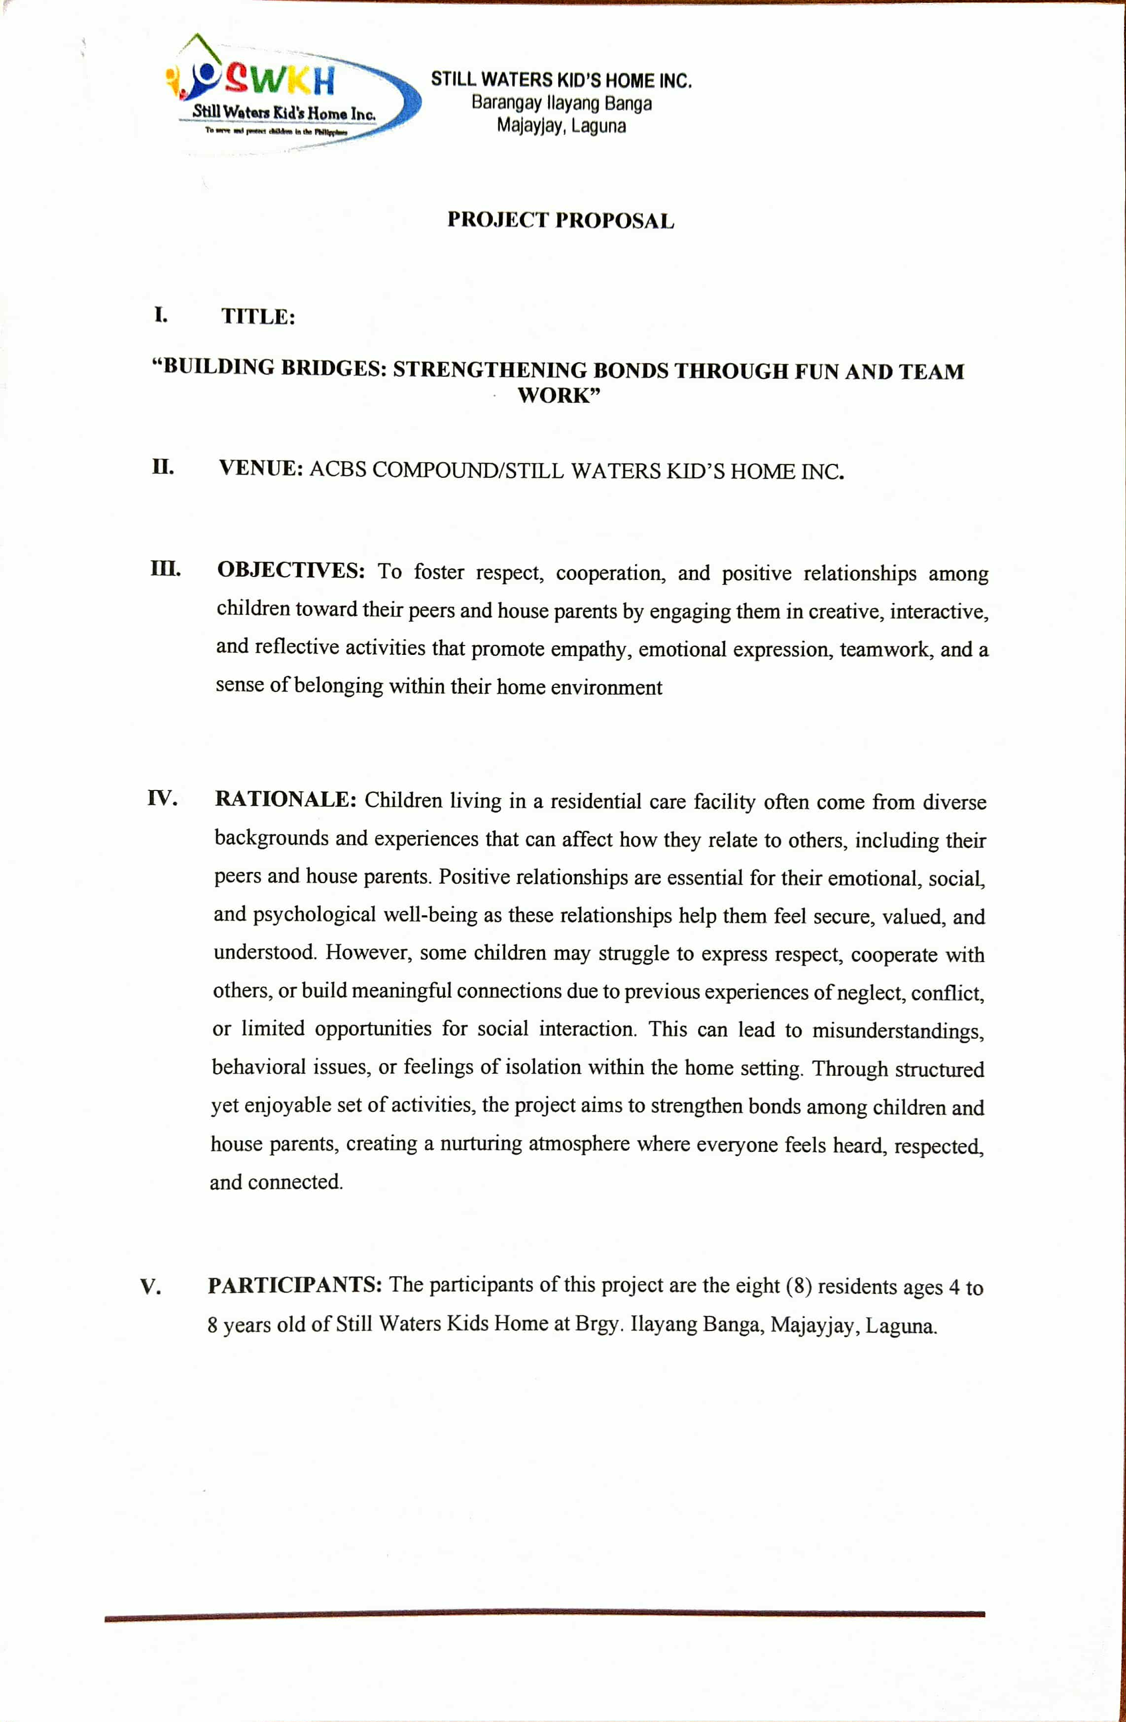

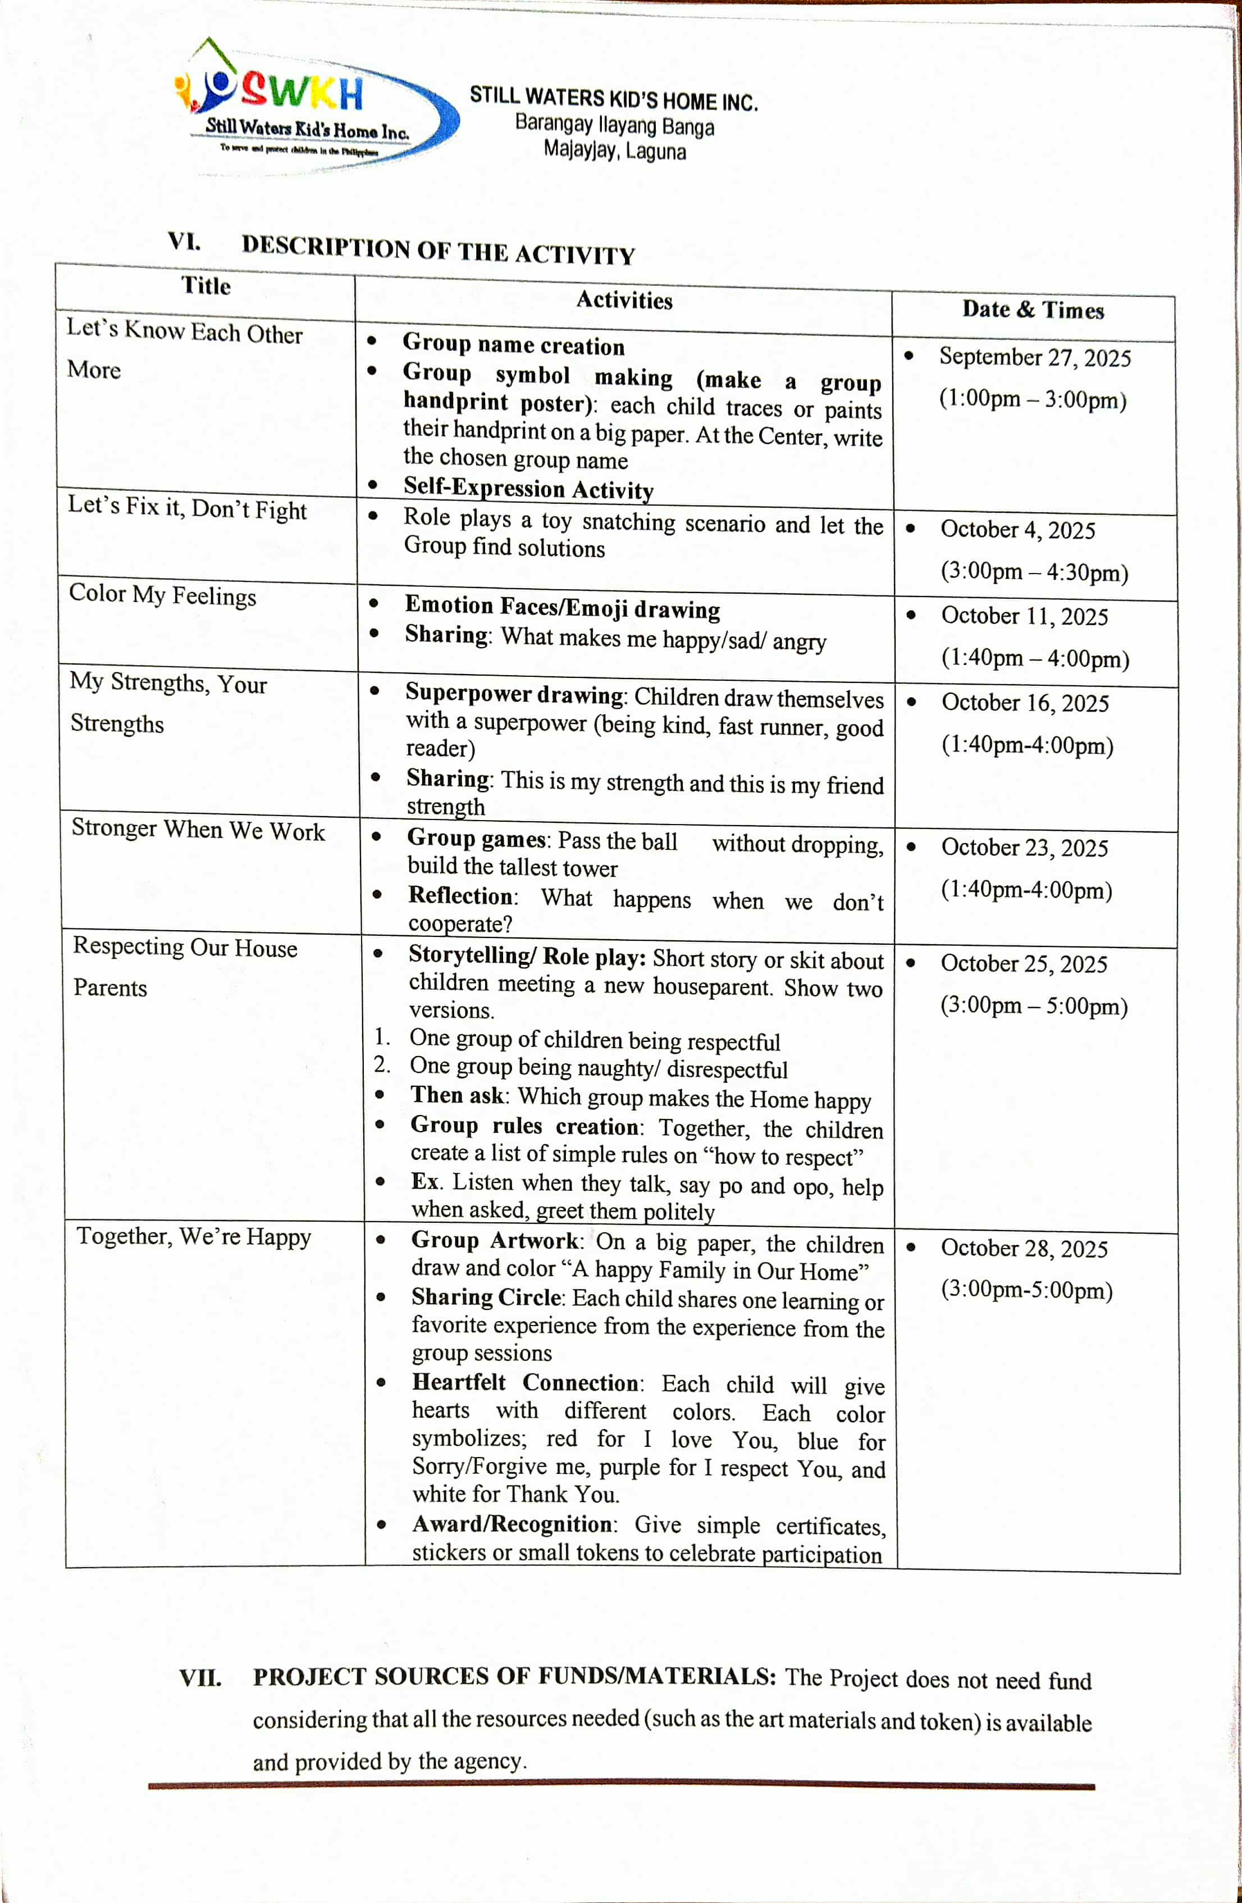

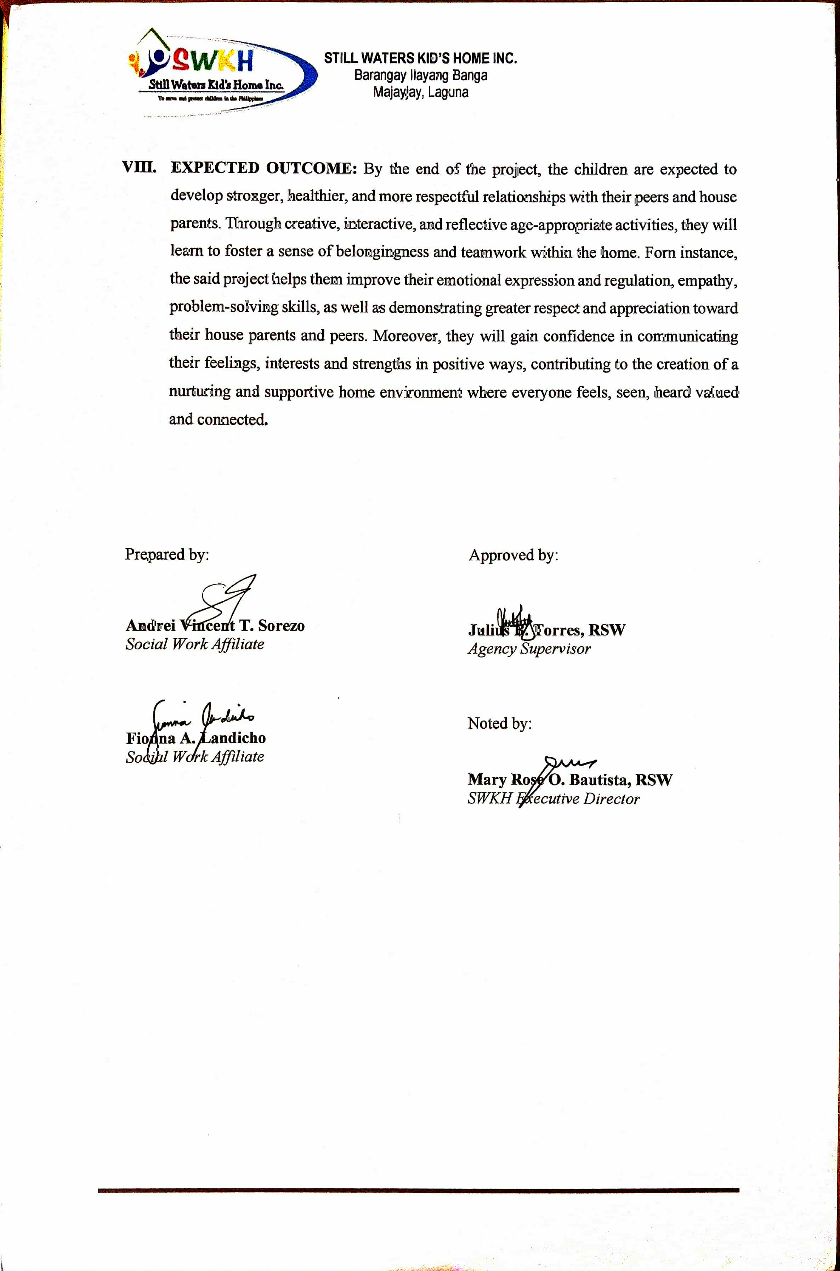

Photo Documentation

SWKH Activities Compilation

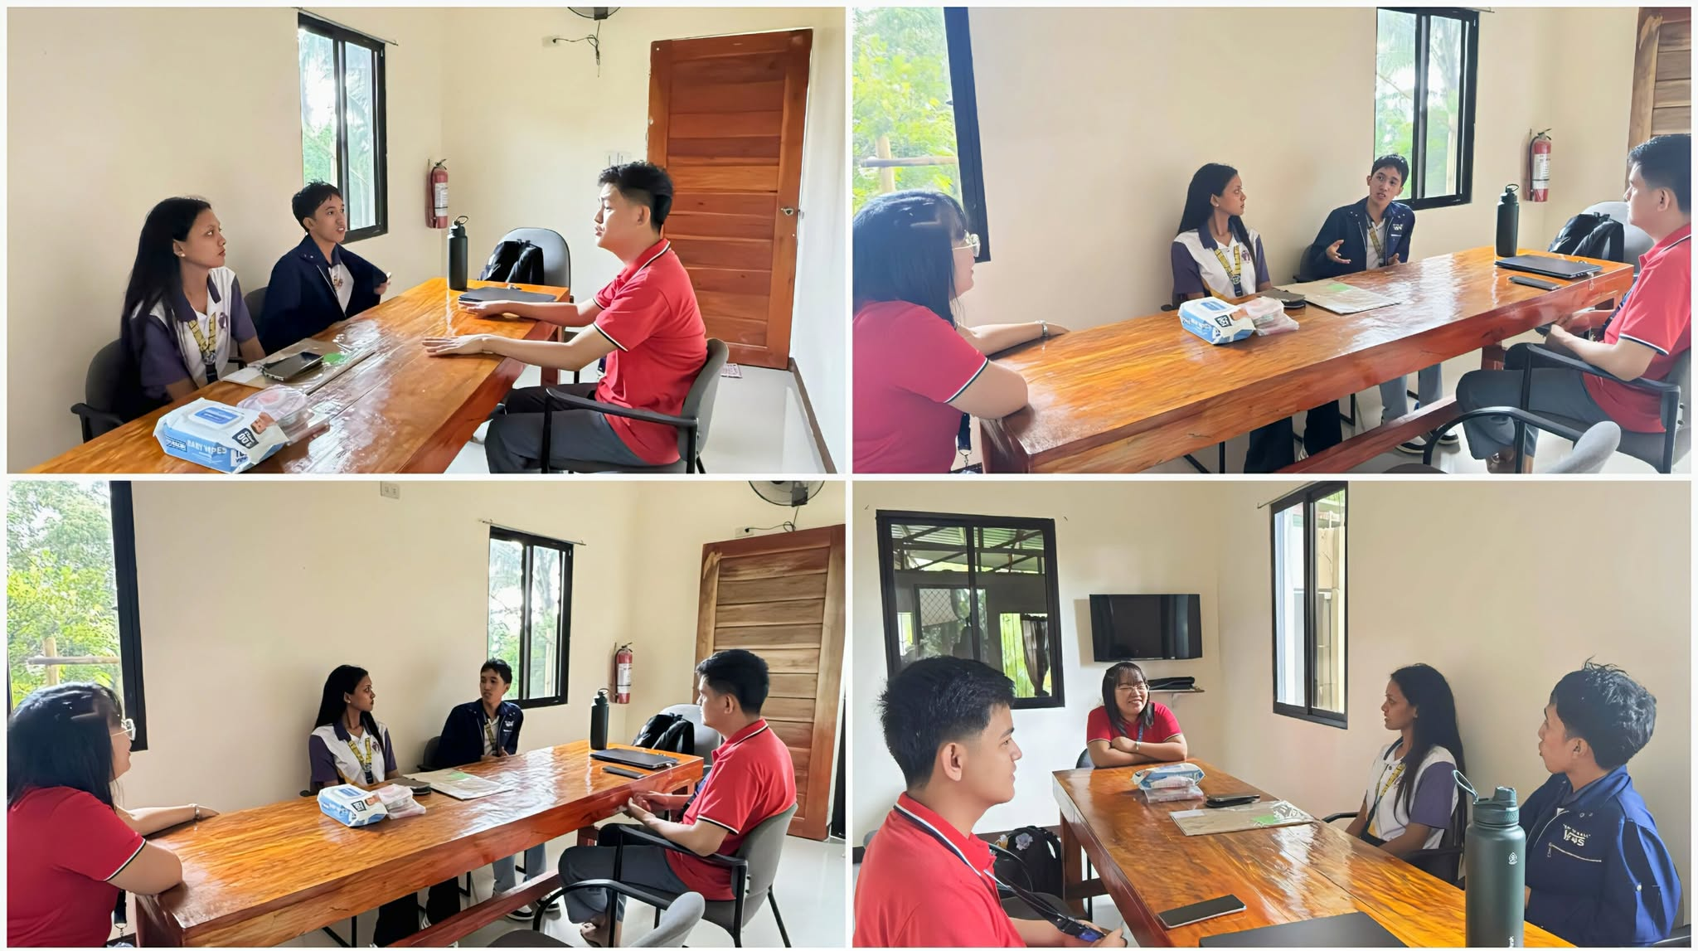
Entry Trialogue – August 6, 2025

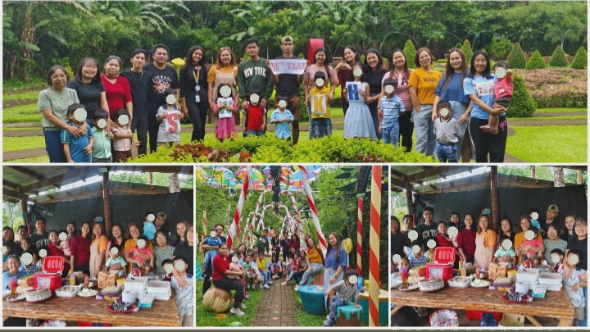
SWKH 10th Year Anniversary (Semara’s Farm) – August 22, 2025

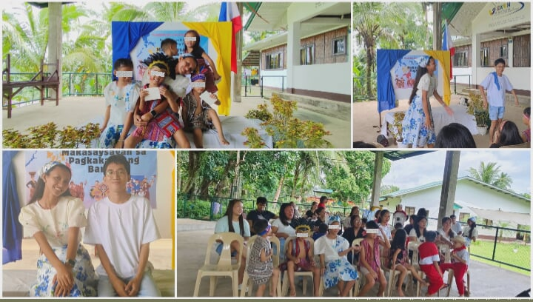
Buwan ng Wika Celebration – August 27, 2025

Fieldwork (Bay & Calamba Laguna) – September 19, 2025
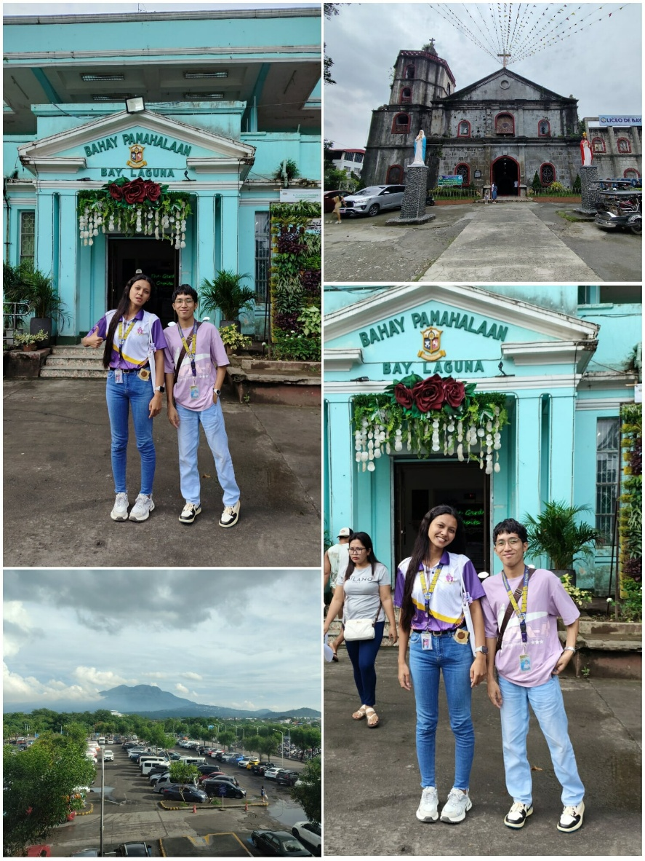

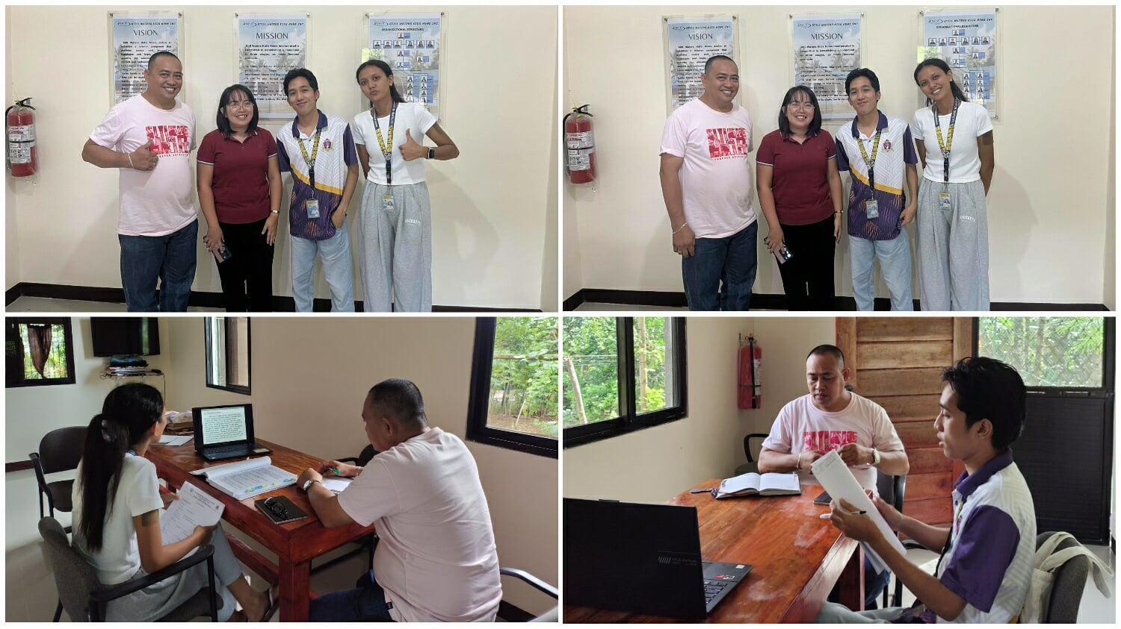
Midterm Trialogue – September 25. 2025

APA Wildlife Rescue & Conservation Park – September 29, 2025
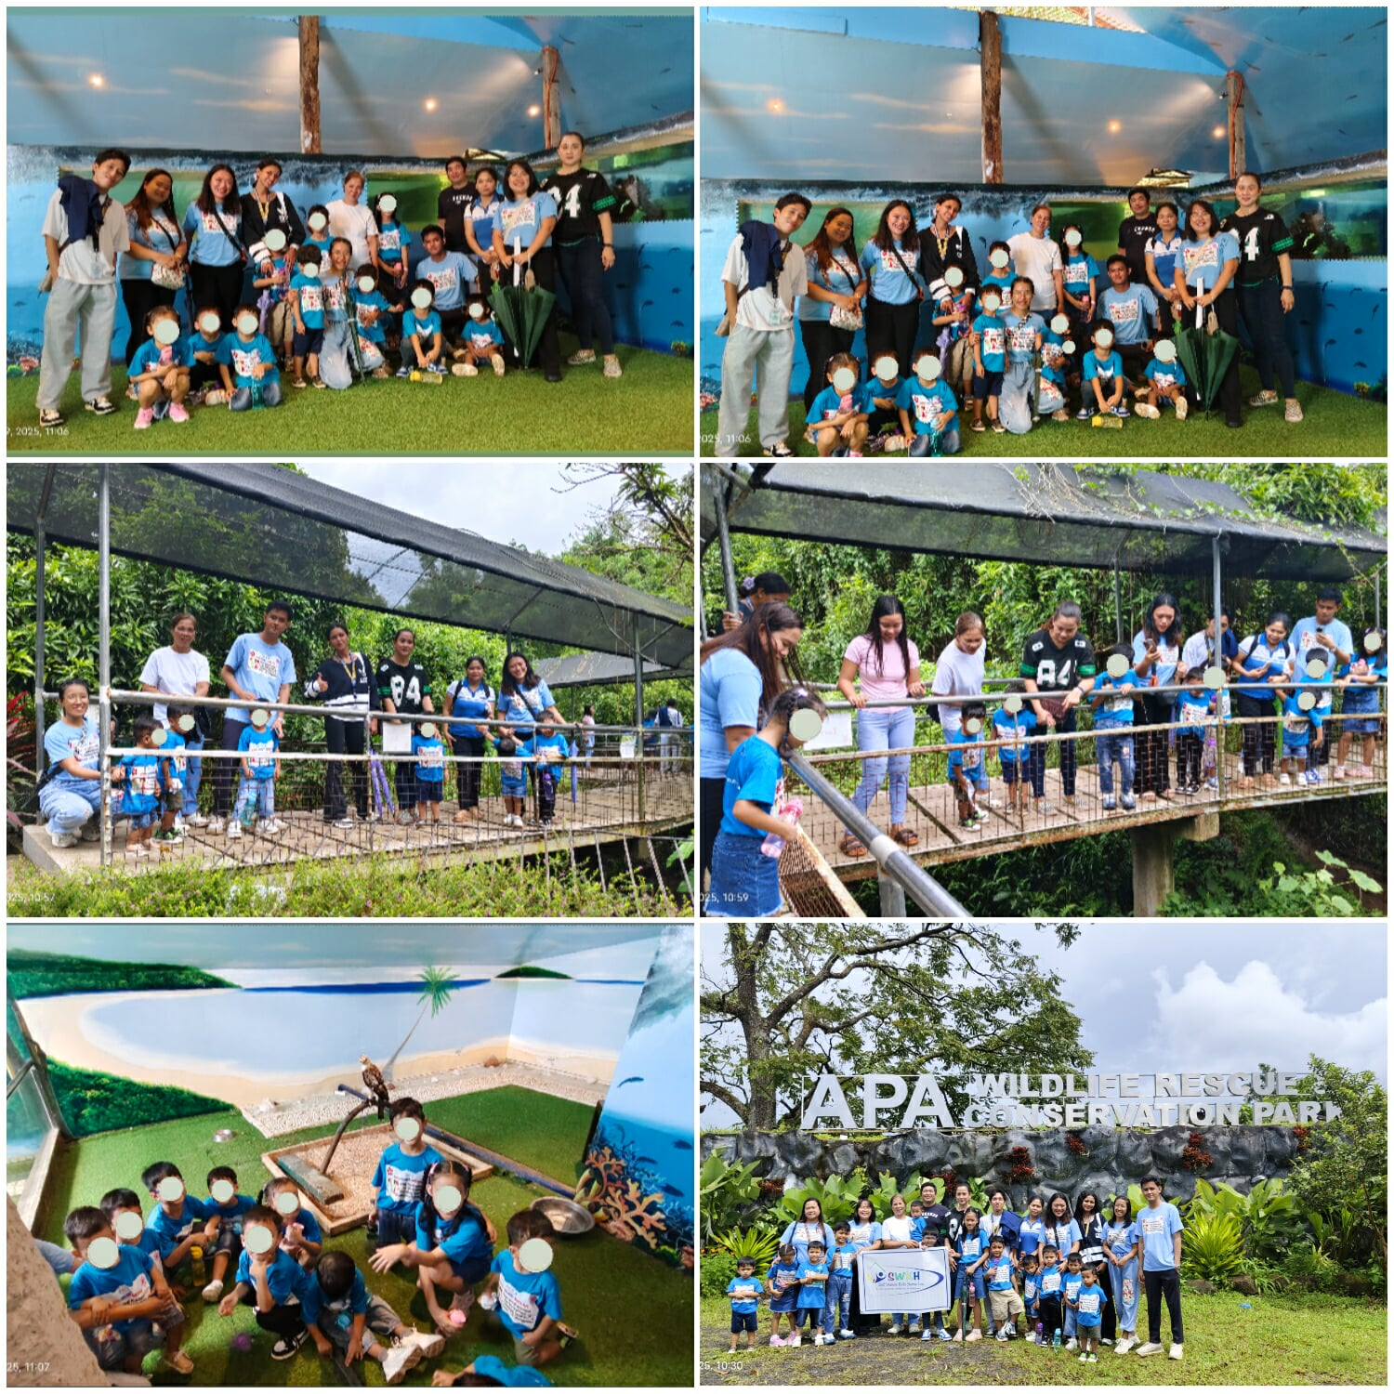

Chapel Time (Once every two months) – September 29, 2025
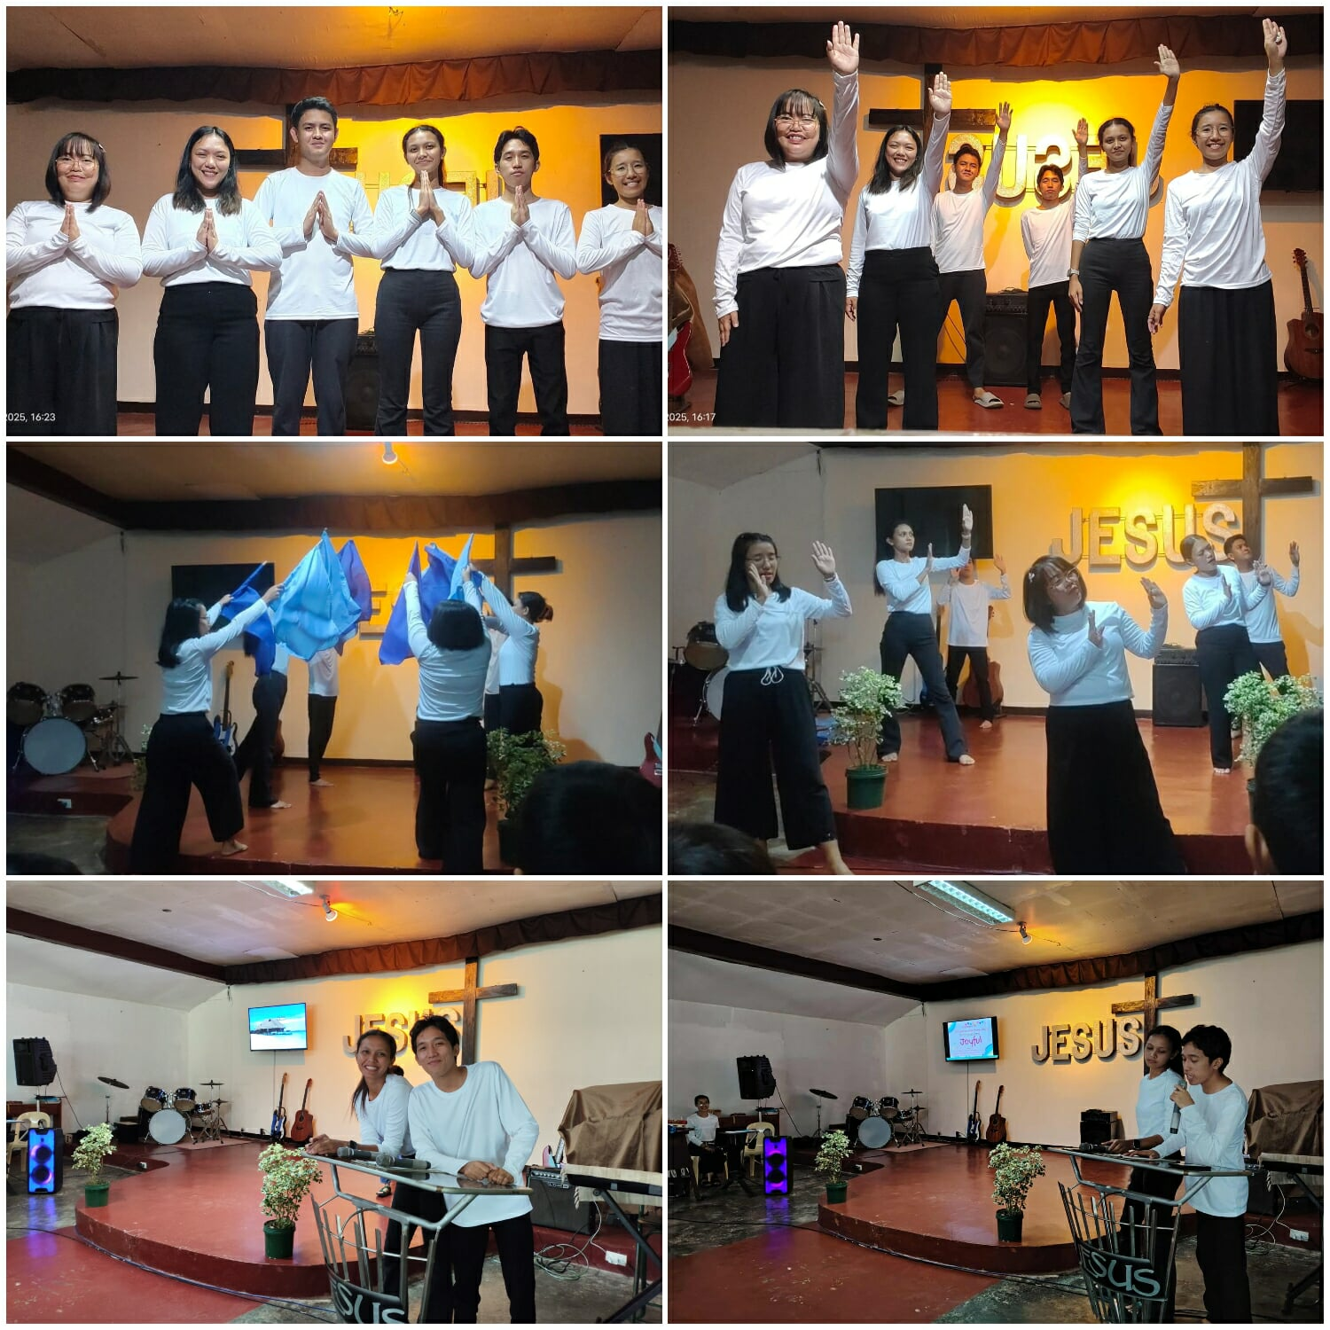

Fieldwork (92.7 Brigada News FM Lucena) – October 17, 2025
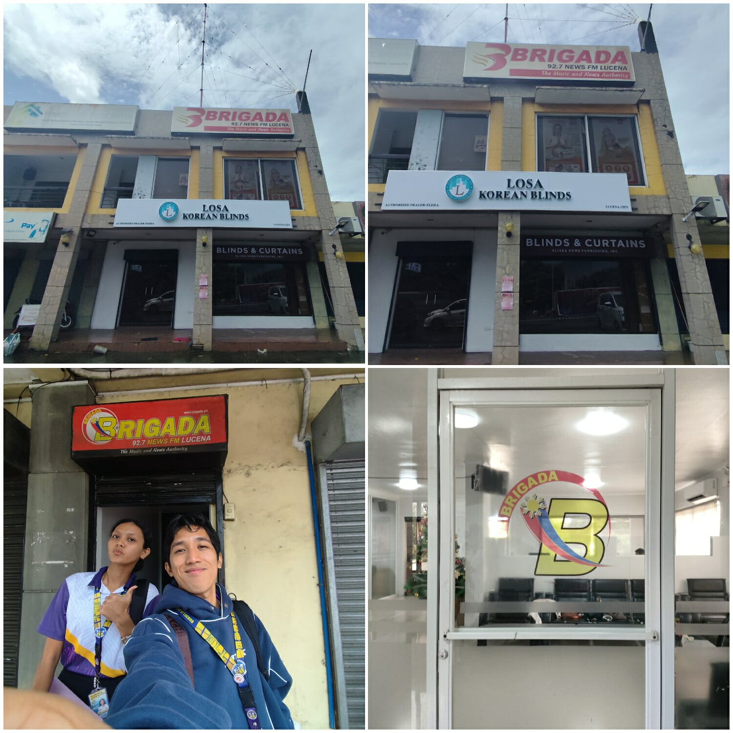

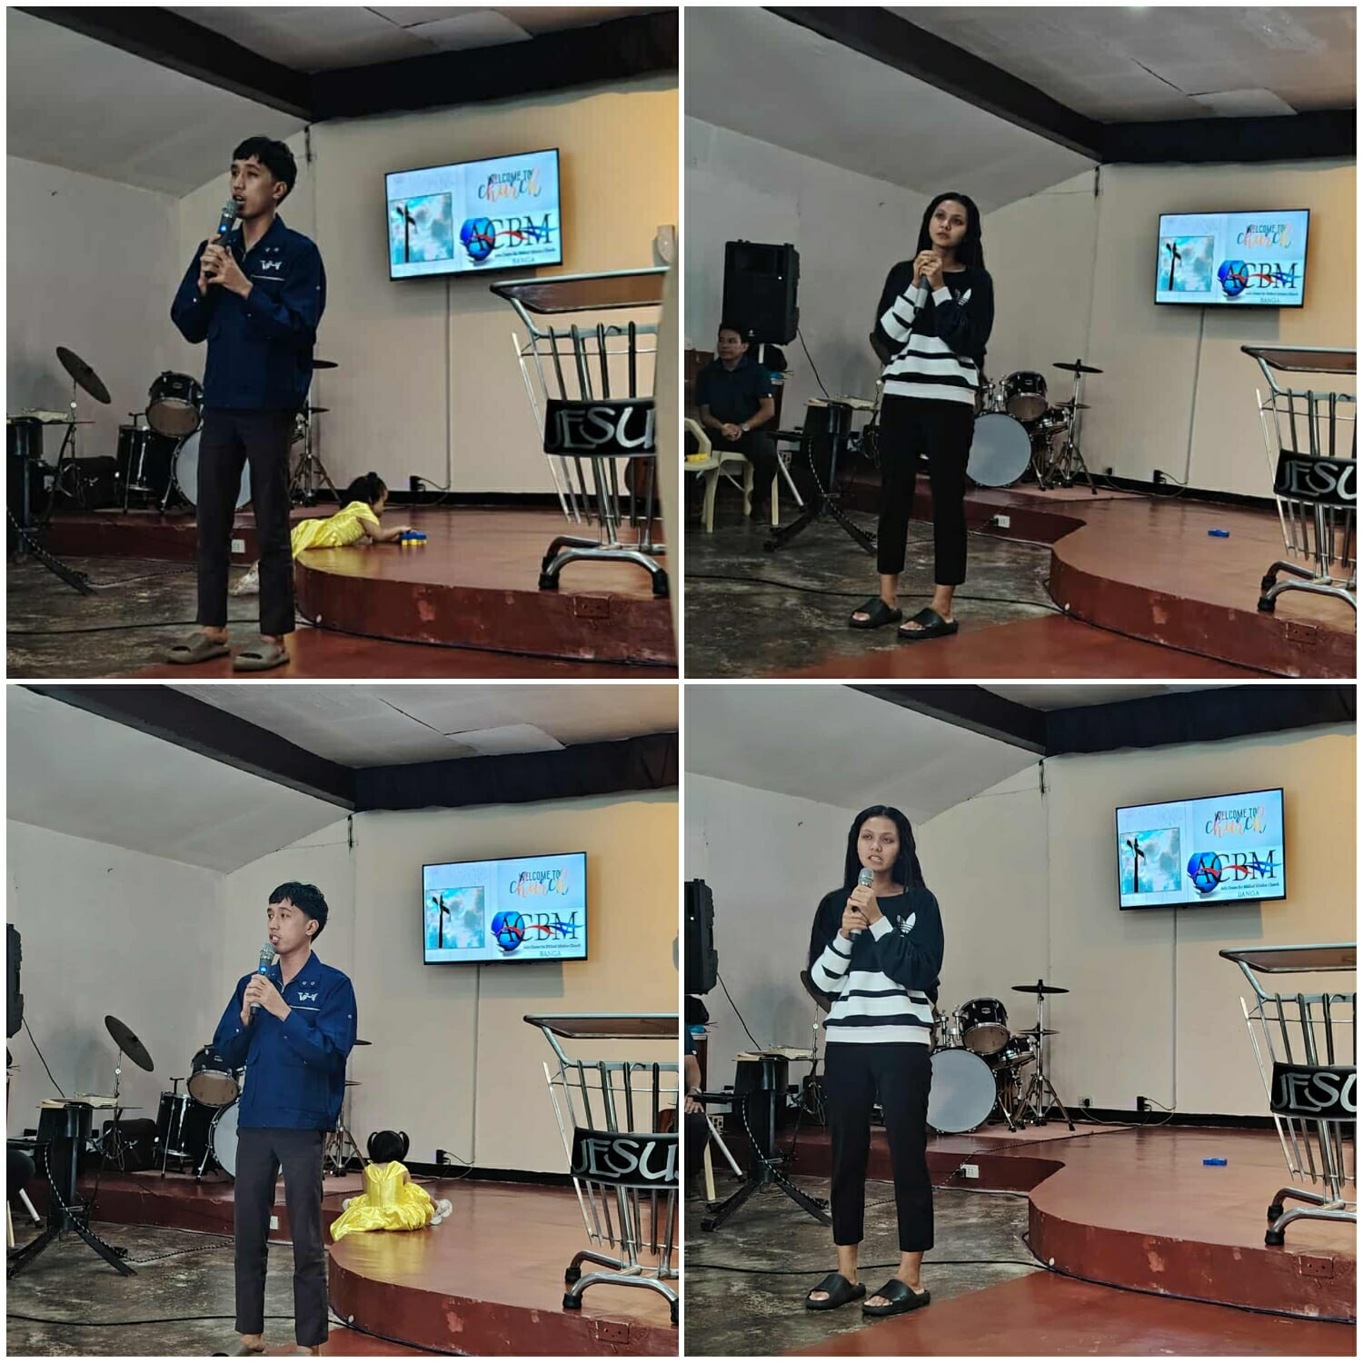
Church Testimony – October 19, 2025

United Nations Celebration – October 22, 2025
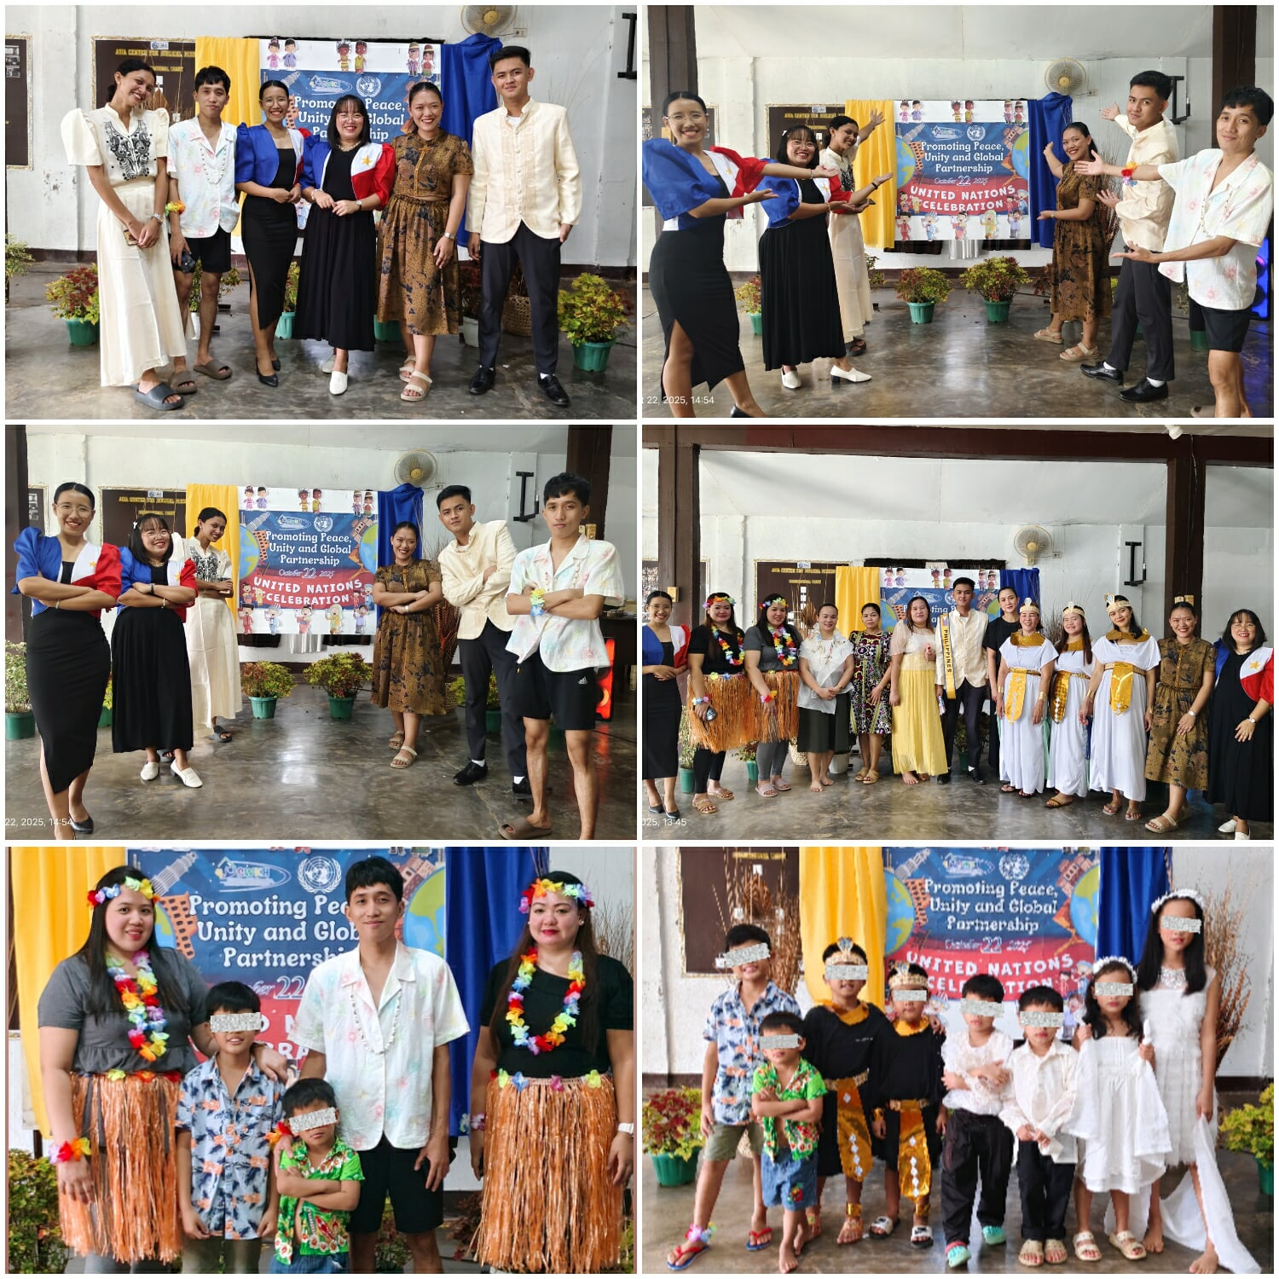

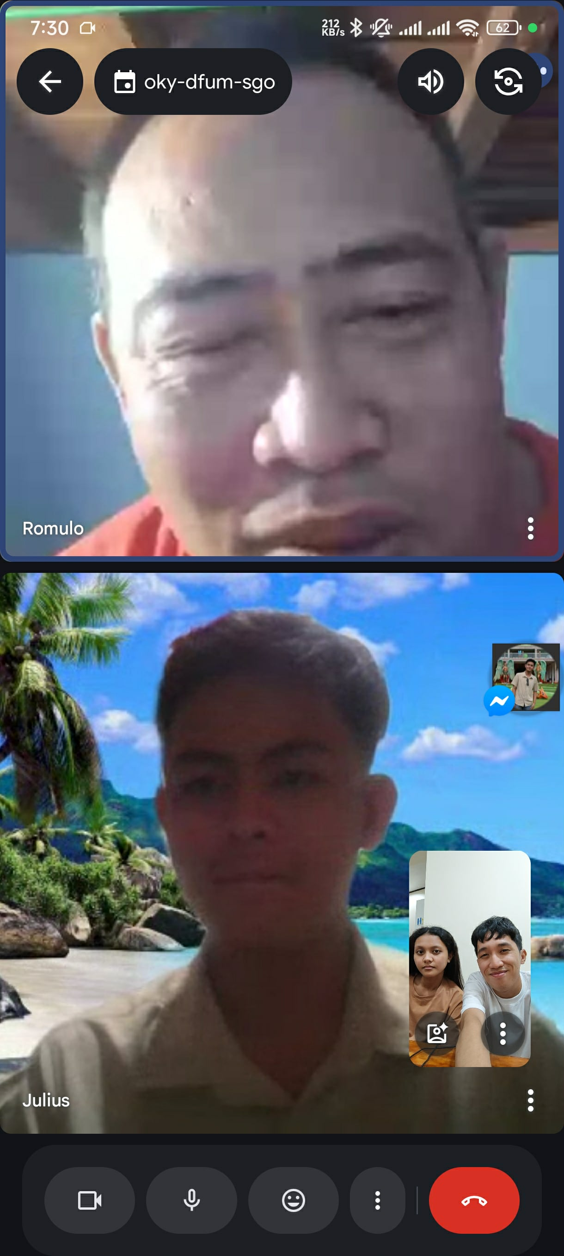
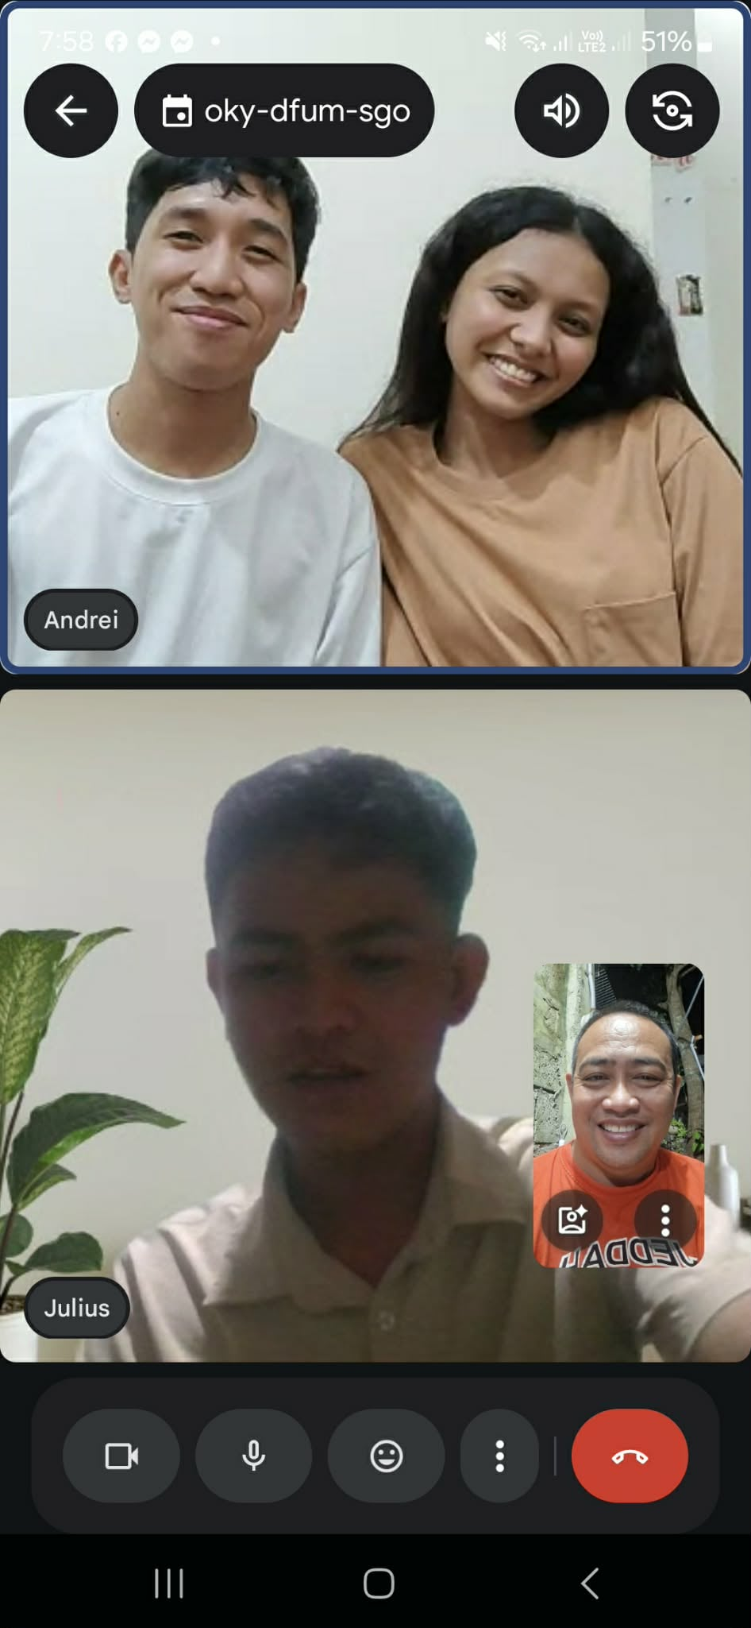
Exit Trialogue – October 25, 2025

Group Work Sessions/Activities
1st Session (Let’s Know Each Other More) – September 27, 2025
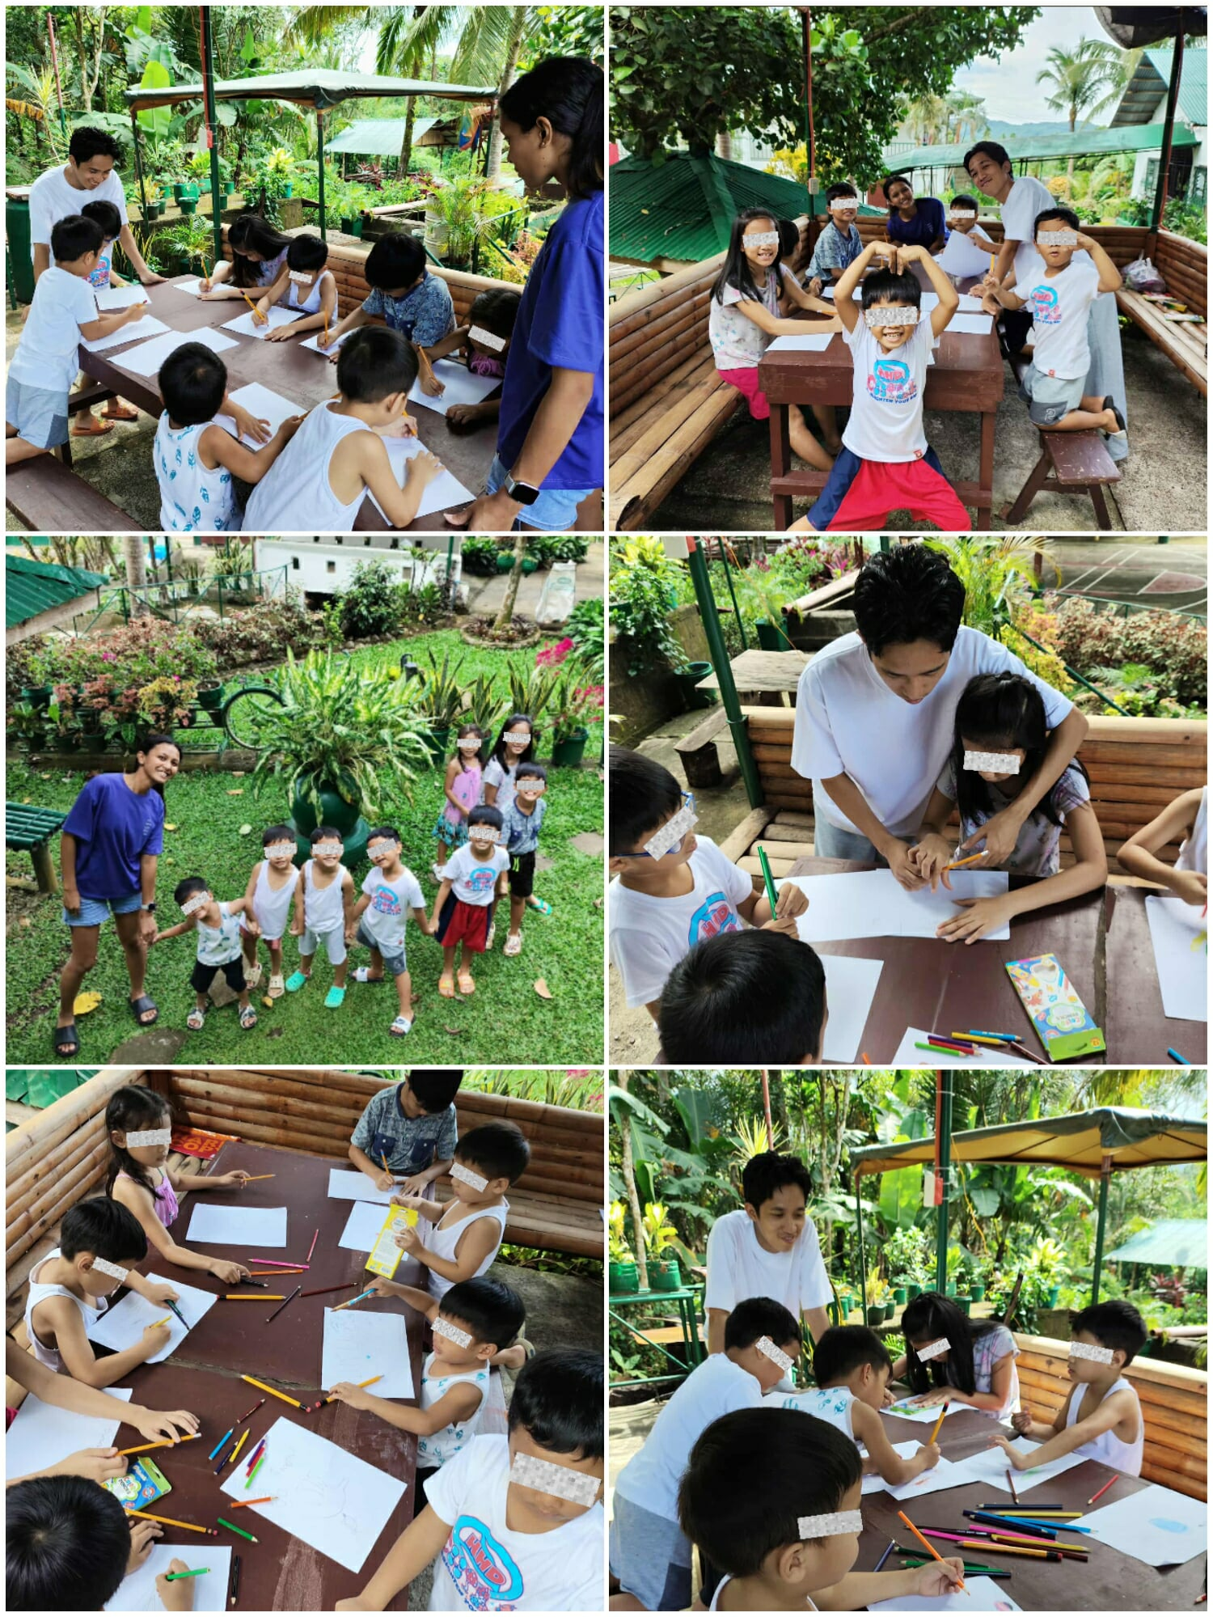

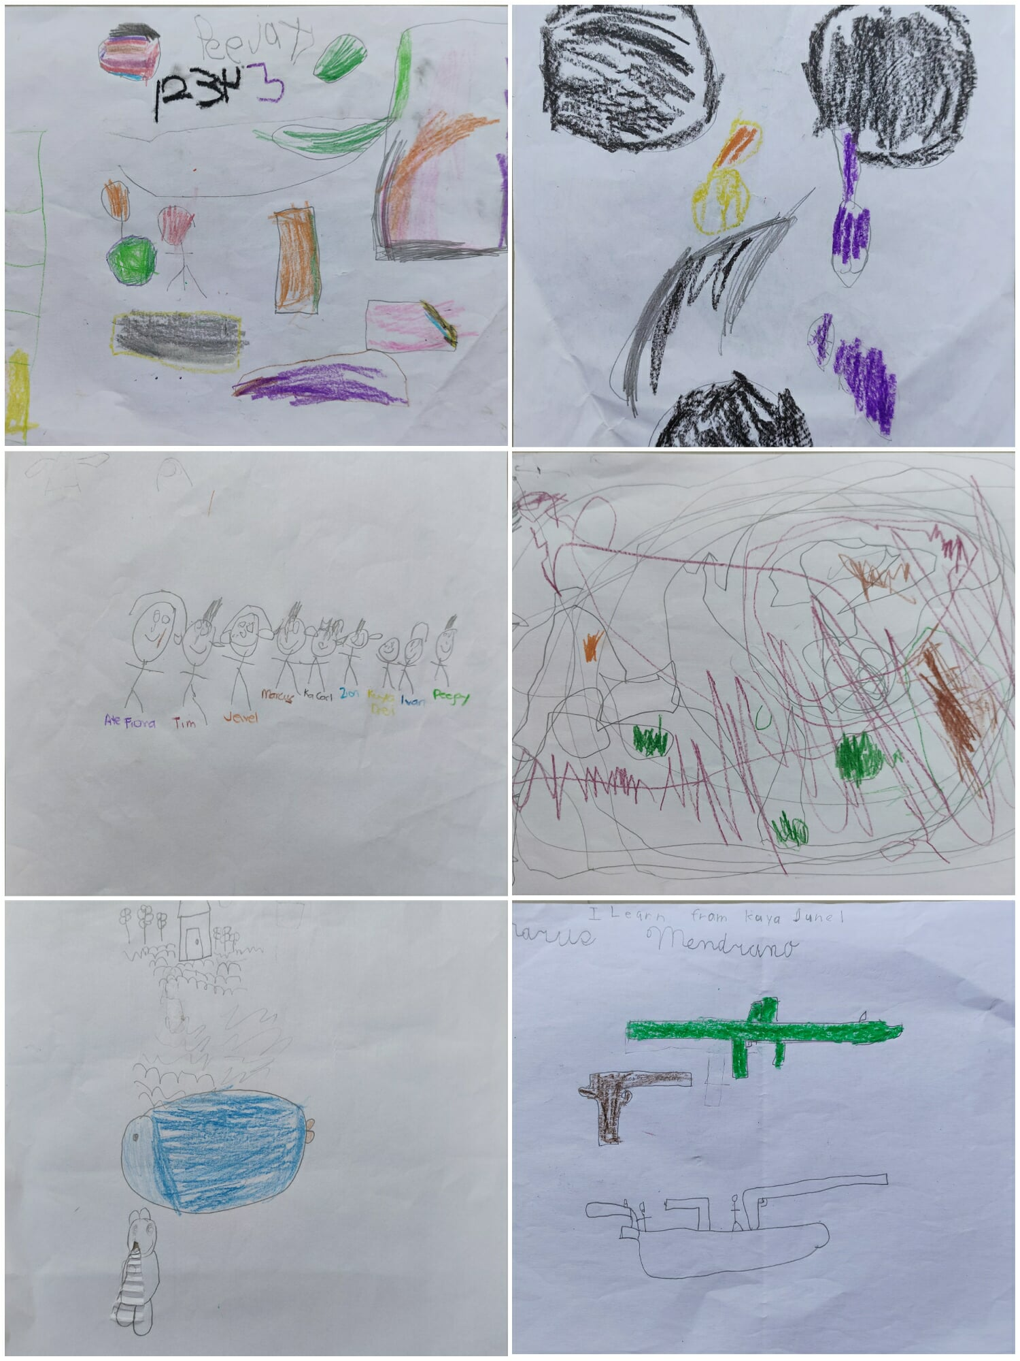
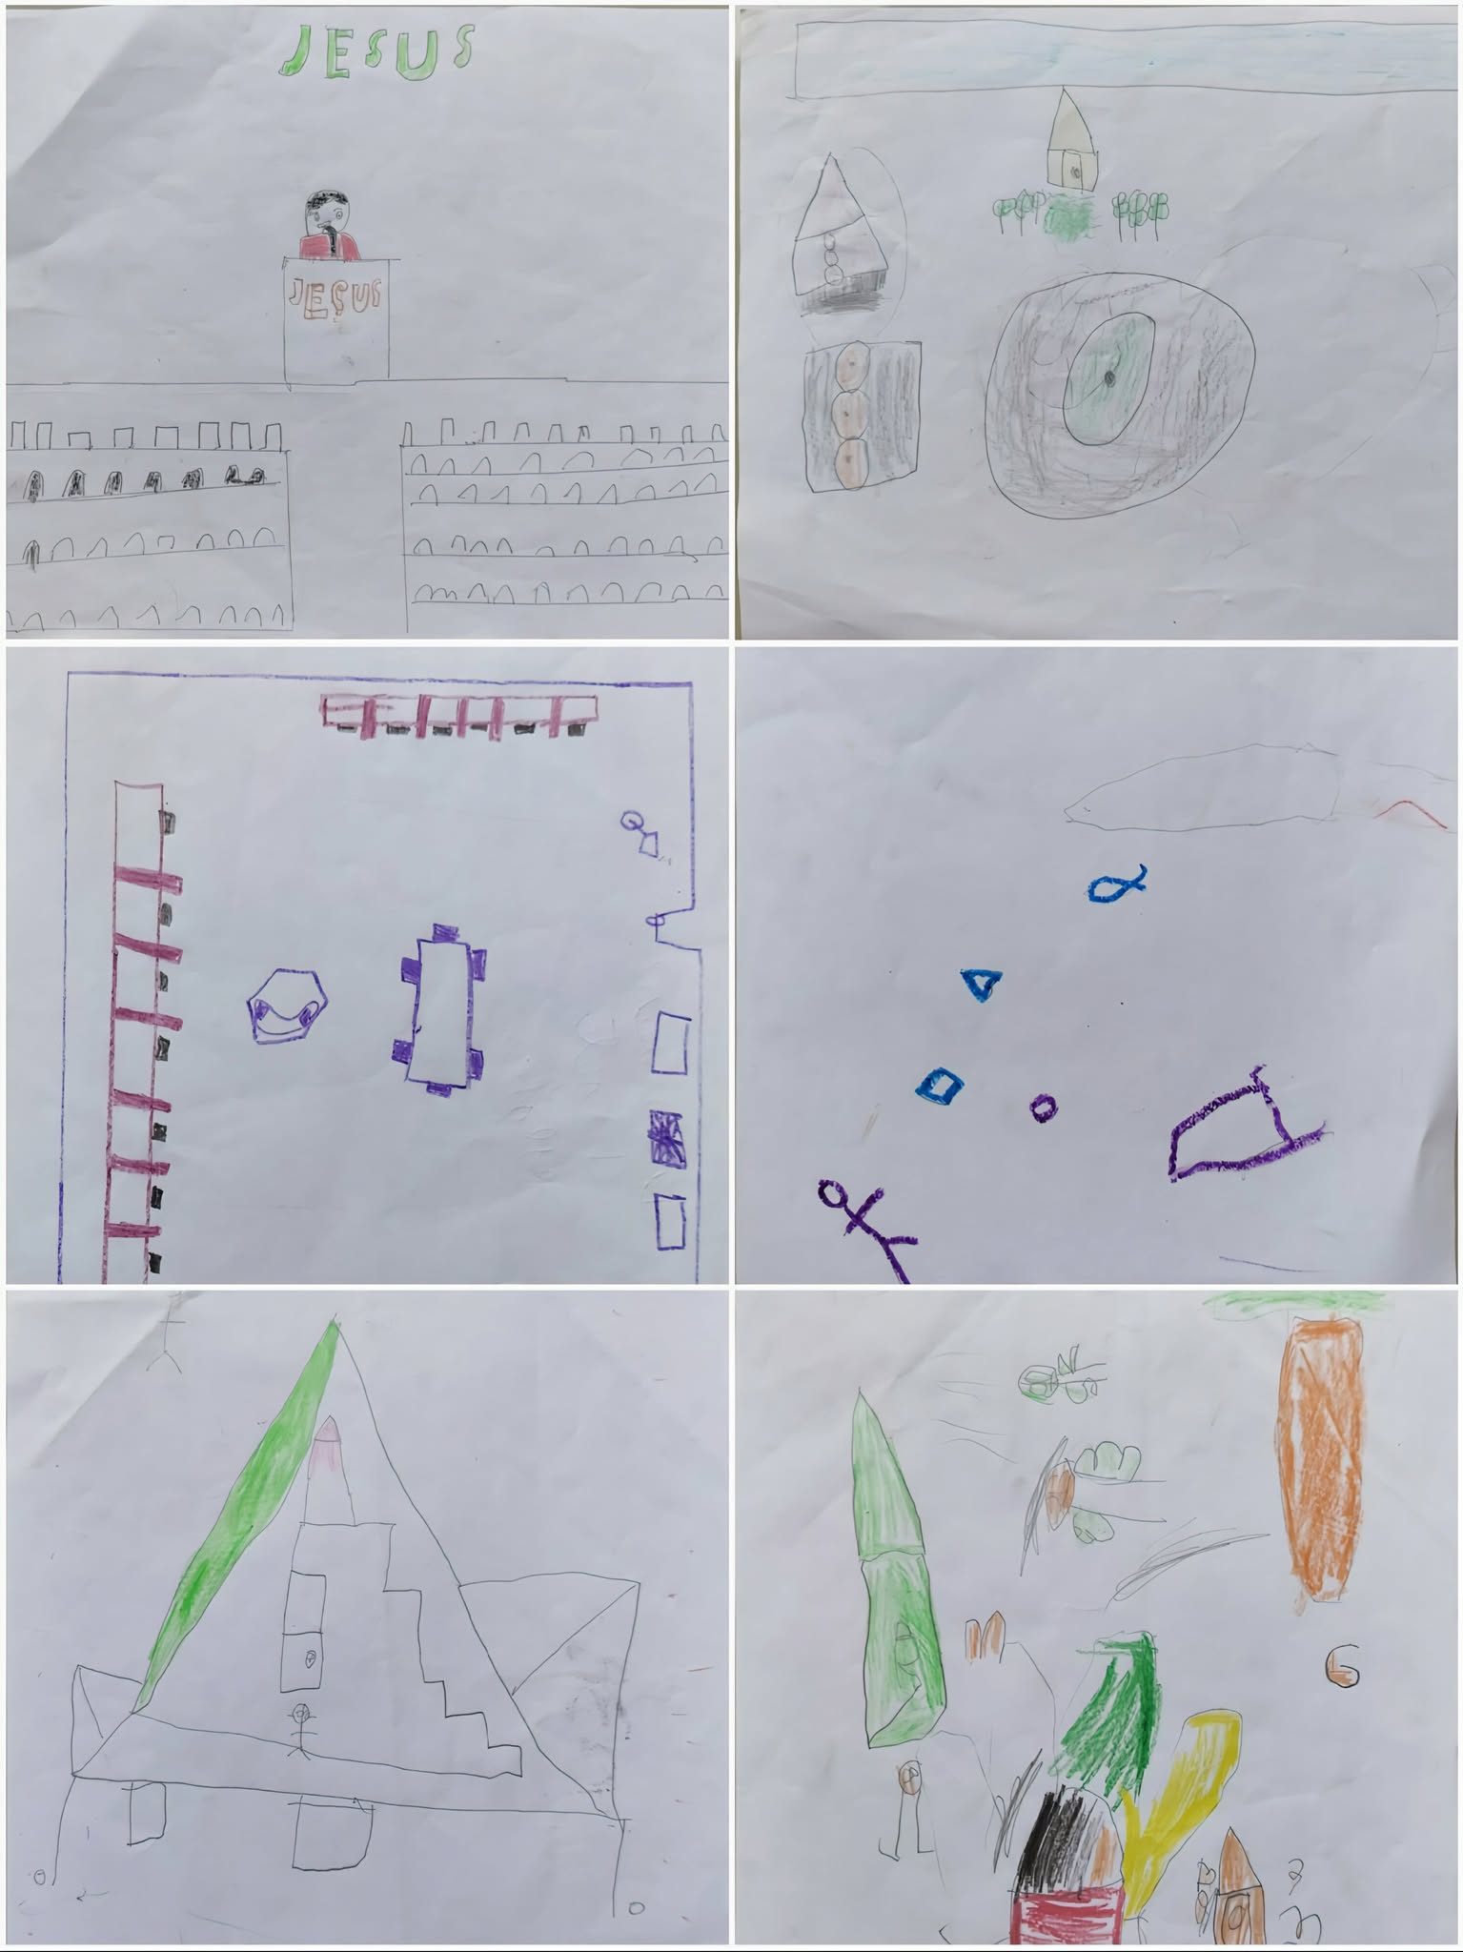

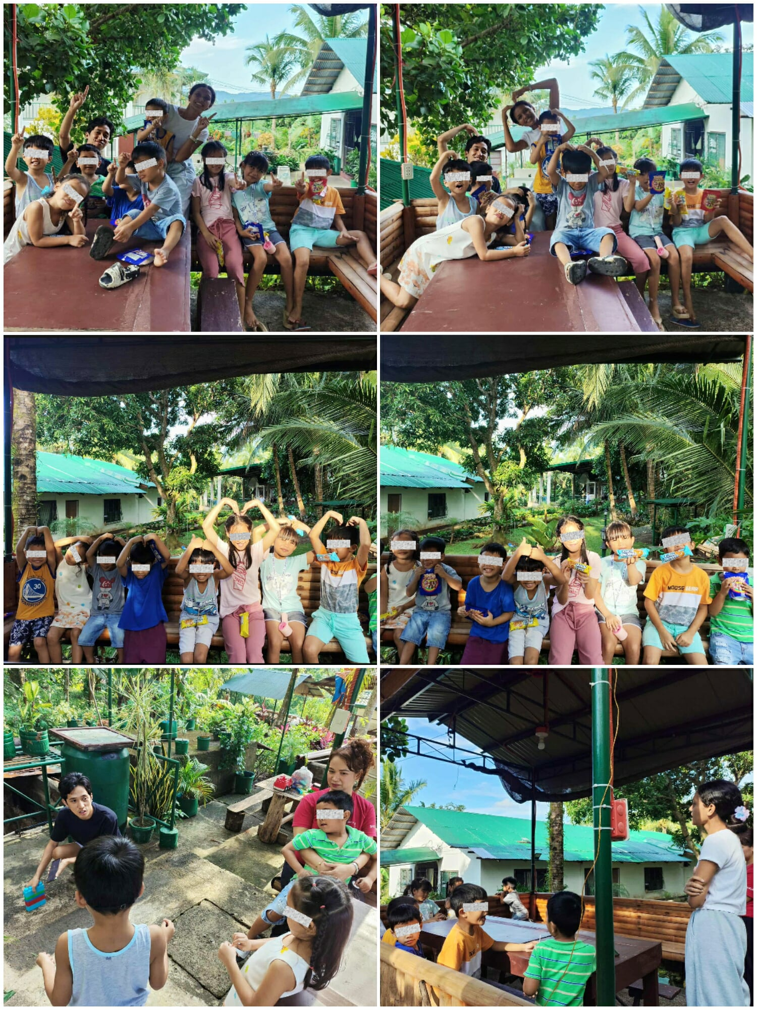
2nd Session (Let’s Fix it, Don’t Fight) – October 5, 2025

3rd Session (Color My Feelings) – October 11, 2025
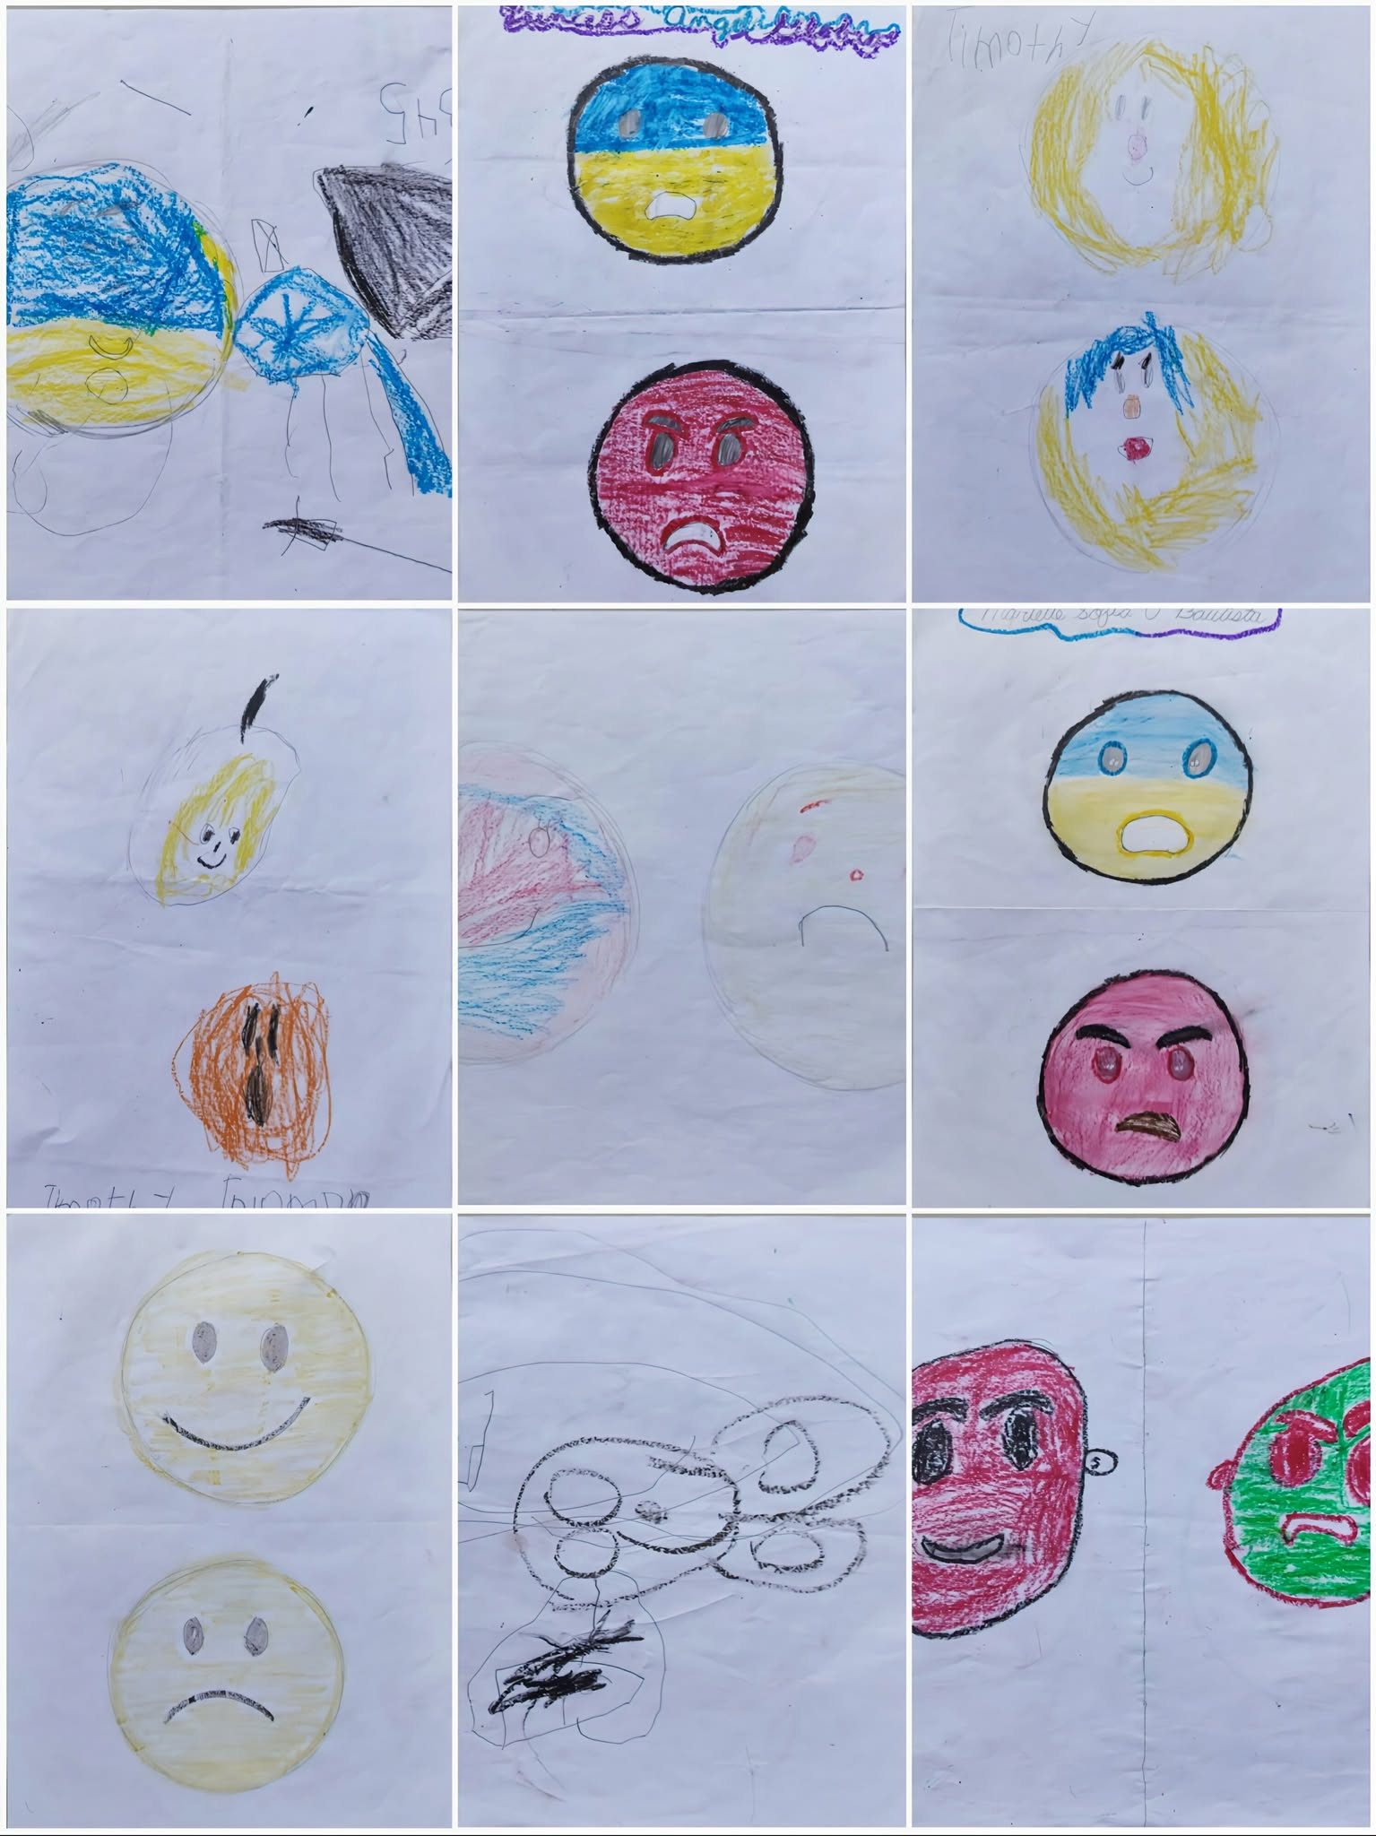
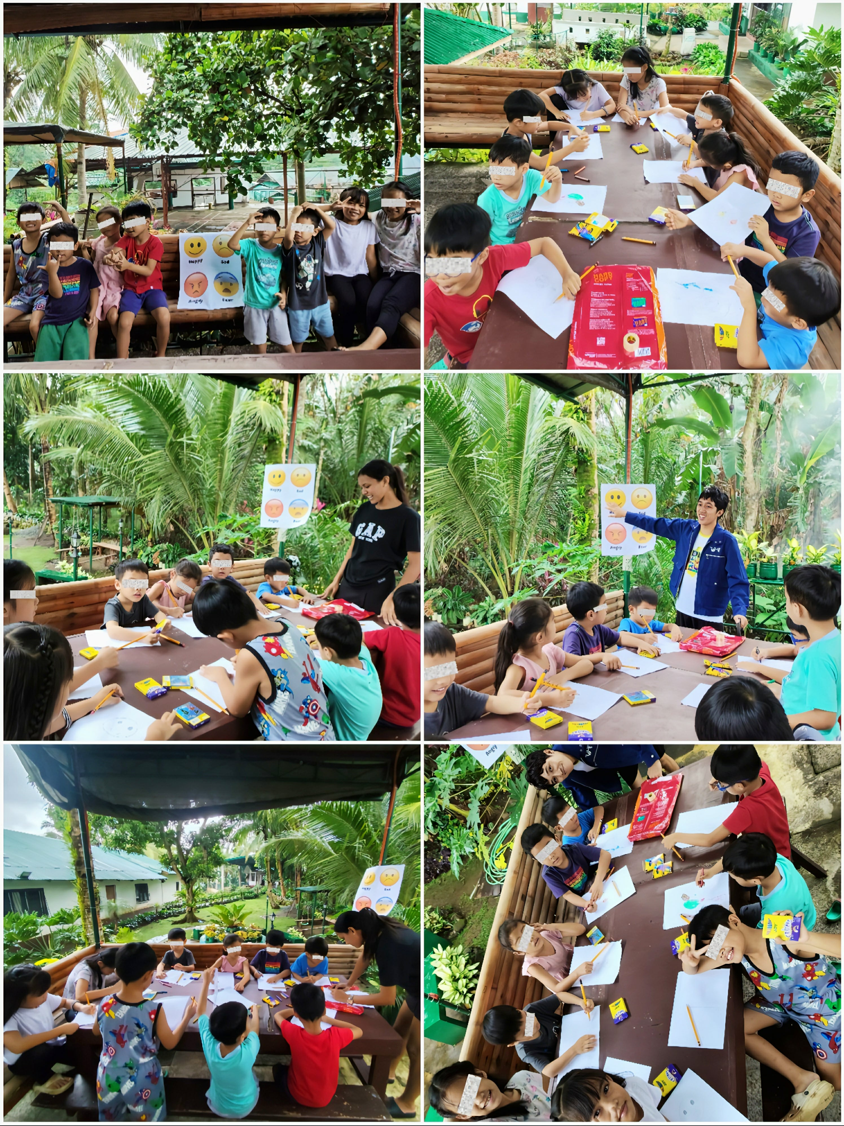

4th Session (My Strengths, Your Strengths) – October 16, 2025


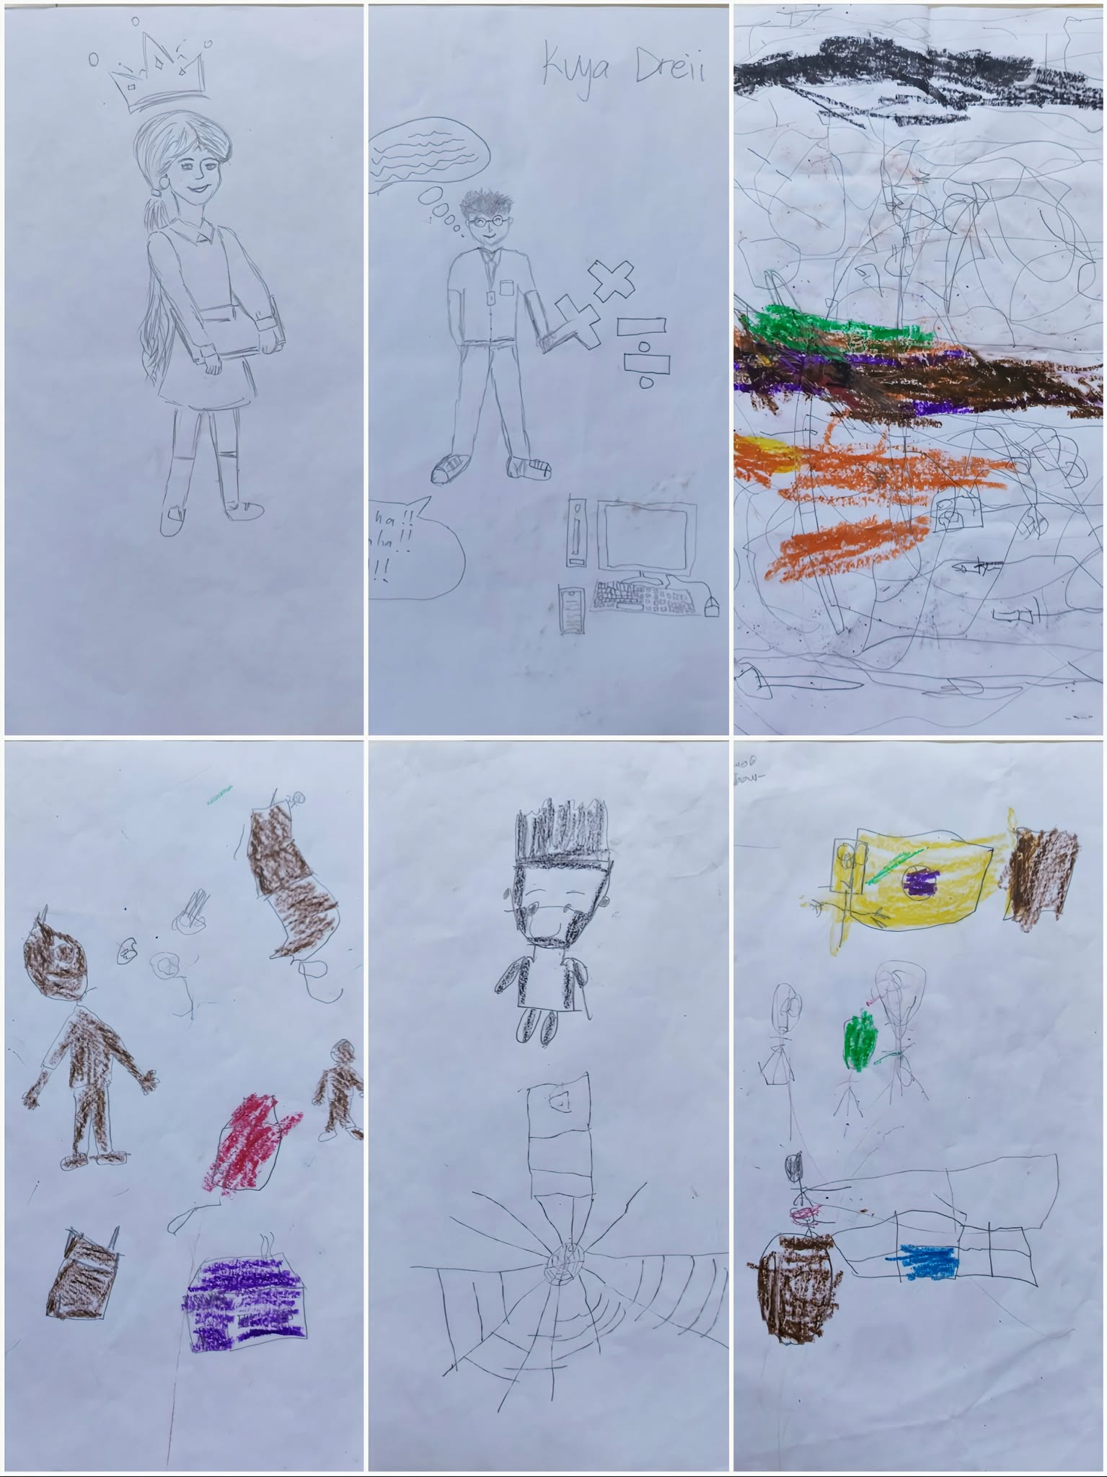
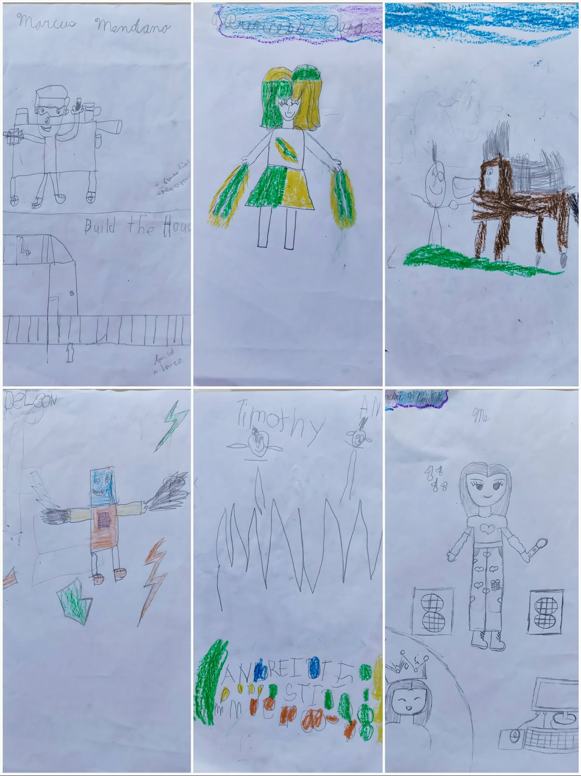

5th Session (Stronger When We Work) – October 23, 2025



6th Session (Respecting Our House Parents) – October 25, 2025

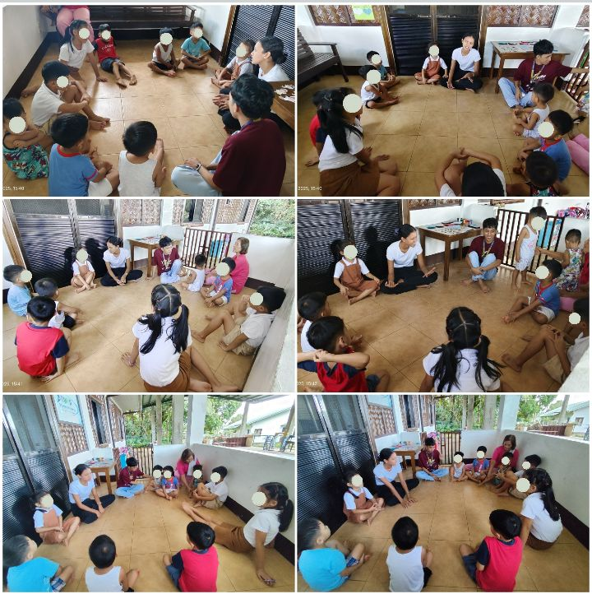
7th Session (Together, We’re Happy) – October 28, 2025






Curriculum Vitae

CURRICULUM VITAE

ANDREI VINCENT T. SOREZO
Address: Nadres Street Purok Paraiso,
Barangay Ibabang Iyam, Lucena City
Mobile: 09919514085
Email: andreisorezo1@gmail.com
Personal Information:

Birthdate : October 13, 1998
Birthplace : Magdalena Laguna
Religion : Roman Catholic
Civil Status : Single
Father’s name : Rosel D. Sorezo
Mother’s name : Maritess T. Sorezo
Educational Attainment:

Tertiary : Dalubhasaan ng Lungsod ng Lucena
Lucena City
2022 - (Present)

Senior High School : Gulang-Gulang National High School
Lucena City
2018-2020

Junior High School : Quezon National High School
Lucena City
2012-2015

Elementary : Ricardo A. Pronove Elementary School
Magdalena, Laguna
2005 – 2011

SUMMARY OF HOURS RENDERED DURING FIELD INSTRUCTION I
Field Instruction 1
Name of Affiliate | Andrei Vincent T. Sorezo
Contact Number | 09919514085
Placement Area | Still Waters Kid’s Home Inc.
Agency Supervisor | Julius B. Torres, RSW
School Field Instructor | Romulo A. Oserin Jr., RSW, MSSW

Date (Months’ Summary) |  | Total hours
From | To
August 6, 2025 | August 29, 2025 | 146 Hours
September 1, 2025 | September 30, 2025 | 194 Hours
October 1, 2025 | October 31, 2025 | 214 Hours
GRAND TOTAL |  | 554 Hours

I certify to the correctness of the above information.

Student: Andrei Vincent T. Sorezo Date___________

Noted by:

Agency
Supervisor: Julius B. Torres, RSW Date___________

School
Field
Instructor: Romulo A. Oserin Jr., RSW, MSSW Date___________

