Supplementary Information
Census and climatic connectivity of the cols of the tropical Andes. Tables S1 to S15 are given in full in L1_Supplementary_Tables.xlsx; tables longer than 60 rows appear there only.
Table S1. Cols of the census by zone, GMBA unit and rank: number of cols with a depth of 30 m or more, number with a depth of 100 m or more, and median height and depth (m). Tropics are 11°N to 23.5°S.
zone | gmba | rank | cols | depth_100m | median_z_m | median_depth_m
tropics | Altiplano | terminal | 69 | 29 | 3.94e+03 | 86.4
tropics | Altiplano | tributary | 2991 | 501 | 3.96e+03 | 50.5
tropics | Cordillera Central (Central Andes) | continental | 824 | 286 | 4.76e+03 | 67.4
tropics | Cordillera Central (Central Andes) | terminal | 328 | 92 | 4.7e+03 | 62
tropics | Cordillera Central (Central Andes) | tributary | 53362 | 9733 | 3.97e+03 | 52
tropics | Cordillera Central (Northern Andes) | continental | 135 | 45 | 3.46e+03 | 66.4
tropics | Cordillera Central (Northern Andes) | tributary | 26139 | 3131 | 1.06e+03 | 44.8
tropics | Cordillera Occidental (Central Andes) | continental | 1734 | 694 | 4.71e+03 | 79
tropics | Cordillera Occidental (Central Andes) | terminal | 5268 | 1583 | 2.3e+03 | 63.3
tropics | Cordillera Occidental (Central Andes) | tributary | 52398 | 9048 | 3.7e+03 | 51.2
tropics | Cordillera Occidental (Northern Andes) | continental | 611 | 192 | 3.09e+03 | 65.5
tropics | Cordillera Occidental (Northern Andes) | terminal | 1977 | 535 | 969 | 59
tropics | Cordillera Occidental (Northern Andes) | tributary | 26335 | 3261 | 727 | 45.6
tropics | Cordillera Oriental (Central Andes) | continental | 453 | 163 | 4.81e+03 | 74.5
tropics | Cordillera Oriental (Central Andes) | terminal | 151 | 54 | 3.12e+03 | 73.3
tropics | Cordillera Oriental (Central Andes) | tributary | 65219 | 10767 | 1.89e+03 | 49.4
tropics | Cordillera Oriental (Northern Andes) | continental | 1016 | 345 | 3.48e+03 | 73
tropics | Cordillera Oriental (Northern Andes) | terminal | 648 | 230 | 1.95e+03 | 66
tropics | Cordillera Oriental (Northern Andes) | tributary | 43851 | 7089 | 1.43e+03 | 48.5
tropics | Cordillera de Mérida | continental | 299 | 101 | 3.02e+03 | 67.9
tropics | Cordillera de Mérida | terminal | 312 | 86 | 2.43e+03 | 60.7
tropics | Cordillera de Mérida | tributary | 7036 | 1056 | 764 | 48.5
tropics | Dry Andes | continental | 82 | 25 | 3.61e+03 | 70.2
tropics | Dry Andes | terminal | 261 | 82 | 4.84e+03 | 67.5
tropics | Dry Andes | tributary | 5326 | 1009 | 3.72e+03 | 50.6
tropics | Sierras Subandinas | terminal | 140 | 31 | 1.39e+03 | 51.8
tropics | Sierras Subandinas | tributary | 34367 | 4269 | 1.1e+03 | 46.6
tropics | all units | continental | 5154 | 1851 | 4.23e+03 | 73
tropics | all units | terminal | 9154 | 2722 | 2.15e+03 | 62.6
tropics | all units | tributary | 317024 | 49864 | 1.94e+03 | 48.9
rest of the Andes | Cordillera Oriental (Northern Andes) | terminal | 24 | 7 | 550 | 70.2
rest of the Andes | Cordillera Oriental (Northern Andes) | tributary | 201 | 27 | 261 | 46.2
rest of the Andes | Dry Andes | continental | 1628 | 687 | 4.45e+03 | 81.2
rest of the Andes | Dry Andes | terminal | 3400 | 1254 | 4.12e+03 | 71
rest of the Andes | Dry Andes | tributary | 55004 | 10430 | 3.06e+03 | 51.3
rest of the Andes | Patagonian Andes | continental | 1230 | 537 | 1.63e+03 | 83.8
rest of the Andes | Patagonian Andes | terminal | 9195 | 4272 | 797 | 90.6
rest of the Andes | Patagonian Andes | tributary | 60793 | 15861 | 724 | 57.5
rest of the Andes | Sierras Subandinas | continental | 47 | 11 | 1.41e+03 | 42.7
rest of the Andes | Sierras Subandinas | tributary | 2731 | 271 | 1.06e+03 | 44.6
rest of the Andes | all units | continental | 2905 | 1235 | 2.97e+03 | 81.8
rest of the Andes | all units | terminal | 12619 | 5533 | 1.02e+03 | 84.4
rest of the Andes | all units | tributary | 118729 | 26589 | 1.46e+03 | 53.8

Table S2. The 36 control passes inside the area: the nearest col (near_) and the nearest col with a depth of 100 m or more (deep_), with distance (km), height (m), depth (m), rank, separated area (km²), width (m) and isolation (km). Measured from relief alone.
control | system | lat | lon | gmba | near_km | near_z | near_depth | near_rank | near_area_sep_km2 | near_isolation_km | deep_km | deep_z | deep_depth | deep_rank | deep_area_sep_km2 | deep_width_m | deep_isolation_km
Paso La Gallina | Mérida | 8.91 | -71 | Cordillera de Mérida | 0.42 | 3.63e+03 | 294 | tributary | 132 | 3.45 | 0.42 | 3.63e+03 | 294 | tributary | 132 | 1.14e+03 | 3.45
Boquerón de Lenguerke | Oriental Colombia | 6.86 | -73.3 | Cordillera Oriental (Northern Andes) | 0.26 | 2.42e+03 | 32.1 | tributary |  | 3.15 | 3.01 | 1.95e+03 | 156 | tributary | 149 | 1.35e+03 | 1.46
Alto de Cruz Verde | Oriental Colombia | 4.51 | -74 | Cordillera Oriental (Northern Andes) | 0.48 | 3.45e+03 | 30.6 | continental | 9.38e+05 | 0.79 | 1.26 | 3.39e+03 | 242 | tributary | 158 | 3.64e+03 | 1.52
Alto del Trigo | Oriental Colombia | 5 | -74.5 | Cordillera Oriental (Northern Andes) | 1.79 | 1.51e+03 | 73.8 | tributary | 276 | 6.98 | 2.53 | 1.86e+03 | 128 | tributary | 4.62e+03 | 4.1e+03 | 3.77
Alto de los Andakíes | Oriental Colombia | 1.72 | -75.9 | Cordillera Oriental (Northern Andes) | 0.33 | 1.81e+03 | 41.1 | tributary | 423 | 7.73 | 4 | 1.92e+03 | 122 | tributary | 2.09e+03 | 2.62e+03 | 3.76
Páramo de Letras | Central Colombia | 5.04 | -75.3 | Cordillera Central (Northern Andes) | 0.51 | 3.68e+03 | 174 | tributary | 6.19e+04 | 2.14 | 0.51 | 3.68e+03 | 174 | tributary | 6.19e+04 | 2.37e+03 | 2.14
Alto de La Línea | Central Colombia | 4.47 | -75.6 | Cordillera Central (Northern Andes) | 0.59 | 3.26e+03 | 1.33e+03 | tributary | 6.19e+04 | 7.78 | 0.59 | 3.26e+03 | 1.33e+03 | tributary | 6.19e+04 | 1.51e+03 | 7.78
El Paso | Occidental Colombia | 3.33 | -76.7 | Cordillera Occidental (Northern Andes) | 0.6 | 3.85e+03 | 65.1 | tributary | 162 | 0.49 | 0.82 | 3.79e+03 | 132 | tributary | 162 | 710 | 2.29
Paso de Papallacta | Real Ecuador | -0.33 | -78.2 | Cordillera Oriental (Northern Andes) | 0.36 | 4.06e+03 | 430 | continental | 5.91e+06 | 2.24 | 0.36 | 4.06e+03 | 430 | continental | 5.91e+06 | 1.73e+03 | 2.24
Tres Cruces | Occidental Ecuador | -2.78 | -79.2 | Cordillera Occidental (Northern Andes) | 0.35 | 4.16e+03 | 112 | continental | 5.91e+06 | 0.57 | 0.35 | 4.16e+03 | 112 | continental | 5.91e+06 | 3.06e+03 | 0.57
Abra de Porculla | Occidental Perú | -5.84 | -79.5 | Cordillera Occidental (Central Andes) | 0.61 | 2.14e+03 | 905 | continental | 5.91e+06 | 4.41 | 0.61 | 2.14e+03 | 905 | continental | 5.91e+06 | 1.6e+03 | 4.41
Abra Patricia | Central Perú | -5.7 | -77.8 | Cordillera Oriental (Central Andes) | 0.21 | 2.33e+03 | 59.8 | tributary |  | 1.31 | 1.44 | 2.24e+03 | 131 | tributary | 3.78e+03 | 2.83e+03 | 2.73
Calla Calla | Central Perú | -6.73 | -77.9 | Cordillera Central (Central Andes) | 0.6 | 3.59e+03 | 182 | tributary | 6.57e+03 | 3.65 | 0.6 | 3.59e+03 | 182 | tributary | 6.57e+03 | 4.59e+03 | 3.65
Abra El Gavilán | Occidental Perú | -7.25 | -78.5 | Cordillera Occidental (Central Andes) | 0.36 | 3.23e+03 | 773 | continental | 5.91e+06 | 5.16 | 0.36 | 3.23e+03 | 773 | continental | 5.91e+06 | 1.2e+03 | 5.16
Abra Punta Callán | Negra | -9.55 | -77.6 | Cordillera Occidental (Central Andes) | 0.39 | 4.22e+03 | 723 | terminal | 1.2e+04 | 10.7 | 0.39 | 4.22e+03 | 723 | terminal | 1.2e+04 | 2.86e+03 | 10.7
Punta Olímpica | Blanca | -9.13 | -77.5 | Cordillera Occidental (Central Andes) | 0.15 | 4.9e+03 | 1.02e+03 | continental | 5.91e+06 | 4.69 | 0.15 | 4.9e+03 | 1.02e+03 | continental | 5.91e+06 | 552 | 4.69
Ticlio | Occidental Perú | -11.6 | -76.2 | Cordillera Occidental (Central Andes) | 0.28 | 4.81e+03 | 598 | continental | 5.91e+06 | 5.16 | 0.28 | 4.81e+03 | 598 | continental | 5.91e+06 | 2.32e+03 | 5.16
Abra Málaga | Oriental Perú | -13.1 | -72.3 | Cordillera Oriental (Central Andes) | 0.27 | 4.32e+03 | 942 | tributary | 482 | 5.28 | 0.27 | 4.32e+03 | 942 | tributary | 482 | 733 | 5.28
Abra Acjanaco | Oriental Perú | -13.2 | -71.6 | Cordillera Oriental (Central Andes) | 0.32 | 3.47e+03 | 106 | tributary | 1.37e+06 | 3.42 | 0.32 | 3.47e+03 | 106 | tributary | 1.37e+06 | 2.06e+03 | 3.42
Abra La Raya | Oriental Perú | -14.5 | -71 | Cordillera Central (Central Andes) | 0.4 | 4.33e+03 | 850 | continental | 5.91e+06 | 14.1 | 0.4 | 4.33e+03 | 850 | continental | 5.91e+06 | 2.34e+03 | 14.1
Patapampa | Occidental Perú | -15.8 | -71.6 | Cordillera Occidental (Central Andes) | 3.24 | 4.81e+03 | 40.5 | terminal | 1.7e+04 | 7.41 | 5.73 | 4.68e+03 | 245 | tributary | 1.55e+03 | 6.1e+03 | 5.8
La Cumbre, La Paz | Real Bolivia | -16.3 | -68 | Cordillera Oriental (Central Andes) | 0.22 | 4.64e+03 | 555 | tributary | 2.14e+03 | 9.1 | 0.22 | 4.64e+03 | 555 | tributary | 2.14e+03 | 3.69e+03 | 9.1
La Cumbre, Oruro-Cochabamba | Oriental Bolivia | -17.7 | -66.8 | Cordillera Oriental (Central Andes) | 0.44 | 4.47e+03 | 34 | tributary | 2.82e+05 | 0.78 | 0.92 | 4.42e+03 | 108 | tributary | 2.82e+05 | 7.82e+03 | 2.55
Chungará-Tambo Quemado | Occidental Altiplano | -18.3 | -69.1 | Cordillera Occidental (Central Andes) | 0.68 | 4.67e+03 | 859 | tributary | 1.06e+03 | 8.81 | 0.68 | 4.67e+03 | 859 | tributary | 1.06e+03 | 7.53e+03 | 8.81
Abra de Tres Cruces | Oriental Argentina | -22.9 | -65.6 | Dry Andes | 0.51 | 3.79e+03 | 48.4 | tributary | 1.75e+04 | 9.26 | 5.03 | 3.89e+03 | 272 | tributary | 1.75e+04 | 4.51e+03 | 5.69
Paso Sico | Puna | -23.8 | -67.3 | Dry Andes | 3.82 | 4.1e+03 | 1.28e+03 | tributary |  | 6.3 | 3.82 | 4.1e+03 | 1.28e+03 | tributary |  |  | 6.3
Paso de San Francisco | Occidental Puna | -26.9 | -68.3 | Dry Andes | 4.03 | 5.19e+03 | 49.7 | continental | 1.49e+05 | 5.08 | 4.22 | 4.64e+03 | 963 | tributary |  |  | 18.3
Paso Pircas Negras | Dry Andes | -28.1 | -69.3 | Dry Andes | 0.46 | 4.16e+03 | 894 | continental | 2.94e+05 | 6.62 | 0.46 | 4.16e+03 | 894 | continental | 2.94e+05 | 4.14e+03 | 6.62
Paso de Agua Negra | Dry Andes | -30.2 | -69.8 | Dry Andes | 0.52 | 4.76e+03 | 858 | continental | 2.94e+05 | 8.12 | 0.52 | 4.76e+03 | 858 | continental | 2.94e+05 | 1.64e+03 | 8.12
Paso de Uspallata | Dry Andes | -32.8 | -70.1 | Dry Andes | 0.54 | 3.83e+03 | 68.1 | continental | 2.94e+05 | 0.42 | 0.63 | 3.8e+03 | 1.41e+03 | continental | 2.94e+05 | 1.3e+03 | 1.29
Paso Vergara | Dry Andes | -35.2 | -70.5 | Dry Andes | 0.53 | 2.5e+03 | 1.59e+03 | continental | 2.94e+05 | 11.2 | 0.53 | 2.5e+03 | 1.59e+03 | continental | 2.94e+05 | 1.49e+03 | 11.2
Paso Pehuenche | Dry Andes | -36 | -70.4 | Dry Andes | 0.48 | 2.55e+03 | 535 | continental | 2.94e+05 | 6.44 | 0.48 | 2.55e+03 | 535 | continental | 2.94e+05 | 2.49e+03 | 6.44
Paso Pino Hachado | Patagónicos | -38.7 | -70.9 | Patagonian Andes | 0.33 | 1.87e+03 | 206 | continental | 1.13e+05 | 5.13 | 0.33 | 1.87e+03 | 206 | continental | 1.13e+05 | 1.69e+03 | 5.13
Paso Cardenal Samoré | Patagónicos | -40.7 | -71.9 | Patagonian Andes | 0.43 | 1.3e+03 | 568 | continental | 1.13e+05 | 4.17 | 0.43 | 1.3e+03 | 568 | continental | 1.13e+05 | 2.44e+03 | 4.17
Paso Roballos | Patagónicos | -47.2 | -71.8 | Patagonian Andes | 1.07 | 634 | 30.4 | tributary | 586 | 8.35 | 2.63 | 739 | 125 | tributary |  | 2.23e+03 | 6.72
Paso Dorotea | Patagónicos | -51.6 | -72.3 | Patagonian Andes | 0.46 | 616 | 161 | continental | 1.05e+04 | 6.85 | 0.46 | 616 | 161 | continental | 1.05e+04 | 1.83e+03 | 6.85

Table S3. OpenStreetMap pass nodes (mountain_pass=yes or natural=saddle, downloaded 8 November 2026): share with a col within 500 m and 1 km by unit and rank (nodes_x), and the identity test for nodes on the divide network (nodes_y): observed share against the mean and 97.5th percentile of 1000 draws of random divide cells of the same block core and unit, with the empirical p value.
group | nodes_x | within_500m | within_1km | nodes_y | obs_500m | null_500m_mean | null_500m_q975 | p_500m | obs_1km | null_1km_mean | null_1km_q975 | p_1km
Altiplano | 5 | 0.4 | 1 | 5 | 0.4 | 0.048 | 0.2 | 0.022 | 1 | 0.153 | 0.4 | 0.001
Cordillera Central (Central Andes) | 66 | 0.636 | 0.818 | 65 | 0.631 | 0.119 | 0.2 | 0.001 | 0.815 | 0.349 | 0.462 | 0.001
Cordillera Central (Northern Andes) | 18 | 0.722 | 0.833 | 17 | 0.706 | 0.133 | 0.294 | 0.001 | 0.824 | 0.383 | 0.59 | 0.002
Cordillera Occidental (Central Andes) | 205 | 0.834 | 0.902 | 197 | 0.843 | 0.09 | 0.137 | 0.001 | 0.909 | 0.277 | 0.335 | 0.001
Cordillera Occidental (Northern Andes) | 30 | 0.6 | 0.733 | 30 | 0.6 | 0.083 | 0.2 | 0.001 | 0.733 | 0.264 | 0.433 | 0.001
Cordillera Oriental (Central Andes) | 165 | 0.764 | 0.879 | 161 | 0.77 | 0.122 | 0.174 | 0.001 | 0.888 | 0.374 | 0.453 | 0.001
Cordillera Oriental (Northern Andes) | 153 | 0.673 | 0.856 | 151 | 0.682 | 0.101 | 0.152 | 0.001 | 0.861 | 0.313 | 0.391 | 0.001
Cordillera de Mérida | 6 | 1 | 1 | 5 | 1 | 0.077 | 0.4 | 0.001 | 1 | 0.251 | 0.6 | 0.002
Dry Andes | 578 | 0.813 | 0.898 | 556 | 0.829 | 0.079 | 0.103 | 0.001 | 0.905 | 0.258 | 0.293 | 0.001
Patagonian Andes | 543 | 0.825 | 0.895 | 522 | 0.83 | 0.104 | 0.132 | 0.001 | 0.897 | 0.326 | 0.366 | 0.001
Sierras Subandinas | 1 | 1 | 1 | 1 | 1 | 0.262 | 1 | 0.263 | 1 | 0.57 | 1 | 0.57
all | 1.77e+03 | 0.791 | 0.886 | 1.71e+03 | 0.799 | 0.096 | 0.111 | 0.001 | 0.891 | 0.301 | 0.322 | 0.001
continental | 459 | 0.865 | 0.924
terminal | 230 | 0.857 | 0.926
tributary | 1.08e+03 | 0.746 | 0.862

Table S4. Official heights of passes (INEI, Peru; UPF, Chile), the nearest col and its error (col minus reference, m).
name | country | lat_dms | lon_dms | lat | lon | elev_ref_m | elev_alt_m | source | coord_source | note | col_km | col_z | col_depth | error_m | zone
Abra de Porculla | PE | 05°50'19 | 79°31'06 | -5.84 | -79.5 | 2144 | 2e+03 | INEI (2009, 2010) Compendio Estadístico Piura, cuadro 1.4; alt: INEI (2017) Compendio Piura cuadro 1.6 | INEI | Weigend (2002) Bot. Rev. 68:38-54 gives 2145 m | 0.42 | 2.18e+03 | 35.9 | 39.2 | tropical
Suropite (Cuello del Indio) | PE | 05°20'49 | 79°32'17 | -5.35 | -79.5 | 3100 | 3.14e+03 | INEI (2009, 2010) Compendio Piura; alt: INEI (2017) | INEI |  | 0.73 | 3.11e+03 | 352 | 11.2 | tropical
Peña Blanca | PE | 05°00'16 | 79°35'09 | -5 | -79.6 | 2980 | 2.96e+03 | INEI (2009, 2010) Compendio Piura; alt: INEI (2017) | INEI |  | 0.1 | 2.99e+03 | 50.2 | 8.3 | tropical
Ingana | PE | 05°18'50 | 79°28'33 | -5.31 | -79.5 | 2950 | 2.8e+03 | INEI (2009, 2010) Compendio Piura; alt: INEI (2017) | INEI |  | 1.57 | 2.79e+03 | 141 | -163 | tropical
Cruz de Huacaray | PE | 05°20'09 | 79°19'27 | -5.34 | -79.3 | 2670 | 2.67e+03 | INEI (2009, 2010, 2017) Compendio Piura | INEI |  | 0.54 | 2.67e+03 | 1.29e+03 | -2.4 | tropical
Tembladera | PE | 06°08'19 | 79°19'44 | -6.14 | -79.3 | 3644 |  | INEI (2017) Compendio Estadístico Lambayeque, cuadro 1.3 | INEI |  | 0.85 | 3.62e+03 | 55.4 | -20.5 | tropical
Quesería | PE | 05°58'02 | 79°27'59 | -5.97 | -79.5 | 2522 |  | INEI (2017) Compendio Lambayeque | INEI |  | 0.72 | 2.54e+03 | 512 | 16.8 | tropical
Escalera | PE | 06°12'10 | 79°31'47 | -6.2 | -79.5 | 1521 |  | INEI (2017) Compendio Lambayeque | INEI |  | 0.48 | 1.64e+03 | 245 | 118 | tropical
El Cruce (Olmos) | PE | 06°00'26 | 79°41'18 | -6.01 | -79.7 | 350 |  | INEI (2017) Compendio Lambayeque | INEI |  | 0.44 | 357 | 888 | 7.4 | tropical
Ñaupe | PE | 05°35'13 | 79°57'13 | -5.59 | -80 | 232 |  | INEI (2017) Compendio Lambayeque | INEI |  | 2.62 | 564 | 70.4 | 332 | tropical
Coimolache | PE | 06°45'46 | 78°38'27 | -6.76 | -78.6 | 4010 |  | INEI (2009) Compendio Estadístico Cajamarca, cuadro 1.6 | INEI |  | 1.17 | 3.84e+03 | 45.2 | -172 | tropical
Cumbre | PE | 07°11'43 | 78°33'21 | -7.2 | -78.6 | 3850 |  | INEI (2009) Compendio Cajamarca | INEI |  | 0.14 | 3.53e+03 | 313 | -318 | tropical
Comullca | PE | 07°02'17 | 78°15'21 | -7.04 | -78.3 | 3800 |  | INEI (2009) Compendio Cajamarca | INEI |  | 0.61 | 3.75e+03 | 408 | -53.9 | tropical
Pumacama | PE | 07°33'09 | 78°01'40 | -7.55 | -78 | 3750 |  | INEI (2009) Compendio Cajamarca | INEI |  | 0.45 | 3.63e+03 | 62.2 | -121 | tropical
Samangay | PE | 06°36'59 | 78°34'43 | -6.62 | -78.6 | 3200 |  | INEI (2009) Compendio Cajamarca | INEI |  | 0.26 | 3.2e+03 | 666 | -4.6 | tropical
Fila Larga | PE | 05°45'26 | 78°47'26 | -5.76 | -78.8 | 1017 |  | INEI (2009) Compendio Cajamarca | INEI |  | 0.62 | 935 | 150 | -82.1 | tropical
Anticona (Ticlio) | PE |  |  | -11.6 | -76.2 | 4843 | 4.82e+03 | INEI (2016) Compendio Estadístico Lima Provincias, cuadro 1.4 | OSM node 3798449885 | 4818 m commonly cited | 0.06 | 4.81e+03 | 598 | -31.6 | tropical
Antajirca | PE |  |  | -11 | -76.5 | 4850 |  | INEI (2016) Compendio Lima Provincias | OSM node 2005411470 |  | 0.02 | 4.78e+03 | 363 | -70.8 | tropical
Agua Negra | CL-AR |  |  | -30.2 | -69.8 | 4779 |  | Unidad de Pasos Fronterizos, Gobierno de Chile (pasosfronterizos.gob.cl), accedido 2026-11-01 | OSM node 311701366 |  | 0.04 | 4.76e+03 | 858 | -17.1 | temperate
Pircas Negras | CL-AR |  |  | -28.1 | -69.3 | 4167 |  | pasosfronterizos.gob.cl | OSM node 4635999469 |  | 0.39 | 4.16e+03 | 894 | -3.4 | temperate
Vergara (Planchón) | CL-AR |  |  | -35.2 | -70.5 | 2505 |  | pasosfronterizos.gob.cl | OSM node 687515208 |  | 0.07 | 2.5e+03 | 1.59e+03 | -1.5 | temperate
Pehuenche | CL-AR |  |  | -36 | -70.4 | 2553 |  | pasosfronterizos.gob.cl | OSM node 3261305238 |  | 0.07 | 2.55e+03 | 535 | -6.7 | temperate
Pino Hachado | CL-AR |  |  | -38.7 | -70.9 | 1884 |  | pasosfronterizos.gob.cl | OSM node 458040116 |  | 0.16 | 1.87e+03 | 206 | -10.8 | temperate
Icalma | CL-AR |  |  | -38.8 | -71.3 | 1300 |  | pasosfronterizos.gob.cl | OSM node 371613059 |  | 0.63 | 1.33e+03 | 37.2 | 27.5 | temperate
Mamuil Malal | CL-AR |  |  | -39.6 | -71.5 | 1210 |  | pasosfronterizos.gob.cl | OSM node 280852248 |  | 1.47 | 1.51e+03 | 71.8 | 299 | temperate
Carirriñe | CL-AR |  |  | -39.8 | -71.7 | 1223 |  | pasosfronterizos.gob.cl | OSM node 2187984137 |  | 0.06 | 1.13e+03 | 790 | -95.7 | temperate
Cardenal Samoré | CL-AR |  |  | -40.7 | -71.9 | 1305 |  | pasosfronterizos.gob.cl | OSM node 1905070711 |  | 0.1 | 1.3e+03 | 568 | -6.7 | temperate
Dorotea | CL-AR |  |  | -51.6 | -72.3 | 605 |  | pasosfronterizos.gob.cl | OSM node 2740329993 |  | 0.01 | 616 | 161 | 11 | temperate

Table S5. Error of the height of the nearest col by zone, against official heights and against the ele tag of OpenStreetMap (which may itself come from an elevation model).
reference | zone | n | median_error_m | median_abs_error_m | share_within_50m
official | temperate | 10 | -5.05 | 10.9 | 0.8
official | tropical | 18 | -12.6 | 46.5 | 0.5
osm_ele (may come from a DEM) | temperate | 373 | -1 | 6.3 | 0.95
osm_ele (may come from a DEM) | tropical | 320 | -5.05 | 11.3 | 0.89

Table S6. OpenStreetMap pass nodes without a col within 1 km.
201 rows; in the workbook, sheet Table S6.
Table S7. Montane limit T2000(lat) (°C), interquartile range of each variable over the domain, and the 5th and 95th percentiles of each variable in the lowland and montane guilds, every 0.5° of latitude. Precipitation variables as log(1 + P).
1330 rows; in the workbook, sheet Table S7.
Table S8. Relative conductance of the tiles per configuration, reading, variable and 0.5° band of latitude of the tile centre: number of tiles, median and quartiles.
11666 rows; in the workbook, sheet Table S8.
Table S9. Control: relative conductance of the tiles in the longitudinal reading with BIO1, per configuration and 0.5° band, around the Huancabamba zone (2 to 10°S) and the Táchira depression (74 to 70°W, north of 5°N). in_zone marks the bands of each control zone.
109 rows; in the workbook, sheet Table S9.
Table S10. Spearman correlation between pairs of variables in the normalized current of the cols (one col per 1 km cell) and in the relative conductance of the tiles, main configuration.
722 rows; in the workbook, sheet Table S10.
Table S11. Agreement of each variable with the others: median and minimum Spearman correlation with the other 18 variables at the level of cols, median at the level of tiles, and correlation with the col median over the 19 variables. Main configuration.
reading | var | median_rho_other_vars_cols | min_rho_other_vars_cols | median_rho_other_vars_tiles | rho_with_col_median
transverse | bio01 | 0.184 | -0.119 | 0.592 | 0.81
transverse | bio02 | 0.215 | -0.123 | 0.636 | 0.537
transverse | bio03 | 0.111 | -0.009 | 0.419 | 0.262
transverse | bio04 | 0.108 | -0.011 | 0.501 | 0.28
transverse | bio05 | 0.182 | -0.111 | 0.576 | 0.796
transverse | bio06 | 0.178 | -0.127 | 0.602 | 0.8
transverse | bio07 | 0.132 | -0.208 | 0.433 | 0.411
transverse | bio08 | 0.181 | -0.111 | 0.624 | 0.802
transverse | bio09 | 0.181 | -0.124 | 0.576 | 0.805
transverse | bio10 | 0.188 | -0.122 | 0.59 | 0.803
transverse | bio11 | 0.177 | -0.11 | 0.601 | 0.812
transverse | bio12 | -0.02 | -0.15 | 0.561 | 0.233
transverse | bio13 | 0.029 | -0.12 | 0.623 | 0.29
transverse | bio14 | -0.028 | -0.171 | 0.302 | 0.125
transverse | bio15 | 0.161 | -0.143 | 0.498 | 0.376
transverse | bio16 | 0.017 | -0.138 | 0.621 | 0.282
transverse | bio17 | -0.025 | -0.208 | 0.282 | 0.13
transverse | bio18 | -0.105 | -0.158 | 0.445 | 0.094
transverse | bio19 | 0.093 | -0.104 | 0.496 | 0.309
longitudinal | bio01 | 0.696 | 0.33 | 0.584 | 0.91
longitudinal | bio02 | 0.461 | 0.343 | 0.253 | 0.559
longitudinal | bio03 | 0.454 | 0.365 | 0.345 | 0.548
longitudinal | bio04 | 0.336 | 0.197 | 0.226 | 0.41
longitudinal | bio05 | 0.679 | 0.356 | 0.554 | 0.893
longitudinal | bio06 | 0.701 | 0.333 | 0.577 | 0.909
longitudinal | bio07 | 0.43 | 0.301 | 0.258 | 0.509
longitudinal | bio08 | 0.705 | 0.345 | 0.601 | 0.911
longitudinal | bio09 | 0.663 | 0.317 | 0.536 | 0.881
longitudinal | bio10 | 0.708 | 0.361 | 0.601 | 0.917
longitudinal | bio11 | 0.675 | 0.298 | 0.538 | 0.892
longitudinal | bio12 | 0.746 | 0.384 | 0.555 | 0.901
longitudinal | bio13 | 0.679 | 0.388 | 0.49 | 0.847
longitudinal | bio14 | 0.657 | 0.197 | 0.471 | 0.78
longitudinal | bio15 | 0.529 | 0.216 | 0.464 | 0.631
longitudinal | bio16 | 0.696 | 0.395 | 0.502 | 0.871
longitudinal | bio17 | 0.675 | 0.233 | 0.498 | 0.805
longitudinal | bio18 | 0.657 | 0.339 | 0.57 | 0.805
longitudinal | bio19 | 0.702 | 0.302 | 0.47 | 0.824

Table S12. Sensitivity of the col medians against the main configuration: cells with a value in both, cells that lose their value, Spearman correlation, share of the top decile that stays in the top decile, and share of cells on the same side of 1.
reading | configuration | cells_both | cells_lost | rho_with_main | top_decile_kept | same_side_of_1
transverse | q 0.05 | 253962 | 0 | 0.988 | 0.918 | 0.978
transverse | q 0.2 | 253962 | 0 | 0.987 | 0.922 | 0.978
transverse | 100 km | 223767 | 30195 | 0.815 | 0.644 | 0.878
transverse | 400 km | 253962 | 0 | 0.811 | 0.692 | 0.858
longitudinal | q 0.05 | 269508 | 0 | 0.996 | 0.931 | 0.984
longitudinal | q 0.2 | 269508 | 0 | 0.996 | 0.931 | 0.985
longitudinal | 100 km | 238136 | 31372 | 0.93 | 0.658 | 0.94
longitudinal | 400 km | 269508 | 0 | 0.954 | 0.725 | 0.945

Table S13. Col medians by GMBA unit and reading: cells, median and 90th percentile of the median over the 19 variables, and number and share of cells that concentrate (above 1) or divert (below 1) current in all five configurations.
reading | gmba | cells | median | p90 | n_robust_above_1 | n_robust_below_1 | robust_above_1 | robust_below_1
transverse | Altiplano | 245 | 0.592 | 0.713 | 3 | 11 | 0.012 | 0.045
transverse | Cordillera Central (Central Andes) | 30272 | 0.948 | 1.04 | 7821 | 5684 | 0.258 | 0.188
transverse | Cordillera Central (Northern Andes) | 21883 | 1.01 | 1.05 | 15018 | 2857 | 0.686 | 0.131
transverse | Cordillera Occidental (Central Andes) | 45066 | 0.994 | 1.08 | 14416 | 7218 | 0.32 | 0.16
transverse | Cordillera Occidental (Northern Andes) | 25335 | 1.02 | 1.1 | 17066 | 3868 | 0.674 | 0.153
transverse | Cordillera Oriental (Central Andes) | 54250 | 1 | 1.09 | 31735 | 10847 | 0.585 | 0.2
transverse | Cordillera Oriental (Northern Andes) | 40195 | 1.01 | 1.1 | 22877 | 8300 | 0.569 | 0.206
transverse | Cordillera de Mérida | 6639 | 1.01 | 1.14 | 4249 | 1267 | 0.64 | 0.191
transverse | Dry Andes | 1899 | 0.993 | 1.01 | 450 | 254 | 0.237 | 0.134
transverse | Sierras Subandinas | 28178 | 1.01 | 1.03 | 16483 | 1761 | 0.585 | 0.062
transverse | all units | 253962 | 1 | 1.07 | 130118 | 42067 | 0.512 | 0.166
longitudinal | Altiplano | 2639 | 1.02 | 1.08 | 2636 | 0 | 0.999 | 0
longitudinal | Cordillera Central (Central Andes) | 46658 | 1.03 | 1.15 | 39598 | 4728 | 0.849 | 0.101
longitudinal | Cordillera Central (Northern Andes) | 20831 | 0.997 | 1.17 | 7590 | 4348 | 0.364 | 0.209
longitudinal | Cordillera Occidental (Central Andes) | 52310 | 1.05 | 1.21 | 36526 | 12274 | 0.698 | 0.235
longitudinal | Cordillera Occidental (Northern Andes) | 21081 | 0.672 | 1.26 | 6368 | 11135 | 0.302 | 0.528
longitudinal | Cordillera Oriental (Central Andes) | 53792 | 0.962 | 1.17 | 21854 | 13694 | 0.406 | 0.255
longitudinal | Cordillera Oriental (Northern Andes) | 38035 | 1.01 | 1.26 | 17042 | 10816 | 0.448 | 0.284
longitudinal | Cordillera de Mérida | 2576 | 1.01 | 1.08 | 1058 | 371 | 0.411 | 0.144
longitudinal | Dry Andes | 4837 | 1.08 | 1.23 | 3887 | 720 | 0.804 | 0.149
longitudinal | Sierras Subandinas | 26749 | 0.554 | 0.848 | 293 | 17518 | 0.011 | 0.655
longitudinal | all units | 269508 | 1.01 | 1.18 | 136852 | 75604 | 0.508 | 0.281

Table S14. Col medians by band of 1° of latitude and reading: cells, median, 90th percentile and share of cells above 1 in all five configurations.
69 rows; in the workbook, sheet Table S14.
Table S15. Mean of the band medians of tile relative conductance inside each control zone (Huancabamba 4 to 6°S; Táchira 7.5 to 8°N) and in the latitudes next to it (north 2 to 4°S, south 6.5 to 8.5°S; Táchira south 5 to 7.5°N), per variable and reading, main configuration.
76 rows; in the workbook, sheet Table S15.
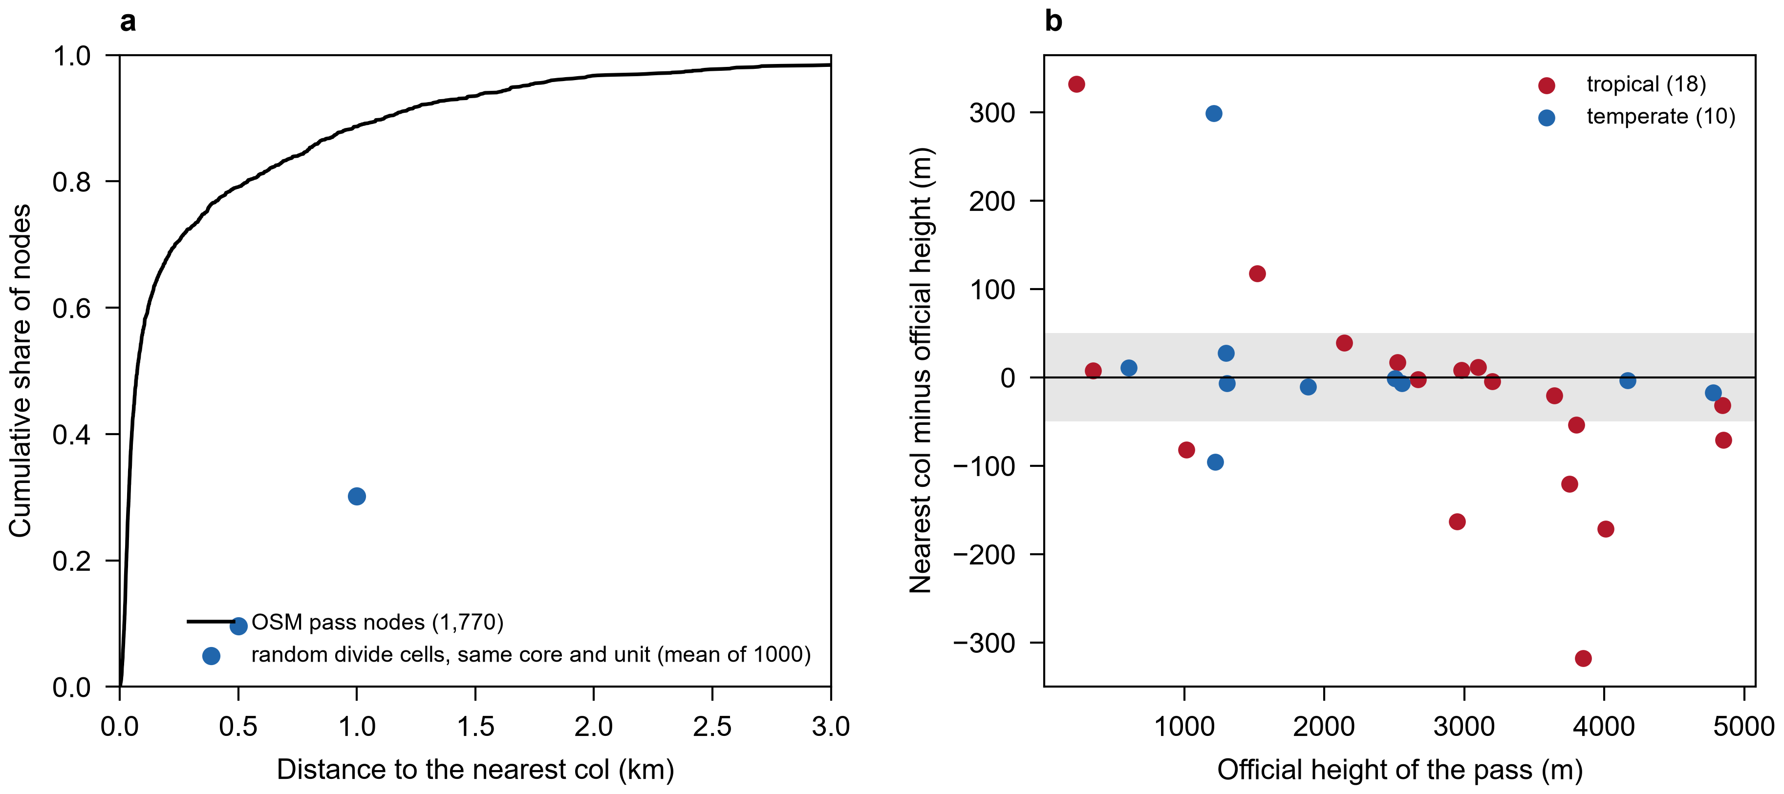
Figure S1. Validation of the census. (a) Cumulative share of OpenStreetMap pass nodes by distance to the nearest col (black), and the mean share of random divide cells of the same block core and unit within 500 m and 1 km (blue). (b) Height of the nearest col minus the official height of the pass, tropical and temperate references; the grey band is 50 m. Tables S3 to S5.
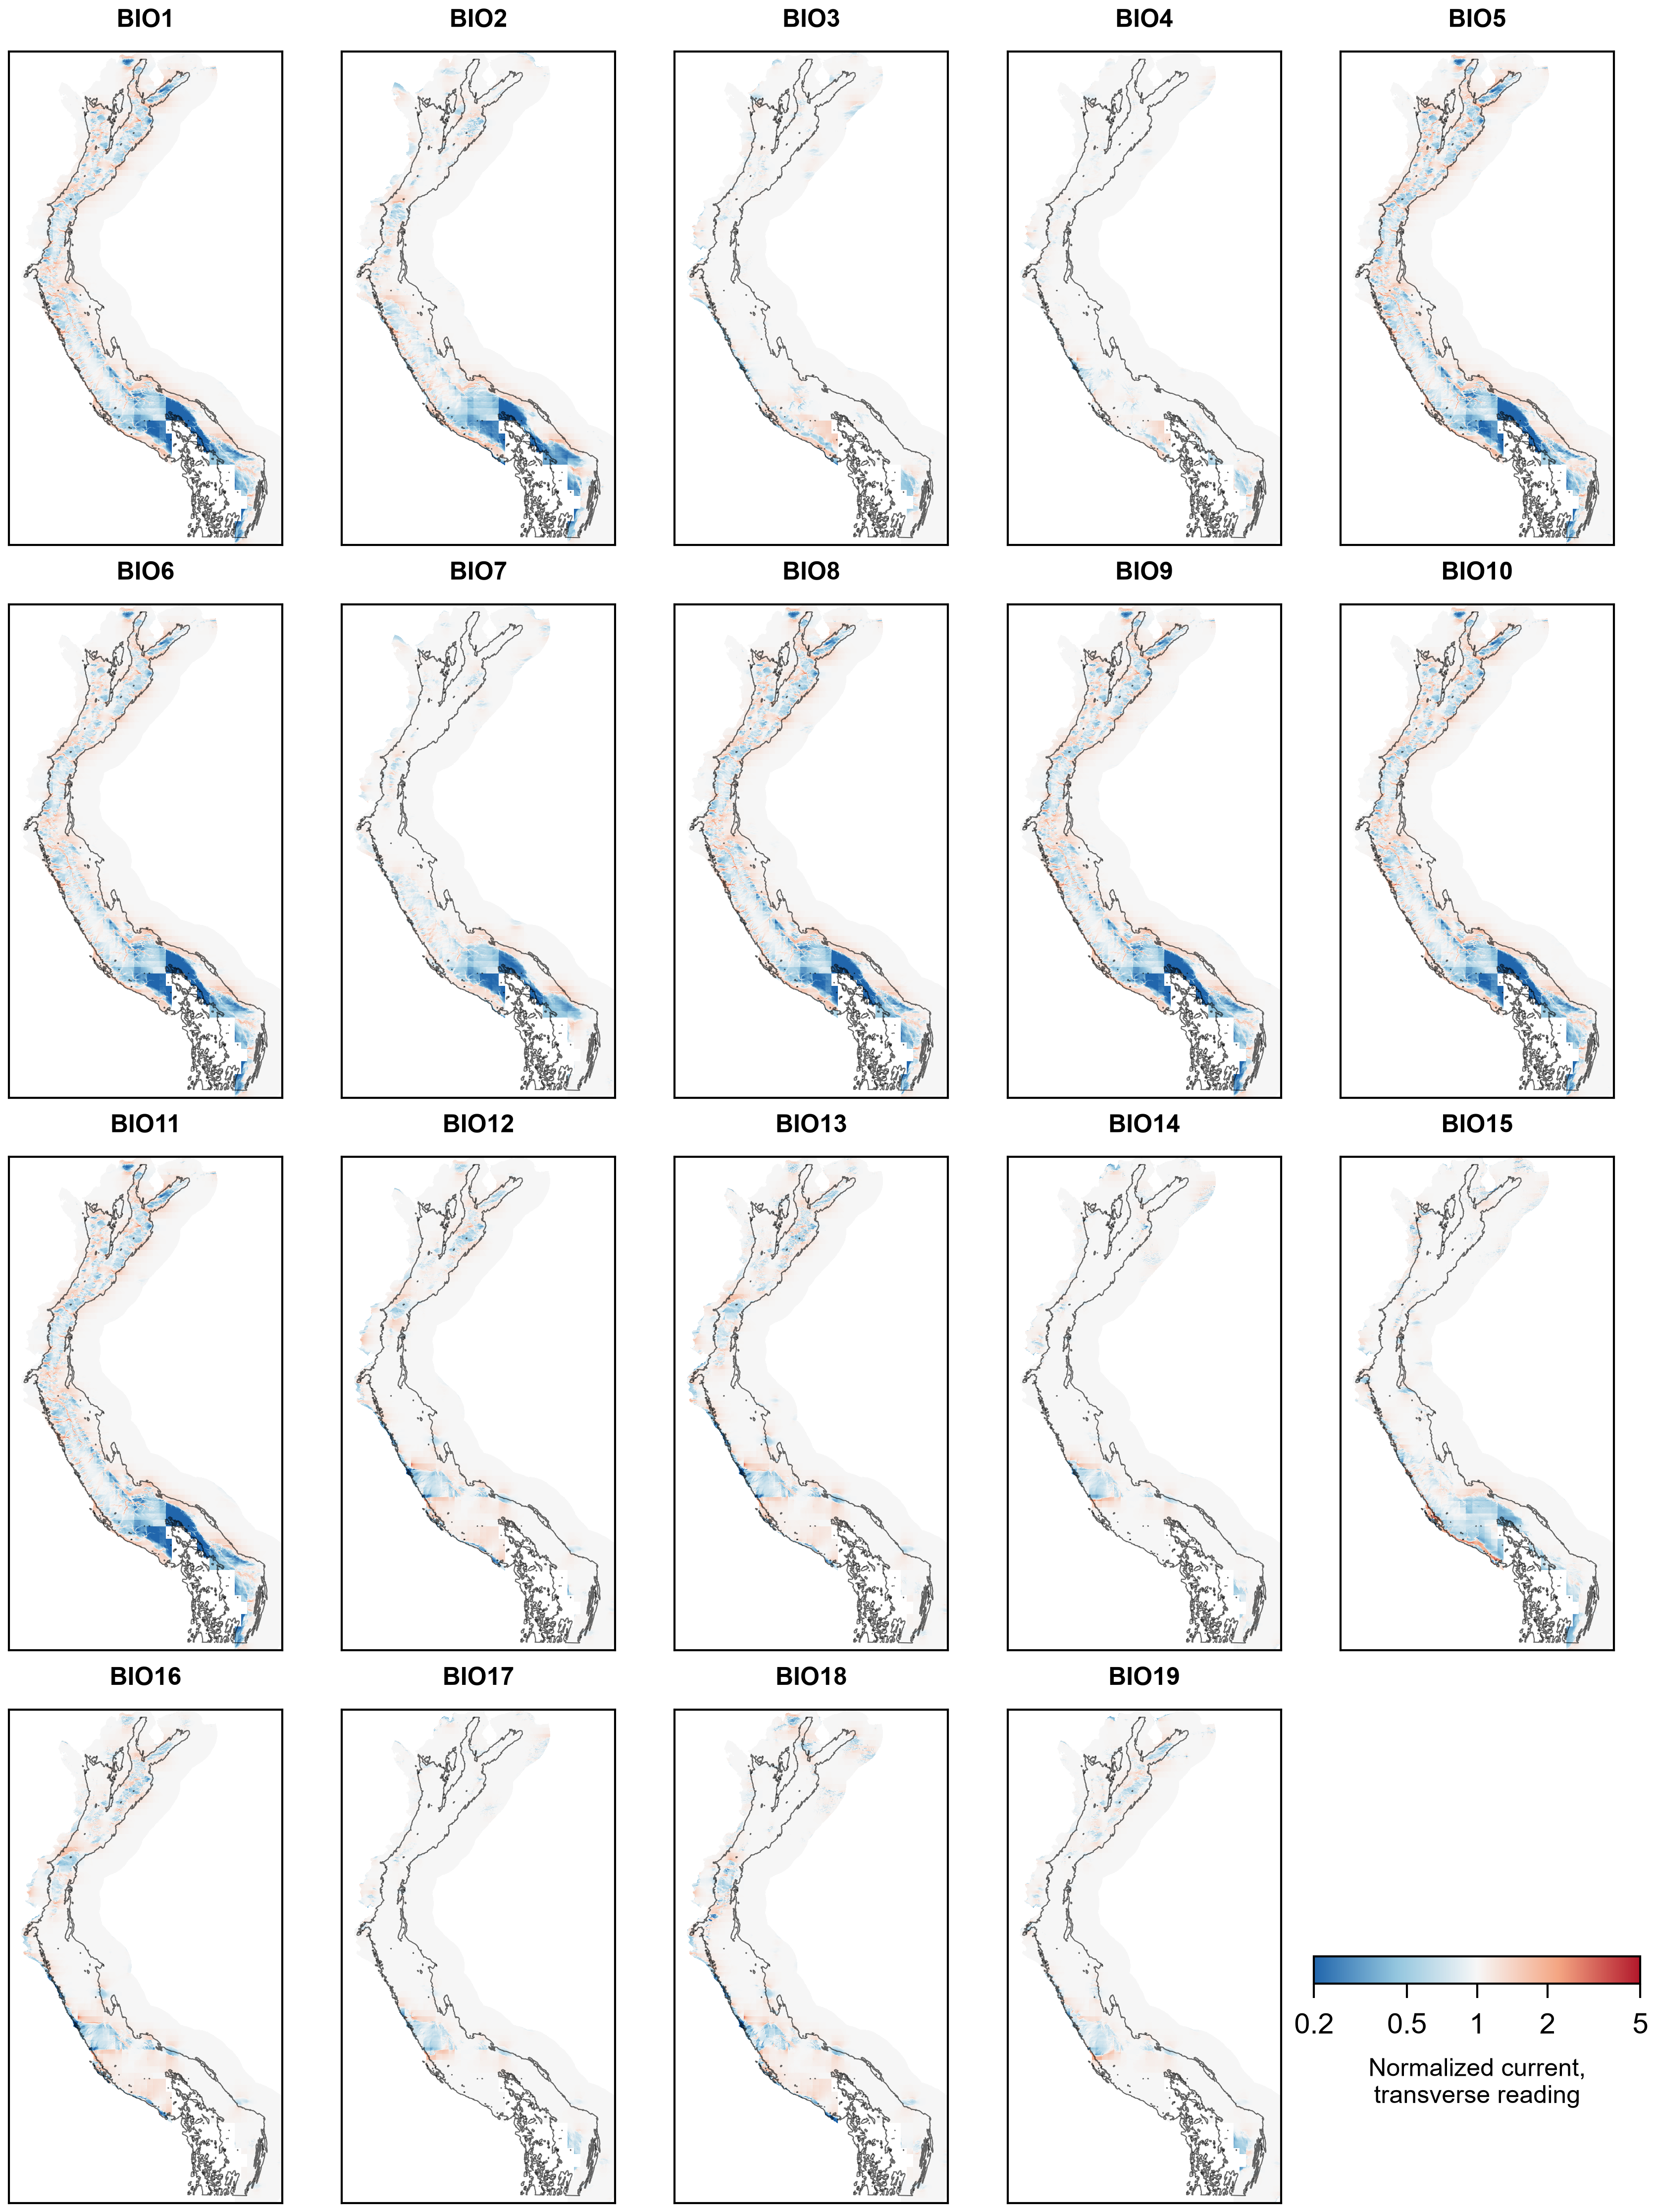
Figure S2. Normalized current in the transverse reading for each of the 19 WorldClim 2.1 variables, main configuration. Colour scale as in Fig. 2.
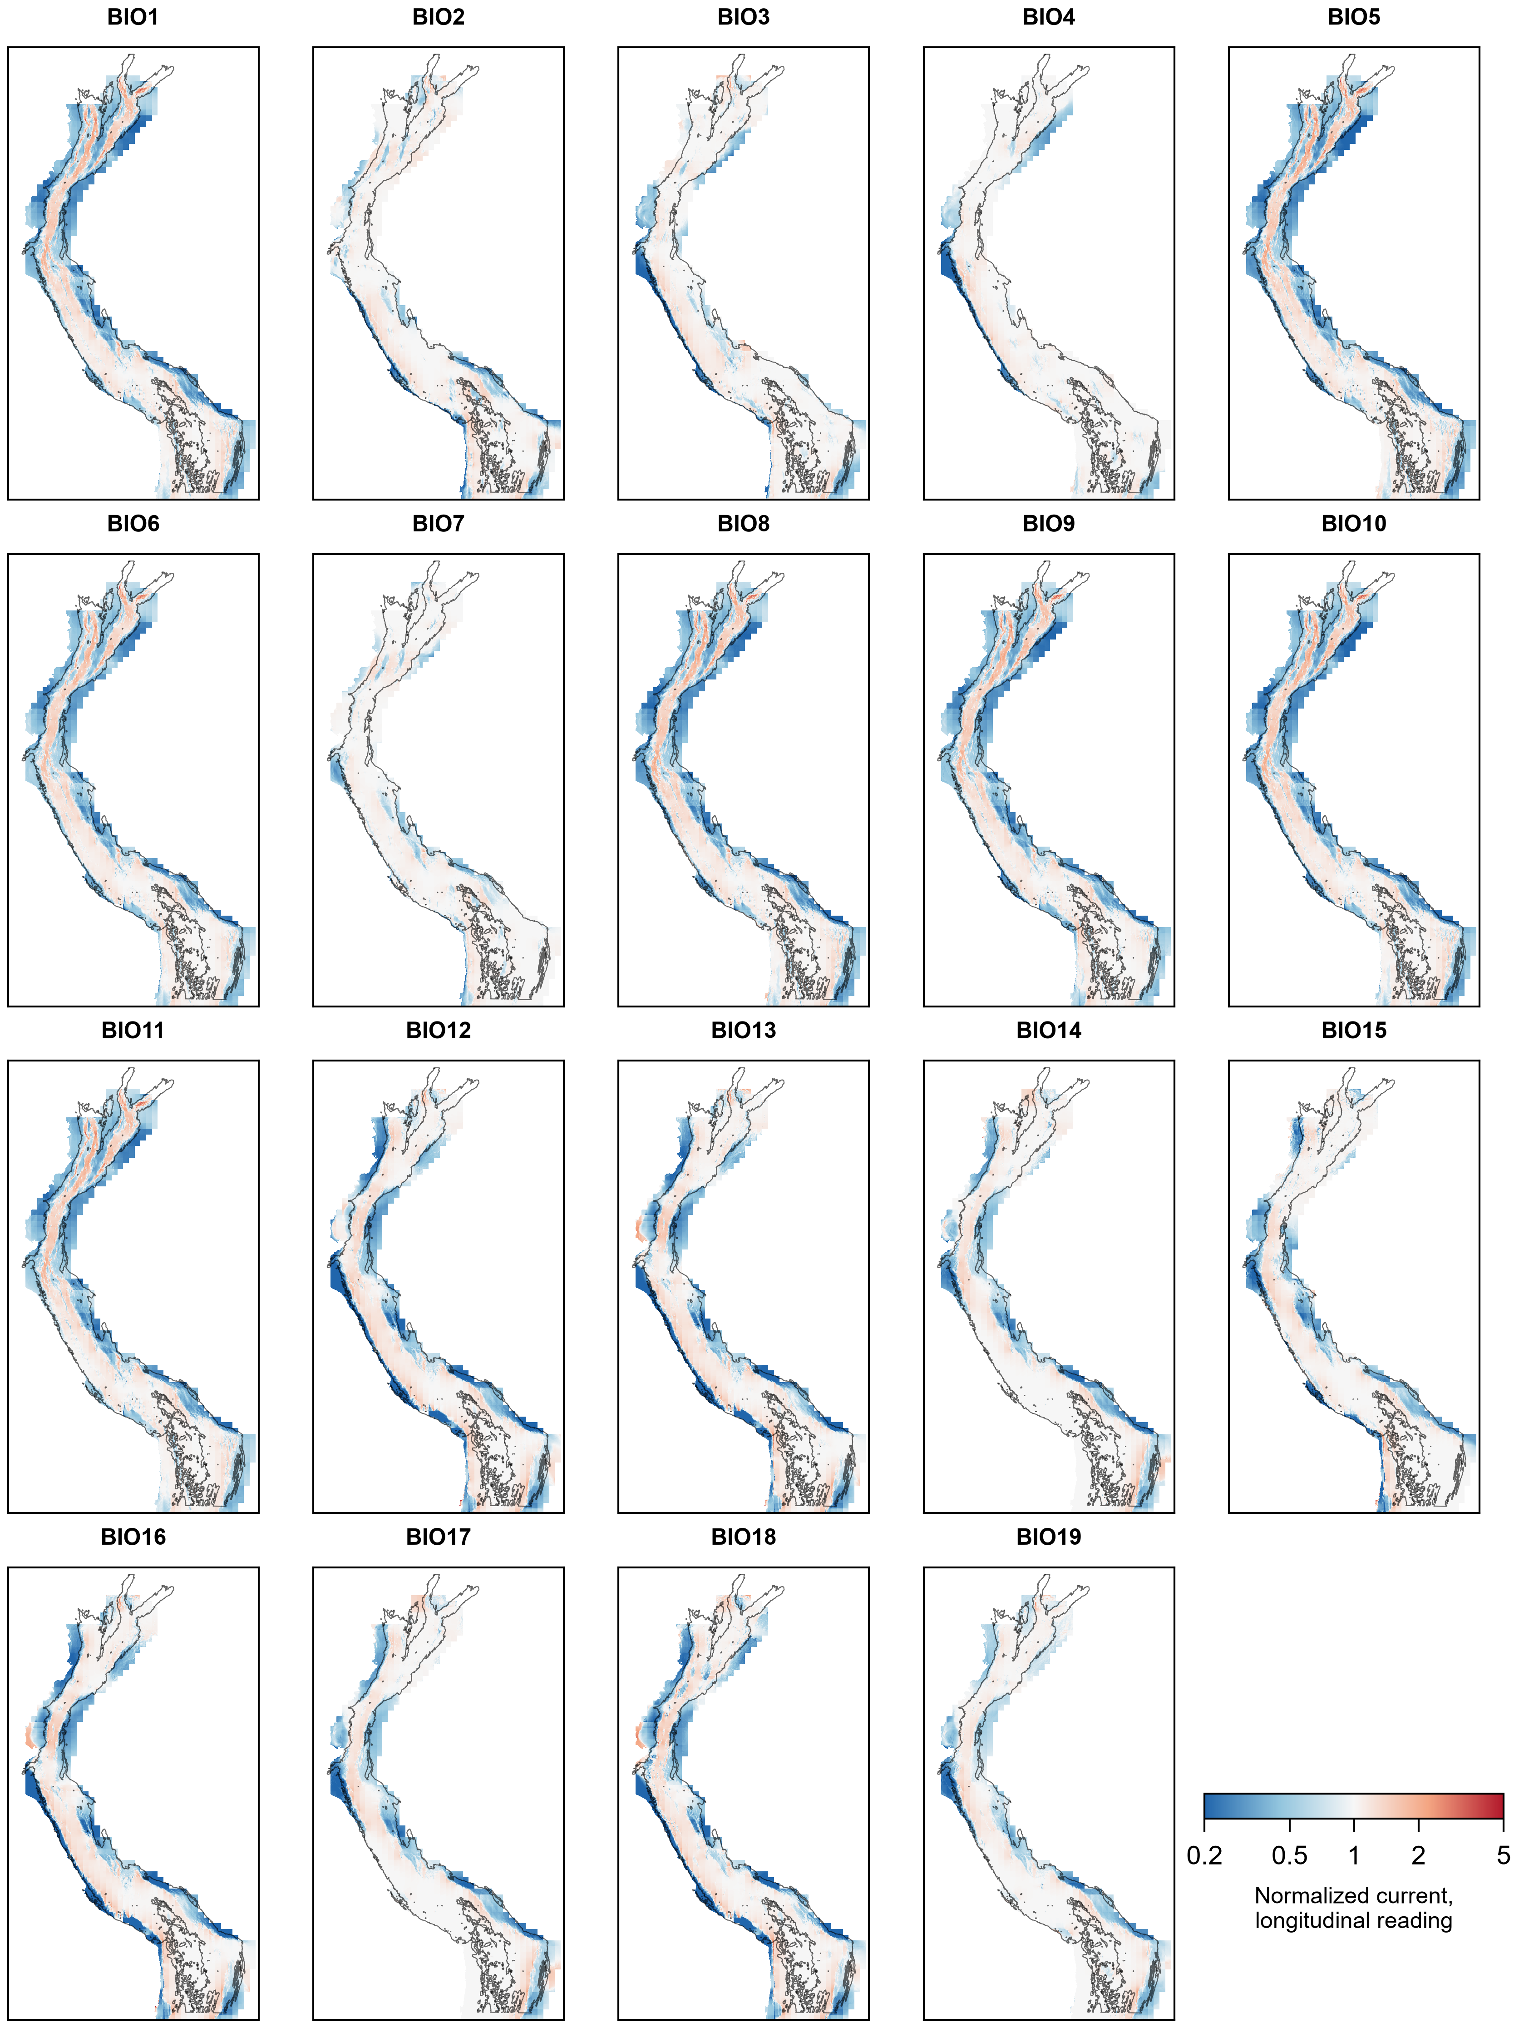
Figure S3. Normalized current in the longitudinal reading for each of the 19 WorldClim 2.1 variables, main configuration. Colour scale as in Fig. 2.
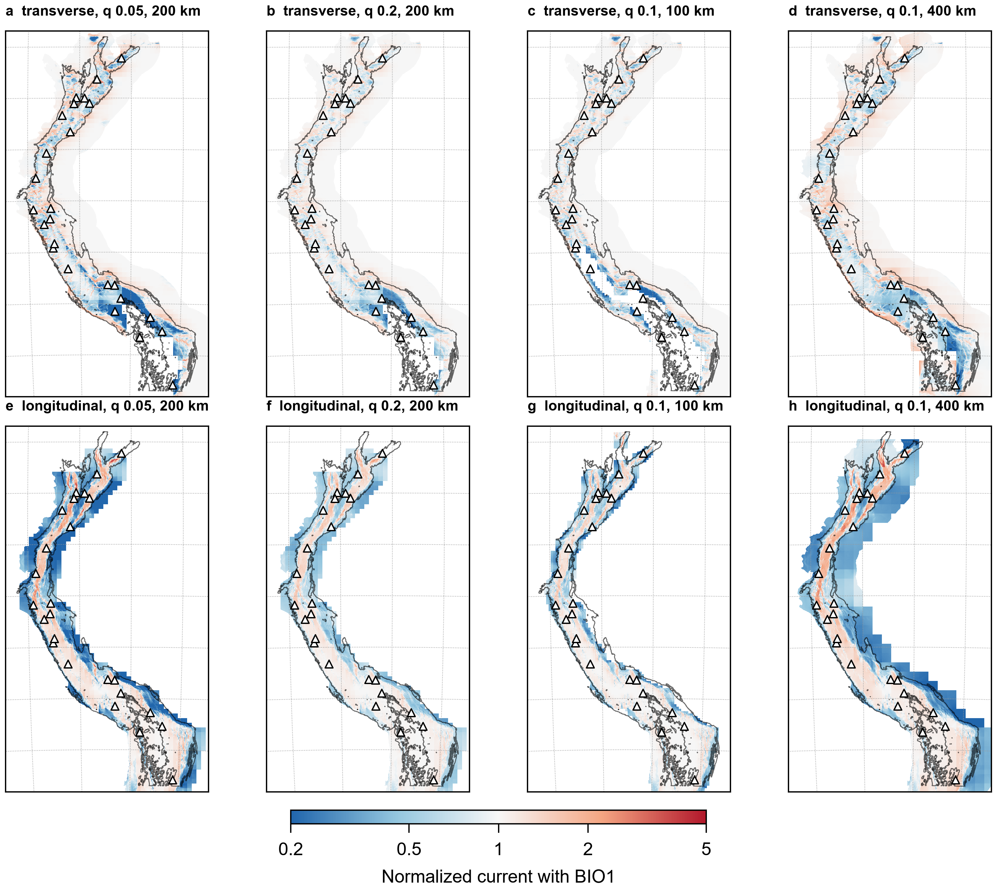
Figure S4. Normalized current with BIO1 in the four sensitivity configurations, both readings: margins q = 0.05 and 0.2 with tiles of 200 km, and tiles of 100 and 400 km with q = 0.1.
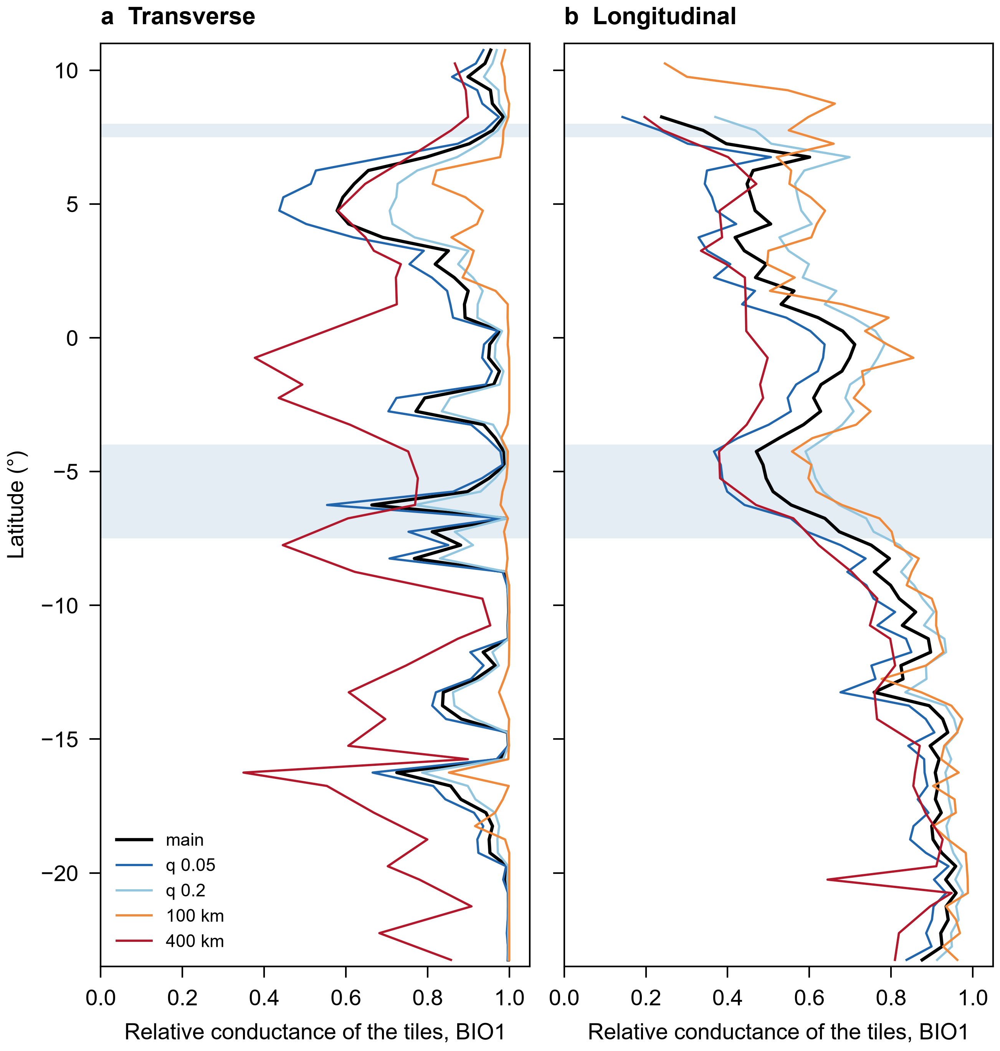
Figure S5. Median relative conductance of the tiles with BIO1 per 0.5° band in the five configurations, both readings. Blue bands mark the Huancabamba zone and the Táchira depression. Table S9.
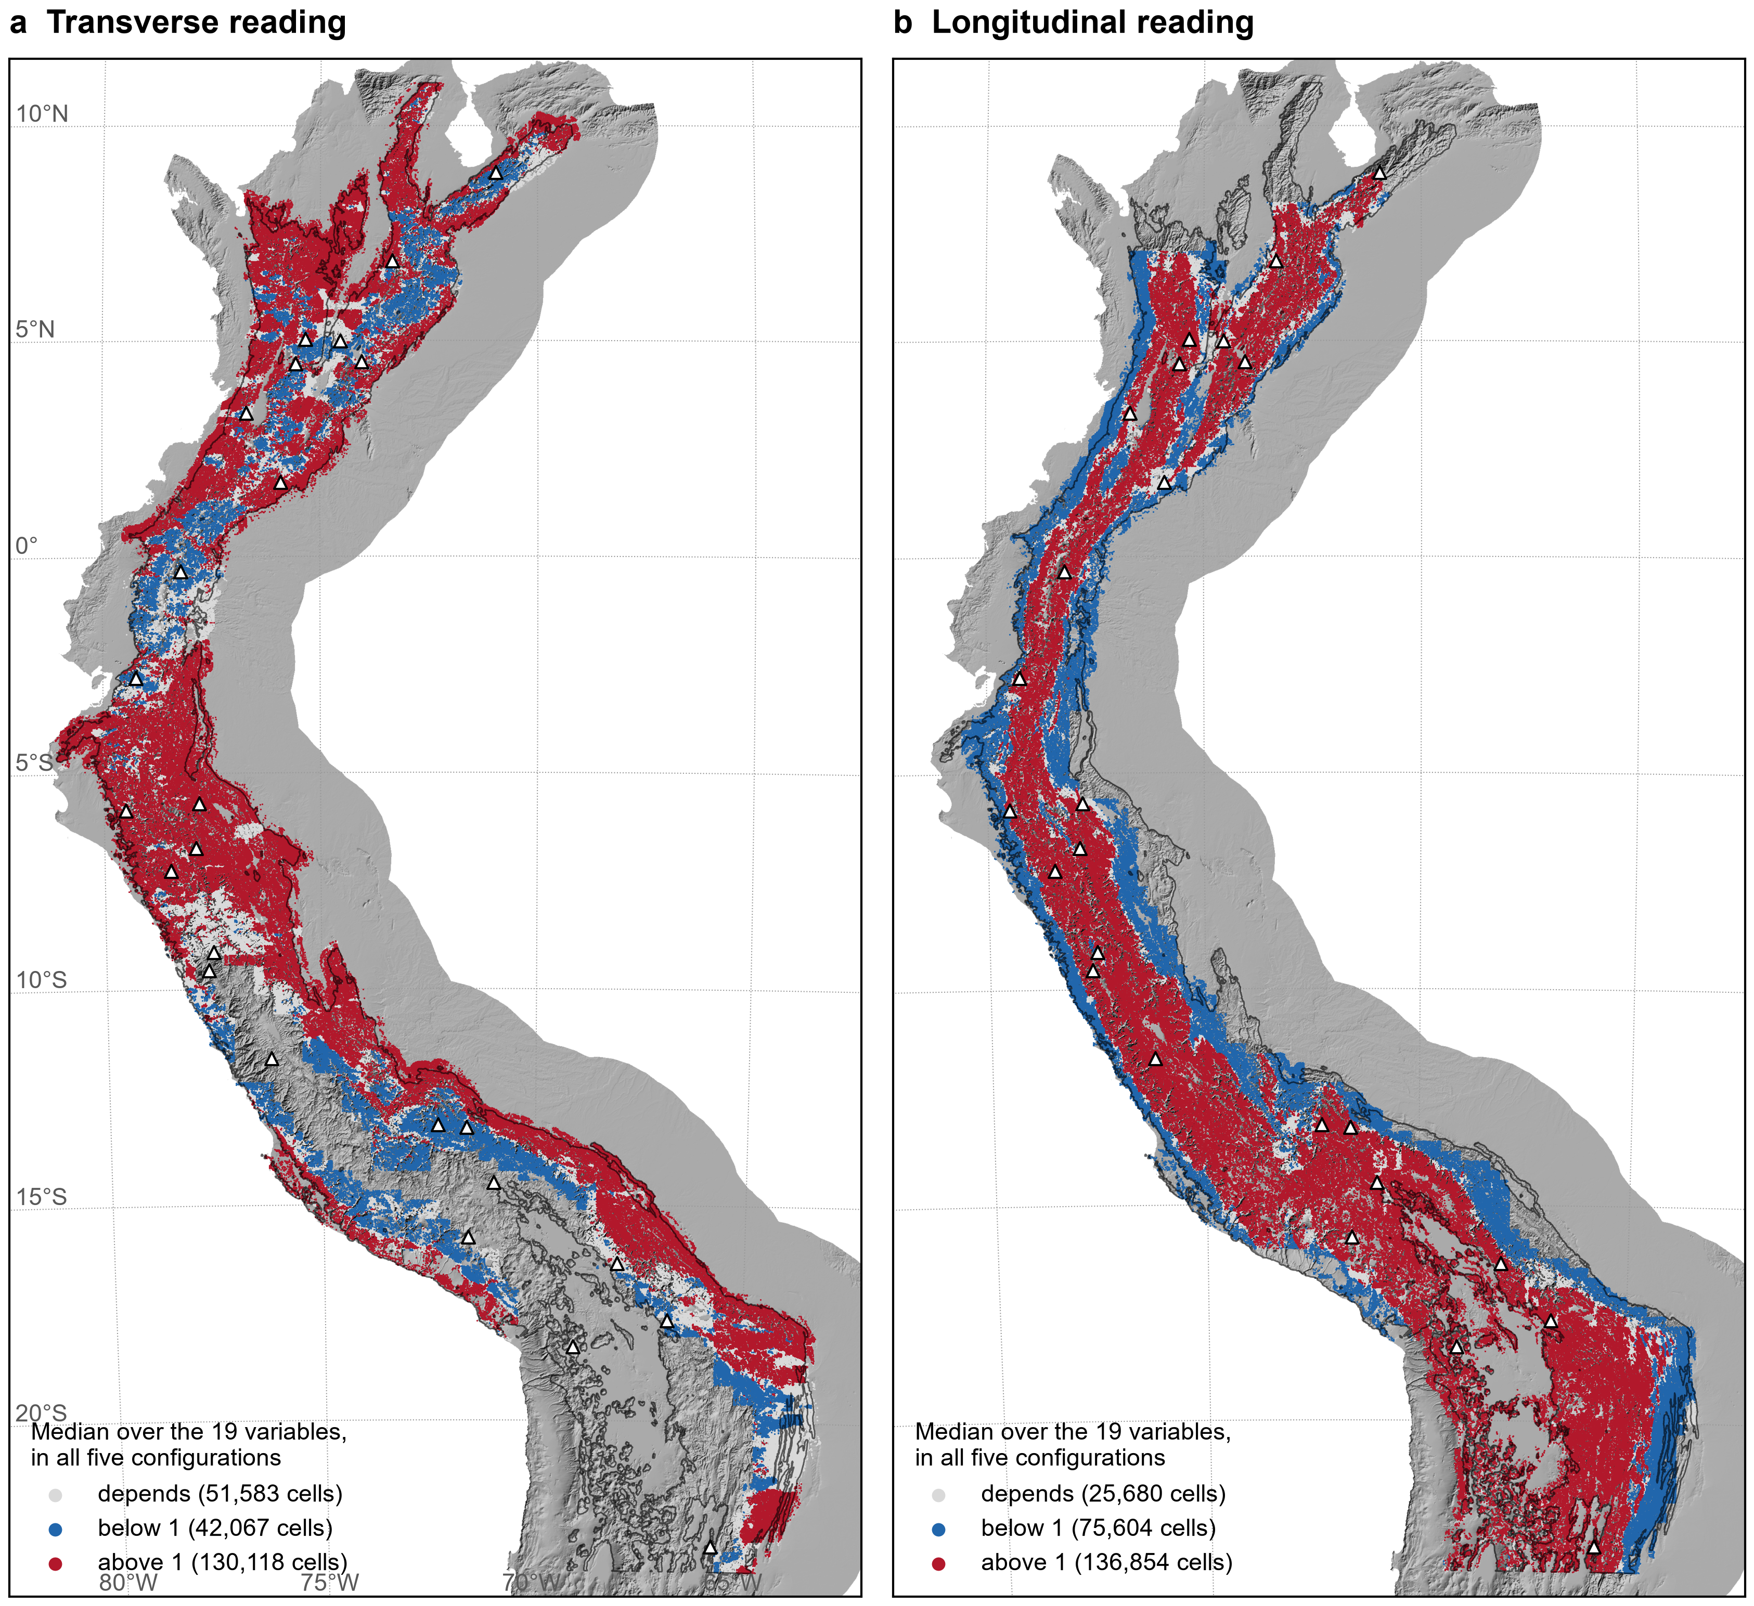
Figure S6. Cells with cols by the median normalized current over the 19 variables: above 1 in all five configurations (red), below 1 in all five (blue), or depending on the configuration (grey). Table S13.
Andean Passes Database (outputs/database/APD_cols.csv.gz). One row per col of the census, with the columns below.
apd_id | identifier of the col in the Andean Passes Database
lat, lon | position of the col (degrees, WGS84)
z_m | height of the col in FABDEM V1-2 (m)
depth_m | depth by prominence along the divide (m)
upper_max_m | height of the higher of the two points that enclose the col (m)
width_m | length of divide below the col height plus 100 m (m); cols with depth of 100 m or more
ring, flat, flat_km2 | col on the rim of a real sink; flat col and area of its flat (km²)
depth_lower_bound | 1 when the lower side reaches the edge of the processing window
lat_a ... lon_b5 | first cells of each side, and the points where each side drains 5 km²
gmba | GMBA v2 unit
sea_a, sea_b, rank | sea or interior reached by each side, and rank (continental, terminal, tributary)
hybas_term_a, hybas_term_b, area_sep_km2 | terminal HydroBASINS basin of each side and separated area (km²)
isolation_km | distance to the nearest lower col with depth of 100 m or more (km)
tropics, cell_1km | 1 for cols between 11°N and 23.5°S; 1 km cell of the connectivity grid
trans_med, longi_med | median normalized current over the 19 variables, transverse and longitudinal, main configuration
trans_min, trans_max, longi_min, longi_max | range over the 19 variables, main configuration
*_med_q005, *_med_q02, *_med_100km, *_med_400km | median in each sensitivity configuration
trans_robust, longi_robust | above 1 or below 1 in all five configurations, or depends

