Project: Midterm
By Todd Irwin

Data Analytics Midterm Project
Excel
1. Dataset Selection and Import
- Select Your Dataset:
  - Choose a dataset that interests you and has potential for meaningful analysis.
As a diver that has been in the water with lemon and hammerhead sharks, I find the subject matter very interesting.
  - Document why you selected this dataset and what business questions you hope to answer.
I hope to review trends based on region, age and sex.

- Dataset Documentation:
  - Column name
  - Data type
  - Brief description of what the data represents
  - Potential business value of this data point
  - Create a table that documents each column in your dataset:
Column Name | Type | Description | Note
Case Number | TEXT | Unique ID, Not Null | Unique ID in dataset
Date | TEXT | Report date, Variable
Year | INTEGER | Year of attack | Can be used as data point, Contains null values
Type | TEXT | Unprovoked/Provoked | Can be used as data point, Contains UNKNOWN values
Country | TEXT | Country, All Caps | Can be used as data point
Area | TEXT | Region of country, Proper | Can be used as data point, Contains null values
Location | TEXT | Location detail, Variable
Activity | TEXT | General activities involved | Can be used as data point, Contains null values
Name | TEXT | Name of victim
Sex | TEXT | Sex of victim | Can be used as data point, Contains null values
Age | TEXT | Age of victim | Can be used as data point, Contains null values
Injury | TEXT | Description of injury
Fatal (Y/N) | TEXT | Boolean, Y/N | Can be used as data point, Contains UNKNOWN values
Time | TEXT | Reported time of attack, Variable
Species | TEXT | Reported species of shark | Can be used as data point, Contains null values
Investigator or Source | TEXT | Source for report
pdf | TEXT | PDF of report
href formula | TEXT | href formula
href | TEXT | href
Case Number2 | TEXT | Case Number2, Contains Char
Case Number3 | TEXT | Case Number3, Contains Char
original order | INTEGER | Sequence of incident in data | Unique ID in dataset

- Initial Data Assessment:
  - Identify potential data quality issues (missing values, duplicates, inconsistent formatting).
I found the data to be inconsistent and missing values. The data contains reports from the last century or more of shark attacks. I do not foresee there being duplicates of incidents, however there are incidents that include multiple victims. Any analytic determinations will be approximations given the data presented per unique case number.
  - Document the data quality issues you'll need to address.
I had to input additional values based on details provided in injury detail column.
  - Create a plan for cleaning each issue you've identified.
I have filtered each column looking for consistent values. Filtering for BLANKS, I reviewed the details for additional fillable information. I highlighted the modified cells in YELLOW for future reference.
2. Data Cleaning and Transformation
Not all cleaning operations will be necessary for any given data set. This list is just for your reference to understand what may need to happen.
- Handle Missing Values: Identify missing data cells, select appropriate strategies (deletion/imputation), document your reasoning, and implement the chosen methods.
I kept all row values and left null values.
- Fix Inconsistent Formatting: Standardize text (case, spaces, special characters), ensure consistent date and numeric formats, and use appropriate Excel functions when needed.
Removed the space after Sex and Species in the column header.
- Remove Duplicates: Identify duplicate records, handle them appropriately, and document your process and rationale.
There are no duplicate case numbers, however I am unable to account for victim count without reviewing manually and creating a new column. For this analysis, I am counting incidents and not victims. The data would need to be reworked for additional granular data.
- Document Your Process: Maintain clear records of all data cleaning decisions, including strategies used and reasoning behind each approach.
All modified cells have been highlighted in the attacks_clean data set. Updates were completed using available data from that incident. Ages were rounded up and average age was added based on word description of victim.
- Validate Results: After cleaning, verify data integrity by checking that all issues have been resolved and that the cleaned dataset maintains its analytical value.
I have identified the key columns that have quantifiable attributes for my analysis.
3. Pivot Table Analysis
- Create Basic Pivot Tables:
  - Create at least 3 different pivot tables that provide different views of your data.
attacks_by_country
fatality_count_by_sex
attacks_by_type
attacks_by_activity

  - Each pivot table should answer a specific business question.
attacks_by_country - View incidents county by country
fatality_count_by_sex - View fatality count by sex
attacks_by_type - View incidents by type
attacks_by_activity - View incidents by activity group

- Pivot Table Analysis:
  - The business question it answers
I am able to quantify the total number of incidents by country, as well as drill down into demographics and activity data.

  - The key insights revealed

The USA has had more recorded incidents than Australia, however Australia has had more fatalities (USA 256 vs AUS 345).

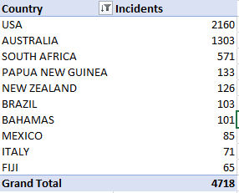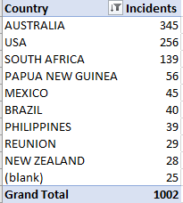
Fatalities are more common among males with an average age of 27.
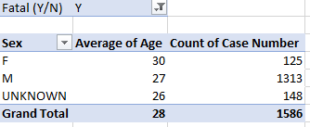
Majority of incidents are unprovoked.
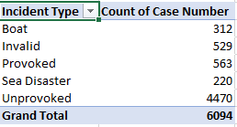

Swimming the most common activity involving fatalities with 33%.
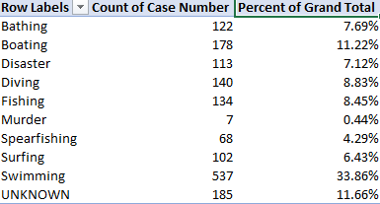

  - How this information could inform business decisions
This information could help with targeting key demographics, locations and activities where incidents occur. Education and marketing campaigns can better target key location to help prevent future incidents.

  - For each pivot table, write a paragraph explaining:

attacks_by_country

The attacks_by_country pivot is meant to provide insight into the location of shark related incidents. I have limited the results to top 10 due to the report being a global combination of all shark related events for over a century.

fatality_count_by_sex

The fatality_count_by_sex pivot breakdown the occurrence of a fatality by sex and average age of the dataset. The average age only represents data where the age was provided in the report. The most interesting data point in this pivot is that males make up 83% of the total fatalities globally.

attacks_by_type

The attacks_by_type pivot demonstrates the general activity that was involved. More importantly, it breaks down the interaction level with the shark. The key takeaway here is that 73% of all incidents are unprovoked.

attacks_by_activity

The attacks_by_activity uses data that manually input based on the activity data that was provided. The original data was unconstrained and contained too many variables. I limited the results to 10 groups. Of note in this data, are the recorded incidents with Alcatraz escapees, asylum seekers and murder victims.

- Combined Analysis:
  - Create a worksheet that combines both visualizations and pivot tables.
  - Show how the different analyses complement each other.
  - Save your analysis as "ProjectName_Analysis.xlsx"

4. Data Visualization in Excel
- Create Basic Visualizations:
  - Create at least 3 different types of charts/graphs from your data.
- Format Visualizations:
  - Clear, descriptive title
  - Properly labeled axes
  - Appropriate color scheme
  - Legend (if needed)
  - Data labels or tooltips as appropriate
  - Ensure each visualization has:
- Visualization Analysis:
  - What the visualization shows
  - What business insights can be derived
  - For each visualization, write a 2-3 sentence description of:

The following data visualization can be filtered using a slicer for Sex and Fatality.
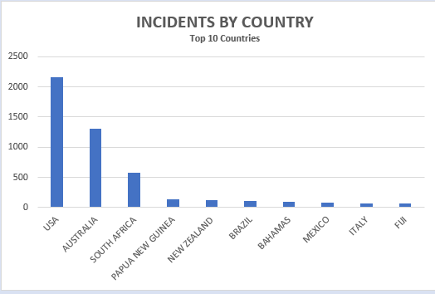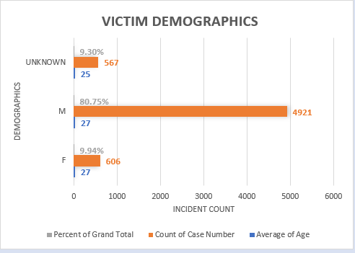
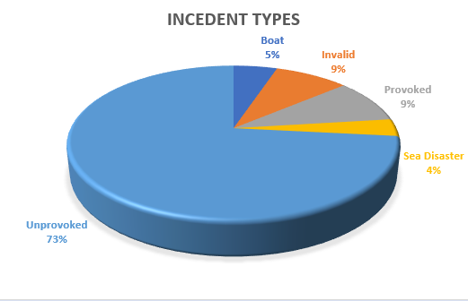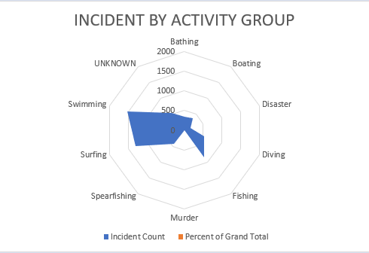

SQL
5. Data Import
- Data Import:
  - Import your cleaned data into your database tables
  - Verify data integrity after import
- Data Verification:
  - Write queries to verify row counts match your original dataset
  - Check for any data type issues or constraints that need addressing
There is a duplicate “original order” # that created a unique values error.
6. Exploratory Query Analysis
- Exploratory Queries: Develop at least 3 basic queries specifically designed to explore potential routes for analysis in your data.
  - Count of records meeting specific criteria
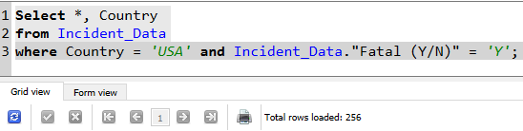
Filtered excel table:
  - Sum or average of numeric fields with grouping
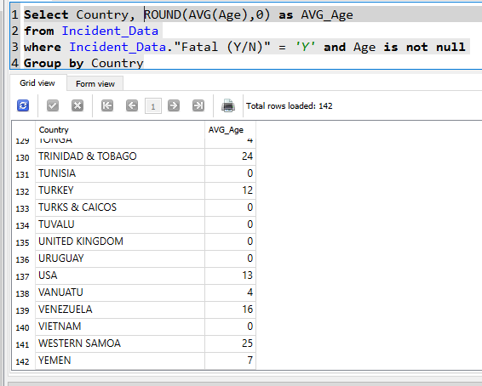
  - Identification of minimum/maximum values
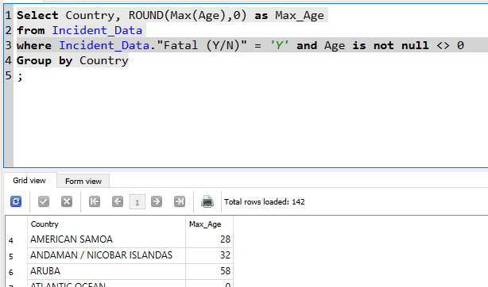
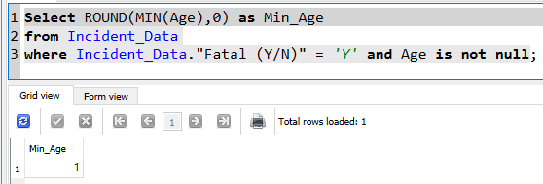

  - Date-based filtering and analysis
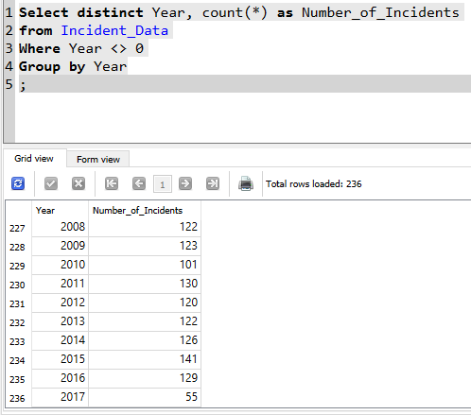

  - Text pattern matching using LIKE
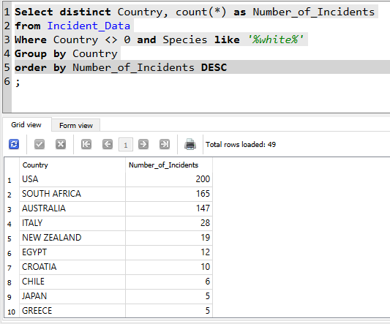
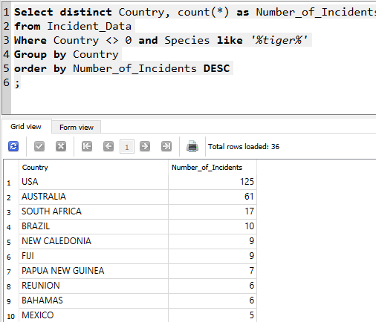
  - Example Queries
Select Country, count() as Incidents, ROUND(AVG(Age),0) as AVG_Age
from Incident_Data
where Incident_Data."Fatal (Y/N)" = 'Y' and Age is not null and Country is not Null
Group by Country
Order by Incidents DESC
Limit 10
;
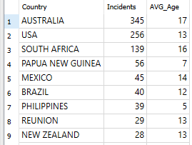

Top 10 results by activity group and country with total count of incidents.
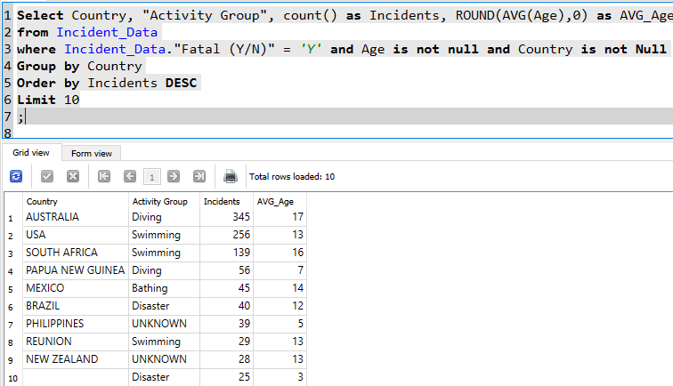

7. Business Query Analysis
- Business Insight Queries: Develop at least 3 advanced queries specifically designed to answer key business questions related to your dataset.
  - Time-series analysis (trends over time)
  - Cohort analysis (grouping related records)
  - Ranking and percentiles
  - Running totals or moving averages
  - Complex filtering with multiple conditions

  - Example Queries:
Top 5 years (Fatal & Non-Fatal) result for incidents and locations.
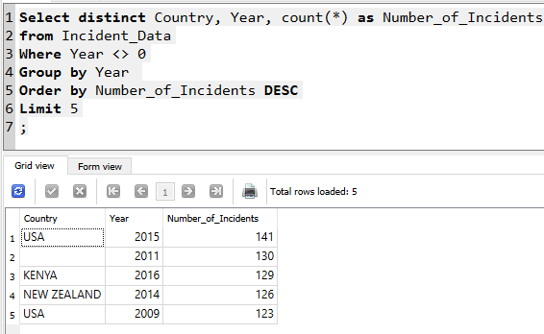

Top 10 results by activity group, sex and country with total count of fatal incidents.
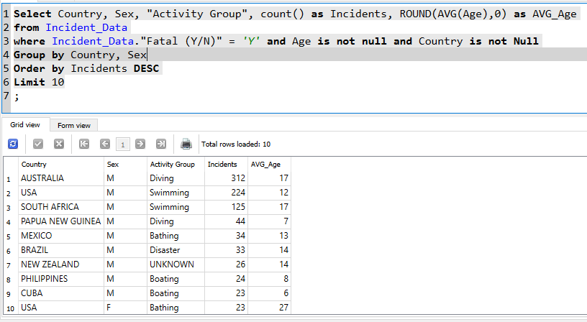

#/ Top 10 results by country and year by total count of fatal incidents.
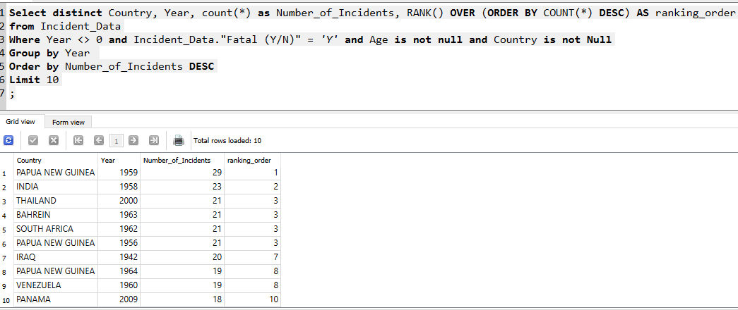

8. Documentation and Insight Reporting
- Comprehensive Query Collection:
  - Compile all your queries into a single SQL file with clear comments
  - Organize queries as either “Exploratory” or “Business”
  - Include sample result sets for each query
  - Save as "ProjectName_Queries.sql"
- Query Documentation: Document your queries in preparation for the SQL Analysis Report described below.
  - Describe your queries and Include sample result screenshots for each query
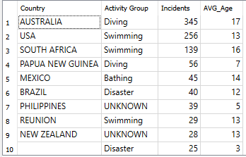
Top 10 results by country, activity, sorted by number of fatal incidents with average age. This query points out the top activities associated with fatal shark attacks and the average age of the victims.
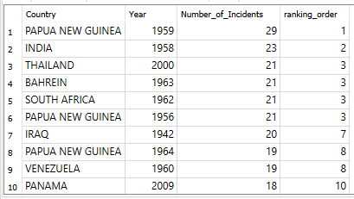
Top 10 results grouped by year for fatal shark attacks. The data shows that the fatal shark attacks have decreased significantly over the past 50 years, with 2000 & 2009 being the outliers.
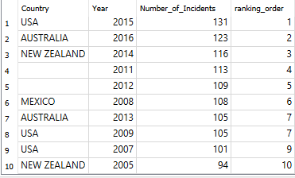
Alternatively, the above table shows the non-fatal attacks grouped by year and number of incidents. The greatest number of non-fatal incidents occurred between 2012 & 2015.
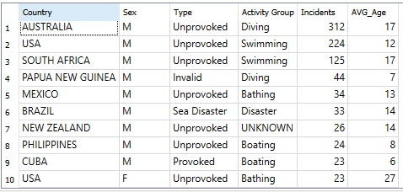
The above table shows fatal incidents grouped by country and sex. The additional data points give the count, average age of victim and what associated activity. In this data, the at risk demographics and locations are presented. Teenage males swimming and diving in Australia, USA and South Africa are at the highest risk of a fatal shark attack.
  - Summary of the types of analysis performed
I reviewed the available data for discernable trends using age, sex, location and types of activities at time of interaction with the shark.
  - Top significant insights discovered
I was surprised to see the highest count of incidents occurred in the USA. The USA had the second highest volume of fatal shark incidents followed by South Africa.
I found that the most common demographic involved in fatal incidents were teen males that were swimming or diving, while surfing did not make the top 10. Therefore, surfing is actually a relatively safe activity when compared to other beach activities such as swimming, diving and fishing.
  - Paragraph explanation of how these insights could inform business decisions
This information could be used by marine biologist, governments and water sport enthusiast to better understand the top risk locations. The additional data pertinent to specific activities and ages helps for creating education campaigns for the at-risk groups.

9. Data Analysis Report
Comprehensive analysis report that demonstrates both your technical Excel & SQL skills and business analysis capabilities.
- Dataset Introduction:
  - Source of the data
Shark Attacks – Kaggle https://www.kaggle.com/datasets/gauravkumar2525/shark-attacks
  - Size (number of tables and approximate records)
1 sheet, 6094 rows
  - General subject matter (e.g., "retail sales data," "healthcare patient records")
Global Shark Attack Data
- Analysis Objectives:
  - Business questions being investigated
Investigating the trends associated with shark attack fatalities.
  - Patterns or trends the analysis hopes to uncover
The final results would show demographic, location and activities that are the highest risk.
  - Specific hypotheses being tested with the data
Does Australia lead in the fatal shark attacks and what activities are involved.
- Analytical Approach and Findings:
  - Brief overview of methods used
The data included text descriptions in fields. Several columns required zero cleaning, such as Type, Country, Area, Sex and Fatal (Y/N). I did need to manually review the activity column. The text was highly variable. I search for key words and input an additional column [Activity Group]. I found that the additional insight gained by drilling down into the activities was worth the additional manual input.
  - Query explanations and insights
The queries that I created were focused on revealing trends over time, activities, demographics and locations. I was able to gain drill down into the highest risk activities and demographics to make overall recommendations.

- Business Recommendations:
  - Strategic suggestions based on your complete analysis
This data shows definitive trends that span over the last century around the world. There is still room for improving the data. The date information was not constrained upon entry and will need additional manually manipulation.
  - Actionable insights for stakeholders derived from your findings
The demographic trends combined with locations could inform local governments and their shark attack prevention campaigns. The data also provides definitive proof that most fatal shark attacks are unprovoked and occur when diving/swimming in Australia, USA and South Africa.

