Mock Test (Assignment 4) - PRN: 25070126076

Problem 1
Field | Details
Problem ID | 136
Problem Name | Single Number
Difficulty | Easy
Submission Date | 2026-09-28
Accepted Submission Screenshot | 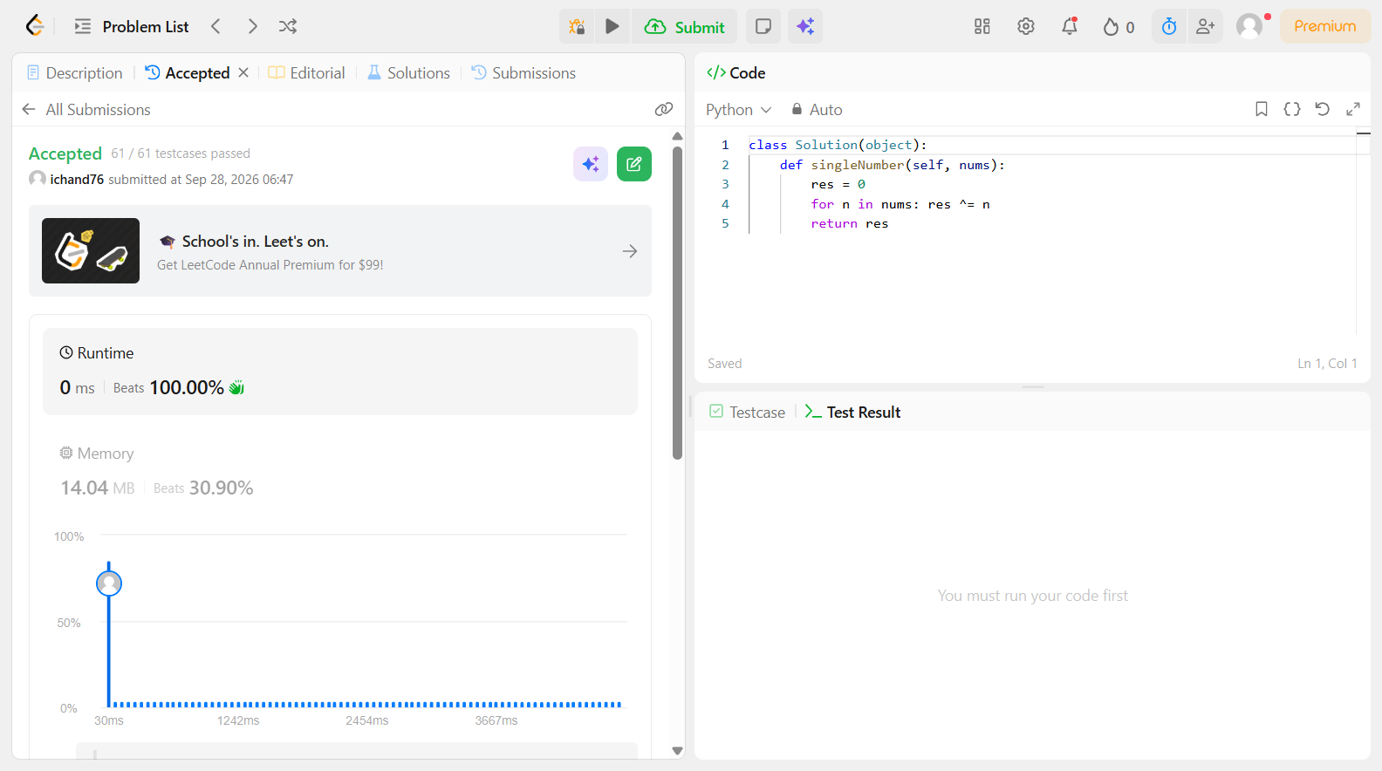

Problem 2
Field | Details
Problem ID | 389
Problem Name | Find the Difference
Difficulty | Easy
Submission Date | 2026-09-28
Accepted Submission Screenshot | 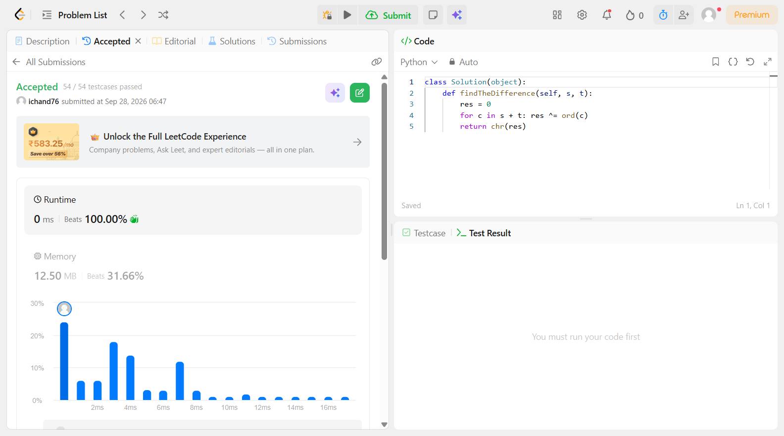

Problem 3
Field | Details
Problem ID | 258
Problem Name | Add Digits
Difficulty | Easy
Submission Date | 2026-09-28
Accepted Submission Screenshot | 