Assignment 1
Name: Ishaan Chand
PRN: 25070126076
Division: A
Batch: A3

Problem 1
Field | Details
Problem ID | 1
Problem Name | Two Sum
Difficulty | Easy
Submission Date | 2026-09-28
Accepted Submission Screenshot | 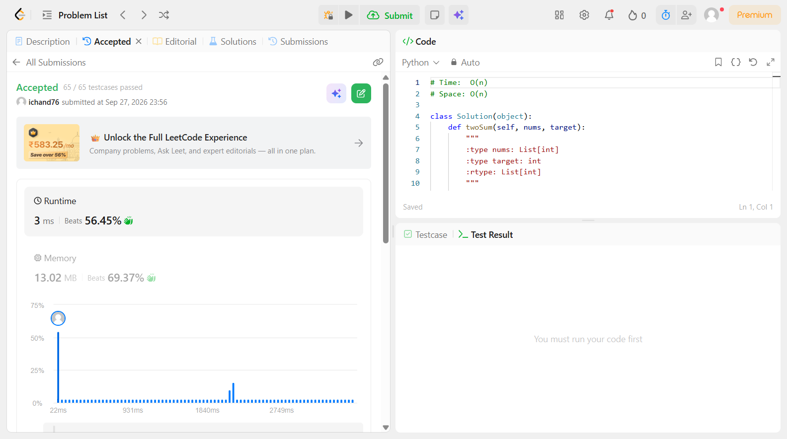

Problem 2
Field | Details
Problem ID | 13
Problem Name | Roman to Integer
Difficulty | Easy
Submission Date | 2026-09-28
Accepted Submission Screenshot | 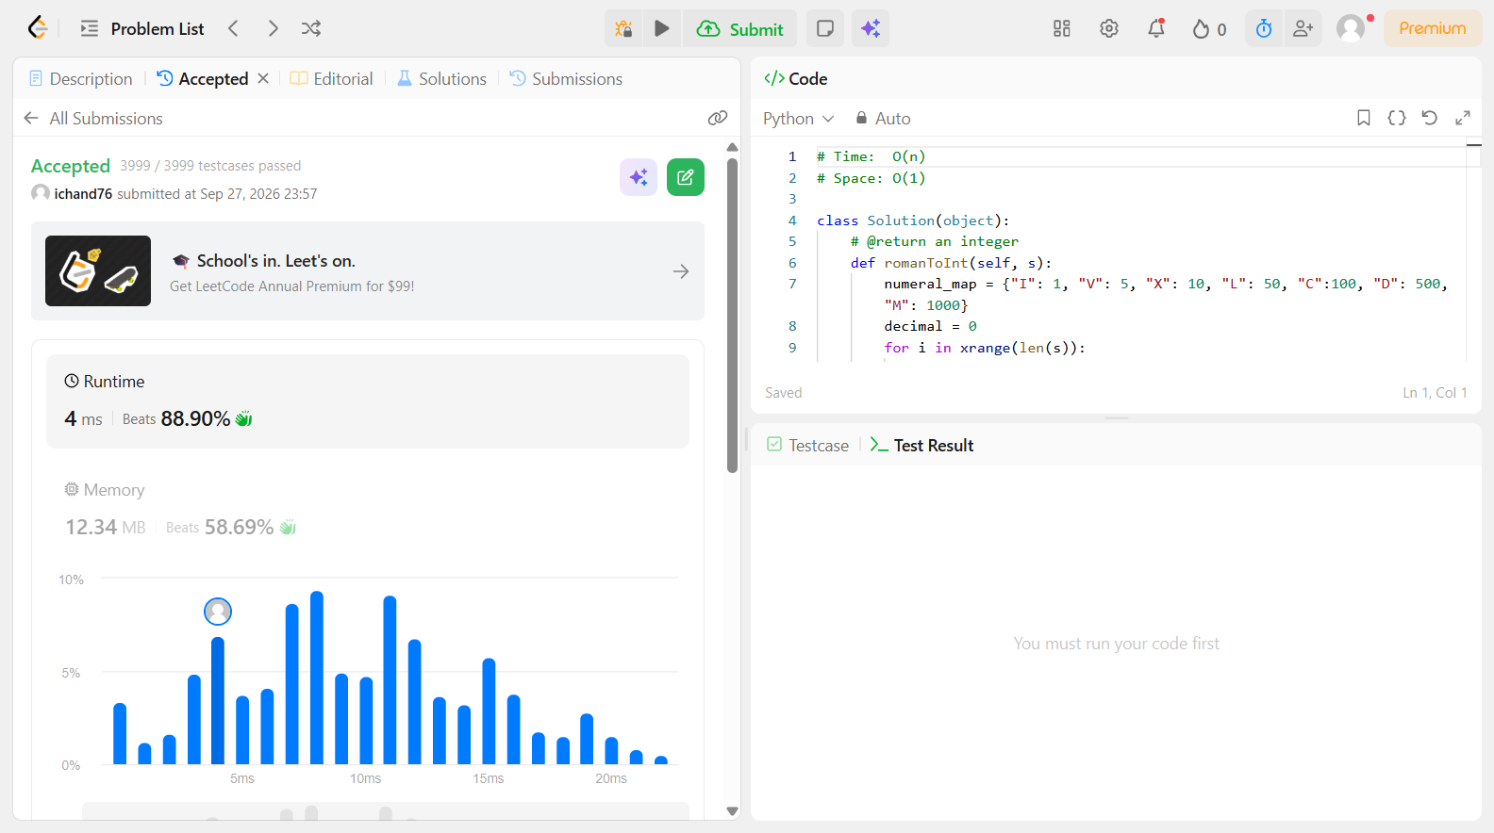

Problem 3
Field | Details
Problem ID | 14
Problem Name | Longest Common Prefix
Difficulty | Easy
Submission Date | 2026-09-28
Accepted Submission Screenshot | 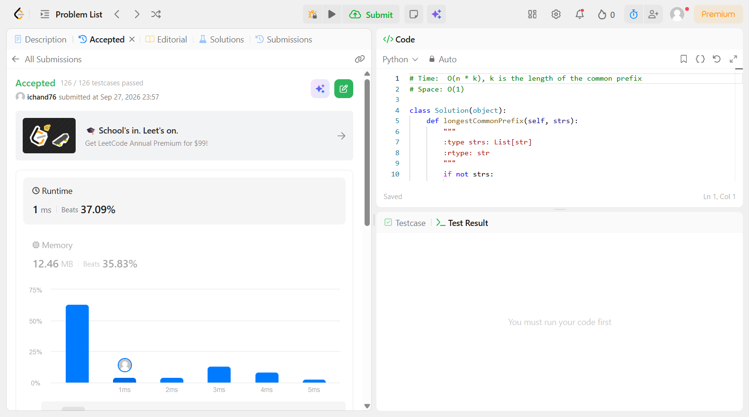

Problem 4
Field | Details
Problem ID | 20
Problem Name | Valid Parentheses
Difficulty | Easy
Submission Date | 2026-09-28
Accepted Submission Screenshot | 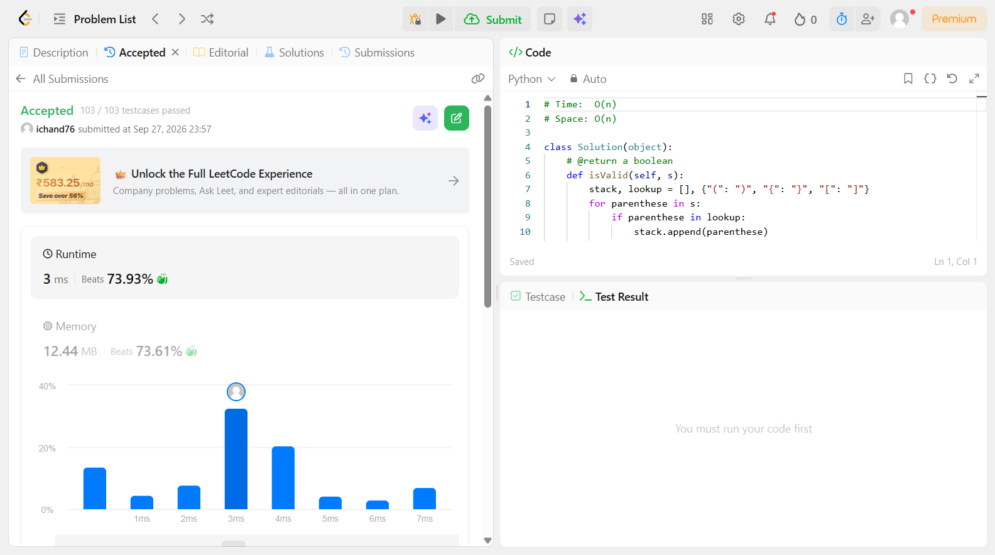

Problem 5
Field | Details
Problem ID | 26
Problem Name | Remove Duplicates from Sorted Array
Difficulty | Easy
Submission Date | 2026-09-28
Accepted Submission Screenshot | 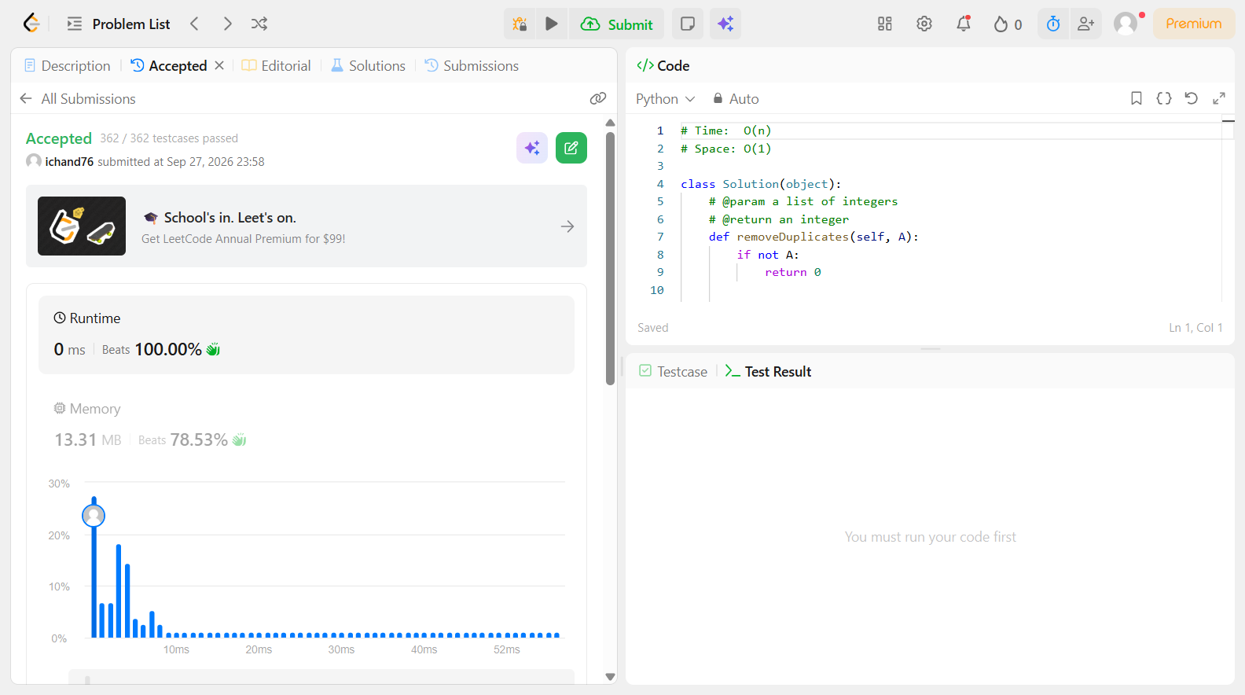

Problem 6
Field | Details
Problem ID | 27
Problem Name | Remove Element
Difficulty | Easy
Submission Date | 2026-09-28
Accepted Submission Screenshot | 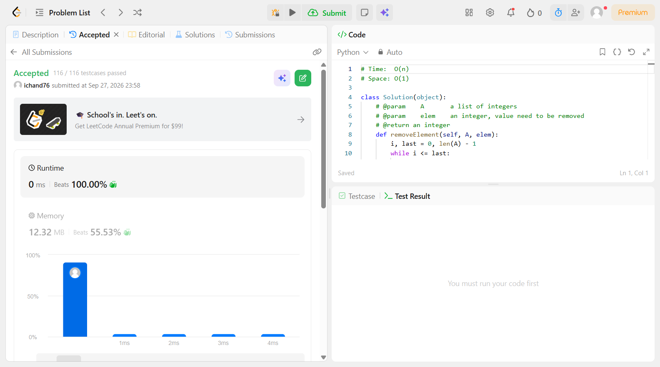

Problem 7
Field | Details
Problem ID | 35
Problem Name | Search Insert Position
Difficulty | Easy
Submission Date | 2026-09-28
Accepted Submission Screenshot | 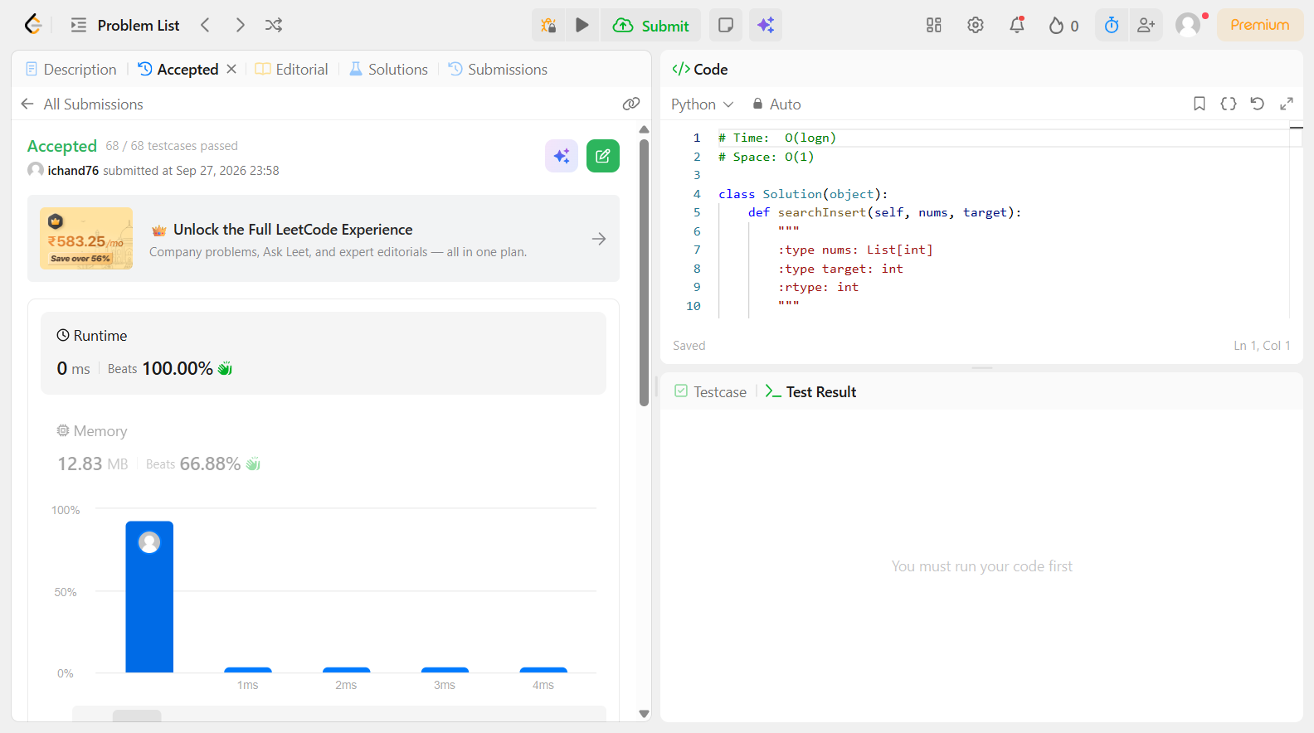

Problem 8
Field | Details
Problem ID | 58
Problem Name | Length of Last Word
Difficulty | Easy
Submission Date | 2026-09-28
Accepted Submission Screenshot | 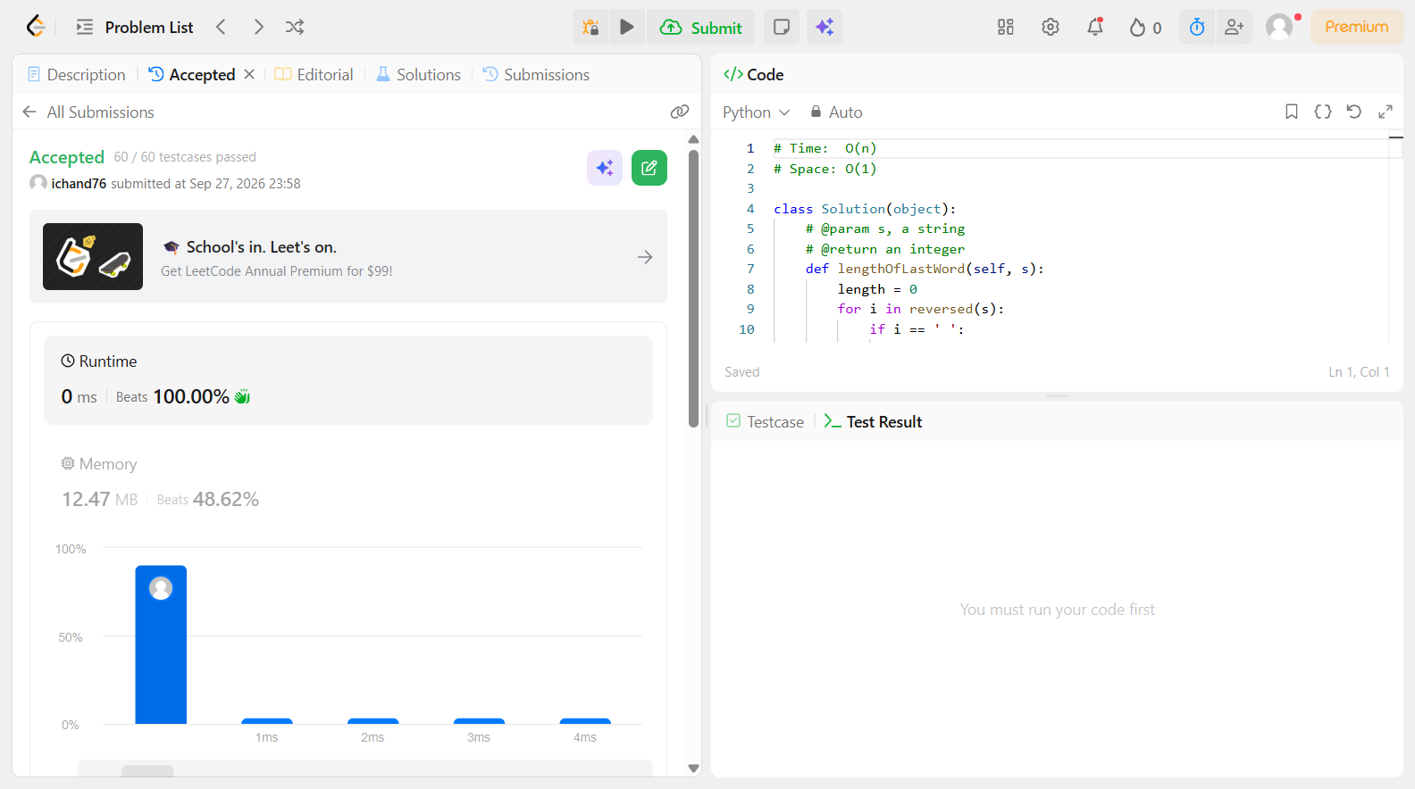

Problem 9
Field | Details
Problem ID | 66
Problem Name | Plus One
Difficulty | Easy
Submission Date | 2026-09-28
Accepted Submission Screenshot | 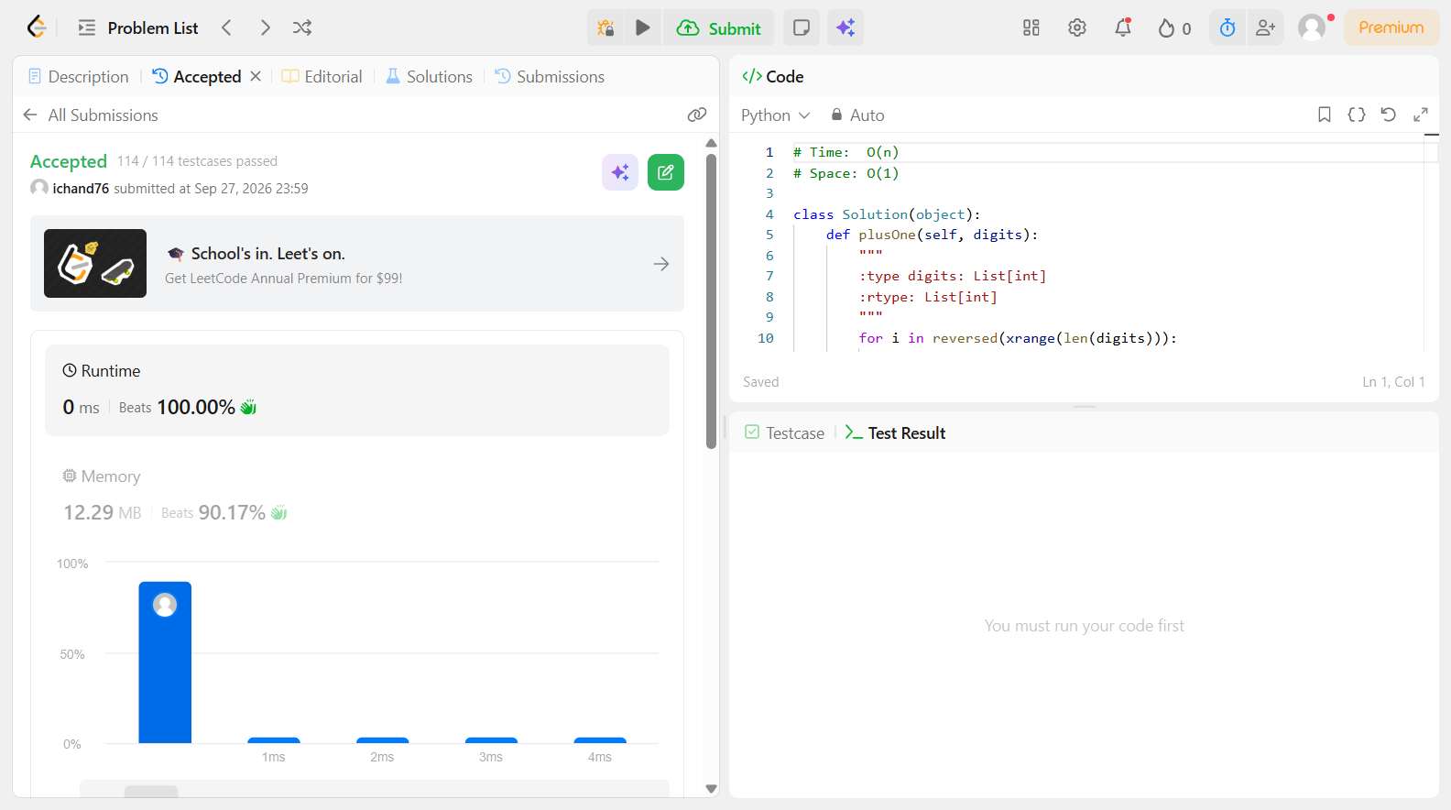

Problem 10
Field | Details
Problem ID | 67
Problem Name | Add Binary
Difficulty | Easy
Submission Date | 2026-09-28
Accepted Submission Screenshot | 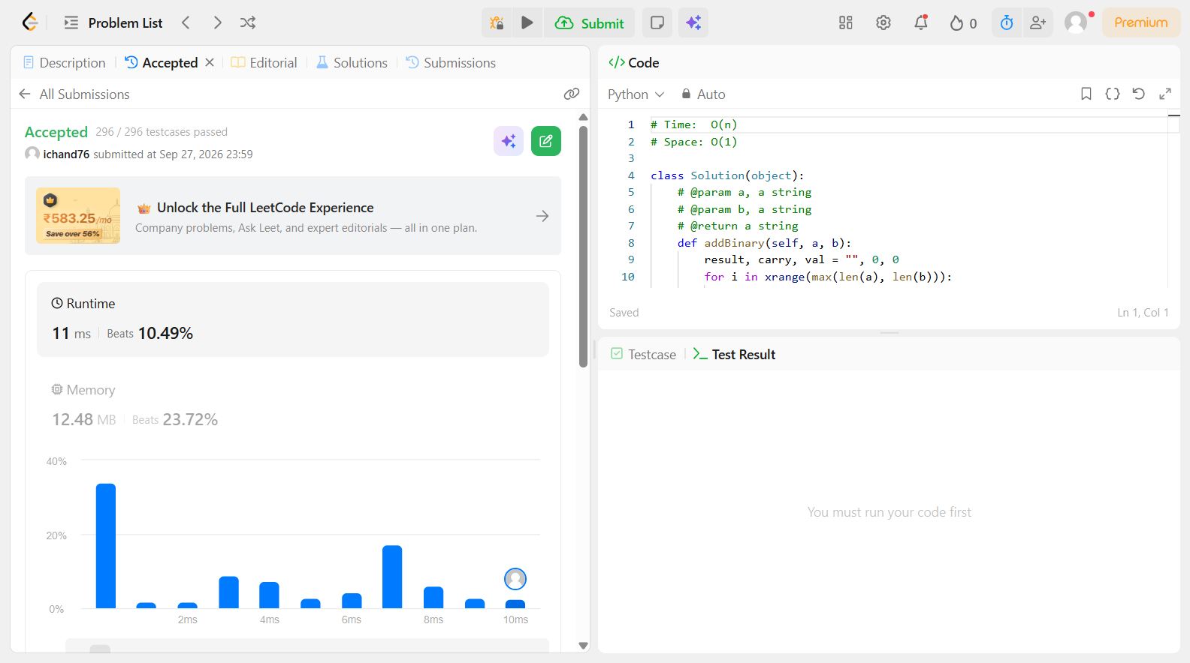

Problem 11
Field | Details
Problem ID | 69
Problem Name | Sqrt(x)
Difficulty | Easy
Submission Date | 2026-09-28
Accepted Submission Screenshot | 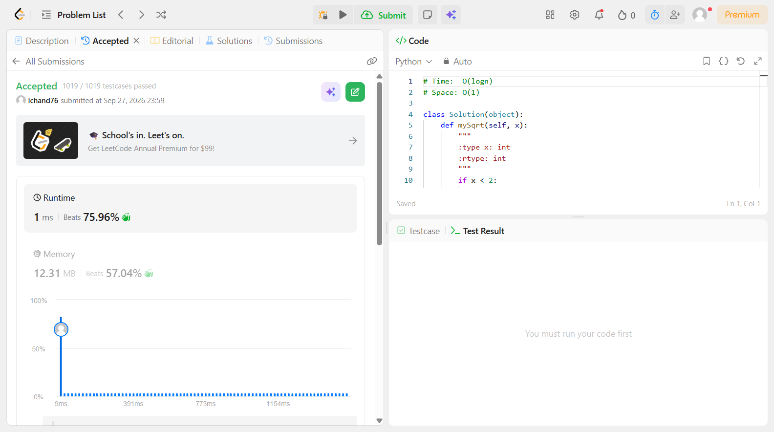

Problem 12
Field | Details
Problem ID | 70
Problem Name | Climbing Stairs
Difficulty | Easy
Submission Date | 2026-09-28
Accepted Submission Screenshot | 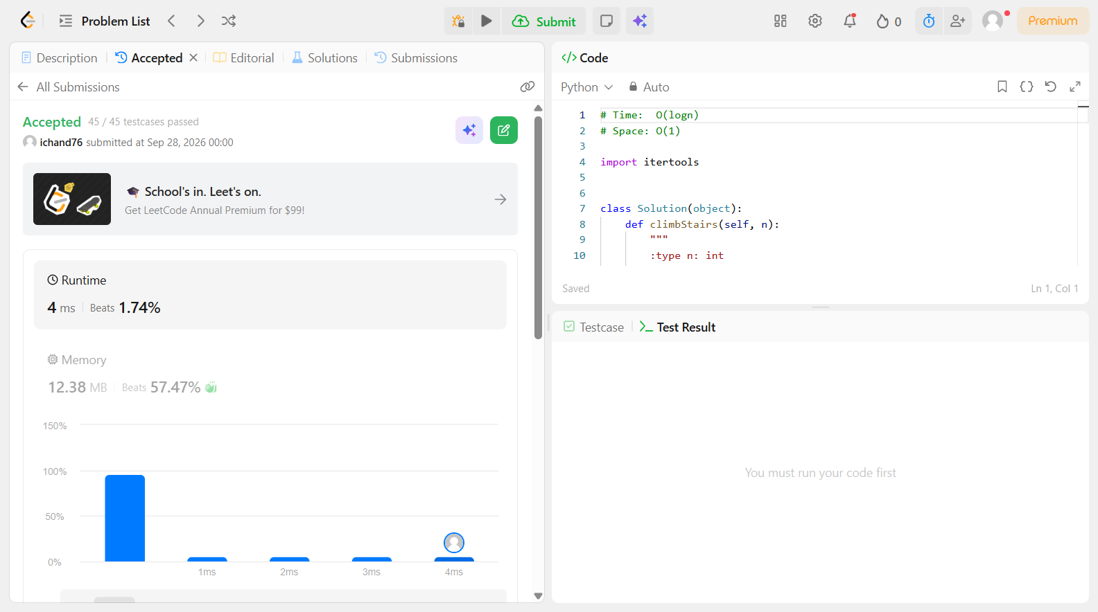

Problem 13
Field | Details
Problem ID | 118
Problem Name | Pascal's Triangle
Difficulty | Easy
Submission Date | 2026-09-28
Accepted Submission Screenshot | 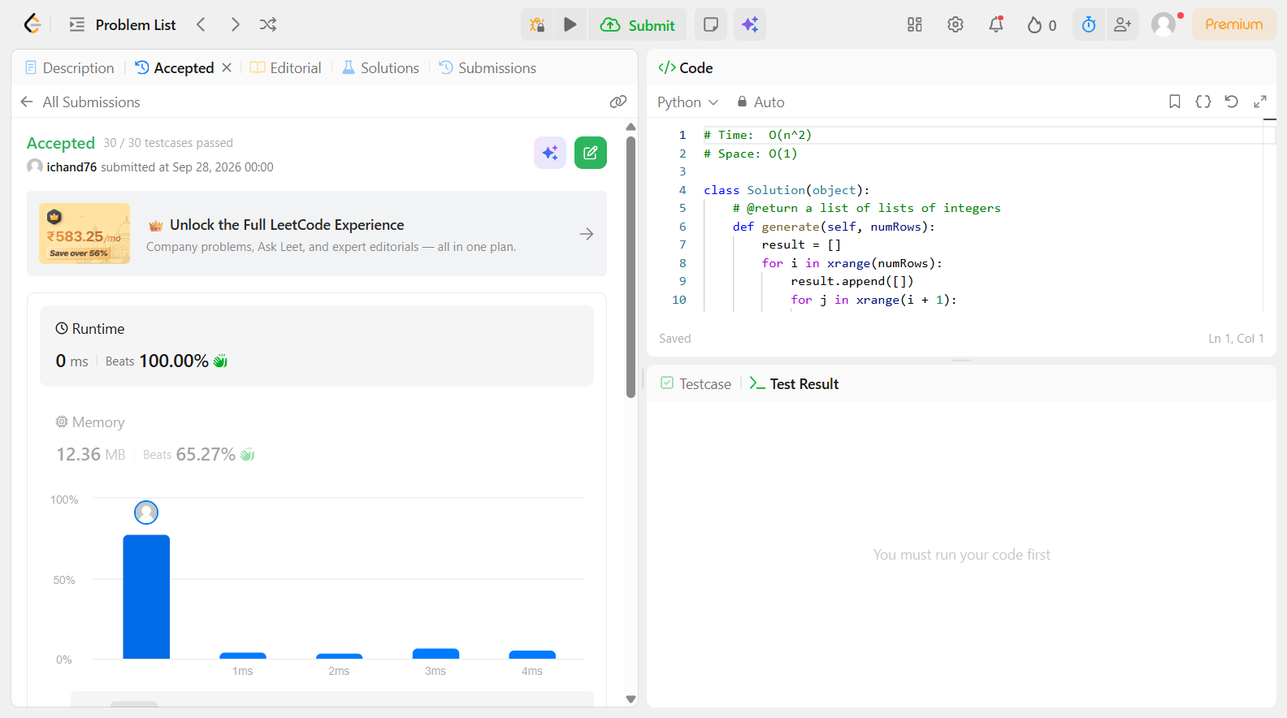

Problem 14
Field | Details
Problem ID | 121
Problem Name | Best Time to Buy and Sell Stock
Difficulty | Easy
Submission Date | 2026-09-28
Accepted Submission Screenshot | 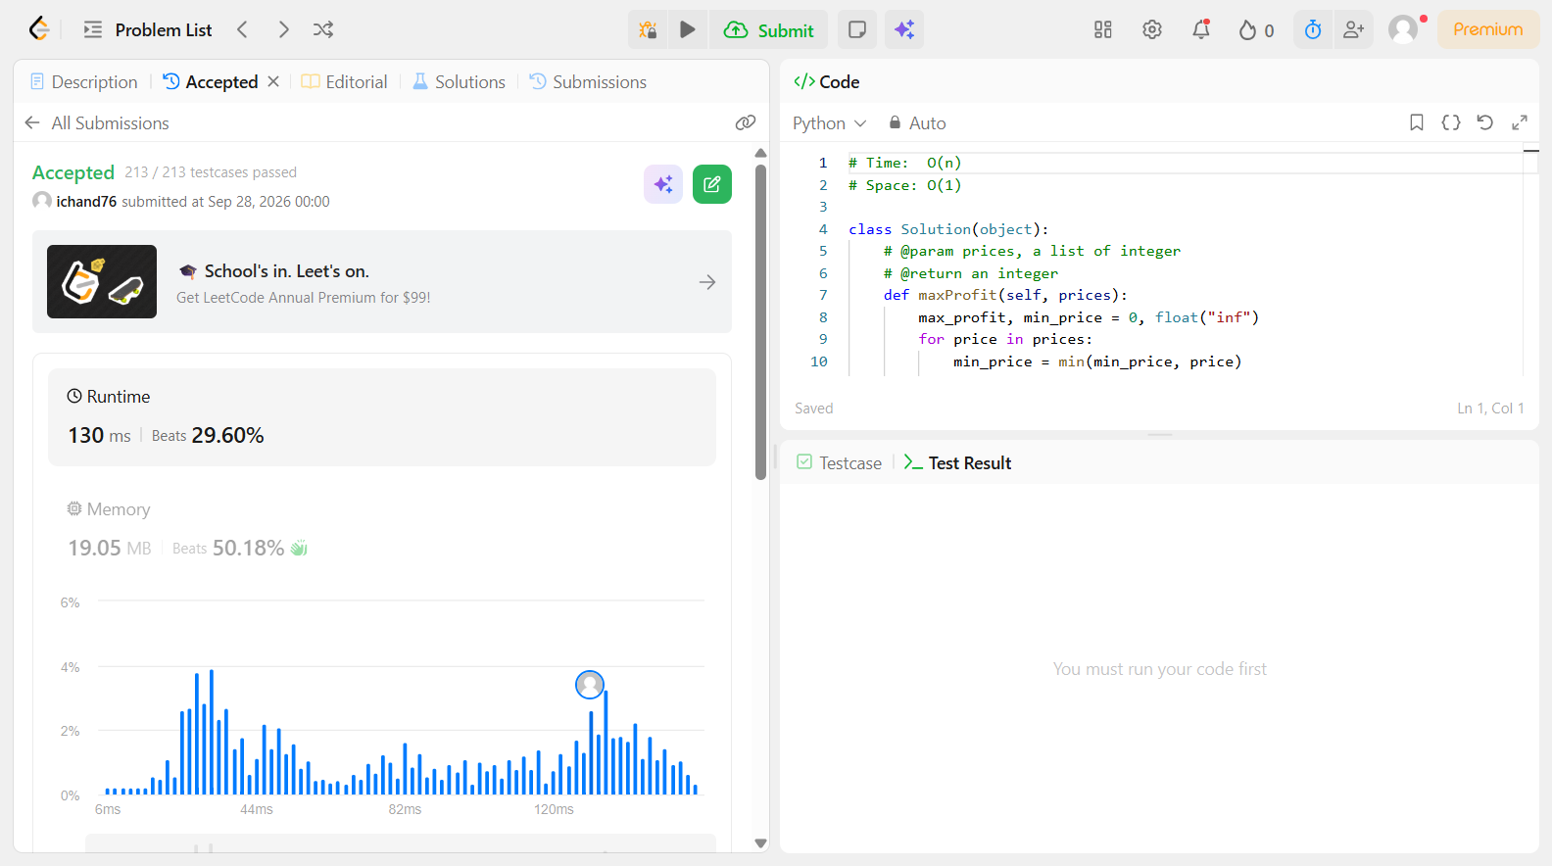

Problem 15
Field | Details
Problem ID | 125
Problem Name | Valid Palindrome
Difficulty | Easy
Submission Date | 2026-09-28
Accepted Submission Screenshot | 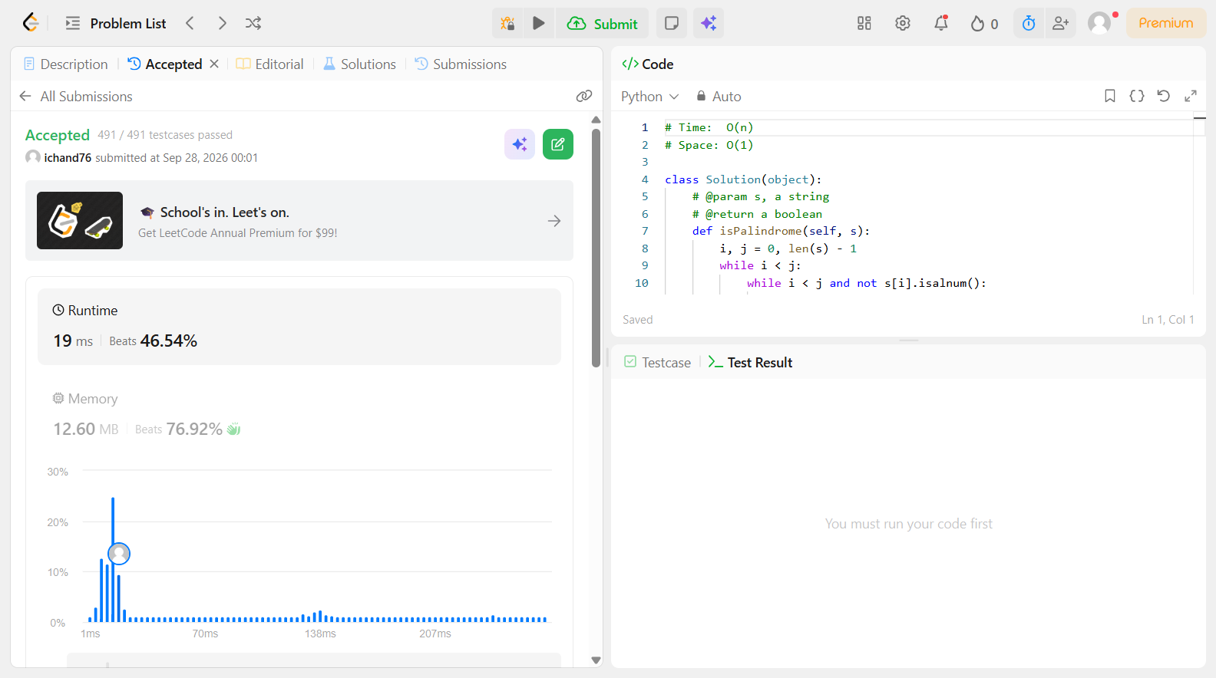

Problem 16
Field | Details
Problem ID | 169
Problem Name | Majority Element
Difficulty | Easy
Submission Date | 2026-09-28
Accepted Submission Screenshot | 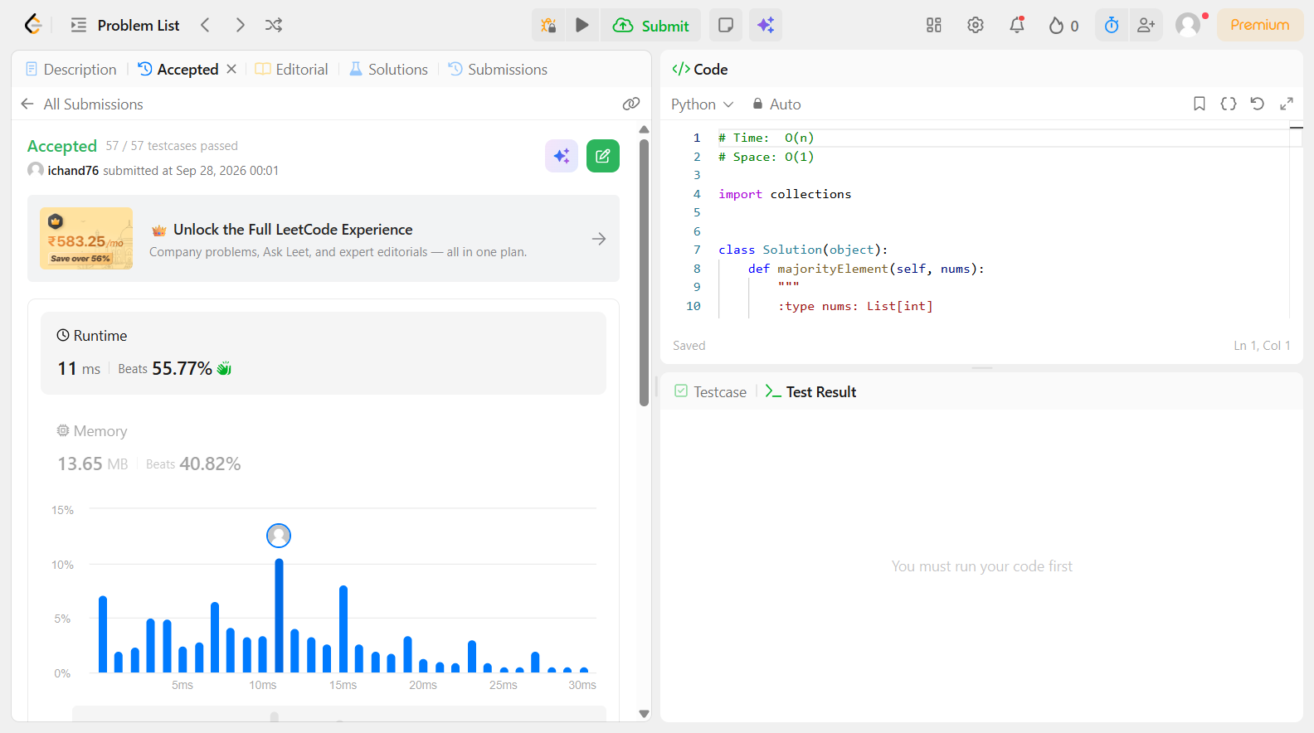

Problem 17
Field | Details
Problem ID | 202
Problem Name | Happy Number
Difficulty | Easy
Submission Date | 2026-09-28
Accepted Submission Screenshot | 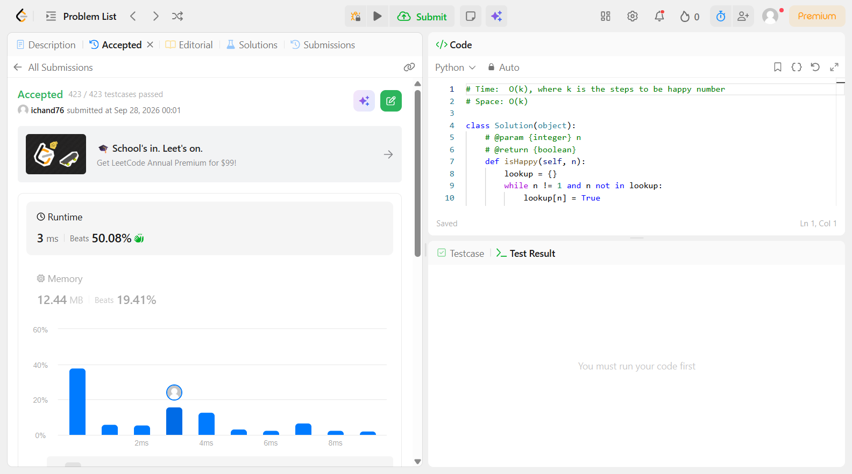

Problem 18
Field | Details
Problem ID | 217
Problem Name | Contains Duplicate
Difficulty | Easy
Submission Date | 2026-09-28
Accepted Submission Screenshot | 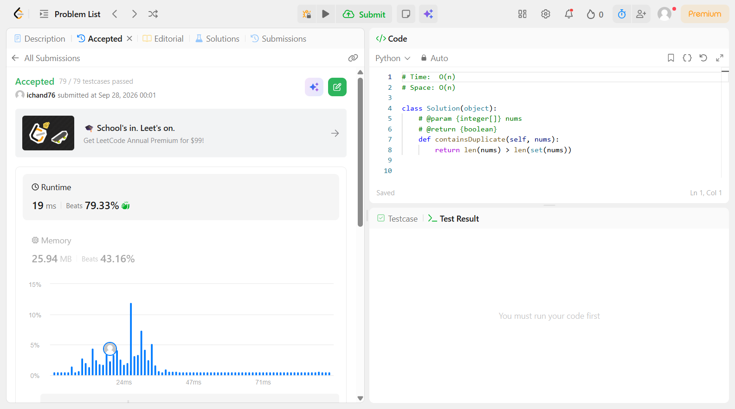

Problem 19
Field | Details
Problem ID | 242
Problem Name | Valid Anagram
Difficulty | Easy
Submission Date | 2026-09-28
Accepted Submission Screenshot | 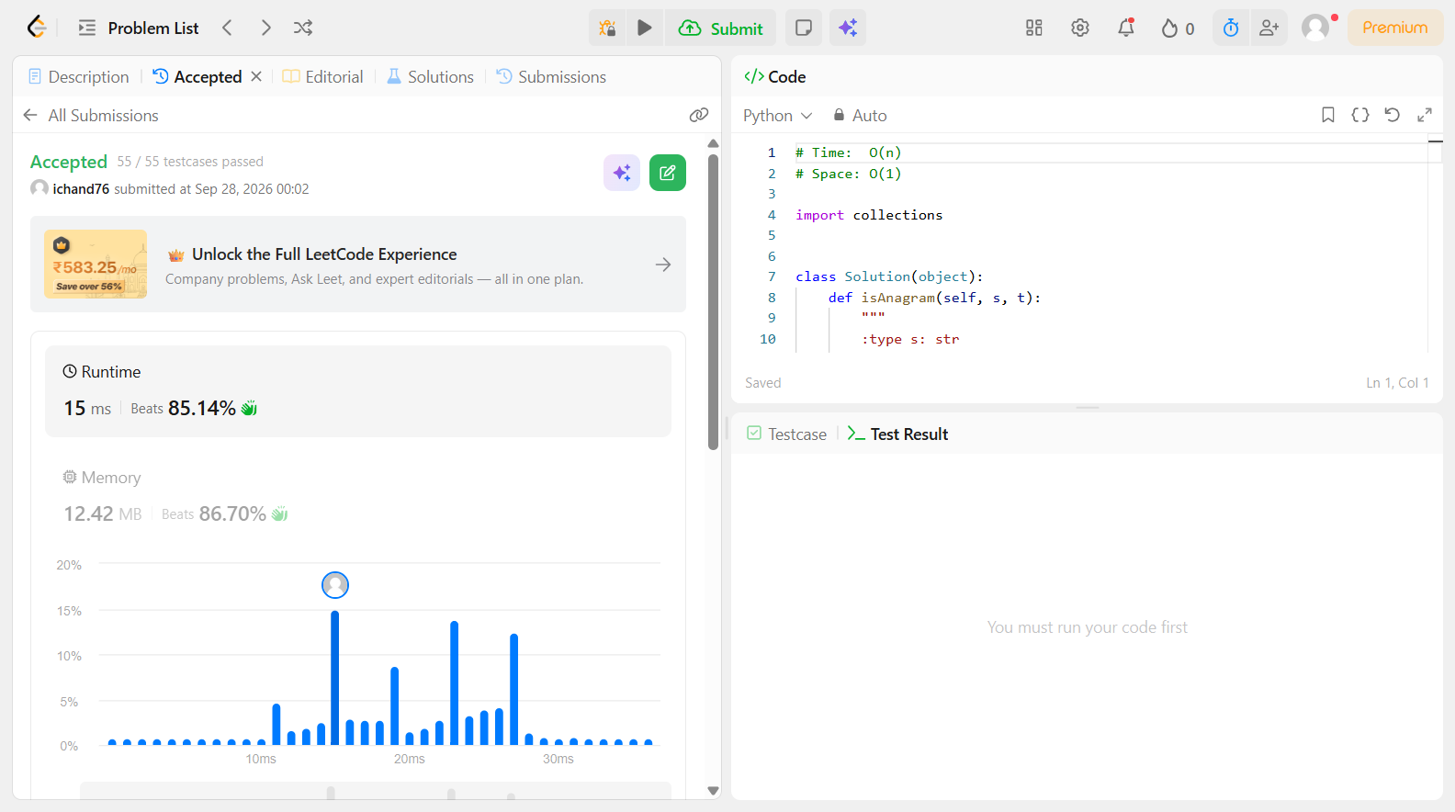

Problem 20
Field | Details
Problem ID | 283
Problem Name | Move Zeroes
Difficulty | Easy
Submission Date | 2026-09-28
Accepted Submission Screenshot | 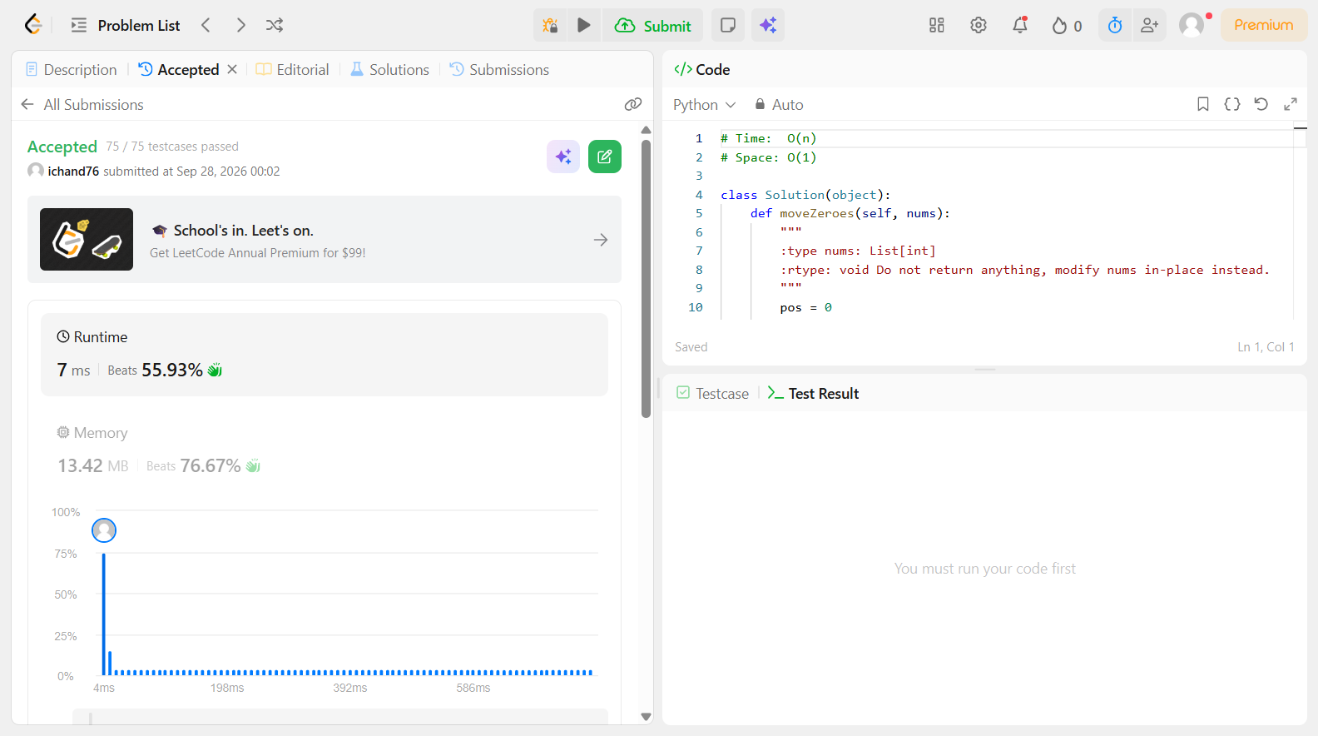

Problem 21
Field | Details
Problem ID | 2877
Problem Name | Create a DataFrame from List
Difficulty | Easy
Submission Date | 2026-09-28
Accepted Submission Screenshot | 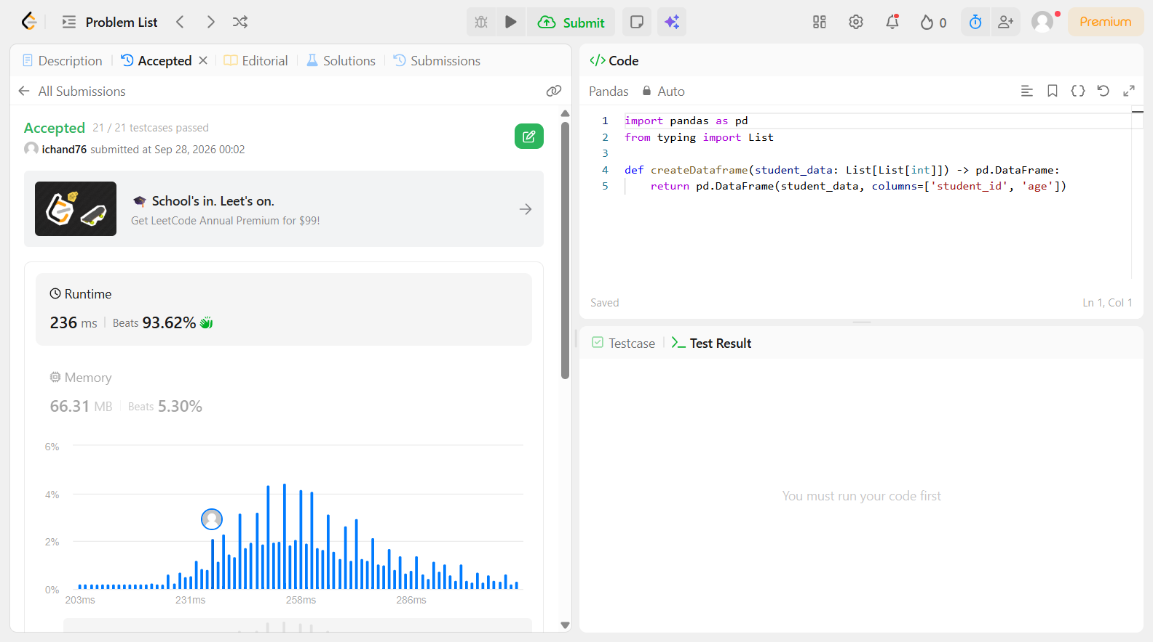

Problem 22
Field | Details
Problem ID | 2878
Problem Name | Get the Size of a DataFrame
Difficulty | Easy
Submission Date | 2026-09-28
Accepted Submission Screenshot | 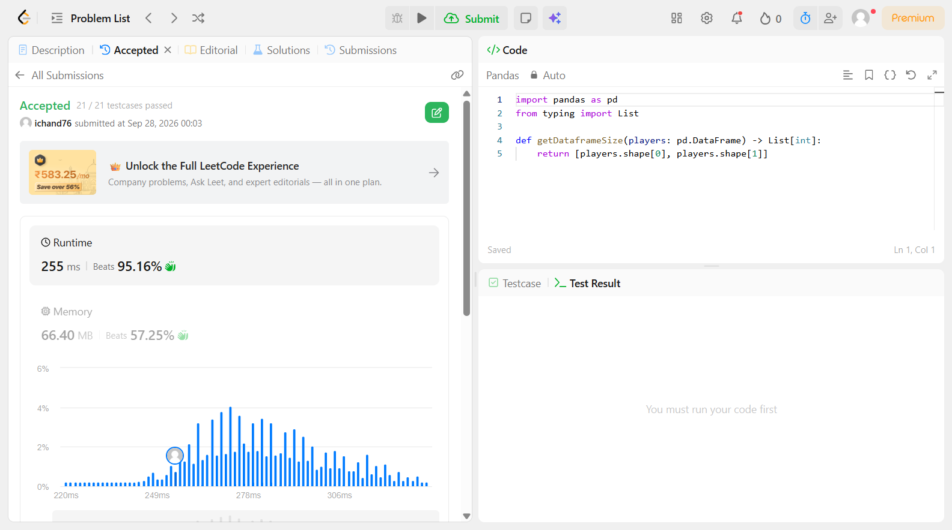

Problem 23
Field | Details
Problem ID | 2879
Problem Name | Display the First Three Rows
Difficulty | Easy
Submission Date | 2026-09-28
Accepted Submission Screenshot | 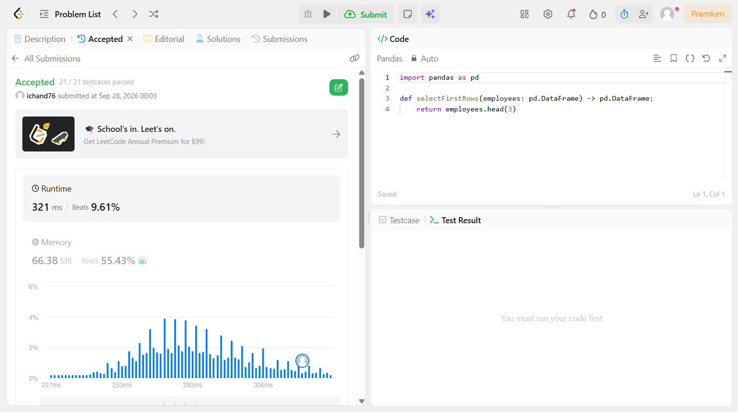

Problem 24
Field | Details
Problem ID | 2880
Problem Name | Select Data
Difficulty | Easy
Submission Date | 2026-09-28
Accepted Submission Screenshot | SUBSCRIBER ONLY

Problem 25
Field | Details
Problem ID | 2881
Problem Name | Create a New Column
Difficulty | Easy
Submission Date | 2026-09-28
Accepted Submission Screenshot | 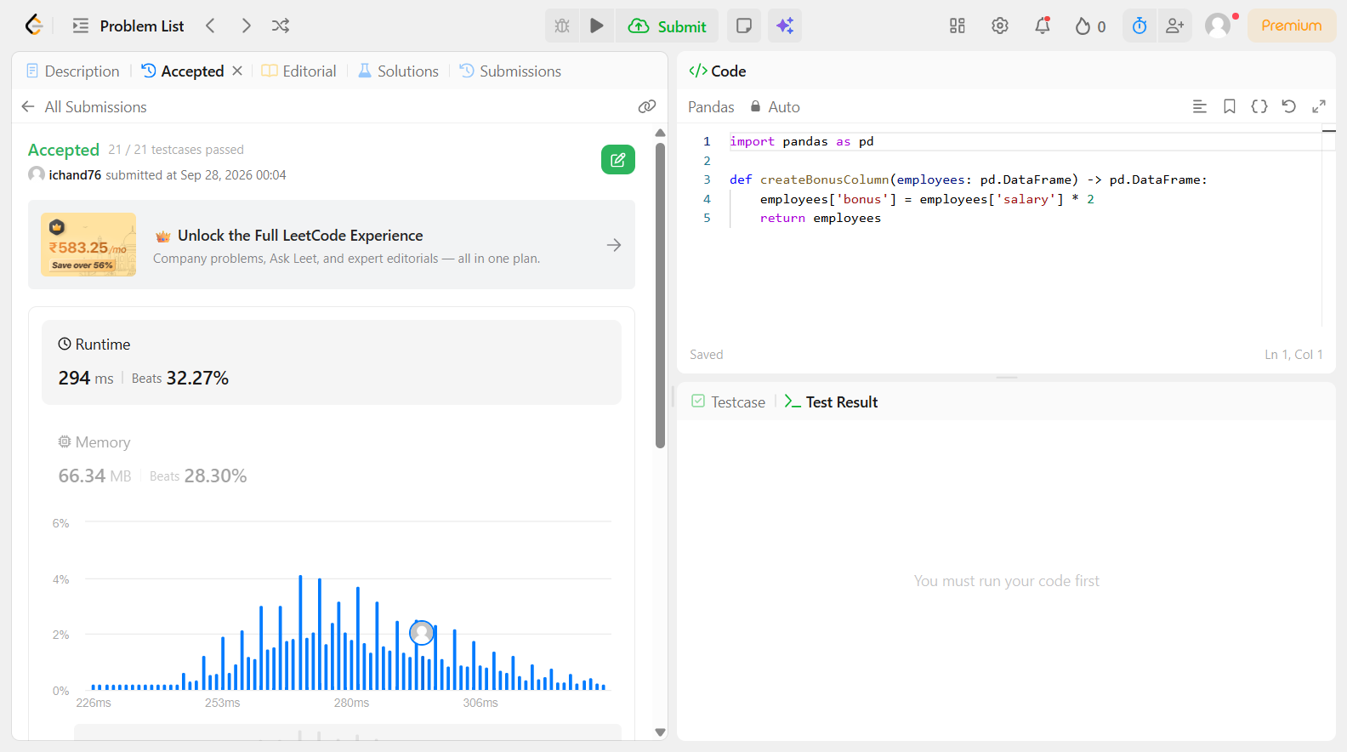

Problem 26
Field | Details
Problem ID | 2882
Problem Name | Drop Duplicate Rows
Difficulty | Easy
Submission Date | 2026-09-28
Accepted Submission Screenshot | 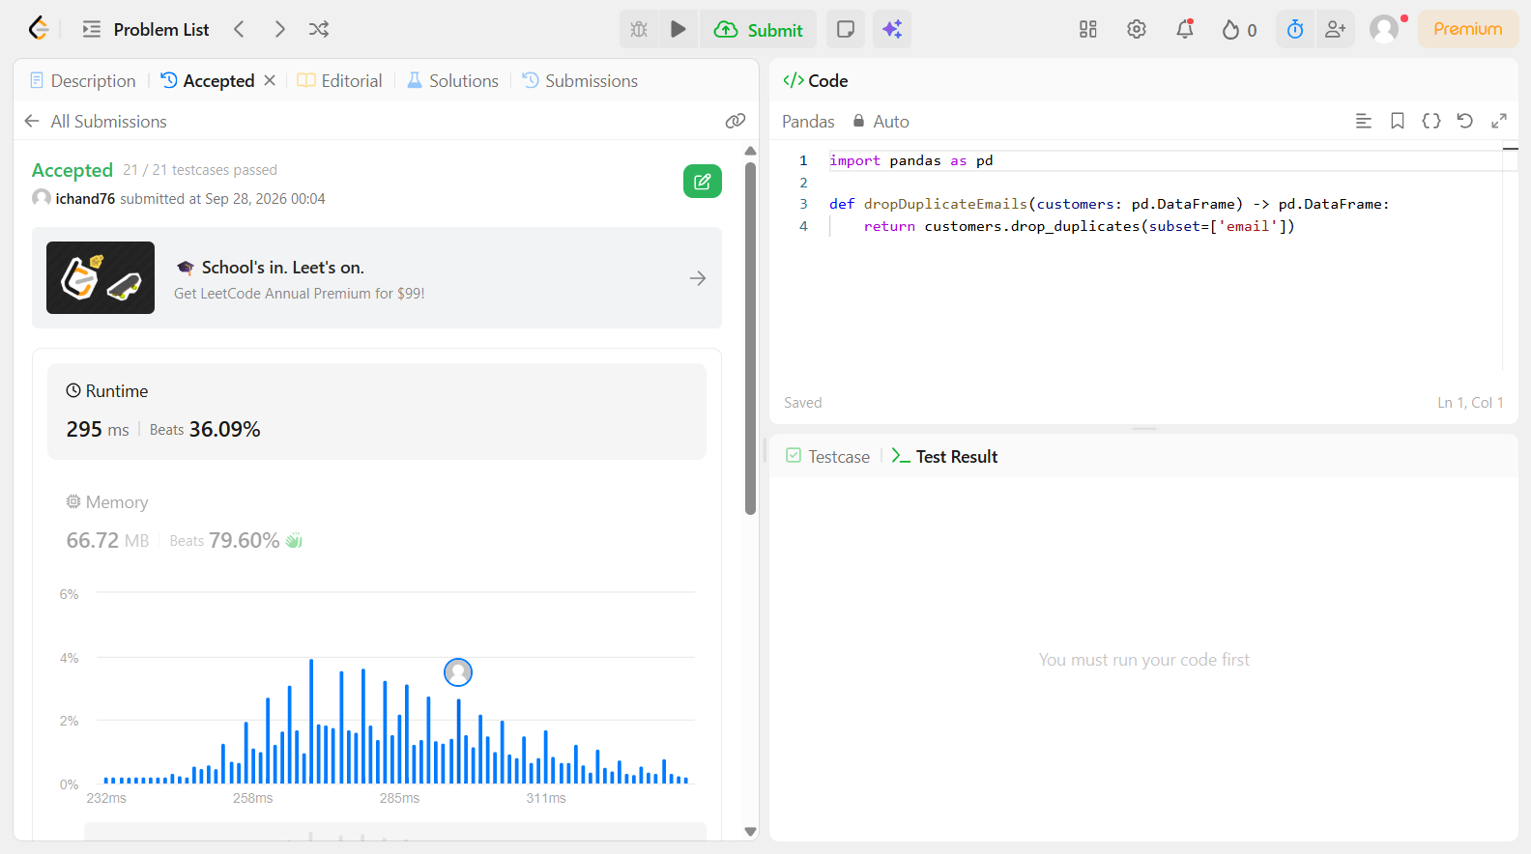

Problem 27
Field | Details
Problem ID | 2883
Problem Name | Drop Missing Data
Difficulty | Easy
Submission Date | 2026-09-28
Accepted Submission Screenshot | 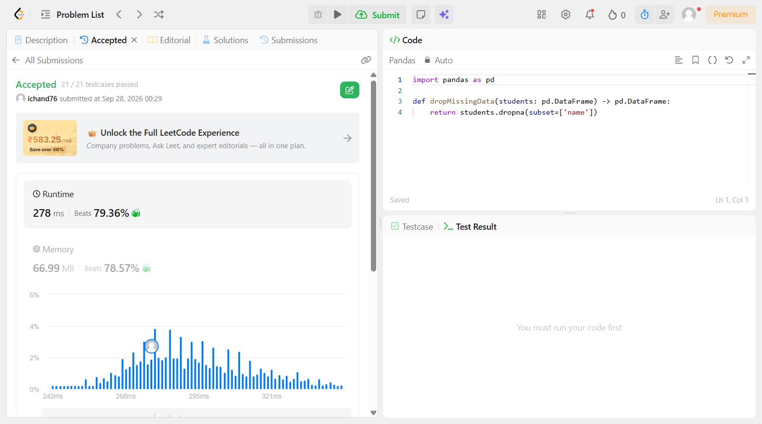

Problem 28
Field | Details
Problem ID | 2884
Problem Name | Modify Columns
Difficulty | Easy
Submission Date | 2026-09-28
Accepted Submission Screenshot | 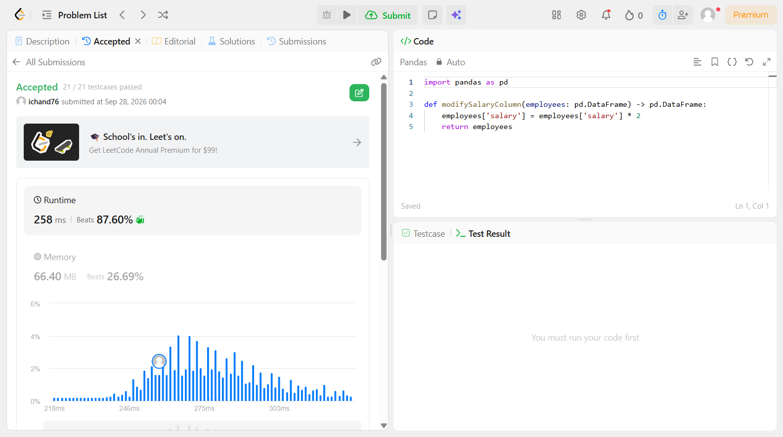

Problem 29
Field | Details
Problem ID | 2885
Problem Name | Rename Columns
Difficulty | Easy
Submission Date | 2026-09-28
Accepted Submission Screenshot | SUBSCRIBER ONLY

Problem 30
Field | Details
Problem ID | 2886
Problem Name | Change Data Type
Difficulty | Easy
Submission Date | 2026-09-28
Accepted Submission Screenshot | 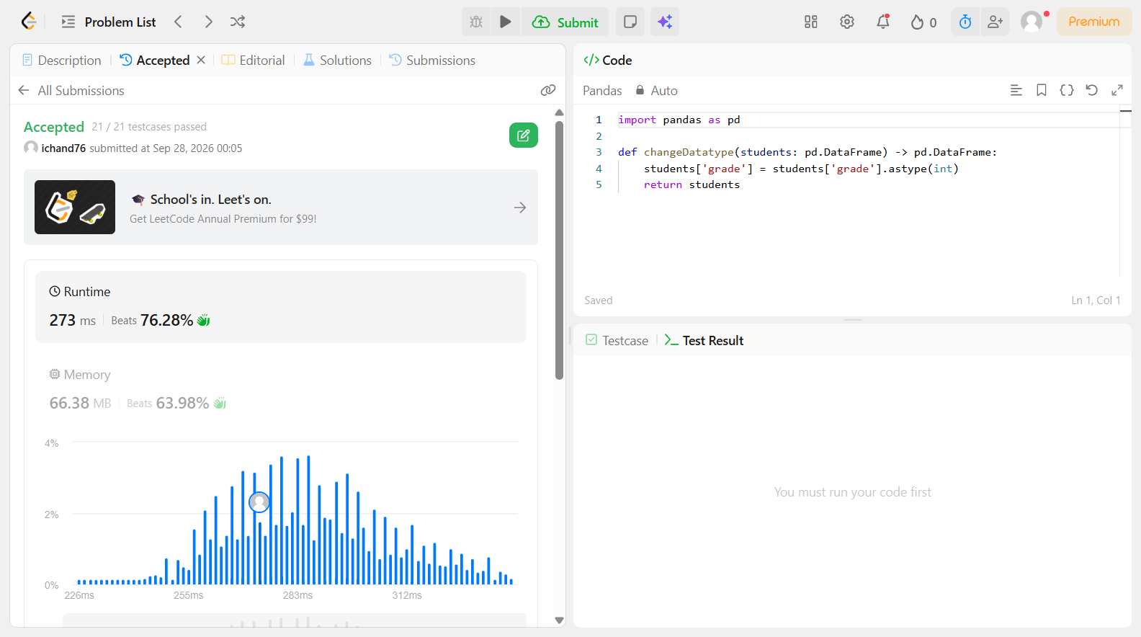

Problem 31
Field | Details
Problem ID | 2887
Problem Name | Fill Missing Data
Difficulty | Easy
Submission Date | 2026-09-28
Accepted Submission Screenshot | 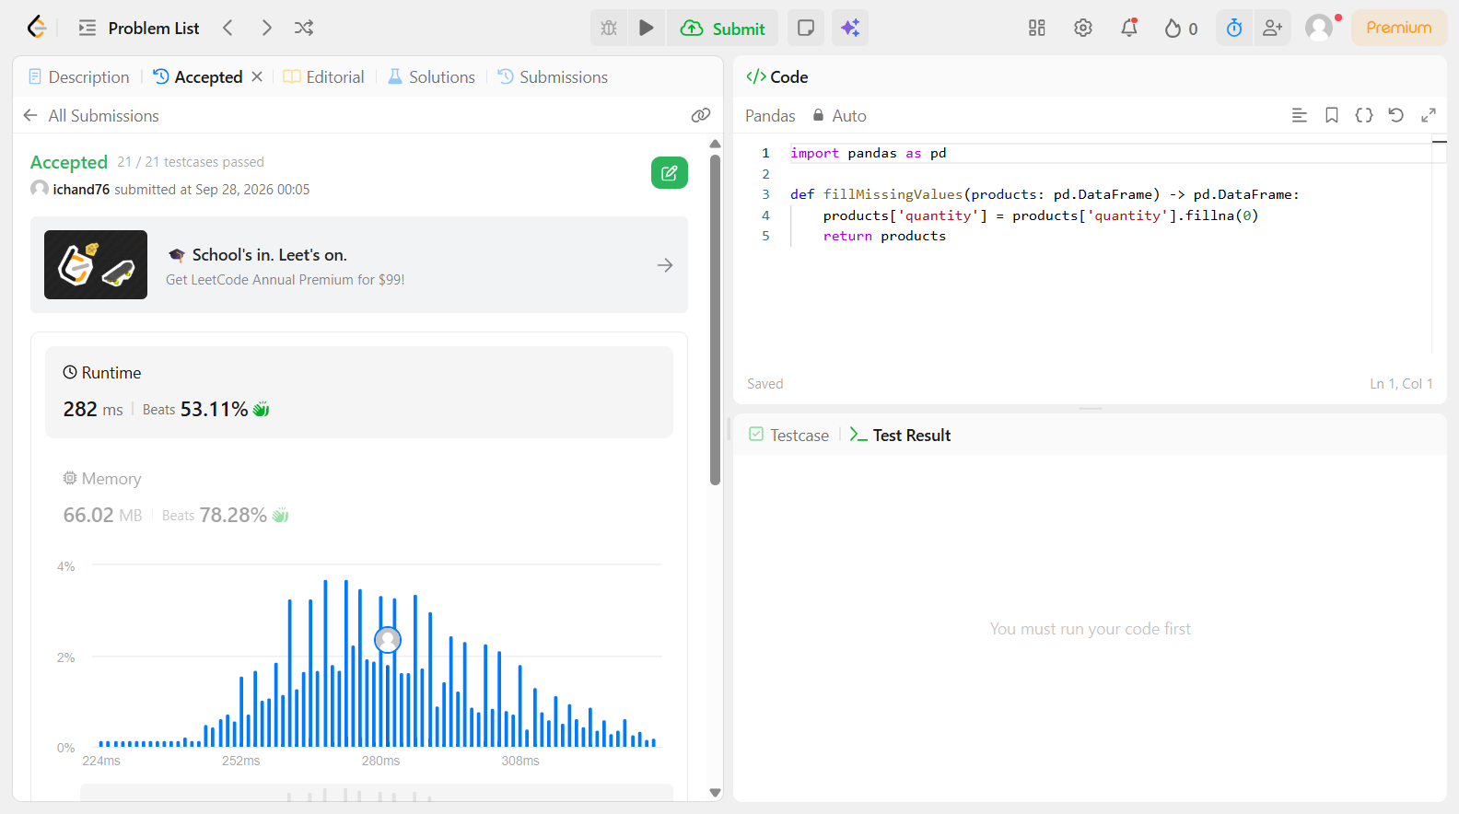

Problem 32
Field | Details
Problem ID | 2888
Problem Name | Reshape Data: Concatenate
Difficulty | Easy
Submission Date | 2026-09-28
Accepted Submission Screenshot | 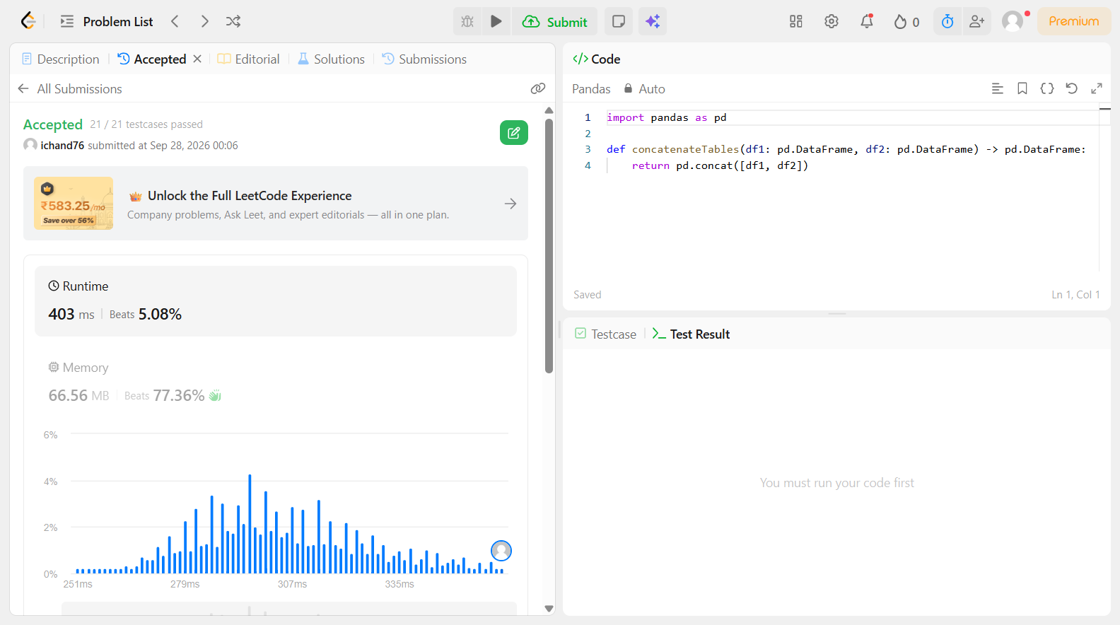

Problem 33
Field | Details
Problem ID | 2889
Problem Name | Reshape Data: Pivot
Difficulty | Easy
Submission Date | 2026-09-28
Accepted Submission Screenshot | 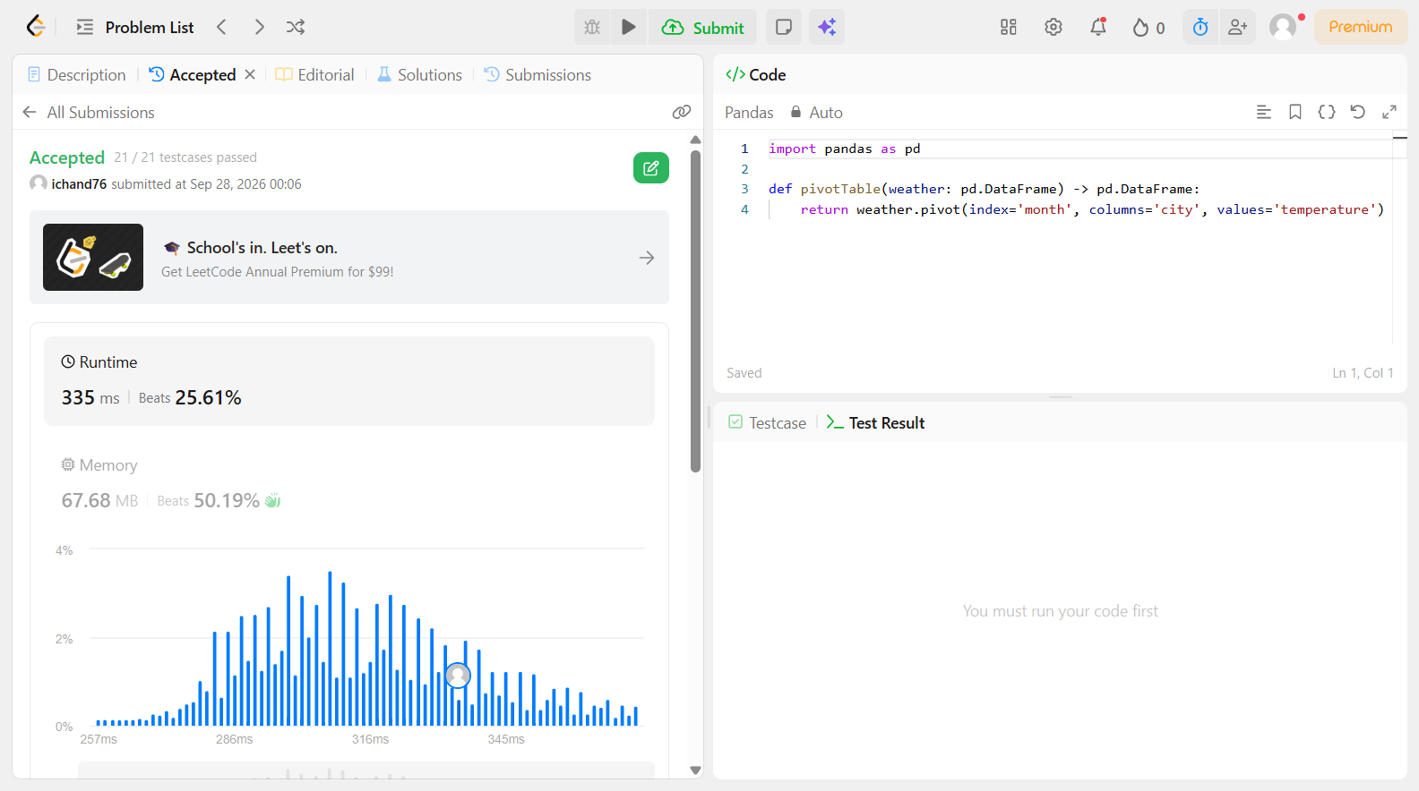

Problem 34
Field | Details
Problem ID | 2890
Problem Name | Reshape Data: Melt
Difficulty | Easy
Submission Date | 2026-09-28
Accepted Submission Screenshot | SUBSCRIBER ONLY

Problem 35
Field | Details
Problem ID | 2891
Problem Name | Method Chaining
Difficulty | Easy
Submission Date | 2026-09-28
Accepted Submission Screenshot | 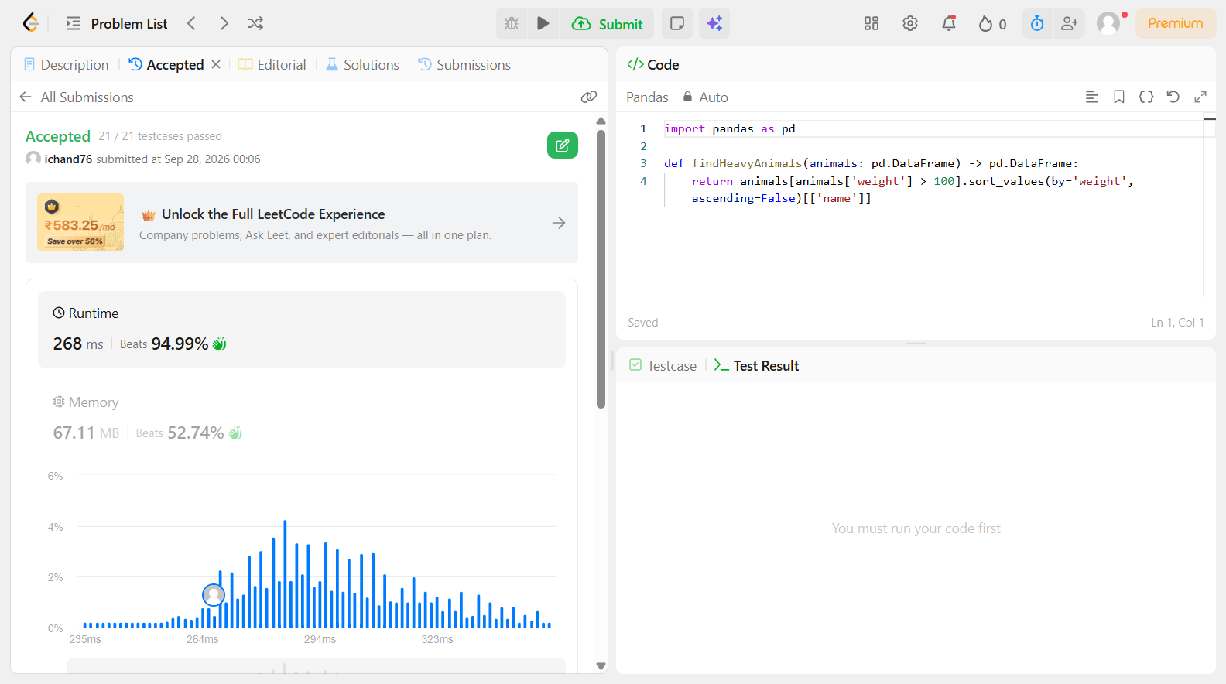

Problem 36
Field | Details
Problem ID | 175
Problem Name | Combine Two Tables
Difficulty | Easy
Submission Date | 2026-09-28
Accepted Submission Screenshot | 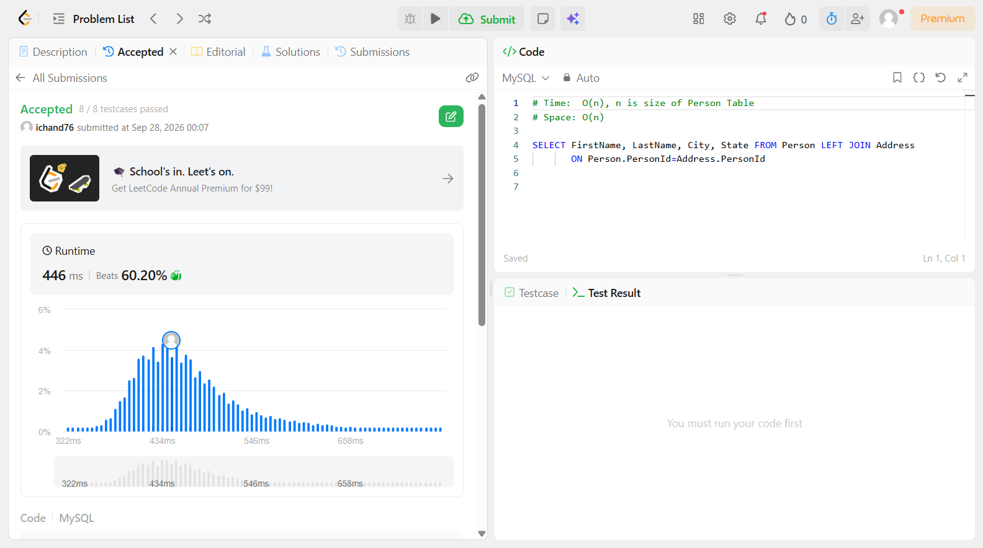

Problem 37
Field | Details
Problem ID | 577
Problem Name | Employee Bonus
Difficulty | Easy
Submission Date | 2026-09-28
Accepted Submission Screenshot | 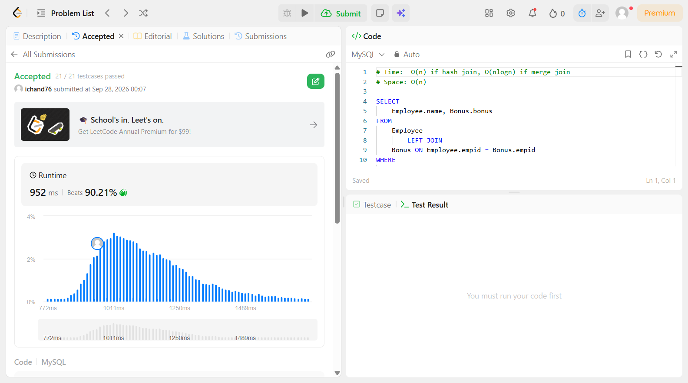

Problem 38
Field | Details
Problem ID | 584
Problem Name | Find Customer Referee
Difficulty | Easy
Submission Date | 2026-09-28
Accepted Submission Screenshot | 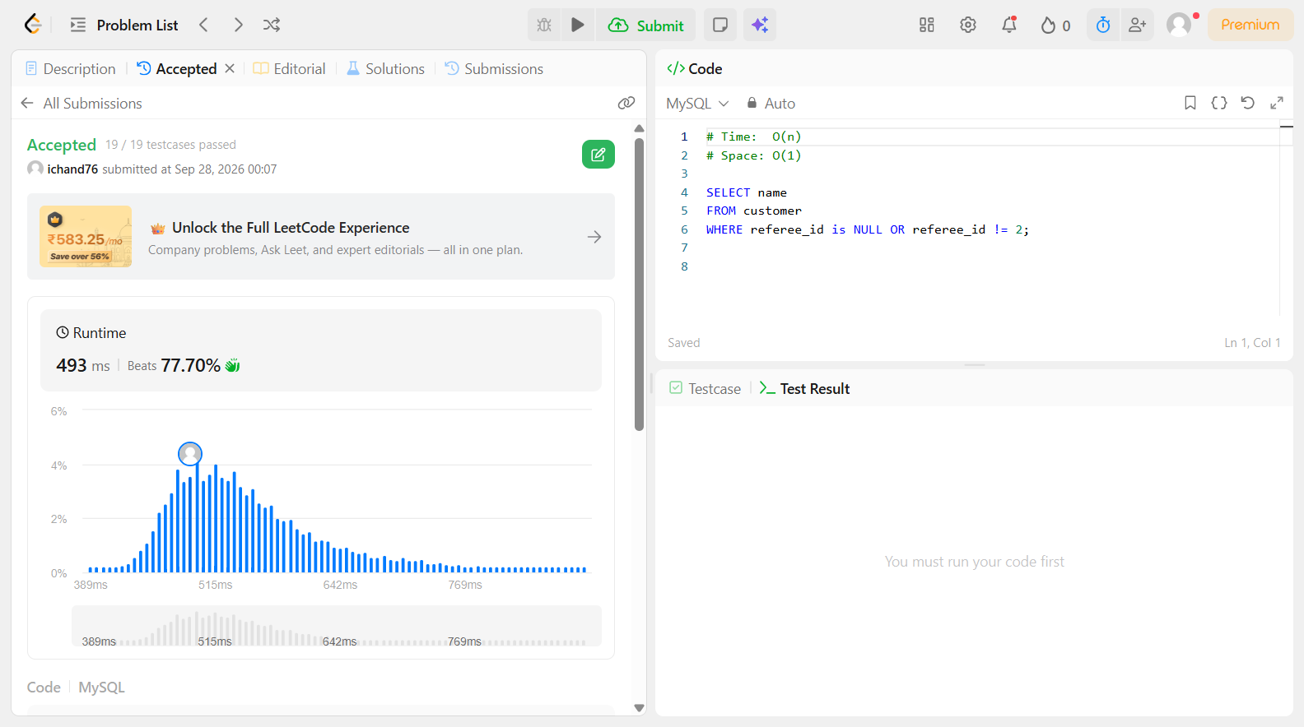

Problem 39
Field | Details
Problem ID | 595
Problem Name | Big Countries
Difficulty | Easy
Submission Date | 2026-09-28
Accepted Submission Screenshot | 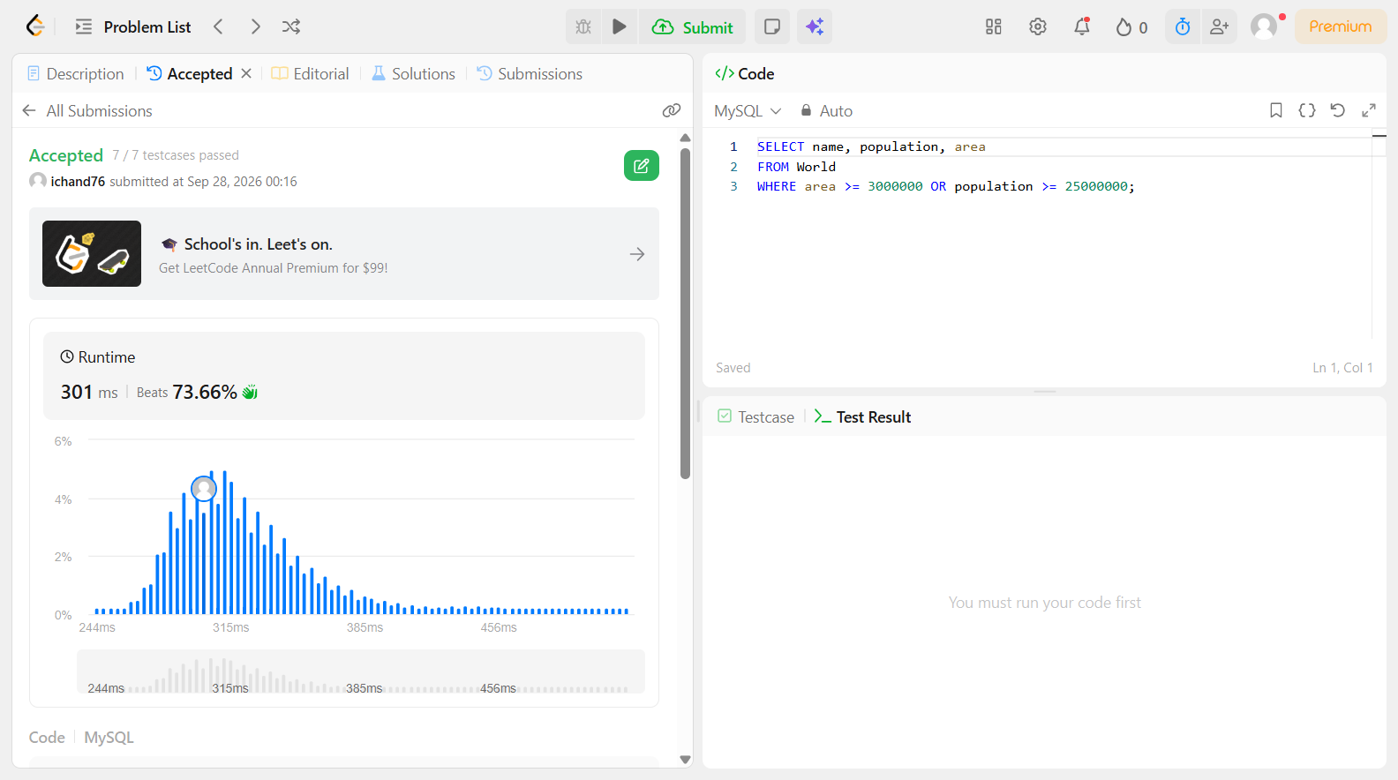

Problem 40
Field | Details
Problem ID | 1068
Problem Name | Product Sales Analysis I
Difficulty | Easy
Submission Date | 2026-09-28
Accepted Submission Screenshot | SUBSCRIBER ONLY

Problem 41
Field | Details
Problem ID | 176
Problem Name | Second Highest Salary
Difficulty | Easy
Submission Date | 2026-09-28
Accepted Submission Screenshot | 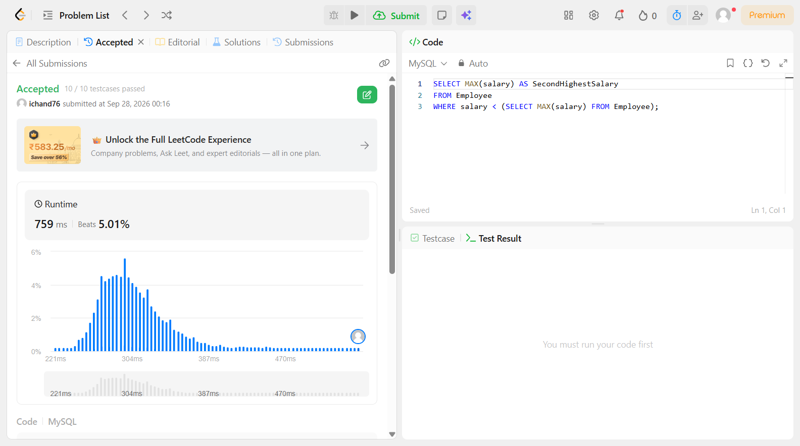

Problem 42
Field | Details
Problem ID | 178
Problem Name | Rank Scores
Difficulty | Easy
Submission Date | 2026-09-28
Accepted Submission Screenshot | 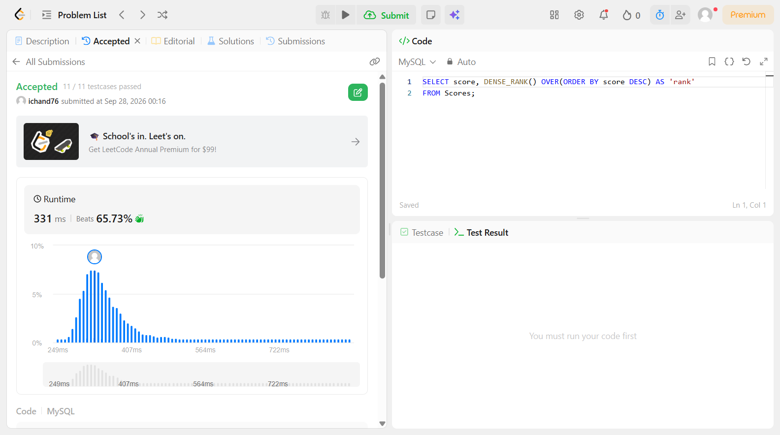

Problem 43
Field | Details
Problem ID | 184
Problem Name | Department Highest Salary
Difficulty | Easy
Submission Date | 2026-09-28
Accepted Submission Screenshot | 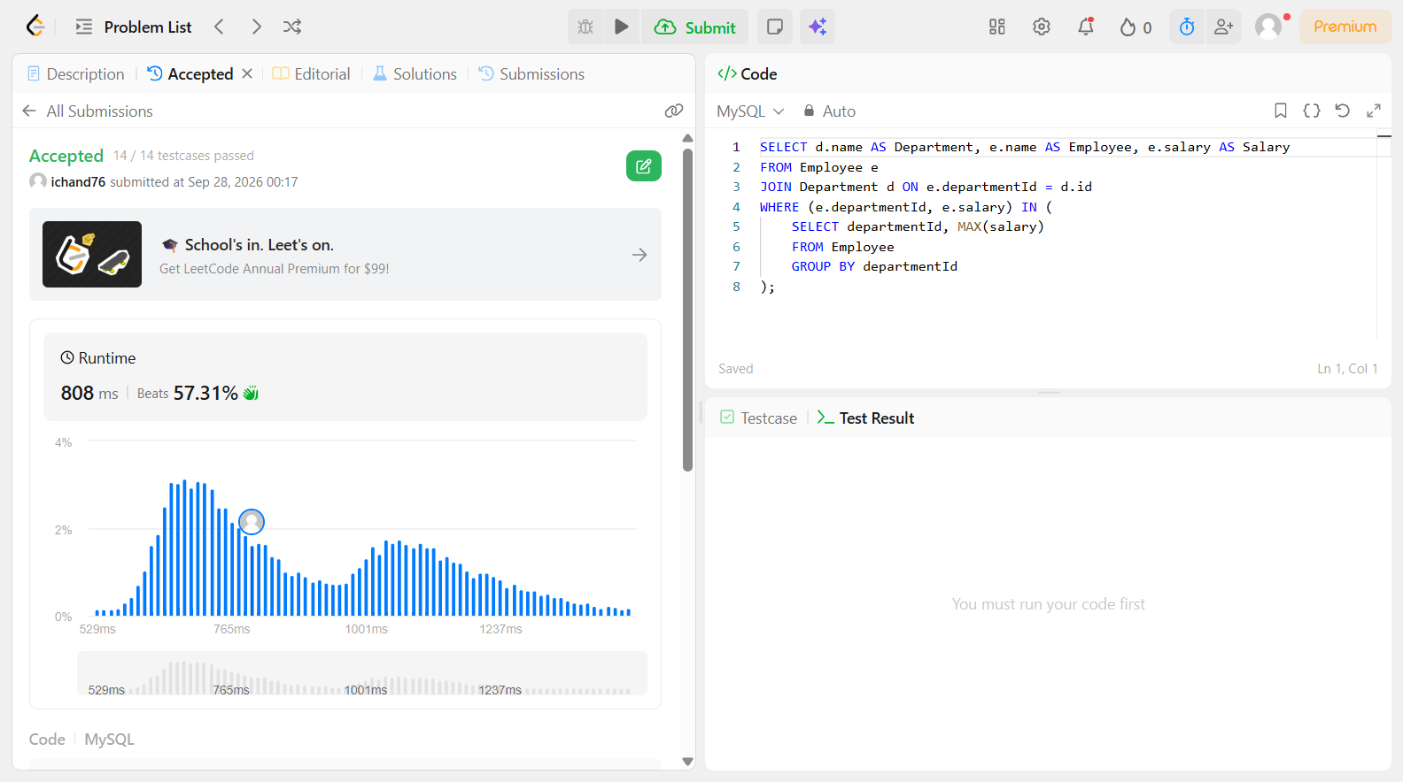

Problem 44
Field | Details
Problem ID | 197
Problem Name | Rising Temperature
Difficulty | Easy
Submission Date | 2026-09-28
Accepted Submission Screenshot | 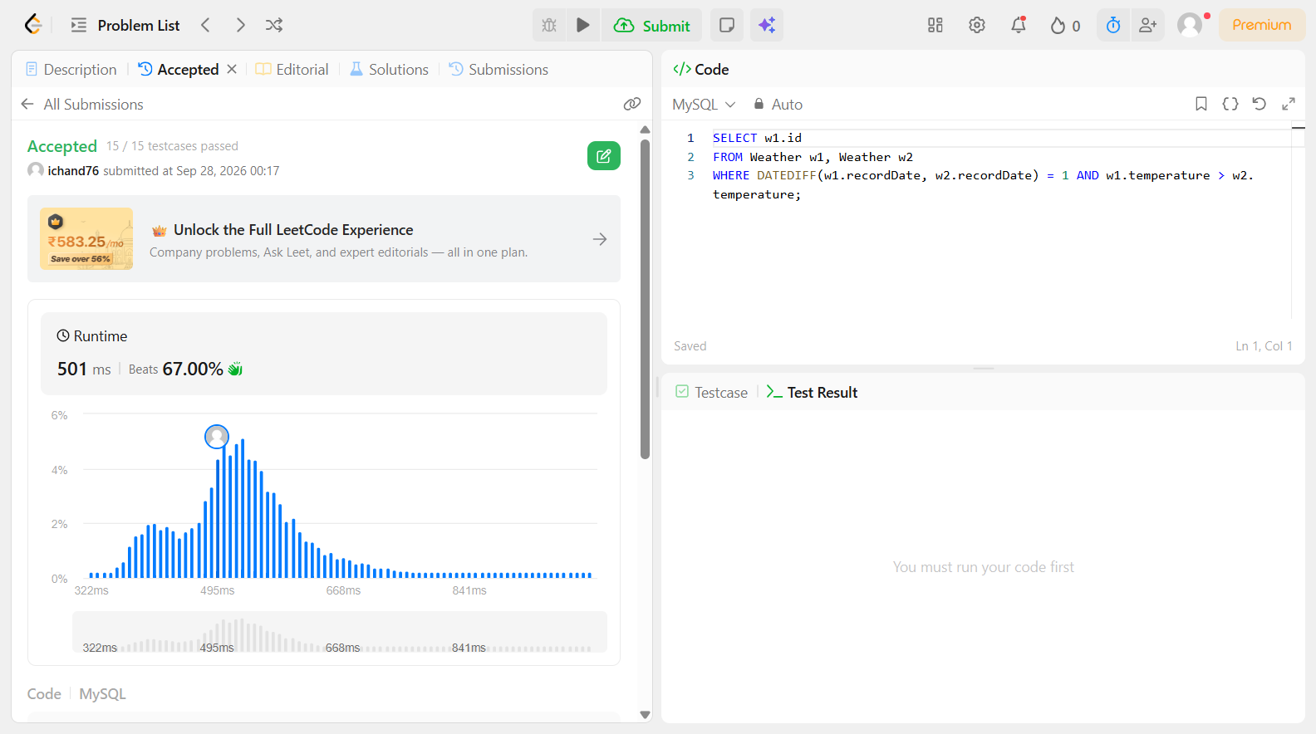

Problem 45
Field | Details
Problem ID | 511
Problem Name | Game Play Analysis I
Difficulty | Easy
Submission Date | 2026-09-28
Accepted Submission Screenshot | SUBSCRIBER ONLY

Problem 46
Field | Details
Problem ID | 550
Problem Name | Game Play Analysis IV
Difficulty | Easy
Submission Date | 2026-09-28
Accepted Submission Screenshot | SUBSCRIBER ONLY

Problem 47
Field | Details
Problem ID | 570
Problem Name | Managers with at Least 5 Direct Reports
Difficulty | Easy
Submission Date | 2026-09-28
Accepted Submission Screenshot | 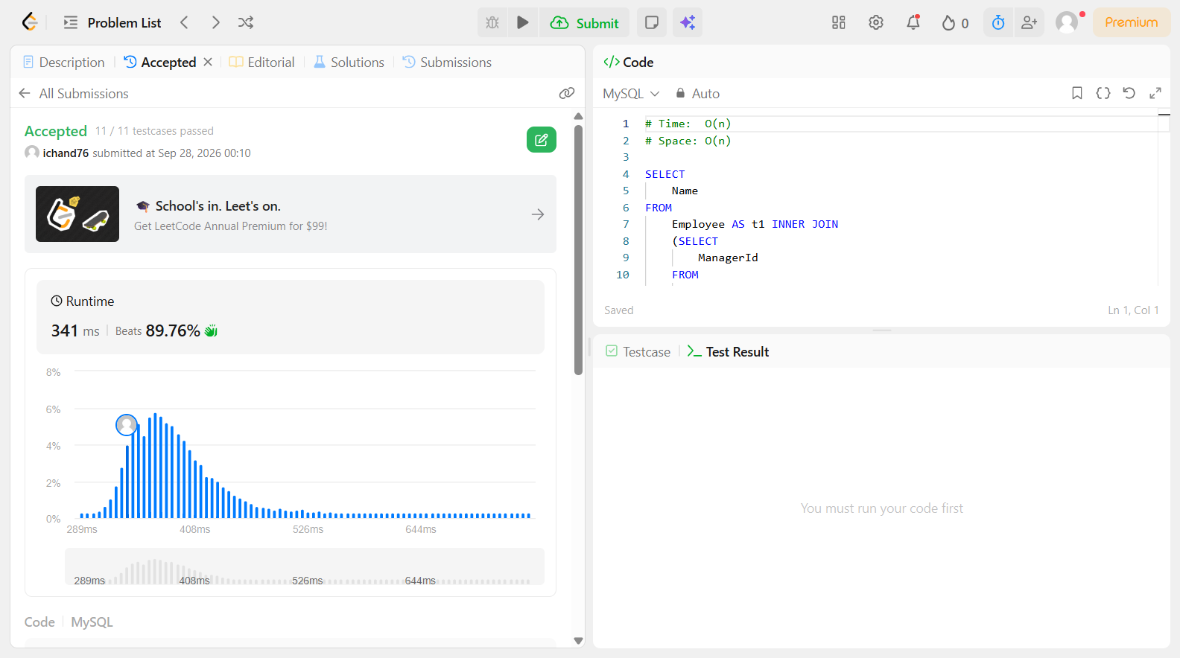

Problem 48
Field | Details
Problem ID | 586
Problem Name | Customer Placing the Largest Number of Orders
Difficulty | Easy
Submission Date | 2026-09-28
Accepted Submission Screenshot | 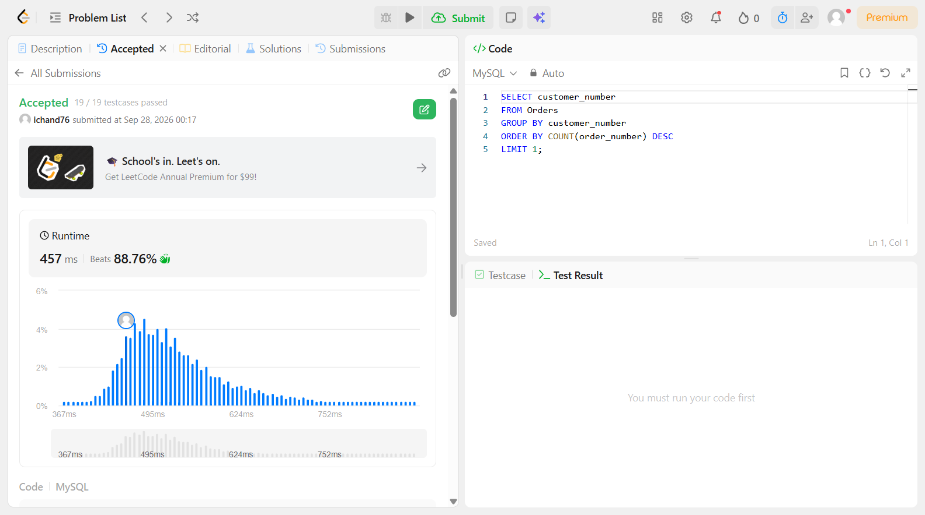

Problem 49
Field | Details
Problem ID | 596
Problem Name | Classes More Than 5 Students
Difficulty | Easy
Submission Date | 2026-09-28
Accepted Submission Screenshot | 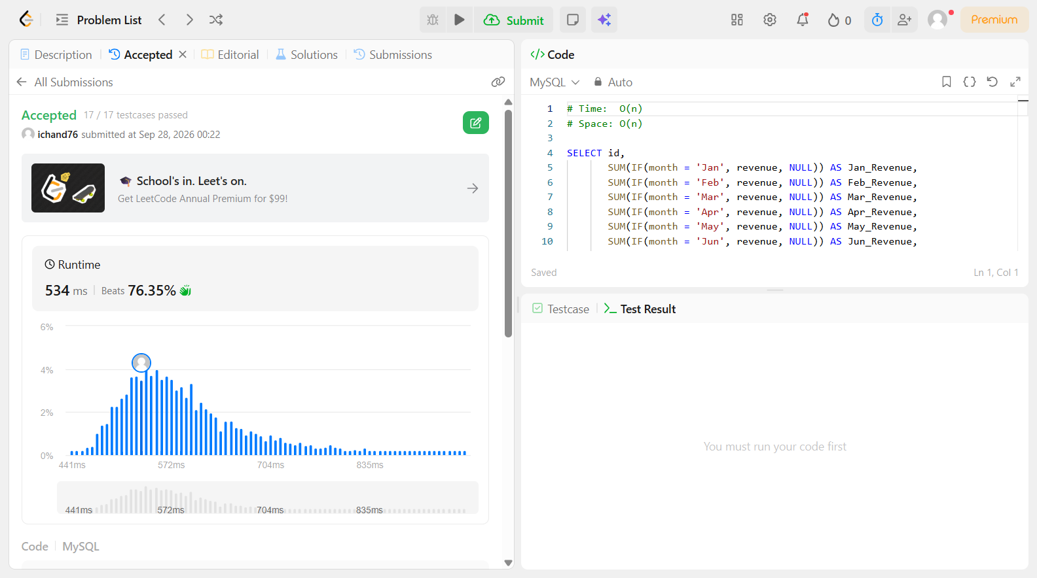

Problem 50
Field | Details
Problem ID | 1179
Problem Name | Reformat Department Table
Difficulty | Easy
Submission Date | 2026-09-28
Accepted Submission Screenshot

