Assignment 2
Name: Ishaan Chand
PRN: 25070126076
Division: A
Batch: A3

Problem 1
Field | Details
Problem ID | 21
Problem Name | Merge Two Sorted Lists
Difficulty | Easy
Submission Date | 2026-09-28
Accepted Submission Screenshot | 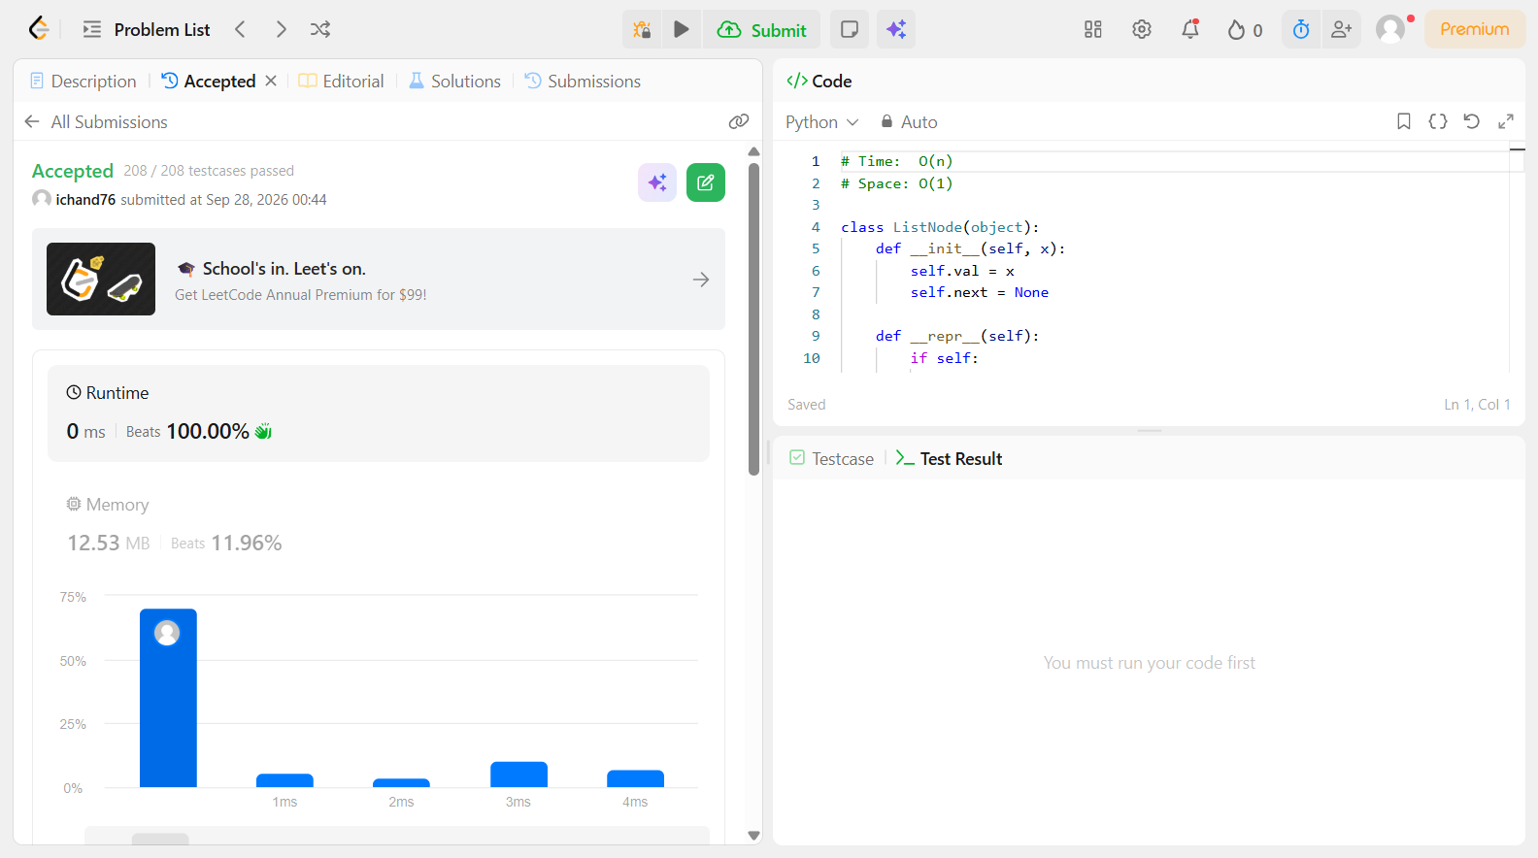

Problem 2
Field | Details
Problem ID | 83
Problem Name | Remove Duplicates from Sorted List
Difficulty | Easy
Submission Date | 2026-09-28
Accepted Submission Screenshot | 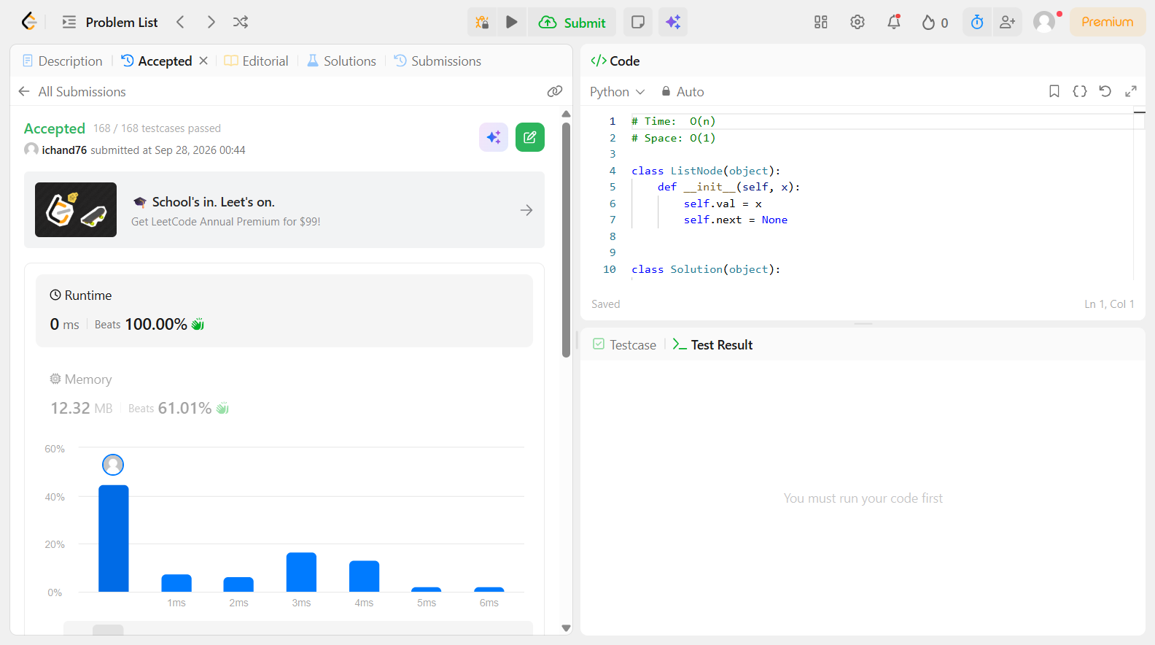

Problem 3
Field | Details
Problem ID | 141
Problem Name | Linked List Cycle
Difficulty | Easy
Submission Date | 2026-09-28
Accepted Submission Screenshot | 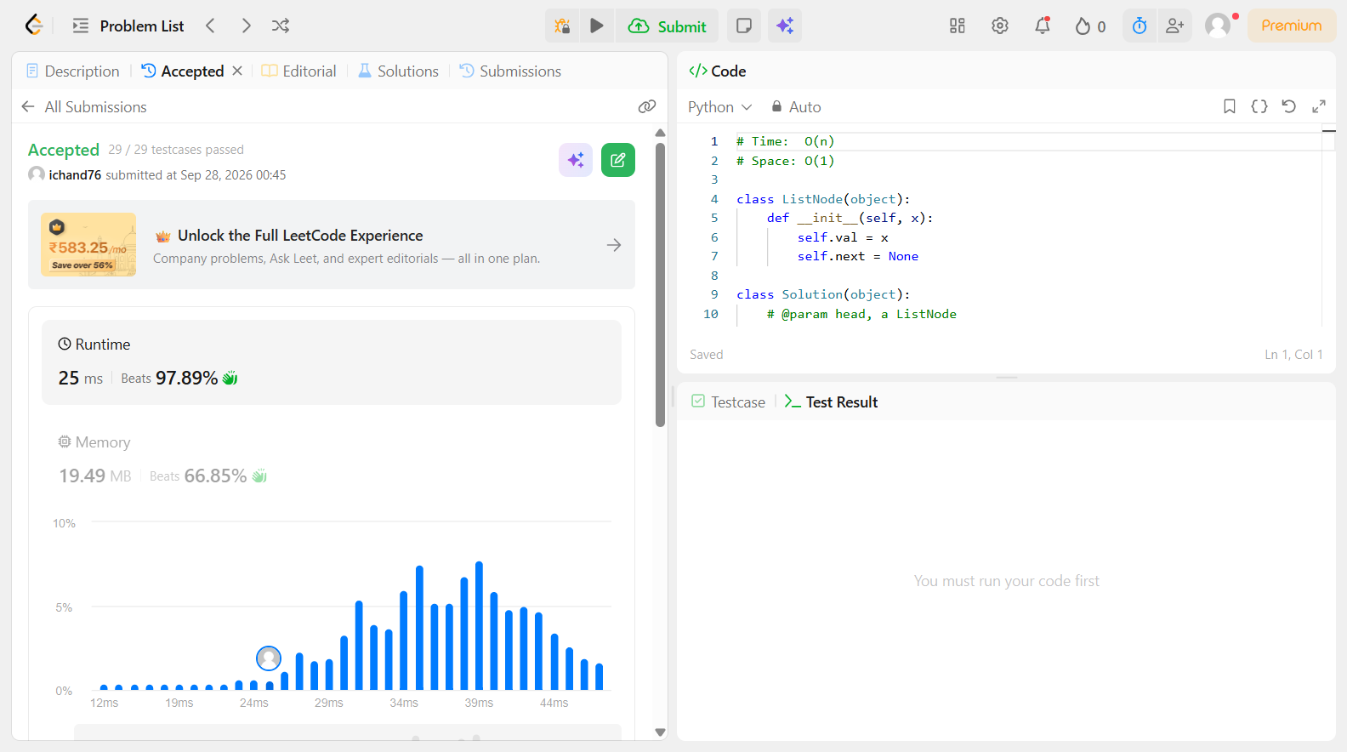

Problem 4
Field | Details
Problem ID | 160
Problem Name | Intersection of Two Linked Lists
Difficulty | Easy
Submission Date | 2026-09-28
Accepted Submission Screenshot | 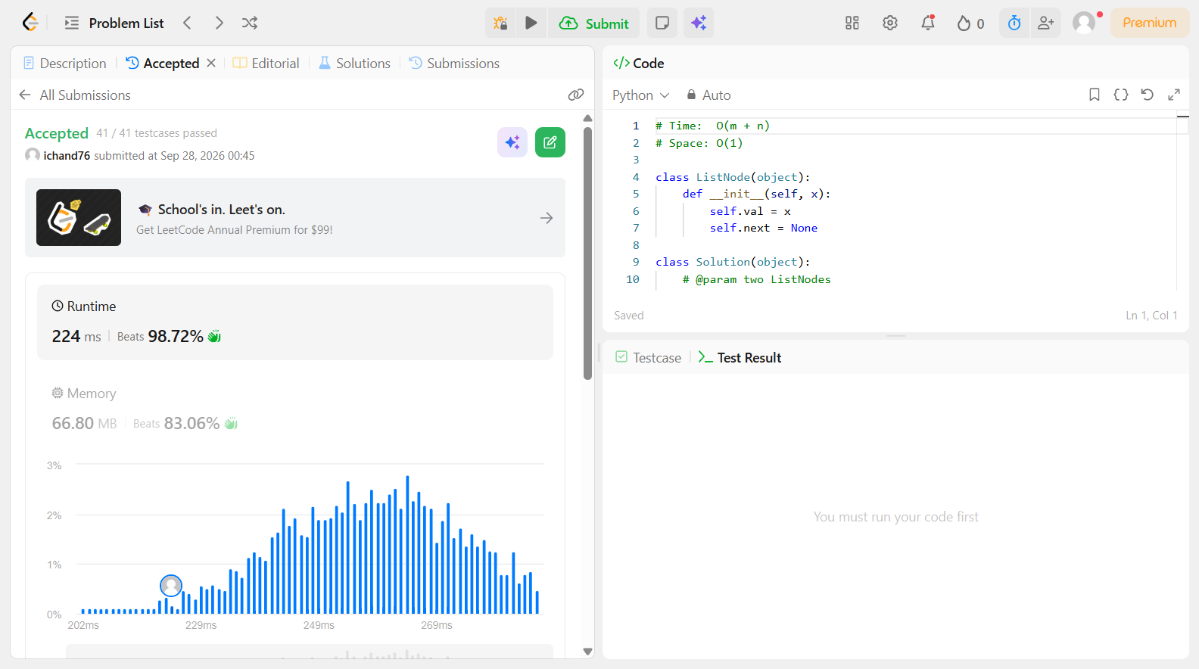

Problem 5
Field | Details
Problem ID | 203
Problem Name | Remove Linked List Elements
Difficulty | Easy
Submission Date | 2026-09-28
Accepted Submission Screenshot | 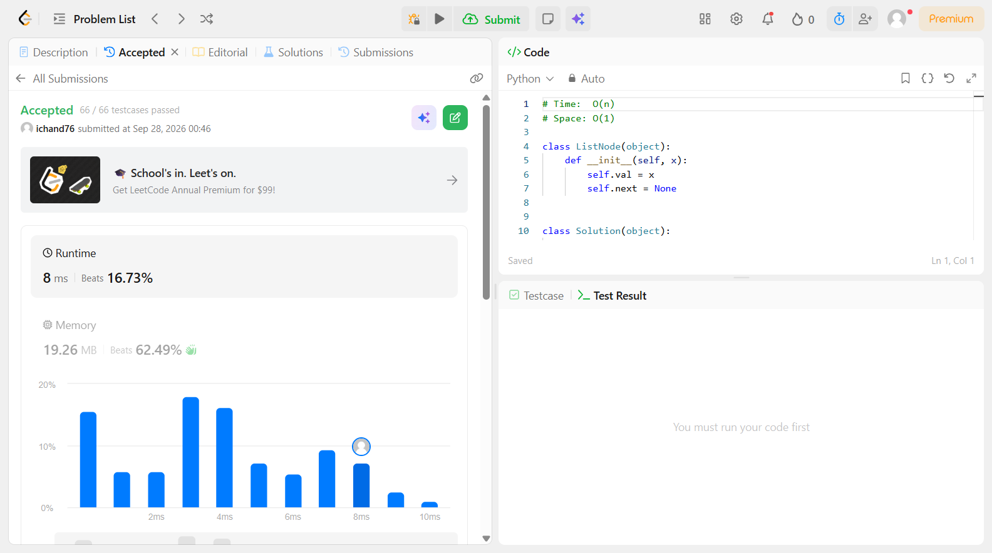

Problem 6
Field | Details
Problem ID | 206
Problem Name | Reverse Linked List
Difficulty | Easy
Submission Date | 2026-09-28
Accepted Submission Screenshot | 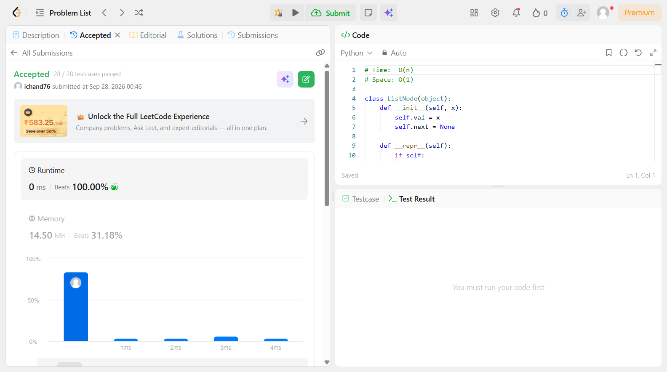

Problem 7
Field | Details
Problem ID | 225
Problem Name | Implement Stack using Queues
Difficulty | Easy
Submission Date | 2026-09-28
Accepted Submission Screenshot | 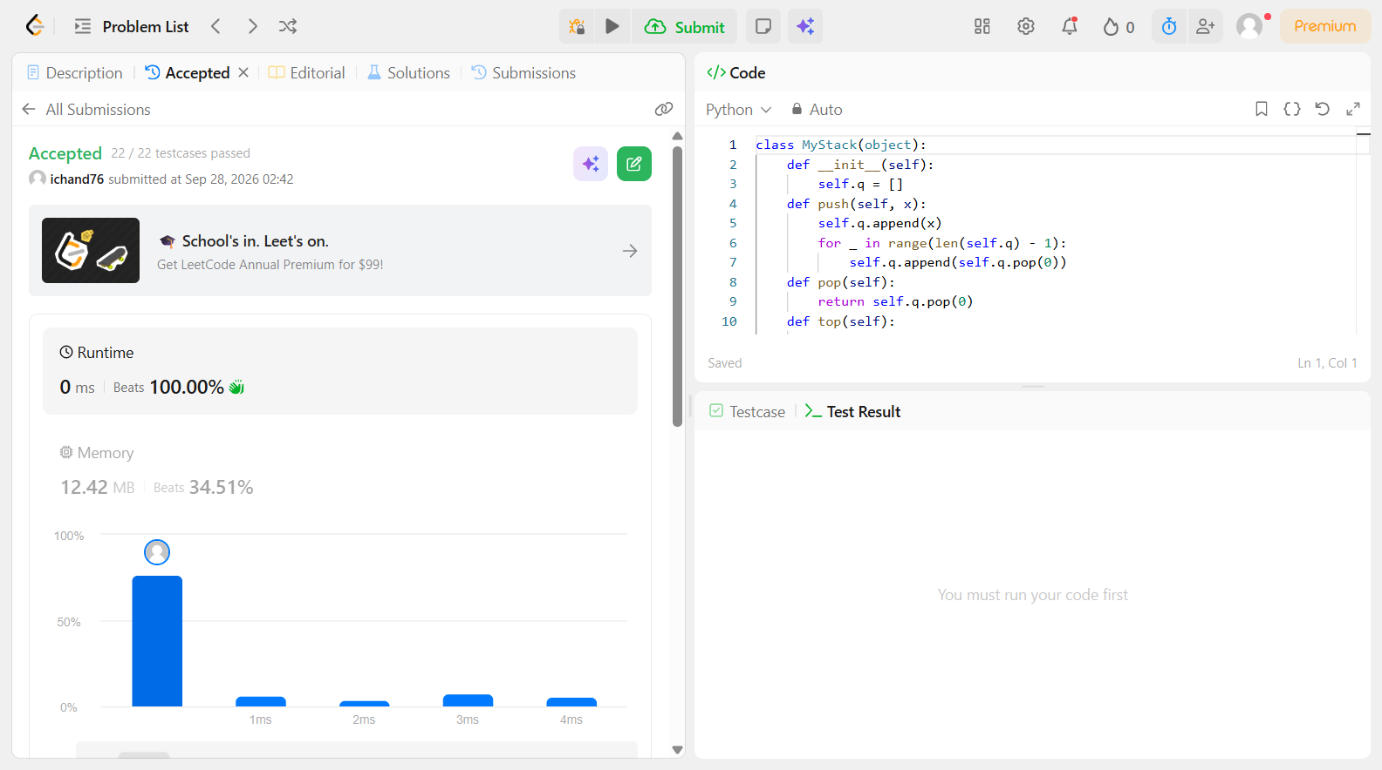

Problem 8
Field | Details
Problem ID | 232
Problem Name | Implement Queue using Stacks
Difficulty | Easy
Submission Date | 2026-09-28
Accepted Submission Screenshot | 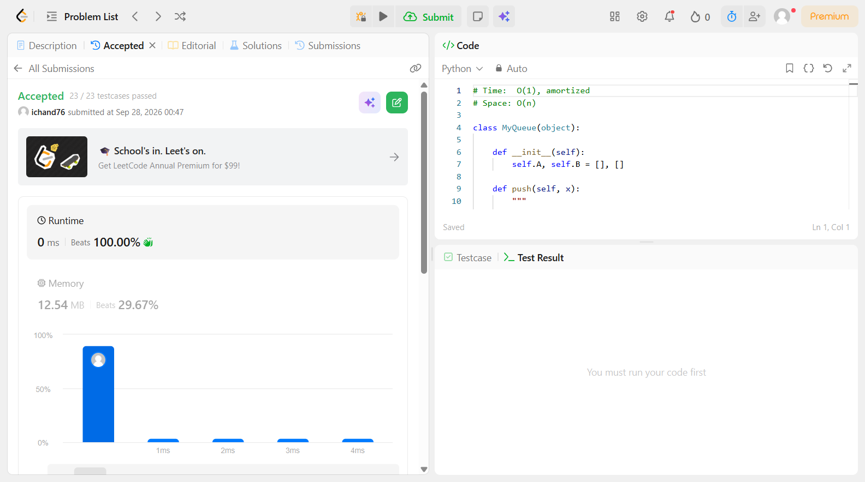

Problem 9
Field | Details
Problem ID | 234
Problem Name | Palindrome Linked List
Difficulty | Easy
Submission Date | 2026-09-28
Accepted Submission Screenshot | 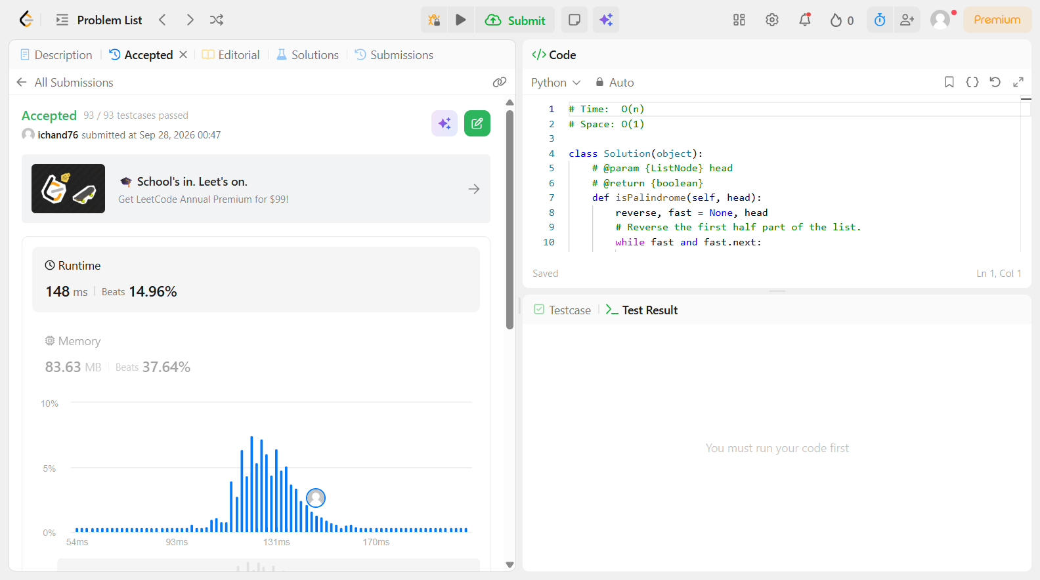

Problem 10
Field | Details
Problem ID | 235
Problem Name | Lowest Common Ancestor of a BST
Difficulty | Easy
Submission Date | 2026-09-28
Accepted Submission Screenshot | 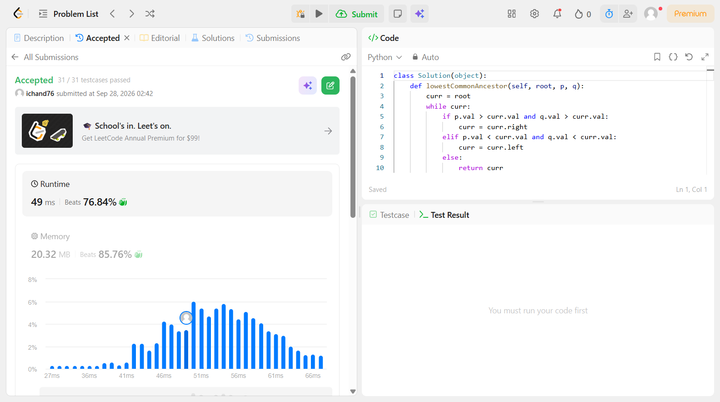

Problem 11
Field | Details
Problem ID | 237
Problem Name | Delete Node in a Linked List
Difficulty | Easy
Submission Date | 2026-09-28
Accepted Submission Screenshot | 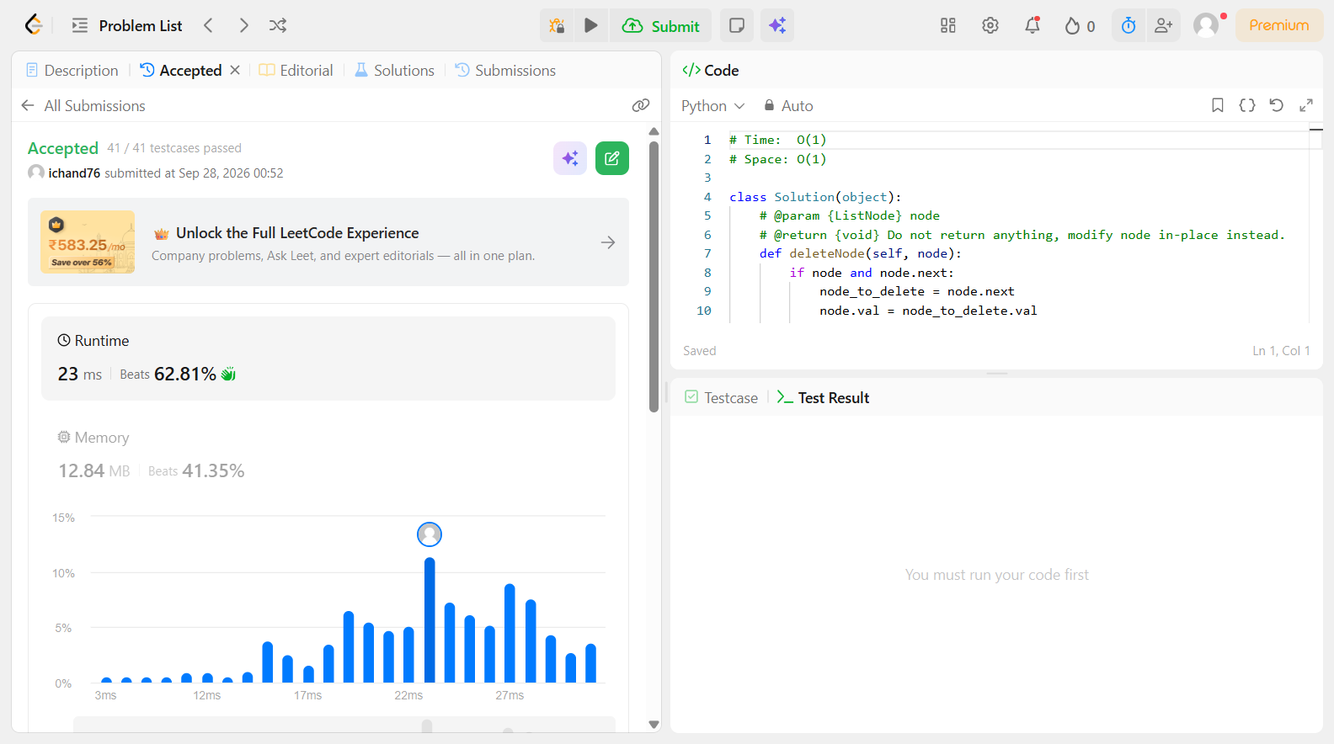

Problem 12
Field | Details
Problem ID | 257
Problem Name | Binary Tree Paths
Difficulty | Easy
Submission Date | 2026-09-28
Accepted Submission Screenshot | 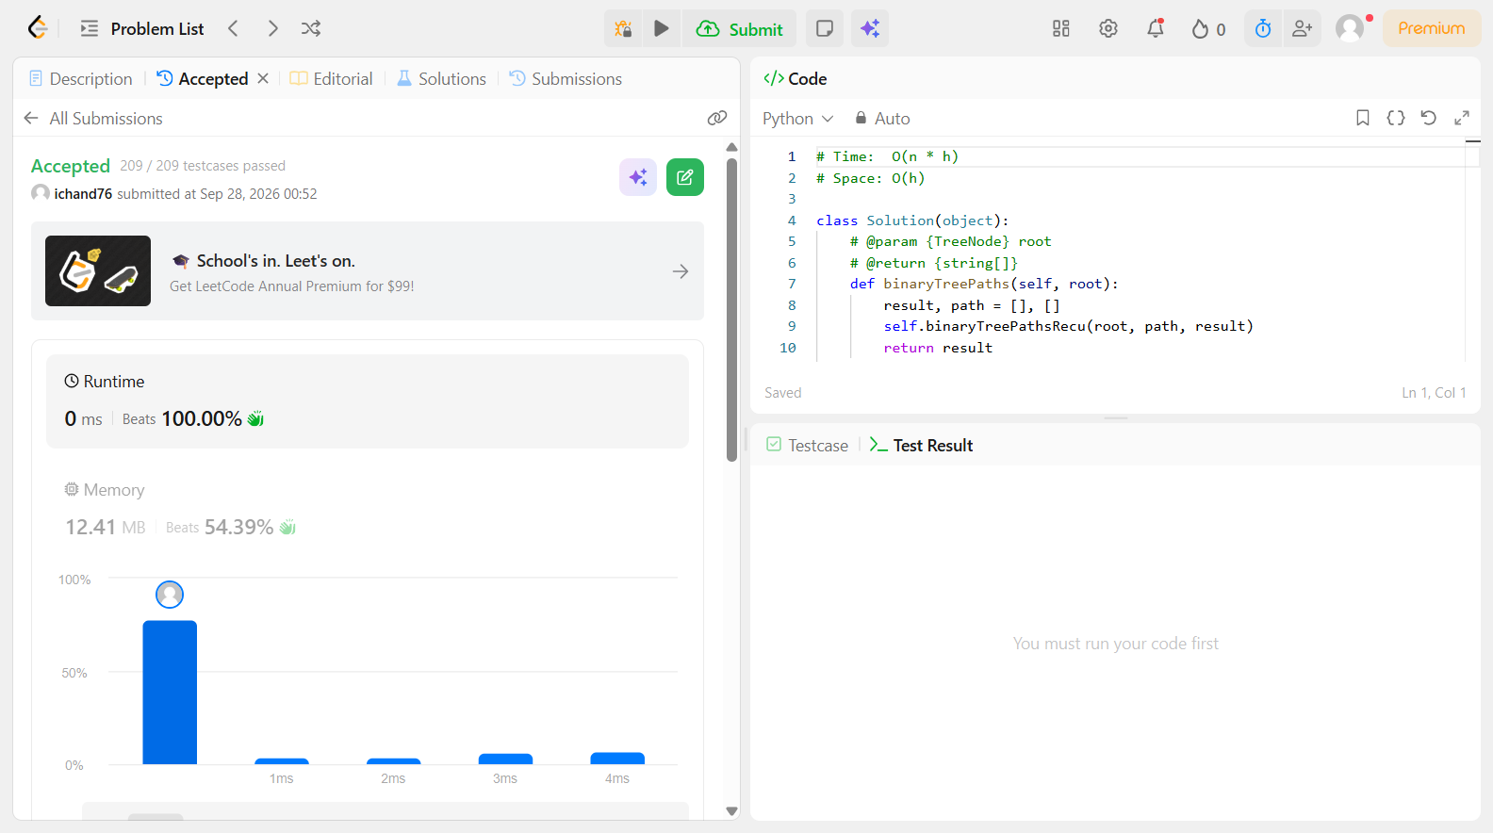

Problem 13
Field | Details
Problem ID | 303
Problem Name | Range Sum Query – Immutable
Difficulty | Easy
Submission Date | 2026-09-28
Accepted Submission Screenshot | 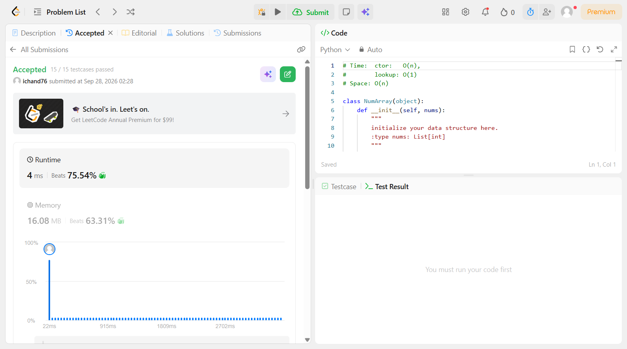

Problem 14
Field | Details
Problem ID | 346
Problem Name | Moving Average from Data Stream
Difficulty | Easy
Submission Date | 2026-09-28
Accepted Submission Screenshot | SUBSCRIBER ONLY

Problem 15
Field | Details
Problem ID | 349
Problem Name | Intersection of Two Arrays
Difficulty | Easy
Submission Date | 2026-09-28
Accepted Submission Screenshot | 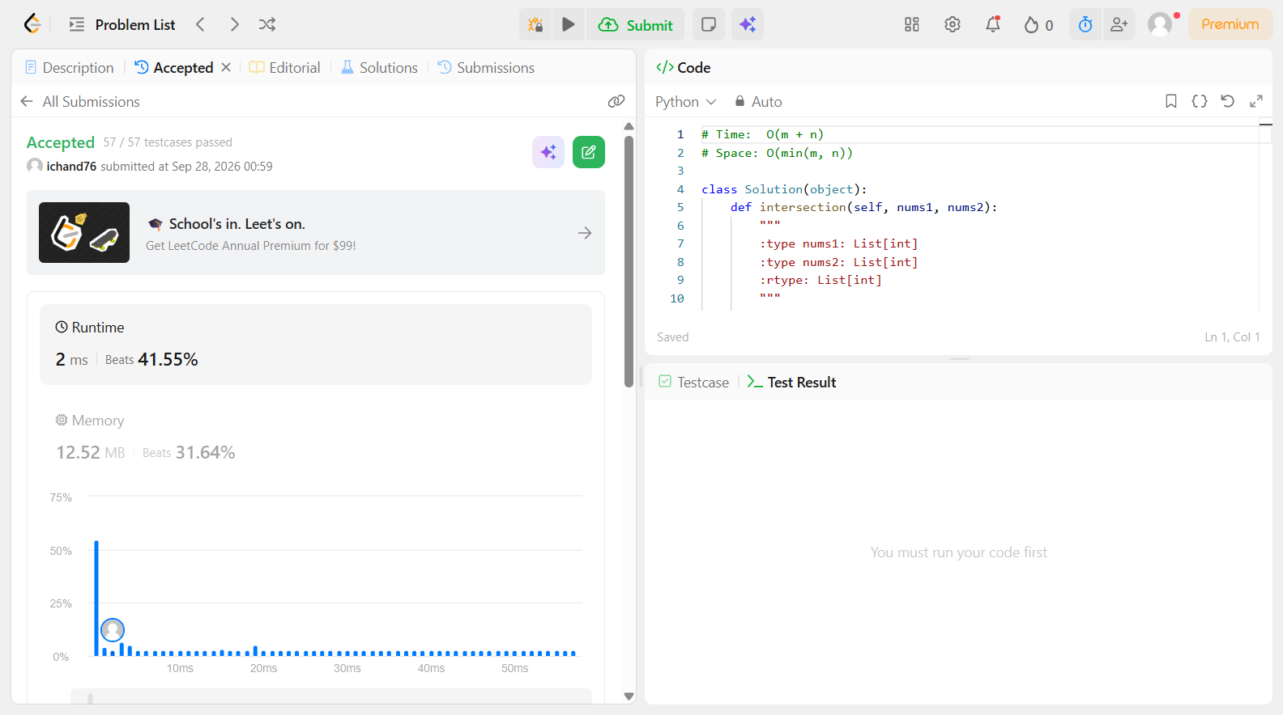

Problem 16
Field | Details
Problem ID | 404
Problem Name | Sum of Left Leaves
Difficulty | Easy
Submission Date | 2026-09-28
Accepted Submission Screenshot | 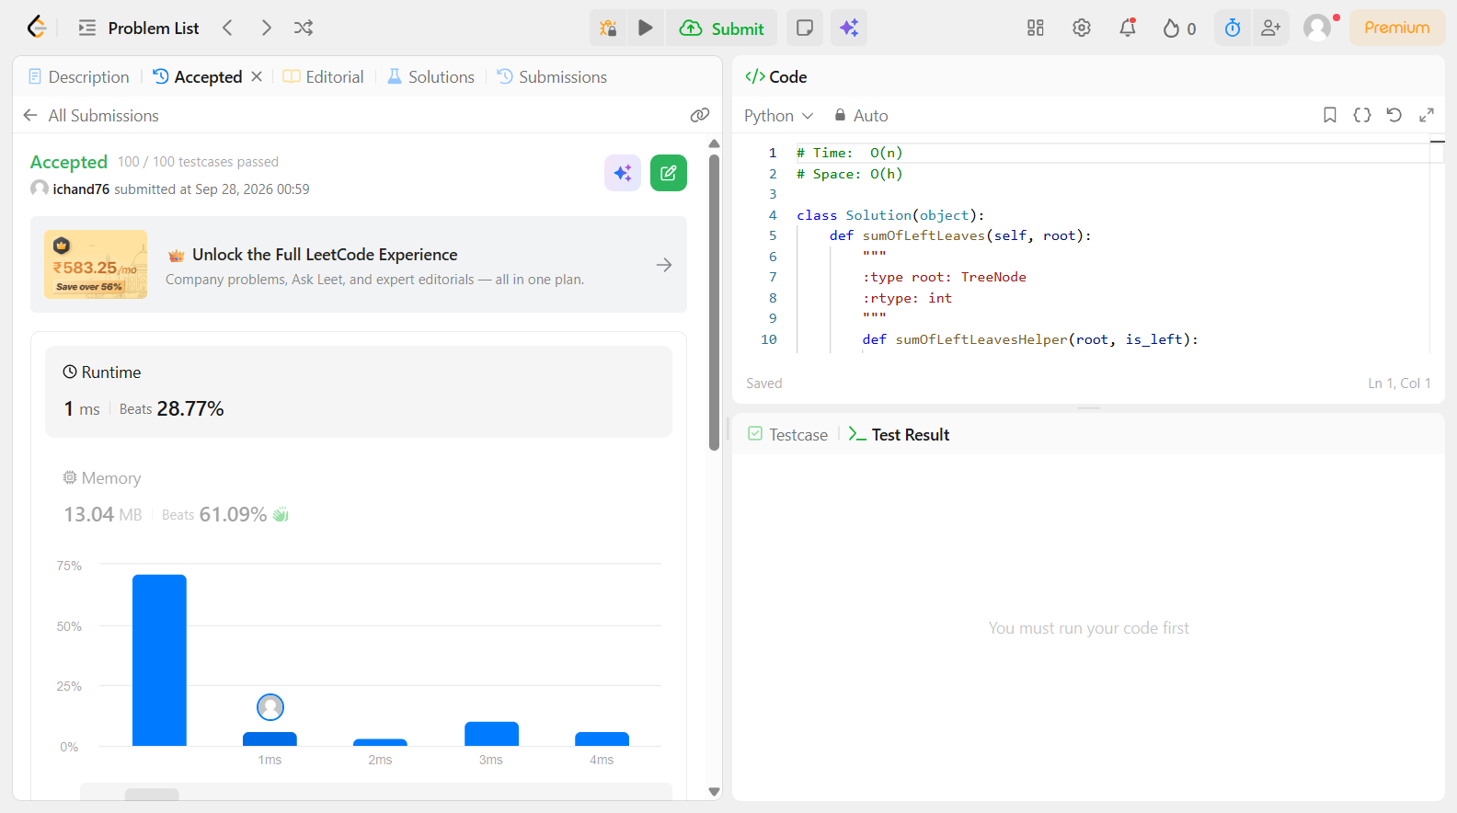

Problem 17
Field | Details
Problem ID | 429
Problem Name | N-ary Tree Level Order Traversal
Difficulty | Easy
Submission Date | 2026-09-28
Accepted Submission Screenshot | 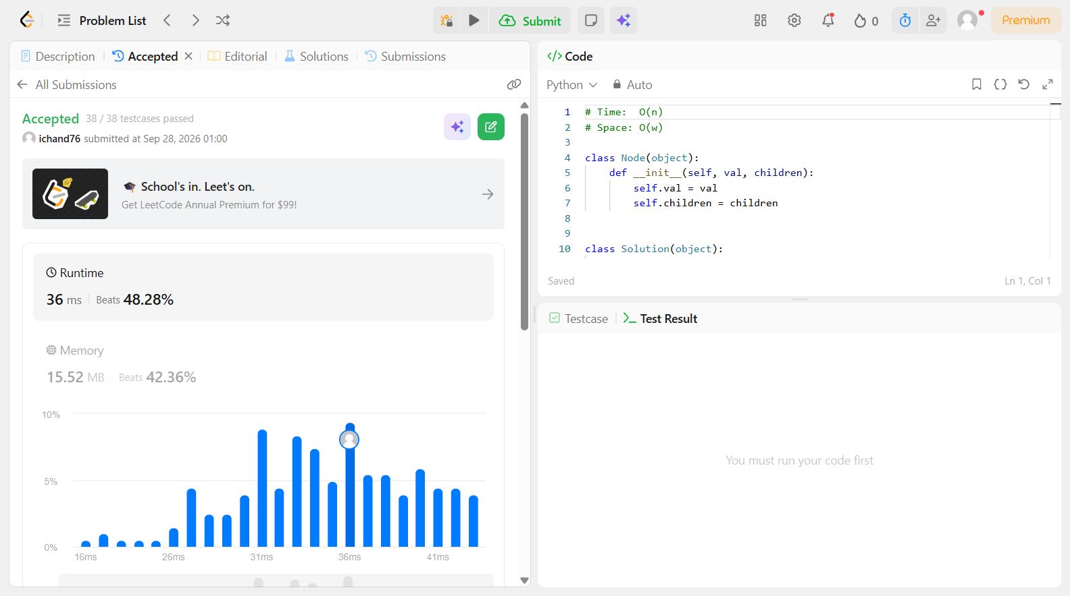

Problem 18
Field | Details
Problem ID | 496
Problem Name | Next Greater Element I
Difficulty | Easy
Submission Date | 2026-09-28
Accepted Submission Screenshot | 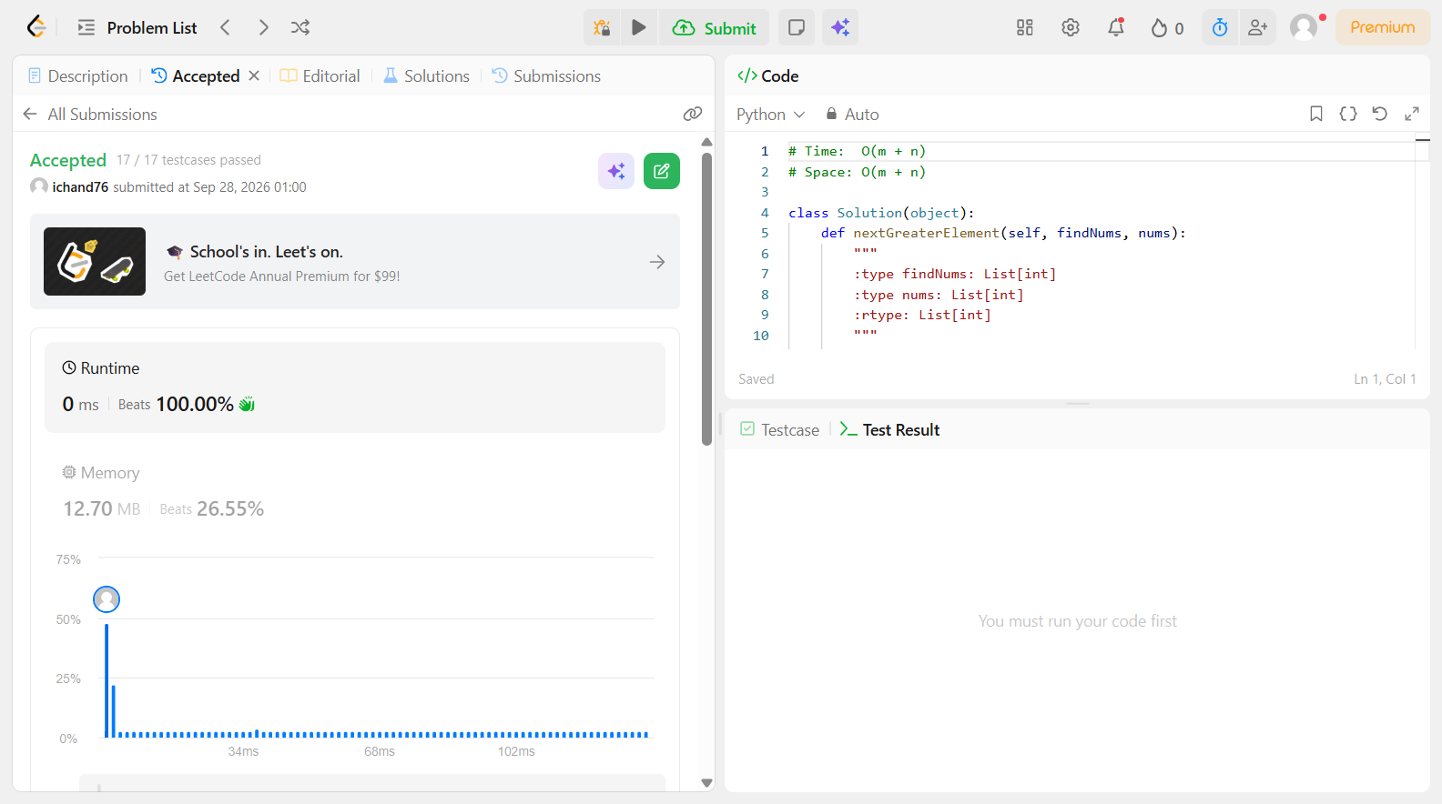

Problem 19
Field | Details
Problem ID | 530
Problem Name | Minimum Absolute Difference in BST
Difficulty | Easy
Submission Date | 2026-09-28
Accepted Submission Screenshot | 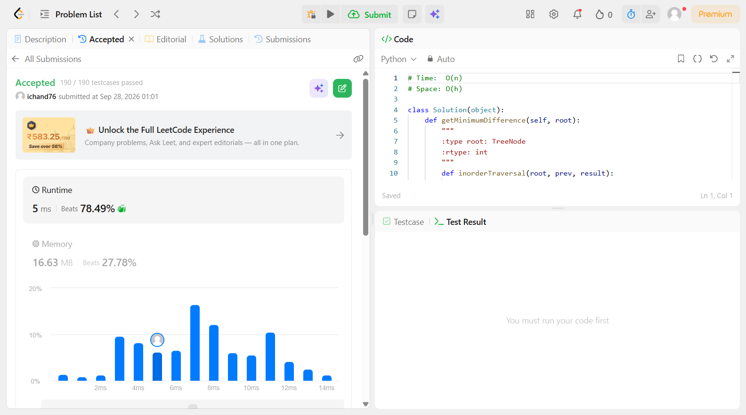

Problem 20
Field | Details
Problem ID | 543
Problem Name | Diameter of Binary Tree
Difficulty | Easy
Submission Date | 2026-09-28
Accepted Submission Screenshot | 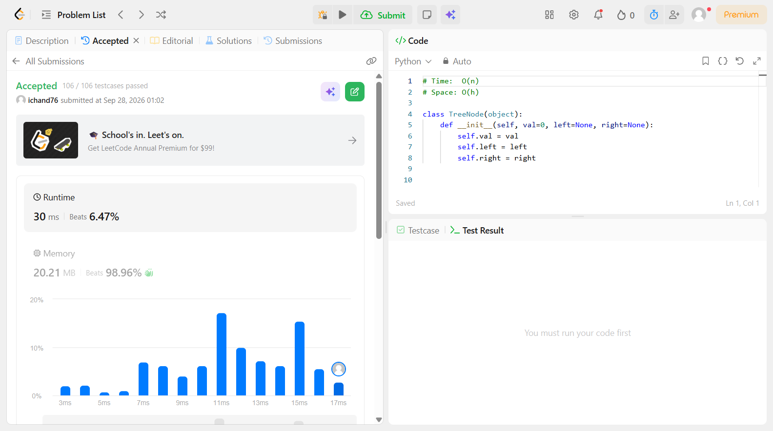

Problem 21
Field | Details
Problem ID | 559
Problem Name | Maximum Depth of N-ary Tree
Difficulty | Easy
Submission Date | 2026-09-28
Accepted Submission Screenshot | 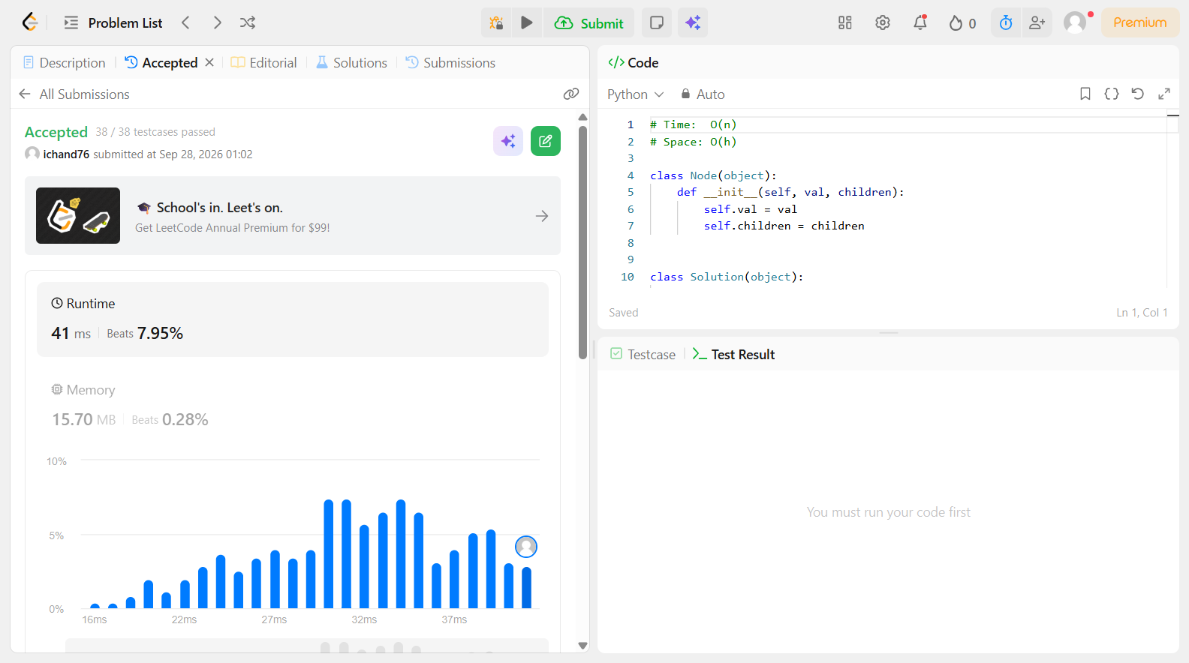

Problem 22
Field | Details
Problem ID | 563
Problem Name | Binary Tree Tilt
Difficulty | Easy
Submission Date | 2026-09-28
Accepted Submission Screenshot | 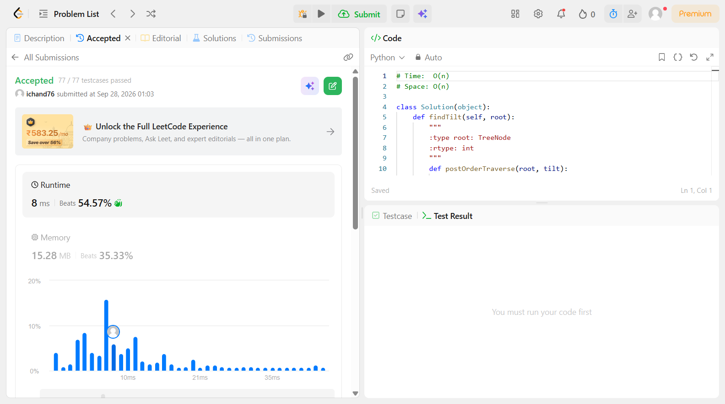

Problem 23
Field | Details
Problem ID | 572
Problem Name | Subtree of Another Tree
Difficulty | Easy
Submission Date | 2026-09-28
Accepted Submission Screenshot | 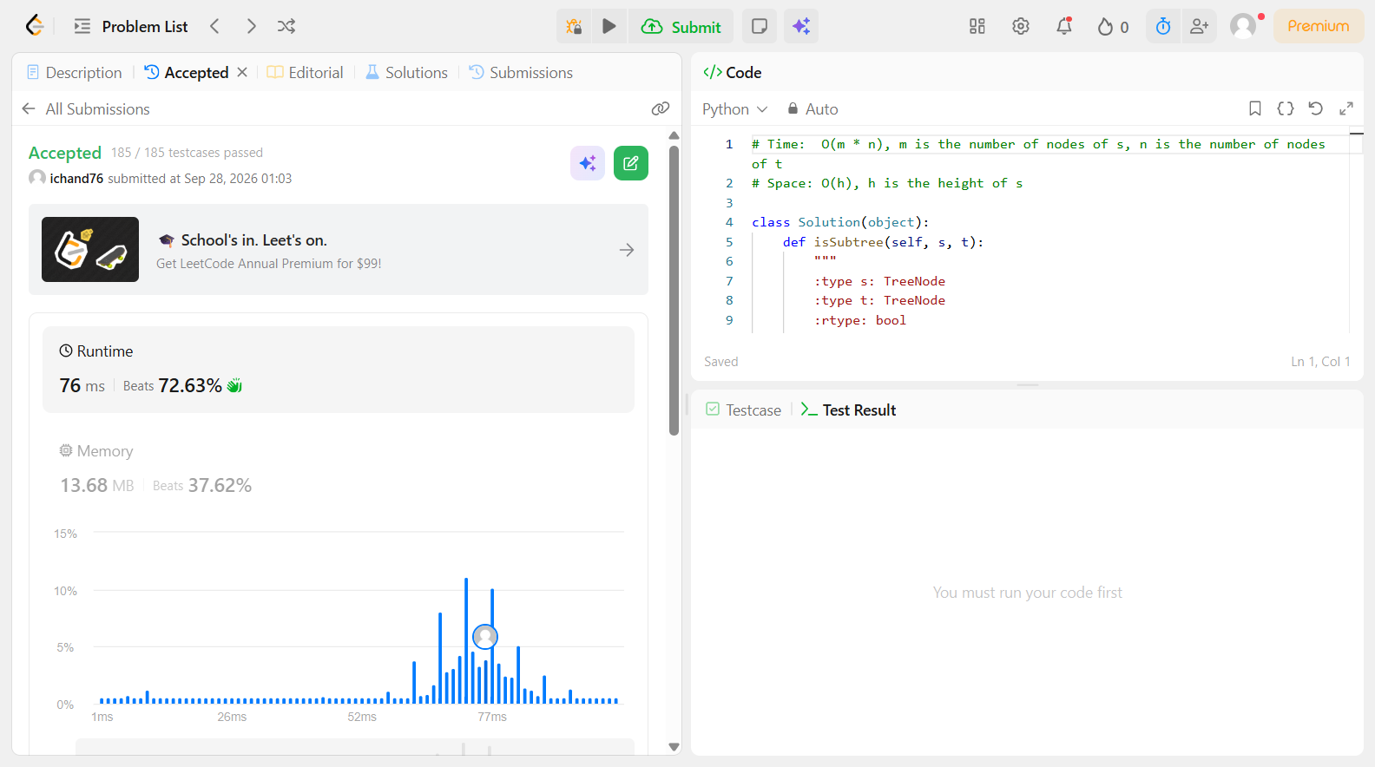

Problem 24
Field | Details
Problem ID | 589
Problem Name | N-ary Tree Preorder Traversal
Difficulty | Easy
Submission Date | 2026-09-28
Accepted Submission Screenshot | 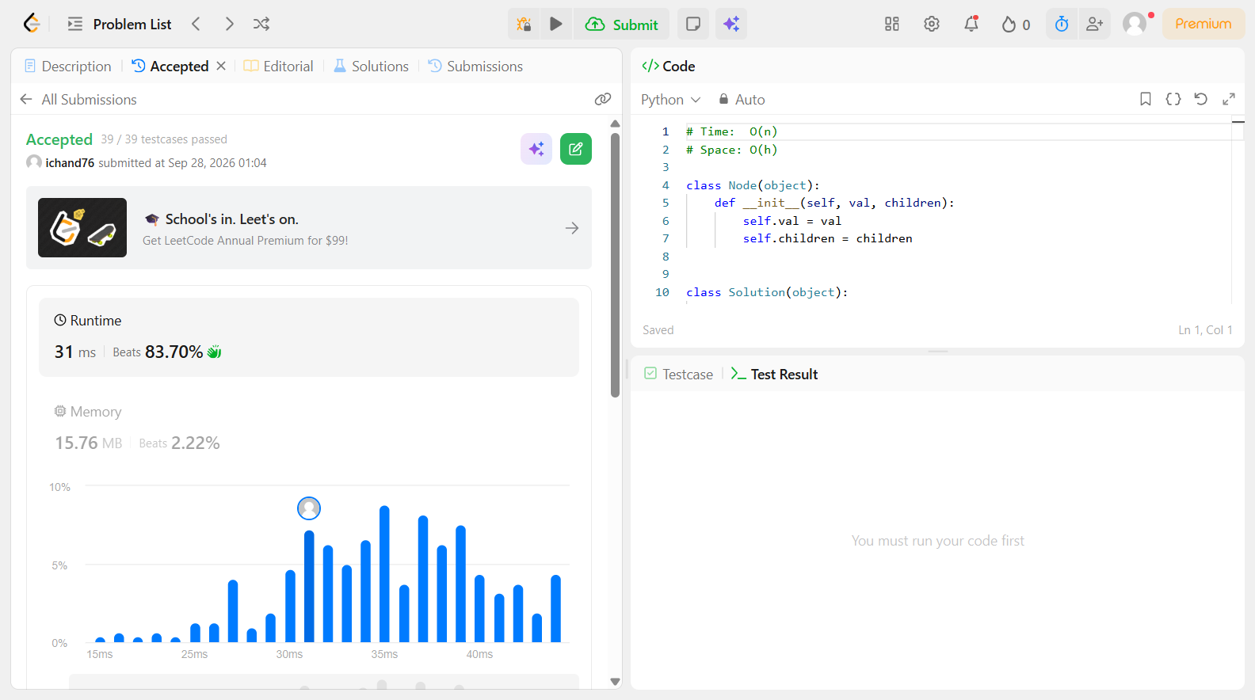

Problem 25
Field | Details
Problem ID | 590
Problem Name | N-ary Tree Postorder Traversal
Difficulty | Easy
Submission Date | 2026-09-28
Accepted Submission Screenshot | 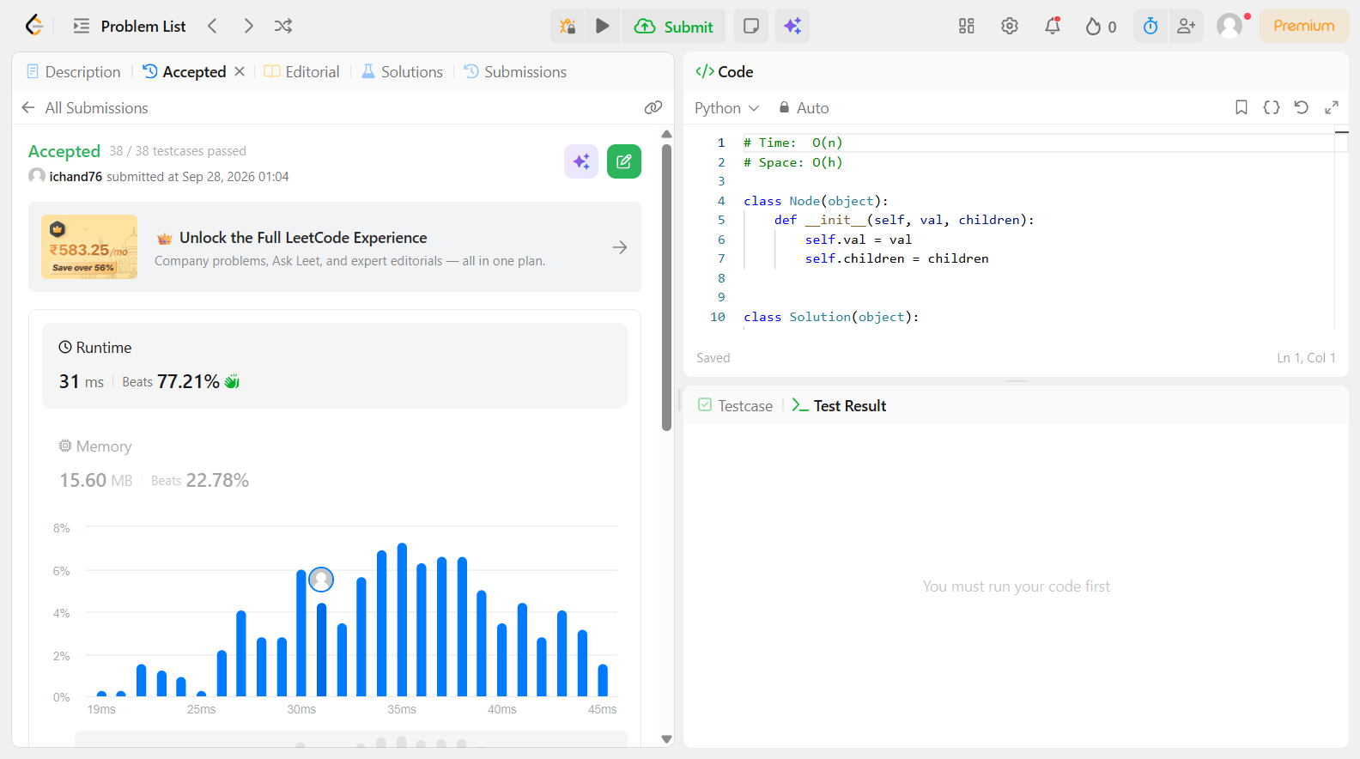

Problem 26
Field | Details
Problem ID | 617
Problem Name | Merge Two Binary Trees
Difficulty | Easy
Submission Date | 2026-09-28
Accepted Submission Screenshot | 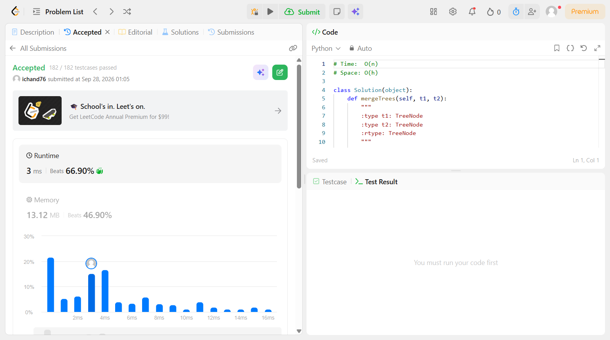

Problem 27
Field | Details
Problem ID | 637
Problem Name | Average of Levels in Binary Tree
Difficulty | Easy
Submission Date | 2026-09-28
Accepted Submission Screenshot | 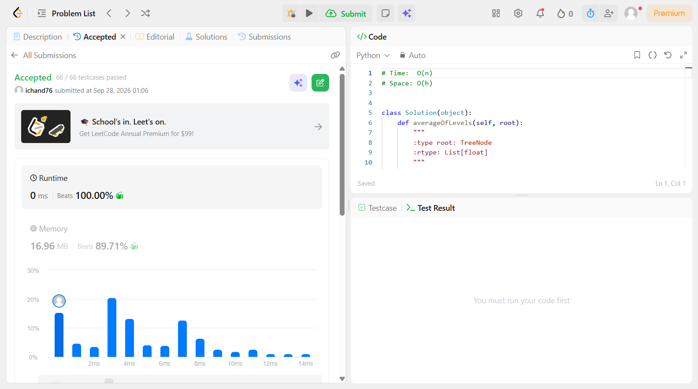

Problem 28
Field | Details
Problem ID | 653
Problem Name | Two Sum IV – Input is a BST
Difficulty | Easy
Submission Date | 2026-09-28
Accepted Submission Screenshot | 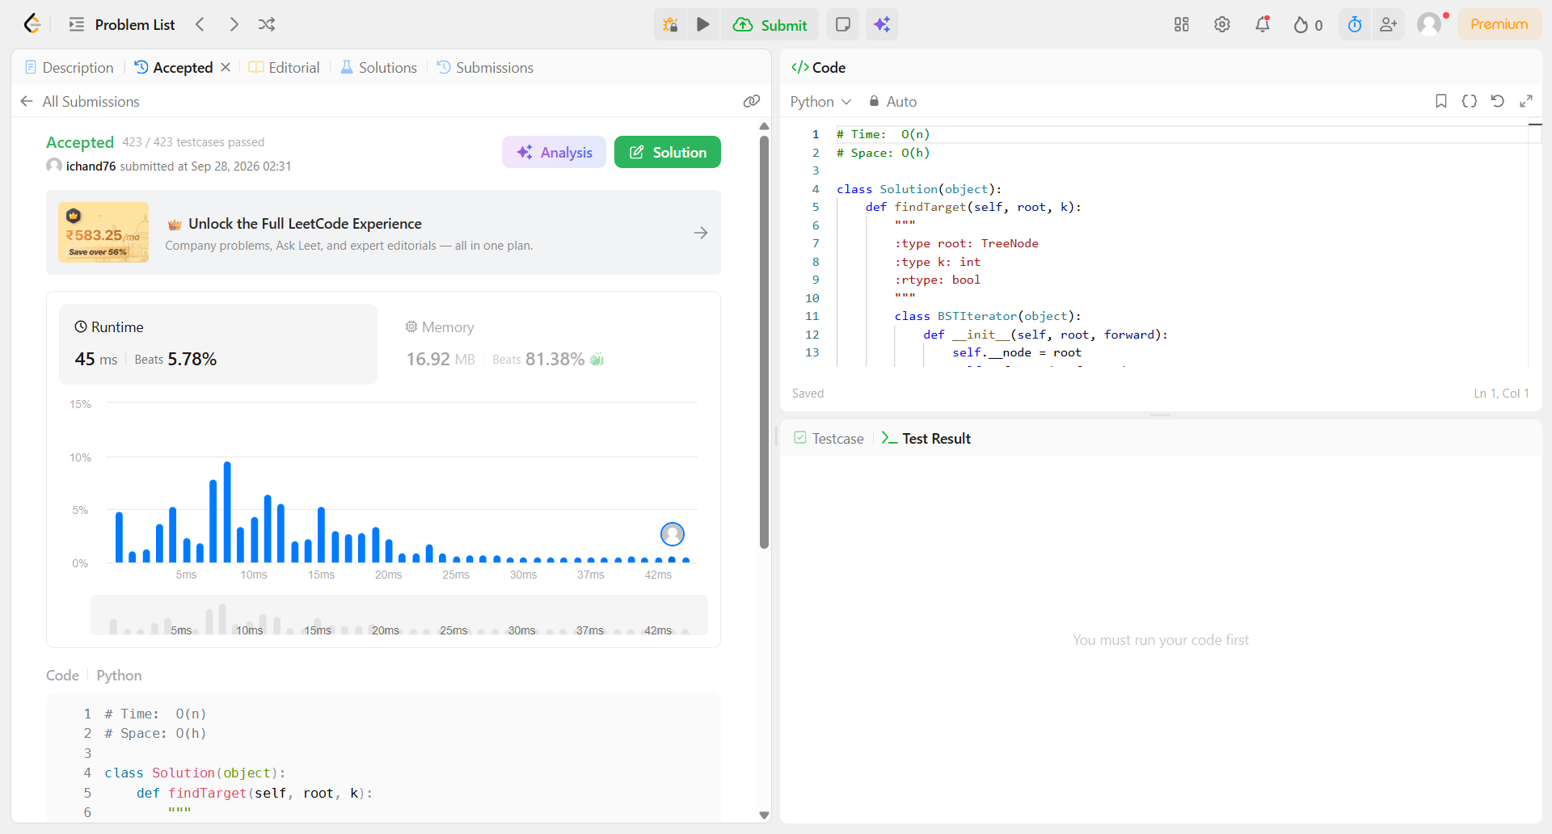

Problem 29
Field | Details
Problem ID | 671
Problem Name | Second Minimum Node in a Binary Tree
Difficulty | Easy
Submission Date | 2026-09-28
Accepted Submission Screenshot | 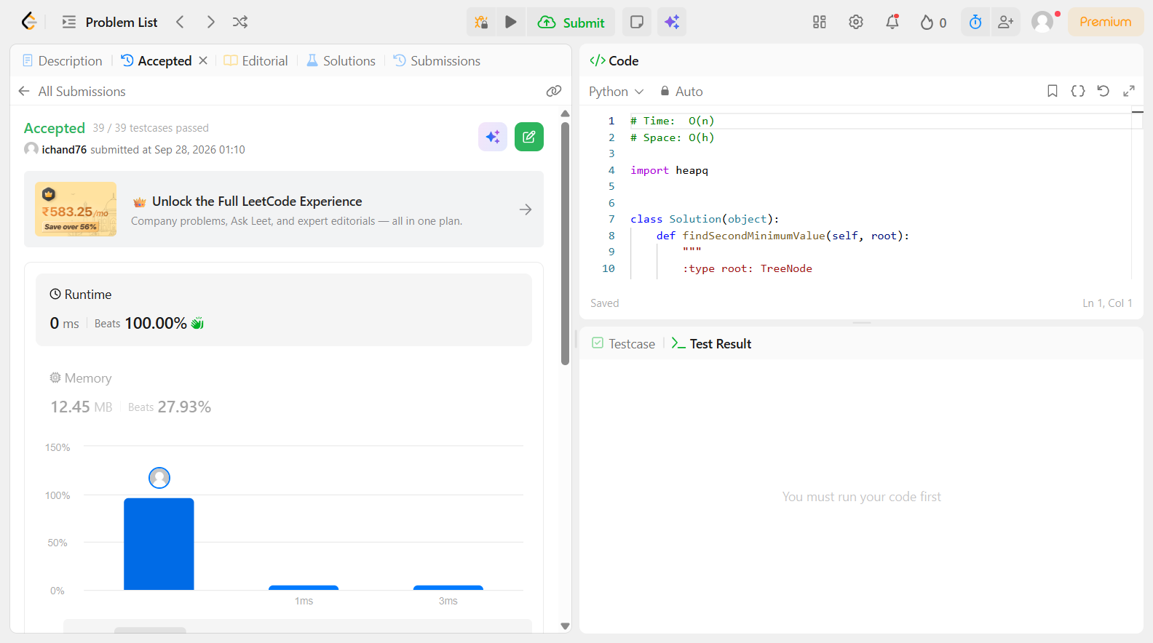

Problem 30
Field | Details
Problem ID | 682
Problem Name | Baseball Game
Difficulty | Easy
Submission Date | 2026-09-28
Accepted Submission Screenshot | 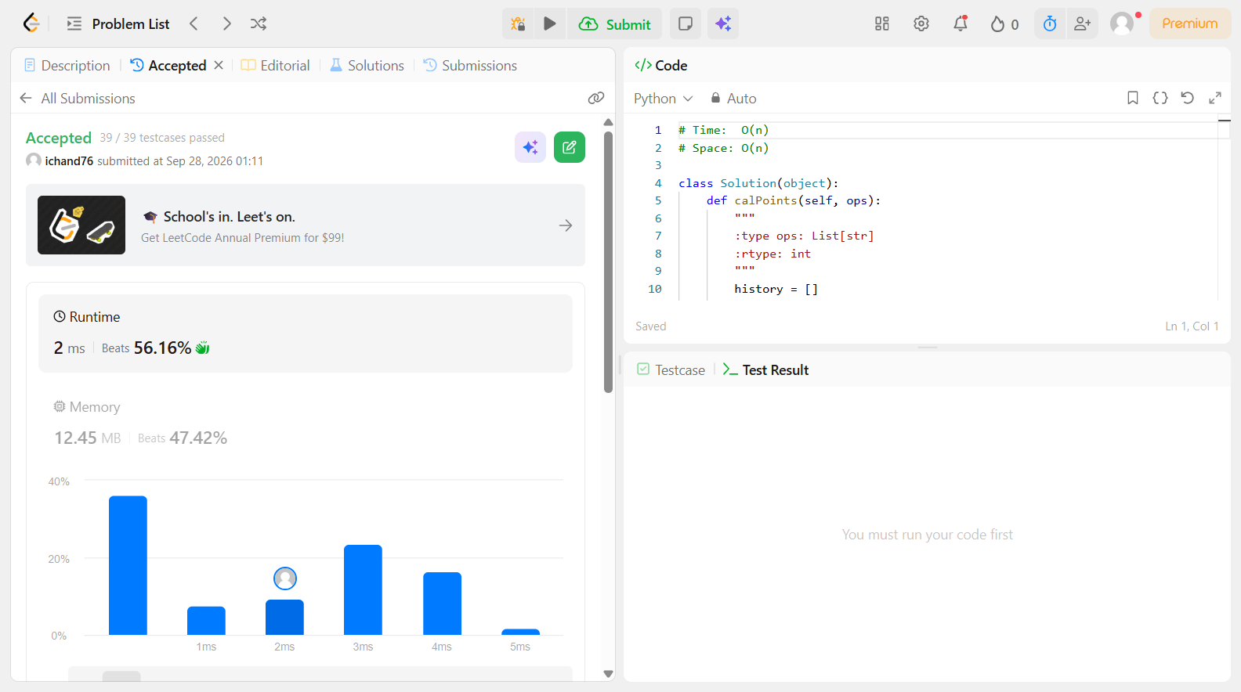

Problem 31
Field | Details
Problem ID | 700
Problem Name | Search in a Binary Search Tree
Difficulty | Easy
Submission Date | 2026-09-28
Accepted Submission Screenshot | 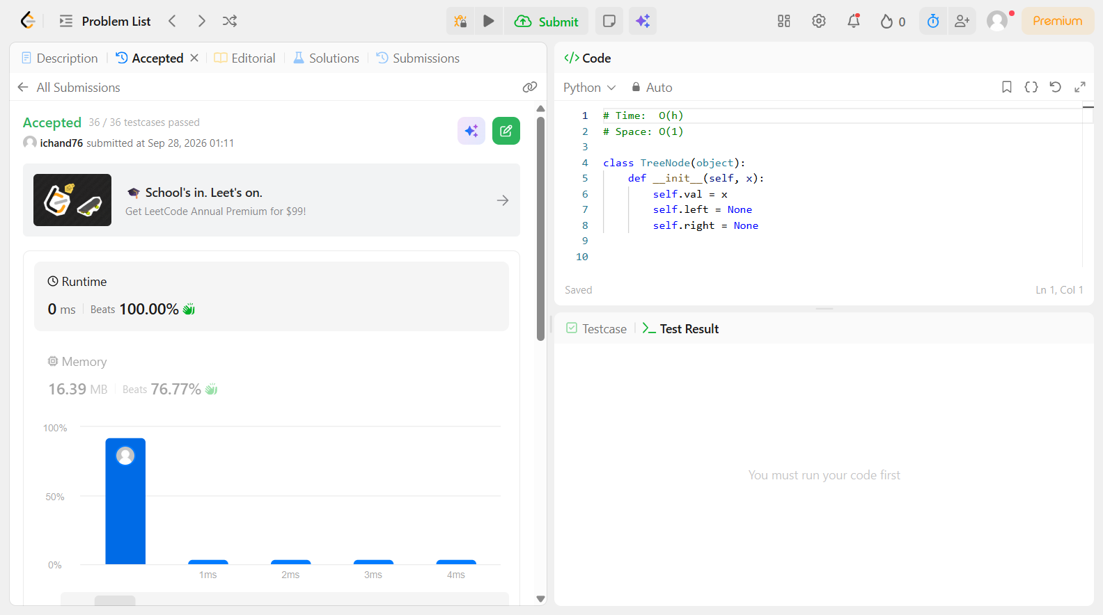

Problem 32
Field | Details
Problem ID | 703
Problem Name | Kth Largest Element in a Stream
Difficulty | Easy
Submission Date | 2026-09-28
Accepted Submission Screenshot | 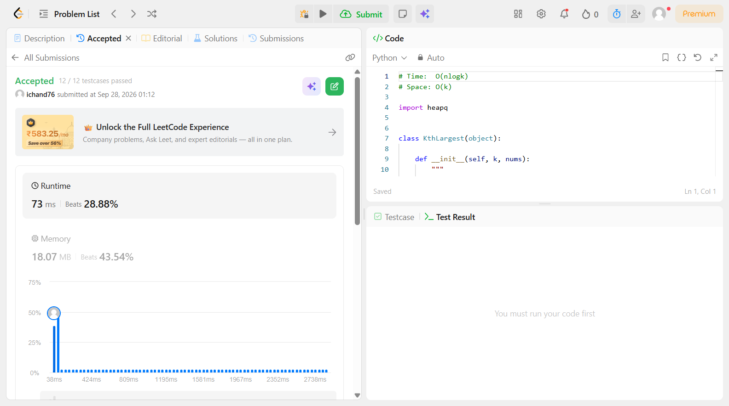

Problem 33
Field | Details
Problem ID | 705
Problem Name | Design HashSet
Difficulty | Easy
Submission Date | 2026-09-28
Accepted Submission Screenshot | 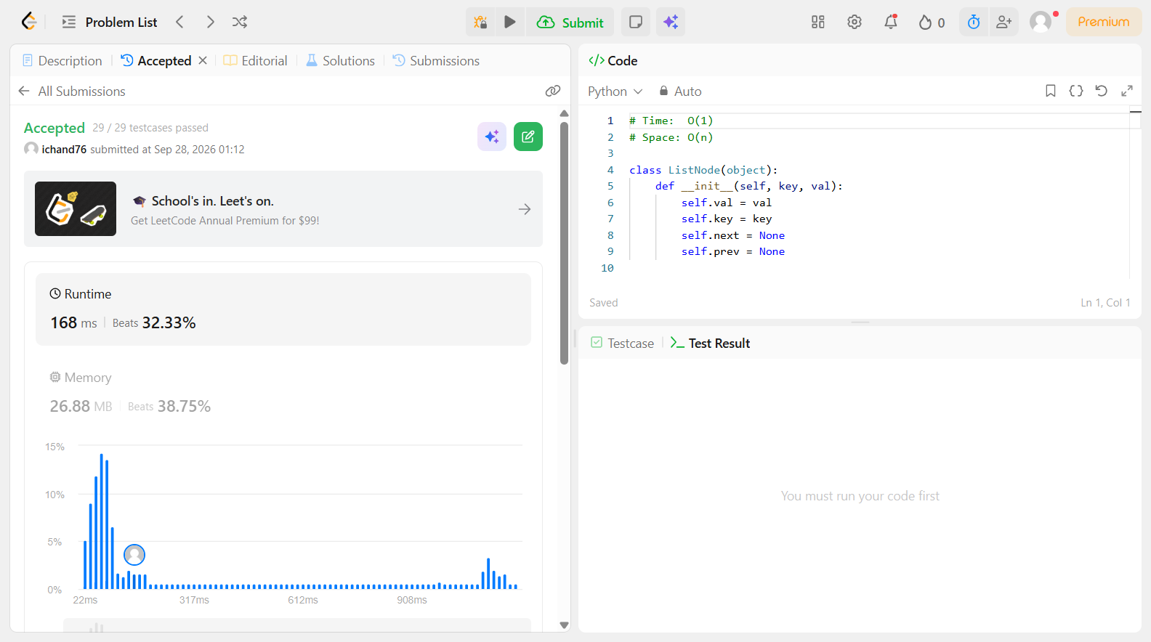

Problem 34
Field | Details
Problem ID | 706
Problem Name | Design HashMap
Difficulty | Easy
Submission Date | 2026-09-28
Accepted Submission Screenshot | 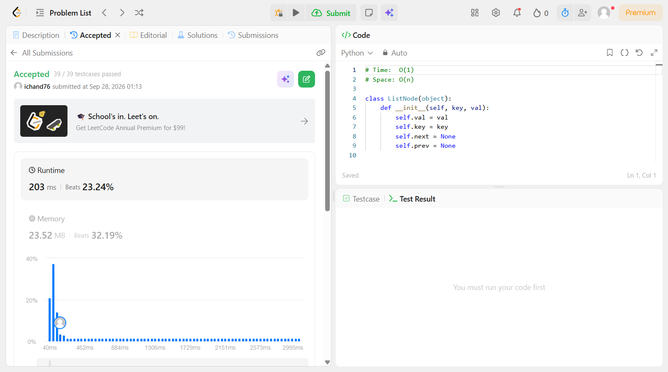

Problem 35
Field | Details
Problem ID | 724
Problem Name | Find Pivot Index
Difficulty | Easy
Submission Date | 2026-09-28
Accepted Submission Screenshot | 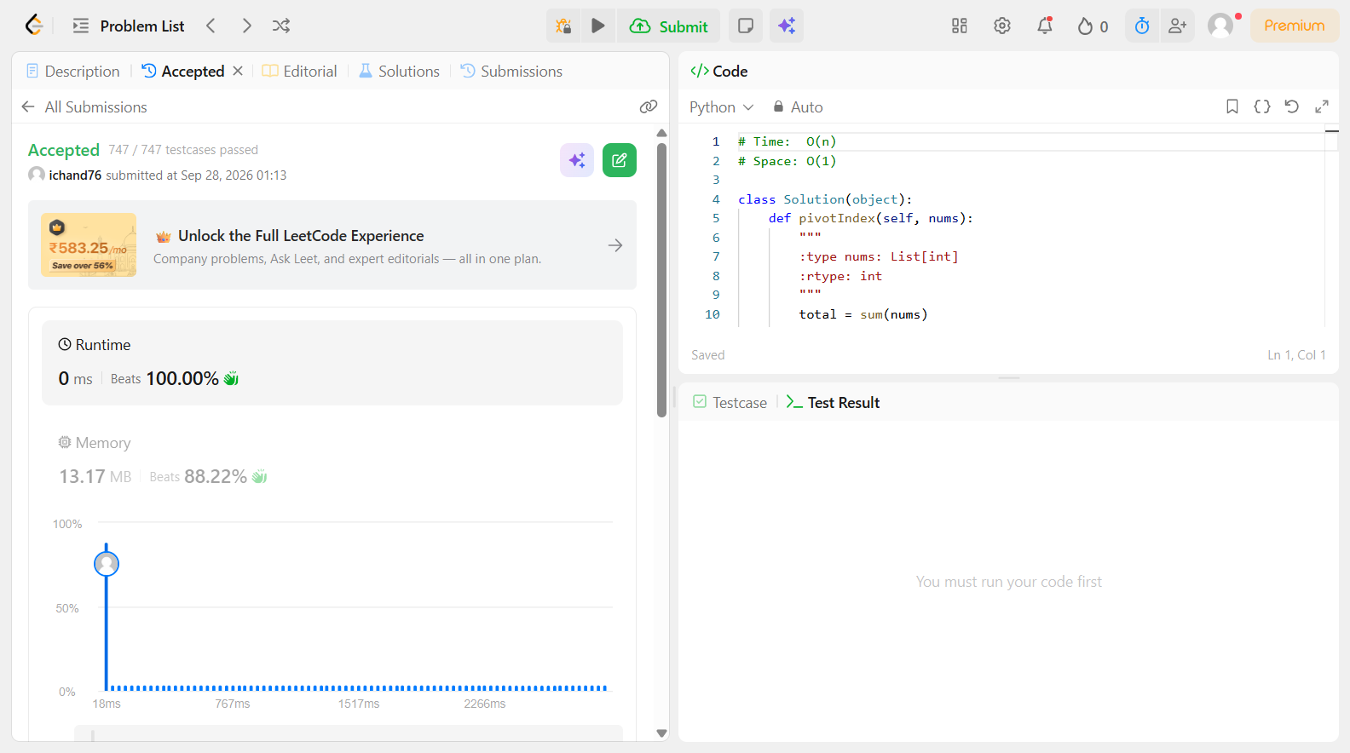

Problem 36
Field | Details
Problem ID | 733
Problem Name | Flood Fill
Difficulty | Easy
Submission Date | 2026-09-28
Accepted Submission Screenshot | 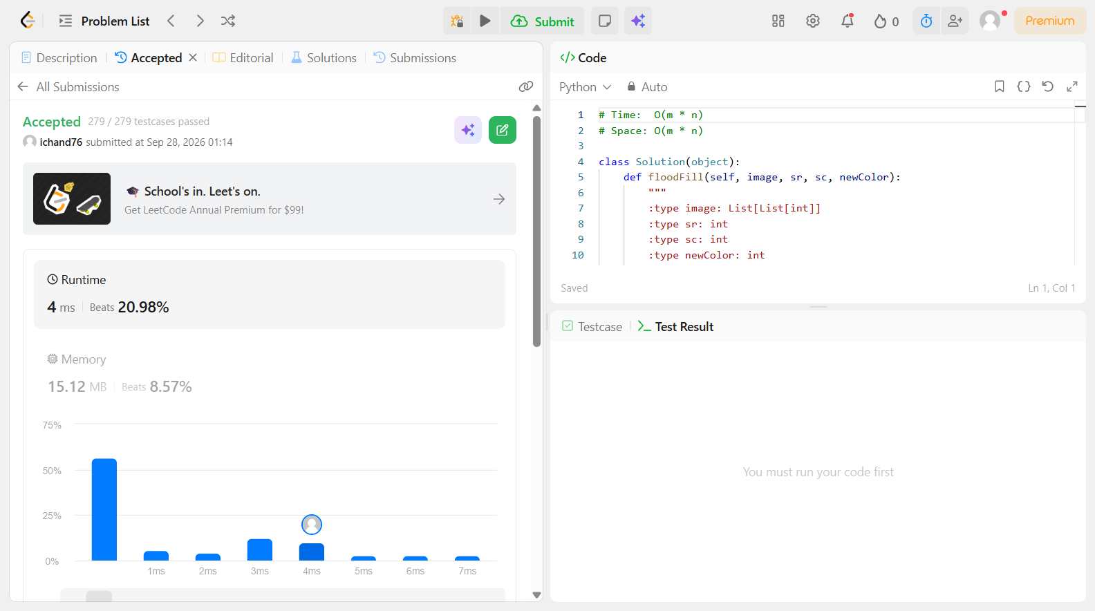

Problem 37
Field | Details
Problem ID | 844
Problem Name | Backspace String Compare
Difficulty | Easy
Submission Date | 2026-09-28
Accepted Submission Screenshot | 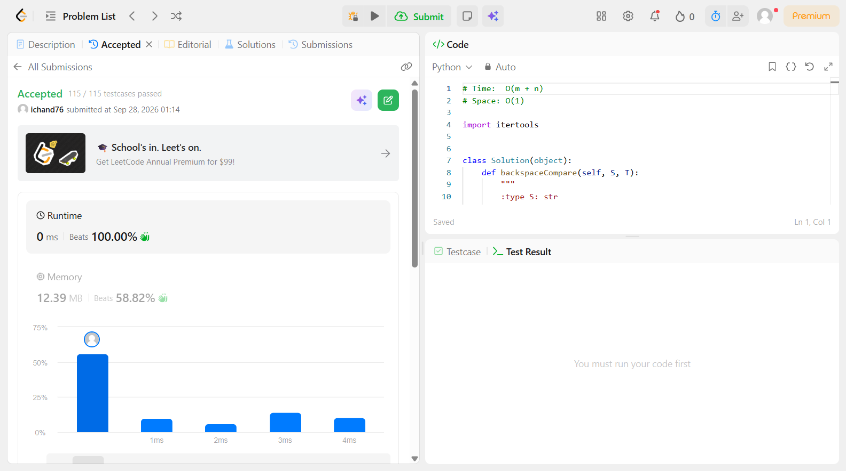

Problem 38
Field | Details
Problem ID | 872
Problem Name | Leaf-Similar Trees
Difficulty | Easy
Submission Date | 2026-09-28
Accepted Submission Screenshot | 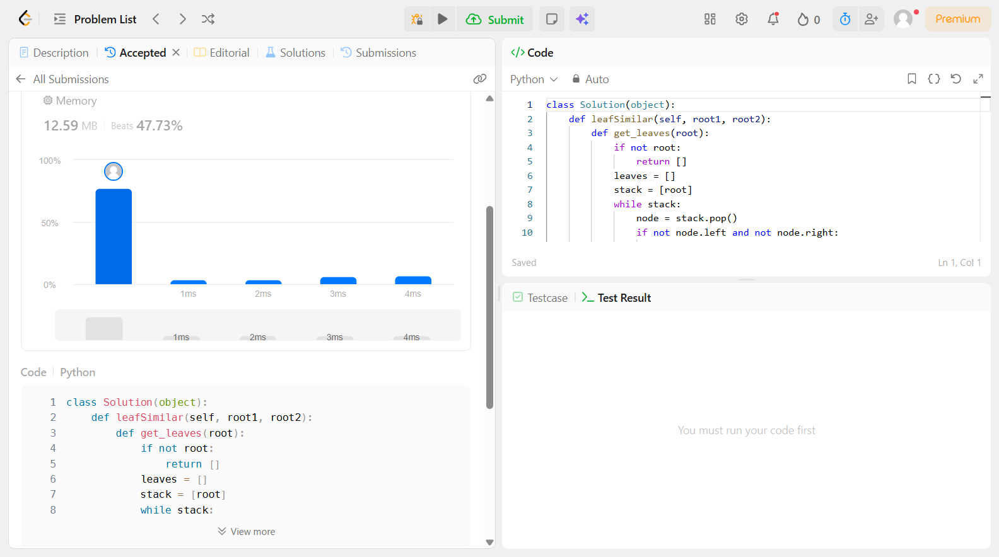

Problem 39
Field | Details
Problem ID | 876
Problem Name | Middle of the Linked List
Difficulty | Easy
Submission Date | 2026-09-28
Accepted Submission Screenshot | 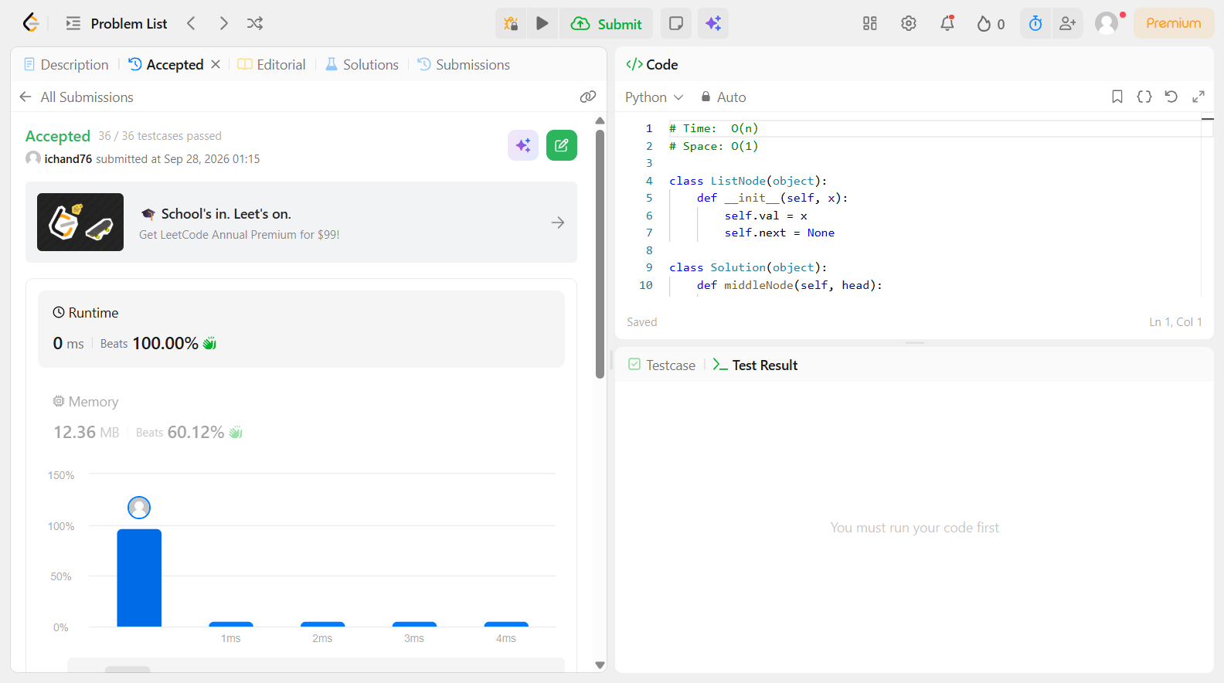

Problem 40
Field | Details
Problem ID | 897
Problem Name | Increasing Order Search Tree
Difficulty | Easy
Submission Date | 2026-09-28
Accepted Submission Screenshot | 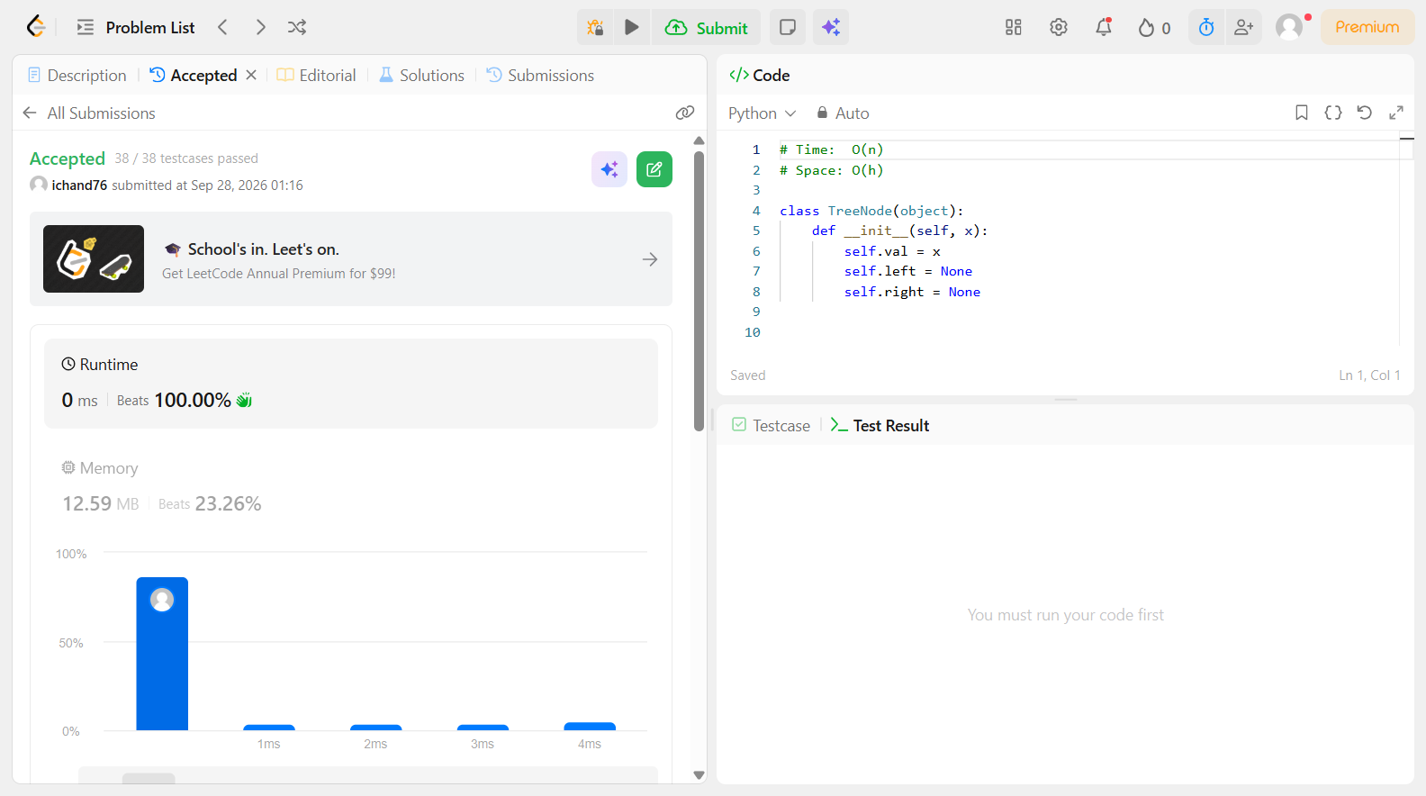

Problem 41
Field | Details
Problem ID | 905
Problem Name | Sort Array By Parity
Difficulty | Easy
Submission Date | 2026-09-28
Accepted Submission Screenshot | 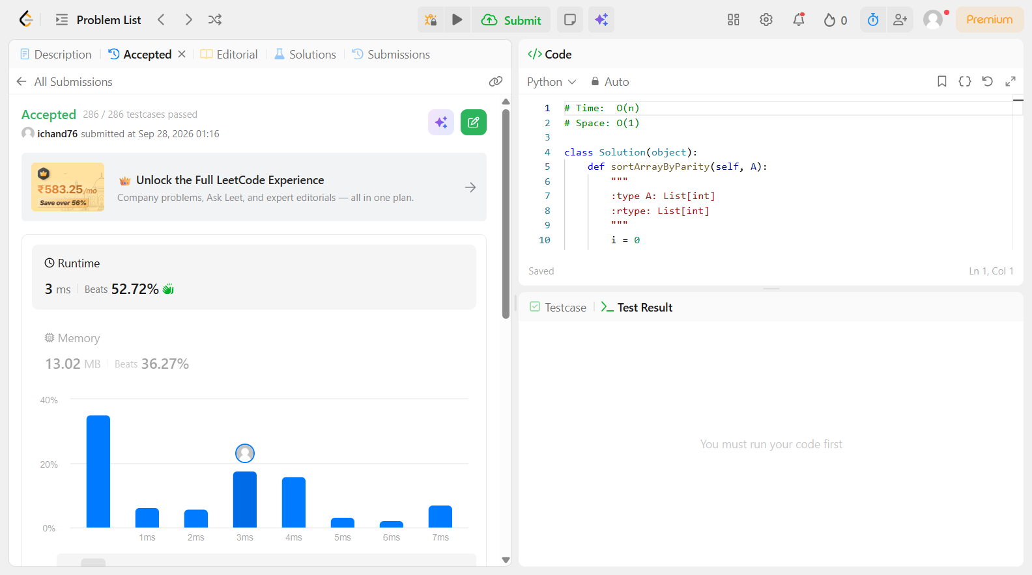

Problem 42
Field | Details
Problem ID | 933
Problem Name | Number of Recent Calls
Difficulty | Easy
Submission Date | 2026-09-28
Accepted Submission Screenshot | 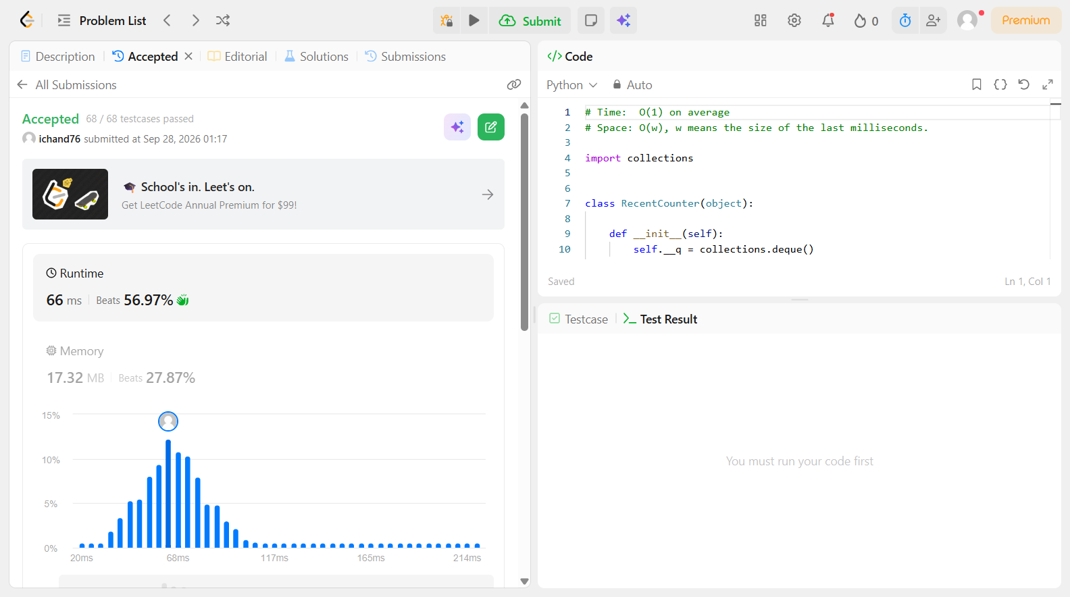

Problem 43
Field | Details
Problem ID | 938
Problem Name | Range Sum of BST
Difficulty | Easy
Submission Date | 2026-09-28
Accepted Submission Screenshot | 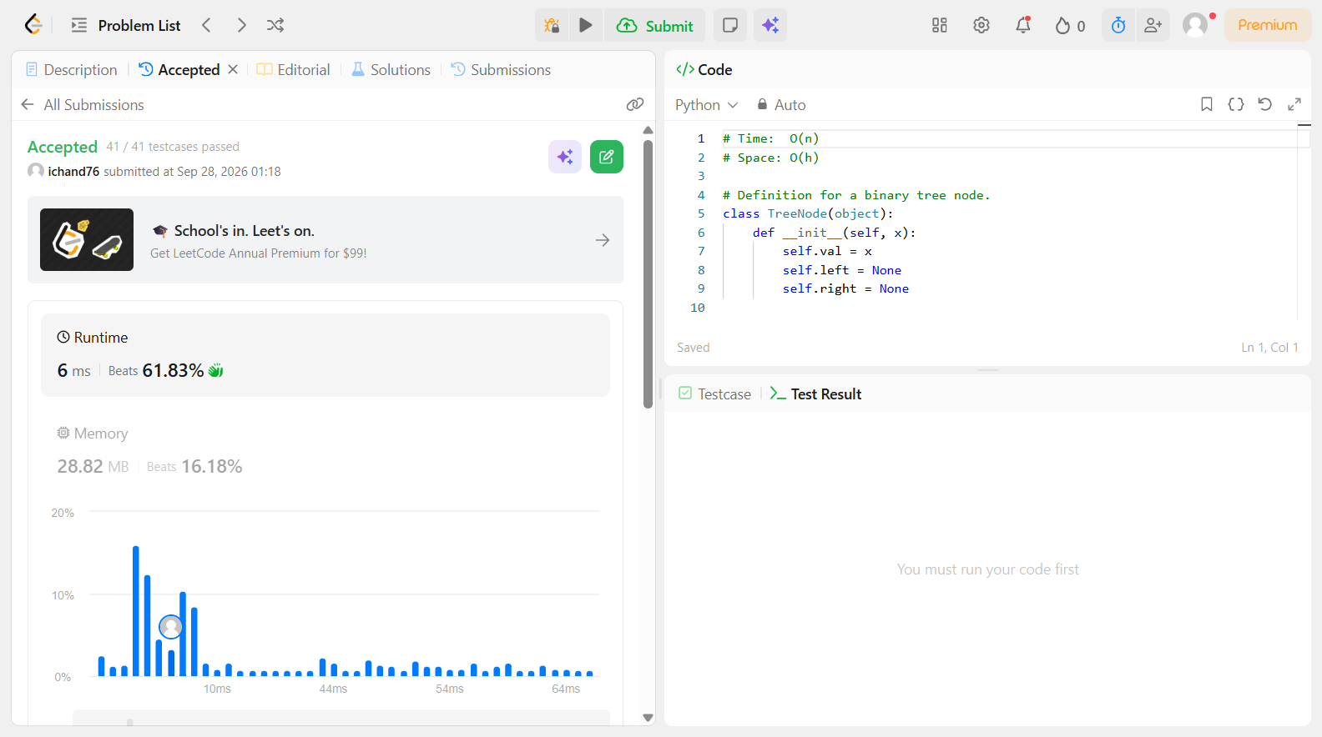

Problem 44
Field | Details
Problem ID | 965
Problem Name | Univalued Binary Tree
Difficulty | Easy
Submission Date | 2026-09-28
Accepted Submission Screenshot | 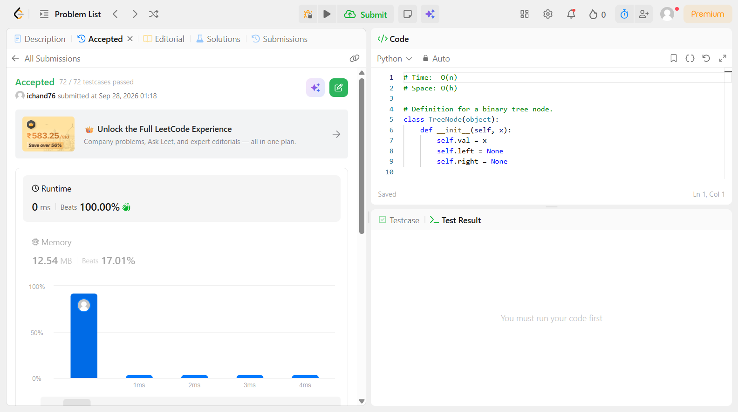

Problem 45
Field | Details
Problem ID | 1022
Problem Name | Sum of Root To Leaf Binary Numbers
Difficulty | Easy
Submission Date | 2026-09-28
Accepted Submission Screenshot | 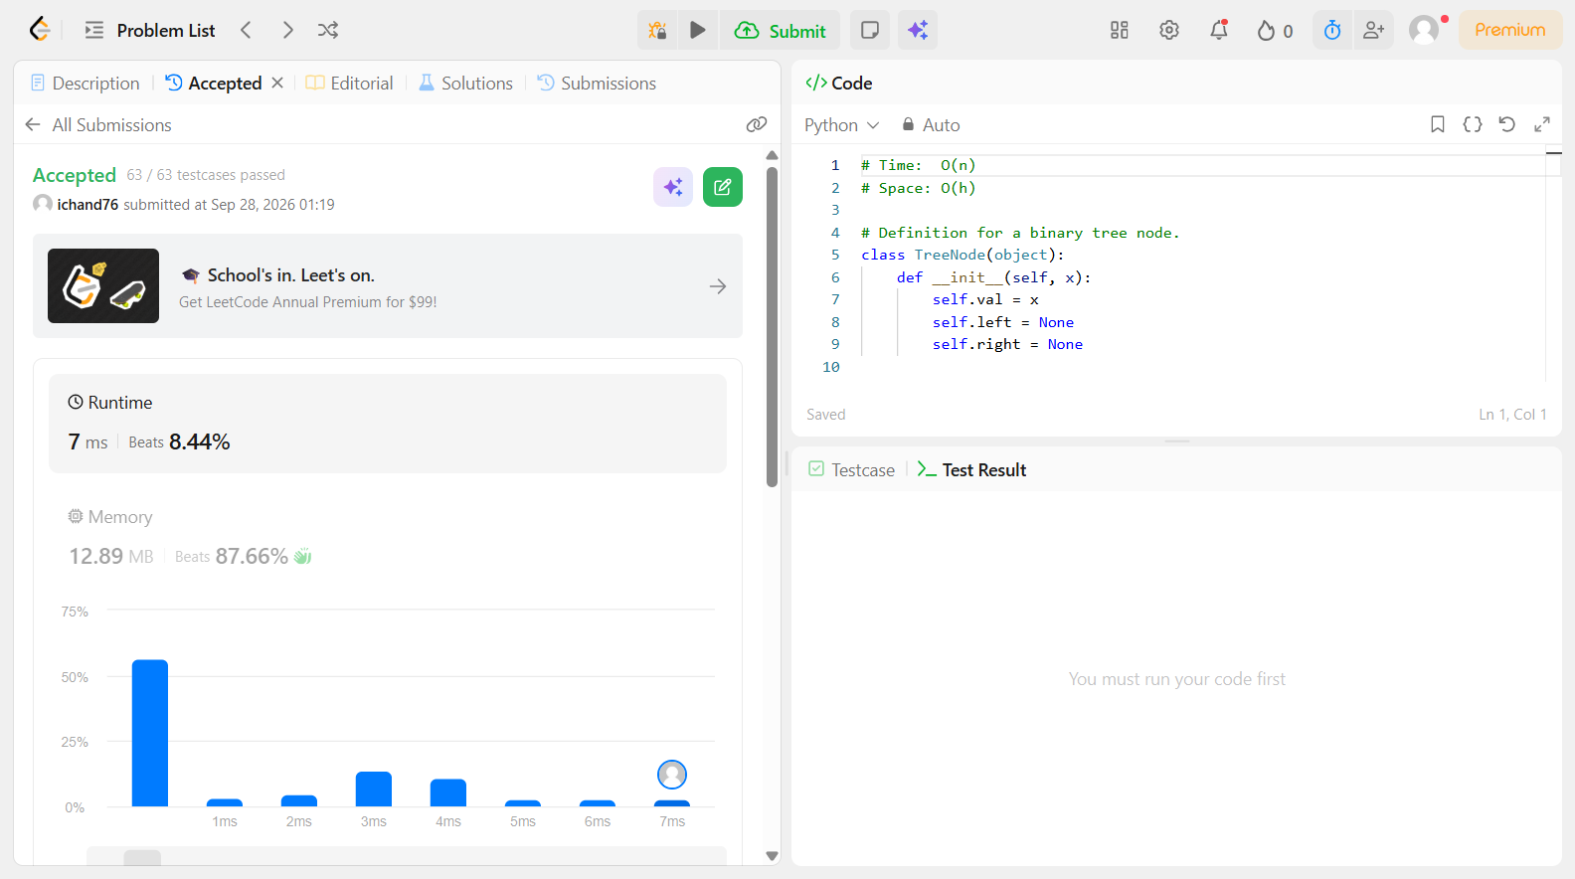

Problem 46
Field | Details
Problem ID | 86
Problem Name | Partition List
Difficulty | Easy
Submission Date | 2026-09-28
Accepted Submission Screenshot | 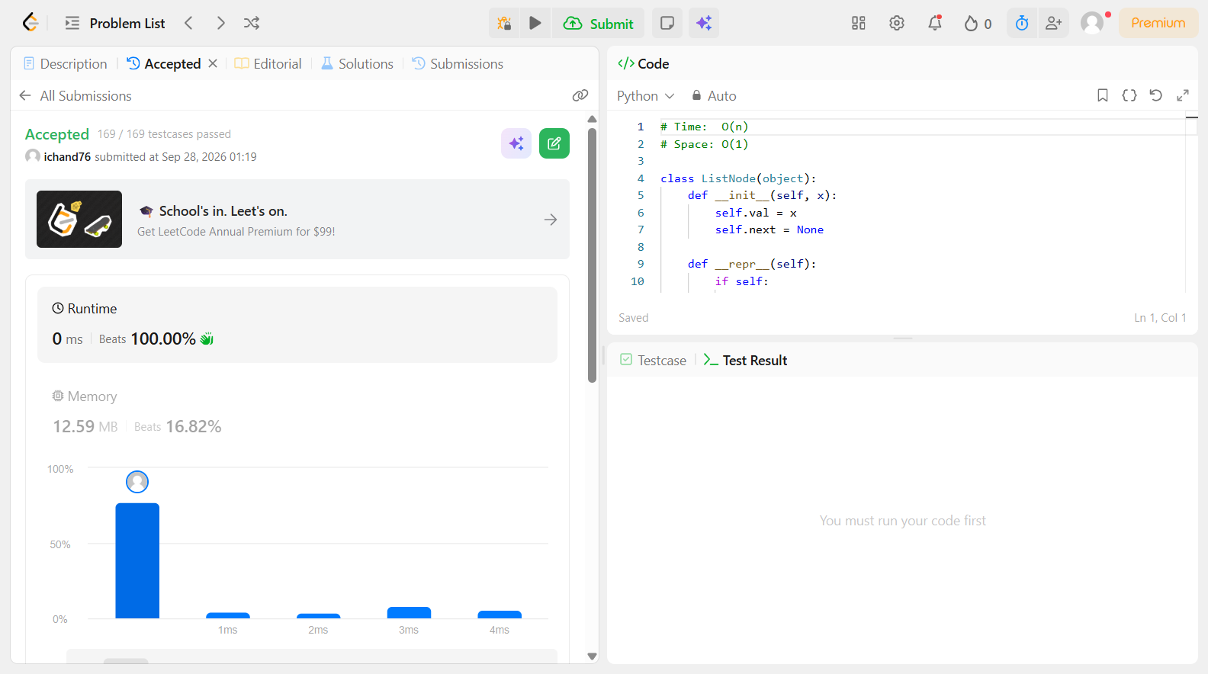

Problem 47
Field | Details
Problem ID | 143
Problem Name | Reorder List
Difficulty | Easy
Submission Date | 2026-09-28
Accepted Submission Screenshot | 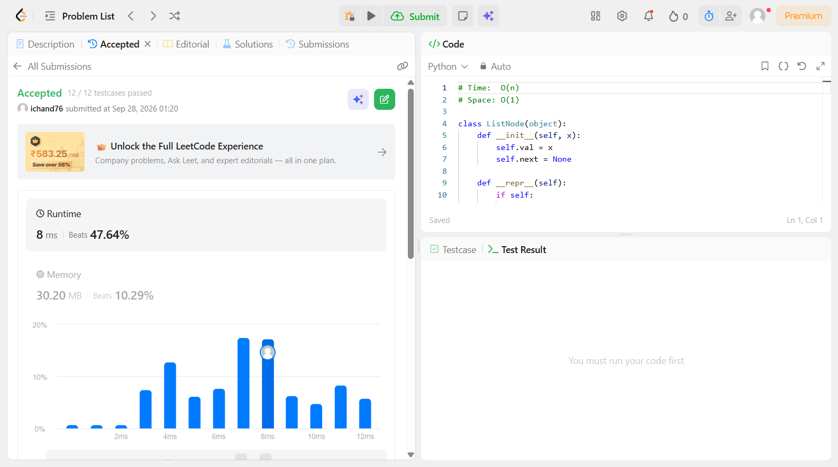

Problem 48
Field | Details
Problem ID | 146
Problem Name | LRU Cache
Difficulty | Easy
Submission Date | 2026-09-28
Accepted Submission Screenshot | 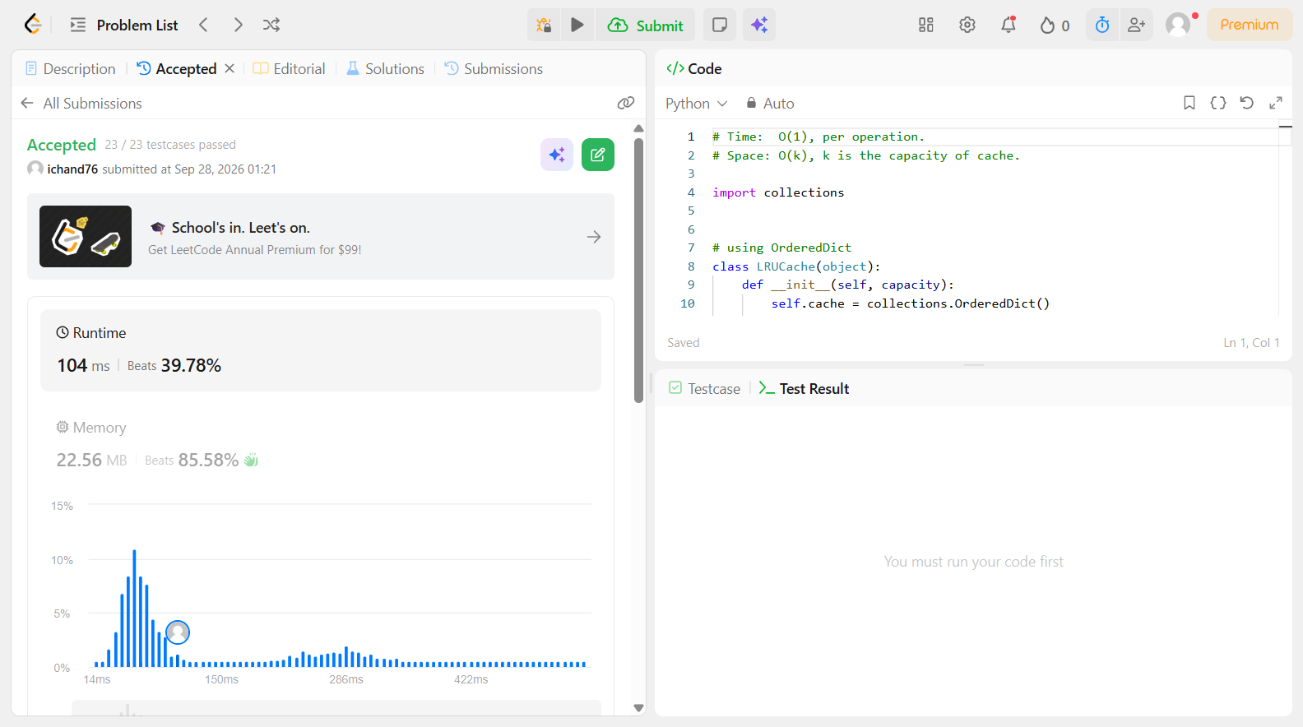

Problem 49
Field | Details
Problem ID | 173
Problem Name | Binary Search Tree Iterator
Difficulty | Easy
Submission Date | 2026-09-28
Accepted Submission Screenshot | 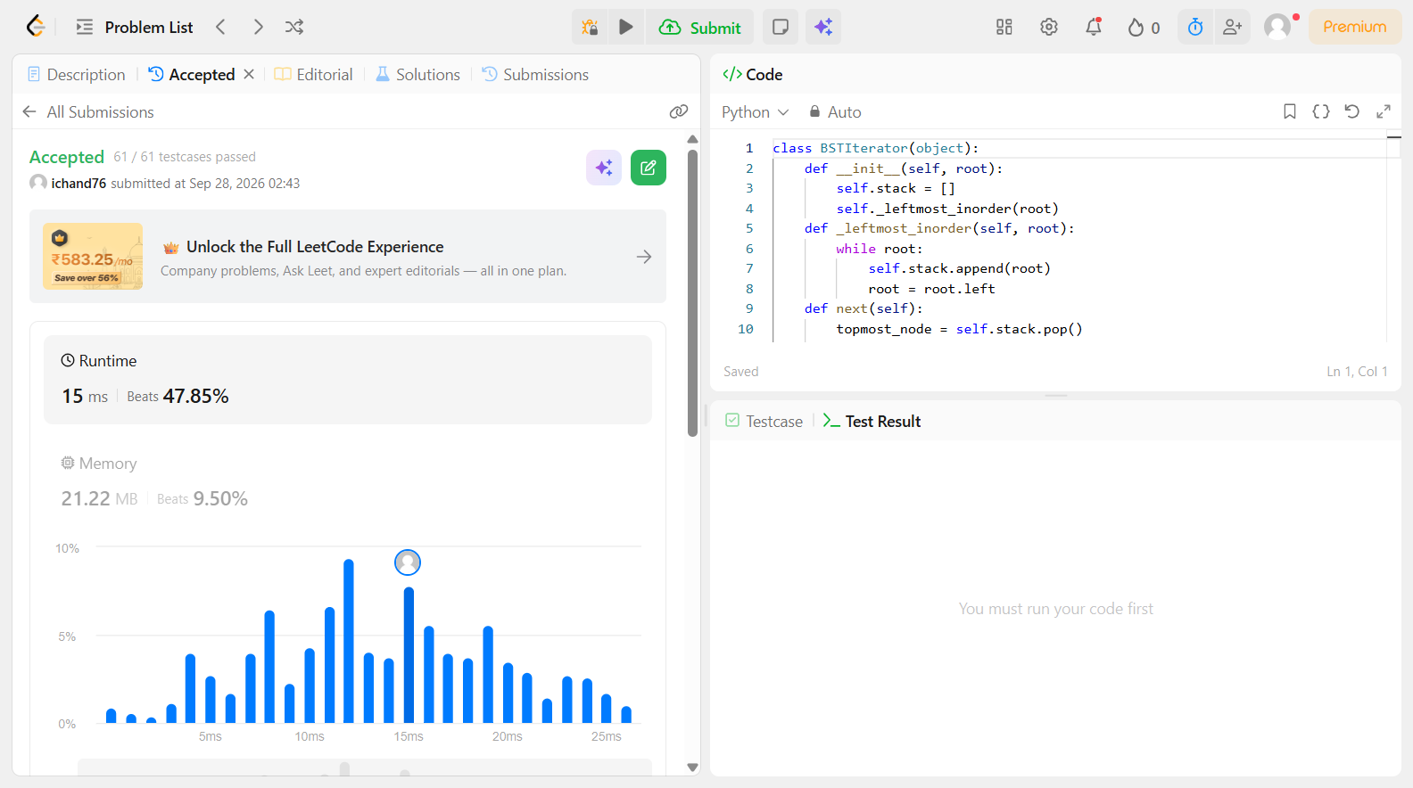

Problem 50
Field | Details
Problem ID | 622
Problem Name | Design Circular Queue
Difficulty | Easy
Submission Date | 2026-09-28
Accepted Submission Screenshot | 