Assignment 3
Name: Ishaan Chand
PRN: 25070126076
Division: A
Batch: A3

Problem 1
Field | Details
Problem ID | 177
Problem Name | Nth Highest Salary
Difficulty | Easy
Submission Date | 2026-09-28
Accepted Submission Screenshot | 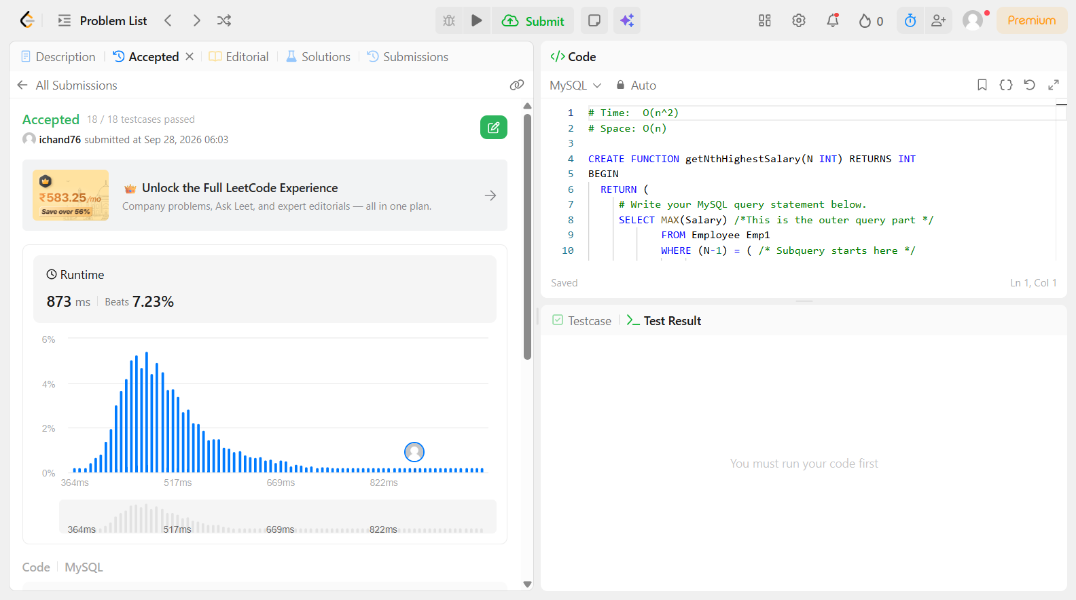

Problem 2
Field | Details
Problem ID | 180
Problem Name | Consecutive Numbers
Difficulty | Easy
Submission Date | 2026-09-28
Accepted Submission Screenshot | 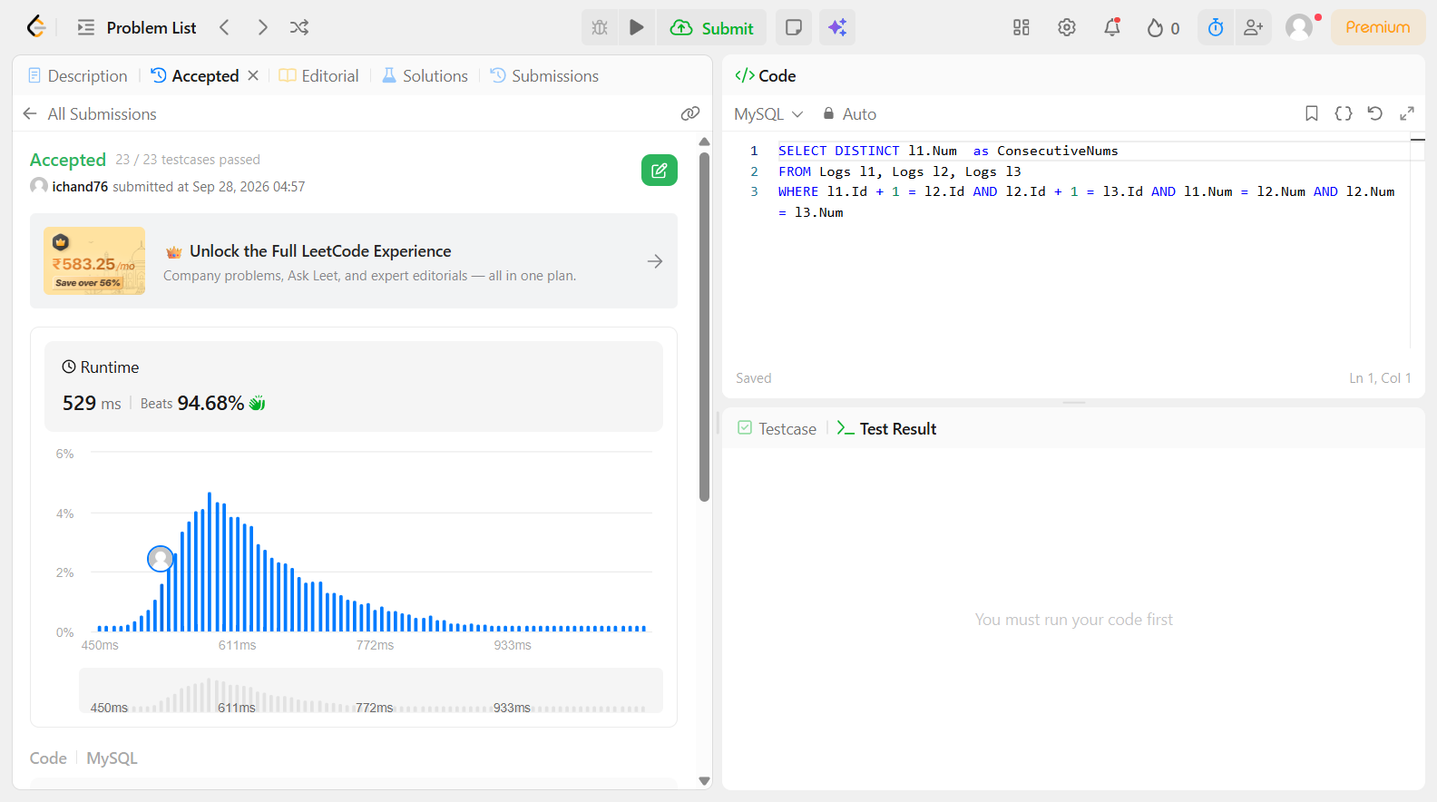

Problem 3
Field | Details
Problem ID | 181
Problem Name | Employees Earning More Than Their Managers
Difficulty | Easy
Submission Date | 2026-09-28
Accepted Submission Screenshot | 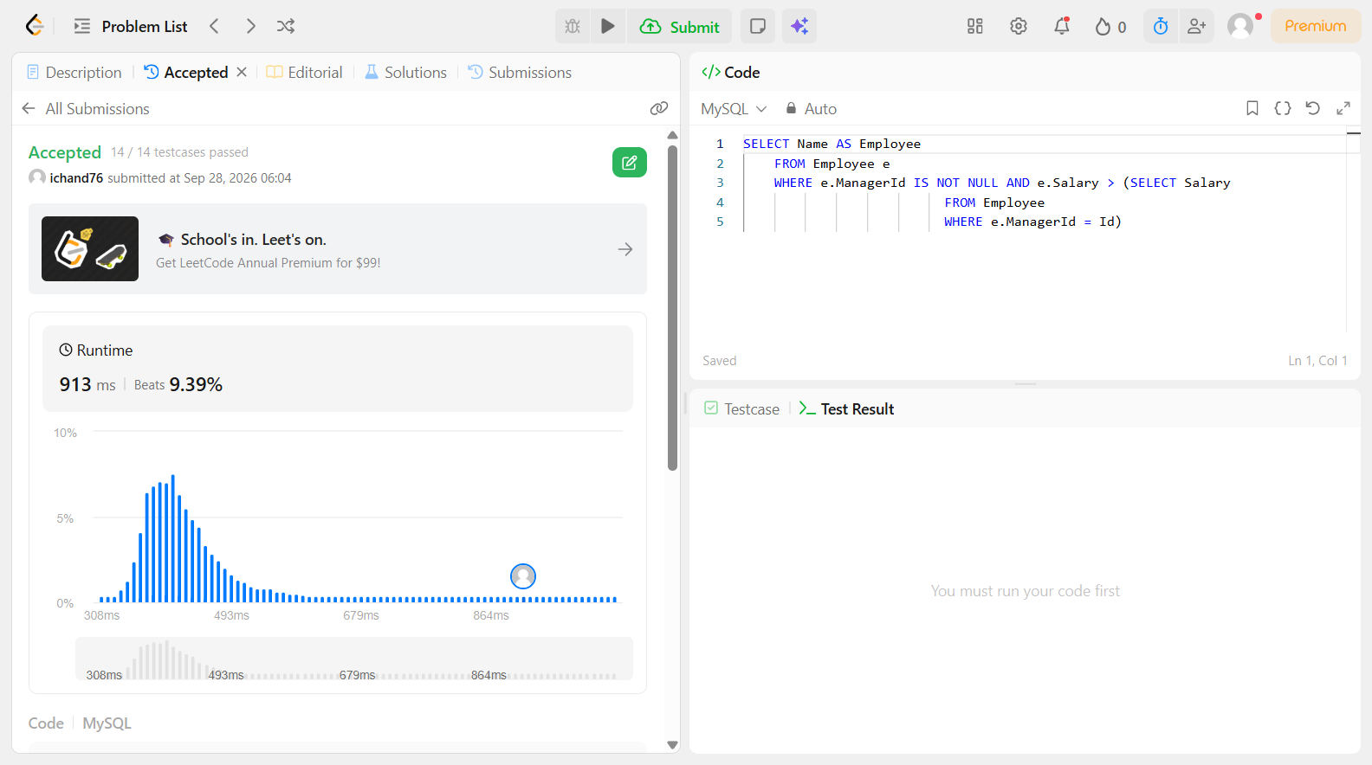

Problem 4
Field | Details
Problem ID | 182
Problem Name | Duplicate Emails
Difficulty | Easy
Submission Date | 2026-09-28
Accepted Submission Screenshot | 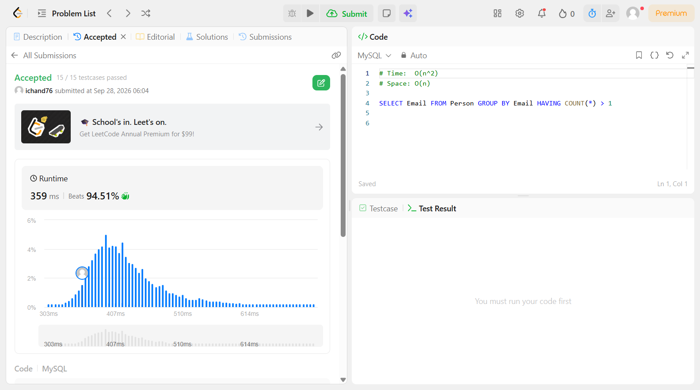

Problem 5
Field | Details
Problem ID | 183
Problem Name | Customers Who Never Order
Difficulty | Easy
Submission Date | 2026-09-28
Accepted Submission Screenshot | 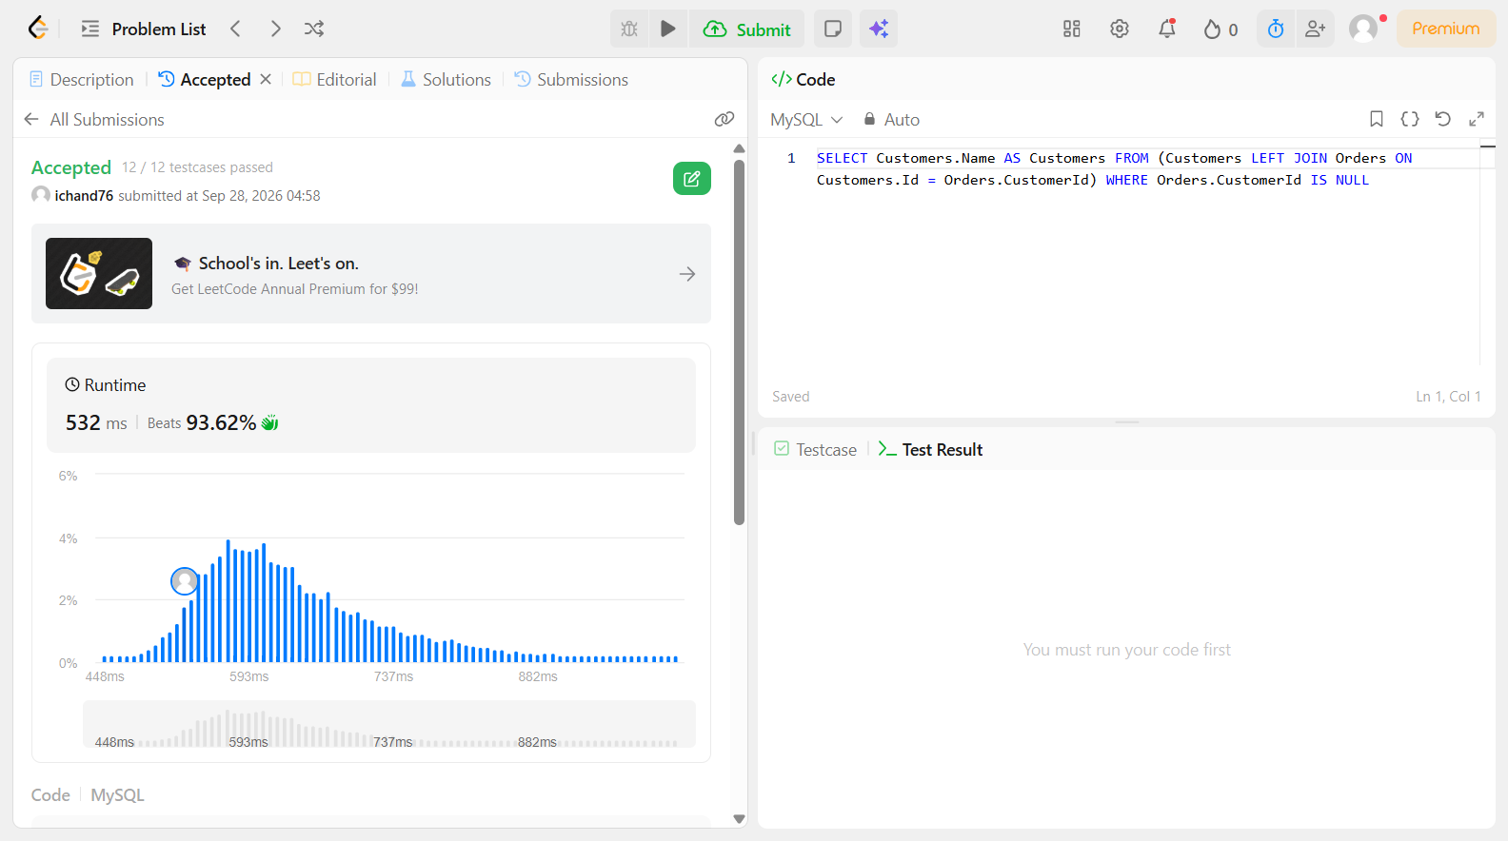

Problem 6
Field | Details
Problem ID | 185
Problem Name | Department Top Three Salaries
Difficulty | Easy
Submission Date | 2026-09-28
Accepted Submission Screenshot | 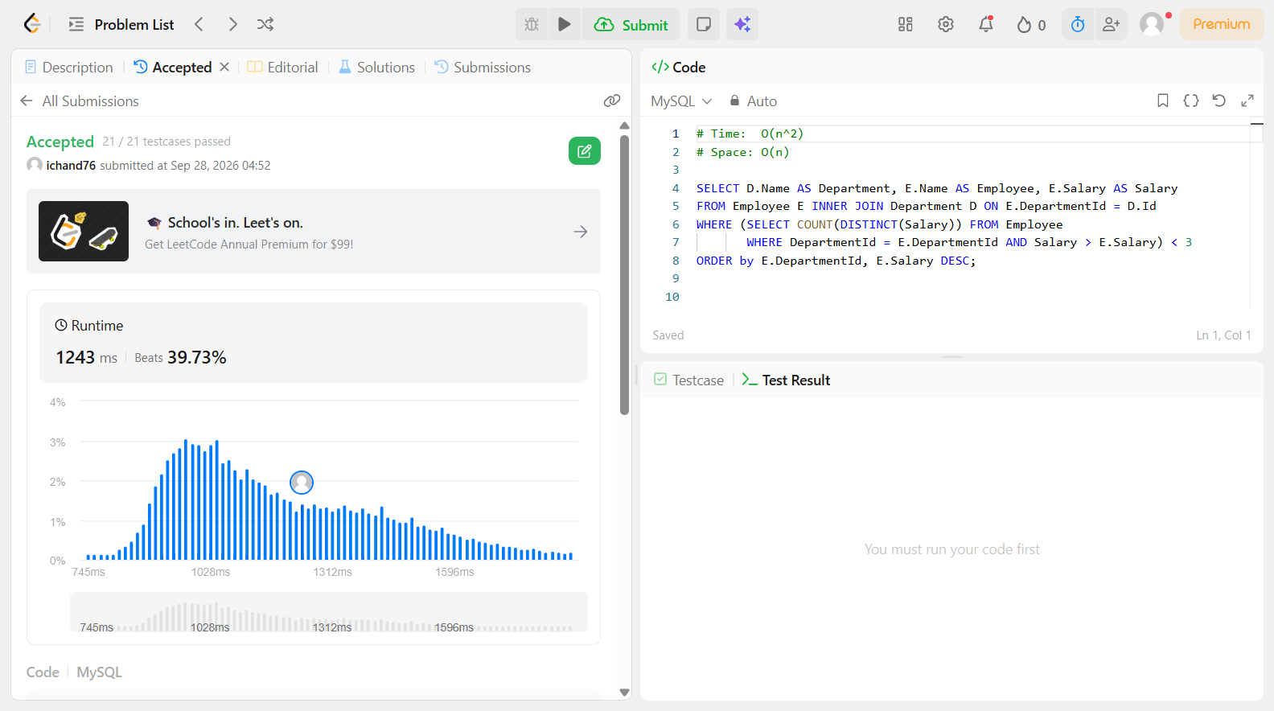

Problem 7
Field | Details
Problem ID | 196
Problem Name | Delete Duplicate Emails
Difficulty | Easy
Submission Date | 2026-09-28
Accepted Submission Screenshot | 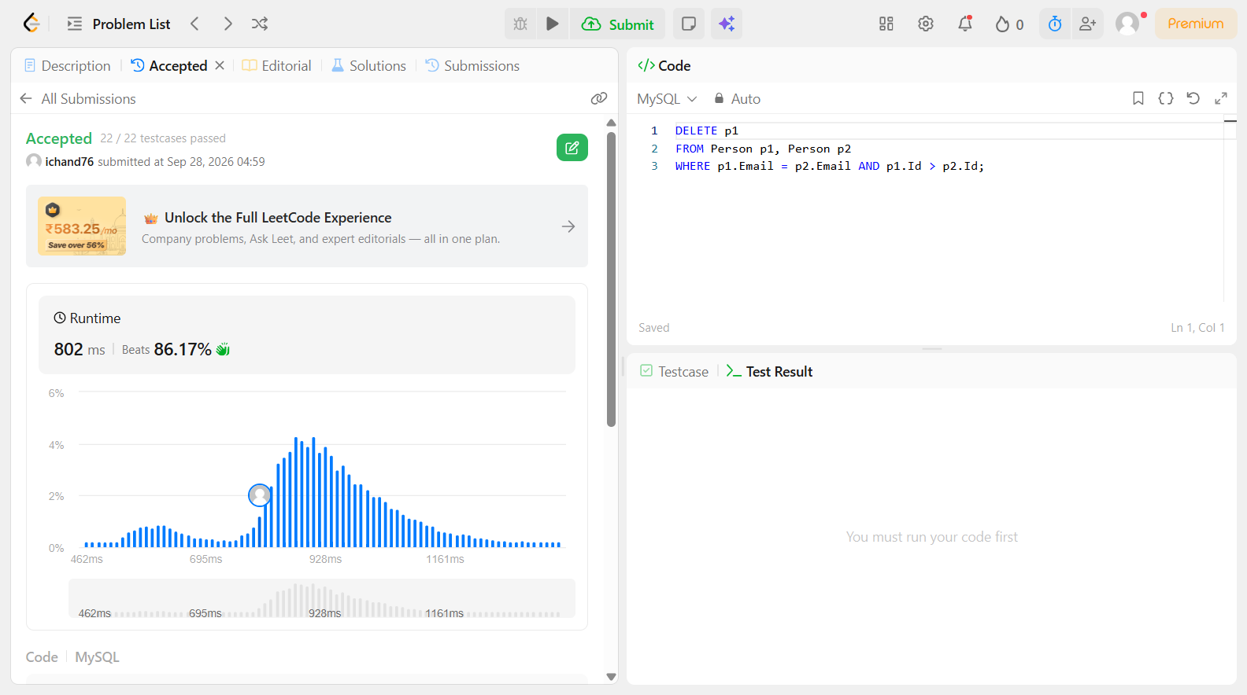

Problem 8
Field | Details
Problem ID | 262
Problem Name | Trips and Users
Difficulty | Easy
Submission Date | 2026-09-28
Accepted Submission Screenshot | 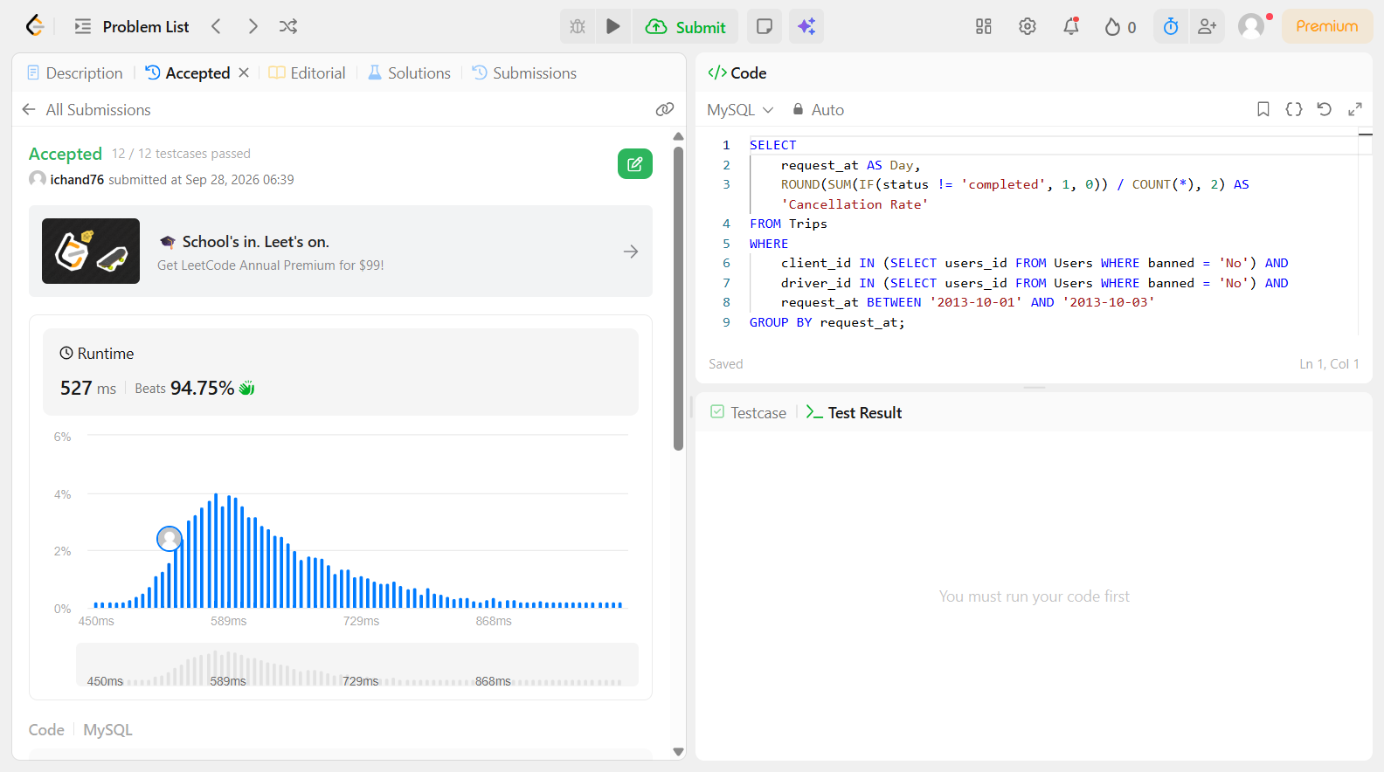

Problem 9
Field | Details
Problem ID | 534
Problem Name | Game Play Analysis III
Difficulty | Easy
Submission Date | 2026-09-28
Accepted Submission Screenshot | SUBSCRIBER ONLY

Problem 10
Field | Details
Problem ID | 569
Problem Name | Median Employee Salary
Difficulty | Easy
Submission Date | 2026-09-28
Accepted Submission Screenshot | SUBSCRIBER ONLY

Problem 11
Field | Details
Problem ID | 578
Problem Name | Get Highest Answer Rate Question
Difficulty | Easy
Submission Date | 2026-09-28
Accepted Submission Screenshot | SUBSCRIBER ONLY

Problem 12
Field | Details
Problem ID | 580
Problem Name | Count Student Number in Departments
Difficulty | Easy
Submission Date | 2026-09-28
Accepted Submission Screenshot | SUBSCRIBER ONLY

Problem 13
Field | Details
Problem ID | 601
Problem Name | Human Traffic of Stadium
Difficulty | Easy
Submission Date | 2026-09-28
Accepted Submission Screenshot | 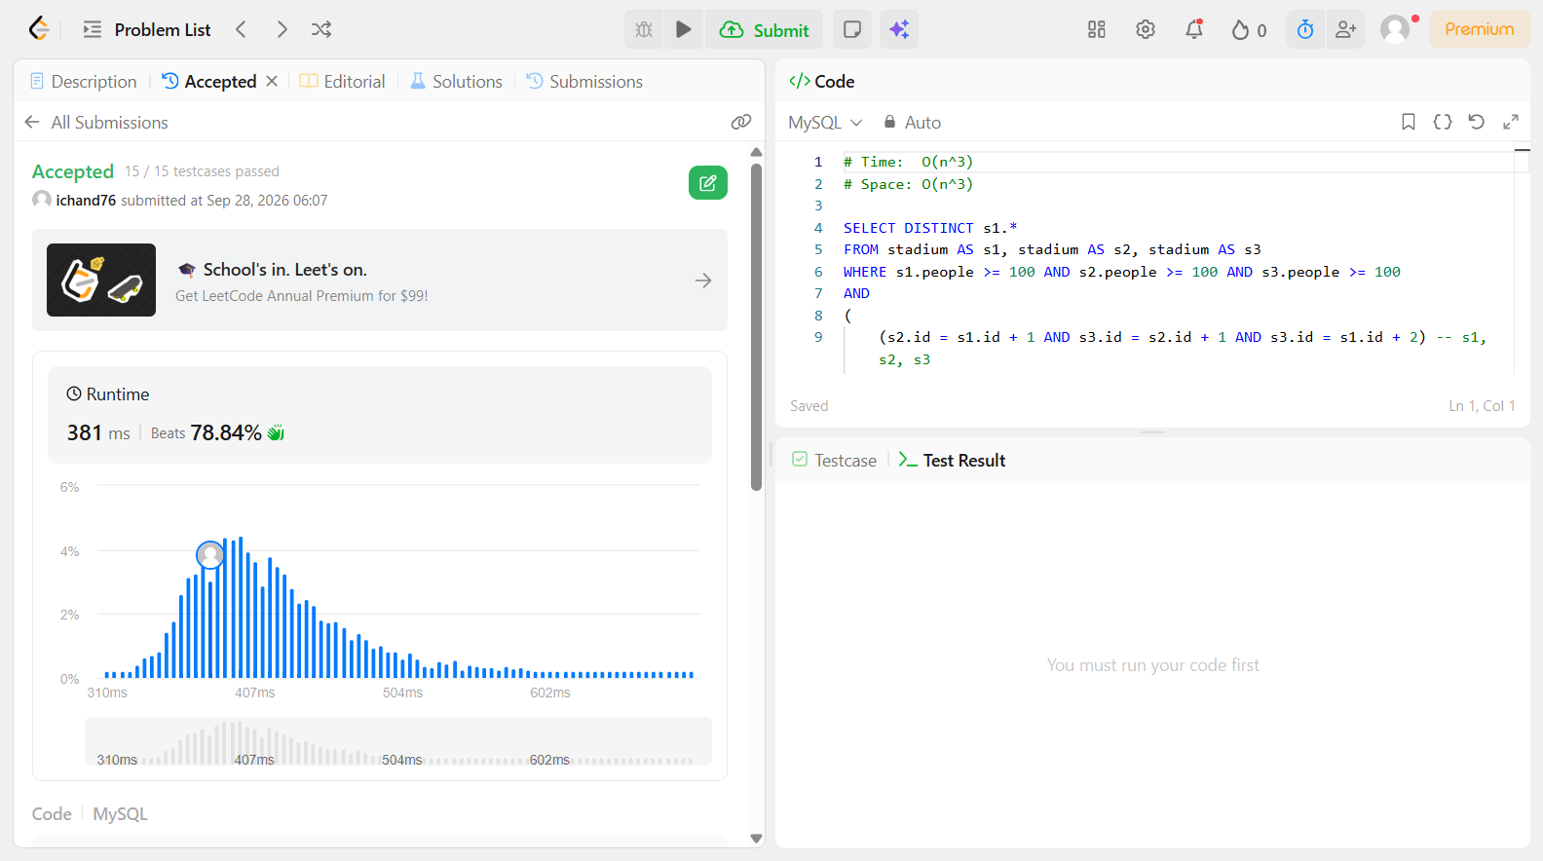

Problem 14
Field | Details
Problem ID | 602
Problem Name | Friend Requests II: Who Has the Most Friends
Difficulty | Easy
Submission Date | 2026-09-28
Accepted Submission Screenshot | 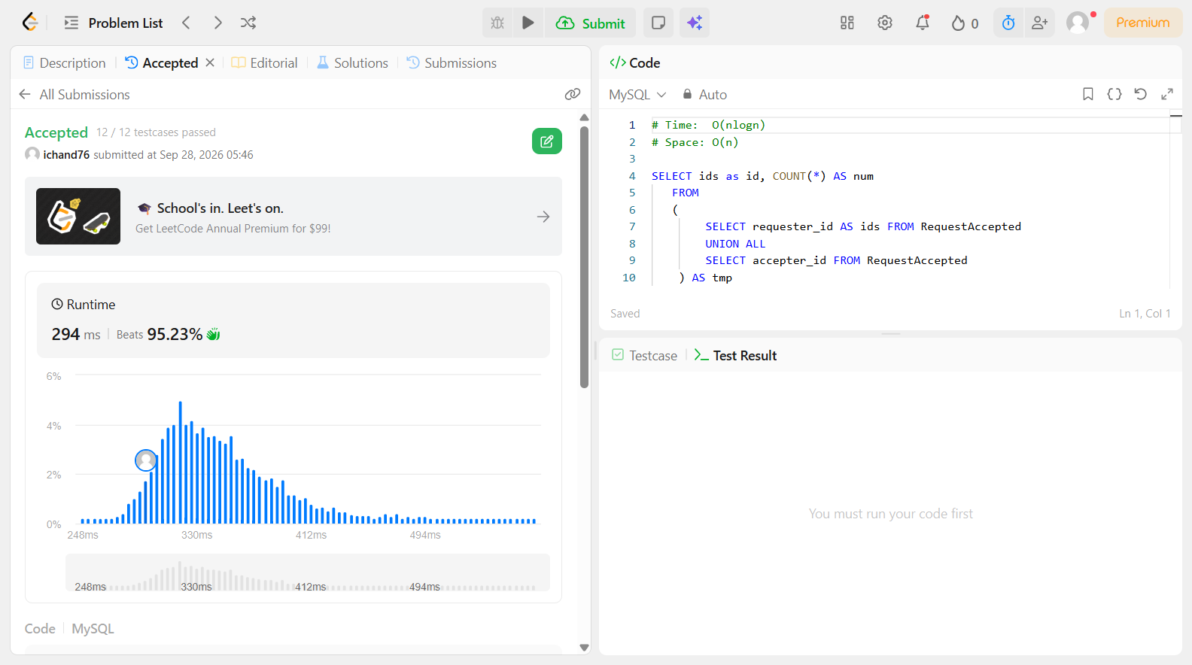

Problem 15
Field | Details
Problem ID | 607
Problem Name | Sales Person
Difficulty | Easy
Submission Date | 2026-09-28
Accepted Submission Screenshot | 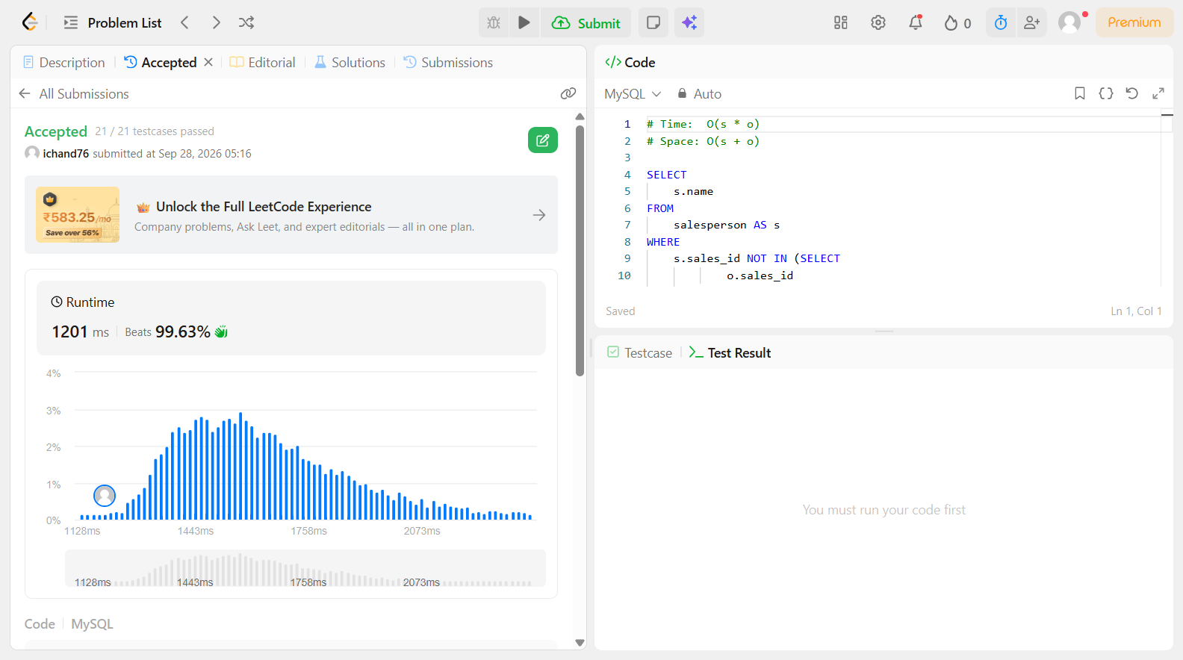

Problem 16
Field | Details
Problem ID | 608
Problem Name | Tree Node
Difficulty | Easy
Submission Date | 2026-09-28
Accepted Submission Screenshot | (Paste Screenshot Here)

Problem 17
Field | Details
Problem ID | 610
Problem Name | Triangle Judgement
Difficulty | Easy
Submission Date | 2026-09-28
Accepted Submission Screenshot | 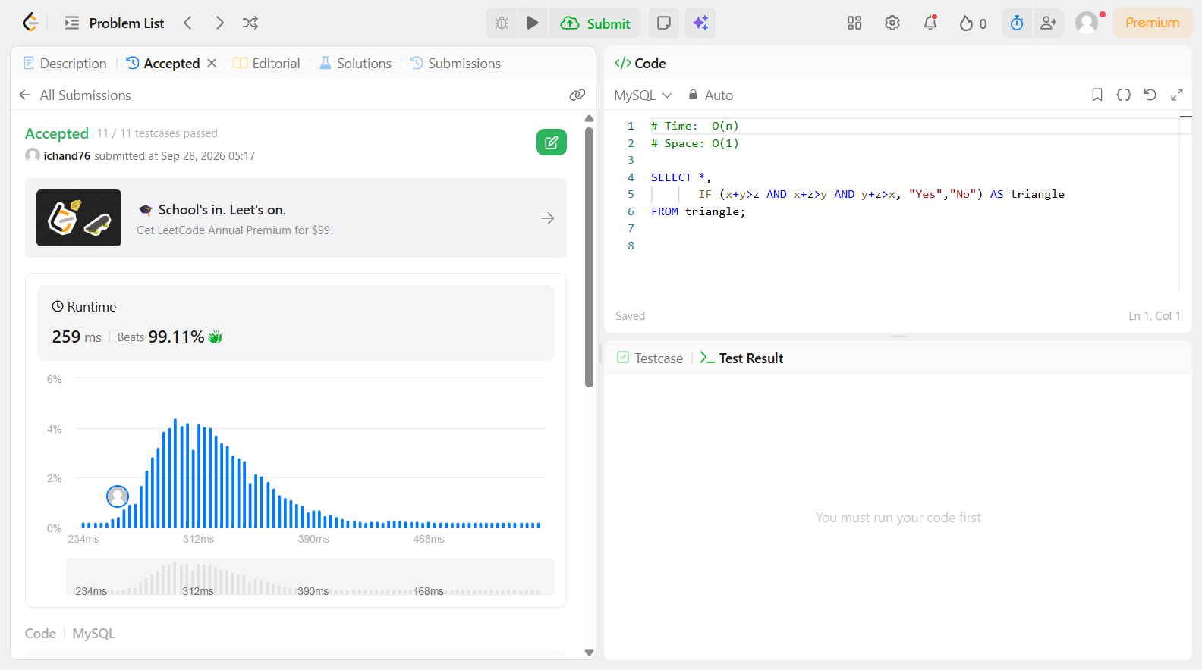

Problem 18
Field | Details
Problem ID | 612
Problem Name | Shortest Distance in a Plane
Difficulty | Easy
Submission Date | 2026-09-28
Accepted Submission Screenshot | SUBSCRIBER ONLY

Problem 19
Field | Details
Problem ID | 613
Problem Name | Shortest Distance in a Line
Difficulty | Easy
Submission Date | 2026-09-28
Accepted Submission Screenshot | SUBSCRIBER ONLY

Problem 20
Field | Details
Problem ID | 614
Problem Name | Second Degree Follower
Difficulty | Easy
Submission Date | 2026-09-28
Accepted Submission Screenshot | SUBSCRIBER ONLY

Problem 21
Field | Details
Problem ID | 615
Problem Name | Average Salary: Departments vs Company
Difficulty | Easy
Submission Date | 2026-09-28
Accepted Submission Screenshot | SUBSCRIBER ONLY

Problem 22
Field | Details
Problem ID | 618
Problem Name | Students Report By Geography
Difficulty | Easy
Submission Date | 2026-09-28
Accepted Submission Screenshot | SUBSCRIBER ONLY

Problem 23
Field | Details
Problem ID | 619
Problem Name | Biggest Single Number
Difficulty | Easy
Submission Date | 2026-09-28
Accepted Submission Screenshot | 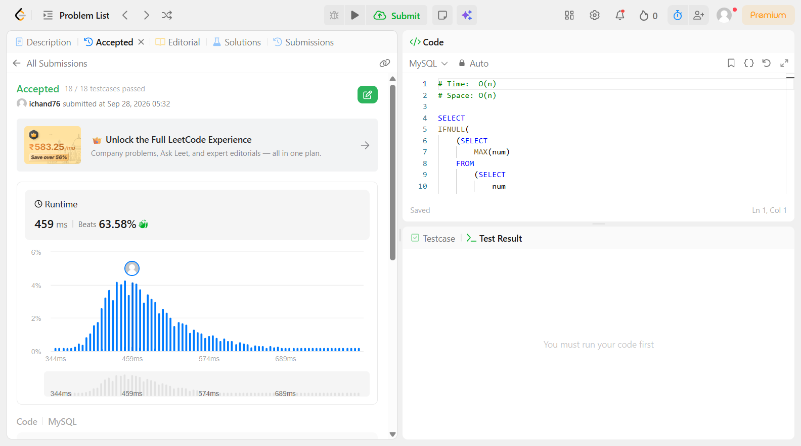

Problem 24
Field | Details
Problem ID | 620
Problem Name | Not Boring Movies
Difficulty | Easy
Submission Date | 2026-09-28
Accepted Submission Screenshot | (Paste Screenshot Here)

Problem 25
Field | Details
Problem ID | 626
Problem Name | Exchange Seats
Difficulty | Easy
Submission Date | 2026-09-28
Accepted Submission Screenshot | 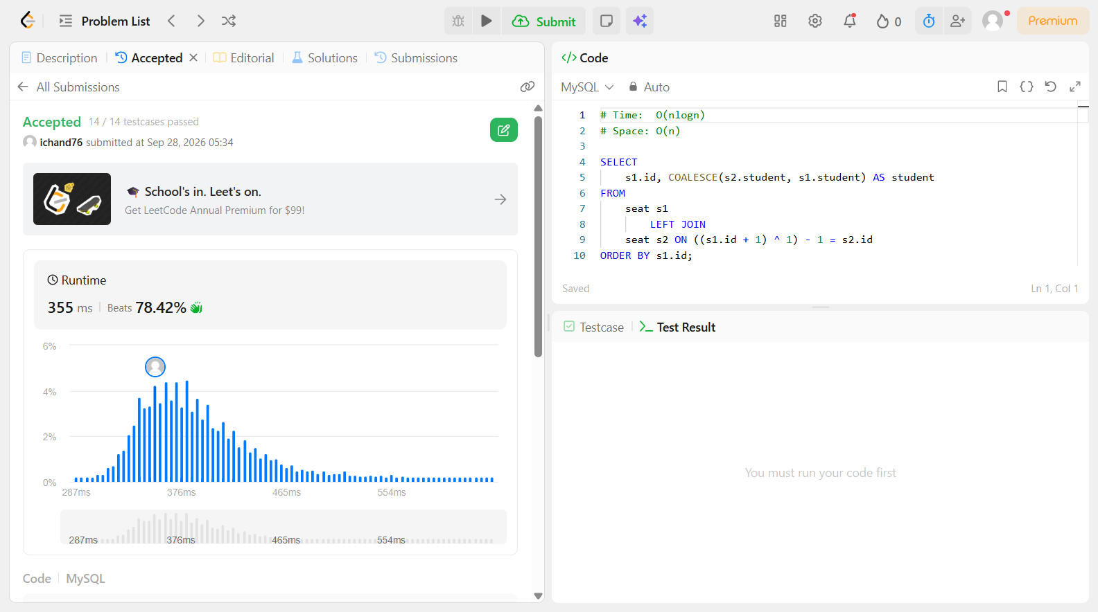

Problem 26
Field | Details
Problem ID | 627
Problem Name | Swap Salary
Difficulty | Easy
Submission Date | 2026-09-28
Accepted Submission Screenshot | 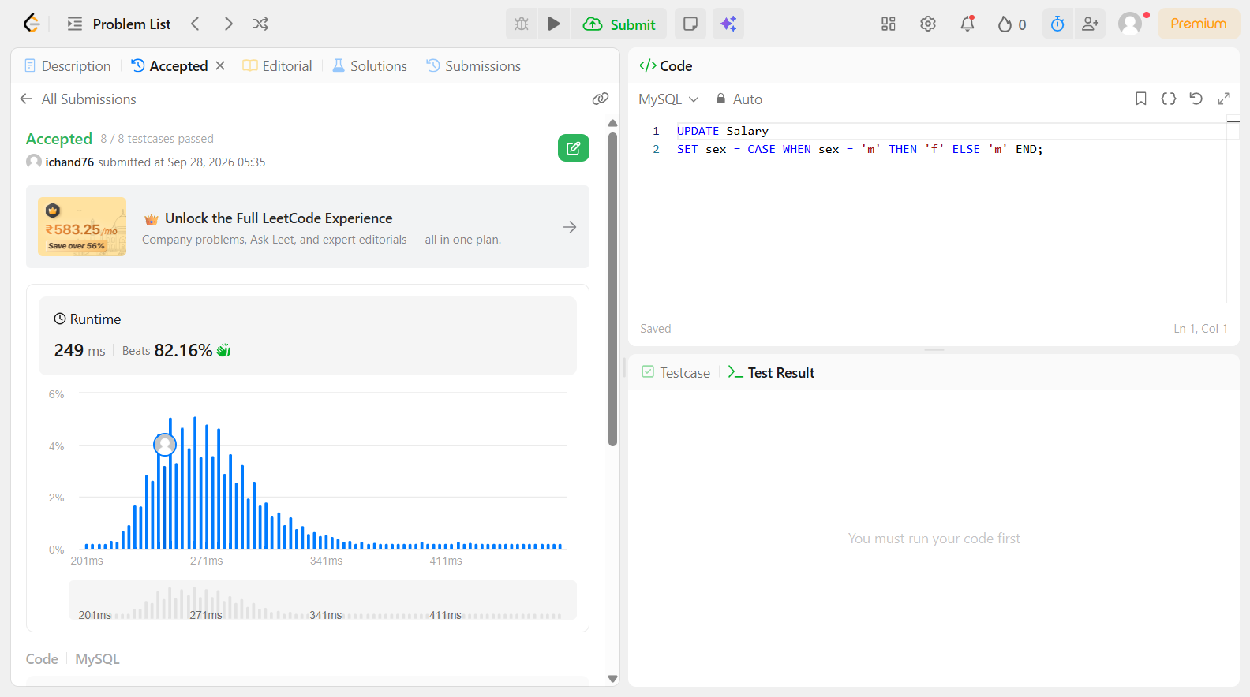

Problem 27
Field | Details
Problem ID | 1045
Problem Name | Customers Who Bought All Products
Difficulty | Easy
Submission Date | 2026-09-28
Accepted Submission Screenshot | 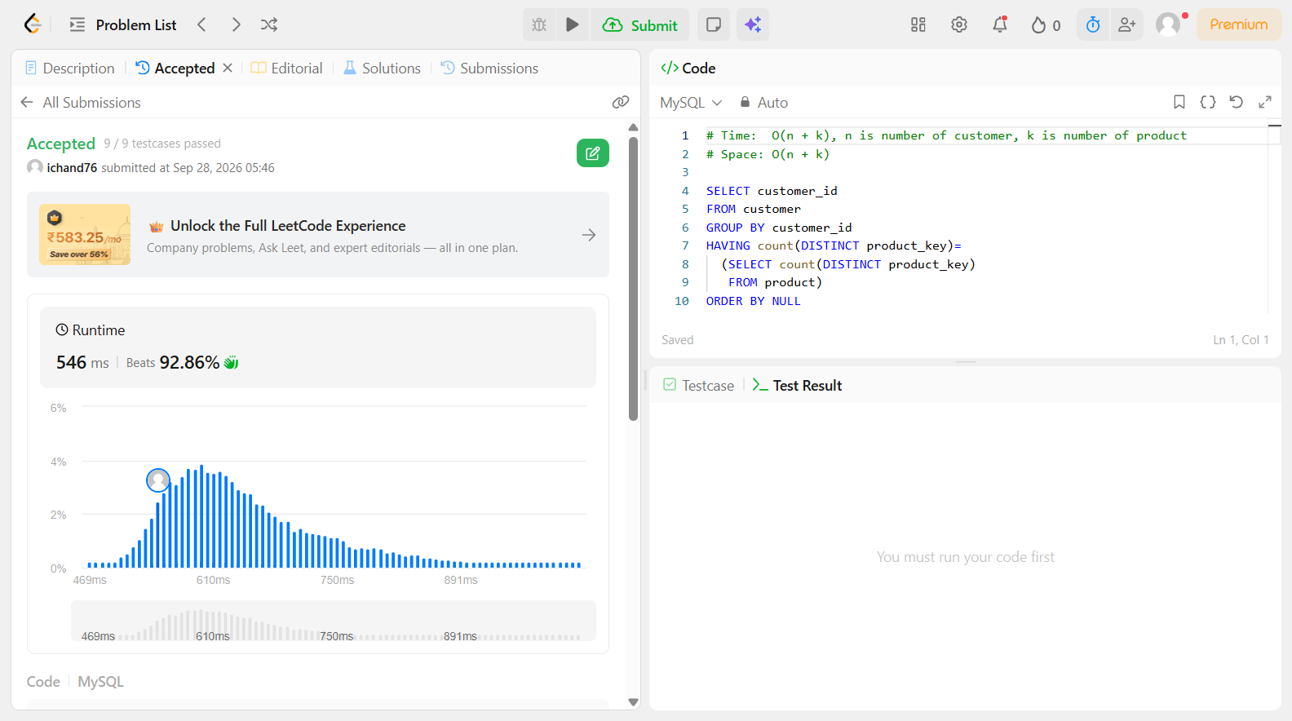

Problem 28
Field | Details
Problem ID | 1070
Problem Name | Product Sales Analysis III
Difficulty | Easy
Submission Date | 2026-09-28
Accepted Submission Screenshot | 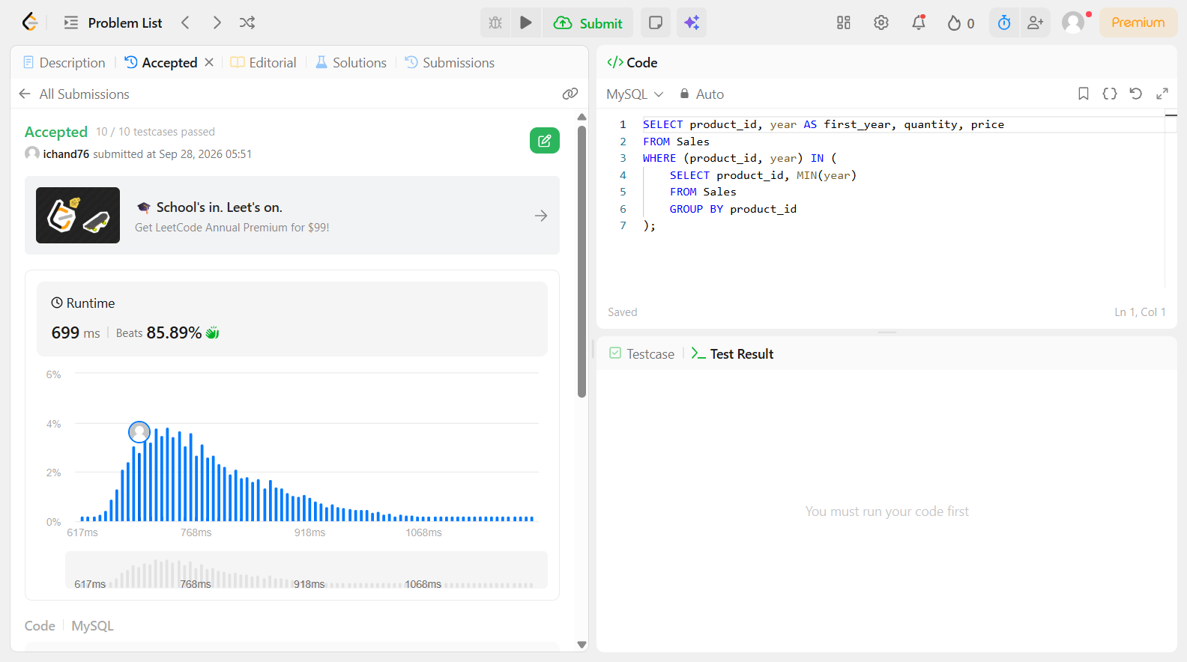

Problem 29
Field | Details
Problem ID | 1076
Problem Name | Project Employees II
Difficulty | Easy
Submission Date | 2026-09-28
Accepted Submission Screenshot | SUBSCRIBER ONLY

Problem 30
Field | Details
Problem ID | 1077
Problem Name | Project Employees III
Difficulty | Easy
Submission Date | 2026-09-28
Accepted Submission Screenshot | SUBSCRIBER ONLY

Problem 31
Field | Details
Problem ID | 1082
Problem Name | Sales Analysis I
Difficulty | Easy
Submission Date | 2026-09-28
Accepted Submission Screenshot | SUBSCRIBER ONLY

Problem 32
Field | Details
Problem ID | 1083
Problem Name | Sales Analysis II
Difficulty | Easy
Submission Date | 2026-09-28
Accepted Submission Screenshot | SUBSCRIBER ONLY

Problem 33
Field | Details
Problem ID | 1084
Problem Name | Sales Analysis III
Difficulty | Easy
Submission Date | 2026-09-28
Accepted Submission Screenshot | SUBSCRIBER ONLY

Problem 34
Field | Details
Problem ID | 1097
Problem Name | Game Play Analysis V
Difficulty | Easy
Submission Date | 2026-09-28
Accepted Submission Screenshot | (Paste Screenshot Here)

Problem 35
Field | Details
Problem ID | 1098
Problem Name | Unpopular Books
Difficulty | Easy
Submission Date | 2026-09-28
Accepted Submission Screenshot | SUBSCRIBER ONLY

Problem 36
Field | Details
Problem ID | 1112
Problem Name | Highest Grade For Each Student
Difficulty | Easy
Submission Date | 2026-09-28
Accepted Submission Screenshot | (Paste Screenshot Here)

Problem 37
Field | Details
Problem ID | 1126
Problem Name | Active Businesses
Difficulty | Easy
Submission Date | 2026-09-28
Accepted Submission Screenshot | SUBSCRIBER ONLY

Problem 38
Field | Details
Problem ID | 1127
Problem Name | User Purchase Platform
Difficulty | Easy
Submission Date | 2026-09-28
Accepted Submission Screenshot | (Paste Screenshot Here)

Problem 39
Field | Details
Problem ID | 1132
Problem Name | Reported Posts II
Difficulty | Easy
Submission Date | 2026-09-28
Accepted Submission Screenshot | SUBSCRIBER ONLY

Problem 40
Field | Details
Problem ID | 1141
Problem Name | User Activity for the Past 30 Days I
Difficulty | Easy
Submission Date | 2026-09-28
Accepted Submission Screenshot | SUBSCRIBER ONLY

Problem 41
Field | Details
Problem ID | 1142
Problem Name | User Activity for the Past 30 Days II
Difficulty | Easy
Submission Date | 2026-09-28
Accepted Submission Screenshot | SUBSCRIBER ONLY

Problem 42
Field | Details
Problem ID | 1148
Problem Name | Article Views I
Difficulty | Easy
Submission Date | 2026-09-28
Accepted Submission Screenshot | (Paste Screenshot Here)

Problem 43
Field | Details
Problem ID | 1149
Problem Name | Article Views II
Difficulty | Easy
Submission Date | 2026-09-28
Accepted Submission Screenshot | SUBSCRIBER ONLY

Problem 44
Field | Details
Problem ID | 1158
Problem Name | Market Analysis I
Difficulty | Easy
Submission Date | 2026-09-28
Accepted Submission Screenshot | 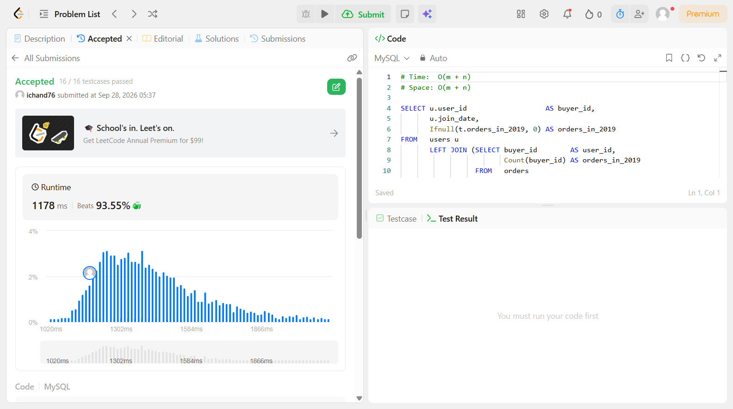

Problem 45
Field | Details
Problem ID | 1164
Problem Name | Product Price at a Given Date
Difficulty | Easy
Submission Date | 2026-09-28
Accepted Submission Screenshot | SUBSCRIBER ONLY

Problem 46
Field | Details
Problem ID | 1173
Problem Name | Immediate Food Delivery I
Difficulty | Easy
Submission Date | 2026-09-28
Accepted Submission Screenshot | SUBSCRIBER ONLY

Problem 47
Field | Details
Problem ID | 1174
Problem Name | Immediate Food Delivery II
Difficulty | Easy
Submission Date | 2026-09-28
Accepted Submission Screenshot | (Paste Screenshot Here)

Problem 48
Field | Details
Problem ID | 1193
Problem Name | Monthly Transactions I
Difficulty | Easy
Submission Date | 2026-09-28
Accepted Submission Screenshot | SUBSCRIBER ONLY

Problem 49
Field | Details
Problem ID | 1204
Problem Name | Last Person to Fit in the Bus
Difficulty | Easy
Submission Date | 2026-09-28
Accepted Submission Screenshot | SUBSCRIBER ONLY

Problem 50
Field | Details
Problem ID | 1211
Problem Name | Queries Quality and Percentage
Difficulty | Easy
Submission Date | 2026-09-28
Accepted Submission Screenshot | (Paste Screenshot Here)

