A Reproducible Audit of Data Leakage, Feature Stability, and Transportability in Transcriptomic Biomarker Classification
Iris Yang^{1*}, Wing-Keung Wong^{2*}, Paul Tan³, Chung-I Huang⁴, Jewel Wang⁵
¹California State University, Los Angeles, USA and Purdue University, USA; ²Asia University, Taiwan; ³Harvard University Extension School; ⁴National Chung Hsing University, Taiwan; ⁵Brandeis University, USA.
*Denotes co-corresponding authors.

Abstract
High-dimensional transcriptomic biomarker studies are vulnerable to data leakage when feature selection, preprocessing, scaling, or class balancing is performed before validation splitting, because reported performance can then reflect contamination of the test fold rather than generalizable signal. We present a reproducible audit of leakage, feature-selection stability, and external-cohort transportability, using a linear support vector machine (SVM)—trained by sequential minimal optimization (SMO)—as a transparent, high-dimensional workhorse model. In the GSE25055 discovery cohort, 306 samples with interpretable pCR/RD labels were analyzed (57 pCR, 249 RD). A naive pipeline that performed supervised feature selection on the full dataset before cross-validation achieved AUROC 0.7705 and PR-AUC 0.4016, whereas a guarded nested pipeline that confined feature selection, scaling, class weighting, and cost tuning to training folds achieved AUROC 0.7265 and PR-AUC 0.3653. The single-cohort naive-minus-guarded gap was positive but modest and its confidence interval included zero (ΔAUROC +0.044, 95% CI −0.013 to +0.103). A 1000-permutation label-shuffle negative control showed the naive pipeline producing strongly above-chance discrimination from randomized labels while the guarded pipeline shifted toward chance, supporting the interpretation that global feature selection is diagnostic of a leakage artifact rather than added signal. Across 30 repeated nested cross-validation seeds the gap was modest but reproducible (positive in 27 of 30 seeds; median ΔAUROC +0.054), reflecting seed/fold-level robustness rather than patient-level inference. Feature selection showed moderate, reproducible stability (single-split Nogueira index 0.5409). Same-platform, same-study-family external validation on GSE25065 (42 pCR, 140 RD) yielded AUROC 0.6078, a transportability drop distinct from internal leakage. A predeclared cross-platform projection onto the independent GSE41998 cohort yielded AUROC 0.6638, a comparable transportability drop, reinforcing that leakage control and cross-platform transportability are distinct. The linear SVM, nested cross-validation, and feature-stability metrics are established methods; the contribution is their integration into a single reproducible, leakage-aware audit, presented as within-cohort diagnostic evidence rather than clinical biomarker discovery.
Keywords: data leakage; transcriptomics; biomarker discovery; support vector machine; nested cross-validation; feature selection; feature stability; pathological complete response; BioData Mining

Introduction

Public transcriptomic biomarker discovery and the reproducibility problem
Public transcriptomic datasets have enabled many machine-learning studies of cancer diagnosis, prognosis, treatment response, and biomarker discovery. These studies are attractive because large repositories such as the Gene Expression Omnibus make historical expression data accessible for new computational analyses. However, transcriptomic prediction usually occurs in a small-sample, high-dimensional setting: thousands to tens of thousands of genes or probes are modeled using tens to hundreds of patient samples. This imbalance between predictors and observations makes overfitting and unstable feature selection central methodological risks rather than minor implementation concerns (Ambroise & McLachlan, 2002; Vabalas et al., 2019).
The problem is particularly serious when a study reports a gene signature as a candidate biomarker. A classifier may show strong internal cross-validation performance while selecting a different gene set each time the training data are perturbed. In that case, the result may be useful as a prediction exercise but weak as a biomarker claim. Prior molecular-signature research has shown that feature-selection method choice can influence not only predictive performance but also stability and interpretability (Haury et al., 2011).

Data leakage as a methodological failure in omics machine learning
Data leakage occurs when information that should be unavailable during model training influences the training process. In scientific machine learning, leakage can produce overoptimistic results and can contribute to reproducibility failures (Kapoor & Narayanan, 2023). In transcriptomics, the most important leakage mechanism for this paper is feature-selection leakage: genes are selected using the full dataset before cross-validation, so the eventual test fold has already helped determine the feature space. Ambroise and McLachlan (2002) demonstrated this issue in microarray classification and showed that selection bias can drive cross-validated error estimates toward misleadingly low values.
Feature-selection leakage is not the only risk. Scaling, imputation, unsupervised transformations, batch handling, and class balancing can also contaminate validation if their parameters are estimated from the full dataset before splitting. The practical implication is simple: any operation that learns from the data distribution or outcome labels must be fit inside the appropriate training fold and then applied to the validation fold without recalculation.

Why a linear SVM remains a useful test case
Support vector machines remain relevant for high-dimensional transcriptomic classification because their margin-based formulation can work well when the predictor dimension exceeds the sample size. SVM-based gene selection has a long history in cancer classification, including recursive feature elimination for gene-expression data (Guyon et al., 2002). The Sequential Minimal Optimization algorithm makes SVM training computationally feasible by decomposing the quadratic optimization problem into small analytic subproblems (Platt, 1999).
The linear SVM is not treated here as a new algorithm. Instead, it is the central classifier used to audit how validation architecture influences transcriptomic biomarker conclusions. Because SVMs are sensitive to feature scaling, feature filtering, class imbalance, and hyperparameter choices, they are a strong model family for demonstrating how leaky preprocessing can inflate apparent performance.

Nested cross-validation as the leakage-control architecture
When a model includes feature selection or hyperparameter tuning, standard cross-validation is insufficient for unbiased performance estimation. Model-selection procedures can overfit the validation folds used for tuning, which produces optimistic performance estimates (Cawley & Talbot, 2010; Varma & Simon, 2006). Nested cross-validation addresses this by separating model selection from model evaluation. The inner loop performs feature selection and tuning, while the outer loop estimates performance on data never used during model construction.
This design is especially important for high-dimensional biomedical data. Vabalas et al. (2019) showed that conventional k-fold validation can produce biased performance estimates under limited sample sizes and high-dimensional settings, and that nested validation or properly separated train/test validation is needed to reduce bias. The nestedcv package provides a practical example of this principle for transcriptomic and high-dimensional biomedical datasets, including embedded feature selection and filtering inside cross-validation loops to avoid information leakage (Lewis et al., 2023).

Feature stability as a missing layer in biomarker evaluation
Predictive performance and biomarker reproducibility are related but distinct. A classifier may achieve an acceptable AUROC or PR-AUC while selecting features that vary substantially across folds, resampling runs, or cohorts. Such instability weakens the biological interpretation of any proposed gene signature. Nogueira et al. (2018) provide a rigorous framework for measuring feature-selection stability and argue that an adequate stability measure should satisfy mathematical properties such as correction for chance and suitability for varying feature-set sizes.
This study treats feature stability as a primary audit dimension, not a secondary supplement. The framework reports Nogueira stability, feature-selection frequencies, and overlap metrics alongside prediction metrics. This design helps distinguish a predictive classifier from a reproducible biomarker signature.

Study objective and contributions
The objective of this manuscript is to apply an established linear-SVM approach as a transparent tool for auditing leakage and feature-stability in public transcriptomic biomarker classification. The study is not positioned as a new biomarker discovery paper or a new algorithm development. The linear SVM classifier, nested cross-validation, and feature-stability metrics employed here are all established methods and are not claimed as contributions. Its contribution is an audit-not-algorithm architecture: an integrated empirical audit that quantifies how much naive feature selection inflates linear SVM performance, profiles feature-selection stability across folds, tests external transportability on an independent cohort, and reports these dimensions together in a single evidence-audit table.
Scope. To avoid overstatement, this work is a reproducible audit case study and is explicitly not: (i) a new SVM algorithm—sequential minimal optimization is only the solver used to train a standard linear SVM; (ii) a clinical biomarker discovery study—recurrent probes are stability-ranked candidates, not validated markers; or (iii) a demonstration of model-agnostic universality—the results are shown with a single linear SVM workhorse on one discovery cohort, one same-study-family validation cohort, and one cross-platform transportability sensitivity cohort, and should be read as a within-cohort methodological demonstration.
1. A leakage-aware linear-SVM workflow for public transcriptomic biomarker classification.
2. An empirical comparison between naive global feature selection and guarded nested validation.
3. A feature-stability audit using fold-level selected-feature sets and the Nogueira stability framework.
4. A class-imbalance-sensitive evaluation strategy using PR-AUC, balanced accuracy, and MCC.
5. An external-validation protocol that freezes preprocessing, feature selection, thresholds, and model configuration before projection onto independent cohorts.
6. A Reproducible Omics Evidence Audit table that reports leakage sensitivity, predictive signal, stability, transportability, and reproducibility artifacts together.

Literature Review

Search and evidence-screening basis
The literature review searched PubMed/MEDLINE, Web of Science, Scopus, and IEEE Xplore for evidence related to data leakage, nested validation, SVM/SMO, feature stability, imbalanced classification, public breast cancer pCR/RD datasets, and trustworthy AI reporting. This manuscript version retains peer-reviewed and foundational sources that directly support the methods. Preprints, blogs, ResearchGate links, publisher marketing pages, and routine one-dataset applied ML papers without methodological contribution were excluded from the reference list.

Data leakage and feature-selection bias in biomedical machine learning
Leakage is increasingly recognized as a general threat to scientific machine learning. Kapoor and Narayanan (2023) describe leakage as a reproducibility failure that can lead to overoptimistic conclusions across multiple scientific domains. Their taxonomy is useful for broad framing, but transcriptomic biomarker studies have a particularly concrete leakage pathway: the feature-selection step can accidentally use all samples before validation, thereby allowing the test set to shape the gene list.
Ambroise and McLachlan (2002) remain the foundational source for this problem in microarray gene-expression classification. Their work demonstrated that selecting genes on the entire dataset before cross-validation creates selection bias, because the test samples have already influenced the candidate predictors. This directly motivates the naive-versus-guarded comparison in this study. The naive pipeline intentionally reproduces global feature selection before cross-validation; the guarded pipeline nests the feature-selection process inside the training folds.

Nested validation for high-dimensional omics
Nested cross-validation is the key design principle for separating model construction from model evaluation. Varma and Simon (2006) showed that cross-validation can yield biased error estimates when used for model selection. Cawley and Talbot (2010) generalized this concern by showing that model-selection procedures can overfit validation criteria and induce optimistic bias in later performance reporting. These findings are directly relevant to transcriptomic classification, where feature selection, hyperparameter tuning, class weighting, and threshold selection may all be adjusted to maximize validation performance.
Vabalas et al. (2019) are particularly relevant because they focus on limited-sample biomedical machine-learning validation. They report that k-fold cross-validation can produce biased estimates in small-sample settings and that nested validation or a properly isolated test set can reduce this bias. Lewis et al. (2023) operationalized these principles for transcriptomic and high-dimensional data through the nestedcv R package, which implements nested cross-validation with embedded feature selection and shows that applying feature filters globally can produce information leakage. This study builds on this literature but focuses more narrowly on linear SVM leakage behavior, feature-stability auditing, class-imbalance sensitivity, and external validation.

SVM/SMO and feature selection in transcriptomic classification
The SVM literature supports the choice of a margin-based classifier for high-dimensional gene-expression data. Cortes and Vapnik (1995) introduced support-vector networks as a foundational supervised-learning method. Platt (1999) introduced Sequential Minimal Optimization as an efficient procedure for training SVMs by solving small analytic subproblems rather than a large monolithic quadratic program. In cancer gene-expression classification, Guyon et al. (2002) demonstrated SVM recursive feature elimination as a gene-selection strategy, reinforcing the historical connection between SVM methods and transcriptomic biomarker discovery.
This study does not overstate algorithmic novelty. linear SVM is not new; the novelty is the audit architecture around it. The literature supports positioning linear SVM as a sensitive and historically important classifier through which to quantify the impact of leakage-aware validation, rather than as a newly invented method.

Feature stability and biomarker reproducibility
Molecular-signature studies require more than discrimination metrics. Haury et al. (2011) showed that feature-selection methods influence not only accuracy but also stability and interpretability of molecular signatures. This is a crucial lesson for this study because transcriptomic biomarker claims are only persuasive when selected features are reproducible under resampling and, ideally, across cohorts.
Nogueira et al. (2018) provide the most important stability source for this audit. Their feature-selection stability framework emphasizes mathematical properties such as correction for chance and behavior under varying selected-set sizes. This study therefore reports Nogueira stability indices and feature-selection frequency distributions, rather than relying only on pairwise overlap or a final gene list.

Imbalanced biomedical classification and evaluation metrics
The pCR/RD endpoint is commonly imbalanced, with fewer patients achieving pathological complete response than residual disease in many cohorts and treatment contexts. Class imbalance can distort both model fitting and model evaluation. SMOTE is frequently used to generate synthetic minority-class samples, but Chawla et al. (2002) introduced it as a resampling method, not as a license to oversample before validation. Blagus and Lusa (2013) specifically warn that SMOTE behaves differently in high-dimensional settings and may require careful feature selection and validation sequencing.
Evaluation metrics must also reflect imbalance. AUROC alone can be misleading when the minority class is clinically important (Berrar & Flach, 2012). Chicco and Jurman (2020, 2023) argue for the Matthews correlation coefficient as a more informative binary-classification measure because it incorporates all four cells of the confusion matrix. Accordingly, this framework reports PR-AUC, MCC, balanced accuracy, sensitivity, and specificity alongside AUROC.

Breast cancer pCR/RD prediction as a biological stress test
Breast cancer neoadjuvant chemotherapy response is an appropriate stress test for leakage-aware transcriptomic modeling because it combines clinical relevance, class imbalance, high-dimensional gene-expression data, public cohorts, and substantial cohort heterogeneity. Hatzis et al. (2011) provide an important genomic-predictor study in taxane-anthracycline chemotherapy response and survival, and the associated public GEO series are frequently reused in subsequent pCR/RD prediction studies. This study treats these datasets as methodological test beds rather than as evidence of a new biological signature.
The most important dataset-design issue is independence. The analysis avoided using a parent or superseries as discovery data and then treating a component subseries as external validation. External validation was held out from feature selection, hyperparameter tuning, threshold choice, and any cross-cohort preprocessing decisions.

Reporting standards and trustworthy biomedical AI
Prediction-model reporting standards increasingly require transparency around data handling, validation, model development, performance metrics, and limitations. TRIPOD+AI provides updated reporting guidance for clinical prediction models that use regression or machine-learning methods (Collins et al., 2024). Although this study is a methodology paper rather than a clinical deployment study, its Reproducible Omics Evidence Audit is aligned with the spirit of these standards because it requires explicit reporting of leakage sensitivity, feature stability, class-imbalance handling, external validation, and code availability.

Remaining methodological gap
The literature establishes all individual components of this project: feature-selection leakage, nested cross-validation, linear SVM, feature stability, imbalanced classification metrics, and prediction-model reporting standards. Reusable tools already operationalize several of these components: nestedcv (Lewis et al., 2023) provides nested cross-validation with embedded feature selection, and automated omics environments such as OmicSelector provide leakage-resistant feature selection and modeling, including nested cross-validation and stability metrics, while the broader leakage literature (Ambroise & McLachlan, 2002; Kapoor & Narayanan, 2023) documents how leakage inflates apparent performance. What remains missing is a focused empirical audit that uses an established linear SVM workhorse to quantify the leakage gap directly (naive versus guarded), profile feature-selection stability across folds, test external transportability on an independent cohort, and report these dimensions together in a single reproducible evidence-audit table. Existing pCR/RD biomarker studies typically emphasize predictive signatures rather than systematically quantifying leakage inflation, feature reproducibility, and transportability. This study addresses this gap by jointly evaluating performance inflation, feature-selection stability, hyperparameter volatility, class-imbalance sensitivity, and external transportability within one reproducible framework.
Table 1
Literature Matrix

Theme | Core sources | How it shapes this manuscript
Leakage and feature-selection bias | Ambroise & McLachlan (2002); Kapoor & Narayanan (2023) | Motivates direct comparison of leaky global feature selection versus guarded nested selection.
Nested validation | Varma & Simon (2006); Cawley & Talbot (2010); Vabalas et al. (2019); Lewis et al. (2023) | Requires inner-loop model selection and outer-loop performance estimation.
SVM/SMO and feature selection | Cortes & Vapnik (1995); Platt (1999); Guyon et al. (2002) | Justifies linear SVM as a historically important, high-dimensional classification engine.
Feature stability | Haury et al. (2011); Nogueira et al. (2018) | Makes stability a main audit dimension rather than a supplement.
Class imbalance and metrics | Chawla et al. (2002); Blagus & Lusa (2013); Chicco & Jurman (2020, 2023) | Supports PR-AUC, MCC, balanced accuracy, and fold-contained resampling.
pCR/RD stress test | Hatzis et al. (2011) | Supports breast cancer neoadjuvant response as a public transcriptomic use case.
Trustworthy AI reporting | Collins et al. (2024) | Supports the Reproducible Omics Evidence Audit as transparent reporting infrastructure.
Note. The table summarizes peer-reviewed and foundational sources that directly support the methodology.
Table 2
Direct Competitor Positioning

Closest literature | What it contributes | What remains missing | How this manuscript differs
Lewis et al. (2023), nestedcv | Implements nested CV with embedded feature selection for transcriptomic/high-dimensional data. | Does not center a leakage-inflation audit of linear SVM with feature-stability and pCR/RD external validation. | Uses nested-CV principles to quantify linear SVM leakage inflation and feature stability.
Kapoor & Narayanan (2023), leakage taxonomy | Frames leakage as a broader reproducibility failure in ML-based science. | Not an omics-specific computational benchmark. | Operationalizes leakage auditing in public transcriptomic classification.
Vabalas et al. (2019), limited-sample validation | Shows bias in validation under limited samples and high dimensions. | Does not focus on transcriptomic linear SVM biomarker stability or pCR/RD cohorts. | Extends validation concern to omics feature selection, class imbalance, and external validation.
Breast cancer pCR signature studies | Provide public datasets and biological endpoint context. | Often focus on predictive signatures rather than auditing leakage, stability, and validation architecture. | Uses pCR/RD as a stress test for methodology, not as a new biomarker claim.
OmicSelector (automated omics feature-selection and deep-learning environment) | Provides leakage-resistant feature selection and modeling with nested cross-validation and stability metrics. | A general selection/modeling environment rather than a focused leakage-gap audit with external-transportability reporting for one workhorse classifier. | Uses an established linear SVM workhorse to produce an integrated empirical audit (leakage gap + feature stability + external validation + evidence-audit table), complementary to such tools.
Note. The table summarizes how this study is positioned relative to existing tools.

Methods

Study design overview
This is a public-data computational methodology study comparing two linear SVM pipeline families: a naive pipeline that intentionally allows global feature-selection leakage and a guarded nested pipeline that prevents feature-selection, preprocessing, tuning, and class-balancing leakage. The biological use case is breast cancer neoadjuvant chemotherapy response, using pCR versus residual disease as the binary endpoint. The present analysis uses GSE25055 for discovery/internal validation, GSE25065 for same-platform same-study-family validation, and GSE41998 as a predeclared cross-platform transportability sensitivity cohort. The two pipelines are contrasted schematically in Figure 1.

Public datasets and cohort eligibility
Eligible datasets must contain pretreatment bulk transcriptomic expression profiles, interpretable pCR/RD labels, adequate sample metadata, and public access through GEO or a comparable repository. Cohorts were excluded when response labels were ambiguous, samples overlapped with another validation cohort, the treatment time point was incompatible with pretreatment prediction, or platform mapping was insufficient for external projection.
• Discovery/nested-CV cohort: GSE25055, with 306 usable labeled samples after excluding 4 samples with missing response labels.
• External validation cohort 1: GSE25065, the non-overlapping Hatzis validation subseries, with 182 usable labeled samples after excluding 16 samples with missing response labels.
• GSE41998 (GPL571) is used in the present analysis as a predeclared cross-platform transportability sensitivity cohort.
• GSE20194 and GSE20271 are documented but not used, owing to MDACC-lineage patient-overlap risk.

Outcome definition
The primary endpoint is pathological complete response versus residual invasive disease. Samples with missing, ambiguous, post-treatment-only, or non-comparable outcome labels were excluded before modeling. Endpoint harmonization decisions are recorded in the dataset audit outputs and summarized in the Results section.

Data preprocessing and leakage-control rules
The central rule is that any parameter estimated from the data must be estimated on training data only and then applied to validation data without recalculation. This applies to scaling, filtering, imputation, class balancing, feature selection, hyperparameter tuning, threshold selection, and probability calibration. External cohorts were not used for feature selection, threshold adjustment, hyperparameter choice, or cross-cohort batch correction unless a fully training-derived transformation was specified in advance.
Expression data and preprocessing. Expression matrices were obtained as author-processed GEO Series Matrix files via GEOquery (GSEMatrix = TRUE; getGPL = FALSE); raw CEL files were not reprocessed. Values were used as provided by the original study (already normalized by the depositors); no additional between-array normalization or log transformation was applied here. Discovery used the Affymetrix HG-U133A platform (GPL96), a feature universe of 22,283 probe sets. Features were retained at the probe level and were not collapsed to gene symbols, preserving probe-level signals for selection and stability analysis. The only label-independent expression filtering was removal of near-zero-variance probes (variance ≤ 1×10⁻⁸); the matrix contained no imputed values, and feature standardization (z-scoring) was fit on training-fold data only. Sample labels were extracted from the pathologic_response_pcr_rd metadata field and mapped to pCR versus RD; samples coded NA, blank, NaN, or N/A were excluded before modeling (4 of 310 in GSE25055, leaving 306; 16 of 198 in GSE25065, leaving 182).

Pipeline A: naive/leaky baseline
The naive pipeline intentionally represents the flawed workflow this paper audits. It used the full discovery cohort to perform feature selection before cross-validation. The top K features were then passed to linear SVM cross-validation. This pipeline is not intended for valid inference; it is included to quantify the inflation that a leaky analysis can produce. Concretely, t-test top-100 feature selection is performed once on the entire discovery cohort before any cross-validation split, after which a linear SVM with a fixed cost of 1 is evaluated by 5×5 repeated cross-validation.

Pipeline B: guarded nested linear SVM framework
The guarded pipeline used an outer loop for performance estimation and an inner loop for model selection. Within each outer split, the outer test fold remained untouched until final evaluation. Within the outer training set, inner folds performed feature selection, class-imbalance handling, scaling, and linear SVM hyperparameter tuning. After choosing the best inner-loop configuration, the model was refit on the full outer training set and evaluated once on the held-out outer test fold. Concretely, within each of the five outer folds the inner five-fold loop performs t-test top-100 feature selection, standardization, and SVM cost tuning over {0.25, 1, 4} using outer-training data only, and the chosen configuration is refit on the full outer-training set and applied once to the untouched outer-test fold. The leaky and guarded pipelines therefore differ in exactly three implemented respects: feature selection is global and precedes the split (leaky) versus confined to training folds (guarded); the SVM cost is fixed at 1 (leaky) versus tuned by inner cross-validation (guarded); and validation uses 5×5 repeated cross-validation (leaky) versus 5-outer by 5-inner nested cross-validation (guarded).
For each outer split, the outer test fold was first withheld from all model-development procedures. All preprocessing, feature selection, class-imbalance handling, and linear SVM hyperparameter tuning were then performed exclusively within the corresponding outer training data by means of the inner validation loop. Candidate configurations were evaluated only on inner validation folds, thereby ensuring that no information from the outer test fold influenced feature selection, scaling, class weighting, or model selection. After the optimal inner-loop configuration had been identified, the selected pipeline was refit on the complete outer training set and evaluated once on the held-out outer test fold. For each outer iteration, predictions, selected-feature sets, hyperparameters, and fold-level metadata were stored for subsequent performance estimation and feature-stability auditing.

Model specification (linear SVM)
The primary classifier was a SMO-trained linear SVM because linear models are more interpretable in high-dimensional transcriptomic settings and reduce unnecessary kernel complexity. The C penalty parameter was tuned inside the inner loop, and class weighting was the primary imbalance-handling strategy. SMOTE was not used in the current pilot analysis; if evaluated in future sensitivity analyses, it should remain restricted to inner training folds only. Sequential minimal optimization (SMO) is used only as the training solver for this linear SVM and is an implementation detail rather than a methodological contribution.
Class weighting. To address pCR/RD imbalance, observations were weighted by inverse class frequency using e1071's class.weights argument, with weight w_k = N / (K · n_k) for class k (N training samples, K = 2 classes, n_k the class count). These weights were computed from each training partition only — recomputed within every cross-validation training fold — in both the naive and guarded pipelines, and no weights were derived using held-out or test-fold labels. The naive pipeline's leakage arises from its global supervised feature selection, not from class weighting, which was handled identically (per training fold) in both pipelines. Class weighting was the primary class-imbalance control in the reported pipelines.

Feature-selection methods
The present empirical analysis used a univariate t-test top-K feature-selection strategy. Information Gain or Gain Ratio, SVM recursive feature elimination, mRMR, CFS, and elastic-net embedded selection remain candidate supplementary analyses. This framing preserves the methodological focus while avoiding overclaiming beyond the completed pilot.
Selector-budget sensitivity analysis. To assess robustness to the feature-selection budget, the univariate Welch t-test selector was held fixed while the top-K budget was varied over K = 25, 50, 100, and 200, and the leaky and guarded nested pipelines were re-evaluated at each K on GSE25055 (scripts/12_selector_k_sweep.R). All other settings — seed, fold structure, scaling, class weighting, and cost grid — were unchanged, and K = 100 reproduced the primary analysis exactly, anchoring the sweep. No external cohorts were used.

Performance, leakage, and stability metrics
Classification performance was reported using AUROC, PR-AUC, balanced accuracy, sensitivity, specificity, and MCC. Leakage inflation was defined as the difference between the naive/leaky and guarded nested pipelines for each metric, with particular emphasis on ΔAUROC and ΔPR-AUC. Feature stability was measured using the Nogueira stability index, feature-selection frequencies, and Jaccard overlap as an intuitive secondary metric. For the guarded nested pipeline, each metric was computed once on the pooled out-of-fold predictions from the five outer folds; for the leaky baseline, each metric was computed within each of the five repeats (pooling that repeat’s folds) and then averaged across repeats. Each pipeline is thus summarized as a single value per metric, and the leakage gap is the leaky-minus-guarded difference of these summaries.
Scores and probabilities. AUROC and PR-AUC were computed from the predicted probability of pCR, P(pCR). Class probabilities were obtained from the e1071/libsvm built-in probability estimates (Platt-style logistic calibration that libsvm fits on the training data via an internal cross-validation); the same probability output defined the operating-point predictions at the 0.5 threshold. The probability model was fit only on training-fold data within cross-validation, and on the discovery cohort only for the frozen external-validation model, so calibration was never fit on held-out test folds or on the external cohort. Because probability calibration is itself label-dependent, fitting it globally across all samples before splitting would constitute leakage; it was therefore kept inside the training partitions.

Uncertainty quantification, permutation control, and repeated cross-validation
To quantify sampling uncertainty, 95% confidence intervals were computed for every performance metric using a stratified percentile bootstrap (B = 2000 resamples, fixed random seed) applied to the stored out-of-fold predictions for the leaky, guarded, and external results. The leakage gap (leaky minus guarded) was tested with a paired stratified bootstrap and, per repeat, with the DeLong test for correlated AUROCs. No models were refit during resampling. The DeLong test is reported only as a secondary sensitivity check; the bootstrap confidence intervals, the permutation negative control, and the repeated nested cross-validation carry the primary interpretation.
As a negative control, a label-shuffle permutation test was run on GSE25055. The pCR/RD labels were randomly permuted 1000 times (plus one identity permutation), and both pipelines were rerun on each permutation with folds and feature selection regenerated inside the permuted data, so that no real-label information entered the null. For each metric an empirical p-value and a null distribution were recorded. The identity permutation reproduced the committed point estimates exactly, confirming the harness.
To assess robustness to fold assignment, the full leaky and guarded pipelines were repeated across 30 random seeds (20260620 through 20260649) in a matched seed-level comparison: within each seed both pipelines drew their stratified partitions from the same master seed, although the leaky 5×5 repeated cross-validation and the guarded nested 5-outer by 5-inner cross-validation do not share an identical fold structure. Per-seed AUROC, PR-AUC, the leakage gap, and feature-stability metrics (Nogueira index, mean Jaccard overlap, and stable-core and unstable-tail counts) were recorded.
The per-seed leakage gaps were tested against zero with a two-sided Wilcoxon signed-rank test for ΔAUROC and ΔPR-AUC. This test characterizes the reproducibility of the gap across fold randomizations and is not a substitute for patient-level statistical inference. Feature selection (Welch two-sample t-test, top 100 probes) and the SVM cost grid (0.25, 1, 4) were unchanged across all analyses.
Resampling unit for the naive baseline. The naive baseline produces five repeat-level predictions per patient (one per repeated-CV run); its AUROC and PR-AUC point estimates are the mean of the five per-repeat values, while operating-point metrics pool the five repeats. The stratified percentile bootstrap resamples patients separately within the pCR and RD strata and, within each resample, recomputes this mean-over-repeats for the naive arm and the single out-of-fold value for the guarded arm; the naive repeat-level predictions were therefore not collapsed to one probability per patient. This procedure matches scripts/07_bootstrap_ci.R.

External validation protocol
After the discovery analysis, the final model design was frozen before GSE25065 was loaded, and external labels were used only for final evaluation. GSE25065 is a same-platform (Affymetrix HG-U133A, GPL96), same-study-family external cohort from the Hatzis lineage and is non-overlapping with GSE25055 by design. The frozen model comprised: (i) a final feature set of the 100 top-ranked probes from a Welch t-test computed on the full GSE25055 discovery cohort; (ii) a final SVM cost selected by guarded, discovery-only cross-validation over {0.25, 1, 4} (selected value C = 0.25); (iii) a fixed classification threshold of 0.5 on the predicted probability of pCR, with no post-hoc threshold tuning; and (iv) standardization (center and scale) parameters estimated on the full discovery cohort using the selected features only, then applied unchanged to GSE25065 with no refitting on the external cohort. All 100 frozen probes were present in GSE25065.
As a predeclared cross-platform transportability sensitivity analysis, the same frozen GSE25055 model — identical 100-probe feature set, cost C = 0.25, 0.5 P(pCR) threshold, and discovery-derived scaling — was additionally projected onto GSE41998 (Affymetrix HG-U133A 2.0, GPL571), an independent, different-platform neoadjuvant breast-cancer cohort. Following a predeclared design (docs/gse41998_external_validation_design.md), only the documented pcr Yes/No endpoint was used: of 279 samples, 20 coded “0” and 6 missing or unclear were excluded as not-evaluable, leaving 253 evaluable (69 pCR, 184 RD). Platform mapping used the exact Affymetrix probe-ID intersection (no gene-symbol collapse, no joint normalization, no ComBat), and all 100 frozen probes were recovered in GPL571. GSE41998 labels were used only for final evaluation, with no tuning, selection, or threshold adjustment. The primary analysis applied the discovery-derived scaling; a within-cohort, label-blind z-score was reported as a clearly separated unsupervised adaptation sensitivity, not as the frozen primary projection.

Reproducibility and software availability
The project repository contains data-download scripts, preprocessing scripts, analysis code, random seeds, fold assignments, selected-feature lists, environment information, and final audit tables. A frozen, version-tagged repository release suitable for DOI archival (for example, through Zenodo) will accompany the final submission. The uncertainty, permutation-control, and repeated cross-validation analyses are implemented in scripts 07_bootstrap_ci.R, 08_permutation_control.R, and 09_repeated_nested_cv.R, with outputs in tables/uncertainty/, results/permutation/, tables/repeated_cv/, and results/repeated_cv/. A machine-readable evidence-audit artifact and a six-panel evidence-audit dashboard are produced from the committed outputs by scripts/10_build_evidence_audit_artifact.R and scripts/11_plot_evidence_audit_dashboard.R, with no new modeling.
Table 3
Naive Versus Guarded Pipeline Design
Component | Naive/leaky pipeline | Guarded nested pipeline
Feature selection | Performed globally before cross-validation. | Performed only inside inner training folds.
Scaling/preprocessing | May use full discovery matrix. | Fit on training data only and applied to validation/test data.
Class imbalance | May apply SMOTE globally before splitting. | Class weighting primary; SMOTE only inside inner training folds as sensitivity analysis.
Hyperparameter tuning | Flat CV after global feature selection. | Inner-loop tuning; outer-loop performance estimation.
External validation | Often treated as a second optimization opportunity. | Frozen pipeline projected once; no retuning.
Note. This table summarizes the methodological contrast underlying the Results section.
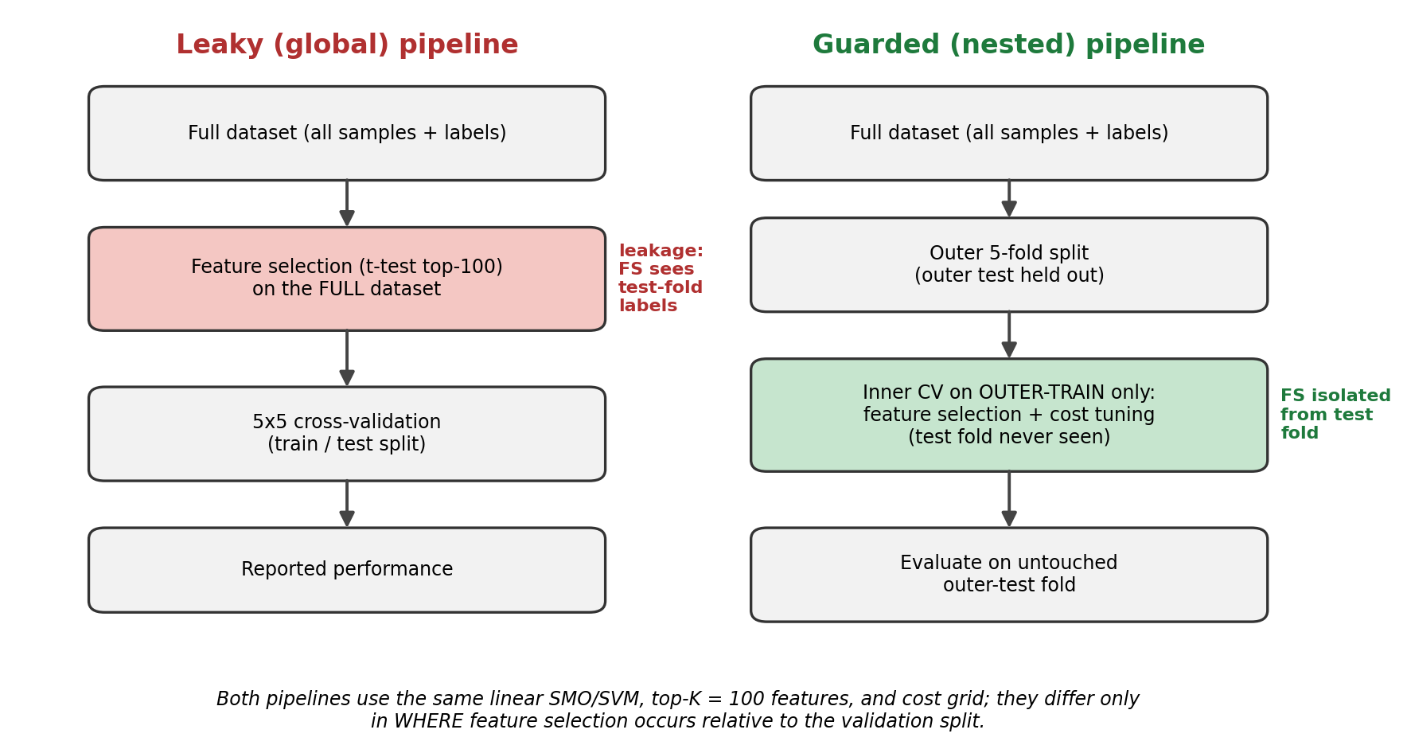
Figure 1. Conceptual comparison of the leaky (global) and guarded (nested) pipelines on GSE25055. The naive baseline intentionally performs supervised feature selection on the full dataset before validation and is evaluated with flat 5×5 repeated cross-validation, whereas the guarded pipeline nests feature selection, scaling, class weighting, and cost tuning inside training folds before outer-fold evaluation. Both use the same linear SVM and t-test top-100 selector.

Results
The contribution described here is methodological and audit-oriented: the analysis characterizes leakage sensitivity, feature reproducibility, class-imbalance behavior, and external-validation transportability for a leakage-aware linear SVM workflow. It does not claim clinical biomarker discovery.

Cohort construction and endpoint harmonization
The analysis used two same-platform breast cancer cohorts profiled on the Affymetrix HG-U133A array (GPL96). GSE25055 served as the discovery cohort and GSE25065 as the non-overlapping, same-study-family external-validation cohort. Both are non-overlapping subseries of the GSE25066 SuperSeries and were drawn from patients receiving neoadjuvant taxane-anthracycline therapy, with endocrine therapy for ER-positive disease, in the HER2-negative setting. The shared endpoint was pathological complete response (pCR) versus residual disease (RD).
In GSE25055, 310 samples were available; after excluding 4 samples without interpretable response labels, 306 usable samples remained (57 pCR, 249 RD), corresponding to a pCR prevalence of 18.6%. In GSE25065, 198 samples were available; after excluding 16 unlabeled samples, 182 usable samples remained (42 pCR, 140 RD), corresponding to a pCR prevalence of 23.1%. Because both cohorts were generated on GPL96, probe-level features could be transferred directly from discovery to validation without cross-platform remapping; in the external-validation step, all 100 selected probes aligned with no missing features.
The cohort roles in this analysis are as follows. GSE25055 served as the discovery/internal-validation cohort, and GSE25065 as the same-platform, same-study-family validation cohort. GSE41998 (GPL571) was used as a predeclared cross-platform transportability sensitivity cohort, requiring cross-platform harmonization. GSE20194 and GSE20271 are documented for audit transparency but were held out, owing to MDACC-lineage patient-overlap risk that would require sample-level de-duplication before use.
Table 4
Cohort Construction and Endpoint Harmonization
Cohort | Role/use | Usable labels | Audit note
GSE25055 | Discovery/internal validation | 306 (57 pCR, 249 RD) | GPL96; 4 missing labels excluded.
GSE25065 | Same-platform, same-study-family validation | 182 (42 pCR, 140 RD) | GPL96; 16 missing labels excluded; non-overlapping with GSE25055.
GSE41998 | Cross-platform transportability sensitivity | 253 evaluable (69 pCR, 184 RD) | GPL571; 20 ‘0’-coded and 6 missing/unclear labels excluded; exact GPL96∩GPL571 probe intersection; frozen GSE25055 model projected once with no retuning.
GSE20194 | Sensitivity candidate | 278 (56 pCR, 222 RD) | GPL96; held because of MDACC lineage overlap risk.
GSE20271 | Sensitivity candidate | 178 (26 pCR, 152 RD) | GPL96; held because of MDACC lineage overlap risk.
Note. GSE41998 was used for the frozen-model cross-platform transportability sensitivity analysis; GSE20194 and GSE20271 are documented for audit transparency but were not used, owing to MDACC-lineage patient-overlap risk. pCR = pathological complete response; RD = residual disease.

Leaky versus guarded nested linear SVM performance
To quantify the impact of feature-selection leakage, two pipelines were compared on the GSE25055 discovery cohort: a leaky baseline in which feature selection was performed once on the full dataset before cross-validation, and a guarded nested pipeline in which feature selection was confined to training partitions within the validation structure.
The leaky baseline produced higher headline discrimination than the guarded nested pipeline. The leaky pipeline achieved AUROC 0.7705 and PR-AUC 0.4020, compared with AUROC 0.7265 and PR-AUC 0.3656 for the guarded nested pipeline. The resulting leakage gaps were +0.0440 in AUROC and +0.0363 in PR-AUC, consistent with optimistic inflation of ranking-based discrimination when feature selection is not isolated within validation folds.
The leaky pipeline inflated threshold-independent discrimination metrics, whereas operating-point metrics varied under class imbalance and should be interpreted cautiously. Relative to the leaky baseline, the guarded nested pipeline values for balanced accuracy (0.5546 to 0.5792), Matthews correlation coefficient (0.2063 to 0.2250), and sensitivity for the minority pCR class (0.1333 to 0.2105) shifted alongside a modest decrease in specificity (0.9759 to 0.9478). These results should be read as a methodological demonstration of leakage sensitivity rather than evidence of a clinically actionable classifier; minority-class sensitivity remained low in absolute terms under both pipelines. These intervals are visualized in Figure 2.
Table 5
Leaky Versus Guarded Nested linear SVM Performance on GSE25055

Metric | Leaky baseline | Guarded nested linear SVM | Leaky - guarded gap
AUROC | 0.7705 (0.711–0.824) | 0.7265 (0.653–0.791) | +0.044 (95% CI −0.013 to +0.103; bootstrap p = 0.13)
PR-AUC | 0.4016 (0.333–0.497) | 0.3653 (0.281–0.472) | +0.036 (−0.048 to +0.125; p = 0.38)
Balanced accuracy | 0.5546 (0.525–0.586) | 0.5792 (0.527–0.633) | −0.025
MCC | 0.2064 (0.105–0.298) | 0.2250 (0.075–0.360) | −0.019
Sensitivity (pCR) | 0.1333 (0.074–0.197) | 0.2105 (0.105–0.316) | −0.077
Specificity | 0.9759 (0.964–0.986) | 0.9478 (0.916–0.972) | +0.028
Note. Values are point estimates with 95% stratified-bootstrap confidence intervals (B = 2000). Positive AUROC and PR-AUC gaps indicate higher apparent discrimination under the intentionally leaky global feature-selection workflow; both gap CIs include zero. MCC = Matthews correlation coefficient.
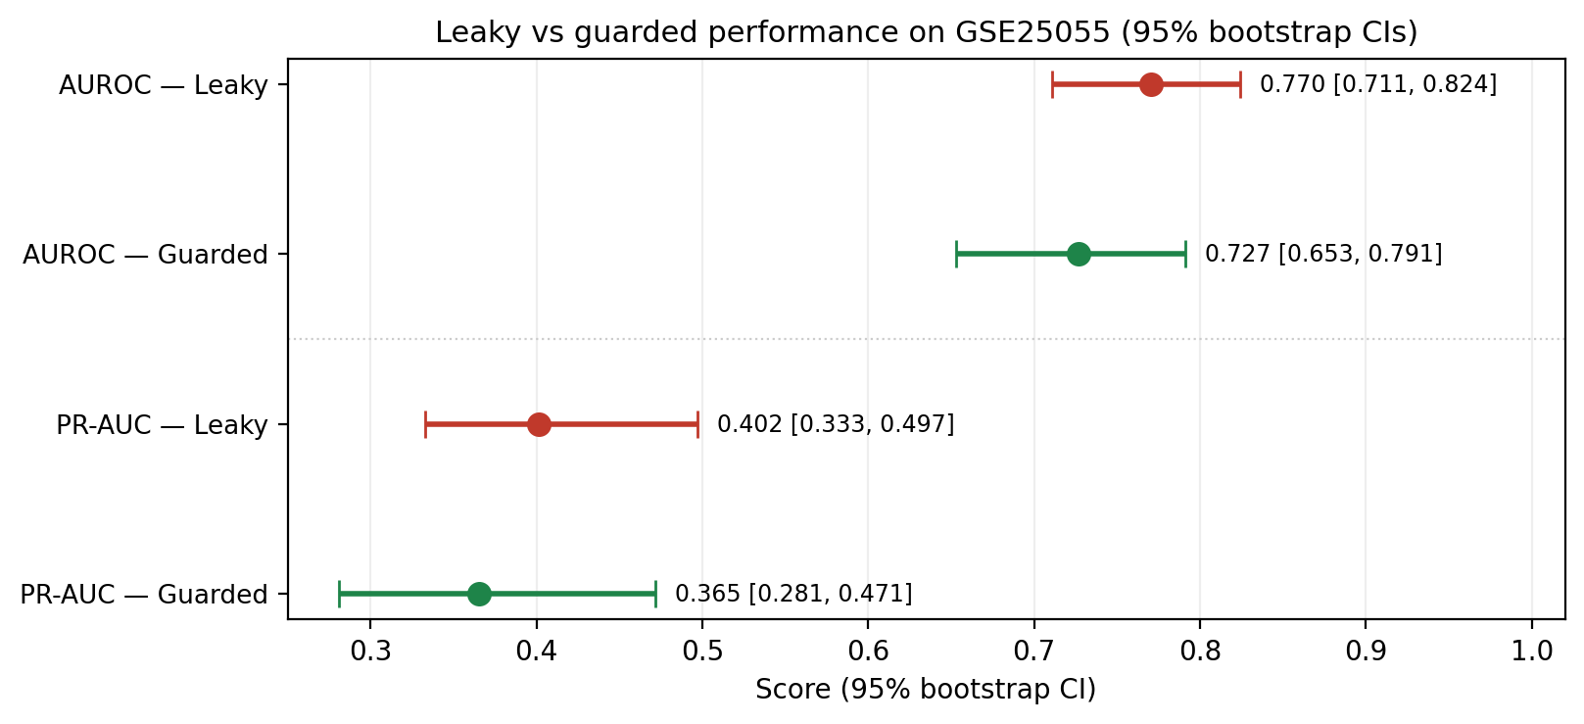
Figure 2. Leaky versus guarded discrimination on GSE25055 with 95% bootstrap confidence intervals (AUROC and PR-AUC). The leaky and guarded intervals overlap, consistent with a positive but modest leakage gap whose confidence interval includes zero.

Uncertainty quantification for the leakage gap
Bootstrapped confidence intervals place the leaky-versus-guarded comparison in context. On GSE25055, leaky AUROC was 0.7705 (95% CI 0.711–0.824) and guarded AUROC was 0.7265 (0.653–0.791); leaky PR-AUC was 0.4016 (0.333–0.497) and guarded PR-AUC 0.3653 (0.281–0.472). The leakage gap was positive but modest, with a confidence interval that included zero: ΔAUROC +0.044 (95% CI −0.013 to +0.103; paired bootstrap p = 0.13) and ΔPR-AUC +0.036 (−0.048 to +0.125; p = 0.38). Per-repeat DeLong tests were consistent, with p-values from 0.07 to 0.51 (median 0.18). Within a single cohort, therefore, the leakage gap is not resolved as nonzero by patient-level resampling; its magnitude is small relative to the sampling uncertainty driven by the 57-sample pCR minority. Confidence intervals for all metrics are reported in Table 5.

Sensitivity to the feature-selection budget (top-K sweep)
To test whether the leakage gap depends on the size of the feature-selection budget, the Welch t-test selector was held fixed and the top-K budget was varied over K = 25, 50, 100, and 200 (GSE25055 only); K = 100 reproduced the primary analysis exactly (Table 5). The leaky pipeline showed higher AUROC and PR-AUC than the guarded nested pipeline at every budget: ΔAUROC was +0.117, +0.067, +0.044, and +0.104 at K = 25, 50, 100, and 200, and ΔPR-AUC was positive at every K (+0.170, +0.089, +0.036, and +0.086). The gap was smallest at K = 100 and larger at the extremes, so its direction was consistent across budgets while its magnitude remained modest. Balanced accuracy (leaky 0.555–0.579 versus guarded 0.533–0.589), MCC (0.206–0.262 versus 0.114–0.225), minority-class sensitivity (0.133–0.186 versus 0.105–0.263), and specificity (0.962–0.976 versus 0.916–0.968) varied with K under class imbalance. Feature-selection stability increased monotonically with K (guarded Nogueira index 0.371 to 0.606, mean Jaccard 0.232 to 0.439, stable core 3 to 77 probes, unstable tail 46 to 174 probes from K = 25 to 200), indicating that larger budgets selected more reproducibly. Full results are in Table 6 and the committed summary table. This is a within-cohort sensitivity analysis of the feature-selection budget and does not test sensitivity to the model class.
Table 6
Selector Top-K Sweep: Leakage Gap and Feature Stability on GSE25055

K | Leaky AUROC | Guarded AUROC | ΔAUROC | Leaky PR-AUC | Guarded PR-AUC | ΔPR-AUC | Nogueira | Mean Jaccard | Stable core | Unstable tail
25 | 0.8365 | 0.7197 | +0.1167 | 0.5041 | 0.3340 | +0.1701 | 0.3713 | 0.2317 | 3 | 46
50 | 0.8094 | 0.7426 | +0.0668 | 0.4627 | 0.3735 | +0.0892 | 0.4448 | 0.2906 | 9 | 68
100 | 0.7705 | 0.7265 | +0.0440 | 0.4020 | 0.3656 | +0.0363 | 0.5409 | 0.3734 | 28 | 102
200 | 0.8198 | 0.7154 | +0.1044 | 0.4572 | 0.3717 | +0.0855 | 0.6055 | 0.4389 | 77 | 174
Note. The Welch t-test selector is held fixed; only the top-K budget varies. Positive ΔAUROC and ΔPR-AUC indicate higher apparent discrimination under leaky global feature selection. K = 100 reproduces the primary analysis (Table 5). Stability indices are from the five guarded outer-fold feature sets. Operating-point metrics per K (balanced accuracy, MCC, sensitivity, specificity) are in the committed summary table (tables/sensitivity/k_sweep_summary.csv). Within-cohort diagnostic; not biomarker discovery.

Permutation-control negative control
To test whether the leaky pipeline’s apparent advantage could arise without real signal, the pCR/RD labels were permuted 1000 times and both pipelines were rerun. Under shuffled labels the leaky pipeline still produced strongly above-chance discrimination (null AUROC mean 0.878, 95% range 0.761–0.956; all 1000 permutations above 0.5), and its real-label AUROC of 0.7705 fell within—indeed below the mean of—its own null distribution (empirical p = 0.97). In contrast, the guarded pipeline’s null centered near chance (null AUROC mean 0.540), and its real-label performance significantly exceeded this null (p = 0.001 for both AUROC and PR-AUC); the guarded PR-AUC null centered on the cohort prevalence (0.192 versus 0.186). These patterns support the interpretation that global feature selection is diagnostic of a leakage artifact—it can produce apparent discrimination under randomized labels—whereas the guarded pipeline result is consistent with label-dependent signal under the guarded validation architecture. The contrast is shown in Figure 3 and summarized in Table 7.
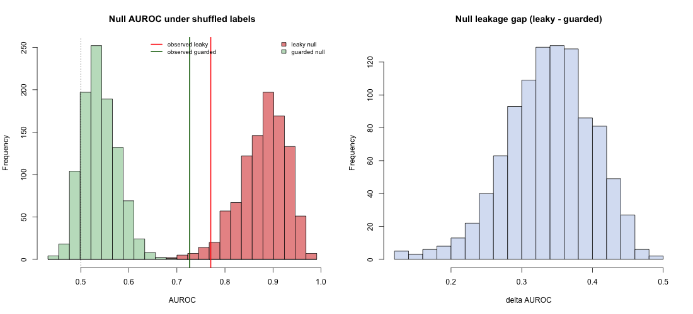
Figure 3. Null distributions of AUROC under 1000 label permutations for the leaky and guarded pipelines (GSE25055). The leaky null sits far above chance while the guarded null sits near 0.5; vertical lines mark the observed real-label AUROC for each pipeline.
Table 7
Permutation-Control Negative Control (B = 1000), GSE25055
Statistic | Observed | Null mean (95% range) | Empirical p | Interpretation
Leaky AUROC | 0.7705 | 0.878 (0.761–0.956) | 0.97 | Leaky null far above chance; observed lies within its own null
Guarded AUROC | 0.7265 | 0.540 (0.478–0.619) | 0.001 | Guarded null near chance; real-label value exceeds null
Leaky PR-AUC | 0.402 | 0.664 (0.413–0.861) | 0.98 | Inflated under randomized labels
Guarded PR-AUC | 0.3656 | 0.192 (0.147–0.261) | 0.001 | Null ≈ prevalence (0.186); real-label value exceeds null
Leakage gap (AUROC) | 0.044 | 0.338 (0.209–0.445) | — | Null gap is large; observed real-label gap is small
Note. Empirical p is the fraction of the 1000 permutation values at or above the observed value. Reference chance is 0.5 for AUROC and the cohort prevalence (0.186) for PR-AUC. The control is a diagnostic of the leakage mechanism, not evidence of biological signal.

Seed-level robustness across 30 repeated cross-validation runs
To assess robustness to fold assignment, both pipelines were repeated across 30 random seeds. The leakage gap was modest but reproducible: ΔAUROC was positive in 27 of 30 seeds (median +0.054, 2.5–97.5 percentile −0.007 to +0.108) and ΔPR-AUC in 27 of 30 seeds (median +0.057), each differing from zero by a two-sided Wilcoxon signed-rank test (V = 456, p = 4.5 × 10⁻⁶ for AUROC; V = 445, p = 1.3 × 10⁻⁵ for PR-AUC). This test characterizes the reproducibility of the gap across fold randomizations and should not be read as patient-level significance; the per-seed interval still grazes zero. Feature stability was likewise reproducible across seeds (median Nogueira index 0.55, range 0.49–0.60; median mean Jaccard 0.38; stable core median 30 probes, range 23–35; unstable tail median 104 probes, range 75–123), consistent with the single-split estimate. Per-seed distributions are shown in Figure 4 (leakage gap) and Figure 5 (feature stability), and summarized in Table 8.
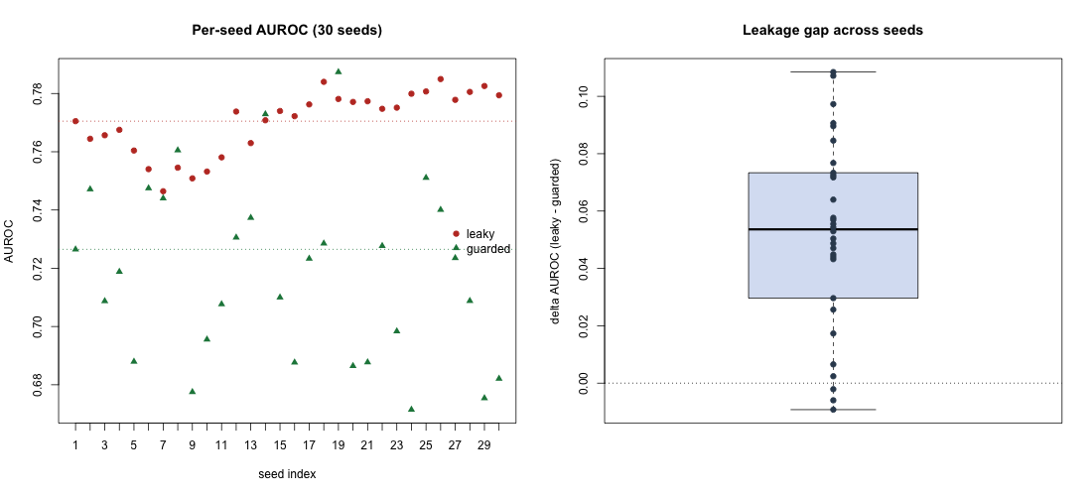
Figure 4. Per-seed AUROC for the leaky and guarded pipelines (left) and the distribution of the leakage gap (right) across 30 repeated nested cross-validation seeds (GSE25055).
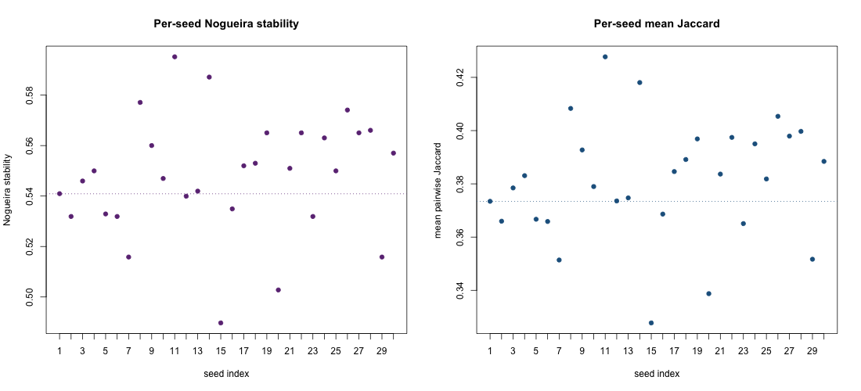
Figure 5. Per-seed Nogueira stability (left) and mean pairwise Jaccard overlap (right) of the guarded pipeline’s fold-level feature sets across 30 seeds.
Table 8
Seed-Level Robustness Across 30 Repeated Nested Cross-Validation Runs, GSE25055

Quantity | Median | 2.5–97.5 percentile | Notes
Leaky AUROC | 0.774 | 0.750–0.784 | Per-seed
Guarded AUROC | 0.721 | 0.674–0.777 | Per-seed; more seed-sensitive than leaky
ΔAUROC (leaky − guarded) | 0.054 | −0.007 to 0.108 | Positive in 27/30 seeds; Wilcoxon V = 456, p = 4.5 × 10⁻⁶
ΔPR-AUC (leaky − guarded) | 0.057 | −0.024 to 0.139 | Positive in 27/30 seeds; Wilcoxon V = 445, p = 1.3 × 10⁻⁵
Nogueira stability | 0.550 | 0.490–0.595 | Moderate, reproducible
Mean Jaccard overlap | 0.383 | 0.328–0.428 | Moderate, reproducible
Stable-core probes | 30 | 23–35 (range) | Selected in all five outer folds
Unstable-tail probes | 103.5 | 75–123 (range) | Selected in only one fold
Note. Percentiles are across 30 seeds. The Wilcoxon signed-rank test characterizes reproducibility of the gap across fold randomizations, not patient-level inference.

Feature-stability audit
Feature reproducibility was assessed across the five outer folds of the guarded nested pipeline, with the top 100 probes selected per fold from a feature universe of 22,283. Across folds, 222 unique probes were selected at least once. Of these, a stable core of 28 probes was selected in all five folds, while a large unstable tail of 102 probes was selected in only one fold. Pairwise overlap between fold-specific feature sets was moderate (mean Jaccard 0.3734, median Jaccard 0.3699), and the Nogueira stability index was 0.5409.
Taken together, these values indicate moderate feature stability: a small reproducible core of probes recurred across every fold, but a substantial fraction of selected features did not generalize across resampling. This audit characterizes reproducibility of the selection procedure rather than nominating specific probes as validated markers. The full selection-frequency distribution across folds is shown in Figure 6.
Table 9
Feature-Stability Summary for the Guarded Nested Pipeline
Metric | Value | Interpretation
Outer folds | 5 | Pilot-scale stability estimate
Features selected per fold | 100 | Fixed top-K feature-selection setting
Feature universe | 22,283 | Probe-level GPL96 feature space
Total unique selected features | 222 | More features selected across folds than in any single model
Selected in all 5 folds | 28 | Stable feature core
Selected in only 1 fold | 102 | Large unstable tail
Mean Jaccard overlap | 0.3734 | Moderate pairwise overlap
Median Jaccard overlap | 0.3699 | Moderate pairwise overlap
Nogueira stability index | 0.5409 | Moderate stability
Note. Feature-stability results are intended as an audit of reproducibility, not as a validated biological signature.
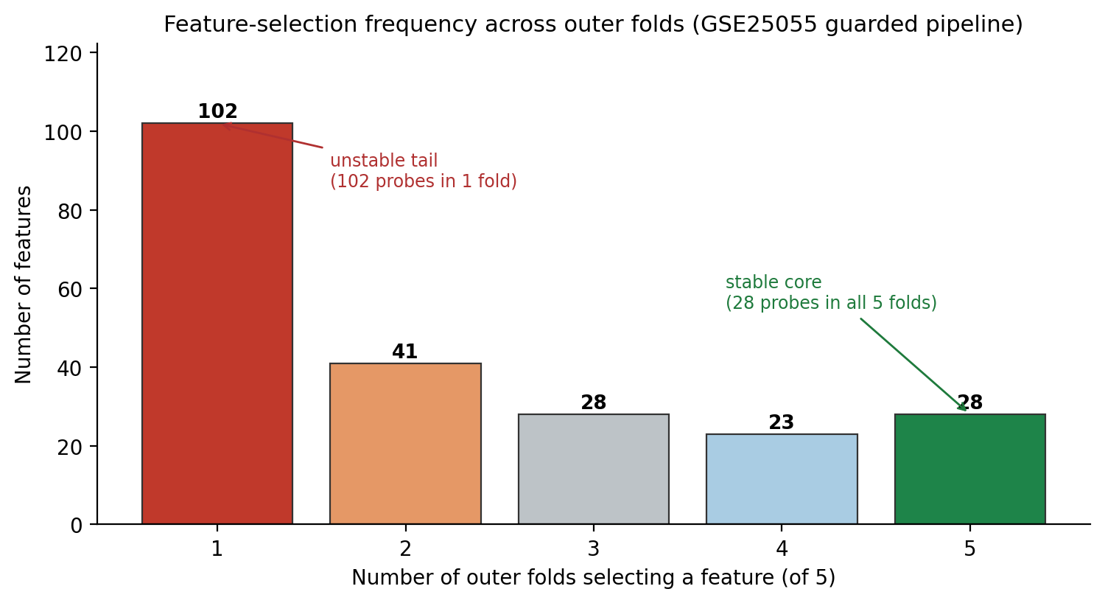
Figure 6. Feature-selection frequency across the five outer folds of the guarded pipeline (GSE25055). A small stable core (28 probes selected in all five folds) coexists with a large unstable tail (102 probes selected in only one fold).

Same-platform, same-study-family validation on GSE25065
The guarded model design was frozen and applied to the independent GSE25065 cohort using a linear SVM with cost 0.25 and the 100 discovery-selected probes. All 100 selected probes aligned to the validation cohort. On external validation, the model achieved AUROC 0.6078 (95% CI 0.506–0.700), PR-AUC 0.3060, balanced accuracy 0.5381, MCC 0.1347, sensitivity 0.1190, and specificity 0.9571. The confusion matrix contained 5 true positives, 6 false positives, 134 true negatives, and 37 false negatives.
Compared with the guarded nested cross-validated estimates on the discovery cohort, external performance showed a transportability drop across most metrics: AUROC fell by 0.1187, PR-AUC by 0.0596, balanced accuracy by 0.0411, MCC by 0.0903, and sensitivity by 0.0915, while specificity was essentially unchanged, increasing by 0.0094. This degradation, particularly in discrimination and minority-class recall, represents a limit of cohort transportability and model generalization rather than a leakage effect. While the internal leakage gap quantified the inflation caused by naive feature selection, this transportability drop reflects the biological and technical heterogeneity inherent in independent transcriptomic cohorts.
Table 10
Same-Platform, Same-Study-Family Validation on GSE25065

Metric | Guarded nested CV (GSE25055) | GSE25065 same-study-family validation | External drop/change
AUROC | 0.7265 | 0.6078 | -0.1187
PR-AUC | 0.3656 | 0.3060 | -0.0596
Balanced accuracy | 0.5792 | 0.5381 | -0.0411
MCC | 0.2250 | 0.1347 | -0.0903
Sensitivity | 0.2105 | 0.1190 | -0.0915
Specificity | 0.9478 | 0.9571 | +0.0094
Note. The external-validation model was trained and configured using GSE25055 only, then projected once onto GSE25065 without refitting, retuning, threshold adjustment, or feature re-selection.

Cross-platform transportability sensitivity on GSE41998
To probe transportability beyond the same study family, the frozen GSE25055 model was projected onto the independent, different-platform cohort GSE41998 (GPL571) as a predeclared sensitivity analysis. After the predeclared label rule (253 evaluable: 69 pCR, 184 RD; prevalence 0.273), the exact probe-ID intersection recovered all 100 frozen probes (coverage 1.000). Under the primary discovery-derived scaling, the frozen model achieved AUROC 0.6638, PR-AUC 0.4353, balanced accuracy 0.5697, MCC 0.1845, sensitivity 0.2319, and specificity 0.9076 (confusion matrix: 16 true positives, 53 false negatives, 167 true negatives, 17 false positives). A within-cohort, label-blind z-score adaptation, reported only as an unsupervised sensitivity variant, gave AUROC 0.6779 and PR-AUC 0.4300. Cross-platform discrimination was above chance but showed a transportability drop relative to the discovery guarded cross-validation (AUROC 0.7265), comparable to — and slightly above — the same-study-family GSE25065 result (AUROC 0.6078); minority-class sensitivity again remained low under class imbalance. This cross-platform projection is a transportability sensitivity analysis: a moderate external number is a generalization limit and supports the interpretation that leakage control and transportability are distinct; it is not evidence that leakage caused the external decline.
Table 11
Cross-Platform Transportability Sensitivity on GSE41998 (Frozen GSE25055 Model)
Metric | Discovery guarded CV (GSE25055) | GSE25065 (same-study-family) | GSE41998 (cross-platform, primary)
AUROC | 0.7265 | 0.6078 | 0.6638
PR-AUC | 0.3656 | 0.3060 | 0.4353
Balanced accuracy | 0.5792 | 0.5381 | 0.5697
MCC | 0.2250 | 0.1347 | 0.1845
Sensitivity (pCR) | 0.2105 | 0.1190 | 0.2319
Specificity | 0.9478 | 0.9571 | 0.9076
Note. GSE41998 is an independent, different-platform (GPL571) cohort; the frozen GSE25055 model (100 probes, C = 0.25, 0.5 threshold, discovery-derived scaling) was projected once with no retuning. Evaluable N = 253 (69 pCR, 184 RD); 100 of 100 frozen probes recovered. A within-cohort z-score sensitivity variant gave AUROC 0.6779 / PR-AUC 0.4300. Cross-platform transportability sensitivity; not the main proof of leakage.
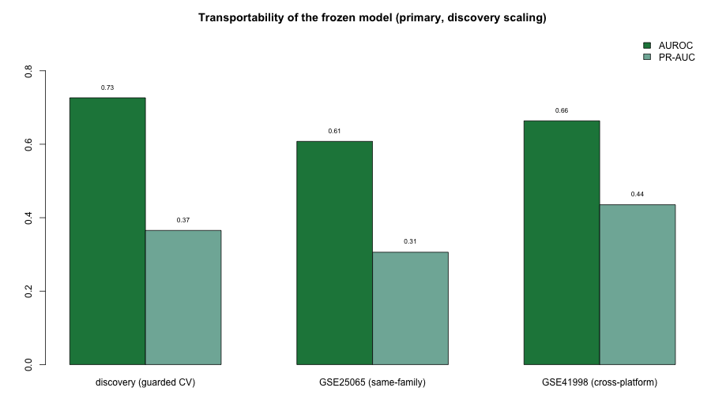
Figure 7. Cross-platform transportability sensitivity on GSE41998. The frozen GSE25055 model (100 probes, C = 0.25) projected onto the independent GPL571 cohort (N = 253) under discovery-derived scaling; discrimination is above chance with a transportability drop, consistent with a generalization limit rather than a leakage effect.

Integrated Reproducible Omics Evidence Audit
The preceding analyses were consolidated into a Reproducible Omics Evidence Audit Table. Every value in the table is read from previously generated stage outputs and recombined deterministically; the table does not require rerunning any model. The audit organizes the evidence across eight domains: dataset integrity, leakage sensitivity, guarded nested performance, feature stability, external validation, class-imbalance behavior, reproducibility status, and limitations or unresolved risks.
The audit table makes visible what a single AUROC value cannot: the leakage risk of the modeling pipeline, the reproducibility of selected features, the behavior of the classifier under class imbalance, and the decline from internal nested validation to external validation. Framed this way, the primary contribution is methodological: a transparent reporting template for public omics classification workflows. The low pCR sensitivity observed both internally and externally, the moderate feature stability, and the same-study-family (GSE25065) and cross-platform (GSE41998) transportability checks are reported as limitations rather than minimized. These dimensions are shown together in the evidence-audit dashboard (Figure 8).
Table 12
Reproducible Omics Evidence Audit Summary
Audit domain | Metric | Value | Interpretation
Dataset integrity | Discovery usable samples | 306 (57 pCR, 249 RD) | Discovery cohort is labeled and same-platform.
Dataset integrity | GSE25065 (same-study-family) usable samples | 182 (42 pCR, 140 RD) | Same-platform, same-study-family validation cohort is non-overlapping.
Leakage sensitivity | AUROC gap (leaky - guarded) | +0.0440 | Global feature selection can inflate apparent discrimination; single-cohort gap CI includes zero (Table 5).
Leakage sensitivity | PR-AUC gap (leaky - guarded) | +0.0363 | Leakage can also raise minority-class (PR-AUC) ranking; single-cohort gap CI includes zero.
Guarded nested performance | Balanced accuracy / MCC | 0.5792 / 0.2250 | Operating-point metrics vary under class imbalance and should be interpreted cautiously.
Feature stability | Nogueira index | 0.5409 | Moderate stability with stable core and unstable tail.
External validation | GSE25065 AUROC / PR-AUC | 0.6078 / 0.3060 | Same-study-family validation shows a transportability drop; GSE41998 provides a separate cross-platform sensitivity check.
Cross-platform transportability | GSE41998 AUROC / PR-AUC | 0.6638 / 0.4353 | Independent different-platform (GPL571) cohort; N = 253; 100 of 100 frozen probes; sensitivity 0.2319, specificity 0.9076; above chance with a transportability drop. Sensitivity analysis, not proof of leakage.
Class-imbalance behavior | GSE25065 sensitivity / specificity | 0.1190 / 0.9571 | High specificity but low pCR sensitivity.
Reproducibility status | Code/results artifacts | Committed outputs and audit table | Pipeline is reproducible from repository artifacts.
Limitations/unresolved risks | Unvalidated biomarker status | No clinical biomarker claim | Findings are methodological and require further validation.
Leakage sensitivity | Internal leakage gap, ΔAUROC (95% CI) | +0.044 (−0.013 to +0.103) | Positive but CI includes zero in one cohort
Leakage sensitivity | Permutation control, leaky null AUROC | 0.88 (all permutations > chance) | Diagnostic of leakage artifact; guarded null near chance
Reproducibility | Seed robustness, ΔAUROC (27/30 seeds) | median +0.054; Wilcoxon p < 0.001 | Modest but reproducible across folds
Note. The evidence audit summarizes the current results.
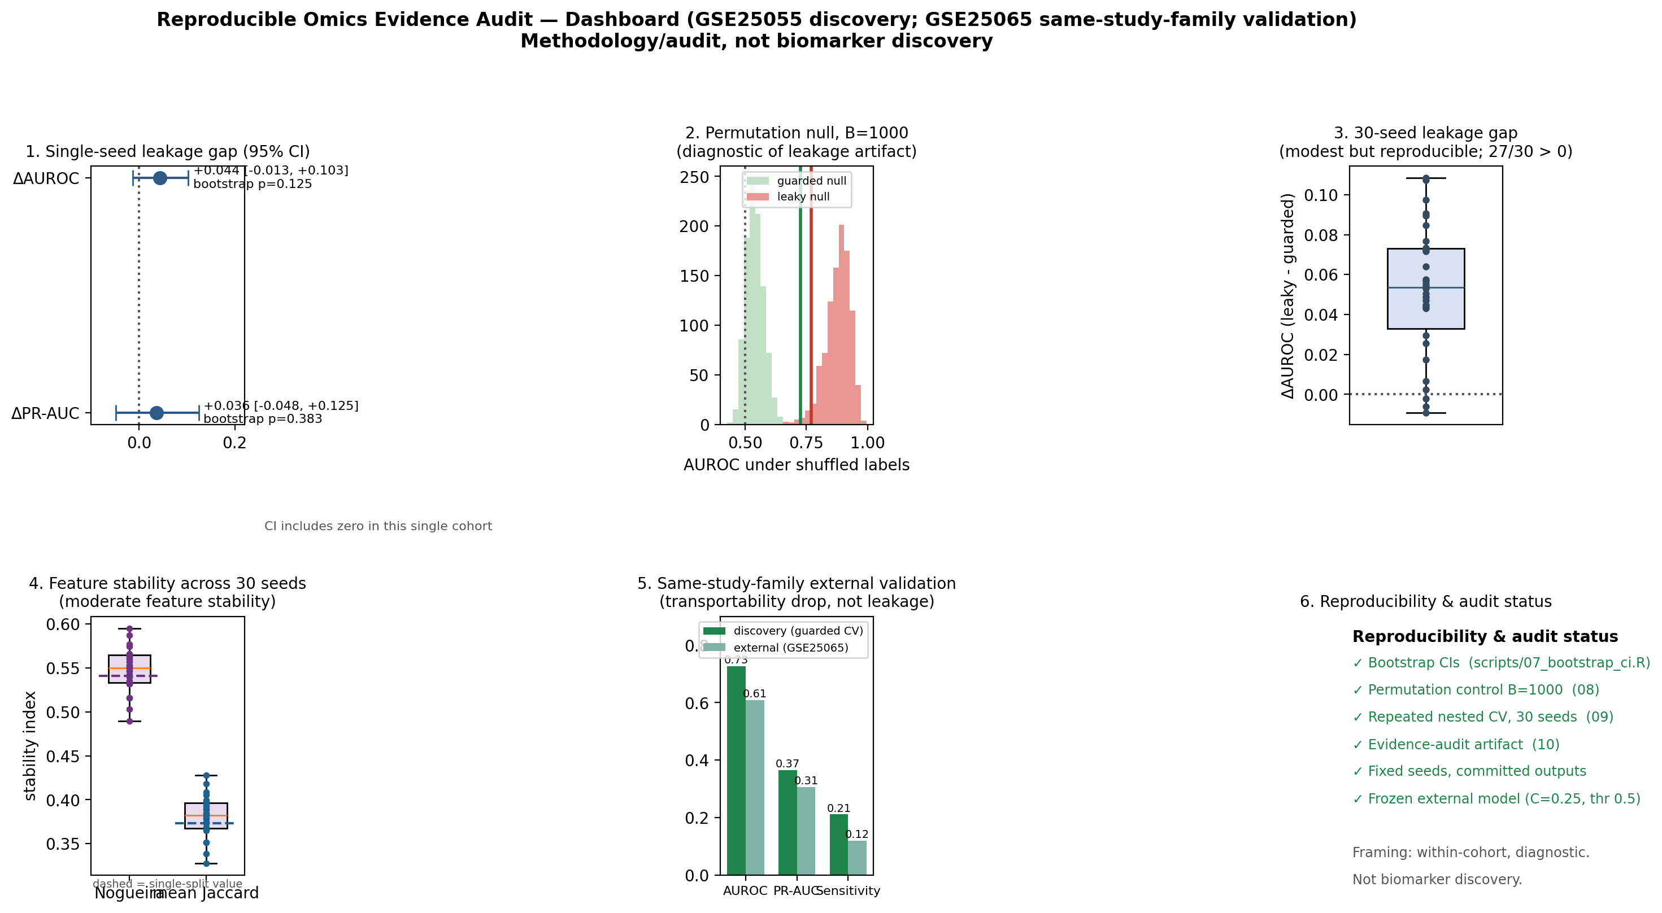
Figure 8. Reproducible Omics Evidence Audit dashboard summarising, from the committed outputs: the single-seed leakage gap with 95% confidence interval; the B=1000 permutation null (diagnostic of a leakage artifact); the 30-seed leakage-gap distribution; feature-stability across seeds; the same-study-family external-validation drop; and reproducibility status. Within-cohort, diagnostic; not biomarker discovery.

Discussion

Principal findings
Three results, taken together, calibrate the leakage finding. First, on the GSE25055 discovery cohort, naive global feature selection produced a positive but modest internal leakage gap (ΔAUROC +0.044) whose 95% confidence interval included zero, so within a single cohort the gap is not resolved as nonzero by patient-level resampling. Second, a 1000-permutation negative control showed the leaky pipeline generating strongly above-chance discrimination from randomized labels while the guarded pipeline shifted toward chance, supporting the interpretation that the leakage mechanism is real and diagnostic even though its measured magnitude on real labels is small. Third, across 30 repeated nested cross-validation seeds the gap was modest but reproducible, positive in 27 of 30 runs. Separately, two external projections showed transportability drops distinct from internal leakage: the same-study-family GSE25065 cohort (AUROC 0.6078) and, as a predeclared cross-platform sensitivity analysis, the independent, different-platform GSE41998 cohort (AUROC 0.6638), where discrimination remained above chance. These five quantities answer different questions: the internal gap is a within-cohort magnitude, the permutation control is a mechanism demonstration, the repeated-CV result is fold-level reproducibility, the same-study-family drop is a within-family generalization limit, and the cross-platform drop is a between-platform generalization limit. Reported together, they argue for leakage-aware, uncertainty-bounded auditing rather than reliance on a single headline metric. The direction of the internal leakage gap was also robust to the feature-selection budget: across K = 25, 50, 100, and 200 the leaky pipeline showed higher AUROC and PR-AUC than the guarded pipeline at every budget, with the smallest gap at K = 100, while feature-selection stability increased with K (Table 6); this robustness concerns the feature-selection budget only and does not test generalization across model classes.

Why leakage-aware validation changes biomarker interpretation
These results connect leakage inflation directly to biomarker credibility. A model that looks stronger under global feature selection is not necessarily more useful; it may simply benefit from test-fold information embedded in the feature list. The leaky pipeline inflated threshold-independent discrimination metrics, whereas operating-point metrics varied under class imbalance and should be interpreted cautiously. The external-validation decline underscores that transparent reporting of transportability is more valuable than preserving an inflated internal AUROC. The permutation control makes the mechanism explicit: because global feature selection can read held-out labels, it can produce apparent discrimination even when no signal exists, which is why leakage-aware validation changes the interpretation of headline metrics rather than merely adjusting them.

Feature stability versus predictive performance
The stability audit shows that performance and feature reproducibility answer different questions. The guarded nested pipeline selected a stable core of 28 probes across all folds, but it also produced a large unstable tail of 102 probes selected only once. This pattern supports the central claim that transcriptomic ML papers should not report a single gene list without fold-level stability evidence. In this analysis, the selected features should be interpreted as audit outputs, not as validated biomarkers. The 30-seed repeated analysis shows that the moderate stability seen in a single split is itself reproducible (median Nogueira index 0.55), reinforcing that the audit characterizes the selection procedure rather than a fixed gene panel.

Relation to existing tools and literature
This work does not replace nestedcv, stabm, OmicSelector, or other existing tools, and it does not introduce a new classifier, validation procedure, or stability metric. Whereas nestedcv (Lewis et al., 2023) and OmicSelector provide reusable machinery for leakage-resistant model building and feature selection, the present contribution is the empirical audit such machinery enables: a side-by-side leakage-gap quantification, a fold-level feature-stability profile, frozen external validation, and an integrated evidence-audit summary applied to a single linear SVM workhorse. The framework is intended to complement existing validation packages by showing how their principles can be translated into an interpretable omics evidence audit.

Practical recommendations
1. Never perform supervised feature selection before splitting.
2. Fit scaling and preprocessing parameters on training data only.
3. Perform feature selection and hyperparameter tuning inside nested cross-validation.
4. Apply SMOTE or other resampling only inside training folds if used at all.
5. Report PR-AUC, MCC, balanced accuracy, sensitivity, and specificity for imbalanced endpoints.
6. Report feature stability and feature-selection frequencies in biomarker studies.
7. Freeze features, thresholds, and hyperparameters before external validation.
8. Release code, data-accession lists, random seeds, fold assignments, and selected-feature outputs.

Limitations
The analysis has several limitations. On the discovery cohort the internal leakage gap, although positive and reproducible in direction, was small and its confidence interval included zero, so it is not established as nonzero at the patient level within this single cohort. The 30-seed Wilcoxon result demonstrates reproducibility of the gap across fold randomizations and is seed/fold-level evidence, not patient-level statistical inference. External validation used a same-study-family, same-platform cohort (GSE25065, from the Hatzis study lineage); although GSE25055 and GSE25065 are non-overlapping by design, broader cross-platform generalization was assessed only by the single GSE41998 sensitivity analysis and otherwise remains limited. GSE41998 was evaluated as a predeclared cross-platform transportability sensitivity analysis; it is an independent, different-platform (GPL571) cohort from a different trial with treatment-regimen heterogeneity (an AC-then-ixabepilone-or-paclitaxel regimen versus the discovery taxane–anthracycline cohorts), so its moderate external performance reflects platform and case-mix differences and should be read as a transportability limit rather than a leakage effect. GSE20194 and GSE20271 were held because of patient-overlap risk. The analysis used a single primary feature selector (varied only in budget through the top-K sweep) and a linear SVM configuration, and pCR sensitivity remained low under both pipelines; whether the leakage and stability behaviour generalizes across selector families and model classes remains untested. No prospective clinical, mechanistic, or wet-lab validation was performed; recurrent probes should be interpreted as stability-ranked candidates for future review, not as clinically validated biomarkers.

Future work
Future work may extend the framework to RNA-seq, multi-omics integration, survival endpoints, other cancer types, and automated evidence-dossier systems for biomarker and therapeutic-target claims. Additional feature selectors and classifiers remain natural sensitivity analyses, and broader multi-cohort, multi-platform external validation would further test transportability. The feature-budget (top-K) sweep and the leakage-safe cross-platform GSE41998 validation have been completed and are reported above (Tables 6 and 11; Figure 7). One pre-specified robustness extension remains, to be reported once executed under its frozen, predeclared protocol: an elastic-net comparator to test whether the leakage and stability behaviour is specific to the SVM model class.

Conclusion
In public transcriptomic biomarker discovery, apparent classification performance can be distorted when feature selection and model development are evaluated without strict validation separation. This study utilized an established linear SVM approach as a transparent, high-dimensional workhorse model for auditing leakage, feature stability, and transportability. A leaky GSE25055 pipeline showed higher AUROC and PR-AUC than the guarded nested audit pipeline, whereas operating-point metrics varied under class imbalance and were interpreted cautiously. These results underscore that the novelty lies in the integrated audit architecture—coupling leakage-gap quantification, feature-stability profiling, and external validation—rather than in the classifier, the nested-validation procedure, or the stability metrics, each of which is established. They support the Reproducible Omics Evidence Audit as a transparent reporting framework for leakage sensitivity, feature reproducibility, and external transportability. The findings should be interpreted as methodological evidence regarding validation rigor, not as a clinical biomarker discovery claim.

List of Abbreviations

Abbreviation | Meaning
AUROC | Area under the receiver operating characteristic curve
GEO | Gene Expression Omnibus
MCC | Matthews correlation coefficient
NCV | Nested cross-validation
pCR | Pathological complete response
PR-AUC | Area under the precision-recall curve
RD | Residual disease
RFE | Recursive feature elimination
SMO | Sequential Minimal Optimization
SMOTE | Synthetic Minority Over-sampling Technique
SVM | Support vector machine

Declarations

Ethics approval and consent to participate
This study uses publicly available, de-identified transcriptomic datasets, for which no new human participants were recruited and no separate ethical approval was required.

Consent for publication
Not applicable.

Availability of data and materials
All public datasets are cited by accession number. The associated code, fold assignments, random seeds, selected-feature lists, and analysis outputs are available in the project GitHub repository. The repository is structured for versioned archival, and a frozen DOI-citable release will accompany the final submission.

Competing interests
Competing interests will be declared by all authors prior to submission.

Funding
Funding sources will be declared prior to submission.

Authors’ contributions
Author contributions will be finalized prior to submission.

Acknowledgements
Acknowledgements will be added prior to submission.

References
Ambroise, C., & McLachlan, G. J. (2002). Selection bias in gene extraction on the basis of microarray gene-expression data. Proceedings of the National Academy of Sciences, 99(10), 6562–6566. https://doi.org/10.1073/pnas.102102699
Berrar, D., & Flach, P. (2012). Caveats and pitfalls of ROC analysis in clinical microarray research (and how to avoid them). Briefings in Bioinformatics, 13(1), 83–97. https://doi.org/10.1093/bib/bbr008
Blagus, R., & Lusa, L. (2013). SMOTE for high-dimensional class-imbalanced data. BMC Bioinformatics, 14. Article 106. https://doi.org/10.1186/1471-2105-14-106
Cawley, G. C., & Talbot, N. L. C. (2010). On over-fitting in model selection and subsequent selection bias in performance evaluation. Journal of Machine Learning Research, 11, 2079–2107. https://jmlr.org/papers/v11/cawley10a.html
Chawla, N. V., Bowyer, K. W., Hall, L. O., & Kegelmeyer, W. P. (2002). SMOTE: Synthetic minority over-sampling technique. Journal of Artificial Intelligence Research, 16, 321–357. https://doi.org/10.1613/jair.953
Chicco, D., & Jurman, G. (2020). The advantages of the Matthews correlation coefficient (MCC) over F1 score and accuracy in binary classification evaluation. BMC Genomics, 21. Article 6. https://doi.org/10.1186/s12864-019-6413-7
Chicco, D., & Jurman, G. (2023). The Matthews correlation coefficient (MCC) should replace the ROC AUC as the standard metric for assessing binary classification. BioData Mining, 16. Article 4. https://doi.org/10.1186/s13040-023-00322-4
Collins, G. S., Moons, K. G. M., Dhiman, P., Riley, R. D., Beam, A. L., Van Calster, B., Ghassemi, M., Liu, X., Reitsma, J. B., van Smeden, M., Boulesteix, A.-L., Camaradou, J., Celi, L. A., Denaxas, S., Denniston, A. K., Glocker, B., Golub, R. M., Harvey, H., Heinze, G., & members of the TRIPOD+AI initiative (2024). TRIPOD+AI statement: Updated guidance for reporting clinical prediction models that use regression or machine learning methods. BMJ, 385. Article e078378. https://doi.org/10.1136/bmj-2023-078378
Cortes, C., & Vapnik, V. (1995). Support-vector networks. Machine Learning, 20, 273–297. https://doi.org/10.1007/BF00994018
Guyon, I., Weston, J., Barnhill, S., & Vapnik, V. (2002). Gene selection for cancer classification using support vector machines. Machine Learning, 46, 389–422. https://doi.org/10.1023/A:1012487302797
Hatzis, C., Pusztai, L., Valero, V., Booser, D. J., Esserman, L., Lluch, A., Vidaurre, T., Holmes, F., Souchon, E., Wang, H., Martin, M., Cotrina, J., Gomez, H., Hubbard, R., Chacón, J. I., Ferrer-Lozano, J., Dyer, R., Buxton, M., Gong, Y., & Symmans, W. F. (2011). A genomic predictor of response and survival following taxane-anthracycline chemotherapy for invasive breast cancer. JAMA, 305(18), 1873–1881. https://doi.org/10.1001/jama.2011.593
Haury, A.-C., Gestraud, P., & Vert, J.-P. (2011). The influence of feature selection methods on accuracy, stability and interpretability of molecular signatures. PLOS ONE, 6(12). Article e28210. https://doi.org/10.1371/journal.pone.0028210
Kapoor, S., & Narayanan, A. (2023). Leakage and the reproducibility crisis in machine-learning-based science. Patterns, 4(9). Article 100804. https://doi.org/10.1016/j.patter.2023.100804
Lewis, M. J., Spiliopoulou, A., Goldmann, K., Pitzalis, C., McKeigue, P., & Barnes, M. R. (2023). nestedcv: An R package for fast implementation of nested cross-validation with embedded feature selection designed for transcriptomics and high-dimensional data. Bioinformatics Advances, 3(1). Article vbad048. https://doi.org/10.1093/bioadv/vbad048
Nogueira, S., Sechidis, K., & Brown, G. (2018). On the stability of feature selection algorithms. Journal of Machine Learning Research, 18(174), 1–54.
Platt, J. C. (1999). Fast training of support vector machines using sequential minimal optimization. In B. Schölkopf, C. J. C. Burges, & A. J. Smola (Eds.), Advances in kernel methods: Support vector learning (pp. 185–208). MIT Press.
Vabalas, A., Gowen, E., Poliakoff, E., & Casson, A. J. (2019). Machine learning algorithm validation with a limited sample size. PLOS ONE, 14(11). Article e0224365. https://doi.org/10.1371/journal.pone.0224365
Varma, S., & Simon, R. (2006). Bias in error estimation when using cross-validation for model selection. BMC Bioinformatics, 7. Article 91. https://doi.org/10.1186/1471-2105-7-91

