Artificial Intelligence

BS (CS) _SP_2024

Lab_03 Manual



Learning Objectives:

1. Agent Basis
2. Environment
3. Simple Reflex Agent
4. Model Based Agent

# Agents

An **agent** is anything that can be viewed as perceiving its environment through **sensors** and acting upon that environment through **actuators**.

* **Percepts** refer to the agent’s perceptual inputs at any given instant.
* An agent’s **percept sequence** is the complete history of everything the agent has ever perceived.

In general, an agent’s choice of action at any given instant can depend on the entire percept sequence observed to date, but not on anything it hasn’t perceived.

An agent is composed of:

* **Percept:** Information received from the environment.
* **Action:** A set of actions the agent can perform.

|  |
| --- |
|  |

## Environment

Agents operate in different environments:

* **Fully observable vs. Partially observable** – Can the agent see everything?
* **Deterministic vs. Stochastic** – Are outcomes predictable?
* **Static vs. Dynamic** – Does the environment change over time?

**Example:** A self-driving car operates in a **dynamic, partially observable, stochastic** environment.

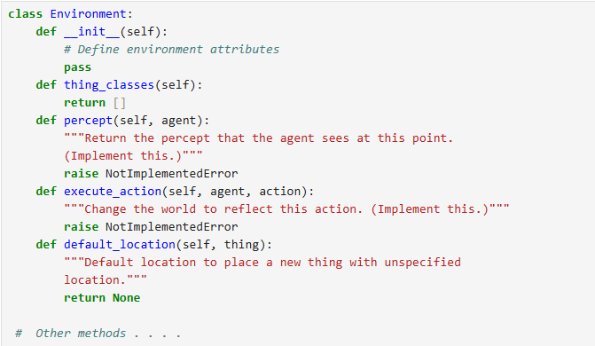

## Simple Reflex Agent

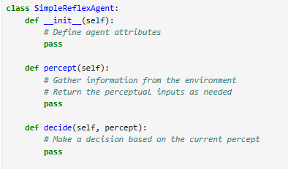Simple reflex agents make decisions based on the current percept only.

### A computer code with text Description automatically generatedExample

## Model Based Agent

Model-based reflex agents maintain an internal state to make decisions.

### 

### Example

# Coding Example

**Vacuum Cleaner:**

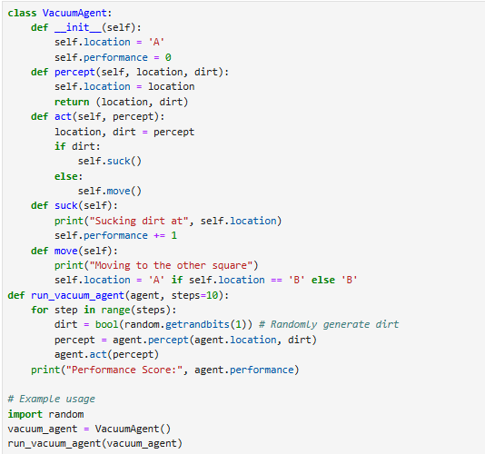

## A screenshot of a computer game Description automatically generatedOutput:

# Lab Tasks

## Task 1: Implementing a Basic Agent Framework

Design a basic agent that interacts with a simple environment.

* Create an **Environment** class that represents a basic world and randomly place Clean or Dirt in a grid.
* Create an **Agent** class that interacts with this environment.
* The agent should be able to perceive the environment and perform actions based on what it perceives.

## Task 2: Implementing a Simple Reflex Agent

Modify the agent to make decisions based only on the **current percept**.

* Implement a **Simple Reflex Agent** that reacts based on the current state of the environment.
* If the agent detects **dirt** in the environment, it should clean it.
* The agent does not remember past actions, only the present condition matters.

## Task 3: Implementing a Model-Based Reflex Agent

Modify the agent to **remember past states** and avoid unnecessary movements.

* The agent should **store an internal model** of the environment.
* It should remember which locations were cleaned to avoid redundant cleaning.
* The agent should navigate more efficiently compared to the Simple Reflex Agent.

## Task 4: Measuring Agent Performance

Track the agent’s efficiency in performing its task.

* Count the number of steps taken by the agent to clean the environment.
* Calculate the **performance score** based on the following criteria**:**
* **Efficiency Score = (Total Dirt Cleaned / Total Steps Taken) × 100**
* Lower Steps Taken = Better Efficiency
* Fewer Unnecessary Moves = Higher Score
* Compare the performance of the **Simple Reflex Agent** and **Model-Based Reflex Agent**.