### Task 1_1

1) Log in to the system as root.

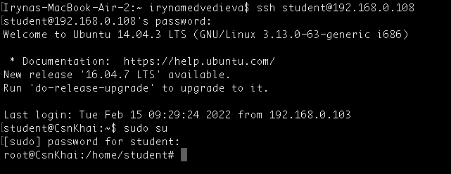

2) Use the passwd command to change the password. Examine the basic parameters of the command. What system file does it change *?

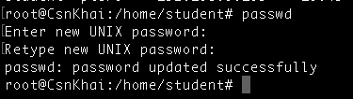

3) Determine the users registered in the system, as well as what commands they execute. What additional information can be gleaned from the command execution?

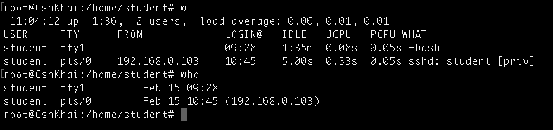

4) Change personal information about yourself.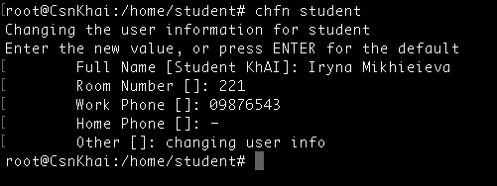

5) Become familiar with the Linux help system and the man and info commands. Get help on the previously discussed commands, define and describe any two keys for these commands. Give examples.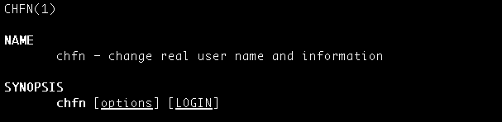

Ключ –f (whatis) ведёт поиск по заголовкам и возвращает все вхождения

6) Explore the more and less commands using the help system. View the contents of files .bash* using commands.

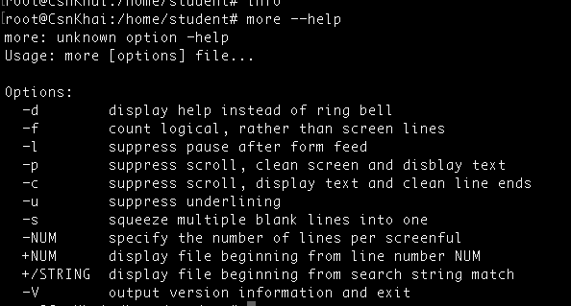

less –help command return much more info it is not convenient to attach a screenshot. It opens file as a file

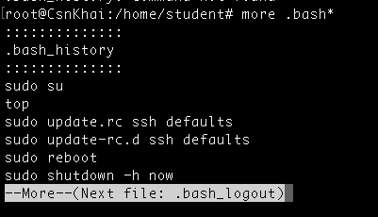

7) * Describe in plans that you are working on laboratory work 1. Tip: You should read the documentation for the finger command.

8) * List the contents of the home directory using the ls command, define its files and directories. Hint: Use the help system to familiarize yourself with the ls command.

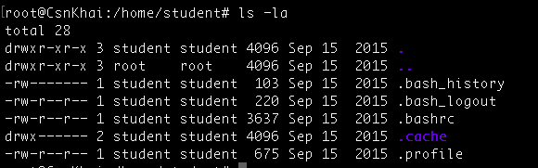



### Task 1_2

* 1) Examine the **tree** command. Master the technique of applying a template, for example, display all files that contain a character **c**, or files that contain a specific sequence of characters. List subdirectories of the root directory up to and including the second nesting level.
* 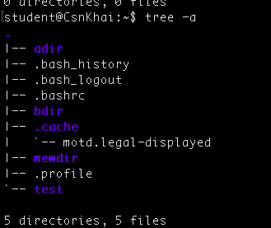

2) What command can be used to determine the type of file (for example, text or binary)? Give an example.

**file**  **~/* -** to determine the type of files stored in the home directory.

**file**  **file_name* -** to determine the type of file.

3) Master the skills of navigating the file system using relative and absolute paths. How can you go back to your home directory from anywhere in the filesystem?

$ cd ~ or cd $HOME

4) Become familiar with the various options for the **ls** command. Give examples of listing directories using different keys. Explain the information displayed on terminal using -l -a  
 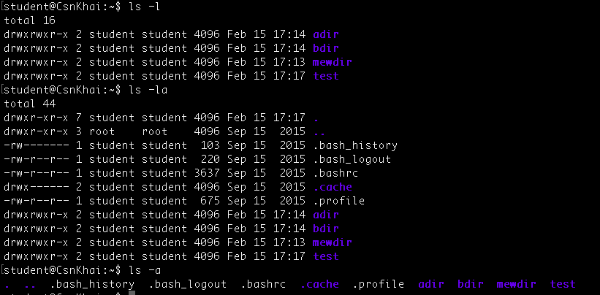

5) Perform the following sequence of operations:  
 - create a subdirectory in the home directory;  
 - in this subdirectory create a file containing information about directories located in the root directory (using I/O redirection operations);  
 - view the created file;  
 - copy the created file to your home directory using relative and absolute addressing.  
 - delete the previously created subdirectory with the file requesting removal; - delete the file copied to the home directory.

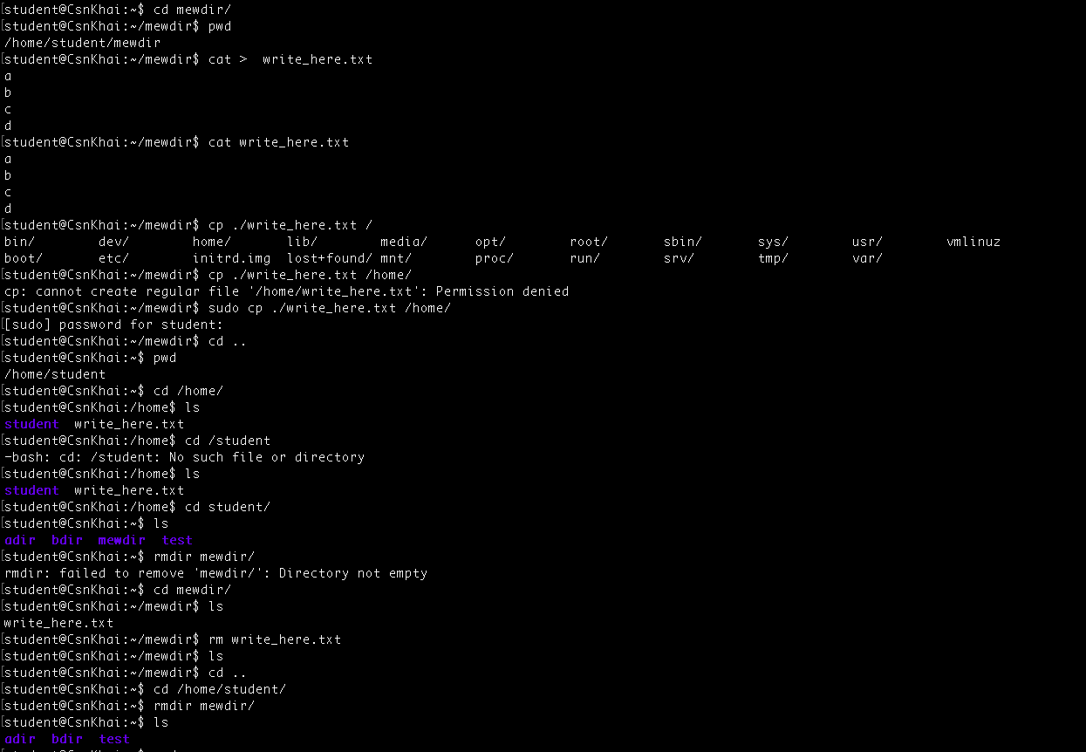

6) Perform the following sequence of operations:  
 - create a subdirectory **test** in the home directory;  
 - copy the **.bash_history** file to this directory while changing its name to **labwork2**;

- create a hard and soft link to the **labwork2** file in the test subdirectory; - how to define soft and hard link, what do these concepts;

- change the data by opening a symbolic link. What changes will happen and why

- rename the hard link file to **hard_lnk_labwork2**;

- rename the soft link file to **symb_lnk_labwork2 file**;

- then delete the **labwork2**. What changes have occurred and why?

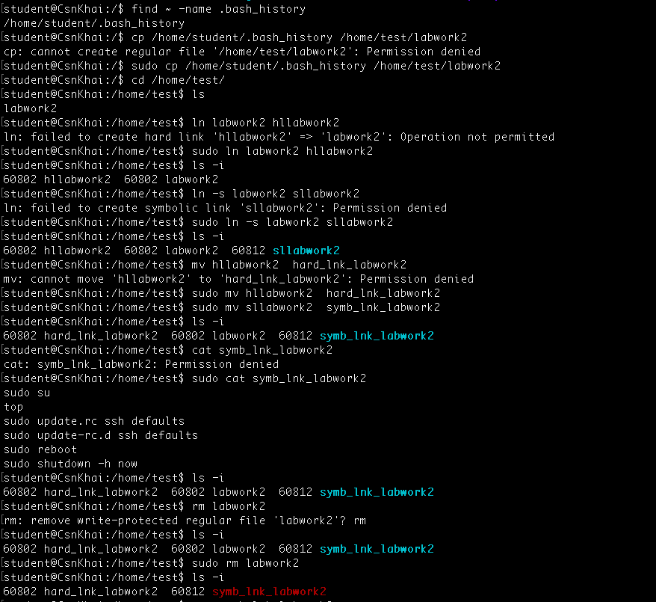

7) Using the locate utility, find all files that contain the squid and traceroute sequence.

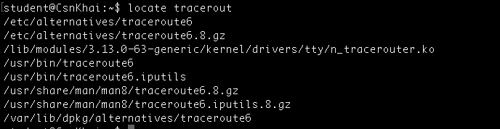  
   
8) Determine which partitions are mounted in the system, as well as the types of these partitions.

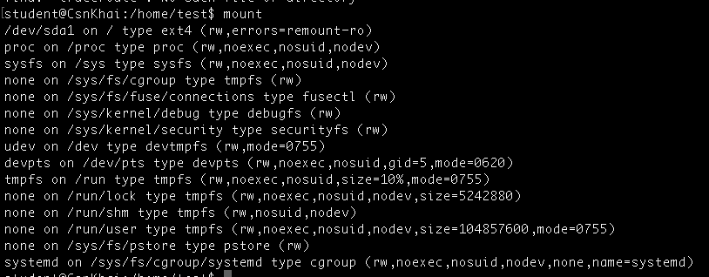

9) Count the number of lines containing a given sequence of characters in a given file.   
 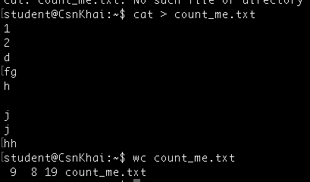

10) Using the **find** command, find all files in the /etc directory containing the **host** character sequence.

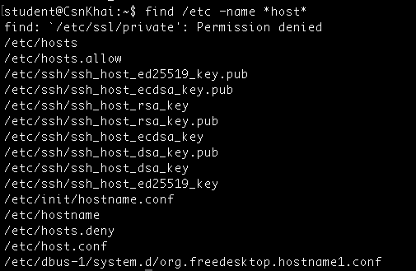

11) List all objects in /etc that contain the ss character sequence. How can I duplicate a similar command using a bunch of **grep**?

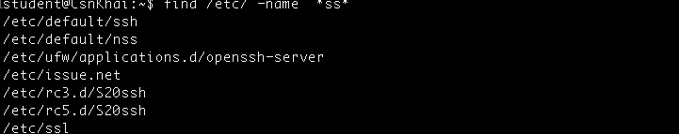

12) Organize a screen-by-screen print of the contents of the /etc directory. Hint: You must use stream redirection operations.

I have used ls -la /etc > etc_output.txt and then use less command to open the file

13) What are the types of devices and how to determine the type of device? Give examples.

Is it possible to use lsblk, which shows information about available block devices. This command can read information of a block device whether or not it is mounted. When run with -f option, it shows the filesystem type of every mounted or unmounted block device.

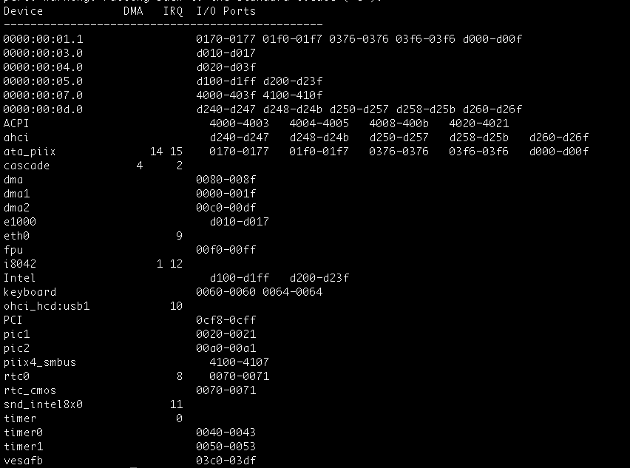

14) How to determine the type of file in the system, what types of files are there?

Using file command we can determine type

| Ordinary/Regular files | Readable files  Binary files  Image files  Compressed files and so on. |
| --- | --- |
| Special files | block files  character files  symbolic links  pipes  sockets |
| Directories |  |

15) * List the first 5 directory files that were recently accessed in the **/etc** directory.

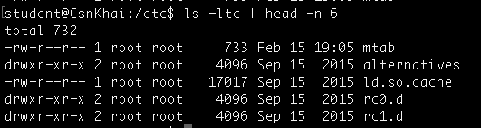

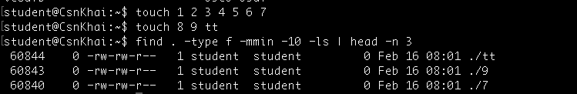

### Task 2

1) Analyze the structure of the **/etc/passwd** and **/etc/group** file, what fields are present in it, what users exist on the system? Specify several pseudo-users, how to define them?   
 Done

2) What are the uid ranges? What is UID? How to define it?   
 UID(user identifier) range is max 32 symbols. To define it id (-u) command is used

3) What is GID? How to define it?

GID ( group identifier), to define it id -g is used

4) How to determine the belonging of a user to a specific group?



5) What are the commands for adding a user to the system? What are the basic parameters required to create a user?

* 2 commands that allow to add user to the system useradd and adduder
* The basic parametrs to create a user - user name and password ( or if you use useradd the parameters in /etc/default/useradd

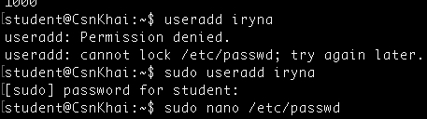 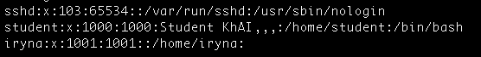

6) How do I change the name (account name) of an existing user?

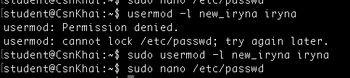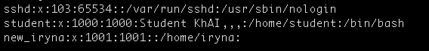

7) What is skell_dir? What is its structure?

Done

8) How to remove a user from the system (including his mailbox)?

To check what is going to be deleted - vi /etc/deluser.conf

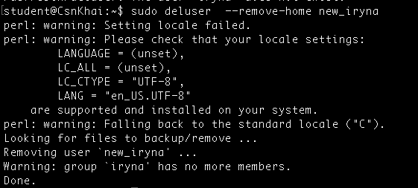

9) What commands and keys should be used to lock and unlock a user account?

To lock a user - passwd -l user_name, usermod -L user_name

To look a user status - passwd -S user_name

To unlock a user - passwd -u user_name, usermod -U user_name

10) How to remove a user's password and provide him with a password-free login for subsequent password change?

To enable its NOPASSWD option. Otherwise, sudo will ask for a password even when you don't have one, and won't accept an empty password.

To do so, open the sudoers configuration file with sudo visudo, and add the following line to the file, replacing iryna with your username:

iryna ALL=(ALL) NOPASSWD:ALL

sudo passwd -d `user_name`

11) Display the extended format of information about the directory, tell abouе the information columns displayed on the terminal.

ls -l –author

After the permissions are set, **ls** displays the following (using the preceding example), in order:

* The number of links to the file.
* The name of the owner of the file or directory.
* The name of the group that owns the file or directory.
* The size of the file, expressed in bytes. For character special files, it displays the major and minor device types.
* For a file, the date and time the file was last changed. For a directory or symlink, when it was created. The **-c** and **-u** options can change which time value is used. If the date is more than 6 months old or if the date is in the future, the year is shown instead of the time.
* The name of the file or directory.

12) What access rights exist and for whom (i. e., describe the main roles)? Briefly describe the acronym for access rights.

Main Roles - Viewer, Editor, Corrector, Admin, User

**r -** Permission to read the file.

**w -** Permission to write on the file.

**x -** Permission to execute the file.

13) What is the sequence of defining the relationship between the file and the user?

* Determining effective user id
* Determining group membership
* Determining file ownership
* Change permission if needed

14) What commands are used to change the owner of a file (directory), as well as the mode of access to the file? Give examples, demonstrate on the terminal.

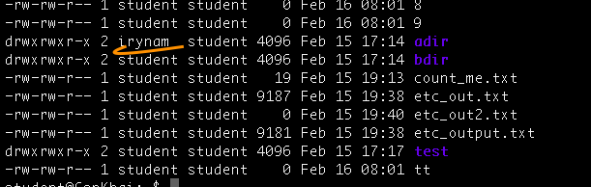

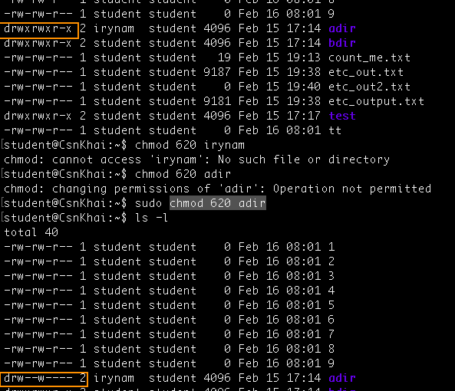

15) What is an example of octal representation of access rights? Describe the umask command.

3 (1+2) – able to execute and write

6 (2+4) – able to write and read

To see the octal permission - stat -f "%OLp" /etc/passwd

Unmask command used to change the access right, for ex:

umask 027 returns rwxr-x—

16) Give definitions of sticky bits and mechanism of identifier substitution. Give an example of files and directories with these attributes.

Done

17) What file attributes should be present in the command script?

script [options] [file]

**Example 1:** To start a typescript without any argument. If no filename is given as argument, *script* will automatically create a file namely *typescript* in the home directory to save the recorded information.

In order to stop the typescript, we just need to execute the exitcommand and the script will stop the capturing process. Since there’s no filename given as argument, the script will automatically create a file namely *typescript* in the home directory to save the recorded information.

### Task 3

1. How many states could have a process in Linux?

* Created
* Ready
* Running
* Waiting
* Terminated

2. Examine the pstree command. Make output (highlight) the chain (ancestors) of the current process.

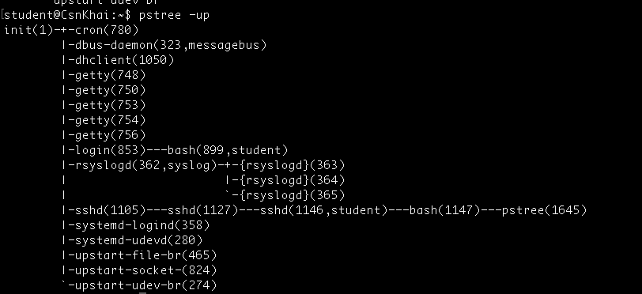

3. What is a proc file system?

Done

4. Print information about the processor (its type, supported technologies, etc.).

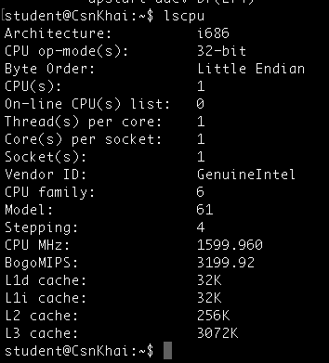

5. Use the ps command to get information about the process. The information should be as follows: the owner of the process, the arguments with which the process was launched for execution, the group owner of this process, etc.

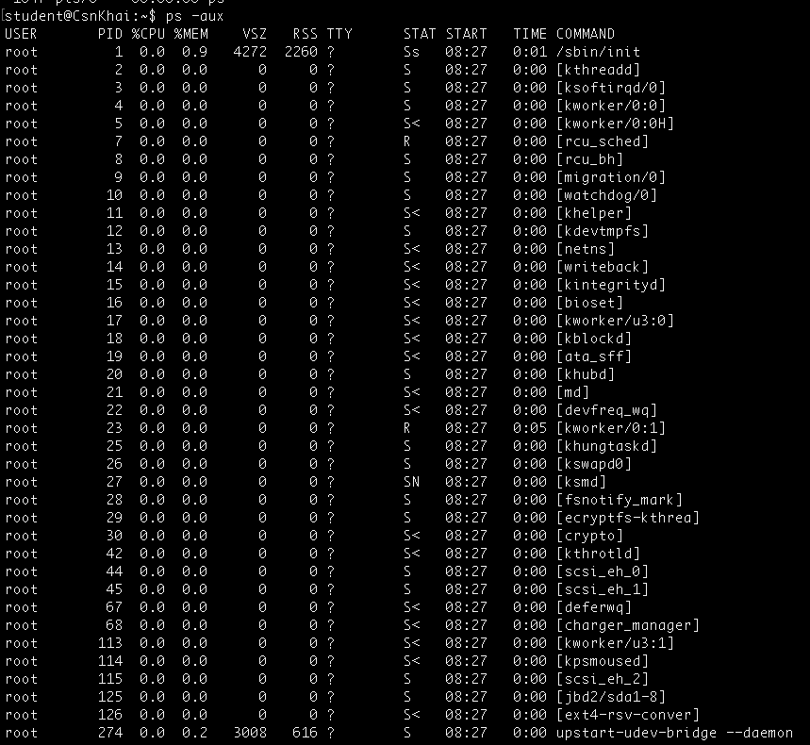

6. How to define kernel processes and user processes?

The kernel processes because they have a name that is between square brackets. As an administrator, it is important to know that kernel threads cannot be managed.

7. Print the list of processes to the terminal. Briefly describe the statuses of the processes.

What condition are they in, or can they be arriving in?

Done

8. Display only the processes of a specific user.

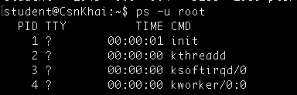

9. What utilities can be used to analyze existing running tasks (by analyzing the help for the ps command)?

vmstat, iostat, netstat, ifstat, dstat

10. What information does the top command display?

The top program provides a dynamic real-time view of a running system.

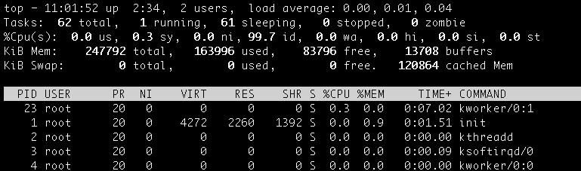

11. Display the processes of the specific user using the top command.

top -u student

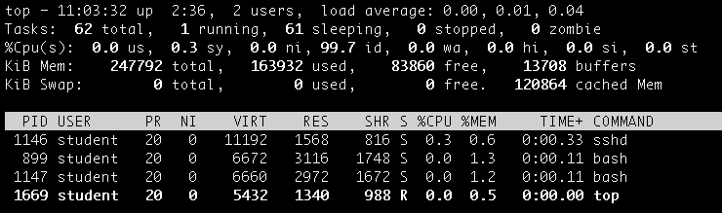

12. What interactive commands can be used to control the top command? Give a couple of examples.

*key* *equivalent-keys*

Left alt + **h**

Down alt + **j**

Up alt + **k**

Right alt + **l**

Home alt + ctrl + **h**

PgDn alt + ctrl + **j**

PgUp alt + ctrl + **k**

End alt + ctrl + **l**

13. Sort the contents of the processes window using various parameters (for example, the

amount of processor time taken up, etc.)

Done

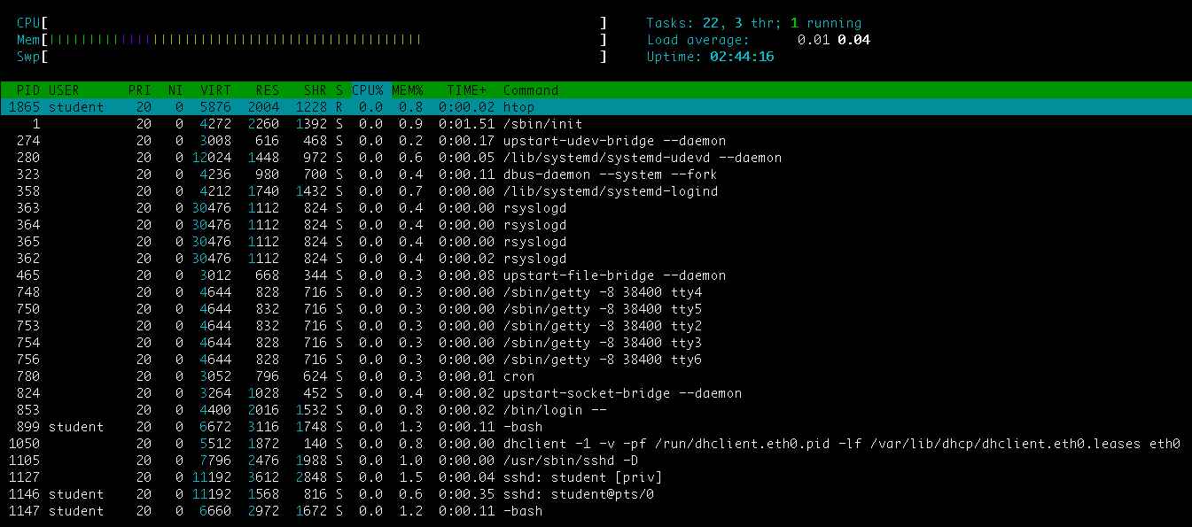

14. Concept of priority, what commands are used to set priority?

Use ***nice*** if you want to start a process with an adjusted priority. Use ***renice*** to change the priority for a currently active process.

15. Can I change the priority of a process using the top command? If so, how?

Once given top command, press r. Give a PID value of the process you want to change the process value. Give renice value (from -20 to +19)

Nice value of -20 means highest priority value and +19 means lowest priority value. 0 is by default value.

16. Examine the kill command. How to send with the kill command

process control signal? Give an example of commonly used signals.

* The signal SIGTERM (15) is used to ask a process to stop.
* The signal SIGKILL (9) is used to force a process to stop.
* The SIGHUP (1) signal is used to hang up a process.

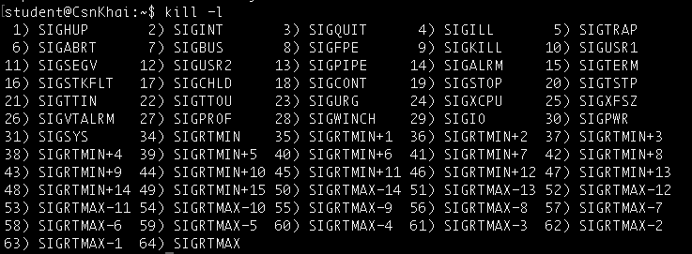

for ex. ***kill -9*** <PID>

17. Commands jobs, fg, bg, nohup. What are they for? Use the sleep, yes command to demonstrate the process control mechanism with fg, bg.

Running command become a job. ( To see it command jobs can be used)

To switch between jobs → fg (shows background job to shell)

To send performed job to background use bg

### 