## Task 1 - IP Routing

Interfaces set up on VM! and VM2

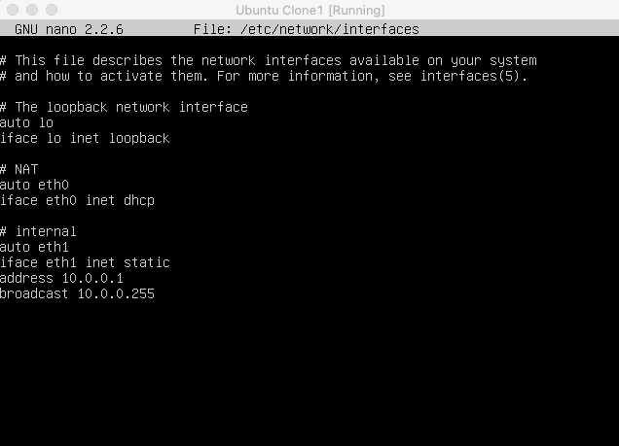

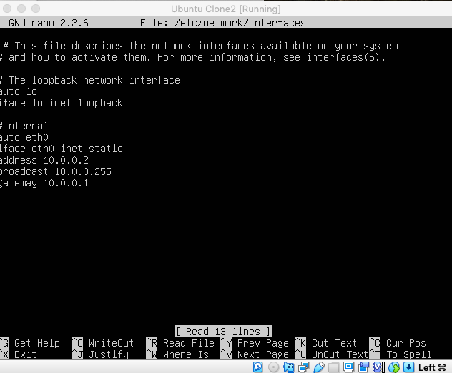

Routing to 8.8.8.8

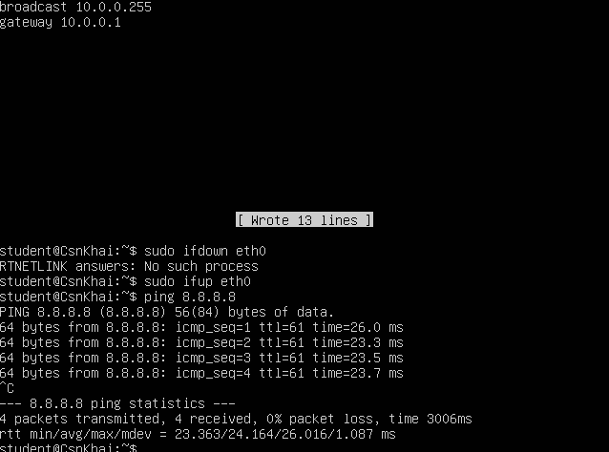

IP address 8.8.8.8 is belong to Google.com

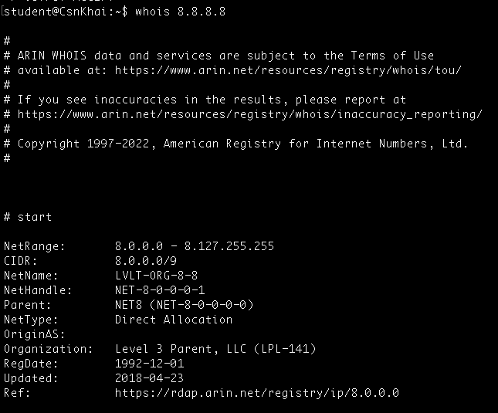

To get IP address of a resource we may use wget, traceroute

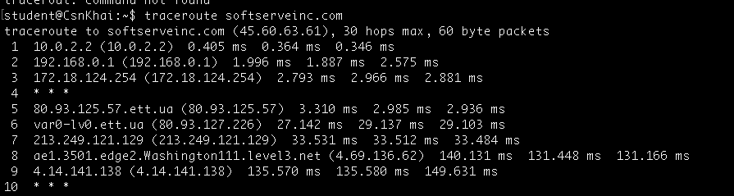

Route table for VM2:

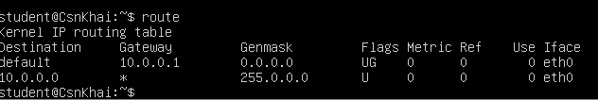

Traceroute to google.com

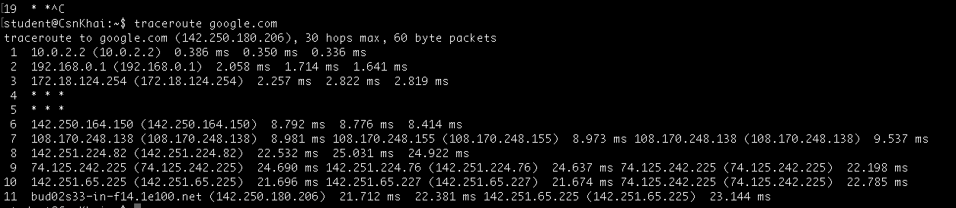

## Task 2 - Configuring DHCP, DNS servers and dynamic routing using OSPF protocol

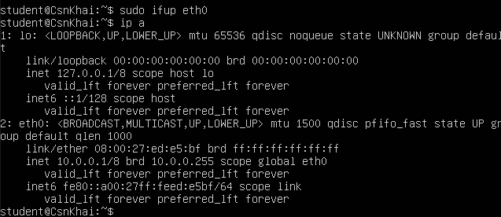

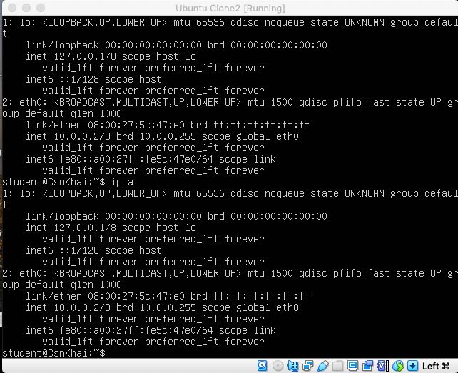

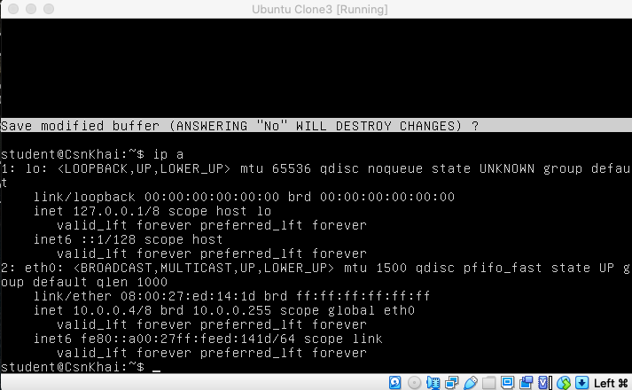

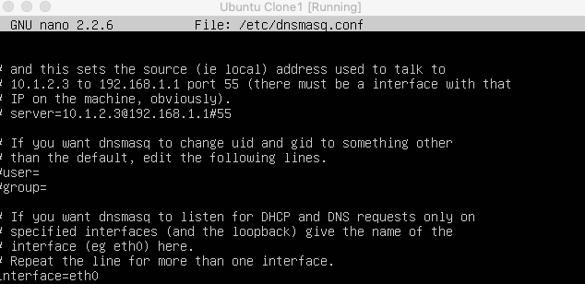

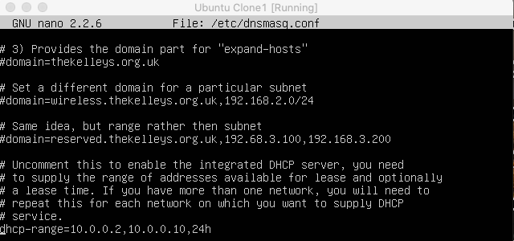

Ubuntu Clone1 and Ubuntu Clone2 obtained IP addresses from the DHCP server that was set in dhcp-range