Results for subjects 3 and 4 (A and B)

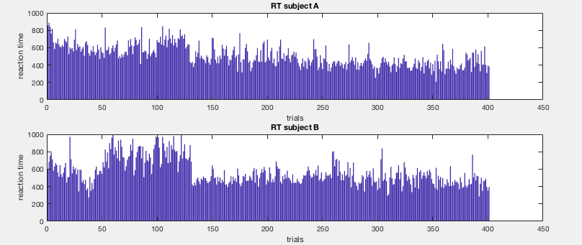

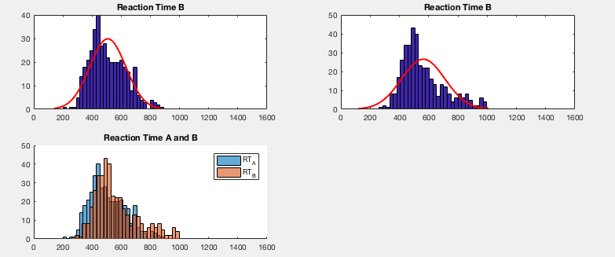

the reaction times differ:

ttest2

h = 1

p = 1.3161e-08

ci =

-74.2072

-36.4048

stats = tstat: -5.7437

df: 800

sd: 136.3456

for ttest

hi = 1

pi = 8.6623e-14

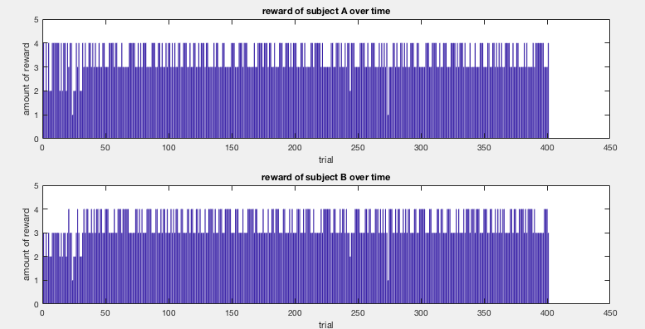

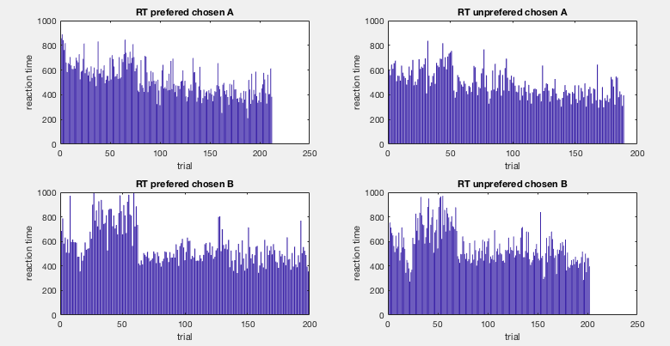

1. Sign. Difference between RT for preferred/ unpreferred targets in subject A

h = 1

p = 0.0124

1. No Sign. Difference between RT for preferred/unpreferred targets in subject B

h = 0

p = 0.8690

1. Sign diff. between RT for up/down preferred targets in subjects A

h = 1

p =8.4127e-06

1. no sign diff between RT for up/down unpreferred targets in subject A

h =0

p = 0.1972

1. no sign diff between RT for up/down preferred target in subject B

h = 0

p =0.2350

1. no sign diff between RT for up/down unpreferred target in subject B

h =0

p = 0.3003

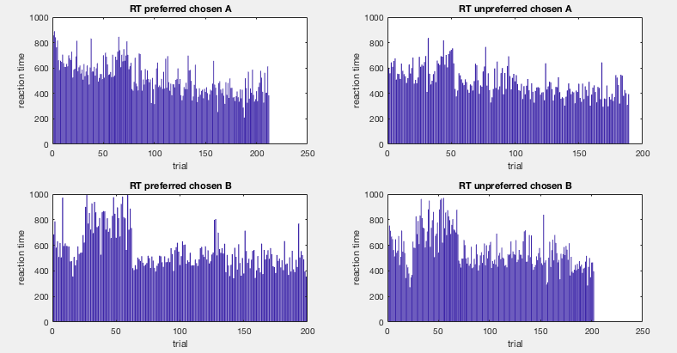

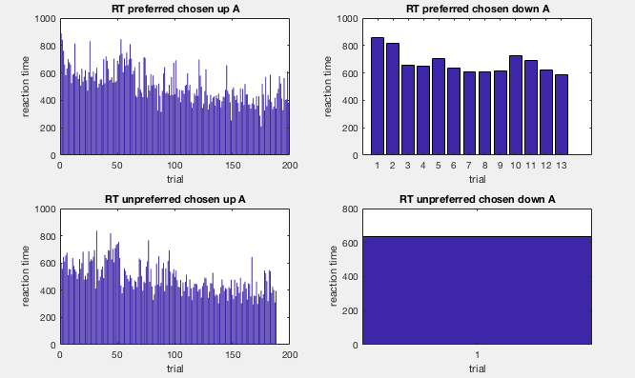

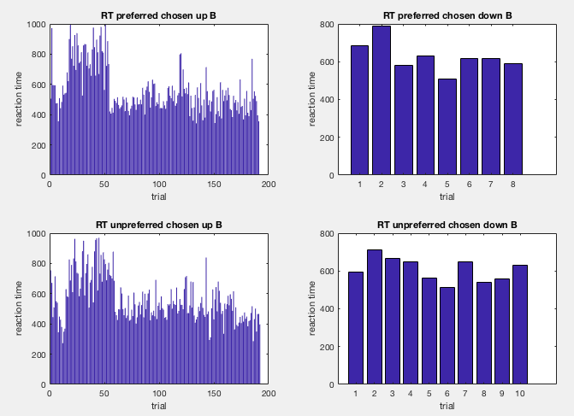

These are the data for anova for subjects 1 and 2

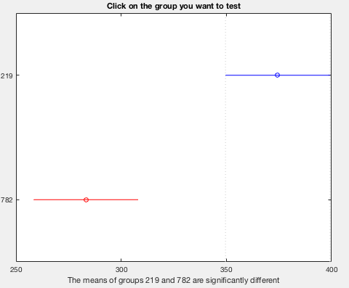

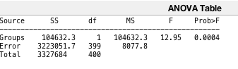

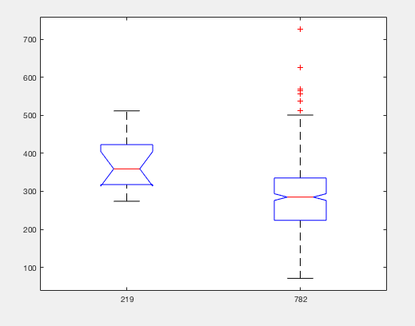

these data shows that there was a sign difference between RT for subject 1 depending on the position of the target, with lower RT for the pos 782 and higher RT for the position 219 (which is below).

It means that the subject was faster to move hand to the upper target from the middle of the screen than to the lower target. ( maybe subjective thought that it is easier to move to the buttom, they were slower than to move to the upper, because they tried to move faster knowing that it is more difficult).

Results for the subject B

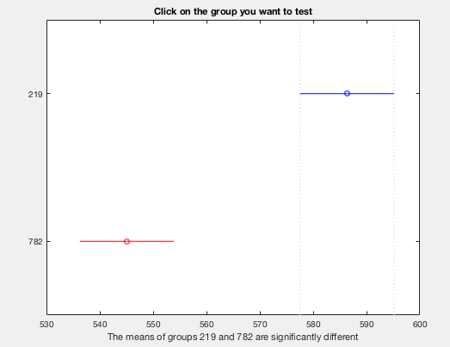

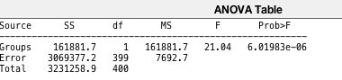

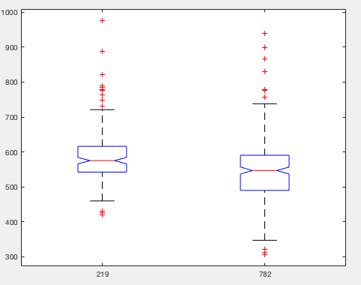

results of anova for subject 1 RT depending on the choice of preferred/unpreferred target

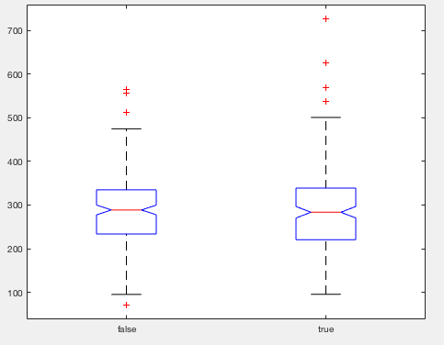

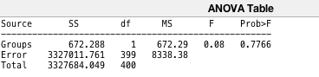

for subject 1 there is no sign difference between RT for chosen/unchosen target.

Results for subject 2:

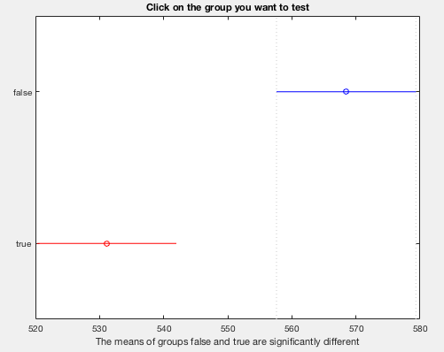

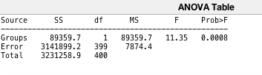

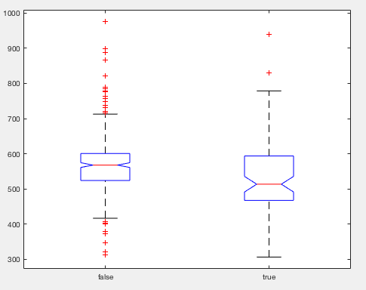

there is a sign diff for subject 2 , RT for preferred position are sign lower. , which shows faster choice of the preferred target.

Results for interaction effect for subject A

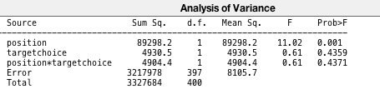

Results for interaction effect for subject B

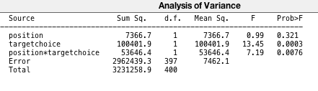

so the interaction effect is sign,

how subjects A and B decided which target to choose:

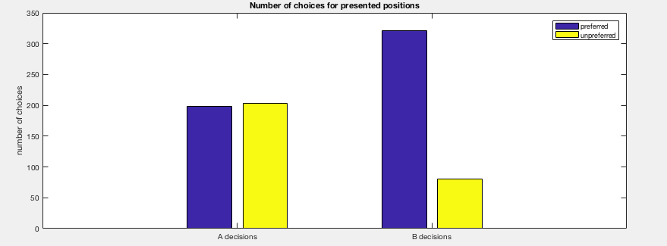

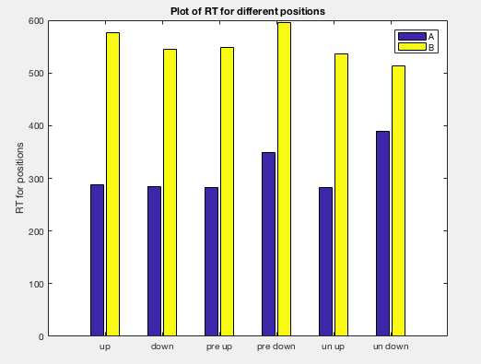

mean RT for up/down for subjects 1 and 2

RT over time for all subjects:

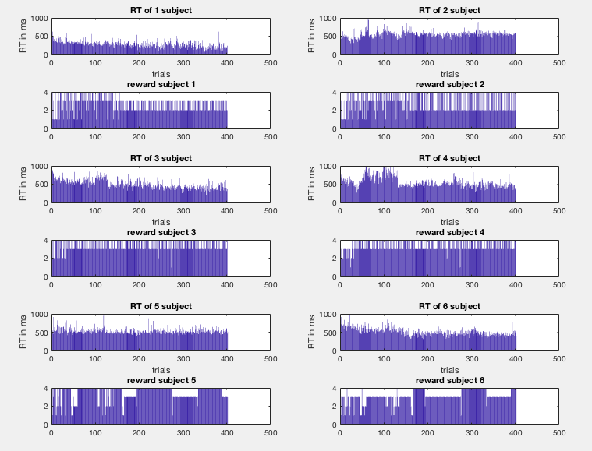

for subject 7-10

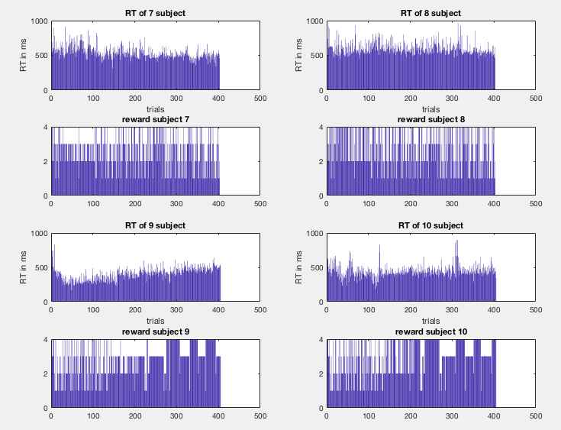

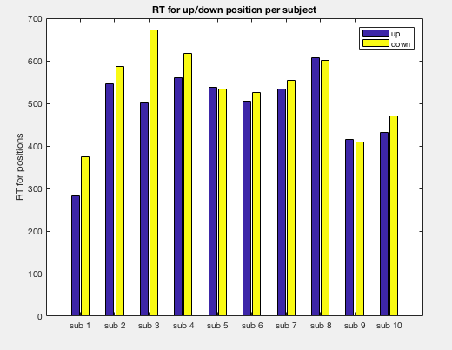

sign diff between RT for up/down (for all subjects)

h = 1

p =2.2838e-16

ci = -45.0178 -27.7149

stats =

struct with fields:

tstat: -8.2411

df: 4022

sd: 133.4849

sign diff between RT for preferred/unpreferred (for all subjects)

h =1

p = 7.0642e-08

ci = 14.6411 31.3343

stats = struct with fields:

tstat: 5.3996

df: 4022

sd: 134.1220

[h,p,ci,stats] = ttest2(RT_up_preferred_all,RT_down_preferred_all)

%h =1

%p =1.0268e-10

%ci = 26.8263 50.0376

%stats = struct with fields:tstat: 6.4939 df: 2243 sd: 135.0186

anova for diff. in RT depending on the position (up / down)

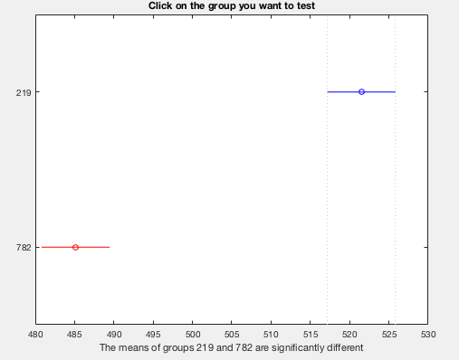

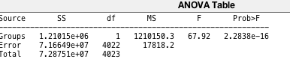

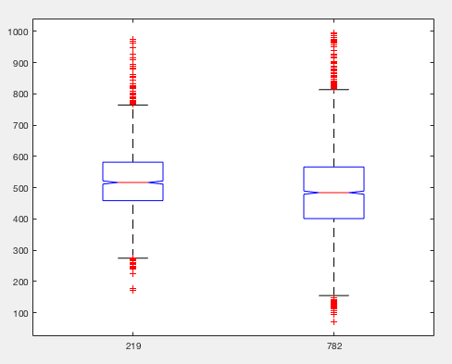

it means that RT for down are significantly lower than for up. (782 lower than for 219).

Anova for RT diff for preferred/not preferred chosen:

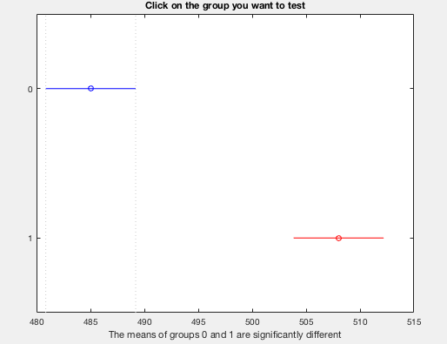

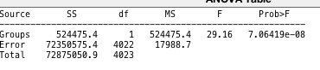

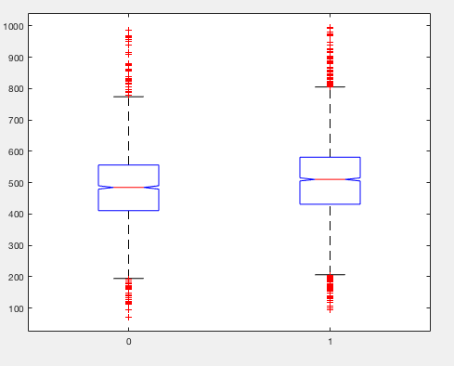

1 is preferred chosen, 0 is not preferred chosen. So for preferred chosen RT are slightly higher.

Anovan for position* target choice(preferred)

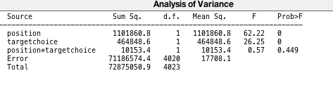

there is no sign interaction effect like my preferred choice and lower position – I am faster. It is not the case.

