Reproducible Research: Peer Assessment 1

Nazri Othman

September 14, 2015

# **Prepare the R environment**

Throughout this report when writing code chunks in the R markdown document, always use echo = TRUE so that someone else will be able to read the code.

Set the working directory accordingly then set echo equal to TRUE and results equal a 'hide' as global options for this document.

setwd("~/")  
setwd("../RepData_PeerAssessment1")  
library(knitr)  
opts_chunk$set(echo = TRUE, warning = FALSE)

# **Loading and Preprocessing the Data**

# Clear the workspace  
rm(list=ls())  
  
# Load the necessary library  
library(ggplot2)  
  
# Unzip the activity dataset  
if(!file.exists('activity.csv')){  
 unzip('activity.zip')  
}  
  
# Load the activity dataset  
activityData <- read.csv('activity.csv', stringsAsFactors=FALSE)  
  
# Transform the date attribute to an actual date format  
activityData$date <- as.Date(activityData$date, format="%Y-%m-%d")  
  
# Check the data structure  
str(activityData)

## 'data.frame': 17568 obs. of 3 variables:  
## $ steps : int NA NA NA NA NA NA NA NA NA NA ...  
## $ date : Date, format: "2012-10-01" "2012-10-01" ...  
## $ interval: int 0 5 10 15 20 25 30 35 40 45 ...

## **What is mean total number of steps taken per day?**

### *1. Compute total number of steps taken per day (NA values removed)*

stepsPerDay <- aggregate(activityData$steps, list(date=activityData$date), sum, na.rm=TRUE)  
names(stepsPerDay)[2] <- "steps"  
  
# Check the dataset  
head(stepsPerDay)

## date steps  
## 1 2012-10-01 0  
## 2 2012-10-02 126  
## 3 2012-10-03 11352  
## 4 2012-10-04 12116  
## 5 2012-10-05 13294  
## 6 2012-10-06 15420

### *2. Plot a histogram of total number of steps taken per day*

ggplot(data=stepsPerDay, aes(stepsPerDay$steps)) + geom_histogram(aes(fill=..count..), binwidth = 1000) + labs(title = "Histogram of Steps Taken per Day", x = "Number of Steps Taken per Day", y = "Frequency") + theme_bw()

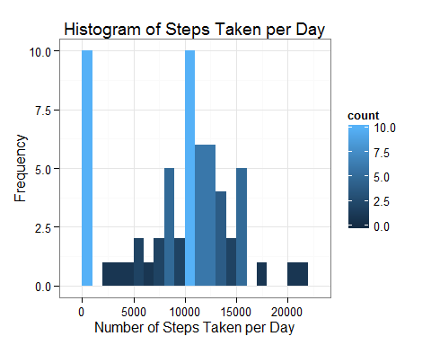

### *3. Calculate and report the mean and median for total number of steps taken per day*

stepsPerDayMean <- mean(stepsPerDay$steps)  
stepsPerDayMedian <- median(stepsPerDay$steps)

* The **Mean** = 9354
* The **Median** = 10395

# **What is the average daily activity pattern?**

### *1. Compute number of steps by intervals of 5-minutes*

stepsMeanPerInterval <- aggregate(activityData$steps, list(interval=activityData$interval), mean, na.rm=TRUE)  
names(stepsMeanPerInterval)[2] <- "stepsmean"  
  
# Check the dataset  
head(stepsMeanPerInterval)

## interval stepsmean  
## 1 0 1.7169811  
## 2 5 0.3396226  
## 3 10 0.1320755  
## 4 15 0.1509434  
## 5 20 0.0754717  
## 6 25 2.0943396

### *2. Plot the time series of the average number of steps taken (averaged across all days) versus the 5-minute intervals*

ggplot(stepsMeanPerInterval, aes(x=interval, y=stepsmean)) + geom_line(color="blue") + labs(title="Average Daily Activity Pattern", x="5-Minute Intervals", y="Mean Number of Steps") + theme_bw()

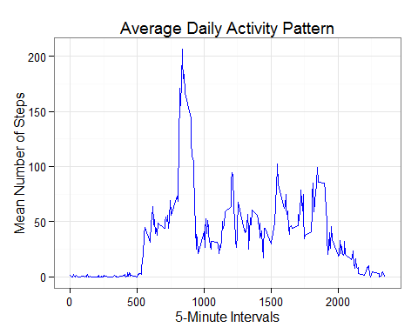

### *3. Calculate the 5-minute interval with the containing the maximum number of steps*

maxStepsInterval <- stepsMeanPerInterval[which.max(stepsMeanPerInterval$stepsmean),]

The max steps is **206** at the **835**th interval.

## **Imputing missing values**

### *1. Total number of missing values*

missingValue <- as.numeric(sum(is.na(activityData$steps)))

The total number of missing values are **2304**.

### *2. Strategy for filling in all of the missing values in the dataset*

# merge activity dataset with steps mean dataset by interval  
activityData <- merge(activityData, stepsMeanPerInterval, by="interval")  
  
# fill in missing value (NA) with a value of steps mean per interval   
for (i in 1:17568) {  
   
 if(is.na(activityData$steps[i])){  
   
 activityData$steps[i] <- activityData$stepsmean[i]}  
   
 }  
  
# Check whether there are still NA   
summary(activityData)

## interval steps date stepsmean   
## Min. : 0.0 Min. : 0.00 Min. :2012-10-01 Min. : 0.000   
## 1st Qu.: 588.8 1st Qu.: 0.00 1st Qu.:2012-10-16 1st Qu.: 2.486   
## Median :1177.5 Median : 0.00 Median :2012-10-31 Median : 34.113   
## Mean :1177.5 Mean : 37.38 Mean :2012-10-31 Mean : 37.383   
## 3rd Qu.:1766.2 3rd Qu.: 27.00 3rd Qu.:2012-11-15 3rd Qu.: 52.835   
## Max. :2355.0 Max. :806.00 Max. :2012-11-30 Max. :206.170

### *3. Compute total number of steps taken per day (NA values replaced with Steps Mean per interval)*

stepsPerDay <- aggregate(activityData$steps, list(date=activityData$date), sum)  
names(stepsPerDay)[2] <- "steps"  
  
# Check the dataset  
head(stepsPerDay)

## date steps  
## 1 2012-10-01 10766.19  
## 2 2012-10-02 126.00  
## 3 2012-10-03 11352.00  
## 4 2012-10-04 12116.00  
## 5 2012-10-05 13294.00  
## 6 2012-10-06 15420.00

### *4. Plot a histogram of total number of steps taken per day*

ggplot(data=stepsPerDay, aes(stepsPerDay$steps)) + geom_histogram(aes(fill=..count..), binwidth = 1000) + labs(title = "Histogram of Steps Taken per Day\n (with replaced NA value)", x = "Number of Steps Taken per Day", y = "Frequency") + theme_bw()

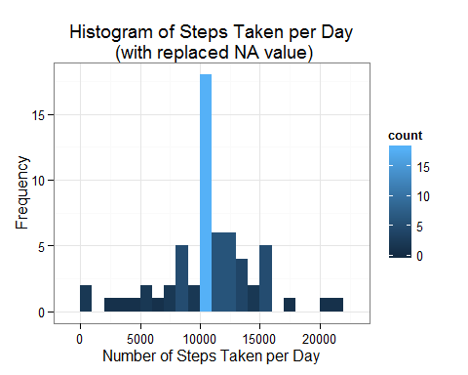

Compute the mean and median

stepsPerDayMean <- mean(stepsPerDay$steps)  
stepsPerDayMedian <- median(stepsPerDay$steps)

The strategy filling in NA value with steps mean per interval gives a mean and median of **10766** and **10766** respectively.

These values differ from the first part of the assignment. The impact of imputing the missing values is to have similar mean and median value.

## **Are there differences in activity patterns between weekdays and weekends?**

### *1. Compute the weekday and weekend*

# Compute the weekdays from the date attribute  
activityData$weekday <- weekdays(activityData$date)  
  
# Compute the day type (weekend or weekday)  
activityData$daytype <- ifelse(activityData$weekday == "Saturday" | activityData$weekday == "Sunday", "weekend", "weekday")  
  
# Check the dataset  
head(activityData)

## interval steps date stepsmean weekday daytype  
## 1 0 1.716981 2012-10-01 1.716981 Monday weekday  
## 2 0 0.000000 2012-11-23 1.716981 Friday weekday  
## 3 0 0.000000 2012-10-28 1.716981 Sunday weekend  
## 4 0 0.000000 2012-11-06 1.716981 Tuesday weekday  
## 5 0 0.000000 2012-11-24 1.716981 Saturday weekend  
## 6 0 0.000000 2012-11-15 1.716981 Thursday weekday

### *2. Compute number of steps by intervals of 5-minutes*

stepsMeanPerInterval <- aggregate(activityData$steps, list(interval=activityData$interval, daytype=activityData$daytype), mean)  
names(stepsMeanPerInterval)[3] <- "stepsmean"  
  
# Check the dataset  
head(stepsMeanPerInterval)

## interval daytype stepsmean  
## 1 0 weekday 2.25115304  
## 2 5 weekday 0.44528302  
## 3 10 weekday 0.17316562  
## 4 15 weekday 0.19790356  
## 5 20 weekday 0.09895178  
## 6 25 weekday 1.59035639

### *3. Plot the time series of the average number of steps taken (averaged across all days) versus the 5-minute intervals*

ggplot(stepsMeanPerInterval, aes(x=interval, y=stepsmean)) + geom_line(color="blue") + labs(title="Average Daily Activity Pattern\n (with replaced NA value)", x="5-Minute Intervals", y="Mean Number of Steps") + facet_wrap(~daytype, ncol=1) + theme_bw()

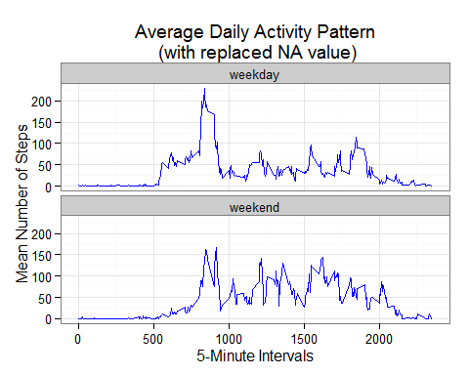

The steps taken during the weekend is slightly higher than weekday but both weekday and weekend activity start and finish more or less at similar time.