4.3 Server Load Testing and Database Concurrency Evaluation

4.3.1 Purpose and Goals of the Test
The Strategic Performance Management System (SPMS) is busiest near evaluation deadlines, when many employees and supervisors are online at the same time, opening, editing and saving their performance documents. A load test was therefore carried out to check the system’s non-functional requirement for performance efficiency under peak loads (NFR-01): how many people SPMS can serve at the same time, and where its limits are.
SPMS stores all of its data in SQLite, a database kept in a single file on the server and built into the application, rather than run as a separate database server. In SQLite’s default setup, called rollback journal mode, a save locks the whole file for a moment. If no waiting time is set, any other read or save that arrives during that moment fails at once with a “database is locked” error. Two settings were changed to prevent this: write-ahead logging (WAL) mode, in which a save is first written to a separate log file so that other users can keep reading while it is in progress; and a 5-second busy timeout, under which a request that finds the database busy waits up to 5 seconds for its turn instead of failing at once. These two changes are referred to below as the fix.
The test was designed to answer three questions:
1. Capacity: How many users can SPMS serve at the same time while keeping response times within 1 second, and at what number does it break down?
2. Database reliability: Does the fix prevent “database is locked” errors when many users read and save at the same time?
3. Bottleneck: When SPMS slows down under heavy load, is the cause the database or the server’s processor?

4.3.2 Testing Environment and How the Test Was Performed
The test ran on a copy of SPMS, with the same code and settings as the live system and a snapshot of its database, on a cloud server. Table 20 lists the server and its software.
Table 20. Test Server Hardware and Software
Component | Specification
Processor (CPU) | ARM Neoverse-N1 with 3 cores, so it can work on 3 tasks at the same instant
Memory and storage | 22 GB RAM; 146 GB solid-state drive
Operating system | Ubuntu 22.04.5 LTS
Web server (receives each browser request) | nginx 1.31.1
Application (builds each page) | PHP 8.3.36 with the CodeIgniter 4.7.0 framework; up to 50 PHP workers, each handling one request at a time
Password check at login | bcrypt, using about 61 ms of processor time per login
Database | SQLite 3.53.4 in WAL mode, with a 5-second busy timeout
Load-testing tool (simulates the users) | k6 2.3.0
Note: k6 ran on the same server as SPMS and used about 0.1 to 0.2 of the 3 processor cores, so the capacity results are slightly conservative.
The users were simulated with k6, an open-source load-testing tool. Each simulated user logged in, then repeatedly opened the dashboard, opened their own performance document, saved it, opened the notifications page and saved again, pausing a random 2 to 5 seconds (3.5 seconds on average) after each action.
Users were added in nine steps: 25, 50, 100, 200, 300, 400, 500, 750 and 1,000. The run before the fix used smaller steps (25, 50, 75, 100 and 150 users) and stopped itself at 150 users. Each step began with a 30-second login rush, in which all of the step’s users logged in, followed by 60 seconds of continuous work. Logging in is the heaviest task for the processor, because the password check is deliberately slow to make stolen passwords hard to crack, so a login rush at every step is a worst case.
The resulting rate of requests was measured: the number of requests the server received in a step, divided by the number of users and by the 90-second length of the step. For example, the 25 users of the first step sent 734 requests, and 734 ÷ 25 ÷ 90 = 0.33 requests per second per user. This count includes logging in, which takes four requests per user, and automatic redirects: for example, an employee account that opens the dashboard is sent on to its own folder page, and the browser follows each redirect as a separate request. In the steps where the server was not yet busy (25 to 300 users), the rate stayed between 0.326 and 0.332, so 0.33 requests per second per user is used to convert user counts into requests asked for in Figures 1 and 3.
Response times are reported as 95th percentiles: the time within which 95 of every 100 requests finished. Unlike an average, this shows the slow requests that some users actually meet, while a few isolated delays cannot decide the result on their own. Each step’s times were taken over the whole step, login rush included, and again over its last 30 seconds, once everyone was logged in. The targets were a 95th-percentile time within 1 second for page loads and autosaves, the limit for keeping a user’s flow of thought uninterrupted (Nielsen, 1993), and fewer than 1% failed requests. Logins were not held to the 1-second target, because the password check is deliberately slow: 95% of logins took under 0.2 seconds up to 200 users, 0.67 seconds at 300 users and 1.8 seconds at 400 users. The test stopped itself at the step where 95% of pages took longer than 10 seconds, the limit for keeping a user’s attention, or more than 20% of requests failed. The test copy also recorded how long each request spent on database queries; this database time includes any wait for a free processor core while a query ran. The same test was run twice: before the fix, with SQLite’s default settings, and after it.

4.3.3 Summary of Key Results
• Capacity: SPMS stayed within the 1-second target up to 400 simultaneous users over the whole step, login rush included, and up to 500 users once everyone was logged in (the last 30 seconds of the step). It reached its breaking point at 1,000 users, where 95% of pages took more than 10 seconds.
• Reliability: None of the 60,336 requests failed after the fix. Before the fix, the same test failed requests from the first step (25 users) and reached 20% failed requests at 150 users, where it stopped itself.
• Bottleneck: The processor, not the database. The server handled at most about 142 requests per second, at 500 users with 92% of the processor in use, and from 750 users all 3 processor cores were fully used; the extra requests waited in line instead of failing, while database time stayed below 0.2 seconds.
• Database headroom: On its own, SQLite completed more than 9,000 saves per second, over 230 times the busiest rate SPMS needed during the test (39 saves per second).

4.3.4 Detailed Results and Visual Analysis
1. Failed requests before and after the fix. Figure 1 compares the two runs. Before the fix, requests failed from the first step, and the share of failures grew with every step until the test stopped itself at 150 users, after the server had logged 1,415 “database is locked” errors. After the fix, no request failed at any step up to 1,000 users.
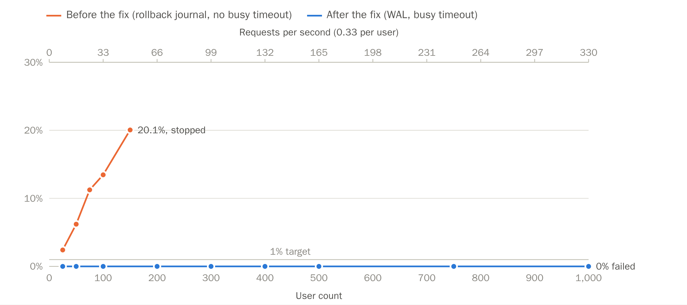
Figure 1. Failed requests before and after the fix. Share of requests that failed at each step of the two runs; the 1% line is the target. The top axis shows the requests per second the users asked for (0.33 per user).
2. Response time and processor use. Figure 2 plots how long page loads and autosaves took at each step, and how much of that time was spent in the database, with the processor use measured during each step along the top. Response times stayed low while the processor had spare capacity: up to 300 users, with at most 56% of the processor in use, 95% of page loads and autosaves finished within 0.2 seconds. As the processor filled up, response times rose quickly. At 400 users (75% processor use) the 1-second target still held for the whole step: 95% of pages loaded within 913 ms, including the login rush. At 500 users (92%) it held only once the rush was over: 95% of pages took 2.26 seconds over the whole step, but 384 ms in the last 30 seconds, after everyone had logged in. From 750 users all 3 cores were busy, and response times rose to several seconds. Database time stayed small throughout, at most 191 ms.
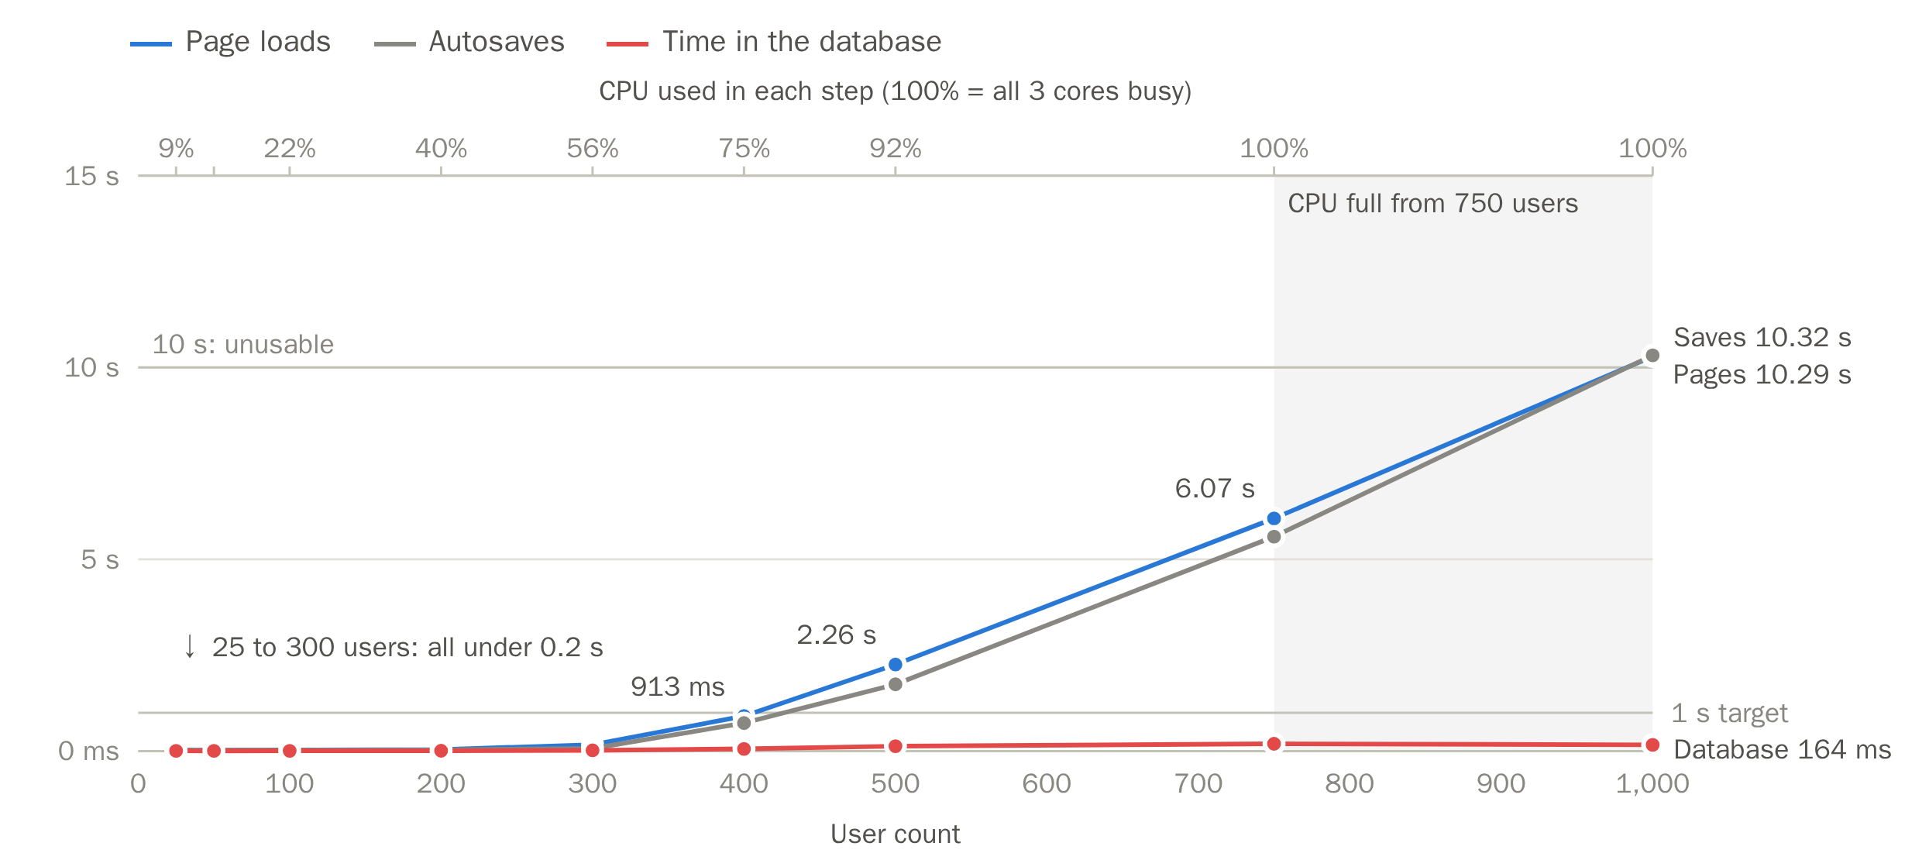
Figure 2. Response time and processor use at each step. 95th-percentile times of page loads, autosaves and the time those requests spent in the database over each whole step, login rush included. The top axis gives the processor (CPU) use measured during each step, and the shaded area marks the steps where all 3 cores were busy. Times stay low while the processor has spare capacity and climb steeply once it is full. The 1-second line is the target and the 10-second line the stopping point. Processor use includes the load-testing tool, about 0.1 to 0.2 cores.
3. Requests asked for and requests handled. Each simulated user asked for about 0.33 requests per second, so the number of requests asked for grew with the number of users (Figure 3). The server kept up until about 400 users. From 500 users it handled at most about 142 requests per second, the most its 3 processor cores could complete, and the remaining requests waited in line for a free PHP worker. At 750 users, about 315 requests were waiting at any moment; with about 135 handled per second, that is roughly 2.3 seconds of waiting per request, close to the measured median page time (the middle value) of 2.0 seconds. Repeating the test with 10, 50 and 100 PHP workers gave nearly the same results, about 142 to 147 requests per second at most and about 6 seconds for 95% of pages at 750 users, because all three were limited by the same fully used processor.
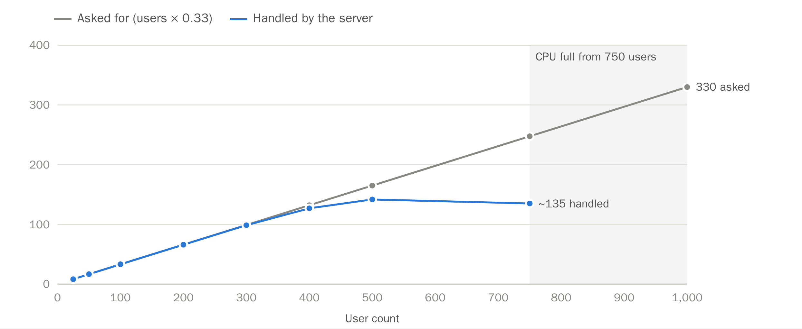
Figure 3. Requests asked for and requests handled per second. The server keeps up until its processor is full, then levels off while the rest of the requests wait in line. The 1,000-user step stopped early, so its handled rate is not shown.
4. Results at each step. Table 21 lists the measurements at every step after the fix.
Table 21. Load Test Results at Each Step (After the Fix)
Users | Requests handled per second | Page loads (95%) | Autosaves (95%) | Database time (95%) | Processor (CPU) used
25 | 8 | 26 ms | 25 ms | 6.4 ms | 9%
50 | 17 | 27 ms | 25 ms | 6.3 ms | 14%
100 | 33 | 31 ms | 27 ms | 7.7 ms | 22%
200 | 66 | 40 ms | 30 ms | 9.4 ms | 40%
300 | 99 | 169 ms | 71 ms | 20.4 ms | 56%
400 | 127 | 913 ms | 732 ms | 58.2 ms | 75%
500 | 142 | 2.26 s | 1.74 s | 129 ms | 92%
750 | 135 | 6.07 s | 5.59 s | 191 ms | 100%
1,000 | — | 10.29 s | 10.32 s | 164 ms | 100%
Note: Times are for the whole step, login rush included. No request failed at any step. Database time stayed under 10 ms between 25 and 200 users while the database handled eight times as many queries per second, and it rose later only as the processor filled up, even when the number of queries fell slightly, as between 500 and 750 users. The test stopped itself about 10 seconds into the 1,000-user step, so that step’s handled rate is not shown (—). Bold: the largest step within the 1-second target over the whole step. Once the rush was over (the last 30 seconds of each step), 95% of pages loaded within 90 ms at 400 users and 384 ms at 500 users, so 500 users also met the target then.
5. The database on its own. To test SQLite without building pages or checking passwords, separate programs read from and saved to a copy of the live database at the same time for 3 seconds: 10 readers, each repeatedly opening a document or a list of documents, and 2 writers, each repeatedly saving the largest document in the system (58 KB). With readers alone, both setups completed about 30,000 reads per second. Adding the two writers before the fix made most read attempts and nearly all save attempts fail, so only one save succeeded in 3 seconds. After the fix, reading continued at nearly the same speed while the writers completed 1,460 saves per second, with no failures (Table 22).
Table 22. Reading and Saving at the Same Time (10 Readers and 2 Writers, 3 Seconds)
Database setup | Reads per second | Failed reads | Saves per second | Failed saves
Before the fix: rollback journal, no busy timeout | 14,461 | 65.5% | 0.3 (1 save in 3 s) | 99.99% (8,023 of 8,024)
After the fix: WAL, 5-second busy timeout | 29,388 | 0% | 1,460 | 0%
Note: Failures are shown as a share of all attempts. Without a busy timeout, a blocked attempt fails at once and is tried again straight away, so failed attempts pile up quickly.
Table 23 compares the busiest rate of saves during the load test with what SQLite can do on its own. One save of the 58 KB document took about 0.11 ms, so even if all 50 PHP workers saved at the same instant, the last would wait about 5.5 ms, far below the 5-second limit. Each request, by contrast, used about 21 ms of processor time (3 cores ÷ about 142 requests per second) to run the application and build the page, nearly 200 times as long as a save. The processor therefore reaches its limit long before the database does.
Table 23. How Far SQLite Is From Its Limit
Test | Saves per second
SPMS at its busiest during the load test (500 users) | 39
SQLite on its own, one save after another | 9,142 (over 230 times as many)
SQLite on its own, 10 writers saving at the same time | 42,045 (over 1,000 times as many)
Note: Saves of the largest real document (58 KB) to a copy of the database on the same server, without building pages.

4.3.5 Test Scope and Practical Interpretation
These results are a conservative, worst-case baseline for three reasons: every step began with all of its users logging in within 30 seconds; each simulated user acted every 2 to 5 seconds, far more often than an employee who also reads and thinks between edits; and the load-testing tool shared the server with SPMS. Because one simulated user generated more traffic than a typical employee, the number of real employees SPMS can serve at the same time is likely higher than the 400 to 500 users found here (400 with the login rush, 500 once everyone was logged in), although this test did not measure that number directly. Each setup was tested once, and the figures apply to this 3-core server; since the processor was the limit, a server with more cores would be expected to handle more requests per second.

References
Nielsen, J. (1993, January 1). Response times: The 3 important limits. Nielsen Norman Group. https://www.nngroup.com/articles/response-times-3-important-limits/

